Vastu/Nashik/08/2024/010542/2307671
12/13-149-RPBS
Date: 12.08.2024

To, `
The Branch Manager,
Bank of Baroda
Regional Office Nashik Road Branch
BSNL Building, Datta Mandir Road, Nashik Road,
Nashik -422 101, State - Maharashtra, Country - India.

Sub: Vetting of Extra Amenities

Sir,

With reference to above subject, we have evaluated the Extra Amenities for Residential Flat No. A-08, Second Floor, " Samarth Park ", Survey No. 99+100 D/1, Plot No. 58 to 71, C.T.S. No. 4545/ 1, Behind Diamond Residency, Sanju Nagar, off Ambad Satpur Link Rd, Village - Chunchale, Taluka & District - Nashik, PIN Code – 422 007, State – Maharashtra, Country – India belongs to Name of Proposed Purchaser : Shri. Sachin Santwan Jayswal & Joyti. Name of Owner: M/s. Jadhav Builders.

We have verified the rates quoted as per current market rates. Details of work and Extra Amenities considered as per copy of Agreement for Extra Amenities issued by Shri. Sachin Santwan Jayswal & Sau. Joyti. (First Party) and Shri. Gorakh Rambhaji Raut (Second Party) received on dated 30.07.2024. The Extra Amenities amount is Rs.4,00,000/- (Rupees Four Lakh Only.)

The said Cost Vetting Certificate is valid upto next 6 months Only.

Thanking you

Sincerely yours

Manoj B. Chalikwar
Registered Valuer
Chartered Engineer (India)
Reg. No. CAT-I-F-1763
Reg. No. IBBI/RV/07/2018/10366
BOB Empanelment No.: ZO:MZ:ADV:46:941
Encl: Valuation report.

Agreement for Extra Amenities
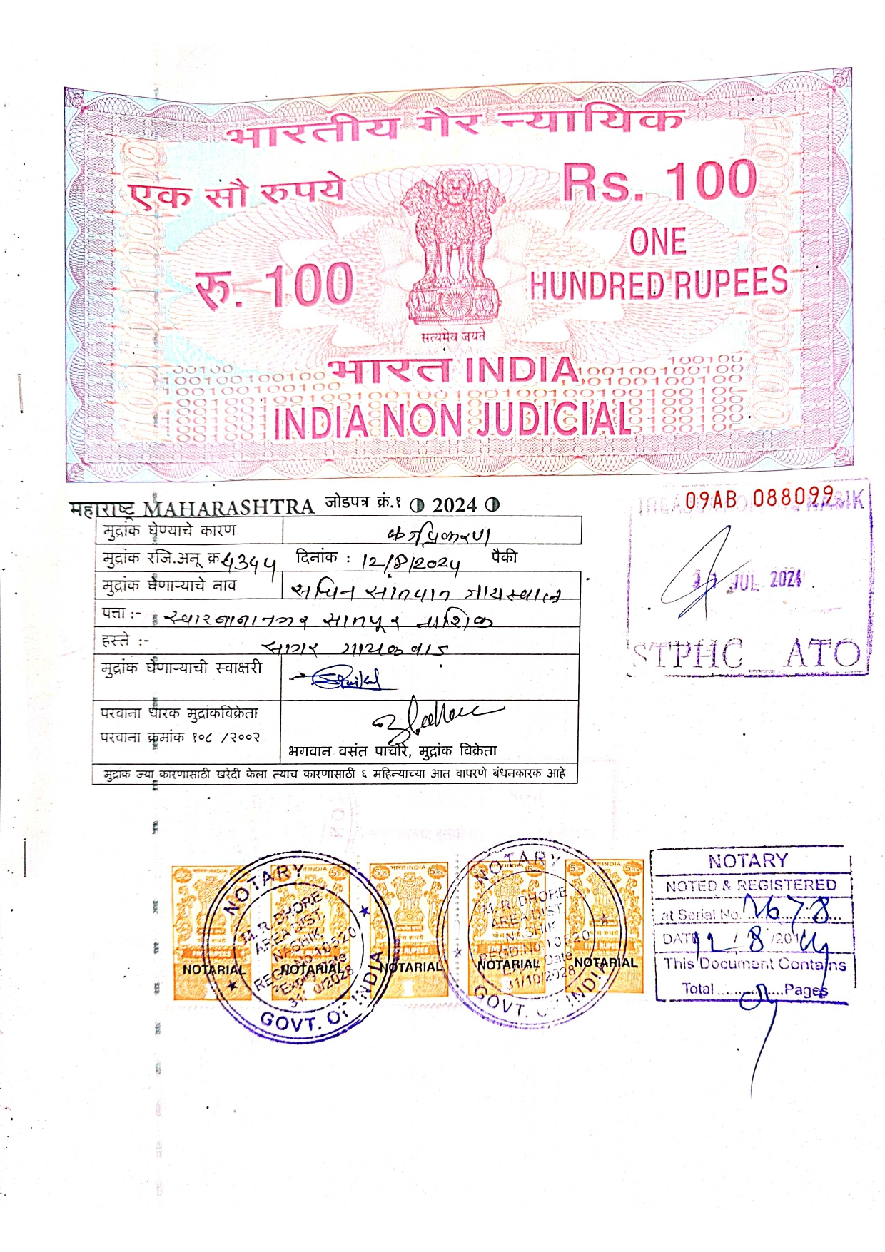
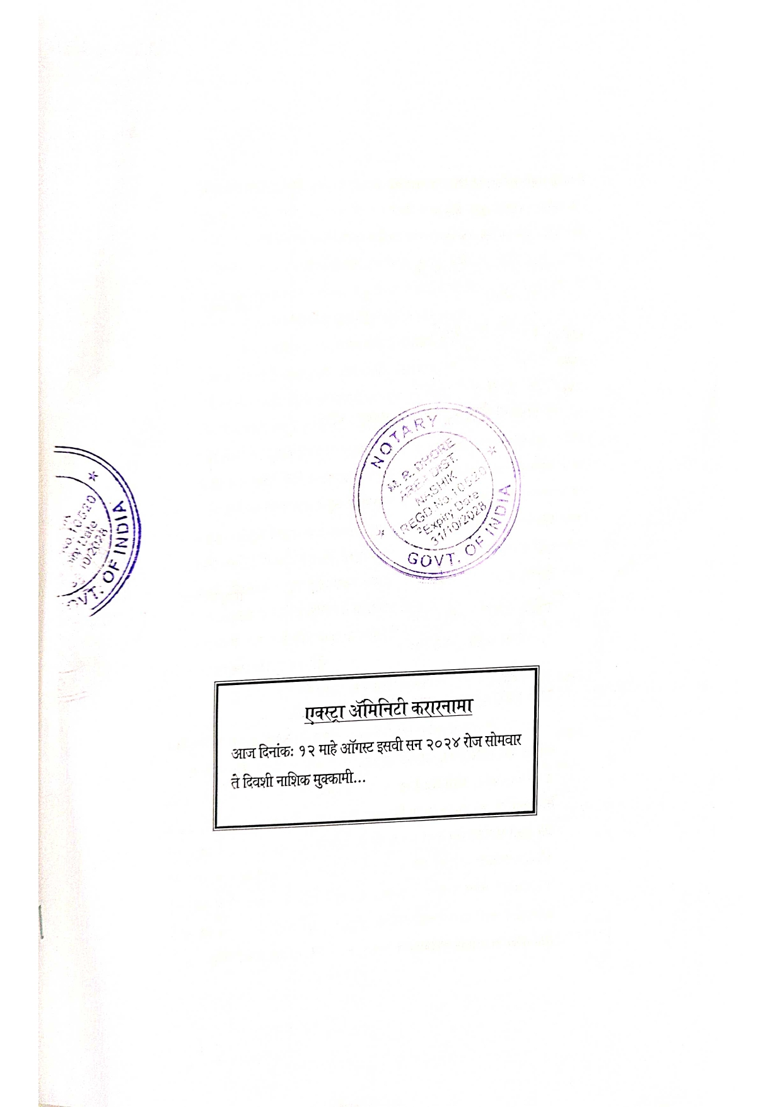

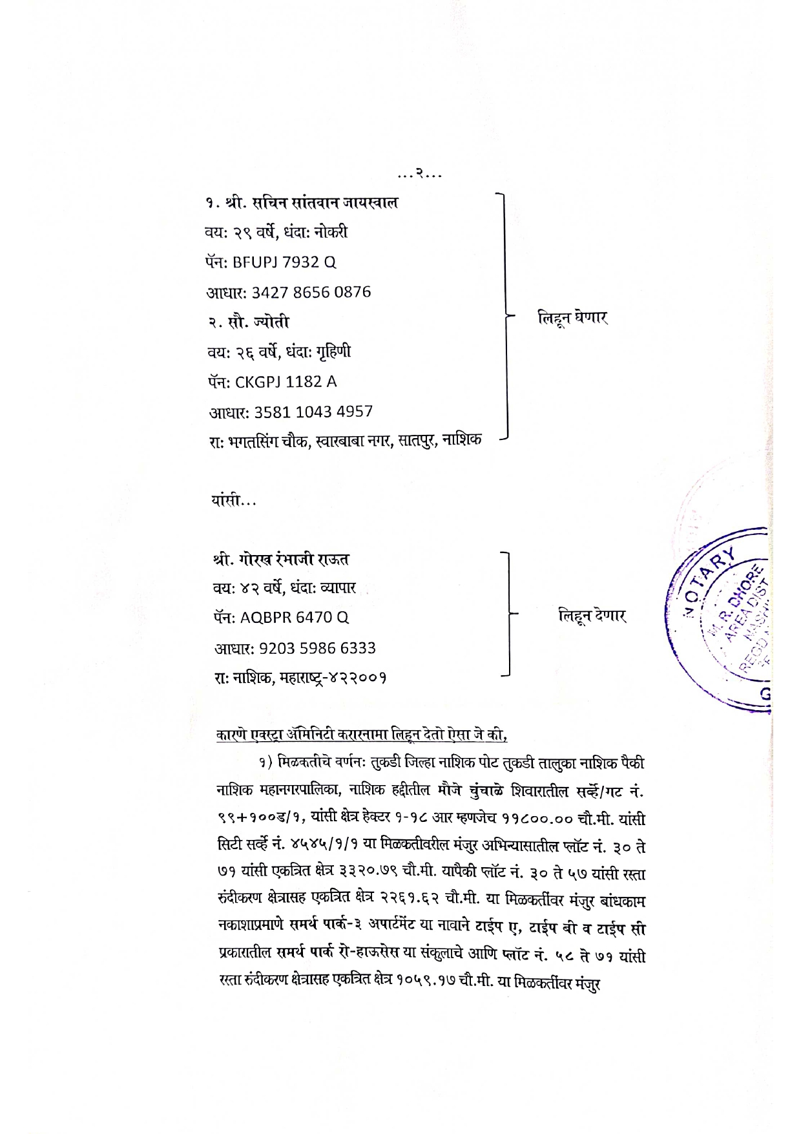

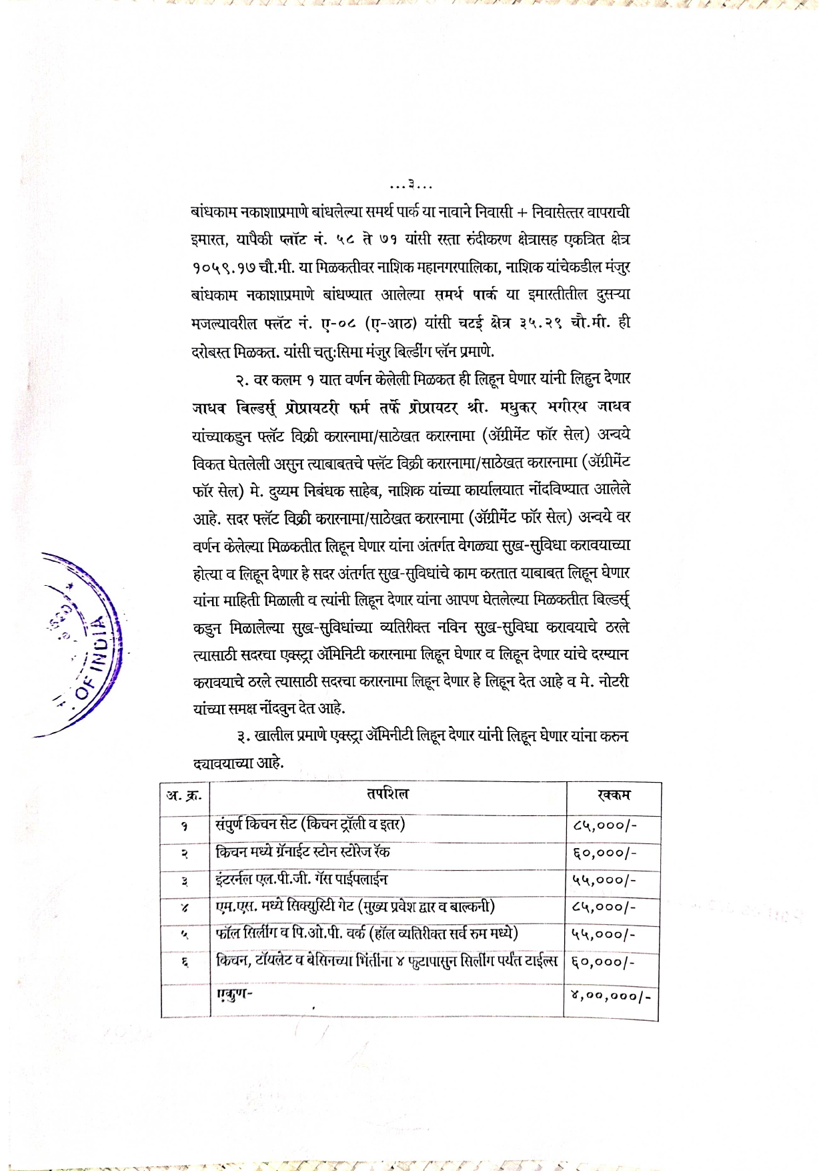
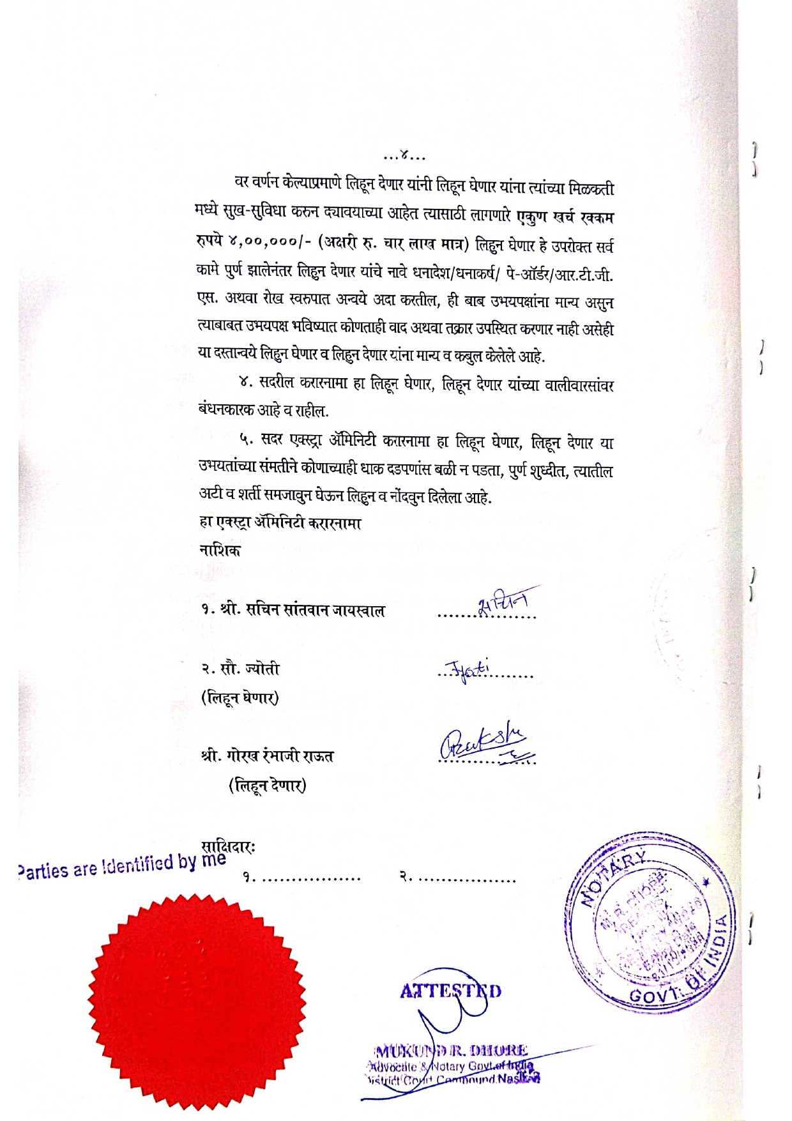

The Extra Amenities amount is Rs. 4,00,000/- (Rupees Four Lakh Only.)

