2nd LENDERS INDEPENDENT ENGINEER REPORT
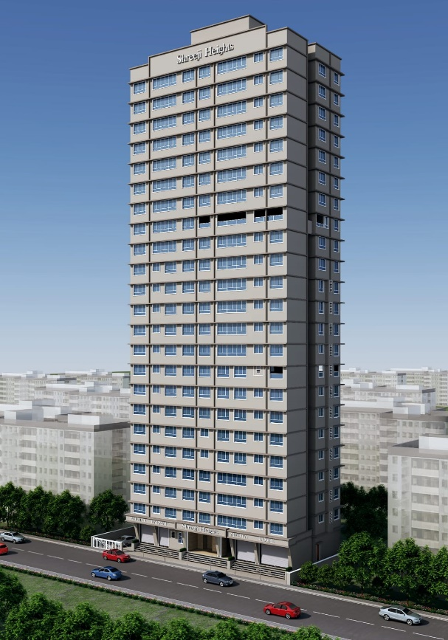

Details of the property under consideration:

Name of Project: Shreeji Heights

"Shreeji Heights", Proposed Redevelopment of existing building known as Ram Niwas, Nath Niwas, & Gool Sorab on Plot bearing CTS. No. 802, 803 & 804, Khetwadi 7th Lane, Girgaon Division, Girgaon, Mumbai – 400 004, State – Maharashtra, Country – India
Latitude Longitude: 18°57'31.2"N 72°49'23.5"E

Intended User:

State Bank of India
SME Chembur Branch
Unit No. 11, Building No. 11, Ground Floor, Corporate Park, Sion Trombay Road,
Chembur, Mumbai, Pin Code – 400 071, State - Maharashtra, Country – India

Vastu/SBI/Mumbai/08/2023/10454/2305834
30/15-582-PY
Date: - 07.08.2024

SECOND LENDERS INDEPENDENT ENGINEER REPORT

To,
State Bank of India
Unit No. 11, Building No. 11, Ground Floor,
Corporate Park, Sion Trombay Road, Chembur,
Mumbai, Pin Code – 400 071,
State - Maharashtra, Country – India.

Subject: Construction of Proposed Redevelopment of existing building known as Ram Niwas, Nath Niwas, & Gool Sorab on Plot bearing CTS. No. 802, 803 & 804, Khetwadi 7th Lane, Girgaon Division, Girgaon, Mumbai – 400 004, State – Maharashtra, Country – India

Ref: You’re Request for Lenders Independent Engineer Report of under Construction Building.
Dear Sir,
The Construction work as per approved plan was in progress during the site visit on 04th July 2024. Total expenditure occurred as on 30/06/2024 on this project by M/s. Anupam Creation is ` 21.50 Cr. & as per CA Certificate actual total expenditure occurred as on 30/062024 is ` 22.03 Cr. Hence, release of Balance Amount as requested by M/s. Anupam Creation is hereby recommended.

DECLARATION
- The information furnished in the report is based on our 2nd site visit Dated 04/07/2024 & Document Provided by Client.
- Vastukala 1st LIE Report of the project dated 30/03/2024.
- Vastukala Project Report of the project dated 15/12/2023.
- Vastukala Cost Vetting Report of the project dated 15/12/2023.
- I have no direct and indirect interest in the property examined for report.
- I have not been found guilty of misconduct in my professional capacity.

Manoj B. Chalikwar
Registered Valuer
Chartered Engineer (India)
Reg. No. IBBI/RV/07/2018/10366
Encl.: LIE report

Purpose & Methodology
• State Bank of India Banks and financial institutions require monitoring & an independent review of the progress of the sanctioned projects
VCIPL undertakes such study to independently review the progress of the project and put forward a comprehensive analysis

Advantages:
- Assurance on present practices
- Identification of risk
- Analyzing the performance of third parties
- Recommendations

The Methodology
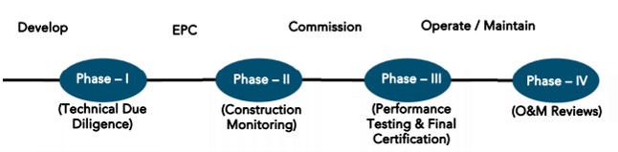
SECOND LENDERS INDEPENDENT ENGINEER REPORT
OF
"SHREEJI HEIGHTS"
"Shreeji Heights", Proposed Redevelopment of existing building known as Ram Niwas, Nath Niwas, & Gool Sorab on Plot bearing CTS. No. 802, 803 & 804, Khetwadi 7th Lane, Girgaon Division, Girgaon, Mumbai – 400 004,
State – Maharashtra, Country – India

Latitude Longitude: 18°57'31.2"N 72°49'23.5"E

NAME OF DEVELOPER: M/s. Anupam Creation
Pursuant to instructions from State of India, SME Chembur Branch, Chembur we have duly visited, inspected, surveyed & assessed the above said property on 04th July 2024 to determine the fair & reasonable market value of the said property/project as on Quarter ending 30th June 2024 for LIE purpose.

1. Location Details:
Proposed Redevelopment of existing building known as Ram Niwas, Nath Niwas, & Gool Sorab on Plot bearing CTS. No. 802, 803 & 804, Khetwadi 7th Lane, Girgaon Division, Girgaon, Mumbai – 400 004. It is about 1.20 Km. travelling distance from Charni Road Railway station. Surface transport to the property is by buses, taxis & private vehicles. The property is in developed locality. All the amenities like shops, banks, hotels, markets, schools, hospitals, etc. are all available in the surrounding locality. The area is higher middle class & developed.
2. Developer Details:
Name of builder | M/s. Anupam Creation
Project Rera Registration Number | P51900052017
Registered office address | 2nd Floor, Anupam Residency Building, V. P. Road, Prathna Samaj, Girgaon, Mumbai – 400 004, State - Maharashtra, Country – India
Contact details | Contact Person:  Mr. Yogesh (Accountant)  Mobile No. +91 9920825249  Mr. Deepak Agarwal (Consultants)  Mobile No. +91 88986 49465
E – mail ID and website
3. Boundaries of the Property:
Direction | Particulars
On or towards North | Golawala Building
On or towards South | 7th Lane Road
On or towards East | Khatri Mansion
On or towards West | Shree Ganesh Apartment

Introduction
As per Information on site M/s. Anupam Creation has acquired land by multiple Conveyance Deed dated 28.01.2021, 07.12.2021 & 07.12.2021 registered vide No. BBE–4-1460/2021 dated 28.01.2021, BBE – 4 - 16805/2021 dated 07.12.2021 & BBE – 4 - 16803/2021 dated 07.12.2021 respectively admeasuring area 685.62 Sq. M. bearing CTS No. 802, 803 & 804. For the Proposed Redevelopment Residential cum Commercial Building.

Area Statement:

Land:
Date | Particular | Area in Sq. M.
28.01.2021 | CTS No. 802 | 306.02
07.12.2021 | CTS No. 803 | 239.97
07.12.2021 | CTS No. 804 | 139.63
TOTAL |  | 685.62

- Copy of Conveyance Deed dated 28.01.2021 Mrs. Rafia Mohamed Iqbal Jumani & 2 Others (The Vendors) and M/s. Anupam Creation (The Purchasers) through registered agreement vide No. BBE–4-1460/2021 dated 28.01.2021
- Copy of Conveyance Deed dated 07.12.2021 between Mr. Bharat Dhirajlal Shah & 2 Others (The Vendors) and M/s. Anupam Creation (The Purchasers) through registered agreement vide No. BBE – 4 - 16805/2021 dated 07.12.2021
- Copy of Conveyance Deed dated 07.12.2021 between Mr. Bharat Dhirajlal Shah & 2 Others (The Vendors) and M/s. Anupam Creation (The Purchasers) through registered agreement vide No. BBE – 4 - 16803/2021 dated 07.12.2021

Building Area As per Approved Plan:
A | AREA STATEMENT |  | In Sq. M.
1 | Area of Plot (Plot Area of CS No. 802 = 306.02 Sq. M. + Plot Area of CS No. 803 = 239.97 Sq. M. + Plot Area of CS No. 804 = 139.63 Sq. M.) |  | 685.62
a | Area of Reservation in plot |  | -
b | Area of Road Set back |  | 36.28
c | Any Reservation |  | -
2 | Deduction for |  | -
A | For Reservation / Road Area
a | Road Setback Area to be handed over (100%) (Regulation No. 16) |  | -
b | Proposed DP Road to be handed over (100%) (Regulation No. 16) |  | -
c i) | Reservation area to be handed over (100%) (Regulation No. 17) |  | -
c ii) | Reservation area to be handed over as per AP (Regulation No. 17) |  | -
B | For Amenity area
a | Area of amenity plot / plots to be handed over as per DCPR 14(A) |  | -
b | Area of amenity plot / plots to be handed over as per DCPR 14(B) |  | -
c | Area of amenity plot / plots to be handed over as per DCPR 35 (abeyance) |  | -
C | Deductions for existing BUA to be retained if any / land component of existing BUA / existing BUA as per regulation under which the development was allowed |  | -
3 | Total deductions: [{2(A) + 2(B)} + (C) as and when applicable] |  | 36.28
4 | Balance area of plot (1 – 3) |  | 649.34
5 | Additions for Floor Space Index |  | -
2a | 100% |  | 36.28
2b | 100% |  | -
 | Plot area under development after areas to be handed over to MCGM / appropriate authority as per Sr. No. 4 above |  | -
6 | Total Area (4 + 5) |  | 685.62
7 | Zonal basic FSI {0.50 or 0.75 or 1 or 1.33 or 3 or incentive as per DCPR 33 (7)] (As per Table – III) appropriate authority as per Sr. No. 4 above |  | INCENTIVE
8 | Floor Space Index Permissible as per DCPR 33 97) (As per Table III) |  | 4,910.43
9 | Built Up equal to area of land handed over as per Regulation 30(A) |  | -
i | As per 2(A) and 2(B) except 2 (A) (c) (ii) above with in cap of “Admissible TDR” as column 6 of table – 12 on remaining / balance plot.) |  | -
ii | In case of 2 (A) (c) ii permissible over and above permissible BUA on remaining / balance plot |  | -
10 | Built up area in lieu of cost of construction of built-up area amenity to be handed over (within the limit of permissible BUA on remaining plot) |  | -
11 | Built up area due to Additional FSI on payment premium as per Table No. 12 of regulations no. 30(A) on remaining /balance plot |  | -
12 | Built up area due to admissible TDR as per Table No. 12 of regulations no. 30(A) and 32 on remaining /balance plot |  | -
13 | Permissible BUA as per Incentive FSI |  | 4,910.43
14 | Proposed BUA |  | 4,910.43
14A | Existing Floor Area |  | -
14B | Purely residential built-up area |  | 4,792.88
14C | Remaining non – residential built-up area |  | 117.55
15 | Fungible compensatory area as per regulation no. 31 (3) |  | Permissible | Proposed
a | Permissible / proposed fungible compensatory area for rehab component without charging premium | REHAB RESI. | 863.41 | 677.31
 |  | REHAB N. R. | 41.14 | 38.48
 |  | TOTAL | 904.55 | 715.79
b | Permissible / proposed fungible compensatory area by charging premium | SALE RESI. | 814.10 | 810.98
 |  | SALE N. R. | - | -
 |  | TOTAL | 814.10 | 810.98
 | Total fungible built-up area vides dcr 33(3) = (15a + 15b) |  | 1,718.65 | 1,526.77
16 | Total Built – up area proposed including fungible compensatory area (14 + 15) |  | 6,629.08 | 6,437.20
 | Rehab Deficit Area |  |  | 188.76
 | Sale Balance Area |  |  | 3.12
17 | FSI consumed on Gross Plot [14/1] |  | 7.16
(II) | Other requirements |  | -
(A) | Reservation / Designation |  | -
a) | Name of reservation |  | -
b) | Area of reservation affecting the plot |  | -
c) | Area of reservation land to be handed / handed over as per regulation no. 17 |  | -
d) | Built-up area of amenity to be handed over as per regulation no. 17 |  | -
e) | Area / Built-up area of designation |  | -
(B) | Plot area / built-up amenity to be handed over as per regulation no. |  | -
i) | 14 (A) |  | -
ii) | 14 (B) |  | -
iii) | 15 |  | -
(C) | Requirement of recreational open space in layout / plot as per regulation no. 27 |  | As per Statement
(D) | Tenement Statement
i) | Proposed built – up area
ii) | Less deduction of non – residential area (shop, etc.)
iii) | Area available for tenements [(i) minus (ii)]
iv) | Tenements permissible (Density of tenements / hectare)
v) | Total number of tenements proposed on the plot
(E) | Parking Statement
i) | Parking required by regulations for Car Scooter / Motor cycle outsiders (visitors)
ii) | Covered garage permissible
iii) | Covered garages proposed Car / Scooter / Motor Cycle Outsiders (visitors)
iv) | Total parking provided
(F) | Transport Vehicles Parking
i) | Spaces for transport vehicles parking required by regulations
ii) | Total no. of transport vehicles parking spaces provided

List of Approvals:
- Copy of Approved Plan No. P-12578/2022/(802 And Other)/D Ward/GIRGAUM/1/New dated 16.11.2022 issued by Municipal Corporation of Greater Mumbai (MCGM).
Approved Upto: Basement + Ground Floor + 1st to 22nd Upper Floors
- Copy of 1st Commencement Certificate No. P-12578/2022/(802 And Other)/D Ward/GIRGAUM/CC/1/New dated 11.04.2023 valid upto 10.04.2024 issued by Municipal Corporation of Greater Mumbai (MCGM).
(This CC is endorsed for the work up to Plinth Level only as per IOD issued dated 16.11.2022).
- Copy of 2nd Commencement Certificate No. P-12578/2022/(802 And Other)/D Ward/GIRGAUM/FCC/1/New dated 08.12.2023 valid upto 10.04.2024 issued by Municipal Corporation of Greater Mumbai (MCGM).
(This CC is endorsed for the work up to top of 22nd Floor + LMR + OHT i.e., CC for entire work as per IOD issued dated 16.11.2022).
- Copy of 3rd Commencement Certificate No. P-12578/2022/(802 And Other)/D Ward/Girgaon/377/1/New dated 10.05.2024 valid upto 10.04.2025 issued by Municipal Corporation of Greater Mumbai (MCGM).
(This CC is endorsed for the work up to top of 22nd Floor + LMR + OHT i.e., CC for entire work as per IOD issued dated 16.11.2022).
- Copy of No Objection Certificate NO. R/NOC/F-2811/4478/MBR &R Board-2022 dated 14.06.2022 issued by Maharashtra Housing and Area Development Authority (MHADA).

LEVEL OF COMPLETION:

Rehab cum Sales Building
Sr. No | Floor No. | Construction Area in Sq. M. | Completed Area in Sq. M. | Work Completion as on 04.07.2024 | Work Completion as on 21.03.2024
1 | Excavation & Shore Piling |  |  | Work is Completed | Work is Completed
2 | Basement | 365.64 | 365.64 | Slab Work & block work is completed | Slab Work is completed
3 | Ground Floor | 365.64 | 365.64 | Slab Work & block work is completed | Slab Work is completed
4 | 1st Floor | 393.26 | 393.26 | Slab Work, block work, plaster work, Door frame & window frame work is completed | Slab Work is completed
5 | 2nd Floor | 391.88 | 391.88 | Slab Work, block work, plaster work, Door frame & window frame work is completed | Slab Work is completed
6 | 3rd Floor | 391.88 | 391.88 | Slab Work, block work, plaster work, Door frame & window frame work is completed | Slab Work is completed
7 | 4th Floor | 391.88 | 391.88 | Slab Work, block work, plaster work, Door frame & window frame work is completed | Slab Work is completed
8 | 5th Floor | 391.88 | 391.88 | Slab Work, block work, plaster work, Door frame & window frame work is completed
9 | 6th Floor | 391.88 | 391.88 | Slab Work, block work, plaster work, Door frame & window frame work is completed
10 | 7th Floor | 391.88 | 391.88 | Slab Work, Block work is completed & Plaster work is in progress
11 | 8th Floor | 408.52 | 408.52 | Slab Work is completed
12 | 9th Floor | 408.52 | 408.52 | Slab Work is completed
13 | 10th Floor | 412.47 | 412.47 | Slab Work is completed
14 | 11th Floor | 415.53 |  | Shuttering work is in progress
15 | 12th Floor | 415.53
16 | 13th Floor | 415.53
17 | 14th Floor | 415.83
18 | 15th Floor | 422.27
19 | 16th Floor | 422.25
20 | 17th Floor | 411.10
21 | 18th Floor | 411.10
22 | 19th Floor | 411.10
23 | 20th Floor | 411.10
24 | 21st Floor | 411.10
25 | 22nd Floor | 411.10
26 | Terrace Floor | 43.87
Total |  | 9,722.80 | 4,705.35
Stack Parking |  | 49.00 | -

Details of the Project as Financed By SBI:

Project Cost: (as per C.A. Certificate)
Particulars | Estimated Cost (in Cr.) | Incurred Cost (In Cr.) till 30.06.2024 dated 31.07.2024 by M/s. S C Vora & Co. | Incurred Cost (In Cr.) till 29.02.2024 dated 28.03.2024 by M/s. S C Vora & Co. | Net
Land Cost | 1.48 | 1.48 | 1.48 | -
Rent Cost | 5.87 | 2.24 | 2.24 | -
Construction cost of Building | 33.80 | 9.28 | 4.50 | 4.78
Premium Cost / FSI / GOM Charges / fees / security Deposits | 9.69 | 7.89 | 7.84 | 0.05
Professional Cost | 1.69 | 0.57 | 0.56 | 0.01
Administrative Cost | 2.03 | 0.05 | 0.03 | 0.02
Marketing Cost | 3.50 | - | - | -
Interest Cost | 4.03 | 0.51 | - | 0.51
Contingency Cost | 1.01 | - | - | -
Total | 63.10 | 22.03 | 16.66 | 5.37

- The Builder has incurred about 9.28 Cr. as construction cost, 7.89 Cr. for approval of project, 0.57 Cr. for professional cost, 0.05 Cr. for admin cost & 0.51 Cr. for interest cost in last quarter till 30.06.2024 as per C.A. certificate issued by M/s. S C Vora & Co. dated 31.07.2024.

Project Cost: (as per Bills):
Particulars | Incurred Cost (in Cr.)
 | 30.06.2024 as per Bill (Inclusive GST) | 29.02.2024 as per Bill (Inclusive GST) | Net
Land Cost | 1.48 | 1.48 | -
Rent Cost | 2.24 | 2.24 | -
Construction cost of Building | 8.69 | 4.84 | 3.85
Premium Cost / FSI / GOM Charges / fees / security Deposits | 7.84 | 7.84 | -
Professional Cost | 0.55 | 0.45 | 0.10
Administrative Cost | 0.65 | 0.38 | 0.27
Marketing Cost | - | 0.00 | -
Interest Cost | 0.05 | 0.00 | 0.05
Contingency Cost | - | - | -
Total | 21.50 | 17.24 | 4.26
Note:

Land Cost:
Sr. No. | Agreement Name | Date | Particulars | Total Cost in ` | Incurred Cost in `
1 | Conveyance Deed | 07.12.2021 | Stamp Duty | 13,97,300.00 | 13,97,300.00
2 |  |  | Reg. Fees | 30,000.00 | 30,000.00
3 |  |  |  | 2,840.00 | 2,840.00
4 | Conveyance Deed | 07.12.2021 | Stamp Duty | 13,97,300.00 | 13,97,300.00
5 |  |  | Reg. Fees | 30,000.00 | 30,000.00
6 |  |  |  | 3,300.00 | 3,300.00
7 | Conveyance Deed | 28.01.2021 | Purchase Cost | 1,16,00,000.00 | 1,16,00,000.00
8 |  |  | Stamp Duty | 3,48,000.00 | 3,48,000.00
9 |  |  | Reg. Fees | 30,000.00 | 30,000.00
10 |  |  |  | 1,600.00 | 1,600.00
 | TOTAL |  |  | 1,48,40,340.00 | 1,48,40,340.00
As per developer agreement.
Summary of Bills
Sr. No. | Particulars | Amount in `  (till 30.06.2024) | Amount in ` (in Cr.) | Amount in `  (till 29.02.2024) | Amount in ` (in Cr.) | Net in ` (in Cr.)
1 | Construction Cost | 8,69,05,388.00 | 8.69 | 4,84,37,952.00 | 4.84 | 3.85
2 | Rent Cost | 2,24,29,806.00 | 2.24 | 2,24,29,806.00 | 2.24 | -
3 | Premium Cost / FSI / GOM Charges / fees / security Deposits | 7,83,89,148.00 | 7.84 | 7,83,89,148.00 | 7.84 | -
4 | Professional Cost | 54,67,076.00 | 0.55 | 44,86,737.00 | 0.45 | 0.10
5 | Administrative Cost | 64,73,094.00 | 0.65 | 37,78,634.00 | 0.38 | 0.27
6 | Marketing Cost | - | - | - | - | -
7 | Contingency Cost | - | - | - | - | -
TOTAL |  | 19,96,64,511.00 | 19.97 | 15,75,22,276.00 | 15.75 | 4.21
Note: Bills were provided by the client up to 30.06.2024

Interest Cost:
Sr. No | Particulars | Estimate Amount in ` | Incurred Amount in ` (till 30.06.2024) | Incurred Amount in ` (till 29.02.2024) | Difference | Balance Amount in `
1 | Interest Cost | 4,03,00,000.00 | 4,95,384.00 | - | 4,95,384.00 | 3,98,04,616.00
TOTAL |  | 4,03,00,000.00 | 4,95,384.00 | - | 4,95,384.00 | 3,98,04,616.00
Interest Cost is based on discussion with the client.

Cost of Construction as on 04th July 2024:
Sr. No | Floor | Total Construction Area in Sq. M. | Completed Area in Sq. M. | Rate per Sq. M. | Full Value after completion | % of work completed | Actual Expenditure till date in `
1 | Excavation Cost |  |  |  | 2,91,68,399.00 | 100% | 2,91,68,399.00
2 | Basement | 365.64 | 365.64 | 30,000.00 | 1,09,69,200.00 | 60% | 65,81,520.00
3 | Ground Floor | 365.64 | 365.64 | 30,000.00 | 1,09,69,200.00 | 60% | 65,81,520.00
4 | 1st Floor | 393.26 | 393.26 | 30,000.00 | 1,17,97,830.00 | 67% | 79,04,546.10
5 | 2nd Floor | 391.88 | 391.88 | 30,000.00 | 1,17,56,430.00 | 67% | 78,76,808.10
6 | 3rd Floor | 391.88 | 391.88 | 30,000.00 | 1,17,56,430.00 | 67% | 78,76,808.10
7 | 4th Floor | 391.88 | 391.88 | 30,000.00 | 1,17,56,430.00 | 67% | 78,76,808.10
8 | 5th Floor | 391.88 | 391.88 | 30,000.00 | 1,17,56,430.00 | 67% | 78,76,808.10
9 | 6th Floor | 391.88 | 391.88 | 30,000.00 | 1,17,56,430.00 | 67% | 78,76,808.10
10 | 7th Floor | 391.88 | 391.88 | 30,000.00 | 1,17,56,430.00 | 61% | 71,71,422.30
11 | 8th Floor | 408.52 | 408.52 | 30,000.00 | 1,22,55,705.00 | 50% | 61,27,852.50
12 | 9th Floor | 408.52 | 408.52 | 30,000.00 | 1,22,55,705.00 | 50% | 61,27,852.50
13 | 10th Floor | 412.47 | 412.47 | 30,000.00 | 1,23,74,205.00 | 40% | 49,49,682.00
14 | 11th Floor | 415.53 |  | 30,000.00 | 1,24,66,005.00 |  | -
15 | 12th Floor | 415.53 |  | 30,000.00 | 1,24,66,005.00 |  | -
16 | 13th Floor | 415.53 |  | 30,000.00 | 1,24,66,005.00 |  | -
17 | 14th Floor | 415.83 |  | 30,000.00 | 1,24,75,005.00 |  | -
18 | 15th Floor | 422.27 |  | 30,000.00 | 1,26,68,205.00 |  | -
19 | 16th Floor | 422.25 |  | 30,000.00 | 1,26,67,605.00 |  | -
20 | 17th Floor | 411.10 |  | 30,000.00 | 1,23,33,105.00 |  | -
21 | 18th Floor | 411.10 |  | 30,000.00 | 1,23,33,105.00 |  | -
22 | 19th Floor | 411.10 |  | 30,000.00 | 1,23,33,105.00 |  | -
23 | 20th Floor | 411.10 |  | 30,000.00 | 1,23,33,105.00 |  | -
24 | 21st Floor | 411.10 |  | 30,000.00 | 1,23,33,105.00 |  | -
25 | 22nd Floor | 411.10 |  | 30,000.00 | 1,23,33,105.00 |  | -
26 | OHT / LMR | 43.87 |  | 30,000.00 | 13,16,100.00 |  | -
Sub - Total (A) |  | 9,722.80 | 2,300.18 |  | 32,08,52,384.00 | 36% | 11,39,96,835.00
STACK PARKING Nos. |  | 49.00 |  | 3,50,000.00 | 1,71,50,000.00 |  | -
TOTAL COST OF CONSTRUCTION (A + B) |  |  |  |  | 33,80,02,384.00 | 34% | 11,39,96,835.00

Note: Details of work completed is as per site visit dated 04.07.2024 but report is prepared for 30th June quarter 2024.

Particulars | Estimated Cost  (In Cr.) | Incurred Cost (in Cr.) |  |  | Net
 |  | Issued dated 31.07.2024 till 30.06.2024 as per CA | As per Bills upto 29.02.2024 | As per Bills upto 29.02.2024
Land Cost | 1.48 | 1.48 | 1.48 | 1.48 | -
Rent Cost | 5.87 | 2.24 | 2.24 | 2.24 | -
Construction cost of Building | 33.80 | 9.28 | 8.69 | 4.84 | 3.85
Premium Cost / FSI / GOM Charges / fees / security Deposits | 9.69 | 7.89 | 7.84 | 7.84 | -
Professional Cost | 1.69 | 0.57 | 0.55 | 0.45 | 0.10
Administrative Cost | 2.03 | 0.05 | 0.65 | 0.38 | 0.27
Marketing Cost | 3.50 | - | - | 0.00 | -
Interest Cost | 4.03 | 0.51 | 0.05 | 0.00 | 0.05
Contingency Cost | 1.01 | - | - | - | -
Total | 63.10 | 22.03 | 21.50 | 17.24 | 4.26
Note:
- We have considered Other Expenses, Printing & Stationery, and Water Bills cost is consider in Administrative cost header but CA has considered them in cost of construction header .
- We have considered bank loan processing charges in administrative cost but CA has considered them in interest cost header.
- As per plinth area, calculation the work completed is up to 34% of total work, which comes to ` 11.40 Cr. However, company has incurred cost of ` 8.69 Cr. till 30.06.2024 as per bill .

Comparison of Cost incurred on dated 30.06.2024 & 29.02.2024
Particulars | 30.06.2024 as per Bill | 29.02.2024 as per Bill | Net | % of net amount
Land Cost | 1.48 | 1.48 | - | 0.00%
Rent Cost | 2.24 | 2.24 | - | 0.00%
Construction cost of Building | 8.69 | 4.84 | 3.85 | 17.91%
Premium Cost / FSI / GOM Charges / fees / security Deposits | 7.84 | 7.84 | - | 0.00%
Professional Cost | 0.55 | 0.45 | 0.10 | 0.47%
Administrative Cost | 0.65 | 0.38 | 0.27 | 1.26%
Marketing Cost | - | 0.00 | - | 0.00%
Interest Cost | 0.05 | 0.00 | 0.05 | 0.23%
Contingency Cost | - | - | - | 0.00%
Total | 21.50 | 17.24 | 4.26 | 19.81%

% of Fund Utilised till 30th June 2024
Particulars | Estimated Project Cost  (in Cr.) | Incurred cost as on 30.06.2022 | % of Incurred Cost | % of Estimated Project Cost
Land Cost | 1.48 | 1.48 | 100.27% | 2.35%
Rent Cost | 5.87 | 2.24 | 38.21% | 3.55%
Construction cost of Building | 33.80 | 8.69 | 25.71% | 13.77%
Premium Cost / FSI / GOM Charges / fees / security Deposits | 9.69 | 7.84 | 80.90% | 12.42%
Professional Cost | 1.69 | 0.55 | 32.35% | 0.87%
Administrative Cost | 2.03 | 0.65 | 31.89% | 1.03%
Marketing Cost | 3.50 | - | 0.00% | 0.00%
Interest Cost | 4.03 | 0.05 | 1.23% | 0.08%
Contingency Cost | 1.01 | - | 0.00% | 0.00%
Total | 63.10 | 21.50 | 34.07% | 34.07%
Based on above Calculation it is found that total Project cost incurred is 34.07% of the Total Project Cost.

Means of Finance:
Sr. No. | Particulars | Exp. Cumulative (Cr.)
 | Equity share capital / Quassi Loan from Promoter / Unsecured Loan | 20.00
 | Sales (Advance from customer) | -
 | Bank Laon Amount | 2.03
 | Total | 22.03
The Details of the Means of Finance are provided by Client as on 30.06.2024.

Mandatory Arrangements:
Sr. No. | Particulars | Status
 | Rainwater Harvesting | To be executed after RCC Structure
 | Firefighting System | To be executed after RCC Structure
 | Solid Waste Management | To be executed after RCC Structure

Quality of Construction:
Sr. No. | Particulars | Status
 | Soundness of Structures | Executing as per approved Structural Design
 | Look of Structures | Good
 | Quality of Material Used | Good
 | Safety Measures for Construction/labour | Taken Care by Contractor

Schedule V/s. Actual Progress:
Activity | Date of Implementation | Date of Completion | Status
Land |  |  | Completed
Development of Land |  |  | Completed
Foundation Work |  |  | Completed
Ground Floor Slab |  |  | Slab work is Completed
1st Floor Slab | 01.12.2023 | 15.01.2024 | Slab work is Completed
2nd Floor Slab | 16.01.2024 | 31.01.2024 | Slab work is Completed
3rd Floor Slab | 01.02.2024 | 15.02.2024 | Slab work is Completed
4th Floor Slab | 16.02.2024 | 28.02.2024 | Slab work is Completed
5th Floor Slab | 01.03.2024 | 15.03.2024 | Slab work is Completed
6th Floor Slab | 16.03.2024 | 31.03.2024 | Slab work is Completed
7th Floor Slab | 01.04.2024 | 15.04.2024 | Slab work is Completed
8th Floor Slab | 16.04.2024 | 30.04.2024 | Slab work is Completed
9th Floor Slab | 01.05.2024 | 15.05.2024 | Slab work is Completed
10th Floor Slab | 16.05.2024 | 31.05.2024 | Slab work is Completed, delay by 1 month
11th Floor Slab | 01.06.2024 | 15.06.2024 | Shuttering work is in progress
12th Floor Slab | 16.06.2024 | 30.06.2024
13th Floor Slab | 01.07.2024 | 15.07.2024
14th Floor Slab | 16.07.2024 | 31.07.2024
15th Floor Slab | 01.08.2024 | 15.08.2024
16th Floor Slab | 16.08.2024 | 31.08.2024
17th Floor Slab | 01.09.2024 | 15.09.2024
18th Floor Slab | 16.09.2024 | 30.09.2024
19th Floor Slab | 01.10.2024 | 15.10.2024
20th Floor Slab | 16.10.2024 | 31.10.2024
21st Floor Slab | 01.11.2024 | 15.11.2024
22nd Floor Slab | 16.11.2024 | 30.11.2024
Block work / Internal Plaster work | 01.04.2024 | 30.06.2025 | 1st to 7th floor block work is completed  1st to 6th floor internal plaster work is completed
Terrace Parapet wall / Overhead water tank / Lift Machine room / compound wall / External Plaster work | 01.12.2024 | 30.09.2025
Electric Work | 01.07.2024 | 30.09.2025
Water Proofing | 01.07.2024 | 30.09.2025
Plumbing Work | 01.07.2024 | 30.09.2025
Tiling / Marble Flooring
Door Frames | 01.10.2024 | 30.09.2025
Window Installation | 01.10.2024 | 30.09.2025
Staircase Flooring
Staircase Railing
Refuge Area Flooring
Internal Painting | 01.01.2025 | 31.03.2026
External Painting | 01.01.2025 | 31.03.2026
Lift Work
Fire Fighting Installation
Stack Parking
CP Fitting & Sanitary Work | 01.07.2024 | 30.09.2025
Final Finishing & Fitting |  | 31.03.2026

Action initiated to complete the project in time:
For Rehab Cum Sales Building: 10th Floor Slab work, 1st to 7th floor block work, 1st to 6th floor plaster work is completed, 11th floor shuttering work is in progress. Project is delay by 1 month.

Comments related to cost overrun if any:
The cost of Sales Building is ` 63.10 Cr.

Balance investment required for completion of project:
We opinion amount of ` 41.60 Cr. Will be required to complete the Project.

Mandatory Approval Status:
Sr. No. | Particulars | Name of Department | Status | Order Details
1 | IOD of Building | Municipal Corporation of Greater Mumbai (MCGM). | Obtained and available at site | P-12578/2022/(802 And Other)/D Ward/GIRGAUM/1/New dated 16.11.2022
1A | 1st Amended | Municipal Corporation of Greater Mumbai (MCGM). | Obtained and available at site | P-12578/2022/(802 And Other)/D Ward/GIRGAUM/1/New dated 16.11.2022
2A | First C.C. | Municipal Corporation of Greater Mumbai (MCGM). | Obtained and available at site | - P-12578/2022/(802 And Other)/D Ward/GIRGAUM/CC/1/New dated 11.04.2023 valid upto 10.04.2024. (This CC is endorsed for the work up to Plinth Level only as per IOD issued dated 16.11.2022).
2B | Second C.C. | Municipal Corporation of Greater Mumbai (MCGM). | Obtained and available at site | - P-12578/2022/(802 And Other)/D Ward/GIRGAUM/FCC/1/New dated 08.12.2023 valid upto 10.04.2024. (This CC is endorsed for the work up to top of 22nd Floor + LMR + OHT i.e., CC for entire work as per IOD issued dated 16.11.2022).
2C | Third C. C. | Municipal Corporation of Greater Mumbai (MCGM). | Obtained and available at site | - P-12578/2022/(802 And Other)/D Ward/Girgaon/377/1/New dated 10.05.2024 valid upto 10.04.2025.  - (This CC is endorsed for the work up to top of 22nd Floor + LMR + OHT i.e., CC for entire work as per IOD issued dated 16.11.2022).
3B | Occupancy | Municipal Corporation of Greater Mumbai (MCGM). | Pending (Project is not completed)

Status Insurance Coverage:
Information not provided

Assumptions & Remarks:
- The adequacy of Engineering / Structural design is beyond the scope of our assignment.
- As per Bank sanctioned letter dated 13.03.2024 estimated project completion date is March 2026.
- As per RERA Certificate estimated project completion date is 31/12/2030 for Rehab cum Sales Building respectively.
- The cost is certified based on the assumptions that the project will be completed within period as per bank sanction letter. Few assumptions were made regarding inflation & cost rise etc. during construction period.

Manoj B. Chalikwar
Registered Valuer
Chartered Engineer (India)
Reg. No. IBBI/RV/07/2018/10366

About the Project:
1. Introduction
a) | Project Name  (With Address & Phone Nos.) | "Shreeji Heights", Proposed Redevelopment of existing building known as Ram Niwas, Nath Niwas, & Gool Sorab on Plot bearing CTS. No. 802, 803 & 804, Khetwadi 7th Lane, Girgaon Division, Girgaon, Mumbai – 400 004, State – Maharashtra, Country – India  Contact Person:  Mr. Yogesh (Accountant)  Mobile No. +91 99208 25249  Mr. Deepak Agarwal (Consultants)  Mobile No. +91 88986 49465
b) | Purpose of Valuation | As per request from State Bank of India, SME Chembur Branch to assess fair market value of the Project for LIE purpose.
c) | Date of Inspection of Property | 04.07.2024
d) | Date of LIE Report | 07.08.2024
e) | Name of the Developer of Property  (in case of developer built properties) | M/s. Anupam Creation  2nd Floor, Anupam Residency Building, V. P. Road, Prathna Samaj, Girgaon, Mumbai – 400 004, State - Maharashtra, Country – India
2. Physical Characteristics of the Property
a) | Location of the Property | "Shreeji Heights", Proposed Redevelopment of existing building known as Ram Niwas, Nath Niwas, & Gool Sorab on Plot bearing CTS. No. 802, 803 & 804, Khetwadi 7th Lane, Girgaon Division, Girgaon, Mumbai – 400 004, State – Maharashtra, Country – India
 | Brief description of the property
TYPE OF THE BUILDING
Rehab cum Sales Building

No. of Floors | Basement + Ground Floor + 1st to 22nd Upper Floors
Building type | Residential Rehab cum Sale building

Rehab cum Sales Building work is given on contract based for RCC contract. Developer has grant to the contractor do the work of construction and completion includes Concrete work, Reinforcement work, Masonry, Internal Plaster, External Plaster and other miscellaneous work such as repairing, joints b/w concrete and masonry surface, etc. Bill must be paid on measurement of construction area exclusive of Steel, Cement & other construction material.
Lift & lift installation contract is not finalized till now.
Firefighting work contract is not finalized.

PROPOSED DATE OF COMPLETION & FUTURE LIFE:
Expected completion date as per RERA is 31st December 2030.

ABOUT PROJECT:

Anupam Shreeji Heights is among the newest addresses for homebuyers. This is an under – construction project right now, and is expected to be delivered by Dec, 2030. It has a variety of options to choose from that too in a varied budget range.

Anupam Shreeji Heights South Mumbai is a RERA registered housing society, which means all projects details are also available on state RERA website for end-users and investors. The RERA registration number of this project is P51900052017.
 | Nearby landmark
 | Postal Address of the Property | "Shreeji Heights", Proposed Redevelopment of existing building known as Ram Niwas, Nath Niwas, & Gool Sorab on Plot bearing CTS. No. 802, 803 & 804, Khetwadi 7th Lane, Girgaon Division, Girgaon, Mumbai – 400 004, State – Maharashtra, Country – India
 | Area of the plot/land  (Supported by a plan) | Net Plot Area: 649.34 Sq. M.
 | Type of Land: Solid, Rocky, Marsh land, reclaimed land, Water-logged, Land locked. | Solid land
 | Independent access/approach to the property etc. | Yes
 | Google Map Location of the Property with a neighborhood layout map | Provided
 | Details of roads abutting the property | 12 M wide road
 | Description of adjoining property | Located in Higher Middle-class locality
 | Plot No. Survey No. | CTS. No. 802, 803 & 804
 | Ward/Village/Taluka | Girgaon Division, Taluka – Mumbai
 | Sub-Registry/Block | Girgaon
 | District | District - Mumbai
b) | Boundaries of the Plot
 | As per Agreement | As per RERA Certificate | Actual
North | Information not available | CS No. 805 | Golawala Building
South | Information not available | CS No. 806 | Khetwadi 7th Lane Road
East | Information not available | 797 to 1800 | Khatri Mansion
West | Information not available | Khetwadi 7th Lane | Shree Ganesh Apartment

4. Document Details and Legal Aspects of Property:
a) | Ownership Documents (Building Permission, Commencement Certificate & Status of Plan)
 | Sale Deed, Gift Deed, Lease Deed
 | - Copy of Indenture Agreement dated 29.11.1990 between Jamila Syed Rehman Khan and Smt. Vasu Manjeshwar (The Vendors) and Dhirajlal Amichand Shah & Others (The Purchasers).
 | - Copy of Conveyance Deed dated 10.05.2001 between Bhaskar Bapulal Shah & Other (The Vendors) and Rafia Mohamed Iqbal Jumani & 4 Others (The Purchasers).
 | - Copy of Conveyance Deed dated 28.01.2021 Mrs. Rafia Mohamed Iqbal Jumani & 2 Others (The Vendors) and M/s. Anupam Creation (The Purchasers) through registered agreement vide No. BBE–4-1460/2021 dated 28.01.2021
 | - Copy of Conveyance Deed dated 07.12.2021 between Mr. Bharat Dhirajlal Shah & 2 Others (The Vendors) and M/s. Anupam Creation (The Purchasers) through registered agreement vide No. BBE – 4 - 16805/2021 dated 07.12.2021
 | - Copy of Conveyance Deed dated 07.12.2021 between Mr. Bharat Dhirajlal Shah & 2 Others (The Vendors) and M/s. Anupam Creation (The Purchasers) through registered agreement vide No. BBE – 4 - 16803/2021 dated 07.12.2021
 | - Copy of Indemnity Deed dated 10.12.2018 between Mr. Bharat Dhirajlal Shah & 2 Others (The Obligors) and The Collector of Mumbai/City survey and Superintendent of Land Records of Mumbai and Sub Registrar Office of Assurances at Mumbai (The Obligees) through registered agreement vide No. BBE – 4 –11032/2018 dated 10.12.2018
- Copy of Approved Plan No. P-12578/2022/(802 And Other)/D Ward/GIRGAUM/1/New dated 16.11.2022 issued by Municipal Corporation of Greater Mumbai (MCGM).
Approved Upto: Basement + Ground Floor + 1st to 22nd Upper Floors
- Copy of 1st Commencement Certificate No. P-12578/2022/(802 And Other)/D Ward/GIRGAUM/CC/1/New dated 11.04.2023 valid upto 10.04.2024 issued by Municipal Corporation of Greater Mumbai (MCGM).
(This CC is endorsed for the work up to Plinth Level only as per IOD issued dated 16.11.2022).
- Copy of 2nd Commencement Certificate No. P-12578/2022/(802 And Other)/D Ward/GIRGAUM/FCC/1/New dated 08.12.2023 valid upto 10.04.2024 issued by Municipal Corporation of Greater Mumbai (MCGM).
(This CC is endorsed for the work up to top of 22nd Floor + LMR + OHT i.e., CC for entire work as per IOD issued dated 16.11.2022).
 | - Copy of No Objection Certificate NO. R/NOC/F-2811/4478/MBR &R Board-2022 dated 14.06.2022 issued by Maharashtra Housing and Area Development Authority (MHADA).
 | - Copy of CA Certificate dated 15.11.2023 issued by SC Vora & Co.
 | - Copy of Title Certificate dated 19.02.2022 issued by Mr. Vikas R. Hirlekar.
 | - Copy of RERA Certificate RERA No. P51900052017 dated 19.07.2023 issued by Maharashtra Real Estate Regulatory Authority (MAHRERA).
 | - Copy of Title Report dated 27.04.2023 issued by Sunil S. Vichare.
 | - Copy of Engineer’s Certificate dated 30.01.2024 issued by Rohan Kishor Raut
 | - Copy of Bills till 29.02.2024
 | - Copy of CA Certificate dated 28.03.2024 issued by M/s. S C Vora & Co.

b) | Documents verified for present LIE report
 | - Copy of CA Certificate dated 31.07.2024 issued by M/s. S C Vora & Co.
 | - Copy of Bills From 01.03.2024 to 30.06.2024
 | - Copy of CA (Form 3) Certificate dated 08.07.2024 issued by M/s. Bharti Thakkar & Co.
 | - Copy of Engineer’s Certificate dated 08.07.2024 issued by Rohan Kishor Raut
 | - Copy of License Surveyor Certificate dated 09.07.2024 issued by M/s. Aparna Consultant.
- Copy of 3rd Commencement Certificate No. P-12578/2022/(802 And Other)/D Ward/Girgaon/377/1/New dated 10.05.2024 valid upto 10.04.2025 issued by Municipal Corporation of Greater Mumbai (MCGM).
(This CC is endorsed for the work up to top of 22nd Floor + LMR + OHT i.e., CC for entire work as per IOD issued dated 16.11.2022).
Actual Site Photographs as on 04.07.2024
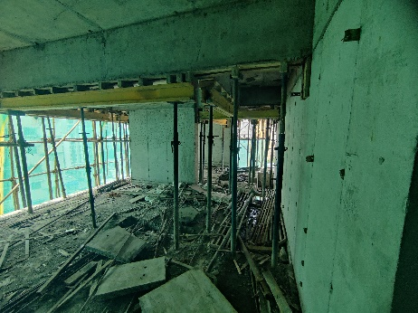
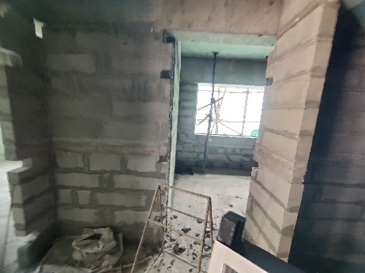
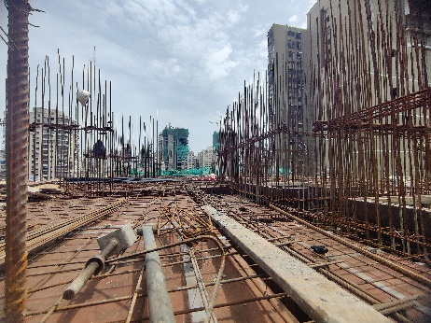
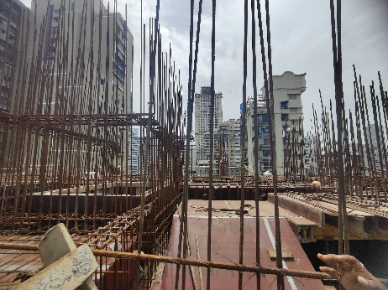
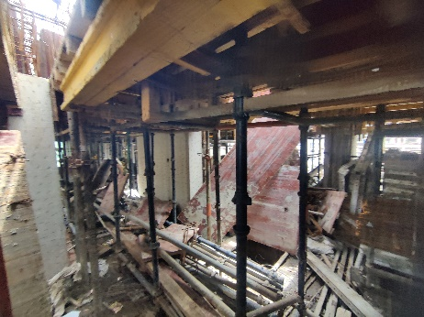
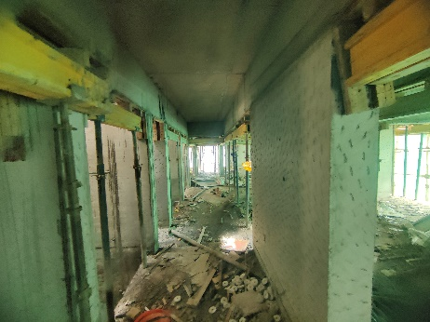
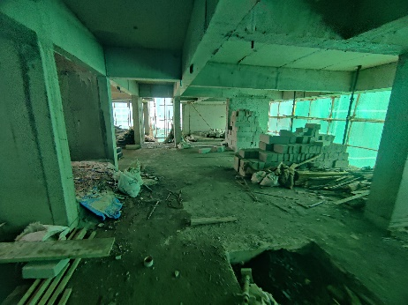
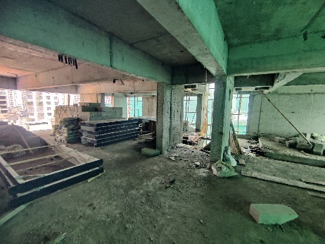
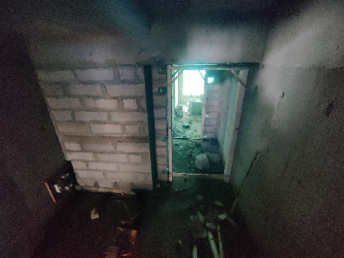
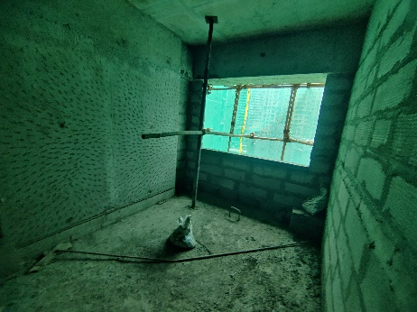
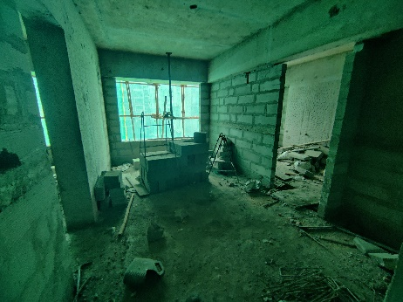
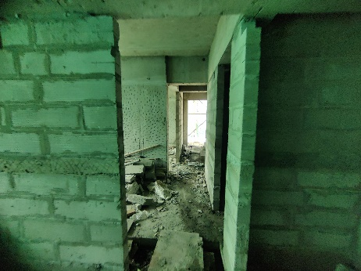
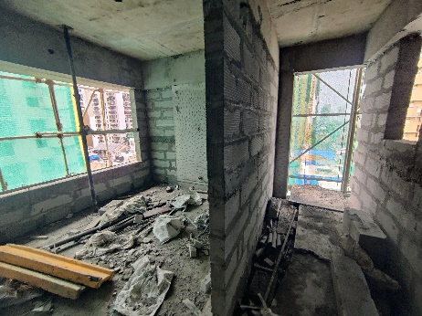
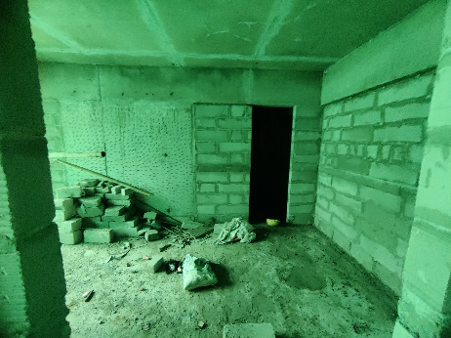
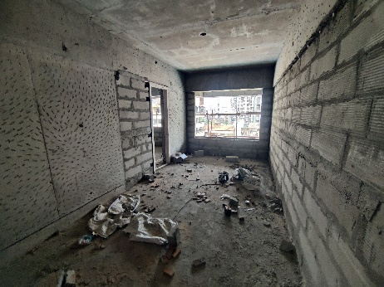
Actual Site Photographs as on 04.07.2024
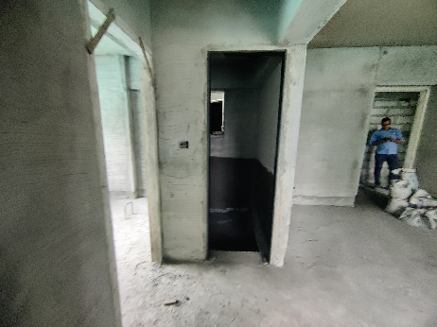
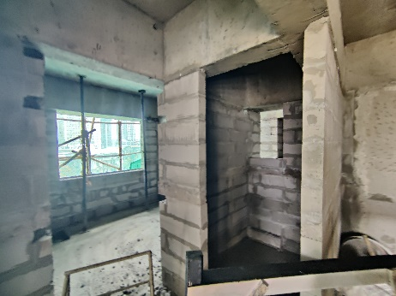
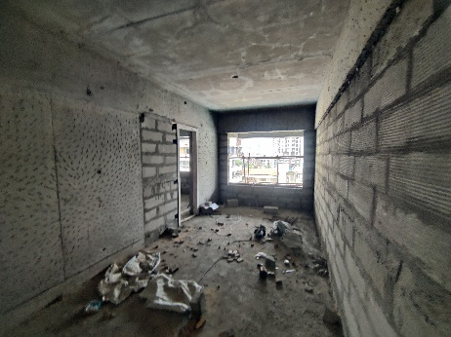
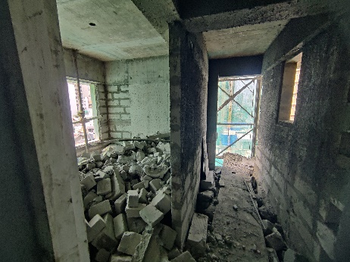
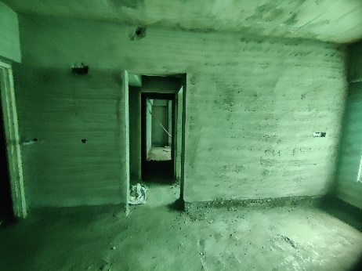
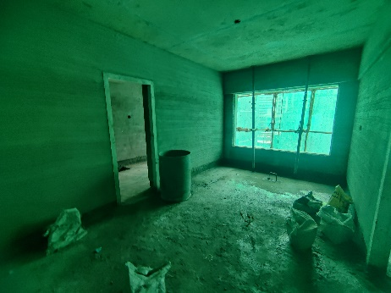
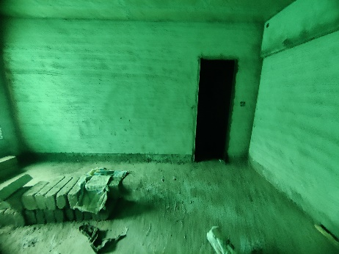
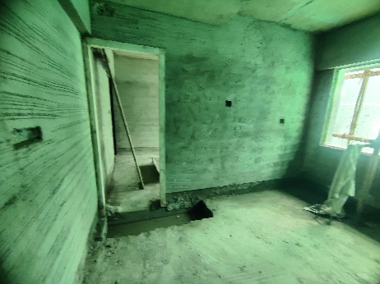
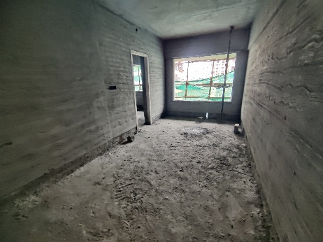
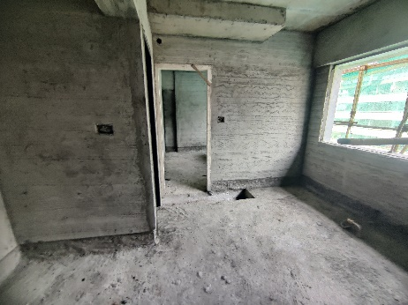
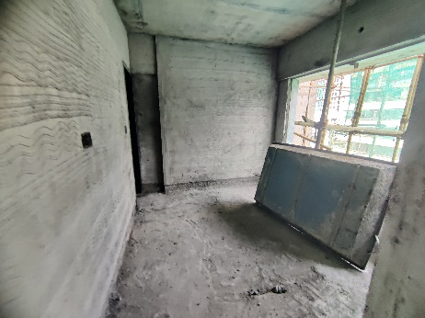
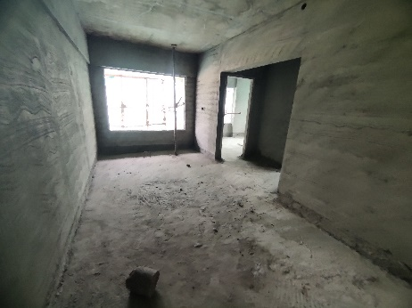
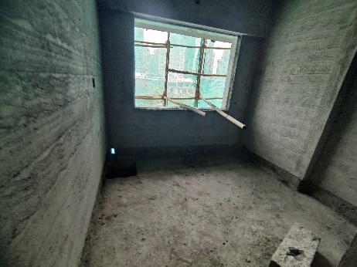
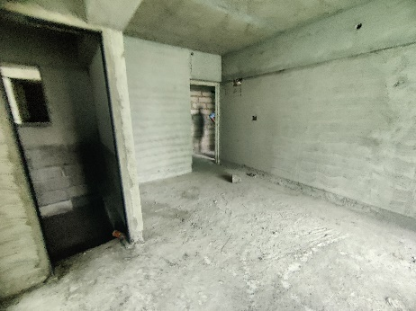
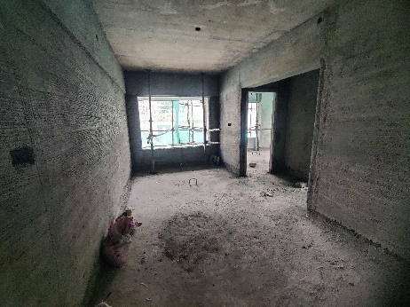
Actual Site Photographs as on 04.07.2024
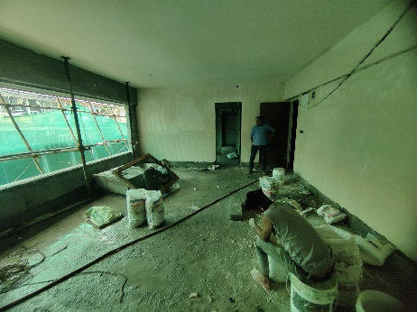
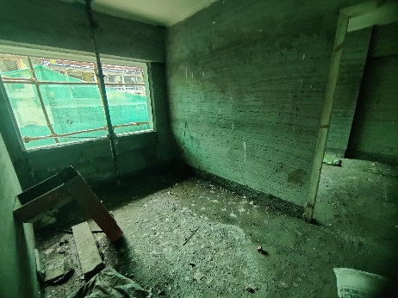
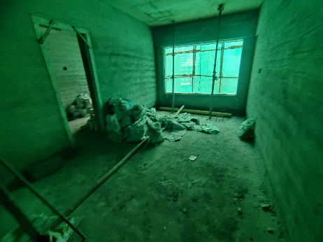
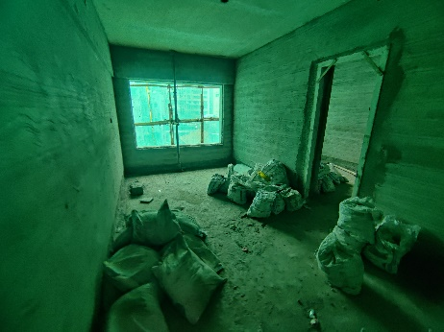
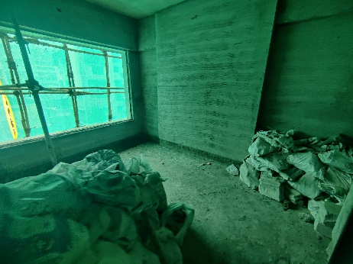
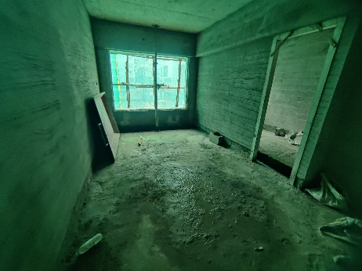
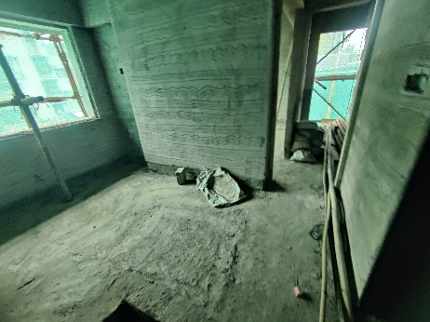
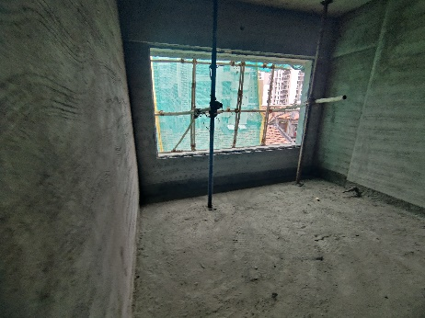
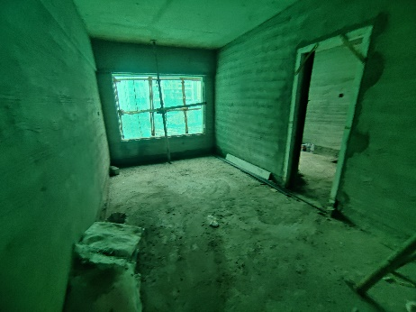
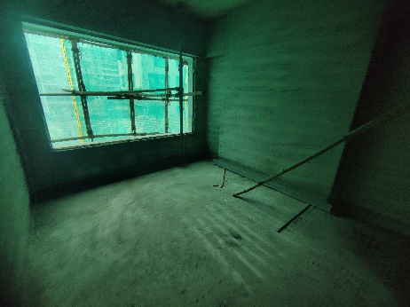
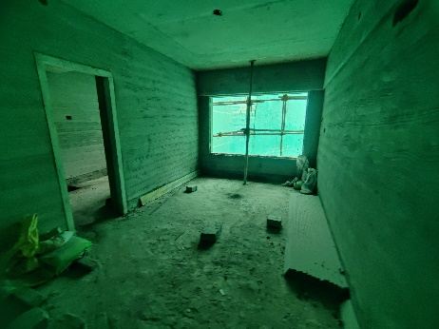
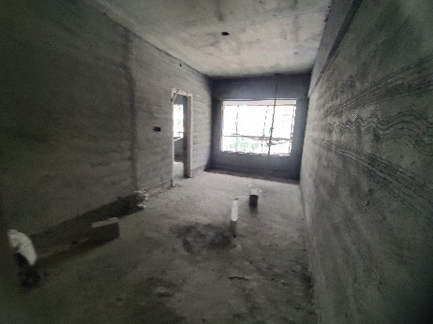
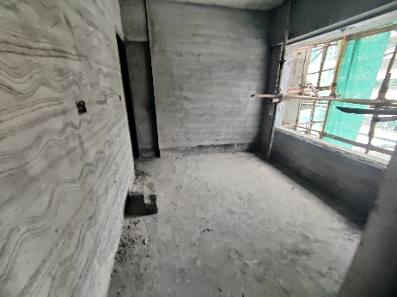
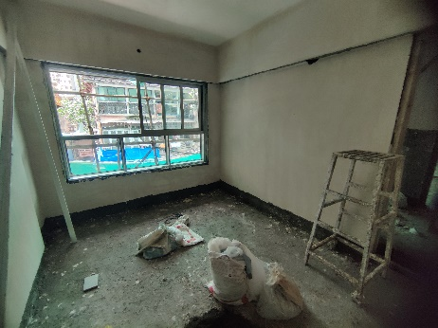
Actual Site Photographs as on 04.07.2024
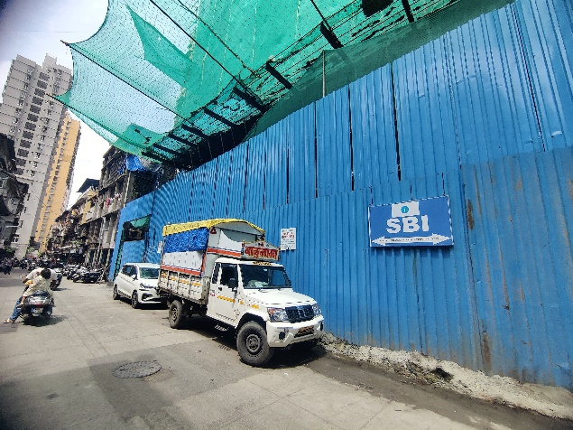
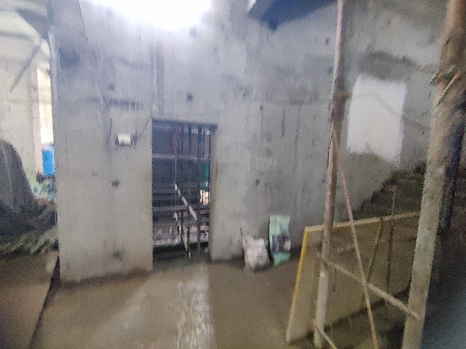
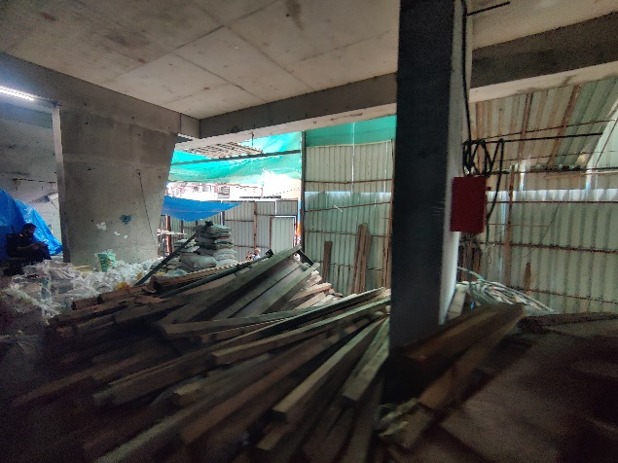

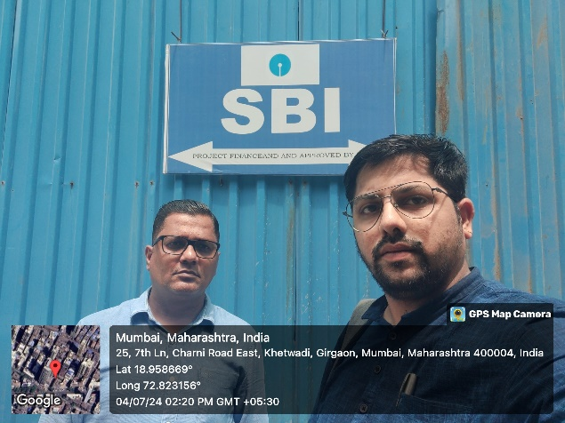

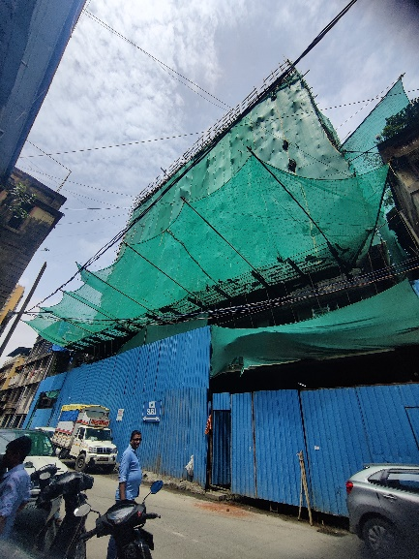

Route Map of the property
Site u/r
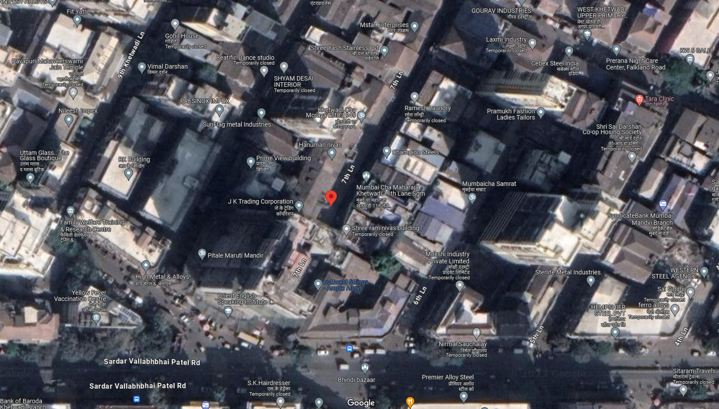

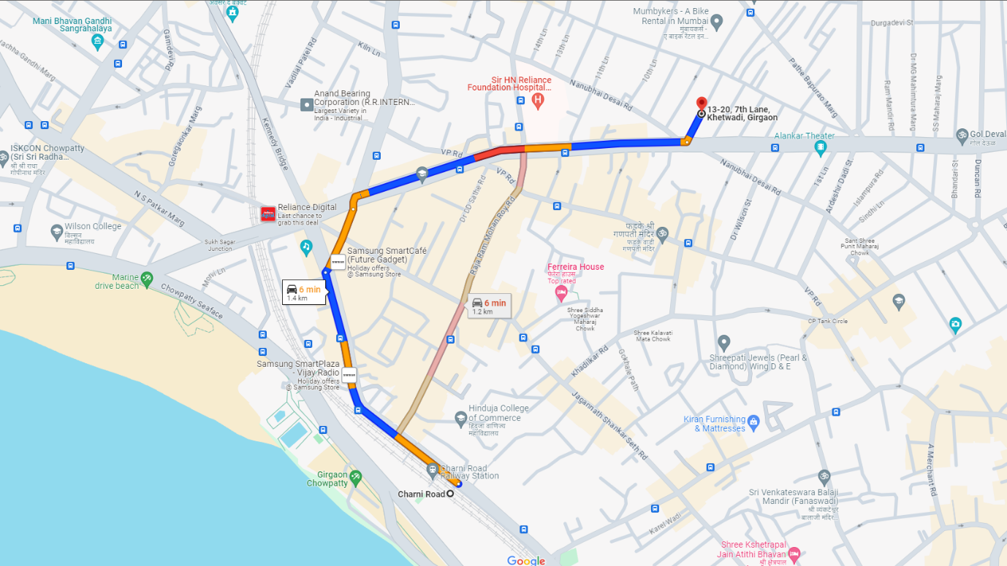

Latitude Longitude: 18°57'31.2"N 72°49'23.5"E

Note: The Blue line shows the route to site from nearest railway station (Charni Road – 1.20 Km.)
CA Certificate Dated 31.07.2024 till 30.06.2024
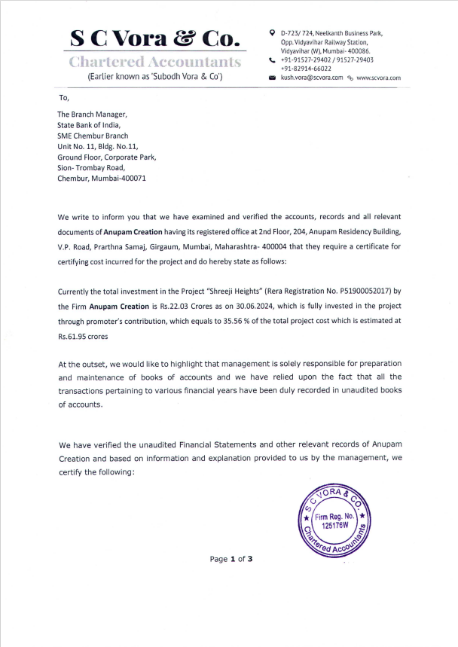
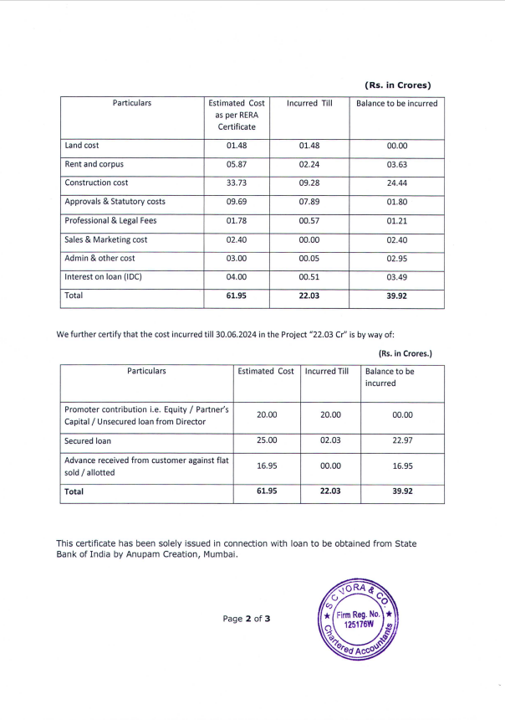
CA Certificate Dated 31.07.2024 till 30.06.2024

CA Certificate Dated 31.07.2024 till 30.06.2024
