1st LENDERS INDEPENDENT ENGINEER REPORT

**Details of the property under consideration:**

**Name of Owner: M/s. Myrayash Hotels Pvt. Ltd.**

**Proposed 5 Star Hotel project on plot bearing SY. No. 206/1 – H, 210/5 – A, 211/1 to 8 and 212/1 to 4 & 6, Village – Anjuna, Taluka – Bardez, District – North Goa, Pin Code – 403 509, State – Goa, Country – India**

**Latitude Longitude: 15°35'10.9"N 73°44'17.3"E**

Intended User for:

State Bank of India

Industrial Finance Branch, Andheri (East)

Natraj Building, 102, 1st Floor, 194, Sir M.V. Road, Western Express Highway,

Andheri (East), Mumbai – 400 069, State - Maharashtra, Country - India

Vastu/SBI/Mumbai/09/2024/10433/2307584

21/07-62-PYU

Date: - 21.09.2024

FIRST LENDERS INDEPENDENT ENGINEER REPORT

**To,**

**State Bank of India**

Industrial Finance Branch, Andheri (East)

Natraj Building, 102, 1st Floor,

194, Sir M.V. Road,

Western Express Highway,

Andheri (East), Mumbai – 400 069,

State – Maharashtra, Country – India.

Subject: Construction of Proposed 5 Star Hotel project on plot bearing SY. No. 206/1 – H, 210/5 – A, 211/1 to 8 and 212/1 to 4 & 6, Village – Anjuna, Taluka – Bardez, District – North Goa, Pin Code – 403 509, State – Goa, Country – India

**Ref:** You’re Request for Lenders Independent Engineer Report of under Construction Building.

**Dear Sir,**

1. As per your instruction, we have inspected the under construction proposed 5 Star Hotel project on plot bearing SY. No. 206/1 – H, 210/5 – A, 211/1 to 8 and 212/1 to 4 & 6, Village – Anjuna, Taluka – Bardez, District – North Goa, Pin Code – 403 509, State – Goa, Country – India which is being developed by M/s. Myrayash Hotels Pvt. Ltd. in order to give the physical progress at site and to certify cost incurred towards project as on 31/08/2024 as per approved plan having 170 Hotel Rooms.
2. While Certifying cost incurred toward project as on 31/08/2024, various important factors such as type & Quality of proposed construction, Specification of building material to be used, grade of the building, height, lead & lift condition, current market price of similar type etc. were given due consideration.
3. As per cost incurred certificate issued by **CA Certificate actual total expenditure occurred as on 25/06/2024 is ` 60.88 Cr. for the Lower Basement Floor + Upper Basement Floor + Ground Floor + 1st Floor having 170 hotel rooms.**
4. Hence, considering current status & progress at site, the total cost incurred as on 31/08/2024 towards the project is fair & reasonable up to ` 65.57 Cr. for the Lower Basement Floor + Upper Basement Floor + Ground Floor + 1st Floor which is including land & site development, cost of building construction, cost of miscellaneous fixed assets, consultant fees, preliminary & pre-operative expenses, advances to suppliers & material laying at site etc. This is verified by observing the actual progress of the construction work at site.
5. As per Bank Sanctioned Letter the loan was sanctioned for 200.00 Cr.

|  |  |  |  |
| --- | --- | --- | --- |
| Particulars | Cost as per Bank Sanction Letter dated 22.02.2024 in ` Cr. | Incurred Cost till 31.08.2024 in ` Cr. | Balance Cost in ` Cr. |
| Term Loan | 200.00 | 4.44 | 195.56 |
| Equity / Margin Cost | 121.63 | 61.13 | 60.50 |
| TOTAL | **321.63** | **65.58** | **256.05** |

1. **Overall progress of the project site as on 31/08/2024 is 20.47% and overall financial progress as per C.A. certificate including land cost as on 25/06/2024 is 19.00% estimated cost of project.**
2. Overall physical progress of the building construction as on 12/082024 is 0.00% as per physical site inspection.
3. Overall physical progress of the P&M utilities as on 12/082024 is 0.00% as per physical site inspection.

**DECLARATION**

1. The information furnished in the report is based on our site visit Dated 12/08/2024 & Document Provided by Client.
2. Dun & Bradstreet Draft TEV Report date was 09.01.2024 for 170 Hotel Rooms.
3. Bank Sanction Letter Ref. No. DGM/IFBA/AMT-I/2023-24/572 dated 22.02.2024 issued by State Bank of India.
4. I have no direct and indirect interest in the property examined for report.
5. I have not been found guilty of misconduct in my professional capacity.

**Manoj B. Chalikwar**

Registered Valuer

Chartered Engineer (India)

Reg. No. IBBI/RV/07/2018/10366

Encl.: LIE report

# Purpose & Methodology

• State Bank of India Banks and financial institutions require monitoring & an independent review of the progress of the sanctioned projects

**VCIPL** undertakes such study to independently review the progress of the project and put forward a comprehensive analysis

# Advantages:

* Assurance on present practices
* Identification of risk
* Analyzing the performance of third parties
* Recommendations

# The Methodology

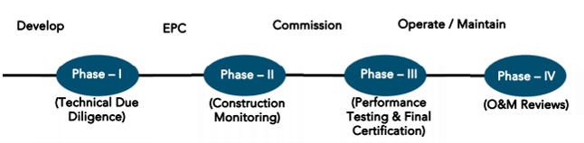

**FIRST LENDERS INDEPENDENT ENGINEER REPORT**

**OF**

**"M/s. Myrayash Hotels Pvt. Ltd."**

**Proposed 5 Star Hotel project on plot bearing SY. No. 206/1 – H, 210/5 – A, 211/1 to 8 and 212/1 to 4 & 6, Village – Anjuna, Taluka – Bardez, District – North Goa, Pin Code – 403 509, State – Goa, Country – India**

**Latitude Longitude: 15°35'10.9"N 73°44'17.3"E**

**NAME OF DEVELOPER: M/s. Myrayash Hotels Pvt. Ltd.**

|  |
| --- |
| Pursuant to instructions from State Bank of India, Industrial Finance Branch, Andheri (East) we have duly visited, inspected, surveyed & assessed the above said property on **12th August 2024** to determine the fair & reasonable market value of the said property/project as on Quarter ending **31st August 2024** for LIE purpose.  **1. Location Details:**  Proposed 5 Star Hotel project on plot bearing SY. No. 206/1 – H, 210/5 – A, 211/1 to 8 and 212/1 to 4 & 6, Village – Anjuna, Taluka – Bardez, District – North Goa, Pin Code – 403 509. It is about 29.10 Km. travelling distance from Manohar International Airport and 46.00 Km. travelling distance from Vasco da Gama Railway station. Surface transport to the property is by buses, taxis & private vehicles. The property is in developing locality. All the amenities like shops, banks, hotels, markets, schools, hospitals, etc. are all available in the surrounding locality. The area is middle class & developing. |

**2. Developer Details:**

|  |  |
| --- | --- |
| **Name of Developer** | **M/s. Myrayash Hotels Pvt. Ltd.** |
| **Project Rera Registration Number** | **N. A.** |
| **Registered office address** | Flat No. 202, Building No. 12, Charvi Reemz, Bardez, Anjuna, North Goa, Pin Code – 403 506, State – Goa, Country – India |
| **Contact details** | **Contact Person:**  Mr. Anirudh Sadhale (CFO)  Mobile No. +91 98338 00026  Mrs. Bhupalee Khanvilkar (Accountant)  Mobile No. +91 98199 31225  Mr. Rohan Karmalkar (Project Licensor)  Mobile No. +91 83086 62239  Mr. Amit Kotharkar (Site Engineer Head)  Mobile No. +91 80734 40228 |
| **E – mail ID and website** |  |

**3. Boundaries of the Property:**

|  |  |
| --- | --- |
| **Direction** | **Particulars** |
| **On or towards North** | Open Plot |
| **On or towards South** | Internal Road |
| **On or towards East** | Anjuna Beach & Ohm Anjuna |
| **On or towards West** | Philip Olinde & Crasto Palace |

# Introduction

**As per Information on site M/s. Myrayash Hotels Pvt. Ltd.** has acquired land by Concession Agreement dated 09.12.2016 admeasuring **total land area is 73,356.80 Sq. M.** bearing **Survey No. 206/Part, 210/5, 211/2 to 8, 212/1 to 11.** For the Proposed 5 Star Hotel Project.

# Area Statement:

# Land:

|  |  |  |
| --- | --- | --- |
| **Date** | **Particular** | **Area in Sq. M.** |
| 09.12.2016 | Survey No. 206/Part, 210/5, 211/2 to 8, 212/1 to 11 | 73,356.80 |
| TOTAL | | 73,356.80 |

1. Copy of Concession Agreement dated 09.12.2016 between M/s. Goa Tourism Development Corporation Ltd. (GTDC) (The Concessioning Authority) and M/s. Myrayash Hotels Private Limited (The Concessionaire).

# Building Area As per Approved Plan:

|  |  |
| --- | --- |
| Description | Area Sq. M. |
| Total Plot Area As per Form 1 & 14 | 70,462.00 |
| Area As per Actual Site Measurement | 70,367.00 |
| Less Area Under Road widening 200 M. | 612.09 |
| Net Plot Area | 69,754.91 |
| Open Space Required (15%) | 10,463.23 |
| Open Space Provided (15%) | 10,464.00 |
| Permissible Coverage (33%) | 23,019.00 |
| Proposed Coverage (14.31%) | 9,982.45 |
| Permissible F.A.R. (33) | 23,221.11 |
| F.A.R. Consumed (25.50%) | 17,946.81 |
| Additional F.A.R. Permissible (7.50%) | 1,346.00 |
| Swimming Pool Area | 437.00 |
| Total No. of Rooms | 161 Nos. |
| Parking Statement |  |
| A Parking |  |
| B Total No. of rooms 161 @ 1 No. Car Parking for 2nd of rooms | 80 Nos. Car Parking |
| Car Parking provided in basement | 45 Nos. |
| Open Space Car Parking provided = 50 X 2 | 100 Nos. |
| Total Car Parking Provided | 145 Nos. |
| Infrastructure Tax Area | 25,925.26 Sq. M. |
| Swimming Pool Area | 437.00 Sq. M. |
| Total Area | 26,362.26 Sq. M. |

**Built Up Area:**

The details of the building / level wise built-up areas for the hotel are as follows:

|  |  |  |  |
| --- | --- | --- | --- |
| Sr. | Level | Floor | Built Up Area in Sq. M. |
|  | + 95.38 | Lower Basement | 1,401.70 |
|  | + 98.45 & + 101.00 | Upper Basement | 3,072.16 |
|  | + 103. 33 & + 101.63 | Ground Floor | 3,888.92 |
|  | + 106.15, + 106.85, + 107.14 & + 108.05 | Ground Floor | 1,026.55 |
|  | First Floor | 2,525.13 |
|  | + 109.35, + 110.50 & + 111.05 | Ground Floor | 1,853.70 |
|  | First Floor | 822.02 |
|  | + 114.55 | Ground Floor | 1,652.07 |
|  | First Floor | 673.51 |
|  | + 117.95 & + 118.50 | Ground Floor | 1,026.46 |
|  | First Floor | 1,216.89 |
|  | + 121.15 | Ground Floor | 1,352.50 |
|  | First Floor | 729.62 |
|  | + 124.55 | Ground Floor | 1,313.81 |
|  | First Floor | 1,174.81 |
|  | + 127.85 | Ground Floor | 761.24 |
|  | First Floor | 794.70 |
|  | + 131.15 | First Floor | 637.94 |
| TOTAL BUILT – UP AREA OF ALL LEVELS | | | **25,923.73** |

**Revised the Number of Rooms as per the Approved Plan & Final Layout Plan:**

The company has modified the number of rooms by increasing the sizes, maintaining the overall built-up area as per the approved plan. The total number of rooms as per the approved plan and as per the final layout is given below:

|  |  |  |  |
| --- | --- | --- | --- |
| Sr. | Level | Rooms Nos. | |
| **As per Approved Plan** | **As per Final Layout Plan** |
|  | + 103. 33 & + 101.63 | 8 | 8 |
|  | + 106.15, + 106.85, + 107.14 & + 108.05 | 17 | 17 |
|  | + 109.35, + 110.50 & + 111.05 | 19 | 17 |
|  | + 114.55 | 20 | 16 |
|  | + 117.95 & + 118.50 | 21 | 17 |
|  | + 121.15 | 24 | 21 |
|  | + 124.55 | 24 | 24 |
|  | + 127.85 | 28 | 28 |
| TOTAL | | **161** | **148** |

In addition, the company proposes to install 22 luxury tents, which being classified as temporary structures, will be located within the CRZ zone.

**The revised approval for 148 rooms & 22 temporary structure tents requires approval from the local authorities.**

**The cost for 22 Tents must be considered after the approval from the local authorities.**

**Construction Area Statement as per Draft TEV Report is as follows –**

|  |  |  |
| --- | --- | --- |
| Sr. | Particulars | Area in Sq. Ft. |
| I | **Civil & Structure Works** |  |
| 1 | Structure Works | 2,80,100.00 |
| 2 | Masonry And Screed Works | 2,80,100.00 |
| 3 | Soil Nailing Works | 2,80,100.00 |
| 4 | Shore Pilling | 2,80,100.00 |
| 5 | Plinth construction for tented Villas | 2,80,100.00 |
| 6 | Retaining Walls in landscape areas | 2,80,100.00 |
| 7 | Allowance for site attendance | 2,80,100.00 |
|  | **Total Civil & Structure Work Cost** |  |
| II | **Façade Works** |  |
| 1 | Glazing | 58,352.00 |
| 2 | Cladding | 51,743.00 |
| 3 | Banquet & Pre - function Canopy | 4,187.00 |
| 4 | Arrival | 11,302.00 |
| 5 | Hanger | 3,692.00 |
| 6 | Kids Club & Play | 7,223.00 |
| 7 | Trills | 3,606.00 |
| 8 | GRC Screen | 55,079.00 |
| 9 | Painting | 1,22,893.00 |
| 10 | Façade Lighting |  |
|  | **Total Façade Work Cost** |  |
| III | **External Works** |  |
| 1 | Boundary Wall | 2,80,100.00 |
| 2 | Terrace Balustrades | 2,80,100.00 |
| 3 | Roof Terrace | 2,80,100.00 |
| 4 | Hardscape | 2,80,100.00 |
| 5 | Walkway | 2,80,100.00 |
| 6 | Deck | 2,80,100.00 |
| 7 | Soft Scape Area | 2,80,100.00 |
| 8 | Buggy Path | 2,80,100.00 |
| 9 | Pool and water bodies | 2,80,100.00 |
| 10 | Great Grand Stair | 2,80,100.00 |
| 11 | Kerb Stone | 2,80,100.00 |
| 12 | Cliff Pool, Deck & Bar, | 2,80,100.00 |
| 13 | Cliff Pool, Deck & Bar, Steppingstones | 2,80,100.00 |
| 14 | Creepers | 2,80,100.00 |
| 15 | Kids Area | 2,80,100.00 |
| 16 | Gate | 2,80,100.00 |
| 17 | External Lighting | 2,80,100.00 |
| 18 | Miscellaneous (For Fixed Furniture / Pots, etc.) | 2,80,100.00 |

# List of Approvals:

|  |
| --- |
| 1. Copy of Final Conversion of Use of land and Non – Agricultural Assessment Order Letter No. 4/679/CNV/ACIII/2022/1671 dated 07.11.2023 issued by Office of the Additional Collector – III, North Goa District, Mapusa, Goa. |
| 1. Copy of Conversion of Use of Land Certificate No. 5/CNV/BAR-950/DCFN/TECH/2022-23/1252 dated 04.01.2023 issued by Office of the Dy. Conservator of Forests, North Goa Division, Ponda – Goa. |
| 1. Copy of NA Order Letter No. MAM/BAR/CI – I/Conv/2022/75 dated 23.12.2022 issued by Mamlatdar of Bardez Taluka, Mapusa, Goa. |
| 1. Copy of Technical Clearance Order Ref. No. TPB/8413/ANJ/TCP-2023/8028 dated 14.09.2023 issued by Office of the Senior Town Planner, Town & Country Planning Dept., North Goa District Office, Goa. |
| 1. Copy of Change of Landuse Certificate Ref. No. 39/9/TCP/137/22/2231 dated 30.08.2022 issued by Office of the Chief Town Planner (Planning), Town and Country Planning Department, Goa. |
| 1. Copy of Approved Plan No. L. No. TPB/8413/ANJ/TLP/23/8028 dated 14.09.2023 issued by Town & Country Planning Dept., Govt. of Goa, Mapusa.   Approved Upto: Lower Basement + Upper Basement + Ground Floor + First Floor |
| 1. Copy of Approved Plan No. VP/ANJ – CAI/2023-24/4963 dated 28.03.2024 issued by Gram Panchayat of Anjuna – Caisum, Bardez, Goa.   Approved Upto: Lower Basement + Upper Basement + Ground Floor + First Floor |
| 1. Copy of Construction License No. VP/ANJ-CAI/Const-LIC/2023-2024/4963 dated 28.03.2024 issued by Gram Panchayat of Anjuna – Caisum, Bardez, Goa. |
| 1. Copy of Pollution Control NOC Certificate No. 12/2023-PCB/1934001/R00013619 dated 10.11.2023 valid upto 09/11/2028 issued by Goa Pollution Control Board. |
| 1. Copy of Environment Clearance Certificate EC Id. No. EC23B038GA174500 & No. SIA/GA/INFRA2/416836/2023/102 dated 19.07.2023 issued by Goa State Environment Impact Assessment Authority. |
| 1. Copy of Initial No Objection Certificate for Fire Risk File No. DFES/FPNA/2023/38 dated 09.11.2023 issued by Directorate of Fire & Emergency Services, Goa. |
| 1. Copy of Fire Safety Measures NOC Certificate File No. DFES/FP/HB/155/23-24/287 dated 08.11.2023 issued by Directorate of Fire & Emergency Services, Goa. |
| 1. Copy of CRZ NOC Certificate Ref. No. GCZMA/N/17-18/122/2606 dated 17.02.2023 issued by Goa Coastal Zone Management Authority. |
| 1. Copy of Sanitary Point of View NOC Certificate NO. DHS/2023/DHS0901/O0023/1785 dated 11.11.2023 issued by Directorate of Health Services, Government of Goa, Primary Health Centre, Siolim Goa. |
| 1. Copy of Basement Construction NOC Certificate No. WRD/WDI/ASW/F.15/10/2017-18 dated 13.04.2017 issued by Works Division I, Water Resources Department, Porvorim, Goa. |
| 1. Copy of Tree Felling No Objection Certificate No. 4/DCFN/Valuation-PJM/2017-18/36/200 dated 16.05.2017 issued by Office of the Dy. Conservator of Forests, North Goa Division, Ponda – Goa. |

# LEVEL OF COMPLETION:

# Construction of Building

| Sr. | Particulars | Construction Area in Sq. Ft. | Completed Area in Sq. Ft. | Work Completion as on 12.08.2024 |
| --- | --- | --- | --- | --- |
| I | **Civil & Structure Works** |  |  | **Work not started yet** |
| 1 | Structure Works | 2,80,100.00 |  |
| 2 | Masonry And Screed Works | 2,80,100.00 |  |
| 3 | Soil Nailing Works | 2,80,100.00 |  |
| 4 | Shore Pilling | 2,80,100.00 |  |
| 5 | Plinth construction for tented Villas | 2,80,100.00 |  |
| 6 | Retaining Walls in landscape areas | 2,80,100.00 |  |
| 7 | Allowance for site attendance | 2,80,100.00 |  |
|  | **Total Civil & Structure Work Cost** |  |  |
| II | **Façade Works** |  |  |
| 1 | Glazing | 58,352.00 |  |
| 2 | Cladding | 51,743.00 |  |
| 3 | Banquet & Pre - function Canopy | 4,187.00 |  |
| 4 | Arrival | 11,302.00 |  |
| 5 | Hanger | 3,692.00 |  |
| 6 | Kids Club & Play | 7,223.00 |  |
| 7 | Trills | 3,606.00 |  |
| 8 | GRC Screen | 55,079.00 |  |
| 9 | Painting | 1,22,893.00 |  |
| 10 | Façade Lighting |  |  |
|  | **Total Façade Work Cost** |  |  |
| III | **External Works** |  |  |
| 1 | Boundary Wall | 2,80,100.00 |  |
| 2 | Terrace Balustrades | 2,80,100.00 |  |
| 3 | Roof Terrace | 2,80,100.00 |  |
| 4 | Hardscape | 2,80,100.00 |  |
| 5 | Walkway | 2,80,100.00 |  |
| 6 | Deck | 2,80,100.00 |  |
| 7 | Soft Scape Area | 2,80,100.00 |  |
| 8 | Buggy Path | 2,80,100.00 |  |
| 9 | Pool and water bodies | 2,80,100.00 |  |
| 10 | Great Grand Stair | 2,80,100.00 |  |
| 11 | Kerb Stone | 2,80,100.00 |  |
| 12 | Cliff Pool, Deck & Bar, | 2,80,100.00 |  |
| 13 | Cliff Pool, Deck & Bar, Steppingstones | 2,80,100.00 |  |
| 14 | Creepers | 2,80,100.00 |  |
| 15 | Kids Area | 2,80,100.00 |  |
| 16 | Gate | 2,80,100.00 |  |
| 17 | External Lighting | 2,80,100.00 |  |
| 18 | Miscellaneous (For Fixed Furniture / Pots, etc.) | 2,80,100.00 |  |

# Plant and Machinery

| Sr. | Particulars | Construction Area in Sq. Ft. | Completed Area in Sq. Ft. | Work Completion as on 12.08.2024 |
| --- | --- | --- | --- | --- |
| I | **Hotel BOH Areas** |  |  | **Work not started yet** |
| 1 | Hotel BOH Areas | 28,180.00 | 655.00 |
| 2 | NON - AC Area | 17,922.00 | 459.00 |
| 3 | Hotel MEP Areas | 21,485.00 | 401.00 |
| II | **Hotel Public Area & F&B** |  |  |
| 1 | Lobby | 6,372.00 | 2,890.00 |
| 2 | Banquet Hall | 8,547.00 | 2,890.00 |
| 3 | Pre - Function Area | 5,845.00 | 2,315.00 |
| 4 | Meeting Room | 1,991.00 | 1,850.00 |
| 5 | Restaurant | 6,512.00 | 4,050.00 |
| 6 | Outdoor F&B Areas | 4,790.00 | 1,740.00 |
| 7 | Spa | 5,909.00 | 3,240.00 |
| 8 | Public Area Circulation | 334.00 | 2,160.00 |
| 9 | Lift Car Interiors | 43.00 | 38,555.00 |
| III | **Guest Room** |  |  |
| 1 | Hill Rooms (Higher Unit) | 25,102.00 | 3,300.00 |
| 2 | Hill Rooms (Lower Unit) | 21,506.00 | 3,500.00 |
| 3 | Sea Room | 14,467.00 | 3,500.00 |
| 4 | Garden Room | 11,195.00 | 3,100.00 |
| 5 | Tented Villas | 11,840.00 | 3,500.00 |
| IV | **Loose & Fixed Furniture** |  |  |
| A | **Hotel BOH Areas** |  |  |
| 1 | Hotel BOH Areas | 28,180.00 | 35.00 |
| 2 | Hotel MEP Areas | 21,485.00 | 20.00 |
| 3 | Lobby | 6,372.00 | 970.00 |
| 4 | Banquet Hall | 8,547.00 | 970.00 |
| 5 | Pre - Function Area | 5,845.00 | 770.00 |
| 6 | Meeting Room | 1,991.00 | 470.00 |
| 7 | Restaurant | 6,512.00 | 1,350.00 |
| 8 | Outdoor F&B Areas | 4,790.00 | 580.00 |
| B | **Guest Rooms** |  |  |
| 1 | Hill Rooms (Higher Unit) | 25,102.00 | 1,150.00 |
| 2 | Hill Rooms (Lower Unit) | 21,506.00 | 1,150.00 |
| 3 | Sea Room | 14,467.00 | 1,160.00 |
| 4 | Garden Room | 11,195.00 | 1,030.00 |
| 5 | Tented Villas | 11,840.00 | 1,170.00 |
| V | **Corridor and Lift Lobby** |  |  |
| 1 | Corridor and Lift Lobby | 41,872.00 | 1,230.00 |
| VI | **Internal Signage @ way finding** |  |  |
| 1 | Guest Rooms | 2,80,100.00 | 3.00 |
| 2 | Guest Room Corridors | 2,80,100.00 | 4.00 |
| 3 | Public | 2,80,100.00 | 2.00 |
| 4 | Outdoor & Pathway | 2,80,100.00 | 3.00 |
| 5 | Main Hotel Signages | 2,80,100.00 | 5.00 |
| VII | **MEP Services** |  |  |
| 1 | HVAC Works | 2,80,100.00 | 224.00 |
| 2 | Electrical | 2,80,100.00 | 291.00 |
| 3 | Plumbing & Sanitary Systems | 2,80,100.00 | 292.00 |
| 4 | HVAC + Electrical + Plumbing for tented villas and hilltop rooms | 2,80,100.00 | 48.00 |
| 5 | Fire Fighting System | 2,80,100.00 | 81.00 |
| 6 | Extra Low Voltage | 2,80,100.00 | 101.00 |
| 7 | Audio Visual | 2,80,100.00 | 60.00 |
| 8 | IT Network and Software | 2,80,100.00 | 90.00 |
| VIII | **Elevators** |  |  |
| 1 | Elevators | 2,80,100.00 | 60.00 |
| IX | **Specialized Building Equipment** |  |  |
| 1 | Hotel Kitchen Equipment | 2,80,100.00 | 160.00 |
| 2 | Hotel Laundry | 2,80,100.00 | 36.00 |
| 3 | Hotel Gym + SPA | 2,80,100.00 | 30.00 |
| 4 | Hotel Security | 2,80,100.00 | 30.00 |
| 5 | Façade Cleaning | 2,80,100.00 | 3.00 |
| 6 | Solar Panel - Electrical | 2,80,100.00 | 3.00 |
| 7 | Solar Panel - Water Heating | 2,80,100.00 | 5.00 |
| X | **Hotel OS&E** |  |  |
| 1 | Hotel OS&E | 2,80,100.00 | 130.00 |

# Details of the Project as Financed By SBI:

# Estimate of the project

|  |  |
| --- | --- |
| Project expenses | Project Cost as per Bank Sanction Letter dated 22.02.2024 in ` Cr. |
| Land Cost (Upfront Fees, Stamp Duty & Other Charges) | 33.50 |
| Construction Cost | 84.89 |
| P&M Utilities | 127.66 |
| Design, Approval Cost & Other Cost | 15.00 |
| Consultancy Fees, Preliminary & Pre – Operative Exp. | 22.47 |
| Contingency Cost | 10.63 |
| Bank Guarantee against FD | 1.25 |
| Interest Cost during Construction | 26.23 |
| Total Cost | **321.63** |

# Project Cost: (as per C.A. Certificate)

|  |  |
| --- | --- |
| **Particulars** | **Incurred Cost (In ` Cr.) till 25.06.2024 dated 25.06.2024 by M/s. R M A & CO LLP** |
| Land Cost (Upfront Fees, Stamp Duty & Other Charges) | 33.41 |
| Construction Cost | 2.75 |
| P&M Utilities | - |
| Design, Approval Cost & Other Cost | 8.80 |
| Consultancy Fees, Preliminary & Pre – Operative Exp. | 12.59 |
| Contingency Cost | - |
| Bank Guarantee against FD |  |
| Interest Cost during Construction | 3.33 |
| **Total** | **60.88** |

* **The Builder has incurred about 33.41 Cr. for land cost, 2.75 Cr. for construction cost 8.80 Cr. for design, approval cost & other cost, 12.59 Cr. for Consultancy Fees, Preliminary & Pre – Operative Exp & 3.33 Cr. for interest cost till 25.06.2024 as per C.A. certificate issued by M/s. R M A & CO LLP dated 25.06.2024.**

# Project Cost: (as per Bills):

|  |  |
| --- | --- |
| **Particulars** | **Incurred Cost (in Cr.)** |
| **31.08.2024 as per Bill (Exclusive GST)** |
| Land Cost (Upfront Fees, Stamp Duty & Other Charges) | 33.41 |
| Construction Cost | 6.08 |
| P&M Utilities | - |
| Design, Approval Cost & Other Cost | 8.82 |
| Consultancy Fees, Preliminary & Pre – Operative Exp. | 17.25 |
| Contingency Cost | - |
| Bank Guarantee against FD | - |
| Interest Cost during Construction | 0.02 |
| **Total** | **65.57** |

**Note:**

# Land Cost:

|  |  |  |  |  |
| --- | --- | --- | --- | --- |
| Sr. No. | Receipt Date | Description | Total Cost in ` | Incurred Cost in ` |
| 1 | 07-03-2017 | 10% Upfront Concession Fees | 3,22,00,000.00 | 3,22,00,000.00 |
| 2 | 12-01-2018 | 90% Upfront Concession Fees | 29,73,60,000.00 | 29,73,60,000.00 |
| 3 | 10-06-2024 | Consultancy Fees | 45,30,000.00 | 45,30,000.00 |
| Total | | | **33,40,90,000.00** | **33,40,90,000.00** |

As per concession agreement & receipt.

|  |  |  |  |
| --- | --- | --- | --- |
| **Summary of Bills** | | | |
| **Sr. No.** | **Particulars** | **Amount in `**  **(Till 31.03.2024)** | **Amount in ` (in Cr.)** |
| **1** | Construction Cost | 6,08,05,075.00 | 6.08 |
| **2** | P&M Utilities | - | - |
| **3** | Design, Approval Cost & Other Cost | 8,81,66,968.00 | 8.82 |
| **4** | Consultancy Fees, Preliminary & Pre – Operative Exp. | 17,24,82,173.00 | 17.25 |
| **5** | Contingency Cost | - | - |
| **6** | Bank Guarantee against FD | - | - |
| **TOTAL** | | **32,14,54,216.00** | **32.15** |

* Note: Bills were provided by the client up to 31.08.2024.

# Interest Cost:

|  |  |  |  |  |
| --- | --- | --- | --- | --- |
| **Sr. No** | **Particulars** | **Project Cost as per Bank Sanction Letter dated 22.02.2024 in `** | **Incurred Amount in ` (till 31.08.2024)** | **Balance Amount in `** |
| **1** | Interest Cost during Construction | 26,23,00,000.00 | 2,00,018.00 | 26,20,99,982.00 |
| **TOTAL** | | **26,23,00,000.00** | **2,00,018.00** | **26,20,99,982.00** |

# Cost of Construction as on 12th August 2024:

# Construction Cost of Building:

| Sr. | Particulars | Area in Sq. Ft. | Rate / Sq. Ft. | Construction Cost in ` | Completed Area in Sq. M. | % of work completed | Actual Expenditure till date in ` |
| --- | --- | --- | --- | --- | --- | --- | --- |
| I | **Civil & Structure Works** | | | | | | |
| 1 | Structure Works | 2,80,100.00 | 1,100.00 | 30,81,10,000.00 |  |  | - |
| 2 | Masonry And Screed Works | 2,80,100.00 | 240.00 | 6,72,24,000.00 |  |  | - |
| 3 | Soil Nailing Works | 2,80,100.00 | 5.00 | 14,00,500.00 |  |  | - |
| 4 | Shore Pilling | 2,80,100.00 | 10.00 | 28,01,000.00 |  |  | - |
| 5 | Plinth construction for tented Villas | 2,80,100.00 | 25.00 | 70,02,500.00 |  |  | - |
| 6 | Retaining Walls in landscape areas | 2,80,100.00 | 145.00 | 4,06,14,500.00 |  |  | - |
| 7 | Allowance for site attendance | 2,80,100.00 | 101.00 | 2,82,90,100.00 |  |  | - |
| Total Civil & Structure Work Cost | | | | **45,54,42,600.00** |  | **0.00%** | - |
| II | **Façade Works** | | | | | | |
| 1 | Glazing | 58,352.00 | 985.00 | 5,74,76,720.00 |  |  | - |
| 2 | Cladding | 51,743.00 | 175.00 | 90,55,025.00 |  |  | - |
| 3 | Banquet & Pre - function Canopy | 4,187.00 | 1,460.00 | 61,13,020.00 |  |  | - |
| 4 | Arrival | 11,302.00 | 765.00 | 86,46,030.00 |  |  | - |
| 5 | Hanger | 3,692.00 | 1,020.00 | 37,65,840.00 |  |  | - |
| 6 | Kids Club & Play | 7,223.00 | 435.00 | 31,42,005.00 |  |  | - |
| 7 | Trells | 3,606.00 | 775.00 | 27,94,650.00 |  |  | - |
| 8 | GRC Screen | 55,079.00 | 465.00 | 2,56,11,735.00 |  |  | - |
| 9 | Painting | 1,22,893.00 | 185.00 | 2,27,35,205.00 |  |  | - |
| 10 | Façade Lighting |  |  | 16,60,000.00 |  |  | - |
| Total Façade Work Cost | | | | **14,10,00,230.00** |  | **0.00%** | - |
| III | **External Works** | | | | | | |
| 1 | Boundary Wall | 2,80,100.00 | 4.00 | 11,20,400.00 |  |  | - |
| 2 | Terrace Balustrades | 2,80,100.00 | 9.00 | 25,20,900.00 |  |  | - |
| 3 | Roof Terrace | 2,80,100.00 | 85.00 | 2,38,08,500.00 |  |  | - |
| 4 | Hardscape | 2,80,100.00 | 65.00 | 1,82,06,500.00 |  |  | - |
| 5 | Walkway | 2,80,100.00 | 8.00 | 22,40,800.00 |  |  | - |
| 6 | Deck | 2,80,100.00 | 17.00 | 47,61,700.00 |  |  | - |
| 7 | Soft Scape Area | 2,80,100.00 | 32.00 | 89,63,200.00 |  |  | - |
| 8 | Buggy Path | 2,80,100.00 | 18.00 | 50,41,800.00 |  |  | - |
| 9 | Pool and water bodies | 2,80,100.00 | 40.00 | 1,12,04,000.00 |  |  | - |
| 10 | Great Grand Stair | 2,80,100.00 | 40.00 | 1,12,04,000.00 |  |  | - |
| 11 | Kerb Stone | 2,80,100.00 | 3.00 | 8,40,300.00 |  |  | - |
| 12 | Cliff Pool, Deck & Bar, | 2,80,100.00 | 45.00 | 1,26,04,500.00 |  |  | - |
| 13 | Cliff Pool, Deck & Bar, Steppingstones | 2,80,100.00 | 14.00 | 39,21,400.00 |  |  | - |
| 14 | Creepers | 2,80,100.00 | 12.00 | 33,61,200.00 |  |  | - |
| 15 | Kids Area | 2,80,100.00 | 7.00 | 19,60,700.00 |  |  | - |
| 16 | Gate | 2,80,100.00 | 5.00 | 14,00,500.00 |  |  | - |
| 17 | External Lighting | 2,80,100.00 | 25.00 | 70,02,500.00 |  |  | - |
| 18 | Miscellaneous (For Fixed Furniture / Pots, etc.) | 2,80,100.00 | 10.00 | 28,01,000.00 |  |  | - |
| Total External Work Cost | | | | **12,29,63,900.00** |  | **0.00%** | **-** |
| SUB - TOTAL CONSTRUCTION COST (I + II + III) | | | | **71,94,06,730.00** |  | **0.00%** | **-** |
| 18% GST Amount on Sub - Total Construction Cost | | | | **12,94,93,211.00** | **-** |  | **-** |
| TOTAL CONSTRUCTION COST | | | | **84,88,99,941.00** |  | **0.00%** | **-** |

# Plant and Machinery:

| Sr. | Particulars | Area in Sq. Ft. | Rate / Sq. Ft. | Construction Cost in ` | Completed Area in Sq. M. | % of work completed | Actual Expenditure till date in ` |
| --- | --- | --- | --- | --- | --- | --- | --- |
| I | **Hotel BOH Areas** | | | | | | |
| 1 | Hotel BOH Areas | 28,180.00 | 655.00 | 1,84,57,900.00 |  |  | - |
| 2 | NON - AC Area | 17,922.00 | 459.00 | 82,26,198.00 |  |  | - |
| 3 | Hotel MEP Areas | 21,485.00 | 401.00 | 86,15,485.00 |  |  | - |
| Total Hotel BOH Areas Cost | | | | **3,52,99,583.00** |  | **0.00%** | - |
| II | **Hotel Public Area & F&B** | | | | | | |
| 1 | Lobby | 6,372.00 | 2,890.00 | 1,84,15,080.00 |  |  | - |
| 2 | Banquet Hall | 8,547.00 | 2,890.00 | 2,47,00,830.00 |  |  | - |
| 3 | Pre - Function Area | 5,845.00 | 2,315.00 | 1,35,31,175.00 |  |  | - |
| 4 | Meeting Room | 1,991.00 | 1,850.00 | 36,83,350.00 |  |  | - |
| 5 | Restaurant | 6,512.00 | 4,050.00 | 2,63,73,600.00 |  |  | - |
| 6 | Outdoor F&B Areas | 4,790.00 | 1,740.00 | 83,34,600.00 |  |  | - |
| 7 | Spa | 5,909.00 | 3,240.00 | 1,91,45,160.00 |  |  | - |
| 8 | Public Area Circulation | 334.00 | 2,160.00 | 7,21,440.00 |  |  | - |
| 9 | Lift Car Interiors | 43.00 | 38,555.00 | 16,57,865.00 |  |  | - |
| Total Hotel Public Area & F&B Cost | | | | **11,65,63,100.00** |  | **0.00%** | - |
| III | **Guest Room** | | | | | | |
| 1 | Hill Rooms (Higher Unit) | 25,102.00 | 3,300.00 | 8,28,36,600.00 |  |  | - |
| 2 | Hill Rooms (Lower Unit) | 21,506.00 | 3,500.00 | 7,52,71,000.00 |  |  | - |
| 3 | Sea Room | 14,467.00 | 3,500.00 | 5,06,34,500.00 |  |  | - |
| 4 | Garden Room | 11,195.00 | 3,100.00 | 3,47,04,500.00 |  |  | - |
| 5 | Tented Villas | 11,840.00 | 3,500.00 | 4,14,40,000.00 |  |  | - |
| Total Guest Room Cost | | | | **28,48,86,600.00** |  | **0.00%** | **-** |
| IV | **Loose & Fixed Furniture** | | | | | | |
| A | **Hotel BOH Areas** | | | |  |  |  |
| 1 | Hotel BOH Areas | 28,180.00 | 35.00 | 9,86,300.00 |  |  | - |
| 2 | Hotel MEP Areas | 21,485.00 | 20.00 | 4,29,700.00 |  |  | - |
| 3 | Lobby | 6,372.00 | 970.00 | 61,80,840.00 |  |  | - |
| 4 | Banquet Hall | 8,547.00 | 970.00 | 82,90,590.00 |  |  | - |
| 5 | Pre - Function Area | 5,845.00 | 770.00 | 45,00,650.00 |  |  | - |
| 6 | Meeting Room | 1,991.00 | 470.00 | 9,35,770.00 |  |  | - |
| 7 | Restaurant | 6,512.00 | 1,350.00 | 87,91,200.00 |  |  | - |
| 8 | Outdoor F&B Areas | 4,790.00 | 580.00 | 27,78,200.00 |  |  | - |
| B | **Guest Rooms** | | | |  |  |  |
| 1 | Hill Rooms (Higher Unit) | 25,102.00 | 1,150.00 | 2,88,67,300.00 |  |  | - |
| 2 | Hill Rooms (Lower Unit) | 21,506.00 | 1,150.00 | 2,47,31,900.00 |  |  | - |
| 3 | Sea Room | 14,467.00 | 1,160.00 | 1,67,81,720.00 |  |  | - |
| 4 | Garden Room | 11,195.00 | 1,030.00 | 1,15,30,850.00 |  |  | - |
| 5 | Tented Villas | 11,840.00 | 1,170.00 | 1,38,52,800.00 |  |  | - |
| Total Loose & Furniture Cost | | | | **12,86,57,820.00** |  | **0.00%** | - |
| V | **Corridor and Lift Lobby** | | | | | | |
| 1 | Corridor and Lift Lobby | 41,872.00 | 1,230.00 | 5,15,02,560.00 |  |  | - |
| Total Corridor and Lift Lobby Cost | | | | **5,15,02,560.00** |  | **0.00%** | **-** |
| VI | **Internal Signage @ way finding** | | | | | | |
| 1 | Guest Rooms | 2,80,100.00 | 3.00 | 8,40,300.00 |  |  | - |
| 2 | Guest Room Corridors | 2,80,100.00 | 4.00 | 11,20,400.00 |  |  | - |
| 3 | Public | 2,80,100.00 | 2.00 | 5,60,200.00 |  |  | - |
| 4 | Outdoor & Pathway | 2,80,100.00 | 3.00 | 8,40,300.00 |  |  | - |
| 5 | Main Hotel Signages | 2,80,100.00 | 5.00 | 14,00,500.00 |  |  | - |
| Total Internal Signage @ way finding Cost | | | | **47,61,700.00** |  | **0.00%** | **-** |
| VII | **MEP Services** | | | | | | |
| 1 | HVAC Works | 2,80,100.00 | 224.00 | 6,27,42,400.00 |  |  | - |
| 2 | Electrical | 2,80,100.00 | 291.00 | 8,15,09,100.00 |  |  | - |
| 3 | Plumbing & Sanitary Systems | 2,80,100.00 | 292.00 | 8,17,89,200.00 |  |  | - |
| 4 | HVAC + Electrical + Plumbing for tented villas and hilltop rooms | 2,80,100.00 | 48.00 | 1,34,44,800.00 |  |  | - |
| 5 | Fire Fighting System | 2,80,100.00 | 81.00 | 2,26,88,100.00 |  |  | - |
| 6 | Extra Low Voltage | 2,80,100.00 | 101.00 | 2,82,90,100.00 |  |  | - |
| 7 | Audio Visual | 2,80,100.00 | 60.00 | 1,68,06,000.00 |  |  | - |
| 8 | IT Network and Software | 2,80,100.00 | 90.00 | 2,52,09,000.00 |  |  | - |
| Total MEP Services Cost | | | | **33,24,78,700.00** |  | **0.00%** | **-** |
| VIII | **Elevators** |  |  |  |  |  |  |
| 1 | Elevators | 2,80,100.00 | 60.00 | 1,68,06,000.00 |  |  | - |
| Total Elevators Cost | | | | **1,68,06,000.00** |  | **0.00%** | - |
| IX | **Specialized Building Equipment** | | | | | | |
| 1 | Hotel Kitchen Equipment | 2,80,100.00 | 160.00 | 4,48,16,000.00 |  |  | - |
| 2 | Hotel Laundry | 2,80,100.00 | 36.00 | 1,00,83,600.00 |  |  | - |
| 3 | Hotel Gym + SPA | 2,80,100.00 | 30.00 | 84,03,000.00 |  |  | - |
| 4 | Hotel Security | 2,80,100.00 | 30.00 | 84,03,000.00 |  |  | - |
| 5 | Façade Cleaning | 2,80,100.00 | 3.00 | 8,40,300.00 |  |  | - |
| 6 | Solar Panel - Electrical | 2,80,100.00 | 3.00 | 8,40,300.00 |  |  | - |
| 7 | Solar Panel - Water Heating | 2,80,100.00 | 5.00 | 14,00,500.00 |  |  | - |
| Total Specialized Building Equipment Cost | | | | **7,47,86,700.00** |  | **0.00%** | **-** |
| X | **Hotel OS&E** | | | | | | |
| 1 | Hotel OS&E | 2,80,100.00 | 130.00 | 3,64,13,000.00 |  |  | - |
| Total Hotel OS&E Cost | | | | **3,64,13,000.00** |  | **0.00%** | - |
| SUB - TOTAL P&M UTILITIES COST (I + II + III) | | | | **1,08,21,55,763.00** |  | **0.00%** | **-** |
| 18% GST Amount on Sub - Total P&M Utilities Cost | | | | **19,47,88,037.00** |  |  | **-** |
| TOTAL P&M UTILITIES COST | | | | **1,27,69,43,800.00** |  | **0.00%** | **-** |

##### Note: Details of work completed is as per site visit dated 12.08.2024 but LIE report is prepared for quarter ending on 31st August 2024.

|  |  |  |  |  |
| --- | --- | --- | --- | --- |
| Project expenses | Project Cost as per Bank Sanction Letter dated 22.02.2024 in ` Cr. | Incurred Cost as per Bill till 31.08.2024 | Incurred Cost as per CA certificate till 25.06.2024 | Difference between the both bill & CA Certificate |
| Land Cost (Upfront Fees, Stamp Duty & Other Charges) | 33.50 | 33.41 | 33.41 | - |
| Construction Cost | 84.89 | 6.08 | 2.75 | 3.33 |
| P&M Utilities | 127.66 | - | - | - |
| Design, Approval Cost & Other Cost | 15.00 | 8.82 | 8.80 | 0.02 |
| Consultancy Fees, Preliminary & Pre – Operative Exp. | 22.47 | 17.25 | 12.59 | 4.66 |
| Contingency Cost | 10.63 | - | - | - |
| Bank Guarantee against FD | 1.25 | - | - | - |
| Interest Cost during Construction | 26.23 | 0.02 | 3.33 | -3.31 |
| Total Cost | **321.63** | **65.57** | **60.88** | **4.69** |

Note:

We have not considered bank guarantee against FD cost for calculation in this LIE Report.

We have considered Bank Processing fees & Stamp Duty in Consultancy Fees, Preliminary & Pre – Operative Exp. Header but CA has considered same in interest cost during construction header.

As per site inspection, 0% of total work is completed, which amounts to` 0.00 Cr. for construction cost & P&M utilities. However, as per data provided by client, they have incurred the cost of ` 6.08 Cr. till 31.08.2024.

|  |  |  |  |
| --- | --- | --- | --- |
| Particulars | Cost as per Bank Sanction Letter dated 22.02.2024 in ` Cr. | Incurred Cost till 31.08.2024 in ` Cr. | Balance Cost in ` Cr. |
| Term Loan | 200.00 | 4.44 | 195.56 |
| Equity / Margin Cost | 121.63 | 61.13 | 60.50 |
| TOTAL | **321.63** | **65.58** | **256.05** |

# % of Fund Utilised till 31st August 2024

|  |  |  |  |  |  |
| --- | --- | --- | --- | --- | --- |
| Particulars | Project Cost as per Bank Sanction Letter dated 22.02.2024 in ` Cr. | % Project cost | Cost as per Bills till 31.08.2024 | Cost incurred as % total cost of that Component | Cost incurred as % of cost incurred as on 31.08.2024 |
| Land Cost (Upfront Fees, Stamp Duty & Other Charges) | 33.50 | 10.42% | 33.41 | 99.73% | 10.39% |
| Construction Cost | 84.89 | 26.39% | 6.08 | 7.16% | 1.89% |
| P&M Utilities | 127.66 | 39.69% | - | 0.00% | 0.00% |
| Design, Approval Cost & Other Cost | 15.00 | 4.66% | 8.82 | 58.78% | 2.74% |
| Consultancy Fees, Preliminary & Pre – Operative Exp. | 22.47 | 6.99% | 17.25 | 76.76% | 5.36% |
| Contingency Cost | 10.63 | 3.31% | - | 0.00% | 0.00% |
| Bank Guarantee against FD | 1.25 | 0.39% | - | 0.00% | 0.00% |
| Interest Cost during Construction | 26.23 | 8.16% | 0.02 | 0.08% | 0.01% |
| Total | **321.63** | **100.00%** | **65.57** | **20.39%** | **20.39%** |

Based on above Calculation it is found that total Project cost incurred is 20.39 % of the of sanction Project cost.

# Means of Finance:

|  |  |  |
| --- | --- | --- |
| **Sr. No.** | **Particulars** | **Exp. Cumulative (Cr.)** |
|  | Equity share capital / Quassi Loan from Promoter | 61.13 |
|  | Bank Laon Amount | 4.44 |
|  | **Total** | **65.57** |

The Details of the Means of Finance are provided by Client as on 31.08.2024.

# Mandatory Arrangements:

|  |  |  |
| --- | --- | --- |
| **Sr. No.** | **Particulars** | **Status** |
|  | Rainwater Harvesting | To be executed after RCC Structure |
|  | Firefighting System | To be executed after RCC Structure |
|  | Solid Waste Management | To be executed after RCC Structure |

# Quality of Construction:

|  |  |  |
| --- | --- | --- |
| **Sr. No.** | **Particulars** | **Status** |
|  | Soundness of Structures | Executing as per approved Structural Design |
|  | Look of Structures | Good |
|  | Quality of Material Used | Good |
|  | Safety Measures for Construction/labour | Taken Care by Contractor |

# Schedule V/s. Actual Progress:

| Activity | Date of Implementation | Date of Completion | Status |
| --- | --- | --- | --- |
| Substitution agreement and handover of site | 01/02/2024 | 31/03/2024 | Completed |
| Mobilisation of Civil Contractor | 01/02/2024 | 31/03/2024 | Contractors are finalized but Mobilisation was not done & delay by 6 months |
| Construction of RCC | 01/03/2024 | 28/02/2026 | Work has not started yet & delay by 6 months |
| Electrical Work | 08/03/2025 | 02/12/2025 |  |
| Plumbing Work | 19/07/2025 | 30/03/2026 |  |
| External Development Work | 11/03/2025 | 04/01/2026 |  |
| Equipment Installation | 11/07/2026 | 06/01/2027 |  |
| Commissioning, Testing, Handover and Launching | 31/03/2026 | 31/01/2027 |  |
| COD / DCCO |  | 31/03/2027 |  |

# Action initiated to complete the project in time:

**For 5 Star Hotel Building:** Work has not started yet. Project is delay by 6 months

# Comments related to cost overrun if any:

The cost of 5-star Hotel Building as per Sanction Letter is 321.63 Cr.

# Balance investment required for completion of project:

We opinion amount of **` 256.06 Cr.** Will be required to complete the Project.

# Mandatory Approval Status:

| **Sr. No.** | **Particulars** | **Name of Department** | **Status** | **Order Details** |
| --- | --- | --- | --- | --- |
| 1 | Basement Construction NOC Certificate | Works Division I, Water Resources Department, Porvorim, Goa | Obtained and available at site | No. WRD/WDI/ASW/F.15/10/2017-18 dated 13.04.2017. |
| 2 | Tree Felling No Objection Certificate | Office of the Dy. Conservator of Forests, North Goa Division, Ponda – Goa | Obtained and available at site | No. 4/DCFN/Valuation-PJM/2017-18/36/200 dated 16.05.2017. |
| 3 | Change of Landuse Certificate | Office of the Chief Town Planner (Planning), Town and Country Planning Department, Goa | Obtained and available at site | Ref. No. 39/9/TCP/137/22/2231 dated 30.08.2022. |
| 4 | NA Order Letter | Mamlatdar of Bardez Taluka, Mapusa, Goa | Obtained and available at site | No. MAM/BAR/CI – I/Conv/2022/75 dated 23.12.2022. |
| 5 | Conversion of Use of Land Certificate | Office of the Dy. Conservator of Forests, North Goa Division, Ponda – Goa | Obtained and available at site | No. 5/CNV/BAR-950/DCFN/TECH/2022-23/1252 dated 04.01.2023. |
| 6 | Technical Clearance Order | Office of the Senior Town Planner, Town & Country Planning Dept., North Goa District Office, Goa | Obtained and available at site | Ref. No. TPB/8413/ANJ/TCP-2023/8028 dated 14.09.2023. |
| 7 | Approved Plan | Town & Country Planning Dept., Govt. of Goa, Mapusa | Obtained and available at site | No. TPB/8413/ANJ/TLP/23/8028 dated 14.09.2023 issued by.  Approved Upto: Lower Basement + Upper Basement + Ground Floor + First Floor |
| 8 | Final Conversion of Use of land and Non – Agricultural Assessment Order | Office of the Additional Collector – III, North Goa District, Mapusa, Goa | Obtained and available at site | No. 4/679/CNV/ACIII/2022/1671 dated 07.11.2023. |
| 9 | Fire Safety Measures NOC Certificate | Directorate of Fire & Emergency Services, Goa | Obtained and available at site | File No. DFES/FP/HB/155/23-24/287 dated 08.11.2023. |
| 10 | Initial No Objection Certificate for Fire Risk | Directorate of Fire & Emergency Services, Goa | Obtained and available at site | File No. DFES/FPNA/2023/38 dated 09.11.2023. |
| 11 | Pollution Control NOC Certificate | Goa Pollution Control Board | Obtained and available at site | No. 12/2023-PCB/1934001/R00013619 dated 10.11.2023 valid upto 09.11.2028. |
| 12 | Sanitary Point of View NOC Certificate | Directorate of Health Services, Government of Goa, Primary Health Centre, Siolim Goa | Obtained and available at site | No.DHS/2023/DHS0901/O0023/1785 dated 11.11.2023. |
| 13 | CRZ NOC Certificate | Goa Coastal Zone Management Authority | Obtained and available at site | Ref. No. GCZMA/N/17-18/122/2606 dated 17.02.2023. |
| 14 | Environment Clearance Certificate | Goa State Environment Impact Assessment Authority | Obtained and available at site | EC Id. No. EC23B038GA174500 & No. SIA/GA/INFRA2/416836/2023/102 dated 19.07.2023 issued by. |
| 15 | Approved Plan | Gram Panchayat of Anjuna – Caisum, Bardez, Goa | Obtained and available at site | No. VP/ANJ – CAI/2023-24/4963 dated 28.03.2024.  Approved Upto: Lower Basement + Upper Basement + Ground Floor + First Floor |
| 16 | Construction License Certificate | Gram Panchayat of Anjuna – Caisum, Bardez, Goa | Obtained and available at site | No. VP/ANJ-CAI/Const-LIC/2023-2024/4963 dated 28.03.2024. |
| 17 | Final No Objection Certificate for Fire Risk | Directorate of Fire & Emergency Services, Goa | Pending (Project is not completed) |  |
| 18 | Occupancy |  | Pending (Project is not completed) |  |

# Status Insurance Coverage:

Information not provided

# Observations & Conclusion:

1. As per cost incurred certificate issued by **CA Certificate actual total expenditure occurred as on 25/06/2024 is ` 60.88 Cr.**
2. Hence, considering current status & progress at site, the total cost incurred as on 31/08/2024 towards the project is fair & reasonable up to ` 65.57 Cr. which is including land & site development, cost of building construction, P& M Utilities, Design, approval cost & other cost, consultancy fees, preliminary & pre-operative expenses, contingency cost & interest cost, etc. This is verified by observing the actual progress of the construction work at site.
3. Revised Approval will be required from local authorities for 148 Rooms & 22 Tents i.e., total 170 Rooms.
4. It is important to observe all provisions of the various relevant codes of the Bureau of Indian Standards (BIS) during the stage of engineering- design as well as during the stage of construction. It will be advisable to have on the record of the bank a certificate from any licensed structural engineer that such BIS code provisions are followed during the ‘design’ as well as during the ‘construction’ stage of the project so as to ensure the safety and stability of the structure.
5. The cost for 22 Tents must be considered after the approval from the local authorities.

# Assumptions & Remarks:

* The adequacy of Engineering / Structural design is beyond the scope of our assignment.
* Estimated project completion date is 31/03/2027. The cost is certified based on the assumptions that the project will be completed within period. Few assumptions were made regarding inflation & cost rise etc. during construction period.

**Manoj B. Chalikwar**

Registered Valuer

Chartered Engineer (India)

Reg. No. IBBI/RV/07/2018/10366

**About the Project:**

|  |  |  |
| --- | --- | --- |
| **1. Introduction** | |  |
| a) | Project Name  (With Address & Phone Nos.) | Proposed 5 Star Hotel project on plot bearing SY. No. 206/1 – H, 210/5 – A, 211/1 to 8 and 212/1 to 4 & 6, Village – Anjuna, Taluka – Bardez, District – North Goa, Pin Code – 403 509, State – Goa, Country – India  Contact Person:  Mr. Anirudh Sadhale (CFO)  Mobile No. +91 98338 00026  Mrs. Bhupalee Khanvilkar (Accountant)  Mobile No. +91 98199 31225  Mr. Rohan Karmalkar (Project Licensor)  Mobile No. +91 83086 62239  Mr. Amit Kotharkar (Site Engineer Head)  Mobile No. +91 80734 40228 |
| b) | Purpose of Valuation | As per request from State Bank of India, Industrial Finance Branch, Andheri (East) to assess value of the Project for LIE purpose. |
| c) | Date of Inspection of Property | 12.08.2024 |
| d) | Date of LIE Report | 21.09.2024 |
| e) | Name of the Developer of Property  (in case of developer built properties) | M/s. Myrayash Hotels Pvt. Ltd.  Flat No. 202, Building No. 12, Charvi Reemz, Bardez, Anjuna, North Goa, Pin Code – 403 506, State – Goa, Country – India |
| **2. Physical Characteristics of the Property** | | |
| a) | Location of the Property | Proposed 5 Star Hotel project on plot bearing SY. No. 206/1 – H, 210/5 – A, 211/1 to 8 and 212/1 to 4 & 6, Village – Anjuna, Taluka – Bardez, District – North Goa, Pin Code – 403 509, State – Goa, Country – India |
| Brief description of the property |  |
|  | **TYPE OF THE BUILDING:**  **5 Star Hotel Building**   |  |  | | --- | --- | | No. of Floors | Lower Basement + Upper Basement + Ground Floor + 1st Floor. | | Building type | 5 Star Hotel building |   5 Star Hotel Building work is given on contract based for RCC contract. Developer has grant to the contractor do the work of construction and completion includes Concrete work, Reinforcement work, Masonry, Internal Plaster, External Plaster and other miscellaneous work such as repairing, joints b/w concrete and masonry surface, etc. Bill must be paid on measurement of construction area exclusive of Steel, Cement & other construction material.  Contractor List & Specification of work are mentioned in below table:   | **Contractor Name** | **Specification of Work** | | --- | --- | | M/s. YKB Infra Pvt. Ltd. | Barrication work | | M/s. Divine Air | Supply & Installation of Dalkin Make Inverter Split A/ C System | | M/s. Impress | Project Management Consultancy Services | | M/s. Mahimtura Consultants Pvt. Ltd. | RCC / Structural Consultancy Services | | M/s. VCNS Global | IT / Telecom / Wi – Fi / Audio Visual & Security Consultancy Services | | M/s. Grune Designs Pvt. Ltd. | MEP Consultancy Services | | M/s. Grune Designs Pvt. Ltd. | Green Building Consultancy | | M/s. Light@Work Design Consultants Pvt. Ltd. | Architectural Lighting Design Consultancy Services | | M/s. Cobra Protech Security Services & Fire Safe | Security Guards | | M/s. Hightec Engineers | Topographical and Contour Survey | | M/s. Gangotri Groundwater Consultants | Groundwater study for well / Borewell |   **PROPOSED DATE OF COMPLETION & FUTURE LIFE:**  Expected completion date as per developer is 31st March 2027 | |
|  | Nearby landmark | Near Mumbai – Agra Road |
| Postal Address of the Property | Proposed 5 Star Hotel project on plot bearing SY. No. 206/1 – H, 210/5 – A, 211/1 to 8 and 212/1 to 4 & 6, Village – Anjuna, Taluka – Bardez, District – North Goa, Pin Code – 403 509, State – Goa, Country – India |
|  | Area of the plot/land  (Supported by a plan) | Plot Area: 2,405.00 Sq. M. |
| Type of Land: Solid, Rocky, Marsh land, reclaimed land, Water-logged, Land locked. | Solid land |
|  | Independent access/approach to the property etc. | Yes |
| Google Map Location of the Property with a neighborhood layout map | Provided |
|  | Details of roads abutting the property | 12 M. wide road |
| Description of adjoining property | Located in Middle-class locality |
| Plot No. Survey No. | SY. No. 206/1 – H, 210/5 – A, 211/1 to 8 and 212/1 to 4 & 6 |
| Ward/Village/Taluka | Village – Anjuna, Taluka – Bardez |
| Sub-Registry/Block | Anjuna Bardez |
| District | District – North Goa |
| b) | **Boundaries of the Plot** |  |
|  | |  |  |  | | --- | --- | --- | |  | **As per Agreement** | **Actual** | | **North** | Information not available | Open Plot | | **South** | Information not available | Internal Road | | **East** | Information not available | Anjuna Beach & Ohm Anjuna | | **West** | Information not available | Philip Olinde & Crasto Palace | | |

|  |  |
| --- | --- |
| **4. Document Details and Legal Aspects of Property:** | |
| a) | Ownership Documents (**Building Permission, Commencement Certificate & Status of Plan)** |
|  | Sale Deed, Gift Deed, Lease Deed |
| 1. Copy of Concession Agreement dated 09.12.2016 between M/s. Goa Tourism Development Corporation Ltd. (GTDC) (The Concessioning Authority) and M/s. Myrayash Hotels Private Limited (The Concessionaire). |
| 1. Copy of Memorandum of Association Agreement dated 20.10.2016. |
| 1. Copy of Bank Sanction Letter No. DGM/IFBA/AMT – I/2023-24/572 dated 22.02.2024 issued by State Bank of India, Industrial Finance Branch, Andheri (East), Mumbai. |
| 1. Copy of Final Conversion of Use of land and Non – Agricultural Assessment Order Letter No. 4/679/CNV/ACIII/2022/1671 dated 07.11.2023 issued by Office of the Additional Collector – III, North Goa District, Mapusa, Goa. |
| 1. Copy of Conversion of Use of Land Certificate No. 5/CNV/BAR-950/DCFN/TECH/2022-23/1252 dated 04.01.2023 issued by Office of the Dy. Conservator of Forests, North Goa Division, Ponda – Goa. |
| 1. Copy of NA Order Letter No. MAM/BAR/CI – I/Conv/2022/75 dated 23.12.2022 issued by Mamlatdar of Bardez Taluka, Mapusa, Goa. |
| 1. Copy of Technical Clearance Order Ref. No. TPB/8413/ANJ/TCP-2023/8028 dated 14.09.2023 issued by Office of the Senior Town Planner, Town & Country Planning Dept., North Goa District Office, Goa. |
| 1. Copy of Change of Landuse Certificate Ref. No. 39/9/TCP/137/22/2231 dated 30.08.2022 issued by Office of the Chief Town Planner (Planning), Town and Country Planning Department, Goa. |
| 1. Copy of Approved Plan No. L. No. TPB/8413/ANJ/TLP/23/8028 dated 14.09.2023 issued by Town & Country Planning Dept., Govt. of Goa, Mapusa.   Approved Upto: Lower Basement + Upper Basement + Ground Floor + First Floor |
| 1. Copy of Approved Plan No. VP/ANJ – CAI/2023-24/4963 dated 28.03.2024 issued by Gram Panchayat of Anjuna – Caisum, Bardez, Goa.   Approved Upto: Lower Basement + Upper Basement + Ground Floor + First Floor |
| 1. Copy of Construction License No. VP/ANJ-CAI/Const-LIC/2023-2024/4963 dated 28.03.2024 issued by Gram Panchayat of Anjuna – Caisum, Bardez, Goa. |
| 1. Copy of Pollution Control NOC Certificate No. 12/2023-PCB/1934001/R00013619 dated 10.11.2023 valid upto 09/11/2028 issued by Goa Pollution Control Board. |
| 1. Copy of Environment Clearance Certificate EC Id. No. EC23B038GA174500 & No. SIA/GA/INFRA2/416836/2023/102 dated 19.07.2023 issued by Goa State Environment Impact Assessment Authority. |
| 1. Copy of Initial No Objection Certificate for Fire Risk File No. DFES/FPNA/2023/38 dated 09.11.2023 issued by Directorate of Fire & Emergency Services, Goa. |
| 1. Copy of Fire Safety Measures NOC Certificate File No. DFES/FP/HB/155/23-24/287 dated 08.11.2023 issued by Directorate of Fire & Emergency Services, Goa. |
| 1. Copy of CRZ NOC Certificate Ref. No. GCZMA/N/17-18/122/2606 dated 17.02.2023 issued by Goa Coastal Zone Management Authority. |
| 1. Copy of Sanitary Point of View NOC Certificate NO. DHS/2023/DHS0901/O0023/1785 dated 11.11.2023 issued by Directorate of Health Services, Government of Goa, Primary Health Centre, Siolim Goa. |
| 1. Copy of Basement Construction NOC Certificate No. WRD/WDI/ASW/F.15/10/2017-18 dated 13.04.2017 issued by Works Division I, Water Resources Department, Porvorim, Goa. |
| 1. Copy of Tree Felling No Objection Certificate No. 4/DCFN/Valuation-PJM/2017-18/36/200 dated 16.05.2017 issued by Office of the Dy. Conservator of Forests, North Goa Division, Ponda – Goa. |
| 1. Copy of Permit for Borewell NOC Certificate No. 1449 dated 01.08.2018 issued by Works Division I, Water Resources Department, Porvorim, Goa. |
| 1. Copy of Permit for Borewell NOC Certificate No. 1450 dated 01.08.2018 issued by Works Division I, Water Resources Department, Porvorim, Goa. |
| 1. Copy of demarcation of High Tide Line (HTL), Low Tide Line (LTL) and Coastal Regulation Zone (CRZ) Report Ref. No. AU/IRS/EV/207-2018 dated 03.12.2018 issued by Institute of Remote Sensing, Anna University, Chennai. |
| 1. Copy of Work Order WO No. MYHPL/ANJUNA/2024/15 dated 26.04.2024 for barrication work in the name of M/s. YKB Infra Pvt. Ltd. issued by Myrayash Hotels Pvt. Ltd. |
| 1. Copy of Work Order WO No. MYHPL/ANJUNA/2024/16 dated 17.05.2024 for Supply & Installation of Dalkin Make Inverter Split A/ C System in the name of M/s. Divine Air issued by Myrayash Hotels Pvt. Ltd. |
| 1. Copy of Work Order WO No. MYHPL/ANJUNA/2024/14 dated 16.04.2024 project management consultancy (PMC) services work in the name of M/s. Impress issued by Myrayash Hotels Pvt. Ltd. |
| 1. Copy of Work Order WO No. MYHPL/ANJUNA/2024/20 dated 10.07.2024 for RCC / Structural Consultancy Services in the name of M/s. Mahimtura Consultants Pvt. Ltd. issued by Myrayash Hotels Pvt. Ltd. |
| 1. Copy of Work Order WO No. MYHPL/ANJUNA/2024/21 dated 16.07.2024 for IT / Telecom / Wi – Fi / Audio Visual & Security Consultancy Service in the name of M/s. VCNS Global issued by Myrayash Hotels Pvt. Ltd. |
| 1. Copy of Contract Agreement dated 02.07.2024 for MEP Services Consultancy Services between M/s. Myrayash Hotels Pvt. Ltd. (Client) and Grune Designs Pvt Ltd. (Consultant) |
| 1. Copy of Contract Agreement dated 02.07.2024 for Green Building Consultancy Services between M/s. Myrayash Hotels Pvt. Ltd. (Client) and Grune Designs Pvt Ltd. (Consultant) |
| 1. Copy of Work Order WO No. MYHPL/ANJUNA/2024/23 dated 22.07.2024 for Architectural Lighting Design Consultancy Services in the name of M/s. Lightwork@Work Design Consultants Pvt. Ltd. issued by Myrayash Hotels Pvt. Ltd. |
| 1. Copy of Work Order WO No. MYHPL/ANJUNA/2024/18 dated 22.05.2024 for Security Guards Services in the name of M/s. Cobra Protech Security Services & Fire Safe issued by Myrayash Hotels Pvt. Ltd. |
| 1. Copy of Work Order WO No. MYHPL/ANJUNA/2024/17 dated 22.05.2024 for Topographical and contour survey work in the name of M/s. Hightec Engineers issued by Myrayash Hotels Pvt. Ltd. |
| 1. Copy of Work Order WO No. MYHPL/ANJUNA/2024/19 dated 24.06.2024 for Groundwater study for well / Borewell work in the name of M/s. Gangotri Groundwater Consultants issued by Myrayash Hotels Pvt. Ltd. |
| 1. Copy of Draft TEV Report dated 28.10.2016 issued by M/s. Dun & Bradstreet. |
| 1. Copy of CA Certificate dated 25.06.2024 incurred cost till 25.06.2024 issued by M/s. R MA & CO LLP |
| 1. Copy of Bills till 31.08.2024. |

**Actual Site Photographs as on 12.08.2024**

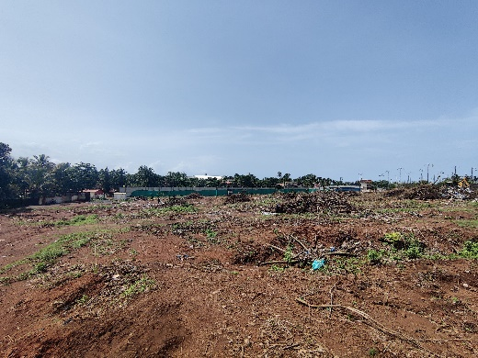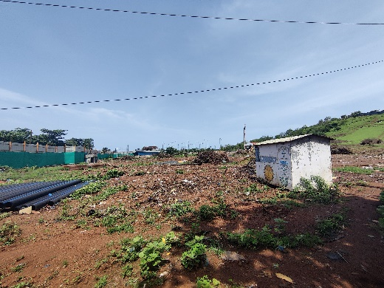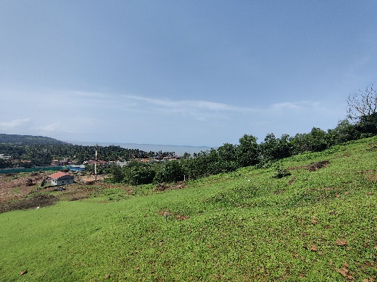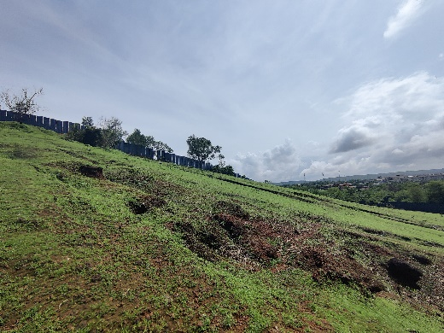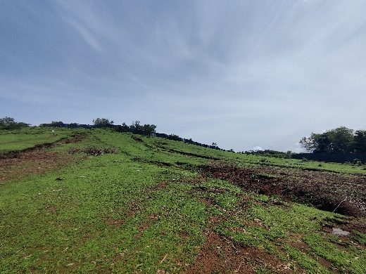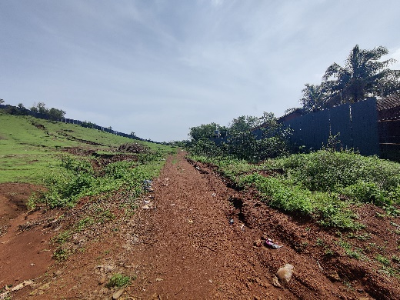

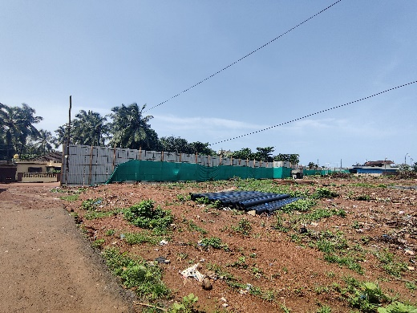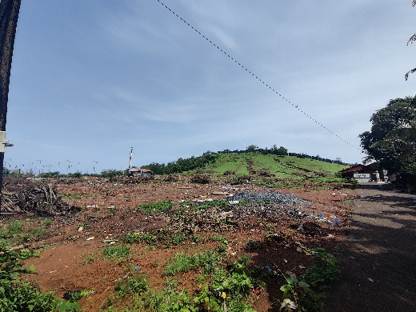

**Actual Site Photographs as on 12.08.2024**

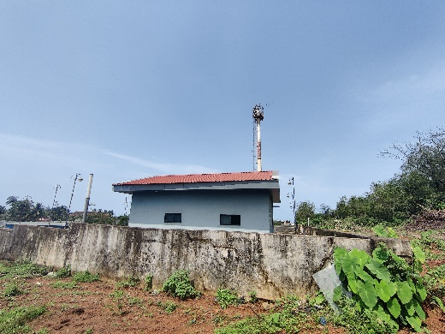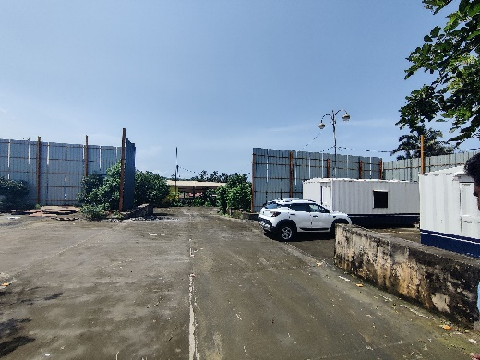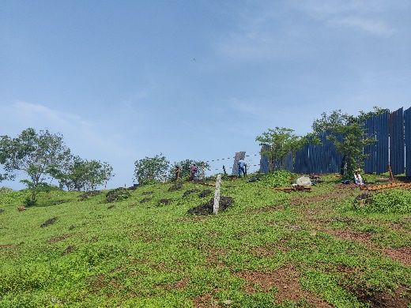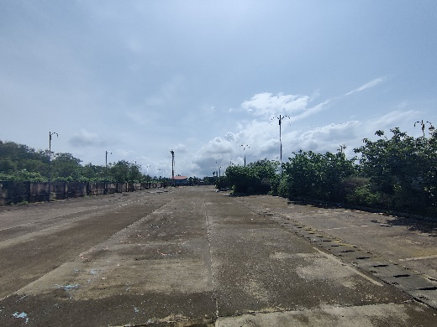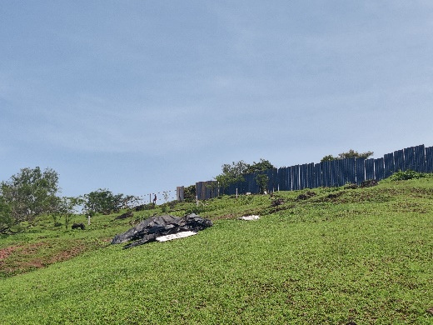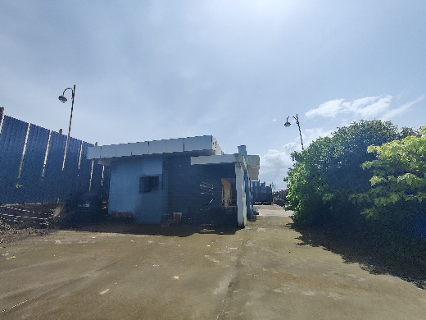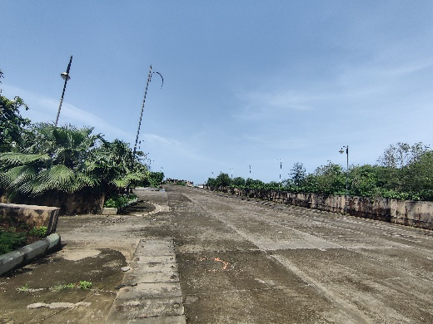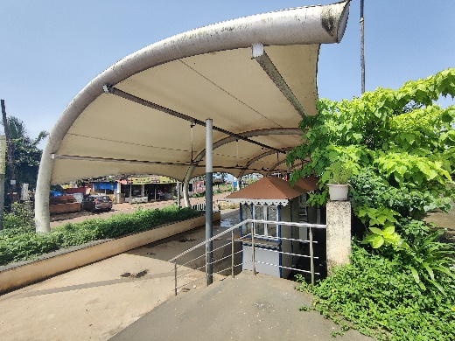

**Actual Site Photographs as on 12.08.2024**

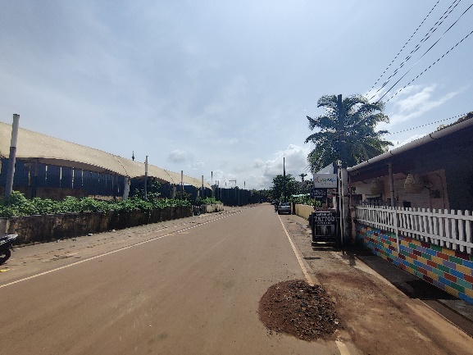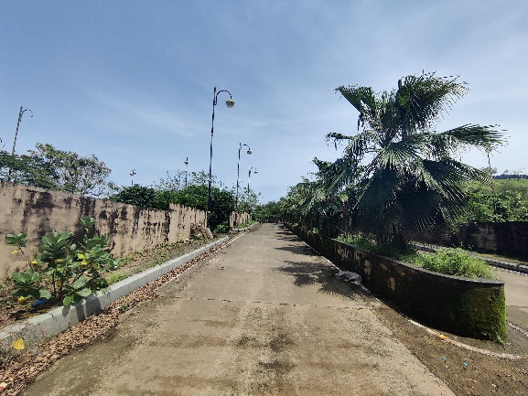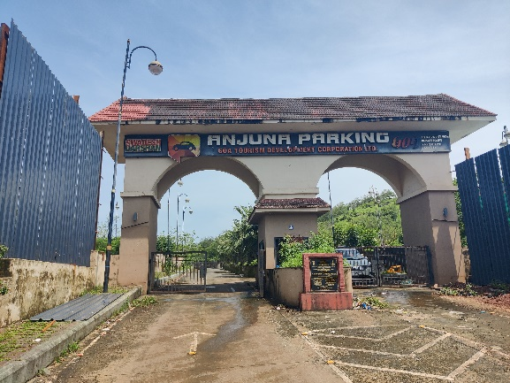

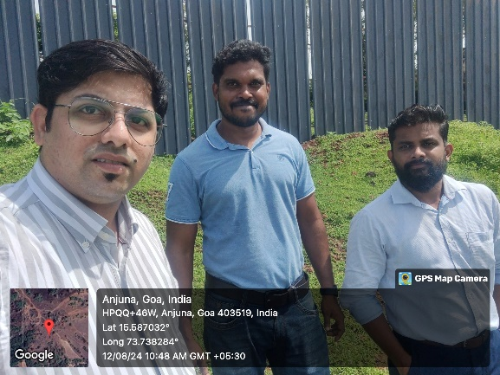

**Route Map of the property**

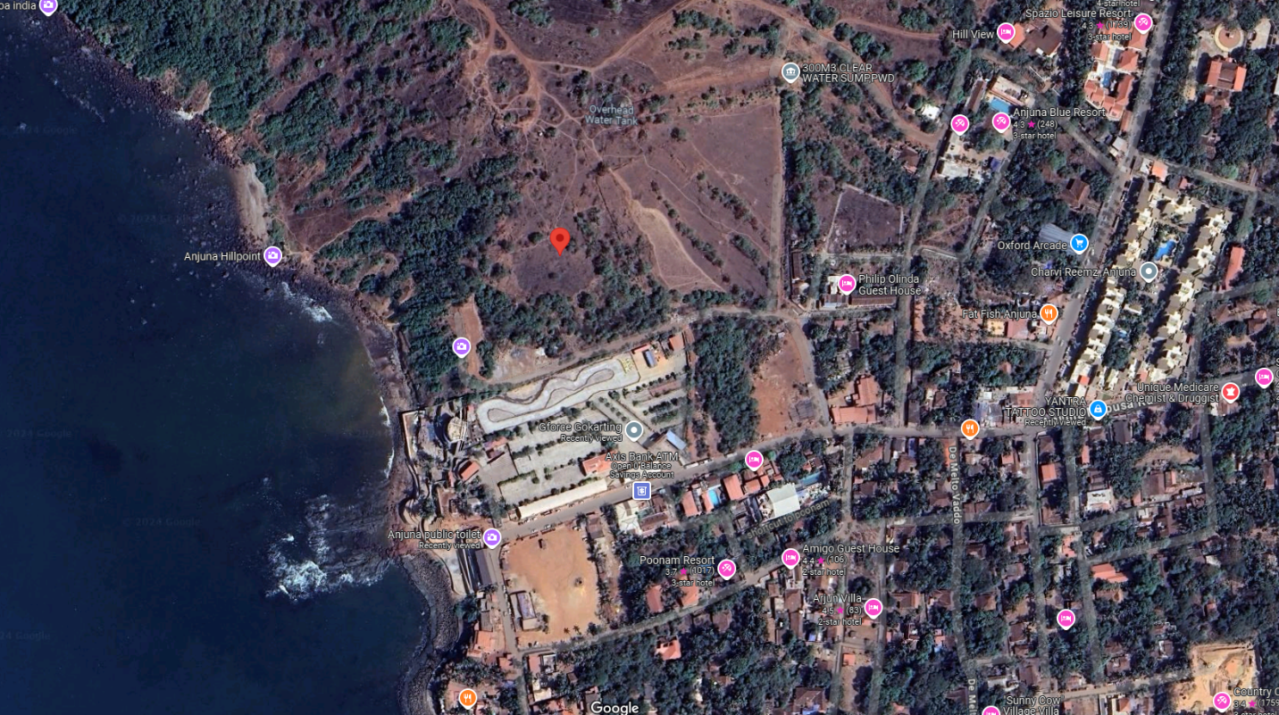**Site u/r**

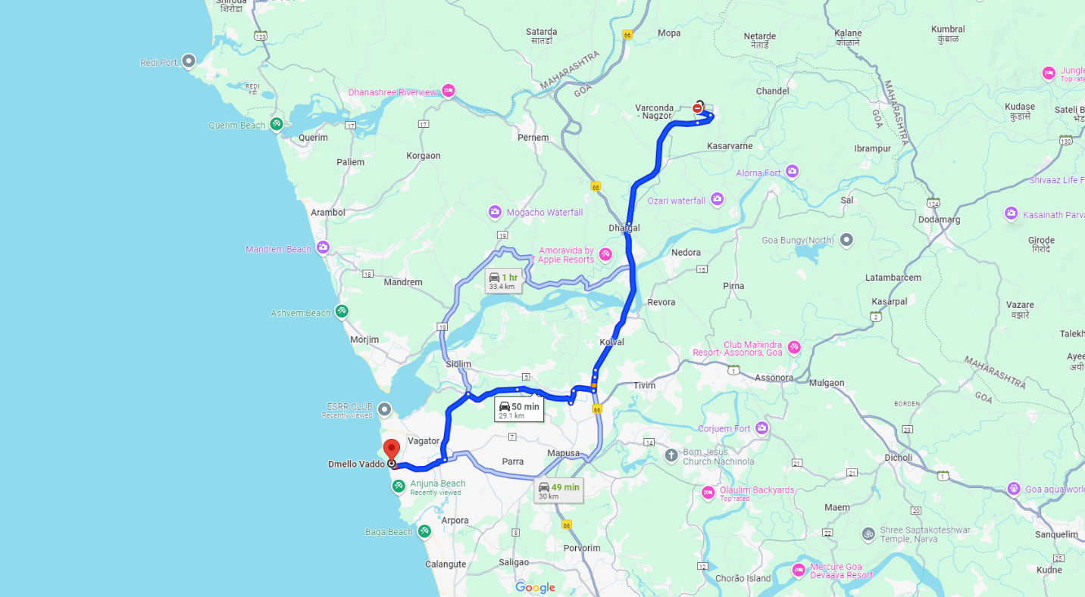

## Latitude Longitude: 15°35'10.9"N 73°44'17.3"E

Note: The Blue line shows the route to site from nearest airport station (Manohar International Airport – 29.10 Km.)