LENDERS INDEPENDENT ENGINEER REPORT

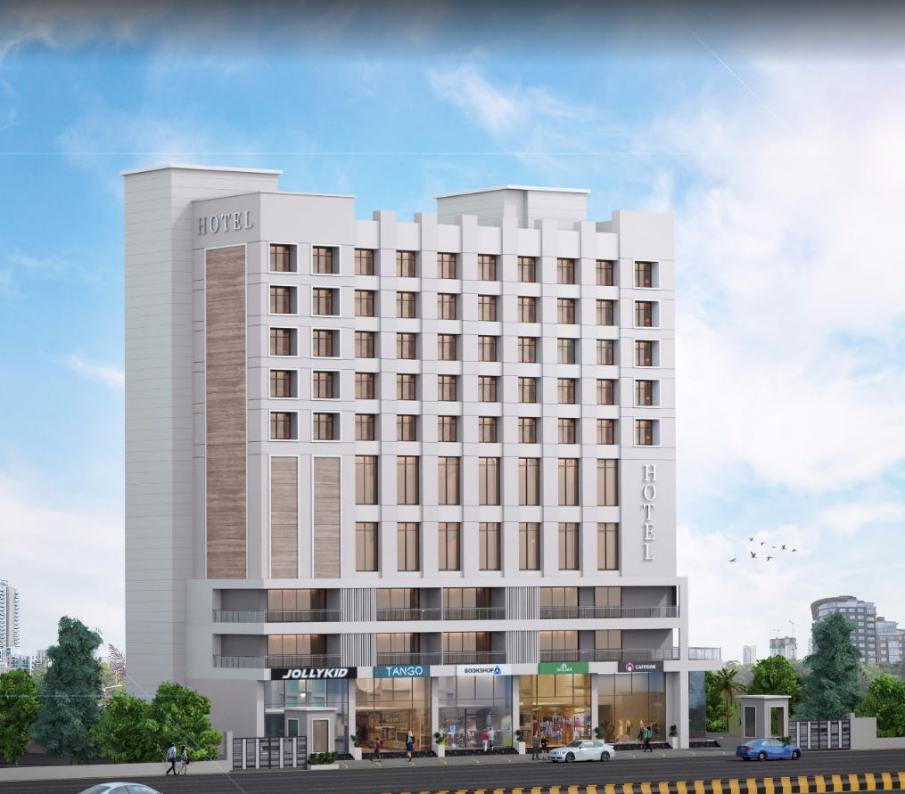

**Details of the property under consideration:**

**Name of Owner: M/s. Gillani Hospitality Pvt. Ltd.**

**Proposed Commercial Cum Residential (3 Star Hotel) building on plot bearing Survey No. 804 / A / 9 / 1 & 2, Plot No. 1 & 2, Mumbai – Agra Road, Govind Nagar, Village – Nashik, Taluka & District – Nashik, Pin Code – 422 009, State – Maharashtra, Country – India**

**Latitude Longitude: 19°58'55.8"N 73°46'53.4"E**

Intended User for:

Union Bank of India

Govind Nagar Branch

1,2,3,4 Thakkar Enclave, B/H/ Karmayogi Nagar, Govind Nagar,

Nashik - 422 008, State – Maharashtra, Country – India.

Vastu/UBI/Nashik/08/2024/10427/2307584

07/07-62-PYU

Date: - 07.08.2024

LENDERS INDEPENDENT ENGINEER REPORT

**To,**

**Union Bank of India**

Govind Nagar Branch

1,2,3,4 Thakkar Enclave,

B/H/ Karmayogi Nagar,

Govind Nagar, Nashik - 422 008,

State – Maharashtra, Country – India.

Subject: Construction of Proposed Commercial Cum Residential (3 Star Hotel) building on plot bearing Survey No. 804 / A / 9 / 1 & 2, Plot No. 1 & 2, Mumbai – Agra Road, Govind Nagar, Village – Nashik, Taluka & District – Nashik, Pin Code – 422 009, State – Maharashtra, Country – India

**Ref:** You’re Request for Lenders Independent Engineer Report of under Construction Building.

**Dear Sir,**

1. As per your instruction, we have inspected the under construction 3 Star Hotel Building project situated on plot bearing Survey No. 804 / A / 9 / 1 & 2, Plot No. 1 & 2, Mumbai – Agra Road, Govind Nagar, Village – Nashik, Taluka & District – Nashik, Pin Code – 422 009, State – Maharashtra, Country – India which is being developed by M/s. Gillani Hospitality Pvt. Ltd. in order to give the physical progress at site and to certify cost incurred towards project as on 31/03/2024 as per amended approved plan having 125 Hotel Rooms for additional loan requested to UBI for completion of the project.
2. While Certifying cost incurred toward project as on 31/03/2024, various important factors such as type & Quality of proposed construction, Specification of building material to be used, grade of the building, height, lead & lift condition, current market price of similar type etc. were given due consideration.
3. As per cost incurred certificate issued by **CA Certificate actual total expenditure occurred as on 31/03/2024 is ` 79.47 Cr. for the 2 Basement + Lower Ground Floor + Ground Floor + 1st to 13th Upper Floor having 125 hotel rooms.**
4. Hence, considering current status & progress at site, the total cost incurred as on 31/03/2024 towards the project is fair & reasonable up to ` 79.53 Cr. for the 2 Basement + Lower Ground Floor + Ground Floor + 1st to 13th Upper Floor which is including land & site development, cost of building construction, cost of miscellaneous fixed assets, consultant fees, preliminary & pre-operative expenses, advances to suppliers & material laying at site etc. This is verified by observing the actual progress of the construction work at site.
5. As per Bank Sanctioned Letter the loan was sanctioned for 41.90 Cr. Which was sub-divided into Hard cost, soft cost & Interest Cost as below:

|  |  |  |  |
| --- | --- | --- | --- |
| Particulars | As per Revised  Sanctioned Letter | Incurred Cost as on 31.03.2024 | Disturbs Amount till date |
| Hard Cost (Land Cost + COC + PM + FF) | 80.07 | 69.18 | 36.74 |
| Interest Cost | 5.22 | 2.91 | - |
| Soft Cost (Approval + Professional + Contingency) | 9.66 | 7.44 | - |
| TOTAL | **94.95** | **79.53** | **36.74** |

As sanctioned amount fully disturbs further disturb should be done after the approval from committee of UBI.

1. **Overall progress of the project site as on 31/03/2024 is 83.76% and overall financial progress as per C.A. certificate including land cost as on 31/03/2024 is 83.70% estimated cost of project.**
2. Overall physical progress of the building construction as on 07/04/2024 is 80.00% as per physical site inspection, Plant & machinery, furniture & fixture and other cost, is considered as per CA Certificate.

**DECLARATION**

1. The information furnished in the report is based on our site visit Dated 07/04/2024 & Document Provided by Client.
2. Vastukala Consultants (I) Pvt. Ltd. Previous LIE Report of the project dated 04/12/2024 for 125 Hotel Rooms.
3. Resurgent India Ltd. Draft TEV Report and site inspection date was 08.08.2023 for 125 Hotel Rooms.
4. Resurgent India Ltd. Draft Cost Vetting Report draft submission dated 25.09.2023 for 125 Hotel Rooms.
5. I have no direct and indirect interest in the property examined for report.
6. I have not been found guilty of misconduct in my professional capacity.

**Sharadkumar B. Chalikwar**

Govt. Reg. Valuer

Chartered Engineer (India)

Reg. No. (N) CCIT/1-14/52/2008-09

Encl.: LIE report

# Purpose & Methodology

• Union Bank of India Banks and financial institutions require monitoring & an independent review of the progress of the sanctioned projects

**VCIPL** undertakes such study to independently review the progress of the project and put forward a comprehensive analysis

# Advantages:

* Assurance on present practices
* Identification of risk
* Analyzing the performance of third parties
* Recommendations

# The Methodology

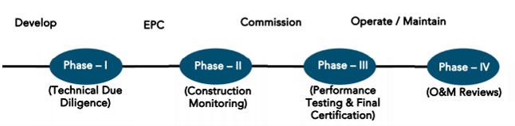

**LENDERS INDEPENDENT ENGINEER REPORT**

**OF**

**"M/s. Gillani Hospitality Pvt. Ltd."**

**Proposed Commercial Cum Residential (3 Star Hotel) building on plot bearing Survey No. 804 / A / 9 / 1 & 2, Plot No. 1 & 2, Mumbai – Agra Road, Govind Nagar, Village – Nashik, Taluka & District – Nashik, Pin Code – 422 009, State – Maharashtra, Country – India**

**Latitude Longitude: 19°58'55.8"N 73°46'53.4"E**

**NAME OF DEVELOPER: M/s. Gillani Hospitality Pvt. Ltd.**

|  |
| --- |
| Pursuant to instructions from Union Bank of India, Govind Nagar Branch, Nashik we have duly visited, inspected, surveyed & assessed the above said property on **07th April 2024** to determine the fair & reasonable market value of the said property/project as on Quarter ending **31st March 2024** for LIE purpose.  **1. Location Details:**  Proposed Commercial Cum Residential (3 Star Hotel) building on plot bearing Survey No. 804 / A / 9 / 1 & 2, Plot No. 1 & 2, Mumbai – Agra Road, Govind Nagar, Village – Nashik, Taluka & District – Nashik, Pin Code – 422 009. It is about 8.80 Km. travelling distance from Nashik Road Railway station. Surface transport to the property is by buses, taxis & private vehicles. The property is in developed locality. All the amenities like shops, banks, hotels, markets, schools, hospitals, etc. are all available in the surrounding locality. The area is higher middle class & developed. |

**2. Developer Details:**

|  |  |
| --- | --- |
| **Name of Developer** | **M/s. Gillani Hospitality Pvt. Ltd.** |
| **Project Rera Registration Number** | **N. A.** |
| **Registered office address** | 46, Aminabad Building, 7th Floor, Aga Hall, Nesbit Road, Mazgaon, Mumbai, Pin Code – 400 010, State – Maharashtra, Country – India |
| **Contact details** | **Contact Person:**  Mr. Zaheer Jamal  Mobile No. +91 9892216700 |
| **E – mail ID and website** |  |

**3. Boundaries of the Property:**

|  |  |
| --- | --- |
| **Direction** | **Particulars** |
| **On or towards North** | Yashika Plaza |
| **On or towards South** | Open Plot |
| **On or towards East** | Mumbai – Agra Road |
| **On or towards West** | Internal Road |

# Introduction

**As per Information on site M/s. Gillani Hospitality Pvt. Ltd.** has acquired land by Conveyance Deed dated 18.02.2016 registered vide No. NSN-3-1638-2016 & registered vide No. NSN-3-1639-2016 admeasuring total **area is 2405.00 Sq. M.** bearing **Survey No. 804/A/9/1 & 2.** For the Proposed Commercial cum Residential (3 Star Hotel) Building.

# Area Statement:

# Land:

|  |  |  |
| --- | --- | --- |
| **Date** | **Particular** | **Area in Sq. M.** |
| 18.02.2016 | Survey No. 804/A/9/1 | 1,202.50 |
| 18.02.2016 | Survey No. 804/A/9/2 | 1,202.50 |
| TOTAL | | 2,405.00 |

1. Copy of Developer Agreement dated 18.02.2016 between Mr. K. Vasudev Vadiraj Rao & Mrs. Seeta Vasudev Rao (The Vendors) and M/s. Gilani Foods Pvt. Ltd. (The Purchaser) registered vide No. NSN-3-1638-2016 dated 18.02.2016.
2. Copy of Developer Agreement dated 18.02.2016 between Mr. K. Shriniwas Vadiraj Shahbhag & Mr. Ravindra Shriniwas Shanbhag (The Vendors) and M/s. Gilani Foods Pvt. Ltd. (The Purchaser) registered vide No. NSN-3-1639-2016 dated 18.02.2016.
3. Copy of Change of Ownership Name from M/s. Gilani Foods Private Limited to Gillani Hospitality Private Limited dated 31.03.2022.

# Building Area As per Approved Plan:

|  | PROFORMA | |
| --- | --- | --- |
| A | AREA STATEMENT | Sq.mt. |
|  | AREA OF THE PLOT AS PER AS PER 7/12 (1+2) | 2,405.00 |
|  | (Minimum area of a, b, c to be considered) |  |
| a | As per ownership document (7/12 CTS extract) | 2,405.00 |
| b | as per measurement sheet (AS PER F.P RECORD) | 2,405.00 |
| c | as per site | 2,405.00 |
| 2 | Deductions for |  |
| a | Proposed D.P./D.P. Road widening Area |  |
| b | Any M.S.E.B. Reservation area |  |
|  | (Total a + b) |  |
| 3 | GROSS AREA OF THE PLOT (1-2) Mr. | 2,405.00 |
| 4 | Recreational Open space |  |
| a | Required |  |
| b | Proposed | 270.00 |
| 5 | Amenity space |  |
|  | Required - Proposed- |  |
| 6 | Service road and highway widening |  |
| 7 | Internal Road area |  |
| 8 | Net Area of Plot = [3-5 (b)] | 2,405.00 |
| 9 | Built up area with reference to basic FSI as per front road width (sr. no. 8x1.1) | 2,645.50 |
| 10 | Addition of area for F.SI. |  |
| a | In-situ area against D. P. road [1.1 x sr. no. 2 (a)], if any | NIL |
| b | in-situ area against amenity space |  |
| C | Premium FSI area (subject to maximum of 0.5 of sr.no.8) | 1,202.50 |
| d | TDR area (1.40 of sr. no.8) | 3,367.00 |
| e | additional HOTEL FSI as per rule no-23(D)=1.9 | 4,569.50 |
|  | (Total of a + b + c + d + e) | 11,784.50 |
| 11 | Total area available (9+10) | 11,784.50 |
| 12 | Maximum utilization of FSI Permissible (as per Road width as per regulation no. 15.4) (3 + 1.9) | 4.90 |
|  |
| 13 | Total built-up Area in proposal. |  |
|  | (Excluding area at sr. no. 15.b) |  |
| a | Existing Built-up Area. | 895.36 |
| b | proposed built-up area | 9,402.46 |
| c | excess balcony area counted in F.S.I. |  |
| d | excess double height terraces area counted in FSI |  |
|  | (Total of a + b + c + d) | 10,297.82 |
| 14 | FSI consumed (13/11) (should not be more than serial no. 12 above.) | 0.87% |
| 15 | area for inclusive housing if any |  |
| a | Required (20% of sr. no.9) |  |
| b | Proposed |  |
| 16 | TOTAL T.D.R. PURCHASED AREA | 3,350.16 |
| 17 | TOTAL PROPOSED T.D.R. AREA | 3,350.00 |

Floor wise Built – Up Area Statement as per amended approved building plan is as below –

|  |  |  |
| --- | --- | --- |
| Floors | Built Up Area as per earlier sanction approved plan in Sq. M. | Built Up Area as per revised approved plan in Sq. M. |
| Basement - 2 | 120.52 | 120.52 |
| Basement - 1 | 337.19 | 435.78 |
| Lower Ground Floor | 247.95 | 402.51 |
| Ground Floor | 664.71 | 791.05 |
| 1st Floor | 491.95 | 503.79 |
| 2nd Floor | 701.62 | 689.37 |
| 3rd Floor | 696.83 | 696.83 |
| 4th Floor | 572.20 | 573.42 |
| 5th Floor | 572.20 | 573.42 |
| 6th Floor | 572.20 | 573.42 |
| 7th Floor | 572.20 | 573.42 |
| 8th Floor | 572.20 | 573.42 |
| 9th Floor | 572.20 | 573.42 |
| 10th Floor | 577.08 | 578.30 |
| 11th Floor | - | 823.32 |
| 12th Floor | - | 1,233.66 |
| 13th Floor | - | 553.61 |
| Terrace & OHT & LMR Area | 28.56 | 28.56 |
| TOTAL | 7,299.61 | 10,297.82 |

Floor wise Total Construction Area Statement as per revised / amended approved building plan is as below –

|  |  |  |  |
| --- | --- | --- | --- |
| Floors | FSI Area in Sq. M. | Non - FSI Area in Sq. M. | Total Construction Area in Sq. M. |
| Basement - 2 | 120.52 | 1,494.08 | 1,614.60 |
| Basement - 1 | 435.78 | 1,221.76 | 1,657.54 |
| Lower Ground Floor | 402.51 | 1,185.65 | 1,588.16 |
| Ground Floor | 791.05 | 168.43 | 959.48 |
| 1st Floor | 503.79 | 160.63 | 664.42 |
| 2nd Floor | 689.37 | 203.18 | 892.55 |
| 3rd Floor | 696.83 | 203.18 | 900.01 |
| 4th Floor | 573.42 | 203.18 | 776.60 |
| 5th Floor | 573.42 | 203.18 | 776.60 |
| 6th Floor | 573.42 | 194.90 | 768.32 |
| 7th Floor | 573.42 | 194.90 | 768.32 |
| 8th Floor | 573.42 | 194.90 | 768.32 |
| 9th Floor | 573.42 | 203.18 | 776.60 |
| 10th Floor | 578.30 | 203.18 | 781.48 |
| 11th Floor | 823.32 | 194.90 | 1,018.22 |
| 12th Floor | 1,233.66 | 194.90 | 1,428.56 |
| 13th Floor | 553.61 | 203.18 | 756.79 |
| Terrace & OHT | 28.56 | 728.23 | 756.79 |
| TOTAL | 10,297.82 | 7,355.54 | 17,653.36 |

# List of Approvals:

1. Copy of Revised Approved Plan No. A41RBP/237/2022 dated 21.10.2022 issued by Nashik Municipal Corporation.

Approved upto: 2 Basement + Lower Ground Floor + Ground Floor + 1st to 13th Upper Floor.

1. Copy of 1st Commencement Certificate No. LND/BP/A4/RBP/237/2022 dated 21.10.2022 issued by Nashik Municipal Corporation.

(This CC is endorsed for the work upto 2 Basement + Lower Ground Floor + Ground Floor + 1st to 13th Upper Floor)

# LEVEL OF COMPLETION:

# Construction of Building

| Sr. No | Floor No. | Construction Area in Sq. M. | Completed Area in Sq. M. | Percentage of work completed | Work Completion as on 07.04.2024 |
| --- | --- | --- | --- | --- | --- |
| 1 | Excavation & Shore Piling | | | 100% | Work is Completed |
| 2 | Basement – 2 Floor | 1,614.60 | 1,614.60 | 80.00% | Slab Work, Block work, Plaster work & Fire Fighting work is completed |
| 3 | Basement – 1 Floor | 1,657.54 | 1,657.54 | 80.00% | Slab Work, Block work, Plaster work & Fire Fighting work is completed |
| 4 | Lower Ground Floor | 1,588.16 | 1,588.16 | 80.00% | Slab Work, Block work, Plaster work, Door Frame & Window Frame, Gypsum work, Plumbing, Water proofing, flooring, toilet dado, firefighting work is completed |
| 5 | Ground Floor | 959.48 | 959.48 | 80.00% | Slab Work, Block work, Plaster work, Door Frame & Window Frame, Gypsum work, Plumbing, Water proofing, flooring, toilet dado, firefighting work is completed |
| 6 | 1st Floor | 664.42 | 664.42 | 80.00% | Slab Work, Block work, Plaster work, Door Frame & Window Frame, Gypsum work, Plumbing, Water proofing, flooring, toilet dado, firefighting work is completed |
| 7 | 2nd Floor | 892.55 | 892.55 | 80.00% | Slab Work, Block work, Plaster work, Door Frame & Window Frame, Gypsum work, Plumbing, Water proofing, flooring, toilet dado, firefighting work is completed |
| 8 | 3rd Floor | 900.01 | 900.01 | 80.00% | Slab Work, Block work, Plaster work, Door Frame & Window Frame, Gypsum work, Plumbing, Water proofing, flooring, toilet dado, firefighting work is completed |
| 9 | 4th Floor | 776.60 | 776.60 | 80.00% | Slab Work, Block work, Plaster work, Door Frame & Window Frame, Gypsum work, Plumbing, Water proofing, flooring, toilet dado, firefighting work is completed |
| 10 | 5th Floor | 776.60 | 776.60 | 80.00% | Slab Work, Block work, Plaster work, Door Frame & Window Frame, Gypsum work, Plumbing, Water proofing, flooring, toilet dado, firefighting work is completed |
| 11 | 6th Floor | 768.32 | 768.32 | 80.00% | Slab Work, Block work, Plaster work, Door Frame & Window Frame, Gypsum work, Plumbing, Water proofing, flooring, toilet dado, firefighting work is completed |
| 12 | 7th Floor | 768.32 | 768.32 | 80.00% | Slab Work, Block work, Plaster work, Door Frame & Window Frame, Gypsum work, Plumbing, Water proofing, flooring, toilet dado, firefighting work is completed |
| 13 | 8th Floor | 768.32 | 768.32 | 80.00% | Slab Work, Block work, Plaster work, Door Frame & Window Frame, Gypsum work, Plumbing, Water proofing, flooring, toilet dado, firefighting work is completed |
| 14 | 9th Floor | 776.60 | 776.60 | 80.00% | Slab Work, Block work, Plaster work, Door Frame & Window Frame, Gypsum work, Plumbing, Water proofing, flooring, toilet dado, firefighting work is completed |
| 15 | 10th Floor | 781.48 | 781.48 | 80.00% | Slab Work, Block work, Plaster work, Door Frame & Window Frame, Gypsum work, Plumbing, Water proofing, flooring, toilet dado, firefighting work is completed |
| 16 | 11th Floor | 1,018.22 | 1,018.22 | 80.00% | Slab Work, Block work, Plaster work, Door Frame & Window Frame, Gypsum work, Plumbing, Water proofing, flooring, toilet dado, firefighting work is completed |
| 17 | 12th Floor | 1,428.56 | 1,428.56 | 80.00% | Slab Work, Block work, Plaster work, Door Frame & Window Frame, Gypsum work, Plumbing, Water proofing, flooring, toilet dado, firefighting work is completed |
| 18 | 13th Floor | 756.79 | 756.79 | 80.00% | Slab Work, Block work, Plaster work, Door Frame & Window Frame, Gypsum work, Plumbing, Water proofing, flooring, toilet dado, firefighting work is completed |
| 19 | Terrace Floor & OHT & LMR Area | 756.79 | 756.79 | 80.00% | Terrace slab work, OHT, LMR Area, parapet wall, plaster work is completed |
| Total | | 17,653.36 | 17,653.36 | 80.00% |  |

# Plant and Machinery

|  |  |
| --- | --- |
| Particulars | Work Completion as on 07.04.2024 |
| Air - Conditioning | A/C ducting work is completed up to 13th Floor |
| Lifts | All the 5 lifts order is placed & received on site, Lift staff work is completed up to 13th Floor & installation work is completed |
| Kitchen & Refrigeration Equipment’s | Order is placed & few materials received on site |
| Gym Equipment’s |  |
| Fire Fighting Equipment’s, Sprinkler & Smoke Detector Systems | Fire Fighting work, Sprinkler & smoke detector system work is completed up to 13th Floor |
| DG Set | DG Set order is placed & received on site, electrical work was the same is completed. |
| Sewage Treatment Plant | RCC work is completed |
| ELV Systems | Work is in progress |
| IT Equipment & Software | Work is in progress |
| Crockery, Cutlery & Glassware |  |
| Housekeeping Supplies, Linens & Uniform |  |

# Furniture and Fixture

|  |  |
| --- | --- |
| Particulars | Work Completion as on 07.04.2024 |
| FF for 125 keys | 2 Sample rooms work is completed on 7th Floor, material received on site and interior work is in progress in all other rooms & some other material order is placed. |
| FF for Restaurant |  |
| FF for Banquet | Material order is placed & few materials received on site. |
| FF for Reception | Material order is placed & few materials received on site. |
| FF for Meeting Rooms |  |
| FF for Roof Top Bar |  |
| FF for Other Public Area |  |
| FF for BOH | Material order is placed & few materials received on site. |

# Details of the Project as Financed By UBI:

# Estimate of the project

|  |  |
| --- | --- |
| Project expenses | Revised Cost as per Revised Draft TEV Report / Draft Cost vetting report dated 25.09.2023 in ` |
| Land Cost | 6.89 |
| Construction Cost of Building (including Civil work, Plumbing & Sanitation & Electrification, etc.) | 46.04 |
| Plant and Machinery | 13.29 |
| Furniture and Fixture | 13.85 |
| Approval & TDR Cost | 5.71 |
| Architect Cost, RCC & other Professional fees | 2.49 |
| Contingencies Expenses | 1.46 |
| Interest Cost | 5.22 |
| Total Cost | 94.95 |

# Project Cost: (as per C.A. Certificate)

|  |  |
| --- | --- |
| **Particulars** | **Incurred Cost (In ` Cr.) till 31.03.2024 dated 26.07.2024 by M/s. Amogh Ghule & Associates** |
| Land Cost | 6.89 |
| Construction Cost of Building (including Civil work, Plumbing & Sanitation & Electrification, etc.) | 43.87 |
| Plant and Machinery | 9.63 |
| Furniture and Fixture | 8.75 |
| Approval & TDR Cost | 5.90 |
| Architect Cost, RCC & other Professional fees | 1.64 |
| Contingencies Expenses | - |
| Interest Cost | 2.79 |
| **Total** | **79.47** |

* **The Builder has incurred about 6.89 Cr. for land cost, 43.87 Cr. for construction cost including the construction cost of shops, 9.63 Cr. for Plant & Machinery cost, 8.75 Cr. As Furniture & Fixture cost, 5.90 Cr. for approval of project, 1.64 Cr. for admin cost & 2.79 Cr. for interest cost till 31.03.2024 as per C.A. certificate issued by M/s. Amogh Ghule & Associates dated 26.07.2024. All the cost incurred is for the 2 Basement + Lower Ground Floor + Ground Floor + 1st to 13th Upper Floor.**
* **In CA Certificate incurred Interest cost is revised because interest cost already incurred for L&T finance loan amount is not considered, only UBI loan interest is considered.**

# Project Cost: (as per Bills):

|  |  |
| --- | --- |
| **Particulars** | **Incurred Cost (in Cr.)** |
| **31.03.2024 as per Bill (Inclusive GST)** |
| Land Cost | 6.90 |
| Construction Cost of Building (including Civil work, Plumbing & Sanitation & Electrification, etc.) | 39.69 |
| Plant and Machinery | 12.71 |
| Furniture and Fixture | 9.89 |
| Approval & TDR Cost | 4.75 |
| Architect Cost, RCC & other Professional fees | 1.43 |
| Contingencies Expenses | 1.26 |
| Interest Cost | 2.91 |
| **Total** | **79.53** |

**Note: We have considered the Land cost as per agreement, Bank loan processing & stamp duty cost in the LIE report. All the cost incurred is for the 2 Basement + Lower Ground Floor + Ground Floor + 1st to 13th Upper Floor.**

**As per discussion with the client & banker interest cost for L&T loan is not considered in this LIE Report only UBI Loan interest incurred cost is considered.**

# Land Cost:

|  |  |  |  |  |  |
| --- | --- | --- | --- | --- | --- |
| Sr. No. | Date | Particulars | Description | Total Cost in ` | Incurred Cost in ` |
| 1 | 16.02.2016 | Survey No. 804/A/9/1 | Purchase Cost | 3,25,00,000.00 | 3,25,00,000.00 |
| 2 | Stamp Duty | 19,50,000.00 | 19,50,000.00 |
| 3 | Reg. Fees | 30,000.00 | 30,000.00 |
| 4 | 580.00 | 580.00 |
| 5 | 16.02.2016 | Survey No. 804/A/9/2 | Purchase Cost | 3,25,00,000.00 | 3,25,00,000.00 |
| 6 | Stamp Duty | 19,50,000.00 | 19,50,000.00 |
| 7 | Reg. Fees | 30,000.00 | 30,000.00 |
| 8 | 580.00 | 580.00 |
| Total | | | | 6,89,61,160.00 | 6,89,61,160.00 |

As per conveyance agreement.

|  |  |  |  |
| --- | --- | --- | --- |
| **Summary of Bills** | | | |
| **Sr. No.** | **Particulars** | **Amount in `**  **(Till 31.03.2024)** | **Amount in ` (in Cr.)** |
| **1** | Construction Cost of Building (including Civil work, Plumbing & Sanitation & Electrification, etc.) | 39,69,02,344.09 | 39.69 |
| **2** | Plant and Machinery | 12,70,77,510.80 | 12.71 |
| **3** | Furniture and Fixture | 9,89,16,240.40 | 9.89 |
| **4** | Approval & TDR Cost | 4,74,60,776.00 | 4.75 |
| **5** | Architect Cost, RCC & other Professional fees | 1,43,07,091.00 | 1.43 |
| **6** | Contingencies Expenses | 1,26,11,039.00 | 1.26 |
| **TOTAL** | | **69,72,75,001.29** | **69.73** |

* Note: Bills were provided by the client up to 31.03.2024 for the 2 Basement + Lower Ground Floor + Ground Floor + 1st to 13th Upper Floor.

# Interest Cost:

|  |  |  |  |  |
| --- | --- | --- | --- | --- |
| **Sr. No** | **Particulars** | **Revised Cost as per Revised Draft TEV Report / Draft Cost vetting report dated 25.09.2023 in `** | **Incurred Amount in ` (till 31.03.2024)** | **Balance Amount in `** |
| **1** | Interest Cost | 5,22,00,000.00 | 2,91,10,048.00 | 2,30,89,952.00 |
| **TOTAL** | | **5,22,00,000.00** | **2,91,10,048.00** | **2,30,89,952.00** |

# Cost of Construction as on 07th July 2024:

# Construction Cost of Building:

|  |  |  |  |  |  |  |
| --- | --- | --- | --- | --- | --- | --- |
| **Floors** | **Total Construction Area in Sq. M.** | **Completed Area in Sq. M.** | **Revised Rate / Sq. M.** | **Full Value after completion** | **Percentage of work completed** | **Actual Expenditure till date in `** |
| Basement - 2 | 1,614.60 | 1,614.60 | 26,080.00 | 42,108,768.00 | 80.00% | 3,36,87,014.40 |
| Basement - 1 | 1,657.54 | 1,657.54 | 26,080.00 | 43,228,643.20 | 80.00% | 3,45,82,914.56 |
| Lower Ground Floor | 1,588.16 | 1,588.16 | 26,080.00 | 41,419,212.80 | 80.00% | 3,31,35,370.24 |
| Ground Floor | 959.48 | 959.48 | 26,080.00 | 25,023,238.40 | 80.00% | 2,00,18,590.72 |
| 1st Floor | 664.42 | 664.42 | 26,080.00 | 17,328,073.60 | 80.00% | 1,38,62,458.88 |
| 2nd Floor | 892.55 | 892.55 | 26,080.00 | 23,277,704.00 | 80.00% | 1,86,22,163.20 |
| 3rd Floor | 900.01 | 900.01 | 26,080.00 | 23,472,260.80 | 80.00% | 1,87,77,808.64 |
| 4th Floor | 776.60 | 776.60 | 26,080.00 | 20,253,728.00 | 80.00% | 1,62,02,982.40 |
| 5th Floor | 776.60 | 776.60 | 26,080.00 | 20,253,728.00 | 80.00% | 1,62,02,982.40 |
| 6th Floor | 768.32 | 768.32 | 26,080.00 | 20,037,785.60 | 80.00% | 1,60,30,228.48 |
| 7th Floor | 768.32 | 768.32 | 26,080.00 | 20,037,785.60 | 80.00% | 1,60,30,228.48 |
| 8th Floor | 768.32 | 768.32 | 26,080.00 | 20,037,785.60 | 80.00% | 1,60,30,228.48 |
| 9th Floor | 776.60 | 776.60 | 26,080.00 | 20,253,728.00 | 80.00% | 1,62,02,982.40 |
| 10th Floor | 781.48 | 781.48 | 26,080.00 | 20,380,998.40 | 80.00% | 1,63,04,798.72 |
| 11th Floor | 1,018.22 | 1,018.22 | 26,080.00 | 26,555,177.60 | 80.00% | 2,12,44,142.08 |
| 12th Floor | 1,428.56 | 1,428.56 | 26,080.00 | 37,256,844.80 | 80.00% | 2,98,05,475.84 |
| 13th Floor | 756.79 | 756.79 | 26,080.00 | 19,737,083.20 | 80.00% | 1,57,89,666.56 |
| Terrace & OHT | 756.79 | - | 26,080.00 | 19,737,083.20 | 80.00% | 1,57,89,666.56 |
| **TOTAL** | **17,653.36** | **16,896.57** |  | **46,03,99,628.80** | **80.00%** | **36,83,19,703.04** |

# Plant and Machinery:

|  |  |  |  |
| --- | --- | --- | --- |
| Particulars | Revised Cost as per Revised Draft TEV Report / Draft Cost vetting report dated 25.09.2023 in ` | Percentage of work completed | Actual Expenditure till date in ` |
| Air - Conditioning | 45,907,000.00 | 97.15% | 4,45,99,711.80 |
| Lifts | 15,694,000.00 | 75.83% | 1,19,01,180.00 |
| Kitchen & Refrigeration Equipment’s | 17,999,000.00 | 167.36% | 3,01,23,591.00 |
| Gym Equipment’s | 1,350,000.00 | 0.00% | - |
| Fire Fighting Equipment’s, Sprinkler & Smoke Detector Systems | 11,046,000.00 | 142.57% | 1,57,48,032.00 |
| DG Set | 9,450,000.00 | 227.91% | 2,15,37,781.00 |
| Sewage Treatment Plant | 1,988,000.00 | 49.86 | 9,91,200.00 |
| ELV Systems | 12,017,000.00 | 0.00% | - |
| IT Equipment & Software | 12,000,000.00 | 18.13% | 21,76,015.00 |
| Crockery, Cutlery & Glassware | 2,700,000.00 | 0.00% | - |
| Housekeeping Supplies, Linens & Uniform | 2,700,000.00 | 0.00% | - |
| TOTAL | **13,28,51,000.00** | **95.65%** | **12,70,77,511.00** |

# Furniture & Fixture:

|  |  |  |  |
| --- | --- | --- | --- |
| Particulars | Revised Cost as Revised Draft TEV Report / Draft Cost vetting report dated 25.09.2023 in ` | Percentage of work completed | Actual Expenditure till date in ` |
| FF for 125 Rooms keys | 55,000,000.00 | 169.15% | 9,30,34,229.40 |
| FF for Restaurant | 10,000,000.00 | 0.00% | - |
| FF for Banquet | 6,000,000.00 | 5.90% | 3,54,000.00 |
| FF for Reception | 8,000,000.00 | 0.00% | - |
| FF for Meeting Rooms | 7,500,000.00 | 0.00% | - |
| FF for Roof Top Bar | 4,000,000.00 | 0.00% | - |
| FF for Other Public Area | 25,000,000.00 | 0.00% | - |
| FF for BOH | 23,000,000.00 | 24.03% | 55,28,011.00 |
| TOTAL | **138,500,000.00** | **71.42%** | **9,89,16,240.00** |

##### Note: Details of work completed is as per site visit dated 07.04.2024 but LIE report is prepared for quarter ending on 31st March 2024.

|  |  |  |  |  |
| --- | --- | --- | --- | --- |
| Project expenses | Revised Cost as per Revised Draft TEV Report / Draft Cost vetting report dated 25.09.2023 in ` | Incurred Cost as per Bill till 31.03.2024 | Incurred Cost as per Bill till 15.10.2023 | Difference between the both bills |
| Land Cost | 6.89 | 6.90 | 6.90 | - |
| Construction Cost of Building (including Civil work, Plumbing and Sanitation & Electrification, etc.) | 46.04 | 39.69 | 32.20 | 7.49 |
| Plant and Machinery | 13.29 | 12.71 | 7.16 | 5.55 |
| Furniture and Fixture | 13.85 | 9.89 | 2.96 | 6.94 |
| Approval & TDR Cost | 5.71 | 4.75 | 4.75 | 0.00 |
| Architect Cost, RCC & other Professional fees | 2.49 | 1.43 | 1.16 | 0.27 |
| Contingencies Expenses | 1.46 | 1.26 | 0.57 | 0.69 |
| Interest Cost | 5.22 | 2.91 | 1.59 | 1.32 |
| Total Cost | **94.95** | **79.53** | **57.28** | **22.26** |

Note:

We have considered Bank Processing fees & Stamp Duty in Contingencies Expenses but CA has not considered this cost.

We have considered Land Cost & Stamp Duty, as per Sale Agreement but CA has considered deprecation on land purchase cost.

We have considered 2.73 Cr. Advance payment in this LIE Report but CA has not considered the same amount in the calculation of incurred cost for the project.

Construction cost is increase by 66.63% due to change of construction area in new amended plan approx. 40% Built – up area is increase from 7,299.61 Sq. M. to 10,297.82 Sq. M. even cost of material, cost of construction rate is increase in the market.

Plant & Machinery cost is increase by 39.89% due to change of construction area in new amended plan approx. 40% Built – up area is increase from 7,299.61 Sq. M. to 10,297.82 Sq. M.

Furniture and Fixture cost is increase by 52.53% due to change of construction area in new amended plan approx. 40% Built – up area is increase from 7,299.61 Sq. M. to 10,297.82 Sq. M. and Meeting rooms and Roof Top Bar items are added in interior works.

Hence, overall project cost is increase by 53% and total revised project cost is coming upto ` 94.45Cr.

**As per discussion with the client & banker interest cost for L&T loan is not considered in this LIE Report only UBI Loan interest incurred cost is considered.**

|  |  |  |  |  |
| --- | --- | --- | --- | --- |
| Particulars | Revised Cost as per Revised Draft TEV Report / Draft Cost vetting report dated 25.09.2023 in ` | Reasonable Cost certified as per Bill till 31.03.2024 | Client  Contribution | Bank  Loan |
| Hard Cost (Land Cost + COC + PM + FF) | 80.27 | 69.18 | 32.44 | 36.74 |
| Interest Cost | 5.22 | 2.91 | 2.91 | - |
| Soft Cost (Approval + Professional + Contingency) | 9.66 | 7.44 | 7.44 | - |
| TOTAL | 94.95 | 79.53 | 42.79 | 36.74 |

# % of Fund Utilised till 31st March 2024

|  |  |  |  |  |  |
| --- | --- | --- | --- | --- | --- |
| Particulars | Revised Cost as per Revised Draft TEV Report / Draft Cost vetting report dated 25.09.2023 in ` | % Project cost | Reasonable Cost as per Bills till 15.10.2023 | Cost incurred as % total cost of that Component | Cost incurred as % of cost incurred as on 31.03.2024 |
| Land Cost | 6.89 | 7.26% | 6.90 | 100.09% | 7.26% |
| Construction Cost of Building (including Civil work, Plumbing and Sanitation & Electrification, etc.) | 46.04 | 48.49% | 39.69 | 86.21% | 41.80% |
| Plant and Machinery | 13.29 | 14.00% | 12.71 | 95.62% | 13.38% |
| Furniture and Fixture | 13.85 | 14.59% | 9.89 | 71.42% | 10.42% |
| Approval & TDR Cost | 5.71 | 6.01% | 4.75 | 83.12% | 5.00% |
| Architect Cost, RCC & other Professional fees | 2.49 | 2.62% | 1.43 | 57.46% | 1.51% |
| Contingencies Expenses | 1.46 | 1.54% | 1.26 | 86.38% | 1.33% |
| Interest Cost | 5.22 | 5.50% | 2.91 | 55.77% | 3.07% |
| Total | **94.95** | **100%** | **79.53** | **83.76%** | **83.76%** |

Based on above Calculation it is found that total Project cost incurred is 83.76 % of the of sanction Project cost.

# Means of Finance:

|  |  |  |
| --- | --- | --- |
| **Sr. No.** | **Particulars** | **Exp. Cumulative (Cr.)** |
|  | Equity share capital / Quassi Loan from Promoter | 11.17 |
|  | Unsecured Loan | 23.55 |
|  | Sales (Advance from customer) | 8.00 |
|  | Bank Laon Amount | 36.74 |
|  | **Total** | **79.47** |

The Details of the Means of Finance are provided by Client as on 31.03.2024.

# Mandatory Arrangements:

|  |  |  |
| --- | --- | --- |
| **Sr. No.** | **Particulars** | **Status** |
|  | Rainwater Harvesting | To be executed after RCC Structure |
|  | Firefighting System | To be executed after RCC Structure |
|  | Solid Waste Management | To be executed after RCC Structure |

# Quality of Construction:

|  |  |  |
| --- | --- | --- |
| **Sr. No.** | **Particulars** | **Status** |
|  | Soundness of Structures | Executing as per approved Structural Design |
|  | Look of Structures | Good |
|  | Quality of Material Used | Good |
|  | Safety Measures for Construction/labour | Taken Care by Contractor |

# Schedule V/s. Actual Progress:

| Activity | Date of Implementation | Date of Completion | Status |
| --- | --- | --- | --- |
| Land |  |  | Completed |
| Development of Land |  |  | Completed |
| Foundation Work |  |  | Completed |
| Ground Floor Slab |  |  | Slab work is Completed |
| 1st Floor Slab |  |  | Slab work is Completed |
| 2nd Floor Slab |  |  | Slab work is Completed |
| 3rd Floor Slab |  |  | Slab work is Completed |
| 4th Floor Slab |  |  | Slab work is Completed |
| 5th Floor Slab |  |  | Slab work is Completed |
| 6th Floor Slab |  |  | Slab work is Completed |
| 7th Floor Slab |  |  | Slab work is Completed |
| 8th Floor Slab |  |  | Slab work is Completed |
| 9th Floor Slab |  |  | Slab work is Completed |
| 10th Floor Slab |  |  | Slab work is Completed |
| 11th Floor Slab |  |  | Slab work is Completed |
| 12th Floor Slab |  |  | Slab work is Completed |
| 13th Floor Slab |  |  | Slab work is Completed |
| Block work / Internal Plaster work |  |  | Blockwork is completed |
| Terrace Parapet wall / Overhead water tank / Lift Machine room / compound wall / External Plaster work |  |  | Work is completed |
| Electric Work |  |  | Work is in progress |
| Water Proofing |  |  | Work is completed |
| Plumbing Work |  |  | Work is in progress |
| Tiling / Marble Flooring |  |  | Work is in progress |
| Door Frames |  |  | Work is in progress |
| Window Installation |  |  | Work is in progress |
| Staircase Flooring |  |  | Work is in progress |
| Staircase Railing |  |  | Work is in progress |
| Refuge Area Flooring |  |  | Work is in progress |
| Internal Painting |  |  | Work is in progress |
| External Painting |  |  |  |
| Lift Work |  |  | All the 5 lifts order is placed & received on site, Lift staff work is completed upto 13th Floor |
| Fire Fighting Installation |  |  | Work is completed upto 13th floor |
| Stack Parking |  |  |  |
| CP Fitting & Sanitary Work |  |  | Work is in progress |
| Final Finishing & Fitting |  |  |  |

# Action initiated to complete the project in time:

**For 3 Star Hotel Building:** RCC work is completed. Interior work is in progress.

# Comments related to cost overrun if any:

The cost of 3-star Hotel Building as per Revised Sanction Letter was 94.95 Cr.

# Balance investment required for completion of project:

We opinion amount of **` 15.42 Cr.** Will be required to complete the Project.

# Mandatory Approval Status:

| **Sr. No.** | **Particulars** | **Name of Department** | **Status** | **Order Details** |
| --- | --- | --- | --- | --- |
| **1** | IOD of Building | Nashik Municipal Corporation | Obtained and available at site | P-6954/2021/(669)/K/E Ward/Andheri dated 11.01.2022 |
| **1A** | 1st Amended | Nashik Municipal Corporation | Obtained and available at site | P-6954/2021/(669)/K/E Ward/Andheri dated 13.04.2022 |
| **2A** | First C.C. | Nashik Municipal Corporation | Obtained and available at site | P – 6954 / 2021 / (669) / K / E Ward / Andheri / FCC / New dated 21.10.2022 valid till 22.10.2023. This CC is endorsed for the work upto Ground for Parking + 1st to 10th Upper Floor of Wing A & B |
| **2B** | Second C.C. | Nashik Municipal Corporation | Obtained and available at site | P – 6954 / 2021 / (669) / K / E Ward / Andheri / FCC / 1 / Amend dated 09.11.2022 valid till 08.11.2023. This CC is endorsed for the work upto Ground for Parking + 1st to 10th Upper Floor of Wing A & B |
| **3B** | Occupancy | Nashik Municipal Corporation | Pending (Project is not completed) |  |

# Status Insurance Coverage:

Information not provided

# Observations & Conclusion:

1. **Overall Physical progress of the project site as on 15/10/2023 is 71.64% of construction cost and overall financial progress as per C.A. certificate including land cost as on 15/10/2023 is 54.40 % estimated cost of project, which doesn’t include additional area not sanctioned by the UBI.**
2. As per cost incurred certificate issued by **CA Certificate actual total expenditure occurred as on 15/10/2023 is ` 51.65 Cr. for the 2 Basement + Lower Ground Floor + Ground Floor + 1st to 13th Upper Floor however.**
3. Hence, considering current status & progress at site, the total cost incurred as on 15/10/2023 towards the project is fair & reasonable up to ` 57.28 Cr. for the 2 Basement + Lower Ground Floor + Ground Floor + 1st to 13th Upper Floor which is including land & site development, cost of building construction, cost of miscellaneous fixed assets, consultant fees, preliminary & pre-operative expenses, advances to suppliers & material laying at site etc. This is verified by observing the actual progress of the construction work at site.
4. Building revised Plan is sanction for entire development **of 2 Basement + Lower Ground Floor + Ground Floor + 1st to 13th Upper Floor.** Construction work was in progress as per 1st Commencement Certificate No. LND/BP/A4/RBP/237/2022 dated 21.10.2022 issued by Nashik Municipal Corporation.
5. It is important to observe all provisions of the various relevant codes of the Bureau of Indian Standards (BIS) during the stage of engineering- design as well as during the stage of construction. It will be advisable to have on the record of the bank a certificate from any licensed structural engineer that such BIS code provisions are followed during the ‘design’ as well as during the ‘construction’ stage of the project so as to ensure the safety and stability of the structure.

# Assumptions & Remarks:

* The adequacy of Engineering / Structural design is beyond the scope of our assignment.
* Estimated project completion date is 31/03/2024. The cost is certified based on the assumptions that the project will be completed within period. Few assumptions were made regarding inflation & cost rise etc. during construction period.

**Sharadkumar B. Chalikwar**

Govt. Reg. Valuer

Chartered Engineer (India)

Reg. No. (N) CCIT/1-14/52/2008-09

**About the Project:**

|  |  |  |
| --- | --- | --- |
| **1. Introduction** | |  |
| a) | Project Name  (With Address & Phone Nos.) | Proposed **Commercial Cum Residential (3 Star Hotel) building** on plot bearing Survey No. 804 / A / 9 / 1 & 2, Plot No. 1 & 2, Mumbai – Agra Road, Govind Nagar, Village – Nashik, Taluka & District – Nashik, Pin Code – 422 009, State – Maharashtra, Country – India  Contact Person:  Mr. Zaheer Jamal  Mobile No. +91 98922 16700 |
| b) | Purpose of Valuation | As per request from Union Bank of India, Govind Nagar Branch, Nashik to assess fair market value of the Project for LIE purpose. |
| c) | Date of Inspection of Property | 07.04.2024 |
| d) | Date of LIE Report | 07.08.2024 |
| e) | Name of the Developer of Property  (in case of developer built properties) | M/s. Gillani Hospitality Pvt. Ltd.  46, Aminabad Building, 7th Floor, Aga Hall, Nesbit Road, Mazgaon, Mumbai, Pin Code – 400 010, State – Maharashtra, Country – India |
| **2. Physical Characteristics of the Property** | | |
| a) | Location of the Property | Proposed **Commercial Cum Residential (3 Star Hotel) building** on plot bearing Survey No. 804 / A / 9 / 1 & 2, Plot No. 1 & 2, Mumbai – Agra Road, Govind Nagar, Village – Nashik, Taluka & District – Nashik, Pin Code – 422 009, State – Maharashtra, Country – India |
| Brief description of the property |  |
|  | **TYPE OF THE BUILDING**   1. **Commercial cum Residential (3 Star Hotel) Building**  |  |  | | --- | --- | | No. of Floors | 2 Basement + Lower Ground Floor + Ground Floor + 1st to 13th Upper Floor. | | Building type | Commercial cum Residential (3 Star Hotel) building |   Commercial cum Residential (3 Star Hotel) Building work is given on contract based for RCC contract. Developer has grant to the contractor do the work of construction and completion includes Concrete work, Reinforcement work, Masonry, Internal Plaster, External Plaster and other miscellaneous work such as repairing, joints b/w concrete and masonry surface, etc. Bill must be paid on measurement of construction area exclusive of Steel, Cement & other construction material.  Lift & lift installation contract is not finalized till now.  Firefighting work contract is not finalized.  **PROPOSED DATE OF COMPLETION & FUTURE LIFE:**  Expected completion date as per developer is 31st March 2024 | |
|  | Nearby landmark | Near Mumbai – Agra Road |
| Postal Address of the Property | Proposed **Commercial Cum Residential (3 Star Hotel) building** on plot bearing Survey No. 804 / A / 9 / 1 & 2, Plot No. 1 & 2, Mumbai – Agra Road, Govind Nagar, Village – Nashik, Taluka & District – Nashik, Pin Code – 422 009, State – Maharashtra, Country – India |
|  | Area of the plot/land  (Supported by a plan) | Plot Area: 2,405.00 Sq. M. |
| Type of Land: Solid, Rocky, Marsh land, reclaimed land, Water-logged, Land locked. | Solid land |
|  | Independent access/approach to the property etc. | Yes |
| Google Map Location of the Property with a neighborhood layout map | Provided |
|  | Details of roads abutting the property | East Side – 30 M. wide road  West Side – 12 M. wide road |
| Description of adjoining property | Located in Higher Middle-class locality |
| Plot No. Survey No. | Survey No. 804 / A / 9 / 1 & 2, Plot No. 1 & 2 |
| Ward/Village/Taluka | Village – Nashik, Taluka – Nashik |
| Sub-Registry/Block | Nashik |
| District | District – Nashik |
| b) | **Boundaries of the Plot** |  |
|  | |  |  |  | | --- | --- | --- | |  | **As per Agreement** | **Actual** | | **North** | CTS No. 665 | Yashika Plaza | | **South** | CTS No. 670 | Open Plot | | **East** | Proposed 13.20 M. wide D. P. Road & presently bearing CTS No. 668. | Mumbai – Agra Road | | **West** | Private Road bearing CTS No. 672 leading from Sahar Road | Internal Road | | |

**Actual Site Photographs as on 07.04.2024**

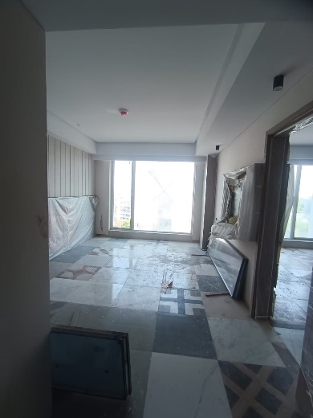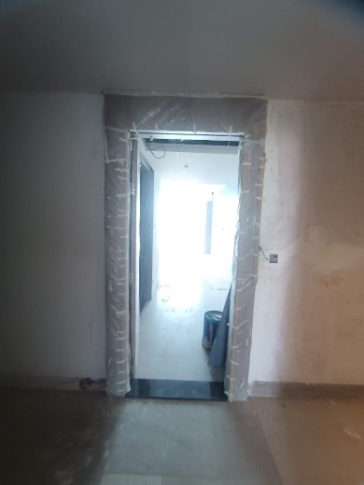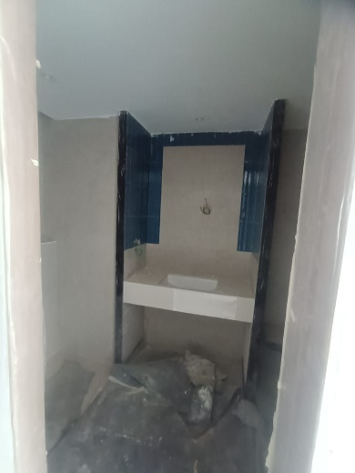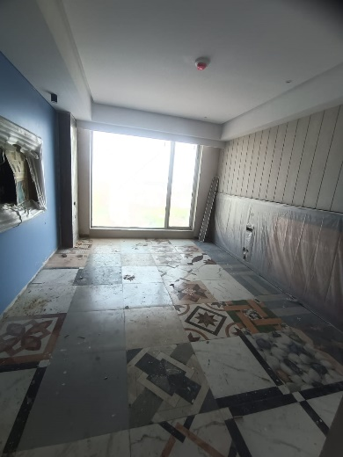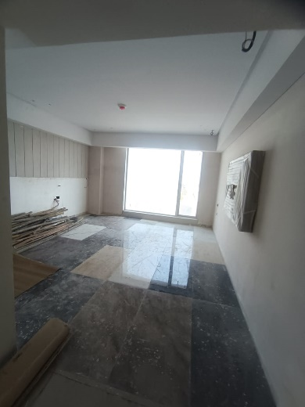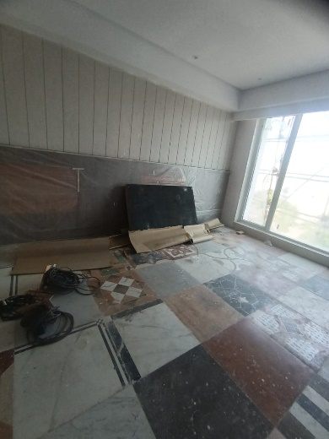

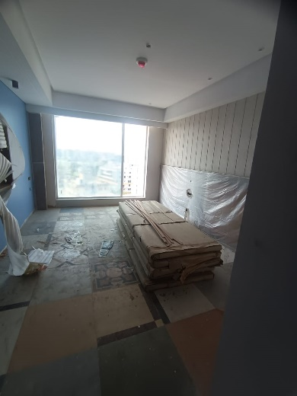

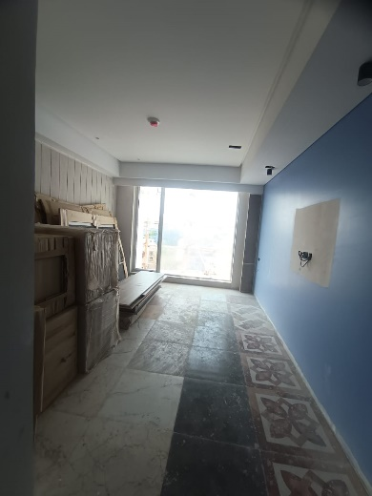

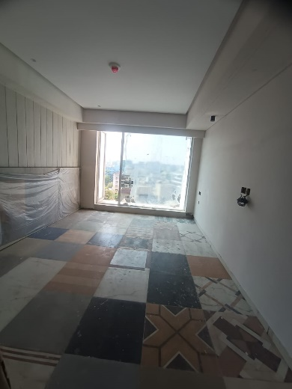

**Actual Site Photographs as on 07.04.2024**

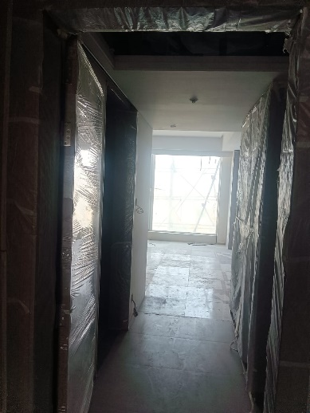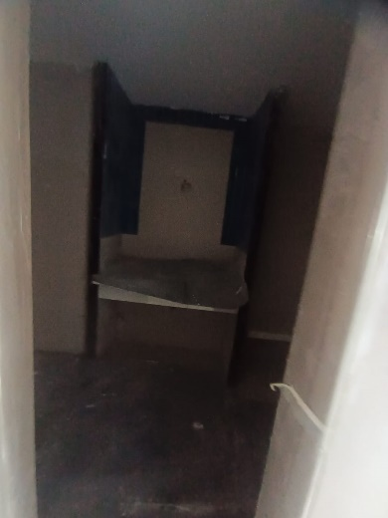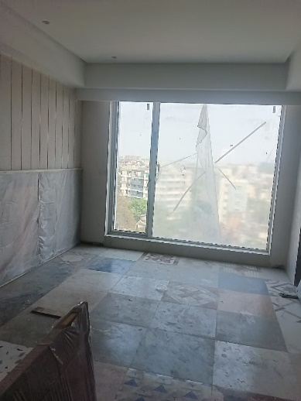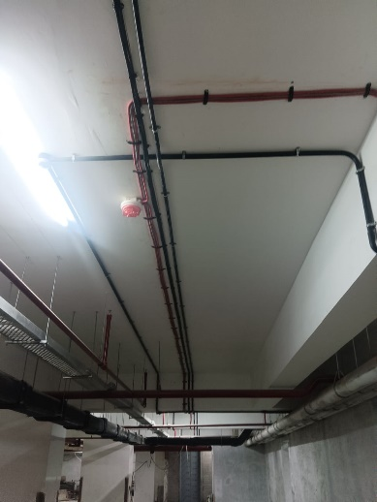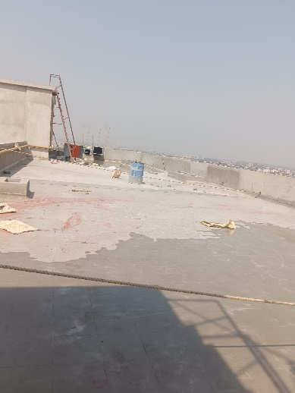

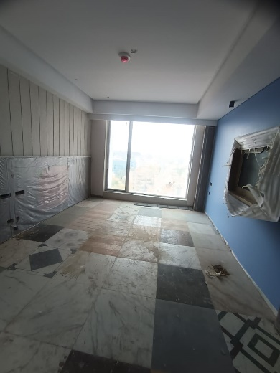

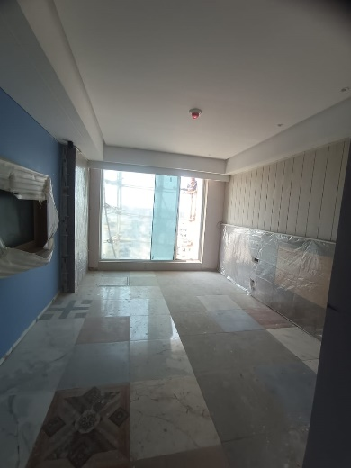

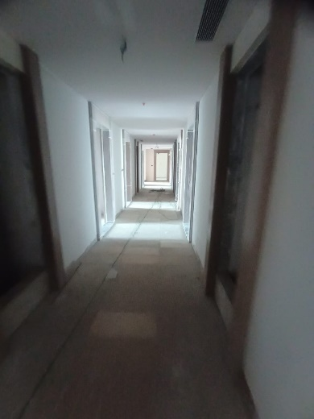

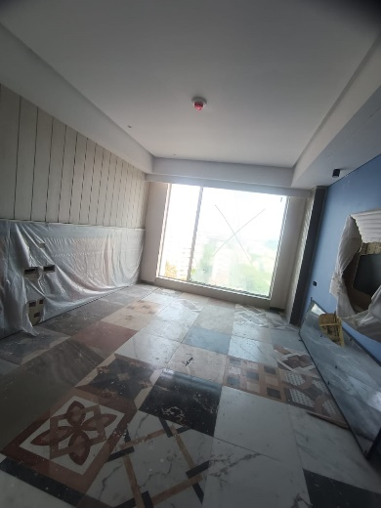

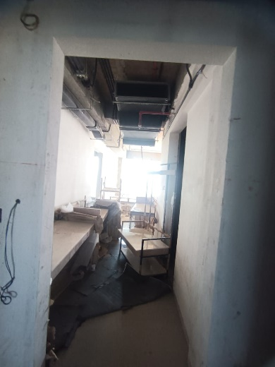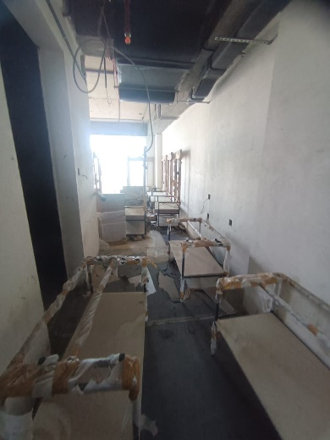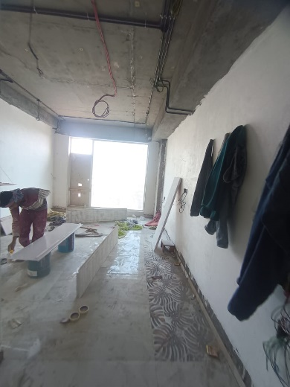**Actual Site Photographs as on 07.04.2024**

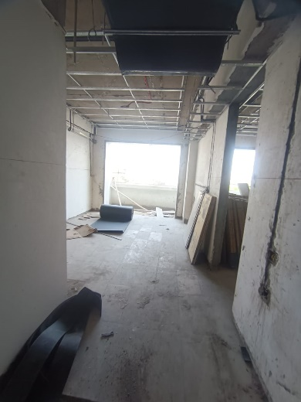

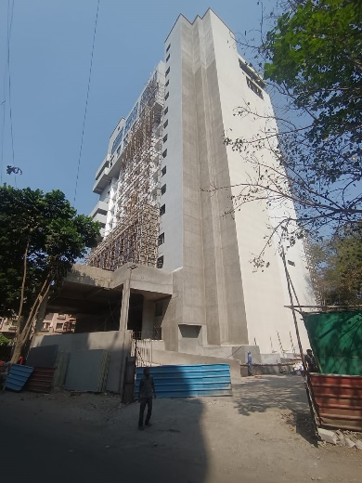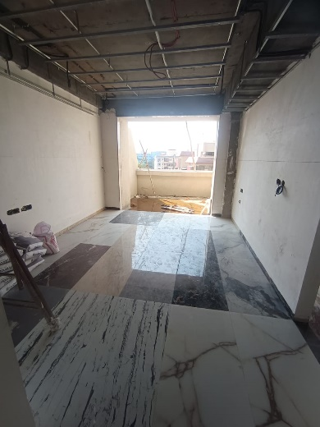

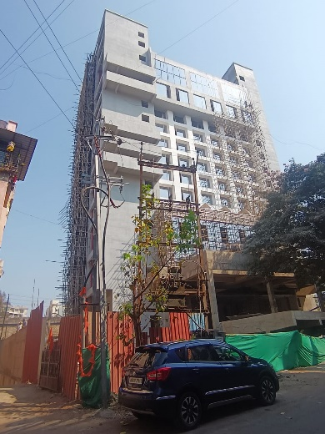

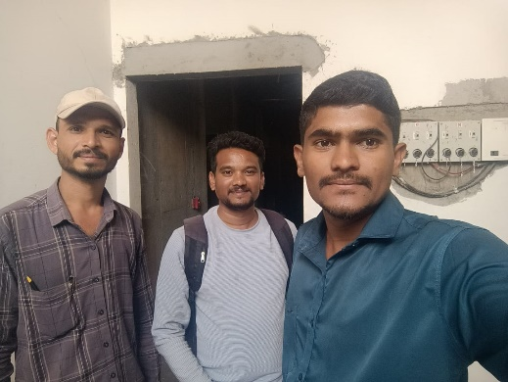

**Route Map of the property**

**Site u/r**

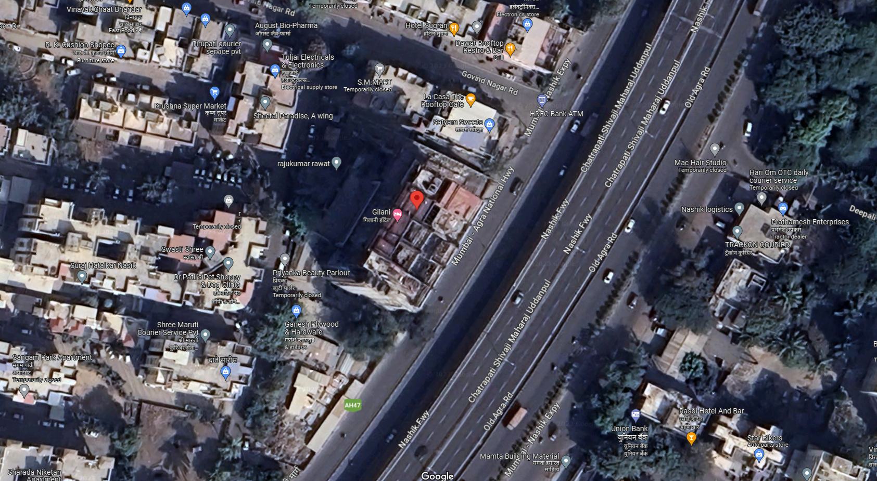

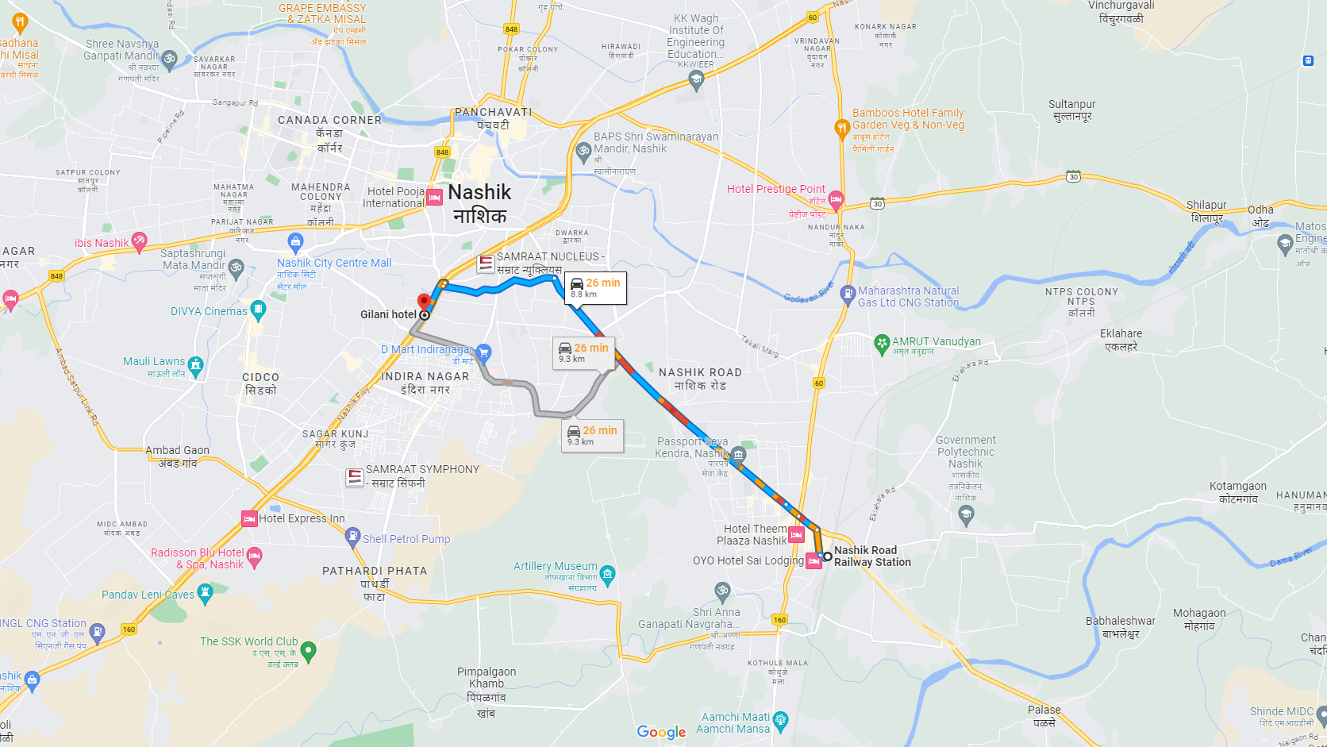

## Latitude Longitude: 19°58'55.8"N 73°46'53.4"E

Note: The Blue line shows the route to site from nearest railway station (Nashik Road – 8.80 Km.)