Valuation Report of the Immovable Property

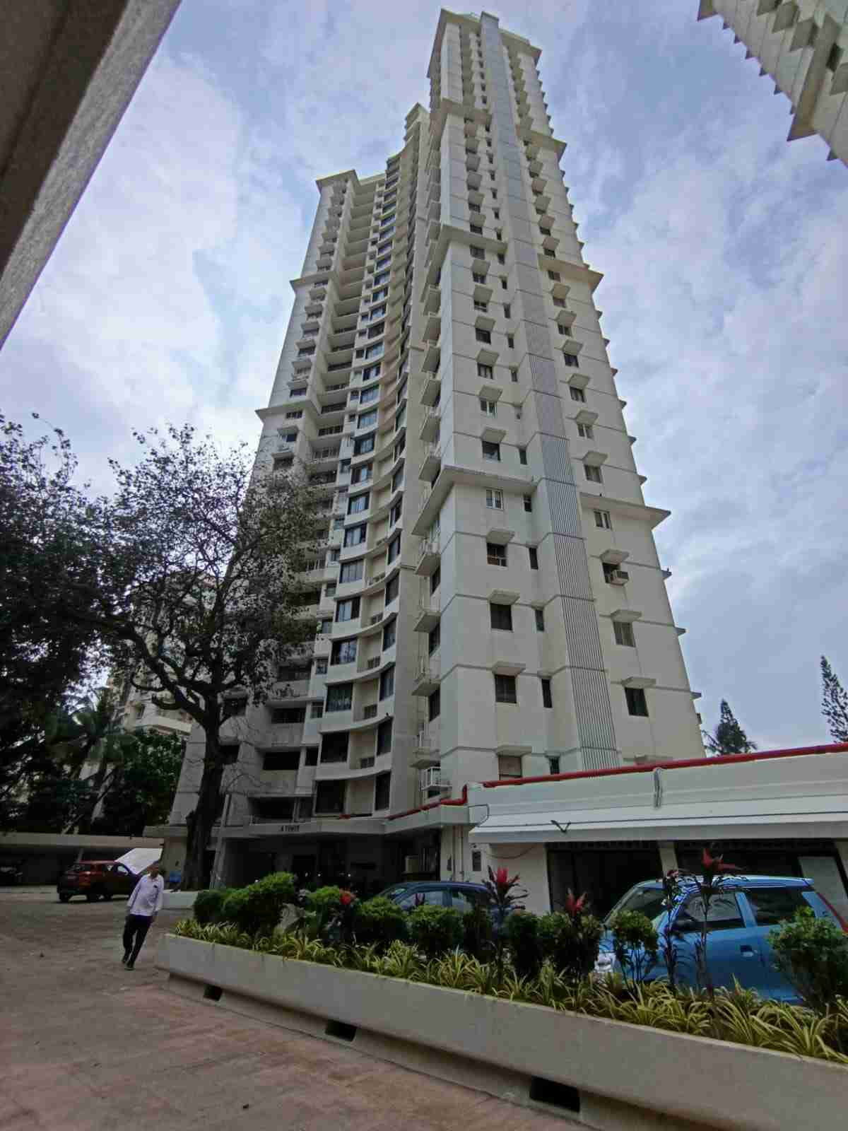

Details of the property under consideration:

Name of Owner: Voltas Limited

Residential Flat No.122, 12th Floor, A - Wing, “Twin Towers Premises Co. Op. Soc. Ltd.”, Off Veer Savarkar Marg, Prabhadevi, Mumbai – 400 025, State - Maharashtra, Country - India

Latitude Longitude: 19°01'10.3"N 72°49'41.4"E

Intended User:

India Exim Bank
Administration Group, Centre One Building, 21st Floor, World Trade Centre Complex,
Cuffe Parade, Mumbai 400 005, State – Maharashtra, Country – India.

Vastu/Mumbai/08/2024/10395/2307687
13/11-165-KPVSM
Date: 13.08.2024

VALUATION OPINION REPORT

This is to certify that the property bearing Residential Flat No.122, 12th Floor, A - Wing, “Twin Towers Premises Co. Op. Soc. Ltd.”, Off Veer Savarkar Marg, Prabhadevi, Mumbai – 400 025, State - Maharashtra, Country – India belongs to Voltas Limited.

Boundaries of the property.

North | : | Sea
South | : | Palkhi Road
East | : | Wing – B
West | : | Tarangini Apartment

Considering various parameters recorded, existing economic scenario, and the information that is available with reference to the development of neighborhood and method selected for valuation, we are of the opinion that, the property premises can be assessed and Fair Market Value at ` 8,68,32,000.00 (Rupees Eight Crore Sixty Eight Lakh Thirty Two Thousand Only).

The valuation of the property is based on the documents produced by the concern. Legal aspects have not been taken into considerations while preparing this valuation report.

Hence certified

Manoj B. Chalikwar
Registered Valuer
Chartered Engineer (India)
Reg. No. CAT-I-F-1763
Encl: Valuation report.

Vastukala Consultants (I) Pvt. Ltd.
B1-001, U/B Floor, Boomerang, Chandivali Farm Road, Powai, Andheri (East), Mumbai – 400 072

VALUATION REPORT (IN RESPECT OF FLAT)
I | General
1. | Purpose for which the valuation is made |  |  | : | To assess Fair Market value of the property for Bank Purpose.
2. | a) | Date of inspection |  | : | 07.08.2024
 | b) | Date on which the valuation is made |  | : | 13.08.2024
3. | List of documents produced for perusal:  - Copy of Agreement for Sale dated 18.07.1974 between The Bombay Dyeing & Manufacturing Company Limited (The Company) AND Voltas Limited ( The Flat - Purchasers)  - Copy of Share Certificate No. 217 dated 01.01.2014 in the name of Voltas Limited issued by Twin Towers Premises Co. Op. Soc. Ltd  - Copy of Society Maintenance Bill dated 04.06.2024 in the name of Voltas Ltd.
4. | Name of the owner(s) and his / their address (es) with Phone no. (details of share of each owner in case of joint ownership) |  |  | : | Voltas Limited  Address Residential Flat No.122, 12th Floor, A - Wing, “Twin Towers Premises Co. Op. Soc. Ltd.”, Off Veer Savarkar Marg, Prabhadevi, Mumbai – 400 025, State - Maharashtra, Country - India  Contact Person:  Mr. Nitin Chawala (Employee JLL)  Mobile No.: 9769041723  Limited Company Ownership
5. | Brief description of the property (Including Leasehold / freehold etc.) |  |  | : | The property is a Residential flat is located on 12th Floor  The composition of flat is having 3 Bedrooms + Living + Kitchen + Passage + 3 Toilets + Servant Room (i.e. 3 BHK with 3 Toilets & Servant Room). The property is at 2.1 km. travelling distance from nearest Railway Station Dadar.
6. | Location of property |  |  | :
 | a) |  | Plot No. / Survey No. | : | Final Plot No. 1216 of TPS, Survey No. 1647 (pt) & CTS No. 25 (pt) of Mahim Division
 | b) |  | Door No. | : | Residential Flat No. 122
 | c) |  | C.T.S. No. / Village | : | CTS No. 25 (pt) of Mahim Division
 | d) |  | Ward / Taluka | : | ‘LG – South Ward of MCGM
 | e) |  | Mandal / District | : | District – Mumbai
 | f) |  | Date of issue and validity of layout of approved map / plan. | : | Approved Building Plan were not provided and not verified.
 | g) |  | Approved map / plan issuing authority | :
 | h) |  | Whether genuineness or authenticity of approved map/ plan is verified | :
 | i) |  | Any other comments by our empanelled valuers on authentic of approved plan.
7. | Postal address of the property |  |  | : | Residential Flat No.122, 12th Floor, A - Wing, “Twin Towers Premises Co. Op. Soc. Ltd.”, Off Veer Savarkar Marg, Prabhadevi, Mumbai – 400025, State - Maharashtra, Country - India
8. | City / Town |  |  | : | Prabhadevi, Mumbai
 | Residential area |  |  | : | Yes
 | Commercial area |  |  | : | No
 | Industrial area |  |  | : | No
9. | Classification of the area |  |  | :
 | i) High / Middle / Poor |  |  | : | High Class
 | ii) Urban / Semi Urban / Rural |  |  | : | Urban
10. | Coming under Corporation limit / Village Panchayat / Municipality |  |  | : | Village – Mahim  Municipal Corporation of Greater Mumbai
11. | Whether covered under any State / Central Govt. enactments (e.g., Urban Land Ceiling Act) or notified under agency area/ scheduled area / cantonment area |  |  | : | No
12. | Boundaries of the property |  |  |  | As per Site | As per documents
 | North |  |  | : | Sea | Final Plot No. 1223 of TPS, Bombay City Ni. IV (Mahim Area)
 | South |  |  | : | Palkhi Road | Sub Plot No. 6A, 7, 8, 9 & 1 of FP No. 1216 of TPS
 | East |  |  | : | Wing – B | Veer Savarkar Marg
 | West |  |  | : | Tarangini Apartment | Mahim Bay & Sub Plot No. 4 B & FP No. 1216
13 | Dimensions of the site |  |  |  | N. A. as property under consideration is a flat in an apartment building.
 |  |  |  |  | A As per the Deed | B Actuals
 | North |  |  | : | - | -
 | South |  |  | : | - | -
 | East |  |  | : | - | -
 | West |  |  | : | - | -
14. | Extent of the site |  |  | : | Carpet Area in Sq. Ft. = 996.00  (Area as per actual site measurement)  Built-up Area in Sq. Ft. = 1,206.00  (Area as per Maintenance Bill)
14.1 | Latitude, Longitude & Co-ordinates of Flat |  |  | : | 19°01'10.3"N 72°49'41.4"E
15. | Extent of the site considered for Valuation (least of 13A& 13B) |  |  | : | Built-up Area in Sq. Ft. = 1,206.00  (Area as per Maintenance Bill)
16 | Whether occupied by the owner / tenant? If occupied by tenant since how long? Rent received per month. |  |  | : | Vacant at the time of visit
II | APARTMENT BUILDING
 | Nature of the Apartment |  |  | : | Residential
 | Location |  |  | :
 | C.T.S. No. |  |  | : | CTS No. 25 (pt) of Mahim Division
 | Block No. |  |  | : | -
 | Ward No. |  |  | : | G- South Ward of MCGM
 | Village / Municipality / Corporation |  |  | : | Village – Mahim  Municipal Corporation of Greater Mumbai
 | Door No., Street or Road (Pin Code) |  |  | : | Residential Flat No.122, 12th Floor, A - Wing, Twin Towers Premises Co. Op. Soc. Ltd., Off Veer Savarkar Marg, Prabhadevi, Mumbai – 400 025, State - Maharashtra, Country – India
 | Description of the locality Residential / Commercial / Mixed |  |  | : | Residential
 | Year of Construction |  |  | : | 1977 (As per site information.)
 | Number of Floors |  |  | : | Basement + Ground + 1st to 27th upper floors
 | Type of Structure |  |  | : | R.C.C. Framed Structure
 | Number of Dwelling units in the building |  |  | : | 3 Flats on 12th Floor
 | Quality of Construction |  |  | : | Good
 | Appearance of the Building |  |  | : | Good
 | Maintenance of the Building |  |  | : | Good
 | Facilities Available |  |  | :
 | Lift |  |  | : | 3 Lifts
 | Protected Water Supply |  |  | : | Municipal Water supply
 | Underground Sewerage |  |  | : | Connected to Municipal Sewerage System
 | Car parking - Open / Covered |  |  | : | Covered Car Parking Space
 | Is Compound wall existing? |  |  | : | Yes
 | Is pavement laid around the building |  |  | : | Yes
III | FLAT
1 | The floor in which the Flat is situated |  |  | : | 12th Floor
2 | Door No. of the Flat |  |  | : | Residential Flat No.122
3 | Specifications of the Flat |  |  | :
 | Roof |  |  | : | R.C.C. Slab
 | Flooring |  |  | : | Vitrified Flooring
 | Doors |  |  | : | Teakwood door frame with flush shutters
 | Windows |  |  | : | Powder coated Aluminium sliding windows
 | Fittings |  |  | : | Concealed plumbing with C.P. fittings.  Electrical wiring with Concealed
 | Finishing |  |  | : | Cement Plastering with POP false ceiling
4 | House Tax |  |  | :
 | Assessment No. |  |  | : | Details not available
 | Tax paid in the name of: |  |  | : | Details not available
 | Tax amount: |  |  | : | Details not available
5 | Electricity Service connection No.: |  |  | : | Details not available
 | Meter Card is in the name of: |  |  | : | Details not available
6 | How is the maintenance of the Flat? |  |  | : | Good
7 | Sale Deed executed in the name of |  |  | : | Voltas Limited
8 | What is the undivided area of land as per Sale Deed? |  |  | : | Details not available
9 | What is the plinth area of the Flat? |  |  | : | Built-up Area in Sq. Ft. = 1,206.00  (Area as per Maintenance Bill)
10 | What is the floor space index (app.) |  |  | : | As per MCGM norms
11 | What is the Carpet Area of the Flat? |  |  | : | Carpet Area in Sq. Ft. = 996.00  (Area as per actual site measurement)
12 | Is it Posh / I Class / Medium / Ordinary? |  |  | : | High Class
13 | Is it being used for Residential or Commercial purpose? |  |  | : | Residential purpose
14 | Is it Owner-occupied or let out? |  |  | : | Vacant at the time of visit
15 | If rented, what is the monthly rent? |  |  | : | ` 1,80,000.00 Expected rental income per month
IV | MARKETABILITY |  |  | :
1 | How is the marketability? |  |  | : | Good
2 | What are the factors favouring for an extra Potential Value? |  |  | : | Located in developed area
3 | Any negative factors are observed which affect the market value in general? |  |  | : | No
V | Rate |  |  | :
1 | After analyzing the comparable sale instances, what is the composite rate for a similar Flat with same specifications in the adjoining locality? - (Along with details / reference of at - least two latest deals / transactions with respect to adjacent properties in the areas) |  |  | : | ` 70,000.00 to ` 80,000.00 per Sq. Ft. on Built up area
2 | What is the adopted basic composite rate of the Flat under valuation after comparing with the specifications and other factors with the Flat under comparison (give details). |  |  | : | ` 72,000.00 per Sq. Ft. on Built up area
3 | Break – up for the rate |  |  | :
 | I. Building + Services |  |  | : | ` 2,900.00 per Sq. Ft.
 | II. Land + others |  |  | : | ` 69,100.00 per Sq. Ft.
4 | Guideline rate obtained from the Registrar's office (an evidence thereof to be enclosed) |  |  | : | ` 2,81,705.00 per Sq. M. i.e. ` 26,171.00 per Sq. Ft.
 | Guideline rate (after depreciation) |  |  | : | ` 2,02,371.00 per Sq. M. i.e. ` 18,801.00 per Sq. Ft.
5 | Age of the building |  |  | : | 47 years
6 | Life of the building estimated |  |  | : | 13 years Subject to proper, preventive periodic maintenance & structural repairs.
 | Remarks:

Details of Valuation:
Sr. No. | Description | Qty. | Rate per  Unit (`) | Estimated  Value (`)
 | Present value of the property | 1,206.00 Sq. Ft. | 72,000.00 | 8,68,32,000.00
 | Realizable Value of the property |  |  | 7,81,48,800.00
 | Distress Sale Value of the property |  |  | 6,94,65,600.00
 | Insurable value of the property (1,206.00 Sq. Ft. X ` 2,900.00) |  |  | 34,97,400.00
 | Guideline value of the property (1,206.00 Sq. Ft. X ` 18,801.00) |  |  | 2,26,74,006.00

The sales comparison approach uses the market data of sale prices to estimate the value of a real estate property. Property valuation in this method is done by comparing a property to other similar properties that have been recently sold. Comparable properties, also known as comparables, or comps, must share certain features with the property in question. Some of these include physical features such as square footage, number of rooms, condition, and age of the building; however, the most important factor is no doubt the location of the property. Adjustments are usually needed to account for differences as no two properties are exactly the same. To make proper adjustments when comparing properties, real estate appraisers must know the differences between the comparable properties and how to value these differences. The sales comparison approach is commonly used for Residential Flat, where there are typically many comparables available to analyze. As the property is a Residential Flat, we have adopted Sale Comparison Approach Method for the purpose of valuation. The Price for similar type of property in the nearby vicinity is in the range of ` 70,000.00 to ` 80,000.00 per Sq. Ft. on Built up area. Considering the rate with attached report, current market conditions, demand and supply position, Flat size, location, upswing in real estate prices, sustained demand for Residential flat, all round development of commercial and residential application in the locality etc. We estimate ` 72,000.00 per Sq. Ft. on Built up area for valuation.

Actual site photographs
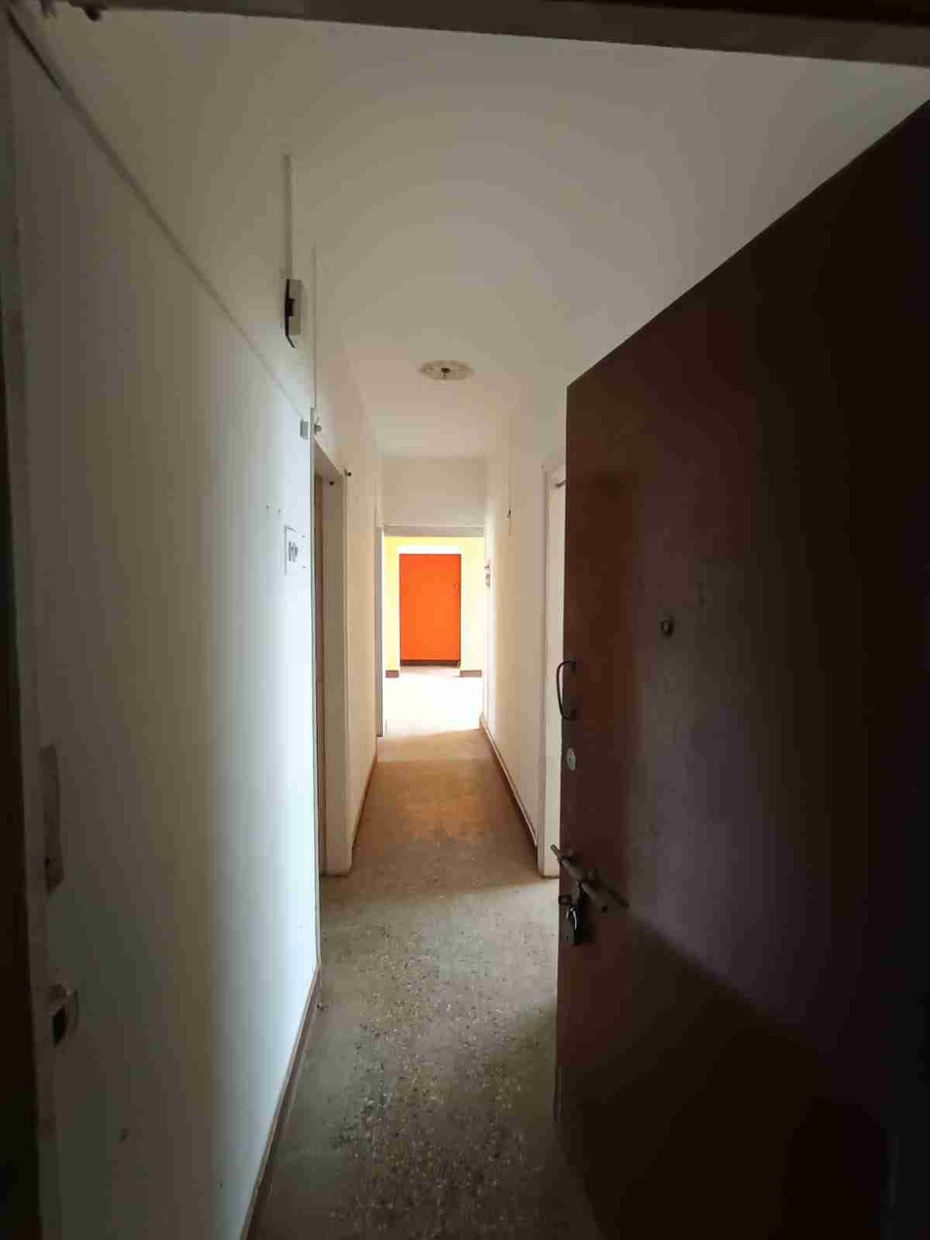
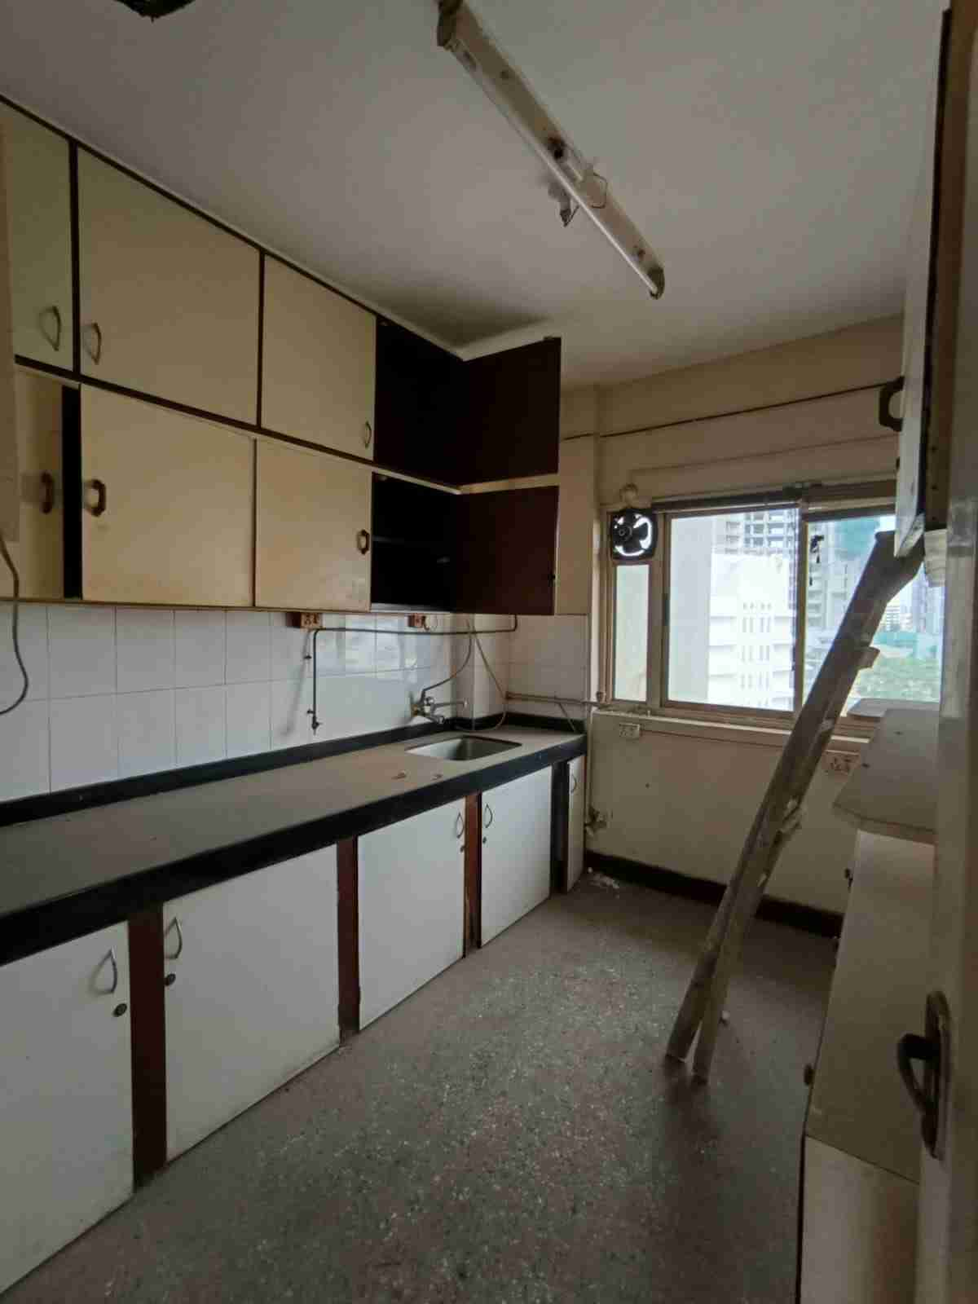
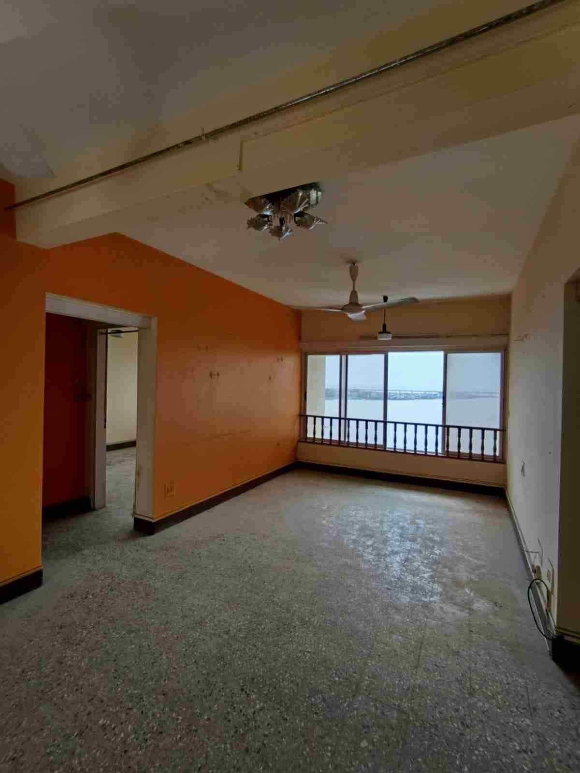

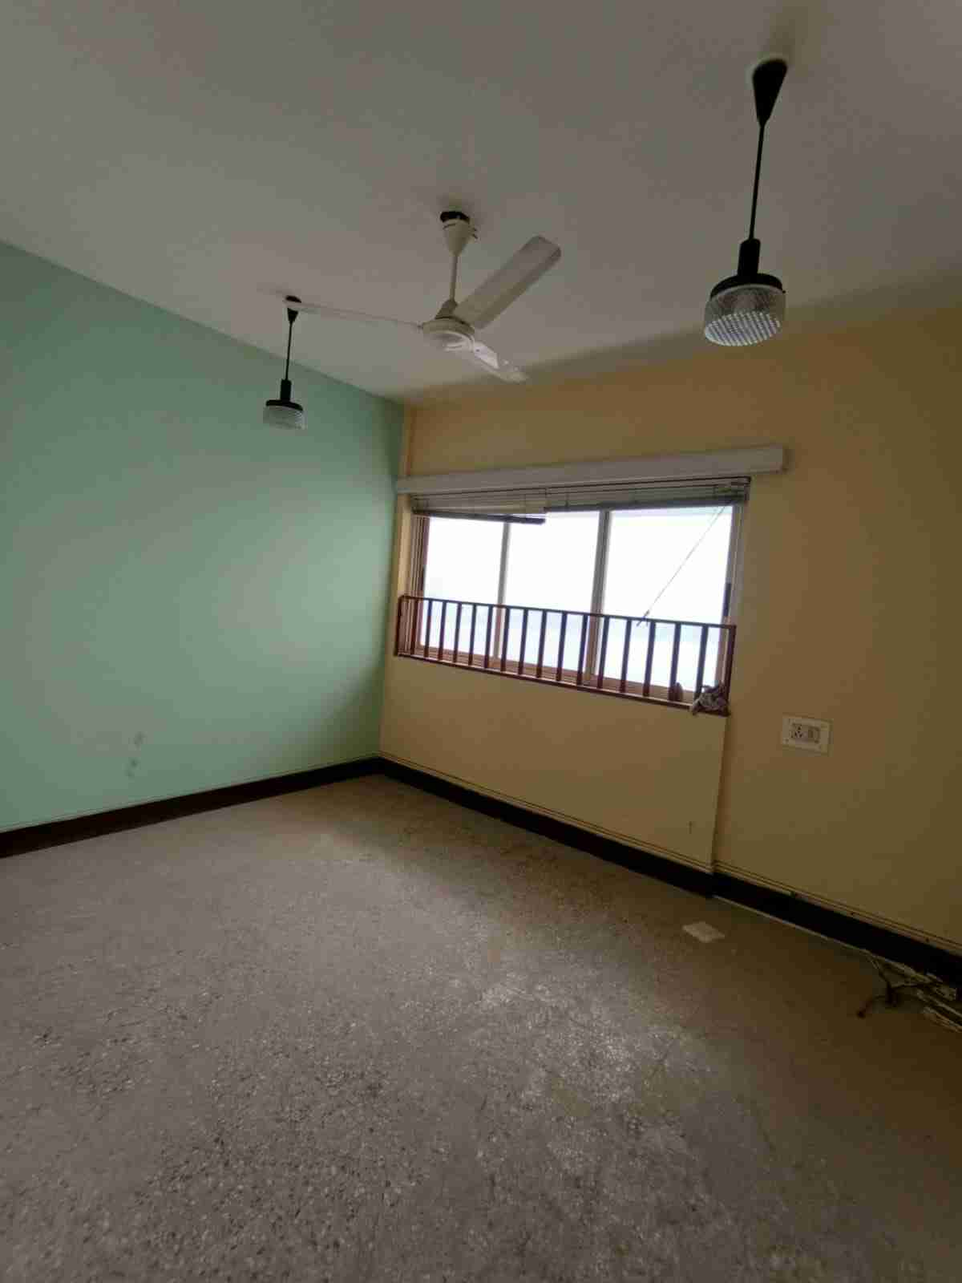
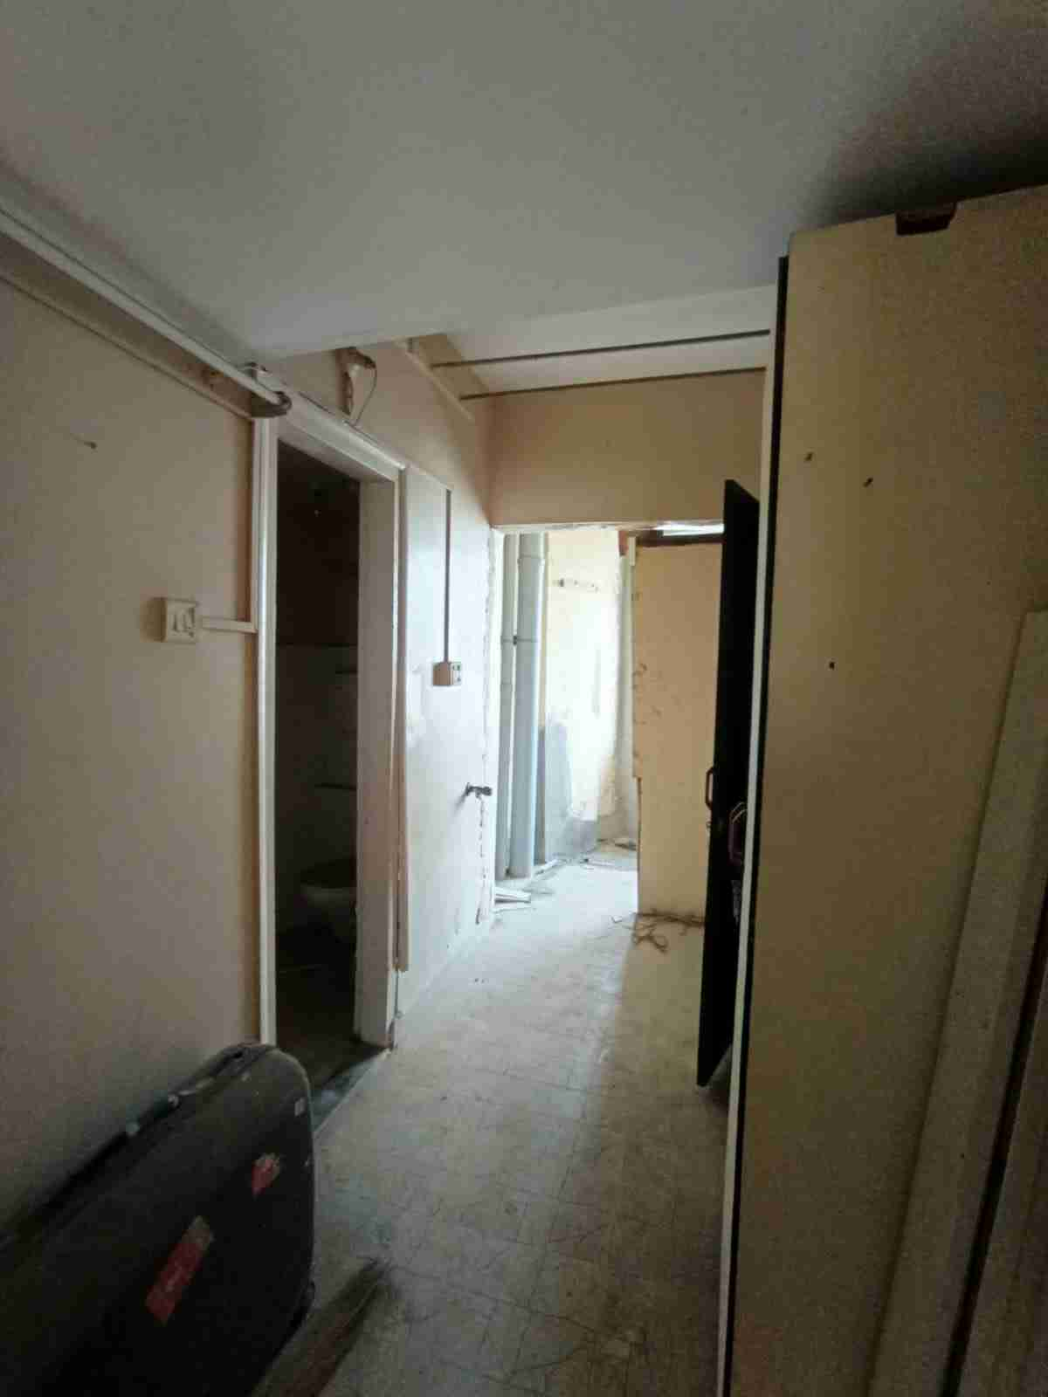
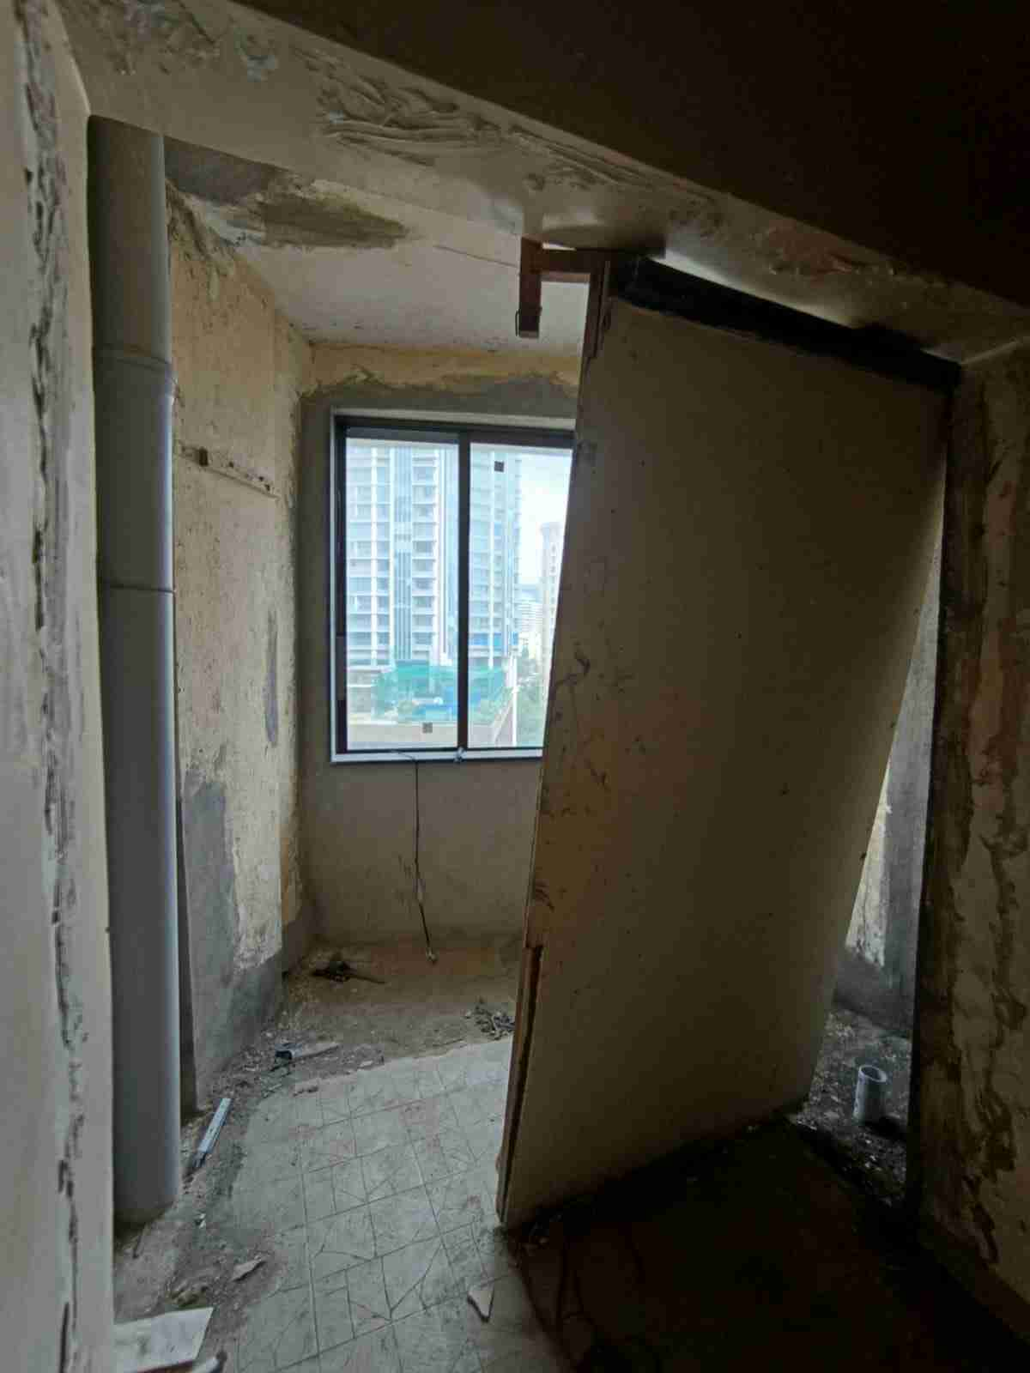


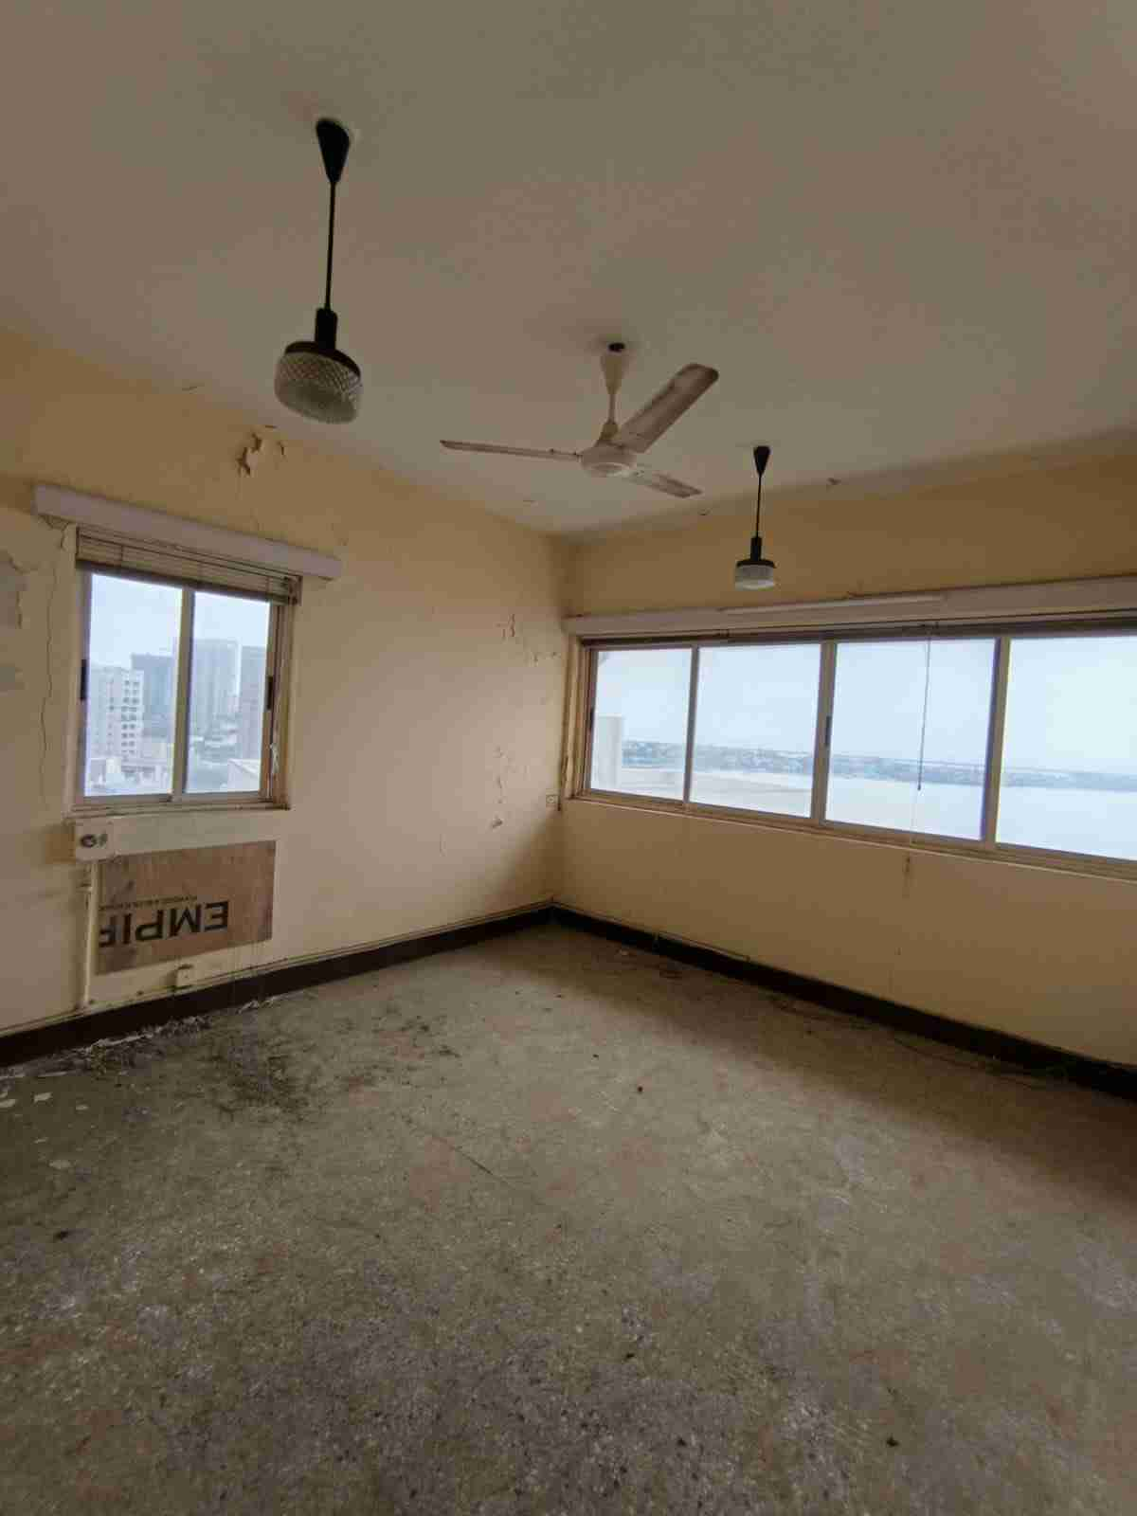
Route Map of the property
Site u/r
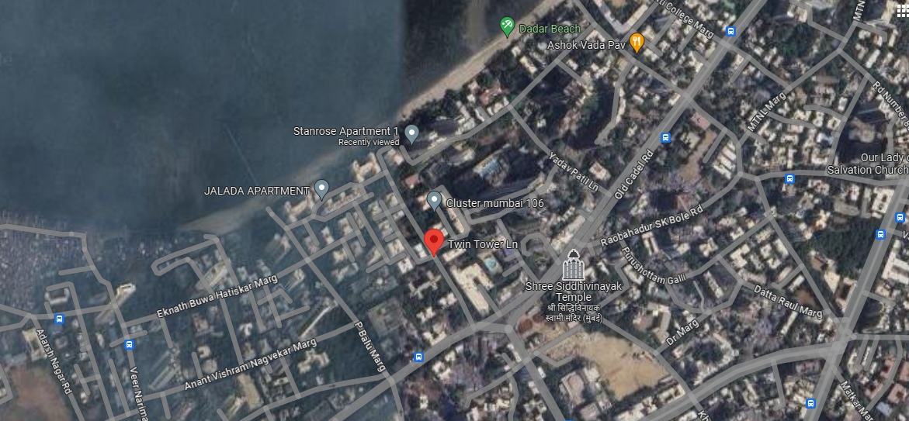

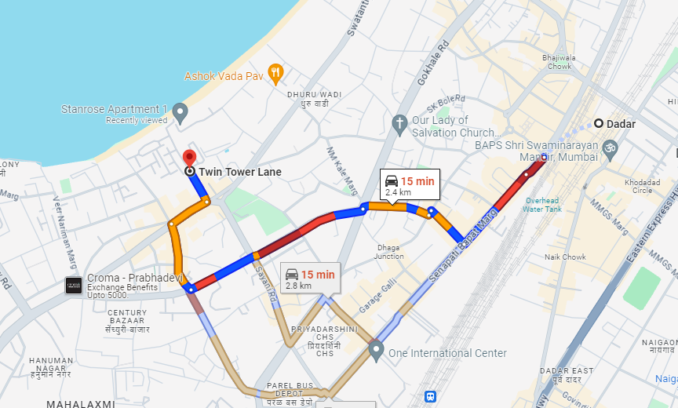



Latitude Longitude: 19°01'10.3"N 72°49'41.4"E

Note: The Blue line shows the route to site from nearest Railway station (Dadar – 2.4 km.)
Ready Reckoner Rate
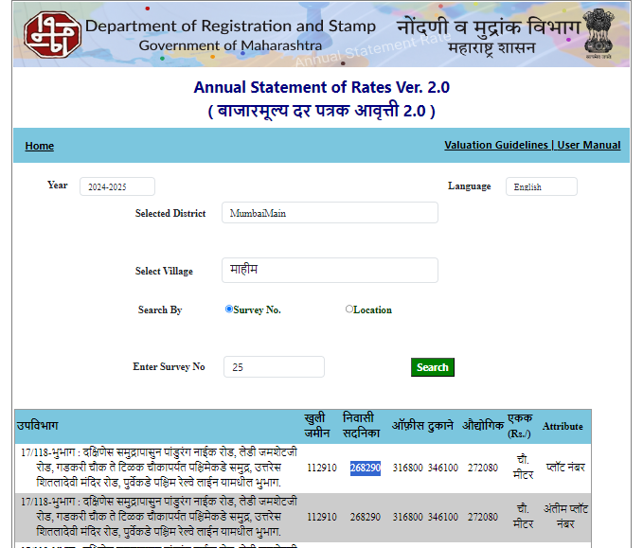

Stamp Duty Ready Reckoner Market Value Rate for Flat | 2,68,290.00
5% Increase for Flat Located on 10th Floor | 13,415.00
Stamp Duty Ready Reckoner Market Value Rate (After Increase) (A) | 2,81,705.00 | Sq. Mtr. | 26,171.00 | Sq. Ft.
Stamp Duty Ready Reckoner Market Value Rate for Land (B) | 1,12,910.00
The difference between land rate and building rate (A – B = C) | 1,68,795.00
Depreciation Percentage as per table (D) [100% - 47%]  (Age of the Building – 47 Years) | 53%
Rate to be adopted after considering depreciation [B + (C x D)] | 2,02,371.00 | Sq. Mtr. | 18,801.00 | Sq. Ft.

Building not having lift
The following table gives the valuation of residential building / flat / commercial unit / office in such building on above floor where there is no lift. Depending upon the floor, ready reckoner rates will be reduced.

 | Floor on which flat is Located | Rate to be adopted
a) | Ground Floor / Stilt / Floor | 100%
b) | First Floor | 95%
c) | Second Floor | 90%
d) | Third Floor | 85%
e) | Fourth Floor and above | 80%

Table – D: Depreciation Percentage Table

Completed Age of Building in Years | Value in percent after depreciation
 | R.C.C. Structure / other Pukka Structure | Cessed Building, Half or Semi – Pukka Structure & Kaccha Structure.
0 to 2 Years | 100% | 100%
Above 2 & up to 5 Years | 95% | 95%
Above 5 Years | After initial 5 year for every year 1% depreciation is to be considered. However maximum deduction available as per this shall be 70% of Market Value rate | After initial 5 year for every year 1.5% depreciation is to be considered. However maximum deduction available as per this shall be 85% of Market Value rate
Price Indicator
Site | Carpet  Area in Sq. Ft. | Built up Area in Sq. Ft. – 20% loading | Value | Rate / Sq. Ft. on Built up Area
99acres | 1,567.00 | 1,880.00 | `15,00,00,000.00 | ` 79,770.00
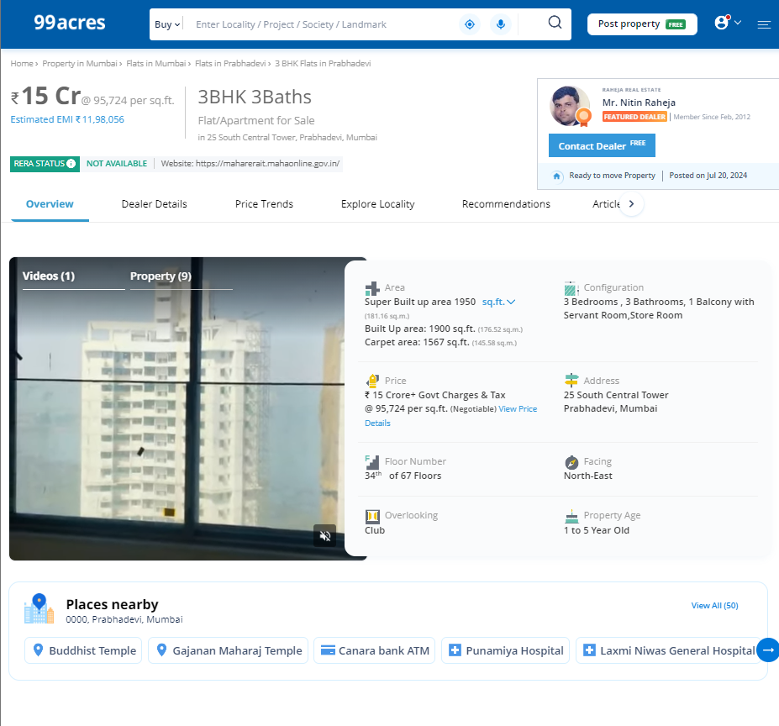

Site | Carpet  Area in Sq. Ft. | Built up Area in Sq. Ft. – 20% loading | Value | Rate / Sq. Ft. on Built up Area
Housing.com | 1,000.00 | 1,200.00 | ` 8,50,00,000.00 | ` 70,833.00
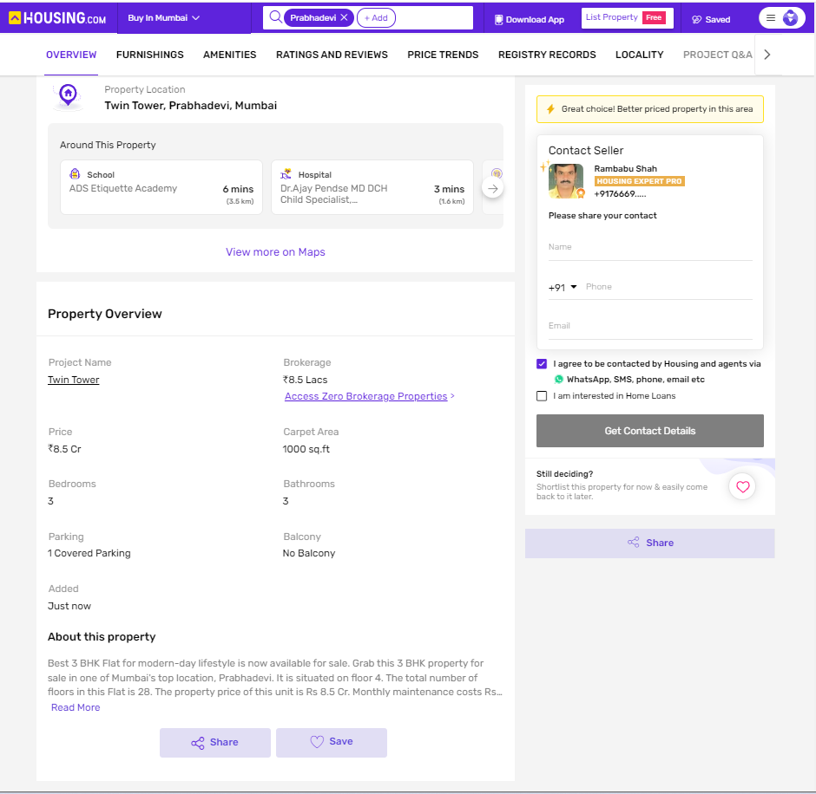

Sales Instance
Regd. Doc. No. | Date | Agreement Value in ` | Built up  Area in Sq. Ft. | Rate / Sq. Ft. on Built up Area
5421/2023 | 04.08.2023 | `10,50,00,000.00 | 1,440.00 | ` 72,889.00

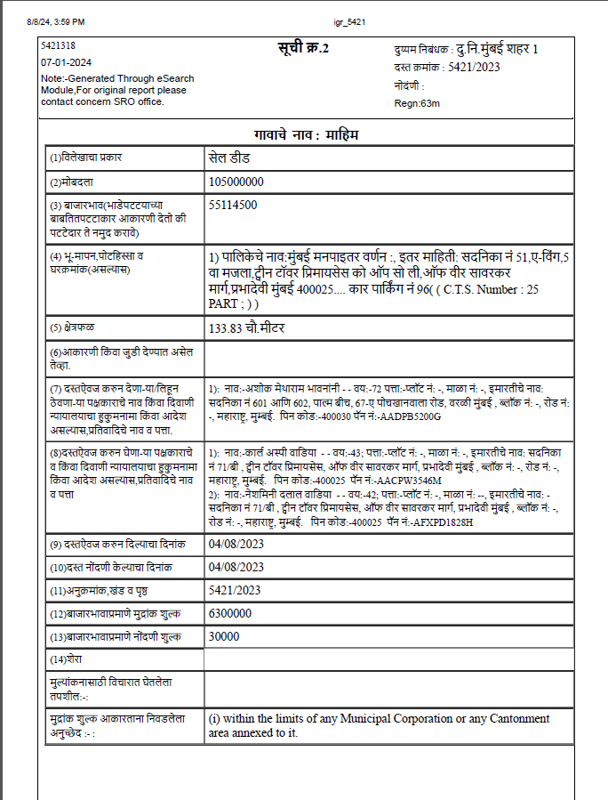

Sr. | Particulars | Valuer comment
 | Background information of the asset being valued; | The property under consideration is owned by Voltas Limited as per Agreement for Sale dated 18.07.1974
 | Purpose of valuation and appointing authority | As per the request India Exim Bank to assess value of the property for Bank Purpose
 | Identity of the valuer and any other experts involved in the valuation; | Manoj B. Chalikwar – Regd. Valuer  Bhavika Chavan – Valuation Engineer  Vaishali Sarmalkar – Technical Manager  Komal Suryawanshi – Technical Officer
 | Disclosure of valuer interest or conflict, if any; | We have no interest, either direct or indirect, in the property valued. Further to state that we do not have relation or any connection with property owner / applicant directly or indirectly. Further to state that we are an independent Valuer and in no way related to property owner / applicant
 | Date of appointment, valuation date and date of  report; | Date of Appointment –07.08.2024  Valuation Date – 12.08.2024  Date of Report – 13.08.2024
 | Inspections and/or investigations undertaken; | Physical Inspection done on 07.08.2024
 | Nature and sources of the information used or relied upon; | - Market Survey at the time of site visit  - Ready Reckoner rates / Circle rates  - Online search for Registered Transactions  - Online Price Indicators on real estate portals  - Enquiries with Real estate consultants  - Existing data of Valuation assignments carried out by us
 | Procedures adopted in carrying out the valuation and valuation standards followed; | Sales Comparison Method
 | Restrictions on use of the report, if any; | This valuation is for the use of the party to whom it is addressed and for no other purpose. No responsibility is accepted to any third party who may use or rely on the whole or any part of this valuation. The valuer has no pecuniary interest that would conflict with the proper valuation of the property.
 | Major factors that were taken into account during the valuation; | Current market conditions, demand and supply position, Residential Flat size, location, upswing in real estate prices, sustained demand for Residential Flat, all-round development of commercial and residential application in the locality etc.
 | Caveats, limitations and disclaimers to the extent they explain or elucidate the limitations faced by valuer, which shall not be for the purpose of limiting his responsibility for the valuation report. | Attached

Assumptions, Disclaimers, Limitations & Qualifications

Value Subject to Change
The subject appraisal exercise is based on prevailing market dynamics as on 13th August 2024 and does not take into account any unforeseeable developments which could impact the same in the future.
Our Investigations
We are not engaged to carry out all possible investigations in relation to the subject property. Where in our report we identify certain limitations to our investigations, this is to enable the reliant party to instruct further investigations where considered appropriate or where we recommend as necessary prior to reliance. Vastukala Consultants India Pvt. Ltd. (VCIPL) is not liable for any loss occasioned by a decision not to conduct further investigations
Assumptions
Assumptions are a necessary part of undertaking valuations. VCIPL adopts assumptions for the purpose of providing valuation advise because some matters are not capable of accurate calculations or fall outside the scope of our expertise, or out instructions. The reliant party accepts that the valuation contains certain specific assumptions and acknowledge and accept the risk of that if any of the assumptions adopted in the valuation are incorrect, then this may have an effect on the valuation.
Information Supplied by Others
The appraisal is based on the information provided by the client. The same has been assumed to be correct and has been used for appraisal exercise. Where it is stated in the report that another party has supplied information to VCIPL, this information is believed to be reliable but VCIPL can accept no responsibility if this should prove not to be so.
Future Matters
To the extent that the valuation includes any statement as to a future matter, that statement is provided as an estimate and/or opinion based on the information known to VCIPL at the date of this document. VCIPL does not warrant that such statements are accurate or correct.
Map and Plans
Any sketch, plan or map in this report is included to assist the reader while visualising the property and assume no responsibility in connection with such matters.
Site Details
Based on inputs received from Client and site visit conducted, we understand that the subject property is Residential Amalgamated Flat, admeasuring Built up area in Sq. Ft. = 1,206.00 in the name of Voltas Limited. Further, VCIPL has assumed that the subject property is free from any encroachment and is available as on the date of the appraisal.
Property Title
Based on our discussion with the Client, we understand that the subject property is owned by Voltas Limited For the purpose of this appraisal exercise, we have assumed that the subject property has a clear title and is free from any encumbrances, disputes and claims. VCIPL has made no further enquiries with the relevant local authorities in this regard and does not certify the property as having a clear and marketable title. Further, no legal advice regarding the title and ownership of the subject property has been obtained for the purpose of this appraisal exercise. It has been assumed that the title deeds are clear and marketable.
Environmental Conditions
We have assumed that the subject property is not contaminated and is not adversely affected by any existing or proposed environmental law and any processes which are carried out on the property are regulated by environmental legislation and are properly licensed by the appropriate authorities.
Area
Based on the information provided by the Client, we understand that the Residential Amalgamated Flat, admeasuring total Built up area in Sq. Ft. = 1,206.00.
Condition & Repair
In the absence of any information to the contrary, we have assumed that there are no abnormal ground conditions, nor archaeological remains present which might adversely affect the current or future occupation, development or value of the property. The property is free from rat, infestation, structural or latent defect. No currently known deleterious or hazardous materials or suspect techniques will be used in the construction of or subsequent alteration or additions to the property and comments made in the property details do not purport to express an opinion about, or advise upon, the condition of uninspected parts and should not be taken as making an implied representation or statement about such parts
Valuation Methodology
For the purpose of this valuation exercise, the valuation methodology used is Direct Comparison Approach / Method and proposed Current use / Existing use premise is considered for this assignment.
The Direct Comparison Approach involves a comparison of the property being valued to similar properties that have actually been sold in arms - length transactions or are offered for sale. This approach demonstrates what buyers have historically been willing to pay (and sellers willing to accept) for similar properties in an open and competitive market and is particularly useful in estimating the value of the Flat and properties that are typically traded on a unit basis.
In case of inadequate recent transaction activity in the subject micro-market, the appraiser would collate details of older transactions. Subsequently, the appraiser would analyse rental / capital value trends in the subject micro-market in order to calculate the percentage increase / decrease in values since the date of the identified transactions. This percentage would then be adopted to project the current value of the same.
Where reliance has been placed upon external sources of information in applying the valuation methodologies, unless otherwise specifically instructed by Client and/or stated in the valuation, VCIPL has not independently verified that information and VCIPL does not advise nor accept it as reliable. The person or entity to whom the report is addressed acknowledges and accepts the risk that if any of the unverified information in the valuation is incorrect, then this may have an effect on the valuation.
Not a Structural Survey
We state that this is a valuation report and not a structural survey
Other
All measurements, areas and ages quoted in our report are approximate
Legal
We have not made any allowances with respect to any existing or proposed local legislation relating to taxation on realization of the sale value of the subject property. VCIPL is not required to give testimony or to appear in court by reason of this appraisal report, with reference to the property in question, unless arrangement has been made thereof. Further, no legal advice on any aspects has been obtained for the purpose of this appraisal exercise
Property specific assumptions
Based on inputs received from the client and site visit conducted, we understand that the subject property is Residential Amalgamated Flat, admeasuring total Built up area in Sq. Ft. = 1,206.00.
ASSUMPTIONS, CAVEATS, LIMITATION AND DISCLAIMERS
1. We assume no responsibility for matters of legal nature affecting the property appraised or the title thereto, nor do we render our opinion as to the title, which is assumed to be good and marketable.
2. The property is valued as though under responsible ownership.
3. It is assumed that the property is free of liens and encumbrances.
4. It is assumed that there are no hidden or unapparent conditions of the subsoil or structure that would render it more or less valuable. No responsibility is assumed for such conditions or for engineering that might be required to discover such factors.
5. There is no direct/ indirect interest in the property valued.
6. The rates for valuation of the property are in accordance with the Govt. approved rates and prevailing market rates.

DEFINITION OF VALUE FOR THIS SPECIFIC PURPOSE

This exercise is to assess Fair Market Value of the property for under reference as on 13th August 2024.

The term Fair Market Value is defined as

“The most probable price, as of a specified date, in cash, terms equivalent to cash, or in other precisely revealed terms for which the specified property rights would sell after reasonable exposure in a competitive market under all conditions requisite to a fair sale, with the buyer and seller each acting prudently knowledgeably and for self interest assuming that neither is under undue duress”.

Fundamental assumptions and conditions presumed in this definition are:

1. Buyer and seller are motivated by self-interest.
2. Buyer and seller are well informed and are acting prudently.
3. The property is exposed for a reasonable time on the open market.
4. Payment is made in cash or equivalent or in specified financing terms.
DECLARATION OF PROFESSIONAL FEES CHARGED

We hereby declare that, our professional fees are not contingent upon the valuation findings. However, if the statute AND/OR clients demands that, the fees should be charged on the percentage of assessed value then, with the full knowledge of the AND/OR end user, it is being charged accordingly.

VALUATION OF THE PROPERTY PREMISES

Considering various parameters recorded herein above, existing economic scenario, and the information that is available with reference to the development of neighborhood and method selected for valuation, we are of the opinion that, the property premises can be assessed and Fair Market value at ` 8,68,32,000.00 (Rupees Eight Crore Sixty Eight Lakh Thirty Two Thousand Only).

Manoj B. Chalikwar
Registered Valuer
Chartered Engineer (India)
Reg. No. CAT-I-F-1763

