Vastu/Nashik/07/2024/0010070/2307330
22/7-334-RPBS
Date: 06.08.2024

To, `
The Branch Manager,
Bank of Baroda
Regional Office Nashik Road Branch
BSNL Building, Datta Mandir Road, Nashik Road,
Nashik -422 101, State - Maharashtra, Country - India.

Sub: Vetting of Extra Amenities

Sir,

With reference to above subject, we have evaluated the Extra Amenities for Residential Flat No. 403, 4th Floor, "Ramalya Sansruti Apartment", Near Nitin Car Towing Service , Plot No. 11+12+13, Jagtap Nagar, Village - Nashik, Taluka - Nashik, District - Nashik, Nashik, 422003, State - Maharashtra, India belongs to Shri. Rajendra Ramdas Pingale & Shri. Sanjay Pundlik Gharte. Name of Proposed Purchaser is Shri. Sujit Gulabrao Bhosale.

We have verified the rates quoted as per current market rates. Details of work and Extra Amenities considered as per copy of Agreement for Extra Amenities issued by Mr. Sujit Gulabrao Bhosale. (First Party) and Mr. Rajendra Ramdas Pingale & Mr. Sanjay Pundlik Gharte (Second Party) received on dated 02.08.2024. The Extra Amenities amount is Rs.14,00,000/- (Rupees Fourteen Lakh Only.)

The said Cost Vetting Certificate is valid upto next 6 months Only.

Thanking you

Sincerely yours

Manoj B. Chalikwar
Registered Valuer
Chartered Engineer (India)
Reg. No. CAT-I-F-1763
Reg. No. IBBI/RV/07/2018/10366
BOB Empanelment No.: ZO:MZ:ADV:46:941
Encl: Valuation report.

Agreement for Extra Amenities
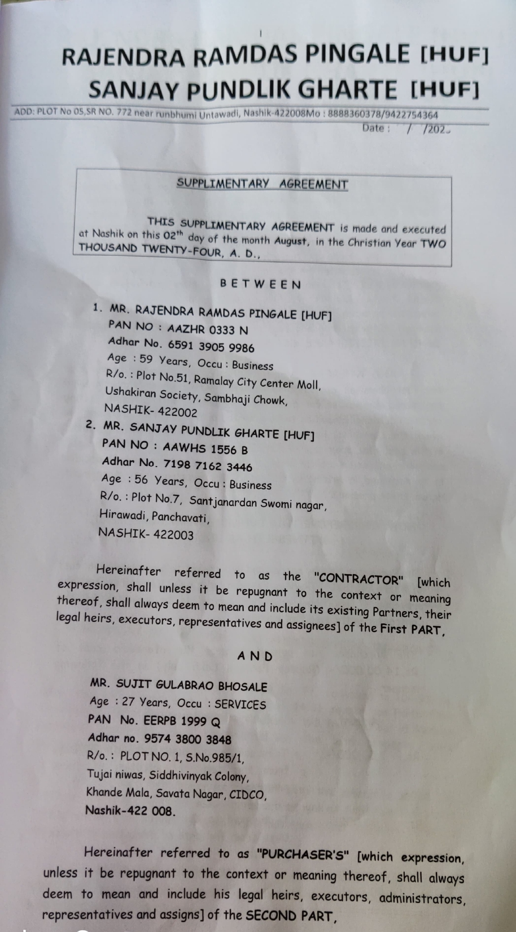
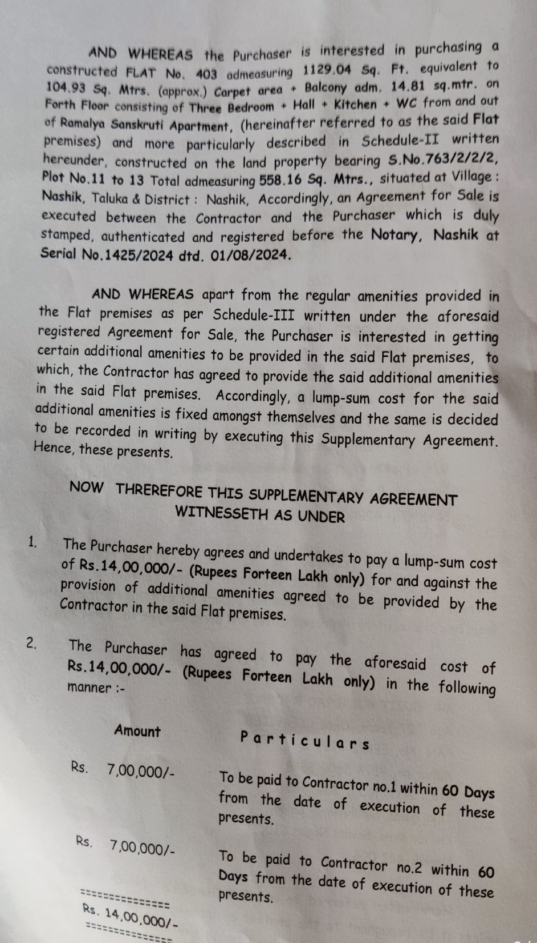

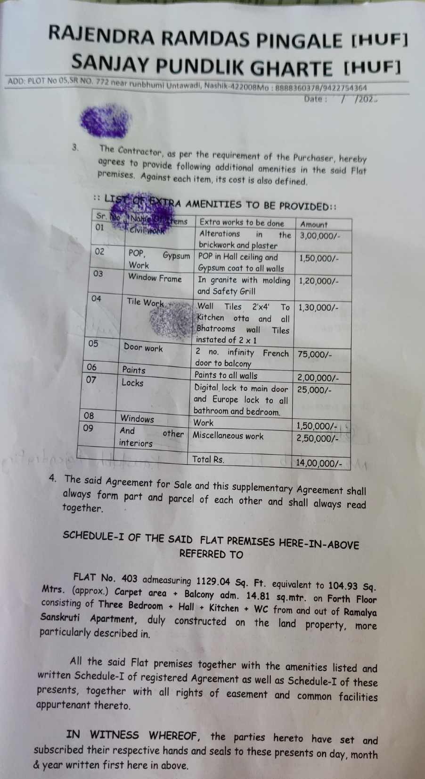
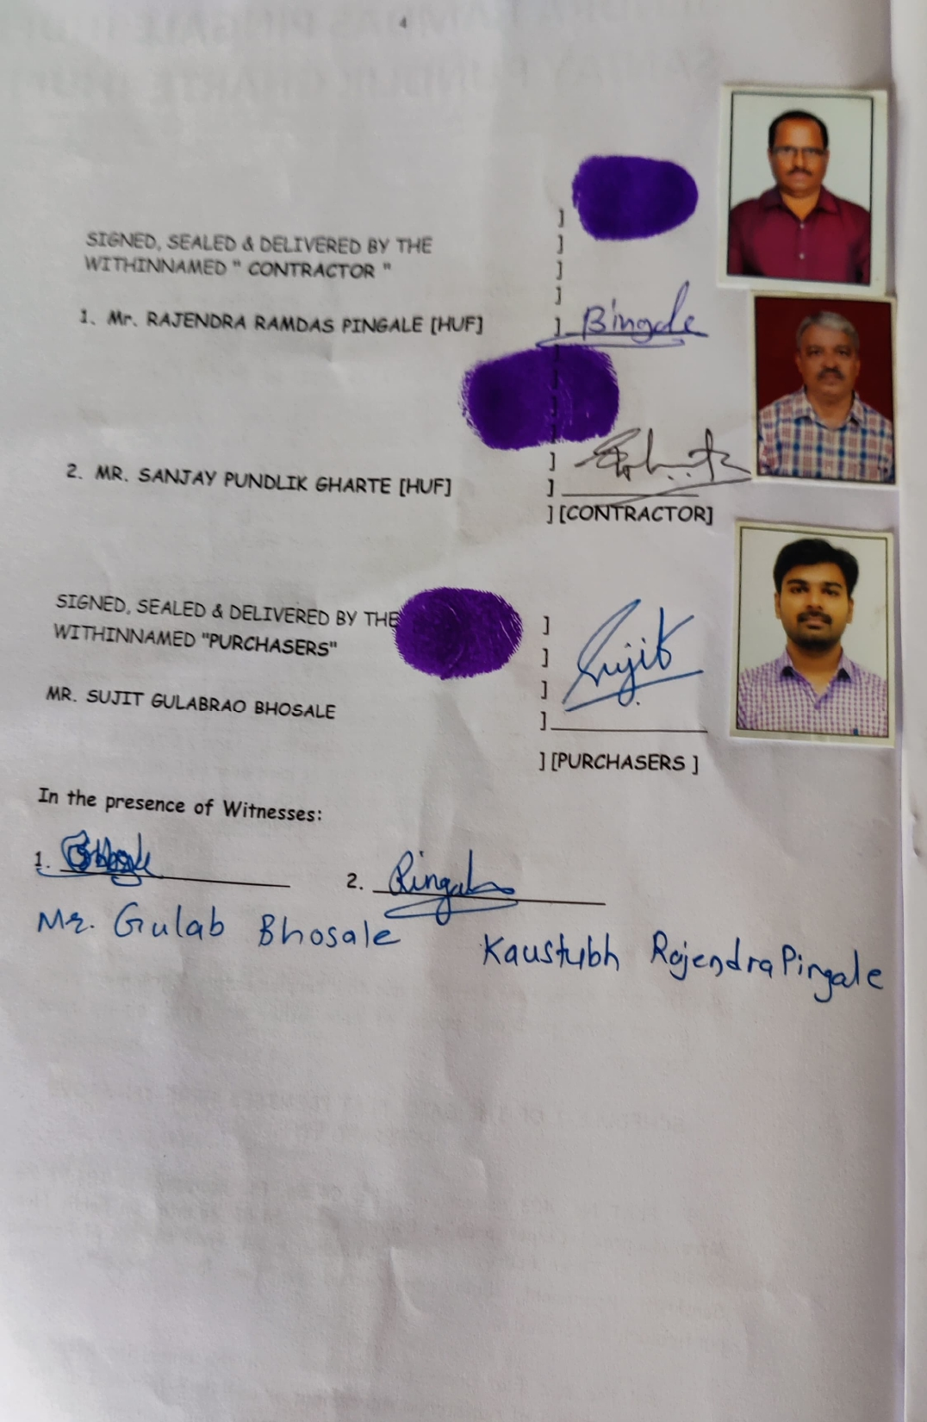

The Extra Amenities amount is Rs. 14,00,000/- (Rupees Fourteen Lakh Only.)

