Vastu/Nashik/08/010388/2307570
06/7-48-RYRJ
Date: 06.08.2024

To,
The Branch Manager,
Bank of Baroda
Regional Office
BSNL Building, Datta Mandir Road, Nashik Road,
Nashik, PIN – 422 101, State - Maharashtra, Country - India.

Sub: Vetting of Extra Amenities

Sir,

With reference to above subject, we have evaluated the Extra Amenities for Residential Flat No. 201, Second Floor, " Sai Darshan Apartment ", Survey No. 49/6, Plot No. 2 & 3, CTS No. 7337 & 7338, Near Shree Mhasoba Maharaj Mandir Devasthan, Gandhi Nagar, Jai Bhavani Road, Village – Deolali, Taluka & District - Nashik, PIN Code –
422 214, State – Maharashtra, Country – India. belongs to Name of Owner: Shri. Sudhir Devidas Koli & Sau. Rupali Sudhir Koli.

We have verified the rates quoted as per current market rates. Details of Extra Amenities considered as per copy of Extra Amenities Agreement between Shri. Sudhir Devidas Koli & Sau. Rupali Sudhir Koli (First Party). Shri. Mayur Dilip Raykar (Second Party) received on dated.12.07.2024. The Extra Amenities amount is Rs. 5,00,000/- (Rupees Five Lakh Only)

The said Cost Vetting Certificate is valid upto next 6 months Only.

Thanking you

Sincerely yours

Manoj B. Chalikwar
Registered Valuer
Chartered Engineer (India)
Reg. No. CAT-I-F-1763
Reg. No. IBBI/RV/07/2018/10366
BOB Empanelment No.: ZO:MZ:ADV:46:941
Encl: Valuation report.

Agreement for Extra Amenities
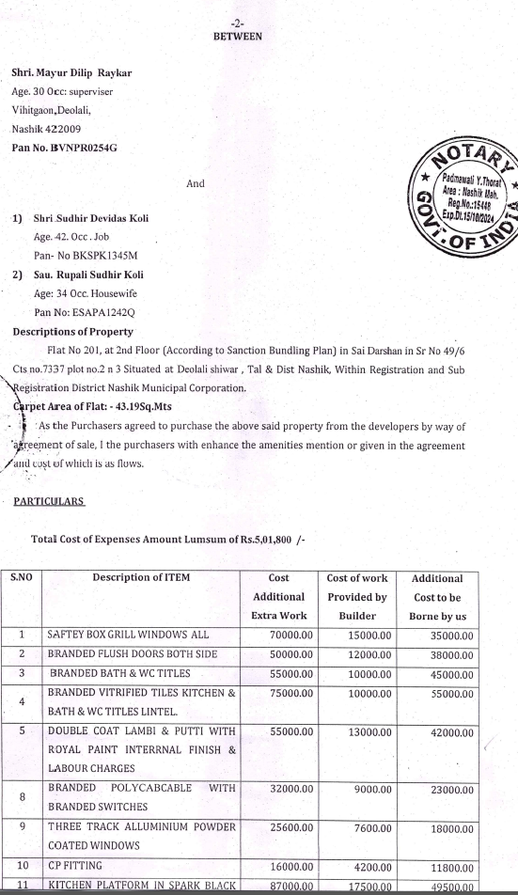
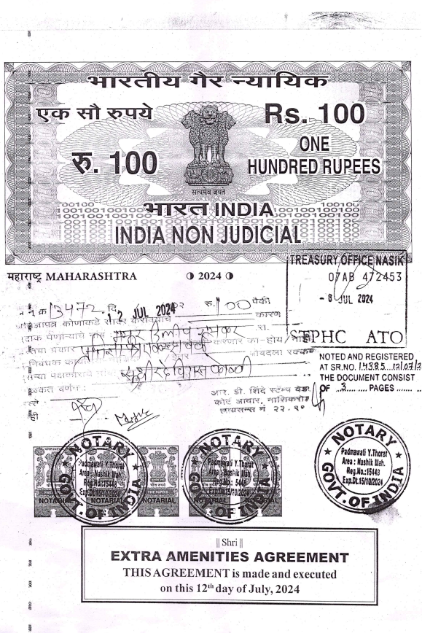

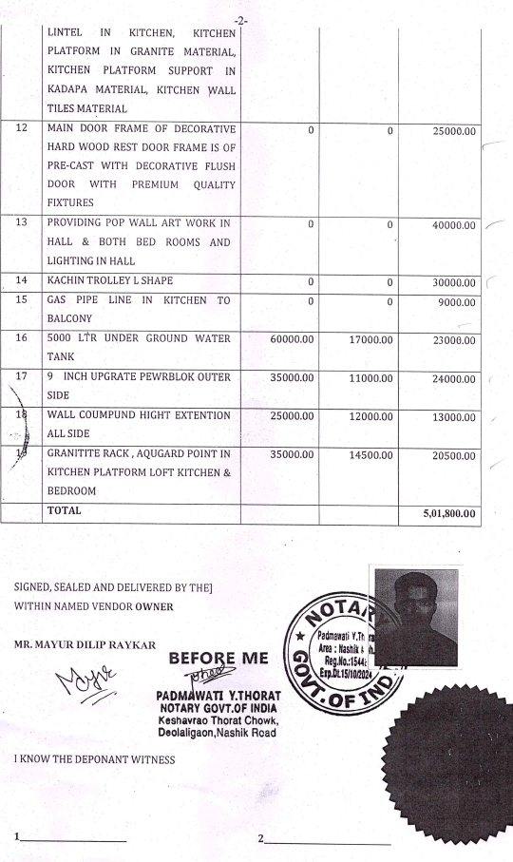

The Extra Amenities amount is Rs. 5,00,000/- (Rupees Five Lakh Only)

