Vastu/Nashik/08/2024/010379/2307567
06/4-45-RYRJ
Date: 05.08.2024

To,
The Branch Manager,
Punjab National Bank

Canada Corner Branch
Shop No.2, 3, 4 Prestige Point, Opp. Vasant Market, Canada Corner
Nashik – 422 005, State – Maharashtra, Country – India.

Sub: Vetting of Extra Amenities Agreement

Sir,

With reference to above subject, we have evaluated the Extra Residential Flat No.101, First Floor, "Vedraj Shambhu", Survey No.165/1, Plot No.34+35, Near Thakare Baba Garden , Thakare Mala, Ayodhya Nagari, Meri Rasbihari Link Road, Village – Nashik , Taluka & District - Nashik, PIN Code – 422 003, State – Maharashtra, Country – India belongs to Name of Owner: M/s.Sadguru Buildcon Name of Proposed Purchaser: Shri.Gopal Ramrao Ghotkar & Sau.Savita Gopal Ghotkar.

We have verified the rates quoted as per current market rates. Details of work and Extra Amenities considered as per copy of Agreement for Extra Amenities Agreement between Shri.Gopal Ramrao Ghotkar & Sau.Savita Gopal Ghotkar. (First Party) and Mr. Dhondiram K. Ghogare (Second Party) received on dated 02.08.2024. The Extra Amenities amount is Rs.2,80,000/- (Rupees Two Lakh Eighty Thousand Only)

The said Cost Vetting Certificate is valid up to next 6 months Only.

Thanking you

Sincerely yours

Sharadkumar B. Chalikwar
Govt. Reg. Valuer
Chartered Engineer (India)
Reg. No. (N) CCIT/1-14/52/2008-09
PNB Empanelment No. ZO:SAMD:1138
Encl: Vetting Report.

Extra Amenities Agreement
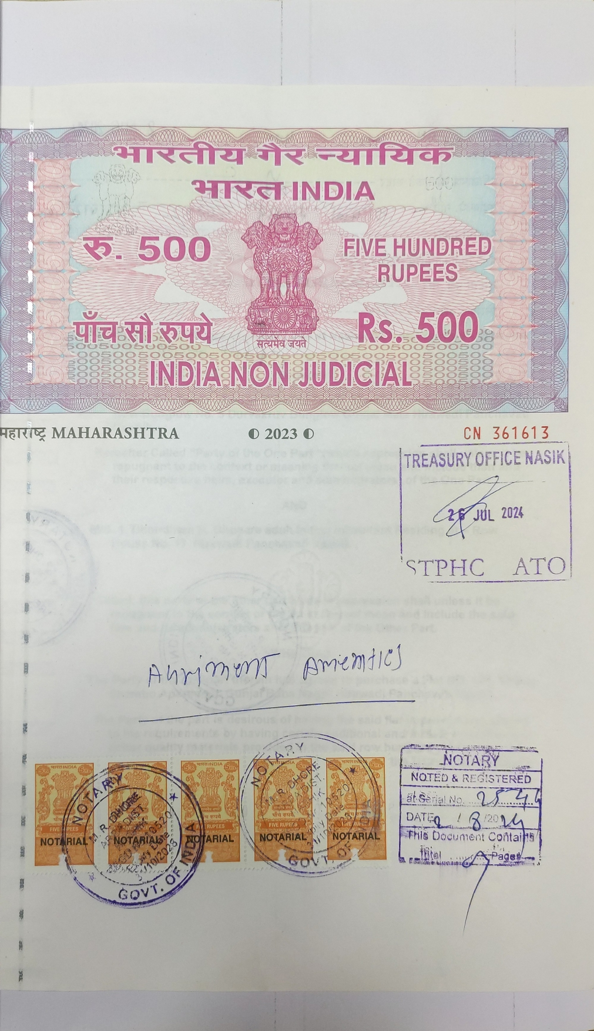
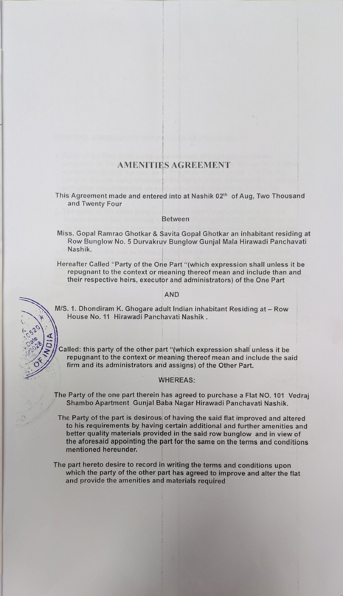

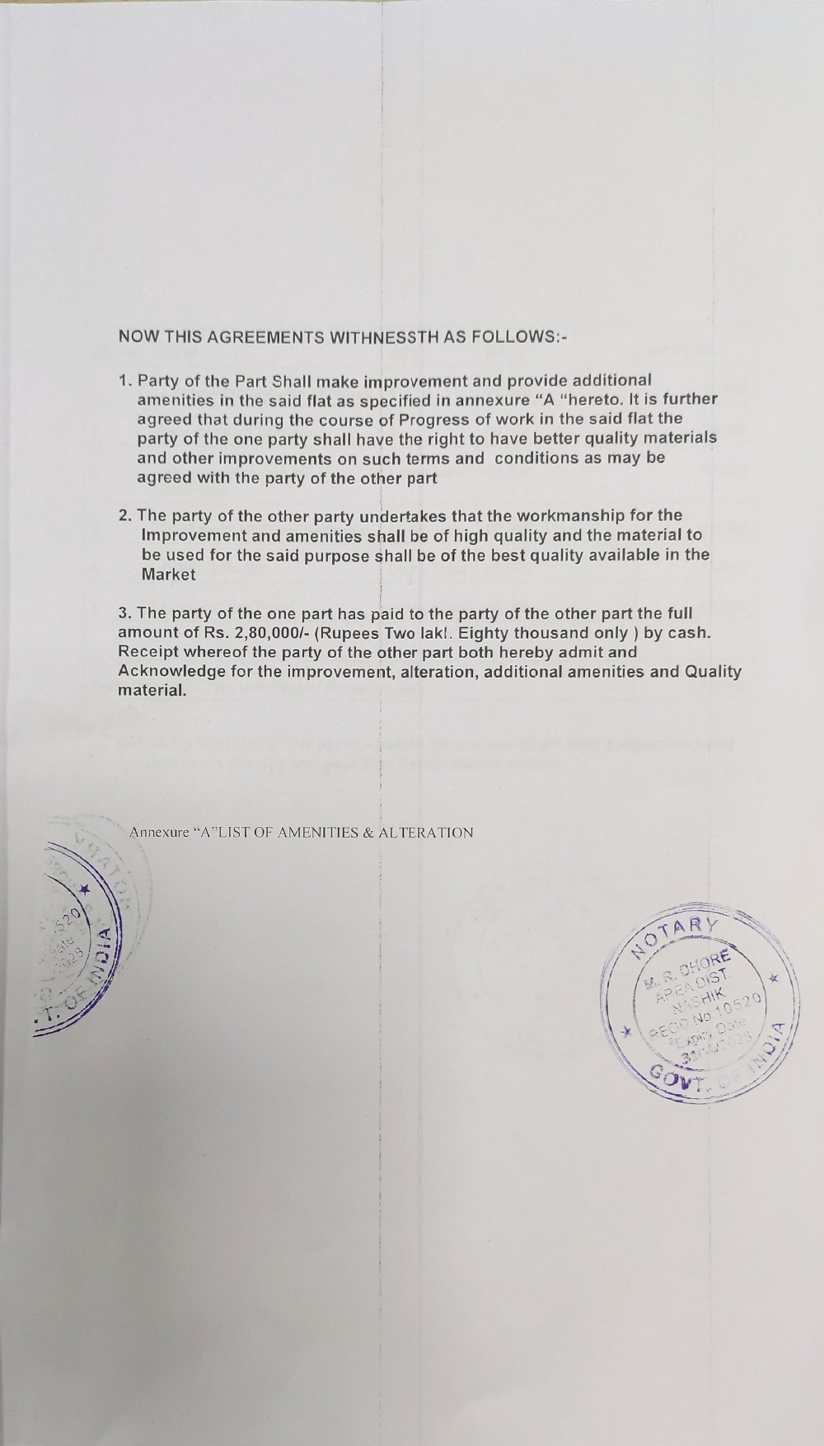
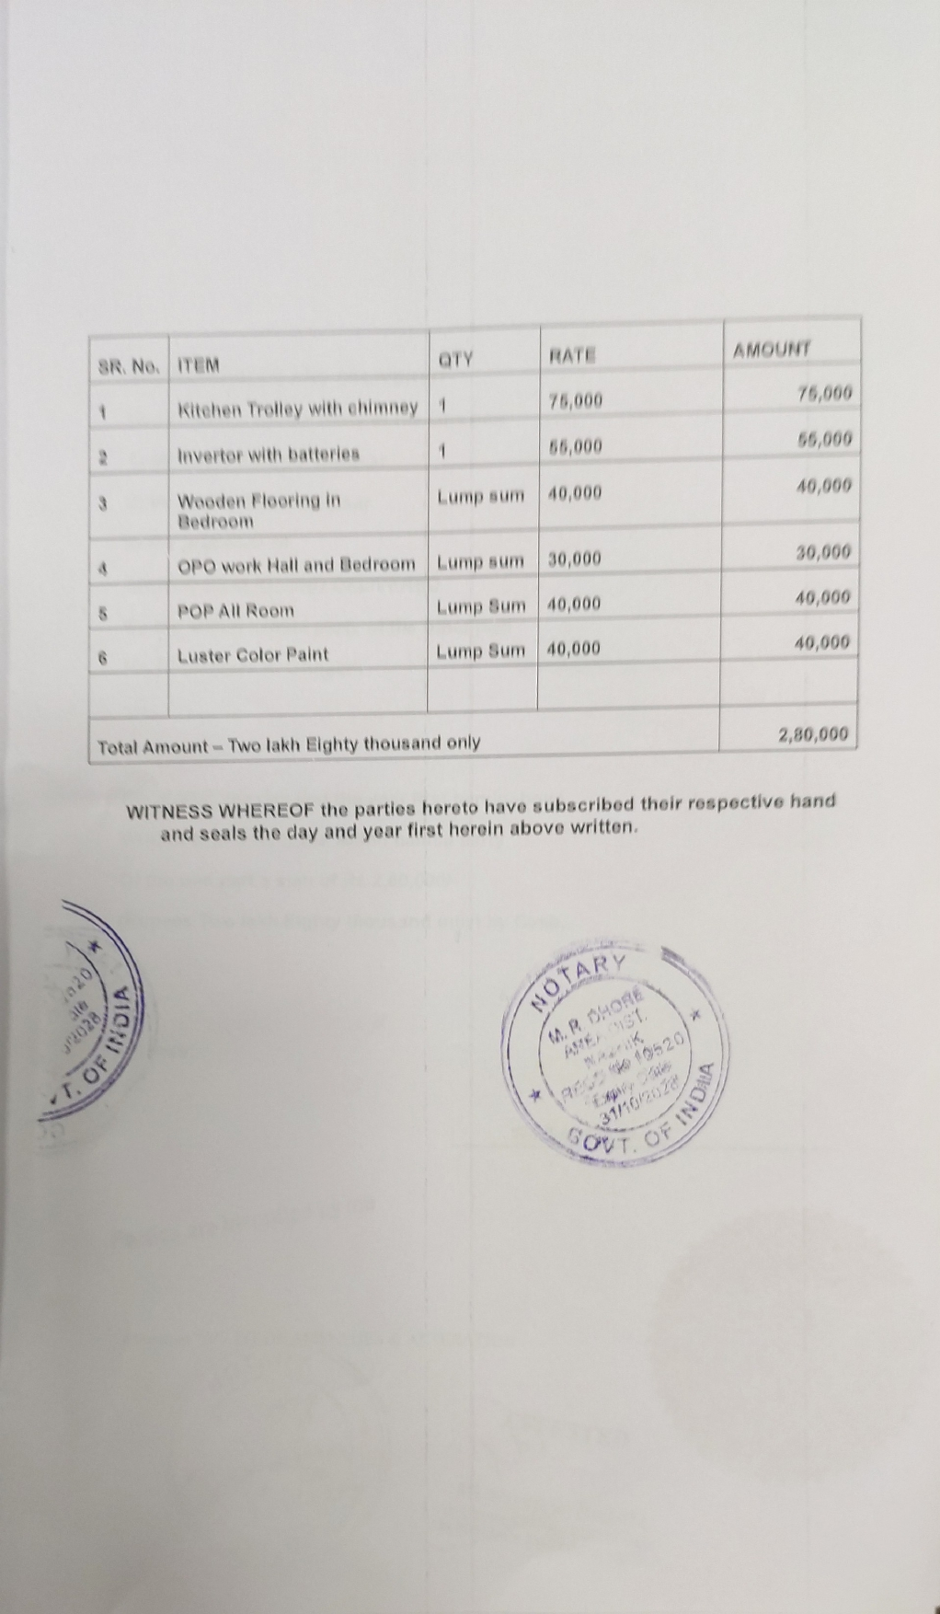

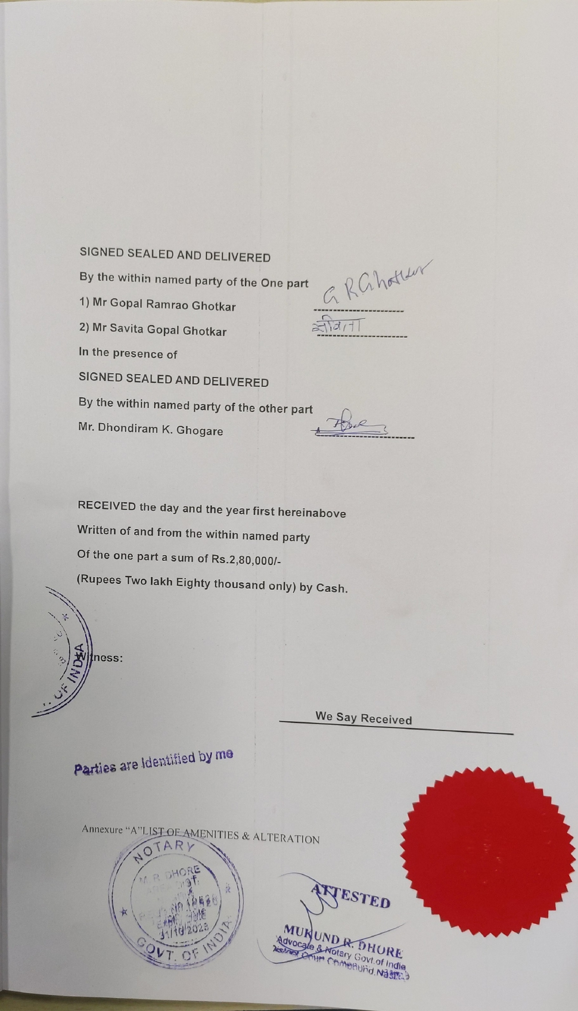

The Extra Amenities amount is Rs.2,80,000/- (Rupees Two Lakh Eighty Thousand Only)

