**Valuation Report of the Immovable Property**

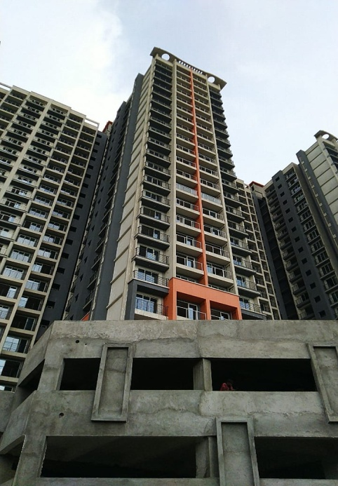

**Details of the property under consideration:**

Name of Owner: **VAP Engineering and Manufacturing Industry**

Residential Flat No. 2101, 21st Floor, C Wing, **“Versatile Valley”,** Off. Kalyan Shill Road,

Near Nilje Grampanchayat, Village – Nilje, Taluka – Kalyan, District – Thane, PIN – 421204,

State - Maharashtra, Country - India

# Latitude Longitude: 19°10'02.0"N 73°04'57.2"E

**Valuation Done for:**

**Cosmos Bank**

**Ghodbunder Road Branch**

Shop No. 4, Cosmos Heritage, Tikujini Wadi, Off Ghodbandar Road, Manpada,

Thane West - 400 610, State - Maharashtra, Country - India.

# Vastukala Consultants (I) Pvt. Ltd.

Mumbai • Delhi NCR • Aurangabad • Nanded

Raipur • Jaipur • Ahmedabad • Rajkot • Thane • Nashik

Vastu/Mumbai/07/2021/20409/35770

08/09-96-SKV

Date: 08.07.2021

**VALUATION OPINION REPORT**

The property bearing Residential Flat No. 2101, 21st Floor, C Wing, **“Versatile Valley”,** Off. Kalyan Shill Road, Near Nilje Grampanchayat, Village – Nilje, Taluka – Kalyan, District – Thane, PIN – 421204, State - Maharashtra, Country – India belongs to **VAP Engineering and Manufacturing Industry**

|  |  |
| --- | --- |
| Boundaries of the property. | |
| North | Nilje Village |
| South | Nilje Gaon Road |
| East | Open Plot |
| West | Nilje Lake |

Considering various parameters recorded, existing economic scenario, and the information that is available with reference to the development of neighbourhood and method selected for valuation, we are of the opinion that, the property premises can be assessed and valued for banking purpose at **`63,00,000.00(Rupees Sixty Three Lakh Only).** As per site inspection 78% of construction work is completed.

The valuation of the property is based on the documents produced by the concern. Legal aspects have not been taken into considerations while preparing this report.

Hence certified

**Sharadkumar B. Chalikwar**

Govt. Reg. Valuer

Chartered Engineer (India)

Reg. No. (N) CCIT/1-14/52/2008-09

Encl.: Valuation report

Residential Flat No. 2101, 21st Floor, C Wing, **“Versatile Valley”,** Off. Kalyan Shill Road,

Near Nilje Grampanchayat, Village – Nilje, Taluka – Kalyan, District – Thane, PIN – 421204,

State - Maharashtra, Country – India

***Form 0-1***

*(See Rule 8 D)*

REPORT OF VALUATION OF IMMOVABLE PROPERTY (OTHER THAN AGRICULTURAL LANDS, PLANTATIONS, FORESTS, MINES AND QUARRIES)

**GENERAL:**

|  |  |  |  |
| --- | --- | --- | --- |
| 1 | Purpose for which the valuation is made | | To assess the Fair Market Value as on 07.07.2021for Bank Loan Purpose |
| 2 | Date of inspection | | 24.05.2021 |
| 3 | Name of the owner/ owners | | **VAP Engineering and Manufacturing Industry** |
| 4 | If the property is under joint Ownership / co-ownership, share of each such owner. Are the shares undivided? | | Company Ownership  (Details of ownership share not available) |
| 5 | Brief description of the property | | Residential Flat No. 2101, 21st Floor, C Wing, **“Versatile Valley”,** Off. Kalyan Shill Road, Near Nilje Grampanchayat, Village – Nilje, Taluka – Kalyan, District – Thane, PIN – 421204, State - Maharashtra, Country – India |
| 6 | Location, street, ward no | | Village – Nilje, Taluka – Kalyan, District – Thane |
| 7 | Survey/ Plot no. of land | | Old Survey No. 11, Hissa No. 9, New Survey No. 12, Hissa No. 9 and others of Village – Nilje |
| 8 | Is the property situated in residential/ commercial/ mixed area/ industrial area? | | Residential |
| 9 | Classification of locality-high class/ middle class/poor class | | Middle Class |
| 10 | Proximity to civic amenities like schools, Hospitals, Offices, market, cinemas etc. | | All available at near by |
| 11 | Means and proximity to surface communication by which the locality is served | | Served by Buses, Auto, Taxies and Private cars |
|  | **LAND** | |  |
| 12 | Area of land supported by documentary proof. Shape, dimension and physical features | | Carpet Area in Sq. Ft. = 602.00  Balcony Area in Sq. Ft. = 121.00  (Area as per actual site measurement)  Carpet Area in Sq. Ft. = 600.00  (Area as per Agreement for Sale)  **Built Up Area in Sq. Ft. = 660.00**  **(Agreement Carpet + 10%)** |
| 13 | Roads, Streets or lanes on which the land is abutting | | Village – Nilje, Taluka – Kalyan, District – Thane |
| 14 | If freehold or leasehold land | | Free hold |
| 15 | If leasehold, the name of Lessor/lessee, nature of lease, date of commencement and termination of lease and terms of renewal of lease.  (i) Initial premium  (ii) Ground rent payable per annum  (iii) Unearned increase payable to the Lessor in the event of sale or transfer | | N.A. |
| 16 | Is there any restriction covenant in regard to use of land? If so attach a copy of the covenant. | | As per documents |
| 17 | Are there any agreements of easements? If so attach a copy of the covenant | | Information not available |
| 18 | Does the land fall in an area included in any Town Planning Scheme or any Development Plan of Government or any statutory body? If so give Particulars. | | Yes |
| 19 | Has any contribution been made towards development or is any demand for such contribution still outstanding. | | Information not available |
| 20 | Has the whole or part of the land been notified for acquisition by government or any statutory body? Give date of the notification. | | N.A. |
| 21 | Attach a dimensioned site plan | | Attached |
|  | **IMPROVEMENTS** | |  |
| 22 | Attach plans and elevations of all structures standing on the land and a lay-out plan. | | Information not available |
| 23 | Furnish technical details of the building on a separate sheet (The Annexure to this form may be used) | | Attached |
| 24 | Is the building owner occupied/tenanted/both? | | Building is under construction |
| 25 | If the property owner occupied, specify portion and extent of area under owner-occupation | | Building is under construction |
| 26 | What is the Floor Space Index permissible and Percentage actually utilized? | | Floor Space Index permissible - As per local norms  Percentage actually utilized – Details not available |
|  | **RENTS** | |  |
|  | (i) | Names of tenants/ lessees/ licensees, etc | N.A. |
|  | (ii) | Portions in their occupation | N.A. |
|  | (iii) | Monthly or annual rent /compensation/license fee, etc. paid by each | N.A. |
|  | (iv) | Gross amount received for the whole property | N.A. |
| 27 | Are any of the occupants related to, or close to business associates of the owner? | | N.A. |
| 28 | Is separate amount being recovered for the use of fixtures, like fans, geysers, refrigerators, cooking ranges, built-in wardrobes, etc. or for services charges? If so, give details | | N.A. |
| 29 | Give details of the water and electricity charges, If any, to be borne by the owner | | N.A. |
| 30 | Has the tenant to bear the whole or part of the cost repairs and maintenance? Give particulars | | N.A. |
| 31 | If a lift is installed, who is to bear the cost of maintenance and operation- owner or tenant? | | N.A. |
| 32 | If a pump is installed, who is to bear the cost of maintenance and operation- owner or tenant? | | N.A. |
| 33 | Who has to bear the cost of electricity charges for lighting of common space like entrance hall, stairs, passage, compound, etc. owner or tenant? | | N.A. |
| 34 | What is the amount of property tax? Who is to bear it? Give details with documentary proof | | Information not available |
| 35 | Is the building insured? If so, give the policy no., amount for which it is insured and the annual premium | | Information not available |
| 36 | Is any dispute between landlord and tenant regarding rent pending in a court of rent? | | N.A. |
| 37 | Has any standard rent been fixed for the premises under any law relating to the control of rent? | | N.A. |
|  | **SALES** | |  |
| 38 | Give instances of sales of immovable property in the locality on a separate sheet, indicating the Name and address of the property, registration No., sale price and area of land sold. | | N.A. |
| 39 | Land rate adopted in this valuation | | N. A. as the property under consideration is a Residential Flatin an apartment. The rate is considered as composite rate. |
| 40 | If sale instances are not available or not relied up on, the basis of arriving at the land rate | | N.A. |
|  | **COST OF CONSTRUCTION** | |  |
| 41 | Year of commencement of construction and year of completion | | Building is under construction  Expected Date of Completion July 2021 |
| 42 | What was the method of construction, by contract/By employing Labour directly/ both? | | N.A. |
| 43 | For items of work done on contract, produce copies of agreements | | N.A. |
| 44 | For items of work done by engaging Labour directly, give basic rates of materials and Labour supported by documentary proof. | | N.A. |
| 45 | **Remarks** | |  |

***PART II- VALUATION***

**GENERAL:**

Under the instruction of Cosmos Bank,Ghodbunder Road Branch, we have valued Residential Flat No. 2101, 21st Floor, C Wing, **“Versatile Valley”,** Off. Kalyan Shill Road, Near Nilje Grampanchayat, Village – Nilje, Taluka – Kalyan, District – Thane, PIN – 421204, State - Maharashtra, Country – Indiabelongsto **VAP Engineering and Manufacturing Industry**

We are in receipt of the following documents:

|  |  |
| --- | --- |
|  | Copy of Agreement for Sale dated 24.02.2021 |
|  | Copy of RERA Certificate No. P51700003860 dated 18.05.2020 |
|  | Copy of Commencement Certificate No. SROT / 27 Villages / 2401 / BP / RHP / Nilaje-11 / Vol-III / 280 / 2016 dated 17.02.2017 issued by Mumbai Metropolitan Region Development Authority. |

**LOCATION:**

The said building is located at Old Survey No. 11, Hissa No. 9, New Survey No. 12, Hissa No. 9 and others of Village – Nilje, Taluka – Kalyan, District – Thane, State - Maharashtra, Country - India It is at a travel distance of 7.4Km from Dombivali Railway station. The surrounding locality is residential.

**BUILDING:**

At the time of site inspection building was under construction &78% work completed. The building under reference is having Stilt (Pt) + Ground (Pt) + 23 upper floors. It is a R.C.C. Framed Structure framed with 9" thick external walls and 6" thick internal POP finished brick walls. The walls are having sand faced plaster from outside. The Staircase is of R.C.C. with R.C.C. trades and risers with chequered tile floor finish. 21stfloor is having 4 Residential Flat.4 Proposed Lifts is provided in the building.At the time of inspection Building was under construction.

**If Under Construction, extent of completion as under :**

|  |  |  |  |
| --- | --- | --- | --- |
| Foundation | **Completed** | RCC Plinth | **Completed** |
| Full Building RCC | **Completed** | Internal Brick work | **Completed** |
| External Brickwork | **Completed** | Internal plastering | **Completed** |
| External plastering | **Completed** | Windows work | **Completed** |
| Kitchen Platform | **Completed** | Lift Work | **1 Service Lift work is in progress** |
| **Total** | **78% Work completed** |  |  |

**Residential Flat:**

The property is a residential flat No. 2101 in under construction building. The flat is located on 21stfloor in the said under construction building. The composition of flat is 2 Bedrooms + Living Room + Dining + Kitchen + 2 Toilets + Passage + Flowerbed area. The Residential Flatis finished with Proposed Vitrified tiles flooring, Proposed Teak Wood door frame with Flush doors, Proposed Cement Paint type, Proposed Cement Paint painting, Powder coated Aluminium Sliding windows &Proposed Concealed electrification.

**Valuation as on 08th July 2021**

|  |  |
| --- | --- |
| The Carpet Area of the Residential Flat | :600.00 Sq. Ft. |

**Deduct Depreciation:**

|  |  |  |
| --- | --- | --- |
| Year of Construction of the building | : | Building is under construction  Expected Date of Completion July 2021 |
| Expected total life of building | : | 60 Years |
| Age of the building as on 2021 | : | Building is under construction  Expected Date of Completion July 2021 |
| Cost of Construction | : | 660.00X2,400.00=`15,84,000.00 |
| Depreciation | : | N.A. as building is under construction |
| Amount of depreciation  Guideline rate obtain from the stamp Duty  Ready Reckoner | :  : | N.A. as building is under construction  `74,060.00 Sq. M. i.e.  `6,880.00 Sq. Ft. |
| **Value of property as on 08.07.2021** | : | (600.00 Sq. Ft. X`10,500.00=`63,00,000.00) |

(Area of property x market rate of developed land & Residential premises as on 2021 published in The Indian Valuer’s Directory and Reference Book for purpose of valuation. – Depreciation)

|  |  |  |
| --- | --- | --- |
| **Depreciated fair value of the property**  **as on 08.07.2021** | : | =**`63,00,000.00** |
| Value of the property | : | **`62,40,000.00** |
| The realizable value of the property | : | **` 56,70,000.00** |
| Distress value of the property | : | **` 50,40,000.00** |
| Insurable value of the property | : | **` 15,84,000.00** |

Taking into consideration above said facts, we can evaluate the value of Residential Flat No. 2101, 21st Floor, C Wing, **“Versatile Valley”,** Off. Kalyan Shill Road, Near Nilje Grampanchayat, Village – Nilje, Taluka – Kalyan, District – Thane, PIN – 421204, State - Maharashtra, Country – Indiafor this particular purpose at**`63,00,000.00(Rupees Sixty Three Lakh Only)** as on 08th July 2021.

**NOTES**

1. I, Sharadkumar B. Chalikwar with my experience and ability to judgment I am of the considered opinion that the fair market value of the property as on 08th July 2021 is at**`63,00,000.00(Rupees Sixty Three Lakh Only).**Value varies with time and purpose and hence this value should not be referred for any purpose other than mentioned in this report.
2. This valuation is done on the basis of information, which the Valuer has obtained by information provided by the client about the premises and location of the surrounding area and also prevailing rates in the surrounding area, and further subject to document as mentioned in valuation report.
3. This Valuer should not be held responsible for authentication of documents, clear title and other such related matters. For that purpose Latest Legal Opinion should be sought.

**PART III- DECLARATION**

I hereby declare that

1. The information furnished in part I is true and correct to the best of my knowledge and belief;
2. I have no direct or indirect interest in the property valued:

**ANNEXURE TO FORM 0-1**

|  |  |  |  |
| --- | --- | --- | --- |
| 1 | No. of floors and height of each floor | | Stilt (pt) + Ground (pt) + 23 upper floors |
| 2 | Plinth area floor wise as per IS 3361-1966 | | N.A. as the said property is a Residential Flat on 21stFloor |
| 3 | Year of construction | | Building is under construction  Expected Date of Completion July 2021 |
| 4 | Estimated future life | | 60 years (after completion) Subject to proper, preventive periodic maintenance and structural repairs. |
| 5 | Type of construction- load bearing walls/RCC frame/ steel frame | | R.C.C. Framed Structure |
| 6 | Type of foundations | | R.C.C. Foundation |
| 7 | Walls | | All external walls are 9" thick and partition walls are 6" thick. |
| 8 | Partitions | | 6" thick brick wall |
| 9 | Doors and Windows | | Proposed Teak wood frame door with flush doors, Powder coated aluminium sliding windows |
| 10 | Flooring | | Vitrified tiles flooring |
| 11 | Finishing | | Cement Plastering |
| 12 | Roofing and Terracing | | R.C.C. Slab |
| 13 | Special architectural or decorative features, if any | | No. |
| 15 | (i) | Internal wiring :surface/conduit | Proposed Concealed |
|  | (ii) | Class of fittings: Superior/Ordinary/Poor. | Building is under construction |
| 15 | Sanitary installations | |  |
|  | (i) | No. of water closets | Proposed |
|  | (ii) | No. of lavatory basins |
|  | (iii) | No. of urinals |
|  | (iv) | No. of sinks |
| 16 | Class of fittings: Superior colored / superior white/ordinary. | | Proposed |
| 17 | Compound wall  Height and length  Type of construction | | 5'.6" High, R.C.C. columns with B. B. Masonry wall. |
| 18 | No. of lifts and capacity | | 4 Proposed Lifts |
| 19 | Underground sump – capacity and type of construction | | R.C.C tank |

|  |  |  |
| --- | --- | --- |
| 20 | Over-head tank  Location, capacity  Type of construction | R.C.C tank on Terrace |
| 21 | Pumps- no. and their horse power | May be provide as per requirement |
| 22 | Roads and paving within the compound approximate area and type of paving | Proposed Stilt + Open Car Parking. Chequered tile in open spaces, etc. |
| 23 | Sewage disposal – whereas connected to public sewers, if septic tanks provided, no. and capacity | Proposed Connected to Municipal Sewerage System |

**Actual site photographs**

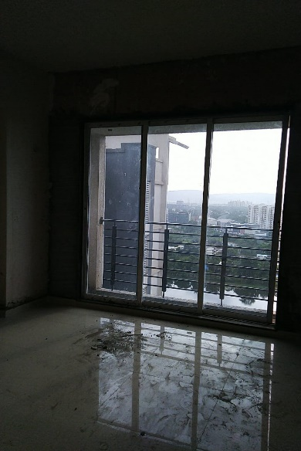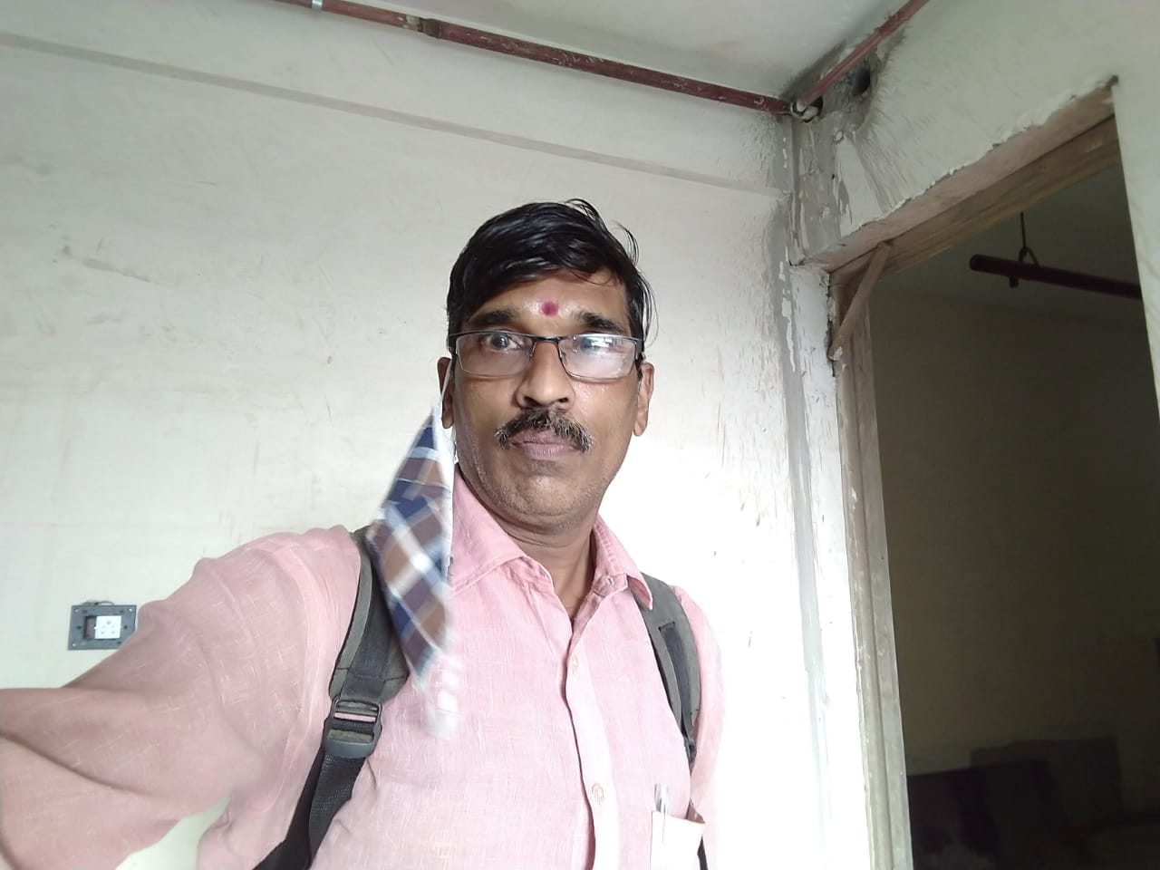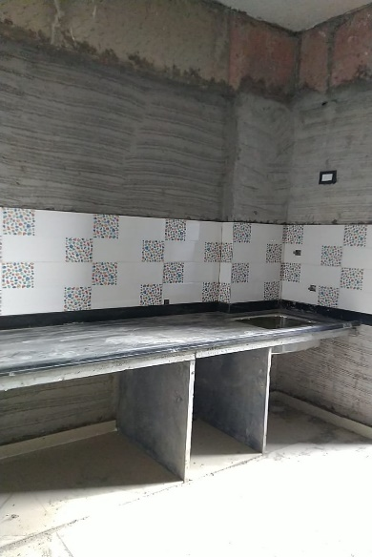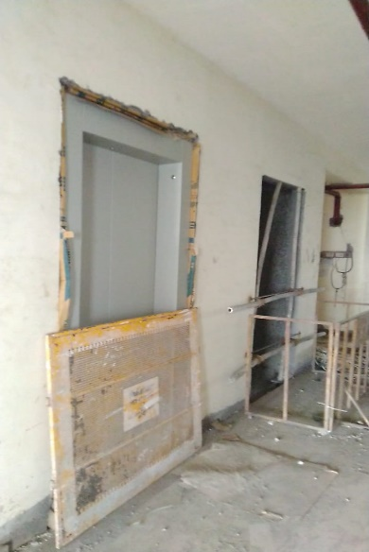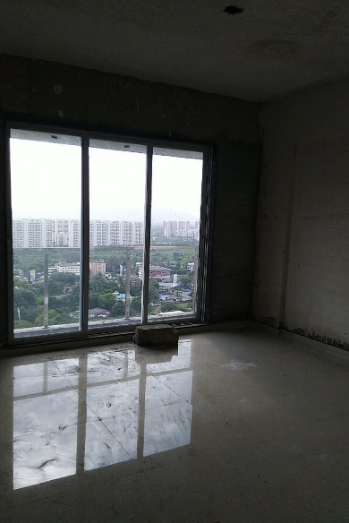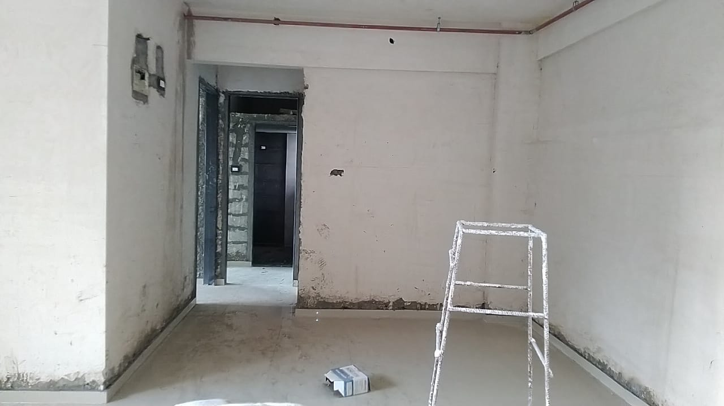

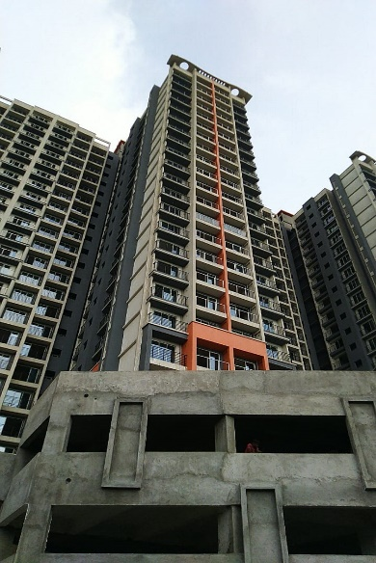

**Route Map of the property**

**Site u/r**

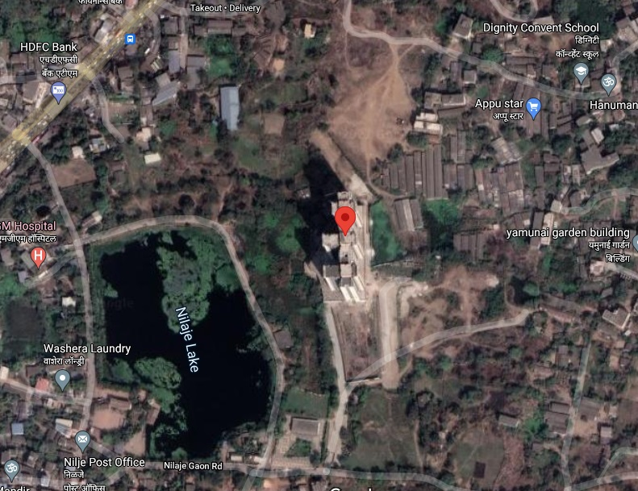

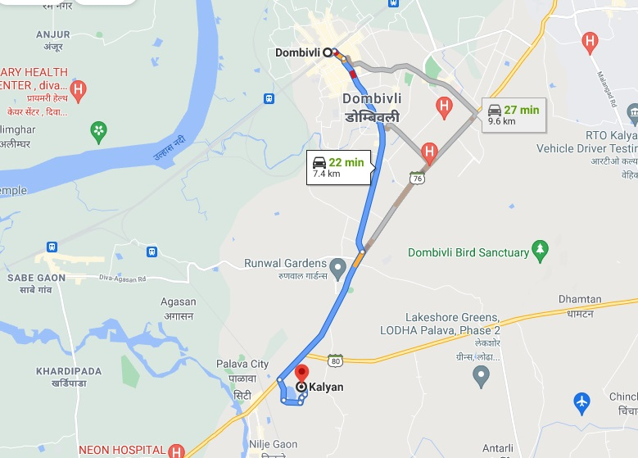

# Latitude Longitude: 19°10'02.0"N 73°04'57.2"E

**Note**: The Blue line shows the route to site from nearest railway station (Dombivali –7.4Km)

**Ready Reckoner**

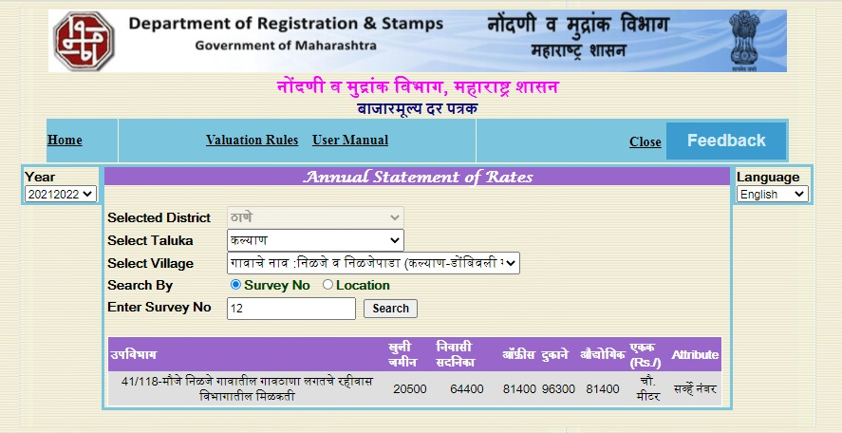

**Sale Instance**

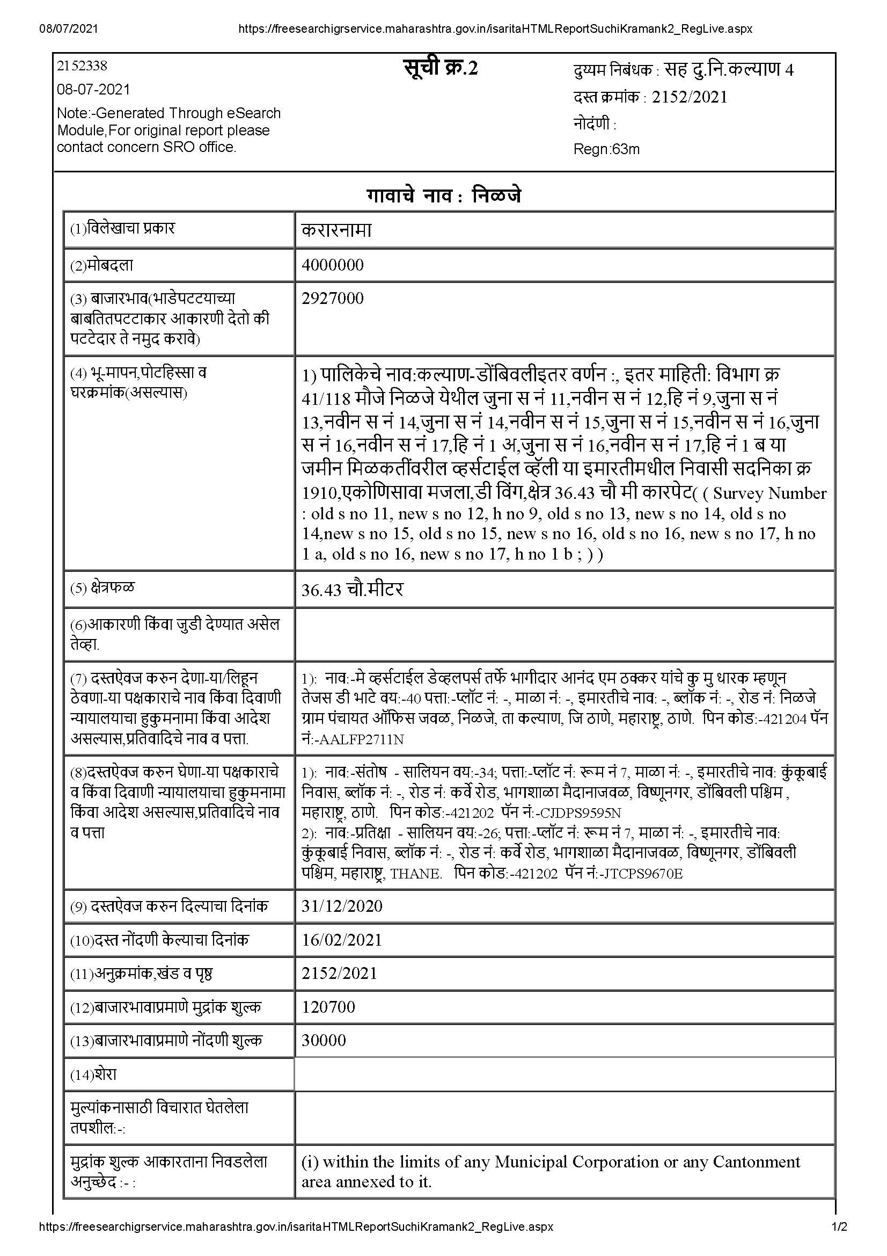

**Price Indicator**

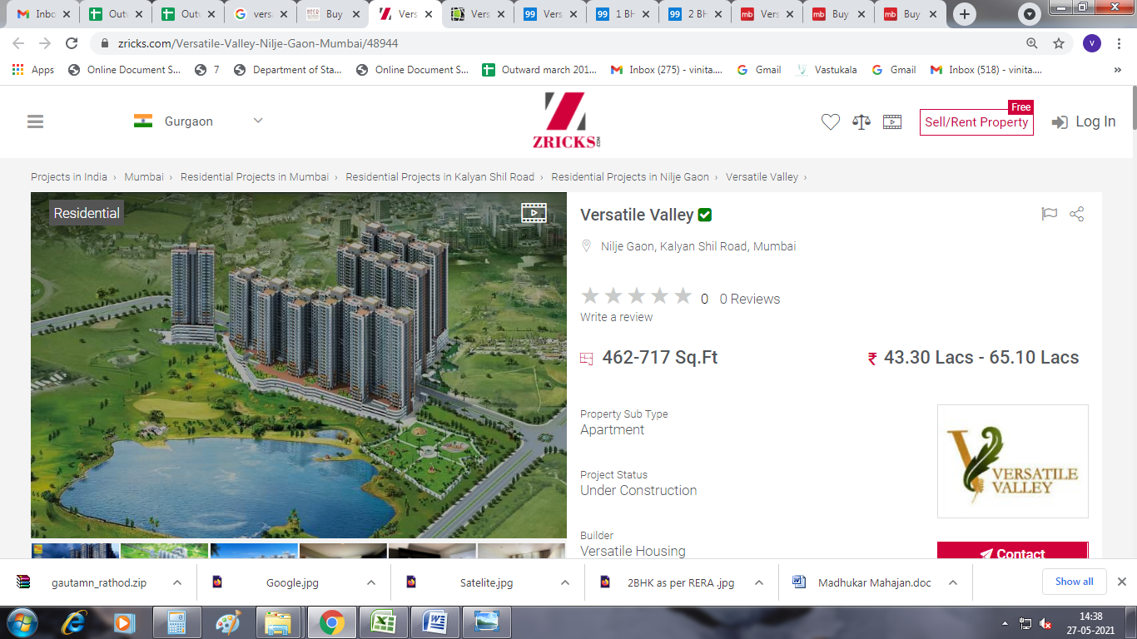

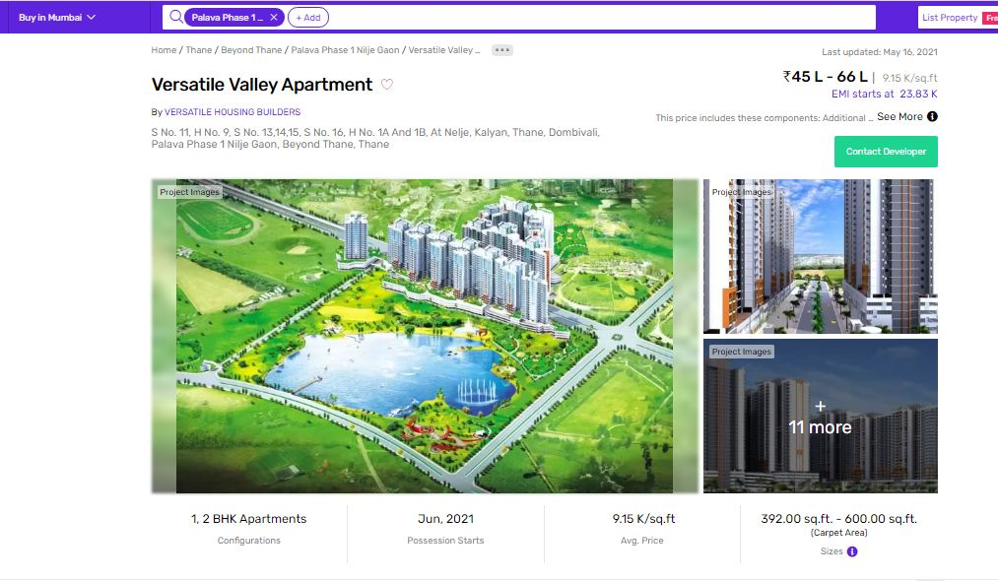

**DEFINITION OF VALUE FOR THIS SPECIFIC PURPOSE**

This exercise is to assess **Fair Market Value** of the property under reference for **Bank Loan** purpose as on date**08th July 2021**

The term Fair Market Value is defined as

*"The most probable price, as of a specified date, in cash, terms equivalent to cash, or in other precisely revealed terms for which the specified property rights would sell after reasonable exposure in a competitive market under all conditions requisite to a fair sale, with the buyer and seller each acting prudently knowledgeably and for self-interest assuming that neither is under undue duress"*

Fundamental assumptions and conditions presumed in this definition are:

1. Buyer and seller are motivated by self-interest.
2. Buyer and seller are well informed and are acting prudently.
3. The property is exposed for a reasonable time on the open market.
4. Payment is made in cash or equivalent or in specified financing terms.

**UNDER LYING ASSUMPTIONS**

1. We assume no responsibility for matters of legal nature affecting the property appraised or the title thereto, nor do we render our opinion as to the title, which is assumed to be good and marketable
2. The property is valued as though under responsible ownership.
3. It is assumed that the property is free of liens and encumbrances.
4. It is assumed that there are no hidden or unapparent conditions of the subsoil or structure that would render it more or less valuable. No responsibility is assumed for such conditions or for engineering that might be required to discover such factors.

**DECLARATION OF PROFESSIONAL FEES CHARGED**

We hereby declare that, our professional fees are not contingent upon the valuation findings. However, if the statute AND/OR clients demands that, the fees should be charged on the percentage of assessed value then, with the full knowledge of the AND/OR end user, it is being charged accordingly.

**VALUATION OF THE PROPERTY PREMISES**

Considering various parameters recorded herein above, existing economic scenario, and the information that is available with reference to the development of neighbourhood and method selected for valuation, we are of the opinion that, the property premises can be assessed and valued for Banking Purpose as on day for is at**`63,00,000.00(Rupees Sixty Three Lakh Thousand Only).** As per site inspection 76% of construction work is completed.

**Sharadkumar B. Chalikwar**

Govt. Reg. Valuer

Chartered Engineer (India)

Reg. No. (N) CCIT/1-14/52/2008-09