Vastu/Nashik/07/2024/0010273/2307520
31/16-524-RYBS
Date: 31.07.2024

To,
The Branch Manager,
Bank of Baroda
Regional Office
BSNL Building, Datta Mandir Road, Nashik Road,
Nashik, PIN – 422 101, State - Maharashtra, Country - India.

Sub: Vetting of Extra Amenities Agreement

Sir,

With reference to above subject, we have evaluated the Extra Amenities For Residential Flat No. 608, Sixth Floor, Building No. 01 " Rachit Kalpavriksha", Survey No. 806/ 2A/ 9+806/ 2B+ 806/ 4/ 2, Plot No. 7+8, Behind Chhan Hotel, Deepali Nagar, Mumbai - Agra Road, Village - Nashik, Taluka & District - Nashik, PIN Code – 422 009, State - Maharashtra, Country - lndia. belongs to Name of Owner: Shri. Sushant Laxmanrao Patil & Sau. Arati Sushant Patil.

We have verified the rates quoted as per current market rates. Details of work and Extra Amenities considered as per copy of Agreement for Extra Amenities Agreement between Shri. Sushant Laxmanrao Patil & Sau. Arati Sushant Patil. (First Party) and Shri. Dhiraj Bholnath Bagde. (Second Party) received on dated 30.07.2024. The Extra Amenities amount is Rs.8,50,000/- (Rupees Eight Lakh Fifty Thousand Only).

The said Cost Vetting Certificate is valid upto next 6 months Only.

Thanking you

Sincerely yours

Manoj B. Chalikwar
Registered Valuer
Chartered Engineer (India)
Reg. No. CAT-I-F-1763
Reg. No. IBBI/RV/07/2018/10366
BOB Empanelment No.: ZO:MZ:ADV:46:941
Encl: Valuation report.

Extra Amenities Agreement
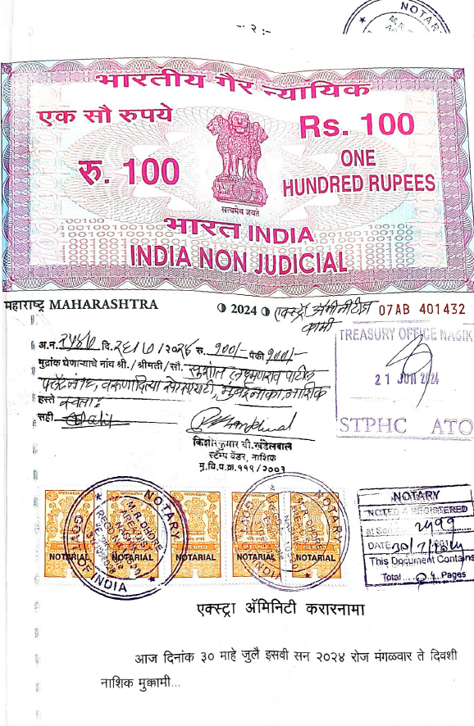
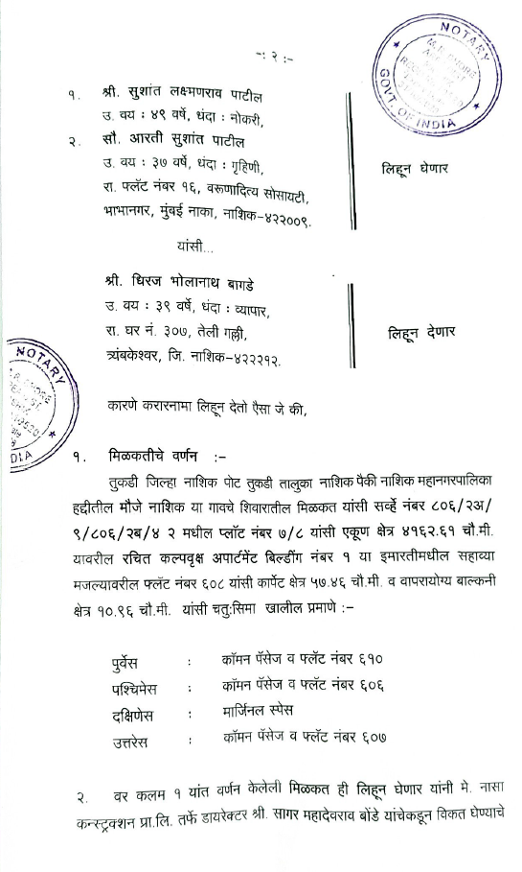

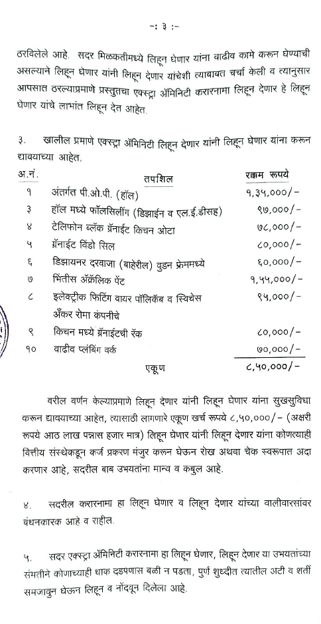
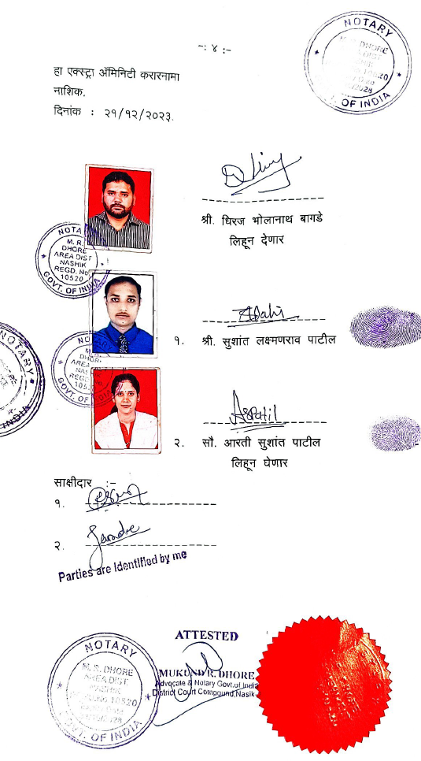

The Extra Amenities amount is Rs.8,50,000/- (Rupees Eight Lakh Fifty Thousand Only)

