Vastu/Nashik/03/2023833/30490/46262
22/24-455-RPBS
Date: 30.07.2024

To, `
The Branch Manager,
State Bank of India
Abhona Branch-05459
Nanduri Road, Abhona, Taluka - Kalwan,
District – Nashik – 423 501, State – Maharashtra,
Country – India
Sub: Vetting of Estimate

Sir,

With reference to above subject, we have evaluated the Estimate for Residential Land and Proposed Bungalow on Plot No.21 ,Gat No.123 Part, Near Arts Collage Abhona ,Abhona to Borgaon Road, Mouje - Abhona , Pin Code – 423 502 Taluka- Kalwan & District – Nashik, State – Maharashtra, Country – India belongs to Shri.Namdev Mohan Thakare.

We have verified the rates quoted as per current market rates. Details of work considered as per copy of Estimate issued by Sankalp Planners received on dated 30.07.2024. The Vetting of Estimate amount is Rs.49,00,000/- ( Rupees Forty Nine Lakh Only. )

The said Cost Vetting Certificate is valid upto next 6 months Only.

Thanking you

Sincerely yours

Sharadkumar B. Chalikwar
Govt. Reg. Valuer
Chartered Engineer (India)
Reg. No. (N) CCIT/1-14/52/2008-010
SBI Empanelment No.: SME/TCC/2021-22/85/13
Encl: Valuation report.

Vetting of Estimate

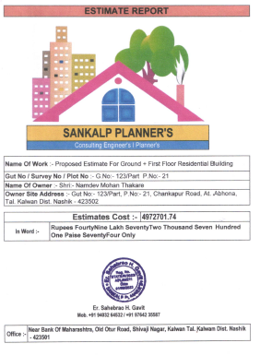
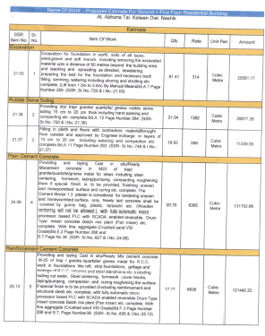

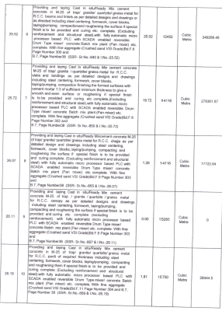
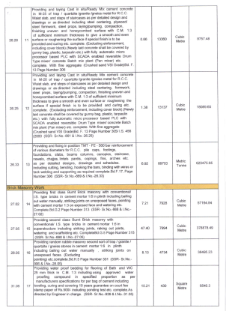

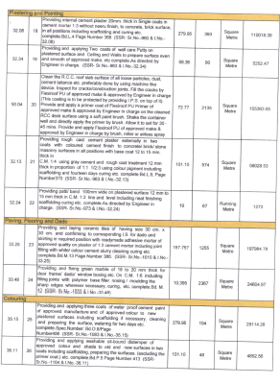
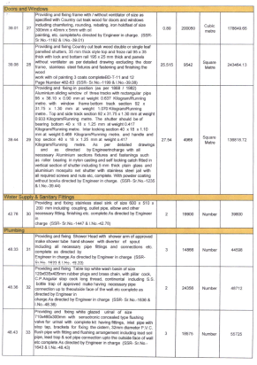

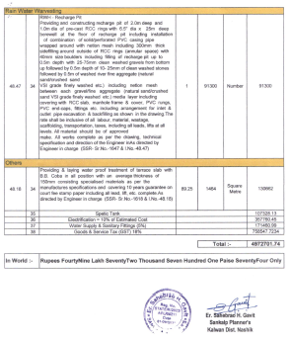

Rs.49,00,000/- ( Rupees Forty Nine Lakh Only. )

