WORK PROGRESS REPORT

Details of the property under consideration:

Name of Owner: M/s. Matrukrupa Stone Crusher LLP

Industrial Land bearing New Gat No. 83/4/A & 83/4/B (Old Gat No. 83/4), Near Indian Oil Petrol Pump, Village - Pandhurli, Taluka – Sinnar, District – Nashik, State – Maharashtra, Country - India

Latitude Longitude: 19°50'03.8"N 73°53'12.5"E

Valuation Done for:
Bank of India
Zonal Office, Nashik
1st Floor, Plot No G-1, MIDC, Satpur Colony, Main Trimbaak Road,
Nashik – 422007, State – Maharashtra, Country - India

Vastu/BOI/Nashik/07/2024/10228/2307477
29/22-481-PY
Date: 29.07.2024

Work Progress Report

The property bearing Industrial Land bearing New Gat No. 83/4/A & 83/4/B (Old Gat No. 83/4), Near Indian Oil Petrol Pump, Village - Pandhurli, Taluka – Sinnar, District – Nashik, State – Maharashtra, Country - India belongs to M/s. Matrukrupa Stone Crusher LLP.

Boundaries of the property.
North | Farm
South | Farm
East | Farm
West | Farm

The project proposed is under construction, which is considered for project approval. As per Cost Vetting Report Ref. No. Vastu/Nashik/05/2024/8536/2306223, 08/04-83-PY Dated 04.05.2024, Estimate Total Cost of Construction of Building was ` 79,44,925.00 and the work completion stage of following items described in cost vetting report is as follows:
Sr. No. | Particulars | Estimate Amount as per Cost Vetting Report | Actual Percentage work completed as on 26.07.2024 | Actual Amount to be incurred as on 26.07.2024 | Remark
1 | RCC Construction of Staff Quarters followed by brickwork, plastering, windows and doors | 23,36,400.00 | 80.00% | 18,69,120.00 | RCC slab, brickwork & plaster work is completed.  Windows & Doors work is Pending.
2 | RCC Construction of Office Room followed by brickwork, plastering, windows and doors | 3,76,420.00 | 80.00% | 3,01,136.00 | RCC slab, brickwork & plaster work is completed.  Windows & Doors work is Pending.
3 | Plinth levelling and Backfilling | 25,48,800.00 | 100.00% | 25,48,800.00 | Work Completed.
4 | Retaining Wall | 14,11,575.00 | 100.00% | 14,11,575.00 | Work Completed.
5 | RCC Construction of Electrical Room followed by brickwork, plastering, windows and doors | 5,31,000.00 | 80.00% | 4,24,800.00 | RCC slab, brickwork & plaster work is completed.  Windows & Doors work is Pending.
6 | RCC Construction of Toilet Blocks followed by brickwork, plastering, windows and doors, Tiling work upto 9 ft. | 3,77,600.00 | 70.00% | 2,64,320.00 | RCC slab, brickwork & plaster work is completed.  Flooring, Windows & Doors work is Pending.
7 | Attached Toilets | 89,680.00 | 0.00% | 0.00 | Work not started yet
8 | Solar Panel | 1,29,800.00 | 0.00% | 0.00 | Work not started yet
9 | Electrical Work | 1,43,650.00 | 0.00% | 0.00 | Work not started yet
Total |  | 79,44,925.00 |  | 68,19,751.00

As per site inspection dated 26.07.2024 cost of construction must incur will be ` 68,19,751.00

The report of the property is based on the site visit dated 26.07.2024 & documents produced by the concern. Construction work going as per approved plan only. Legal aspects have not been taken into considerations while preparing this report.

Hence certified

For Vastukala Consultants (I) Pvt. Ltd.

Manoj B. Chalikwar
Registered Valuer
Chartered Engineer (India)
Reg. No. IBBI / RV / 07/2018/10366
Reg. No. CAT-I-F-1763
BOI Empanelment No.: MNZ:C&IC:VAL19-20
Actual Site Photographs
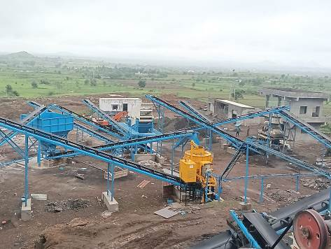
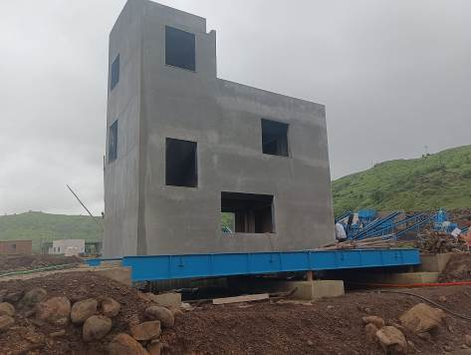

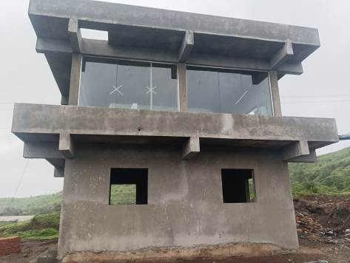

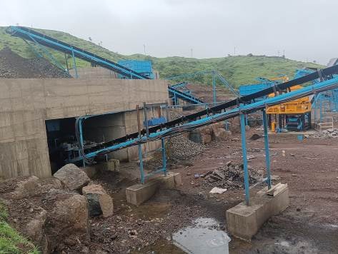

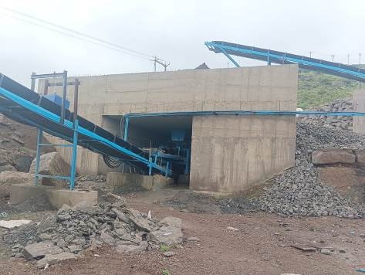

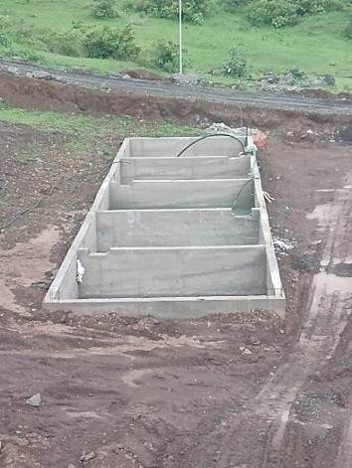
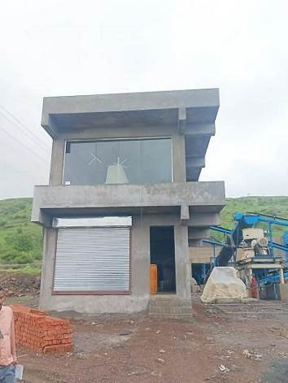
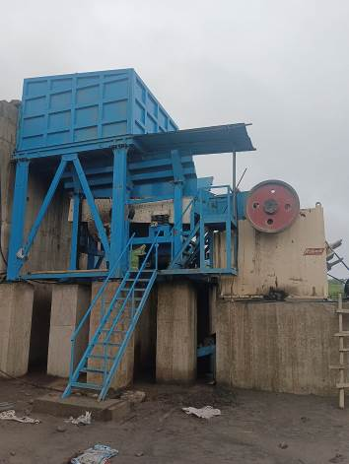

Route Map of the property

Site u/r

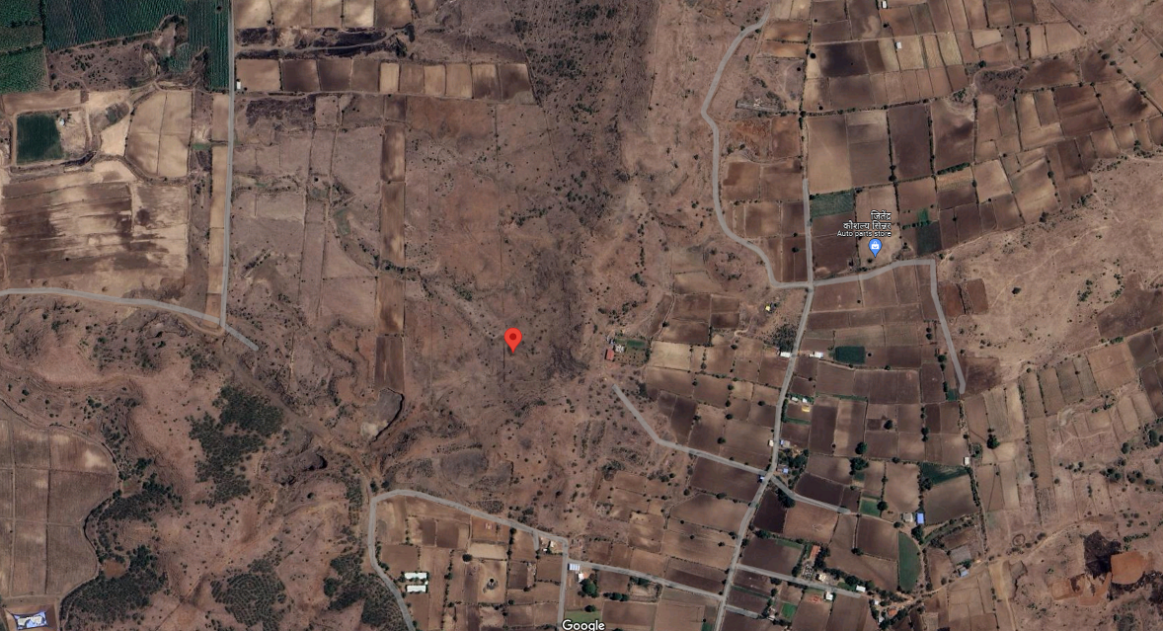

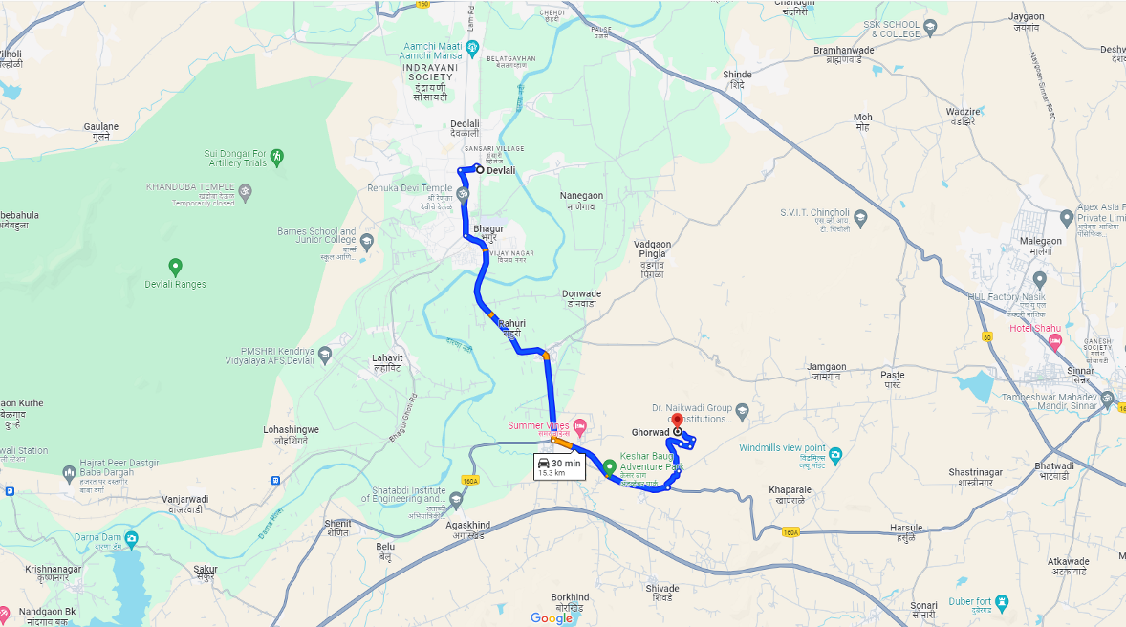

Latitude Longitude: 19°50'03.8"N 73°53'12.5"E

Note: The Blue line shows the route to site from nearest railway station (Deolali – 15.3 Km.)

