Vastu/Nashik/03/2023833/30490/46262
22/24-455-RPBS
Date: 26.07.2024

To, `
The Branch Manager,
Bank of Baroda
Hingoli Branch
Indira Chowk, Nr Kandi Hospital Hingoli, PIN – 431513
State - Maharashtra, Country - India

Sub: Vetting of Estimate

Sir,

With reference to above subject, we have evaluated the Extra Amenities for Residential Row House No. 7, Ground Floor + First Floor, “Shree Mangal Murty Row-Houses”, Survey No. 908/ 2/ 1/ 30, Plot No. 30 + 31, Near Police Headquarter Ground, Mauli Nagari, Dnyaneshwar Nagar, Pathardi Phata, Village – Nashik, Taluka & District - Nashik, PIN Code – 422 010, State – Maharashtra, Country – India belongs to Shri. Sandip Gajanan Shukla & Sau. Shweta Sandip Shukla. Name of Proposed Purchaser: Sau. Swati Gautam Khadase.

We have verified the rates quoted as per current market rates. Details of work considered as per copy of Estimate issued by Mrs. Swati Gautam Khadase (First Party) and Er. Tushar H. Sonawane (Second Party) received on dated 26.07.2024. The Vetting of Estimate amount is Rs.5,50,000/- ( Rupees Five Lakh Fifty Thousand Only. )

The said Cost Vetting Certificate is valid upto next 6 months Only.

Thanking you

Sincerely yours

Manoj B. Chalikwar
Registered Valuer
Chartered Engineer (India)
Reg. No. CAT-I-F-1763
Reg. No. IBBI/RV/07/2018/10366
BOB Empanelment No.: ZO:MZ:ADV:46:941
Encl: Valuation report.

Vetting of Estimate
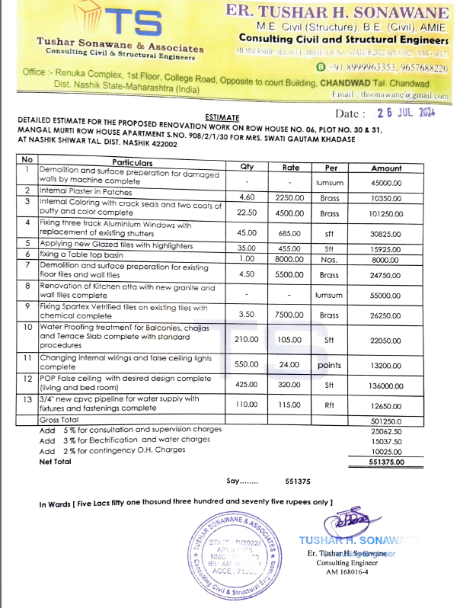

The Extra Amenities amount is Rs.5,50,000/- ( Rupees Five Lakh Fifty Thousand Only. )

