5th LENDER’S INDEPENDENT ENGINEER REPORT

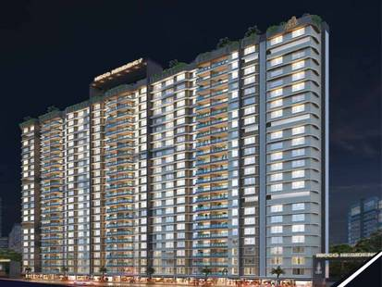

**Details of the property under consideration:**

**Name of Project: NICCO Residency**

**"NICCO Residency", Proposed S. R. Scheme Residential building on Plot bearing C.T.S. No. 190 A/6/2(pt), Poonam Nagar, MMRDA Colony, JVLR Road, Village – Majas – III, Jogeshwari (East), Mumbai – 400 093, State – Maharashtra, Country – India**

**Latitude Longitude: 19°08'19.0"N 72°52'15.7"E**

Intended User:

State Bank of India

SME Chembur Branch

Unit No. 11, Building No. 11, Ground Floor, Corporate Park, Sion Trombay Road,

Chembur, Mumbai, Pin Code – 400 071, State - Maharashtra, Country – India

Vastu/SBI/Mumbai/07/2024/10178/2306358

17/14-218-PY

Date: - 26.07.2024

FIFTTH LENDER’S INDEPENDENT ENGINEER REPORT

**To,**

**State Bank of India**

SME Chembur Branch

Unit No. 11, Building No. 11,

Ground Floor, Corporate Park,

Sion Trombay Road, Chembur,

Mumbai, Pin Code – 400 071,

State - Maharashtra, Country – India

Subject: Construction of Proposed S. R. Scheme Residential building on Plot bearing C.T.S. No. 190 A/6/2(pt), Poonam Nagar, MMRDA Colony, JVLR Road, Village – Majas – III, Jogeshwari (East), Mumbai – 400 093, State – Maharashtra, Country – India.

**Ref:** You’re Request for Lender’s Independent Engineer Report of under Construction Building.

**Dear Sir,**

**The Construction work as per approved plan was in progress during the site visit on 09th July 2024.**

**Status of work:**

**For Rehab Building No. 1:** Plinth work is completed.

**For Amenity Building No. 2:** Building work is completed.

**For Sales Building No. 3 (Wing A, B & C):** Till 11th Floor Slab work is completed, Ground to 7th Floor blockwork is completed, Ground to 6th Floor plaster work & waterproofing is completed, Ground & 1st floor gypsum work, firefighting, kitchen platform, kitchen tiling, flooring, door and window frames, internal painting, electrical & plumbing conducting work is completed and 2nd to 5th floor gypsum work & door and window frame is completed, 6th floor gypsum work is in progress.

**NOTE:**

* **Amended building approval drawings for sale building no. 3 was submitted to us and has building permission are as below:**
* **Wing A & B: Basement (Part) + Ground Floor (Part) + Stlit Floor (Part) + 1st & 2nd (Part) Podium Floor + 3rd & 4th (Part) E – deck Floor + 4th (Part) to 21st (Part) Upper Residential Floor**
* **Wing C: Basement (Part) + Ground Floor (Part) + Stlit Floor (Part) + 1st & 2nd (Part) Podium Floor + 3rd & 4th (Part) E – deck Floor + 4th (Park) to 20th Upper Residential Floor**
* **As bank has sanctioned the loan upto 3rd floor of amenity building no. 2, 23rd floor of rehab building no. 1 & upto 19th floor of sale building no. 3 (Wing A to C).**
* **Hence for the LIE Report we have considered as following for Plinth Calculation.**
* **Rehab Building No. 1 – Ground Floor + 1st to 23rd Upper Residential Floors**
* **Amenity Building No. 2 – Ground Floor + 1st to 3rd Upper Residential Floors**
* **Sale Building No. 3 (Wing A to C) – Basement (Part) + Ground Floor (Part) + Stilt Floor (Part) + 1st & 2nd (Part) Podium Floor + 3rd & 4th (Part) E – deck Floor + 4th (Part) to 19th (Part) Upper Residential Floor**

**Total expenditure occurred as on 30/06/2024 on this project by M/s. Neelkamal Realty & Construction LLP is ` 117.95 Cr. & as per CA Certificate actual total expenditure occurred as on 30/06/2024 is ` 116.63 Cr. Hence, release of Balance Amount as requested by M/s. Neelkamal Realty & Construction LLP is hereby recommended.**

**DECLARATION**

1. The information furnished in the report is based on our 5th site visit Dated 09/07/2024 & Document Provided by Client.
2. Vastukala 4th LIE Report of the project dated 17/05/2023.
3. I have no direct and indirect interest in the property examined for report.
4. I have not been found guilty of misconduct in my professional capacity.

**Manoj B. Chalikwar**

Registered Valuer

Chartered Engineer (India)

Reg. No. IBBI/RV/07/2018/10366

Encl.: LIE report

# Purpose & Methodology

• State Bank of India Banks and financial institutions require monitoring & an independent review of the progress of the sanctioned projects

**VCIPL** undertakes such study to independently review the progress of the project and put forward a comprehensive analysis

# Advantages:

* Assurance on present practices
* Identification of risk
* Analyzing the performance of third parties
* Recommendations

# The Methodology

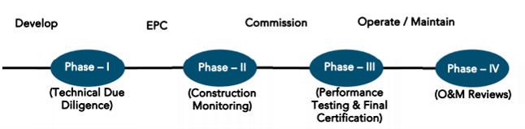

**FIFTH LENDER’S INDEPENDENT ENGINEER REPORT**

**OF**

**"NICCO RESIDENCY"**

**"NICCO Residency",** Proposed S. R. Scheme Residential building on Plot bearing C.T.S. No. 190 A/6/2(pt), Poonam Nagar, MMRDA Colony, JVLR Road, Village – Majas – III, Jogeshwari (East), Mumbai – 400 093,

State – Maharashtra, Country – India

**Latitude Longitude: 19°08'19.0"N 72°52'15.7"E**

**NAME OF DEVELOPER: M/s. Neelkamal Realty & Construction LLP**

|  |
| --- |
| Pursuant to instructions from State of India, SME Chembur Branch, Mumbai we have duly visited, inspected, surveyed & assessed the above said property on **09th July 2024** to determine the fair & reasonable market value of the said property/project as on Quarter ending **30th June 2024** for LIE purpose.  **1. Location Details:**  Proposed S. R. Scheme Residential building on Plot bearing C.T.S. No. 190 A/6/2(pt), Poonam Nagar, MMRDA Colony, JVLR Road, Village – Majas – III, Jogeshwari (East), Mumbai – 400 093. It is about 2.10 Km. travelling distance from Jogeshwari (East) Railway station. Surface transport to the property is by buses, taxis & private vehicles. The property is in developed locality. All the amenities like shops, banks, hotels, markets, schools, hospitals, etc. are all available in the surrounding locality. The area is higher middle class & developed. |

**2. Developer Details:**

|  |  |
| --- | --- |
| **Name of builder** | **M/s. Neelkamal Realty & Construction LLP** |
| **Project Rera Registration Number** | **P51800045221** |
| **Registered office address** | Office at 201-A, Vertex Vikas, Sir M.V. Road, Andheri (East),  Mumbai – 400 069, State - Maharashtra, Country – India |
| **Contact details** | **Contact Person:**  Mrs. Mona Mehta (Consultant)  Mobile No. 7977952834 |
| **E – mail ID and website** |  |

**3. Boundaries of the Property:**

|  |  |
| --- | --- |
| **Direction** | **Particulars** |
| **On or towards North** | Open Plot/R G Reservation |
| **On or towards South** | 18.30 D P Road |
| **On or towards East** | 9.0 M. D P Road |
| **On or towards West** | CTS No. 185 |

# Introduction

**As per Information on site M/s. Neelkamal Realty & Construction LLP** has acquired land by conveyance Agreement dated 21.12.2018 through registered agreement vide No. BDR-18-13205-2018 dated 24.12.2018 admeasuring **area is 5,669.67 Sq. M.** bearing **CTS No. 190/A/6/2 (Part).** For the Proposed Residential Building.

# Area Statement:

# Land:

|  |  |  |
| --- | --- | --- |
| **Date** | **Particular** | **Area in Sq. M.** |
| 21.12.2018 | CTS No. 190/A/6/2 | 5,669.67 |
| TOTAL | | 5,669.67 |

1. Copy of Development Agreement dated 21.12.2018 between M/s. Advaita Estate & Development Private Limited (The Vendor) and M/s. Neelkamal Realty & Construction LLP (The Purchasers) through registered agreement vide No. BDR-18-13205-2018 dated 24.12.2018.
2. Copy of Rectification Deed dated 22.07.2019 between M/s. Advaita Estate & Development Private Limited (The Vendor) and M/s. Neelkamal Realty & Construction LLP (The Purchasers) through registered agreement vide No. BDR-18-9088-2019 dated 08.08.2019.
3. Copy of Confirmation Deed dated 03.04.2019 between M/s. Advaita Estate & Development Private Limited (The Vendor) and M/s. Neelkamal Realty & Construction LLP (The Purchasers) through registered agreement vide No. BDR-18-3868-2019 dated 05.04.2019.
4. Copy of Indenture Agreement dated 26.05.1998 between M/s. Madhu Fantasy Land Pvt. Ltd. (The Vendor) and M/s. Advaita Estate & Development Private Limited (The Purchasers)

# Building Area:

# As per Approved Plan:

| (I) | AREA STATEMENT | | | | SLUM | NON - SLUM | TOTAL IN SQ. M. |
| --- | --- | --- | --- | --- | --- | --- | --- |
| 1 | Gross Area Of Plot | | | | 2,200.00 | 3,469.67 | 5,669.67 |
| a) | Area Of Rehabilitation And Resettlement | | | |  | 3,469.67 | 3,469.67 |
| 2 | Deduction For | | | |  |  |  |
| A) | For Reservation / Road Area | | | |  |  |  |
| a) | Proposed Rehabilitation And Resettlement (Rr 2.1) (3469.67 X 40% = 138.87 | | | |  | 1,387.87 | 1,387.87 |
| B) | For Amenity Area | | | |  |  |  |
| a) | Area Of Amenity Plot/Plot To Be Handed Over As Per Dcr 14(A) | | | |  |  |  |
| b) | Area Of Amenity Plot/Plot To Be Handed Over As Per Dcr 14(B) | | | |  |  |  |
| c) | Area Of Amenity Plot/Plot To Be Handed Over As Per Dcr 15 | | | |  |  |  |
| d) | Area Of Amenity Plot/Plot To Be Handed Over As Per Dcr 32 | | | |  |  |  |
| c) | Deduction For Existing Built-Up Area To Be Retained If Any | | | |  |  |  |
| a) | Land Component Of Existing Bus As Per Regulation Under Which The Development | | | |  |  |  |
| 3 | Total Deduction [2(A) + 2 (B) + 2 (C)] | | | |  | 1,387.87 | 1,387.87 |
| 4 | Balance Area Of Plot (1 Minus 3) | | | | 2,200.00 | 2,081.80 | 4,281.80 |
| 4(i) | Addition For | | | |  |  |  |
| A) | For Reservation /Road | | | |  |  |  |
| b) | Proposed Rehabilitation And Resettlement (Rr 2.1) (3469.67 X 40% = 138.87 | | | |  | 1,387.87 | 1,387.87 |
| 5 | Plot Area Under Development (As Per Sr. No. 4 Above) | | | | 2,200.00 | 3,469.67 | 5,669.67 |
| 6 | Zonal (Basic) Fsi (1 Or 1.33) | | | | 4.00 OR MORE | 1.00 |  |
| 7 | Permissible Built-Up Area As Per Zonal (Basic) Fsi (5*6) (In Case Of Mill Land Permissible Built-Up Area Kept In Abeyance) | | | |  | 3,469.67 | 3,469.67 |
| 8 | Built Up Area Equal To Area Of Land Handed Over As Per 3(A) Of Regulation 30 (A) | | | |  |  |  |
| 9 | Built Up Area In Lieu Of Cost Of Construction Of Built-Up Amenity To Be Handed Over | | | |  |  |  |
| 10 | Built Up Area Due To Additional Fsi On Payment Of Premium As Per Table No. 12 Of Regulation No. 30(A) 3 | | | |  | 1,734.84 | 1,734.84 |
| 11 | Built Up Area Due To Admissible Tdr As Per Table No. 12 Of | | | |  |  |  |
|  | Regulation No. 30 (A) Subject To Regulation No. 30 (A) 3  (DRC No. – Road/0072/2023 (road), dated- 27/12/2023, area = 69.66 Sq. M.)  (DRC No. – Res/0040/2024 (Amenity Open Space), dated- 05/02/2024, area = 175.79 Sq. M.)  (DRC No. – Road/0073/2024 (road), dated- 05/02/2024, area = 435.57 Sq. M.)  (DRC No. – Res/0042/2024 (Reservation), dated- 07/03/2024, area = 900.52 Sq. M.) | | | |  | 1581.54 | 1581.54 |
| 11a | Regulation No. 30(A) subject to regulation No. 30(A)3 | | | |  |  |  |
| 12 | Permissible Built-Up Area (7 + 8 + 9 + 10 + 11) | | | |  | 6,786.05 | 6,786.05 |
| 13 | Proposed Built Up Area | | | |  |  |  |
|  | Bldgs | Amenity | Rehab | Sale |  |  |  |
|  | Rehab Bldg. No. 1 |  | 4876.3 | 548.76 |  |  |  |
|  | Amenity Bldg. No. 2 | 1734.36 |  |  |  |  |  |
|  | Sale Bldg No. 3 | |  | 15943.15 |  |  |  |
| 14 | Total Rehab Bua | | 4876.3 |  | 4,876.30 |  | 4,876.30 |
| 15 | Total Rehab Component Area | | | | 8,317.99 |  | 8,317.99 |
| 16 | Incentive Sale Area (15 X 1.00) | | | | 8,317.99 |  | 8,317.99 |
| 17 | Sale Area Permissible On Non-Slum Plot | | | |  | 6786.05 | 6786.05 |
| 18 | Total Area Permissible | | | | 13,194.29 | 6786.05 | 19980.34 |
| 19 | Sanctioned Fsi | | | | 6.00 | 1.96 |  |
| 20 a | Sale Bua Permissible | | | | 8,317.99 | 6786.05 | 15104.04 |
| 20 b | Built Up Area Equal To Area Of Land Handed Over As Per (Regulation No. 17) | | | |  | 1,387.87 | 1,387.87 |
| 20 c | Total Sale Bua Permissible | | | | 8,317.99 | 8173.92 | 16491.91 |
| 20 | Total Sale Bua Proposed | | | | 8,317.99 | 8173.92 | 16491.91 |
| 21 | Total Proposed Bua (Rehab + Sale) (14 + 20) | | | | 13,194.29 | 8173.92 | 21368.21 |
| 22 | Tdr Generated If Any As Per Regulation 30 (A) (3469.67 X 50% = 1734.84 [(1743.36 X 30,250) / 65,040] X 1.50 + 1216.25 Sq. M. | | | |  | 1,216.25 | 1,216.25 |
| 23 | Fungible Compensatory Area As Per Regulation No. 31 (3) | | | |  |  |  |
| a) | i) Permissible Fungible Compensatory Area For Rehab Component Without Charging Premium | | | |  |  | 1,706.70 |
|  | ii) Fungible Compensatory Area Availed For Rehab Component Without Charging Premium | | | |  |  | 95.28 |
| b) | i)Basic Sale Commercial Bua | | | |  |  | 735.14 |
|  | ii)Basic Sale Residential Bua | | | |  |  | 15756.77 |
| c) | i) Permissible Commercial Fungible Compensatory By Charging Premium | | | |  |  | 257.30 |
|  | ii) Proposed Sale Commercial Fungible Compensatory Area Already Paid Wide Receipt No. 53535 Dated 13/08/2021 | | | |  |  | 227.50 |
| d) | i) Permissible Commercial Fungible Compensatory By Charging Premium | | | |  |  | 5514.87 |
|  | ii) Proposed Sale Commercial Fungible Compensatory Area Already Paid Wide Receipt No. 53535 Dated 13/08/2021 | | | |  |  | 4,987.17 |
|  | iii) Proposed Sale residential fungible compensatory area already paid wide receipt no. 783219 Dated 03/06/2024 | | | |  |  | 492.82 |
| e) | Total Proposed Sale Commercial And Residential Fungible Area 23 (C) ii + 23 (D)ii) | | | |  |  | 5707.49 |
| f) | Total Proposed Sale Commercial And Residential Fungible Area 23 (B)(F) Ii + 23 (E) | | | |  |  | 22199.40 |
| 25 | Fsi Consumed On Net Plot [21/4] | | | | 6.00 | 2.36 |  |
| II | Others Requirements | | | |  |  |  |
| A) | Reservation / Designments | | | |  |  |  |
| a) | Name Of Reservation | | | |  |  |  |
| b) | Area Of Reservation Affecting The Plot | | | |  |  |  |
|  | Area Of Reservation Land To Be Handed/Handed Over As Per Regulation No. 17 | | | |  | 1,387.87 | 1,387.87 |
| B) | Plot Area/Built Up To Amenity To Be Handed Over As Per Regulation | | | |  |  |  |
|  | I) 14 (A) | | | |  |  |  |
|  | Ii) 14 (B) | | | |  |  |  |
|  | Iii) 15 | | | |  |  |  |
| C | Requirements Of Recreational Open Space In Layout / Plot As Per Regulation No. 27 | | | |  |  |  |
| D) | Tenement Statement | | | |  |  |  |
|  | I) Proposed Built Up Area (13 Above) | | | | REFFER ABOVE STATEMENTS | | |
|  | Ii) Less Deduction Of Non - Residential Area (Shop Etc) | | | |
|  | Iii) Aera Available For Tenements [(I) Minimum (Ii)] | | | |
|  | Iv) Tenements Permissible Of Tenements Proposed On The Plot | | | |
|  | V) Total Number Of Tenements Proposed On The Plot | | | |
| e) | Parking Statements | | | |
|  | I) Parking Required By Regulation For | | | |  | | |
|  | Car | | | | REFFER ABOVE STATEMENTS | | |
|  | Scooter/Motor Cycle | | | |
|  | Ii) Covered Garbage Permissible | | | |
|  | Iii) Covered Garbage Proposed | | | |
|  | Car | | | |
|  | Scooter / Motor Cycle | | | |
|  | Outsider (Visitors) | | | |
|  | Iv)Total Parking Proposed | | | |
|  | Transport Vehicles Parking | | | |  | | |
|  | i) Spaces For Transport Vehicles Parking Required By Regulation | | | |
|  | ii) Total No. Of Transport Vehicles Parking Space Provided | | | |

# List of Approvals:

1. Copy of Letter of Intent (LOI) No. KE/PVT/0250/20201009/LOI dated 04.08.2021 issued by Slum Rehabilitation Authority (SRA).
2. Copy of Rehab Building No. 1 IOA Letter No. SRA/ENG/KE/PVT/0250/20201009/AP/R – 1 dated 18.08.2021 issued by Slum Rehabilitation Authority (SRA).
3. Copy of Amenity Building No. 2 IOA Letter No. SRA/ENG/KE/PVT/0250/20201009/AP/A – 2 dated 18.08.2021 issued by Slum Rehabilitation Authority (SRA).
4. Copy of Sale Building No. 3 IOA Letter No. SRA/ENG/KE/PVT/0250/20201009/AP/S/3 dated 18.08.2021 issued by Slum Rehabilitation Authority (SRA).
5. Copy of Rehab Building No. 1 Approved Plan No. KE/PVT/0250/2020/009/AP/R – 1 dated 30.09.2022 issued by Slum Rehabilitation Authority (SRA).

**Approved upto: Ground Floor + 1st to 23rd Upper Residential Floor**

1. Copy of Amenity Building No. 2 Approved Plan No. SRA/ENG/KE/PVT/0250/2020/009/AP/A – 2 dated 18.08.2021 issued by Slum Rehabilitation Authority (SRA).

**Approved upto: Ground Floor + 1st to 3rd Upper Residential Floor**

1. Copy of Sale Building No. 3 Approved Plan No. SRA/ENG/KE/PVT/0250/20201009/AP/S/3 dated 30.09.2022 issued by Slum Rehabilitation Authority (SRA).

**Approved upto (Wing A to C): Basement (Part) + Ground Floor (Part) + Stilt Floor (Part) + 1st & 2nd (Pt.) Podium Floor + 3rd & 4th (pt.) E – deck Floor + 4th (Pt.) to 19th (Pt.) Upper Residential Floor**

1. Copy of Sale Building No. 3 Amended Approved Plan No. KE/PVT/0250/20201009/AP/S/3 dated 24.06.2024 issued by Slum Rehabilitation Authority (SRA).

**Approved upto:**

**Wing A & B: Basement (Part) + Ground Floor (Part) + Stilt Floor (Part) + 1st & 2nd (Part) Podium Floor + 3rd & 4th (Part) E – deck Floor + 4th (Part) to 21st (Part) Upper Residential Floor**

**Wing C: Basement (Part) + Ground Floor (Part) + Stilt Floor (Part) + 1st & 2nd (Part) Podium Floor + 3rd & 4th (Part) E – deck Floor + 4th (Park) to 20th Upper Residential Floor**

1. Copy of Rehab Building No. 1 1st Commencement Certificate No. KE/PVT/0250/20201009/AP/R-1 dated 17.01.2023 issued by Slum Rehabilitation Authority (SRA).

**(This CC is endorsed for the work for Plinth Level by excluding portion of religious structure)**

1. Copy of Amenity Building No. 2 1st Commencement Certificate No. KE/PVT/0250/20201009/AP/A-2 dated 17.01.2023 issued by Slum Rehabilitation Authority (SRA).

**(This CC is endorsed for the work for Plinth Level)**

1. Copy of Amenity Building No. 2 2nd Commencement Certificate No. KE/PVT/0250/20201009/AP/A-2 dated 23.06.2023 issued by Slum Rehabilitation Authority (SRA).

**(This CC is endorsed for the work for Ground floor + 1st to 3rd Upper Floor & OHT & LMR)**

1. Copy of Sale Building No. 3 1st Commencement Certificate No. KE/PVT/0250/20201009/AP/S-3 dated 17.01.2023 issued by Slum Rehabilitation Authority (SRA).

**(This CC is endorsed for the work for Plinth Level)**

1. Copy of Sale Building No. 3 2nd Commencement Certificate No. KE/PVT/0250/20201009/AP/S-3 dated 17.01.2023 issued by Slum Rehabilitation Authority (SRA).

**(This CC is endorsed for the work for Ground Floor + 1st to 11th (Pt.) Upper Floors as per approved plans dated 30.09.2022)**

1. Copy of Sale Building No. 3 3rd Commencement Certificate No. KE/PVT/0250/20201009/AP/S-3 dated 24.06.2024 issued by Slum Rehabilitation Authority (SRA).

**(This CC is endorsed for the work for Ground Floor + 1st to 13th (Pt.) Upper Floors as per approved plans dated 24.06.2024)**

# LEVEL OF COMPLETION:

**For Rehab Building No. 1:** Plinth work is completed.

**For Amenity Building No. 2:** Building work is completed.

**For Sales Building No. 3 (Wing A, B & C):** Till 11th Floor Slab work is completed, Ground to 7th Floor blockwork is completed, Ground to 6th Floor plaster work & waterproofing is completed, Ground & 1st floor gypsum work, firefighting, kitchen platform, kitchen tiling, flooring, door and window frames, internal painting, electrical & plumbing conducting work is completed and 2nd to 5th floor gypsum work & door and window frame is completed, 6th floor gypsum work is in progress.

# Amenity Buidling No. 2

| Sr. No | Floor No. | Construction Area in Sq. M. | Completed Area in Sq. M. | Work Completion as on 09.07.2024 | Work Completion as on 4th LIE Report |
| --- | --- | --- | --- | --- | --- |
| 1 | Excavation & Shore Piling | | | Work is Completed | Work is Completed |
| 2 | Ground Floor | 476.44 | 476.44 | 100 % Work is completed | Building work is completed & site development work is in progress |
| 3 | 1st Floor | 508.48 | 508.48 | 100 % Work is completed | Building work is completed & site development work is in progress |
| 4 | 2nd Floor | 508.48 | 508.48 | 100 % Work is completed | Building work is completed & site development work is in progress |
| 5 | 3rd Floor | 508.48 | 508.48 | 100 % Work is completed | Building work is completed & site development work is in progress |
| 6 | Terrace Floor | 55.17 | 55.17 | 100 % Work is completed | Building work is completed & site development work is in progress |
| Total | | 2,057.05 | 2,057.05 |  |  |

# Rehab Buidling No. 1

| Sr. No | Floor No. | Construction Area in Sq. M. | Completed Area in Sq. M. | Work Completion as on 09.07.2024 | Work Completion as on 4th LIE Report |
| --- | --- | --- | --- | --- | --- |
| 1 | Excavation & Shore Piling | | | Excavation work is completed | Work not started yet |
| 2 | Ground Floor | 464.47 | 464.47 | Plinth work is completed |  |
| 3 | 1st Floor | 478.02 |  |  |  |
| 4 | 2nd Floor | 486.64 |  |  |  |
| 5 | 3rd Floor | 505.09 |  |  |  |
| 6 | 4th Floor | 505.09 |  |  |  |
| 7 | 5th Floor | 505.09 |  |  |  |
| 8 | 6th Floor | 505.09 |  |  |  |
| 9 | 7th Floor | 505.09 |  |  |  |
| 10 | 8th Floor | 505.09 |  |  |  |
| 11 | 9th Floor | 505.09 |  |  |  |
| 12 | 10th Floor | 505.09 |  |  |  |
| 13 | 11th Floor | 505.09 |  |  |  |
| 14 | 12th Floor | 505.09 |  |  |  |
| 15 | 13th Floor | 505.09 |  |  |  |
| 16 | 14th Floor | 505.09 |  |  |  |
| 17 | 15th Floor | 505.09 |  |  |  |
| 18 | 16th Floor | 505.09 |  |  |  |
| 19 | 17th Floor | 505.09 |  |  |  |
| 20 | 18th Floor | 505.09 |  |  |  |
| 21 | 19th Floor | 505.09 |  |  |  |
| 22 | 20th Floor | 505.09 |  |  |  |
| 23 | 21st Floor | 505.09 |  |  |  |
| 24 | 22nd Floor | 505.09 |  |  |  |
| 25 | 23rd Floor | 505.09 |  |  |  |
| 26 | Terrace Floor | 30.93 |  |  |  |
| Total | | 12,066.94 | 467.47 |  |  |
| No. of Puzzle Car Parking | | 131 Nos |  |  |  |

# Sales Building No. 3 (Wing A, B & C)

| Sr. No | Floor No. | Construction Area in Sq. M. | Completed Area in Sq. M. | Work Completion as on 06.04.2024 | Work Completion as on 4th LIE Report |
| --- | --- | --- | --- | --- | --- |
| 1 | Excavation & Shore Piling | | | 50% Work is Completed | 50% Work is Completed |
| 2 | Ground Floor | 1,877.06 | 938.53 | Slab Work, blockwork, plaster work, kitchen platorm, kitchen tiling, toilet dadoing, flooring, firefighting, plumbing & electrical conducting work, door & window frame work, internal painting is completed | Slab Work, Blockwork, plaster work, gypsum, shuttering work is completed |
| 3 | 1st Floor | 1,877.06 | 938.53 | Slab Work, blockwork, plaster work, kitchen platorm, kitchen tiling, toilet dadoing, flooring, firefighting, plumbing & electrical conducting work, door & window frame work, internal painting is completed | Slab Work, blockwork, plaster work, kitchen platorm, kitchen tiling, toilet dadoing, flooring, firefighting, plumbing & electrical conducting work, door & window frame work is completed |
| 4 | 2nd Floor | 1,877.06 | 938.53 | Slab Work, block work, waterproofing, plaster work & gypsum work is completed | Slab Work, block work, waterproofing, plaster work & gypsum work is completed |
| 5 | 3rd Floor | 1,771.12 | 885.56 | Slab Work, block work, waterproofing, plaster work & gypsum work is completed | Slab Work, block work, waterproofing, plaster work & gypsum work is completed |
| 6 | 4th Floor | 1,654.66 | 827.33 | Slab Work, blockwork, waterproofing work, 50% plaster work & gypsum work is completed | Slab Work, blockwork, waterproofing work, 50% plaster work & gypsum work is completed |
| 7 | 5th Floor | 1,484.69 | 1,484.69 | Slab Work, blockwork, waterproofing work, plaster work, Gyspum & door frame work is completed | Slab Work, blockwork, waterproofing work is completed |
| 8 | 6th Floor | 1,484.69 | 1,484.69 | Slab Work & block work is completed, Plaster & Gypsum work is in progress | Slab Work, (Wing C) blockwork, (Wing B) 60% block work is completed, (Wing A) block work is in progress |
| 9 | 7th Floor | 1,484.69 | 1,484.69 | Slab Work & Block work is completed | Slab Work is completed |
| 10 | 8th Floor | 1,468.40 | 1,468.40 | Slab Work is completed | Slab Work is completed |
| 11 | 9th Floor | 1,484.69 | 1,484.69 | Slab Work is completed | Slab Work is completed |
| 12 | 10th Floor | 1,484.69 | 1,484.69 | Slab Work is completed | 50% Slab Work is completed & reamining slab shuttering work is in progress |
| 13 | 11th Floor | 1,484.69 | 1,484.69 | Slab Work is completed |  |
| 14 | 12th Floor | 1,484.69 |  | Shuttering work is in progress |  |
| 15 | 13th Floor | 1,484.69 |  |  |  |
| 16 | 14th Floor | 1,484.69 |  |  |  |
| 17 | 15th Floor | 1,498.47 |  |  |  |
| 18 | 16th Floor | 1,484.69 |  |  |  |
| 19 | 17th Floor | 1,484.69 |  |  |  |
| 20 | 18th Floor | 1,484.69 |  |  |  |
| 21 | 19th Floor | 990.59 |  |  |  |
| 22 | Terrace Floor | 160.32 |  |  |  |
| Total | | 30,990.95 | 15,843.52 |  |  |
| No. of Puzzle Car Parking | | 300 Nos |  |  |  |

* **As per site inspection following building work is completed as below,**
* **Amenity building No. 2 – 100% work is completed**
* **Rehab building No. 1 – Plinth work is completed**
* **Sale building No. 3 (Wing A to C) - Slab work is completed upto 11th floors.**
* **Amended building approval drawings for sale building no. 3 was submitted to us and has building permission are as below:**
* **Wing A & B: Basement (Part) + Ground Floor (Part) + Stilt Floor (Part) + 1st & 2nd (Part) Podium Floor + 3rd & 4th (Part) E – deck Floor + 4th (Part) to 21st (Part) Upper Residential Floor**
* **Wing C: Basement (Part) + Ground Floor (Part) + Stilt Floor (Part) + 1st & 2nd (Part) Podium Floor + 3rd & 4th (Part) E – deck Floor + 4th (Park) to 20th Upper Residential Floor**
* **As bank has sanctioned the loan upto 3rd floor of amenity building no. 2, 23rd floor of rehab building no. 1 & upto 19th floor of sale building no. 3 (Wing A to C).**
* **Hence for the LIE Report we have considered as following for Plinth Calculation.**
* **Rehab Building No. 1 – Ground Floor + 1st to 23rd Upper Residential Floors**
* **Amenity Building No. 2 – Ground Floor + 1st to 3rd Upper Residential Floors**
* **Sale Building No. 3 (Wing A to C) – Basement (Part) + Ground Floor (Part) + Stilt Floor (Part) + 1st & 2nd (Part) Podium Floor + 3rd & 4th (Part) E – deck Floor + 4th (Part) to 19th (Part) Upper Residential Floor**

# Details of the Project as Financed By SBI:

# Project Cost: (as per C.A. Certificate)

|  |  |  |  |  |
| --- | --- | --- | --- | --- |
| **Particulars** | **Estimated Cost (in Cr.)** | **Incurred Cost (In Cr.) 30.06.2024 by M/s. Varma & Associates** | **Incurred Cost (In Cr.) 31.03.2024 by M/s. Varma & Associates** | **Net** |
| Land Cost | 36.80 | 36.80 | 36.80 | - |
| Rent Cost | 3.85 | 5.15 | 2.35 | 2.80 |
| Construction Cost of Rehab & Amenity Building | 48.50 | 34.57 | 29.49 | 5.08 |
| Construction Cost of Sale Building | 117.27 |
| Premium Cost / FSI / GOM Charges / fees / security Deposits & TDR Cost | 32.43 | 26.26 | 21.74 | 4.52 |
| Architect Cost, RCC & Other Professional Cost | 8.29 | 2.63 | 2.61 | 0.02 |
| Administrative Cost | 6.63 | 8.89 | 6.77 | 2.12 |
| Marketing Cost | 16.77 |
| Interest Cost (Bank Loan) | 50.00 | 2.33 | 1.44 | 0.89 |
| Contingency Cost | 4.97 | - | - | - |
| **Total** | **325.51** | **116.63** | **101.20** | **15.43** |

* **The Builder has incurred about 5.15 Cr. Rent Cost, 34.57 Cr. as construction cost of all the 3 building, 26.26 Cr. for approval of project, 2.63 Cr. for Professional charges, 8.89 Cr. for admin cost & marketing cost and 2.33 Cr. for interest cost in last quarter till 30.06.2024 as per C.A. certificate issued by M/s. Varma & Associates dated 16.07.2024.**

# Project Cost: (as per Bills):

|  |  |  |  |
| --- | --- | --- | --- |
| **Particulars** | **Incurred Cost (in Cr.)** | | |
| **30.06.2024 as per Bill (Inclusive GST)** | **31.03.2024 as per Bill (Inclusive GST)** | **Net** |
| Land Cost | 36.80 | 36.80 | - |
| Rent Cost | 5.30 | 2.49 | 2.80 |
| Construction cost of Rehab & Amenity Building | 32.68 | 28.16 | 4.51 |
| Construction cost of Sale Building |
| Premium Cost / FSI / GOM Charges / fees / security Deposits & TDR Cost | 25.77 | 21.65 | 4.12 |
| Architect Cost, RCC & Other Professional Cost | 2.69 | 2.66 | 0.03 |
| Administrative Cost | 4.15 | 3.61 | 0.55 |
| Marketing Cost | 8.24 | 6.22 | 2.03 |
| Interest Cost | 2.33 | 1.44 | 0.89 |
| Contingency Cost | - | - | - |
| **Total** | **117.95** | **103.02** | **14.92** |

Note:

# Land Cost:

|  |  |  |  |  |  |
| --- | --- | --- | --- | --- | --- |
| Sr. No. | Agreement Name | Date | Particulars | Total Cost in ` | Incurred Cost in ` |
| 1 | Conveyance Deed | 21.12.2018 | Purchase Cost | 35,04,00,000.00 | 35,04,00,000.00 |
| 2 | Stamp Duty | 1,75,20,000.00 | 1,75,20,000.00 |
| 3 | Reg. Fees | 30,000.00 | 30,000.00 |
| 4 | 1,900.00 | 1,900.00 |
| 5 | Confirmation Deed | 03.04.2019 | Stamp Duty | 500.00 | 500.00 |
| 6 | Reg. Fees | 1,900.00 | 1,900.00 |
| 7 | 100.00 | 100.00 |
| 5 | Rectification Deed | 22.06.2019 | Stamp Duty | 500.00 | 500.00 |
| 6 | Reg. Fees | 1,900.00 | 1,900.00 |
| 7 | 100.00 | 100.00 |
| TOTAL | | | | 36,79,56,900.00 | 36,79,56,900.00 |

As per conveyance agreement.

|  |  |  |  |  |  |  |
| --- | --- | --- | --- | --- | --- | --- |
| **Summary of Bills** | | | | | | |
| **Sr. No.** | **Particulars** | **Amount in `**  **(Till 30.06.2024)** | **Amount in ` (in Cr.)** | **Amount in `**  **(Till 31.03.2024)** | **Amount in ` (in Cr.)** | **Net in ` (in Cr.)** |
| **1** | Construction Cost of Rehab & Amenity Building | 32,67,74,057.00 | 32.68 | 28,16,43,876.00 | 28.16 | 4.51 |
| **2** | Construction Cost of Sale Building |
| **3** | Rent Cost | 5,29,58,946.00 | 5.30 | 2,49,49,000.00 | 2.49 | 2.80 |
| **4** | Premium Cost / FSI / GOM Charges / fees / security Deposits & TDR Cost | 25,76,84,850.00 | 25.77 | 21,64,54,888.00 | 21.65 | 4.12 |
| **5** | Professional Cost | 2,68,59,615.00 | 2.69 | 2,65,60,935.00 | 1.20 | 0.03 |
| **6** | Administrative Cost | 4,15,39,260.00 | 4.15 | 3,60,81,954.00 | 3.16 | 0.55 |
| **7** | Marketing Cost | 8,24,26,974.00 | 8.24 | 6,21,71,450.00 | 4.84 | 2.03 |
| **TOTAL** | | **78,82,43,702.00** | **78.82** | **64,78,62,103.00** | **64.79** | **14.04** |

Note: Bills were provided by the client up to 30.06.2024

# Interest Cost:

|  |  |  |  |  |  |  |
| --- | --- | --- | --- | --- | --- | --- |
| **Sr. No** | **Particulars** | **Estimate Amount in `** | **Incurred Amount in ` (till 30.06.2024)** | **Incurred Amount in ` (till 31.03.2024)** | **Difference** | **Balance Amount in `** |
| **1** | Interest Cost | 50,00,00,000.00 | 2,32,80,567.00 | 1,44,20,469.00 | 88,60,098.00 | 47,67,19,433.00 |
| **TOTAL** | | **50,00,00,000.00** | **2,32,80,567.00** | **1,44,20,469.00** | **88,60,098.00** | **47,67,19,433.00** |

Interest Cost is based on discussion with the client.

# Cost of Construction as on 09th July 2024:

# Rehab Building No. 1

|  |  |  |  |  |  |  |  |
| --- | --- | --- | --- | --- | --- | --- | --- |
| Sr. No. | Floor | Total Construction Area in Sq. M. | Completed Area in Sq. M. | Rate per Sq. M. | Full Value after completion | % of work completed | Actual Expenditure till date in ` |
| 1 | Excavation & Piling Work | 10% of Construction Cost of Building | | | 3,25,80,726.00 | 100% | 3,25,80,726.00 |
| 2 | Ground | 464.47 |  | 27,000.00 | 1,25,40,673.80 | 40% | 50,16,269.52 |
| 3 | 1st | 478.02 |  | 27,000.00 | 1,29,06,523.80 |  | - |
| 4 | 2nd | 486.64 |  | 27,000.00 | 1,31,39,263.80 |  | - |
| 5 | 3rd | 505.09 |  | 27,000.00 | 1,36,37,413.80 |  | - |
| 6 | 4th | 505.09 |  | 27,000.00 | 1,36,37,413.80 |  | - |
| 7 | 5th | 505.09 |  | 27,000.00 | 1,36,37,413.80 |  | - |
| 8 | 6th | 505.09 |  | 27,000.00 | 1,36,37,413.80 |  | - |
| 9 | 7th | 505.09 |  | 27,000.00 | 1,36,37,413.80 |  | - |
| 10 | 8th | 505.09 |  | 27,000.00 | 1,36,37,413.80 |  | - |
| 11 | 9th | 505.09 |  | 27,000.00 | 1,36,37,413.80 |  | - |
| 12 | 10th | 505.09 |  | 27,000.00 | 1,36,37,413.80 |  | - |
| 13 | 11th | 505.09 |  | 27,000.00 | 1,36,37,413.80 |  | - |
| 14 | 12th | 505.09 |  | 27,000.00 | 1,36,37,413.80 |  | - |
| 15 | 13th | 505.09 |  | 27,000.00 | 1,36,37,413.80 |  | - |
| 16 | 14th | 505.09 |  | 27,000.00 | 1,36,37,413.80 |  | - |
| 17 | 15th | 505.09 |  | 27,000.00 | 1,36,37,413.80 |  | - |
| 18 | 16th | 505.09 |  | 27,000.00 | 1,36,37,413.80 |  | - |
| 19 | 17th | 505.09 |  | 27,000.00 | 1,36,37,413.80 |  | - |
| 20 | 18th | 505.09 |  | 27,000.00 | 1,36,37,413.80 |  | - |
| 21 | 19th | 505.09 |  | 27,000.00 | 1,36,37,413.80 |  | - |
| 22 | 20th | 505.09 |  | 27,000.00 | 1,36,37,413.80 |  | - |
| 23 | 21st | 505.09 |  | 27,000.00 | 1,36,37,413.80 |  | - |
| 24 | 22nd | 505.09 |  | 27,000.00 | 1,36,37,413.80 |  | - |
| 25 | 23rd | 505.09 |  | 27,000.00 | 1,36,37,413.80 |  | - |
| 26 | OHT / LMR | 30.93 |  | 27,000.00 | 8,35,110.00 |  | - |
| Sub - Total (A) | | **12,066.94** | **-** |  | **35,83,87,987.20** | **10%** | **3,75,96,995.52** |
| PUZZLE PARKING Nos. (B) | | **131.00** |  | **5,00,000.00** | **6,55,00,000.00** |  | **-** |
| TOTAL COST OF CONSTRUCTION (A + B) | | | | | **42,38,87,987.20** | **9%** | **3,75,96,995.52** |

# Amenity Building No. 2

|  |  |  |  |  |  |  |  |
| --- | --- | --- | --- | --- | --- | --- | --- |
| Sr. No. | Floor | Total Construction Area in Sq. M. | Completed Area in Sq. M. | Rate per Sq. M. | Full Value after completion | % of work completed | Actual Expenditure till date in ` |
| 1 | Excavation & Piling Work | 10% of Construction Cost of Building | | | 55,54,035.00 | 100% | 55,54,035.00 |
| 2 | Ground | 476.44 | 476.44 | 27,000.00 | 1,28,63,880.00 | 100% | 1,28,63,880.00 |
| 3 | 1st | 508.48 | 508.48 | 27,000.00 | 1,37,28,960.00 | 100% | 1,37,28,960.00 |
| 4 | 2nd | 508.48 | 508.48 | 27,000.00 | 1,37,28,960.00 | 100% | 1,37,28,960.00 |
| 5 | 3rd | 508.48 | 508.48 | 27,000.00 | 1,37,28,960.00 | 100% | 1,37,28,960.00 |
| 6 | OHT / LMR | 55.17 | 55.17 | 27,000.00 | 14,89,590.00 | 100% | 14,89,590.00 |
| TOTAL COST OF CONSTRUCTION | | **2,057.05** | **2,057.05** |  | **6,10,94,385.00** | **100%** | **6,10,94,385.00** |

# Sales Building No. 3 (Wing A, B & C)

|  |  |  |  |  |  |  |  |
| --- | --- | --- | --- | --- | --- | --- | --- |
| Sr. No. | Floor | Total Construction Area in Sq. M. | Completed Area in Sq. M. | Rate per Sq. M. | Full Value after completion | % of work completed | Actual Expenditure till date in ` |
| 1 | Excavation & Piling Work | 10% of Construction Cost of Building | | | 9,29,72,843.00 | 50% | 4,64,86,421.50 |
| 2 | Ground | 1,877.06 | 1,877.06 | 30,000.00 | 5,63,11,875.00 | 90% | 5,06,80,687.50 |
| 3 | 1st | 1,877.06 | 938.53 | 30,000.00 | 5,63,11,762.50 | 70% | 3,94,18,233.75 |
| 4 | 2nd | 1,877.06 | 938.53 | 30,000.00 | 5,63,11,762.50 | 50% | 2,81,55,881.25 |
| 5 | 3rd | 1,771.12 | 885.56 | 30,000.00 | 5,31,33,675.00 | 50% | 2,65,66,837.50 |
| 6 | 4th | 1,654.66 | 827.33 | 30,000.00 | 4,96,39,650.00 | 60% | 2,97,83,790.00 |
| 7 | 5th | 1,484.69 | 1,484.69 | 30,000.00 | 4,45,40,550.00 | 70% | 3,11,78,385.00 |
| 8 | 6th | 1,484.69 | 1,484.69 | 30,000.00 | 4,45,40,550.00 | 70% | 3,11,78,385.00 |
| 9 | 7th | 1,484.69 | 1,484.69 | 30,000.00 | 4,45,40,550.00 | 60% | 2,67,24,330.00 |
| 10 | 8th | 1,468.40 | 1,468.40 | 30,000.00 | 4,40,51,850.00 | 50% | 2,20,25,925.00 |
| 11 | 9th | 1,484.69 | 1,484.69 | 30,000.00 | 4,45,40,550.00 | 50% | 2,22,70,275.00 |
| 12 | 10th | 1,484.69 | 1,484.69 | 30,000.00 | 4,45,40,550.00 | 50% | 2,22,70,275.00 |
| 13 | 11th | 1,484.69 | 1,484.69 | 30,000.00 | 4,45,40,550.00 | 45% | 2,00,43,247.50 |
| 14 | 12th | 1,484.69 |  | 30,000.00 | 4,45,40,550.00 |  | - |
| 15 | 13th | 1,484.69 |  | 30,000.00 | 4,45,40,550.00 |  | - |
| 16 | 14th | 1,484.69 |  | 30,000.00 | 4,45,40,550.00 |  | - |
| 17 | 15th | 1,498.47 |  | 30,000.00 | 4,49,53,950.00 |  | - |
| 18 | 16th | 1,484.69 |  | 30,000.00 | 4,45,40,550.00 |  | - |
| 19 | 17th | 1,484.69 |  | 30,000.00 | 4,45,40,550.00 |  | - |
| 20 | 18th | 1,484.69 |  | 30,000.00 | 4,45,40,550.00 |  | - |
| 21 | 19th | 990.59 |  | 30,000.00 | 2,97,17,700.00 |  | - |
| 22 | OHT / LMR | 160.32 |  | 30,000.00 | 48,09,600.00 |  | - |
| Sub - Total (A) | | **30,990.95** | **15,843.52** |  | **1,02,27,01,268.00** | **39%** | **39,67,82,674.00** |
| PUZZLE PARKING Nos. (B) | | **300.00** |  | **5,00,000.00** | **15,00,00,000.00** |  | **-** |
| TOTAL COST OF CONSTRUCTION (A + B) | | | |  | **1,17,27,01,268.00** | **34%** | **39,67,82,674.00** |

# SUMMARY TABLE OF PLINTH AREA CALCULATION

|  |  |  |  |  |  |
| --- | --- | --- | --- | --- | --- |
| Sr. No. | Building | Total Construction Area in Sq. M. | Full Value after completion | Percentage of work completed | Actual Expenditure till date in ` |
| 1 | Amenity Building No. 2 | 2,057.05 | 6,10,94,385.00 | 100% | 6,10,94,385.00 |
| 2 | Rehab Building No. 1 | 12,066.94 | 35,83,87,987.20 | 10% | 3,75,96,955.52 |
| 3 | Sale Building | 30,990.95 | 1,02,27,01,268.00 | 39% | 39,67,82,674.00 |
|  | **Sub Total (A)** | **45,114.93** | **1,44,21,83,640.20** | **34%** | **49,54,74,054.52** |
| 4 | Puzzle Parking of Rehab Building in No. | 131.00 | 6,55,00,000.00 | 0% | - |
| 5 | Puzzle Parking of Sale Building in No. | 300.00 | 15,00,00,000.00 | 0% | - |
|  | **Sub Total (B)** | **431.00** | **21,55,00,000.00** | **0%** | **-** |
| Total Cost of Construction (A + B) | | | 1,65,76,83,640.20 | 30% | 49,54,74,054.52 |

##### Note: Details of work completed is as per site visit dated 09.07.2024 but report is prepared for 30th June quarter 2024.

* **As per site inspection following building work is completed as below,**
* **Amenity building No. 2 – 100% work is completed**
* **Rehab building No. 1 – Plinth work is completed**
* **Sale building No. 3 (Wing A to C) - Slab work is completed upto 11th floors.**
* **Amended building approval drawings for sale building no. 3 was submitted to us and has building permission are as below:**
* **Wing A & B: Basement (Part) + Ground Floor (Part) + Stilt Floor (Part) + 1st & 2nd (Part) Podium Floor + 3rd & 4th (Part) E – deck Floor + 4th (Part) to 21st (Part) Upper Residential Floor**
* **Wing C: Basement (Part) + Ground Floor (Part) + Stilt Floor (Part) + 1st & 2nd (Part) Podium Floor + 3rd & 4th (Part) E – deck Floor + 4th (Park) to 20th Upper Residential Floor**
* **As bank has sanctioned the loan upto 3rd floor of amenity building no. 2, 23rd floor of rehab building no. 1 & upto 19th floor of sale building no. 3 (Wing A to C).**
* **Hence for the LIE Report we have considered as following for Plinth Calculation.**
* **Rehab Building No. 1 – Ground Floor + 1st to 23rd Upper Residential Floors**
* **Amenity Building No. 2 – Ground Floor + 1st to 3rd Upper Residential Floors**

**Sale Building No. 3 (Wing A to C) – Basement (Part) + Ground Floor (Part) + Stilt Floor (Part) + 1st & 2nd (Part) Podium Floor + 3rd & 4th (Part) E – deck Floor + 4th (Part) to 19th (Part) Upper Residential Floor**

|  |  |  |  |  |  |
| --- | --- | --- | --- | --- | --- |
| **Particulars** | **Estimated Cost**  **(In Cr.)** | **Incurred Cost (in Cr.)** | | | **Net** |
| **Issued dated 16.07.2024 till 30.06.2024 as per CA** | **As per Bills upto 30.06.2024** | **As per Bills upto 31.03.2024** |
| Land Cost | 36.80 | 36.80 | 36.80 | 36.80 | - |
| Rent Cost | 3.85 | 5.15 | 5.30 | 2.49 | 2.80 |
| Construction cost of Rehab & Amenity Building | 48.50 | 34.57 | 32.68 | 28.16 | 4.51 |
| Construction cost of Sale Building | 117.27 |
| Premium Cost / FSI / GOM Charges / fees / security Deposits & TDR Cost | 32.43 | 26.26 | 25.77 | 21.65 | 4.12 |
| Architect Cost, RCC & Other Professional Cost | 8.29 | 2.63 | 2.69 | 2.66 | 0.03 |
| Administrative Cost | 6.63 | 8.89 | 4.15 | 3.61 | 0.55 |
| Marketing Cost | 16.77 | 8.24 | 6.22 | 2.03 |
| Interest Cost | 50.00 | 2.33 | 2.33 | 1.44 | 0.89 |
| Contingency Cost | 4.97 | - | - | - | - |
| **Total** | **325.51** | **116.63** | **117.95** | **103.02** | **14.92** |

Note:

We have considered Other Expenses, Printing & Stationery, and Water Bills cost is consider in administrative cost header but CA has considered them in cost of construction header .

We have considered Stamp Duty, Registration Charges and Brokerage against of sale flat are cosnidered in marketing cost header.

In cost of construction builder have paid some advance payment against to some vendors but CA has not considered the advance payment of ` 1.32 Cr.

As per site inpsection, 9% of total work is completed, which amounts to` 3.76 Cr. for Rehab building No. 1, 100% of total work is completed, which amounts to` 6.11 Cr. for Amenity building No. 2 and 34% of total work is completed, which amounts to ` 39.68 Cr. for Sale Building No. 3. Hence 30% of total work is completed in project, which amounts to ` 49.55 Cr. However, as per data provided by client, they have incurred the cost of ` 32.68 Cr. till 30.06.2024.

# Comparison of Cost incurred on dated 30.06.2024 & 31.03.2024

|  |  |  |  |  |
| --- | --- | --- | --- | --- |
| Particulars | 30.06.2024 as per Bill | 31.03.2024 as per Bill | Net | % of net amount |
| Land Cost | 36.80 | 36.80 | - | 0.00% |
| Rent Cost | 5.30 | 2.49 | 2.80 | 2.37% |
| Construction cost of Rehab & Amenity Building | 32.68 | 28.16 | 4.51 | 3.82% |
| Construction cost of Sale Building |
| Premium Cost / FSI / GOM Charges / fees / security Deposits & TDR Cost | 25.77 | 21.65 | 4.12 | 3.49% |
| Architect Cost, RCC & Other Professional Cost | 2.69 | 2.66 | 0.03 | 0.03% |
| Administrative Cost | 4.15 | 3.61 | 0.55 | 0.47% |
| Marketing Cost | 8.24 | 6.22 | 2.03 | 1.72% |
| Interest Cost | 2.33 | 1.44 | 0.89 | 0.75% |
| Contingency Cost | - | - | - | 0.00% |
| Total | **117.95** | **103.02** | **14.92** | **12.65%** |

# % of Fund Utilised till 30th June 2024

|  |  |  |  |  |
| --- | --- | --- | --- | --- |
| Particulars | Estimated Project Cost  (in Cr.) | Incurred cost as on 30.06.2024 | % of Incurred Cost | % of Estimated Project Cost |
| Land Cost | 36.80 | 36.80 | 99.99% | 11.30% |
| Rent Cost | 3.85 | 5.30 | 137.56% | 1.63% |
| Construction cost of Rehab & Amenity Building | 48.50 | 32.68 | 19.71% | 10.04% |
| Construction cost of Sale Building | 117.27 |
| Premium Cost / FSI / GOM Charges / fees / security Deposits | 32.43 | 25.77 | 79.46% | 7.92% |
| Architect Cost, RCC & Other Professional Cost | 8.29 | 2.69 | 32.40% | 0.83% |
| Administrative Cost | 6.63 | 4.15 | 62.65% | 1.28% |
| Marketing Cost | 16.77 | 8.24 | 49.15% | 2.53% |
| Interest Cost | 50.00 | 2.33 | 4.66% | 0.72% |
| Contingency Cost | 4.97 | - | 0.00% | 0.00% |
| Total | **325.51** | **117.95** | **36.23%** | **36.23%** |

Based on above Calculation it is found that total Project cost incurred is 36.23% of the Total Project Cost.

# Means of Finance:

|  |  |  |
| --- | --- | --- |
| **Sr. No.** | **Particulars** | **Exp. Cumulative (Cr.)** |
|  | Equity share capital / Quassi Loan from Promoter | 14.98 |
|  | Unsecured Loan | 32.75 |
|  | Sales (Advance from customer) | 35.37 |
|  | Bank Laon Amount | 33.73 |
|  | **Total** | **116.63** |

The Details of the Means of Finance are provided by Client as on 30.06.2024.

# Mandatory Arrangements:

|  |  |  |
| --- | --- | --- |
| **Sr. No.** | **Particulars** | **Status** |
|  | Rainwater Harvesting | To be executed after RCC Structure |
|  | Firefighting System | To be executed after RCC Structure |
|  | Solid Waste Management | To be executed after RCC Structure |

# Quality of Construction:

|  |  |  |
| --- | --- | --- |
| **Sr. No.** | **Particulars** | **Status** |
|  | Soundness of Structures | Executing as per approved Structural Design |
|  | Look of Structures | Good |
|  | Quality of Material Used | Good |
|  | Safety Measures for Construction/labour | Taken Care by Contractor |

# Schedule V/s. Actual Progress:

# Rehab Building No. 1

| Activity | Date of Implementation | Date of Completion | Status |
| --- | --- | --- | --- |
| Land |  |  | Completed |
| Development of Land |  |  | Completed |
| Foundation Work |  |  | Completed |
| Ground Floor Slab |  |  | Plinth work is completed |
| 1st Floor Slab |  |  |  |
| 2nd Floor Slab |  |  |  |
| 3rd Floor Slab |  |  |  |
| 4th Floor Slab |  |  |  |
| 5th Floor Slab |  |  |  |
| 6th Floor Slab |  |  |  |
| 7th Floor Slab |  |  |  |
| 8th Floor Slab |  |  |  |
| 9th Floor Slab |  |  |  |
| 10th Floor Slab |  |  |  |
| 11th Floor Slab |  |  |  |
| 12th Floor Slab |  |  |  |
| 13th Floor Slab |  |  |  |
| 14th Floor Slab |  |  |  |
| 15th Floor Slab |  |  |  |
| 16th Floor Slab |  |  |  |
| 17th Floor Slab |  |  |  |
| 18th Floor Slab |  |  |  |
| 19th Floor Slab |  |  |  |
| 20th Floor Slab |  |  |  |
| 21st Floor Slab |  |  |  |
| 22nd Floor Slab |  |  |  |
| 23rd Floor Slab |  |  |  |
| Block work / Internal Plaster work |  |  |  |
| Terrace Parapet wall / Overhead water tank / Lift Machine room / compound wall / External Plaster work |  |  |  |
| Electric Work |  |  |  |
| Water Proofing |  |  |  |
| Plumbing Work |  |  |  |
| Tiling / Marble Flooring |  |  |  |
| Door Frames |  |  |  |
| Window Installation |  |  |  |
| Staircase Flooring |  |  |  |
| Staircase Railing |  |  |  |
| Refuge Area Flooring |  |  |  |
| Internal Painting |  |  |  |
| External Painting |  |  |  |
| Lift Work |  |  |  |
| Fire Fighting Installation |  |  |  |
| Stack Parking |  |  |  |
| CP Fitting & Sanitary Work |  |  |  |
| Final Finishing & Fitting |  |  |  |

# Amenity Building No. 2

| Activity | Date of Implementation | Date of Completion | Status |
| --- | --- | --- | --- |
| Land |  |  | Completed |
| Development of Land |  |  | Completed |
| Foundation Work |  |  | Completed |
| Ground Floor Slab |  |  | Slab work is Completed |
| 1st Floor Slab |  |  | Slab work is Completed |
| 2nd Floor Slab |  |  | Slab work is Completed |
| 3rd Floor Slab |  |  | Slab work is in progress |
| Block work / Internal Plaster work |  |  | Work is completed |
| Terrace Parapet wall / Overhead water tank / Lift Machine room / compound wall / External Plaster work |  |  | Work is completed |
| Electric Work |  |  | Work is completed |
| Water Proofing |  |  | Work is completed |
| Plumbing Work |  |  | Work is completed |
| Tiling / Marble Flooring |  |  | Work is completed |
| Door Frames |  |  | Work is completed |
| Window Installation |  |  | Work is completed |
| Staircase Flooring |  |  | Work is completed |
| Staircase Railing |  |  | Work is completed |
| Refuge Area Flooring |  |  | Work is completed |
| Internal Painting |  |  | Work is completed |
| External Painting |  |  | Work is completed |
| Lift Work |  |  | Work is completed |
| Fire Fighting Installation |  |  | Work is completed |
| Stack Parking |  |  | Work is completed |
| CP Fitting & Sanitary Work |  |  | Work is completed |
| Final Finishing & Fitting |  |  | Work is completed |

# Sale Building No. 3 (Wing A, B & C)

| Activity | Date of Implementation | Date of Completion | Status |
| --- | --- | --- | --- |
| Land |  |  | Completed |
| Development of Land |  |  | Completed |
| Foundation Work |  |  | Completed |
| Ground Floor Slab |  |  | Wing A, B & C Slab work is Completed |
| 1st Floor Slab |  |  | Wing A, B & C Slab work is Completed |
| 2nd Floor Slab |  |  | Wing A, B & C Slab work is Completed |
| 3rd Floor Slab |  |  | Wing A, B & C Slab work is Completed |
| 4th Floor Slab |  |  | Wing A, B & C Slab work is Completed |
| 5th Floor Slab |  |  | Wing A, B & C Slab work is Completed |
| 6th Floor Slab |  |  | Wing A, B & C Slab work is Completed |
| 7th Floor Slab |  |  | Wing A, B & C Slab work is Completed |
| 8th Floor Slab |  |  | Wing A, B & C Slab work is Completed |
| 9th Floor Slab |  |  | Wing A, B & C Slab work is Completed |
| 10th Floor Slab |  |  | Wing A, B & C Slab work is Completed |
| 11th Floor Slab |  |  | Wing A, B & C Slab work is Completed |
| 12th Floor Slab |  |  | Shuttering work is in progress |
| 13th Floor Slab |  |  |  |
| 14th Floor Slab |  |  |  |
| 15th Floor Slab |  |  |  |
| 16th Floor Slab |  |  |  |
| 17th Floor Slab |  |  |  |
| 18th Floor Slab |  |  |  |
| 19th Floor Slab |  |  |  |
| Block work / Internal Plaster work |  |  | Ground to 7th Floor block work is completed, 8th floor block work is in progress |
| Terrace Parapet wall / Overhead water tank / Lift Machine room / compound wall / External Plaster work |  |  |  |
| Electric Work |  |  | Ground & 1st floor work is completed |
| Water Proofing |  |  | Ground & 1st floor work is completed |
| Plumbing Work |  |  | Ground & 1st floor work is completed |
| Tiling / Marble Flooring |  |  | Ground & 1st floor work is completed |
| Door Frames |  |  | Ground & 1st floor work is completed |
| Window Installation |  |  | Ground & 1st floor work is completed |
| Staircase Flooring |  |  | Ground & 1st floor work is completed |
| Staircase Railing |  |  | Ground & 1st floor work is completed |
| Refuge Area Flooring |  |  |  |
| Internal Painting |  |  | Ground & 1st floor work is completed |
| External Painting |  |  |  |
| Lift Work |  |  |  |
| Fire Fighting Installation |  |  | Ground & 1st floor work is completed |
| Stack Parking |  |  |  |
| CP Fitting & Sanitary Work |  |  | Ground & 1st floor work is completed |
| Final Finishing & Fitting |  |  |  |

Work progress schedule is not shared by the developer.

# Action initiated to complete the project in time:

**For Rehab Building No. 1:** Plinth work is completed.

**For Amenity Building No. 2:** Building work is completed.

**For Sales Building No. 3 (Wing A, B & C):** Till 11th Floor Slab work is completed, Ground to 7th Floor blockwork is completed, Ground to 6th Floor plaster work & waterproofing is completed, Ground & 1st floor gypsum work, firefighting, kitchen platform, kitchen tiling, flooring, door and window frames, internal painting, electrical & plumbing conducting work is completed and 2nd to 5th floor gypsum work & door and window frame is completed, 6th floor gypsum work is in progress.

# Comments related to cost overrun if any:

**The cost of Project is ` 325.51 Cr., project cost will overrun as two additional floors are added in Sale Building No. 3 (Wing A to C).**

* **As per site inspection following building work is completed as below,**
* **Amenity building No. 2 – 100% work is completed**
* **Rehab building No. 1 – Plinth work is completed**
* **Sale building No. 3 (Wing A to C) - Slab work is completed upto 11th floors.**
* **Amended building approval drawings for sale building no. 3 was submitted to us and has building permission are as below:**
* **Wing A & B: Basement (Part) + Ground Floor (Part) + Stilt Floor (Part) + 1st & 2nd (Part) Podium Floor + 3rd & 4th (Part) E – deck Floor + 4th (Part) to 21st (Part) Upper Residential Floor**
* **Wing C: Basement (Part) + Ground Floor (Part) + Stilt Floor (Part) + 1st & 2nd (Part) Podium Floor + 3rd & 4th (Part) E – deck Floor + 4th (Park) to 20th Upper Residential Floor**
* **As bank has sanctioned the loan upto 3rd floor of amenity building no. 2, 23rd floor of rehab building no. 1 & upto 19th floor of sale building no. 3 (Wing A to C).**
* **Hence for the LIE Report we have considered as following for Plinth Calculation.**
* **Rehab Building No. 1 – Ground Floor + 1st to 23rd Upper Residential Floors**
* **Amenity Building No. 2 – Ground Floor + 1st to 3rd Upper Residential Floors**
* **Sale Building No. 3 (Wing A to C) – Basement (Part) + Ground Floor (Part) + Stilt Floor (Part) + 1st & 2nd (Part) Podium Floor + 3rd & 4th (Part) E – deck Floor + 4th (Part) to 19th (Part) Upper Residential Floor**

# Balance investment required for completion of project:

We opinion amount of **` 207.56 Cr.** Will be required to complete the Project.

# Mandatory Approval Status:

| **Sr. No.** | **Particulars** | **Name of Department** | **Status** | **Order Details** |
| --- | --- | --- | --- | --- |
| **1** | Letter of Intent (LOI) Building | Slum Rehabilitation Authority (SRA) | Obtained and available at site | KE/PVT/0250/20201009/LOI dated 04.08.2021 |
| **2A** | Rehab Building No. 1 IOA | Slum Rehabilitation Authority (SRA) | Obtained and available at site | SRA/ENG/KE/PVT/0250/20201009/AP/R – 1 dated 18.08.2021 |
| **2B** | Amenity Building No. 2 IOA | Slum Rehabilitation Authority (SRA) | Obtained and available at site | SRA/ENG/KE/PVT/0250/20201009/AP/A – 2 dated 18.08.2021 |
| **2C** | Sale Building No. 3 IOA | Slum Rehabilitation Authority (SRA) | Obtained and available at site | SRA/ENG/KE/PVT/0250/20201009/AP/S/3 dated 18.08.2021 |
| **3A** | Rehab Building No. 1 Approved Plan | Slum Rehabilitation Authority (SRA) | Obtained and available at site | KE/PVT/0250/2020/009/AP/R – 1 dated 30.09.2022 |
| **3B** | Amenity Building No. 2 Approved Plan | Slum Rehabilitation Authority (SRA) | Obtained and available at site | SRA/ENG/KE/PVT/0250/2020/009/AP/A – 2 dated 18.08.2021 |
| **3C** | Sale Building No. 3 Approved Plan | Slum Rehabilitation Authority (SRA) | Obtained and available at site | SRA/ENG/KE/PVT/0250/20201009/AP/S/3 dated 30.09.2022 |
| **3D** | Sale Building No. 3 Amended Approved Plan | Slum Rehabilitation Authority (SRA) | Obtained and available at site | KE/PVT/0250/20201009/AP/S-3 dated 24.06.2024 |
| **4A** | First C.C. of Rehab Building No. 1 | Slum Rehabilitation Authority (SRA) | Obtained and available at site | KE/PVT/0250/20201009/AP/R-1 dated 17.01.2023. This CC is endorsed for the work for Plinth Level by excluding portion of religious structure |
| **4B** | Second C.C. of Rehab Building No. 1 | Slum Rehabilitation Authority (SRA) | Pending | - |
| **5A** | First C.C. of Amenity Building No. 2 | Slum Rehabilitation Authority (SRA) | Obtained and available at site | KE/PVT/0250/20201009/AP/A-2 dated 17.01.2023. This CC is endorsed for the work for Plinth Level |
| **5B** | Second C.C. of Amenity Building No. 2 | Slum Rehabilitation Authority (SRA) | Obtained and available at site | KE/PVT/0250/20201009/AP/A-2 dated 23.06.2023. This CC is endorsed for the work for Ground Floor + 1st to 3rd Floor + OHT & LMR |
| **6A** | First C.C. of Sale Building No. 3 | Slum Rehabilitation Authority (SRA) | Obtained and available at site | KE/PVT/0250/20201009/AP/S-3 dated 17.01.2023. This CC is endorsed for the work for Plinth Level |
| **6B** | Second C.C. of Sale Building No. 3 | Slum Rehabilitation Authority (SRA) | Obtained and available at site | KE/PVT/0250/20201009/AP/S-3 dated 17.01.2023  (This CC is endorsed for the work for Ground Floor + 1st to 11th (Pt.) Upper Floors as per approved plans dated 30.09.2022) |
| **6C** | Third C.C. of Sale Building No. 3 | Slum Rehabilitation Authority (SRA) | Obtained and available at site | KE/PVT/0250/20201009/AP/S-3 dated 24.06.2024  (This CC is endorsed for the work for Ground Floor + 1st to 13th (Pt.) Upper Floors as per approved plans dated 24.06.2024) |
| **7A** | Occupancy of Rehab Building No. 1 | Slum Rehabilitation Authority (SRA) | Pending (Project is not completed) |  |
| **7B** | Occupancy of Amenity Building No. 2 | Slum Rehabilitation Authority (SRA) | Pending (Project is not completed) |  |
| **7C** | Occupancy of Sale Building No. 3 | Slum Rehabilitation Authority (SRA) | Pending (Project is not completed) |  |

# Documents Required for Occupancy Certificate

1. Notice u/s 337/342 of MMC Act, 1888 in prescribed format & application u/s 44/69 of MR&TP Act, 1966 along with complete set of plans (15 sets or as required in) as prescribed in the regulation 5(2) of DCR-1991, indicating therein the prominent roads, landmarks in the neighbourhood near the site under reference on the location plan as well as block plan.
2. Form of supervision by Architect / Licensed Surveyor (L.S.) / Structural Engineer / Site Supervisor in the prescribed proforma.
3. ULC Clearance if necessary.
4. Property Register Card in words and in the name of applicant, issued along with City Survey Plan/ True Extract.
5. Triangulation calculation for area of the plot, & Architect / L.S.'s certificate for area of the plot as prescribed in regulation 5(3 (ii) (c) of DCR-1991.
6. Owner/ applicant's affidavit for area of the plot.
7. Certified copy of General Body Resolution of Society wherever applicable or as the conditions may be.
8. In case of GOVT. / MCGM land, NOC from Collector/ Concern Authority of Govt. / Estate dept. of MCGM.
9. Survey Remarks & or B form from T.P.
10. In case plot is to be developed by deriving a "Right of Way", a registered agreement from the concerned owner.
11. Copy of approved layout / sub-division / Amalgamation along with terms & conditions.
12. In case of no cutting of trees, Self-certification by Consultants & Developer for the same along with plan showing the details of tree on plot duly certified by both Architect/ L.S. & Developer.
13. Formation level of Roads from E.E. (Roads) dept.
14. Invert level of nearby manhole from E.E (Sewerage Operation) dept.
15. Invert level remarks from E.E. (S.W.D.) dept. / Survey Remarks.
16. Nalla Remarks from E.E. (S.W.D.) Dept., wherever required.
17. Digitally signed, appointment and acceptance of all consultants appointed by developer, such as,
18. Structural Engineer
19. Site Supervisor
20. Licensed Plumber (SWD, Water, and SP)
21. Public Health Consultant (Rainwater Harvesting/PCO/SWM).
22. Mech. & Elect. Consultant.
23. Road Construction.
24. Fire Safety.
25. Traffic/parking.
26. Horticulturist.
27. Digitally signed, Remarks, design, planning, etc. from the respective consultant for the following.
28. Third party certification parking arrangement and maneuverability.
29. Internal SWD.
30. Internal Water works and Rainwater harvesting.
31. Internal Drainage Works.
32. Internal Mechanical & Electrical.
33. Structural design & plan showing the structural details for the proposed building.
34. Detail Plan & Design for Sewerage Treatment Plant from consultant, wherever required.
35. Internal Road.
36. Horticulture.
37. Solid Waste Management Plan.
38. Registered comprehensive undertaking/ declaration from the developer agreeing to the Terms & Conditions of the approval.
39. Copies of plan showing Demarcation for Regular/ sanctioned/ proposed lines and reservations through A.E. (Survey) jointly with DILR.
40. Identification proforma with PAN Card of applicant, all consultants, Architects/L.S.

# Status Insurance Coverage:

Information not provided

# Remark:

* **As per site inspection following building work is completed as below,**
* **Amenity building No. 2 – 100% work is completed**
* **Rehab building No. 1 – Plinth work is completed**
* **Sale building No. 3 (Wing A to C) - Slab work is completed upto 11th floors.**
* **Amended building approval drawings for sale building no. 3 was submitted to us and has building permission are as below:**
* **Wing A & B: Basement (Part) + Ground Floor (Part) + Stilt Floor (Part) + 1st & 2nd (Part) Podium Floor + 3rd & 4th (Part) E – deck Floor + 4th (Part) to 21st (Part) Upper Residential Floor**
* **Wing C: Basement (Part) + Ground Floor (Part) + Stilt Floor (Part) + 1st & 2nd (Part) Podium Floor + 3rd & 4th (Part) E – deck Floor + 4th (Park) to 20th Upper Residential Floor**
* **As bank has sanctioned the loan upto 3rd floor of amenity building no. 2, 23rd floor of rehab building no. 1 & upto 19th floor of sale building no. 3 (Wing A to C).**
* **Hence for the LIE Report we have considered as following for Plinth Calculation.**
* **Rehab Building No. 1 – Ground Floor + 1st to 23rd Upper Residential Floors**
* **Amenity Building No. 2 – Ground Floor + 1st to 3rd Upper Residential Floors**
* **Sale Building No. 3 (Wing A to C) – Basement (Part) + Ground Floor (Part) + Stilt Floor (Part) + 1st & 2nd (Part) Podium Floor + 3rd & 4th (Part) E – deck Floor + 4th (Part) to 19th (Part) Upper Residential Floor**

# Assumptions & Remarks:

* The adequacy of Engineering / Structural design is beyond the scope of our assignment.
* Estimated project completion date is 31/12/2026 for Rehab, Amenity & Sales Building respectively. The cost is certified based on the assumptions that the project will be completed within period. Few assumptions were made regarding inflation & cost rise etc. during construction period.

**Manoj B. Chalikwar**

Registered Valuer

Chartered Engineer (India)

Reg. No. IBBI/RV/07/2018/10366

**About the Project:**

|  |  |  |
| --- | --- | --- |
| **1. Introduction** | |  |
| a) | Project Name  (With Address & Phone Nos.) | **"NICCO Residency",** Proposed S. R. Scheme Residential building on Plot bearing C.T.S. No. 190 A/6/2(pt), Poonam Nagar, MMRDA Colony, JVLR Road, Village – Majas – III, Jogeshwari (East), Mumbai – 400 093, State – Maharashtra, Country – India  Contact Person:  Mrs. Mona Mehta  Mobile No. 79779 52834 |
| b) | Purpose of Valuation | As per request from State Bank of India, SME Chembur Branch to assess fair market value of the Project for LIE purpose. |
| c) | Date of Inspection of Property | 09.07.2024 |
| d) | Date of LIE Report | 26.07.2024 |
| e) | Name of the Developer of Property  (in case of developer built properties) | M/s. Neelkamal Realty & Construction LLP  Office No. 201A, 2nd Floor, Wing No. A, Vikas Vertex, Behind Andheri Police Station, Andheri (East), Mumbai – 400 069, State - Maharashtra, Country – India |
| **2. Physical Characteristics of the Property** | | |
| a) | Location of the Property | **"NICCO Residency",** Proposed S. R. Scheme Residential building on Plot bearing C.T.S. No. 190 A/6/2(pt), Poonam Nagar, MMRDA Colony, JVLR Road, Village – Majas – III, Jogeshwari (East), Mumbai – 400 093, State – Maharashtra, Country – India |
| Brief description of the property |  |
|  | **TYPE OF THE BUILDING**   1. **Rehab Building No. 1**  |  |  | | --- | --- | | No. of Floors | Ground Floor + 1st to 23rd Upper Residential Floor | | Building type | Residential Rehab Building |  1. **Amenity Building No. 2**  |  |  | | --- | --- | | No. of Floors | Ground Floor + 1st to 3rd Upper Residential Floor | | Building type | Amenity building |  1. **Sale Building No. 3 (Wing A, B & C)**  |  |  | | --- | --- | | No. of Floors | Ground Floor + 1st to 19th Upper Residential Floor | | Building type | Residential Sale building |   Rehab Building No. 1, Amenity Building No. 2 & Sale Building No. 3 work is given on contract based for RCC contract. Developer has grant to the contractor do the work of construction and completion includes Concrete work, Reinforcement work, Masonry, Internal Plaster, External Plaster and other miscellaneous work such as repairing, joints b/w concrete and masonry surface, etc. Bill must be paid on measurement of construction area exclusive of Steel, Cement & other construction material.  Lift & lift installation contract is not finalized till now.  Firefighting work contract is not finalized.  **PROPOSED DATE OF COMPLETION & FUTURE LIFE:**  Expected completion date as per RERA is 31st December 2026  **ABOUT PROJECT:**  Nicco Residency is a well-planned project that is ideally positioned in Jogeshwari East, Mumbai. This precisely planned Nicco Residency project's prices are available in the range of Rs. 1. 90 Cr - 4. 32 Cr. It is spread over a sprawling area of 1 Acre. The entire project consists of over 252 residential units.  It is a wonderfully crafted Residential property that is likely to impress you. The residential dwellings are in Under Construction state. Flat are the various types of units available, each of which has been created to provide total satisfaction. The residential units offered are spacious and available in different sizes as 2 BHK Flat (772. 0 Sq. Ft. - 826. 0 Sq. Ft.), 3 BHK Flat (1002. 0 Sq. Ft. - 1228. 0 Sq. Ft.), 4 BHK Flat (1671. 0 Sq. Ft. - 1671. 0 Sq. Ft.). The project comprises of 3 well-executed towers which offer a nice view of the surroundings. This sought-after project is already commissioned in 01 April 2023. The project is available for possession from 01 December 2026.  This world class Nicco Residency has been granted. its commencement certificate. The project's occupancy certificate not granted. The well-known builder Neelkamal Realty & Construction LLP has developed Nicco Residency project. Nicco Residency is creating a benchmark with top-in-class amenities including Earth quake resistant, Grand Entrance lobby, Multipurpose Hall, Meditation Area, Fire Fighting Equipment, Indoor Games Room, Kids play area, CCTV Camera, Swimming Pool, Garden View. Planning to invest in this exclusive property. You can visit the property at MMRDA Colony, Kranti Nagar, Jogeshwari East, Mumbai, Maharashtra. This project comes under the pincode of 400060. Nicco Residency is where fine living meets seamless connectivity to provide you comfort living. | |
|  | Postal Address of the Property | **"NICCO Residency",** Proposed S. R. Scheme Residential building on Plot bearing C.T.S. No. 190 A/6/2(pt), Poonam Nagar, MMRDA Colony, JVLR Road, Village – Majas – III, Jogeshwari (East), Mumbai – 400 093, State – Maharashtra, Country – India |
|  | Area of the plot/land  (Supported by a plan) | Plot Area: 4,281.80 Sq. M. |
| Type of Land: Solid, Rocky, Marsh land, reclaimed land, Water-logged, Land locked. | Solid land |
|  | Independent access/approach to the property etc. | Yes |
| Google Map Location of the Property with a neighborhood layout map | Provided |
|  | Details of roads abutting the property | North Side – 30 M wide road  West Side – 15 M wide road |
| Description of adjoining property | Located in Higher Middle-class locality |
| Plot No. Survey No. | C.T.S. No. 190 A/6/2(pt) |
| Ward/Village/Taluka | Village Majas - III, Taluka – Andheri |
| Sub-Registry/Block | Mumbai Suburban |
| District | District - Mumbai Suburban |
| b) | **Boundaries of the Plot** |  |
|  | |  |  |  |  | | --- | --- | --- | --- | |  | **As per Agreement** | **As per RERA Certificate** | **Actual** | | **North** | Jogeshwari – Vikhroli Link Road | Jogeshwari – Vikhroli Link Road | Jogeshwari – Vikhroli Link Road | | **South** | CTS No. 190A (Part) | CTS 190 A By 5 of Village Majas | Slum Area | | **East** | CTS No. 190A (Part) | CTS No 188 | Slum Area | | **West** | S. V. P. Road | Vallabhai Patel Road | Vallabhai Patel Road | | |

|  |  |
| --- | --- |
| **4. Document Details and Legal Aspects of Property:** | |
| a) | Ownership Documents (**Building Permission, Commencement Certificate & Status of Plan)** |
|  | Sale Deed, Gift Deed, Lease Deed |
| 1. Copy of Development Agreement dated 21.12.2018 between M/s. Advaita Estate & Development Private Limited (The Vendor) and M/s. Neelkamal Realty & Construction LLP (The Purchasers) through registered agreement vide No. BDR-18-13205-2018 dated 24.12.2018. |
| 1. Copy of Rectification Deed dated 22.07.2019 between M/s. Advaita Estate & Development Private Limited (The Vendor) and M/s. Neelkamal Realty & Construction LLP (The Purchasers) through registered agreement vide No. BDR-18-9088-2019 dated 08.08.2019. |
| 1. Copy of Confirmation Deed dated 03.04.2019 between M/s. Advaita Estate & Development Private Limited (The Vendor) and M/s. Neelkamal Realty & Construction LLP (The Purchasers) through registered agreement vide No. BDR-18-3868-2019 dated 05.04.2019. |
| 1. Copy of Indenture Agreement dated 26.05.1998 between M/s. Madhu Fantasy Land Pvt. Ltd. (The Vendor) and M/s. Advaita Estate & Development Private Limited (The Purchasers) |
| 1. Copy of Letter of Intent (LOI) No. KE/PVT/0250/20201009/LOI dated 04.08.2021 issued by Slum Rehabilitation Authority (SRA). |
| 1. Copy of Rehab Building No. 1 IOA Letter No. SRA/ENG/KE/PVT/0250/20201009/AP/R – 1 dated 18.08.2021 issued by Slum Rehabilitation Authority (SRA). |
| 1. Copy of Amenity Building No. 2 IOA Letter No. SRA/ENG/KE/PVT/0250/20201009/AP/A – 2 dated 18.08.2021 issued by Slum Rehabilitation Authority (SRA). |
| 1. Copy of Sale Building No. 3 IOA Letter No. SRA/ENG/KE/PVT/0250/20201009/AP/S/3 dated 18.08.2021 issued by Slum Rehabilitation Authority (SRA). |
| 1. Copy of Rehab Building No. 1 Approved Plan No. KE/PVT/0250/2020/009/AP/R – 1 dated 30.09.2022 issued by Slum Rehabilitation Authority (SRA).   **Approved upto: Ground Floor + 1st to 23rd Upper Residential Floor** |
| 1. Copy of Amenity Building No. 2 Approved Plan No. SRA/ENG/KE/PVT/0250/2020/009/AP/A – 2 dated 18.08.2021 issued by Slum Rehabilitation Authority (SRA).   **Approved upto: Ground Floor + 1st to 3rd Upper Residential Floor** |
| 1. Copy of Sale Building No. 3 Approved Plan No. SRA/ENG/KE/PVT/0250/2020/009/AP/S/3 dated 30.09.2022 issued by Slum Rehabilitation Authority (SRA).   **Approved upto (Wing A to C): Basement (Part) + Ground Floor (Part) + Stilt Floor (Part) + 1st & 2nd (Pt.) Podium Floor + 3rd & 4th (pt.) E – deck Floor + 4th (Pt.) to 19th (Pt.) Upper Residential Floor** |
| 1. Copy of Rehab Building No. 1 Commencement Certificate No. KE/PVT/0250/20201009/AP/R-1 dated 17.01.2023 issued by Slum Rehabilitation Authority (SRA).   **(This CC is endorsed for the work for Plinth Level by excluding portion of religious structure)** |
| 1. Copy of Amenity Building No. 2 Commencement Certificate No. KE/PVT/0250/20201009/AP/A-2 dated 17.01.2023 issued by Slum Rehabilitation Authority (SRA).   **(This CC is endorsed for the work for Plinth Level)** |
| 1. Copy of Sale Building No. 3 Commencement Certificate No. KE/PVT/0250/20201009/AP/S-3 dated 17.01.2023 issued by Slum Rehabilitation Authority (SRA).   **(This CC is endorsed for the work for Plinth Level)** |
| 1. Copy of Annexure II Letter No. Sub–District/AT–Nasaka/Andheri-2/Office – 1/S. R. 6/2020/No.573/2021 dated 05.03.2021 issued by Subdistrict Collector of Andheri – 2. |
| 1. Copy of No Objection Certificate for Height Clearance NOC ID. SNCR/WEST/B/120421/639260 dated 07.02.2022 valid upto 06.02.2030 issued by Airports Authority of India. |
| 1. Copy of DP Remark Plan No. CHE/DP34202109111346644/DP/K/E dated 27.09.2021 issued by Municipal Corporation of Greater Mumbai (MCGM). |
| 1. Copy of Engineer Certificate dated 22.02.2023 issued by Dhaval H. Shah. |
|  | 1. Copy of CA Certificate (Form 3) dated 22.02.2023 issued by Rajan Menda. |
| 1. Copy of CA Certificate dated 03.05.2023 issued by M/s. Varma & Associates |
| 1. Copy of RERA Certificate No. P51800050433 dated 12.04.2023 issued by Maharashtra Real Estate Regulatory Authority. |
| 1. Copy of Property Card |
| 1. Copy of Approval Cost / Premium Charges Estimation Letter dated 11.05.2023 issued by M/s. Jiyani Consultancy LLP |
| 1. Copy of Amenity Building No. 2 Commencement Certificate No. KE/PVT/0250/20201009/AP/A-2 dated 23.06.2023 issued by Slum Rehabilitation Authority (SRA).   **(This CC is endorsed for the work for Ground Floor + 1st to 3rd Floor + OHT & LMR)** |
| 1. Bills Upto 31.07.2023 |
| 1. Copy of CA Certificate dated 23.08.2023 for cost incurred till 31.07.2023 issued by M/s. Varma & Associates |
| 1. Copy of CA Certificate dated 31.10.2023 for cost incurred till 30.09.2023 issued by M/s. Varma & Associates |
| 1. Copy of Bills From 01.08.2023 to 30.09.2023 |
| 1. Copy of Sale Building No. 3 2nd Commencement Certificate No. KE/PVT/0250/20201009/AP/S-3 dated 17.01.2023 issued by Slum Rehabilitation Authority (SRA).   **(This CC is endorsed for the work for Ground Floor + 1st to 11th (Pt.) Upper Floors as per approved plans dated 30.09.2022)** |
| 1. Copy of CA Certificate dated 24.02.2024 for cost incurred till 31.12.2023 issued by M/s. Varma & Associates |
| 1. Copy of Bills From 01.09.2023 to 31.12.2023 |
| 1. Copy of CA Certificate dated 27.04.2024 for cost incurred till 31.03.2024 issued by M/s. Varma & Associates |
| 1. Copy of Bills From 01.10.2024 to 31.03.2024 |

|  |  |
| --- | --- |
| b) | **Documents verified for present LIE report** |
|  | 1. Copy of CA Certificate dated 16.07.2024 for cost incurred till 31.03.2024 issued by M/s. Varma & Associates |
| 1. Copy of Bills From 01.04.2024 to 30.06.2024 |
| 1. Copy of Sale Building No. 3 3rd Commencement Certificate No. KE/PVT/0250/20201009/AP/S-3 dated 17.01.2023 issued by Slum Rehabilitation Authority (SRA).   **(This CC is endorsed for the work for Ground Floor + 1st to 11th (Pt.) Upper Floors as per approved plans dated 30.09.2022)** |
| 1. Copy of Sale Building No. 3 Amended Approved Plan No. KE/PVT/0250/20201009/AP/S/3 dated 24.06.2024 issued by Slum Rehabilitation Authority (SRA).   **Approved upto:**  **Wing A & B: Basement (Part) + Ground Floor (Part) + Stilt Floor (Part) + 1st & 2nd (Part) Podium Floor + 3rd & 4th (Part) E – deck Floor + 4th (Part) to 21st (Part) Upper Residential Floor**  **Wing C: Basement (Part) + Ground Floor (Part) + Stilt Floor (Part) + 1st & 2nd (Part) Podium Floor + 3rd & 4th (Part) E – deck Floor + 4th (Park) to 20th Upper Residential Floor** |

**Actual Site Photographs As on 09.07.2024**

**AMENITY BUILDING NO. 2**

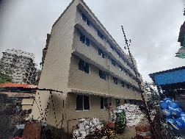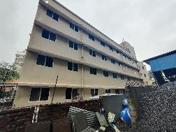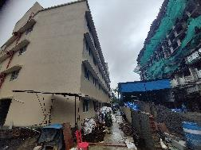

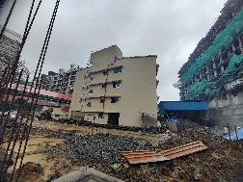

**Actual Site Photographs As on 09.07.2024**

**REHAB BUILDING NO. 1**

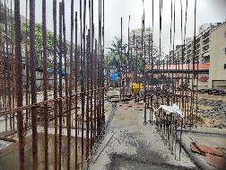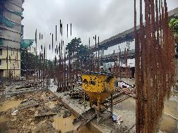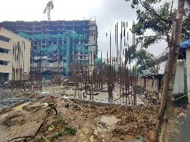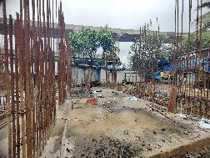

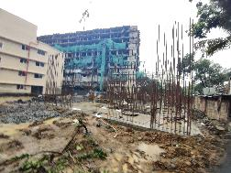

**Actual Site Photographs As on 09.07.2024**

**SALE BUILDING NO. 3**

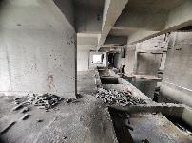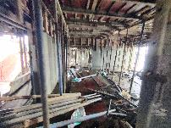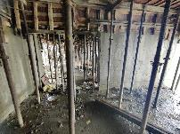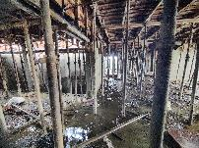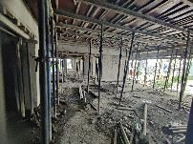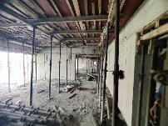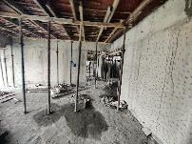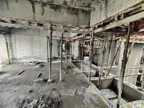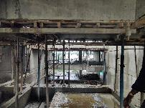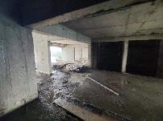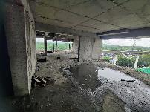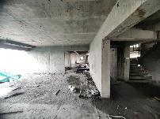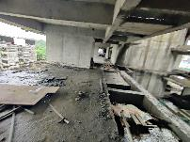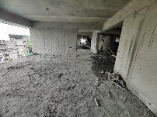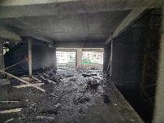

**Actual Site Photographs As on 09.07.2024**

**SALE BUILDING NO. 3**

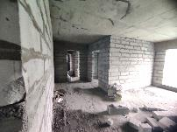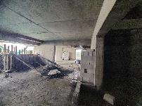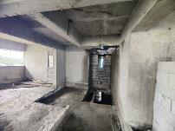

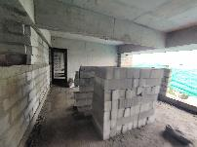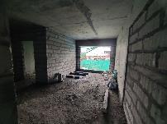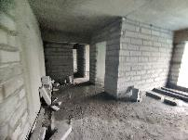

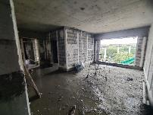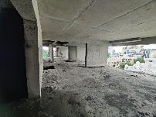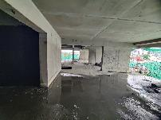

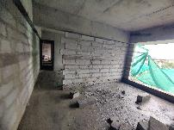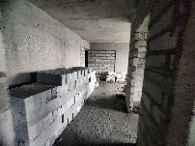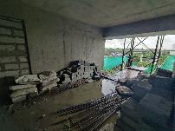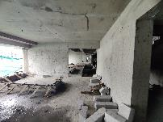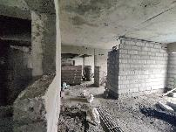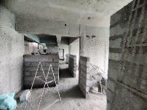

**Actual Site Photographs As on 09.07.2024**

**SALE BUILDING NO. 3**

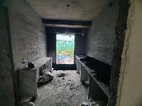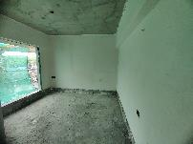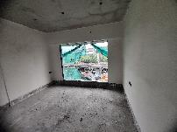

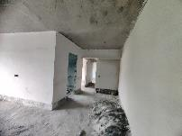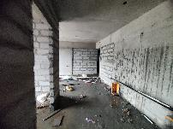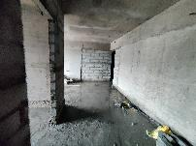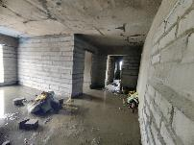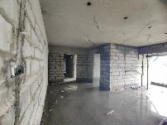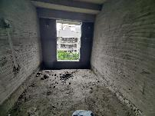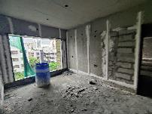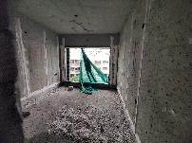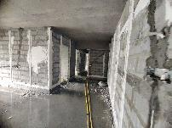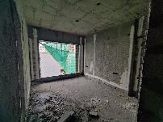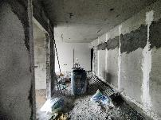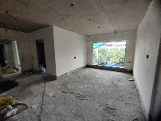

**Actual Site Photographs As on 09.07.2024**

**SALE BUILDING NO. 3**

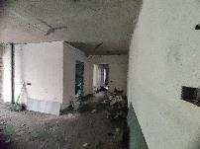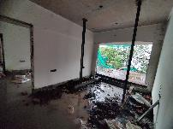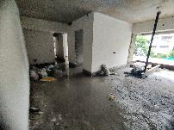

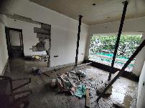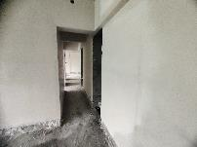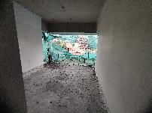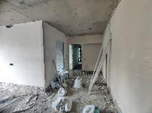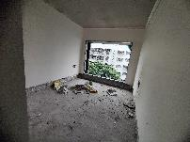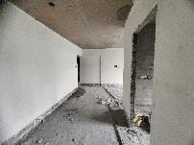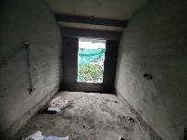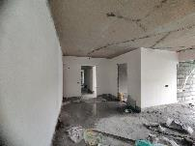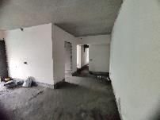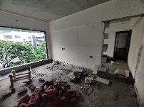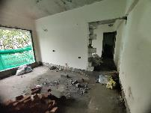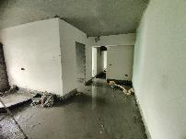

**Actual Site Photographs As on 09.07.2024**

**SALE BUILDING NO. 3**

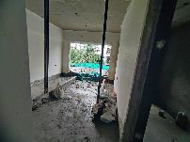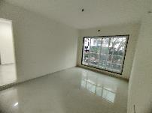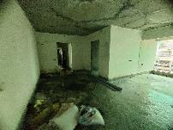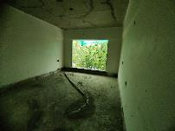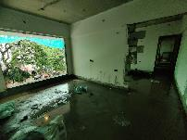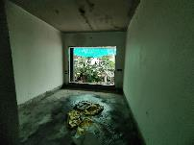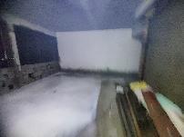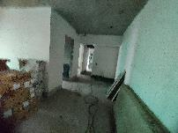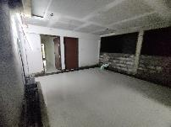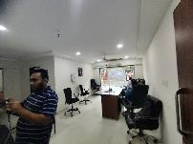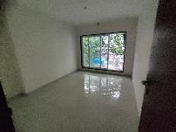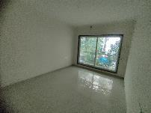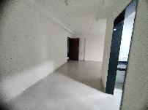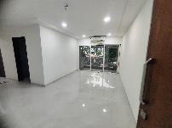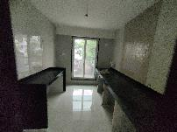

**Actual Site Photographs As on 09.07.2024**

**SALE BUILDING NO. 3**

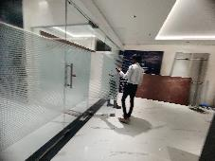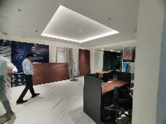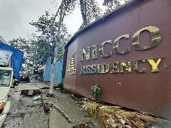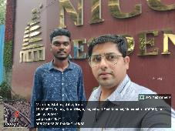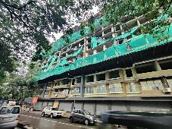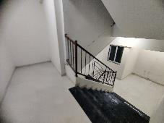

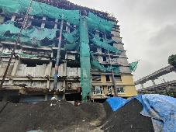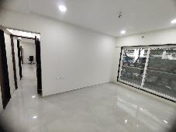

**Route Map of the property**

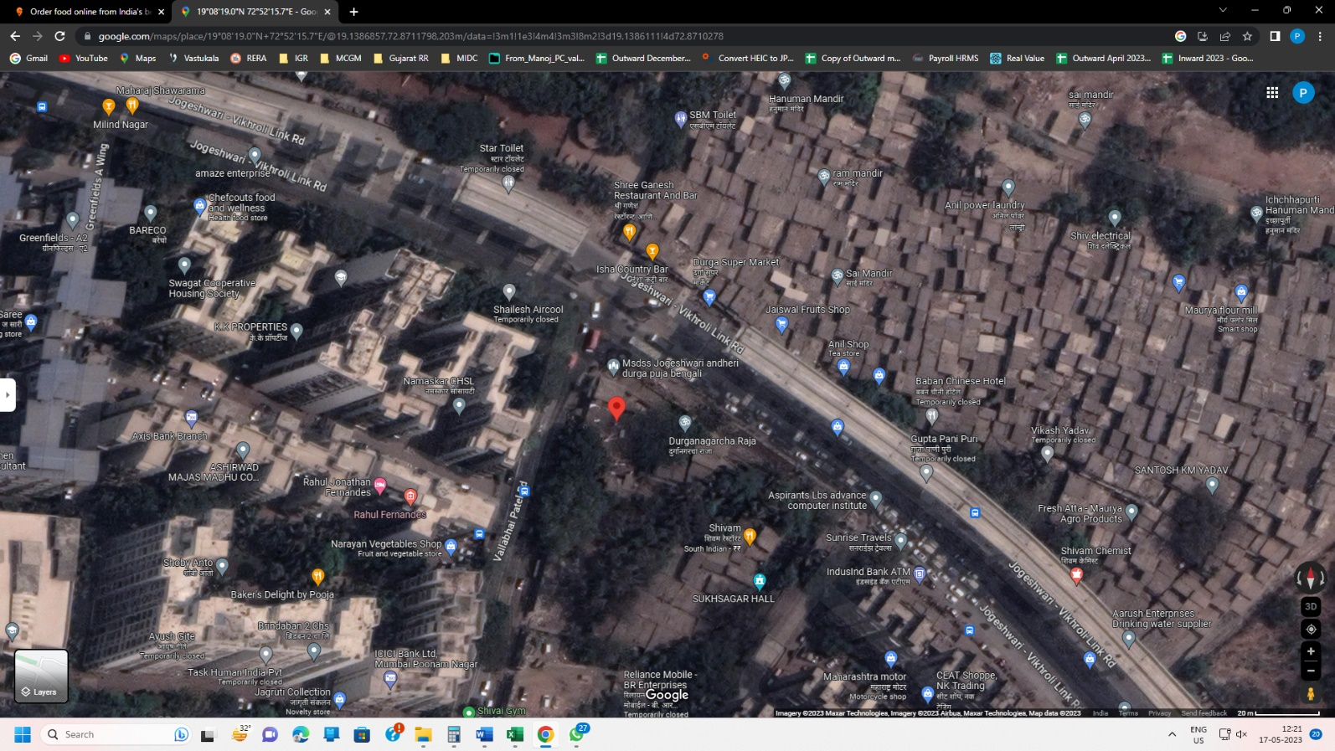**Site u/r**

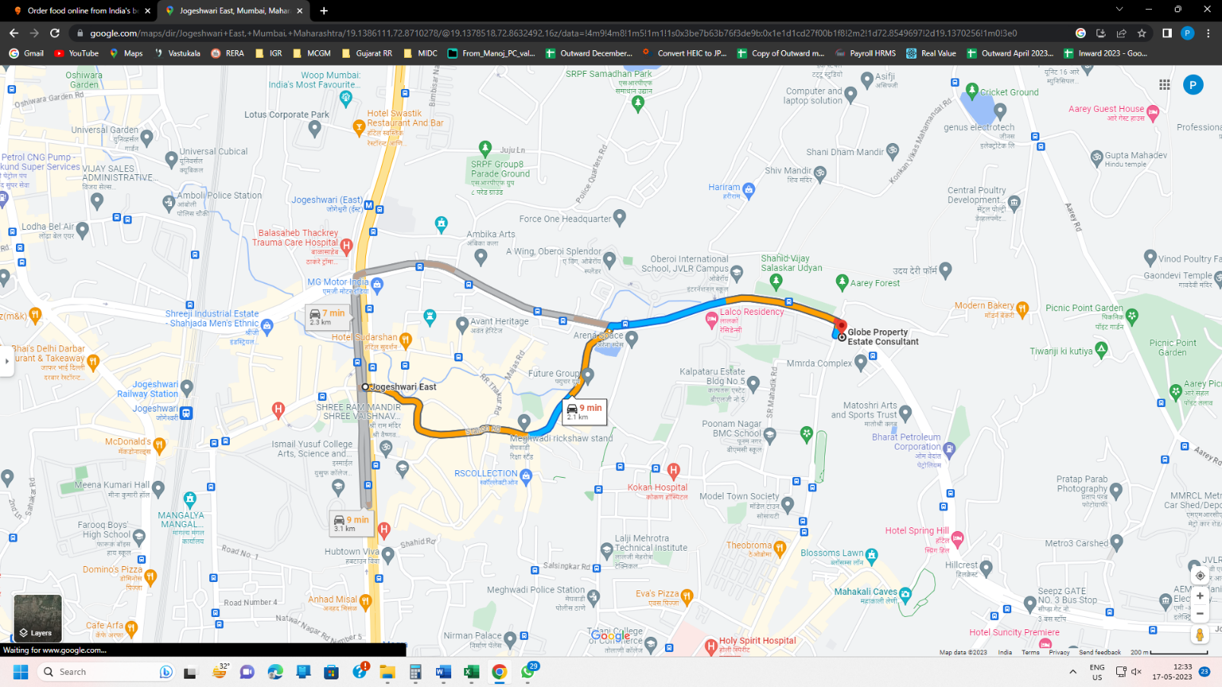

## Latitude Longitude: 19°08'19.0"N 72°52'15.7"E

Note: The Blue line shows the route to site from nearest railway station (Jogeshwari – 2.10 Km.)

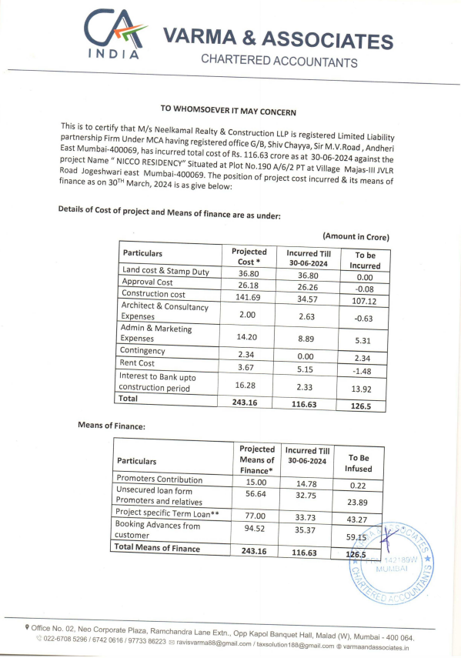**CA Certificate Dated 16.07.2024 till 30.06.2024**

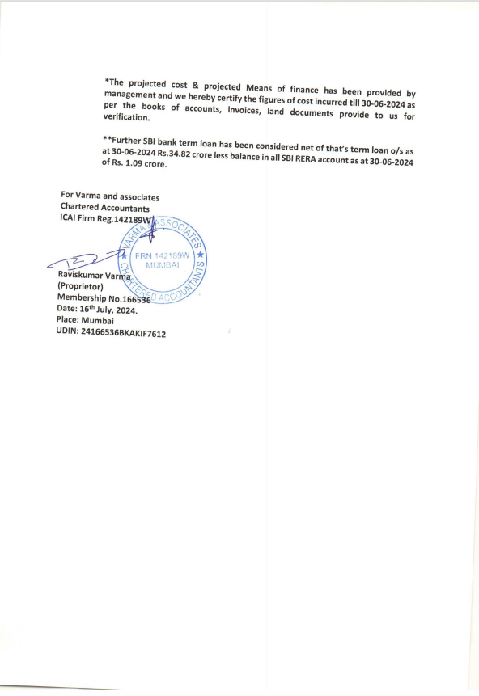**CA Certificate Dated 16.07.2024 till 30.06.2024**