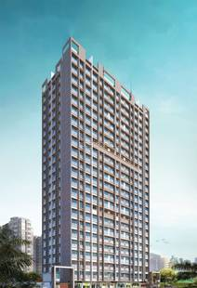
4th LENDER’S INDEPENDENT ENGINEER REPORT

Details of the property under consideration:

Name of Project: Ashtavinayak Apartments

"Ashtavinayak Apartments", Proposed S. R. Scheme Residential building on Plot bearing C.T.S. No. 68, 68/1, to 20, 69, 70, 70/1 to 26, 71, 71/1 to 38, 72, 72/1 to 26, 73, 73/1 to 14, 74 & 74/1 to 17, Village – Majas, Jogeshwari (East), Taluka – Andheri, Mumbai – 400 060, State – Maharashtra, Country – India
Latitude Longitude: 19°08'11.8"N 72°51'41.8"E

Intended User:

State Bank of India
SME Chembur Branch
Unit No. 11, Building No. 11, Ground Floor, Corporate Park, Sion Trombay Road,
Chembur, Mumbai, Pin Code – 400 071, State - Maharashtra, Country – India

Vastu/SBI/Mumbai/07/2024/10170/2307407
25/18-411-PY
Date: - 25.07.2024

FOURTH LENDER’S INDEPENDENT ENGINEER REPORT

To,
State Bank of India
SME Chembur Branch
Unit No. 11, Building No. 11,
Ground Floor, Corporate Park,
Sion Trombay Road, Chembur,
Mumbai, Pin Code – 400 071,
State - Maharashtra, Country – India

Subject: Construction of Proposed S. R. Scheme Residential building on Plot bearing C.T.S. No. 68, 68/1, to 20, 69, 70, 70/1 to 26, 71, 71/1 to 38, 72, 72/1 to 26, 73, 73/1 to 14, 74 & 74/1 to 17, Village – Majas, Jogeshwari (East), Taluka – Andheri, Mumbai – 400 060, State – Maharashtra, Country – India.

Ref: You’re Request for Lender’s Independent Engineer Report of under Construction Building.
Dear Sir,
The Construction work as per approved plan was in progress during the site visit on 09th July 2024.
Status of work:
For Rehab Building No. 1 (Wing C): All floor Slab work, till 23rd floor block work and door & window frames, till 21st floor plaster work & gypsum work, till 19th floor kitchen platform, till 12th Floor & 14th floor waterproofing, kitchen & toilet dadoing, till 12th floor flooring, electrical & plumbing concealed, firefighting, electrical fitting work is completed. Parapet wall & OHT tank work is completed.

For Sales Building No. 2 (Wing A): Till 16th Floor Slab work, till 10th floor block work, door & windows frames, internal plaster work, gypsum work, is completed and 11th floor block work is in progress

For Sales Building No. 2 (Wing B): Till 23rd Floor Slab work, till 15th floor block work and door & windows frames, till 10th floor plaster work, gypsum work, kitchen platform, flooring, firefighting, waterproofing, kitchen dadoing, door & window frames, electrical & plumbing concealed works are completed and Terrace shuttering work is in progress

NOTE:
- As per site inspection, Sale building no. 2, Wing B block work is completed upto 15th floor.
- Copy of Sale Building No. 2 (Wing A & B) 5th Commencement Certificate No. KE/PVT/0232/20180327/AP/S-2 dated 08.05.2024 issued by Slum Rehabilitation Authority (SRA).
- (This CC is endorsed for the work for Wing A: Ground Floor + 23rd Upper Floor including LMR & OHWT & Wing B: Ground Floor + 23rd Upper Floor for RCC framework and brick work upto 11(pt.) floor as per approved plan 05.04.2024)
- Hence, further approval for block work from 11th (Part) to 15th floor work is not provided for the verification and same is not considered for the plinth area calculation in this LIE report.

Total expenditure occurred as on 30/06/2024 on this project by M/s. Shiv Shruti Developers LLP is ` 91.01 Cr. & as per CA Certificate actual total expenditure occurred as on 30/06/2024 is ` 91.78 Cr. Hence, release of Balance Amount as requested by M/s. Shiv Shruti Developers LLP is hereby recommended.

DECLARATION
- The information furnished in the report is based on our 4th site visit Dated 09/07/2024 & Document Provided by Client.
- Vastukala 3rd LIE Report of the project dated 23/05/2024.
- I have no direct and indirect interest in the property examined for report.
- I have not been found guilty of misconduct in my professional capacity.

Manoj B. Chalikwar
Registered Valuer
Chartered Engineer (India)
Reg. No. IBBI/RV/07/2018/10366

Encl.: LIE report

Purpose & Methodology
• State Bank of India Banks and financial institutions require monitoring & an independent review of the progress of the sanctioned projects
VCIPL undertakes such study to independently review the progress of the project and put forward a comprehensive analysis

Advantages:
- Assurance on present practices
- Identification of risk
- Analyzing the performance of third parties
- Recommendations

The Methodology
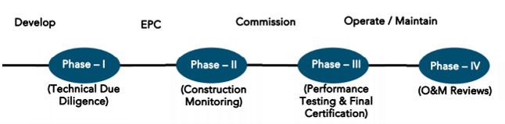
FOURTH LENDER’S INDEPENDENT ENGINEER REPORT
OF
"ASHTAVINAYAK APARTMENTS"

"Ashtavinayak Apartments", Proposed S. R. Scheme Residential building on Plot bearing C.T.S. No. 68,
68/1, to 20, 69, 70, 70/1 to 26, 71, 71/1 to 38, 72, 72/1 to 26, 73, 73/1 to 14, 74 & 74/1 to 17, Village – Majas,
Jogeshwari (East), Taluka – Andheri, Mumbai – 400 060, State – Maharashtra, Country – India

Latitude Longitude: 19°08'11.8"N 72°51'41.8"E

NAME OF DEVELOPER: M/s. Shiv Shruti Developers LLP
Pursuant to instructions from State of India, SME Chembur Branch, Mumbai we have duly visited, inspected, surveyed & assessed the above said property on 09th July 2024 to determine the fair & reasonable market value of the said property/project as on Quarter ending 30th June 2024 for LIE purpose.

1. Location Details:
Proposed S. R. Scheme Residential building on Plot bearing C.T.S. No. 68, 68/1, to 20, 69, 70, 70/1 to 26, 71, 71/1 to 38, 72, 72/1 to 26, 73, 73/1 to 14, 74 & 74/1 to 17, Village – Majas, Jogeshwari (East), Taluka – Andheri, Mumbai – 400 060. It is about 3.20 Km. travelling distance from Jogeshwari (East) Railway station. Surface transport to the property is by buses, taxis & private vehicles. The property is in developed locality. All the amenities like shops, banks, hotels, markets, schools, hospitals, etc. are all available in the surrounding locality. The area is higher middle class & developed.

2. Developer Details:
Name of builder | M/s. Shiv Shruti Developers LLP
Project Rera Registration Number | P51800049920
Registered office address | Office No. 201A, 2nd Floor, Wing No. A, Vikas Vertex, Behind Andheri Police Station, Andheri (East), Mumbai – 400 069, State - Maharashtra, Country – India
Contact details | Contact Person:  Mrs. Mona Mehta  Mobile No. 7977952834
E – mail ID and website
3. Boundaries of the Property:
Direction | Particulars
On or towards North | Slum Area
On or towards South | Under Construction Building
On or towards East | Road
On or towards West | Open & Slum Area

Introduction
As per Information on site M/s. Shiv Shruti Developers LLP has acquired land by Sale Agreement dated 29.12.2020 through registered agreement vide No. BDR-18-1136-2021 dated 22.01.2021 admeasuring area is 3,217.80 Sq. M. bearing C.T.S. No. 68, 68/1, to 20, 69, 70, 70/1 to 26, 71, 71/1 to 38, 72, 72/1 to 26, 73, 73/1 to 14, 74 & 74/1 to 17. For the Proposed Residential Building.

Area Statement:

Land:
Date | Particular | Area in Sq. M.
29.12.2020 | CTS No. 68, 68/1, to 20, 69, 70, 70/1 to 26, 71, 71/1 to 38, 72, 72/1 to 26, 73, 73/1 to 14, 74 & 74/1 to 17 | 3,217.80
TOTAL |  | 3,217.80

- Copy of Sale Agreement dated 29.12.2020 between M/s. Aishwarya Light Construction Company (The Vendor) and M/s. Shiv Shruti Developers LLP (The Purchasers) through registered agreement vide No. BDR-18-1136-2021 dated 22.01.2021.
- Copy of Rectification Deed dated 29.06.2021 between M/s. Aishwarya Light Construction Company (The Vendor) and M/s. Shiv Shruti Developers LLP (The Purchasers) through registered agreement vide No. BDR-18-8232-2021 dated 05.07.2021.

Building Area:

As per Approved Plan:
I | Area Statement |  |  |  |  |  |  | 33(10) | 30 (non-Slum) | Total Area in Sq. M.
1 | Gross area of plot |  |  |  |  |  |  | 3062.75 | 155.05 | 3217.8
a | Area of Road Set back / D.P Road
2 | Deductions for
(A) | For Reservation/ Road area
a | Road set-back area to be handed over (100%)
(B) | For Amenity area
a | Area of Amenity plot/plots to be handed over as per dcr 14(a)
b | Area of amenity plot/plots to be handed over as per dcr 14(b)
c | Area of amenity plot/plots to be handed over as per dcr 15
d | Area of amenity plot/plots to be handed over as per dcr 35
(C) | Deductions for existing built-up area to be retained if any
a | Land component of existing bua as per regulation under which the development was allowed
3 | Total deductions: [2(A)+2(B) +2(C)]
4 | Balance area of plot (1 minus 3) |  |  |  |  |  |  | 3062.75 | 155.05 | 3217.8
4a | Addition For
A | For Reservation / Road Area
a | Road Set-Back Area to be Handed Over (100%)
 | Total
5 | Plot area under development (As per Sr. No. 4 above) |  |  |  |  |  |  | 3062.75 | 155.05 | 3217.8
6 | Zonal (basic) fsi (1 or 1.33) |  |  |  |  |  |  |  | 155.05 | 155.05
7 | Permissible built-up area as per zonal(basic) fsi (5*6) (in case of mill land permissible built up area kept in abeyance)
8 | Built up area equal to area of land handed over as per 3(a) of regulation 30(a)
9 | Built up area in lieu of cost of construction of built-up amenity to be handed over
10 | Built up area due to "additional fsi on payment of premium" as per table no 12 of regulation no 30(a) subject to regulation no 30(a)3 |  |  |  |  |  |  |  | 77.52 | 77.52
11 | Built up area due to admissible "tdr" as per table no 12 of regulation no 30(a) subject to regulation no 30(a)3 |  |  |  |  |  |  |  | 139.54 | 139.54
12 | Permissible built up area (7 + 8 + 9 + 10 + 11) |  |  |  |  |  |  |  | 372.11 | 372.11
13 | Proposed built up area
 | Bldgs. | Rehab Bua | Sale Resi. BUA |  | Sale Comm. BUA. |  | Clubbing PTC BUA
 | Rehab Building No.1 | 6168.86 | - |  | - |  | -
 | Sale Bldg. No. 2 (U/R) | 1003.88 | 6479.88 |  | 32.99 |  | -
14 | Excess PTC Counted in Sale | - | - |  | - |  | - | - | - | -
15 | Total Clubbing PTC Area | - | - |  | - |  | 7116.84 | - | - | 7116.84
16 | Total Rehab BUA | 7172.74 | - |  | - |  | - | 7172.74 | - | 7172.74
17 | Total Rehab Component Area |  |  |  |  |  |  | 12052.36 |  | 12052.36
18 | Incentive Sale Area (17 x 1.10) |  |  |  |  |  |  | 13257.60 |  | 13198.36
19 | Total Area Permissible (16 + 18) |  |  |  |  |  |  | 20430.34 | 372.11 | 20802.45
20 | Total Sale Permissible area for the scheme |  |  |  |  |  |  | 13257.60 | 372.11 | 13629.71
21 | Sanctioned FSI. |  |  |  |  |  |  | 6.66 | 2.4
22 | PTC received from FP No. 109 of TPS Borivali No. III TPS scheme in R / Central ward |  |  |  |  |  |  |  |  | 7116.84
23 | Sale BUA transferred to FP No. 109 of TPS Borivali No. III TPS scheme in R / Central ward |  |  |  |  |  |  |  |  | 7116.84
24 | Balance sale BUA for the scheme (20 – 23) |  |  |  |  |  |  |  |  | 6512.87
25 | Total Sale BUA Proposed |  |  | 6479.88 |  | 32.99 |  |  |  | 6512.87
26 | Total Proposed BUA (PTC + Rehab + Sale)  (15 + 16 + 25) |  |  |  |  |  |  | 20117.25 | 372.11 | 20800.44
27 | Fungible compensatory area as per regulation no 31(3)
a) | i) Permissible Fungible Compensatory area for Rehab component without charging premium |  |  |  |  |  |  |  |  | 2510.46
 | ii) Fungible Compensatory area availed for Rehab component without charging premium |  |  |  |  |  |  |  |  | 350.28
b) | i) Sale Commercial Area |  |  |  |  |  |  |  |  | 32.99
 | ii) Permissible Sale Commercial Fungible Compensatory area by charging premium |  |  |  |  |  |  |  |  | 11.55
 | iii)Sale Commercial Fungible Compensatory area availed on payment of premium  already paid wide receipt no. 76399 dated 01/04/2024 |  |  |  |  |  |  |  |  | 11.54
c) | i) Sale Residential Area |  |  |  |  |  |  |  |  | 6479.88
 | ii) Permissible Sale Residential Fungible Compensatory area by charging premium |  |  |  |  |  |  |  |  | 2267.96
 | iii) Sale Residential Fungible Compensatory area availed on payment of premium  already paid wide receipt no. 76399 dated 01/04/2024 |  |  |  |  |  |  |  |  | 2267.96
28 | Total Sale Built up Area proposed including Fungible Compensatory Area [27(b)(i) + 27(b)(iii) + 27(c)(i) + 27(c)(iii)] |  |  |  |  |  |  |  |  | 8789.65
29 | FSI consumed on Net Plot [ 19/4 ] |  |  |  |  |  |  | 6.46 | 2.4
II | Other Requirements
A | Reservation/Designation
a | Name of Reservation
b | Area of Reservation affecting the plot
 | Area of Reservation land to be handed/ handed over as per Regulation No.17
 | Built up area of Amenity to be handed over as per Regulation No.17
 | Area/ Built up Area of Designation
 | Plot area/ Built up Amenity to be Handed Over as per Regulation No
 | i) 14(A)
 | ii) 14(B)
 | iii) 15
 | Requirement of Open Space in Layout/ Plot as per Regulation No. 27
 | Tenement Statement
 | (i) Proposed built up area (13 above) |  |  |  |  |  |  | Refer above statements
 | (ii) Less deduction of Non-residential area (Shop etc.)
 | (iii) Area available for tenements [(i) minus (ii).]
 | (iv) Tenements permissible (Density of tenements/hectare)
 | (v) Total number of Tenements proposed on the plot
 | Parking Statement
 | (i) Parking required by Regulations for.- |  |  |  |  |  |  | Refer above statements
 | Scooter/Motor cycle
 | Outsider (Visitors)
 | (ii) Covered garage permissible
 | (iii) Covered garages proposed
 | Scooter/Motor cycle
 | Outsider (Visitors)
 | (iv) Total parking provided
 | Transport Vehicles Parking
 | (i)Spaces for transport vehicles parking required by Regulations
 | (ii) Total No. of transport vehicles parking spaces provided

List of Approvals:
- Copy of Letter of Intent (LOI) No. KE/PVT/0232/20180327/LOI dated 31.03.2022 issued by Slum Rehabilitation Authority (SRA).
- Copy of Rehab Building No. 1 IOA Letter No. KE/PVT/0232/20180327/AP/R – 1 dated 21.04.2022 issued by Slum Rehabilitation Authority (SRA).
- Copy of Sale Building No. 2 IOA Letter No. KE/PVT/0232/20180327/AP/S-2 dated 21.04.2022 issued by Slum Rehabilitation Authority (SRA).
- Copy of Rehab Building No. 1 Approved Plan No. KE/PVT/0232/20180327/AP/R – 1 dated 21.04.2022 issued by Slum Rehabilitation Authority (SRA).
Approved upto: Wing C: Ground Floor + 1st to 23rd Upper Residential Floor
- Copy of Sale Building No. 2 Approved Plan No. SRA/ENG/KE/PVT/0232/20180327/AP/S-2 dated 21.04.2022 issued by Slum Rehabilitation Authority (SRA).
Approved upto:
Wing A: Ground Floor + 1st to 11th Upper Residential Floor
Wing B: Ground Floor + 1st to 23rd Upper Residential Floor
- Copy of Amended Sale Building No. 2 Approved Plan No. KE/PVT/0232/20180327/AP/S-2 dated 05.04.2024 issued by Slum Rehabilitation Authority (SRA).
Approved upto:
Wing A: Stilt Floor (Part) + Ground Floor (Part) + 1st to 23rd Upper Residential Floor
Wing B: Stilt Floor (Part) + Ground Floor (Part) + 1st to 23rd Upper Residential Floor
- Copy of Sale Building No. 2 Concession / Architect Plan drawn by M/s. Jiyani Consultancy LLP.
Wing A: Ground Floor + 1st to 23rd Upper Residential Floor
Wing B: Ground Floor + 1st to 23rd Upper Residential Floor
- Copy of Rehab Building No. 1 (Wing C) 1st Commencement Certificate No. KE/PVT/0232/20180327/AP/R-1 dated 11.03.2022 issued by Slum Rehabilitation Authority (SRA).
(This CC is endorsed for the work for Wing C: Plinth level Work)
- Copy of Rehab Building No. 1 (Wing C) 2nd Commencement Certificate No. KE/PVT/0232/20180327/AP/R-1 dated 06.09.2022 issued by Slum Rehabilitation Authority (SRA).
(This CC is endorsed for the work for Wing C: Ground Floor + 14th Upper Floor as per approved plan dated 21.04.2022)
- Copy of Rehab Building No. 1 (Wing C) 3rd Commencement Certificate No. KE/PVT/0232/20180327/AP/R-1 dated 05.09.2023 issued by Slum Rehabilitation Authority (SRA).
(This CC is endorsed for the work for Wing C: Ground Floor + 23rd Upper Floor + LMR + OHT as per approved plan dated 21.04.2022)
- Copy of Sale Building No. 2 (Wing A & B) 1st Commencement Certificate No. KE/PVT/0232/20180327/AP/S-2 dated 11.03.2023 issued by Slum Rehabilitation Authority (SRA).
(This CC is endorsed for the work for Wing A & B : Plinth level work)
- Copy of Sale Building No. 2 (Wing A & B ) 2nd Commencement Certificate No. KE/PVT/0232/20180327/AP/S-2 dated 25.11.2022 issued by Slum Rehabilitation Authority (SRA).
(This CC is endorsed for the work for Wing A: Ground Floor + 6th Upper Floor as per approved plan 21.04.2022)
- Copy of Sale Building No. 2 (Wing A & B ) 3rd Commencement Certificate No. KE/PVT/0232/20180327/AP/S-2 dated 24.02.2023 issued by Slum Rehabilitation Authority (SRA).
(This CC is endorsed for the work for Wing A: Ground Floor + 11th Upper Floor & Wing B: Ground Floor + 12th Upper Floor as per approved plan 21.04.2022)
- Copy of Sale Building No. 2 (Wing A & B ) 4th Commencement Certificate No. KE/PVT/0232/20180327/AP/S-2 dated 09.11.2023 issued by Slum Rehabilitation Authority (SRA).
(This CC is endorsed for the work for Wing A: Ground Floor + 11th Upper Floor & Wing B: Ground Floor + 21st (part) Upper Floor as per approved plan 21.04.2022)
- Copy of Sale Building No. 2 (Wing A & B ) 5th Commencement Certificate No. KE/PVT/0232/20180327/AP/S-2 dated 08.05.2024 issued by Slum Rehabilitation Authority (SRA).
(This CC is endorsed for the work for Wing A: Ground Floor + 23rd Upper Floor including LMR & OHWT & Wing B: Ground Floor + 23rd Upper Floor for RCC framework and brick work upto 11(pt.) floor as per approved plan 05.04.2024)

LEVEL OF COMPLETION:
For Rehab Building No. 1 (Wing C): All floor Slab work, till 23rd floor block work and door & window frames, till 21st floor plaster work & gypsum work, till 19th floor kitchen platform, till 12th Floor & 14th floor waterproofing, kitchen & toilet dadoing, till 12th floor flooring, electrical & plumbing concealed, firefighting, electrical fitting work is completed. Parapet wall & OHT tank work is completed.
For Sales Building No. 2 (Wing A): Till 16th Floor Slab work, till 10th floor block work, door & windows frames, internal plaster work, gypsum work, is completed and 11th floor block work is in progress
For Sales Building No. 2 (Wing B): Till 23rd Floor Slab work, till 15th floor block work and door & windows frames, till 10th floor plaster work, gypsum work, kitchen platform, flooring, firefighting, waterproofing, kitchen dadoing, door & window frames, electrical & plumbing concealed works are completed and Terrace shuttering work is in progress.

Rehab Buidling No. 1 (Wing C)
Sr. No | Floor No. | Construction Area in Sq. M. | Completed Area in Sq. M. | Work Completion as 3rd LIE Report as on 23.05.2024 | Work Completion as on 09.07.2024
1 | Excavation & Shore Piling |  |  | Work is completed | Work is completed
2 | Ground Floor | 627.92 | 627.92 | Slab work is completed | Slab work is completed
3 | 1st Floor | 627.92 | 627.92 | Slab work, Blockwork, Plaster work, Door & Window Frames, Gypsum work, Kitchen Platform, Flooring work, Kitchen dadoing & Toilet dadoing work is completed | Slab work, Blockwork, Plaster work, Door & Window install, Gypsum work, Kitchen Platform, Flooring work, Kitchen dadoing & Toilet dadoing work, flooring, electrical & plumbing concealed, lobby flooring work, firefighting, electrical fitting is completed. Internal painting work is in progress.
4 | 2nd Floor | 627.92 | 627.92 | Slab work, Blockwork, Plaster work, Door & Window install, Gypsum work, Kitchen Platform, Flooring work, Kitchen dadoing & Toilet dadoing work, flooring, electrical & plumbing concealed, fire fighting work is completed | Slab work, Blockwork, Plaster work, Door & Window install, Gypsum work, Kitchen Platform, Flooring work, Kitchen dadoing & Toilet dadoing work, flooring, electrical & plumbing concealed, lobby flooring work, firefighting, electrical fitting is completed. Internal painting work is in progress.
5 | 3rd Floor | 584.55 | 584.55 | Slab work, Blockwork, Plaster work, Door & Window install, Gypsum work, Kitchen Platform, Flooring work, Kitchen dadoing & Toilet dadoing work, flooring, electrical & plumbing concealed, fire fighting work is completed | Slab work, Blockwork, Plaster work, Door & Window install, Gypsum work, Kitchen Platform, Flooring work, Kitchen dadoing & Toilet dadoing work, flooring, electrical & plumbing concealed, lobby flooring work, firefighting, electrical fitting is completed. Internal painting work is in progress.
6 | 4th Floor | 584.55 | 584.55 | Slab work, Blockwork, Plaster work, Door & Window install, Gypsum work, Kitchen Platform, Flooring work, Kitchen dadoing & Toilet dadoing work, flooring, electrical & plumbing concealed, fire fighting work is completed | Slab work, Blockwork, Plaster work, Door & Window install, Gypsum work, Kitchen Platform, Flooring work, Kitchen dadoing & Toilet dadoing work, flooring, electrical & plumbing concealed, lobby flooring work, firefighting, electrical fitting is completed. Internal painting work is in progress.
7 | 5th Floor | 584.55 | 584.55 | Slab work, Blockwork, Plaster work, Door & Window install, Gypsum work, Kitchen Platform, Flooring work, Kitchen dadoing & Toilet dadoing work, flooring, electrical & plumbing concealed, fire fighting work is completed | Slab work, Blockwork, Plaster work, Door & Window install, Gypsum work, Kitchen Platform, Flooring work, Kitchen dadoing & Toilet dadoing work, flooring, electrical & plumbing concealed, lobby flooring work, firefighting, electrical fitting is completed. Internal painting work is in progress.
8 | 6th Floor | 584.55 | 584.55 | Slab work, Blockwork, Plaster work, Door & Window install, Gypsum work, Kitchen Platform, Flooring work, Kitchen dadoing & Toilet dadoing work, flooring, electrical & plumbing concealed, fire fighting work is completed | Slab work, Blockwork, Plaster work, Door & Window install, Gypsum work, Kitchen Platform, Flooring work, Kitchen dadoing & Toilet dadoing work, flooring, electrical & plumbing concealed, lobby flooring work, firefighting, electrical fitting is completed. Internal painting work is in progress.
9 | 7th Floor | 584.55 | 584.55 | Slab work, Blockwork, Plaster work, Door & Window install, Gypsum work, Kitchen Platform, Flooring work, Kitchen dadoing & Toilet dadoing work, flooring, electrical & plumbing concealed, fire fighting work is completed | Slab work, Blockwork, Plaster work, Door & Window install, Gypsum work, Kitchen Platform, Flooring work, Kitchen dadoing & Toilet dadoing work, flooring, electrical & plumbing concealed, lobby flooring work, firefighting, electrical fitting is completed. Internal painting work is in progress.
10 | 8th Floor | 584.66 | 584.66 | Slab work, Blockwork, Plaster work, Door & Window install, Gypsum work, Kitchen Platform, Flooring work, Kitchen dadoing & Toilet dadoing work, flooring, electrical & plumbing concealed, fire fighting work is completed | Slab work, Blockwork, Plaster work, Door & Window install, Gypsum work, Kitchen Platform, Flooring work, Kitchen dadoing & Toilet dadoing work, flooring, electrical & plumbing concealed, lobby flooring work, firefighting, electrical fitting is completed. Internal painting work is in progress.
11 | 9th Floor | 584.55 | 584.55 | Slab work, Blockwork, Plaster work, Door & Window install, Gypsum work, Kitchen Platform, Flooring work, Kitchen dadoing & Toilet dadoing work, flooring, electrical & plumbing concealed, fire fighting work is completed | Slab work, Blockwork, Plaster work, Door & Window install, Gypsum work, Kitchen Platform, Flooring work, Kitchen dadoing & Toilet dadoing work, flooring, electrical & plumbing concealed, lobby flooring work, firefighting, electrical fitting is completed. Internal painting work is in progress.
12 | 10th Floor | 584.55 | 584.55 | Slab work, Blockwork, Plaster work, Door & Window install, Gypsum work, Kitchen Platform, Flooring work, Kitchen dadoing & Toilet dadoing work, flooring, electrical & plumbing concealed, lobby flooring work is completed | Slab work, Blockwork, Plaster work, Door & Window install, Gypsum work, Kitchen Platform, Flooring work, Kitchen dadoing & Toilet dadoing work, flooring, electrical & plumbing concealed, lobby flooring work, firefighting is completed. Internal painting work is in progress.
13 | 11th Floor | 584.55 | 584.55 | Slab work, Blockwork, Plaster work, Door & Window install, Gypsum work, Kitchen Platform, Flooring work, Kitchen dadoing & Toilet dadoing work, flooring, electrical & plumbing concealed, lobby flooring work is completed | Slab work, Blockwork, Plaster work, Door & Window install, Gypsum work, Kitchen Platform, Flooring work, Kitchen dadoing & Toilet dadoing work, flooring, electrical & plumbing concealed, lobby flooring work, firefighting is completed. Internal painting work is in progress.
14 | 12th Floor | 584.55 | 584.55 | Slab work, Blockwork, Plaster work, Door & Window install, Gypsum work, Kitchen Platform, Flooring work, Kitchen dadoing & Toilet dadoing work, flooring, electrical & plumbing concealed, lobby flooring work is completed | Slab work, Blockwork, Plaster work, Door & Window install, Gypsum work, Kitchen Platform, Flooring work, Kitchen dadoing & Toilet dadoing work, flooring, electrical & plumbing concealed, lobby flooring work, firefighting is completed. Internal painting work is in progress.
15 | 13th Floor | 584.55 | 584.55 | Slab work, Blockwork, Door & Window Frames work, Plaster & Gypsum work is completed | Slab work, Blockwork, Door & Window Frames work, Plaster work is completed
16 | 14th Floor | 584.55 | 584.55 | Slab work, Blockwork, Door & Window Frames work, Plaster & Gypsum work is completed | Slab work, block work, door & window frame work, plaster work, gypsum, water proofing, kitchen platform & tiling work is completed
17 | 15th Floor | 585.30 | 585.30 | Slab work, Blockwork, Door & Window Frames work, Plaster & Gypsum work is completed | Slab work, block work, door & window frame work, plaster work, gypsum, water proofing, kitchen platform work is completed
18 | 16th Floor | 584.55 | 584.55 | Slab work, Blockwork, Door & Window Frames work, Plaster & Gypsum work is completed | Slab work, block work, door & window frame work, plaster work, gypsum, water proofing, kitchen platform work is completed
19 | 17th Floor | 584.55 | 584.55 | Slab work, Blockwork, Door & Window Frames work and 75% gyspum work is completed, remaining gyspum work is in progress | Slab work, block work, door & window frame work, plaster work, gypsum, water proofing, kitchen platform work is completed
20 | 18th Floor | 584.55 | 584.55 | Slab work, block work are completed, Gpysum work is in progress | Slab work, block work, door & window frame work, plaster work, gypsum, water proofing, kitchen platform work is completed
21 | 19th Floor | 584.55 | 584.55 | Slab work, block work are completed | Slab work, block work, door & window frame work, plaster work, gypsum, water proofing, kitchen platform work is completed
22 | 20th Floor | 584.55 | 584.55 | Slab work, block work are completed | Slab work, block work, door & window frame work, plaster work, gypsum, water proofing work is completed
23 | 21st Floor | 584.55 | 584.55 | Slab work is completed | Slab work, block work, door & window frame work, plaster work, gypsum, water proofing work is completed
24 | 22nd Floor | 584.55 | 584.55 | Slab work is completed | Slab work, block work, door & window frame work is completed, gypsum work is in progress
25 | 23rd Floor | 584.55 | 584.55 | Slab work is completed | Slab work, block work, door & window frame work is completed
26 | Terrace | 264.56 | 264.56 | Shuttering work is in progress | Slab work, OHT water tank, block work, parapet wall, plaster work, water proofing work is completed
Total |  | 14,424.73 | 14,424.73
No. of Puzzle Car Parking |  | 27 Nos

Sales Building No. 3 (Wing A & B)
Sr. No | Floor No. | Construction Area in Sq. M. | Completed Area in Sq. M. | Work Completion as 3rd LIE Report as on 23.05.2024 | Work Completion as on 09.07.2024
1 | Excavation & Shore Piling |  |  | Work is Completed | Work is Completed
2 | Ground Floor | 1,138.60 | 1,138.60 | Wing A & B: Slab Work is completed | Wing A & B: Slab Work is completed
3 | 1st Floor | 1,138.60 | 1,138.60 | Wing A: Slab work, Block work & Plaster work is completed  Wing B: Slab work, Blockwork, Plaster work, Gypsum work, Kitchen Platform, Kitchen dadoing, Plumbing work, Toilet tiling work, flooring, Door & Windows Frames, 2 Flats Windows Installation work are completed | Wing A: Slab work, Blockwork, Internal Plaster work, Door & Window Frame, Kitchen Platform, Plumbing conceal works, waterproofing work, kitchen & toilet tiling work are completed and windows are installed. Flooring work is in progress  Wing B: Slab work, Blockwork, Internal Plaster work, Gypsum, Door & Window Frame, Kitchen Platform, Plumbing conceal works, waterproofing work, firefighting, flooring, kitchen & toilet tiling, works are completed and windows are installed
4 | 2nd Floor | 1,138.60 | 1,138.60 | Wing A: Slab work, Block work is completed  Wing B: Slab work, Blockwork, Internal Plaster work, Door & Window Frame, Kitchen Platform, Plumbing conceal works, waterproofing work, Fire fighting, Kitchen & Toilet dadoing work are completed | Wing A: Slab work, Blockwork, Internal Plaster work, Door & Window Frame, Kitchen Platform, Plumbing conceal works, waterproofing work, kitchen & toilet tiling work are completed and windows are installed. Flooring work is in progress  Wing B: Slab work, Blockwork, Internal Plaster work, Gypsum, Door & Window Frame, Kitchen Platform, Plumbing conceal works, waterproofing work, firefighting, flooring, kitchen & toilet tiling, works are completed and windows are installed
5 | 3rd Floor | 1,131.03 | 1,131.03 | Wing A: Slab work, Block work is completed  Wing B: Slab work, Blockwork, Internal Plaster work, Door & Window Frame, Kitchen Platform, Plumbing conceal works, waterproofing work, Fire fighting, Kitchen & Toilet dadoing work are completed | Wing A: Slab work, Blockwork, Internal Plaster work, Door & Window Frame, Kitchen Platform, Plumbing conceal works, waterproofing work, kitchen & toilet tiling work are completed and windows are installed. Flooring work is in progress  Wing B: Slab work, Blockwork, Internal Plaster work, Gypsum, Door & Window Frame, Kitchen Platform, Plumbing conceal works, waterproofing work, firefighting, flooring, kitchen & toilet tiling, works are completed and windows are installed
6 | 4th Floor | 1,126.92 | 1,126.92 | Wing A: Slab work, Block work is completed  Wing B: Slab work, Blockwork, Internal Plaster work, Door & Window Frame, Kitchen Platform, Plumbing conceal works, waterproofing work, Fire fighting, Kitchen & Toilet dadoing work are completed | Wing A: Slab work, Blockwork, Internal Plaster work, Door & Window Frame, Kitchen Platform, Plumbing conceal works, waterproofing work, kitchen & toilet tiling work are completed and windows are installed. Flooring work is in progress  Wing B: Slab work, Blockwork, Internal Plaster work, Gypsum, Door & Window Frame, Kitchen Platform, Plumbing conceal works, waterproofing work, firefighting, flooring, kitchen & toilet tiling, works are completed and windows are installed
7 | 5th Floor | 1,126.92 | 1,126.92 | Wing A: Slab work, Block work is completed  Wing B: Slab work, Blockwork, Internal Plaster work, Door & Window Frame, Kitchen Platform, Plumbing conceal works, waterproofing work, Fire fighting, Kitchen & Toilet dadoing work are completed | Wing A: Slab work, Blockwork, Internal Plaster work, Door & Window Frame, Kitchen Platform, Plumbing conceal works, waterproofing work, kitchen & toilet tiling work are completed and windows are installed. Flooring work is in progress  Wing B: Slab work, Blockwork, Internal Plaster work, Gypsum, Door & Window Frame, Kitchen Platform, Plumbing conceal works, waterproofing work, firefighting, flooring, kitchen & toilet tiling, works are completed and windows are installed
8 | 6th Floor | 1,126.92 | 1,126.92 | Wing A: Slab work, Block work is completed  Wing B: Slab work, Blockwork, Internal Plaster work, Door & Window Frame, Kitchen Platform, Plumbing conceal works, waterproofing work, Fire fighting are completed | Wing A: Slab work, Blockwork, Internal Plaster work, Door & Window Frame, Kitchen Platform, Plumbing conceal works, waterproofing work, kitchen & toilet tiling work are completed and windows are installed. Flooring work is in progress  Wing B: Slab work, Blockwork, Internal Plaster work, Gypsum, Door & Window Frame, Kitchen Platform, Plumbing conceal works, waterproofing work, firefighting, flooring, kitchen & toilet tiling, works are completed and windows are installed
9 | 7th Floor | 1,126.92 | 1,126.92 | Wing A & Wing B: Slab work, Blockwork, Internal Plaster work, Door & Window Frame, Kitchen Platform, Plumbing conceal works, waterproofing work are completed | Wing A: Slab work, Blockwork, Internal Plaster work, Door & Window Frame, Kitchen Platform, Plumbing conceal works, waterproofing work, are completed and windows are installed  Wing B: Slab work, Blockwork, Internal Plaster work, Gypsum, Door & Window Frame, Kitchen Platform, Plumbing conceal works, waterproofing work, firefighting, flooring, kitchen & toilet tiling, works are completed and windows are installed
10 | 8th Floor | 1,139.10 | 1,139.10 | Wing A & Wing B: Slab work, Blockwork, Internal Plaster work, Door & Window Frame, Kitchen Platform, Plumbing conceal works, waterproofing work are completed | Wing A: Slab work, Blockwork, Internal Plaster work, Door & Window Frame, Kitchen Platform, Plumbing conceal works, waterproofing work, are completed and windows are installed  Wing B: Slab work, Blockwork, Internal Plaster work, Gypsum, Door & Window Frame, Kitchen Platform, Plumbing conceal works, waterproofing work, firefighting, flooring, kitchen & toilet tiling, works are completed and windows are installed
11 | 9th Floor | 1,126.92 | 1,126.92 | Wing A & Wing B: Slab work, Blockwork, Internal Plaster work, Door & Window Frame, Kitchen Platform, Plumbing conceal works, waterproofing work are completed | Wing A: Slab work, Blockwork, Internal Plaster work, Door & Window Frame, Kitchen Platform, Plumbing conceal works, waterproofing work, are completed and windows are installed  Wing B: Slab work, Blockwork, Internal Plaster work, Gypsum, Door & Window Frame, Kitchen Platform, Plumbing conceal works, waterproofing work, firefighting, flooring, kitchen & toilet tiling, works are completed and windows are installed
12 | 10th Floor | 1,126.92 | 1,126.92 | Wing A: Slab work is completed, Block work is in progress  Wing B: Slab work, Blockwork, Internal Plaster work, Door & Window Frame, Kitchen Platform, Plumbing conceal works are completed | Wing A: Slab work, block work & plaster work is completed.  Wing B: Slab work, Blockwork, Internal Plaster work, Door & Window Frame, Kitchen Platform, Plumbing conceal works are completed
13 | 11th Floor | 1,126.92 | 1,126.92 | Wing A: Slab work is completed  Wing B: Slab work is completed, Block work is in progress | Wing A: Slab work is completed  Wing B: Slab work, block work is completed, plaster work is in progress
14 | 12th Floor | 1,126.92 | 1,126.92 | Wing B: Slab work is completed | Wing A: Slab work is completed  Wing B: Slab work, block work is completed, plaster work is in progress
15 | 13th Floor | 1,126.92 | 1,126.92 | Wing B: Slab work is completed | Wing A: Slab work is completed  Wing B: Slab work, block work is completed, plaster work is in progress
16 | 14th Floor | 1,126.92 | 1,126.92 | Wing B: Slab work is completed | Wing A: Slab work is completed  Wing B: Slab work, block work is completed, plaster work is in progress
17 | 15th Floor | 1,129.81 | 1,129.81 | Wing B: Slab work is completed | Wing A: Slab work is completed  Wing B: Slab work, block work is completed
18 | 16th Floor | 1,126.92 | 1,126.92 | Wing B: Slab work is completed | Wing A: Slab work is completed  Wing B: Slab work, block work is completed
19 | 17th Floor | 1,126.92 | 563.46 | Wing B: Slab work is completed | Wing B: Slab work is completed
20 | 18th Floor | 1,126.92 | 563.46 | Wing B: Slab work is completed | Wing B: Slab work is completed
21 | 19th Floor | 1,126.92 | 563.46 | Wing B: Slab work is completed | Wing B: Slab work is completed
22 | 20th Floor | 1,126.92 | 563.46 | Wing B: Slab work is completed | Wing B: Slab work is completed
23 | 21st Floor | 1,126.92 | 563.46 | Wing B: Shuttering work is in progress | Wing B: Slab work is completed
24 | 22nd Floor | 1,134.51 | 567.25 |  | Wing B: Slab work is completed
25 | 23rd Floor | 1,134.49 | 567.24 |  | Wing B: Slab work is completed
26 | Terrace Floor | 302.44 |  |  | Wing B: Shuttering work is in progress
Total |  | 27,417.85 | 23,163.62
No. of Puzzle Car Parking |  | 78 Nos

- As per site inspection, Sale building no. 2, Wing B block work is completed upto 15th floor.
- Copy of Sale Building No. 2 (Wing A & B) 5th Commencement Certificate No. KE/PVT/0232/20180327/AP/S-2 dated 08.05.2024 issued by Slum Rehabilitation Authority (SRA).
- (This CC is endorsed for the work for Wing A: Ground Floor + 23rd Upper Floor including LMR & OHWT & Wing B: Ground Floor + 23rd Upper Floor for RCC framework and brick work upto 11(pt.) floor as per approved plan 05.04.2024)
- Hence, further approval for block work from 11th (Part) to 15th floor work is not provided for the verification and same is not considered for the plinth area calculation in this LIE report.

Details of the Project as Financed By SBI:

Project Cost: (as per C.A. Certificate)
Particulars | Estimated Cost (in Cr.) | Incurred Cost (In Cr.) till 30.06.2024 by M/s. Varma & Associates | Incurred Cost (In Cr.) till 31.03.2024 by M/s. Varma & Associates | Net
Land Cost | 0.38 | 0.44 | 0.44 | -
Rent Cost | 11.26 | 10.58 | 10.58 | -
Construction Cost of Rehab Building | 30.97 | 58.40 | 53.76 | 4.64
Construction Cost of Sale Building | 85.33
Premium Cost / FSI / GOM Charges / fees / security Deposits & TDR Cost | 13.00 | 14.82 | 12.23 | 2.59
Architect Cost, RCC & Other Professional Cost | 2.33 | 1.16 | 1.12 | 0.04
Administrative Cost | 1.16 | 3.42 | 3.26 | 0.16
Marketing Cost | 5.07
Interest Cost (Bank Loan) | 4.00 | 1.59 | 0.98 | 0.61
Contingency Cost | 1.74 | 1.37 | 1.37 | -
Total | 155.24 | 91.78 | 83.74 | 8.04

- The Builder has incurred about 10.58 Cr. Rent Cost, 58.40 Cr. as construction cost of all buildings, 14.82 Cr. for approval of project, 1.16 Cr. for professional cost, 3.42 Cr. for admin cost & marketing cost, 1.59 Cr. for interest cost & 1.37 Cr. for contingency cost in last quarter till 30.06.2024 as per C.A. certificate issued by M/s. Varma & Associates dated 16.07.2024.

Project Cost: (as per Bills):
Particulars | Incurred Cost (in Cr.) |  | Net
 | 30.06.2024 as per Bill (Inclusive GST) | 31.03.2024 as per Bill (Inclusive GST)
Land Cost | 0.38 | 0.38 | -
Rent Cost | 10.57 | 10.57 | -
Construction cost of Rehab Building | 57.62 | 52.92 | 4.64
Construction cost of Sale Building
Premium Cost / FSI / GOM Charges / fees / security Deposits & TDR Cost | 15.52 | 13.19 | 2.34
Architect Cost, RCC & Other Professional Cost | 1.15 | 1.10 | 0.05
Administrative Cost | 3.79 | 3.32 | 0.47
Marketing Cost | 0.39 | 0.39 | -
Interest Cost | 1.59 | 0.98 | 0.61
Contingency Cost | - | - | -
Total | 91.01 | 82.84 | 8.16
Note:

Land Cost:
Sr. No. | Agreement Name | Date | Particulars | Total Cost in ` | Incurred Cost in `
1 | Agreement for Sale | 24.12.2020 | Stamp Duty | 31,06,500.00 | 31,06,500.00
2 |  |  | Reg. Fees | 30,000.00 | 30,000.00
3 |  |  |  | 7,700.00 | 7,700.00
4 | Rectification Deed | 05.07.2021 | Stamp Duty | 40,000.00 | 40,000.00
5 |  |  | Reg. Fees | 30,000.00 | 30,000.00
6 |  |  |  | 9,800.00 | 9,800.00
7 | Power of Attorney | 22.01.2021 | Stamp Duty | 500.00 | 500.00
8 |  |  | Reg. Fees | 100.00 | 100.00
9 |  |  |  | 800.00 | 800.00
10 | Surrender Deed | 02.01.2023 | Purchase Cost | 5,50,000.00 | 5,50,000.00
11 |  |  | Stamp Duty | 38,500.00 | 38,500.00
 | TOTAL |  |  | 38,13,900.00 | 38,13,900.00
As per conveyance agreement.
Summary of Bills
Sr. No. | Particulars | Amount in `  (till 30.06.2024) | Amount in ` (in Cr.) | Amount in `  (till 31.03.2024) | Amount in ` (in Cr.) | Net
1 | Construction Cost of Rehab Building | 57,61,96,382.00 | 57.62 | 52,91,71,155.00 | 52.92 | 4.70
2 | Construction Cost of Sale Building
3 | Rent Cost | 10,56,81,600.00 | 10.57 | 10,56,81,600.00 | 10.57 | -
4 | Premium Cost / FSI / GOM Charges / fees / security Deposits & TDR Cost | 15,52,42,571.00 | 15.52 | 13,18,71,784.00 | 13.19 | 2.34
5 | Professional Cost | 1,14,73,801.00 | 1.15 | 1,10,12,901.00 | 1.10 | 0.05
6 | Administrative Cost | 3,78,61,392.00 | 3.79 | 3,31,80,742.00 | 3.32 | 0.47
7 | Marketing Cost | 39,37,434.00 | 0.46 | 39,37,434.00 | 0.46 | -
TOTAL |  | 90,62,59,045.00 | 90.63 | 81,48,55,616.00 | 81.49 | 7.55
Note: Bills were provided by the client up to 30.06.2024

Interest Cost:
Sr. No | Particulars | Estimate Amount in ` | Incurred Amount in ` (till 30.06.2024) | Incurred Amount in ` (till 31.03.2024) | Difference in ` | Balance Amount in `
1 | Interest Cost | 4,00,00,000.00 | 1,58,65,865.00 | 97,71,780.00 | 60,94,085.00 | 2,41,34,135.00
TOTAL |  | 4,00,00,000.00 | 1,58,65,865.00 | 97,71,780.00 | 60,94,085.00 | 2,41,34,135.00
Interest Cost is based on discussion with the client.

Cost of Construction as on 09th July 2024:

Rehab Building No. 1 (Wing C)
Sr. No. | Floor | Total Construction Area in Sq. M. | Completed Area in Sq. M. | Rate per Sq. M. | Full Value after completion | % of work completed | Actual Expenditure till date in `
1 | Excavation & Piling Work | 5% of Construction Cost of Building |  |  | 1,44,24,730.00 | 100% | 1,44,24,730.00
2 | Ground | 627.92 | 627.92 | 20,000.00 | 62,79,200.00 | 50% | 62,79,200.00
3 | 1st | 627.92 | 627.92 | 20,000.00 | 94,18,800.00 | 86% | 1,08,00,224.00
4 | 2nd | 627.92 | 627.92 | 20,000.00 | 94,18,800.00 | 86% | 1,08,00,224.00
5 | 3rd | 584.55 | 584.55 | 20,000.00 | 87,68,250.00 | 86% | 1,00,54,260.00
6 | 4th | 584.55 | 584.55 | 20,000.00 | 87,68,250.00 | 86% | 1,00,54,260.00
7 | 5th | 584.55 | 584.55 | 20,000.00 | 87,68,250.00 | 86% | 1,00,54,260.00
8 | 6th | 584.55 | 584.55 | 20,000.00 | 87,68,250.00 | 86% | 1,00,54,260.00
9 | 7th | 584.55 | 584.55 | 20,000.00 | 87,68,250.00 | 86% | 1,00,54,260.00
10 | 8th | 584.66 | 584.66 | 20,000.00 | 87,69,900.00 | 86% | 1,00,56,152.00
11 | 9th | 584.55 | 584.55 | 20,000.00 | 87,68,250.00 | 86% | 1,00,54,260.00
12 | 10th | 584.55 | 584.55 | 20,000.00 | 87,68,250.00 | 86% | 1,00,54,260.00
13 | 11th | 584.55 | 584.55 | 20,000.00 | 87,68,250.00 | 86% | 1,00,54,260.00
14 | 12th | 584.55 | 584.55 | 20,000.00 | 87,68,250.00 | 86% | 1,00,54,260.00
15 | 13th | 584.55 | 584.55 | 20,000.00 | 81,83,700.00 | 70% | 81,83,700.00
16 | 14th | 584.55 | 584.55 | 20,000.00 | 81,83,700.00 | 72% | 84,17,520.00
17 | 15th | 585.30 | 585.30 | 20,000.00 | 81,94,200.00 | 72% | 84,28,320.00
18 | 16th | 584.55 | 584.55 | 20,000.00 | 70,14,600.00 | 72% | 84,17,520.00
19 | 17th | 584.55 | 584.55 | 20,000.00 | 1,16,91,000.00 | 72% | 84,17,520.00
20 | 18th | 584.55 | 584.55 | 20,000.00 | 1,16,91,000.00 | 72% | 84,17,520.00
21 | 19th | 584.55 | 584.55 | 20,000.00 | 1,16,91,000.00 | 72% | 84,17,520.00
22 | 20th | 584.55 | 584.55 | 20,000.00 | 1,16,91,000.00 | 70% | 81,83,700.00
23 | 21st | 584.55 | 584.55 | 20,000.00 | 1,16,91,000.00 | 70% | 81,83,700.00
24 | 22nd | 584.55 | 584.55 | 20,000.00 | 1,16,91,000.00 | 50% | 58,45,500.00
25 | 23rd | 584.55 | 584.55 | 20,000.00 | 1,16,91,000.00 | 65% | 75,99,150.00
26 | OHT / LMR | 264.56 | 264.56 | 20,000.00 | 52,91,200.00 | 60% | 31,74,720.00
Total Area in Sq. M. |  | 14,424.73 | 14,424.73 |  | 30,29,19,330.00 | 77% | 23,45,35,260.00
STACK PARKING Nos. |  | 27.00 |  | 2,50,000.00 | 67,50,000.00
TOTAL COST OF CONSTRUCTION (A + B) |  |  |  |  | 30,96,69,330.00 | 76% | 23,45,35,260.00

Sales Building No. 2 (Wing A & B)
Sr. No. | Floor | Total Construction Area in Sq. M. | Completed Area in Sq. M. | Rate per Sq. M. | Full Value after completion | % of work completed | Actual Expenditure till date in `
 | Excavation & Piling Work | 10% of Construction Cost of Building |  |  | 7,40,28,200.00 | 100% | 7,40,28,200.00
1 | Ground | 1,138.60 | 1,138.60 | 27,000.00 | 3,07,42,146.00 | 50% | 1,53,71,073.00
2 | 1st | 1,138.60 | 1,138.60 | 27,000.00 | 3,07,42,146.00 | 75% | 2,30,56,609.50
3 | 2nd | 1,138.60 | 1,138.60 | 27,000.00 | 3,07,42,146.00 | 75% | 2,30,56,609.50
4 | 3rd | 1,131.03 | 1,131.03 | 27,000.00 | 3,05,37,756.00 | 75% | 2,29,03,317.00
5 | 4th | 1,126.92 | 1,126.92 | 27,000.00 | 3,04,26,786.00 | 75% | 2,28,20,089.50
6 | 5th | 1,126.92 | 1,126.92 | 27,000.00 | 3,04,26,786.00 | 75% | 2,28,20,089.50
7 | 6th | 1,126.92 | 1,126.92 | 27,000.00 | 3,04,26,786.00 | 75% | 2,28,20,089.50
8 | 7th | 1,126.92 | 1,126.92 | 27,000.00 | 3,04,26,786.00 | 75% | 2,28,20,089.50
9 | 8th | 1,139.10 | 1,139.10 | 27,000.00 | 3,07,55,646.00 | 75% | 2,30,66,734.50
10 | 9th | 1,126.92 | 1,126.92 | 27,000.00 | 3,04,26,786.00 | 75% | 2,28,20,089.50
11 | 10th | 1,126.92 | 1,126.92 | 27,000.00 | 3,04,26,786.00 | 75% | 2,28,20,089.50
12 | 11th | 1,126.92 | 1,126.92 | 27,000.00 | 3,04,26,786.00 | 50% | 1,52,13,393.00
13 | 12th | 1,126.92 | 1,126.92 | 27,000.00 | 3,04,26,786.00 | 50% | 1,52,13,393.00
14 | 13th | 1,126.92 | 1,126.92 | 27,000.00 | 3,04,26,786.00 | 50% | 1,52,13,393.00
15 | 14th | 1,126.92 | 1,126.92 | 27,000.00 | 3,04,26,786.00 | 50% | 1,52,13,393.00
16 | 15th | 1,129.81 | 1,129.81 | 27,000.00 | 3,05,04,816.00 | 50% | 1,52,52,408.00
17 | 16th | 1,126.92 | 1,126.92 | 27,000.00 | 3,04,26,840.00 | 45% | 1,36,92,053.70
18 | 17th | 1,126.92 | 563.46 | 27,000.00 | 3,04,26,840.00 | 25% | 76,06,696.50
19 | 18th | 1,126.92 | 563.46 | 27,000.00 | 3,04,26,840.00 | 25% | 76,06,696.50
20 | 19th | 1,126.92 | 563.46 | 27,000.00 | 3,04,26,840.00 | 25% | 76,06,696.50
21 | 20th | 1,126.92 | 563.46 | 27,000.00 | 3,04,26,840.00 | 25% | 76,06,696.50
22 | 21st | 1,126.92 | 563.46 | 27,000.00 | 3,04,26,840.00 | 25% | 76,06,696.50
23 | 22nd | 1,134.51 | 567.25 | 27,000.00 | 3,06,31,770.00 | 25% | 76,57,929.00
24 | 23rd | 1,134.49 | 567.24 | 27,000.00 | 3,06,31,230.00 | 25% | 76,57,794.00
25 | OHT / LMR | 302.44 |  | 27,000.00 | 81,65,880.00 |  | -
Total Area in Sq. M. |  | 27,417.90 | 23,163.62 |  | 81,43,11,500.00 | 57% | 46,15,50,319.70
STACK PARKING Nos. |  | 78.00 |  | 5,00,000.00 | 3,90,00,000.00 |  | -
TOTAL COST OF CONSTRUCTION (A + B) |  |  |  |  | 85,33,11,500.00 | 54% | 46,15,50,319.70

SUMMARY TABLE OF PLINTH AREA CALCULATION
Sr. No. | Building | Total Construction Area in Sq. M. | Full Value after completion | % of work completed | Actual Expenditure till date in `
1 | Rehab Building No. 1 | 14,424.73 | 30,29,19,330.00 | 77% | 23,45,35,260.00
2 | Sale Building | 27,417.90 | 81,43,11,500.00 | 57% | 46,15,50,319.70
 | Sub Total (A) | 41,842.63 | 111,72,30,830.00 | 62% | 69,60,85,579.70
3 | Puzzle Parking of Rehab Building in No. | 27.00 | 67,50,000.00 | 0% | -
4 | Puzzle Parking of Sale Building in No. | 78.00 | 3,90,00,000.00 | 0% | -
 | Sub Total (B) | 105.00 | 4,57,50,000.00 | 0% | -
Total Cost of Construction (A + B) |  |  | 116,29,80,830.00 | 60% | 69,60,85,579.70

Note: Details of work completed is as per site visit dated 09.07.2024 but report is prepared for 30th June quarter 2024.

Particulars | Estimated Cost  (In Cr.) | Incurred Cost (in Cr.) |  |  | Net
 |  | Issued dated 16.07.2024 till 30.06.2024 as per CA | As per Bills upto 30.06.2024 | As per Bills upto 31.03.2024
Land Cost | 0.38 | 0.44 | 0.38 | 0.38 | -
Rent Cost | 11.26 | 10.58 | 10.57 | 10.57 | -
Construction cost of Rehab & Amenity Building | 30.97 | 58.40 | 57.62 | 52.92 | 4.64
Construction cost of Sale Building | 85.33
Premium Cost / FSI / GOM Charges / fees / security Deposits & TDR Cost | 13.00 | 14.82 | 15.52 | 13.19 | 2.34
Architect Cost, RCC & Other Professional Cost | 2.33 | 1.16 | 1.15 | 1.10 | 0.05
Administrative Cost | 1.16 | 3.42 | 3.79 | 3.32 | 0.47
Marketing Cost | 5.07 |  | 0.39 | 0.39 | -
Interest Cost | 4.00 | 1.59 | 1.59 | 0.98 | 0.61
Contingency Cost | 1.74 | 1.37 | - | - | -
Total | 155.24 | 91.78 | 91.01 | 82.84 | 8.16
Note:
In CA Certificate , security deposits 0.06 Cr. is considered in land cost header & DSRA amount of 1.37 Cr. is considered in contingency cost header but we have not considered same.
We have considered Other Expenses, Printing & Stationery, and Water Bills cost is consider in administrative cost header but CA has considered them in cost of construction header .
We have considered Stamp Duty, Registration Charges and Brokerage against of sale flat are cosnidered in marketing cost header.

As per site inpsection, 76% of total work is completed, which amounts to` 23.45 Cr. for Rehab building No. 1 and 54% of total work is completed, which amounts to ` 46.16 Cr. for Sale Building No. 2. Hence 60% of total work is completed in project, which amounts to ` 69.61 Cr. However, as per data provided by client, they have incurred the cost of ` 57.62 Cr. till 30.06.2024.

Comparison of Cost incurred on dated 30.06.2024 & 31.03.2024
Particulars | 30.06.2024 as per Bill | 31.03.2024 as per Bill | Net | % of net amount
Land Cost | 0.38 | 0.38 | - | 0.00%
Rent Cost | 10.57 | 10.57 | - | 0.00%
Construction cost of Rehab & Amenity Building | 57.62 | 52.92 | 4.70 | 5.16%
Construction cost of Sale Building
Premium Cost / FSI / GOM Charges / fees / security Deposits & TDR Cost | 15.52 | 13.19 | 2.34 | 2.57%
Architect Cost, RCC & Other Professional Cost | 1.15 | 1.10 | 0.05 | 0.05%
Administrative Cost | 3.79 | 3.32 | 0.47 | 0.52%
Marketing Cost | 0.39 | 0.39 | - | 0.00%
Interest Cost | 1.59 | 0.98 | 0.61 | 0.67%
Contingency Cost | - | - | - | 0.00%
Total | 91.01 | 82.84 | 8.16 | 8.97%

% of Fund Utilised till 30th June 2024
Particulars | Estimated Project Cost  (in Cr.) | Incurred cost as on 30.06.2024 | % of Incurred Cost | % of Estimated Project Cost
Land Cost | 0.38 | 0.38 | 100.00% | 0.25%
Rent Cost | 11.26 | 10.57 | 93.86% | 6.81%
Construction cost of Rehab & Amenity Building | 30.97 | 57.62 | 49.54% | 37.12%
Construction cost of Sale Building | 85.33
Premium Cost / FSI / GOM Charges / fees / security Deposits | 13.00 | 15.52 | 119.42% | 10.00%
Architect Cost, RCC & Other Professional Cost | 2.33 | 1.15 | 49.24% | 0.74%
Administrative Cost | 1.16 | 3.79 | 326.39% | 2.44%
Marketing Cost | 5.07 | 0.39 | 7.77% | 0.25%
Interest Cost | 4.00 | 1.59 | 39.66% | 1.02%
Contingency Cost | 1.74 | - | 0.00% | 0.00%
Total | 155.24 | 91.01 | 58.62% | 58.62%
Based on above Calculation it is found that total Project cost incurred is 58.62% of the Total Project Cost.

Means of Finance:
Sr. No. | Particulars | Exp. Cumulative (Cr.)
 | Equity share capital / Quassi Loan from Promoter | 4.05
 | Unsecured Loan | 48.59
 | Sales (Advance from customer) | 17.42
 | Bank Laon Amount | 21.71
 | Total | 91.77
The Details of the Means of Finance are provided by Client as on 30.06.2024.

Mandatory Arrangements:
Sr. No. | Particulars | Status
 | Rainwater Harvesting | To be executed after RCC Structure
 | Firefighting System | To be executed after RCC Structure
 | Solid Waste Management | To be executed after RCC Structure

Quality of Construction:
Sr. No. | Particulars | Status
 | Soundness of Structures | Executing as per approved Structural Design
 | Look of Structures | Good
 | Quality of Material Used | Good
 | Safety Measures for Construction/labour | Taken Care by Contractor

Schedule V/s. Actual Progress:

Rehab Building No. 1
Activity | Date of Implementation | Date of Completion | Status
Land |  |  | Completed
Development of Land |  |  | Completed
Foundation Work |  |  | Completed
Ground Floor Slab |  |  | Slab work is completed
1st Floor Slab |  |  | Slab work is completed
2nd Floor Slab |  |  | Slab work is completed
3rd Floor Slab |  |  | Slab work is completed
4th Floor Slab |  |  | Slab work is completed
5th Floor Slab |  |  | Slab work is completed
6th Floor Slab |  |  | Slab work is completed
7th Floor Slab |  |  | Slab work is completed
8th Floor Slab |  |  | Slab work is completed
9th Floor Slab |  |  | Slab work is completed
10th Floor Slab |  |  | Slab work is completed
11th Floor Slab |  |  | Slab work is completed
12th Floor Slab |  |  | Slab work is completed
13th Floor Slab |  |  | Slab work is completed
14th Floor Slab |  |  | Slab work is completed
15th Floor Slab |  |  | Slab work is completed
16th Floor Slab |  |  | Slab work is completed
17th Floor Slab |  |  | Slab work is completed
18th Floor Slab |  |  | Slab work is completed
19th Floor Slab |  |  | Slab work is completed
20th Floor Slab |  |  | Slab work is completed
21st Floor Slab |  |  | Slab work is completed
22nd Floor Slab |  |  | Slab work is completed
23rd Floor Slab |  |  | Slab work is completed
Block work / Internal Plaster work |  |  | Block work is completed  Till 21st floor Internal Plaster Work is completed & remaining work is in progress
Terrace Parapet wall / Overhead water tank / Lift Machine room / compound wall / External Plaster work |  |  | Terrace Parapet wall / Overhead water tank work is completed
Electric Work |  |  | Till 12th floor work is completed & remaining work is in progress
Water Proofing |  |  | Work is completed
Plumbing Work |  |  | Work is in progress
Tiling / Marble Flooring |  |  | Till 12th floor work is completed & remaining work is in progress
Door Frames |  |  | Till 12th floor work is completed & remaining work is in progress
Window Installation |  |  | Till 12th floor work is completed & remaining work is in progress
Staircase Flooring |  |  | Till 12th floor work is completed & remaining work is in progress
Staircase Railing
Refuge Area Flooring
Internal Painting |  |  | Work is in progress
External Painting
Lift Work
Fire Fighting Installation |  |  | Till 12th floor work is completed & remaining work is in progress
Stack Parking
CP Fitting & Sanitary Work |  |  | Till 12th floor concealed work is completed & remaining work is in progress
Final Finishing & Fitting

Sale Building No. 2 (Wing A & B)
Activity | Date of Implementation | Date of Completion | Status
Land |  |  | Completed
Development of Land |  |  | Completed
Foundation Work |  |  | Completed
Ground Floor Slab |  |  | Wing A & B Slab work is Completed
1st Floor Slab |  |  | Wing A & B Slab work is Completed
2nd Floor Slab |  |  | Wing A & B Slab work is Completed
3rd Floor Slab |  |  | Wing A & B Slab work is Completed
4th Floor Slab |  |  | Wing A & B Slab work is Completed
5th Floor Slab |  |  | Wing A & B Slab work is Completed
6th Floor Slab |  |  | Wing A & B Slab work is Completed
7th Floor Slab |  |  | Wing A & B Slab work is Completed
8th Floor Slab |  |  | Wing A & B Slab work is Completed
9th Floor Slab |  |  | Wing A & B Slab work is Completed
10th Floor Slab |  |  | Wing A & B Slab work is Completed
11th Floor Slab |  |  | Wing A & B Slab work is Completed
12th Floor Slab |  |  | Wing A & B Slab work is Completed
13th Floor Slab |  |  | Wing A & B Slab work is Completed
14th Floor Slab |  |  | Wing A & B Slab work is Completed
15th Floor Slab |  |  | Wing A & B Slab work is Completed
16th Floor Slab |  |  | Wing A & B Slab work is Completed
17th Floor Slab |  |  | Wing B: Slab work is Completed
18th Floor Slab |  |  | Wing B: Slab work is Completed
19th Floor Slab |  |  | Wing B: Slab work is Completed
20th Floor Slab |  |  | Wing B: Slab work is Completed
21st Floor Slab |  |  | Wing B: Slab work is Completed
22nd Floor Slab |  |  | Wing B: Slab work is Completed
23rd Floor Slab |  |  | Wing B: Slab work is Completed
Block work / Internal Plaster work |  |  | Work is in progress
Terrace Parapet wall / Overhead water tank / Lift Machine room / compound wall / External Plaster work |  |  | Wing B: Shuttering work is in progress
Electric Work
Water Proofing |  |  | Work is in progress
Plumbing Work |  |  | Work is in progress
Tiling / Marble Flooring |  |  | Work is in progress
Door Frames |  |  | Work is in progress
Window Installation
Staircase Flooring
Staircase Railing
Refuge Area Flooring
Internal Painting
External Painting
Lift Work
Fire Fighting Installation |  |  | Work is in progress
Stack Parking
CP Fitting & Sanitary Work
Final Finishing & Fitting
Work progress schedule is not shared by the developer.

Action initiated to complete the project in time:
For Rehab Building No. 1 (Wing C): All floor Slab work, till 23rd floor block work and door & window frames, till 21st floor plaster work & gypsum work, till 19th floor kitchen platform, till 12th Floor & 14th floor waterproofing, kitchen & toilet dadoing, till 12th floor flooring, electrical & plumbing concealed, firefighting, electrical fitting work is completed. Parapet wall & OHT tank work is completed.
For Sales Building No. 2 (Wing A): Till 16th Floor Slab work, till 10th floor block work, door & windows frames, internal plaster work, gypsum work, is completed and 11th floor block work is in progress
For Sales Building No. 2 (Wing B): Till 23rd Floor Slab work, till 15th floor block work and door & windows frames, till 10th floor plaster work, gypsum work, kitchen platform, flooring, firefighting, waterproofing, kitchen dadoing, door & window frames, electrical & plumbing concealed works are completed and Terrace shuttering work is in progress.

Comments related to cost overrun if any:
The cost of Project is ` 155.24 Cr.

Balance investment required for completion of project:
We opinion amount of ` 64.23 Cr. Will be required to complete the Project.

Mandatory Approval Status:
Sr. No. | Particulars | Name of Department | Status | Order Details
1 | Letter of Intent (LOI) Building | Slum Rehabilitation Authority (SRA) | Obtained and available at site | KE/PVT/0232/20180327/LOI dated 31.03.2022
2A | Rehab Building No. 1 IOA | Slum Rehabilitation Authority (SRA) | Obtained and available at site | KE/PVT/0232/20180327/AP/R – 1 dated 21.04.2022
2B | Sale Building No. 2 IOA | Slum Rehabilitation Authority (SRA) | Obtained and available at site | KE/PVT/0232/20180327/AP/S-2 dated 21.04.2022
3A | Rehab Building No. 1 Approved Plan | Slum Rehabilitation Authority (SRA) | Obtained and available at site | KE/PVT/0232/20180327/AP/R – 1 dated 21.04.2022
3B | Sale Building No. 2 Approved Plan | Slum Rehabilitation Authority (SRA) | Obtained and available at site | SRA/ENG/KE/PVT/0232/20180327/AP/S-2 dated 21.04.2022
3C | Amended Sale Building No. 2 Approved Plan | Slum Rehabilitation Authority (SRA) | Obtained and available at site | KE/PVT/0232/20180327/AP/S-2 dated 05.04.2024
4A | First C.C. of Rehab Building No. 1 | Slum Rehabilitation Authority (SRA) | Obtained and available at site | KE/PVT/0232/20180327/AP/R-1 dated 11.03.2022. This CC is endorsed for the work for Wing C: Plinth level Work
4B | Second C.C. of Rehab Building No. 1 | Slum Rehabilitation Authority (SRA) | Obtained and available at site | KE/PVT/0232/20180327/AP/R-1 dated 06.09.2022. This CC is endorsed for the work for Wing C: Ground Floor + 14th Upper Floor as per approved plan dated 21.04.2022
4C | Third C.C. of Rehab Building No. 1 | Slum Rehabilitation Authority (SRA) | Obtained and available at site | KE/PVT/0232/20180327/AP/R-1 dated 05.09.2023. This CC is endorsed for the work for Wing C: Ground Floor + 23rd Upper Floor + LMR + OHT as per approved plan dated 21.04.2022
5A | First C.C. of Sale Building No. 2 | Slum Rehabilitation Authority (SRA) | Obtained and available at site | KE/PVT/0232/20180327/AP/S-2 dated 11.03.2023. This CC is endorsed for the work for Wing A & B: Plinth level work
5B | Second C.C. of Sale Building No. 2 | Slum Rehabilitation Authority (SRA) | Obtained and available at site | KE/PVT/0232/20180327/AP/S-2 dated 25.11.2022. This CC is endorsed for the work for Wing A: Ground Floor + 6th Upper Floor as per approved plan 21.04.2022
6A | Third C.C. of Sale Building No. 2 | Slum Rehabilitation Authority (SRA) | Obtained and available at site | KE/PVT/0232/20180327/AP/S-2 dated 24.02.2023. This CC is endorsed for the work for Wing A: Ground Floor + 11th Upper Floor & Wing B: Ground Floor + 12th Upper Floor as per approved plan 21.04.2022
6B | Fourth C.C. of Sale Building No. 2 | Slum Rehabilitation Authority (SRA) | Obtained and available at site | KE/PVT/0232/20180327/AP/S-2 dated 09.11.2023 issued by Slum Rehabilitation Authority (SRA).  (This CC is endorsed for the work for Wing A: Ground Floor + 11th Upper Floor & Wing B: Ground Floor + 21st (part) Upper Floor as per approved plan 21.04.2022)
6C | Fifth C. C. of Sale of Building No. 2 | Slum Rehabilitation Authority (SRA) | Obtained and available at site | KE/PVT/0232/20180327/AP/S-2 dated 08.05.2024 issued by Slum Rehabilitation Authority (SRA).  (This CC is endorsed for the work for Wing A: Ground Floor + 23rd Upper Floor including LMR & OHWT & Wing B: Ground Floor + 23rd Upper Floor for RCC framework and brick work upto 11(pt.) floor as per approved plan 05.04.2024)
6D | Sixth C. C. of Sale of Building No. 2 | Slum Rehabilitation Authority (SRA) | Pending
7A | Occupancy of Rehab Building No. 1 | Slum Rehabilitation Authority (SRA) | Pending (Project is not completed)
7B | Occupancy of Sale Building No. 2 | Slum Rehabilitation Authority (SRA) | Pending (Project is not completed)

Documents Required for Occupancy Certificate
- Notice u/s 337/342 of MMC Act, 1888 in prescribed format & application u/s 44/69 of MR&TP Act, 1966 along with complete set of plans (15 sets or as required in) as prescribed in the regulation 5(2) of DCR-1991, indicating therein the prominent roads, landmarks in the neighbourhood near the site under reference on the location plan as well as block plan.
- Form of supervision by Architect / Licensed Surveyor (L.S.) / Structural Engineer / Site Supervisor in the prescribed proforma.
- ULC Clearance if necessary.
- Property Register Card in words and in the name of applicant, issued along with City Survey Plan/ True Extract.
- Triangulation calculation for area of the plot, & Architect / L.S.'s certificate for area of the plot as prescribed in regulation 5(3 (ii) (c) of DCR-1991.
- Owner/ applicant's affidavit for area of the plot.
- Certified copy of General Body Resolution of Society wherever applicable or as the conditions may be.
- In case of GOVT. / MCGM land, NOC from Collector/ Concern Authority of Govt. / Estate dept. of MCGM.
- Survey Remarks & or B form from T.P.
- In case plot is to be developed by deriving a "Right of Way", a registered agreement from the concerned owner.
- Copy of approved layout / sub-division / Amalgamation along with terms & conditions.
- In case of no cutting of trees, Self-certification by Consultants & Developer for the same along with plan showing the details of tree on plot duly certified by both Architect/ L.S. & Developer.
- Formation level of Roads from E.E. (Roads) dept.
- Invert level of nearby manhole from E.E (Sewerage Operation) dept.
- Invert level remarks from E.E. (S.W.D.) dept. / Survey Remarks.
- Nalla Remarks from E.E. (S.W.D.) Dept., wherever required.
- Digitally signed, appointment and acceptance of all consultants appointed by developer, such as,
- Structural Engineer
- Site Supervisor
- Licensed Plumber (SWD, Water, and SP)
- Public Health Consultant (Rainwater Harvesting/PCO/SWM).
- Mech. & Elect. Consultant.
- Road Construction.
- Fire Safety.
- Traffic/parking.
- Horticulturist.
- Digitally signed, Remarks, design, planning, etc. from the respective consultant for the following.
- Third party certification parking arrangement and maneuverability.
- Internal SWD.
- Internal Water works and Rainwater harvesting.
- Internal Drainage Works.
- Internal Mechanical & Electrical.
- Structural design & plan showing the structural details for the proposed building.
- Detail Plan & Design for Sewerage Treatment Plant from consultant, wherever required.
- Internal Road.
- Horticulture.
- Solid Waste Management Plan.
- Registered comprehensive undertaking/ declaration from the developer agreeing to the Terms & Conditions of the approval.
- Copies of plan showing Demarcation for Regular/ sanctioned/ proposed lines and reservations through A.E. (Survey) jointly with DILR.
- Identification proforma with PAN Card of applicant, all consultants, Architects/L.S.

Status Insurance Coverage:
Information not provided

Remark:
- As per site inspection, Sale building no. 2, Wing B block work is completed upto 15th floor.
- Copy of Sale Building No. 2 (Wing A & B) 5th Commencement Certificate No. KE/PVT/0232/20180327/AP/S-2 dated 08.05.2024 issued by Slum Rehabilitation Authority (SRA).
- (This CC is endorsed for the work for Wing A: Ground Floor + 23rd Upper Floor including LMR & OHWT & Wing B: Ground Floor + 23rd Upper Floor for RCC framework and brick work upto 11(pt.) floor as per approved plan 05.04.2024)
- Hence, further approval for block work from 11th (Part) to 15th floor work is not provided for the verification and same is not considered for the plinth area calculation in this LIE report.

Assumptions & Remarks:
- The adequacy of Engineering / Structural design is beyond the scope of our assignment.
- Estimated project completion date is 31/12/2025 for Rehab & Sales Building respectively. The cost is certified based on the assumptions that the project will be completed within period. Few assumptions were made regarding inflation & cost rise etc. during construction period.

Manoj B. Chalikwar
Registered Valuer
Chartered Engineer (India)
Reg. No. IBBI/RV/07/2018/10366

About the Project:
1. Introduction
a) | Project Name  (With Address & Phone Nos.) | "Ashtavinayak Apartments", Proposed S. R. Scheme Residential building on Plot bearing C.T.S. No. 68, 68/1, to 20, 69, 70, 70/1 to 26, 71, 71/1 to 38, 72, 72/1 to 26, 73, 73/1 to 14, 74 & 74/1 to 17, Village – Majas, Jogeshwari (East), Taluka – Andheri, Mumbai – 400 060, State – Maharashtra, Country – India  Contact Person:  Mrs. Mona Mehta  Mobile No. 79779 52834
b) | Purpose of Valuation | As per request from State Bank of India, SME Chembur Branch to assess fair market value of the Project for LIE purpose.
c) | Date of Inspection of Property | 09.07.2024
d) | Date of LIE Report | 25.07.2024
e) | Name of the Developer of Property  (in case of developer-built properties) | M/s. Shiv Shruti Developers LLP  Office No. 201A, 2nd Floor, Wing No. A, Vikas Vertex, Behind Andheri Police Station, Andheri (East), Mumbai – 400 069, State - Maharashtra, Country – India
2. Physical Characteristics of the Property
a) | Location of the Property | "Ashtavinayak Apartments", Proposed S. R. Scheme Residential building on Plot bearing C.T.S. No. 68, 68/1, to 20, 69, 70, 70/1 to 26, 71, 71/1 to 38, 72, 72/1 to 26, 73, 73/1 to 14, 74 & 74/1 to 17, Village – Majas, Jogeshwari (East), Taluka – Andheri, Mumbai – 400 060, State – Maharashtra, Country – India
 | Brief description of the property
TYPE OF THE BUILDING
- Rehab Building No. 1

No. of Floors | Ground Floor + 1st to 23rd Upper Residential Floor
Building type | Residential Rehab Building

- Sale Building No. 2 (Wing A & B)

No. of Floors | Ground Floor + 1st to 23rd Upper Residential Floor
Building type | Residential Sale building

Rehab Building No. 1 & Sale Building No. 2 work is given on contract based for RCC contract. Developer has grant to the contractor do the work of construction and completion includes Concrete work, Reinforcement work, Masonry, Internal Plaster, External Plaster and other miscellaneous work such as repairing, joints b/w concrete and masonry surface, etc. Bill must be paid on measurement of construction area exclusive of Steel, Cement & other construction material.
Lift & lift installation contract is not finalized till now.
Firefighting work contract is not finalized.

PROPOSED DATE OF COMPLETION & FUTURE LIFE:
Expected completion date as per RERA is 31st December 2025

ABOUT PROJECT:
Positioned at well-connected locality Jogeshwari East, Ashtavinayak Apartments is an aesthetically built project of Mumbai. This reasonably priced Ashtavinayak Apartments project lies in the range of Rs. 71. 0 Lac - 1. 06 Cr. This project has its expanse over an area of 1 Acre. The project features a total of 201 units that are well-ventilated.
The carefully laid out units of this Residential complex are sure to mesmerize most buyers. All the units in the property are Under Construction. Flat are the various types of units available, each of which has been created to provide total satisfaction. The property units provide a comfortable environment and range in size from 1 BHK Flat (317. 0 Sq. Ft. - 469. 0 Sq. Ft.). The design of the project is such that it is classified into 1 tower. The launch date of this beautiful project is 01 March 2022. 01 June 2025 is the date of possession.
Ashtavinayak Apartments's commencement certificate has been granted. The status of the occupancy certificate of this project not granted. Ashtavinayak Apartments has been built by reputed real estate developer Shiv Shruti Developers LLP. Ashtavinayak Apartments ensures the availability of first-class premium amenities such as Private Terrace/Garden, Earth quake resistant, Grand Entrance lobby, Lift, Meditation Area, Indoor Games Room, Kids play area, Waste Disposal, Intercom Facility, Vaastu Compliant. The site's exact address is Shyam Nagar, Off JVLR, Jogeshwari East, Mumbai. The pin code of this masterpiece project is 400060. Ashtavinayak Apartments is where fine living meets seamless connectivity to provide you comfort living.
 | Postal Address of the Property | "Ashtavinayak Apartments", Proposed S. R. Scheme Residential building on Plot bearing C.T.S. No. 68, 68/1, to 20, 69, 70, 70/1 to 26, 71, 71/1 to 38, 72, 72/1 to 26, 73, 73/1 to 14, 74 & 74/1 to 17, Village – Majas, Jogeshwari (East), Taluka – Andheri, Mumbai – 400 060, State – Maharashtra, Country – India
 | Area of the plot/land  (Supported by a plan) | Plot Area: 3,217.80 Sq. M.
 | Type of Land: Solid, Rocky, Marsh land, reclaimed land, Water-logged, Land locked. | Solid land
 | Independent access/approach to the property etc. | Yes
 | Google Map Location of the Property with a neighborhood layout map | Provided
 | Details of roads abutting the property | Proposed 30 M wide road
 | Description of adjoining property | Located in Higher Middle-class locality
 | Plot No. Survey No. | C.T.S. No. 68, 68/1, to 20, 69, 70, 70/1 to 26, 71, 71/1 to 38, 72, 72/1 to 26, 73, 73/1 to 14, 74 & 74/1 to 17
 | Ward/Village/Taluka | Village Majas Taluka – Andheri
 | Sub-Registry/Block | Mumbai Suburban
 | District | District - Mumbai Suburban
b) | Boundaries of the Plot
 | As per Agreement | As per RERA Certificate | Actual
North | CTS No. 33 | CTS NO 76 | Slum Area
South | Road | CTS NO 67 | Under Construction Building
East | CTS No. 76 | CTS NO 378 And 18 Point 30 M. Road | Road
West | CTS No. 66 & 67 | CTS NO 33 | Open & Slum Area

4. Document Details and Legal Aspects of Property:
a) | Ownership Documents (Building Permission, Commencement Certificate & Status of Plan)
 | Sale Deed, Gift Deed, Lease Deed
 | - Copy of Sale Agreement dated 29.12.2020 between M/s. Aishwarya Light Construction Company (The Vendor) and M/s. Shiv Shruti Developers LLP (The Purchasers) through registered agreement vide No. BDR-18-1136-2021 dated 22.01.2021.
 | - Copy of Rectification Deed dated 29.06.2021 between M/s. Aishwarya Light Construction Company (The Vendor) and M/s. Shiv Shruti Developers LLP (The Purchasers) through registered agreement vide No. BDR-18-8232-2021 dated 05.07.2021.
 | - Copy of Letter of Intent (LOI) No. KE/PVT/0232/20180327/LOI dated 31.03.2022 issued by Slum Rehabilitation Authority (SRA).
 | - Copy of Rehab Building No. 1 IOA Letter No. KE/PVT/0232/20180327/AP/R – 1 dated 21.04.2022 issued by Slum Rehabilitation Authority (SRA).
 | - Copy of Sale Building No. 2 IOA Letter No. KE/PVT/0232/20180327/AP/S-2 dated 21.04.2022 issued by Slum Rehabilitation Authority (SRA).
- Copy of Rehab Building No. 1 Approved Plan No. KE/PVT/0232/20180327/AP/R – 1 dated 21.04.2022 issued by Slum Rehabilitation Authority (SRA).
Approved upto: Wing C: Ground Floor + 1st to 23rd Upper Residential Floor
- Copy of Sale Building No. 2 Approved Plan No. SRA/ENG/KE/PVT/0232/20180327/AP/S-2 dated 21.04.2022 issued by Slum Rehabilitation Authority (SRA).
Approved upto:
Wing A: Ground Floor + 1st to 11th Upper Residential Floor
Wing B: Ground Floor + 1st to 23rd Upper Residential Floor
- Copy of Sale Building No. 2 Concession / Architect Plan drawn by M/s. Jiyani Consultancy LLP.
Wing A: Ground Floor + 1st to 23rd Upper Residential Floor
Wing B: Ground Floor + 1st to 23rd Upper Residential Floor
- Copy of Rehab Building No. 1 (Wing C) 1st Commencement Certificate No. KE/PVT/0232/20180327/AP/R-1 dated 11.03.2022 issued by Slum Rehabilitation Authority (SRA).
(This CC is endorsed for the work for Wing C: Plinth level Work)
- Copy of Rehab Building No. 1 (Wing C) 2nd Commencement Certificate No. KE/PVT/0232/20180327/AP/R-1 dated 06.09.2022 issued by Slum Rehabilitation Authority (SRA).
(This CC is endorsed for the work for Wing C: Ground Floor + 14th Upper Floor as per approved plan dated 21.04.2022)
- Copy of Rehab Building No. 1 (Wing C) 3rd Commencement Certificate No. KE/PVT/0232/20180327/AP/R-1 dated 05.09.2023 issued by Slum Rehabilitation Authority (SRA).
(This CC is endorsed for the work for Wing C: Ground Floor + 23rd Upper Floor + LMR + OHT as per approved plan dated 21.04.2022)
- Copy of Rehab Building No. 1 (Wing C) 3rd Commencement Certificate No. KE/PVT/0232/20180327/AP/R-1 dated 05.09.2023 issued by Slum Rehabilitation Authority (SRA).
(This CC is endorsed for the work for Wing C: Ground Floor + 23rd Upper Floor + LMR + OHT as per approved plan dated 21.04.2022)
- Copy of Sale Building No. 2 (Wing A & B) 1st Commencement Certificate No. KE/PVT/0232/20180327/AP/S-2 dated 11.03.2023 issued by Slum Rehabilitation Authority (SRA).
(This CC is endorsed for the work for Wing A & B : Plinth level work)
- Copy of Sale Building No. 2 (Wing A & B) 2nd Commencement Certificate No. KE/PVT/0232/20180327/AP/S-2 dated 25.11.2022 issued by Slum Rehabilitation Authority (SRA).
(This CC is endorsed for the work for Wing A: Ground Floor + 6th Upper Floor as per approved plan 21.04.2022)
- Copy of Sale Building No. 2 (Wing A & B) 3rd Commencement Certificate No. KE/PVT/0232/20180327/AP/S-2 dated 24.02.2023 issued by Slum Rehabilitation Authority (SRA).
(This CC is endorsed for the work for Wing A: Ground Floor + 11th Upper Floor & Wing B: Ground Floor + 12th Upper Floor as per approved plan 21.04.2022)
 | - Copy of Environmental Clearance Certificate No. SIA/MH/MIS/273404/2022 dated 13.09.2022 issued by State Environment Impact Assessment Authority (SEIAA), Maharashtra.
 | - Copy of CA Certificate dated 10.08.2023 issued by M/s. Varma & Associates
 | - Copy of RERA Certificate No. P51800049920 dated 06.03.2023 issued by Maharashtra Real Estate Regulatory Authority.
 | - Copy of Legal Title Report dated 07.02.2022 issued by M/s. Mehta & Co.
 | - Bills Upto 31.08.2023
 | - Copy of CA Certificate dated 26.10.2023 for cost incurred till 31.08.2023 issued by M/s. Varma & Associates
 | - Copy of CA Certificate dated 20.01.2024 issued by M/s. M/s. Varma & Associates.
 | - Copy of Bills from 01.09.2023 to 31.12.2023
- Copy of Sale Building No. 2 (Wing A & B) 4th Commencement Certificate No. KE/PVT/0232/20180327/AP/S-2 dated 09.11.2023 issued by Slum Rehabilitation Authority (SRA).
(This CC is endorsed for the work for Wing A: Ground Floor + 11th Upper Floor & Wing B: Ground Floor + 21st (part) Upper Floor as per approved plan 21.04.2022)
 | - Copy of CA Certificate dated 25.04.2024 cost incurred till 31.03.2024 issued by M/s. M/s. Varma & Associates.
 | - Copy of Bills from 01.10.2024 to 31.03.2024.

b) | Documents verified for present LIE report
 | - Copy of CA Certificate dated 16.07.2024 cost incurred till 30.06.2024 issued by M/s. M/s. Varma & Associates.
 | - Copy of Bills from 01.04.2024 to 30.06.2024.
- Copy of Sale Building No. 2 (Wing A & B) 5th Commencement Certificate No. KE/PVT/0232/20180327/AP/S-2 dated 08.05.2024 issued by Slum Rehabilitation Authority (SRA).
(This CC is endorsed for the work for Wing A: Ground Floor + 23rd Upper Floor including LMR & OHWT & Wing B: Ground Floor + 23rd Upper Floor for RCC framework and brick work upto 11(pt.) floor as per approved plan 05.04.2024)
- Copy of Sale Building No. 2 Approved Plan No. SRA/ENG/KE/PVT/0232/20180327/AP/S-2 dated 21.04.2022 issued by Slum Rehabilitation Authority (SRA).
Approved upto:
Wing A: Stilt Floor (Part) + Ground Floor (Part) + 1st to 23rd Upper Residential Floor
Wing B: Stilt Floor (Part) + Ground Floor (Part) + 1st to 23rd Upper Residential Floor

Actual Site Photographs As on 09.07.2024
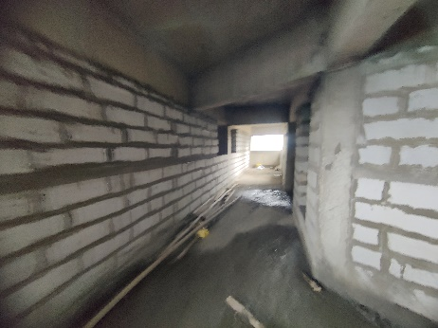
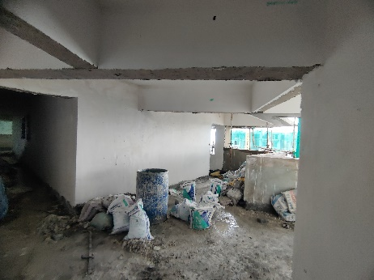
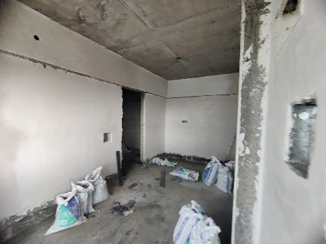
Rehab Building

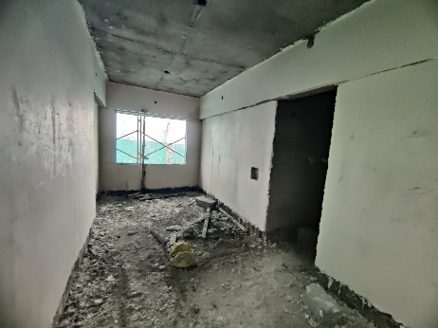
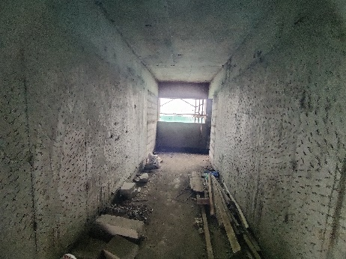
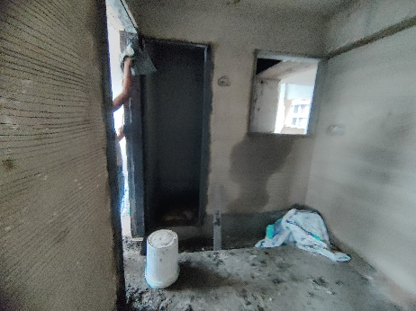
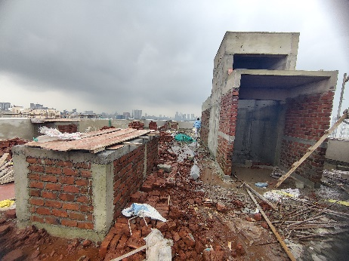
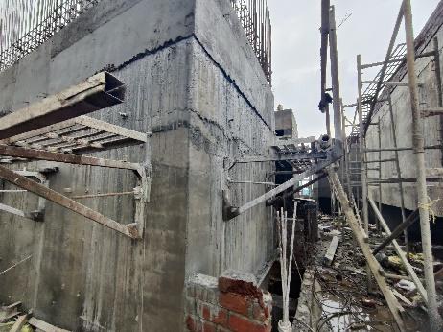
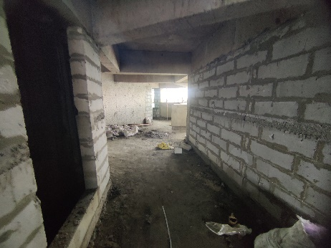
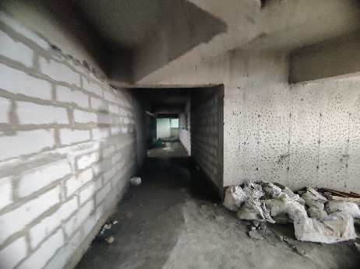
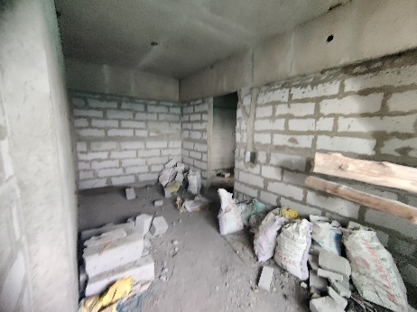
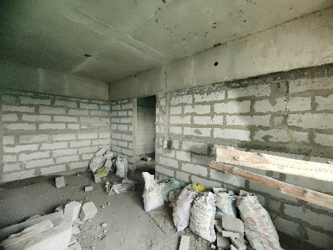
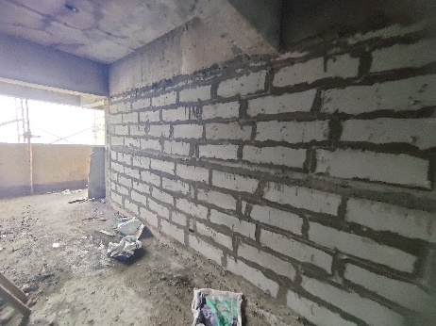
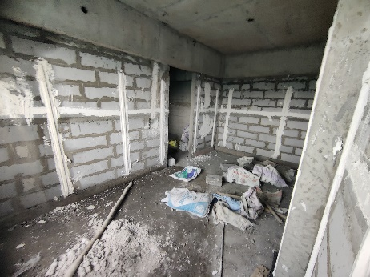
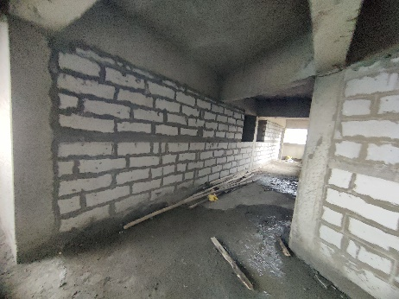
Actual Site Photographs As on 09.07.2024
Rehab Building
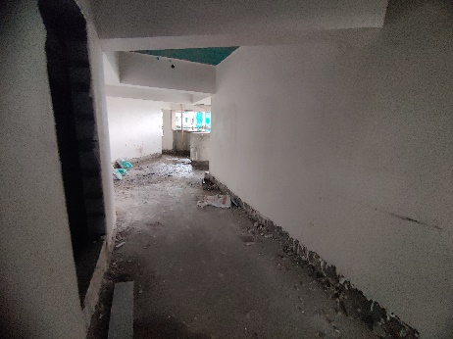
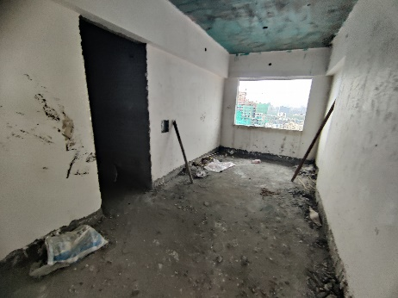
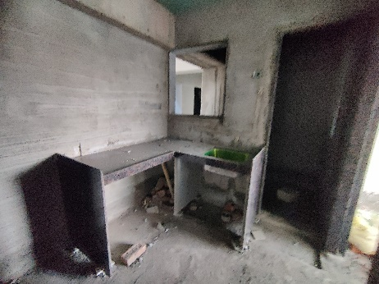
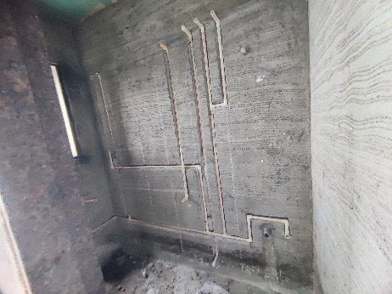
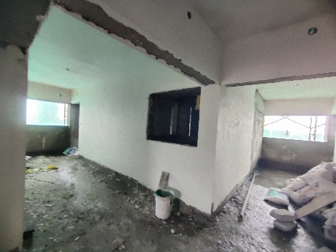
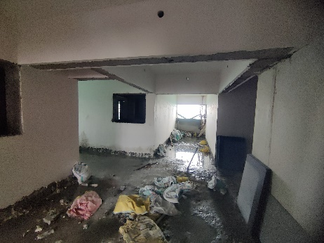
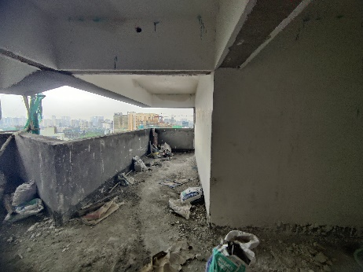
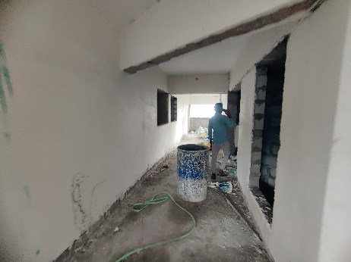
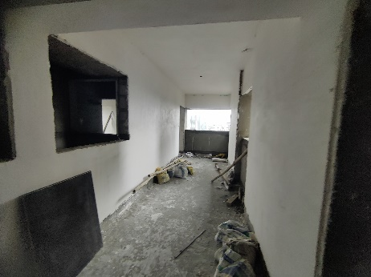
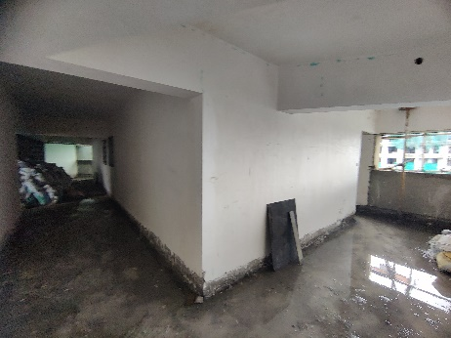
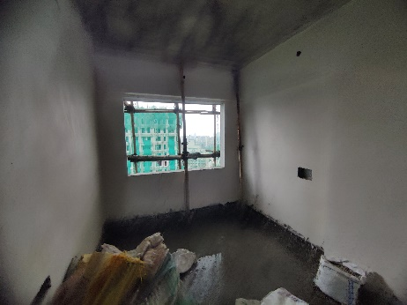
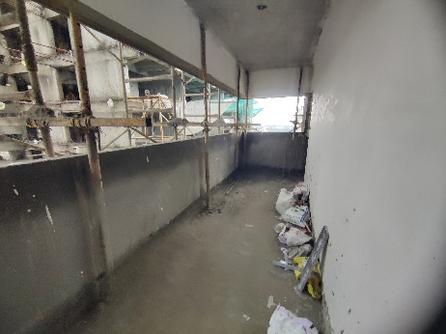
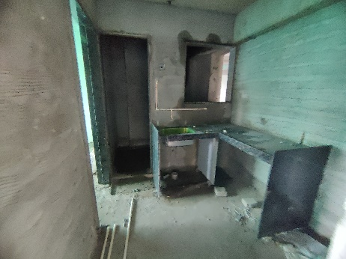
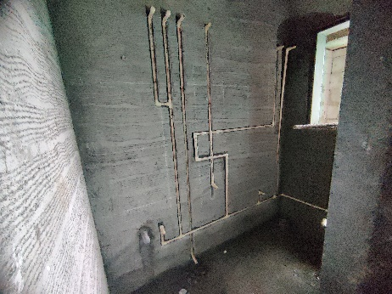
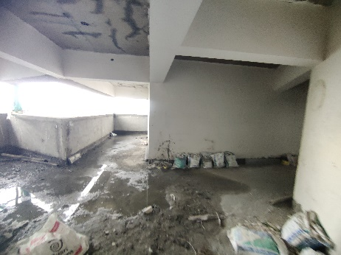
Actual Site Photographs As on 09.07.2024
Rehab Building
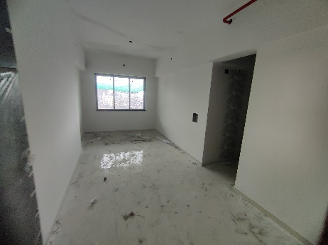
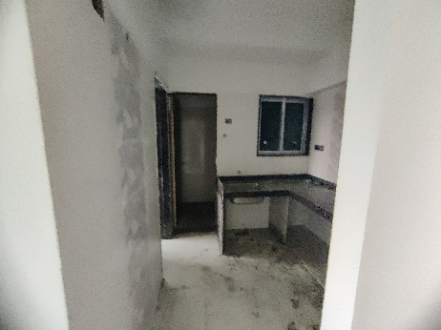
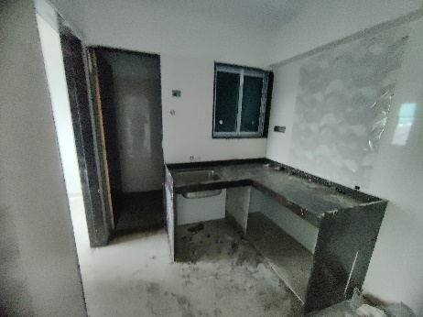
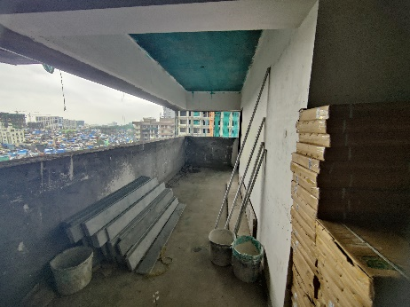
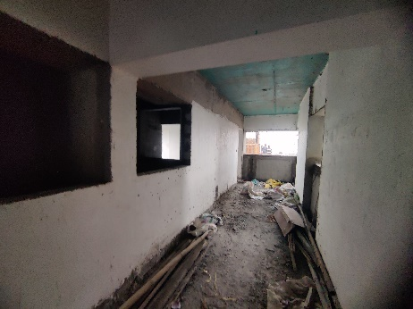
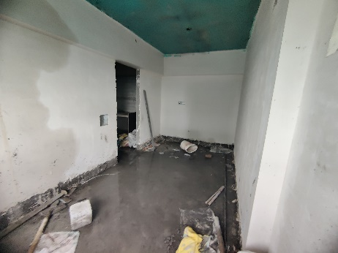
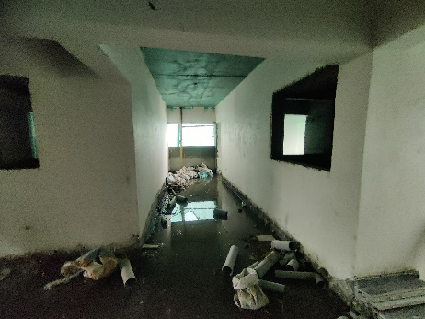
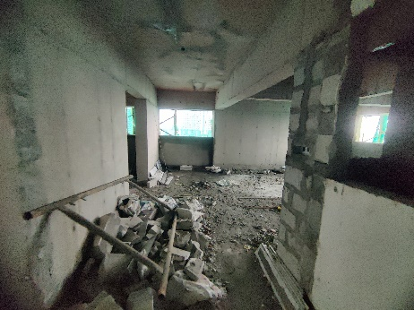
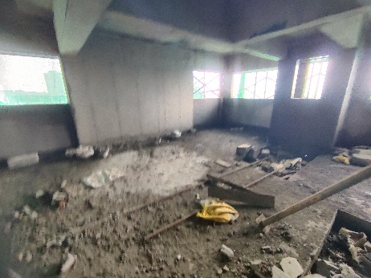
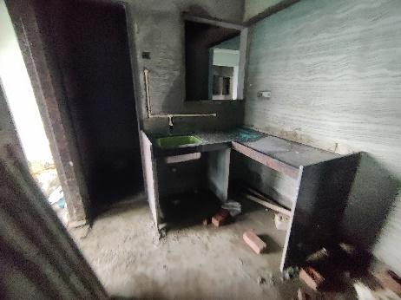
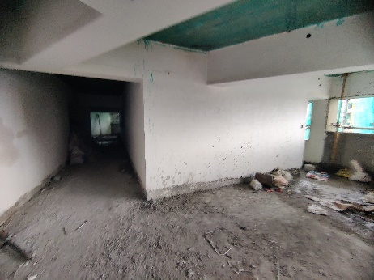
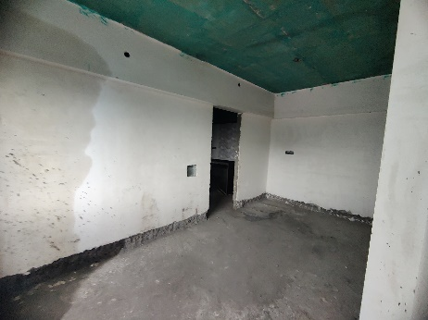
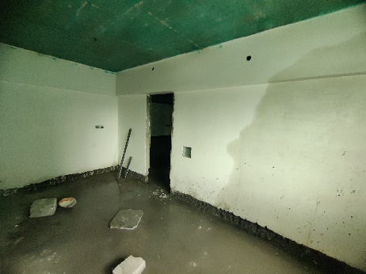
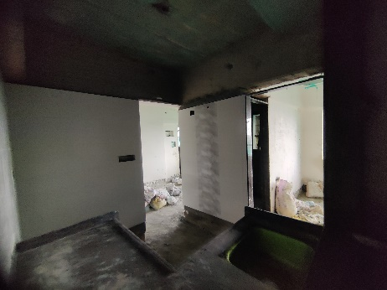
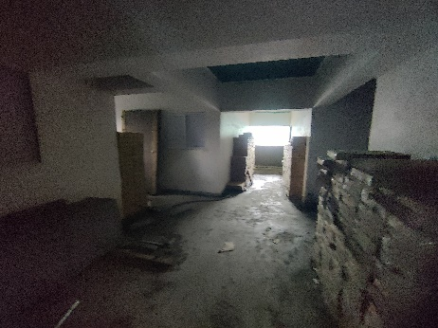
Actual Site Photographs As on 09.07.2024
Rehab Building
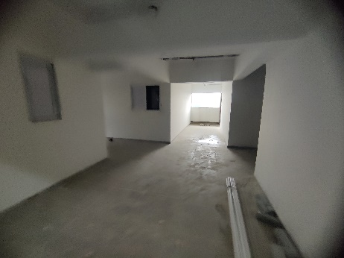
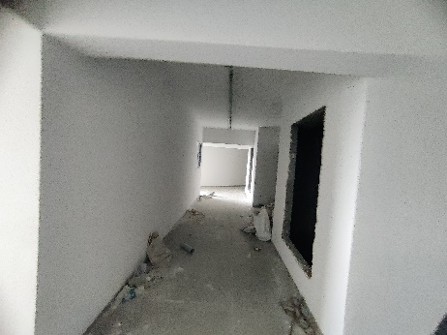
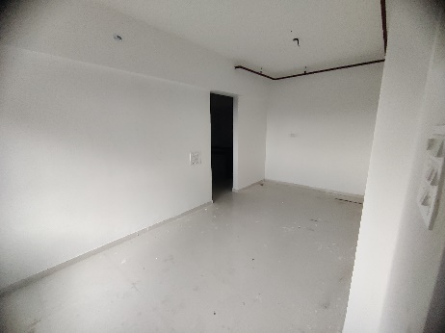

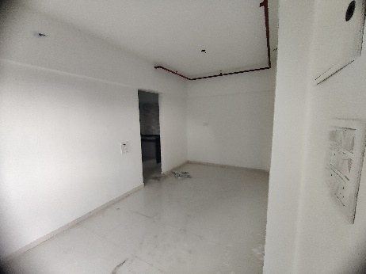
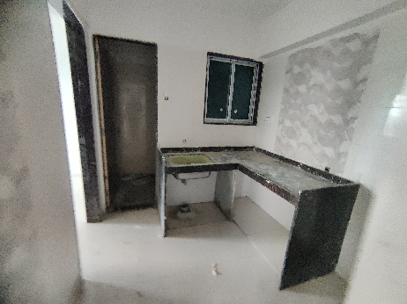
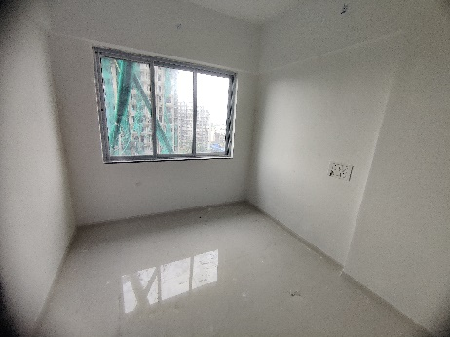

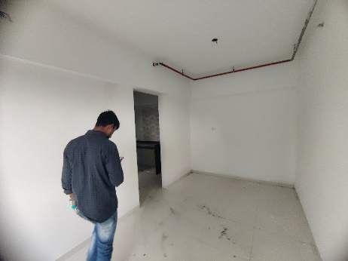
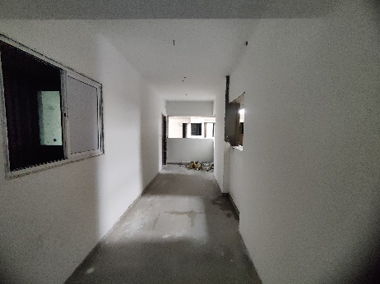
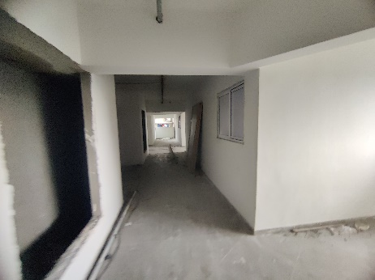

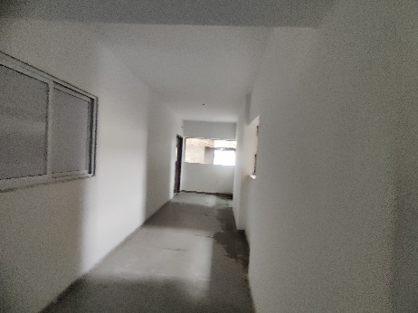
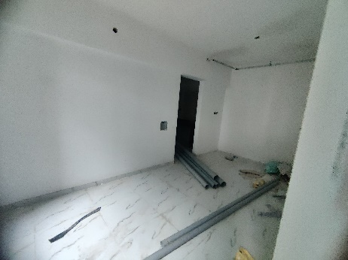
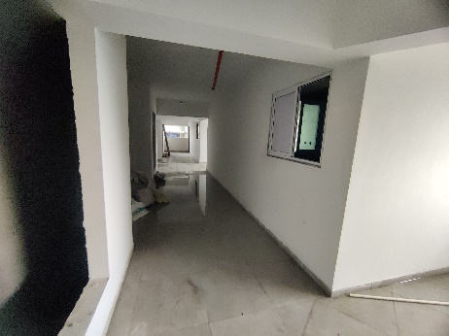

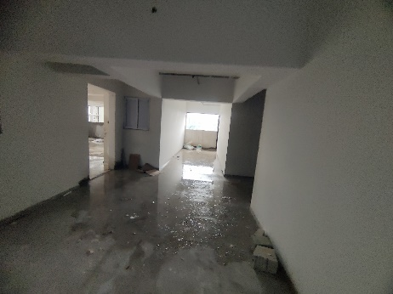
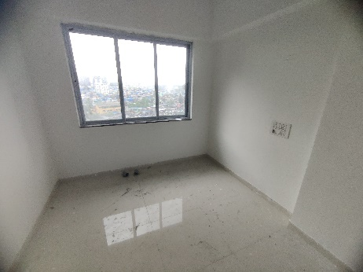
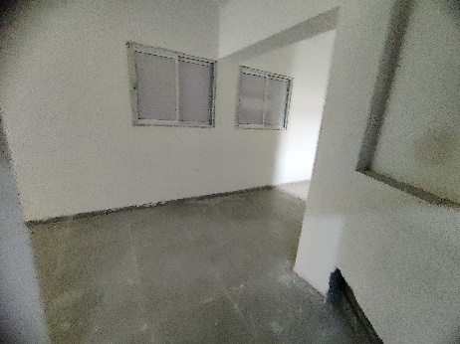

Actual Site Photographs As on 09.07.2024
Rehab Building
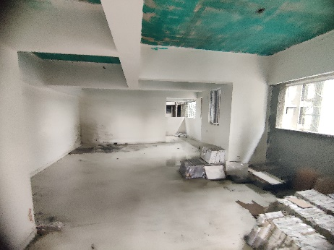
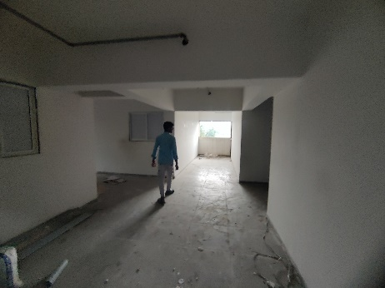
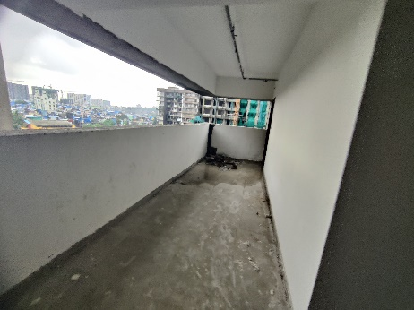
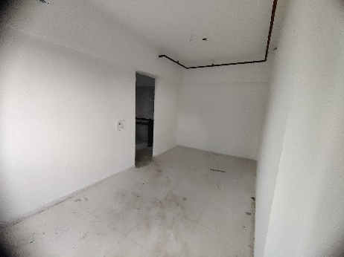
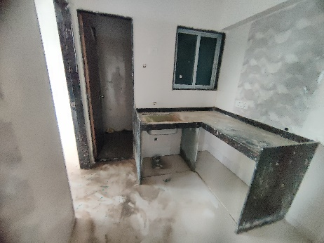
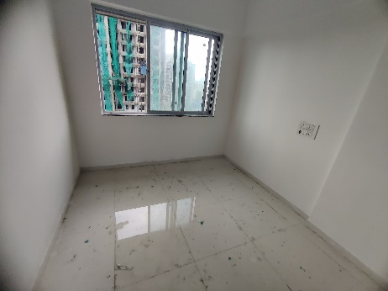
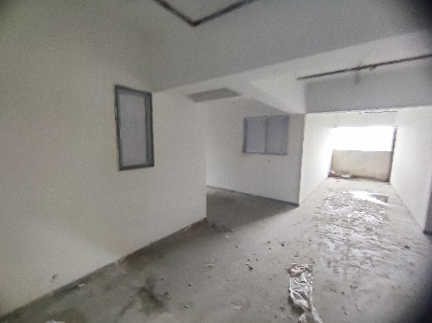
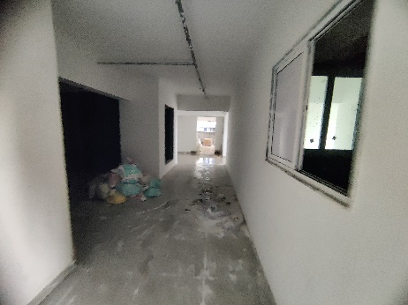
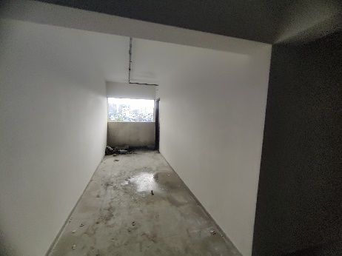
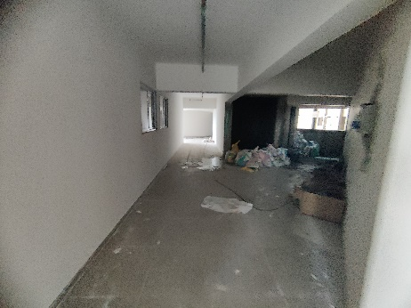
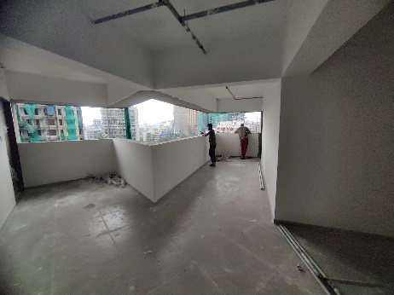
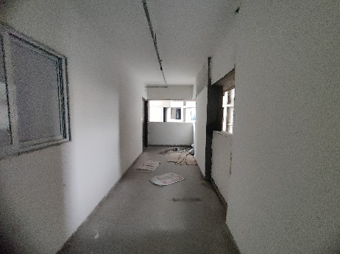
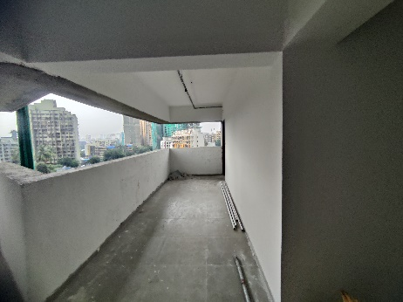
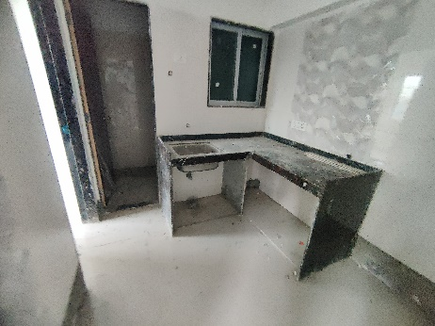
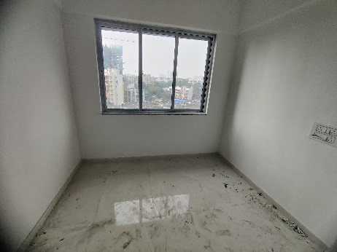
Actual Site Photographs As on 09.07.2024
Sale Building
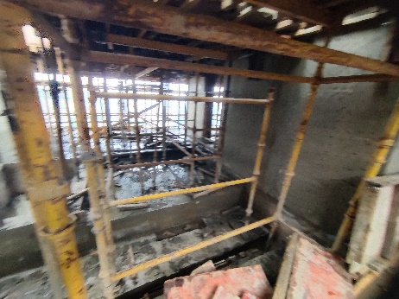
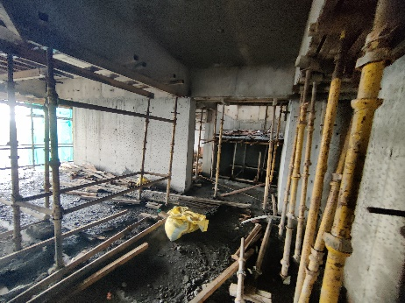
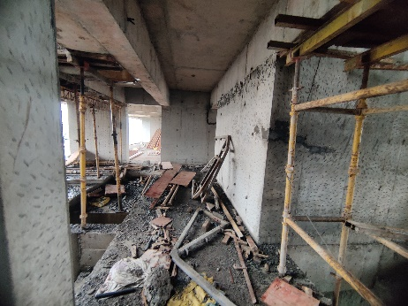
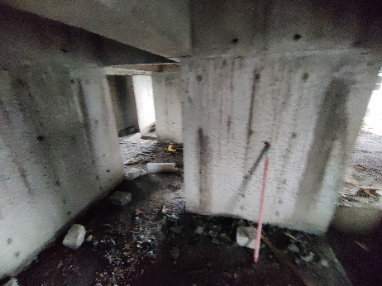
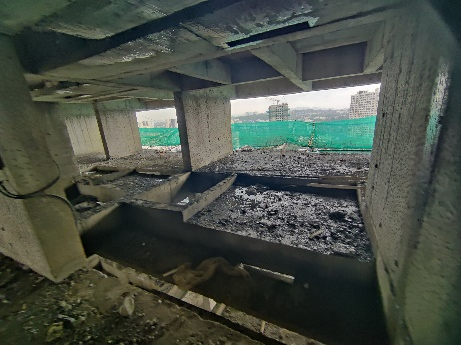
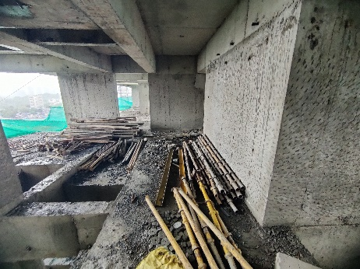
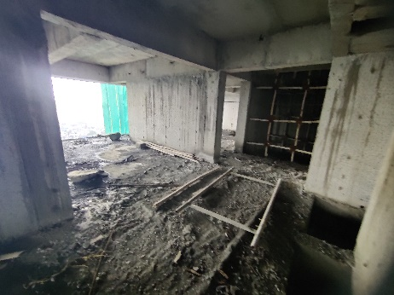
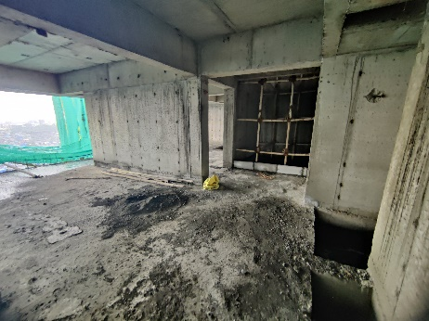
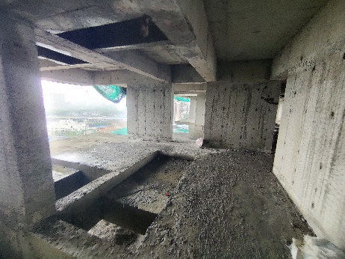
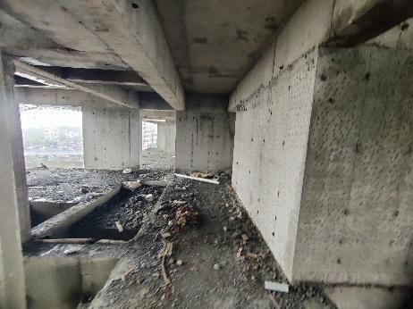
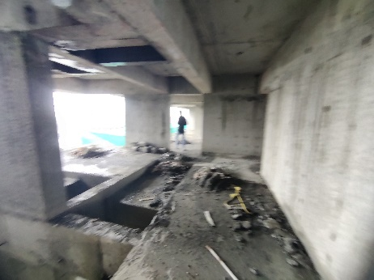
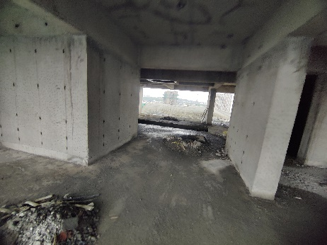
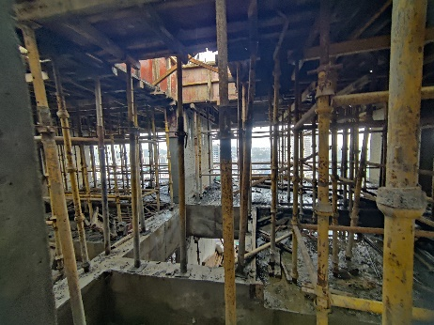
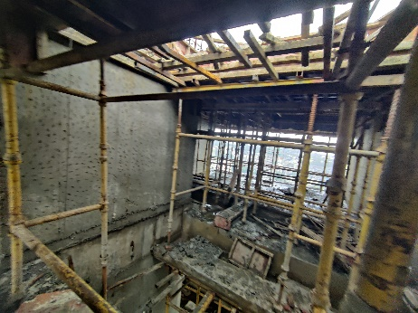
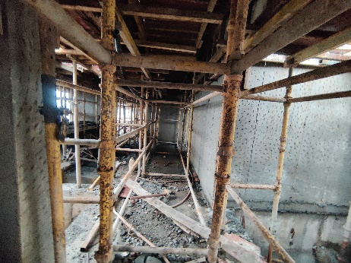
Actual Site Photographs As on 09.07.2024.
Sale Building
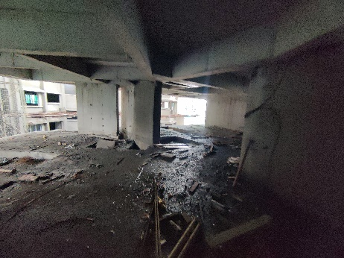
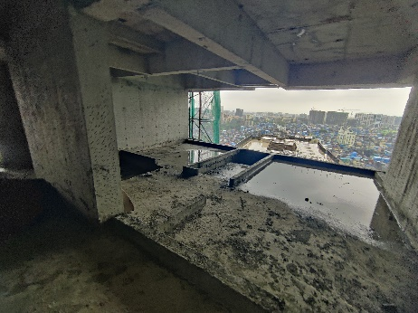
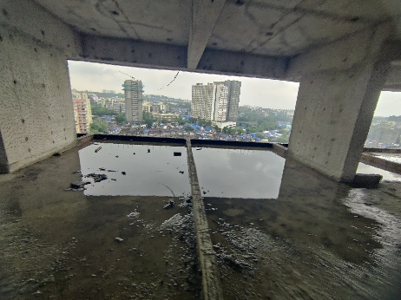
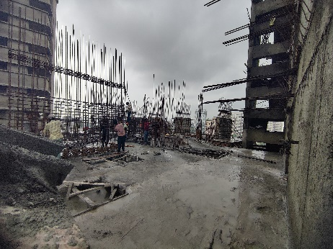
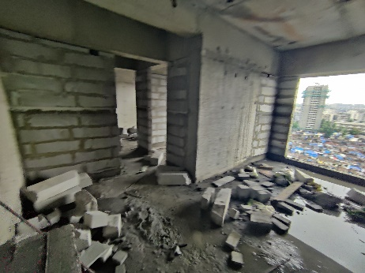
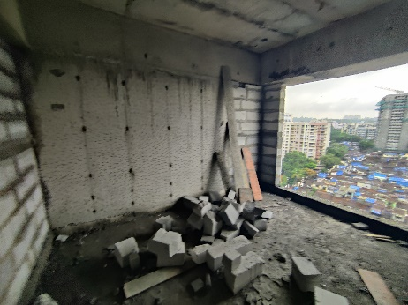
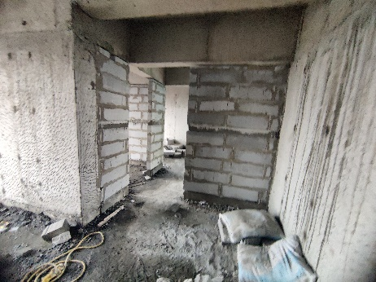
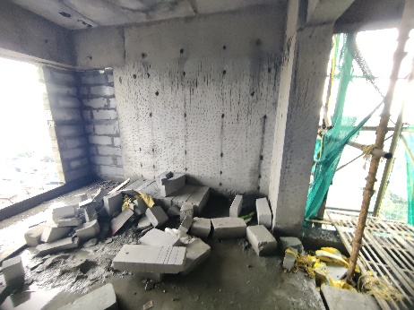
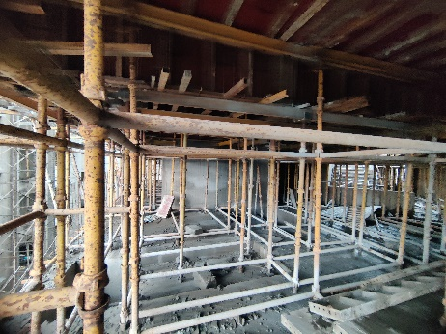
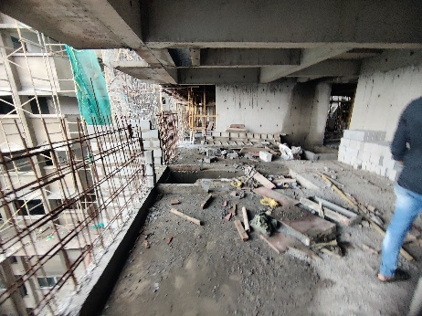
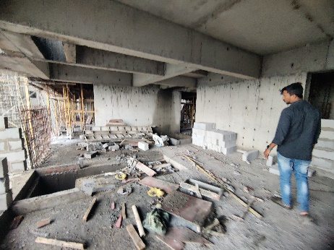
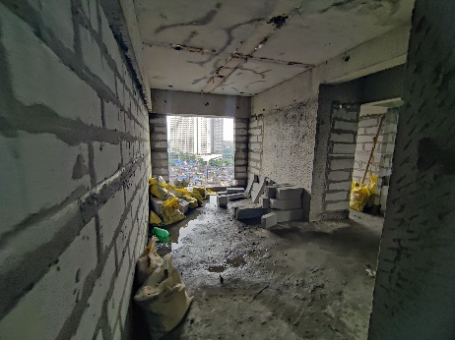
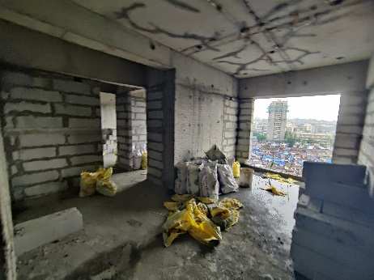
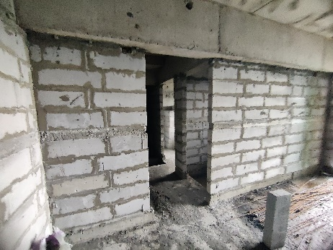
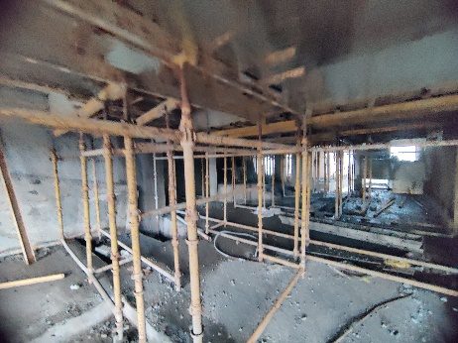
Actual Site Photographs As on 09.07.2024
Sale Building
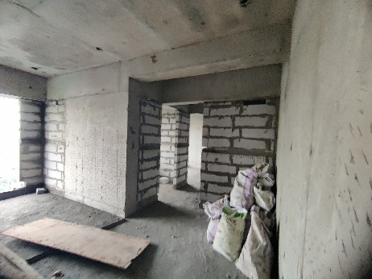
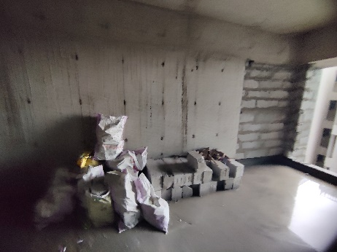
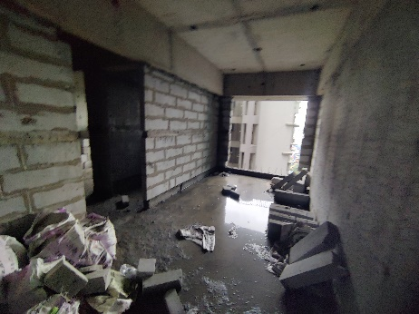
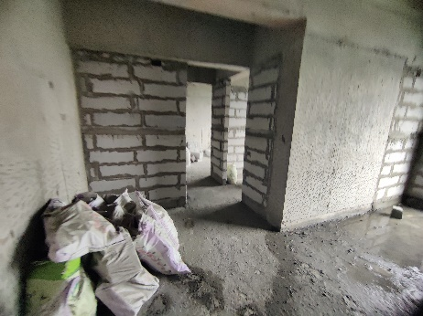
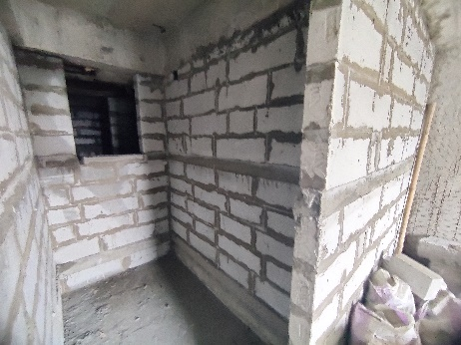
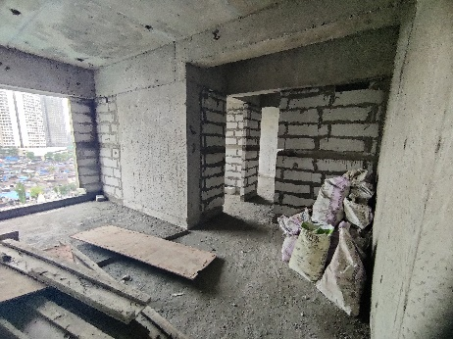
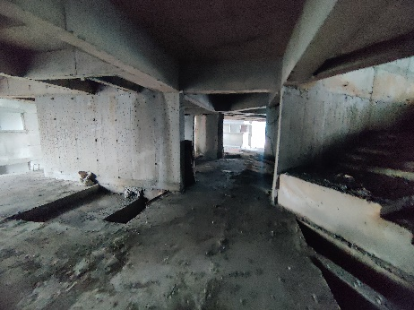
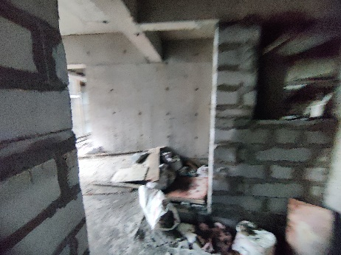
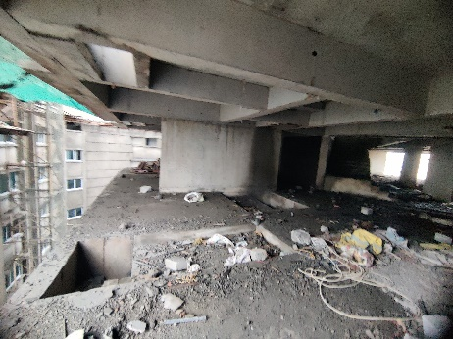
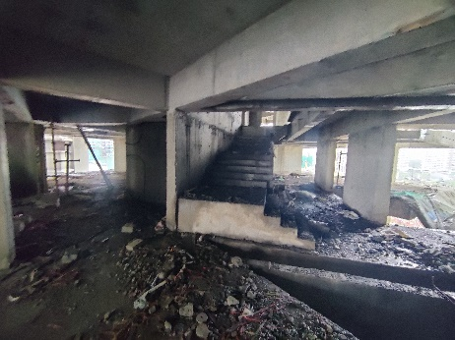
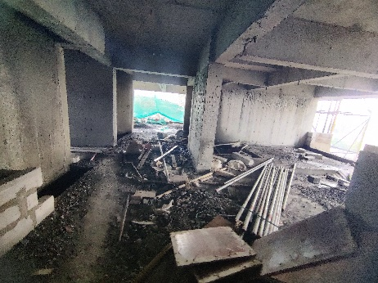
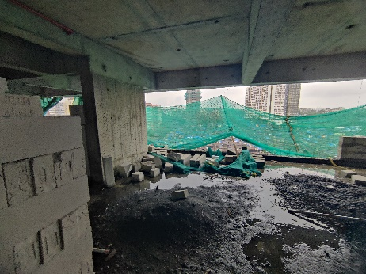
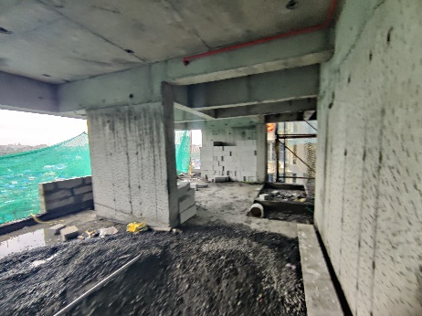
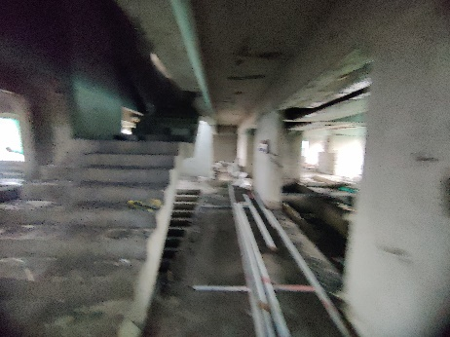
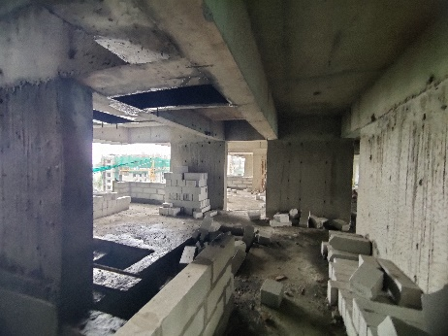
Actual Site Photographs As on 09.07.2024
Sale Building
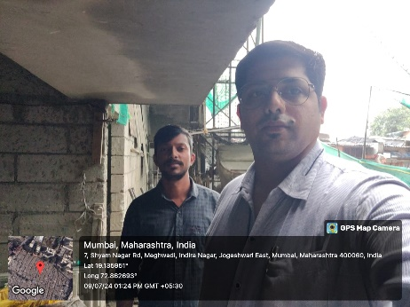
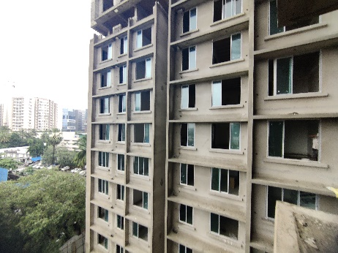
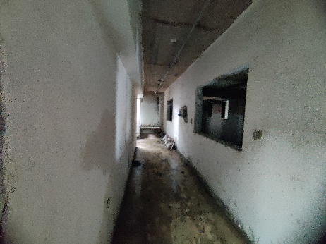
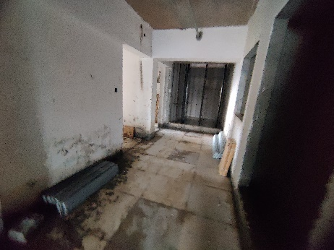
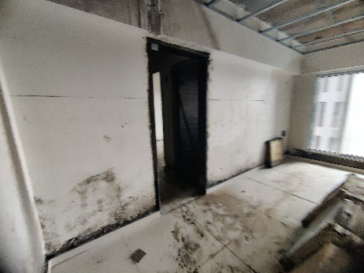
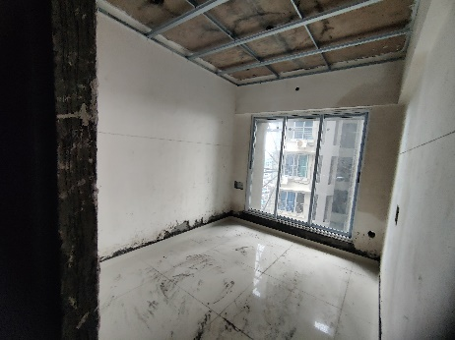
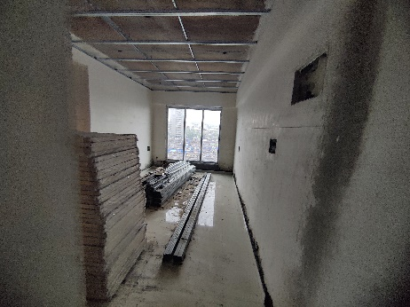
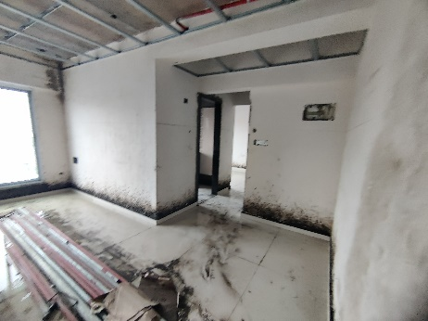
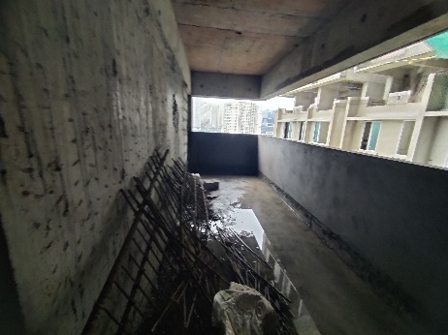
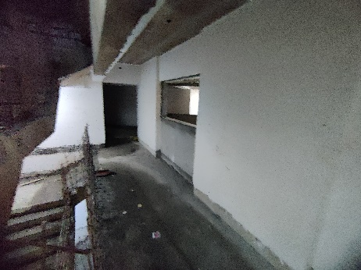
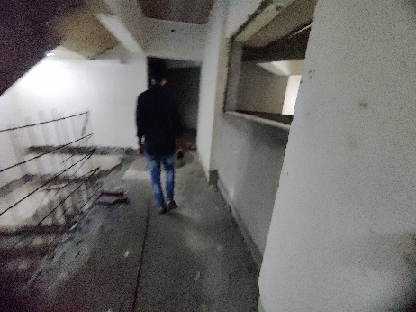
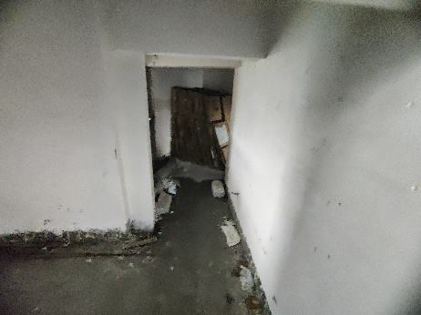
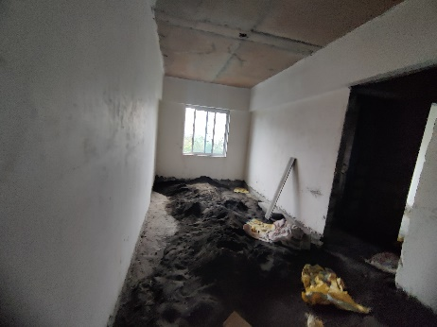
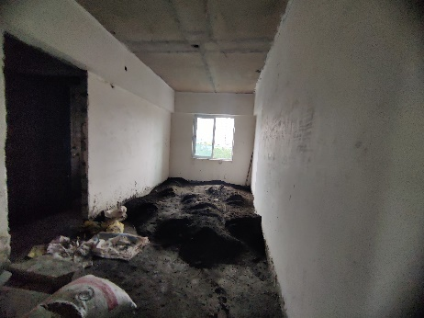
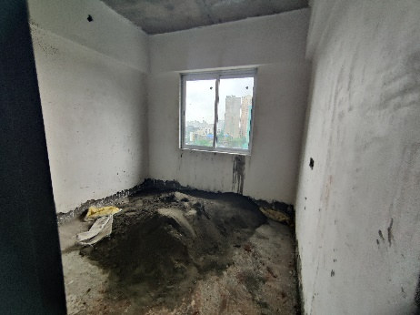
Route Map of the property
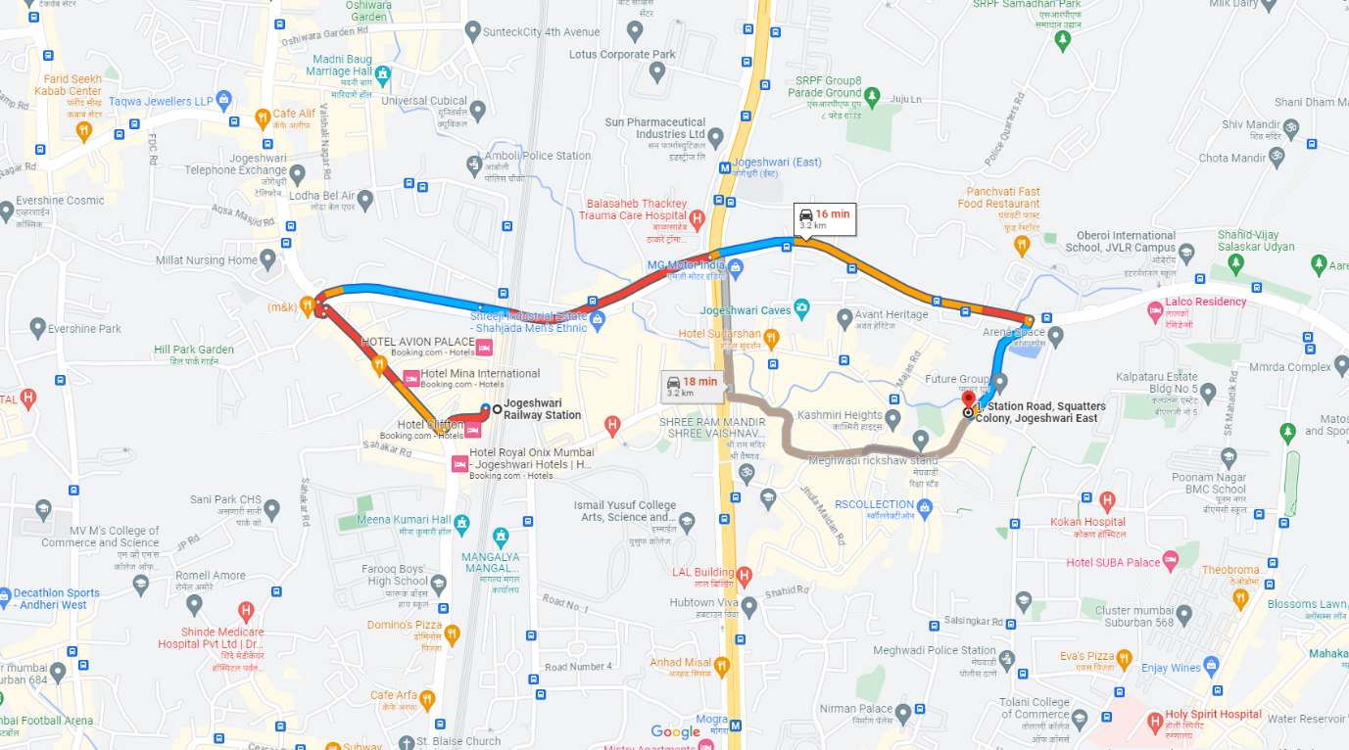
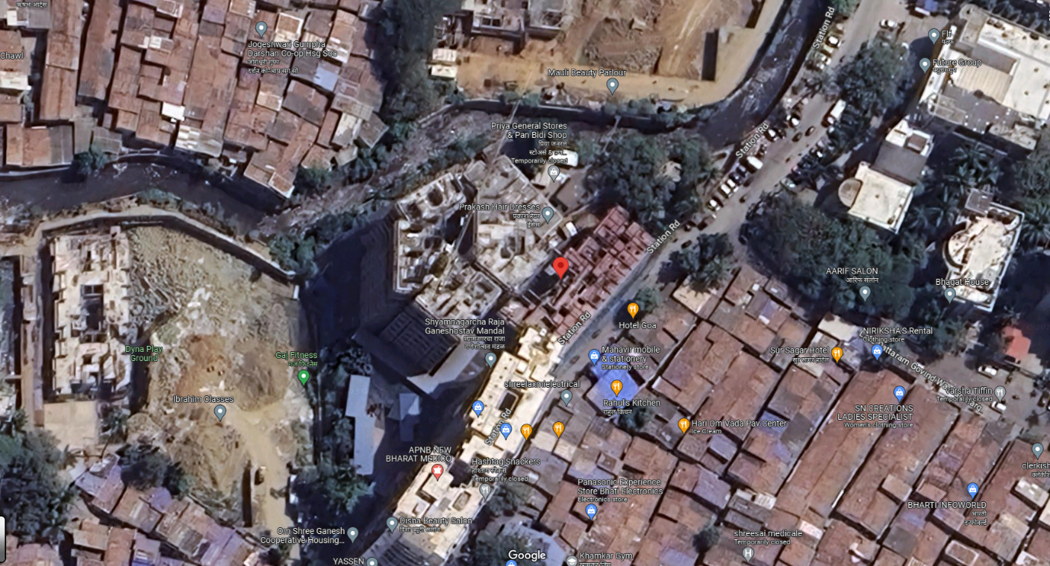
Site u/r

Latitude Longitude: 19°08'11.8"N 72°51'41.8"E

Note: The Blue line shows the route to site from nearest railway station (Jogeshwari – 3.20 Km.)
CA Certificate Dated 16.07.2024 till 30.06.2024
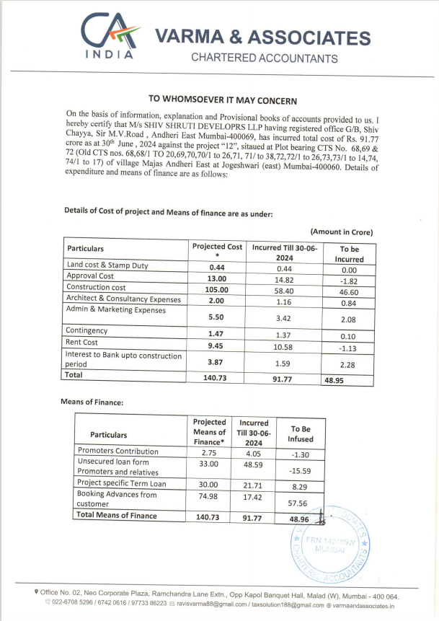

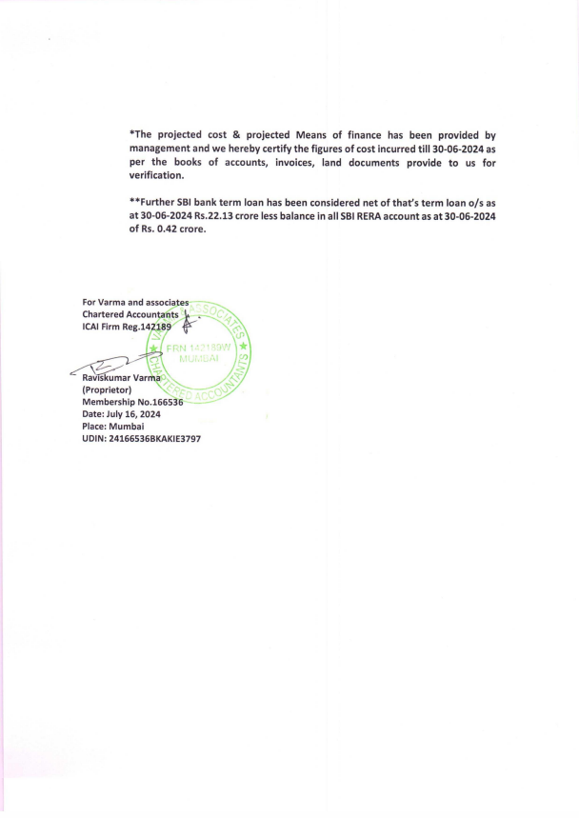
CA Certificate Dated 16.07.2024 till 30.06.2024

