6th LENDERS INDEPENDENT ENGINEER REPORT

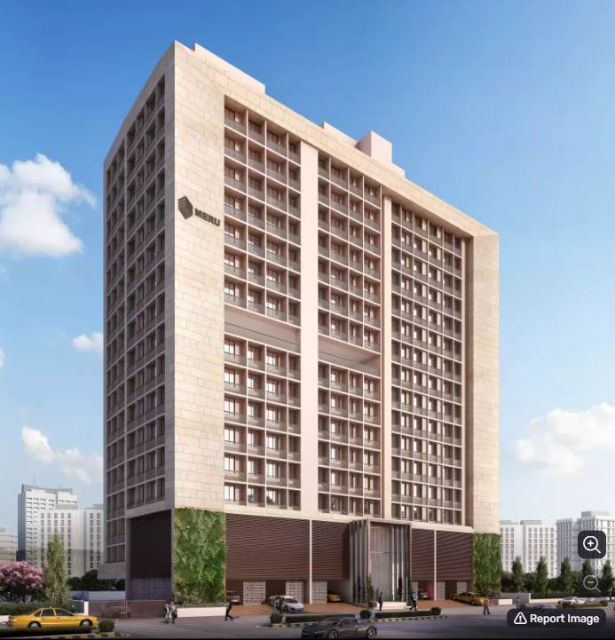

**Details of the property under consideration:**

**Name of Project: Yojan One**

**"Yojan One", Proposed Slum Rehabilitation Scheme Residential Building on plot bearing on**

**C.T.S. No.131 (pt),131/1 to 131/50, 131/52 to 131/84, Match Factory Lane, H.P.K Marg,**

**Village – Kurla (IV), Kurla (West), Mumbai, Pin Code – 400 070, State - Maharashtra, Country – India**

**Latitude Longitude: 19°04'08.2"N 72°52'33.2"E**

Valuation Prepared for:

State Bank of India

SME Chembur Branch

Unit No. 11, Building No. 11, Ground Floor, Corporate Park, Sion Trombay Road,

Chembur, Mumbai, Pin Code – 400 071, State - Maharashtra, Country – India

Vastu/SBI/Mumbai/07/2024/10152/2307397

25/08-401-PY

Date: - 25.07.2024

SIXTH LENDERS INDEPENDENT ENGINEER REPORT

**To,**

**State Bank of India**

SME Chembur Branch

Unit No. 11, Building No. 11,

Ground Floor, Corporate Park,

Sion Trombay Road, Chembur,

Mumbai, Pin Code – 400 071,

State - Maharashtra, Country – India

Subject: Construction of Proposed Slum Rehabilitation Scheme - Residential Building on plot bearing on C.T.S. No.131,131/1 to 131/50, 131/52 to 131/84 Match Factory Lane, H.P.K Marg, Village – Kurla (IV), Kurla (West), Mumbai, Pin Code – 400 070, State - Maharashtra, Country – India.

**Ref:** You’re Request for Lenders Independent Engineer Report of under Construction Building.

**Dear Sir,**

**The Construction work as per approved plan was in progress during the site visit on 03rd July 2024. Total expenditure occurred as on 30/06/2024 on this project by M/s. Meru Realty LLP is ` 64.70 Cr. & as per CA Certificate actual total expenditure occurred as on 30/06/2024 is ` 63.47 Cr. Hence, release of Balance Amount as requested by M/s. Meru Realty LLP is hereby recommended.**

**DECLARATION**

1. The information furnished in the report is based on our 6th site visit Dated 03/07/2024 & Document Provided by Client.
2. Vastukala 5th LIE Report dated 17.06.2024.
3. I have no direct and indirect interest in the property examined for report.
4. I have not been found guilty of misconduct in my professional capacity.

**Manoj B. Chalikwar**

Registered Valuer

Chartered Engineer (India)

Reg. No. IBBI/RV/07/2018/10366

Encl.: LIE report

# Purpose & Methodology

* State Bank of India Banks and financial institutions require monitoring & an independent review of the progress of the sanctioned projects
* **VCIPL** undertakes such study to independently review the progress of the project and put forward a comprehensive analysis

# Advantages:

* Assurance on present practices
* Identification of risk
* Analyzing the performance of third parties
* Recommendations

# The Methodology

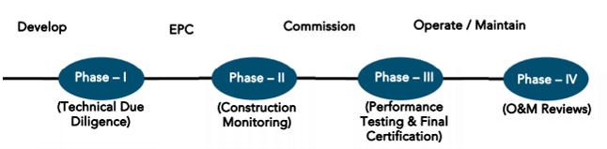

**SIXTH LENDERS INDEPENDENT ENGINEER REPORT**

**OF**

**"YOJAN ONE"**

**"Yojan One",** Proposed Slum Rehabilitation Scheme Residential Building on plot bearing on C.T.S. No.131 (pt),131/1 to 131/50, 131/52 to 131/84, Match Factory Lane, H.P.K Marg, Village – Kurla (IV), Kurla (West),

Mumbai, Pin Code – 400 070, State - Maharashtra, Country – India

**Latitude Longitude: 19°04'08.2"N 72°52'33.2"E**

**NAME OF DEVELOPER: M/s. Meru Realty LLP**

|  |
| --- |
| Pursuant to instructions from State of India, SME Chembur Branch, we have duly visited, inspected, surveyed & assessed the above said property on **03rd July 2024** to determine the fair & reasonable market value of the said property/project as on Quarter ending **30th June 2024** for LIE purpose.  **1. Location Details:**  Proposed Residential Building on plot bearing on C.T.S. No.131,131/1 to 131/50, 131/52 to 131/84 Match Factory Lane, H.P.K Marg, Village – Kurla (IV), Kurla (West), Mumbai, Pin Code – 400 070 It is about 850 M. tarvelling distance from Kurla Railway station. Surface transport to the property is by buses, taxis & private vehicles. The property is in developed locality. All the amenities like shops, banks, hotels, markets, schools, hospitals, etc. are all available in the surrounding locality. The area is higher middle class & developed. |

**2. Developer Details:**

|  |  |
| --- | --- |
| **Name of builder** | **M/s. Meru Realty LLP** |
| **Project Rera Registration Number** | **P51800028864** |
| **Registered office address** | Office No. 243, Behind Akshaya Jewellers, Opp. Kurla Police Staion, Sarveshwar Mandir Marg, Kurla (West), Mumbai, Pin Code – 400070, State - Maharashtra, Country – India |
| **Contact details** | **Contact Person:**  Mr. Arnik A. Shah (Director)  Mobile No. 9930084006 |
| **E – mail ID and website** | [merurealtyllp@gmail.com](mailto:merurealtyllp@gmail.com)  [www.merurealty.in](http://www.merurealty.in) |

**3. Boundaries of the Property:**

|  |  |
| --- | --- |
| **Direction** | **Particulars** |
| **On or towards North** | Manraj Heights |
| **On or towards South** | Slum Area |
| **On or towards East** | HP Keluskar Marg |
| **On or towards West** | Slum Area |

# Introduction

**As per Information on site M/s. Meru Realty LLP** has acquired land by Conveyance Deed dated 10.10.2017 admeasuring **area is 3,674.10 Sq. M.** bearing **C.T.S. No.131,131/1 to 131/50, 131/52 to 131/84 & 132.** For the Proposed Residential Building.

# Area Statement:

# Land:

|  |  |  |
| --- | --- | --- |
| **Date** | **Particular** | **Area in Sq. M.** |
| 10.10.2017 | C.T.S. No.131,131/1 to 131/50, 131/52 to 131/84 & 132 | 3,674.10 |
| TOTAL | | 3,674.10 |

1. Copy of Conveyance Deed dated 10.10.2017 b/w M/s. A. H. Wadia Trust (The Vendors) & M/s. Meru Realty LLP (The Purchasers)

# Building Area As per Approved Plan:

| **Sr. No.** | **Area Statement** | **Area in Sq. M.** |
| --- | --- | --- |
| **1** | Area of Plot | 3,248.10 |
| **a** | Area of Reservation in Plot |  |
| **b** | Area of Road Set Back | 261.19 |
| **c** | Area of DP Road | - |
| **2** | Ductions For |  |
| **A** | For Reservation / Road Area | - |
| **a** | Road Set Back Area to Be Handed Over (100%) (Regulation No. (16) | 261.19 |
| **b** | Proposed DP Road to Be Handed Over (100%)  (Regulation No. (16) | - |
| **c** | i) Reservation Area to Be Handed Over (100%) (Regulation No. (17) |  |
|  | ii) Reservation Area to Be Handed Over as Per AR (Regulation No. (17) | - |
| **B** | For Amenity Area | - |
| **a** | Area of Amenity Plots / Plots to Be Handed Over as Per DSR 14 A | - |
| **b** | Area of Amenity Plots / Plots to Be Handed Over as Per DSR 14 B | - |
| **c** | Area of Amenity Plots / Plots to Be Handed Over as Per DSR 35 (Abeyance) | - |
| **C** | Deduction For Existing BUA to Be Retained If Any / Land Component of Existing BUA/ Existing BUA as Per Regulation Under which the Development Was Allowed | - |
| **3** | Total Deduction [(2(A) +2(B)+2(C)] and when Applicable | 2,986.91 |
| **4** | Balance Area of Plot (1 Minus 3) | - |
| **5** | Plot Area Under Development After Area to Be Handed Over to MCGM / Applicable Authority as Per SR No. 4 Above | - |
| **6** | Zonal (Basic FSI (0.50 or 0.75 or 0.33) | - |
| **SR 1.1** | Minimum FSI to Be Attained as Per Clouse Use 3.8 of 33 (10) of DCPR 2034 | - |
| **SR 1.2** | Permissible FSI as Per 33(11)A | - |
| **7** | Built Up Area as Per Zonal (Basic) FSI (5X6) (In Case of Mill Land Permissible BUA / Keep in Abeyance |  |
| **8** | Built Up Equal to Area of Land Handed Over as Per Regulation 30 (A) |  |
|  | i) As Per 2(A) And 2 (B) Except 2(A) (C) ii) Above with In Cap of Permissible TDR as Column 6 of Table-12 On Remaining/ Balance Plot |  |
|  | ii) In Case of 2 (A)(C) ii) Permissible Over and Above Permissible BUA on Remaining/ Balance Plot. |  |
| **9** | Built Up Area In Lieu of Cost of Construction of Built-Up Amenity to Be Handed Over (Within the Limit of Premises BUA On Remaining Plot) |  |
| **10** | Built Up Area Due to Additional FSI on Payment of Premium as per Table No. 12 of Regulation No. 30 (A) On Remaining / Balance Plot |  |
| **11** | Built Up Area Due to Admissible TDR as Per Table No. 12 of Regulation NC 30 (A) And 32 On remaining / Balance Plot |  |
| **12** | Permissible Built-Up Area (As the Case May Be with / without BUA as Per 2 (C) |  |
| **SR 2.1** | Proposed Built Up Area of Rehab | 4,903.76 |
|  | Rehab Component | 5,945.47 |
|  | Permissible Sale Component (Incentive x Rehab Component) 5945.64 X 1.10 | 5945.64 X 1.10 |
| **SR 2.2** | Permissible Built-Up Transit Tenements for SRA / of Total Additional BUA |  |
|  | Permissible BUA for Sale Components of Total Additional BUA | 6,540.02 |
| **SR 3** | Total BUA Sanctioned for The Project | 11,443.78 |
| **13** | Proposed BUA (As the Case May Be with / Without BUA as Per 2C |  |
| **SR 4.1** | Total BUA Proposed to Be Consumed In Situ |  |
| **SR 4.1** | Proposed BUA for Transit Tenements For SRA/Of Total Additional BUA |  |
|  | Proposed BUA for Sale Component of Total Additional BUA | 6,540.02 |
| **14** | TDR Generate If Any as Per Regulation No. 30 (A) And 32 |  |
| **SR 5** | TDR Generate in Schedule |  |
| **15** | Fungible Compensatory Area as Per Regulation No. 31(3) |  |
| **a** | i) Permissible Fungible Compensatory Area for Rehab Component Without Charging Premium | 1,716.52 |
|  | ii) Fungible Compensatory Area Availed for Rehab Component Without Charging Premium | 155.52 |
| **b** | i) Permissible Fungible Compensatory Area by Charging Premium for Sale | 2,289.00 |
|  | ii) Fungible Compensatory Area Availed on Payment of Premium for Sale | 2,283.29 |
| **16** | i) Total BUA Including Fungible for Rehab Component |  |
| **SR 6** | ii) Total BUA Including Fungible for Sale Component | 8,823.31 |
|  | Total Built Up Area Proposed Including Fungible Compensatory Area [13 + 15 (a) (ii) + 15 (b)(ii)] |  |
| **17** | FSI Consumed on Net Plot 13 SR 4.1 / 4 |  |

# List of Approvals:

1. Copy of IOD Plan for Rehab Building No. L/PVT/0076/20180604/LOI dated 28.08.2020 issued by Slum Rehabilitation Authority (SRA).
2. Copy of Approved Plan for Rehab Building No. L/PVT/0076/20180604/AP/R dated 15.09.2020 issued by Slum Rehabilitation Authority (SRA).

**Approval Up to: Basement + Ground Floor + 1st to 15th Upper Floors**

1. Copy of Amended Approved Plan for Rehab Building No. SRA/ENG/L/PVT/0076/20180604/AP/R dated 24.08.2023 issued by Slum Rehabilitation Authority (SRA).

**Approval Up to: Basement + Ground Floor + 1st to 17th Upper Floors**

1. Copy of 1st Commencement Certificate for Rehab Building No. L/PVT/0076/20180604/AP/R dated 29.01.2021 issued by Slum Rehabilitation Authority (SRA).

**(This CC is now endorsed for the work of Plinth Level)**

1. Copy of 2nd Commencement Certificate for Rehab Building No. L/PVT/0076/20180604/AP/R dated 29.06.2021 issued by Slum Rehabilitation Authority (SRA).

**(This CC is now endorsed for the work of Basement + Ground Floor + 1st to 15th Upper Floors including OHT& LMR)**

1. Copy of IOD Plan for Sale Building No. L/PVT/0076/20180604/AP/S dated 15.09.2020 issued by Slum Rehabilitation Authority (SRA).
2. Copy of Approved Plan for Sale Building No. L/PVT/0076/20180604/AP/LAY dated 24.11.2020 issued by Slum Rehabilitation Authority (SRA).

**Approval Up to: Ground Floor + 1st to 11th Upper Floors**

1. Copy of 1st Amended Approved Plan for Sale Building No. L/PVT/0076/20180604/AP/S dated 14.10.2021 issued by Slum Rehabilitation Authority (SRA).

**Approval Up to: Ground Floor + 1st to 16th Upper Floors**

1. Copy of 2nd Amended Approved Plan for Sale Building No. SRA/ENG/L/PVT/0076/2018/0604/AP/S dated 23.01.2023 issued by Slum Rehabilitation Authority (SRA).

**Approval Up to: Ground Floor + 1st to 16th Upper Floors**

1. Copy of 3rd Amended Approved Plan for Sale Building No. L/PVT/0076/20180604/AP/S dated 24.08.2023 issued by Slum Rehabilitation Authority (SRA).

**Approval Up to: Ground Floor + 1st to 14th Upper Floors**

1. Copy of Concession Plan for Sale dated 23.01.2023 issued by Slum Rehabilitation Authority (SRA).

**Approval Up to: Ground Floor + 1st to 16th Upper Floors**

1. Copy of 1st Commencement Certificate for Sale Building No. L/PVT/0076/20180604/AP/S dated 10.02.2021 issued by Slum Rehabilitation Authority (SRA).

**(This CC is now endorsed for the work of Plinth level)**

1. Copy of 2nd Commencement Certificate for Sale Building No. L/PVT/0076/20180604/AP/S dated 25.10.2021 issued by Slum Rehabilitation Authority (SRA).

**(This CC is now endorsed for the work of Ground Floor + 1st to 3rd Upper Floors)**

1. Copy of 3rd Commencement Certificate for Sale Building No. L/PVT/0076/20180604/AP/S dated 23.01.2023 issued by Slum Rehabilitation Authority (SRA).

**(This CC is now endorsed for the work of Ground Floor + 1st to 6th Upper Floors)**

1. Copy of 4th Commencement Certificate for Sale Building No. L/PVT/0076/20180604/AP/S dated 05.09.2023 issued by Slum Rehabilitation Authority (SRA).

**(This CC is now endorsed for the work of Ground Floor + 1st to 10th Upper Floors)**

1. Copy of 5th Commencement Certificate for Sale Building No. L/PVT/0076/20180604/AP/S dated 07.03.2024 issued by Slum Rehabilitation Authority (SRA).

**(This CC is now endorsed for the work of Ground Floor + 1st to 14th Upper Floors + OWH Tank + LMR room as per amended approved plans 24.08.2023)**

# LEVEL OF COMPLETION:

# REHAB BUILDING

| Sr. No | Floor Nos. | Construction Area  in Sq. M. | Completed Area in Sq. M. | Work Completion as on 5th LIE Report | Work Completion as on 03.07.2024 |
| --- | --- | --- | --- | --- | --- |
| 1 | Deep Excavation  & Piling Work |  |  | Excavation & Piling work is completed | Excavation & Piling work is completed |
| 2 | **Basement** | 508.14 | 508.14 | Slab work, Block work Plaster work & Electrical conducting work are completed | Slab work, Block work Plaster work & Electrical conducting work are completed |
| 3 | **Ground Floor** | 458.54 | 458.54 | Slab work, Block work Plaster work & Electrical conducting work are completed | Slab work, Block work Plaster work & Electrical conducting work are completed |
| 4 | **1st Floor** | 464.21 | 464.21 | Slab work, Block work, Plaster work, Door & Window Frame, Kitchen Platform, Gypsum work, toilet dadoing work & electrical conducting work are completed | Slab work, blockwork, Plasterwork, Firefighting, Waterproofing, Kitchen Platform, Flooring, Kitchen & Toilet tiling, Doors & Windows are installed Plumbing work, Electrical concealed work is completed |
| 5 | **2nd Floor** | 457.14 | 457.14 | Slab work, blockwork, Plasterwork, Firefighting, Waterproofing, Kitchen Platform, Door & Window Frame work, Plumbing work, Gypsum work, 10 Flats flooring work is completed | Slab work, blockwork, Plasterwork, Firefighting, Waterproofing, Kitchen Platform, Flooring, Kitchen & Toilet tiling, Doors & Windows are installed Plumbing work, Electrical concealed work is completed |
| 6 | **3rd Floor** | 453.64 | 453.64 | Slab work, blockwork, Plasterwork, Firefighting, Waterproofing, Kitchen Platform, Door & Window Frame work, Plumbing work, Gypsum work, 10 Flats flooring work is completed | Slab work, blockwork, Plasterwork, Firefighting, Waterproofing, Kitchen Platform, Flooring, Kitchen & Toilet tiling, Doors & Windows are installed Plumbing work, Electrical concealed work is completed |
| 7 | **4th Floor** | 453.64 | 453.64 | Slab work, blockwork, Plasterwork, Firefighting, Waterproofing, Kitchen Platform, Door & Window Frame work, Plumbing work, Gypsum work, 10 Flats flooring work is completed | Slab work, blockwork, Plasterwork, Firefighting, Waterproofing, Kitchen Platform, Flooring, Kitchen & Toilet tiling, Doors & Windows are installed Plumbing work, Electrical concealed work is completed |
| 8 | **5th Floor** | 453.64 | 453.64 | Slab work, blockwork, Plasterwork, Firefighting, Waterproofing, Kitchen Platform, Door & Window Frame work, Plumbing work, Gypsum work, 10 Flats flooring work is completed | Slab work, blockwork, Plasterwork, Firefighting, Waterproofing, Kitchen Platform, Flooring, Kitchen & Toilet tiling, Doors & Windows are installed Plumbing work, Electrical concealed work is completed |
| 9 | **6th Floor** | 453.64 | 453.64 | Slab work, blockwork, Plasterwork, Firefighting, Waterproofing, Kitchen Platform, Door & Window Frame work, Plumbing work, Gypsum work, 10 Flats flooring work is completed | Slab work, blockwork, Plasterwork, Firefighting, Waterproofing, Kitchen Platform, Flooring, Kitchen & Toilet tiling, Doors & Windows are installed Plumbing work, Electrical concealed work is completed |
| 10 | **7th Floor** | 453.64 | 453.64 | Slab work, blockwork, Plasterwork, Firefighting, Waterproofing, Kitchen Platform, Door & Window Frame work, Plumbing work, Gypsum work, 10 Flats flooring work is completed | Slab work, blockwork, Plasterwork, Firefighting, Waterproofing, Kitchen Platform, Flooring, Kitchen & Toilet tiling, Doors & Windows are installed Plumbing work, Electrical concealed work is completed |
| 11 | **8th Floor** | 456.64 | 456.64 | Slab work, blockwork, Plasterwork, Firefighting, Waterproofing, Kitchen Platform, Door & Window Frame work, Plumbing work, Gypsum work, 10 Flats flooring work is completed | Slab work, blockwork, Plasterwork, Firefighting, Waterproofing, Kitchen Platform, Flooring, Kitchen & Toilet tiling, Doors & Windows are installed Plumbing work, Electrical concealed work is completed |
| 12 | **9th Floor** | 453.64 | 453.64 | Slab work, blockwork, Plasterwork, Firefighting, Waterproofing, Kitchen Platform, Door & Window Frame work, Plumbing work, Gypsum work, 10 Flats flooring work is completed | Slab work, blockwork, Plasterwork, Firefighting, Waterproofing, Kitchen Platform, Flooring, Kitchen & Toilet tiling, Doors & Windows are installed Plumbing work, Electrical concealed work is completed |
| 13 | **10th Floor** | 453.64 | 453.64 | Slab work, blockwork, Plasterwork, Firefighting, Waterproofing, Kitchen Platform, Door & Window Frame work, Plumbing work, Gypsum work, 10 Flats flooring work is completed | Slab work, blockwork, Plasterwork, Firefighting, Waterproofing, Kitchen Platform, Flooring, Kitchen & Toilet tiling, Doors & Windows are installed Plumbing work, Electrical concealed work is completed |
| 14 | **11th Floor** | 453.64 | 453.64 | Slab work, blockwork, Plasterwork, Firefighting, Waterproofing, Kitchen Platform, Door & Window Frame work, Plumbing work, Gypsum work, 10 Flats flooring work is completed | Slab work, blockwork, Plasterwork, Firefighting, Waterproofing, Kitchen Platform, Flooring, Kitchen & Toilet tiling, Doors & Windows are installed Plumbing work, Electrical concealed work is completed |
| 15 | **12th Floor** | 453.64 | 453.64 | Slab work, blockwork, Plasterwork, Firefighting, Waterproofing, Kitchen Platform, Door & Window Frame work, Plumbing work, Gypsum work, 10 Flats flooring work is completed | Slab work, blockwork, Plasterwork, Firefighting, Waterproofing, Kitchen Platform, Flooring, Kitchen & Toilet tiling, Doors & Windows are installed Plumbing work, Electrical concealed work is completed |
| 16 | **13th Floor** | 453.64 | 453.64 | Slab work, blockwork, Plasterwork, Firefighting, Waterproofing, Kitchen Platform, Door & Window Frame work, Plumbing work is completed, Gypsum work is in progress | Slab work, blockwork, Plasterwork, Firefighting, Waterproofing, Kitchen Platform, Flooring, Kitchen & Toilet tiling, Doors & Windows are installed Plumbing work, Electrical concealed work is completed |
| 17 | **14th Floor** | 453.64 | 453.64 | Slab work, blockwork, Plasterwork, Firefighting, Waterproofing, Kitchen Platform, Door & Window Frame work, Plumbing work is completed, Gypsum work is in progress | Slab work, blockwork, Plasterwork, Firefighting, Waterproofing, Kitchen Platform, Flooring, Kitchen & Toilet tiling, Doors & Windows are installed Plumbing work, Electrical concealed work is completed |
| 18 | **15th Floor** | 306.54 | 306.54 | Slab work, blockwork, Plasterwork, Firefighting, Waterproofing, Kitchen Platform, Door & Window Frame work, Plumbing work is completed, Gypsum work is in progress | Slab work, blockwork, Plasterwork, Firefighting, Waterproofing, Kitchen Platform, Flooring, Kitchen & Toilet tiling, Doors & Windows are installed Plumbing work, Electrical concealed work is completed |
| 19 | **16th Floor** | - | - | Slab work, blockwork, Plasterwork, Firefighting, Waterproofing, Kitchen Platform, Door & Window Frame work, Plumbing work is completed, Gypsum work is in progress | Slab work, blockwork, Plasterwork, Firefighting, Waterproofing, Kitchen Platform, Flooring, Kitchen & Toilet tiling, Doors & Windows are installed Plumbing work, Electrical concealed work is completed |
| 20 | **17th Floor** | - | - | Slab work, blockwork, Plasterwork, Firefighting, Waterproofing, Kitchen Platform, Door & Window Frame work, Plumbing work is completed | Slab work, blockwork, Plasterwork, Firefighting, Waterproofing, Kitchen Platform, Flooring, Kitchen & Toilet tiling, Doors & Windows are installed Plumbing work, Electrical concealed work is completed |
| 21 | **Terrace** | 39.15 | 39.15 | Slab work, Blockwork, Plasterwork, waterproofing, parapet wall work is completed | Slab work, Blockwork, Plasterwork, waterproofing, parapet wall, flooring work is completed, Tank material is available at site. |
| 22 | **No. Parking** | 24.00 |  |  |  |
|  | **Total** | **7,680.40** | **7,680.40** |  |  |

# SALE BUILDING

|  |  |  |  |  |  |
| --- | --- | --- | --- | --- | --- |
| Sr. No | Floor Nos. | Construction Area in Sq. M. | Completed Area in Sq. M. | Work Completion as on 5th LIE Report | Work Completion as on 03.07.2024 |
| 1 | **Deep Excavation**  **& Piling Work** |  |  | Excavation & Piling work is completed | Excavation & Piling work is completed |
| 2 | **Ground Floor** | 948.93 | 948.93 | Slab work is completed | Slab work is completed |
| 3 | **1st Floor** | 943.22 | 943.22 | Slab work, Block work, Plaster work is completed, Gypsum work is in progress | Slab work, Block work, Plaster work is completed, Gypsum work is in progress |
| 4 | **2nd Floor** | 915.04 | 915.04 | Slab work, Block work is completed | Slab work, Block work is completed |
| 5 | **3rd Floor** | 813.76 | 813.76 | Slab work, Block work is completed | Slab work, Block work is completed |
| 6 | **4th Floor** | 813.76 | 813.76 | Slab work is completed, Block work is in progress | Slab work, Block work is completed |
| 7 | **5th Floor** | 813.76 | 813.76 | Slab work is completed | Slab work is completed |
| 8 | **6th Floor** | 813.76 | 813.76 | Slab work is completed | Slab work is completed |
| 9 | **7th Floor** | 813.76 | 813.76 | Slab work is completed | Slab work is completed, 95% block work is completed |
| 10 | **8th Floor** | 813.76 | 813.76 | Slab work is completed | Slab work is completed, Block work is in progress |
| 11 | **9th Floor** | 813.76 | 813.76 | Slab work is completed | Slab work is completed, Block work is in progress |
| 12 | **10th Floor** | 813.76 | 813.76 | Slab work is completed | Slab work is completed, Block work is in progress |
| 13 | **11th Floor** | 813.76 | 813.76 | Slab work is completed | Slab work is completed, Block work is in progress |
| 14 | **12th Floor** | 813.76 | 813.76 | Slab work is completed | Slab work is completed |
| 15 | **13th Floor** | 813.76 | 813.76 | Shuttering work is in progress | Slab work is completed |
| 16 | **14th Floor** | 813.76 | 813.76 |  | Slab work is completed |
| 17 | **15th Floor** | 813.76 |  |  | Shuttering work is in progress |
| 18 | **16th floor** | 831.79 |  |  |  |
| 19 | **Terrace** | 137.84 |  |  |  |
| 20 | No. Parking | 92 |  |  |  |
|  | **Total** | **14,355.69** | **10,944.79** |  |  |

* **As per site inspection, rehab building slab work is completed upto 17th Floors and sale building slab work is completed upto 14th floors.**
* **Revised building approval drawings for rehab building was submitted to us and has building permission upto 17th Floor only.**
* **Revised building approval drawings for sale building was submitted to us and has building permission upto 14th Floor only and after the OC of rehab building 15th & 16th floor LOI & CC we be sanctioned by SRA authority.**
* **As bank has sanctioned the loan upto 15th floor of rehab building & upto 16th floor of sale building.**
* **Hence for the LIE Report we have considered as following for Plinth Calculation.**

**Rehab Building – Basement (Part) + Ground Floor + 1st to 15th floor**

**Sale Building – Ground Floor + 1st to 16th floor.**

# Details of the Project as Financed By SBI:

# Project Cost: (as per C.A. Certificate)

|  |  |  |  |  |
| --- | --- | --- | --- | --- |
| **Particulars** | **Estimated Cost (in Cr.)** | **Incurred Cost (In Cr.) dated 30.06.2024 by M/s H L Jain & Associates** | **Incurred Cost (In Cr.) dated 31.03.2024 by M/s H L Jain & Associates** | **Net** |
| Land Cost | 8.07 | 8.07 | 8.07 | - |
| Payment payable to Rehab Tenants Alter Accommodation | 6.77 | 6.42 | 5.93 | 0.49 |
| Construction Cost of Rehab Building | 22.44 | 33.84 | 29.84 | 4.00 |
| Construction Cost of Sale Building | 47.70 |
| Approval Cost of Fungible Cost & Development cess premium & Stamp Duty | 9.33 | 5.13 | 5.13 | - |
| Architect Cost, RCC & other Professional fees | 3.51 | 2.08 | 1.79 | 0.29 |
| On- site expenditure for development / Advance for Project/ Administrative Cost / Fixed Assets | 2.81 | 2.75 | 2.75 | - |
| Marketing Expenses | 3.81 | 2.55 | 2.02 | 0.53 |
| Interest Cost | 8.00 | 1.21 | 0.74 | 0.47 |
| Contingency | 2.10 | 1.42 | 0.61 | 0.81 |
| **Total** | **114.54** | **63.47** | **56.88** | **6.59** |

* **The Builder has incurred about 6.42 Cr. for Rent Cost, 33.84 Cr. for construction cost, 2.08 Cr. for professional, 2.55 Cr. for marketing cost, 1.21 Cr. For Interest Cost, 1.42 for contingency cost in last quarter till 30.06.2024 as per C.A. certificate issued by M/s. H L Jain & Associates dated 10.07.2024.**

# Project Cost: (as per Bills):

|  |  |  |  |
| --- | --- | --- | --- |
| **Particulars** | **Incurred Cost (in Cr.)** | | |
| **30.06.2024 as per Bill (Inclusive GST)** | **31.03.2024 as per Bill (Inclusive GST)** | **Net** |
| Land Cost | 8.07 | 8.07 | - |
| Payment payable to Rehab Tenants Alter Accommodation | 6.42 | 5.93 | 0.49 |
| Construction cost of Rehab Building | 33.15 | 29.82 | 3.33 |
| Construction cost of Sale Building |
| Premium Cost / FSI / GOM Charges / fees / security Deposits | 5.14 | 5.14 | - |
| Architect Cost, RCC & Professional Cost | 2.14 | 1.88 | 0.26 |
| On- site expenditure for development / Advance for Project/ Administrative Cost / Fixed Assets | 4.00 | 3.71 | 0.29 |
| Marketing Cost | 4.57 | 3.84 | 0.72 |
| Interest Cost | 1.21 | 0.74 | 0.47 |
| Contingency Cost | - | - | - |
| **Total** | **64.70** | **59.13** | **5.57** |

Note:

# Land Cost:

|  |  |  |  |  |
| --- | --- | --- | --- | --- |
| Sr. No. | Date | Description | Total Cost in ` | Incurred Cost in ` |
| 1 | 06.10.2017 | Land Cost | 7,40,71,573.00 | 7,40,71,573.00 |
| 2 | Stamp Duty | 66,28,427.00 | 66,28,427.00 |
| 3 | Reg. Fees | 30,000.00 | 30,000.00 |
| 5 | 100.00 | 100.00 |
| Total | | | **8,07,30,100.00** | **8,07,30,100.00** |

As per Sale Agreement.

|  |  |  |  |  |  |  |
| --- | --- | --- | --- | --- | --- | --- |
| **Summary of Bills** | | | | | | |
| **Sr. No.** | **Particulars** | **Amount in `**  **(Till 30.06.2024)** | **Amount in ` (in Cr.)** | **Amount in `**  **(Till 31.03.2024)** | **Amount in ` (in Cr.)** | **Net in ` (in Cr.)** |
| **1** | Payment payable to Rehab Tenants Alter Accommodation | 6,42,49,125.00 | 6.42 | 5,93,44,125.00 | 5.93 | 0.49 |
| **2** | Construction Cost of Rehab & Sale Building | 33,15,17,788.00 | 33.15 | 29,81,81,502.00 | 29.82 | 3.33 |
| **3** | Premium Cost / FSI / GOM Charges / fees / security Deposits | 5,13,50,806.00 | 5.14 | 5,13,50,806.00 | 5.14 | - |
| **4** | Professional Cost | 2,14,21,536.00 | 2.14 | 1,87,96,617.00 | 1.88 | 0.26 |
| **5** | Administrative Cost | 4,00,05,266.00 | 4.00 | 3,70,92,202.00 | 3.71 | 0.29 |
| **6** | Marketing Cost | 4,56,52,457.00 | 4.57 | 3,84,20,671.00 | 3.84 | 0.72 |
| **TOTAL** | | **55,41,96,978.00** | **55.42** | **50,31,85,923.00** | **50.32** | **5.10** |

Note: Bills were provided by the client up to 30.06.2024

|  |  |  |  |  |  |  |
| --- | --- | --- | --- | --- | --- | --- |
| **Sr. No** | **Particulars** | **Estimate Amount in `** | **Incurred Amount in ` (till 30.06.2024)** | **Incurred Amount in ` (till 31.03.2024)** | **Difference in `** | **Balance to be incurred in `** |
| **1** | Interest Cost | 8,00,00,000.00 | 1,20,73,707.00 | 73,81,500.00 | 46,92,207.00 | 6,79,26,293.00 |
| **TOTAL** | | **8,00,00,000.00** | **1,20,73,707.00** | **73,81,500.00** | **46,92,207.00** | **6,79,26,293.00** |

# Interest Cost:

# Cost of Construction as on 03rd July 2024:

# REHAB BUILDING

|  |  |  |  |  |  |  |  |
| --- | --- | --- | --- | --- | --- | --- | --- |
| PLINTH AREA CALCULATION | | | | | | | |
| Sr. No | **Floor Nos.** | **Construction Area in Sq. M.** | **Completed Area in Sq. M.** | **Rate per Sq. M.** | **Full Value after completion** | **% of work completed** | **Actual Expenditure till date in `** |
| 1 | Deep Excavation & Piling Work | | | | 2,04,01,000.00 | 100% | 2,04,01,000.00 |
| 2 | **Basement** | 508.14 | 508.14 | 25,000.00 | 1,27,03,500.00 | 60% | 76,22,100.00 |
| 3 | **Ground Floor** | 458.54 | 458.54 | 25,000.00 | 1,14,63,500.00 | 65% | 74,51,275.00 |
| 4 | **1st Floor** | 464.21 | 464.21 | 25,000.00 | 1,16,05,250.00 | 86% | 99,80,515.00 |
| 5 | **2nd Floor** | 457.14 | 457.14 | 25,000.00 | 1,14,28,500.00 | 86% | 98,28,510.00 |
| 6 | **3rd Floor** | 453.64 | 453.64 | 25,000.00 | 1,13,41,000.00 | 86% | 97,53,260.00 |
| 7 | **4th Floor** | 453.64 | 453.64 | 25,000.00 | 1,13,41,000.00 | 86% | 97,53,260.00 |
| 8 | **5th Floor** | 453.64 | 453.64 | 25,000.00 | 1,13,41,000.00 | 86% | 97,53,260.00 |
| 9 | **6th Floor** | 453.64 | 453.64 | 25,000.00 | 1,13,41,000.00 | 86% | 97,53,260.00 |
| 10 | **7th Floor** | 453.64 | 453.64 | 25,000.00 | 1,13,41,000.00 | 86% | 97,53,260.00 |
| 11 | **8th Floor** | 456.64 | 456.64 | 25,000.00 | 1,14,16,000.00 | 86% | 98,17,760.00 |
| 12 | **9th Floor** | 453.64 | 453.64 | 25,000.00 | 1,13,41,000.00 | 86% | 97,53,260.00 |
| 13 | **10th Floor** | 453.64 | 453.64 | 25,000.00 | 1,13,41,000.00 | 86% | 97,53,260.00 |
| 14 | **11th Floor** | 453.64 | 453.64 | 25,000.00 | 1,13,41,000.00 | 86% | 97,53,260.00 |
| 15 | **12th Floor** | 453.64 | 453.64 | 25,000.00 | 1,13,41,000.00 | 86% | 97,53,260.00 |
| 16 | **13th Floor** | 453.64 | 453.64 | 25,000.00 | 1,13,41,000.00 | 86% | 97,53,260.00 |
| 17 | **14th Floor** | 453.64 | 453.64 | 25,000.00 | 1,13,41,000.00 | 86% | 97,53,260.00 |
| 18 | **15th Floor** | 306.54 | 306.54 | 25,000.00 | 76,63,500.00 | 86% | 65,90,610.00 |
| 19 | **Terrace** | 39.15 | 39.15 | 25,000.00 | 9,78,750.00 | 86% | 8,41,725.00 |
| 20 | No. Parking | 24.00 |  | 5,00,000.00 | 1,20,00,000.00 | 0% | - |
|  | **Total** | **7,680.40** | **7,680.40** |  | **22,44,11,000.00** | **80%** | **17,98,19,355.00** |

##### Note: Details of work completed is as per site visit dated 03.07.2024 but report is prepared for 30th June quarter 2024.

# SALE BUILDING

|  |  |  |  |  |  |  |  |
| --- | --- | --- | --- | --- | --- | --- | --- |
| Sr. No | Floor Nos. | Construction Area in Sq. M. | Completed Area in Sq. M. | Rate per Sq. M. | Full Value after completion | % of work completed | Actual Expenditure till date in ` |
| 1 | Deep Excavation & Piling Work | | | | 4,33,08,885.00 | 100% | 4,33,08,885.00 |
| 2 | **Ground Floor** | 948.93 | 948.93 | 27,000.00 | 2,56,21,110.00 | 50% | 1,28,10,555.00 |
| 3 | **1st Floor** | 943.22 | 943.22 | 27,000.00 | 2,54,66,950.80 | 70% | 1,78,26,865.56 |
| 4 | **2nd Floor** | 915.04 | 915.04 | 27,000.00 | 2,47,06,169.10 | 60% | 1,48,23,701.46 |
| 5 | **3rd Floor** | 813.76 | 813.76 | 27,000.00 | 2,19,71,503.80 | 60% | 1,31,82,902.28 |
| 6 | **4th Floor** | 813.76 | 813.76 | 27,000.00 | 2,19,71,503.80 | 60% | 1,31,82,902.28 |
| 7 | **5th Floor** | 813.76 | 813.76 | 27,000.00 | 2,19,71,503.80 | 60% | 1,31,82,902.28 |
| 8 | **6th Floor** | 813.76 | 813.76 | 27,000.00 | 2,19,71,503.80 | 50% | 1,09,85,751.90 |
| 9 | **7th Floor** | 813.76 | 813.76 | 27,000.00 | 2,19,71,503.80 | 58% | 1,27,43,472.20 |
| 10 | **8th Floor** | 813.76 | 813.76 | 27,000.00 | 2,19,71,503.80 | 50% | 1,09,85,751.90 |
| 11 | **9th Floor** | 813.76 | 813.76 | 27,000.00 | 2,19,71,503.80 | 50% | 1,09,85,751.90 |
| 12 | **10th Floor** | 813.76 | 813.76 | 27,000.00 | 2,19,71,503.80 | 50% | 1,09,85,751.90 |
| 13 | **11th Floor** | 813.76 | 813.76 | 27,000.00 | 2,19,71,503.80 | 50% | 1,09,85,751.90 |
| 14 | **12th Floor** | 813.76 | 813.76 | 27,000.00 | 2,19,71,503.80 | 50% | 1,09,85,751.90 |
| 15 | **13th Floor** | 813.76 | 813.76 | 27,000.00 | 2,19,71,503.80 | 50% | 1,09,85,751.90 |
| 16 | **14th Floor** | 813.76 | 813.76 | 27,000.00 | 2,19,71,503.80 | 40% | 87,88,601.52 |
| 17 | **15th Floor** | 813.76 |  | 27,000.00 | 2,19,71,503.80 | 0% | - |
| 18 | **16th floor** | 831.79 |  | 27,000.00 | 2,24,58,278.70 | 0% | - |
| 19 | **Terrace** | 137.84 |  | 27,000.00 | 37,21,680.00 | 0% | - |
| 20 | No. Parking | 92 |  | 5,00,000.00 | 4,60,00,000.00 | 0% | - |
|  | **Total** | **14,355.69** | **12,572.31** |  | **47,69,12,623.00** | **48%** | **22,67,51,050.88** |

##### Note: Details of work completed is as per site visit dated 03.07.2024 but report is prepared for 30th June quarter 2024.

# SUMMARY

|  |  |  |  |  |  |
| --- | --- | --- | --- | --- | --- |
| Sr. No. | Building | Total Construction Area in Sq. M. | Cost of Construction | % of work completed | Actual Expenditure till date in ` |
| 1 | Rehab Building No. 1 | 7,680.40 | 21,24,11,000.00 | 84.66% | 17,98,19,355.00 |
| 2 | Sale Building | 14,355.69 | 43,09,12,623.00 | 52.62% | 22,67,51,050.88 |
|  | **Sub Total (A)** | **22,036.09** | **64,33,23,623.00** | **63.20%** | **40,65,70,405.88** |
| 3 | Puzzle Parking of Rehab Building in No. | 24.00 | 1,20,00,000.00 | 0% | - |
| 4 | Puzzle Parking of Sale Building in No. | 92.00 | 4,60,00,000.00 | 0% | - |
|  | **Sub Total (B)** | **116.00** | **5,80,00,000.00** | **0%** | **-** |
| Total Cost of Construction (A + B) | | | **70,13,23,623.00** | **57.97%** | **40,65,70,405.88** |

|  |  |  |  |  |  |
| --- | --- | --- | --- | --- | --- |
| **Particulars** | **Estimated Cost**  **(In Cr.)** | **Incurred Cost (in Cr.)** | | | |
| **Issued dated 10.07.2024 till 30.06.2024 as per CA** | **As per Bills upto 30.06.2024** | **As per Bills upto 31.03.2024** | **Net** |
| Land Cost | 8.07 | 8.07 | 8.07 | 8.07 | - |
| Payment payable to Rehab Tenants Alter Accommodation | 6.77 | 6.42 | 6.42 | 5.93 | 0.49 |
| Construction cost of Rehab Building | 22.44 | 33.84 | 33.15 | 29.82 | 3.33 |
| Construction cost of Sale Building | 47.70 |
| Premium Cost / FSI / GOM Charges / fees / security Deposits | 9.33 | 5.13 | 5.14 | 5.14 | - |
| Architect, RCC & Other Professional Cost | 3.51 | 2.08 | 2.14 | 1.88 | 0.26 |
| On- site expenditure for development / Advance for Project/ Administrative Cost/ Fixed Assets | 2.81 | 2.75 | 4.00 | 3.71 | 0.29 |
| Marketing Cost | 3.81 | 2.55 | 4.57 | 3.84 | 0.72 |
| Interest Cost | 8.00 | 1.21 | 1.21 | 0.74 | 0.47 |
| Contingency Cost | 2.10 | 1.42 | - | - | - |
| **Total** | **114.54** | **63.47** | **64.70** | **59.13** | **5.57** |

Note:

In CA Certificate, TDS Amount & Tax Amount is not calculated but for the LIE report we have considered the same amount as per there heads.

As per plinth area, calculation the total work completed is up to 62.93% of total work, which comes to ` 40.48 Cr. However, company has incurred cost of ` 33.15 Cr. till 30.06.2024 as per bill .

As per site inspection, rehab building slab work is completed upto 17th Floors and sale building slab work is completed upto 14th floors.

Revised building approval drawings for rehab building was submitted to us and has building permission upto 17th Floor only.

Revised building approval drawings for sale building was submitted to us and has building permission upto 14th Floor only and after the OC of rehab building 15th & 16th floor LOI & CC we be sanctioned by SRA authority.

As bank has sanctioned the loan upto 15th floor of rehab building & upto 16th floor of sale building.

Hence for the LIE Report we have considered as following for Plinth Calculation.

* Rehab Building – Basement (Part) + Ground Floor + 1st to 15th floor
* Sale Building – Ground Floor + 1st to 16th floor.

# Comparison of Cost incurred on dated 30.06.2024 & 31.03.2024

|  |  |  |  |  |
| --- | --- | --- | --- | --- |
| Particulars | 30.06.2024 as per Bill | 31.03.2024 as per Bill | Net | % of net amount |
| Land Cost | 8.07 | 8.07 | - | 0.00% |
| Payment payable to Rehab Tenants Alter Accommodation | 6.42 | 5.93 | 0.49 | 0.76% |
| Construction cost of Rehab Building | 33.15 | 29.82 | 3.33 | 5.15% |
| Construction cost of Sale Building |
| Premium Cost / FSI / GOM Charges / fees / security Deposits | 5.14 | 5.14 | - | 0.00% |
| Architect, RCC & Other Professional Cost | 2.14 | 1.88 | 0.26 | 0.40% |
| On- site expenditure for development / Advance for Project/ Administrative Cost/ Fixed Assets | 4.00 | 3.71 | 0.29 | 0.45% |
| Marketing Cost | 4.57 | 3.84 | 0.72 | 1.11% |
| Interest Cost | 1.21 | 0.74 | 0.47 | 0.73% |
| Contingency Cost | - | - | - | 0.00% |
| Total | **64.70** | **59.13** | **5.57** | **8.59%** |

# % of Fund Utilised till 30th June 2024

|  |  |  |  |  |
| --- | --- | --- | --- | --- |
| Particulars | Estimated Project Cost  (in Cr.) | Incurred cost as on 30.06.2024 | % of Incurred Cost | % of Estimated Project Cost |
| Land Cost | 8.07 | 8.07 | 100.00% | 7.05% |
| Payment payable to Rehab Tenants Alter Accommodation | 6.77 | 6.42 | 94.90% | 5.61% |
| Construction cost of Rehab Building | 22.44 | 33.15 | 47.27% | 28.94% |
| Construction cost of Sale Building | 47.70 |
| Premium Cost / FSI / GOM Charges / fees / security Deposits | 9.33 | 5.14 | 55.04% | 4.48% |
| Architect, RCC & Other Professional Cost | 3.51 | 2.14 | 61.03% | 1.87% |
| On- site expenditure for development / Advance for Project/ Administrative Cost/ Fixed Assets | 2.81 | 4.00 | 142.37% | 3.49% |
| Marketing Cost | 3.81 | 4.57 | 119.82% | 3.99% |
| Interest Cost | 8.00 | 1.21 | 15.09% | 1.05% |
| Contingency Cost | 2.10 | - | 0.00% | 0.00% |
| Total | **114.54** | **64.70** | 56.48% | 56.48% |

Based on above Calculation it is found that total Project cost incurred is 56.48% of the Total Project Cost.

# Means of Finance:

|  |  |  |
| --- | --- | --- |
| **Sr. No.** | **Particulars** | **Exp. Cumulative (Cr.)** |
|  | Equity share capital / Quassi Loan from Promoter | 23.66 |
|  | Sales (Advance from customer) | 21.59 |
|  | Bank Laon Amount | 15.63 |
|  | Unsecured Loan | 2.59 |
|  | **Total** | **63.47** |

The Details of the Means of Finance are provided by Client as on 30.06.2024.

# Mandatory Arrangements:

|  |  |  |
| --- | --- | --- |
| **Sr. No.** | **Particulars** | **Status** |
|  | Rainwater Harvesting | To be executed after RCC Structure |
|  | Firefighting System | To be executed after RCC Structure |
|  | Solid Waste Management | To be executed after RCC Structure |

# Quality of Construction:

|  |  |  |
| --- | --- | --- |
| **Sr. No.** | **Particulars** | **Status** |
|  | Soundness of Structures | Executing as per approved Structural Design |
|  | Look of Structures | Good |
|  | Quality of Material Used | Good |
|  | Safety Measures for Construction/labour | Taken Care by Contractor |

# Schedule V/s. Actual Progress:

# REHAB BUILDING

| Activity | Date of Implementation | Date of Completion | Status |
| --- | --- | --- | --- |
| Land |  |  | Completed |
| Development of Land |  |  | Completed |
| Foundation Work |  |  | Completed |
| Basement |  |  | Slab work is Completed |
| Ground Floor Slab |  |  | Slab work is Completed |
| 1st Floor Slab |  |  | Slab work is Completed |
| 2nd Floor Slab |  |  | Slab work is Completed |
| 3rd Floor Slab |  |  | Slab work is Completed |
| 4th Floor Slab |  |  | Slab work is Completed |
| 5th Floor Slab |  |  | Slab work is Completed |
| 6th Floor Slab |  |  | Slab work is Completed |
| 7th Floor Slab |  |  | Slab work is Completed |
| 8th Floor Slab |  |  | Slab work is Completed |
| 9th Floor Slab |  |  | Slab work is Completed |
| 10th Floor Slab |  |  | Slab work is Completed |
| 11th Floor Slab |  |  | Slab work is Completed |
| 12th Floor Slab |  |  | Slab work is Completed |
| 13th Floor Slab |  |  | Slab work is Completed |
| 14th Floor Slab |  |  | Slab work is Completed |
| 15th Floor Slab |  |  | Slab work is Completed |
| Block work / Internal Plaster work |  |  | Block work & Plaster work is completed |
| Terrace Parapet wall / Overhead water tank / Lift Machine room / compound wall / External Plaster work |  |  | Terrace Parapet wall & Overhead water tank work & External Plaster work is completed |
| Electric Work |  |  | Work is completed |
| Water Proofing |  |  | Work is completed |
| Plumbing Work |  |  | Work is completed |
| Tiling / Marble Flooring |  |  | Work is completed |
| Door Frames |  |  | Work is completed |
| Window Installation |  |  | Work is completed |
| Staircase Flooring |  |  | Work is completed |
| Staircase Railing |  |  |  |
| Refuge Area Flooring |  |  | Work is in progress |
| Internal Painting |  |  | Work is in progress |
| External Painting |  |  |  |
| Lift Work |  |  |  |
| Fire Fighting Installation |  |  | Work is completed |
| Stack Parking |  |  |  |
| CP Fitting & Sanitary Work |  |  | Work is in progress |
| Final Finishing & Fitting |  |  | Work is in progress |

Work progress schedule is not shared by the developer.

# SALE BUILDING

| Activity | Date of Implementation | Date of Completion | Status |
| --- | --- | --- | --- |
| Land |  |  | Completed |
| Development of Land |  |  | Completed |
| Foundation Work |  |  | Completed |
| Ground Floor Slab |  |  | Slab work is Completed |
| 1st Floor Slab |  |  | Slab work is Completed |
| 2nd Floor Slab |  |  | Slab work is Completed |
| 3rd Floor Slab |  |  | Slab work is Completed |
| 4th Floor Slab |  |  | Slab work is Completed |
| 5th Floor Slab |  |  | Slab work is Completed |
| 6th Floor Slab |  |  | Slab work is Completed |
| 7th Floor Slab |  |  | Slab work is Completed |
| 8th Floor Slab |  |  | Slab work is Completed |
| 9th Floor Slab |  |  | Slab work is Completed |
| 10th Floor Slab |  |  | Slab work is Completed |
| 11th Floor Slab |  |  | Slab work is Completed |
| 12th Floor Slab |  |  | Slab work is Completed |
| 13th Floor Slab |  |  | Slab work is Completed |
| 14th Floor Slab |  |  | Slab work is Completed |
| 15th Floor Slab |  |  | Shuttering work is in progress |
| 16th Floor Slab |  |  |  |
| Block work / Internal Plaster work |  |  | 1st to 4th & 7th Floor Block work is completed, 8th to 11th floor block work is in progress |
| Terrace Parapet wall / Overhead water tank / Lift Machine room / compound wall / External Plaster work |  |  |  |
| Electric Work |  |  |  |
| Water Proofing |  |  |  |
| Plumbing Work |  |  |  |
| Tiling / Marble Flooring |  |  |  |
| Door Frames |  |  |  |
| Window Installation |  |  |  |
| Staircase Flooring |  |  |  |
| Staircase Railing |  |  |  |
| Refuge Area Flooring |  |  |  |
| Internal Painting |  |  |  |
| External Painting |  |  |  |
| Lift Work |  |  |  |
| Fire Fighting Installation |  |  |  |
| Stack Parking |  |  |  |
| CP Fitting & Sanitary Work |  |  |  |
| Final Finishing & Fitting |  |  |  |

Work progress schedule is not shared by the developer.

# Action initiated to complete the project in time:

**For Rehab Building:** Slab work, blockwork, plaster work, flooring, kitchen platform, kitchen & toilet tiling, waterproofing, firefighting, Gypsum work, plumbing & electrical concealed work are completed, Doors & Windows are installed & Internal Painting & Lift work is in progress.

**For Sale Building:** 14th Floor Slab work, 1st & 4th & 7th floor block work is completed, 15th floor shuttering work is in progress & 8th to 11th floor block work is in progress.

# Comments related to cost overrun if any:

The cost of Rehab cum Sales Building is ` 114.54 Cr., project cost will overrun as two additional floors are added in rehab building.

* **As per site inspection, rehab building slab work is completed upto 17th Floors and sale building slab work is completed upto 14th floors.**
* **Revised building approval drawings for rehab building was submitted to us and has building permission upto 17th Floor only.**
* **Revised building approval drawings for sale building was submitted to us and has building permission upto 14th Floor only and after the OC of rehab building 15th & 16th floor LOI & CC we be sanctioned by SRA authority.**
* **As bank has sanctioned the loan upto 15th floor of rehab building & upto 16th floor of sale building.**
* **Hence for the LIE Report we have considered as following for Plinth Calculation.**

**Rehab Building – Basement (Part) + Ground Floor + 1st to 15th floor**

**Sale Building – Ground Floor + 1st to 16th floor.**

# Balance investment required for completion of project:

We opinion amount of **` 49.84 Cr.** Will be required to complete the Project.

# Mandatory Approval Status:

|  |  |  |  |  |
| --- | --- | --- | --- | --- |
| **Sr. No.** | **Particulars** | **Name of Department** | **Status** | **Order Details** |
| **1A** | IOD of Rehab Building | Slum Rehabilitation Authority (SRA). | Obtained and available at site | L/PVT/0076/20180604/LOI dated 28.08.2020 |
| **1B** | Approved Plan of Rehab Building | Slum Rehabilitation Authority (SRA). | Obtained and available at site | L/PVT/0076/20180604/AP/R dated 15.09.2020 |
| **1C** | 1st Amended Approved plan of Rehab Building | Slum Rehabilitation Authority (SRA). | Obtained and available at site | L/PVT/0076/20180604/AP/R dated 24.08.2023 |
| **1D** | IOD of Sale Building | Slum Rehabilitation Authority (SRA). | Obtained and available at site | L/PVT/0076/20180604/AP/S dated 15.09.2020 |
| **1E** | Approved Plan of Sale Building | Slum Rehabilitation Authority (SRA). | Obtained and available at site | L/PVT/0076/20180604/AP/LAY dated 24.11.2020 |
| **1F** | 1st Amended Approved plan of Sale Building | Slum Rehabilitation Authority (SRA). | Obtained and available at site | L/PVT/0076/20180604/AP/S dated 14.10.2021 |
| **1G** | 2nd Amended Approved plan of Sale Building | Slum Rehabilitation Authority (SRA). | Obtained and available at site | SRA/ENG/L/PVT/0076/2018/0604/AP/S dated 23.01.2023 |
| **1H** | 3rd Amended Approved plan of Sale Building | Slum Rehabilitation Authority (SRA). | Obtained and available at site | SRA/ENG/L/PVT/0076/20180604/AP/S dated 24.08.2023 |
| **2A** | First C.C. for Rehab Building | Slum Rehabilitation Authority (SRA). | Obtained and available at site | V.P. No. S02/0021/08TMC/TDD/4217/22 dated 10.10.2022. This CC is endorsed for the work for Plinth level |
| **2B** | Second C.C. for Rehab Building | Slum Rehabilitation Authority (SRA). | Obtained and available at site | L/PVT/0076/20180604/AP/R dated 29.06.2021. This CC is endorsed for the work for Basement + Ground Floor + 1st to 15th Upper Floors including OHT& LMR |
| **2C** | First C.C. for Sale Building | Slum Rehabilitation Authority (SRA). | Obtained and available at site | L/PVT/0076/20180604/AP/S dated 10.02.2021. This CC is endorsed for the work for Plinth Level |
| **2D** | Second C.C. for Sale Building | Slum Rehabilitation Authority (SRA). | Obtained and available at site | L/PVT/0076/20180604/AP/S dated 25.10.2021. This CC is endorsed for the work for Ground Floor + 1st to 3rd Upper Floors |
| **2E** | Third C. C. for Sale Building | Slum Rehabilitation Authority (SRA). | Obtained and available at site | L/PVT/0076/20180604/AP/S dated 23.01.2023. This CC is endorsed for the work for Ground Floor + 1st to 6th Upper Floors |
| **2F** | Fourth C. C. for Sale Building | Slum Rehabilitation Authority (SRA). | Obtained and available at site | L/PVT/0076/20180604/AP/S dated 05.09.2023. This CC is endorsed for the work for Ground Floor + 1st to 10th Upper Floors |
| **2G** | Fifth C. C. for Sale Building | Slum Rehabilitation Authority (SRA). | Obtained and available at site | L/PVT/0076/20180604/AP/S dated 07.03.2024. This CC is endorsed for the work for Ground Floor + 1st to 14th Upper Floors as per amended approved plan 24.08.2023. |
| **2H** | Sixth C. C. for Sale Building | Slum Rehabilitation Authority (SRA). | Pending |  |
| **3A** | Occupancy of Rehab Building | Slum Rehabilitation Authority (SRA). | Pending (Project is not completed) |  |
| **3B** | Occupancy of Sale Building | Slum Rehabilitation Authority (SRA). |  |  |

# Status Insurance Coverage:

Information not available

# Assumptions & Remarks:

* The adequacy of Engineering / Structural design is beyond the scope of our assignment.
* Estimated project completion date is 30/09/2026 for Sales Building respectively. The cost is certified based on the assumptions that the project will be completed within period. Few assumptions were made regarding inflation & cost rise etc. during construction period.

**Manoj B. Chalikwar**

Registered Valuer

Chartered Engineer (India)

Reg. No. IBBI/RV/07/2018/10366

**About the Project:**

|  |  |  |
| --- | --- | --- |
| **1. Introduction** | |  |
| a) | Project Name  (With Address & Phone Nos.) | **"Yojan One",** Proposed Slum Rehabilitation Scheme Residential Building on plot bearing on C.T.S. No.131 (pt),131/1 to 131/50, 131/52 to 131/84, Match Factory Lane, H.P.K Marg, Village – Kurla (IV), Kurla (West), Mumbai, Pin Code – 400 070, State - Maharashtra, Country – India  Contact Person:  Mr. Arnik A. Shah (Director)  Mobile No. 9930084006 |
| b) | Purpose of Valuation | As per request from State Bank of India, SME Chembur Branch to assess fair market value of the Project for LIE purpose. |
| c) | Date of Inspection of Property | 03.07.2024 |
| d) | Date of LIE Report | 25.07.2024 |
| e) | Name of the Developer of Property  (in case of developer built properties) | M/s. Meru Realty LLP  Office No. 243, Behind Akshaya Jewellers, Opp. Kurla Police Staion, Sarveshwar Mandir Marg, Kurla (West), Mumbai, Pin Code – 400070, State - Maharashtra, Country – India |
| **2. Physical Characteristics of the Property** | | |
| a) | Location of the Property | **"Yojan One",** Proposed Slum Rehabilitation Scheme Residential Building on plot bearing on C.T.S. No.131 (pt),131/1 to 131/50, 131/52 to 131/84, Match Factory Lane, H.P.K Marg, Village – Kurla (IV), Kurla (West), Mumbai, Pin Code – 400 070, State - Maharashtra, Country – India |
| Brief description of the property |  |
|  | **About "Yojan One" Project:**  Yojan One is strategically located in Kurla West and is a well-planned project. A location so convenient, a project so viable, a home so cozy. A life so secure, peaceful and comfortable; everything so perfect. The promise of lifestyle that is at the very heart of the city. A life so full of cheer, it will put a smile one everyone's face. The property units offer a comfortable space, and vary in size from 1 BHK Flat (369.00 to 416.00 Sq. Ft.), 2 BHK Flat (572.00 Sq. Ft. to 591.00 Sq. Ft.).  At Yojan One you get to enjoy the best of facilities and amenities, such as Lift, Landscape Garden, Children Play Area, Mediation Deck, Banquet Hall, Jogging Track.  TYPE OF THE BUILDING   |  |  |  | | --- | --- | --- | | **Project Name** | **Building** | **Number of Floors** | | **"Yojan One"** | **REHAB** | Basement + Ground Floor + 1st to15th Upper Floor + Terrace Floor | | **SALE** | Ground Floor + 1st to16th Upper Floor + Terrace Floor |   Building work is given on contract based for RCC contract. Developer has grant to the contractor do the work of construction and completion includes Concrete work, Reinforcement work, Masonry, Internal Plaster, External Plaster and other miscellaneous work such as repairing, joints b/w concrete and masonry surface, etc. Bill must be paid on measurement of construction area exclusive of Steel, Cement & other construction material.  Lift & lift installation contract is not finalized till now.  Firefighting work contract is finalized.  **PROPOSED DATE OF COMPLETION & FUTURE LIFE:**  Expected completion date as per RERA is 30th September 2026 | |
|  | Nearby landmark | Kurla Station |
| Postal Address of the Property | **"Yojan One",** Proposed Slum Rehabilitation Scheme Residential Building on plot bearing on C.T.S. No.131 (pt),131/1 to 131/50, 131/52 to 131/84, Match Factory Lane, H.P.K Marg, Village – Kurla (IV), Kurla (West), Mumbai, Pin Code – 400 070, State - Maharashtra, Country – India |
|  | Area of the plot/land  (Supported by a plan) | Plot Area: 2,986.91 Sq. M. |
| Type of Land: Solid, Rocky, Marsh land, reclaimed land, Water-logged, Land locked. | Solid land |
|  | Independent access/approach to the property etc. | Yes |
| Google Map Location of the Property with a neighborhood layout map | Provided |
|  | Details of roads abutting the property | 30.00 Mt. wide Road |
| Description of adjoining property | Located in Higher Middle-class locality |
| Plot No. Survey No. | C.T.S. No.131,131/1 to 131/50, 131/52 to 131/84 |
| Ward/Village/Taluka | Village – Kurla (IV), Taluka – Kurla |
| Sub-Registry/Block | Mumbai Suburban |
| District | District – Mumbai Suburban |
| b) | **Boundaries of the Plot** |  |
|  | |  |  |  |  | | --- | --- | --- | --- | |  | **As per Agreement** | **As per RERA Certificate** | **Actual** | | **North** | CTS No. 131pt | CTS No. 131pt & 132 | Manraj Heights | | **South** | CTS No 177 &181 | CTS No 177 &181 | Slum Area | | **East** | HP Keluskar Marg | 13.40 M. D P Road | HP Keluskar Marg | | **West** | CTS No 131pt, 133, 134, 135 & 136 | CTS No 132, 135 & 136 | Slum Area | | |

| **4. Document Details and Legal Aspects of Property:** | |
| --- | --- |
| a) | Ownership Documents (**Building Permission, Commencement Certificate & Status of Plan)** |
|  | Sale Deed, Gift Deed, Lease Deed |
| 1. Copy of Conveyance Deed dated 10.10.2017 b/w M/s. A. H. Wadia Trust (The Vendors) & M/s. Meru Realty LLP (The Purchasers) |
| 1. Copy of Limited Liability Partnership Agreement dated 06.07.2019. |
| 1. Copy of Amended Approved Plan for Sale Building No. SRA/ENG/L/PVT/0076/2018/0604/AP/S dated 23.01.2023 issued by Slum Rehabilitation Authority (SRA).   **Approval Up to: Ground Floor + 1st to 16th Upper Floors** |
| 1. Copy of Amended Approved Plan for Sale Building No. L/PVT/0076/20180604/AP/S dated 14.10.2021 issued by Slum Rehabilitation Authority (SRA).   **Approval Up to: Ground Floor + 1st to 16th Upper Floors** |
| 1. Copy of Approved Plan for Sale Building No. L/PVT/0076/20180604/AP/LAY dated 24.11.2020 issued by Slum Rehabilitation Authority (SRA).   **Approval Up to: Ground Floor + 1st to 11th Upper Floors** |
| 1. Copy of Approved Plan for Rehab Building No. L/PVT/0076/20180604/AP/R dated 15.09.2020 issued by Slum Rehabilitation Authority (SRA).   **Approval Up to: Basement + Ground Floor + 1st to 15th Upper Floors** |
| 1. Copy of IOD Plan for Sale Building No. L/PVT/0076/20180604/AP/S dated 15.09.2020 issued by Slum Rehabilitation Authority (SRA). |
| 1. Copy of IOD Plan for Rehab Building No. L/PVT/0076/20180604/LOI dated 28.08.2020 issued by Slum Rehabilitation Authority (SRA). |
| 1. Copy of Commencement Certificate for Rehab Building No. L/PVT/0076/20180604/AP/R dated 29.06.2021 issued by Slum Rehabilitation Authority (SRA).   **(This CC is now endorsed for the work of Basement + Ground Floor + 1st to 15th Upper Floors including OHT& LMR)** |
| 1. Copy of Commencement Certificate for Sale Building No. L/PVT/0076/20180604/AP/S dated 23.01.2023 issued by Slum Rehabilitation Authority (SRA).   **(This CC is now endorsed for the work of Ground Floor + 1st to 6th Upper Floors)** |
| 1. Copy of Commencement Certificate for Sale Building No. L/PVT/0076/20180604/AP/S dated 10.02.2021 issued by Slum Rehabilitation Authority (SRA).   **(This CC is now endorsed for the work of Plinth level)** |
| 1. Copy of No Objection Certificate for Height Clearance No. SNCR/WEST/B/031919/378819 dated 05.04.2019 valid upto 04.04.2027 issued by Airports Authority of India.   **(Permissible Top Elevation of the building above Mean Sea Level (AMSL) should be 57.13 M)** |
| 1. Copy of CA Certificate dated 18.04.2023 issued by M/s. H. L. Jain & Associates. |
| 1. Copy of CA Certificate (Form 3) dated 14.04.2023 issued by M/s. H. L. Jain & Associates. |
| 1. Copy of CA Certificate dated 15.12.2021 issued by M/s. H. L. Jain & Associates. |
| 1. Copy of Title Report dated 25.03.2021 issued by Mr. G.S. Bhat |
| 1. Copy of Title Report dated 18.06.2021 issued by M/s. R. K. Consultant |
| 1. Copy of Search Report dated 21.02.2017 issued by R.K Consultant |
| 1. Copy of RERA Certificate No. **P51800028864** dated 08.09.2021 issued by Maharashtra Real Estate Regulatory Authority (MAHRERA). |
| 1. Copy of Architect Certificate dated 31.12.2022 issued by Consultants Combined Architects |
| 1. Copy of Architect Certificate dated 11.02.2021 issued by Consultants Combined Architects |
| 1. Copy of Architect Certificate dated 08.12.2021 issued by Consultants Combined Architects |
| 1. Copy of Engineer Certificate dated 30.01.2023 issued by Mr. Sailesh R. Mahimtura. |
| 1. Copy of Engineer Certificate dated 03.03.2021 issued by M/s. Mahimtura Consultants Pvt. Ltd. |
| 1. Copy of Engineer Certificate dated 30.09.2021 issued by Mr. Sailesh R. Mahimtura. |
| 1. Bills till 31.03.2023 |
| 1. Copy of Architect Certificate dated 04.07.2023 issued by M/s. Consultants Combined Architects. |
| 1. Copy of Engineer Certificate dated 30.06.2022 issued by Mr. Shailendra Talekar |
| 1. Copy of CA Certificate dated 18.07.2023 issued by M/s. H. L. Jain & Associates. |
| 1. Copy of CA Certificate Form 3 dated 10.07.2023 issued by M/s. H. L. Jain & Associates |
| 1. Copy of Bills From 01.04.2023 to 30.06.2023 |
| 1. Copy of Architect Certificate dated 27.10.2023 issued by M/s. Consultants Combined Architects. |
| 1. Copy of Engineer Certificate dated 30.09.2023 issued by Mr. Shailendra Talekar |
| 1. Copy of CA Certificate dated 21.10.2023 issued by M/s. H. L. Jain & Associates. |
| 1. Copy of CA Certificate Form 3 dated 19.10.2023 issued by M/s. H. L. Jain & Associates |
| 1. Copy of Bills From 01.07.2023 to 30.09.2023 |
| 1. Copy of Amended Approved Plan for Rehab Building No. L/PVT/0076/20180604/AP/R dated 24.08.2023 issued by Slum Rehabilitation Authority (SRA).   **Approval Up to: Basement + Ground Floor + 1st to 17th Upper Floors.** |
| 1. Copy of CA Certificate dated 30.01.2024 issued by M/s. H. L. Jain & Associates. |
| 1. Copy of CA Certificate Form 3 dated 30.01.2024 issued by M/s. H. L. Jain & Associates |
| 1. Copy of Bills From 01.10.2023 to 31.12.2023 |
| 1. Copy of 4th Commencement Certificate for Sale Building No. L/PVT/0076/20180604/AP/S dated 05.09.2023 issued by Slum Rehabilitation Authority (SRA).   **(This CC is now endorsed for the work of Ground Floor + 1st to 10th Upper Floors)** |
| 1. Copy of CA Certificate dated 15.05.2024 issued by M/s. H. L. Jain & Associates. |
| 1. Copy of CA Certificate Form 3 dated 30.05.2024 issued by M/s. Ashish S Agarwal & Associates |
| 1. Copy of Bills From 01.01.2024 to 31.03.2024 |
| 1. Copy of Architect Certificate dated 04.04.2024 issued by M/s. Consultants Combined Architects. |
| 1. Copy of Engineer Certificate dated 31.03.2024 issued by Mr. Shailendra Talekar |

|  |  |
| --- | --- |
| b) | **Documents verified for present LIE report** |
|  | 1. Copy of CA Certificate dated 10.07.2024 issued by M/s. H. L. Jain & Associates. |
| 1. Copy of CA Certificate Form 3 dated 23.07.2024 issued by M/s. Ashish S Agarwal & Associates |
| 1. Copy of Bills From 01.04.2024 to 30.06.2024 |
| 1. Copy of Engineer Certificate dated 23.07.2024 issued by Mr. Shailendra U. Talekar. |
| 1. Copy of 3rd Amended Approved Plan for Sale Building No. L/PVT/0076/20180604/AP/S dated 24.08.2023 issued by Slum Rehabilitation Authority (SRA).   **Approval Up to: Ground Floor + 1st to 14th Upper Floors** |
| 1. Copy of 5th Commencement Certificate for Sale Building No. L/PVT/0076/20180604/AP/S dated 07.03.2024 issued by Slum Rehabilitation Authority (SRA).   **(This CC is now endorsed for the work of Ground Floor + 1st to 14th Upper Floors + OWH Tank + LMR room as per amended approved plans 24.08.2023)** |

**Actual Site Photographs**

**Rehab Building**

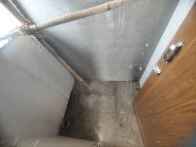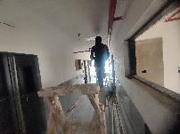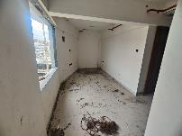

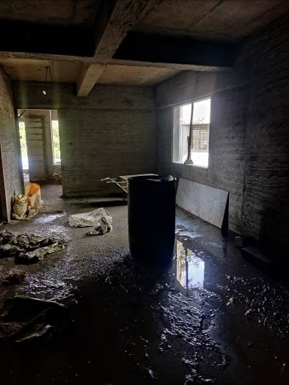

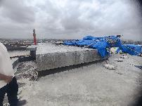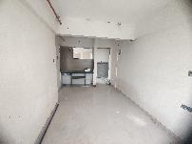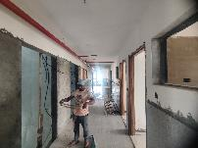

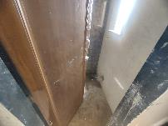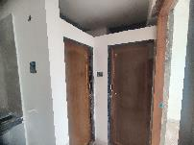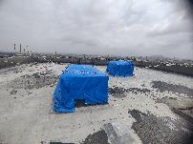

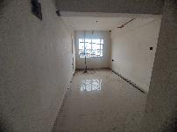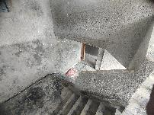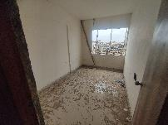

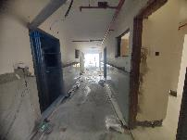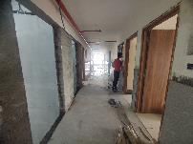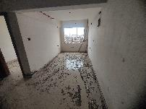**Actual Site Photographs**

**Rehab Building**

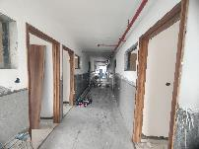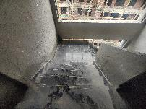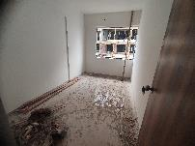

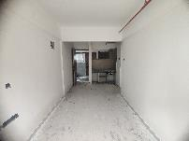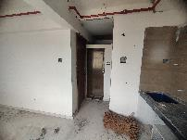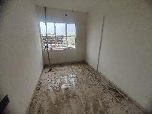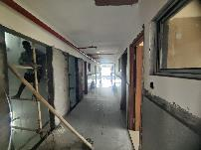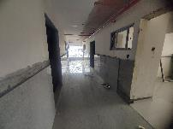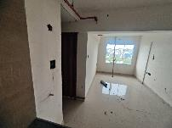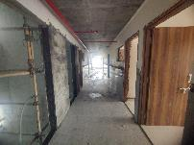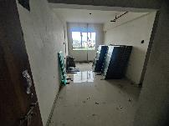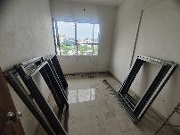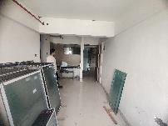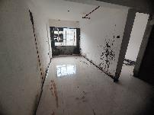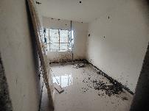**Actual Site Photographs**

**Rehab Building**

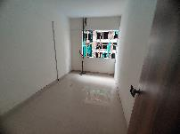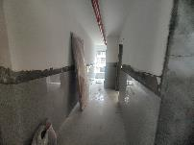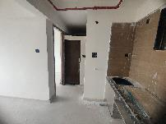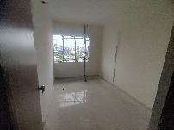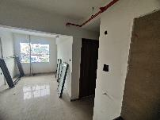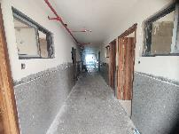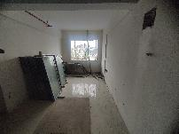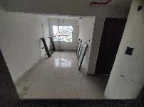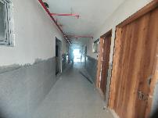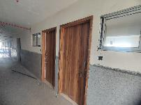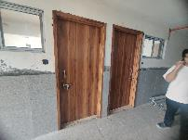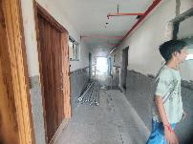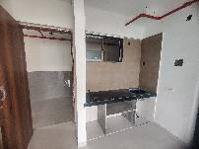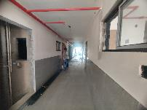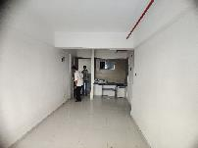

**Actual Site Photographs**

**Rehab Building**

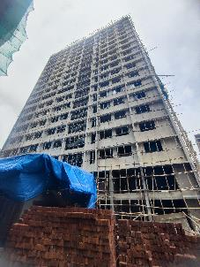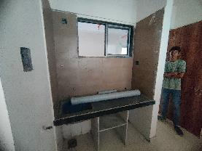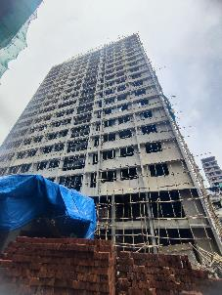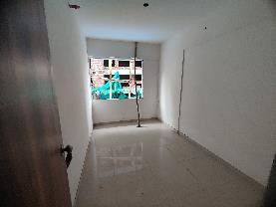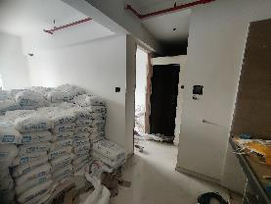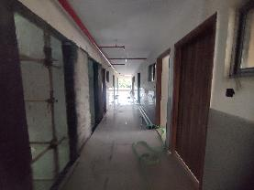

**Actual Site Photographs**

**Sale Building**

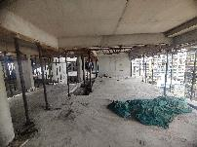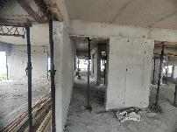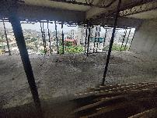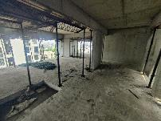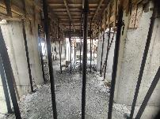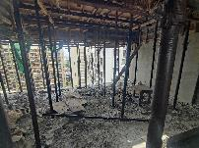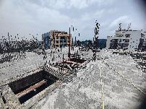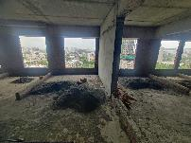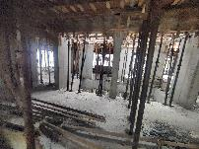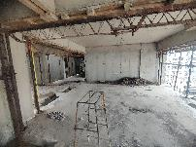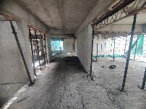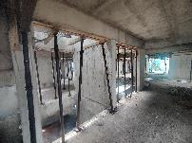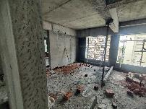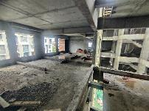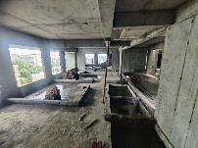

**Actual Site Photographs**

**Sale Building**

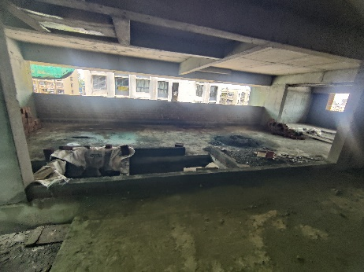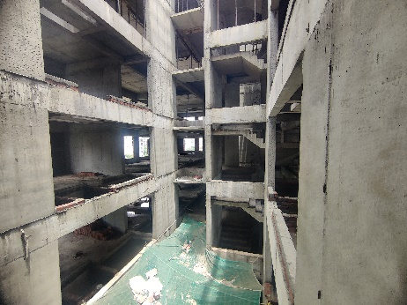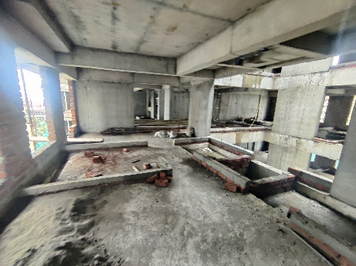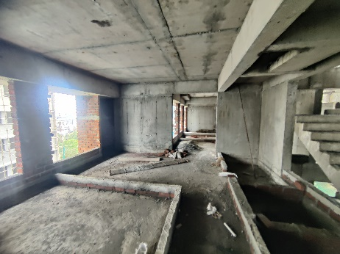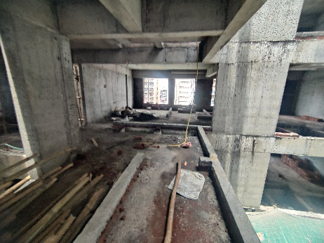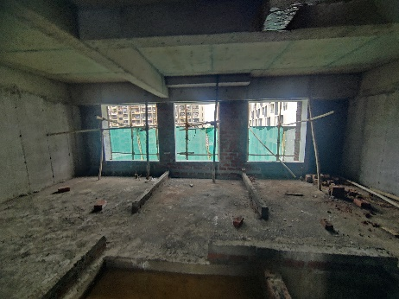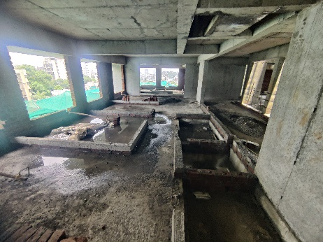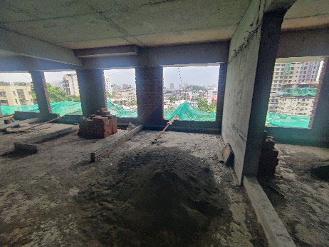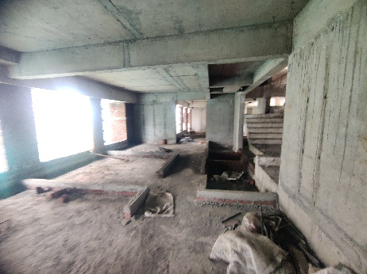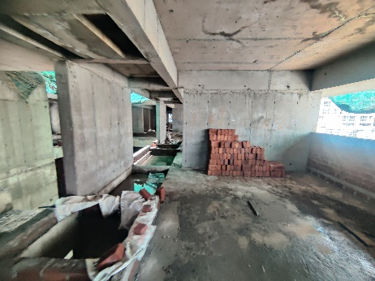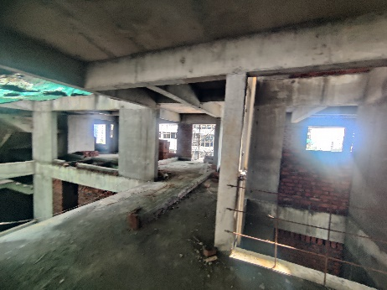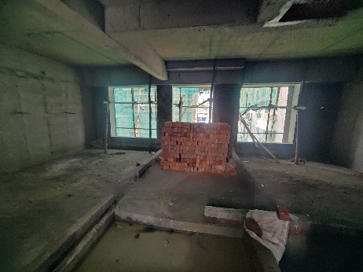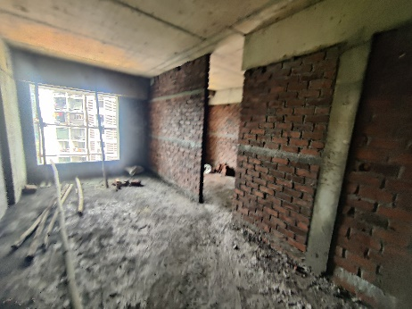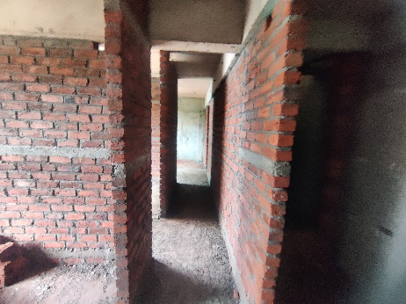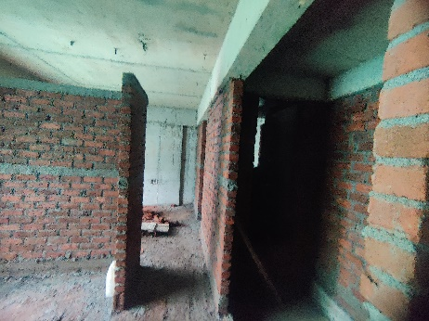

**Actual Site Photographs**

**Sale Building**

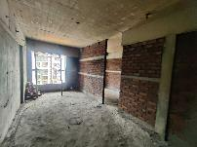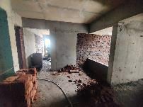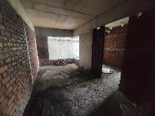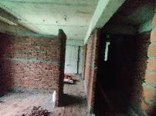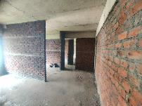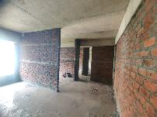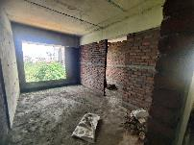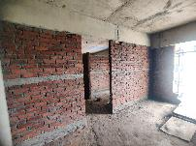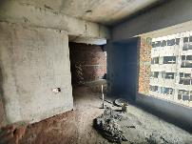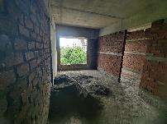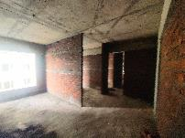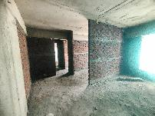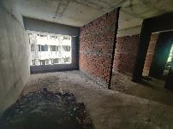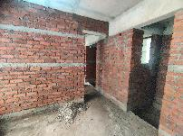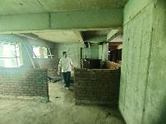

**Actual Site Photographs**

**Sale Building**

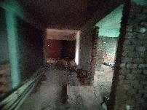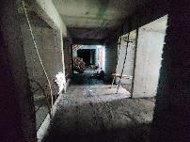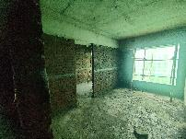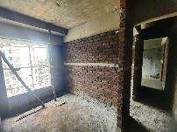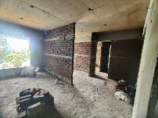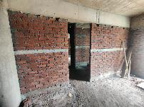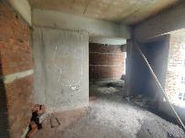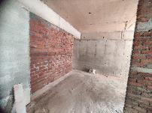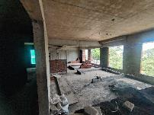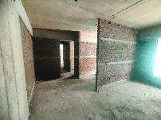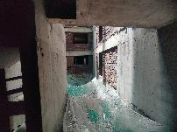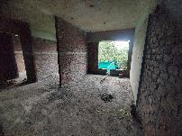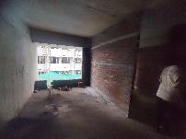

**Actual Site Photographs**

**Sale Building**

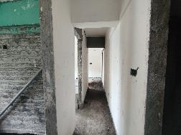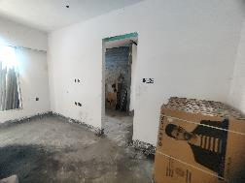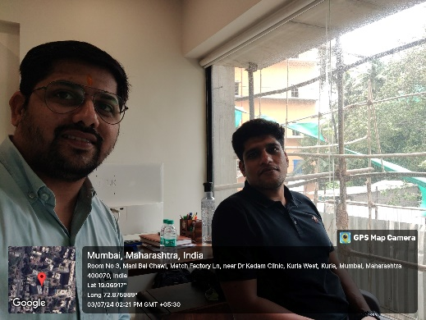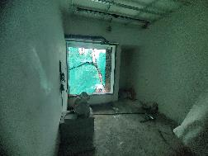

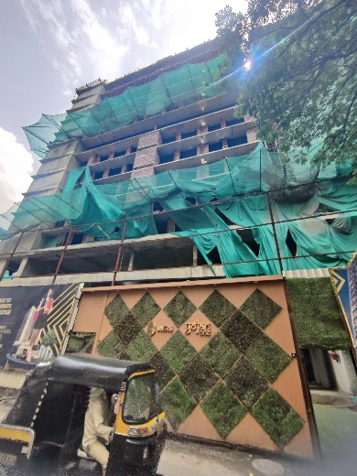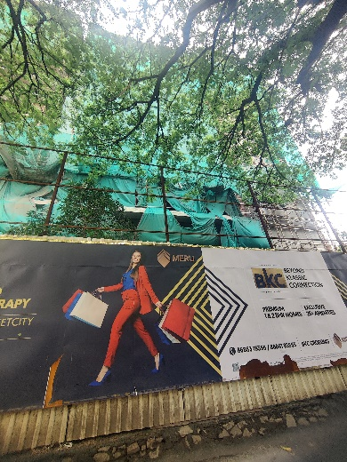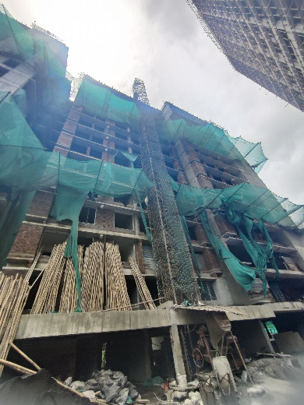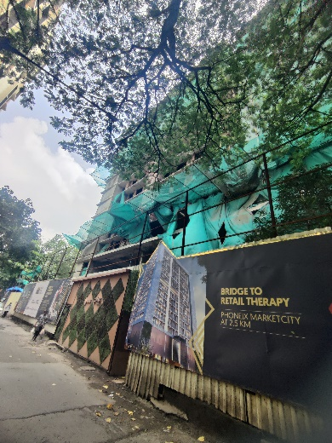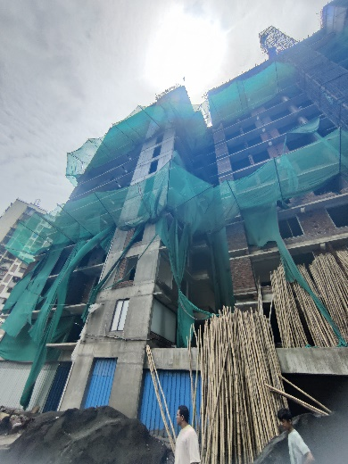**Route Map of the property**

**Site u/r**

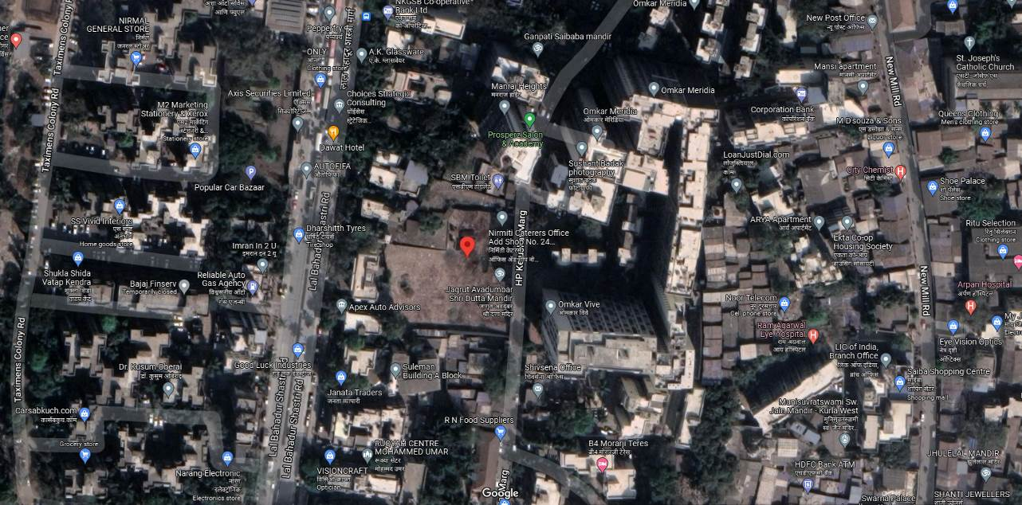

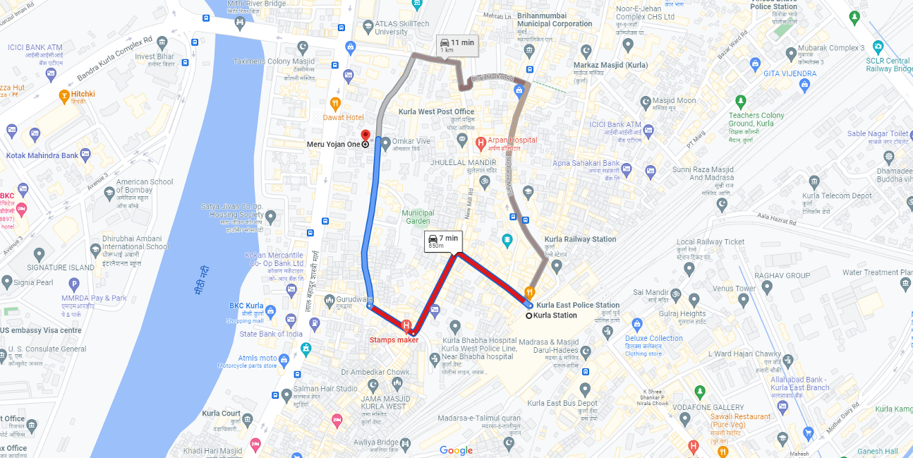

## Latitude Longitude: 19°04'08.2"N 72°52'33.2"E

Note: The Blue line shows the route to site from nearest railway station (Kurla – 850 M.)

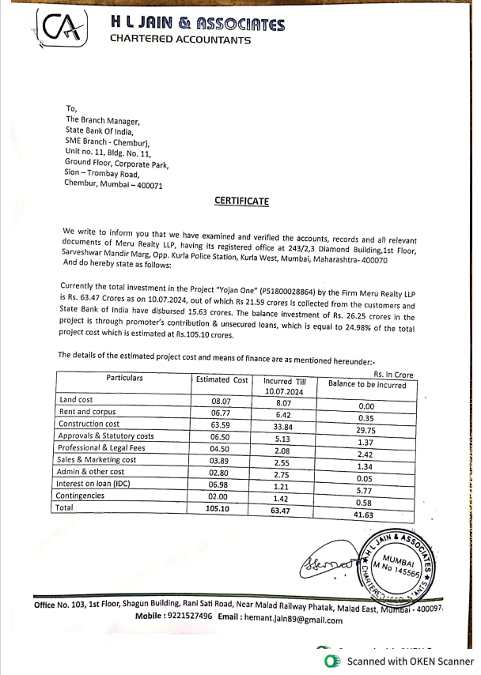**CA Certificate Dated 10.07.2024 incurred cost till 30.06.2024**

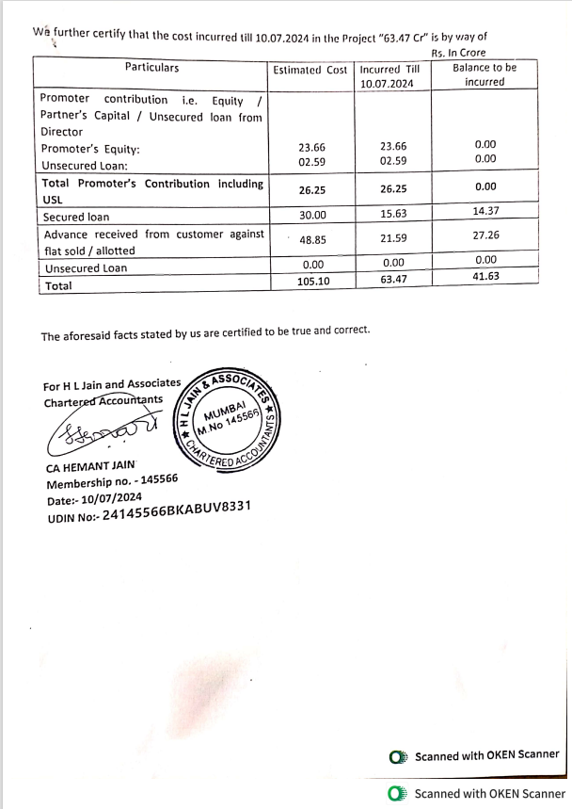**CA Certificate Dated 10.07.2024 incurred cost till 30.06.2024**