2nd LENDER’S INDEPENDENT ENGINEER REPORT

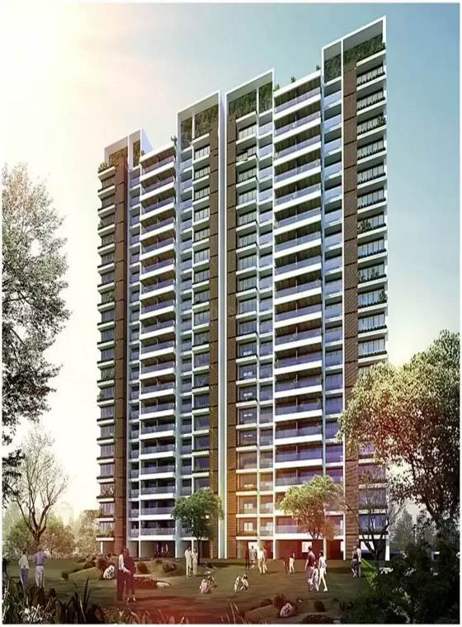

**Details of the property under consideration:**

**Name of Project: “One Meraki Wing C”**

**"One Meraki Wing C" Proposed Residential Building on Plot bearing, CTS No. 619/14, 619/15, 619/21A & 619/21B, Motibaug, Opp R.K Studio, V.N Purav Marg, Village – Borla,**

**Chembur (West), Mumbai – 400 071, State - Maharashtra, Country - India**

**Latitude Longitude: 19°02’54.3”N 72°54’29.6”E**

Valuation Prepared for:

State Bank of India

SME Chembur Branch

Unit No. 11, Building No. 11, Ground Floor, Corporate Park, Sion Trombay Road,

Chembur, Mumbai, Pin Code – 400 071, State - Maharashtra, Country – India

Vastu/SBI/Mumbai/07/202410147/2307393

25/04-397-PY

Date: - 25.07.2024

SECOND LENDER’S INDEPENDENT ENGINEER REPORT

**To,**

**State Bank of India**

SME Chembur Branch

Unit No. 11, Building No. 11,

Ground Floor, Corporate Park,

Sion Trombay Road, Chembur,

Mumbai, Pin Code – 400 071,

State - Maharashtra, Country – India

Subject: Construction of Proposed Residential Building Wing C on Plot bearing, CTS No. 619/14, 619/15, 619/21A & 619/21B, Motibaug, Opp. R.K Studio, V.N Purav Marg, Village – Borla, Chembur (West), Mumbai – 400 071, State - Maharashtra, Country - India.

**Ref:** You’re Request for Lenders Independent Engineer Report of under Construction Building.

**Dear Sir,**

1. As per your instruction, we have inspected the under-construction Sale Building project situated on plot bearing CTS No. 619/14, 619/15, 619/21A & 619/21B, Motibaug, Opp. R.K Studio, V.N Purav Marg, Village – Borla, Chembur (West), Mumbai – 400 071, State - Maharashtra, Country - India which is being developed by M/s. Meraki Habitats LLP in order to give the physical progress at site and to certify cost incurred towards project as on 30/06/2024.
2. **The Construction work as per approved plan was in progress during the site visit on 04th July 2024.**
3. **Status of work:**
4. **For Sales Building (Wing C):** 4th floor slab work is completed. 5th floor Slab shuttering work is in progress.
5. As per cost incurred certificate issued by **CA Certificate actual total expenditure occurred as on 30/06/2024 is ` 47.97 Cr. for Residential of Sale Building (Wing C) is proposed of 3 Basement + Ground Floor + 1st Part Podium floor + 2nd to 19th Upper Residential Floors.**
6. **Overall financial progress as per C.A. certificate including land cost, approval cost, professional, admin, marketing & interest cost as on 30/06/2024 is 49.34% estimated cost of project.**
7. **Overall financial progress as per bills provided by the client including land cost, approval cost, professional, admin, marketing & interest cost as on 30/06/2024 is 49.14% estimated cost of project.**
8. Overall Physical progress of the sale building construction as on 05/07/2024 is 34% as per physical site inspection.

**DECLARATION**

1. The information furnished in the report is based on our 2nd site visit Dated 04/07/2024 & Document Provided by Client.
2. Vastukala Consultants (I) Pvt. Ltd. 1st LIE Report of the project dated 17/05/2024.
3. Vastukala Consultants (I) Pvt. Ltd. Project Report of the project dated 15/01/2024.
4. Vastukala Consultants (I) Pvt. Ltd. Cost Vetting Report dated 15/01/2024.
5. I have no direct and indirect interest in the property examined for report.
6. I have not been found guilty of misconduct in my professional capacity.

**Manoj B. Chalikwar**

Registered Valuer

Chartered Engineer (India)

Reg. No. IBBI/RV/07/2018/10366

Encl.: LIE report

# Purpose & Methodology

• State Bank of India Banks and financial institutions require monitoring & an independent review of the progress of the sanctioned projects

**VCIPL** undertakes such study to independently review the progress of the project and put forward a comprehensive analysis

# Advantages:

* Assurance on present practices
* Identification of risk
* Analyzing the performance of third parties
* Recommendations

# The Methodology

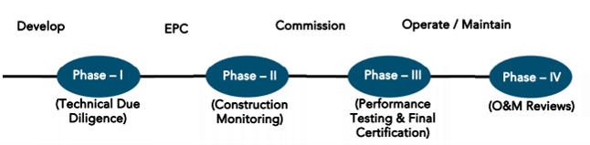

**SECOND LENDER’S INDEPENDENT ENGINEER REPORT**

**OF**

**"ONE MERAKI WING C"**

**"One Meraki Wing C", Proposed Residential Building on Plot bearing, CTS No. 619/14, 619/15, 619/21A & 619/21B, Motibaug, Opp. R.K Studio, V.N Purav Marg, Village – Borla, Chembur (West), Mumbai – 400 071, State - Maharashtra, Country – India**

**Latitude Longitude: 19°02’54.3”N 72°54’29.6”E**

**NAME OF DEVELOPER: M/s. Meraki Habitats LLP**

|  |
| --- |
| Pursuant to instructions from State of India, SME Chembur Branch, Chembur we have duly visited, inspected, surveyed & assessed the above said property on **04th July 2024** to determine the fair & reasonable market value of the said property/project as on Quarter ending **30th June 2024** for LIE purpose.  **1. Location Details:**  Proposed Residential Building on Plot bearing, CTS No. 619/14, 619/15, 619/21A & 619/21B, Motibaug, Opp. R.K Studio, V.N Purav Marg, Village – Borla, Chembur (West), Mumbai – 400 071. It is about 2 Km. walking distance from Chembur Railway station. Surface transport to the property is by buses, taxis & private vehicles. The property is in developed locality. All the amenities like shops, banks, hotels, markets, schools, hospitals, etc. are all available in the surrounding locality. The area is higher middle class & developed. |

**2. Developer Details:**

|  |  |
| --- | --- |
| **Name of builder** | **M/s. Meraki Habitats LLP** |
| **Project Rera Registration Number** | **P51800048237** |
| **Registered office address** | Office No. 501, 5th Floor, Meraki Arena, Motibaug, Opp. R. K. Studio, V.N Purav Marg, Chembur (West), Mumbai – 400 071, State - Maharashtra, Country – India |
| **Contact details** | **Contact Person:**  Mr. Akshay Patani (Senior Executive Manager)  Mobile No. 9820620783  Mr. Vishal Tapal (Accountant)  Mobile No. 8080700006 |
| **E – mail ID and website** |  |

**3. Boundaries of the Property:**

|  |  |
| --- | --- |
| **Direction** | **Particulars** |
| **On or towards North** | Open Plot |
| **On or towards South** | D Wing and V.N Purav Marg |
| **On or towards East** | Mahinder Chamber |
| **On or towards West** | A and B Wing |

# Introduction

**As per Information on site M/s. Meraki Habitats LLP formerly known as M/s. Shiv Sabari Developers** has acquired land by Conveyance Deed Date 31.03.2006 & 17.01.2017 admeasuring **area is 19,954.30 Sq. M.** bearing **CTS No. 619(14), 619(15), 619(21) and 667.** For the Proposed Residential Building.

# Area Statement:

# Land:

|  |  |  |
| --- | --- | --- |
| **Date** | **Particular** | **Area in Sq. M.** |
| 31.03.2006 | CTS No. 619(14), 619(15), 619(21) | 17,181.30 |
| 17.01.2017 | CTS No. 667 | 2,773.00 |
| TOTAL | | 19,954.30 |

1. Copy of Deed of Conveyance dated 31.03.2006 b/w Mr. Fatema Ali Sutarwala & 6 others (The Vendors) And M/s. Shiv Sabari Developers (The Purchaser)
2. Copy of Deed of Conveyance dated 17.01.2017 b/w M/s. Natraj Realcon Pvt. Ltd. (The Vendors) And M/s. Shiv Sabari Developers (The Purchaser).

# Building Area:

| I | Area Statement |  |
| --- | --- | --- |
| 1) | Gross area of Plot | 19916.05 |
| a) | Area of Reservation in Plot |  |
| b) | Area of Road Set back |  |
| c) | Area of DP Road |  |
| 2) | Deduction for |  |
| A | For reservation/road area |  |
| a) | Road set-back area to be handed over (100%) (Regulation no. 16) |  |
| b) | Proposed d p road to be handed over (100%) (Regulation no. 16) |  |
| c) | Reservation area to be handed over as per AR (Regulation no. 17) |  |
|  | Existing Recreation Ground Reservation area (plot) | 2623.00 |
|  | Reservation Play Ground area (plot) to be handed over (Regulation no 17 of DCR 2034) | 406.05 |
|  | Reservation Garden area (plot) to be handed over (Regulation no 17 of DCPR 2034) | 2939.50 |
| d) | Encroachment area | 133.00 |
| B | For amenity area |  |
| a) | Area of amenity plot/plots to be handed over as per dcr 14(a) |  |
| b) | Area of amenity plot/plots to be handed over as per dcr 14(b) |  |
| c) | Area of amenity plot/plots to be handed over as per dcr 15 |  |
| d) | Area of amenity plot/plots to be handed over as per dcr 35 |  |
| C | Deduction for existing built-up area to be retained if any |  |
| a) | Land component of existing BUA as per regulation under which the development was allowed |  |
| 3) | Total deduction (2(A) +2(B) +2(C)) | 6103.55 |
| 4) | Balance area of plot (1 minus 3) | 13812.50 |
| 4A | ADD FOR F.S.I AS PER PROPOSED ACCOMODATION AND RESERVATION |  |
|  | Existing Recreation Ground Reservation area (plot) |  |
|  | Reservation Garden area (plot) to be handed over (Regulation no 17) |  |
|  | Reservation Garden area (plot) to be handed over (Regulation no 17) | 2496.19 |
| 5) | Plot area under development (4 + 2 A(a)) | 16308.69 |
| 6) | Zonal (basic) FSI (1 or 1.33) | One |
| 7) | Permissible built-up area as per zonal (basic) FSI (5*6) | 16308.69 |
| 8) | Built up area equal to area of land handed over as per 3(a) of regulation 30(a) |  |
| 9) | Built up area in Lieu of cost of construction of built-up amenity to be handed over |  |
| 10) | Built up area due to additional FSI on payment of premium as per table no 12-regulation no 30(a) | 8154.35 |
| 11) | Built up area due to additional FSI on payment of premium as per table no 12-regulation no 30(a)3 | 11188.54 |
| 12) | Reservation Garden area plot to be handed over (Regulation no. 17) |  |
| 12(a) | TDR generated Amenity area set-off as per regulation 14(B) | 1702.72 |
| 13) | Incentive FSI as per regulation 30(18) |  |
| 14) | Permissible built-up area | 37354.3 |
| b) | Proposed built up area in building no. 1 | 21600.36 |
| c) | Proposed built up area in building no. 2 | 3343.65 |
| d) | Proposed built up area in building no. 3 | 12337.97 |
| 15 | Total Proposed built up area in building no 31(3) | 37281.98 |
| 16 | Fungible commentary area as per regulation 31(3) |  |
| a) | i) Permissible Fungible Compensatory Commercial Area Rehab component without charging premium |  |
| b) | ii) Fungible Compensatory Commercial area availed for Rehab component without charging premium | 5061.21 |
| c) | i) Permissible Fungible Compensatory Commercial Area Rehab component without charging premium |  |
| d) | ii) Fungible Compensatory Commercial area availed for Rehab component without charging premium |  |
| e) | i) Permissible Fungible Compensatory Commercial Area Rehab component without charging premium |  |
| 17 | ii) Fungible Compensatory Commercial Residential area availed on payment of premium | 7987.49 |
| 18 | Total Fungible Compensatory area by charging premium | 13048.70 |
| II | Total Built up Area proposed including Fungible Compensatory Area (15 + 16(a)(ii) + 16(b)(ii) | 50330.68 |
| A | FSI consumed on Net Plot (15/4) | 2.29 |
| a) | Other Requirements |  |
| b) | Reservation/Designation |  |
| c) | Name of Reservation |  |
| d) | Area of Reservation affecting the plot |  |
| e) | Area of Reservation land to be handed over as per Regulation No. 17 |  |
| (B) | Built up area of Amenity to be handed over as per Regulation No.17 |  |
|  | Area /Built up Amenity to be handed over as per Regulation No |  |
|  | (I) 14(A) |  |
|  | (ii) 14(b) |  |
|  | (iii) 15 |  |
| (C) | Requirement of Recreational Open Space in Layout/ Plot as per Regulation No. 27 |  |
| (D) | Tenement Statement |  |
|  | (i) Proposed built up area (13 above) | 50330.68 |
|  | (ii) Less deduction of Non-residential area (Shop etc) | 14460.61 |
|  | (iii) Area available for tenements ((i) minus(ii)) | 35870.07 |
|  | (iv) Tenements permissible (Density of tenements/hectare) | 1614 Nos |
|  | (v) Total number of Tenements proposed on the plot | 283 Nos |
| (E) | Parking Statement |  |
|  | (i) Parking required by regulations for |  |
|  | Car |  |
|  | Scooter/Motor Cycle | 446 Nos |
|  | Outsider (Visitor) |  |
|  | (i) Covered garage permissible |  |
|  | (iii) Covered Garages proposed |  |
|  | Car |  |
|  | Scooter/Motor Cycle |  |
|  | Outsider (Visitor) |  |
|  | (iv) Total parking provided | 762 Nos |
| (F) | Transport Vehicle Parking |  |
|  | (i) Space for transport vehicle parking required by Regulations |  |
|  | (ii) Total No. of transport vehicles parking spaces provided |  |

# List of Approvals:

1. Copy of IOD No. CHE/ES/0840/M/W/337(NEW) issued by Municipal Corporation of Greater Mumbai
2. Copy of Approved Plans No. CHE/ES/0840/M/W/337(NEW) dated 28.12.2021 issued by Municipal Corporation of Greater Mumbai

**Approved upto: Wing C: 3 Basement + Ground Floor + 1st Podium Floor + 2nd to 19th Upper Floors**

1. Copy of 1st Commencement Certificate No. CHE/ES/0840/M/W/337(NEW) dated 29.12.2023 issued by Municipal Corporation of Greater Mumbai

**(This C.C. up to top of Stilt Slab of Wing C of Building No. 1, as per approved IOD plans dated 28.12.2021)**

1. Copy of 2nd Commencement Certificate No. CHE/ES/0840/M/W/337(NEW) dated 29.12.2023 issued by Municipal Corporation of Greater Mumbai

**(C.C. for 3 Basement + Ground Floor + 1st Podium Floor + 2nd to 19th Upper Floors (Full C.C.) of Wing C, as per approved plans dated 28.12.2021)**

# LEVEL OF COMPLETION:

**For Sales Building (Wing C):** 4th floor slab work is completed. 5th floor Slab shuttering work is in progress.

# Sales Building (Wing C)

| Sr. No | Floor No. | Construction Area in Sq. M. | Completed Area in Sq. M. | Work Completion as on 04.07.2024 | Work Completion as 1st LIE Report as on 17.05.2024 |
| --- | --- | --- | --- | --- | --- |
| 1 | Excavation & Shore Piling | | | Work is Completed | Work is Completed |
| 2 | Basement 1 | 1,761.59 | 1,761.59 | Slab work is completed | Slab work is completed |
| 3 | Basement 2 | 1,761.59 | 1,761.59 | Slab work is completed | Slab work is completed |
| 3 | Basement 3 | 1,761.59 | 1,761.59 | Slab work is completed | Slab work is completed |
| 4 | Ground Floor | 1,860.68 | 1,860.68 | Slab work is completed | Slab work is completed |
| 5 | 1st Floor | 794.10 | 794.10 | Slab work is completed | Slab work is completed |
| 6 | 2nd Floor | 496.76 | 496.76 | Slab work is completed |  |
| 7 | 3rd Floor | 496.76 | 496.76 | Slab work is completed |  |
| 8 | 4th Floor | 496.76 | 496.76 | Slab work is completed |  |
| 9 | 5th Floor | 496.76 |  | Shuttering work is in progress |  |
| 10 | 6th Floor | 496.76 |  |  |  |
| 11 | 7th Floor | 491.46 |  |  |  |
| 12 | 8th Floor | 498.31 |  |  |  |
| 13 | 9th Floor | 496.76 |  |  |  |
| 14 | 10th Floor | 496.76 |  |  |  |
| 15 | 11th Floor | 496.76 |  |  |  |
| 16 | 12th Floor | 496.76 |  |  |  |
| 17 | 13th Floor | 496.76 |  |  |  |
| 18 | 14th Floor | 491.45 |  |  |  |
| 19 | 15th Floor | 498.31 |  |  |  |
| 20 | 16th Floor | 496.76 |  |  |  |
| 21 | 17th Floor | 496.76 |  |  |  |
| 22 | 18th Floor | 496.76 |  |  |  |
| 23 | 19th Floor | 496.76 |  |  |  |
| 24 | Terrace Floor | 39.15 |  |  |  |
| Total | | **16,912.81** | **9,429.82** |  |  |

# Details of the Project as Financed By SBI:

# Estimated Project Cost: (As per Cost Vetting Report)

|  |  |
| --- | --- |
| **Particulars** | **Estimated Cost (in Cr.)** |
| Land & Stamp Cost | 12.50 |
| Construction Cost of Sale Building | 55.81 |
| Approval Cost including Premium Cost / FSI / GOM Charges / fees & TDR Cost | 13.02 |
| Architect Cost, RCC & Other Professional Cost | 0.56 |
| Administrative Cost | 3.07 |
| Marketing Cost | 5.35 |
| Interest Cost (Bank Loan) | 6.91 |
| **Total** | **106.76** |

# Project Cost: (as per C.A. Certificate)

|  |  |  |  |
| --- | --- | --- | --- |
| **Particulars** | **Incurred Cost (In Cr.) till 30.06.2024 by M/s K. F. Jetsey & Co.** | **Incurred Cost (In Cr.) till 31.03.2024 by M/s K. F. Jetsey & Co.** | **Net** |
| Land & Stamp Cost | 12.50 | 12.50 | - |
| Construction Cost of Sale Building | 23.56 | 8.13 | 15.43 |
| Approval Cost including Premium Cost / FSI / GOM Charges / fees & TDR Cost | 10.60 | 10.60 | - |
| Architect Cost, RCC & Other Professional Cost | 0.33 | 0.26 | 0.07 |
| Administrative Cost | 0.25 | - | 0.25 |
| Marketing Cost | 0.64 | 0.64 | - |
| Interest Cost (Bank Loan) | 0.09 | - | 0.09 |
| **Total** | **47.97** | **32.13** | **15.84** |

* **The Builder has incurred about 23.56 Cr. as construction cost, 0.33 Cr. for Professional cost, 0.25 Cr. Admin Cost & 0.09 Cr. interest cost till 30.06.2024 as per C.A. certificate issued by M/s. K. F. Jetsey & Co. dated 22.07.2024.**

# Project Cost: (as per Bills):

|  |  |  |  |
| --- | --- | --- | --- |
| **Particulars** | **Incurred Cost (in Cr.)** | | **Net** |
| **30.06.2024 as per Bill (Inclusive GST)** | **31.03.2024 as per Bill (Inclusive GST)** |
| Land Cost | 12.50 | 12.50 | - |
| Construction cost of Sale Building | 22.80 | 8.12 | 14.68 |
| Approval Cost including Premium Cost / FSI / GOM Charges / fees & TDR Cost | 10.60 | 10.60 | - |
| Architect Cost, RCC & Other Professional Cost | 0.33 | 0.26 | 0.07 |
| Administrative Cost | 1.00 | 0.28 | 0.72 |
| Marketing Cost | 0.45 | 0.37 | 0.08 |
| Interest Cost | 0.09 | - | 0.09 |
| **Total** | **47.78** | **32.13** | **15.65** |

Note:

# Land Cost:

|  |  |  |
| --- | --- | --- |
| Sr. No. | Land Cost: | Amount (in `) |
| 1 | Payment to Land Owners | 43,71,53,000.00 |
| 2 | Payment to Tenants | 30,40,88,299.00 |
| 3 | Stamp Duty | 3,86,02,044.00 |
| 4 | Tenancy Purchase Cost & Other Cost | 6,85,64,179.00 |
|  | **Total Land Cost** | **84,84,07,522.00** |

As per conveyance deed.

|  |  |  |  |  |
| --- | --- | --- | --- | --- |
| Sr. No. | Particulars | Land Cost (in Rs.) | BUA | % of Land Covered |
| 1 | Arena (Commercial) | 21,96,07,901.47 | 16,122.03 | 28% |
| 2 | One Meraki -Wing A & B | 19,82,40,325.86 | 14,171.63 | 25% |
| 3 | **One Meraki -Wing C** | **12,50,00,430.49** | **7,223.11** | **13%** |
| 4 | One Meraki -Wing D | 13,51,44,430.49 | 7,223.11 | 13% |
| 5 | One Meraki -Wing E | 7,98,41,530.97 | 5,861.39 | 10% |
| 6 | Platina | 9,05,72,902.70 | 6,649.21 | 12% |
| TOTAL | | **84,84,07,522.00** | **57,250.48** | **100%** |

As per information from client, 13% of land is covered for Wing C so proportionate land cost for One Meraki – Wing C Project is **` 12,50,00,430.00 i.e., ` 12.50 Cr.**

|  |  |  |  |  |  |  |
| --- | --- | --- | --- | --- | --- | --- |
| **Summary of Bills** | | | | | | |
| **Sr. No.** | **Particulars** | **Amount in `**  **(till 30.06.2024)** | **Amount in ` (in Cr.)** | **Amount in `**  **(till 31.03.2024)** | **Amount in ` (in Cr.)** | **Net** |
| 1 | Construction Cost of Sale Building | 22,80,45,860.00 | 22.80 | 8,12,12,166.00 | 8.12 | 14.68 |
| 2 | Premium Cost / FSI / GOM Charges / fees / security Deposits & TDR Cost | 10,60,06,165.00 | 10.60 | 10,60,06,165.00 | 10.60 | - |
| 3 | Professional Cost | 33,41,970.00 | 0.33 | 26,08,870.00 | 0.26 | 0.07 |
| 4 | Administrative Cost | 99,87,469.00 | 1.00 | 27,63,700.00 | 0.28 | 0.72 |
| 5 | Marketing Cost | 44,55,348.00 | 0.45 | 36,98,028.00 | 0.37 | 0.08 |
| **TOTAL** | | **35,18,36,812.00** | **35.18** | **19,62,88,929.00** | **19.63** | **15.55** |

Note: Bills were provided by the client up to 30.06.2024

# Interest Cost:

|  |  |  |  |  |  |  |
| --- | --- | --- | --- | --- | --- | --- |
| **Sr. No** | **Particulars** | **Estimate Amount in `** | **Incurred Amount in ` (till 30.06.2024)** | **Incurred Amount in ` (till 31.03.2024)** | **Difference in `** | **Balance Amount in `** |
| **1** | Interest Cost | 6,91,00,000.00 | 9,13,270.00 | - | 9,13,270.00 | 6,81,86,730.00 |
| **TOTAL** | | **6,91,00,000.00** | **9,13,270.00** | **-** | **9,13,270.00** | **6,81,86,730.00** |

Interest Cost is based on discussion with the client.

# Cost of Construction as on 04th July 2024:

# Sales Building (Wing C)

|  |  |  |  |  |  |  |  |
| --- | --- | --- | --- | --- | --- | --- | --- |
| Plinth Area Calculation | | | | | | | |
| Sr. No | **Floor Nos.** | **Construction Area in Sq. M.** | **Completed Area in Sq. M.** | **Rate per Sq. M.** | **Full Value after completion** | **% of work completed** | **Actual Expenditure till date in `** |
| 1 | Deep Excavation & Piling Working (As per Bills) | | | | 5,07,38,418.00 | 100% | 5,07,38,418.00 |
| 2 | Basement 1 | 1,761.59 | 1,761.59 | 30,000.00 | 5,28,47,700.00 | 50% | 2,64,23,850.00 |
| 3 | Basement 2 | 1,761.59 | 1,761.59 | 30,000.00 | 5,28,47,700.00 | 50% | 2,64,23,850.00 |
| 4 | Basement 3 | 1,761.59 | 1,761.59 | 30,000.00 | 5,28,47,700.00 | 50% | 2,64,23,850.00 |
| 5 | Ground Floor | 1,860.68 | 1,860.68 | 30,000.00 | 5,58,20,400.00 | 50% | 2,79,10,200.00 |
| 6 | 1st Podium Floor | 794.10 | 794.10 | 30,000.00 | 2,38,23,000.00 | 50% | 1,19,11,500.00 |
| 7 | 2nd Floor | 496.76 | 496.76 | 30,000.00 | 1,49,02,680.00 | 50% | 74,51,340.00 |
| 8 | 3rd Floor | 496.76 | 496.76 | 30,000.00 | 1,49,02,680.00 | 50% | 74,51,340.00 |
| 9 | 4th Floor | 496.76 | 496.76 | 30,000.00 | 1,49,02,680.00 | 40% | 59,61,072.00 |
| 10 | 5th Floor | 496.76 |  | 30,000.00 | 1,49,02,680.00 |  |  |
| 11 | 6th Floor | 496.76 |  | 30,000.00 | 1,49,02,680.00 |  |  |
| 12 | 7th Floor | 491.46 |  | 30,000.00 | 1,47,43,800.00 |  |  |
| 13 | 8th Floor | 498.31 |  | 30,000.00 | 1,49,49,180.00 |  |  |
| 14 | 9th Floor | 496.76 |  | 30,000.00 | 1,49,02,680.00 |  |  |
| 15 | 10th Floor | 496.76 |  | 30,000.00 | 1,49,02,680.00 |  |  |
| 16 | 11th Floor | 496.76 |  | 30,000.00 | 1,49,02,680.00 |  |  |
| 17 | 12th Floor | 496.76 |  | 30,000.00 | 1,49,02,680.00 |  |  |
| 18 | 13th Floor | 496.76 |  | 30,000.00 | 1,49,02,680.00 |  |  |
| 19 | 14th Floor | 491.45 |  | 30,000.00 | 1,47,43,500.00 |  |  |
| 20 | 15th Floor | 498.31 |  | 30,000.00 | 1,49,49,180.00 |  |  |
| 21 | 16th Floor | 496.76 |  | 30,000.00 | 1,49,02,680.00 |  |  |
| 22 | 17th Floor | 496.76 |  | 30,000.00 | 1,49,02,680.00 |  |  |
| 23 | 18th Floor | 496.76 |  | 30,000.00 | 1,49,02,680.00 |  |  |
| 24 | 19th Floor | 496.76 |  | 30,000.00 | 1,49,02,680.00 |  |  |
| 25 | Terrace | 39.15 |  | 30,000.00 | 11,74,500.00 |  |  |
| Total | | **16,912.81** | **7,939.55** |  | **55,81,22,598.00** | **34%** | **19,06,95,420.00** |

##### Note: Details of work completed is as per site visit dated 04.07.2024 but report is prepared for 30th June 2024.

|  |  |  |  |  |  |
| --- | --- | --- | --- | --- | --- |
| **Particulars** | **Estimated Cost**  **(In Cr.)** | **Incurred Cost (in Cr.)** | | | **Net** |
| **Issued dated 22.07.2024 till 30.06.2024 as per CA** | **As per Bills upto 30.06.2024** | **As per Bills upto 31.03.2024** |
| Land Cost | 12.50 | 12.50 | 12.50 | 12.50 | - |
| Construction cost of Sale Building | 55.81 | 23.56 | 22.80 | 8.12 | 14.68 |
| Approval Cost including Premium Cost / FSI / GOM Charges / fees & TDR Cost | 13.02 | 10.60 | 10.60 | 10.60 | - |
| Architect Cost, RCC & Other Professional Cost | 0.56 | 0.33 | 0.33 | 0.26 | 0.07 |
| Administrative Cost | 3.07 | 0.25 | 1.00 | 0.28 | 0.72 |
| Marketing Cost | 5.35 | 0.64 | 0.45 | 0.37 | 0.08 |
| Interest Cost | 6.91 | 0.09 | 0.09 | - | 0.09 |
| **Total** | **106.76** | **47.97** | **47.78** | **32.13** | **15.65** |

Note:

We have considered Water Charges in Admininstrative cost header but CA has considered them in cost of construction header .

We have considered Testing Charges, Geotechinal Report cost is consider in Professional sot header but CA has considered them in cost of construction header .

We have considered bank loan processing charges in Administrative cost header bu CA has considered them in marketing cost header.

As per site inspection, 34% of total work is completed, which amounts to ` 19.07 Cr. However, as per data provided by client, they have incurred the cost of ` 22.80 Cr. till 30.06.2024 which consits of adavnces to vendors and cost incurred for on site matertial.

# Comparison of Cost incurred on dated 30.06.2024 & 31.03.2024

|  |  |  |  |  |
| --- | --- | --- | --- | --- |
| Particulars | 30.06.2024 as per Bill | 31.03.2024 as per Bill | Net | % of net amount |
| Land Cost | 12.50 | 12.50 | - | 0.00% |
| Construction cost of Sale Building | 22.80 | 8.12 | 14.68 | 30.73% |
| Approval Cost including Premium Cost / FSI / GOM Charges / fees & TDR Cost | 10.60 | 10.60 | - | 0.00% |
| Architect Cost, RCC & Other Professional Cost | 0.33 | 0.26 | 0.07 | 0.15% |
| Administrative Cost | 1.00 | 0.28 | 0.72 | 1.51% |
| Marketing Cost | 0.45 | 0.37 | 0.08 | 0.17% |
| Interest Cost | 0.09 | - | 0.09 | 0.19% |
| Total | **47.78** | **32.13** | **15.65** | **100.00%** |

# % of Fund Utilised till 30th June 2024

|  |  |  |  |  |
| --- | --- | --- | --- | --- |
| Particulars | Estimated Cost (in Cr.) | Incurred Cost as on 30.06.2024 | % of Incurred Cost | % of Estimated Project Cost |
| Land & Stamp Cost | 12.50 | 12.50 | 100.00% | 12.86% |
| Construction Cost of Sale Building | 55.81 | 22.80 | 40.86% | 23.46% |
| Approval Cost including Premium Cost / FSI / GOM Charges / fees & TDR Cost | 13.02 | 10.60 | 81.42% | 10.90% |
| Architect Cost, RCC & Other Professional Cost | 0.56 | 0.33 | 59.68% | 0.34% |
| Administrative Cost | 3.07 | 1.00 | 32.53% | 1.03% |
| Marketing Cost | 5.35 | 0.45 | 8.33% | 0.46% |
| Interest Cost (Bank Loan) | 6.91 | 0.09 | 1.32% | 0.09% |
| Total | **106.76** | **47.78** | **49.14%** | **49.14%** |

Based on above Calculation it is found that total Project cost incurred is 49.14% of the Total Project Cost.

# Means of Finance:

|  |  |  |
| --- | --- | --- |
| **Sr. No.** | **Particulars** | **Exp. Cumulative (Cr.)** |
|  | Equity share capital / Quassi Loan from Promoter | 31.83 |
|  | Sales (Advance from customer) | 5.39 |
|  | Bank Laon Amount | 10.74 |
|  | **Total** | **47.96** |

The Details of the Means of Finance are provided by Client as on 30.06.2024.

# Mandatory Arrangements:

|  |  |  |
| --- | --- | --- |
| **Sr. No.** | **Particulars** | **Status** |
|  | Rainwater Harvesting | To be executed after RCC Structure |
|  | Firefighting System | To be executed after RCC Structure |
|  | Solid Waste Management | To be executed after RCC Structure |

# Quality of Construction:

|  |  |  |
| --- | --- | --- |
| **Sr. No.** | **Particulars** | **Status** |
|  | Soundness of Structures | Executing as per approved Structural Design |
|  | Look of Structures | Good |
|  | Quality of Material Used | Good |
|  | Safety Measures for Construction/labour | Taken Care by Contractor |

# Schedule V/s. Actual Progress:

| Activity | Date of Implementation | Date of Completion | Status |
| --- | --- | --- | --- |
| Land |  |  | Completed |
| Development of Land |  |  | Completed |
| Foundation Work |  |  | Completed |
| Ground Floor Slab |  |  | Slab work is Completed |
| 1st Floor Slab |  |  | Slab work is Completed |
| 2nd Floor Slab |  |  | Slab work is Completed |
| 3rd Floor Slab |  |  | Slab work is Completed |
| 4th Floor Slab |  |  | Slab work is Completed |
| 5th Floor Slab |  |  | Shuttering work is in progress |
| 6th Floor Slab |  |  |  |
| 7th Floor Slab |  |  |  |
| 8th Floor Slab |  |  |  |
| 9th Floor Slab |  |  |  |
| 10th Floor Slab |  |  |  |
| 11th Floor Slab |  |  |  |
| 12th Floor Slab |  |  |  |
| Block work / Internal Plaster work |  |  |  |
| Terrace Parapet wall / Overhead water tank / Lift Machine room / compound wall / External Plaster work |  |  |  |
| Electric Work |  |  |  |
| Water Proofing |  |  |  |
| Plumbing Work |  |  |  |
| Tiling / Marble Flooring |  |  |  |
| Door Frames |  |  |  |
| Window Installation |  |  |  |
| Staircase Flooring |  |  |  |
| Staircase Railing |  |  |  |
| Refuge Area Flooring |  |  |  |
| Internal Painting |  |  |  |
| External Painting |  |  |  |
| Lift Work |  |  |  |
| Fire Fighting Installation |  |  |  |
| Stack Parking |  |  |  |
| CP Fitting & Sanitary Work |  |  |  |
| Final Finishing & Fitting |  |  |  |

Work progress schedule is not shared by the developer.

# Action initiated to complete the project in time:

**For Sales Building (Wing C):** 4th floor slab work is completed. 5th floor Slab shuttering work is in progress.

# Comments related to cost overrun if any:

The cost of Project is ` 97.22 Cr.

# Balance investment required for completion of project:

We opinion amount of **` 49.44 Cr.** Will be required to complete the Project.

# Mandatory Approval Status:

|  |  |  |  |  |
| --- | --- | --- | --- | --- |
| **Sr. No.** | **Particulars** | **Name of Department** | **Status** | **Order Details** |
| **1** | IOD of Building & Approved Plan | Municipal Corporation of Greater Mumbai (MCGM). | Obtained and available at site | No. CHE/ES/0840/M/W/337(NEW) dated 28.12.2021 |
| **2A** | First C.C. | Municipal Corporation of Greater Mumbai (MCGM). | Obtained and available at site | No. CHE/ES/0840/M/W/337(NEW) dated 29.12.2023. This CC is endorsed for the work upto top of Stilt Slab of Wing C of Building No. 1, as per approved IOD plans dated 28.12.2021 |
| **2B** | Second C.C. | Municipal Corporation of Greater Mumbai (MCGM). | Obtained and available at site | No. CHE/ES/0840/M/W/337(NEW) dated 29.12.2023.  (This CC is endorsed for the work for 3 Basement + Ground Floor + 1st Podium Floor + 2nd to 19th Upper Floors (Full C.C.) of Wing C, as per approved plans dated 28.12.2021) |
| **3B** | Occupancy | Municipal Corporation of Greater Mumbai (MCGM). | Pending (Project is not completed) |  |

# Status Insurance Coverage:

|  |  |  |  |
| --- | --- | --- | --- |
| **Particulars** | **Descriptions** | **Particulars** | **Descriptions** |
| **Policy No.** | 0000000038623167 | **Policy Issued Date** | 31.03.2024 |
| **Period of Insurance** | From 03.05.2023 to 31.12.2026 | **Total Sum Insured** | ` 55,00,00,000.00 |
| **Insurance Policy Name** | Contractors All Risk Policy | **Issued By** | SBI General Insurance |
| **Type of Cover / Benefit** | 1. Material Damage / Contract Price  2. Third Party Liabilities/ All accidents during policy period | | |

# Assumptions & Remarks:

* The adequacy of Engineering / Structural design is beyond the scope of our assignment.
* Estimated project completion date is 31/12/2026 for Sales Building respectively. The cost is certified based on the assumptions that the project will be completed within period. Few assumptions were made regarding inflation & cost rise etc. during construction period.

**Manoj B. Chalikwar**

Registered Valuer

Chartered Engineer (India)

Reg. No. IBBI/RV/07/2018/10366

**About the Project:**

|  |  |  |
| --- | --- | --- |
| **1. Introduction** | |  |
| a) | Project Name  (With Address & Phone Nos.) | **"One Meraki Wing C",** Proposed Building on Plot bearing, CTS No. 619/14, 619/15, 619/21A & 619/21B, Motibaug, Opp R.K Studio, V.N Purav Marg, Village – Borla, Chembur (West), Mumbai – 400 071, State - Maharashtra, Country – India  Contact Person:  Mr. Akshay Patani (Senior Executive Manager)  Mobile No. 9820620783  Mr. Vishal Tapal (Accountant)  Mobile No. 8080700006 |
| b) | Purpose of Valuation | As per request from State Bank of India, SME Chembur Branch to assess fair market value of the Project for LIE purpose. |
| c) | Date of Inspection of Property | 04.07.2024 |
| d) | Date of LIE Report | 25.07.2024 |
| e) | Name of the Developer of Property  (in case of developer built properties) | M/s. Meraki Habitats LLP  Office No. 501, 5th Floor, Meraki Arena, Motibaug, Opp. R. K. Studio, V.N Purav Marg, Chembur (West), Mumbai – 400 071, State - Maharashtra, Country – India |
| **2. Physical Characteristics of the Property** | | |
| a) | Location of the Property | **"One Meraki Wing C",** Proposed Building on Plot bearing, CTS No. 619/14, 619/15, 619/21A & 619/21B, Motibaug, Opp R.K Studio, V.N Purav Marg, Village – Borla, Chembur (West), Mumbai – 400 071, State - Maharashtra, Country – India |
| Brief description of the property |  |
|  | **TYPE OF THE BUILDING**   1. **Sale Building (Wing C)**  |  |  | | --- | --- | | No. of Floors | 3 Basement + Ground Floor + 1st Podium Floor + 2nd to 19th Residential Floor | | Building type | Residential Sale building |   Sales Building work is given on contract based for RCC contract. Developer has grant to the contractor do the work of construction and completion includes Concrete work, Reinforcement work, Masonry, Internal Plaster, External Plaster, and other miscellaneous work such as repairing, joints b/w concrete and masonry surface, etc. Bill must be paid on measurement of construction area exclusive of Steel, Cement & other construction material.  Lift & lift installation contract is not finalized till now.  Firefighting work contract is not finalized.  **PROPOSED DATE OF COMPLETION & FUTURE LIFE:**  Expected completion date as per RERA is 31st December 2025  **ABOUT PROJECT:**  One Meraki by Meraki Habitats LLP is situated in Chembur, Mumbai. The project focuses on one sense of open space to create a perfect living space. Each home is open to let the positive vibes come in, with impressive views of lush greenery. Every convenience you need is close at hand. Opulent and Efficient, One Meraki is a place that is filled up with tranquillity and calmness. The homes have everything for your convenience and promise a luxurious yet comfortable lifestyle. Feel the essence of freshness inside the house and indulge into a peaceful gathering with your loved ones.  It has an availability of comfy apartments of 3 and 4 BHK in the Chembur region of Mumbai. The apartments are all ready to move in phase. Necessities including park, bank, hospital, bus station, petrol pump, ATM, restaurant all are available in the neighbourhood. The other guarantees of the project are a contamination free setting along with covered parking space for each apartment, gym, club house, and security for 24 hours, a power back up system and much more. The price range of the apartments is about Rs 4.1 to 4.8 crore. | |
|  | Postal Address of the Property | **"One Meraki Wing C",** Proposed S. R. Scheme Commercial cum Residential building on Plot bearing C.T.S. No. 2293/B, Nensey Complex Building, Sant Dnyaneshwar Road & Western Expressway, Village – Dahisar, Borivali (East), Mumbai – 400 066, State – Maharashtra, Country – India |
|  | Area of the plot/land  (Supported by a plan) | Plot Area: 17,181.30 Sq. M. |
| Type of Land: Solid, Rocky, Marsh land, reclaimed land, Water-logged, Land locked. | Solid land |
|  | Independent access/approach to the property etc. | Yes |
| Google Map Location of the Property with a neighborhood layout map | Provided |
|  | Details of roads abutting the property | 30.00 Mt. wide Road |
| Description of adjoining property | Located in Higher Middle-class locality |
| Plot No. Survey No. | C. T. S. No. 619/14, 619/15, 619/21A & 619/21B |
| Ward/Village/Taluka | Village – Borla, Taluka - Kurla |
| Sub-Registry/Block | Mumbai Suburban |
| District | District - Mumbai Suburban |
| b) | **Boundaries of the Plot** |  |
|  | |  |  |  |  | | --- | --- | --- | --- | |  | **As per Agreement** | **As per RERA Certificate** | **Actual** | | **North** | CTS No.646,646/1,7 | CTS No 646 | Open Plot | | **South** | CTS No.619/21, 667 | V N Purav Marg | D Wing and V.N Purav Marg | | **East** | CTS No.647,619/22 | 12 M Wide D.P. Road | Mahinder Chamber | | **West** | CTS No.619/20 | CTS no 619 20 | A and B Wing | | |

|  |  |
| --- | --- |
| **4. Document Details and Legal Aspects of Property:** | |
| a) | Ownership Documents (**Building Permission, Commencement Certificate & Status of Plan)** |
|  | Sale Deed, Gift Deed, Lease Deed |
| 1. Copy of Deed of Conveyance dated 17.01.2017 b/w M/s. Natraj Realcon Pvt. Ltd. (The Vendors) And M/s. Shiv Sabari Developers (The Purchaser) |
| 1. Copy of Deed of Conveyance dated 31.03.2006 b/w Mr. Fatema Ali Sutarwala & 6 others (The Vendors) And M/s. Shiv Sabari Developers (The Purchaser) |
| 1. Copy of Development Permission Certificate No. Dy. Ch.E./B.P./4024/E.S. dated on 27.08.2021 issued by Municipal Corporation of Greater Mumbai |
| 1. Copy of IOD No. CHE/ES/0840/M/W/337(NEW) issued by Municipal Corporation of Greater Mumbai |
| 1. Copy of 1st Commencement Certificate No. CHE/ES/0840/M/W/337(NEW) dated 29.12.2023 issued by Municipal Corporation of Greater Mumbai   **(C.C. up to top of Stilt Slab of Wing C of Building No. 1, as per approved IOD plans dated 28.12.2021)** |
| 1. Copy of Approved Plans No. CHE/ES/0840/M/W/337(NEW) dated 28.12.2021 issued by Municipal Corporation of Greater Mumbai   **Approval Upto: 3 Basement + Ground Floor + 1st Podium Floor + 2nd to 19th Upper Floors** |
| 1. Copy of 2nd Commencement Certificate No. CHE/ES/0840/M/W/337(NEW) dated 29.12.2023 issued by Municipal Corporation of Greater Mumbai   **(C.C. for 3 Basement + Ground Floor + 1st Podium Floor + 2nd to 19th Upper Floors (Full C.C.) of Wing C, as per approved plans dated 28.12.2021)** |
| 1. Copy of CA Certificate dated 08.01.2024 issued by M/s. K. F. Jetsey & Co. |
| 1. Copy of CA Certificate dated 02.08.2023 issued by M/s. K. F. Jetsey & Co. |
| 1. Copy of Title Report dated 14.11.2020 issued by M/s. J Law Associates. |
| 1. Copy of Name Change Certificate dated 06.01.2022 from M/s. Shiv Sabari Developers to M/s. Meraki Habitats LLP. |
| 1. Copy of RERA Certificate No. P51800050796 dated 03.05.2023 issued by Maharashtra Real Estate Regulatory Authority. |
| 1. Copy of Bills till 31.03.2024. |
| 1. Copy of CA Certificate dated 14.05.2024 issued by M/s. K. F. Jetsey & Co. |

|  |  |
| --- | --- |
| b) | **Documents verified for present LIE report** |
|  | 1. Copy of CA Certificate dated 22.07.2024 for cost incurred till 30.06.2024 issued by M/s. K. F. Jetsey & Co. |
| 1. Copy of Bills from 01.04.2024 to 30.06.2024 |

**Actual Site Photographs As on 04.07.2024**

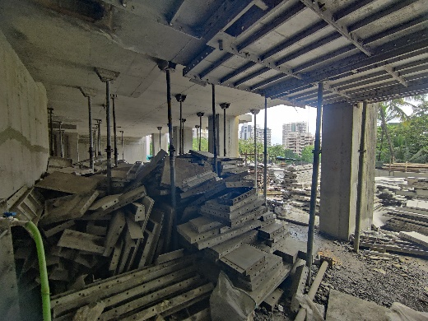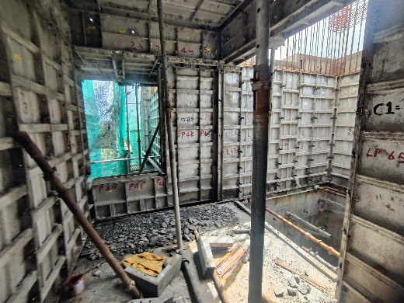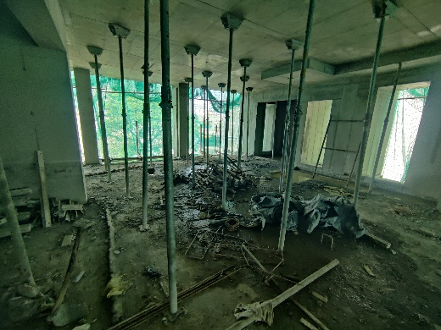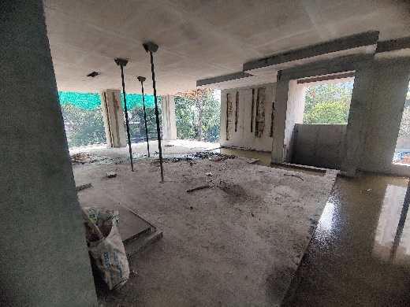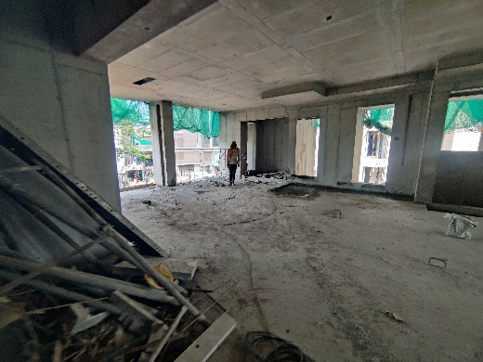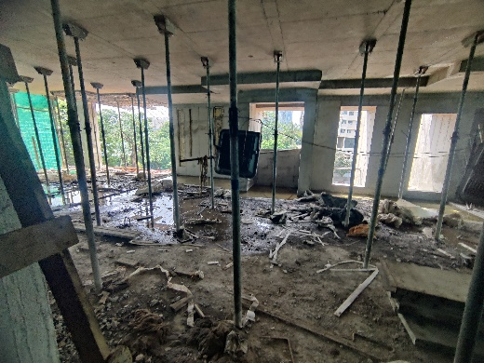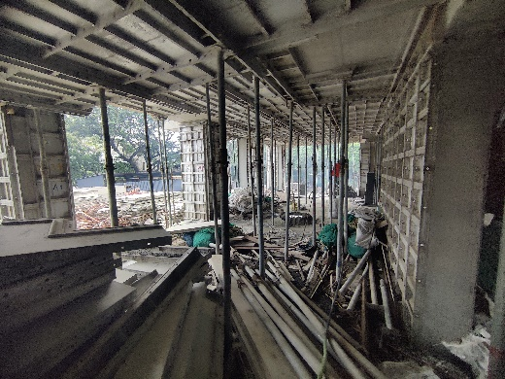

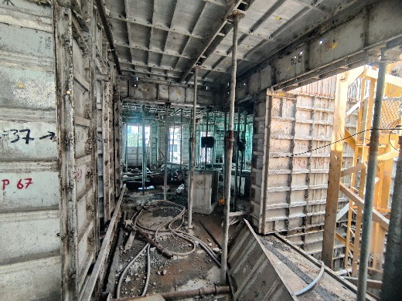

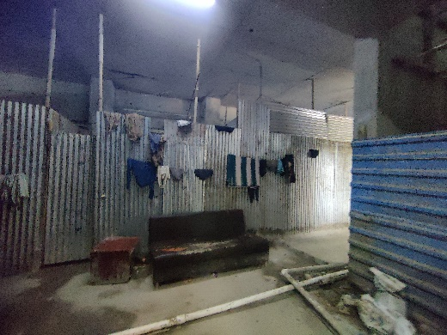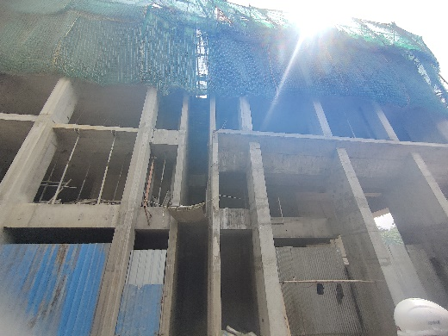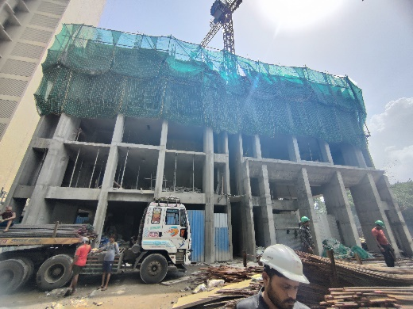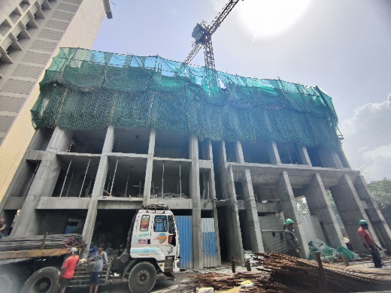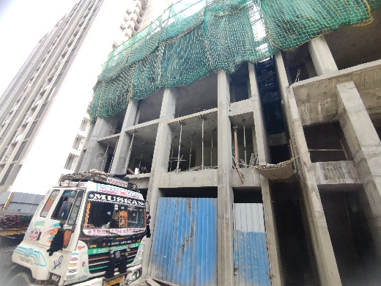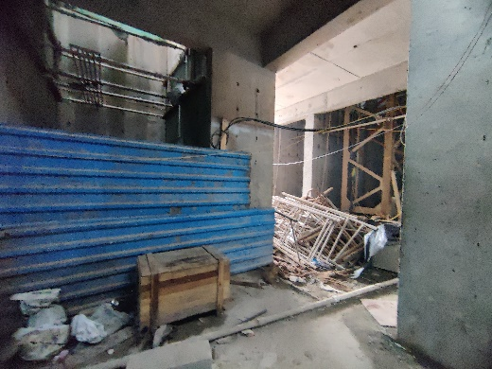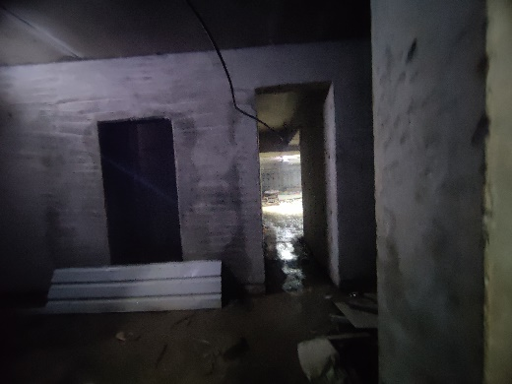**Actual Site Photographs As on 04.07.2024**

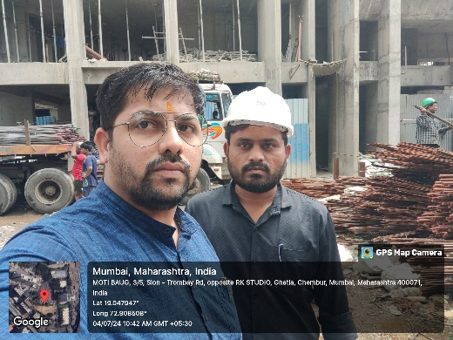

**Route Map of the property**

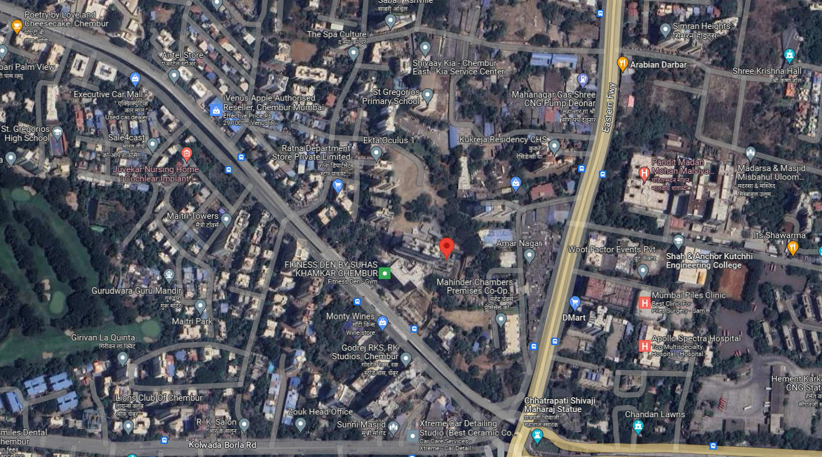**Site u/r**

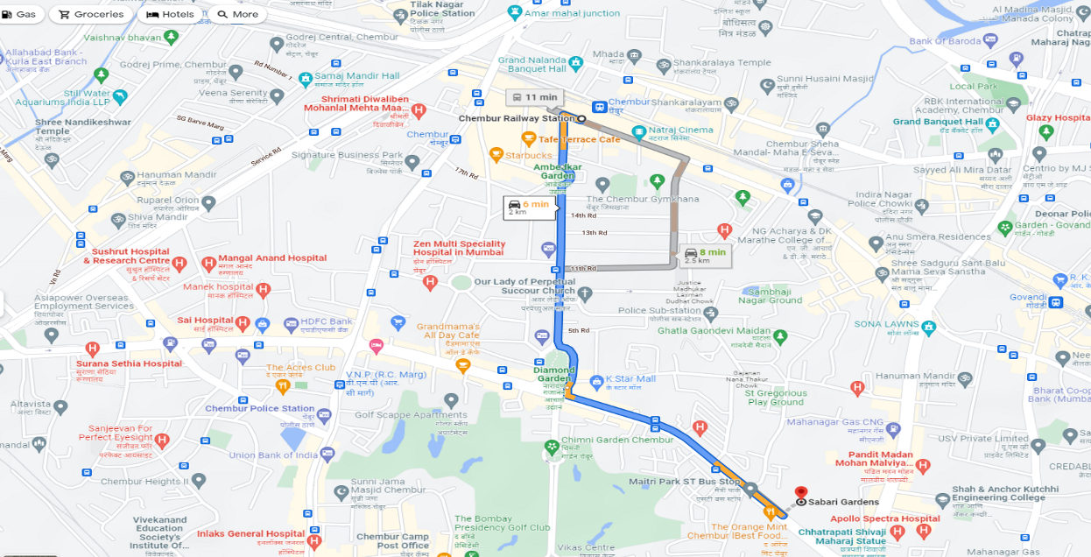

## Latitude Longitude: 19°02'54.3"N 72°54'29.6"E

Note: The Blue line shows the route to site from nearest railway station (Chembur – 2.00 Km.)

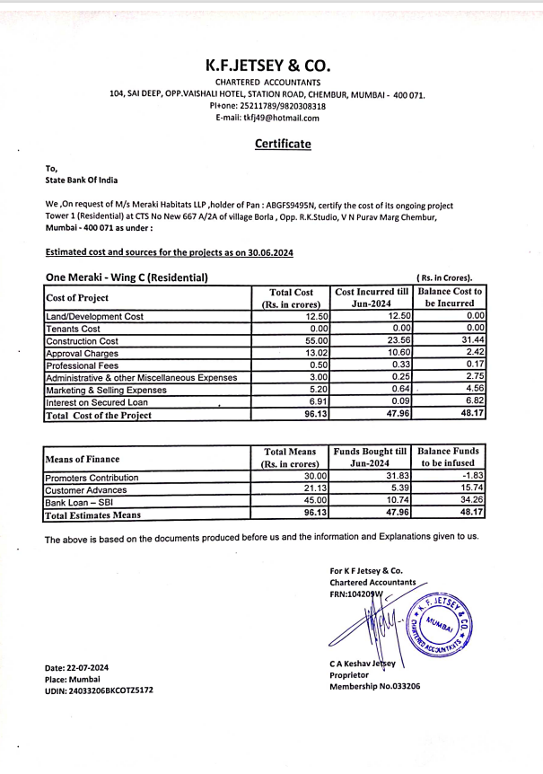**CA Certificate Dated 22.07.2024 till 30.06.2024**