1st LENDER’S INDEPENDENT ENGINEER REPORT
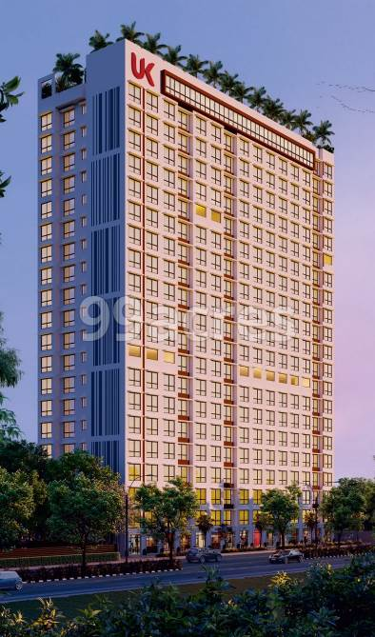

Details of the property under consideration:

Name of Project: UK IONA

"UK IONA", Proposed SRA Scheme Residential cum Commercial building on Plot bearing
C.T.S. No. 165 (PT), 166/A/1(PT) & 169/7/A(PT), New Shyam Nagar, New Balvikas School,
Village – Majas, Jogeshwari (East), Mumbai – 400 060, State – Maharashtra, Country – India

Latitude Longitude: 19°08'06.9"N 72°51'51.6"E

Intended User:

State Bank of India
SME Centre Borivali (West) Branch
SME Centre Borivali (15521) 101, 1st Floor, Landmark Building, S. V. Road, Near Petrol Pump,
Borivali (West), Mumbai – 400 092, State – Maharashtra, Country – India.

Vastu/SBI/Mumbai/08/2024/10090/2307948
30/10-426-PY
Date: - 30.08.2024

FIRST LENDER’S INDEPENDENT ENGINEER REPORT

To,
State Bank of India
SME Centre Borivali (West) Branch,
SME Centre Borivali (15521),
101, 1st Floor, Landmark Building,
S. V. Road, Near Petrol Pump,
Borivali (West), Mumbai – 400 092,
State – Maharashtra, Country – India

Subject: Construction of Proposed SRA Scheme Residential cum Commercial building on Plot bearing C.T.S. No. 165 (PT), 166/A/1(PT) & 169/7/A(PT), New Shyam Nagar, New Balvikas School, Village – Majas, Jogeshwari (East), Mumbai – 400 060, State – Maharashtra, Country – India

Ref: You’re Request for Lenders Independent Engineer Report of under Construction Building.
Dear Sir,
- As per your instruction, we have inspected the under construction residential building situated on plot bearing C.T.S. No. 165 (PT), 166/A/1(PT) & 169/7/A(PT), New Shyam Nagar, New Balvikas School, Village – Majas, Jogeshwari (East), Mumbai – 400 060, State – Maharashtra, Country – India which is being developed by M/s. Keemaya Build Pvt. Ltd. in order to give the physical progress of work completion as on 30/062024 as per amended approved plan dated 14.02.2024.

- While Certifying cost as per plinth area calculation as on 30/06/2024, various important factors such as type & Quality of proposed construction, Specification of building material to be used, grade of the building, height, lead & lift condition, current market price of similar type etc. were given due consideration.

- As per cost incurred certificate issued by CA Certificate actual total expenditure occurred as on 30/06/2024 is ` 47.07 Cr.

- Overall physical progress of the rehab building construction as on 30/06/2024 is 69.32% as per physical site inspection.

- Overall physical progress of the sale building (Wing A & B) construction as on 30/06/2024 is 61.91% as per physical site inspection.

- Overall physical progress of the sale building (Wing C) construction as on 30/06/2024 is 17.64% as per physical site inspection.

DECLARATION
- The information furnished in the report is based on our site visit Dated 25/07/2024 & Document Provided by Client.
- Vastukala Consultants (I) Pvt. Ltd. Cost Vetting Report of the project Ref. No. Vastu/SBI/Mumbai/04/2024/3534/2305966 15/01-105-PY dated 15.12.2023.
- Vastukala Consultants (I) Pvt. Ltd. Project Valuation Report of the project Ref. No. Vastu/SBI/Mumbai/04/2024/8124/2305967 15/02/106-PY dated 15.12.2023.
- I have no direct and indirect interest in the property examined for report.
- I have not been found guilty of misconduct in my professional capacity.

Manoj B. Chalikwar
Registered Valuer
Chartered Engineer (India)
Reg. No. IBBI/RV/07/2018/10366

Encl.: LIE report

Purpose & Methodology
• State Bank of India Banks and financial institutions require monitoring & an independent review of the progress of the sanctioned projects
VCIPL undertakes such study to independently review the progress of the project and put forward a comprehensive analysis

Advantages:
- Assurance on present practices
- Identification of risk
- Analyzing the performance of third parties
- Recommendations

The Methodology
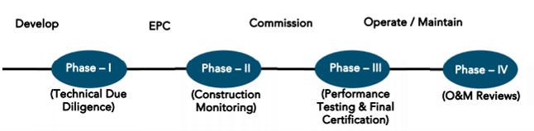
FIRST LENDER’S INDEPENDENT ENGINEER REPORT
OF
"UK IONA"
"UK IONA", Proposed SRA Scheme Residential cum Commercial building on Plot bearing
C.T.S. No. 165 (PT), 166/A/1(PT) & 169/7/A(PT), New Shyam Nagar, New Balvikas School,
Village – Majas, Jogeshwari (East), Mumbai – 400 060, State – Maharashtra, Country – India

Latitude Longitude: 19°08'06.9"N 72°51'51.6"E

NAME OF DEVELOPER: M/s. Keemaya Build Pvt. Ltd.
Pursuant to instructions from State Bank of India, SME Centre Borivali (West) Branch, Borivali we have duly visited, inspected, surveyed & assessed the above said property on 25th July 2024 to determine the fair & reasonable market value of the said property/project as on Quarter ending 30th June 2024 for LIE purpose.

1. Location Details:
Proposed SRA Scheme Residential cum Commercial building on Plot bearing C.T.S. No. 165 (PT), 166/A/1(PT) & 169/7/A(PT), New Shyam Nagar, New Balvikas School, Village – Majas, Jogeshwari (East), Mumbai – 400 060. It is about 2.80 Km. travelling distance from Jogeshwari (East) Railway station. Surface transport to the property is by buses, taxis & private vehicles. The property is in developed locality. All the amenities like shops, banks, hotels, markets, schools, hospitals, etc. are all available in the surrounding locality. The area is higher middle class & developed.

2. Developer Details:
Name of Developer | M/s. Keemaya Build Pvt. Ltd.
Project Rera Registration Number | Wing A & B – P51800047785  Wing C – P51800051359
Registered office address | 8, Abhishek Dalia Industrial Estate, Off. New Andheri Link Road, Andheri (West), Mumbai – 400 058, State – Maharashtra, Country – India.
Contact details | Contact Person:  Mr. Palani Arumugam  Mobile No. +91 93212 64009 / + 91 93225 02945
E – mail ID and website
3. Boundaries of the Property:
Direction | Particulars
On or towards North | Late Dattaram Govind Waykar Marg
On or towards South | Bal Vikas Vidya Mandir School & Slum Area
On or towards East | Open Area
On or towards West | Slum Area

Introduction
As per Information on site M/s. Keemaya Build Pvt. Ltd. has acquired land by Sale cum Developer Agreement dated 24.06.2012 admeasuring total area is 3,100.00 Sq. M. bearing C.T.S. No. 165 (PT), 166/A/1(PT) & 169/7/A(PT).

Area Statement:

Land:
Date | Particular | Area in Sq. M.
24.06.2012 | C.T.S. No. 165 (PT), 166/A/1(PT) & 169/7/A(PT) | 3,100.00
TOTAL |  | 3,100.00

- Copy of Sale cum Developer Agreement dated 24.06.2012 between M/s. Praijatak CHSL (The Society) and M/s. Keemaya Build Pvt. Ltd. (The Developers) through Notary.

Building Area As per Approved Plan:
AREA STATEMENT
1 | Area of plot | 2681.78
2 | a. Garden Reservation | 32.57
 | b. Road Set Back Area | 2.92
 | c. Police Station Reservation | 97.92
 | (Total a + b + c) | 133.41
3 | Balanced area of plot (1 - 2) | 2548.37
4 | Deduction for | -
 | (a)Recreation Ground (If Deductible) | -
5 | Net Plot Area (3 - 4) | 2548.37
6 | Addition for FSI
 | (2a) Garden Reservation | 32.57
 | (2b) Road Set Back Area | 2.92
 | (2c) Police Station Reservation | 97.92
7 | Total Area (5 + 6) | 2681.78
8 | FSI Permissible | 4.00
9 | Permissible Built-Up Area | 10727.12
10 | Proposed Rehab Built – Up Area | 5372.15
11 | Proposed Rehab Component Area | 7519.46
12 | Sale Incentive | 1.00
13 | Sale Permissible (Incentive Area X Rehab Component) | 7519.46
14 | Sale Permissible to be restrict as per LOI | 7445.08
15 | Proposed Sale Built – up area in Rehab Bldg. | 24.07
16 | Proposed Sale Built – up area in Sale Bldg. | 7395.51
17 | Total Proposed Built – up area (Sale + Rehab) (14 + 15) | 7419.58
B | FUNGIBLE AREA STATEMENT
 | (a) Permissible Fungible Area per floor = 7445.08 X 35% | 2605.78
 | (b) Proposed Fungible area per floor
 | (c) Existing fungible area per floor
 | (d) Excess fungible area per floor
 | Total Fungible Area
C | TENEMENT STATEMENT
 | (a) Total Proposed area
 | (b) Less deduction of Non – Res.
 | (c) Area of Tenements (a – b)
 | (d) Tenements permissible (500 T/D/Per Hectare)
 | (e) Tenements existing
D | PARKING AREA STATEMENT | As Stated,
 | (i) Parking required by regulations
 | Car
 | Scooter / Motor Cycle
 | Outsiders (Visitors)
 | (ii) Covered Garages Permissible
 | (iii) Covered Garages Provided
 | Car
 | Scooter / Motor Cycle
 | Outsiders (Visitors)
 | (iv) Total Parking Provided

List of Approvals:
- Copy of Approved Plan No. KE/MCGM & MHADA/0001/20171117/AP dated 15.03.2023 issued by Slum Rehabilitation Authority (SRA).
Approved upto:
Rehab Building: Ground Floor + 1st to 20th Upper Residential Floors
Sale Building (Wing A): Ground Floor + 1st to 12th Upper Residential Floors
Sale Building (Wing B & C): Ground Floor + 1st to 14th Upper Residential Floors
- Copy of 1st Commencement Certificate No. KE/MCGM & MHADA/0001/20171117/AP dated 19.10.2022 issued by Slum Rehabilitation Authority (SRA).
(This CC is endorsed for the work for Plinth Level)
- Copy of 2nd Commencement Certificate No. KE/MCGM & MHADA/0001/20171117/AP/C dated 18.07.2023 issued by Slum Rehabilitation Authority (SRA).
(This CC is endorsed for the work for Rehab Building: Ground Floor + 1st to 19th Upper Floors + 20th (pt) Upper Floor + OHWT + LMR, Sale Building (Wing A): Ground Floor + 1st to 12th Upper Floors & Sale Building (Wing B): Ground Floor + 1st to 14th Upper Floors as per approved plan 15.03.2022)
- Copy of Amended Letter of Intent No. KE/MCGM & MHADA/0001/20171117/AP/C dated 14.02.2024 issued by Slum Rehabilitation Authority (SRA).
- Copy of Amended Approved Plan No. KE/MCGM & MHADA/0001/20171117/AP/C dated 14.02.2024 issued by Slum Rehabilitation Authority (SRA).
Approved upto:
Rehab Building: Ground Floor + 1st to 20th Upper Residential Floors
Sale Building (Wing A & B): Ground Floor + 1st to 20th Upper Residential Floors
Sale Building (Wing C): Ground Floor + 1st to 4th Upper Residential Floors
- Copy of 3rd Commencement Certificate No. KE/MCGM & MHADA/0001/20171117/AP/C dated 06.05.2024 issued by Slum Rehabilitation Authority (SRA).
(This CC is endorsed for the work for Rehab Building: Ground Floor + 1st to 19th Upper Floors + 20th (pt) Upper Floor + OHWT + LMR, Sale Building (Wing A & B): Ground Floor + 1st to 19th + 20th (Pt.) Upper Floors & Sale Building (Wing C): Ground Floor + 1st to 4th Upper Floors as per amended approved plan 14.02.2024)
- Copy of Concession / Architect Plan drawn by M/s. Ellora Project Consultants Pvt. Ltd.
Rehab Building: Ground Floor + 1st to 20th Upper Residential Floors
Sale Building (Wing A & B & C): Ground Floor + 1st to 20th (Pt.) Upper Residential Floors

LEVEL OF COMPLETION:

Rehab Building
Sr. No | Floor No. | Construction Area in Sq. M. | Completed Area in Sq. M. | Percentage of work completed | Work Completion as on 25.07.2024
1 | Excavation & Shore Piling |  |  | 100% | Work is Completed
2 | Ground Floor | 421.88 | 421.88 | 50% | Slab work is completed
3 | 1st Floor | 421.87 | 421.87 | 75% | Slab work, Block work, Plaster work, kitchen platform, flooring, toilet tiling, door & window frame work, concealed plumbing & electrical work is completed. Gypsum work is in progress.
4 | 2nd Floor | 421.87 | 421.87 | 75% | Slab work, Block work, Plaster work, kitchen platform, flooring, toilet tiling, door & window frame work, concealed plumbing & electrical work is completed. Gypsum work is in progress.
5 | 3rd Floor | 421.88 | 421.88 | 75% | Slab work, Block work, Plaster work, kitchen platform, flooring, toilet tiling, door & window frame work, concealed plumbing & electrical work is completed. Gypsum work is in progress.
6 | 4th Floor | 421.88 | 421.88 | 75% | Slab work, Block work, Plaster work, kitchen platform, flooring, toilet tiling, door & window frame work, concealed plumbing & electrical work is completed. Gypsum work is in progress.
7 | 5th Floor | 421.88 | 421.88 | 75% | Slab work, Block work, Plaster work, kitchen platform, flooring, toilet tiling, door & window frame work, concealed plumbing & electrical work is completed. Gypsum work is in progress.
8 | 6th Floor | 421.88 | 421.88 | 75% | Slab work, Block work, Plaster work, kitchen platform, flooring, toilet tiling, door & window frame work, concealed plumbing & electrical work is completed. Gypsum work is in progress.
9 | 7th Floor | 421.88 | 421.88 | 75% | Slab work, Block work, Plaster work, kitchen platform, flooring, toilet tiling, door & window frame work, concealed plumbing & electrical work is completed. Gypsum work is in progress.
10 | 8th Floor | 421.88 | 421.88 | 75% | Slab work, Block work, Plaster work, kitchen platform, flooring, toilet tiling, door & window frame work, concealed plumbing & electrical work is completed. Gypsum work is in progress.
11 | 9th Floor | 421.88 | 421.88 | 75% | Slab work, Block work, Plaster work, kitchen platform, flooring, toilet tiling, door & window frame work, concealed plumbing & electrical work is completed. Gypsum work is in progress.
12 | 10th Floor | 421.88 | 421.88 | 65% | Slab work, Block work, Plaster work, door & window frame work, concealed plumbing & electrical work is completed. Gypsum work is in progress.
13 | 11th Floor | 421.88 | 421.88 | 65% | Slab work, Block work, Plaster work is completed. Gypsum work is in progress.
14 | 12th Floor | 421.88 | 421.88 | 65% | Slab work, Block work, Plaster work is completed. Gypsum work is in progress.
15 | 13th Floor | 421.88 | 421.88 | 65% | Slab work, Block work, Plaster work is completed. Gypsum work is in progress.
16 | 14th Floor | 485.61 | 485.61 | 65% | Slab work, Block work, Plaster work is completed. Gypsum work is in progress.
17 | 15th Floor | 358.15 | 358.15 | 65% | Slab work, Block work, Plaster work is completed. Gypsum work is in progress.
18 | 16th Floor | 421.88 | 421.88 | 65% | Slab work, Block work, Plaster work is completed. Gypsum work is in progress.
19 | 17th Floor | 421.88 | 421.88 | 65% | Slab work, Block work, Plaster work is completed. Gypsum work is in progress.
20 | 18th Floor | 421.88 | 421.88 | 50% | Slab work is completed.
21 | 19th Floor | 421.88 | 421.88 | 50% | Slab work is completed.
22 | 20th Floor | 358.15 | 358.15 | 50% | Slab work is completed.
23 | OHT & LMR Area | 39.86
Total |  | 8,835.59 | 8,795.73 | 69.32%

Sale Building (Wing A & B)
Sr. No |  | Floor No. | Construction Area in Sq. M. | Completed Area in Sq. M. | Percentage of work completed | Work Completion as on 25.07.2024
1 |  | Excavation & Shore Piling |  |  | 100% | Work is Completed
2 |  | Ground Floor | 437.59 | 437.59 | 50% | Slab work is completed
3 |  | 1st Floor | 437.59 | 437.59 | 68% | Slab work, Block work, Plaster work, kitchen platform, door & window frame work, concealed plumbing & electrical work is completed. Gypsum work is in progress.
4 |  | 2nd Floor | 437.59 | 437.59 | 68% | Slab work, Block work, Plaster work, kitchen platform, door & window frame work, concealed plumbing & electrical work is completed. Gypsum work is in progress.
5 |  | 3rd Floor | 437.59 | 437.59 | 68% | Slab work, Block work, Plaster work, kitchen platform, door & window frame work, concealed plumbing & electrical work is completed. Gypsum work is in progress.
6 |  | 4th Floor | 437.59 | 437.59 | 68% | Slab work, Block work, Plaster work, kitchen platform, door & window frame work, concealed plumbing & electrical work is completed. Gypsum work is in progress.
7 |  | 5th Floor | 437.59 | 437.59 | 68% | Slab work, Block work, Plaster work, kitchen platform, door & window frame work, concealed plumbing & electrical work is completed. Gypsum work is in progress.
8 |  | 6th Floor | 437.59 | 437.59 | 68% | Slab work, Block work, Plaster work, kitchen platform, door & window frame work, concealed plumbing & electrical work is completed. Gypsum work is in progress.
9 |  | 7th Floor | 437.59 | 437.59 | 68% | Slab work, Block work, Plaster work, kitchen platform, door & window frame work, concealed plumbing & electrical work is completed. Gypsum work is in progress.
10 |  | 8th Floor | 437.59 | 437.59 | 68% | Slab work, Block work, Plaster work, kitchen platform, door & window frame work, concealed plumbing & electrical work is completed. Gypsum work is in progress.
11 |  | 9th Floor | 437.59 | 437.59 | 68% | Slab work, Block work, Plaster work, kitchen platform, door & window frame work, concealed plumbing & electrical work is completed. Gypsum work is in progress.
12 |  | 10th Floor | 437.59 | 437.59 | 68% | Slab work, Block work, Plaster work, kitchen platform, door & window frame work, concealed plumbing work is completed. Gypsum work is in progress.
13 |  | 11th Floor | 437.59 | 437.59 | 68% | Slab work, Block work, Plaster work, kitchen platform, door & window frame work, concealed plumbing work is completed. Gypsum work is in progress.
14 |  | 12th Floor | 437.59 | 437.59 | 68% | Slab work, Block work, Plaster work, kitchen platform, concealed plumbing work is completed. Gypsum work is in progress.
15 |  | 13th Floor | 437.59 | 437.59 | 68% | Slab work, Block work, Plaster work, concealed plumbing work is completed. Gypsum work is in progress.
16 |  | 14th Floor | 437.59 | 437.59 | 68% | Slab work, Block work, Plaster work is completed. Gypsum work is in progress.
17 |  | 15th Floor | 437.59 | 437.59 | 68% | Slab work, Block work, Plaster work is completed. Gypsum work is in progress.
18 |  | 16th Floor | 437.59 | 437.59 | 68% | Slab work, Block work, Plaster work is completed. Gypsum work is in progress.
19 |  | 17th Floor | 437.59 | 437.59 | 68% | Slab work, Block work, Plaster work is completed. Gypsum work is in progress.
20 |  | 18th Floor | 437.59 | 437.59 | 68% | Slab work, Block work, Plaster work is completed. Gypsum work is in progress.
21 |  | 19th Floor | 437.59 | 437.59 | 68% | Slab work, Block work, Plaster work is completed. Gypsum work is in progress.
22 |  | 20th Floor | 437.59 | 437.59 | 68% | Slab work, Block work, Plaster work is completed. Gypsum work is in progress.
23 |  | OHT & LMR Area | 61.67
Total |  |  | 9,251.06 | 9,189.39
24 | Stack Parking |  | 77 Nos.

Sale Building (Wing C)
Sr. No |  | Floor No. | Construction Area in Sq. M. | Completed Area in Sq. M. | Percentage of work completed | Work Completion as on 25.07.2024
1 |  | Excavation & Shore Piling |  |  | 100% | Work is Completed
2 |  | Ground Floor | 656.39 | 656.39 | 50% | Slab work is completed
3 |  | 1st Floor | 656.39 | 656.39 | 50% | Slab work is completed
4 |  | 2nd Floor | 656.39 | 656.39 | 50% | Slab work is completed
5 |  | 3rd Floor | 656.39 | 656.39 | 50% | Slab work is completed
6 |  | 4th Floor | 656.39 | 656.39 | 50% | Slab work is completed
7 |  | 5th Floor | 656.39 | 437.59 | 50%
8 |  | 6th Floor | 656.39 | 437.59 | 50%
9 |  | 7th Floor | 656.39 | 437.59 | 50%
10 |  | 8th Floor | 656.39 | 437.59 | 50%
11 |  | 9th Floor | 656.39 | 437.59
12 |  | 10th Floor | 656.39 | 437.59
13 |  | 11th Floor | 656.39 | 437.59
14 |  | 12th Floor | 656.39 | 437.59
15 |  | 13th Floor | 656.39 | 437.59
16 |  | 14th Floor | 656.39 | 437.59
17 |  | 15th Floor | 656.39 | 437.59
18 |  | 16th Floor | 656.39 | 437.59
19 |  | 17th Floor | 656.39 | 437.59
20 |  | 18th Floor | 656.39 | 437.59
21 |  | 19th Floor | 656.39 | 437.59
22 |  | 20th Floor | 656.39 | 437.59
23 |  | OHT & LMR Area | 92.51
Total |  |  | 13,876.70 | 10,283.39
24 | Stack Parking |  | 38 Nos.

Details of the Project as Financed By SBI:

Estimate of the project
Project expenses | Estimate Cost As per Cost Vetting Report in ` Cr.
Land Cost | -
Rent Cost | 8.29
Construction Cost of Rehab Building | 26.24
Construction Cost of Sale Building | 51.54
Approval Cost | 33.93
Professional Cost | 3.89
Admin Cost | 3.11
Marketing Cost | 7.30
Interest Cost | 10.01
Contingency Cost | 2.33
Total Cost | 146.64

Note: -

Project Cost: (as per C.A. Certificate)
Particulars | Incurred Cost (In ` Cr.) for Wing (A & B) till 30.06.2024 dated 25.07.2024 by M/s. V. M. Tated & Co. | Incurred Cost (In ` Cr.) for Wing (C) till 30.06.2024 dated 25.07.2024 by M/s. V. M. Tated & Co. | Total Incurred Cost (In ` Cr.) till 30.06.2024 dated 25.07.2024 by M/s. V. M. Tated & Co.
Land Cost | - | - | -
Rent Cost | 4.33 | 0.83 | 5.16
Construction Cost of Rehab Building | 7.55 | 3.78 | 11.33
Construction Cost of Sale Building | 11.40 | 1.29 | 12.69
Approval Cost | 8.87 | 3.16 | 12.03
Professional Cost | 3.99 | 1.80 | 5.79
Admin Cost
Marketing Cost
Interest Cost | 0.06 | 0.01 | 0.07
Contingency Cost | - | - | -
Total | 36.20 | 10.87 | 47.07

Cost of Construction as on 25th July 2024:

Construction Cost of Rehab Building:
Sr. | Floor | Construction Area in Sq. M. | Completed Area in Sq. M. | Rate per Sq. M. | Full Value after completion | % of work completed | Actual Expenditure till date in `
1 | Excavation Cost |  |  |  | 2,38,56,093.00 | 100% | 2,38,56,093.00
2 | Ground Floor | 421.88 | 421.88 | 27,000.00 | 1,13,90,760.00 | 50% | 56,95,380.00
3 | 1st Floor | 421.87 | 421.87 | 27,000.00 | 1,13,90,490.00 | 75% | 85,42,867.50
4 | 2nd Floor | 421.87 | 421.87 | 27,000.00 | 1,13,90,490.00 | 75% | 85,42,867.50
5 | 3rd Floor | 421.88 | 421.88 | 27,000.00 | 1,13,90,760.00 | 75% | 85,43,070.00
6 | 4th Floor | 421.88 | 421.88 | 27,000.00 | 1,13,90,760.00 | 75% | 85,43,070.00
7 | 5th Floor | 421.88 | 421.88 | 27,000.00 | 1,13,90,760.00 | 75% | 85,43,070.00
8 | 6th Floor | 421.88 | 421.88 | 27,000.00 | 1,13,90,760.00 | 75% | 85,43,070.00
9 | 7th Floor | 421.88 | 421.88 | 27,000.00 | 1,13,90,760.00 | 75% | 85,43,070.00
10 | 8th Floor | 421.88 | 421.88 | 27,000.00 | 1,13,90,760.00 | 75% | 85,43,070.00
11 | 9th Floor | 421.88 | 421.88 | 27,000.00 | 1,13,90,760.00 | 75% | 85,43,070.00
12 | 10th Floor | 421.88 | 421.88 | 27,000.00 | 1,13,90,760.00 | 65% | 74,03,994.00
13 | 11th Floor | 421.88 | 421.88 | 27,000.00 | 1,13,90,760.00 | 65% | 74,03,994.00
14 | 12th Floor | 421.88 | 421.88 | 27,000.00 | 1,13,90,760.00 | 65% | 74,03,994.00
15 | 13th Floor | 421.88 | 421.88 | 27,000.00 | 1,13,90,760.00 | 65% | 74,03,994.00
16 | 14th Floor | 485.61 | 485.61 | 27,000.00 | 1,31,11,470.00 | 65% | 85,22,455.50
17 | 15th Floor | 358.15 | 358.15 | 27,000.00 | 96,70,050.00 | 65% | 62,85,532.50
18 | 16th Floor | 421.88 | 421.88 | 27,000.00 | 1,13,90,760.00 | 65% | 74,03,994.00
19 | 17th Floor | 421.88 | 421.88 | 27,000.00 | 1,13,90,760.00 | 65% | 74,03,994.00
20 | 18th Floor | 421.88 | 421.88 | 27,000.00 | 1,13,90,760.00 | 50% | 56,95,380.00
21 | 19th Floor | 421.88 | 421.88 | 27,000.00 | 1,13,90,760.00 | 50% | 56,95,380.00
22 | 20th Floor | 358.15 | 358.15 | 27,000.00 | 96,70,050.00 | 50% | 48,35,025.00
23 | OHT / LMR | 39.86 |  | 27,000.00 | 10,76,220.00 |  | -
TOTAL |  | 8,835.59 | 8,795.73 |  | 26,24,17,023.00 | 69.32% | 18,18,96,435.00

Note: Details of work completed is as per site visit dated 25.07.2024 but LIE report is prepared for quarter ending on 30th June 2024.

Construction Cost of Sale Building (Wing A & B):
Sr | Floor | Construction Area in Sq. M. | Completed Area in Sq. M. | Rate per Sq. M. | Full Value after completion | % of work completed | Actual Expenditure till date in `
1 | Excavation Cost |  |  |  | 2,77,53,180.00 | 100% | 2,77,53,180.00
2 | Ground Floor | 437.59 | 437.59 | 30,000.00 | 1,31,27,700.00 | 50% | 65,63,850.00
3 | 1st Floor | 437.59 | 437.59 | 30,000.00 | 1,31,27,700.00 | 68% | 89,26,836.00
4 | 2nd Floor | 437.59 | 437.59 | 30,000.00 | 1,31,27,700.00 | 68% | 89,26,836.00
5 | 3rd Floor | 437.59 | 437.59 | 30,000.00 | 1,31,27,700.00 | 68% | 89,26,836.00
6 | 4th Floor | 437.59 | 437.59 | 30,000.00 | 1,31,27,700.00 | 68% | 89,26,836.00
7 | 5th Floor | 437.59 | 437.59 | 30,000.00 | 1,31,27,700.00 | 68% | 89,26,836.00
8 | 6th Floor | 437.59 | 437.59 | 30,000.00 | 1,31,27,700.00 | 68% | 89,26,836.00
9 | 7th Floor | 437.59 | 437.59 | 30,000.00 | 1,31,27,700.00 | 68% | 89,26,836.00
10 | 8th Floor | 437.59 | 437.59 | 30,000.00 | 1,31,27,700.00 | 68% | 89,26,836.00
11 | 9th Floor | 437.59 | 437.59 | 30,000.00 | 1,31,27,700.00 | 68% | 89,26,836.00
12 | 10th Floor | 437.59 | 437.59 | 30,000.00 | 1,31,27,700.00 | 68% | 89,26,836.00
13 | 11th Floor | 437.59 | 437.59 | 30,000.00 | 1,31,27,700.00 | 68% | 89,26,836.00
14 | 12th Floor | 437.59 | 437.59 | 30,000.00 | 1,31,27,700.00 | 68% | 89,26,836.00
15 | 13th Floor | 437.59 | 437.59 | 30,000.00 | 1,31,27,700.00 | 68% | 89,26,836.00
16 | 14th Floor | 437.59 | 437.59 | 30,000.00 | 1,31,27,700.00 | 68% | 89,26,836.00
17 | 15th Floor | 437.59 | 437.59 | 30,000.00 | 1,31,27,700.00 | 68% | 89,26,836.00
18 | 16th Floor | 437.59 | 437.59 | 30,000.00 | 1,31,27,700.00 | 68% | 89,26,836.00
19 | 17th Floor | 437.59 | 437.59 | 30,000.00 | 1,31,27,700.00 | 68% | 89,26,836.00
20 | 18th Floor | 437.59 | 437.59 | 30,000.00 | 1,31,27,700.00 | 68% | 89,26,836.00
21 | 19th Floor | 437.59 | 437.59 | 30,000.00 | 1,31,27,700.00 | 68% | 89,26,836.00
22 | 20th Floor | 437.59 | 437.59 | 30,000.00 | 1,31,27,700.00 | 68% | 89,26,836.00
23 | OHT / LMR | 61.67 |  | 30,000.00 | 18,50,100.00 | - | -
SUB - TOTAL |  | 9,251.06 | 9,189.39 |  | 30,52,84,980.00 | 69.72% | 21,28,53,750.00
24 | Stack Parking | 77.00 |  | 5,00,000.00 | 3,85,00,000.00 |  | -
TOTAL |  |  |  |  | 34,37,84,980.00 | 61.91% | 21,28,53,750.00

Note: Details of work completed is as per site visit dated 25.07.2024 but LIE report is prepared for quarter ending on 30th June 2024.

Construction Cost of Sale Building (Wing C):
Sr. | Floor | Construction Area in Sq. M. | Completed Area in Sq. M. | Rate per Sq. M. | Full Value after completion | % of work completed | Actual Expenditure till date in `
1 | Excavation Cost |  |  |  | 1,38,76,920.00 | 100% | 1,38,76,920.00
2 | Ground Floor | 218.80 | 218.80 | 30,000.00 | 65,64,000.00 | 50% | 32,82,000.00
3 | 1st Floor | 218.80 | 218.80 | 30,000.00 | 65,64,000.00 | 50% | 32,82,000.00
4 | 2nd Floor | 218.80 | 218.80 | 30,000.00 | 65,64,000.00 | 50% | 32,82,000.00
5 | 3rd Floor | 218.80 | 218.80 | 30,000.00 | 65,64,000.00 | 50% | 32,82,000.00
6 | 4th Floor | 218.80 | 218.80 | 30,000.00 | 65,64,000.00 | 50% | 32,82,000.00
7 | 5th Floor | 218.80 |  | 30,000.00 | 65,64,000.00 |  | -
8 | 6th Floor | 218.80 |  | 30,000.00 | 65,64,000.00 |  | -
9 | 7th Floor | 218.80 |  | 30,000.00 | 65,64,000.00 |  | -
10 | 8th Floor | 218.80 |  | 30,000.00 | 65,64,000.00 |  | -
11 | 9th Floor | 218.80 |  | 30,000.00 | 65,64,000.00 |  | -
12 | 10th Floor | 218.80 |  | 30,000.00 | 65,64,000.00 |  | -
13 | 11th Floor | 218.80 |  | 30,000.00 | 65,64,000.00 |  | -
14 | 12th Floor | 218.80 |  | 30,000.00 | 65,64,000.00 |  | -
15 | 13th Floor | 218.80 |  | 30,000.00 | 65,64,000.00 |  | -
16 | 14th Floor | 218.80 |  | 30,000.00 | 65,64,000.00 |  | -
17 | 15th Floor | 218.80 |  | 30,000.00 | 65,64,000.00 |  | -
18 | 16th Floor | 218.80 |  | 30,000.00 | 65,64,000.00 |  | -
19 | 17th Floor | 218.80 |  | 30,000.00 | 65,64,000.00 |  | -
20 | 18th Floor | 218.80 |  | 30,000.00 | 65,64,000.00 |  | -
21 | 19th Floor | 218.80 |  | 30,000.00 | 65,64,000.00 |  | -
22 | 20th Floor | 218.80 |  | 30,000.00 | 65,64,000.00 |  | -
23 | OHT / LMR | 30.84 |  | 30,000.00 | 9,25,200.00 |  | -
SUB - TOTAL |  | 4,625.64 | 1,094.00 |  | 15,26,46,120.00 | 19.84% | 3,02,86,920.00
24 | Stack Parking | 38.00 |  | 5,00,000.00 | 1,90,00,000.00 |  | -
TOTAL |  |  |  |  | 17,16,46,120.00 | 17.64% | 3,02,86,920.00

Note: Details of work completed is as per site visit dated 25.07.2024 but LIE report is prepared for quarter ending on 30th June 2024.

Means of Finance:
Sr. No. | Particulars | Wing (A & B) (Amount in ` Cr.) | Wing (C)  (Amount in ` Cr.) | Total Exp. Cumulative (Cr.)
 | Equity share capital / Quassi Loan from Promoter | 7.94 | 5.00 | 12.94
 | Unsecured Loan | - | - | -
 | Bank Loan Amount | 3.06 | 0.66 | 3.72
 | Sales (Advance from customer) | 25.20 | 5.21 | 30.41
 | Total | 36.20 | 10.87 | 47.07
The Details of the Means of Finance are provided by Client as on 30.06.2024.

Mandatory Arrangements:
Sr. No. | Particulars | Status
 | Rainwater Harvesting | To be executed after RCC Structure
 | Firefighting System | To be executed after RCC Structure
 | Solid Waste Management | To be executed after RCC Structure

Quality of Construction:
Sr. No. | Particulars | Status
 | Soundness of Structures | Executing as per approved Structural Design
 | Look of Structures | Good
 | Quality of Material Used | Good
 | Safety Measures for Construction/labour | Taken Care by Contractor

Schedule V/s. Actual Progress:

Rehab Building
Activity | Date of Implementation | Date of Completion | Status
Land |  |  | Completed
Development of Land |  |  | Completed
Foundation Work |  |  | Completed
Ground Floor Slab |  |  | Slab work is Completed
1st Floor Slab |  |  | Slab work is Completed
2nd Floor Slab |  |  | Slab work is Completed
3rd Floor Slab |  |  | Slab work is Completed
4th Floor Slab |  |  | Slab work is Completed
5th Floor Slab |  |  | Slab work is Completed
6th Floor Slab |  |  | Slab work is Completed
7th Floor Slab |  |  | Slab work is Completed
8th Floor Slab |  |  | Slab work is Completed
9th Floor Slab |  |  | Slab work is Completed
10th Floor Slab |  |  | Slab work is Completed
11th Floor Slab |  |  | Slab work is Completed
12th Floor Slab |  |  | Slab work is Completed
13th Floor Slab |  |  | Slab work is Completed
14th Floor Slab |  |  | Slab work is Completed
15th Floor Slab |  |  | Slab work is Completed
16th Floor Slab |  |  | Slab work is Completed
17th Floor Slab |  |  | Slab work is Completed
18th Floor Slab |  |  | Slab work is Completed
19th Floor Slab |  |  | Slab work is Completed
20th Floor Slab |  |  | Slab work is Completed
Block work / Internal Plaster work |  |  | 1st to 20th floor blockwork is completed  1st to 17th floor plaster work is completed
Terrace Parapet wall / Overhead water tank / Lift Machine room / compound wall / External Plaster work
Electric Work |  |  | Concealed Work is completed
Water Proofing
Plumbing Work |  |  | Concealed Work is completed
Tiling / Marble Flooring |  |  | 1st to 9th floor flooring & tiling work is completed
Door Frames |  |  | 1st to 10th floor door frame work is completed
Window Installation |  |  | 1st to 10th floor window frame work is completed
Staircase Flooring
Staircase Railing
Refuge Area Flooring
Internal Painting
External Painting
Lift Work
Fire Fighting Installation
Stack Parking
CP Fitting & Sanitary Work
Final Finishing & Fitting

Sale Building (Wing A & B)
Activity | Date of Implementation | Date of Completion | Status
Land |  |  | Completed
Development of Land |  |  | Completed
Foundation Work |  |  | Completed
Ground Floor Slab |  |  | Slab work is Completed
1st Floor Slab |  |  | Slab work is Completed
2nd Floor Slab |  |  | Slab work is Completed
3rd Floor Slab |  |  | Slab work is Completed
4th Floor Slab |  |  | Slab work is Completed
5th Floor Slab |  |  | Slab work is Completed
6th Floor Slab |  |  | Slab work is Completed
7th Floor Slab |  |  | Slab work is Completed
8th Floor Slab |  |  | Slab work is Completed
9th Floor Slab |  |  | Slab work is Completed
10th Floor Slab |  |  | Slab work is Completed
11th Floor Slab |  |  | Slab work is Completed
12th Floor Slab |  |  | Slab work is Completed
13th Floor Slab |  |  | Slab work is Completed
14th Floor Slab |  |  | Slab work is Completed
15th Floor Slab |  |  | Slab work is Completed
16th Floor Slab |  |  | Slab work is Completed
17th Floor Slab |  |  | Slab work is Completed
18th Floor Slab |  |  | Slab work is Completed
19th Floor Slab |  |  | Slab work is Completed
20th Floor Slab |  |  | Slab work is Completed
Block work / Internal Plaster work |  |  | 1st to 20th floor blockwork is completed  1st to 14th floor plaster work is completed
Terrace Parapet wall / Overhead water tank / Lift Machine room / compound wall / External Plaster work
Electric Work
Water Proofing
Plumbing Work
Tiling / Marble Flooring
Door Frames
Window Installation
Staircase Flooring
Staircase Railing
Refuge Area Flooring
Internal Painting
External Painting
Lift Work
Fire Fighting Installation
Stack Parking
CP Fitting & Sanitary Work
Final Finishing & Fitting

Sale Building (Wing C)
Activity | Date of Implementation | Date of Completion | Status
Land |  |  | Completed
Development of Land |  |  | Completed
Foundation Work |  |  | Completed
Ground Floor Slab |  |  | Slab work is Completed
1st Floor Slab |  |  | Slab work is Completed
2nd Floor Slab |  |  | Slab work is Completed
3rd Floor Slab |  |  | Slab work is Completed
4th Floor Slab
5th Floor Slab
6th Floor Slab
7th Floor Slab
8th Floor Slab
9th Floor Slab
10th Floor Slab
11th Floor Slab
12th Floor Slab
13th Floor Slab
14th Floor Slab
15th Floor Slab
16th Floor Slab
17th Floor Slab
18th Floor Slab
19th Floor Slab
20th Floor Slab
Block work / Internal Plaster work
Terrace Parapet wall / Overhead water tank / Lift Machine room / compound wall / External Plaster work
Electric Work
Water Proofing
Plumbing Work
Tiling / Marble Flooring
Door Frames
Window Installation
Staircase Flooring
Staircase Railing
Refuge Area Flooring
Internal Painting
External Painting
Lift Work
Fire Fighting Installation
Stack Parking
CP Fitting & Sanitary Work
Final Finishing & Fitting

Developer have not shared the work schedule of the project.

Action initiated to complete the project in time:
For Rehab Building: Till 20th floor slab work is completed, terrace slab work is in progress, 1st to 20th floor block work is completed, 1st to 18th floor plaster work is completed, 1st to 9th Floor kitchen platform, flooring, toilet tiling work is completed, 1st to 10th floor concealed plumbing & electrical work and door & window frame work is completed.
Sale Building:
Wing A & B: Till 20th Slab work is completed, terrace slab work is in progress, 1st to 20th floor block work is completed, 1st to 13th floor plaster work is completed, 1st to 12th floor kitchen platform work is completed, 1st to 11th floor door & window frame work is completed, 1st to 13th floor concealed plumbing work is completed, 1st to 9th floor concealed electrical work is completed.
Wing C: Till 4th floor slab work is completed.

Comments related to cost overrun if any:
The cost of Sales Building is ` 146.64 Cr.

Balance investment required for completion of project:
We opinion amount of ` 99.57 Cr. Will be required to complete the Project.

Mandatory Approval Status:
Sr. No. | Particulars | Name of Department | Status | Order Details
1A | LOI of Building | Slum Rehabilitation Authority (SRA). | Obtained and available at site | KE/MCGM & MHADA/0001/20171117/AP dated 15.03.2023
1B | Amended LOI of Building | Slum Rehabilitation Authority (SRA). | Obtained and available at site | KE/MCGM & MHADA/0001/20171117/AP/C dated 14.02.2024
2A | Approved Plan | Slum Rehabilitation Authority (SRA). | Obtained and available at site | KE/MCGM & MHADA/0001/20171117/AP dated 15.03.2023  Approved upto:  Rehab Building: Ground Floor + 1st to 20th Upper Residential Floors  Sale Building (Wing A): Ground Floor + 1st to 12th Upper Residential Floors  Sale Building (Wing B & C): Ground Floor + 1st to 14th Upper Residential Floors
2B | Amended Approved Plan | Slum Rehabilitation Authority (SRA). | Obtained and available at site | KE/MCGM & MHADA/0001/20171117/AP/C dated 14.02.2024  Approved upto:  Rehab Building: Ground Floor + 1st to 20th Upper Residential Floors  Sale Building (Wing A & B): Ground Floor + 1st to 20th Upper Residential Floors  Sale Building (Wing C): Ground Floor + 1st to 4th Upper Residential Floors
3A | First C.C. | Slum Rehabilitation Authority (SRA). | Obtained and available at site | KE/MCGM & MHADA/0001/20171117/AP dated 19.10.2022. This CC is endorsed for the work for Plinth Level
3B | Second C.C. | Slum Rehabilitation Authority (SRA). | Obtained and available at site | KE/MCGM & MHADA/0001/20171117/AP/C dated 18.07.2023. This CC is endorsed for the work for Rehab Building: Ground Floor + 1st to 19th Upper Floors + 20th (pt) Upper Floor + OHWT + LMR, Sale Building (Wing A): Ground Floor + 1st to 12th Upper Floors & Sale Building (Wing B): Ground Floor + 1st to 14th Upper Floors as per approved plan 15.03.2022.
3C | Third C.C. | Slum Rehabilitation Authority (SRA). | Obtained and available at site | KE/MCGM & MHADA/0001/20171117/AP/C dated 06.05.2024. This CC is endorsed for the work for Rehab Building: Ground Floor + 1st to 19th Upper Floors + 20th (pt) Upper Floor + OHWT + LMR, Sale Building (Wing A & B): Ground Floor + 1st to 19th + 20th (Pt.) Upper Floors & Sale Building (Wing C): Ground Floor + 1st to 4th Upper Floors as per amended approved plan 14.02.2024
3D | Fourth C.C. | Slum Rehabilitation Authority (SRA). | Pending (Project is not completed)
3 | Occupancy | Slum Rehabilitation Authority (SRA). | Pending (Project is not completed)

Status Insurance Coverage:
Information not provided

Assumptions & Remarks:
- The adequacy of Engineering / Structural design is beyond the scope of our assignment.
- Verification of the bills is not there in our scope of the assignment.
- Estimated project completion date for Wing (A & B) is 31/12/2026 & Wing (C) is 31.12.2027. The cost is certified based on the assumptions that the project will be completed within period. Few assumptions were made regarding inflation & cost rise etc. during construction period.

Manoj B. Chalikwar
Registered Valuer
Chartered Engineer (India)
Reg. No. IBBI/RV/07/2018/10366

About the Project:
1. Introduction
a) | Project Name  (With Address & Phone Nos.) | "UK IONA", Proposed SRA Scheme Residential cum Commercial building on Plot bearing C.T.S. No. 165 (PT), 166/A/1(PT) & 169/7/A(PT), New Shyam Nagar, New Balvikas School, Village – Majas, Jogeshwari (East), Mumbai – 400 060, State – Maharashtra, Country – India.  Contact Person:  Mr. Palani Arumugam  Mobile No. +91 93212 64009 / + 91 93225 02945
b) | Purpose of Valuation | As per request from State Bank of India, SME Centre Borivali (West) Branch, Borivali to assess cost of the Project for LIE purpose.
c) | Date of Inspection of Property | 25.07.2024
d) | Date of LIE Report | 30.08.2024
e) | Name of the Developer of Property  (in case of developer built properties) | M/s. Keemaya Build Pvt. Ltd.  8, Abhishek Dalia Industrial Estate, Off. New Andheri Link Road, Andheri (West), Mumbai – 400 058, State – Maharashtra, Country – India.
2. Physical Characteristics of the Property
a) | Location of the Property | "UK IONA", Proposed SRA Scheme Residential cum Commercial building on Plot bearing C.T.S. No. 165 (PT), 166/A/1(PT) & 169/7/A(PT), New Shyam Nagar, New Balvikas School, Village – Majas, Jogeshwari (East), Mumbai – 400 060, State – Maharashtra, Country – India.
 | Brief description of the property
TYPE OF THE BUILDING
- Rehab Building
No. of Floors | Ground Floor + 1st to 20th Upper Floor.
Building type | Residential building

- Sale Building (Wing A, B & C)
No. of Floors | Ground Floor + 1st to 20th Upper Floor.
Building type | Residential building

Residential Building work is given on contract based for RCC contract. Developer has grant to the contractor do the work of construction and completion includes Concrete work, Reinforcement work, Masonry, Internal Plaster, External Plaster and other miscellaneous work such as repairing, joints b/w concrete and masonry surface, etc. Bill must be paid on measurement of construction area exclusive of Steel, Cement & other construction material.
Lift & lift installation contract is not finalized till now.
Firefighting work contract is not finalized.

PROPOSED DATE OF COMPLETION & FUTURE LIFE:
Expected completion date as informed by builder for Wing A & B is 31.12.2026 and for Wing C is 31.12.2027 (As per RERA Certificate)
 | Nearby landmark | -
 | Postal Address of the Property | "UK IONA", Proposed SRA Scheme Residential cum Commercial building on Plot bearing C.T.S. No. 165 (PT), 166/A/1(PT) & 169/7/A(PT), New Shyam Nagar, New Balvikas School, Village – Majas, Jogeshwari (East), Mumbai – 400 060, State – Maharashtra, Country – India.
 | Area of the plot/land  (Supported by a plan) | Net Plot Area: 2,548.37 Sq. M.
 | Type of Land: Solid, Rocky, Marsh land, reclaimed land, Water-logged, Land locked. | Solid land
 | Independent access/approach to the property etc. | Yes
 | Google Map Location of the Property with a neighborhood layout map | Provided
 | Details of roads abutting the property
 | Description of adjoining property | Located in Higher – Middle Class locality
 | Plot No. Survey No. | C.T.S. No. 165 (PT), 166/A/1(PT) & 169/7/A(PT),
 | Ward/Village/Taluka | Village – Majas, Jogeshwari (East), Taluka – Andheri
 | Sub-Registry/Block | Andheri
 | District | District – Mumbai Suburban
b) | Boundaries of the Plot
 | As per Agreement | As per RERA Certificate | Actual
North | Information not available | New Shyam Nagar | Late Dattaram Govind Waykar Marg
South | Information not available | Balvikas Vidya Mandir | Bal Vikas Vidya Mandir School & Slum Area
East | Information not available | Dattaram Waikar Marg | Open Area
West | Information not available | Kokan Nagar Road | Slum Area

4. Document Details and Legal Aspects of Property:
- Ownership Documents (Building Permission, Commencement Certificate & Status of Plan)
- Copy of Sale Agreement / Developer Agreement dated 24.06.2012 between M/s. Praijatak CHSL (The Society) and M/s. Keemaya Build Pvt. Ltd. (The Developers) through Notary.
- Copy of Annexure II No. J.No.K.A/VV/UPV-1/MM/ET/1903/2021 dated 23.07.2021 issued by Maharashtra Housing & Area Development Authority (MHADA)
- Copy of Letter of Intent (LOI) No. KE/MCGM & MHADA/0001/20171117 dated 21.12.2021 issued by Slum Rehabilitation Authority (SRA).
- Copy of Intimation of Approval (IOA) Letter No. KE/MCGM & MHADA/0001/20171117/AP dated 15.03.2022 issued by Slum Rehabilitation Authority (SRA).
- Copy of Approved Plan No. KE/MCGM & MHADA/0001/20171117/AP dated 15.03.2023 issued by Slum Rehabilitation Authority (SRA).
Approved upto:
Rehab Building: Ground Floor + 1st to 20th Upper Residential Floors
Sale Building (Wing A): Ground Floor + 1st to 12th Upper Residential Floors
Sale Building (Wing B & C): Ground Floor + 1st to 14th Upper Residential Floors
- Copy of CFO Plan No. FB/HRIR-II/84 dated 14.09.2022 issued by Municipal Corporation of Greater Mumbai, Mumbai Fire Brigade.
Approved upto:
Rehab Building: Ground Floor + 1st to 20th Upper Residential Floors
Sale Building (Wing A): Ground Floor + 1st to 20th Upper Residential Floors
Sale Building (Wing B & C): Ground Floor + 1st to 19th Upper Residential Floors
- Copy of Concession / Architect Plan drawn by M/s. Ellora Project Consultants Pvt. Ltd.
Rehab Building: Ground Floor + 1st to 20th Upper Residential Floors
Sale Building (Wing A): Ground Floor + 1st to 20th Upper Residential Floors
Sale Building (Wing B & C): Ground Floor + 1st to 19th Upper Residential Floors
- Copy of 1st Commencement Certificate No. KE/MCGM & MHADA/0001/20171117/AP dated 19.10.2022 issued by Slum Rehabilitation Authority (SRA).
(This CC is endorsed for the work for Plinth Level)
- Copy of 2nd Commencement Certificate No. KE/MCGM & MHADA/0001/20171117/AP/C dated 18.07.2023 issued by Slum Rehabilitation Authority (SRA).
(This CC is endorsed for the work for Rehab Building: Ground Floor + 1st to 19th Upper Floors + 20th (pt) Upper Floor + OHWT + LMR, Sale Building (Wing A): Ground Floor + 1st to 12th Upper Floors & Sale Building (Wing B): Ground Floor + 1st to 14th Upper Floors as per approved plan 15.03.2022)
- Copy of Height Clearance Certificate No. SNCR/WEST/B/05118/305412 dated 07.06.2018 valid upto 06.06.2026 issued by Airports Authority of India.
- Copy of CA Certificate (Form 3) for Wing C dated 14.07.2023 issued by M/s. V. M. Tated & Co.
- Copy of CA Certificate (Form 3) for Wing A & B dated 14.07.2023 issued by M/s. V. M. Tated & Co.
- Copy of RERA Certificate No. P51800047785 dated 28.11.2023 issued by Maharashtra Real Estate Regulatory Authority for Wing A & B.
- Copy of RERA Certificate No. P51800051359 dated 08.06.2023 issued by Maharashtra Real Estate Regulatory Authority for Wing C.
- Copy of DP Remark No. Ch.E/SP342021707111333760 dated 21.07.2021 issued by Municipal Corporation of Greater Mumbai.
- Copy of Developer Letter for the numbering of Wing B dated 15.12.2023 issued by M/s. Keemaya Build Pvt. Ltd.
- Copy of Amended Letter of Intent No. KE/MCGM & MHADA/0001/20171117/AP/C dated 14.02.2024 issued by Slum Rehabilitation Authority (SRA).
- Copy of Amended Approved Plan No. KE/MCGM & MHADA/0001/20171117/AP/C dated 14.02.2024 issued by Slum Rehabilitation Authority (SRA).
Approved upto:
Rehab Building: Ground Floor + 1st to 20th Upper Residential Floors
Sale Building (Wing A & B): Ground Floor + 1st to 20th Upper Residential Floors
Sale Building (Wing C): Ground Floor + 1st to 4th Upper Residential Floors
- Copy of 3rd Commencement Certificate No. KE/MCGM & MHADA/0001/20171117/AP/C dated 06.05.2024 issued by Slum Rehabilitation Authority (SRA).
(This CC is endorsed for the work for Rehab Building: Ground Floor + 1st to 19th Upper Floors + 20th (pt) Upper Floor + OHWT + LMR, Sale Building (Wing A & B): Ground Floor + 1st to 19th + 20th (Pt.) Upper Floors & Sale Building (Wing C): Ground Floor + 1st to 4th Upper Floors as per amended approved plan 14.02.2024)
- Copy of Concession / Architect Plan drawn by M/s. Ellora Project Consultants Pvt. Ltd.
Rehab Building: Ground Floor + 1st to 20th Upper Residential Floors
Sale Building (Wing A & B & C): Ground Floor + 1st to 20th (Pt.) Upper Residential Floors
- Copy of Engineer’s Certificate for Wing A & B Ref. No. J5216/REC/WAB/L06/2024 dated 15.07.2024 issued by M/s. Creative Consultants.
- Copy of Engineer’s Certificate for Wing A & B Ref. No. J5216/REC/WAB/L05/2024 dated 15.07.2024 issued by M/s. Creative Consultants.
- Copy of CA Certificate (Form 3) for Wing A & B dated 25.07.2024 issued by M/s. V. M. Tated & Co.
- Copy of CA Certificate (Form 3) for Wing C dated 25.07.2024 issued by M/s. V. M. Tated & Co.
- Copy of Architect Certificate for Wing A & B dated 17.07.2024 issued by M/s. Ellora Project Consultants Pvt. Ltd.
- Copy of Architect Certificate for Wing C dated 17.07.2024 issued by M/s. Ellora Project Consultants Pvt. Ltd.

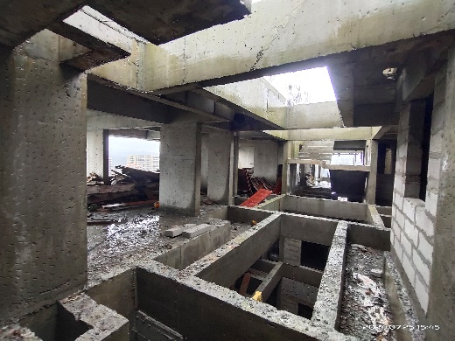
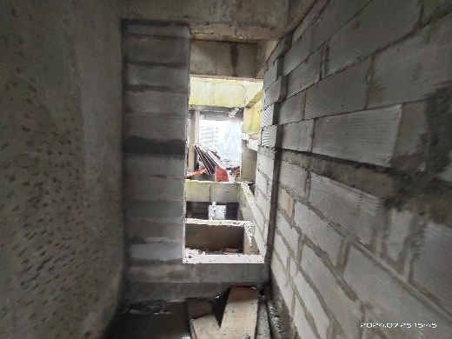
Actual Site Photographs
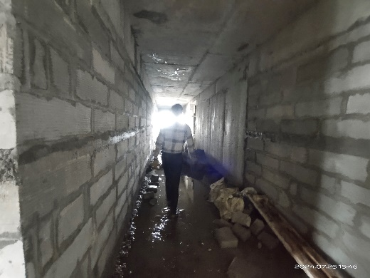
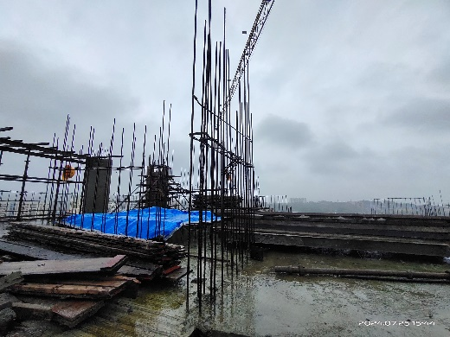
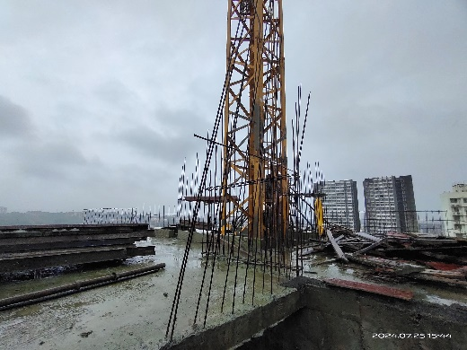
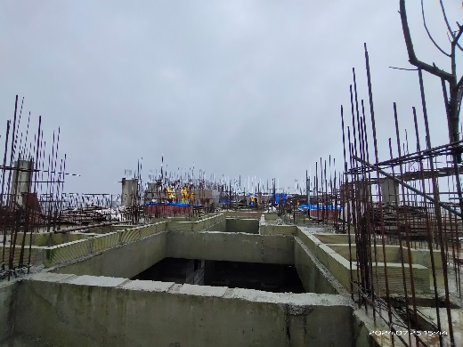
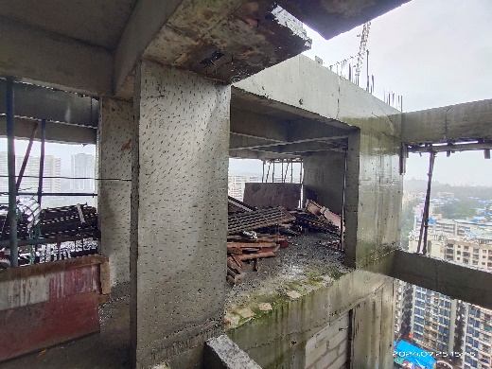
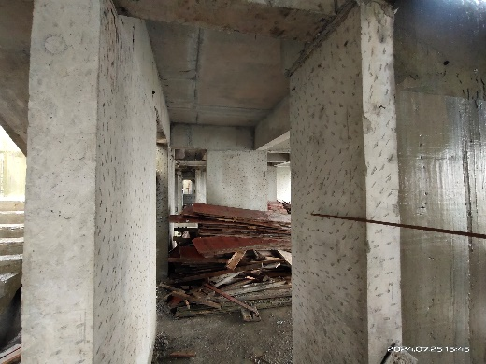
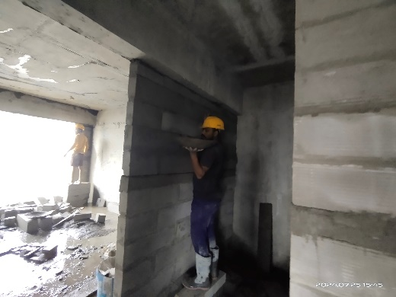
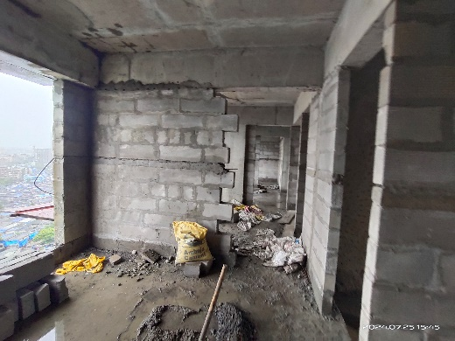
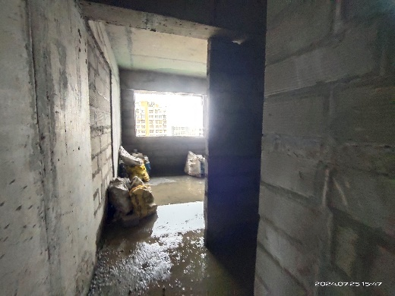
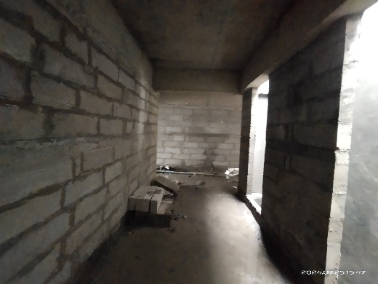
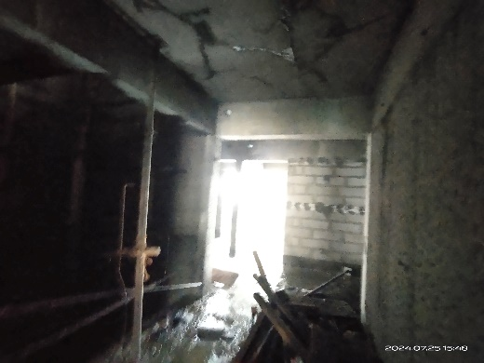
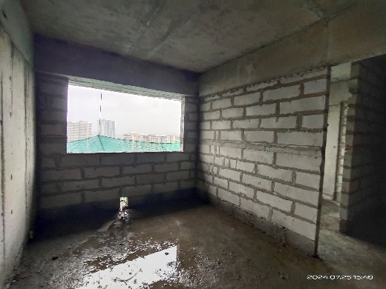
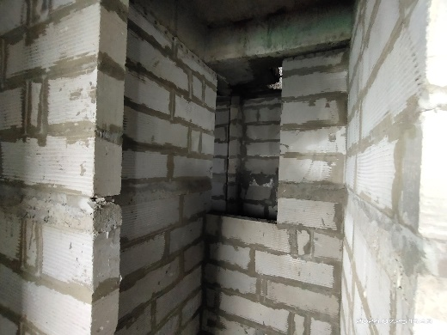
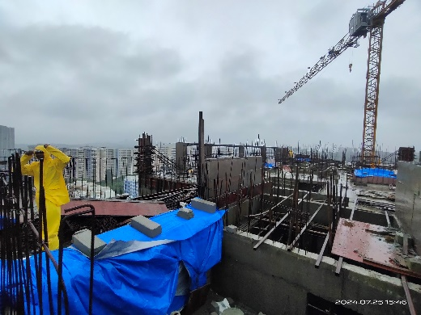
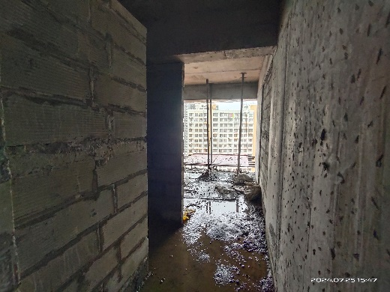
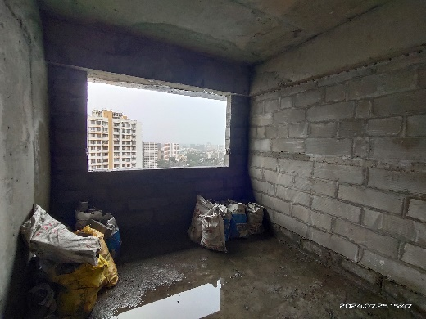
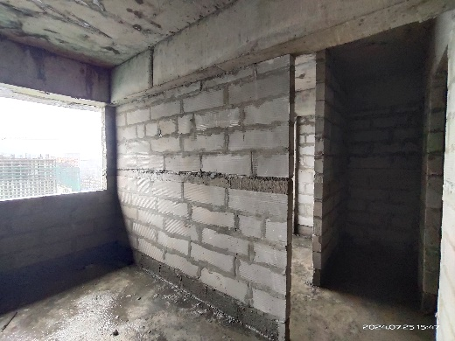
Actual Site Photographs
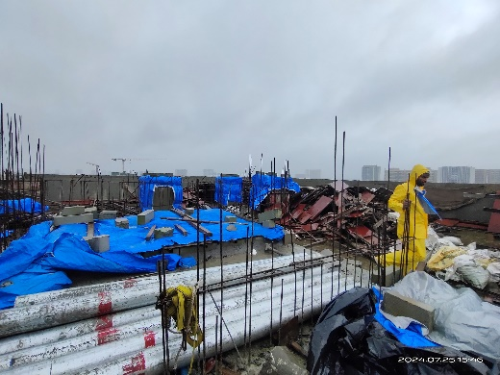
Actual Site Photographs
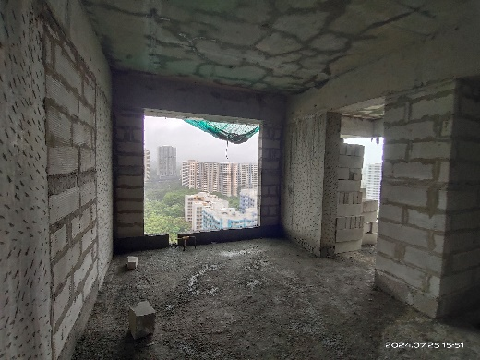
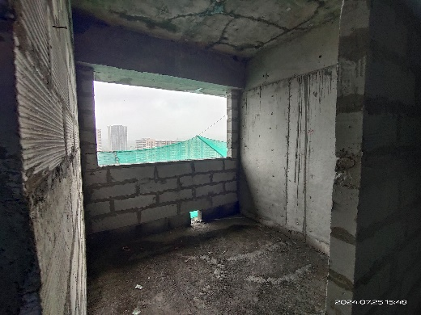
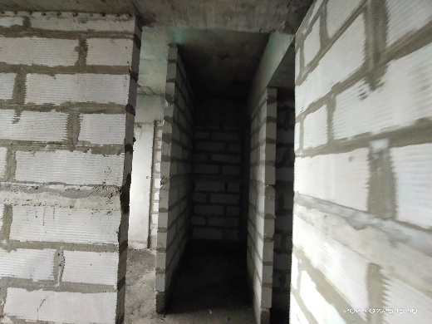
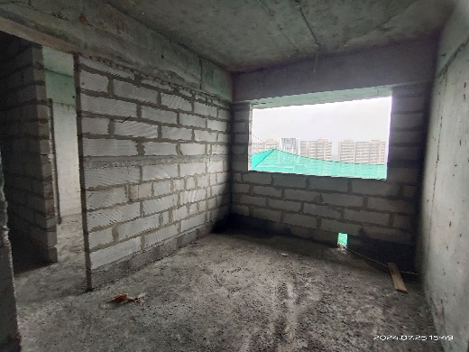
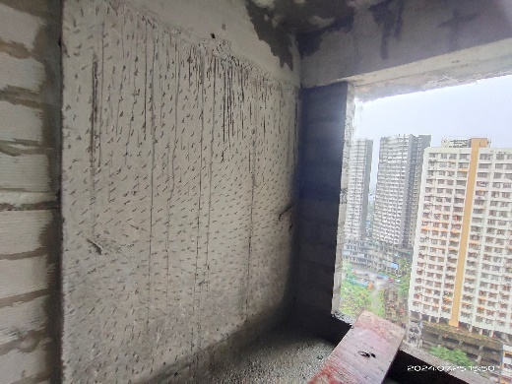
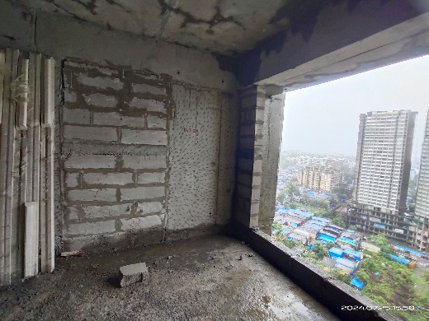
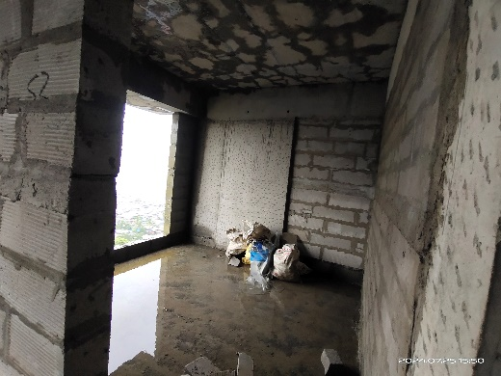
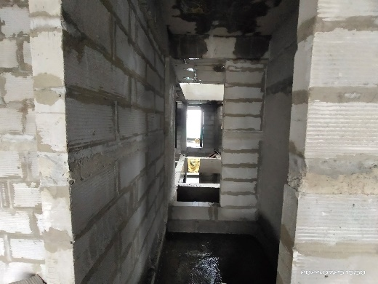
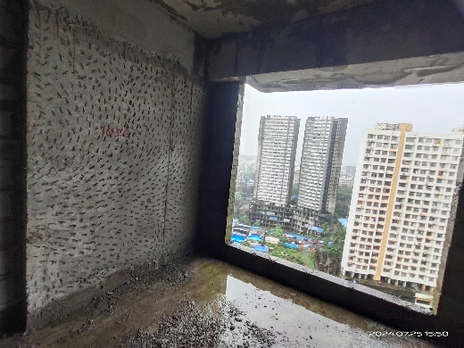
Actual Site Photographs
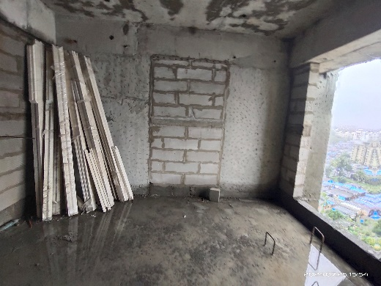
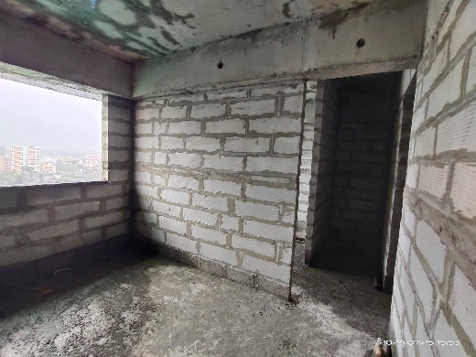
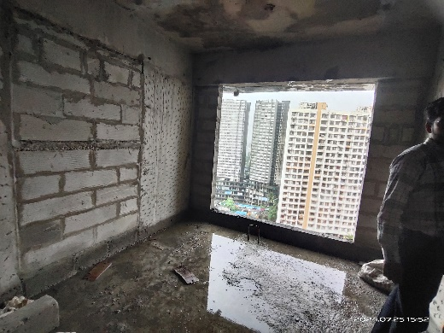
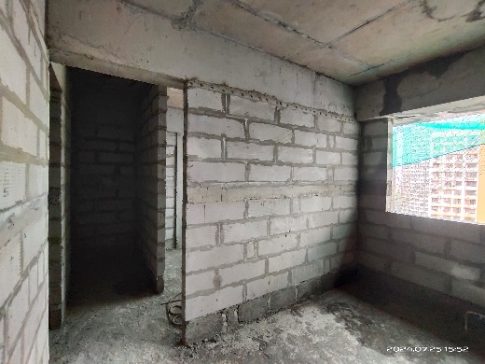
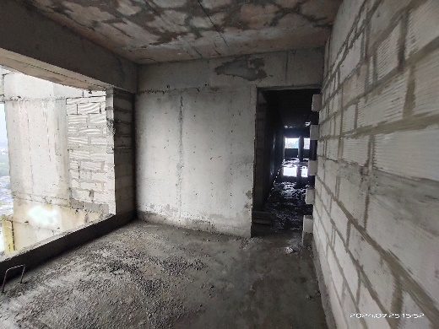
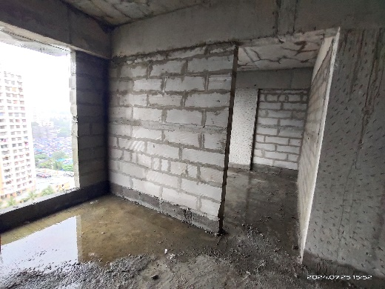
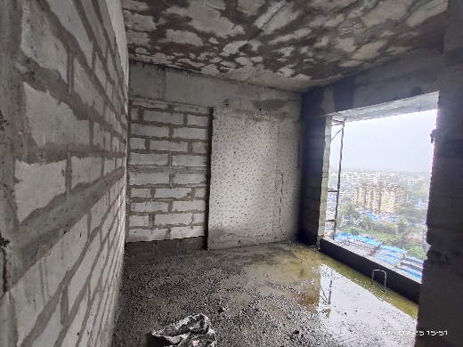
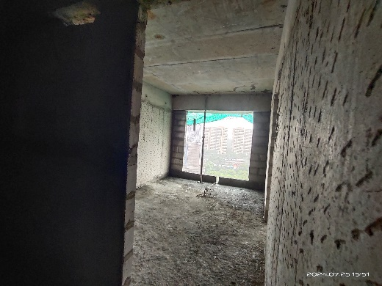
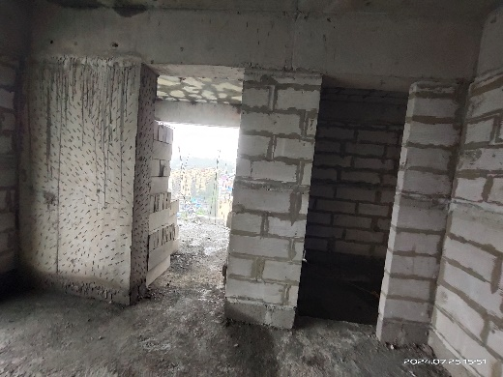
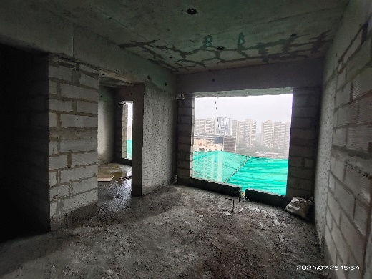
Actual Site Photographs
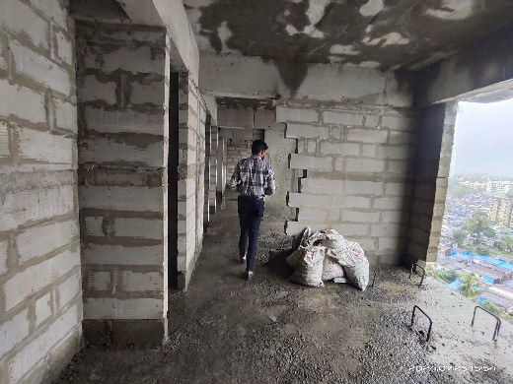
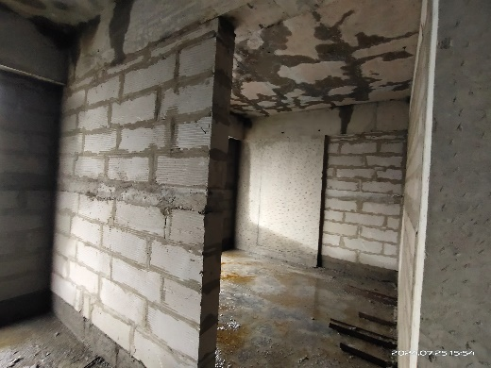
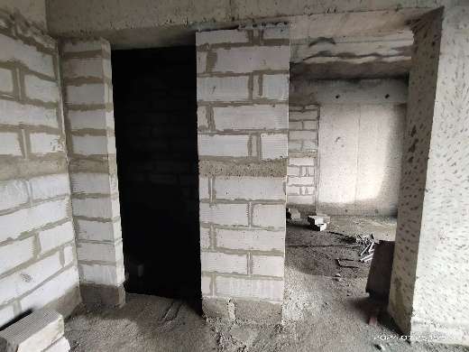
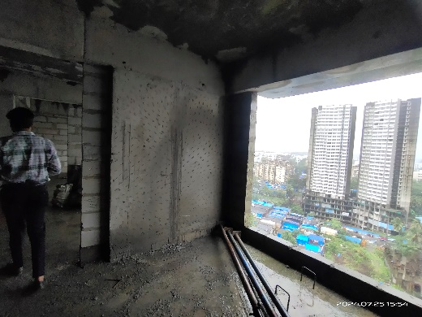
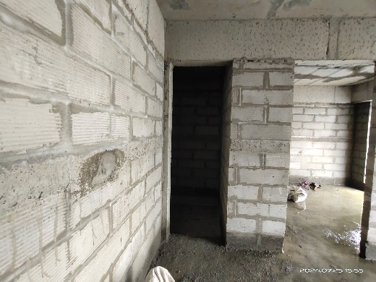
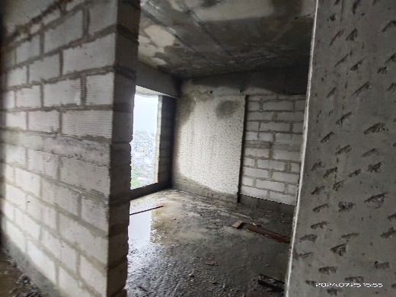
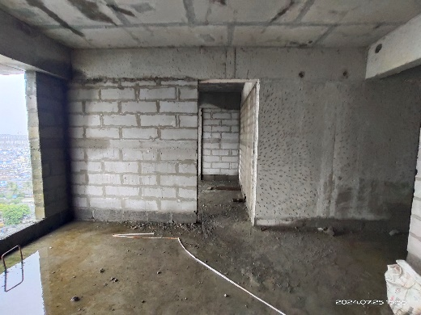
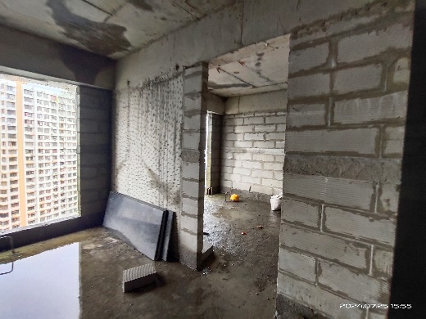
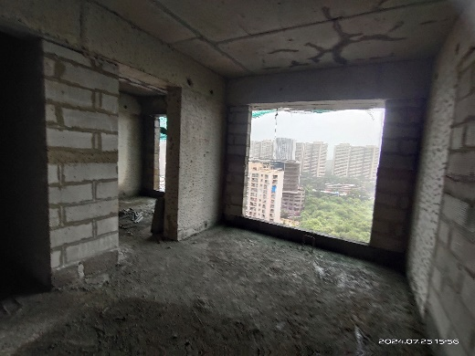
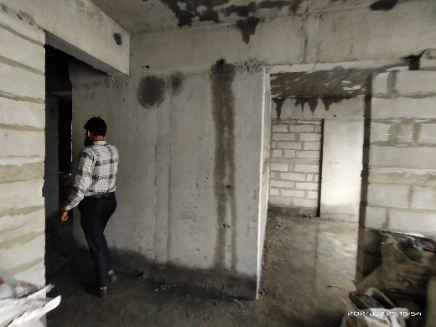
Actual Site Photographs
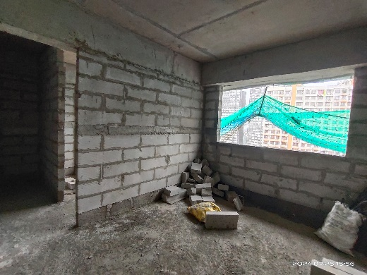
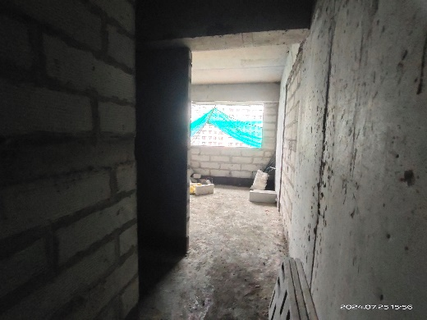
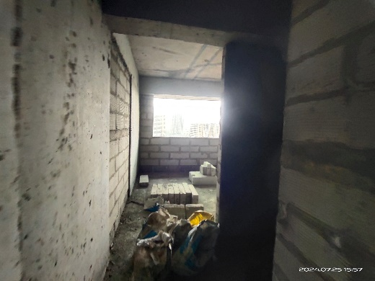
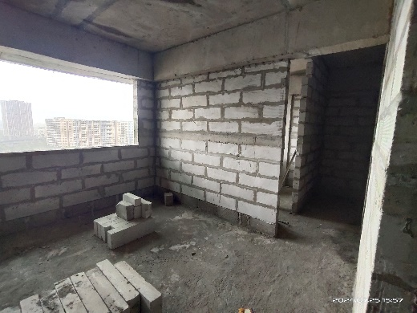
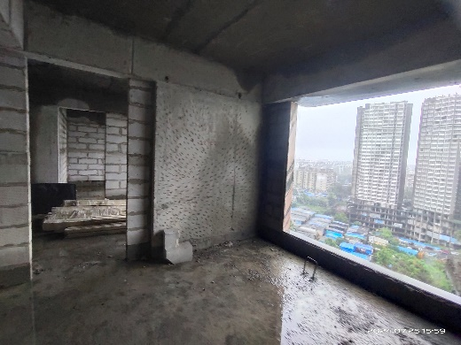
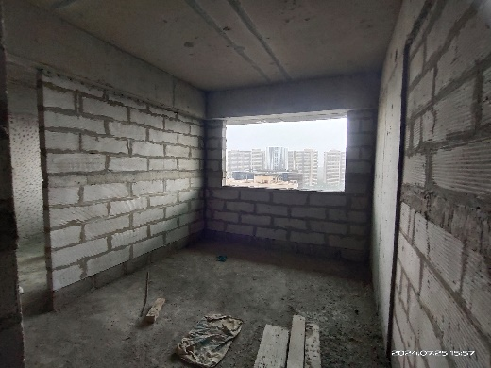
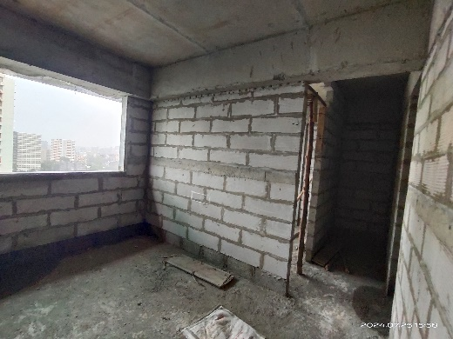
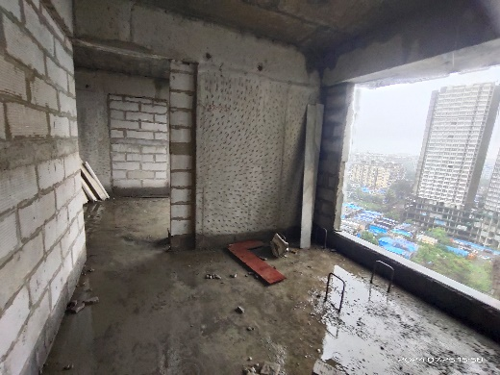
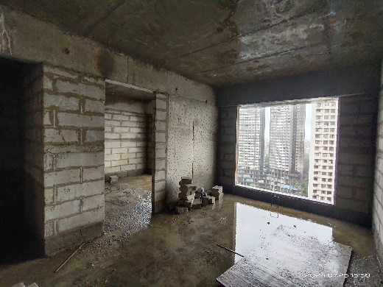
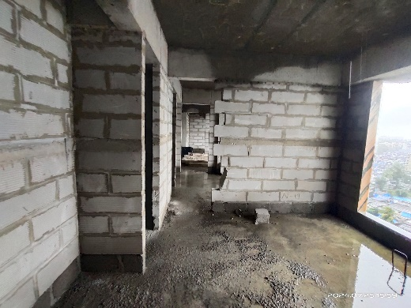
Actual Site Photographs
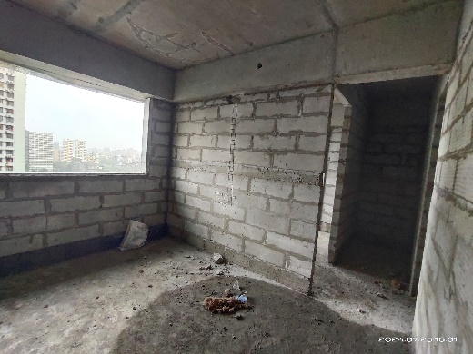
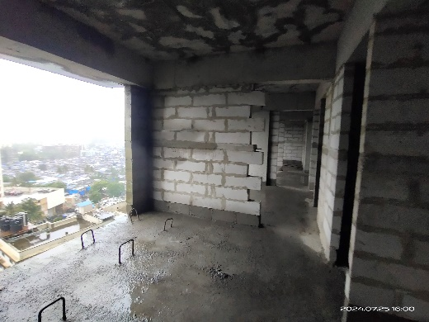
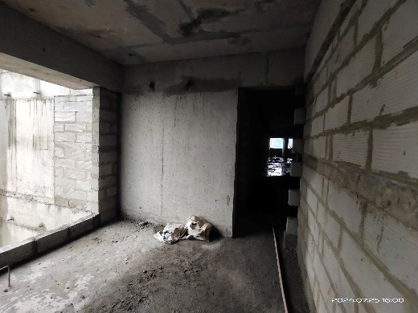
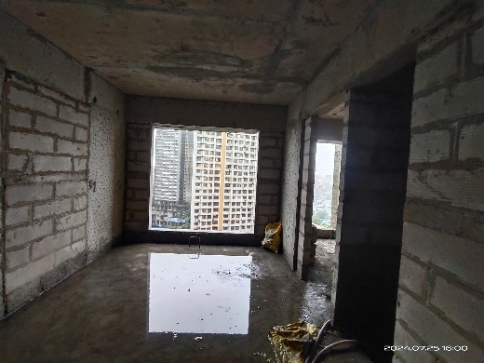
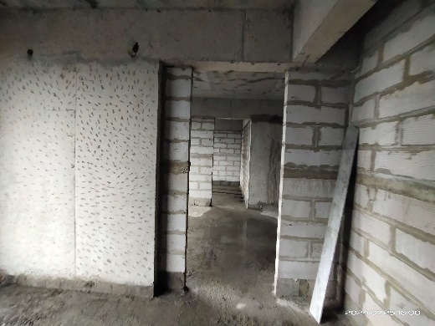
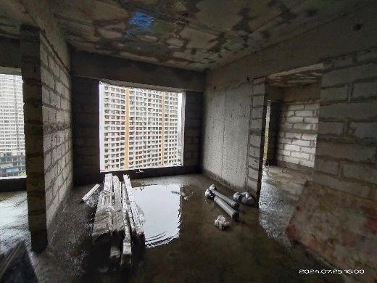
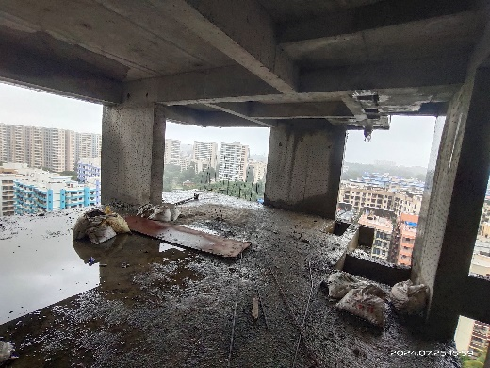
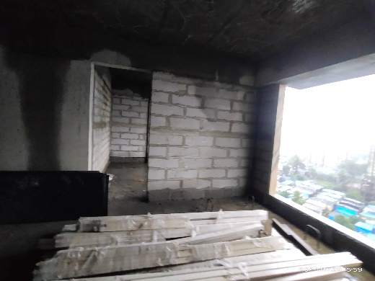
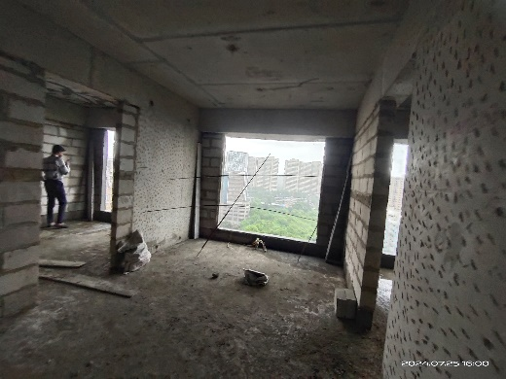
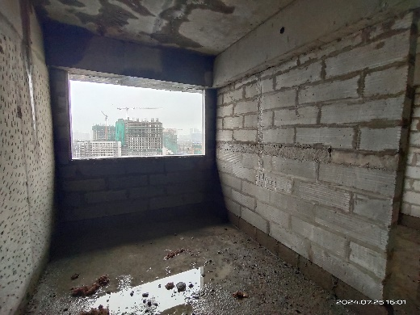
Actual Site Photographs
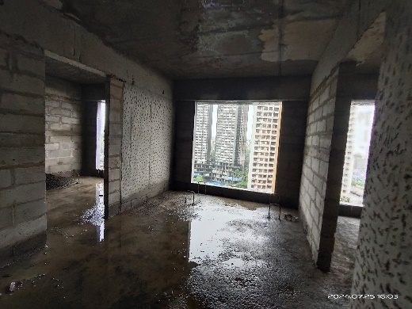
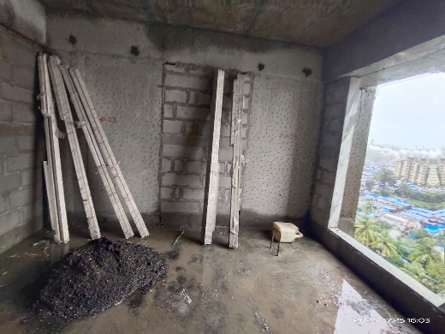
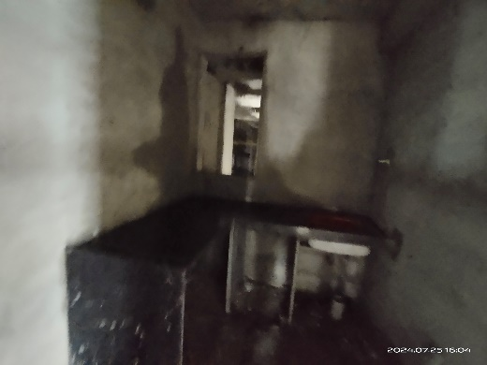
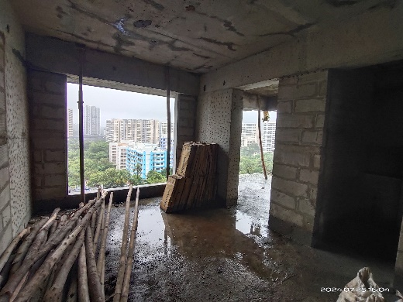
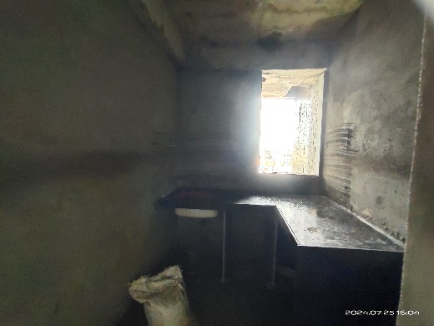
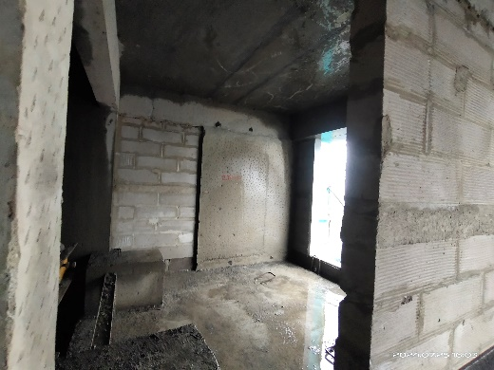
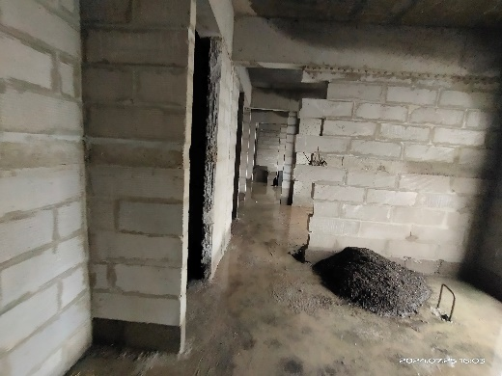
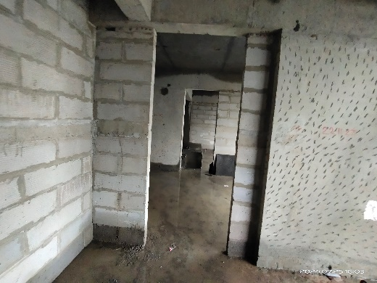
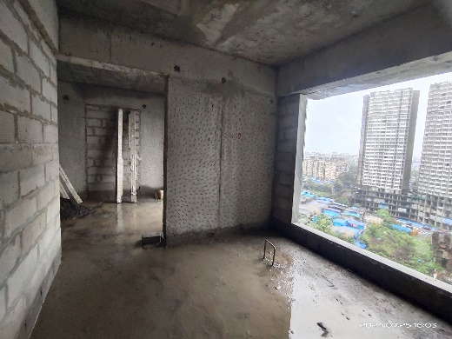
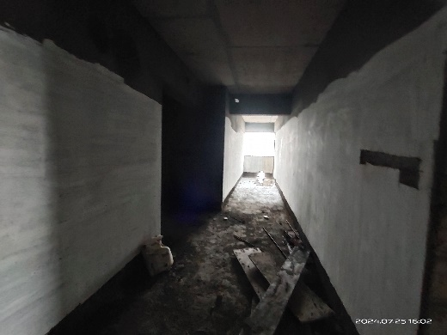
Actual Site Photographs
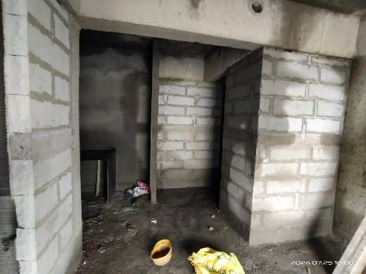
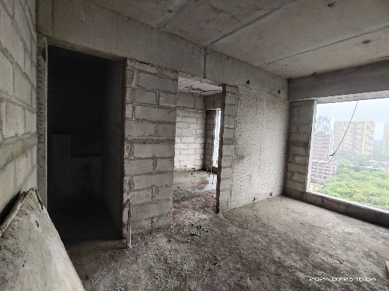
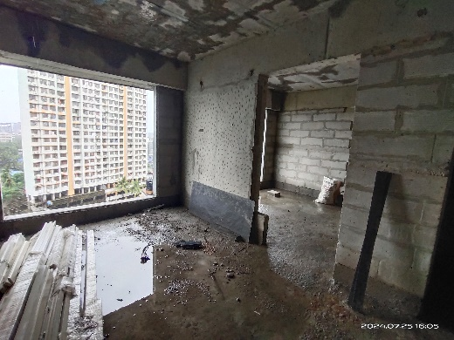
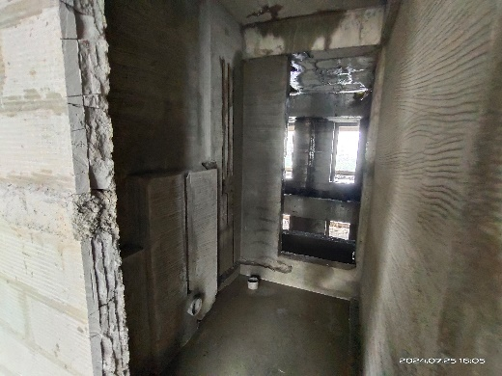
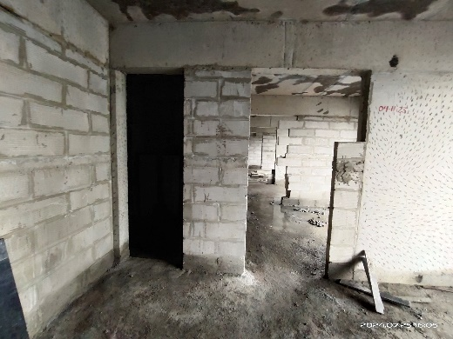
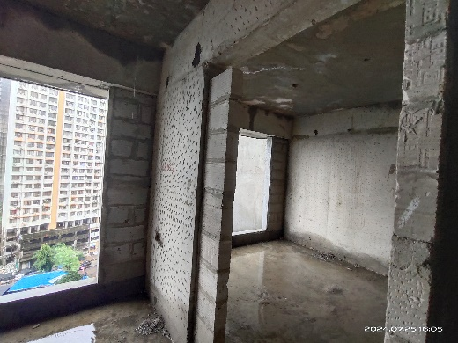
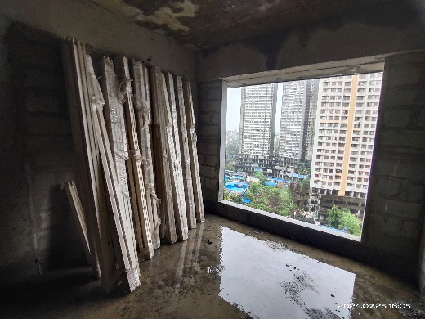
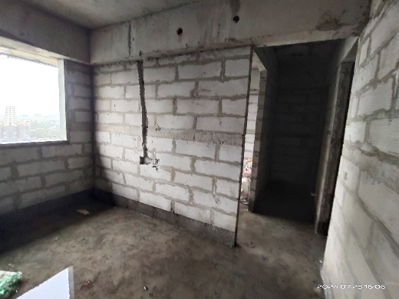
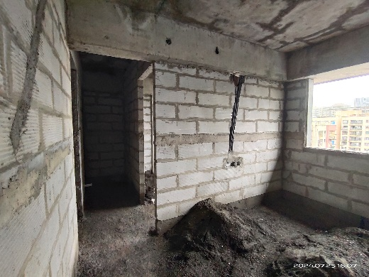
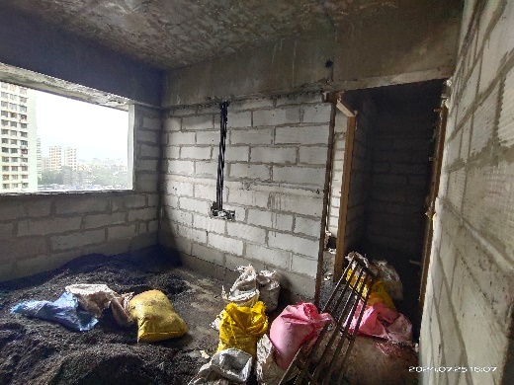
Actual Site Photographs
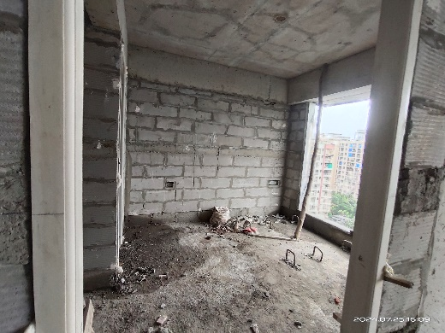
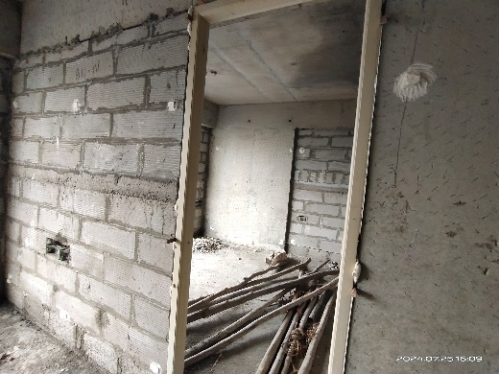
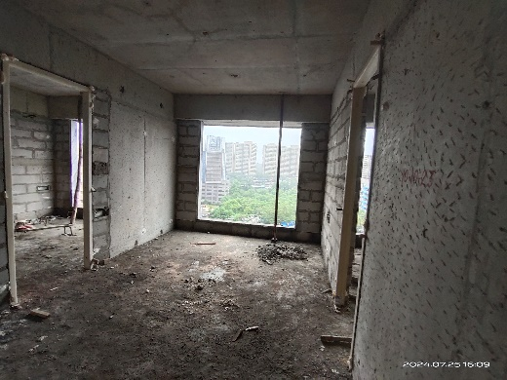
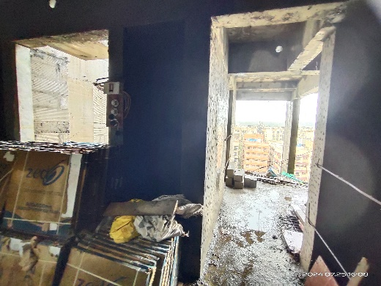
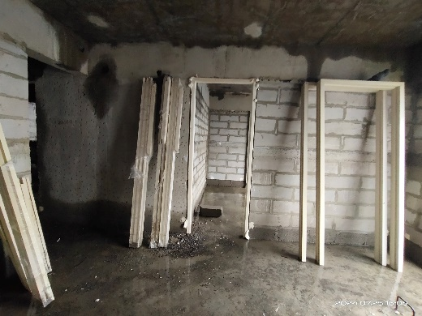
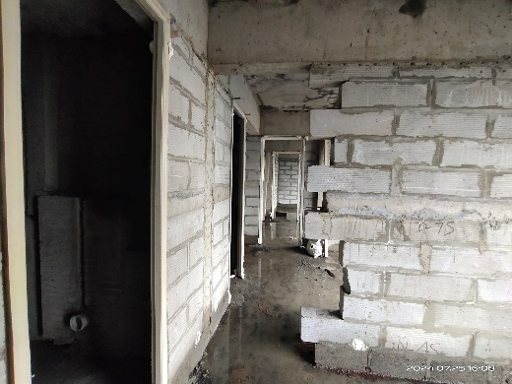
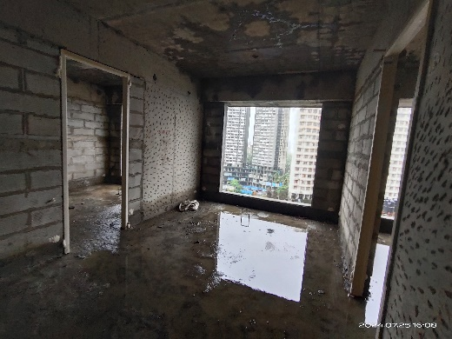
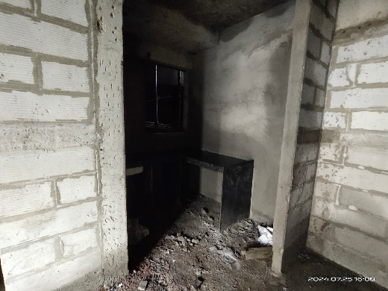
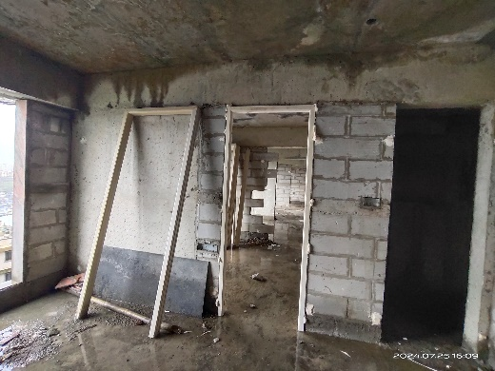
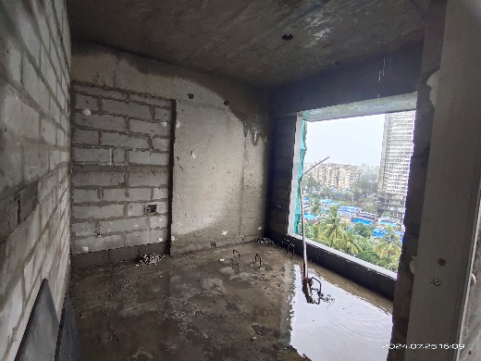
Actual Site Photographs
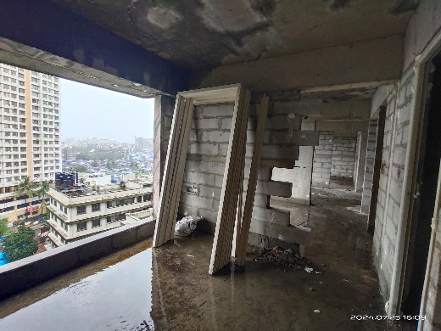
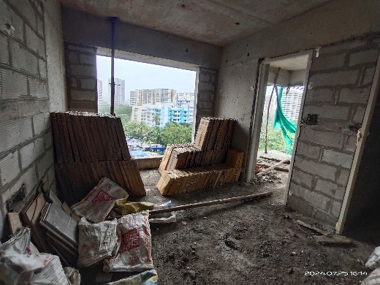
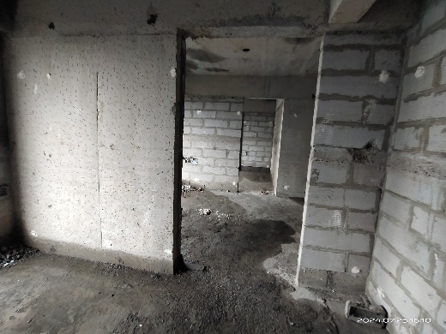
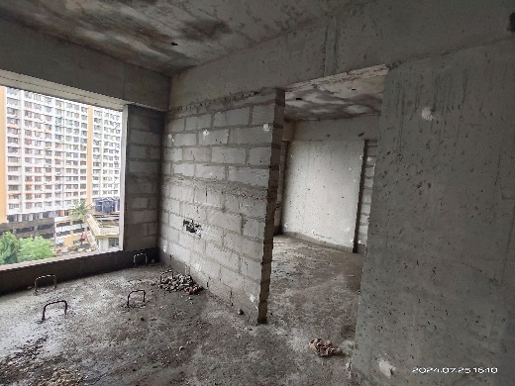
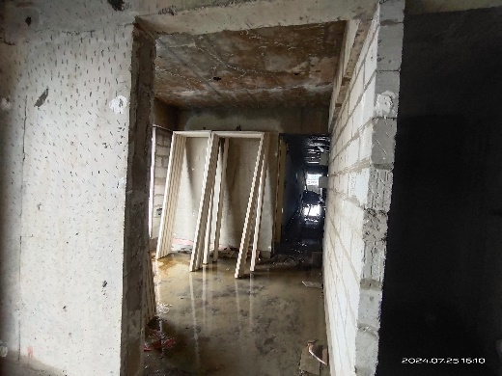
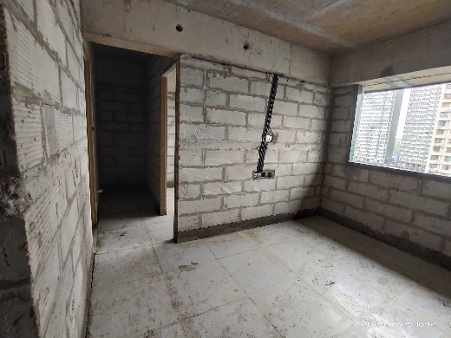
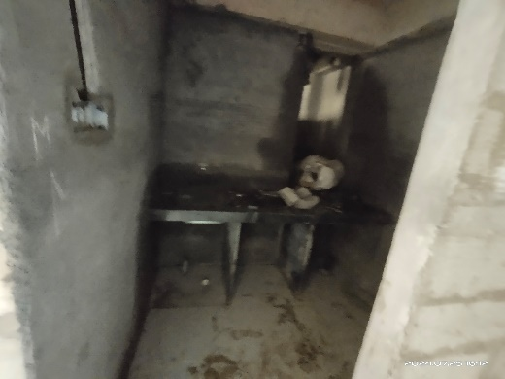
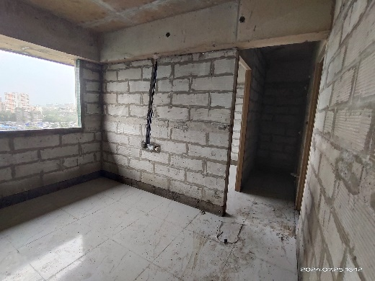
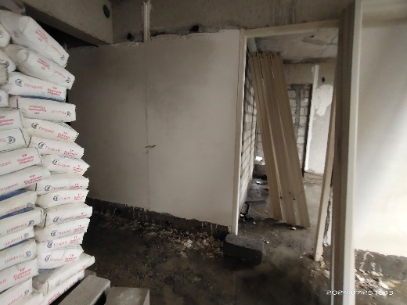
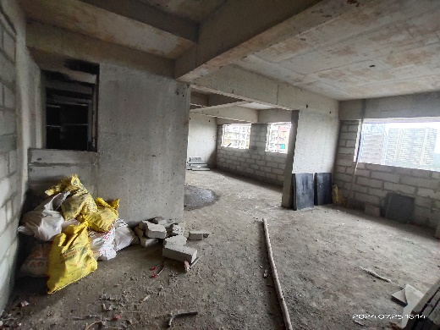
Actual Site Photographs
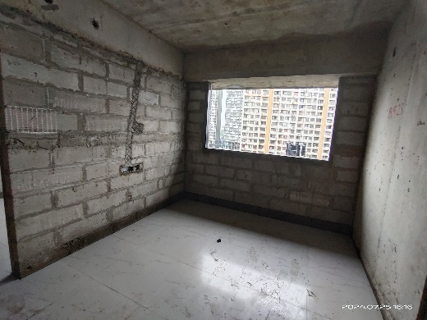
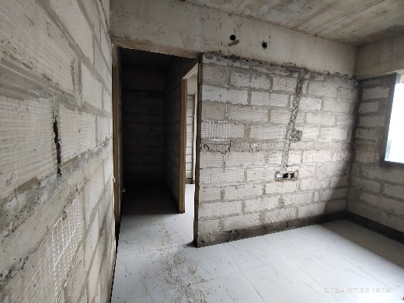
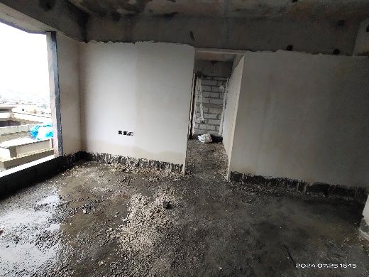
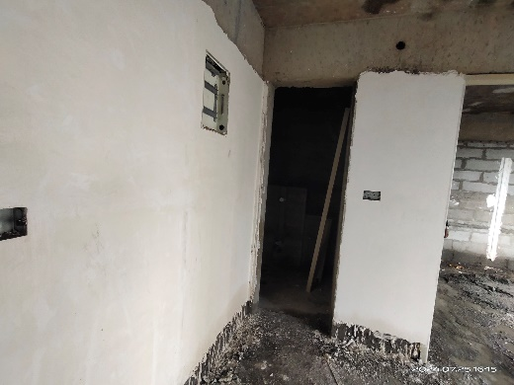
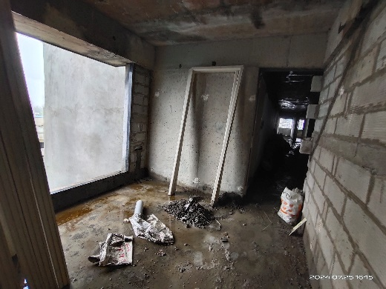
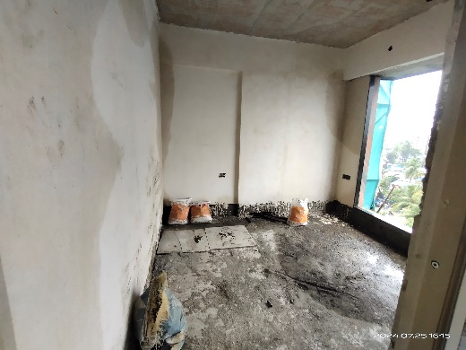
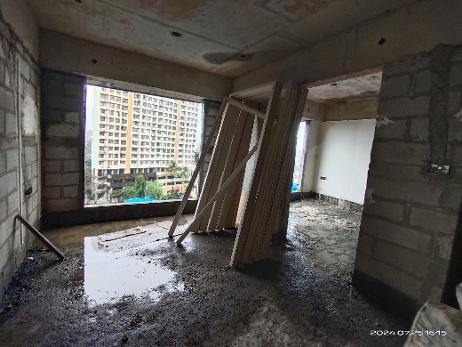
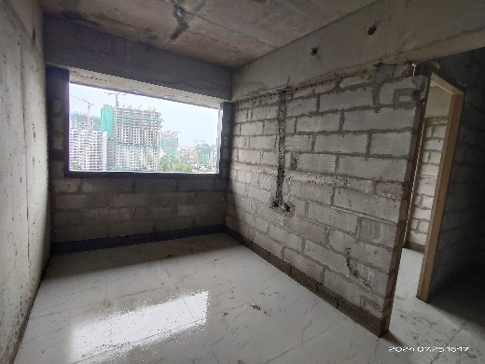
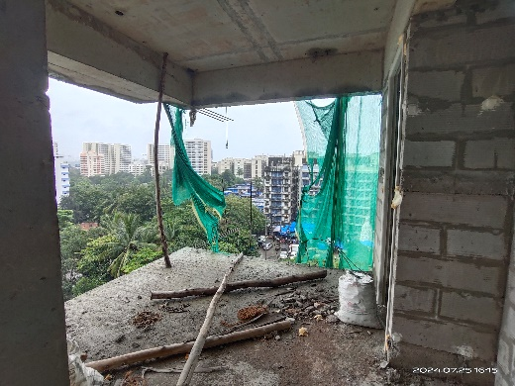
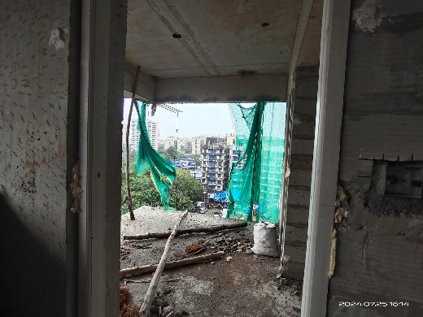
Actual Site Photographs
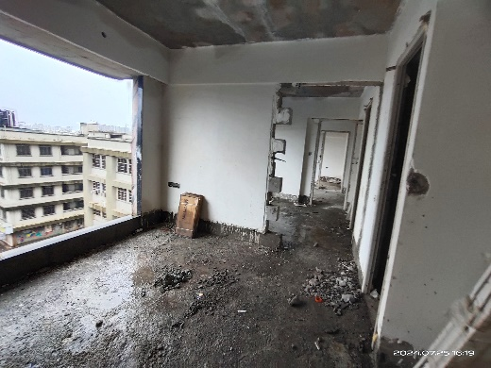
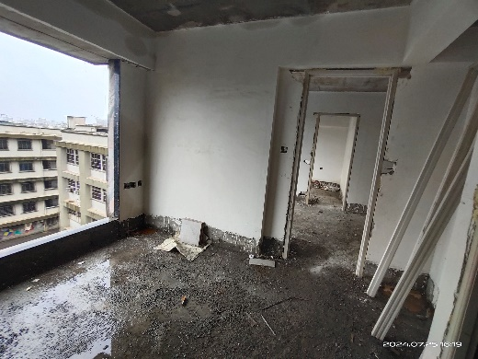
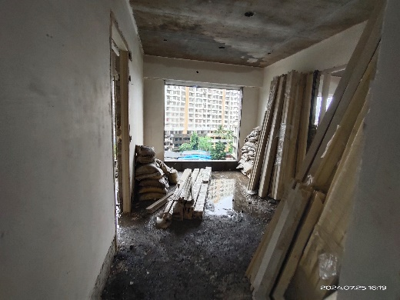
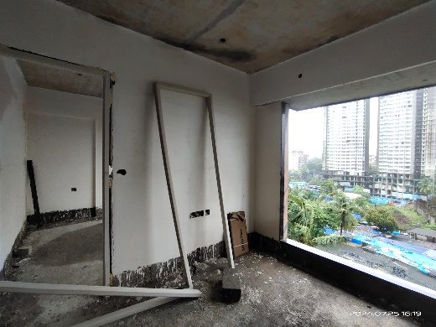
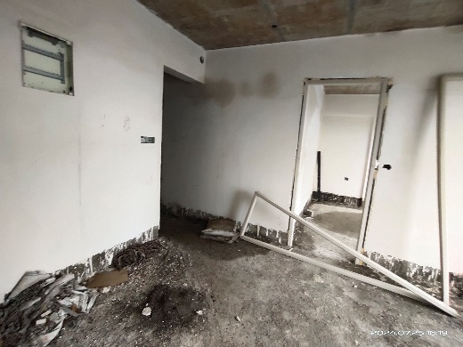
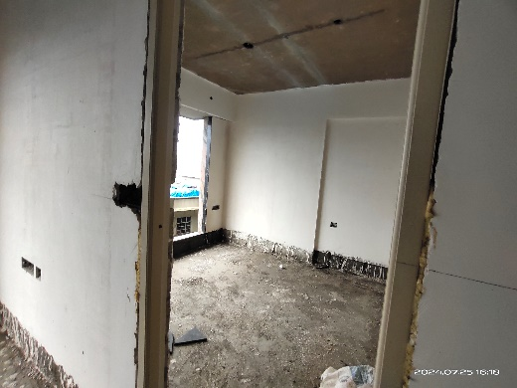
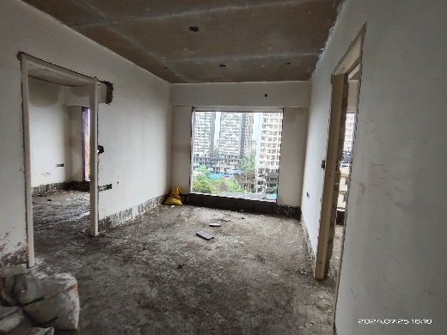
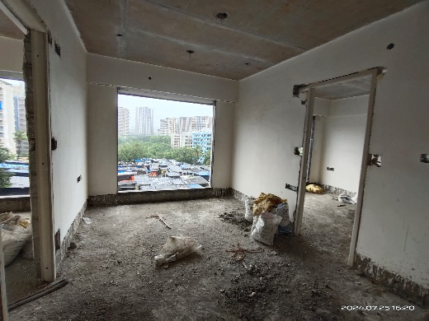
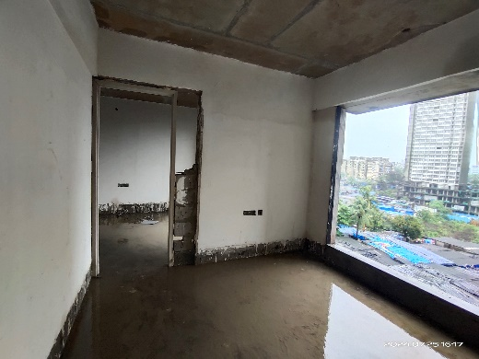
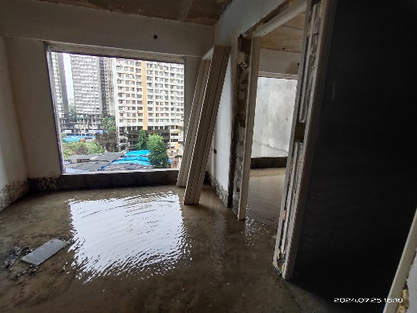
Actual Site Photographs
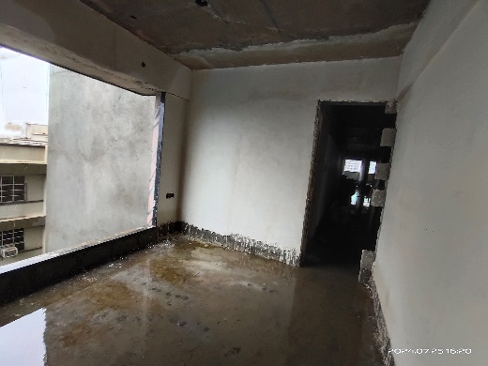
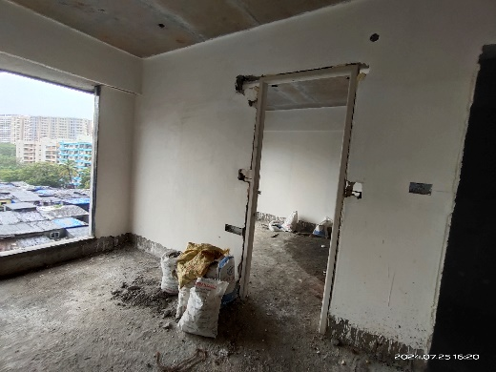
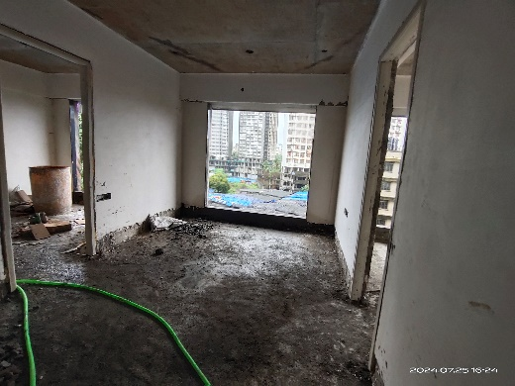
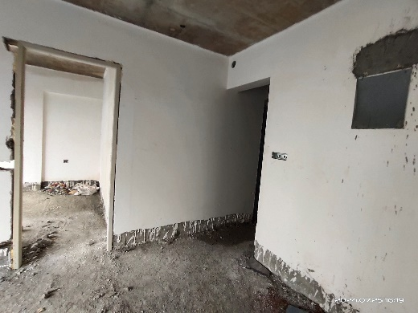
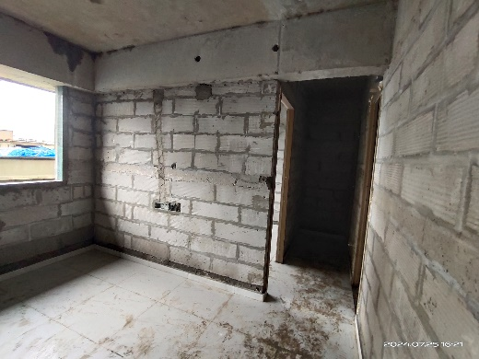
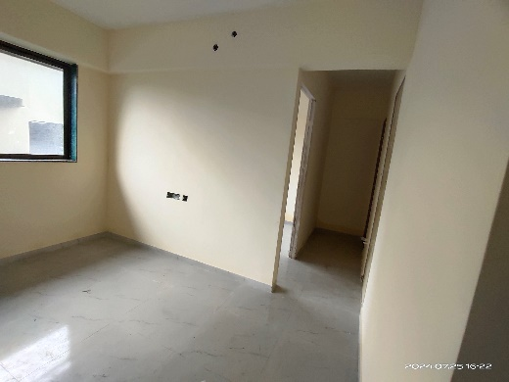
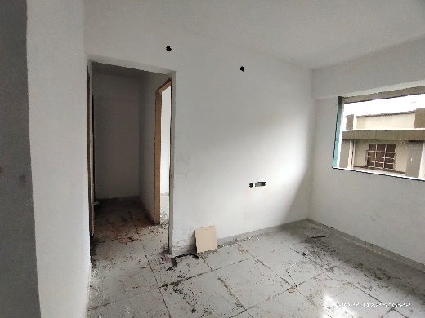
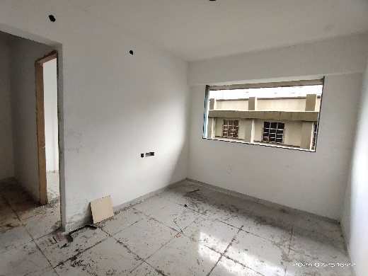
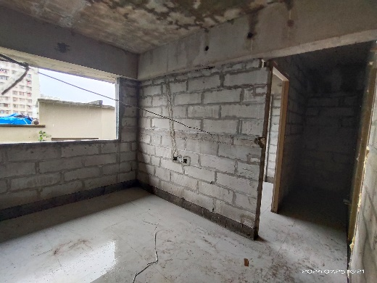
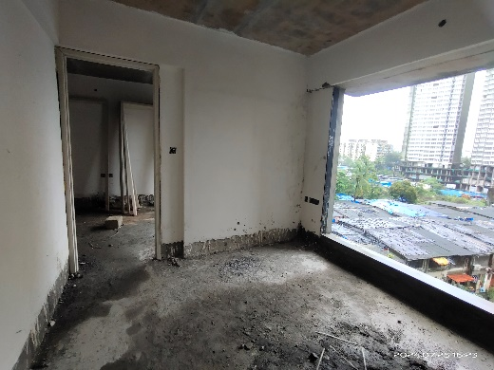
Actual Site Photographs
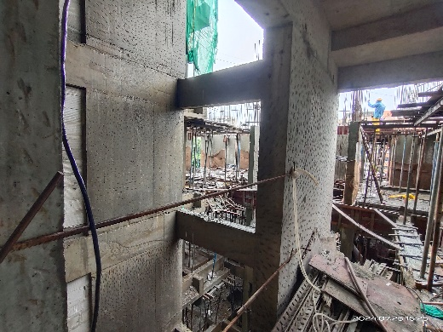
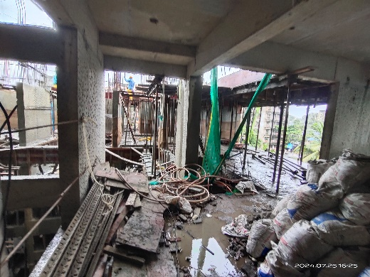
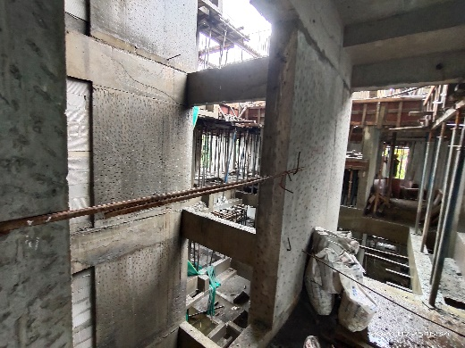
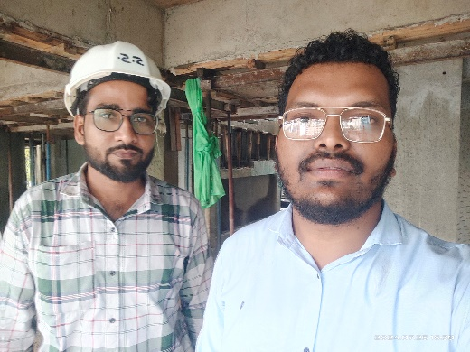
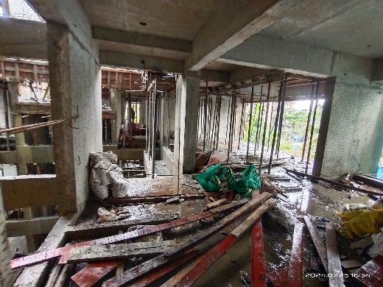
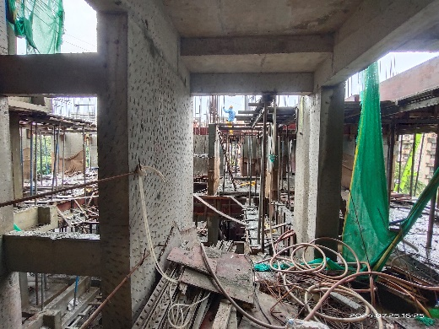

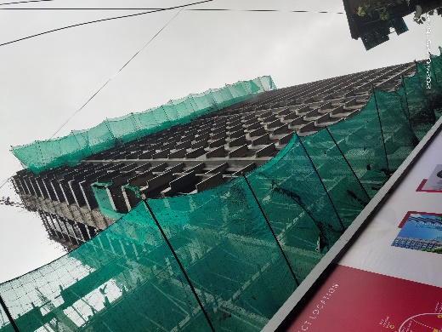
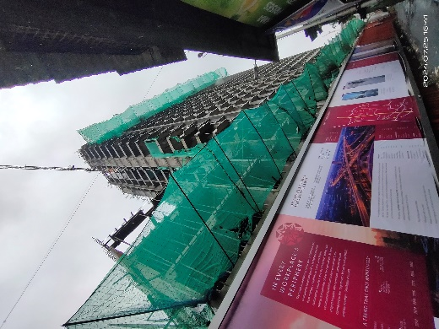

Route Map of the property
Site u/r
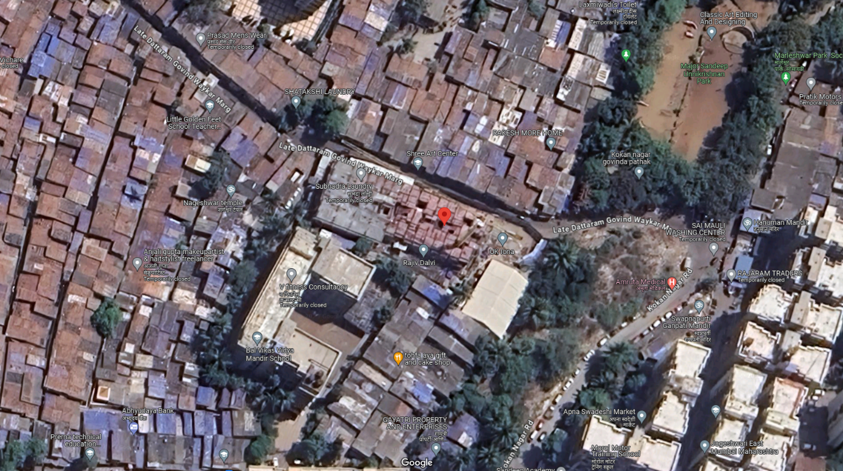

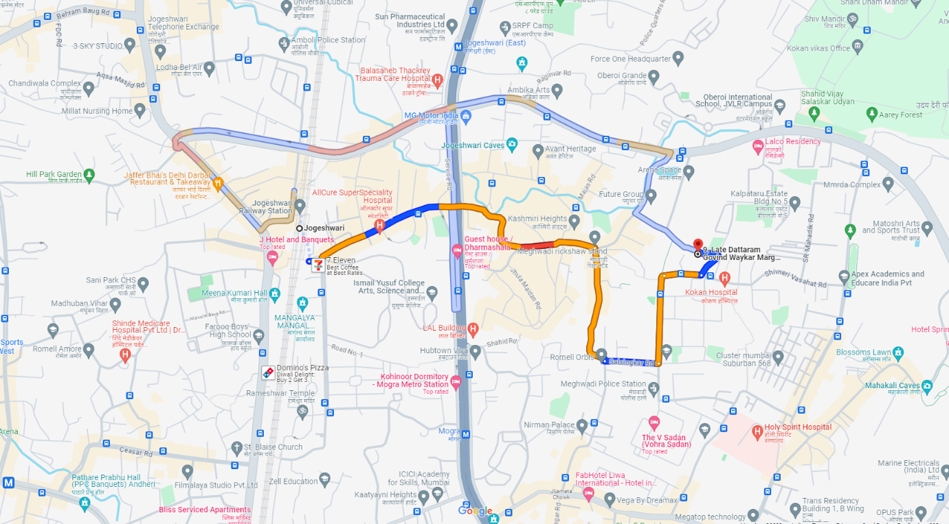

Latitude Longitude: 19°08'06.9"N 72°51'51.6"E
Note: The Blue line shows the route to site from nearest railway station (Jogeshwari – 2.80 Km.)

