Vastu/Nashik/03/2023833/30490/46262
22/24-455-RPBS
Date: 22.07.2024

To, `
The Branch Manager,
Bank of Baroda
Regional Office Nashik Road Branch
BSNL Building, Datta Mandir Road, Nashik Road,
Nashik -422 101, State - Maharashtra, Country - India.

Sub: Vetting of Extra Amenities

Sir,

With reference to above subject, we have evaluated the Extra Amenities for Residential Flat No. 301, Third Floor, " Arfat Heights ", Survey No. 9/ 1 to 9/ 10, Plot No. 36+37, Behind Ashoka Universal School, Near Nisarga Park, Tirumla Nagar, Pakhal Road, Village - Wadala, Taluka & District - Nashik, PIN Code – 422 006, State - Maharashtra, Country - lndia belongs to Name of Owner: Mr. Samir Nashir Shaikh & Mrs. Jubeda Nashir Shaikh.

We have verified the rates quoted as per current market rates. Details of work and Extra Amenities considered as per copy of Agreement for Extra Amenities issued by Shri. Samir Nashir Shaikh & Sau. Jubeda Nashir Shaikh (First Party) and Sau. Nikat Samir Shaikh (Second Party) received on dated 18.07.2024. The Extra Amenities amount is Rs.2,40,000/- ( Rupees Two Lakh Seventy Forty Thousand Only. )

The said Cost Vetting Certificate is valid upto next 6 months Only.

Thanking you

Sincerely yours

Manoj B. Chalikwar
Registered Valuer
Chartered Engineer (India)
Reg. No. CAT-I-F-1763
Reg. No. IBBI/RV/07/2018/10366
BOB Empanelment No.: ZO:MZ:ADV:46:941
Encl: Valuation report.

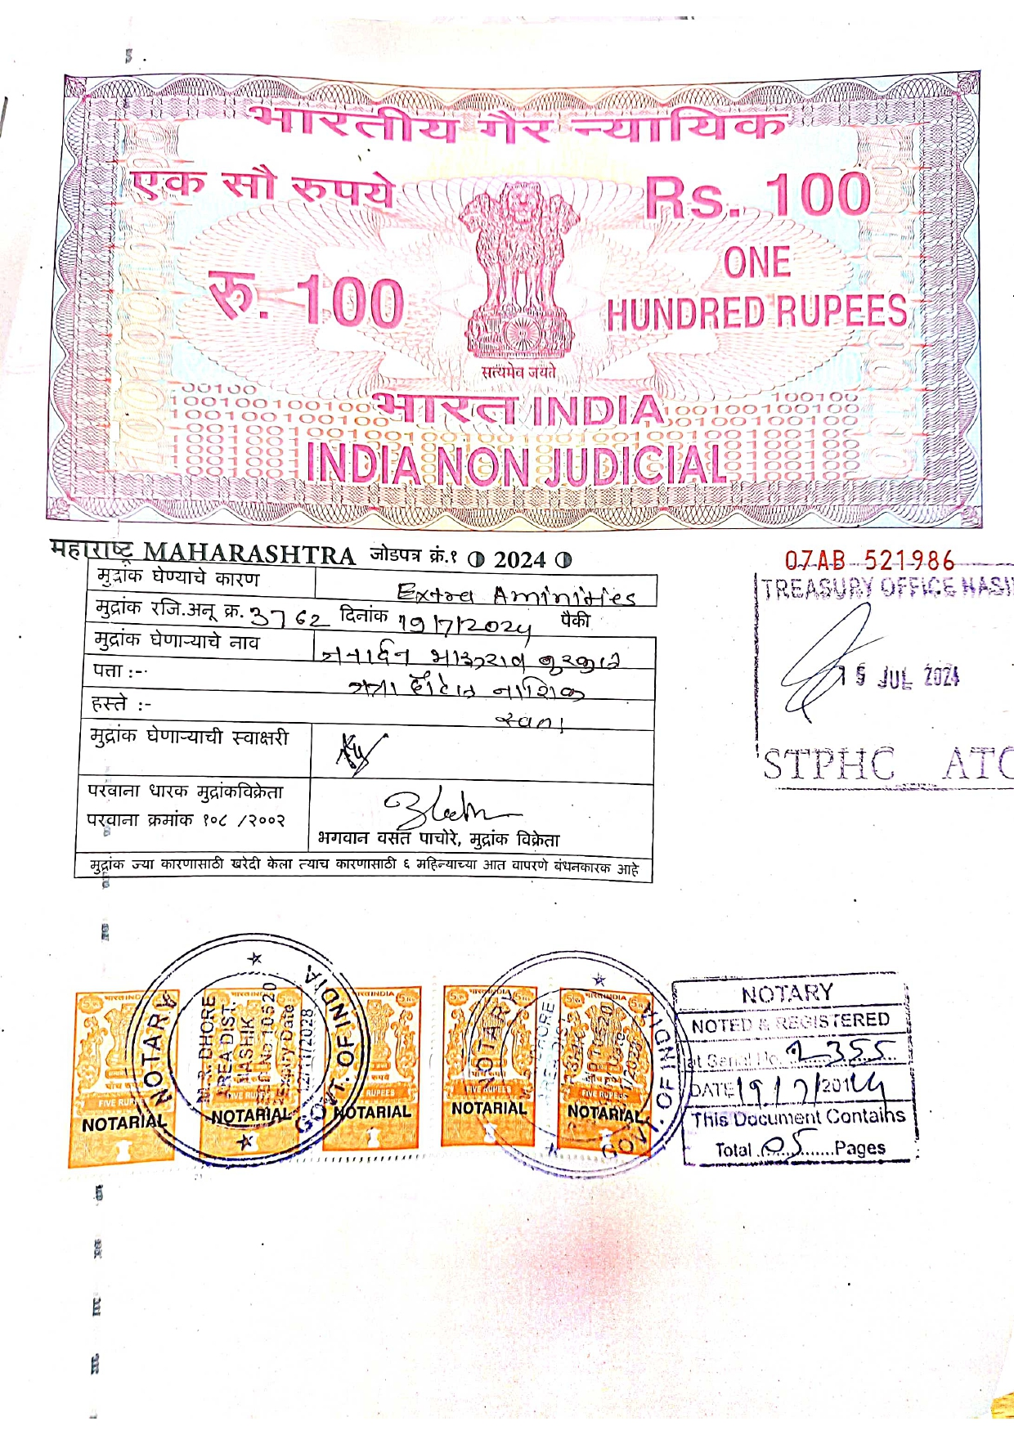
Agreement for Extra Amenities
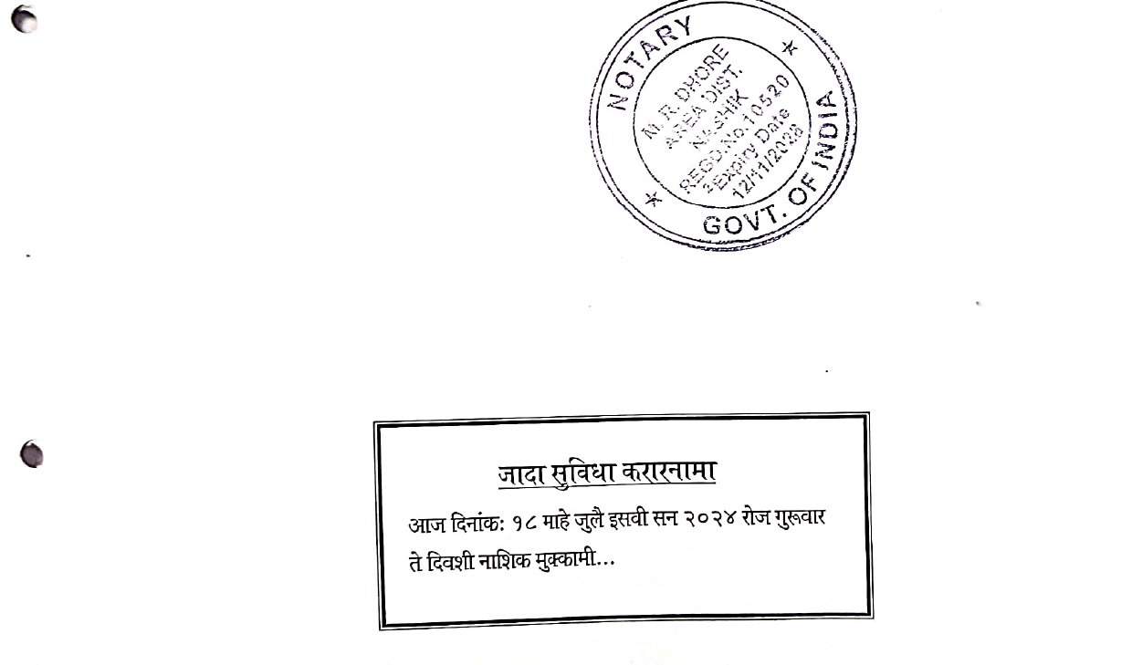

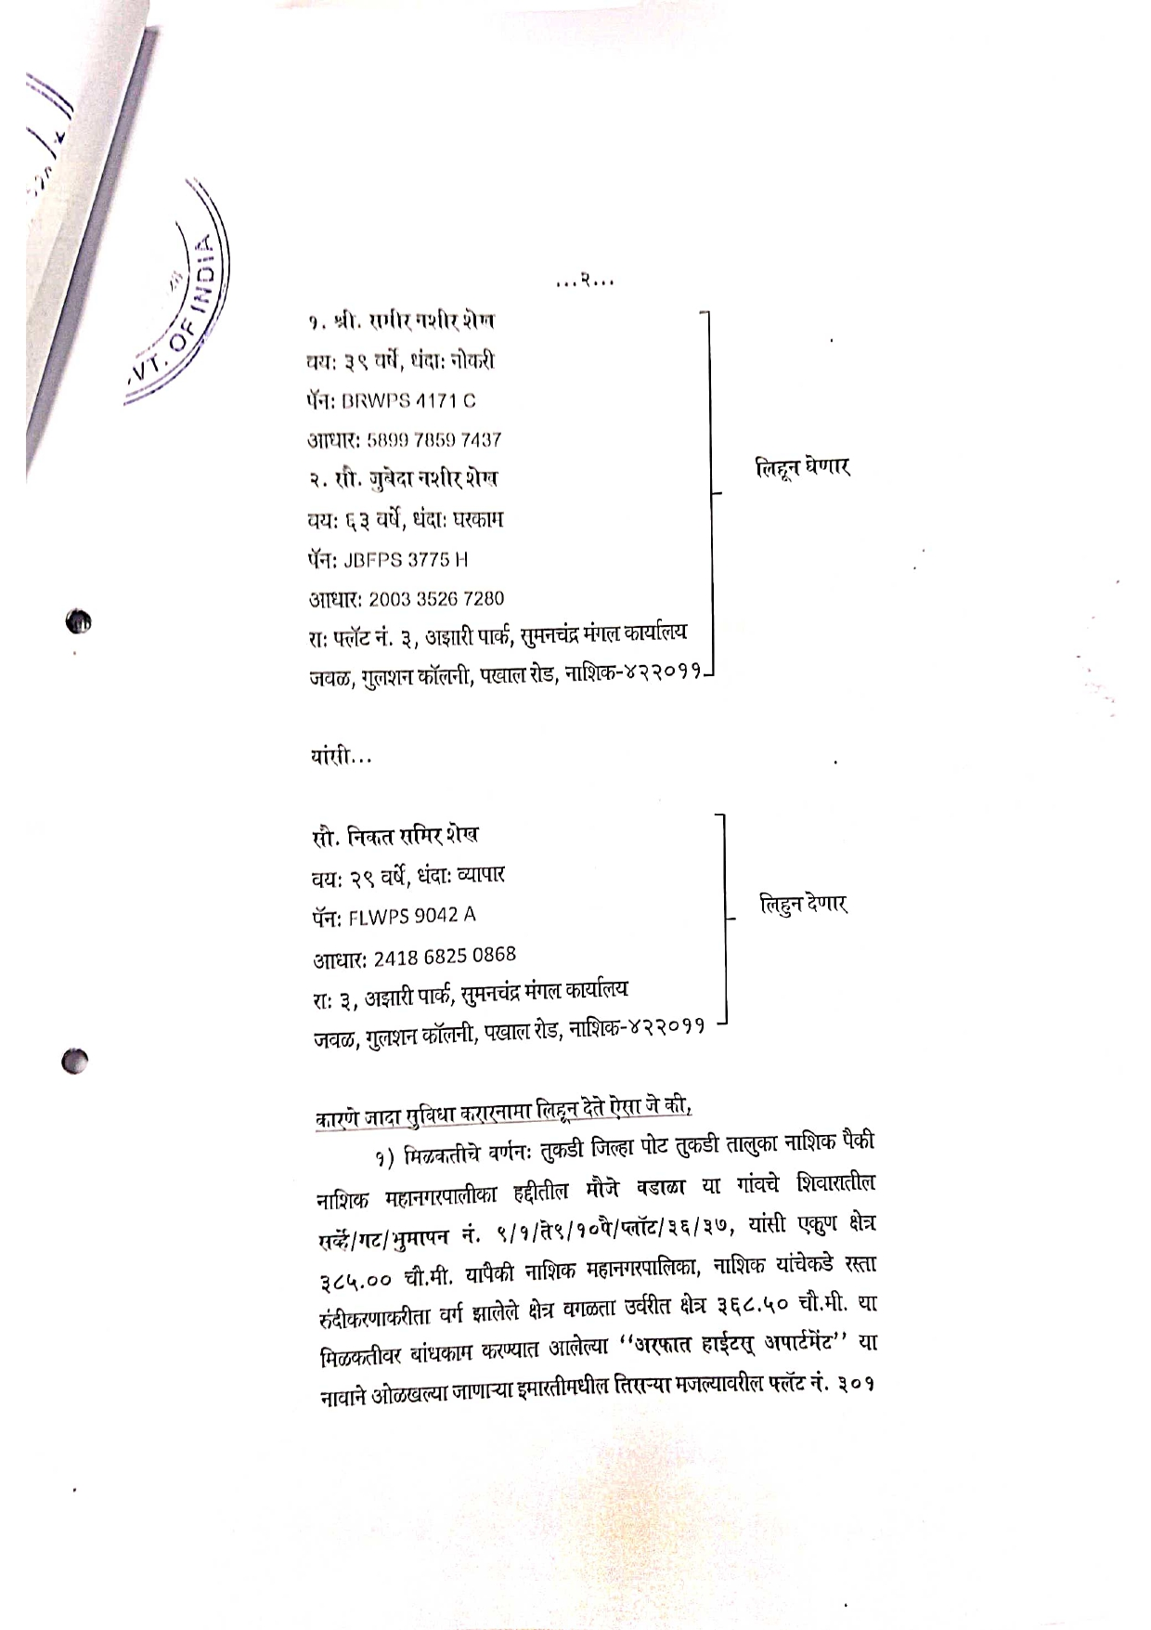

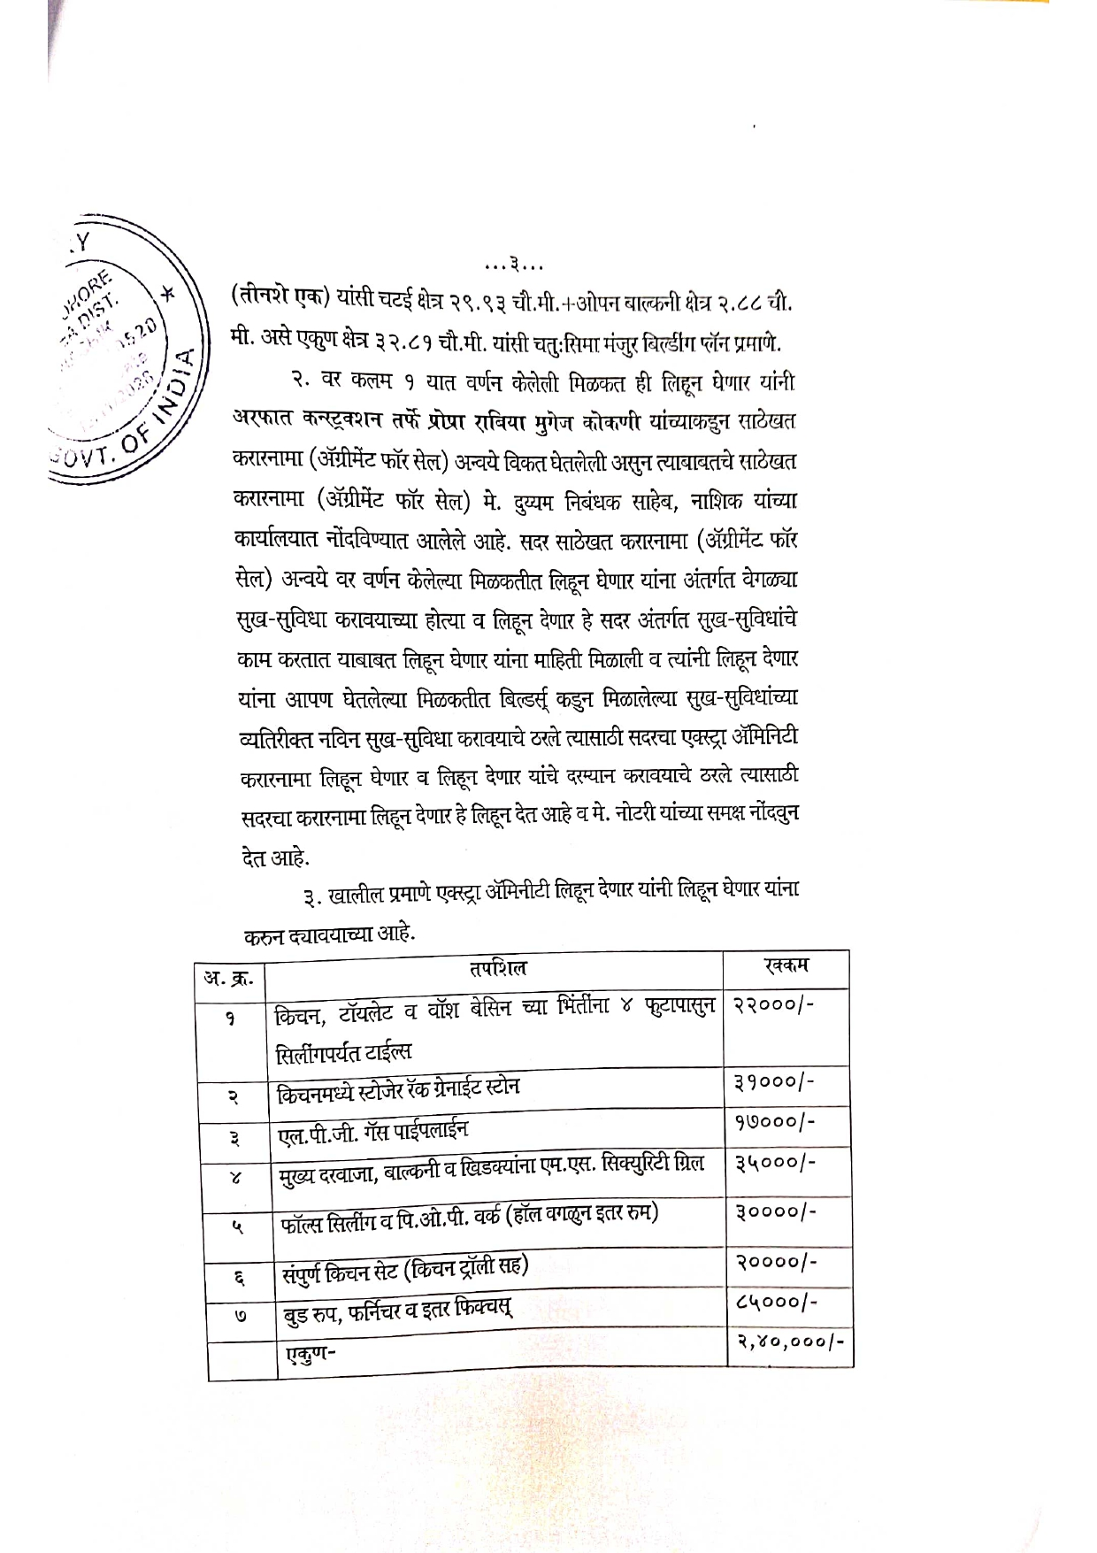
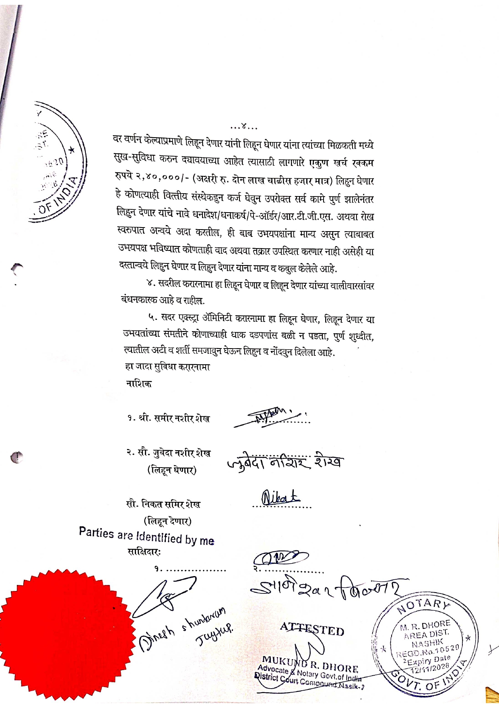

The Extra Amenities amount is Rs.2,40,000/- ( Rupees Two Lakh Seventy Forty Thousand Only.)

