Vastu/Nashik/07/2024/009923/2307242
15/15-246-RPBS
Date: 15.07.2024

To, `
The Branch Manager,
Bank of Baroda
Regional Office Nashik Road Branch
BSNL Building, Datta Mandir Road, Nashik Road,
Nashik -422 101, State - Maharashtra, Country - India.

Sub: Vetting of Extra Amenities

Sir,

With reference to above subject, we have evaluated the Extra Amenities for Residential Flat No. 403, Fourth Floor, " Sai Shraddha Apartment ", Survey No. 24/1 to 5/A, Plot No. 8+9, Near Vikhe Patil Memorial School, Vrindawan Nagar, off Ambad - Kamtwade Road, Village - Kamtwade, Taluka & District - Nashik, PIN Code – 422 007, State – Maharashtra, Country – India belongs to Name of Proposed Purchaser: Shri. Vishal Ramchandra Ghodke. Name of Owner: Shri. Vijay Ramdas Jadhav.

We have verified the rates quoted as per current market rates. Details of work and Extra Amenities considered as per copy of Agreement for Extra Amenities issued by Shri. Vishal Ramchandra Ghodke (First Party) and Shri. Pankaj Vijaykunar Kahate (Second Party) received on dated 11.07.2024. The Extra Amenities amount is Rs.6,75,000/- (Rupees Six Lakh Seventy-Five Thousand Only)

The said Cost Vetting Certificate is valid upto next 6 months Only.

Thanking you

Sincerely yours

Manoj B. Chalikwar
Registered Valuer
Chartered Engineer (India)
Reg. No. CAT-I-F-1763
Reg. No. IBBI/RV/07/2018/10366
BOB Empanelment No.: ZO:MZ:ADV:46:941
Encl: Valuation report.

Agreement for Extra Amenities
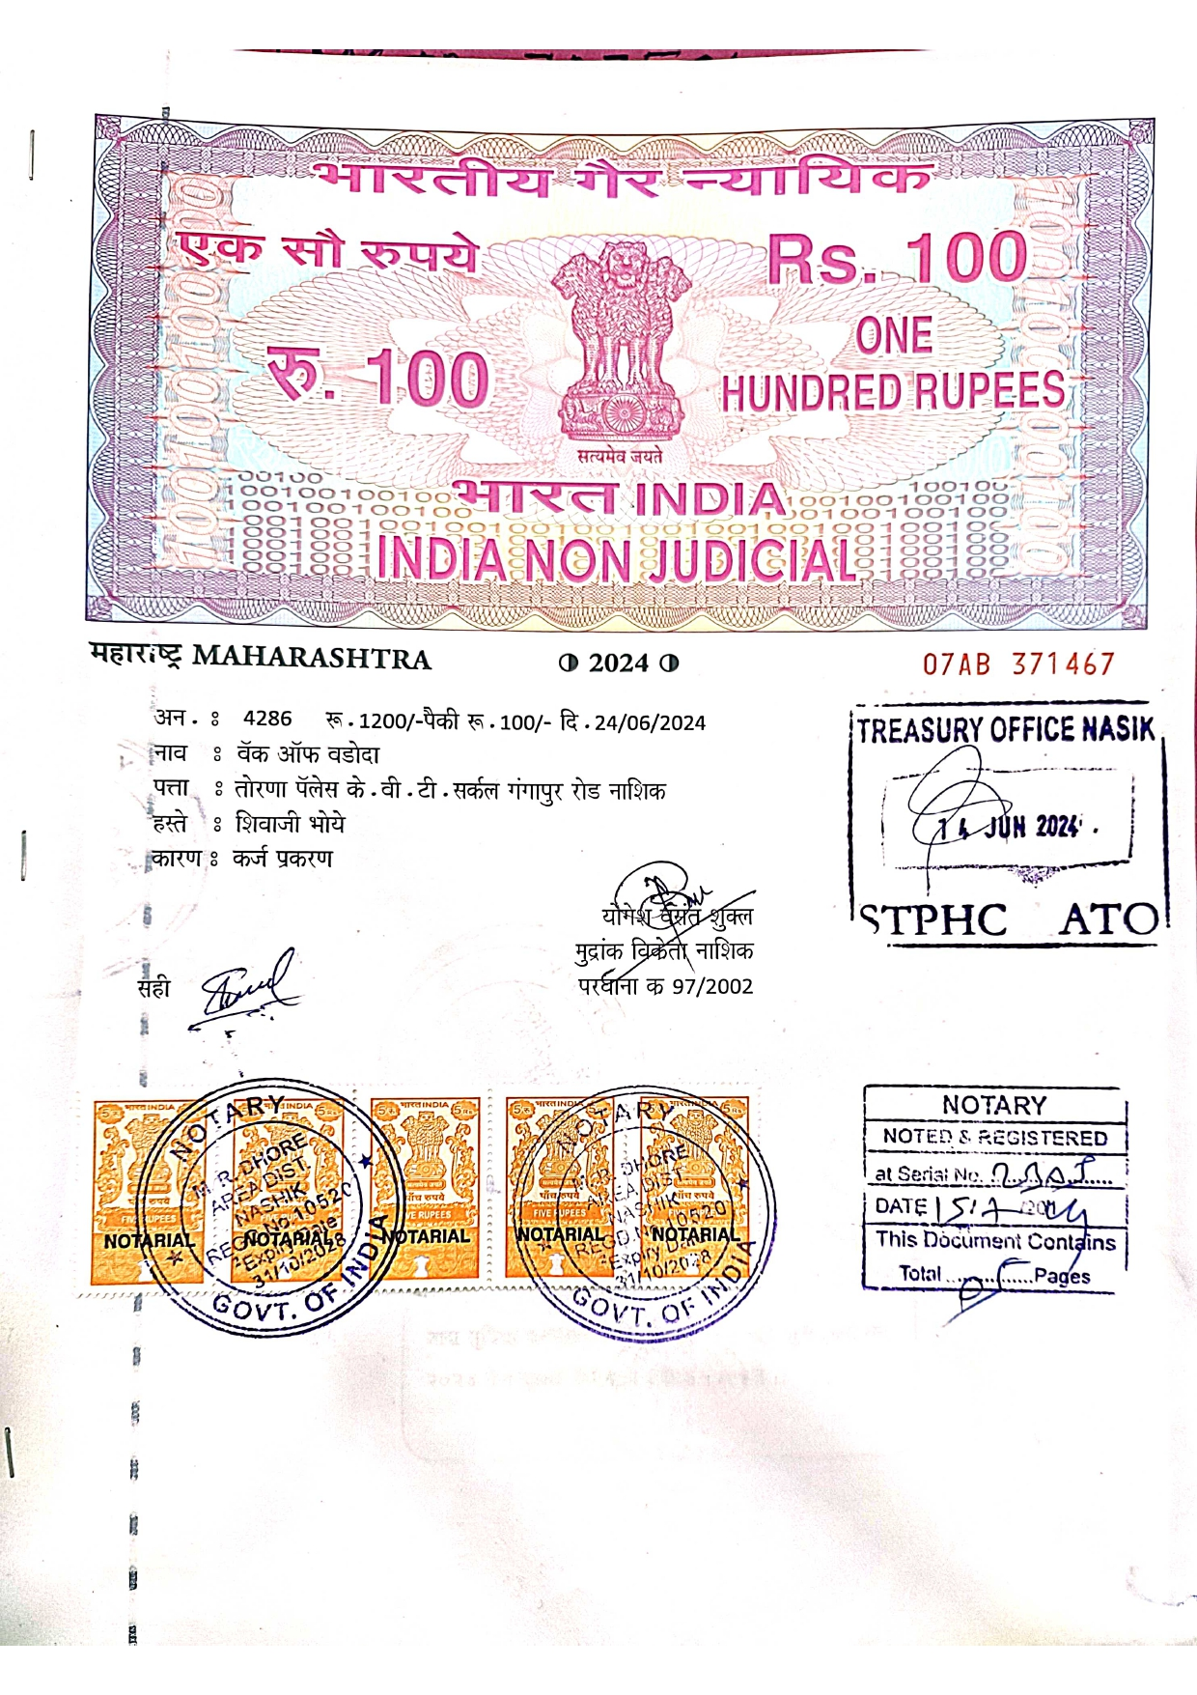
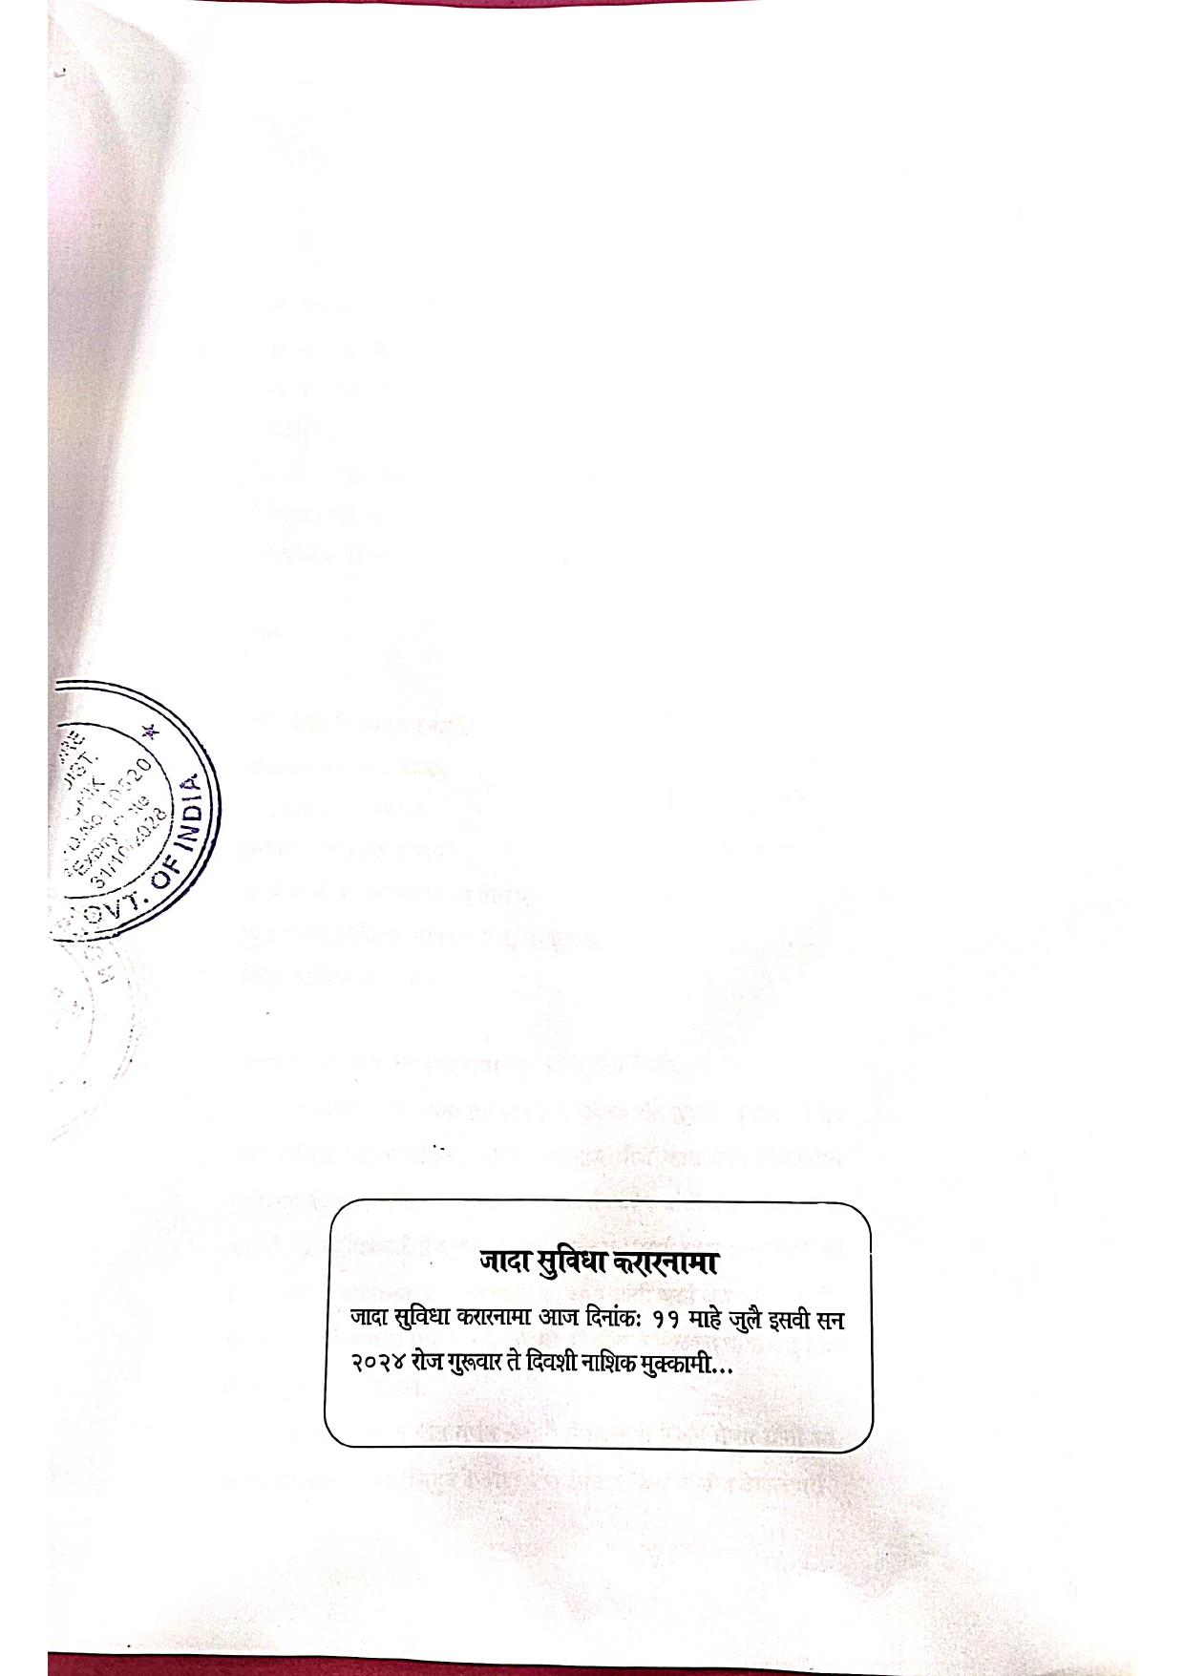

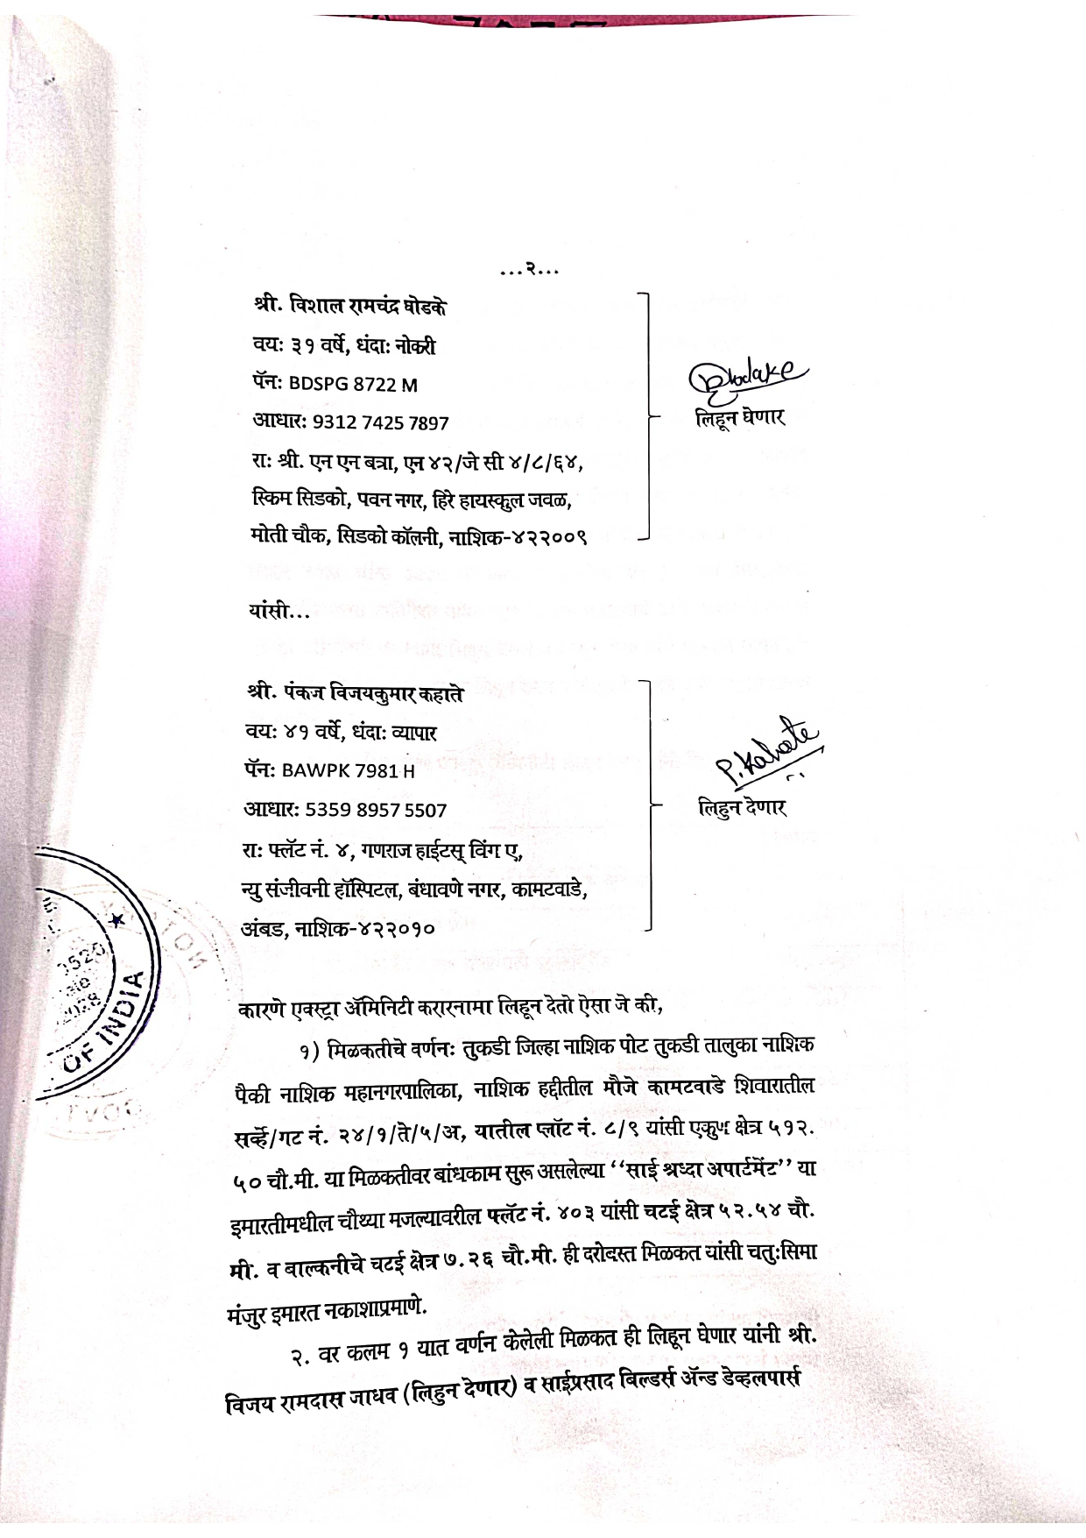

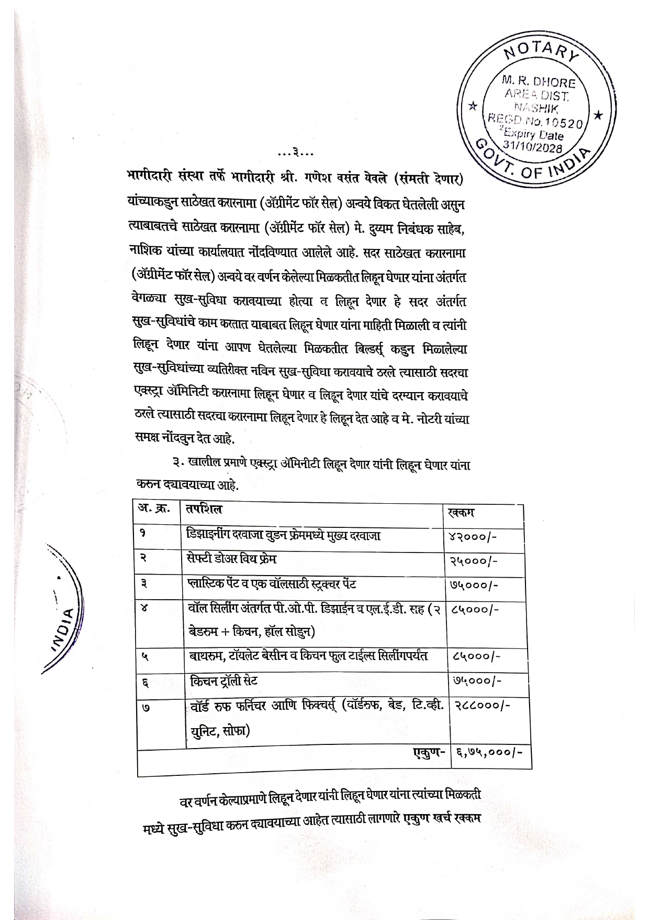
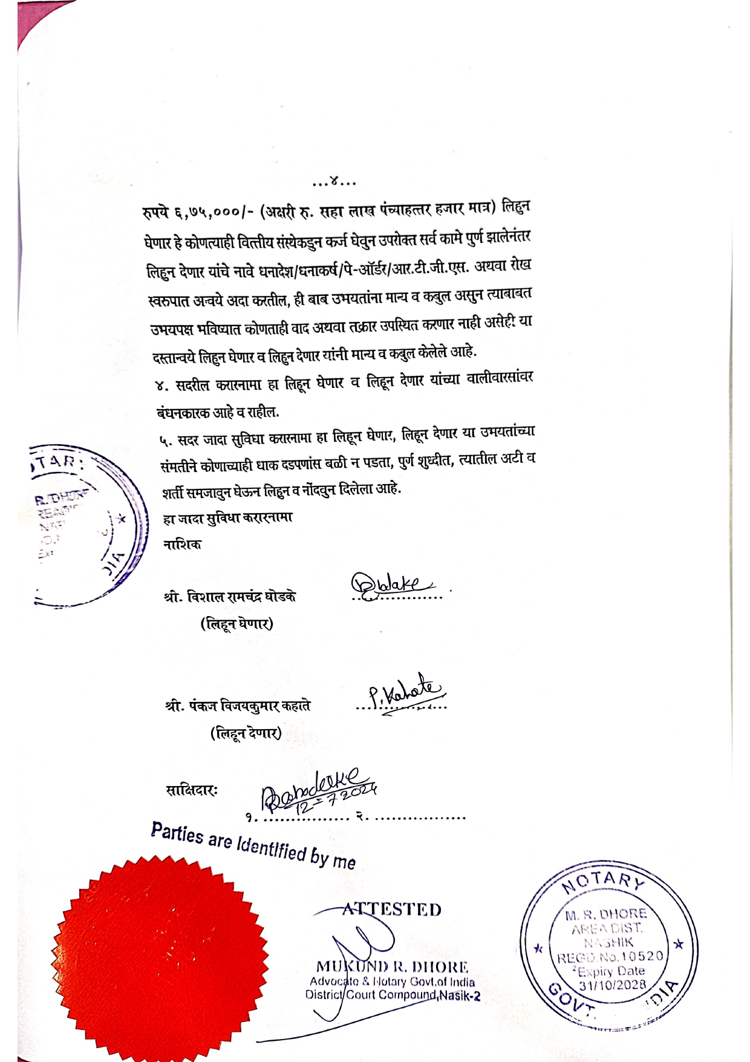

The Extra Amenities amount is Rs.6,75,000/- (Rupees Six Lakh Seventy-Five Thousand Only)

