MASTER VALUATION REPORT
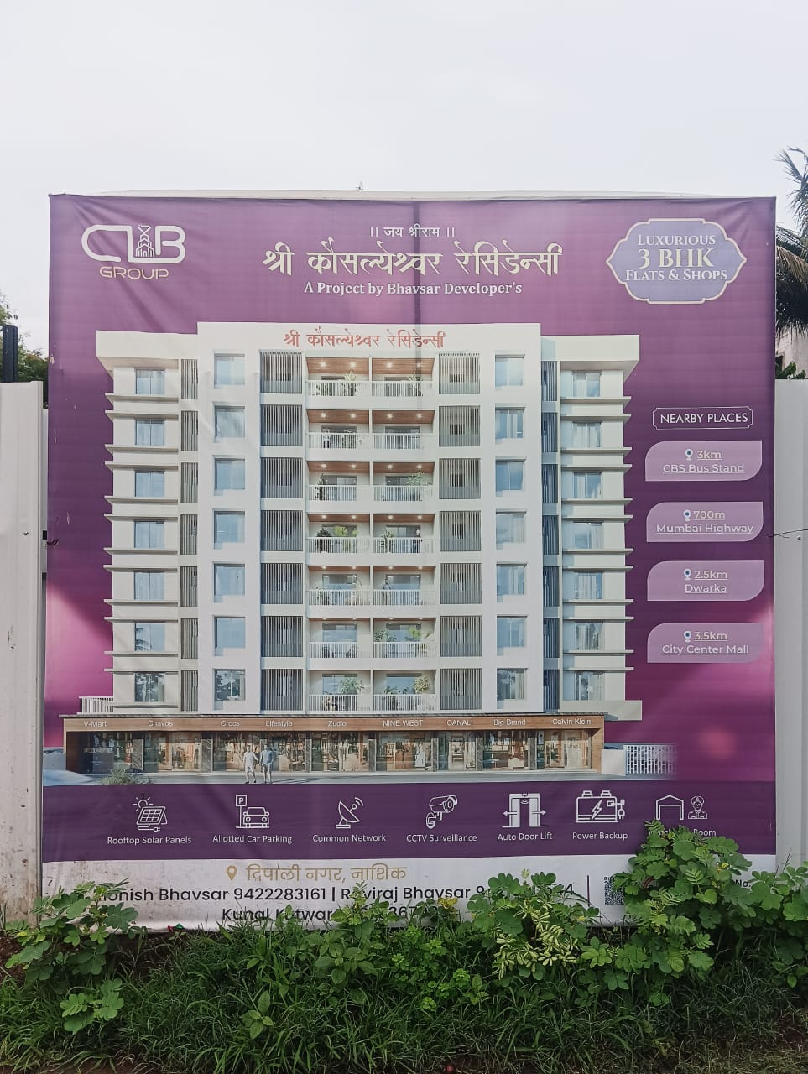

Details of the property under consideration:

Name of Project: "Shree Kausalyeshwar Residency”

"SHREE KAUSALYESHWAR RESIDENCY", Building Permission of Proposed Commercial & Residential on Survey No. 868/9, Plot No.2+3+4+5, at Village - Nashik, Near Mahadev Mandir, Behind Sayaji Hotel, Dindi Nagar, Deepali Nagar – Vinay Nagar Link Road, Mumbai Agra Highway, Taluka & District - Nashik,
PIN Code - 422 009, State - Maharashtra, Country - India.

Latitude Longitude: 19°58'48.4"N 73°47'09.8"E

Intended User :
State Bank of India
AGM HLST, Administrative Office, 1st Floor, BSNL - CTTC Building, Plot No. 45-47,
D - Road, MIDC, Satpur, Nashik Pin Code – 422 007, State - Maharashtra, Country - India

Vastu/SBI/Nashik/07/2024/9900/2307203
12/20-207-CCV
Date: 12.07.2024

MASTER VALUATION REPORT
OF
"SHREE KAUSALYESHWAR RESIDENCY"

"SHREE KAUSALYESHWAR RESIDENCY", Building Permission of Proposed Commercial & Residential on Survey No. 868/9, Plot No.2+3+4+5, at Village - Nashik, Near Mahadev Mandir, Behind Sayaji Hotel,Dindi Nagar, Deepali Nagar – Vinay Nagar Link Road, Mumbai Agra Highway, Taluka & District - Nashik, PIN Code - 422 009, State - Maharashtra, Country – India

Latitude Longitude: 19°58'48.4"N 73°47'09.8"E

NAME OF DEVELOPER: Sau. Sunita Rajendra Bhavsar

Pursuant to instructions from State Bank of India, AGM HLST, Administrative Office, Satpur, Nashik, Project Approval Cell, Nashik, we have duly visited, inspected, surveyed & assessed the above said property to determine the fair & reasonable market value of the said property as on 12th July 2024 for approval of Advance Processing Facility.

1. Location Details:
The property is situated at "SHREE KAUSALYESHWAR RESIDENCY", Building Permission of Proposed Commercial & Residential on Survey No. 868/9, Plot No. 2+3+4+5, at Village - Nashik, Near Mahadev Mandir, Behind Sayaji Hotel, Dindi Nagar, Deepali Nagar – Vinay Nagar Link Road, Mumbai Agra Highway, Taluka & District - Nashik, PIN Code - 422 009, State - Maharashtra, Country - India. It is about 8.5 Km. distance from Nashik Railway Station Surface transport to the property is by buses, Auto, taxis & private vehicles. Surface transport to the property is by buses, taxis & private vehicles. The property is in developed locality. All the amenities like shops, banks, hotels, markets, schools, hospitals, etc. are all available in the surrounding locality. The locality is middle class & developed.
2. Developer Details:

Name of builder | Sau. Sunita Rajendra Bhavsar
Project Registration Number
  Project | RERA Project Number
  Shree Kausalyeshwar Residency | P51600054627
Register office address | Sau. Sunita Rajendra Bhavsar  House No.18, "Vatsalya Bungalow", Behind Tupsakhare Lawns, Tidke Colony, Village - Nashik, Taluka & Dist. - Nashik, PIN Code - 422 002, State - Maharashtra, Country – India.
Contact Numbers | Contact Person:  Mr. Alikesh Shinde (Builder Person - Mobile No. 9096600551 / Office No.09422283161)

3. Boundaries of the Property:

Direction | Particulars
On or towards North | Niyati Apartment
On or towards South | Road
On or towards East | Open Plot
On or towards West | Open Plot & Road

Vastukala Consultants (I) Pvt. Ltd.
B1-001, U/B Floor, Boomerang, Chandivali Farm Road, Powai, Andheri (East), Mumbai – 400 072
To,
The Branch Manager,
State Bank of India
AGM HLST, Administrative Office, 1st Floor, BSNL - CTTC Building,
Plot No. 45-47, D - Road, MIDC, Satpur, Nashik
Pin Code – 422 007, State - Maharashtra, Country - India

VALUATION REPORT (IN RESPECT OF MASTER VALUATION REPORT)
I | General
1. | Purpose for which the valuation is made |  |  |  |  |  | : |  | As per request from State Bank of India, Home Loans Sales, Project Approval Cell, Satpur, Nashik to assess fair market value of the property for bank loan purpose.
2. | a) |  |  | Date of inspection |  |  | : |  | 11.07.2024
 | b) |  |  | Date on which the valuation is made |  |  | : |  | 12.07.2024
3. | List of documents produced for perusal
 | - Copy of Self Declaration Regarding Encumbrance issued by Bhavsar Developers Dated.26.12.2023
 | - Copy of Legal Title Report issued by Adv. Nandkishor H.Lahoti dated.18.12.2023 (As per RERA Certificate)
 | - Copy of Declaration About Commencement Certificate issued by Bhavsar Developers dated18.10.2023
 | - Copy of MAHARERA Registration Certificate of Project No. P51600054627 issued by Maharashtra Real Estate Regulatory Authority dated02/02/2024.
 | - Copy of Sanction of Building Permission and Commencement Certificate No. LND/ BP/ A4/ 182/ 2023 dated.18.10.2023 issued by Executive Engineer Town Planning Department Nashik Municipal Corporation Nashik.
- Copy of Approved Building Plan Accompanying Commencement Certificate No. A4/ BP/182/ 2023 dated.18.10.2023 issued by Executive Engineer Town Planning Nashik Municipal Corporation, Nashik.
Approved up to:
Project | Number of Floors
Shree Kausalyeshwar Residency | Ground / Parking + 1st Floor + 7th Upper Floors.

 | - Copy of 7/12 extract
 | Project Name  (with address & phone nos.) |  |  |  |  |  | : |  | "SHREE KAUSALYESHWAR RESIDENCY", Building Permission of Proposed Commercial & Residential on Survey No. 868/9, Plot No.2+3+4+5, at Village - Nashik, Near Mahadev Mandir, Behind Sayaji Hotel,Dindi Nagar, Deepali Nagar – Vinay Nagar Link Road, Mumbai Agra Highway, Taluka & District - Nashik, PIN Code - 422 009, State - Maharashtra, Country - India
4. | Name of the owner(s) and his / their address (es) with Phone no. (details of share of each owner in case of joint ownership) |  |  |  |  |  | : |  | Sau. Sunita Rajendra Bhavsar  House No.18, "Vatsalya Bungalow", Behind Tupsakhare Lawns, Tidke Colony, Village - Nashik, Taluka & Dist. - Nashik, PIN Code - 422 002, State - Maharashtra, Country – India.  Contact Person:  Mr. Alikesh Shinde (Builder Person - Mobile No. 9096600551 / Office No.09422283161)
5. | Brief description of the property (Including Leasehold / freehold etc.) |  |  |  |  |  | :
TYPE OF THE BUILDING:
Project | Number of Floors
Shree Kausalyeshwar Residency | Proposed Ground/ Parking + 1st Floor + 7th Upper Floors.

LEVEL OF COMPLETEION:
Project | Present stage of Construction | Percentage of work completion
Shree Kausalyeshwar Residency | RCC work upto 3rd floor slab is completed. | 25%

DATE OF COMPLETION & FUTURE LIFE:
Expected completion date as RERA Certificates is December - 2026

Future estimated life of the Structure is 60 years (after completion) Subject to proper, preventive periodic maintenance & Structural repairs.

PROPOSED PROJECT AMENITIES:
- Vitrified tiles flooring in all rooms
- Granite Kitchen platform with Stainless Steel Sink
- Powder coated aluminum sliding windows with Mosquito Net
- Laminated wooden flush doors with Safety door
- Concealed wiring
- Concealed plumbing
- Rooftop Solar Panels
- Allotted Car Parking
- Common Network
- CCTV Surveillance
- Auto Door Lift
- Power Backup

6. | Location of property |  |  |  |  |  | :
 | a) |  | Plot No. / Survey No. |  |  |  | : |  | Survey No. 868/9, Plot No.2+3+4+5
 | b) |  | Door No. |  |  |  | : |  | Not applicable
 | c) |  | C. T.S. No. / Village |  |  |  | : |  | Survey No. 868/9, Plot No. 2+3+4+5, at Village - Nashik
 | d) |  | Ward / Taluka |  |  |  | : |  | Taluka - Nashik
 | e) |  | Mandal / District |  |  |  | : |  | Dist. - Nashik
7. | Postal address of the property |  |  |  |  |  | : |  | "SHREE KAUSALYESHWAR RESIDENCY", Building Permission of Proposed Commercial & Residential on Survey No. 868/9, Plot No. 2+3+4+5, at Village - Nashik, Near Mahadev Mandir, Behind Sayaji Hotel, Dindi Nagar, Deepali Nagar – Vinay Nagar Link Road, Mumbai Agra Highway, Taluka & District - Nashik, PIN Code - 422 009, State - Maharashtra, Country - India
8. | City / Town |  |  |  |  |  | : |  | Near Mahadev Mandir, Behind Sayaji Hotel,Dindi Nagar
 | Residential area |  |  |  |  |  | : |  | Yes
 | Commercial area |  |  |  |  |  | : |  | Yes
 | Industrial area |  |  |  |  |  | : |  | No
9. | Classification of the area |  |  |  |  |  | :
 | i) High / Middle / Poor |  |  |  |  |  | : |  | Middle Class
 | ii) Urban / Semi Urban / Rural |  |  |  |  |  | : |  | Urban
10. | Coming under Corporation limit / Village Panchayat / Municipality |  |  |  |  |  | : |  | Nashik Municipal Corporation
11. | Whether covered under any State / Central Govt. enactments (e.g., Urban Land Ceiling Act) or notified under agency area/ scheduled area / cantonment area |  |  |  |  |  | : |  | No
12. | In Case it is Agricultural land, any conversion to house site plots is contemplated |  |  |  |  |  | : |  | N.A.
13. |  | Boundaries of the property |  |  | As per Plan | As per MAHARERA |  |  |  |  |  | As per Site
 |  | North |  |  | Survey No. 868/1 | Survey No. 868/1 |  |  |  |  |  | Niyati Apartment
 |  | South |  |  | Colony Road | Colony Road |  |  |  |  |  | Road
 |  | East |  |  | Adjoining Land | Adjoining Land |  |  |  |  |  | Open Plot
 |  | West |  |  | Plot No.1 | Plot No.1 |  |  |  |  |  | Open Plot & Road
14.1 |  | Dimensions of the site |  |  |  |  |  |  | N. A. as the land is irregular in shape
 |  |  |  |  |  |  |  |  | A As per the Deed |  |  |  | B Actuals
 |  | North |  |  |  |  |  | : | - |  |  |  | -
 |  | South |  |  |  |  |  | : | - |  |  |  | -
 |  | East |  |  |  |  |  | : | - |  |  |  | -
 |  | West |  |  |  |  |  | : | - |  |  |  | -
14.2 |  | Latitude, Longitude & Co-ordinates of property |  |  |  |  |  | : | 19°58'48.4"N 73°47'09.8"E
14. |  | Extent of the site |  |  |  |  |  | : | Plot area – 1062.60 Sq. M. (As per Approved Plan & RERA Certificate)  Structure - As per table attached to the report
15. |  | Extent of the site considered for Valuation (least of 14A& 14B) |  |  |  |  |  | : | Plot area – 1062.60 Sq. M. (As per Approved Plan & RERA Certificate)  Structure - As per table attached to the report
16 |  | Whether occupied by the owner / tenant? If occupied by tenant since how long? Rent received per month. |  |  |  |  |  | : | N.A. Building Construction work is in progress
II |  | CHARACTERSTICS OF THE SITE
 |  | Classification of locality |  |  |  |  |  | : | Middle class
 |  | Development of surrounding areas |  |  |  |  |  | : | Good
 |  | Possibility of frequent flooding/ sub-merging |  |  |  |  |  | : | No
 |  | Feasibility to the Civic amenities like School, Hospital, Bus Stop, Market etc. |  |  |  |  |  | : | All available near by
 |  | Level of land with topographical conditions |  |  |  |  |  | : | Plain
 |  | Shape of land |  |  |  |  |  | : | Rectangular
 |  | Type of use to which it can be put |  |  |  |  |  | : | For Residential Cum Commercial purpose
 |  | Any usage restriction |  |  |  |  |  | : | Residential Cum Commercial
 |  | Is plot in town planning approved layout? |  |  |  |  |  | : | Copy of Approved Building Plan Accompanying Commencement Certificate No. A4/ BP/182/ 2023 dated.18.10.2023 issued by Executive Engineer Town Planning Nashik Municipal Corporation, Nashik.  Approved up to:
  Project | Number of Floors
  Shree Kausalyeshwar Residency | Ground / Parking + 1st Floor + 7th Upper Floors.
 |  | Corner plot or intermittent plot? |  |  |  |  |  | : | Intermediate Plot
 |  | Road facilities |  |  |  |  |  | : | Yes
 |  | Type of road available at present |  |  |  |  |  | : | B. T. Road
 |  | Width of road – is it below 20 ft. or more than 20 ft. |  |  |  |  |  | : | 9.00 Mtr. Road
 |  | Is it a Land – Locked land? |  |  |  |  |  | : | No
 |  | Water potentiality |  |  |  |  |  | : | Municipal Water supply
 |  | Underground sewerage system |  |  |  |  |  | : | Connected to Municipal sewer
 |  | Is Power supply is available in the site |  |  |  |  |  | : | Yes
 |  | Advantages of the site |  |  |  |  |  | : | Located in developed area
 |  | Special remarks, if any like threat of acquisition of land for publics service purposes, road widening or applicability of CRZ provisions etc.(Distance from sea-cost / tidal level must be incorporated) |  |  |  |  |  | : | No
Part – A (Valuation of land)
1 |  | Size of plot |  |  |  |  |  | : | Plot area – 1062.60 Sq. M. (As per Approved Plan & RERA Certificate)
 |  | North & South |  |  |  |  |  | : | -
 |  | East & West |  |  |  |  |  | : | -
2 |  | Total extent of the plot |  |  |  |  |  | : | As per table attached to the report
3 |  | Prevailing market rate ( Along With details / reference of at least two latest deals / transactions with respect to adjacent properties in the areas) |  |  |  |  |  | : | As per table attached to the report  Details of recent transactions/online listings are attached with the report.
4 |  | Guideline rate obtained from the Register’s Office (an evidence thereof to be enclosed) |  |  |  |  |  | : | ` 39,100.00 per Sq. M. for Residential  ` 16,500.00 per Sq. M. for Land
5 |  | Assessed / adopted rate of valuation |  |  |  |  |  | : | As per table attached to the report
6 |  | Estimated value of land |  |  |  |  |  | :
  As per Approved Plan & RERA
  Land Area  in Sq. M. | Rate in  Sq. M. | Value in (`)
  1062.60 | 16,500 | 1,75,32,900.00
Part – B (Valuation of Building)
1 |  | Technical details of the building |  |  |  |  |  | :
 |  | - Type of Building (Residential / Commercial / Industrial) |  |  |  |  |  | : | Residential Cum Commercial
 |  | - Type of construction (Load bearing / RCC / Steel Framed) |  |  |  |  |  | : | RCC Framed Structure
 |  | - Year of construction |  |  |  |  |  | : | N.A. Building Construction work is in progress
 |  | - Number of floors and height of each floor including basement, if any |  |  |  |  |  | :
Project | Number of Floors
Shree Kausalyeshwar Residency | Proposed Ground / Parking + 1st Floor + 7th Upper Floors

 |  | - Plinth area floor-wise |  |  |  |  |  |  |  | : | As per table attached to the report
 |  | - Condition of the building |  |  |  |  |  |  |  | :
 |  | - Exterior – Excellent, Good, Normal, Poor |  |  |  |  |  |  |  | : | N.A. Building Construction work is in progress
 |  | - Interior – Excellent, Good, Normal, Poor |  |  |  |  |  |  |  | : | N.A. Building Construction work is in progress
 |  | - Date of issue and validity of layout of approved map |  |  |  |  |  |  |  | : | Copy of Approved Building Plan Accompanying Commencement Certificate No. A4/ BP/182/ 2023 dated.18.10.2023 issued by Executive Engineer Town Planning Nashik Municipal Corporation, Nashik.  Approved upto:
  Project | Number of Floors
  Shree Kausalyeshwar Residency | Ground/ Parking + 1st Floor + 7th Upper Floors
 |  | - Approved map / plan issuing authority |  |  |  |  |  |  |  | :
 |  | - Whether genuineness or authenticity of approved map / plan is verified |  |  |  |  |  |  |  | : | Yes
 |  | - Any other comments by our empanelled valuers on authentic of approved plan |  |  |  |  |  |  |  | : | No.

Specifications of construction (floor-wise) in respect of

Sr.  No. | Description
 | Foundation | : | R.C.C. Footing
 | Basement | : | Building is Under Construction
 | Superstructure | : | Building is Under Construction
 | Joinery / Doors & Windows (Please furnish details about size of frames, shutters, glazing, fitting etc. and specify the species of timber | : | Building is Under Construction
 | RCC Works | : | Building is Under Construction
 | Plastering | : | Building is Under Construction
 | Flooring, Skirting, dado | : | Building is Under Construction
 | Special finish as marble, granite, wooden paneling, grills etc. | : | Building is Under Construction
 | Roofing including weather proof course | : | Building is Under Construction
 | Drainage | : | Proposed Connected to Municipal Sewerage System
2. | Compound Wall | :
 | Height | : | Building is Under Construction
 | Length | : | Building is Under Construction
 | Type of construction | : | Building is Under Construction
3. | Electrical installation | : | Building is Under Construction
 | Type of wiring | : | Building is Under Construction
 | Class of fittings (superior / ordinary / poor) | : | Building is Under Construction
 | Number of light points | : | Building is Under Construction
 | Fan points | : | Building is Under Construction
 | Spare plug points | : | Building is Under Construction
 | Any other item | : | -
4. | Plumbing installation
 | - No. of water closets and their type | : | Building is Under Construction
 | - No. of wash basins | : | Building is Under Construction
 | - No. of urinals | : | Building is Under Construction
 | - No. of bath tubs | : | Building is Under Construction
 | - Water meters, taps etc. | : | Building is Under Construction
 | - Any other fixtures | : | Building is Under Construction

CONFIGURATION OF PROJECT AS PER APPROVED PLAN & DEVELOPER’S INFORMATION:

- SHREE KAUSALYESHWAR RESIDENCY:

Sr. No. | Flat No. | Floor No. | Comp. | As per  Approved Plan |  |  | Total Area in  Sq. Ft. | Built up Area in  Sq. Ft. (10%) | Rate per  Sq. ft. on Total Area  in ` | Fair Market Value in ` | Realizable Value in ` | Distress Sale Value in ` | Expected Rent per month in `
 |  |  |  | RERA Carpet Area in  Sq. Ft. | Balcony Area in  Sq. Ft. | Attached Terrace Area in Sq. Ft. (50%)
 |  |  |  | A | B | C | A + B + C
1 | 101 | 1 | 3 BHK | 832 | 215 |  | 1047 | 1152 | 6400 | 67,00,800 | 63,65,760 | 53,60,640 | 14000
2 | 102 | 1 | 3 BHK | 810 | 237 |  | 1047 | 1152 | 6400 | 67,00,800 | 63,65,760 | 53,60,640 | 14000
3 | 103 | 1 | 3 BHK | 808 | 217 |  | 1025 | 1128 | 6400 | 65,60,000 | 62,32,000 | 52,48,000 | 13500
4 | 104 | 1 | 3 BHK | 889 | 136 | 65 | 1090 | 1199 | 6400 | 69,76,000 | 66,27,200 | 55,80,800 | 14500
5 | 201 | 2 | 3 BHK | 832 | 215 |  | 1047 | 1152 | 6400 | 67,00,800 | 63,65,760 | 53,60,640 | 14000
6 | 202 | 2 | 3 BHK | 810 | 237 |  | 1047 | 1152 | 6400 | 67,00,800 | 63,65,760 | 53,60,640 | 14000
7 | 203 | 2 | 3 BHK | 808 | 217 |  | 1025 | 1128 | 6400 | 65,60,000 | 62,32,000 | 52,48,000 | 13500
8 | 204 | 2 | 3 BHK | 889 | 136 |  | 1025 | 1128 | 6400 | 65,60,000 | 62,32,000 | 52,48,000 | 13500
9 | 301 | 3 | 3 BHK | 832 | 215 |  | 1047 | 1152 | 6400 | 67,00,800 | 63,65,760 | 53,60,640 | 14000
10 | 302 | 3 | 3 BHK | 810 | 237 |  | 1047 | 1152 | 6400 | 67,00,800 | 63,65,760 | 53,60,640 | 14000
11 | 303 | 3 | 3 BHK | 808 | 217 |  | 1025 | 1128 | 6400 | 65,60,000 | 62,32,000 | 52,48,000 | 13500
12 | 304 | 3 | 3 BHK | 889 | 136 |  | 1025 | 1128 | 6400 | 65,60,000 | 62,32,000 | 52,48,000 | 13500
13 | 401 | 4 | 3 BHK | 832 | 215 |  | 1047 | 1152 | 6400 | 67,00,800 | 63,65,760 | 53,60,640 | 14000
14 | 402 | 4 | 3 BHK | 810 | 237 |  | 1047 | 1152 | 6400 | 67,00,800 | 63,65,760 | 53,60,640 | 14000
15 | 403 | 4 | 3 BHK | 808 | 217 |  | 1025 | 1128 | 6400 | 65,60,000 | 62,32,000 | 52,48,000 | 13500
16 | 404 | 4 | 3 BHK | 889 | 136 |  | 1025 | 1128 | 6400 | 65,60,000 | 62,32,000 | 52,48,000 | 13500
17 | 501 | 5 | 3 BHK | 832 | 215 |  | 1047 | 1152 | 6400 | 67,00,800 | 63,65,760 | 53,60,640 | 14000
18 | 502 | 5 | 3 BHK | 810 | 237 |  | 1047 | 1152 | 6400 | 67,00,800 | 63,65,760 | 53,60,640 | 14000
19 | 503 | 5 | 3 BHK | 808 | 217 |  | 1025 | 1128 | 6400 | 65,60,000 | 62,32,000 | 52,48,000 | 13500
20 | 504 | 5 | 3 BHK | 889 | 136 |  | 1025 | 1128 | 6400 | 65,60,000 | 62,32,000 | 52,48,000 | 13500
21 | 601 | 6 | 3 BHK | 832 | 215 |  | 1047 | 1152 | 6400 | 67,00,800 | 63,65,760 | 53,60,640 | 14000
22 | 602 | 6 | 3 BHK | 810 | 237 |  | 1047 | 1152 | 6400 | 67,00,800 | 63,65,760 | 53,60,640 | 14000
23 | 603 | 6 | 3 BHK | 808 | 217 |  | 1025 | 1128 | 6400 | 65,60,000 | 62,32,000 | 52,48,000 | 13500
24 | 604 | 6 | 3 BHK | 889 | 136 |  | 1025 | 1128 | 6400 | 65,60,000 | 62,32,000 | 52,48,000 | 13500
25 | 701 | 7 | 3 BHK | 832 | 215 |  | 1047 | 1152 | 6400 | 67,00,800 | 63,65,760 | 53,60,640 | 14000
26 | 702 | 7 | 3 BHK | 810 | 237 |  | 1047 | 1152 | 6400 | 67,00,800 | 63,65,760 | 53,60,640 | 14000
27 | 703 | 7 | 3 BHK | 808 | 217 |  | 1025 | 1128 | 6400 | 65,60,000 | 62,32,000 | 52,48,000 | 13500
28 | 704 | 7 | 3 BHK | 889 | 136 |  | 1025 | 1128 | 6400 | 65,60,000 | 62,32,000 | 52,48,000 | 13500
Total |  |  |  | 23373 | 5635 |  | 29073 | 31980 |  | 18,60,67,200 | 17,67,63,840 | 14,88,53,760

Summary of the Project:

Project | Comp. /  Total Number of Flat | Total Carpet Area in Sq. Ft. | Total Built up Area in Sq. Ft. | Fair Market Value in (`) | Realizable Value in (`) | Distress Sale Value  in (`)
Shree Kausalyeshwar Residency | 3 BHK- 28  Total Flat - 28 | 29073 | 31980 | 18,60,67,200.00 | 17,67,63,840.00 | 14,88,53,760.00

Particulars | Market Value (`)
Fair Market Value as on date | 18,60,67,200.00
Realizable Value as on date | 17,67,63,840.00
Distress Sale Value as on date | 14,88,53,760.00
Cost of Construction  (Total Built up area x Rate)  31980 Sq. Ft. x ` 2300.00 | 7,35,54,690.00

Project | Percentage of work done as on date | Built up area  in Sq. Ft. | Total Cost Of Construction in (`) | Cost of construction as of today in (`)
Shree Kausalyeshwar Residency | 25% | 31980 | 7,35,54,690.00 | 1,83,88,673.00

Part – C (Extra Items) |  | : | Amount in `
 | Portico | : | Provided as per requirement
 | Ornamental front door | : | Provided as per requirement
 | Sit out / Verandah with steel grills | : | Provided as per requirement
 | Overhead water tank | : | Provided as per requirement
 | Extra steel / collapsible gates | : | Provided as per requirement
 | Total

Part – D (Amenities) |  | : | Amount in `
 | Wardrobes | : | Provided as per requirement
 | Glazed tiles | : | Provided as per requirement
 | Extra sinks and bath tub | : | Provided as per requirement
 | Marble / ceramic tiles flooring | : | Provided as per requirement
 | Interior decorations | : | Provided as per requirement
 | Architectural elevation works |  | Provided as per requirement
 | Paneling works |  | Provided as per requirement
 | Aluminum works |  | Provided as per requirement
 | Aluminum hand rails |  | Provided as per requirement
 | False ceiling |  | Provided as per requirement
 | Total

Part – E (Miscellaneous) |  | : | Amount in `
 | Separate toilet room | : | Provided as per requirement
 | Separate lumber room | : | Provided as per requirement
 | Separate water tank / sump | : | Provided as per requirement
 | Trees, gardening | : | Provided as per requirement
 | Total

Part – F (Services) |  | : | Amount in `
 | Water supply arrangements | : | Provided as per requirement
 | Drainage arrangements | : | Provided as per requirement
 | Compound wall | : | Provided as per requirement
 | C.B. deposits, fittings etc. | : | Provided as per requirement
 | Pavement |  | Provided as per requirement
 | Total

Total abstract of the entire property
Part – A | Land | : | As per table attached to the report `
Part – B | Building | : | As per table attached to the report `
 | Land development |  | As per table attached to the report `
Part – C | Compound wall | : | As per table attached to the report `
Part - D | Amenities | : | As per table attached to the report `
Part – E | Pavement | : | As per table attached to the report `
Part – F | Services | : | As per table attached to the report `
Fair Market Value as on date in ` |  | : | ` 18,60,67,200.00
Realizable Value as on date in ` |  | : | ` 17,67,63,840.00
Distress Sale Value as on date in ` |  |  | ` 14,88,53,760.00

The sales comparison approach uses the market data of sale prices to estimate the value of a real estate property. Property valuation in this method is done by comparing a property to other similar properties that have been recently sold. Comparable properties, also known as comparable, or comps, must share certain features with the property in question. Some of these include physical features such as square footage, number of rooms, condition, and age of the building; however, the most important factor is no doubt the location of the property. Adjustments are usually needed to account for differences as no two properties are exactly the same. To make proper adjustments when comparing properties, real estate appraisers must know the differences between the comparable properties and how to value these differences. The sales comparison approach is commonly used for Residential Flat, where there are typically many comparables available to analyze. As the property is a residential flat, we have adopted Sale Comparison Approach Method for the purpose of valuation .The Price for similar type of property in the nearby vicinity is in the range of ` 6,000.00 to ` 7,500.00 per Sq. Ft. on Carpet area Considering the rate with attached report, current market conditions , demand and supply position, Flat size, location, upswing in real estate prices, sustained demand for Residential Flat, all round development commercial and residential application in the locality etc. We estimate ` 6,400.00 per Sq. Ft. on Carpet Area for valuation.
Actual Site Photographs
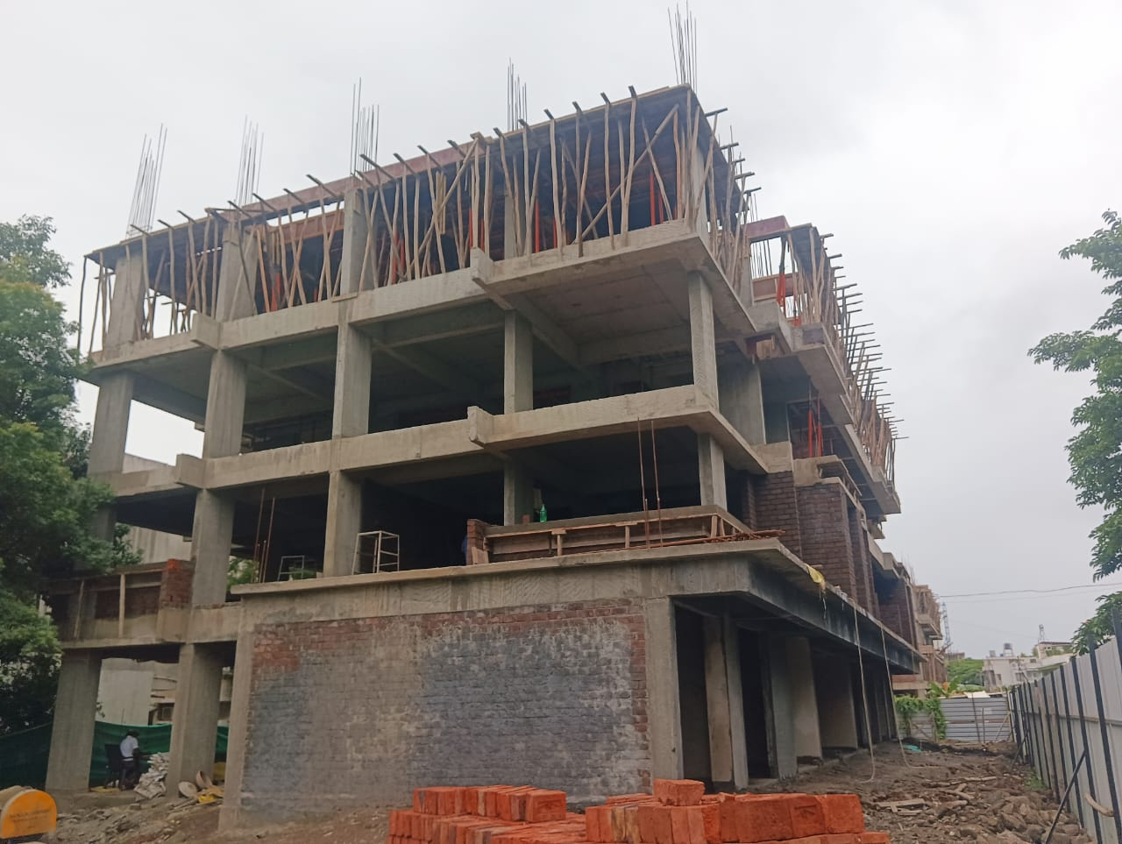
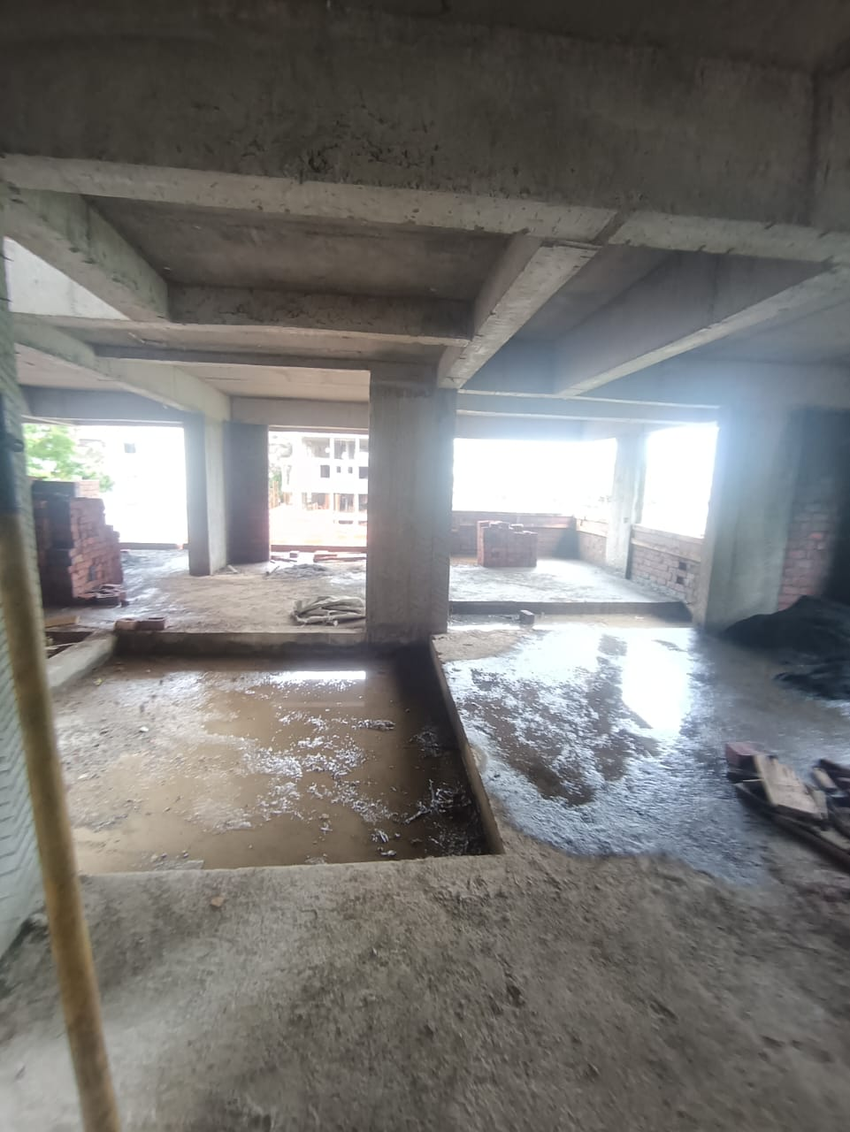

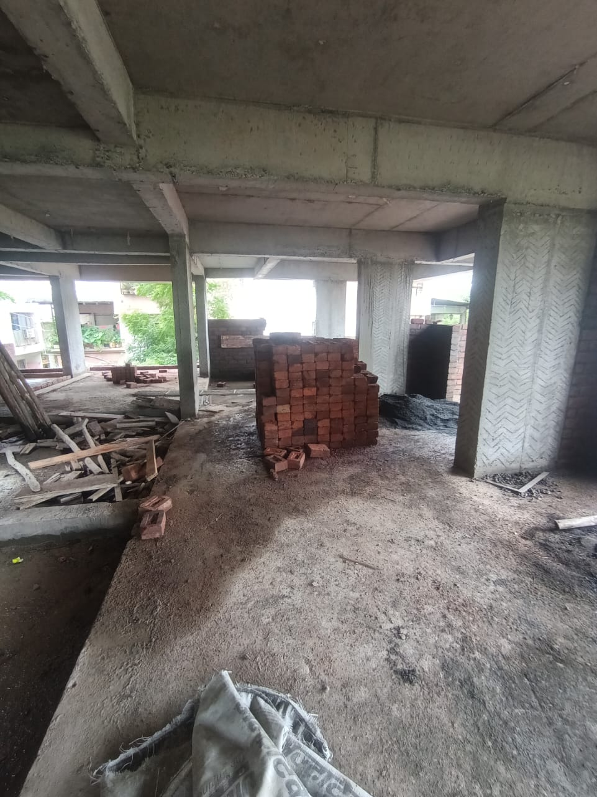
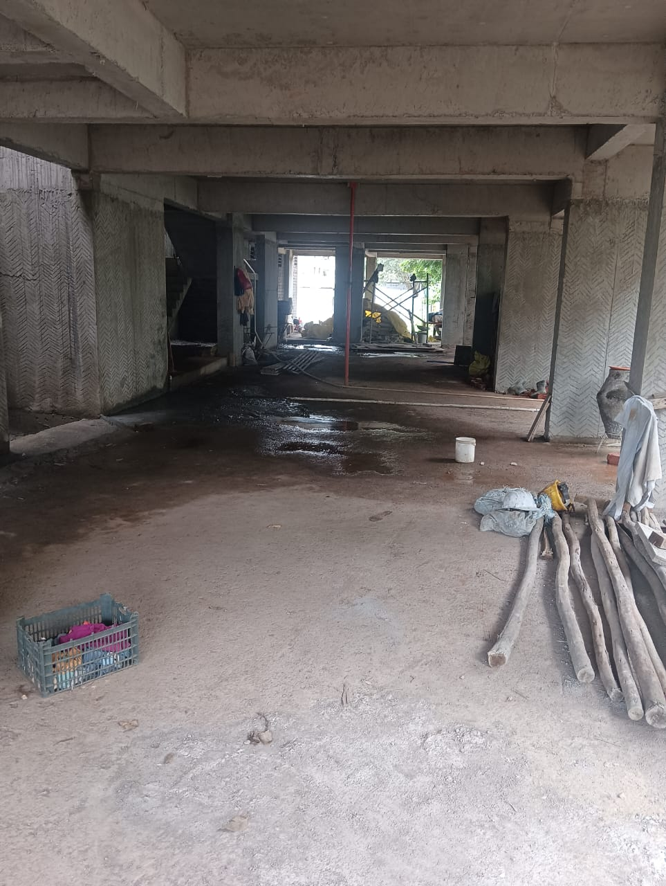
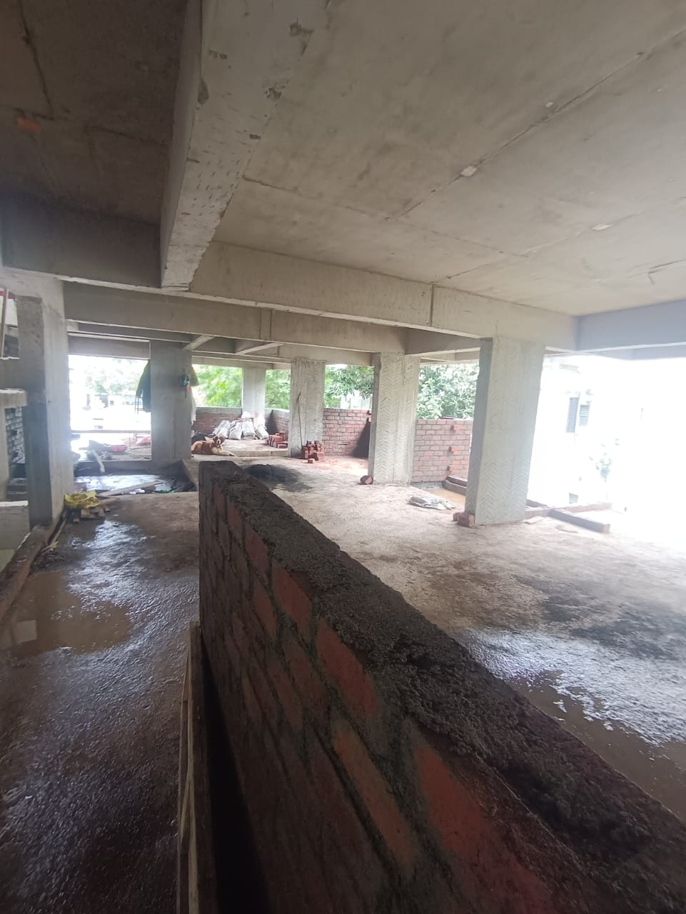
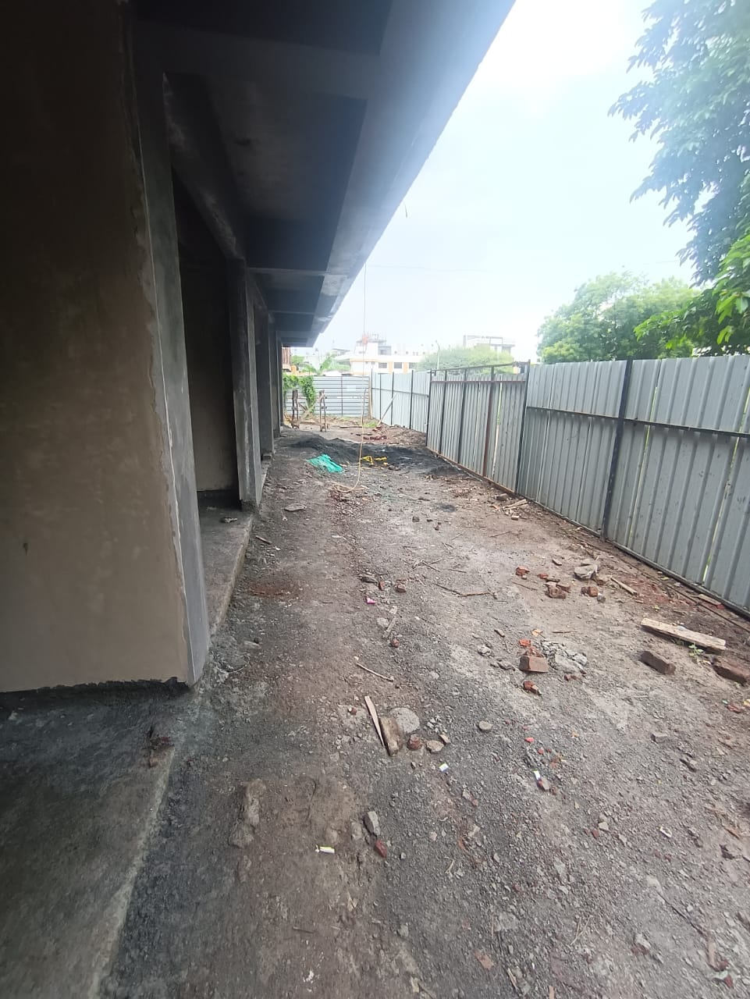
Actual Site Photographs
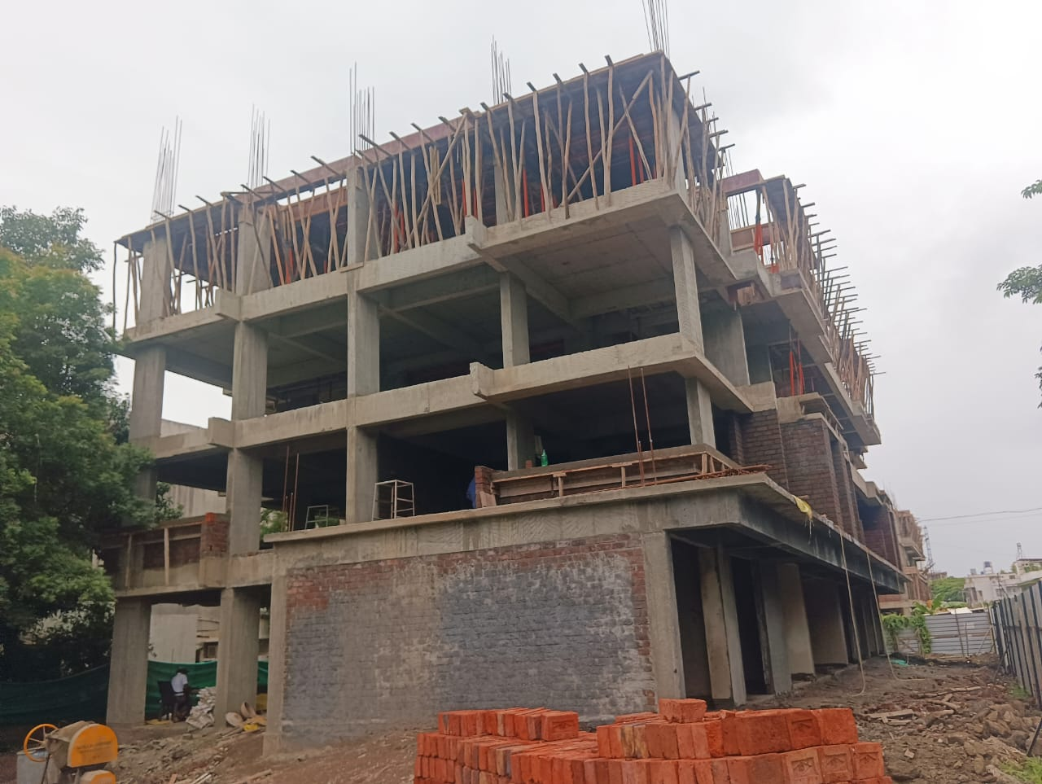

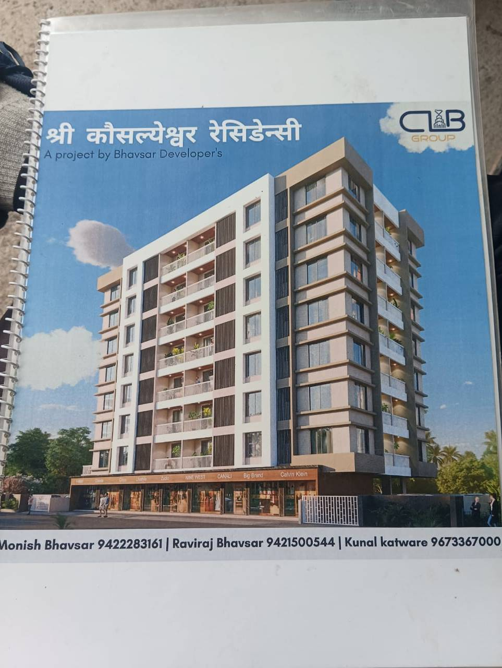
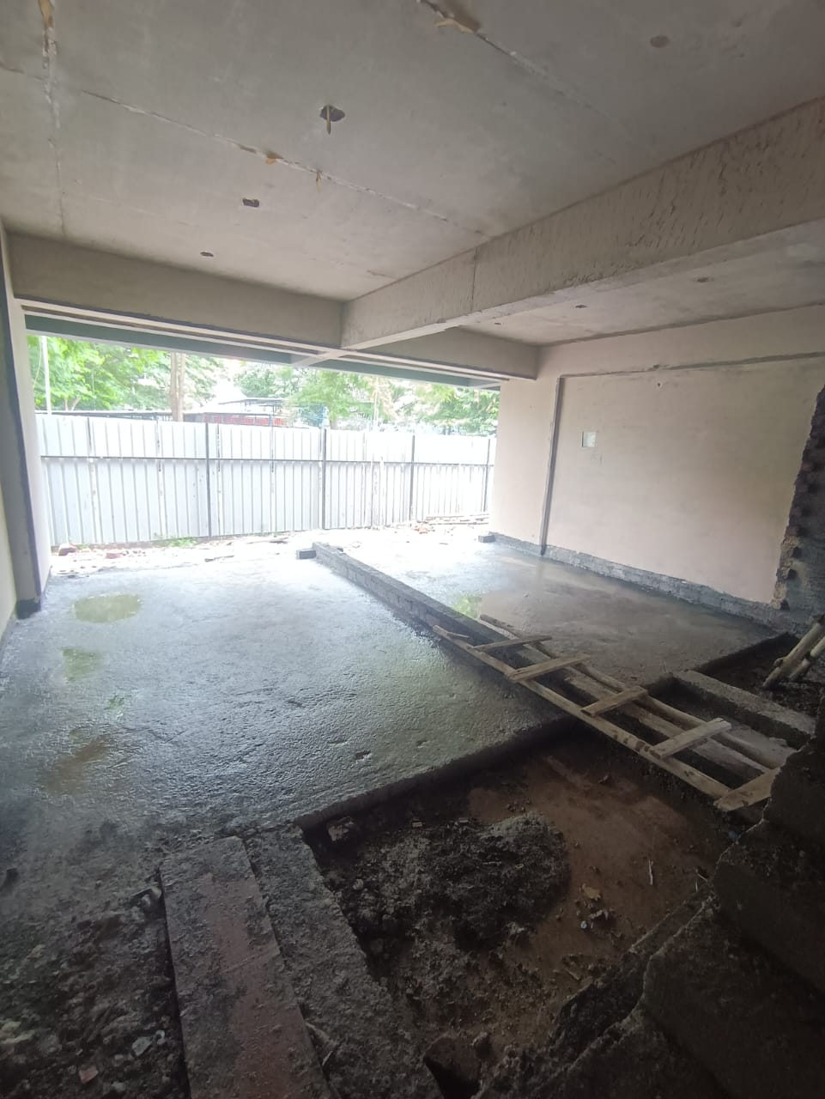

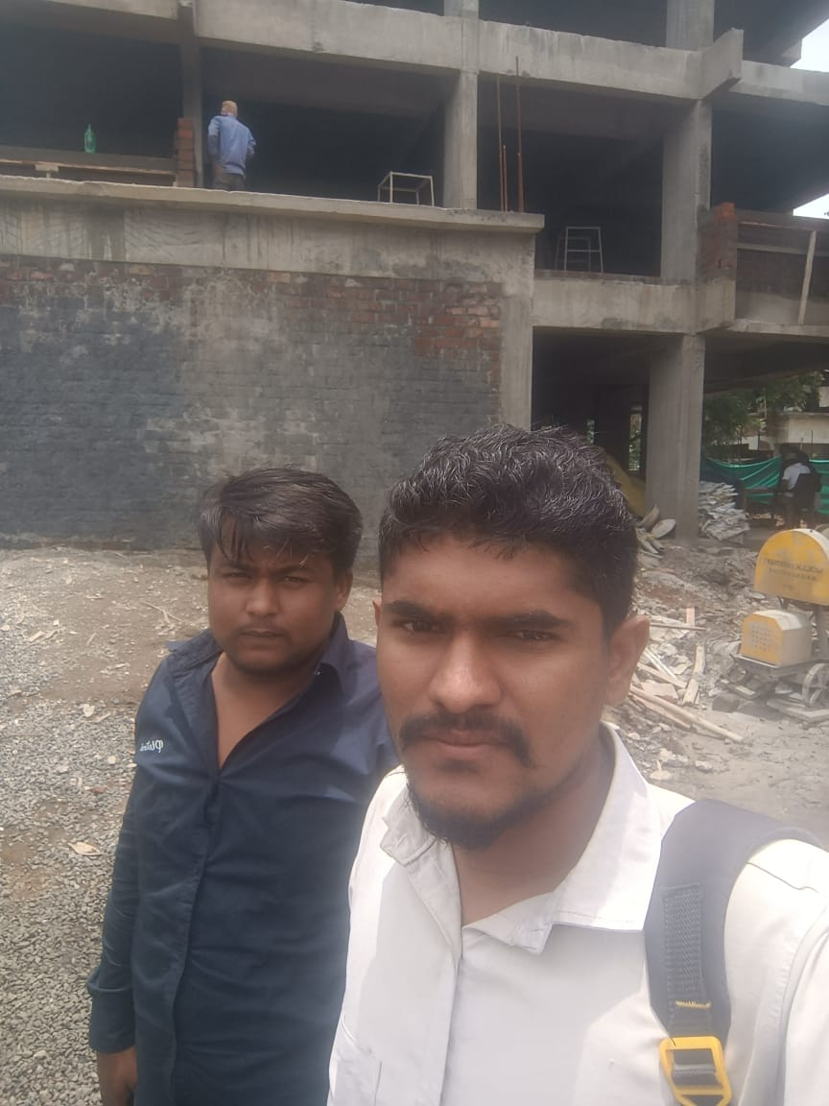

Route Map of the property
Site u/r
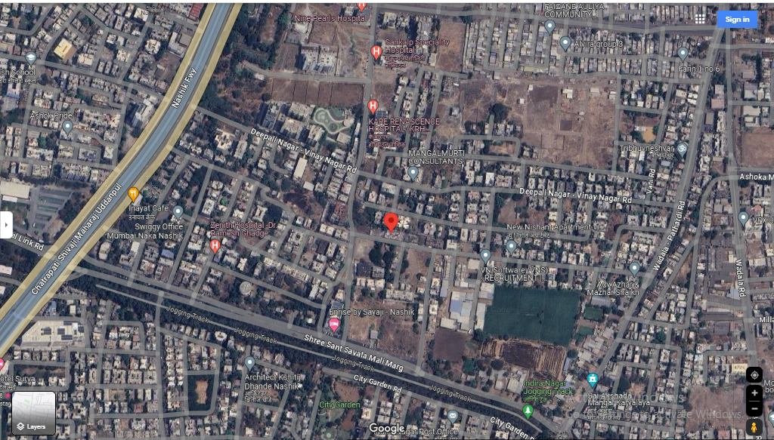

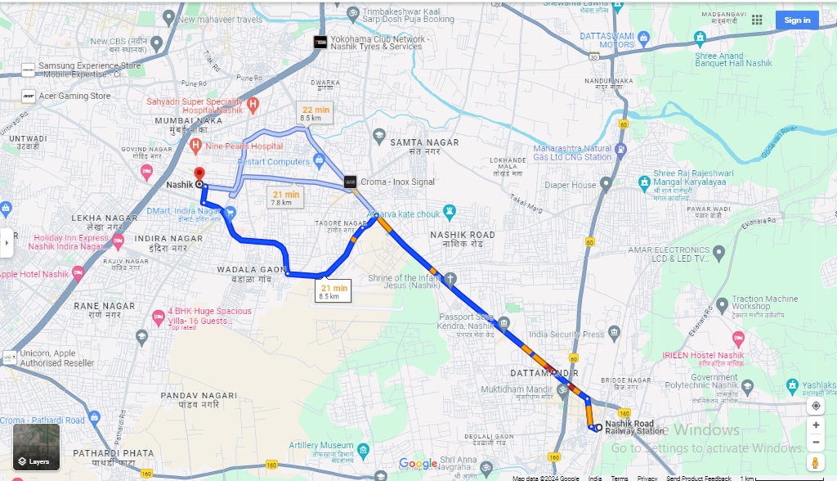

Latitude Longitude: 19°58'48.4"N 73°47'09.8"E
Note: The Blue line shows the route to site from nearest Railway Station (Nashik– 8.5 Km.)
Ready Reckoner Rate
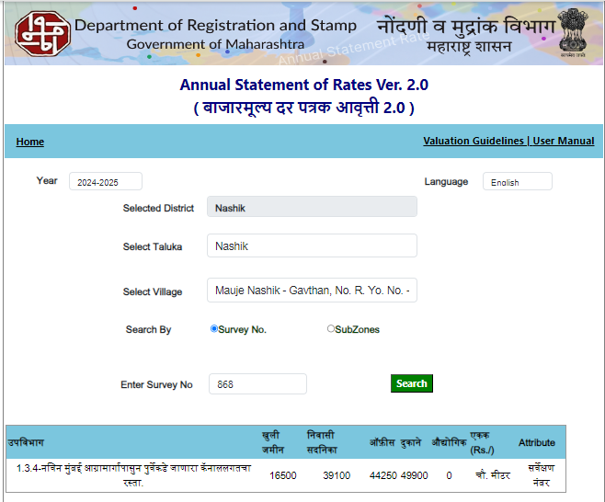

Price Indicators

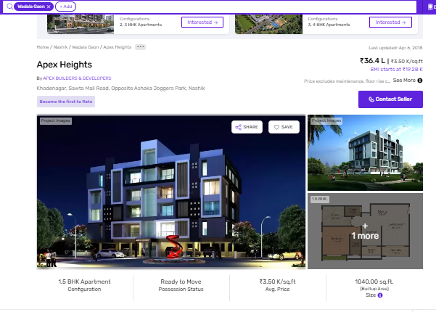

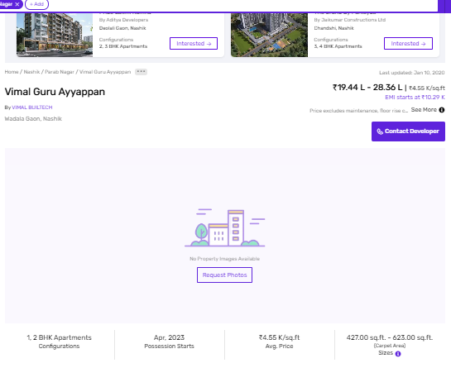

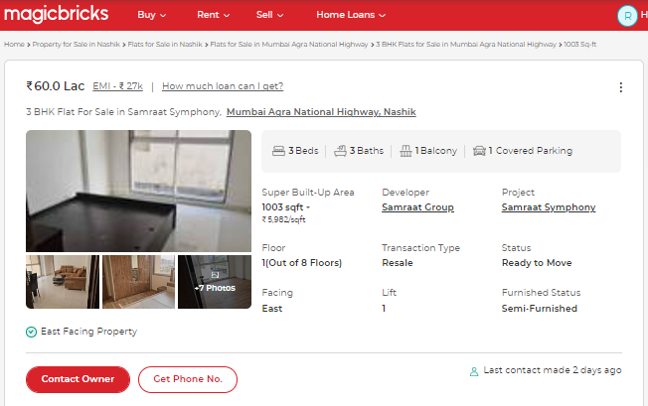
Price Indicators 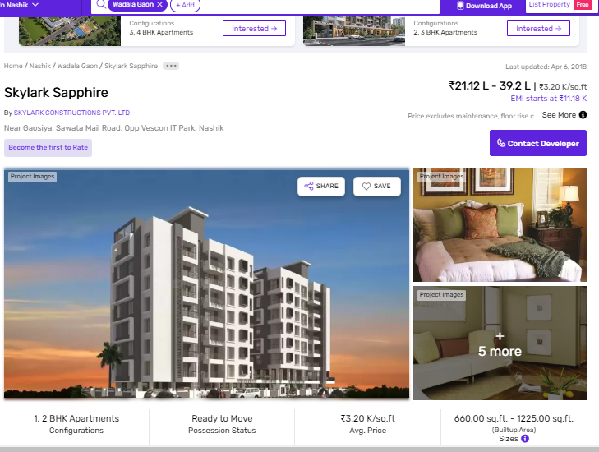
As a result of my appraisal and analysis, it is my considered opinion that the realizable Value of the above
property in the prevailing condition with aforesaid specification is (As per table attached to the report)

Place: Nashik
Date: 12.07.2024

Manoj B. Chalikwar
Registered Valuer
Chartered Engineer (India)
Reg. No. CAT-I-F-1763
SBI Empanelment No.: SME/TCC/2021-22/86/3

The undersigned has inspected the property detailed in the Valuation Report dated _______________________

on ____________________. We are satisfied that the fair and reasonable market value of the property is

`_________________________ (Rupees ________________________________________________________

________________________________________only).

Date
Signature
(Name & Designation of the Inspecting Official/s)

Countersigned
(BRANCH MANAGER)

Enclosures
 | Declaration-cum-undertaking from the valuer (Annexure- I) | Attached
 | Model code of conduct for valuer - (Annexure - II) | Attached
(Annexure-I)

DECLARATION-CUM-UNDERTAKING

I, Manoj Chalikwar son of Shri. Baburao Chalikwar do hereby solemnly affirm and state that:

- I am a citizen of India.

- I will not undertake valuation of any assets in which I have a direct or indirect interest or become so interested at any time during a period of three years prior to my appointment as valuer or three years after the valuation of assets was conducted by me.

- The information furnished in my valuation report dated 12.07.2024 is true and correct to the best of my knowledge and belief and I have made an impartial and true valuation of the property.

- I/ my authorized representative have personally inspected the property on 11.07.2024. The work is not sub - contracted to any other valuer and carried out by myself.

- Valuation report is submitted in the format as prescribed by the bank.

- I have not been depanelled / delisted by any other bank and in case any such depanelment by other banks during my empanelment with you, I will inform you within 3 days of such depanelment.

- I have not been removed / dismissed from service / employment earlier.

- I have not been convicted of any offence and sentenced to a term of imprisonment

- I have not been found guilty of misconduct in my professional capacity.

- I have not been declared to be unsound mind

- I am not an undischarged bankrupt, or has not applied to be adjudicated as a bankrupt;

- I am not an undischarged insolvent.

- I have not been levied a penalty under section 271J of Income-tax Act, 1961 (43 of 1961) and time limit for filing appeal before Commissioner of Income-tax (Appeals) or Income-tax Appellate Tribunal, as the case may be has expired, or such penalty has been confirmed by Income-tax Appellate Tribunal, and five years have not elapsed after levy of such penalty

- I have not been convicted of an offence connected with any proceeding under the Income Tax Act 1961, Wealth Tax Act 1957 or Gift Tax Act 1958 and

- My PAN Card number as applicable is AERPC9086P

- I undertake to keep you informed of any events or happenings which would make me ineligible for empanelment as a valuer

- I have not concealed or suppressed any material information, facts and records and I have made a complete and full disclosure

- I have read the Handbook on Policy, Standards and procedure for Real Estate Valuation, 2011 of the IBA and this report is in conformity to the "Standards" enshrined for valuation in the Part - B of the above handbook to the best of my ability.

- I have read the International Valuation Standards (IVS) and the report submitted to the Bank for the respective asset class is in conformity to the "Standards" as enshrined for valuation in the IVS in "General Standards" and "Asset Standards" as applicable. The valuation report is submitted in the prescribed format of the bank.

- I abide by the Model Code of Conduct for empanelment of valuer in the Bank. (Annexure V - A signed copy of same to be taken and kept along with this declaration)

- I am valuer registered with Insolvency & Bankruptcy Board of India (IBBI)

- My CIBIL Score and credit worthiness is as per Bank's guidelines.

- I am the Director of the company, who is competent to sign this valuation report.

- I will undertake the valuation work on receipt of Letter of Engagement generated from the system (i.e. LLMS / LOS) only.

- Further, I hereby provide the following information.

 | Particulars | Valuer comment
 | Background information of the asset being valued; | The property under consideration was purchased by Sau. Sunita Rajendra Bhavsar.
 | Purpose of valuation and appointing authority | As per request from State Bank of India, Home Loans Sales, Project Approval Cell, Satpur, Nashik to assess fair market value of the property for bank loan purpose.
 | Identity of the Valuer and any other experts involved in the valuation; | Manoj B. Chalikwar – Regd. Valuer  Sanjy Phadol– Regional Technical Head  Sachin Raundal – Valuation Engineer  Chintamani Chaudhari – Technical Officer  Vinita Surve – Processing Manager
 | Disclosure of Valuer interest or conflict, if any; | We have no interest, either direct or indirect, in the property valued. Further to state that we do not have relation or any connection with property owner / applicant directly or indirectly. Further to state that we are an independent Valuer and in no way related to property owner / applicant
 | Date of appointment, valuation date and date of report; | Date of Appointment - 11.07.2024  Valuation Date - 12.07.2024  Date of Report - 12.07.2024
 | Inspections and/or investigations undertaken; | Physical Inspection done on date 11.07.2024
 | Nature and sources of the information used or relied upon; | Market Survey at the time of site visit  Ready Reckoner rates / Circle rates  Online search for Registered Transactions  Online Price Indicators on real estate portals  Enquiries with Real estate consultants  Existing data of Valuation assignments carried out by us
 | Procedures adopted in carrying out the valuation and valuation standards followed; | Sales Comparative Method
 | Restrictions on use of the report, if any; | This valuation is for the use of the party to whom it is addressed and for no other purpose. No responsibility is accepted to any third party who may use or rely on the whole or any part of this valuation. The valuer has no pecuniary interest that would conflict with the proper valuation of the property.
- . | Major factors that were taken into account during the valuation; | Current market conditions, demand and supply position, industrial land size, location, sustained demand for industrial land, all round development of commercial and industrial application in the locality etc.
 | Caveats, limitations and disclaimers to the extent they explain or elucidate the limitations faced by valuer, which shall not be for the purpose of limiting his responsibility for the valuation report. | Attached

Assumptions, Disclaimers, Limitations & Qualifications
Value Subject to Change
The subject appraisal exercise is based on prevailing market dynamics as on 12th July 2024 and does not take into account any unforeseeable developments which could impact the same in the future.
Our Investigations
We are not engaged to carry out all possible investigations in relation to the subject property. Where in our report we identify certain limitations to our investigations, this is to enable the reliant party to instruct further investigations where considered appropriate or where we recommend as necessary prior to reliance. Vastukala Consultants India Pvt. Ltd. (VCIPL) is not liable for any loss occasioned by a decision not to conduct further investigations
Assumptions
Assumptions are a necessary part of undertaking valuations. VCIPL adopts assumptions for the purpose of providing valuation advise because some matters are not capable of accurate calculations or fall outside the scope of our expertise, or out instructions. The reliant party accepts that the valuation contains certain specific assumptions and acknowledge and accept the risk of that if any of the assumptions adopted in the valuation are incorrect, then this may have an effect on the valuation.
Information Supplied by Others
The appraisal is based on the information provided by the client. The same has been assumed to be correct and has been used for appraisal exercise. Where it is stated in the report that another party has supplied information to VCIPL, this information is believed to be reliable but VCIPL can accept no responsibility if this should prove not to be so.
Future Matters
To the extent that the valuation includes any statement as to a future matter, that statement is provided as an estimate and/or opinion based on the information known to VCIPL at the date of this document. VCIPL does not warrant that such statements are accurate or correct.
Map and Plans
Any sketch, plan or map in this report is included to assist the reader while visualising the property and assume no responsibility in connection with such matters.
Site Details
Based on inputs received from Client's representative and site visit conducted, we understand that the subject property is currently a Building Under Construction work is in progress contiguous and non-agricultural land parcel admeasuring as per table attached to the report and in the name Sau. Sunita Rajendra Bhavsar. Further, VCIPL has assumed that the subject property is free from any encroachment and is available as on the date of the appraisal.
Property Title
Based on our discussion with the Client, we understand that the subject property is owned by Sau. Sunita Rajendra Bhavsar. For the purpose of this appraisal exercise, we have assumed that the subject property has a clear title and is free from any encumbrances, disputes and claims. VCIPL has made no further enquiries with the relevant local authorities in this regard and does not certify the property as having a clear and marketable title. Further, no legal advice regarding the title and ownership of the subject property has been obtained for the purpose of this appraisal exercise. It has been assumed that the title deeds are clear and marketable.
Environmental Conditions
We have assumed that the subject property is not contaminated and is not adversely affected by any existing or proposed environmental law and any processes which are carried out on the property are regulated by environmental legislation and are properly licensed by the appropriate authorities.
Town Planning
The permissible land use, zoning, achievable FSI, area statement adopted for purpose of this valuation is based on the information provided by the Client's representative and the same has been adopted for this valuation purpose. VCIPL has assumed the same to be correct and permissible. VCIPL has not validated the same from any authority.
Area
Based on the information provided by the Client's representative, we understand that the subject property is a Building Under Construction work is in progress, contiguous and non-agricultural land parcel admeasuring as per table attached to the report.
Condition & Repair
In the absence of any information to the contrary, we have assumed that there are no abnormal ground conditions, nor archaeological remains present which might adversely affect the current or future occupation, development or value of the property. The property is free from rat, infestation, structural or latent defect. No currently known deleterious or hazardous materials or suspect techniques will be used in the construction of or subsequent alteration or additions to the property and comments made in the property details do not purport to express an opinion about , or advise upon, the condition of uninspected parts and should not be taken as making an implied representation or statement about such parts
Valuation Methodology
For the purpose of this valuation exercise, the valuation methodology used is Direct Comparison Approach Method and proposed Highest and Best Use model is used for analysing development potential.
The Direct Comparison Approach involves a comparison of the property being valued to similar properties that have actually been sold in arms - length transactions or are offered for sale. This approach demonstrates what buyers have historically been willing to pay (and sellers willing to accept) for similar properties in an open and competitive market and is particularly useful in estimating the value of the land and properties that are typically traded on a unit basis.
In case of inadequate recent transaction activity in the subject micro-market, the appraiser would collate details of older transactions. Subsequently, the appraiser would analyse rental / capital value trends in the subject micro-market in order to calculate the percentage increase / decrease in values since the date of the identified transactions. This percentage would then be adopted to project the current value of the same.
Where reliance has been placed upon external sources of information in applying the valuation methodologies, unless otherwise specifically instructed by Client and/or stated in the valuation, VCIPL has not independently verified that information and VCIPL does not advise nor accept it as reliable. The person or entity to whom the report is addressed acknowledges and accepts the risk that if any of the unverified information in the valuation is incorrect, then this may have an effect on the valuation.
Not a Structural Survey
We state that this is a valuation report and not a structural survey
Other
All measurements, areas and ages quoted in our report are approximate
Legal
We have not made any allowances with respect to any existing or proposed local legislation relating to taxation on realization of the sale value of the subject property. VCIPL is not required to give testimony or to appear in court by reason of this appraisal report, with reference to the property in question, unless arrangement has been made thereof. Further, no legal advice on any aspects has been obtained for the purpose of this appraisal exercise
Property specific assumptions
Based on inputs received from the client and site visit conducted, we understand that the subject property is currently Building Under Construction work is in progress, contiguous and non-agricultural land parcel admeasuring area as per table attached to the report.

ASSUMPTIONS, CAVEATS, LIMITATION AND DISCLAIMERS
- We assume no responsibility for matters of legal nature affecting the property appraised or the title thereto, nor do we render our opinion as to the title, which is assumed to be good and marketable.
- The property is valued as though under responsible ownership.
- It is assumed that the property is free of liens and encumbrances.
- It is assumed that there are no hidden or unapparent conditions of the subsoil or structure that would render it more or less valuable. No responsibility is assumed for such conditions or for engineering that might be required to discover such factors.
- There is no direct/ indirect interest in the property valued.
- The rates for valuation of the property are in accordance with the Govt. approved rates and prevailing market rates.

(Annexure - II)

MODEL CODE OF CONDUCT FOR VALUERS

Integrity and Fairness
- A valuer shall, in the conduct of his/its business, follow high standards of integrity and fairness in all his/its dealings with his/its clients and other valuers.
- A valuer shall maintain integrity by being honest, straightforward, and forthright in all professional relationships.
- A valuer shall endeavour to ensure that he/it provides true and adequate information and shall not misrepresent any facts or situations.
- A valuer shall refrain from being involved in any action that would bring disrepute to the profession.
- A valuer shall keep public interest foremost while delivering his services.

Professional Competence and Due Care
- A valuer shall render at all times high standards of service, exercise due diligence, ensure proper care and exercise independent professional judgment.
- A valuer shall carry out professional services in accordance with the relevant technical and professional standards that may be specified from time to time.
- A valuer shall continuously maintain professional knowledge and skill to provide competent professional service based on up-to-date developments in practice, prevailing regulations / guidelines and techniques.
- In the preparation of a valuation report, the valuer shall not disclaim liability for his/its expertise or deny his/its duty of care, except to the extent that the assumptions are based on statements of fact provided by the company or its auditors or consultants or information available in public domain and not generated by the valuer.
- A valuer shall not carry out any instruction of the client insofar as they are incompatible with the requirements of integrity, objectivity and independence.
- A valuer shall clearly state to his client the services that he would be competent to provide and the services for which he would be relying on other valuers or professionals or for which the client can have a separate arrangement with other valuers.

Independence and Disclosure of Interest
- A valuer shall act with objectivity in his/its professional dealings by ensuring that his/its decisions are made without the presence of any bias, conflict of interest, coercion, or undue influence of any party, whether directly connected to the valuation assignment or not.
- A valuer shall not take up an assignment if he/it or any of his/its relatives or associates is not independent in terms of association to the company.
- A valuer shall maintain complete independence in his/its professional relationships and shall conduct the valuation independent of external influences.
- A valuer shall wherever necessary disclose to the clients, possible sources of conflicts of duties and interests, while providing unbiased services.
- A valuer shall not deal in securities of any subject company after any time when he/it first becomes aware of the possibility of his / its association with the valuation, and in accordance with the Securities and Exchange Board of India (Prohibition of Insider Trading)Regulations,2015 or till the time the valuation report becomes public, whichever is earlier.
- A valuer shall not indulge in "mandate snatching" or offering "convenience valuations" in order to cater to a company or client's needs.
- As an independent valuer, the valuer shall not charge success fee.
- In any fairness opinion or independent expert opinion submitted by a valuer, if there has been a prior engagement in an unconnected transaction, the valuer shall declare the association with the company during the last five years.
Confidentiality
- A valuer shall not use or divulge to other clients or any other party any confidential information about the subject company, which has come to his / its knowledge without proper and specific authority or unless there is a legal or professional right or duty to disclose.
Information Management
- A valuer shall ensure that he/ it maintains written contemporaneous records for any decision taken, the reasons for taking the decision, and the information and evidence in support of such decision. This shall be maintained so as to sufficiently enable a reasonable person to take a view on the appropriateness of his /its decisions and actions.
- A valuer shall appear, co-operate and be available for inspections and investigations carried out by the authority, any person authorised by the authority, the registered valuers organisation with which he/it is registered or any other statutory regulatory body.
- A valuer shall provide all information and records as may be required by the authority, the Tribunal, Appellate Tribunal, the registered valuers organisation with which he/it is registered, or any other statutory regulatory body.
- A valuer while respecting the confidentiality of information acquired during the course of performing professional services, shall maintain proper working papers for a period of three years or such longer period as required in its contract for a specific valuation, for production before a regulatory authority or for a peer review. In the event of a pending case before the Tribunal or Appellate Tribunal, the record shall be maintained till the disposal of the case.
Gifts and hospitality:

- A valuer or his / its relative shall not accept gifts or hospitality which undermines or affects his independence as a valuer.
Explanation: For the purposes of this code the term 'relative' shall have the same meaning as defined in clause (77) of Section 2 of the Companies Act, 2013 (18 of 2013).
- A valuer shall not offer gifts or hospitality or a financial or any other advantage to a public servant or any other person with a view to obtain or retain work for himself / itself, or to obtain or retain an advantage in the conduct of profession for himself / itself.

Remuneration and Costs.
- A valuer shall provide services for remuneration which is charged in a transparent manner, is a reasonable reflection of the work necessarily and properly undertaken, and is not inconsistent with the applicable rules.
- A valuer shall not accept any fees or charges other than those which are disclosed in a written contract with the person to whom he would be rendering service.
Occupation, employability and restrictions.

- A valuer shall refrain from accepting too many assignments, if he/it is unlikely to be able to devote adequate time to each of his/ its assignments.
- A valuer shall not conduct business which in the opinion of the authority or the registered valuer organisation discredits the profession.
Miscellaneous
- A valuer shall refrain from undertaking to review the work of another valuer of the same client except under written orders from the bank or housing finance institutions and with knowledge of the concerned valuer.
- A valuer shall follow this code as amended or revised from time to time.

Manoj B. Chalikwar
Registered Valuer
Chartered Engineer (India)
Reg. No. CAT-I-F-1763
SBI Empanelment No.: SME/TCC/2021-22/86/3

