Vastu/DRT/Mumbai/07/2024/9888/2307480

29/25-484-PY

Date: 29.07.2024

To,

Debts Recovery Tribunal No-II, Mumbai,

MTNL Bhavan, 3rd Floor, Strand Road, Apollo Bandar,

Badhwar Park, Colaba Market, Colaba, Mumbai 400 005.

**Ref.:** Your Letter for Valuation of Immovable Property in the Matter of N K Jewellers & Ors.

Recovery Proceeding No: 7/2023

**Sub:** Site Visit Report dated 15 July 2024.

Dear Sir,

This is in reference to your work order & Telephonic conversation with Mr. Nilesh Desai (Recovery Manager HDFC Bank) for Valuation of Flat No. A/1201, 12th floor, Brookhill Tower, Swami Samarth Nagar, Oshiwara, Andheri (W), Mumbai 400102.

**Date of Site Visit:** 15/07/2024 at 2.00 P.M.

**In the presence of:**

Mr. Nilesh Desai (HDFC Bank)

Mr. Umang Patel (Valuer), Mr. Prayush Parekh, Mr. Saiprasad & Mrs. Bhavika Chavan all representing Vastukala Consultants (I) Pvt. Ltd.

We visited the premises and found at the time of visit the property was occupied by **Mishra Family.** On inquiry it was found that Mishar’s have purchased the property from Bank about 4-5 years back. We have inquired with Mr. Kamat (Society Manager) and the same was also confirmed by him valid Email.

*(We would like to inform you that as per the records available with the society the said Flat A/1201 has been sold to Mr. Sanjay Mishra by Bank of Baroda who had taken possession of the said flat under the Securitisation and Reconstruction of Financial assets and Enforcement of Security Interest 28{Act}, 2002. and acquired by Mr. Sanjay Mishra vide Sale Agreement entered on 06.05.2019.)*

Hence as per preliminary survey it is found that the property was not in the name of N K Jewellers & Ors. Hence no valuation was carried out.

This is for your information & Necessary action.

For Vastukala Consultants (I) Pvt. Ltd.

## Sharadkumar B. Chalikwar

Govt. Reg. Valuer

Chartered Engineer (India)

Reg. No. (N) CCIT/1-14/52/2008-09

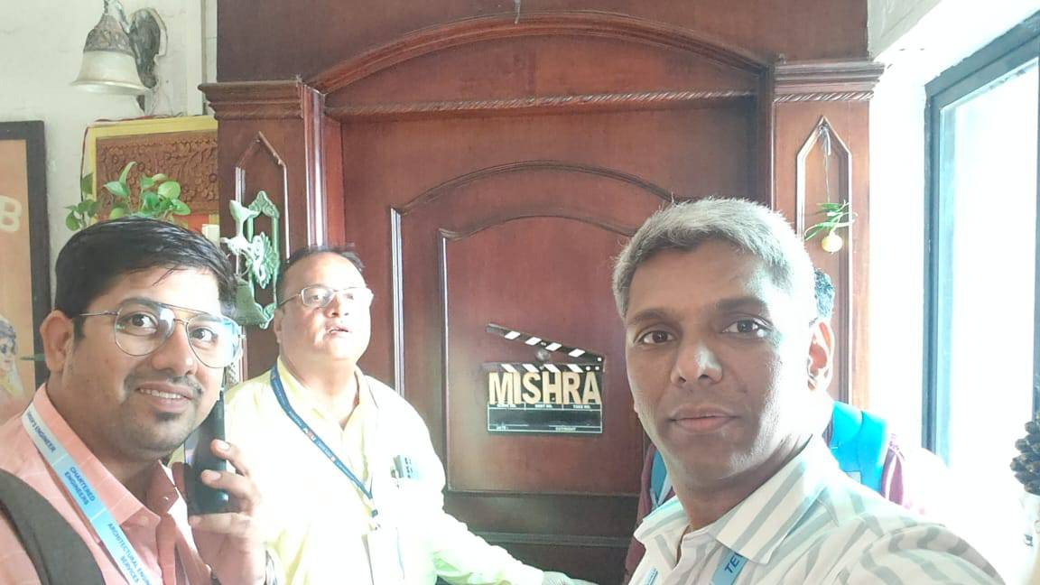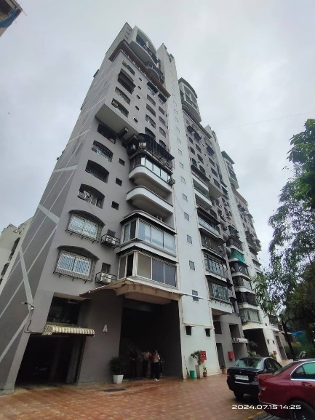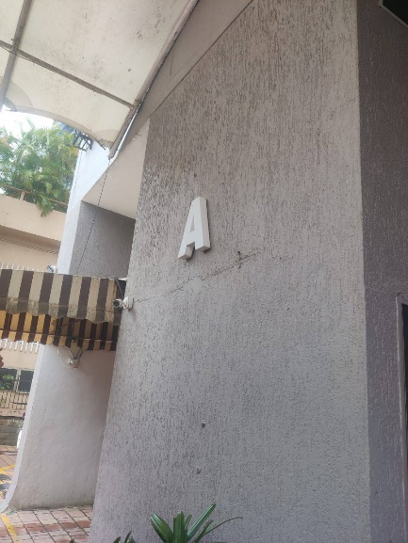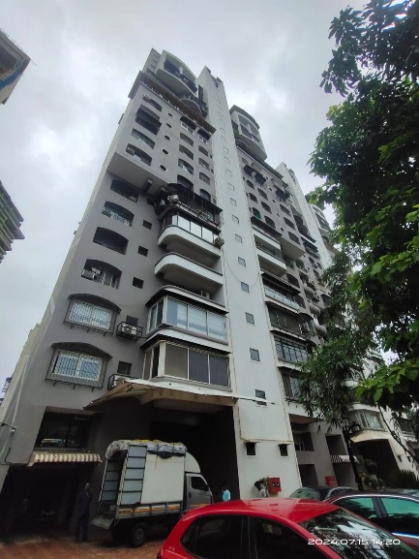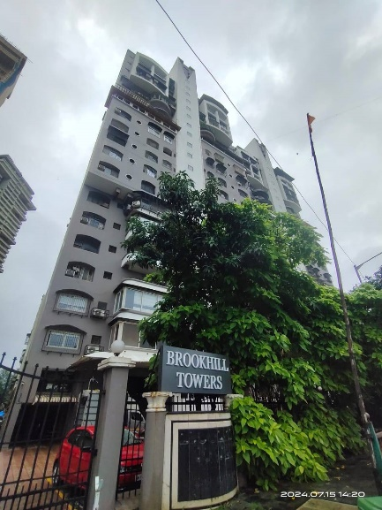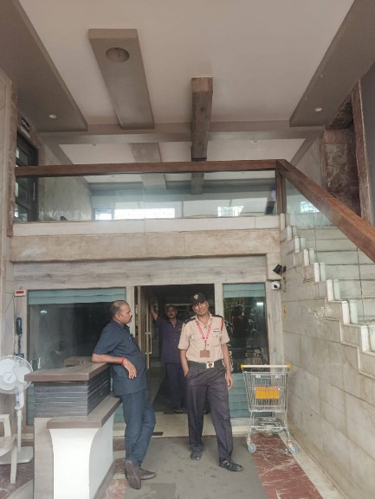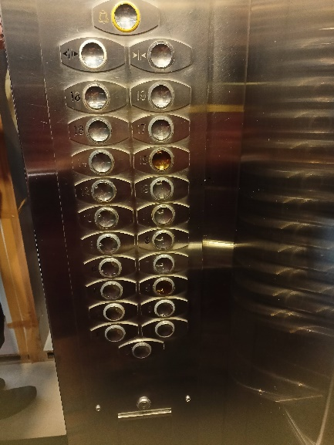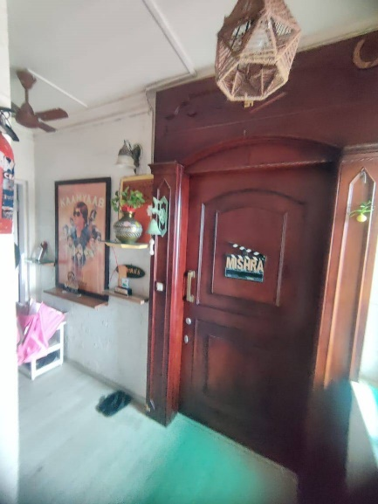**ACTUAL SITE PHOTOGRAPH**