Valuation Report of the Immovable Property

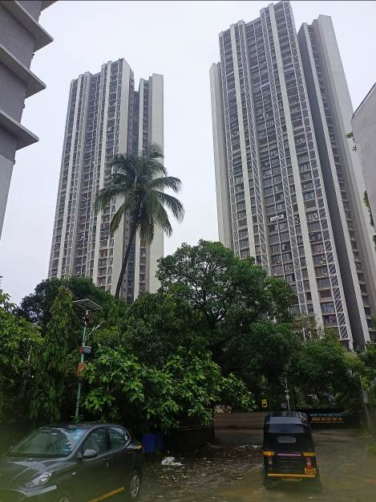

Details of the property under consideration:

Name of Client: Mr. Rahul Ramchandra Bijai & Mrs. Shreya R. Bijai

Residential Flat No. 2106, 21st Floor, "Oasis – Tower 2", Off. Akurli Road, Near Mahindra & Mahindra Gate No.1, Kandivali (East), Mumbai - 400101, State – Maharashtra, Country – India

Latitude Longitude: 19°12'00.8"N 72°52'04.6"E

Intended User:

Mr. Rahul Ramchandra Bijai & Mrs. Shreya R. Bijai

Vastu/Mumbai/07/2024/23100/39302
19/11-275-VSM
Date: 19.02.2022

VALUATION OPINION REPORT

This is to certify that the property bearing Residential Flat No. 2106, 21st Floor, "Oasis – Tower 2", Off. Akurli Road, Near Mahindra & Mahindra Gate No.1, Kandivali (East), Mumbai - 400101, State – Maharashtra, Country – India belongs to Mr. Rahul Ramchandra Bijai & Mrs. Shreya R. Bijai.
Boundaries of the property.

North | : | Open Plot / Mahindra Group
South | : | Open Plot
East | : | Tower 2 / Parking
West | : | Road & Slum
Considering various parameters recorded, existing economic scenario, and the information that is available with reference to the development of neighborhood and method selected for valuation, we are of the opinion that, the property premises can be assessed for Government Ready Reckoner Value in the year 2011 at ` 87,55,390.00 (Rupees Eighty Seven Lakh Fifty Five Thousand Three Hundred Ninety Only).

The valuation of the property is based on the documents produced by the concern. Legal aspects have not been taken into considerations while preparing this valuation report.

Hence certified

For Vastukala Architects & Engineers

Manoj B. Chalikwar
Registered Valuer
Chartered Engineer (India)
Reg. No. CAT-I-F-1763
Encl: Valuation report.

Vastukala Consultants (I) Pvt. Ltd.
B1-001, U/B Floor, Boomerang, Chandivali Farm Road, Andheri (E), Mumbai - 400 072

VALUATION REPORT (IN RESPECT OF FLAT)
I | General
1. | Purpose for which the valuation is made |  |  | : | To assess Government Ready Reckoner Value as on date of allotment letter ( i.e. 09.05.2011)
2. | a) | Date of inspection |  | : | 11.07.2024
 | b) | Date on which the valuation is Made |  | :
3. | List of documents produced for perusal:  - Copy of Agreement dated 21.03.2016 between ACME Housing India Private Limited (Promoter) & Mr. Rahul Ramchandra Bijai & Mrs. Shreya R. Bijai (Purchasers)  - Copy of Commencement Certificate No. CHE / A – 4566 / BP (WS) / Ar dated 13.04.2010 issued by MCGM.  - Copy of Earnest Money Receipt Cum Allotment Letter No. OASIS / T – 2 / 2106 dated 09.05.2011 issued by ACME Housing India Pvt. Ltd. (Builder / Promoter)  - Copy of Letter dated 16.04.2011 issued by ACME Housing India Pvt. Ltd. (Builder / Promoter) for Delay in completion of the project Oasis
4. | Name of the owner(s) and his / their address (es) with Phone no. (details of share of each owner in case of joint ownership) |  |  | : | Mr. Rahul Ramchandra Bijai & Mrs. Shreya R. Bijai  Address: Residential Flat No. 2106, 21st Floor, "Oasis – Tower 2", Off. Akurli Road, Near Mahindra & Mahindra Gate No.1, Kandivali (East), Mumbai - 400101, State – Maharashtra, Country – India  Contact Person:  Mr. Ishwar (Agent)  Mobile No.: 98216 11086  Joint ownership  Details of share of each owner is not available.
5. | Brief description of the property (Including Leasehold / freehold etc.) |  |  | : | The property is a Residential Flat is located on 21st Floor. The composition of Flat is 2 Bedrooms + Living + Kitchen + 2 Toilets (2 BHK + 2 Toilets). The property is at 3.7 Km. travelling distance from nearest Railway station Kandivali.  The building was under construction in the year 2011.
6. | Location of property |  |  | :
 | a) |  | Plot No. / Survey No. | : | CTS No. 170, S. No. 16 (Part) & 19 (Part)
 | b) |  | Door No. | : | Residential Flat No. 2106
 | c) |  | C.T.S. No. / Village | : | Village – Akurli
 | d) |  | Ward / Taluka | : | Taluka – Borivali
 | e) |  | Mandal / District | : | District – Mumbai
 | f) |  | Date of issue and validity of layout of approved map / plan | : | Copy of Approved Building plans were not provided and not verified.
 | g) |  | Approved map / plan issuing authority | :
 | h) |  | Whether genuineness or authenticity of approved map/ plan is verified | : | N.A.
 | i) |  | Any other comments by our empanelled valuers on authentic of approved plan |  | N.A.
7. | Postal address of the property |  |  | : | Residential Flat No. 2106, 21st Floor, "Oasis – Tower 2", Off. Akurli Road, Near Mahindra & Mahindra Gate No.1, Kandivali (East), Mumbai - 400101, State – Maharashtra, Country – India
8. | City / Town |  |  | : | Mumbai
 | Residential area |  |  | : | Yes
 | Commercial area |  |  | : | No
 | Industrial area |  |  | : | No
9. | Classification of the area |  |  | :
 | i) High / Middle / Poor |  |  | : | Middle Class
 | ii) Urban / Semi Urban / Rural |  |  | : | Urban
10. | Coming under Corporation limit / Village Panchayat / Municipality |  |  | : | Village – Akurli  Municipal Corporation of Greater Mumbai
11. | Whether covered under any State / Central Govt. enactments (e.g., Urban Land Ceiling Act) or notified under agency area/ scheduled area / cantonment area |  |  | : | No
12. | Boundaries of the property |  |  |  | As per Site | As per documents
 | North |  |  | : | Open Plot / Mahindra Group | 18.30 Mts. W Akurli Road
 | South |  |  | : | Open Plot | ADJ C.T.S. No. 181
 | East |  |  | : | Tower 2 / Parking | ADJ C.T.S. No. 171/1A
 | West |  |  | : | Road & Slum | 9 Mts. W Balaji Industrial Road
13 | Dimensions of the site |  |  |  | N. A. as property under consideration is a flat in an apartment building.
 |  |  |  |  | A As per the Deed |  | B Actuals
 | North |  |  | : | - |  | -
 | South |  |  | : | - |  | -
 | East |  |  | : | - |  | -
 | West |  |  | : | - |  | -
14. | Extent of the site |  |  | : | Carpet Area = 946.00 Sq. Ft.  (Area as per Agreement for sale)  Built up area = 1,135.00 Sq. Ft.  (Area as per Agreement for sale)
14.1 | Latitude, Longitude & Co-ordinates of flat |  |  | : | 19°12'00.8"N 72°52'04.6"E
15. | Extent of the site considered for Valuation (least of 13A& 13B) |  |  | : | Built up area = 1,135.00 Sq. Ft.  (Area as per Agreement for sale)
16 | Whether occupied by the owner / tenant? If occupied by tenant since how long? Rent received per month. |  |  | : | Under construction as on 2011
II | APARTMENT BUILDING
 | Nature of the Apartment |  |  | : | Residential
 | Location |  |  | :
 | C.T.S. No. |  |  | : | CTS No. 170, S. No. 16 (Part) & 19 (Part)
 | Block No. |  |  | : | -
 | Ward No. |  |  | : | -
 | Village / Municipality / Corporation |  |  | : | Village – Akurli  Municipal Corporation of Greater Mumbai
 | Door No., Street or Road (Pin Code) |  |  | : | Residential Flat No. 2106, 21st Floor, "Oasis – Tower 2", Off. Akurli Road, Near Mahindra & Mahindra Gate No.1, Kandivali (East), Mumbai - 400101, State – Maharashtra, Country – India
 | Description of the locality Residential / Commercial / Mixed |  |  | : | Residential
 | Year of Construction |  |  | : | Building work was started in the year 2010 & completed in the year 2020 (As per site information)
 | Number of Floors |  |  | : | Stilt + 3 Podium + 1 to 36 upper floors
 | Type of Structure |  |  | : | R.C.C. Framed Structure
 | Number of Dwelling units in the building |  |  | : | 6 Flats on 11th Floor
 | Quality of Construction |  |  | : | Good
 | Appearance of the Building |  |  | : | Good
 | Maintenance of the Building |  |  | : | Good
 | Facilities Available |  |  | :
 | Lift |  |  | : | 4 Lifts
 | Protected Water Supply |  |  | : | Municipal Water supply
 | Underground Sewerage |  |  | : | Connected to Municipal Sewerage System
 | Car parking - Open / Covered |  |  | : | Podium & Stilt Car Parking
 | Is Compound wall existing? |  |  | : | Yes
 | Is pavement laid around the building |  |  | : | Yes

III | FLAT
1 | The floor in which the flat is situated | : | 21st Floor
2 | Door No. of the flat | : | Residential Flat No. 2106
3 | Specifications of the flat | :
 | Roof | : | R.C.C. Slab
 | Flooring | : | Vitrified flooring
 | Doors | : | Teak Wood door frame with Flush doors
 | Windows | : | Alluminum sliding windows and wooden framed openable windows with MS grills.
 | Fittings | : | Concealed plumbing with C.P. fittings. Electrical wiring with Concealed.
 | Finishing | : | Cement Plastering
4 | House Tax | :
 | Assessment No. | : | Details not available
 | Tax paid in the name of: | : | Details not available
 | Tax amount: | : | Details not available
5 | Electricity Service connection No.: | : | Details not available
 | Meter Card is in the name of: | : | Details not available
6 | How is the maintenance of the flat? | : | Good
7 | Sale Deed executed in the name of | : | Mr. Rahul Ramchandra Bijai & Mrs. Shreya R. Bijai
8 | What is the undivided area of land as per Sale Deed? | : | Details not available
9 | What is the plinth area of the flat? | : | Built up area = 1,135.00 Sq. Ft.  (Area as per Agreement for sale)
10 | What is the floor space index (app.) | : | As per Local norms
11 | What is the Carpet Area of the flat? | : | Carpet Area = 946.00 Sq. Ft.  (Area as per Agreement for sale)
12 | Is it Posh / I Class / Medium / Ordinary? | : | Middle Class
13 | Is it being used for Residential or Commercial purpose? | : | Residential purpose
14 | Is it Owner-occupied or let out? | : | Under construction as on 2011
15 | If rented, what is the monthly rent? | : | Not Applicable as building was under construction in the year 2011
IV | MARKETABILITY | :
1 | How is the marketability? | : | Poor in the year 2011 - 2014 as Construction was stop in between.
2 | What are the factors favouring for an extra Potential Value? | : | Located in developed area
3 | Any negative factors are observed which affect the market value in general? | : | Construction was stop in between.
V | Rate | :
3 | Break – up for the rate | :
 | I. Cost of Construction in the year 2011 | : | ` 15,000.00 per Sq. M. i.e. ` 1,394.00 per Sq. Ft.
 | II. Rate in the year 2011 | : | ` 72,200.00 per Sq. M. i.e. ` 6,708.00 per Sq. Ft.  As per Ready Reckoner 2011  Flats on 21st floors to 30th floors increase by 15%  Rate considered = ` 7,714.00
5 | Age of the building as on 2014 | : | Under Construction
6 | Life of the building estimated | : | 60 years on completion of building, Subject to proper, preventive periodic maintenance & structural repairs.
7 | Remarks | :

GOVERNMENT READY RECKONER VALUE IN THE YEAR 2011

Sr. No. | Description | Qty. | Rate per  Unit (`) | Estimated  Value (`)
1 | Guideline value of the Flat | 1,135.00 Sq. Ft. | 7,714.00 | 87,55,390.00

Actual site photographs (As on date of visit)
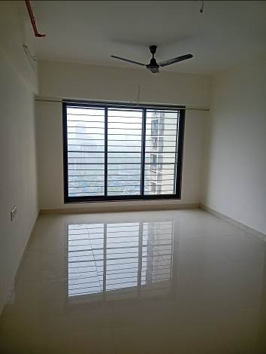
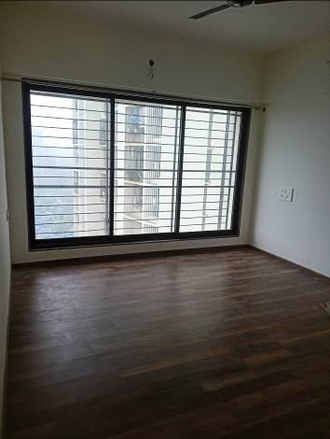
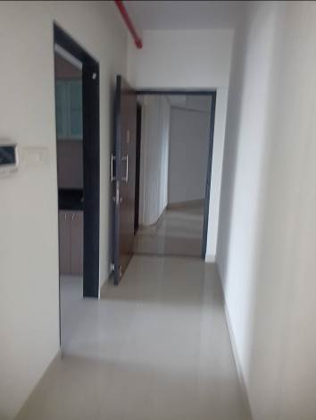
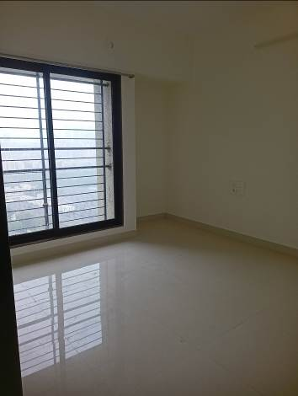
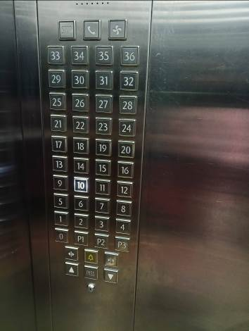
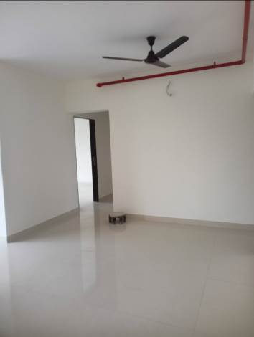
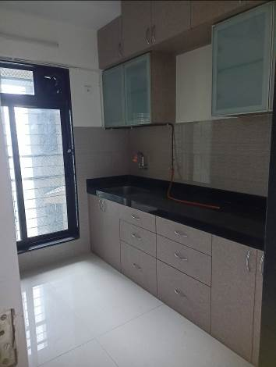
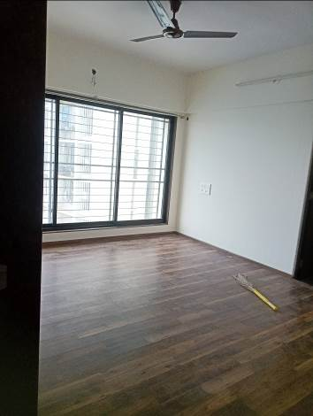

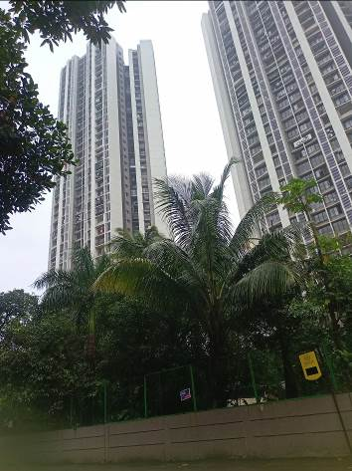
Route Map of the property
Site u/r
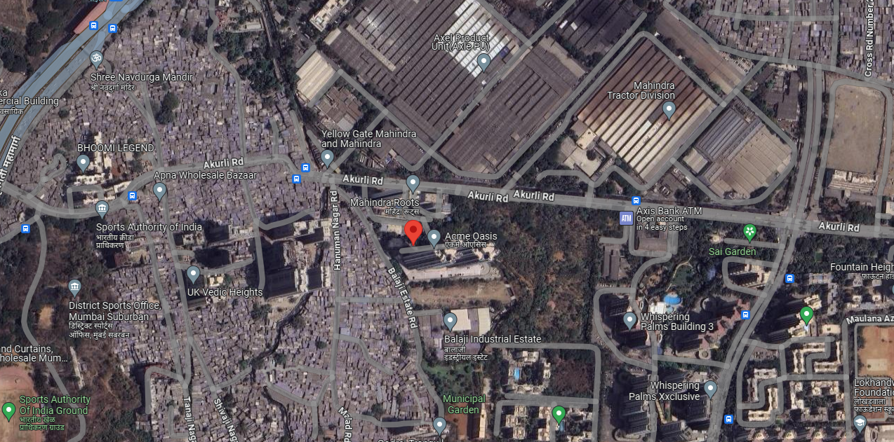

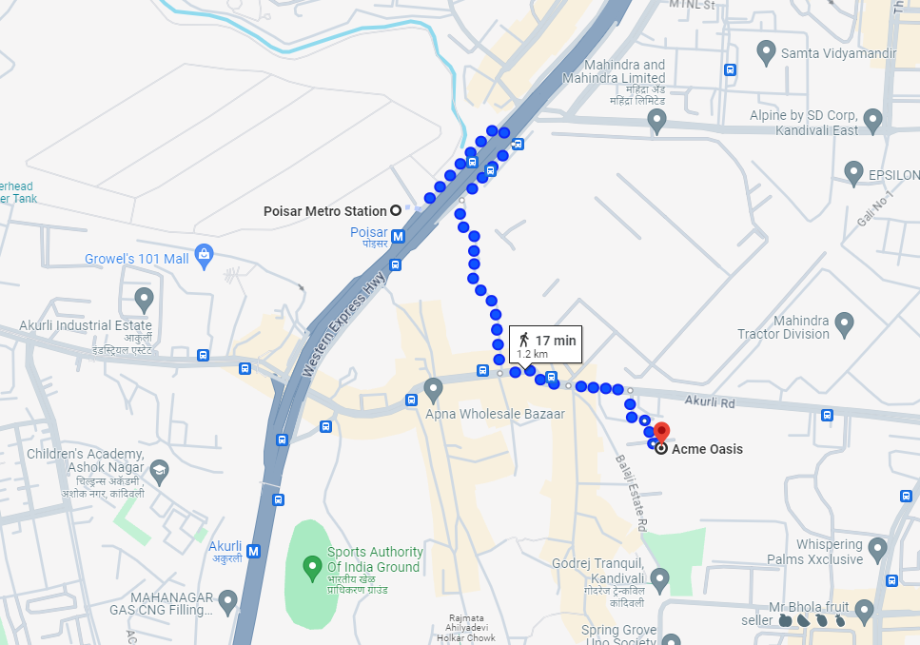



Latitude Longitude: 19°12'00.2"N 72°52'06.2"E

Note: The Blue line shows the route to site from nearest Metro station (Poisar –Km.)
Ready Reckoner Rate – 2011
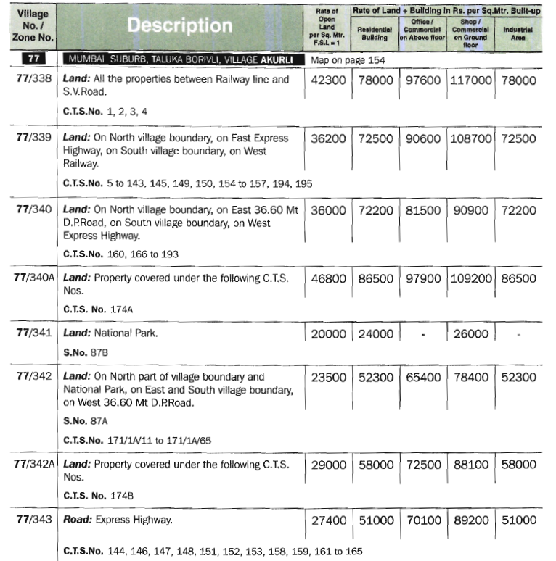

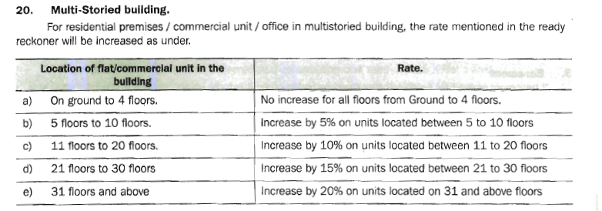

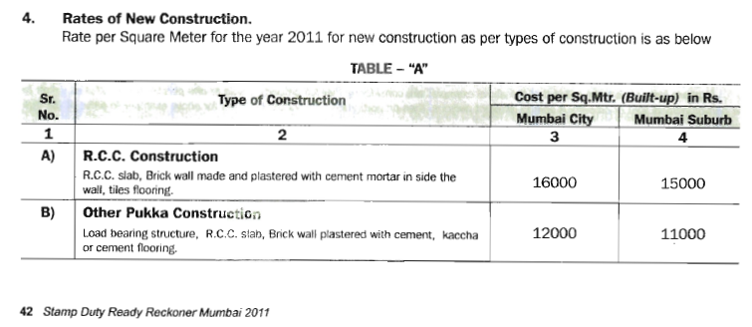

NOTES
- I, Manoj B. Chalikwar with my experience and ability to judgment I am of the considered opinion that the Government value of the property is ` 87,55,390.00 (Rupees Eighty Seven Lakh Fifty Five Thousand Three Hundred Ninety Only) in the year 2011. Value varies with time and purpose and hence this value should not be referred for any purpose other than mentioned in this report.

- This valuation is done on the basis of information, which the valuer has obtained by information provided by the client about the premises and location of the surrounding area and also prevailing rates in the surrounding area, and further subject to document as mentioned in valuation report.

- This valuer should not be held responsible for authentication of documents, clear title and other such related matters. For that purpose Latest Legal Opinion should be sought.

For Vastukala Architects & Engineers

Manoj B. Chalikwar
Registered Valuer
Chartered Engineer (India)

Reg. No. CAT-I-F-1763

