Vastu/Nashik/07/2024/009775/2307110
06/13-114-CCRJ
Date: 11.07.2024

To,
The Branch Manager,
Union Bank of India
Mumbai Naka Branch
Ground Floor of Dr. Torane Hospital Opp. Suyash Hospital
Ahilyabai Holkar Marg, Behind Mahamarg Bus Stand, Mumbai Naka,
Nashik - 422 001, State – Maharashtra, Country – India.

Sub: Vetting of Extra Amenities

Sir,

With reference to above subject, we have evaluated the Extra Amenities for Residential Land and Bungalow on Plot No.33, Ground + First Floor, Survey No.74A/1 Behind Chagan Bhujbal Office, Aurangabad Nashik Highway, At-Angangaon , Taluka- Yeola , District - Nashik, PIN Code – 423 401,State – Maharashtra, Country – India belongs to Sau.Sunita Sanjay Kulkarni.

We have verified the rates quoted as per current market rates. Details of Extra Amenities considered as per copy of Extra Amenities Agreement between Mrs.Sunita Sanjay Kulkarni. (First Party). Miss.Sharada Prasad Joshi (Second Party) received on dated.03.07.2024. The Extra Amenities amount is Rs. 5,00,000/- (Rupees Five Lakh Only)

The said Cost Vetting Certificate is valid upto next 6 months Only.

Thanking you

Sincerely yours

Sharadkumar B. Chalikwar
Govt. Reg. Valuer
Chartered Engineer (India)
Reg. No. (N) CCIT/1-14/52/2008-09
Encl: Valuation report..

Agreement for Extra Amenities
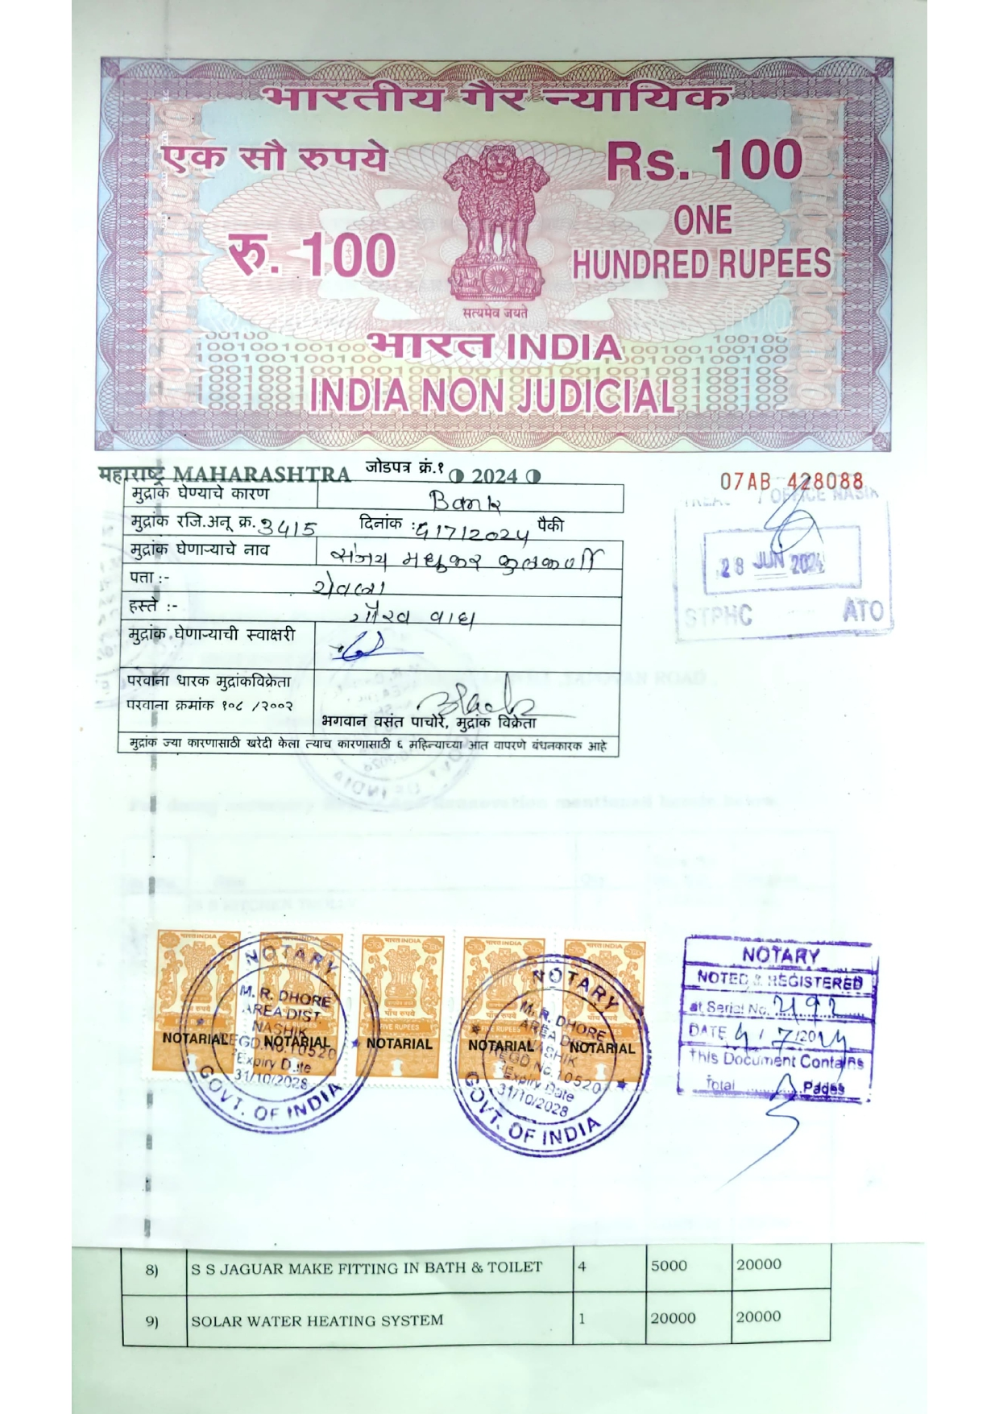
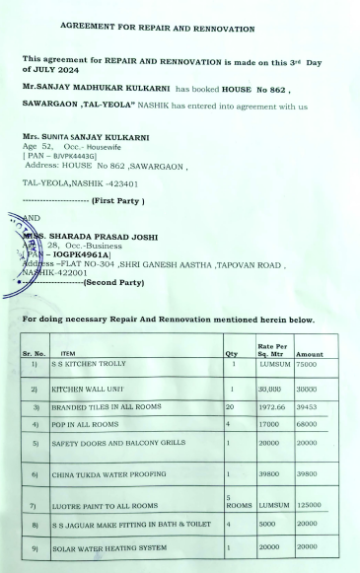

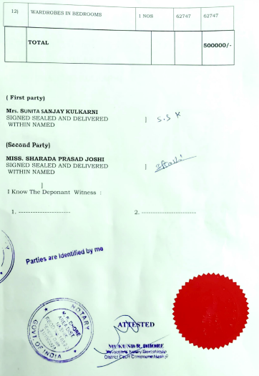

The Extra Amenities amount is Rs. 5,00,000/- (Rupees Five Lakh Only)

