Vastu/Nashik/07/2024/009859/2307169
11/7-173-CCBS
Date: 11.07.2024

To,
The Branch Manager,
Bank of Baroda
Regional Office
BSNL Building, Datta Mandir Road, Nashik Road,
Nashik, PIN – 422 101, State - Maharashtra, Country - India.

Sub: Vetting of Extra Amenities

Sir,

With reference to above subject, we have evaluated the Extra Amenities for Residential Row House No.4, Ground + First Floor “Kartiki Villa-2”, Survey No.980/1+2+5+9 (1237), Plot No.101, Near Vijay Laundry, Devi Road, Village - Sinnar , Taluka- Sinnar, District - Nashik, PIN Code – 422 113, State – Maharashtra, Country – India. belongs to Shri.Nilesh Vishnu Mohite Name of Proposed Purchaser: Sau.Suvarna Bharat Borse.

We have verified the rates quoted as per current market rates. Details of Extra Amenities considered as per copy of Extra Amenities Agreement between Sau.Suvarna Bharat Borse. (First Party). Shri.Deepak Prabhakar Dhurjad (Second Party) received on dated.09.07.2024. The Extra Amenities amount is Rs. 5,00,000/- (Rupees Five Lakh Only)

The said Cost Vetting Certificate is valid upto next 6 months Only.

Thanking you

Sincerely yours

Manoj B. Chalikwar
Registered Valuer
Chartered Engineer (India)
Reg. No. CAT-I-F-1763
Reg. No. IBBI/RV/07/2018/10366
BOB Empanelment No.: ZO:MZ:ADV:46:941
Encl: Valuation report.

Agreement for Extra Amenities
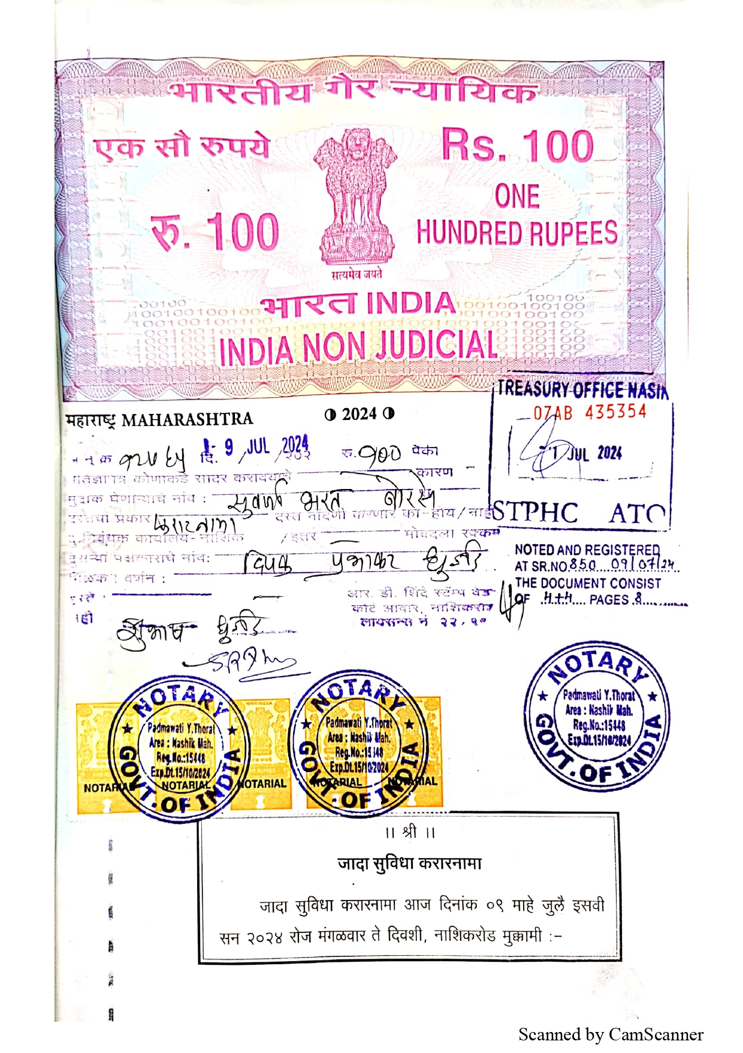
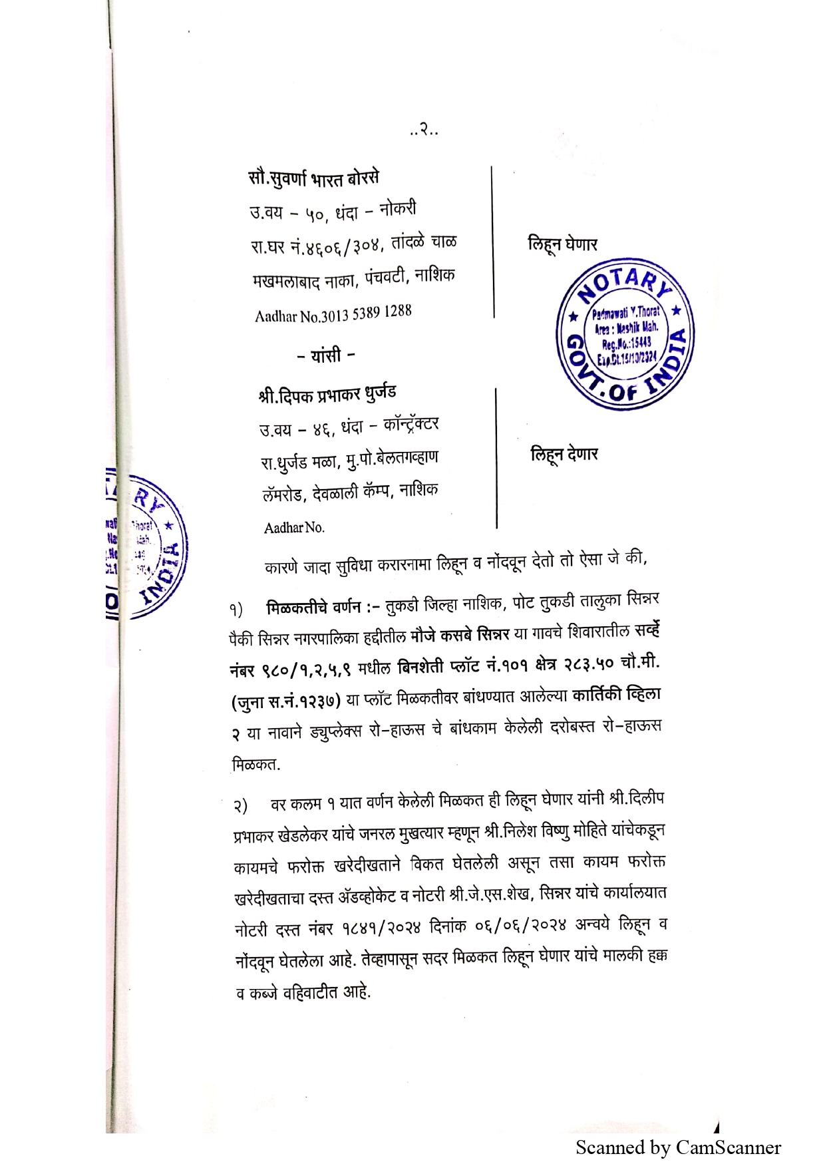

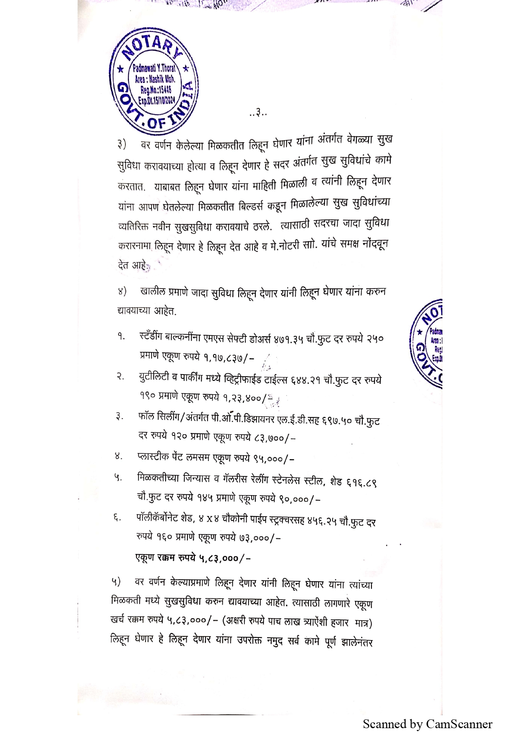
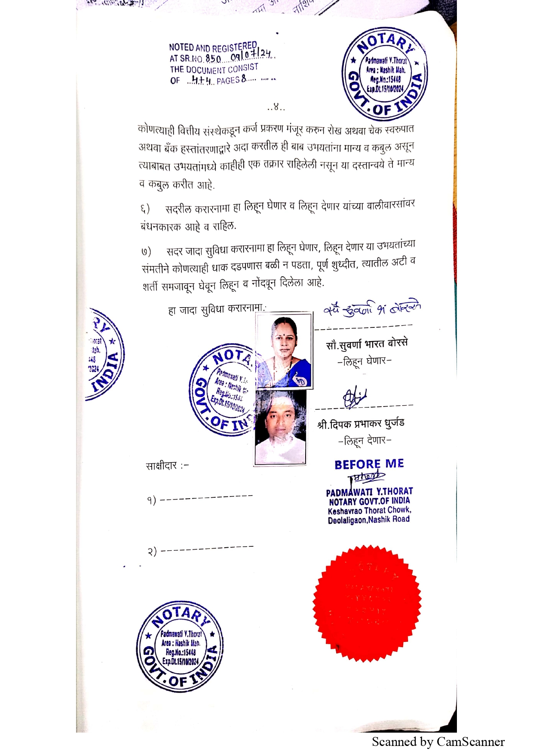

The Extra Amenities amount is Rs. 5,00,000/- (Rupees Five Lakh Only)

