Vastu/Nashik/07/2024/009827/2307145
10/1-149 -CCBS
Date: 10.07.2024

To,
The Branch Manager,
Bank of Baroda
Dwarka Circle Branch
Time Square Building, Dwarka Circle,
Nashik, PIN – 422 011, State - Maharashtra, Country - India.
.

Sub: Vetting of Extra Amenities Estimate

Sir,

With reference to above subject, we have evaluated the Extra Amenities Estimate for Residential Flat No.4, “Krushna Audumbar Apartment”, Charwak Chowk, Indira Nagar, Village – Nashik, Taluka & District - Nashik, PIN Code – 422 009, State – Maharashtra, Country – India belongs to Mr.Sachin Gajanan Ghodke

We have verified the rates quoted as per current market rates. Details of Extra Amenities Estimate considered as per copy of Extra Amenities Estimate Provided by Pallavi Rahul Joshi received on dated.06.07.2024. The Extra Amenities amount is Rs. 14,00,000/- (Rupees Fourteen Lakh Only)

The said Cost Vetting Certificate is valid upto next 6 months Only.

Thanking you

Sincerely yours

Manoj B. Chalikwar
Registered Valuer
Chartered Engineer (India)
Reg. No. CAT-I-F-1763
Reg. No. IBBI/RV/07/2018/10366
BOB Empanelment No.: ZO:MZ:ADV:46:941
Encl: Valuation report.

Agreement for Extra Amenities Estimate
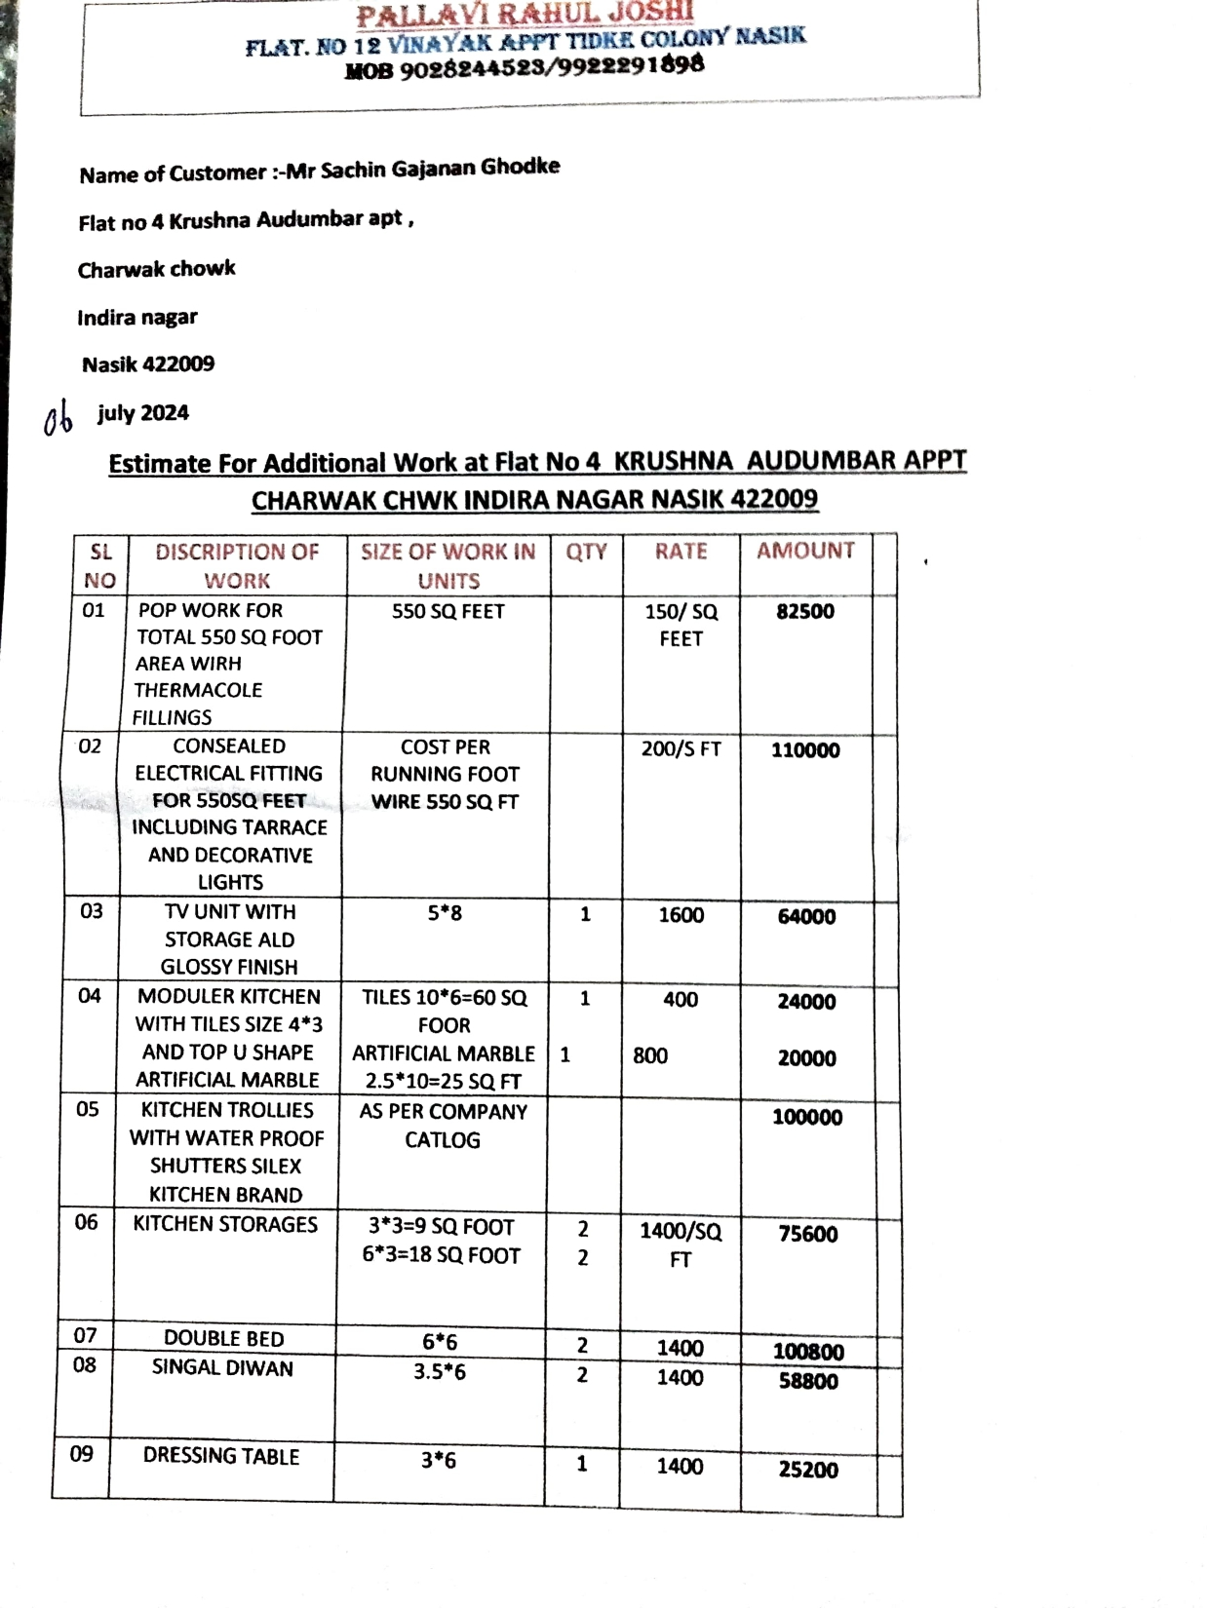
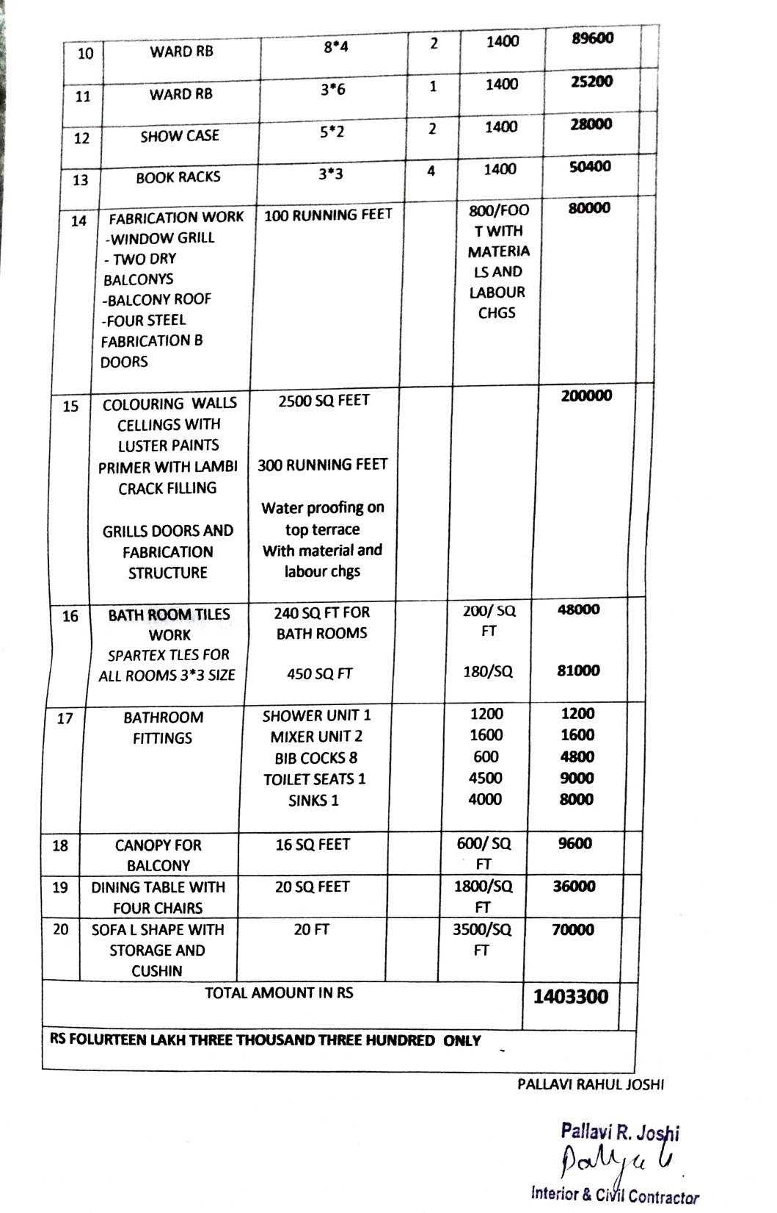

The Extra Amenities Estimate amount is Rs. 14,00,000/- (Rupees Fourteen Lakh Only)

