Vastu/Nashik/05/2024/009012/2306523
30/12-383-CCBS
Date: 08.07.2024

To,
The Branch Manager,
State Bank of India
Maharashtra Eng. Research Institute Branch
Dindori Road, MERI, Nashik, Maharashtra, Nashik - 422004,
State - Maharashtra, Country - lndia

Sub: Vetting of Extra Work

Sir,

With reference to above subject, we have evaluated the Extra Amenities for Residential Row Bungalow No.1, Ground + First Floor “ Krushnakunj Row Bungalow”, Survey No.247, Plot No.25/1, Opposite Renuka Nagar Udyan , Renuka Nagar, Dindori Link Road, Village – Mhasrul , Taluka & District – Nashik, PIN – 422 004, State – Maharashtra, Country – India belongs to : Shri.Yogesh Subhash Mahajan Name of Proposed Purchaser: Sau.Kavita Bhaurao Deshmukh.

We have verified the rates quoted as per current market rates. Details of Extra Work considered as per copy of Extra Work Agreement between Sau.Kavita Bhaurao Deshmukh. (First Party). Shri.Yogesh Subhash Mahajan (Second Party) received on dated 03.07.2024. The Extra Work amount is Rs. 8,50,000/- (Rupees Eight Lakh Fifty Thousand Only)

The said Cost Vetting Certificate is valid upto next 6 months Only.

Thanking you

Sincerely yours

Manoj B. Chalikwar
Registered Valuer
Chartered Engineer (India)
Reg. No. CAT-I-F-1763
SBI Empanelment No.: SME/TCC/2021-22/86/3
Encl: Vetting report.

Vetting of Extra Work
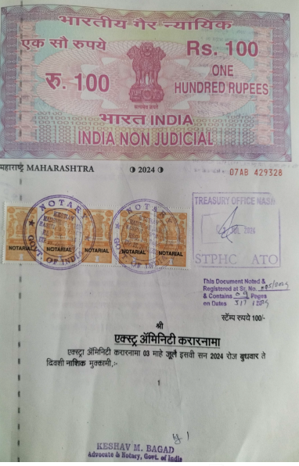
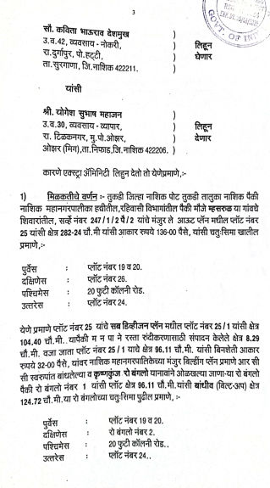

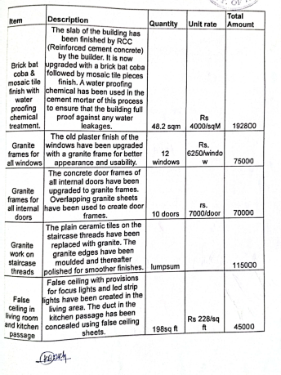
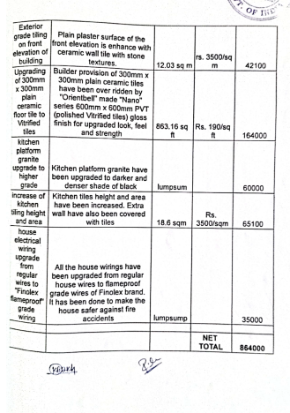

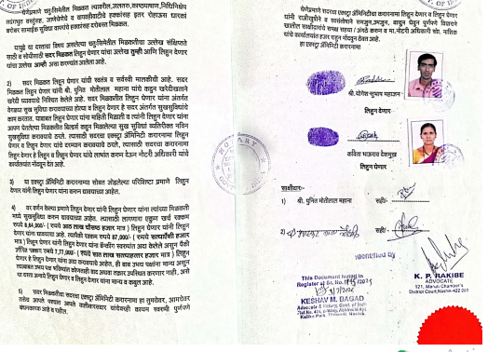

The Extra Work amount is Rs. 8,50,000/- (Rupees Eight Lakh Fifty Thousand Only)

