Vastu/Nashik/06/2024/009364/2306807
19/1-251-RYBS
Date: 06.07.2024

To,
The Branch Manager,
Bank of Baroda
Regional Office
BSNL Building, Datta Mandir Road, Nashik Road,
Nashik, PIN – 422 101, State - Maharashtra, Country - India.

Sub: Vetting of Extra Amenities

Sir,

With reference to above subject, we have evaluated the Extra Amenities for Residential Flat No.602, Sixth Floor, A-Wing, “Dream Paradise ", Survey No.110, Plot No.3+4,Opposite Arambh Medicare ,Medage Nagar, Ambad Satpur Link Road, Village – Chunchale, Taluka & District - Nashik, PIN Code – 422 009, State – Maharashtra, Country – India belongs to Shri.Sunil Rambabu Pandit & Shri.Sandip Rambabu Pandit & Sau.Sunita Ram Pandit

We have verified the rates quoted as per current market rates. Details of Extra Amenities considered as per copy of Extra Amenities Agreement between Shri.Sunil Rambabu Pandit & Shri.Sandip Rambabu Pandit & Sau.Sunita Ram Pandit. (First Party). Shri.Balmiki Kumar (Second Party) received on dated.06.07.2024. The Extra Amenities amount is Rs. 5,00,000/- (Rupees Five Lakh Only)

The said Cost Vetting Certificate is valid upto next 6 months Only.

Thanking you

Sincerely yours

Manoj B. Chalikwar
Registered Valuer
Chartered Engineer (India)
Reg. No. CAT-I-F-1763
Reg. No. IBBI/RV/07/2018/10366
BOB Empanelment No.: ZO:MZ:ADV:46:941
Encl: Valuation report.

Agreement for Extra Amenities

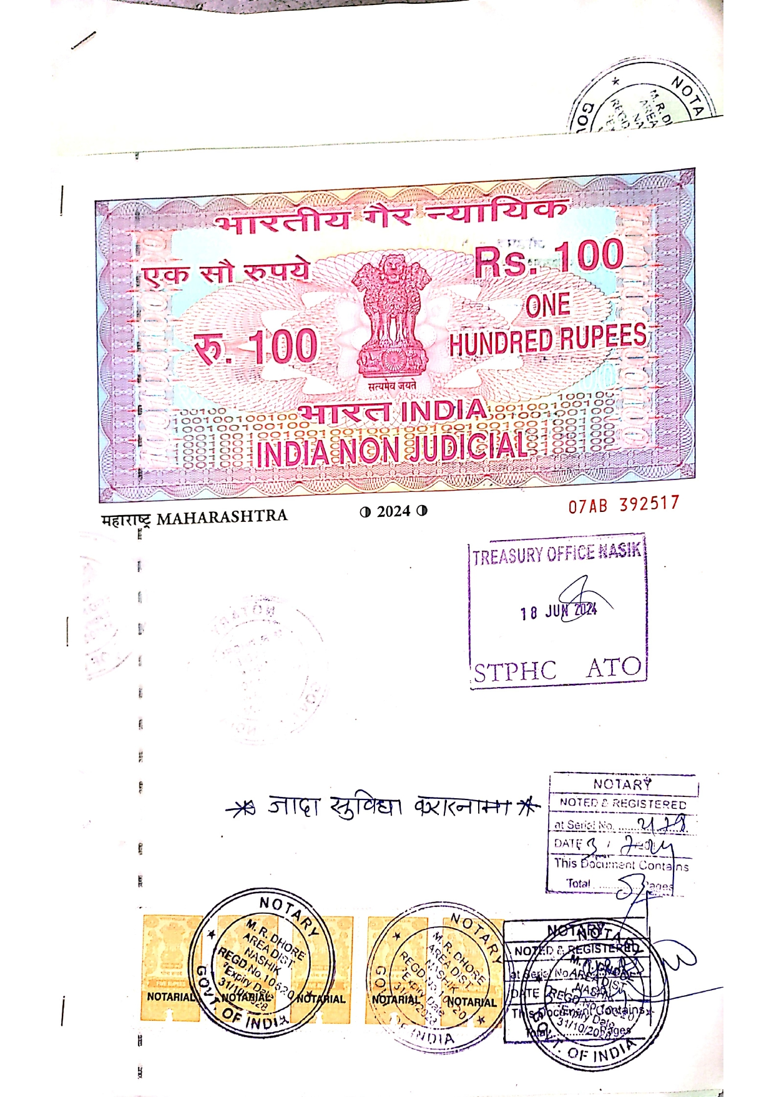
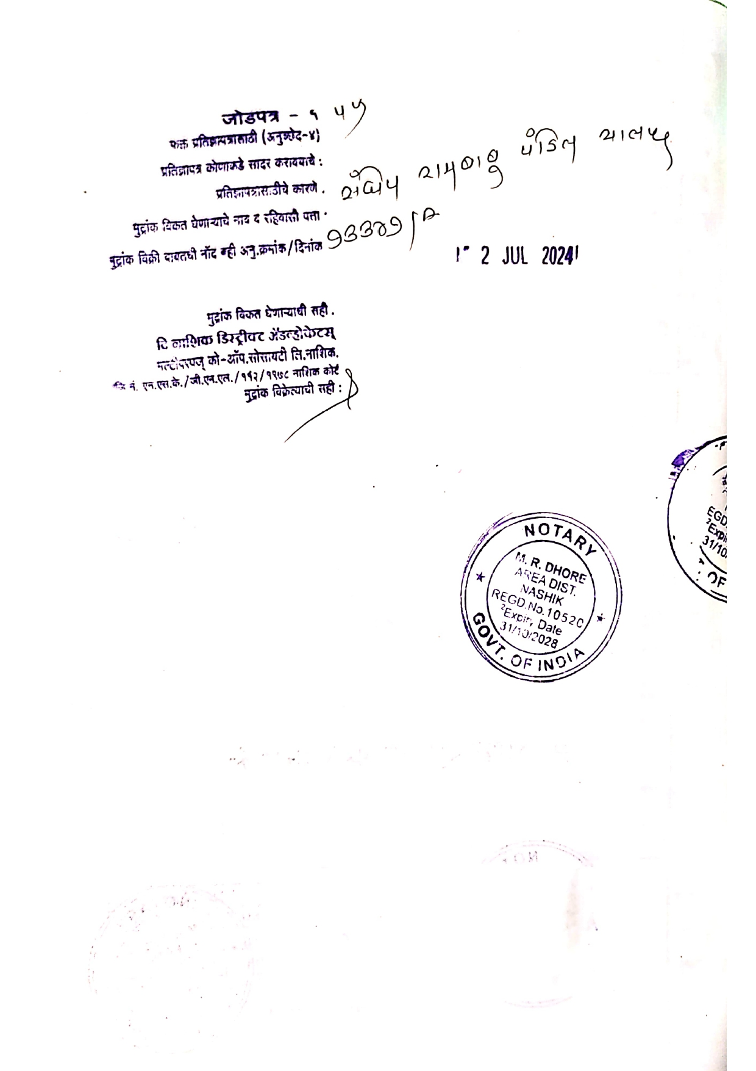

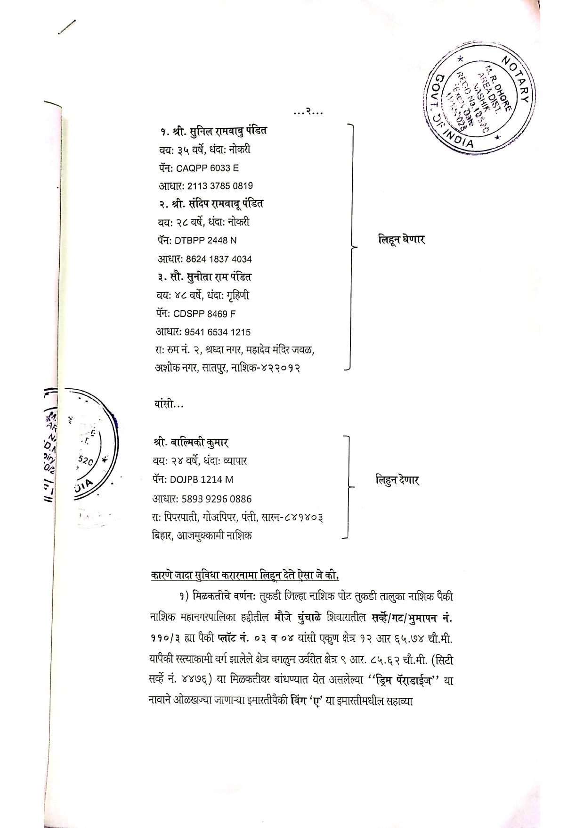
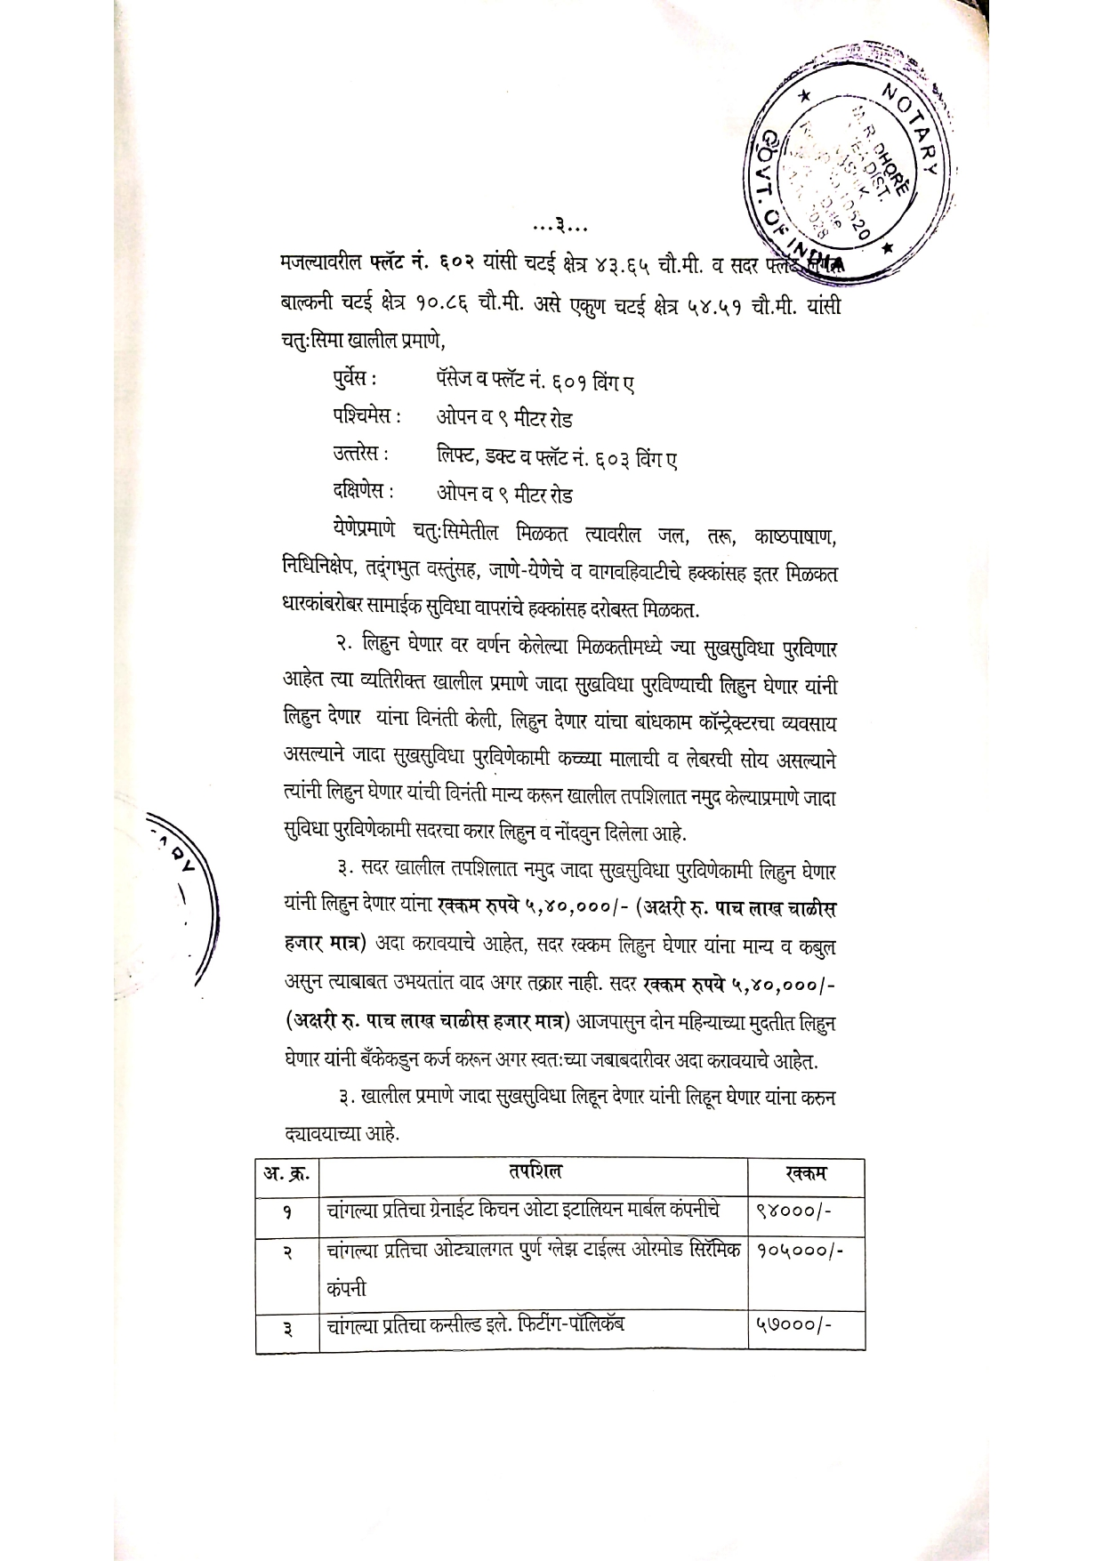

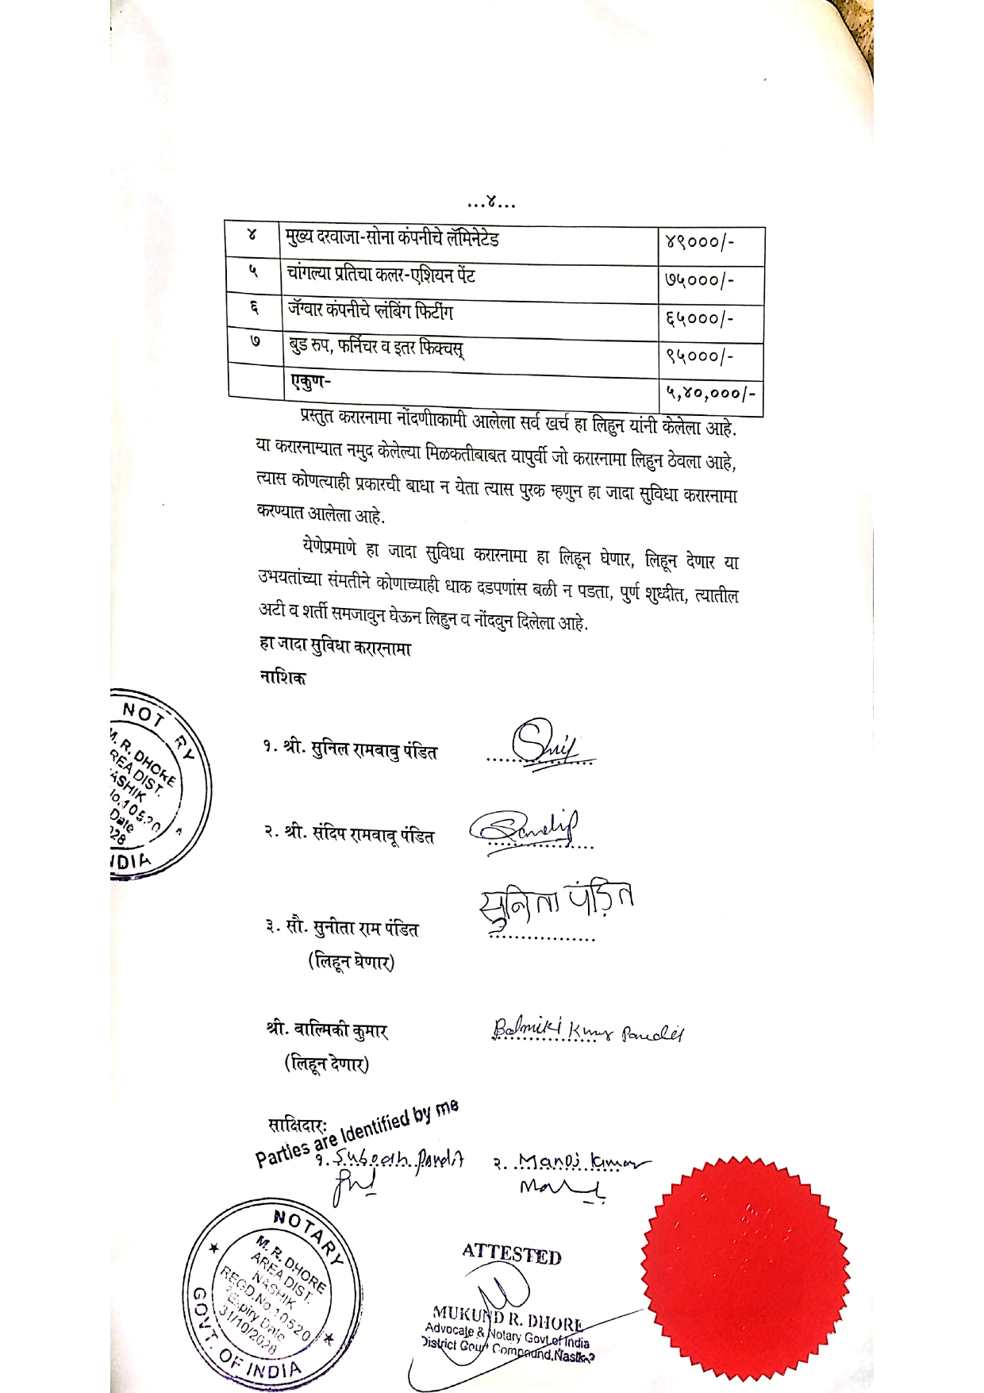

The Extra Amenities amount is Rs. 5,00,000/- (Rupees Five Lakh Only)

