Valuation Report of the Immovable Property
(For Capital Gain Purpose)
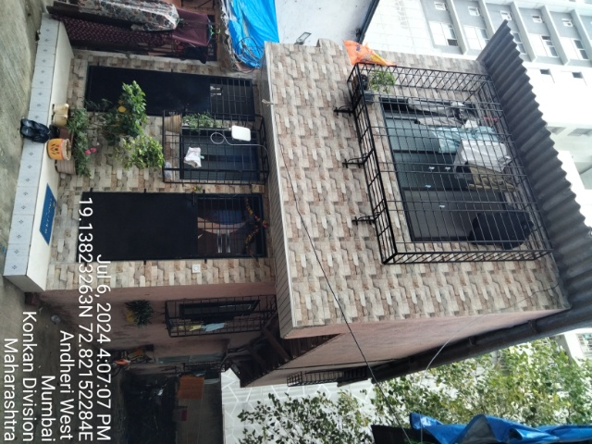

Details of the property under consideration:

Name of client: Mrs. Savita Vinayak Narvekar

Residential Room No. C/9, “Versova Andheri Samata Co-Op. Hsg. Soc. Ltd.”, Plot No. CD-70, RSC -23,
S. V. P. Nagar, Versova MHADA, Four Bungalow, Andheri (West), Mumbai, Pin – 400 053,
State – Maharashtra, Country – India

Latitude Longitude: 19°08’17.7”N 72°49’18.0”E

Table of Contents
1. VALUATION OPINION REPORT 3
2. Part-1 Form 0-1 5
2.1. GENERAL: 5
2.2. LAND 5
2.3. IMPROVEMENTS 6
2.4. RENTS 7
2.5. SALES 7
2.6. COST OF CONSTRUCTION 8
3. PART II- VALUATION 8
3.1. General: 8
3.2. Location: 8
3.3. Building / Property: 9
3.4. Flat: 9
3.5. Valuation as on 1st April 2001 of the Residential Flat: 9
3.6. Indexed Cost of Acquisition 9
3.7. NOTES 10
4. ANNEXURE TO FORM 0-1 10
5. PART III- DECLARATION 11
5.1. DECLARATION OF PROFESSIONAL FEES CHARGED 11
5.2. DEFINITION OF VALUE FOR THIS SPECIFIC PURPOSE 12
5.3. UNDER LYING ASSUMPTIONS 12
6. Actual site photographs 13
7. Route Map of the property 15
8. Ready Reckoner Rate for Year 2001 16
8.1. Rate for Property 16
8.2. Construction Rate 16
9. VALUATION OF THE PROPERTY PREMISES 17

Vastu/Mumbai/07/2024/9728/2307247
16/05-251-VVS
Date: 16.07.2024

VALUATION OPINION REPORT

This is to certify that the property bearing Residential Room No. C/9, “Versova Andheri Samata Co-Op. Hsg. Soc. Ltd.”, Plot No. CD-70, RSC -23, S. V. P. Nagar, Versova MHADA, Four Bungalow, Andheri (West), Mumbai, Pin – 400 053, State – Maharashtra, Country – India was belonging to Mrs. Savita Vinayak Narvekar till sold the property to Mr. Nilesh Bechar Patel & Mr. Kalpesh Bechar Patel as per Agreement for Sale dated 06.11.2023.

Boundaries of the property.
North | : | Open Plot
South | : | The Luxeria Apartment
East | : | SVP Nagar Road & Room No. C/8
West | : | Room No. C-12/13

- The purpose of this report is to ascertain the Indexed Cost of Acquisition (F. Y. 2023 - 24) of the property as detailed above.
- The property premises can be assessed and valued for calculation of Capital Gain Tax purpose as on 1st April 2001 at ` 9,71,731.00 (Rupees Nine Lakh Seventy One Thousand Seven Hundred Thirty One Only).
- The Indexed Cost of Acquisition of Property under consideration as on 2023 – 24 is ` 33,81,624.00 (Rupees Thirty Three Lakh Eighty One Thousand Six Hundred Twenty Four Only) without any major Renovation & improvement after 2001.
- The following documents were perused :
- Copy of Agreement for sale dated 06.11.2023 between Mrs. Savita Vinayak Narvekar (the Transferor) AND Mr. Nilesh Bechar Patel & Mr. Kalpesh Bechar Patel (the Transferees)
- Copy of Share Certificate No. 9 transferred on 24.09.2023 the name of Savita V. Narvekar
- Copy of Society NOC dated 08.10.2023
- Copy of MHADA Letter dated 13.09.2023
- Copy of Agreement dated 25.11.1993 between Mr. Chandrakant Laxman Bandekar (the Transferor) AND Mrs. Savita Vinayak Narvekar (the Transferee)
- Copy of Electricity Bill dated 19.06.2024 in the name of Mr. Nilesh Bechar Patel & Kalpesh Bechar Patel
- Copy of Property Tax Bill No. KW1712969790000 dated 01.01.2020 for the period of 2019-2020
- Copy of MHADA Letter dated 01.08.1992

This assignment is undertaken based on the request from our client Mrs. Savita Vinayak Narvekar.

The valuation of the property is based on the documents produced by the concern. Legal aspects have not been taken into considerations while preparing this valuation report.

Hence certified.

For Vastukala Architects & Engineers

Sharadkumar B. Chalikwar
Govt. Reg. Valuer
Chartered Engineer (India)
Reg. No. (N) CCIT/1-14/52/2008-09
Encl: Valuation report in Form – 01
Valuation Report of Residential Room No. C/9, “Versova Andheri Samata Co-Op. Hsg. Soc. Ltd.”, Plot No. CD-70, RSC -23, S. V. P. Nagar, Versova MHADA, Four Bungalow, Andheri (West), Mumbai, Pin – 400 053,
State – Maharashtra, Country – India

Part-1 Form 0-1

(See Rule 8 D)
REPORT OF VALUATION OF IMMOVABLE PROPERTY (OTHER THAN AGRICULTURAL LANDS, PLANTATIONS, FORESTS, MINES AND QUARRIES)

GENERAL:

1 | Purpose for which the valuation is made | To assess the Fair Market Value as on 01-04-2001 for computation of Capital Gains Tax.
2 | Date of Report | 16.07.2024
3 | Name of the Owner | Mrs. Savita Vinayak Narvekar till sold the property to Mr. Nilesh Bechar Patel & Mr. Kalpesh Bechar Patel as per Agreement for Sale dated 06.11.2023
4 | If the property is under joint ownership, Ownership / co-ownership, share of each such owner. Are the shares undivided? | Sole Ownership
5 | Brief description of the property | Residential Room No. C/9, “Versova Andheri Samata Co-Op. Hsg. Soc. Ltd.”, Plot No. CD-70, RSC -23, S. V. P. Nagar, Versova MHADA, Four Bungalow, Andheri (West), Mumbai, Pin – 400053, State – Maharashtra, Country – India
6 | Location, street, ward no | S. V. P. Nagar, Versova MHADA, Four Bungalow
7 | Survey/ Plot no. of land | Plot No. CD-70, RSC -23, CTS No. 1374 /B, Village - Versova
8 | Is the property situated in Residential / commercial/ mixed area/ industrial area? | Residential
9 | Classification of locality-high class/ middle class/poor class | Middle Class
10 | Proximity to civic amenities like schools, Hospitals, Offices, market, cinemas etc. | All the amenities are available in the vicinity.
11 | Means and proximity to surface communication by which the locality is served | Served by BEST Buses, Taxies, Autos and Private Vehicles

LAND

12 | Area of land supported by documentary proof. Shape, dimension and physical features | Built Up Area = 30.00 Sq. M. i.e. 323.00 Sq. Ft.  (Area as Agreement for Sale)
  Area as per actual site measurement
  Floors | Carpet Area (Sq. Ft.)
  Ground | 275.00
  First | 362.00
13 | Roads, Streets or lanes on which the land is abutting | S. V. P. Nagar, Versova MHADA, Four Bungalow
14 | If freehold or leasehold land | Leasehold
15 | If leasehold, the name of Lessor/lessee, nature of lease, date of commencement and termination of lease and terms of renewal of lease.  (i) Initial premium  (ii) Ground rent payable per annum  (iii) Unearned increase payable to the Lessor in the event of sale or transfer | Leasehold
16 | Is there any restriction covenant in regard to use of land? If so attach a copy of the covenant. | As per documents
17 | Are there any agreements of easements? If so attach a copy of the covenant | Information not available
18 | Does the land fall in an area included in any Town Planning Scheme or any Development Plan of Government or any statutory body? If so give Particulars. | MHADA / Municipal Corporation of Greater Mumbai
19 | Has any contribution been made towards development or is any demand for such contribution still outstanding. | Information not available
20 | Has the whole or part of the land been notified for acquisition by government or any statutory body? Give date of the notification. | No
21 | Attach a dimensioned site plan | Attached

IMPROVEMENTS

22 | Attach plans and elevations of all structures standing on the land and a lay-out plan. | N.A.
23 | Furnish technical details of the building on a separate sheet (The Annexure to this form may be used) | Attached
24 | Is the building owner occupied/ tenanted/ both? | Ground Floor – Tenant Occupied – Mr. Ashok Vishwakarma  First Floor - Owner Occupied
 | If the property owner occupied, specify portion and extent of area under owner-occupation | Ground Floor – Tenant Occupied – Mr. Ashok Vishwakarma  First Floor - Owner Occupied
25 | What is the Floor Space Index permissible and Percentage actually utilized? | - Floor Space Index Permissible – As per Development Control of Regulation of MHADA / Municipal Corporation of Greater Mumbai  - FSI percentage actually utilized - Information not available

RENTS

26 | (i) | Names of tenants/ lessees/ licensees, etc. | Mr. Ashok Vishwakarma
 | (ii) | Portions in their occupation | Ground Floor
 | (iii) | Monthly or annual rent /compensation/license fee, etc. paid by each | ` 21,000.00 Presented rental income per month
 | (iv) | Gross amount received for the whole property | N.A.
27 | Are any of the occupants related to, or close to business associates of the owner? |  | N.A.
28 | Is separate amount being recovered for the use of fixtures, like fans, geysers, refrigerators, cooking ranges, built-in wardrobes, etc. or for services charges? If so, give details |  | N.A.
29 | Give details of the water and electricity charges, If any, to be borne by the owner |  | Electricity charges of Rs. 2,920.00 as per Copy of Electricity Bill Consumer date 19.06.2024 in the name of Nilesh Bechar Patel & Kalpesh Bechar Patel
30 | Has the tenant to bear the whole or part of the cost repairs and maintenance? Give particulars |  | N.A.
31 | If a lift is installed, who is to bear the cost of maintenance and operation- owner or tenant? |  | N.A.
32 | If a pump is installed, who is to bear the cost of maintenance and operation- owner or tenant? |  | N.A.
33 | Who has to bear the cost of electricity charges for lighting of common space like entrance hall, stairs, passage, compound, etc. owner or tenant? |  | N.A.
34 | What is the amount of property tax? Who is to bear it? Give details with documentary proof |  | N.A.
35 | Is the building insured? If so, give the policy no., amount for which it is insured and the annual premium |  | N.A.
36 | Is any dispute between landlord and tenant regarding rent pending in a court of rent? |  | Information not available
37 | Has any standard rent been fixed for the premises under any law relating to the control of rent? |  | Information not available

SALES

38 | Give instances of sales of immovable property in the locality on a separate sheet, indicating the Name and address of the property, registration No., sale price and area of land sold. | As per sub registrar assurance records
39 | Land rate adopted in this valuation | N. A. as the property is valued by composite rate method
40 | If sale instances are not available or not relied up on, the basis of arriving at the land rate | Copy of Stamp Duty Ready Reckoner for the year 2001 attached

COST OF CONSTRUCTION

41 | Year of commencement of construction and year of completion | 1993 (As per Society NOC)
42 | What was the method of construction, by contract/By employing Labour directly/ both? | Information not available
43 | For items of work done on contract, produce copies of agreements | N. A.
44 | For items of work done by engaging Labour directly, give basic rates of materials and Labour supported by documentary proof. | N. A.

PART II- VALUATION

General:

Under the instructions of Mrs. Savita Vinayak Narvekar, we have valued the Residential Room No. C/9, “Versova Andheri Samata Co-Op. Hsg. Soc. Ltd.”, Plot No. CD-70, RSC -23, S. V. P. Nagar, Versova MHADA, Four Bungalow, Andheri (West), Mumbai, Pin – 400 053, State – Maharashtra, Country – India to ascertain the market value of said property, as on 1st April 2001 for computation of Capital Gains Tax.

We are in receipt of the following documents:
- Copy of Agreement for sale dated 06.11.2023 between Mrs. Savita Vinayak Narvekar (the Transferor) AND Mr. Nilesh Bechar Patel & Mr. Kalpesh Bechar Patel (the Transferees)
- Copy of Share Certificate No. 9 transferred on 24.09.2023 the name of Savita V. Narvekar
- Copy of Society NOC dated 08.10.2023
- Copy of MHADA Letter dated 13.09.2023
- Copy of Agreement dated 25.11.1993 between Mr. Chandrakant Laxman Bandekar (the Transferor) AND Mrs. Savita Vinayak Narvekar (the Transferee)
- Copy of Electricity Bill dated 19.06.2024 in the name of Mr. Nilesh Bechar Patel & Kalpesh Bechar Patel
- Copy of Property Tax Bill No. KW1712969790000 dated 01.01.2020 for the period of 2019-2020
- Copy of MHADA Letter dated 01.08.1992

Location:
The said building is located at Plot No. CD-70, RSC -23, CTS No. 1374 /B, Village - Versova, S. V. P. Nagar, Versova MHADA, Four Bungalow, Andheri (West) in MHADA / Municipal Corporation of Greater Mumbai. The property falls in Residential Zone. It is at 1.9 Km. travel distance from Lower Oshiwara Metro station.

Row House / Property:
The Structure is a Ground + 1 upper floor. The Residential Row House is known as “Versova Andheri Samata Co-Op. Hsg. Soc. Ltd.” The Row House is used for Residential purpose. The Row House is without lift.

Row House:

The Row House under reference is situated on the Ground + 1 Floor. The composition of Row House is Living + Kitchen + 1 Bedroom + Toilet on Ground Floor and Living + Kitchen + 1 Bedroom + Bath + W.C. on 1st Floor. It is finished with Vitrified tiles flooring, Teakwood door frames with solid flush doors with Powder coated Aluminum Sliding windows with M.S. Grills, Concealed plumbing & Concealed electrification is provided.

Valuation as on 1st April 2001 of the Residential Row House:

The Built-Up area of the Property in Sq. Ft. | : | 323.00
The Built-Up area of the Property in Sq. M. | : | 30.00
Depreciation Calculation:
Year of Construction of the Row House | : | 1993 (As per Society NOC)
Expected total life of Row House | : | 70 years
Age of the row house as on 2001 | : | 08 years
Cost of Construction | : | 30.00 Sq. M. x ` 5,500.00 = ` 1,65,000.00
Depreciation | : | 10.29%
Amount of depreciation | : | ` 16,979.00
Rate as on 01-04-2001 for Residential Property Premises | : | ` 31,500.00 per Sq. M.
Rate considered for valuation Value of Property as on 2001. | : | 30.00 Sq. M. x ` 31,500.00  = ` 9,45,000.00
Depreciated Fair Value of the property as on 01-04-2001 (A) | : | ` 9,45,000.00 (-) ` 16,979.00  = ` 9,28,021.00
Add for Stamp Duty charges (B) | : | ` 34,430.00
Add for Registration charges (C) | : | ` 9,280.00
Total Cost of Acquisition (A + B + C) | : | ` 9,71,731.00

Indexed Cost of Acquisition
- Cost Inflation Index for 2001 : 100
(Considering the transaction shall be made
after 01.04.2017)
- Cost Inflation Index for 2023 - 24 : 348
- Indexed Cost of Acquisition : ` 33,81,624.00
(` 9,71,731.00 * 348/ 100)

Taking into consideration above said facts, we can evaluate the value Residential Room No. C/9, “Versova Andheri Samata Co-Op. Hsg. Soc. Ltd.”, Plot No. CD-70, RSC -23, S. V. P. Nagar, Versova MHADA, Four Bungalow, Andheri (West), Mumbai, Pin – 400 053, State – Maharashtra, Country – India at ` 9,71,731.00 (Rupees Nine Lakh Seventy One Thousand Seven Hundred Thirty One Only) as on 1st April 2001.

NOTES
- I, Sharadkumar B. Chalikwar with my experience and ability to judgment I am of the considered opinion that the fair market value of the property as on 1st April 2001 is ` 9,71,731.00 (Rupees Nine Lakh Seventy One Thousand Seven Hundred Thirty One Only). Value varies with time and purpose and hence this value should not be referred for any purpose other than mentioned in this report.

- This valuation is done on the basis of information, which the valuer has obtained by information provided by the client about the premises and location of the surrounding area and also prevailing rates in the surrounding area, and further subject to document as mentioned in valuation report.

- This valuer should not be held responsible for authentication of documents, clear title and other such related matters. For that purpose Latest Legal Opinion should be sought.

ANNEXURE TO FORM 0-1

1. | No. of floors and height of each floor | Ground + 1 upper floor.
2. | Plinth area floor wise as per IS 3361-1966 | Information not available
3 | Year of construction | 1993 (As per Society NOC)
4 | Estimated future life as on year 2001 | 62 years
5 | Type of construction- load bearing walls/RCC frame/ steel frame | R.C.C. Framed structure with AC Sheet Roofing
6 | Type of foundations | R.C.C with AC Sheet Roofing
7 | Walls | All external walls are 9” thick and partition walls are 6” thick.
8 | Partitions | 6” thick brick wall
9 | Doors and Windows | Teak wood door frames with solid flush doors with Powder coated aluminium Sliding windows with M.S. Grills
10 | Flooring | Vitrified tiles flooring
11 | Finishing | Internal walls are finished with POP + Cement Plaster. External walls are finished with sand faced plaster
12 | Roofing and terracing | R. C. C. Slab with AC Sheet Roofing
13 | Special architectural or decorative features, if any | No
14 |  | Concealed  Ordinary
  (i) | Internal wiring – surface or conduit
  (ii) | Class of fittings: Superior/ Ordinary/ Poor.
15 | Sanitary installations  Class of fittings: Superior colored / superior white/ordinary. | -  -  Ordinary
  (i) | No. of water closets
  (ii) | No. of lavatory basins
  (iii) | No. of urinals
  (iv) | No. of sinks
16 | Compound wall  Height and length  Type of construction | 6'.0" High, R.C.C. columns with B. B. Masonry wall.
17 | No. of lifts and capacity | No lift
18 | Underground sump – capacity and type of construction | R.C.C. Tank
19 | Over-head tank  Location, capacity  Type of construction | Overhead Water Tank
20 | Pumps- no. and their horse power | Available as per requirement
21 | Roads and paving within the compound approximate area and type of paving | Cemented road in open spaces, Open parking Space etc.
22 | Sewage disposal – whereas connected to public sewers, if septic tanks provided, no. and capacity | Connected to Municipal Sewers

PART III- DECLARATION
I hereby declare that
    - The information furnished in part I is true and correct to the best of my knowledge and belief;
    - I have no direct or indirect interest in the property valued:

DECLARATION OF PROFESSIONAL FEES CHARGED

We hereby declare that, our professional fees are not contingent upon the valuation findings. However, if the statute AND/OR clients demands that, the fees should be charged on the percentage of assessed value then, with the full knowledge of the AND/OR end user, it is being charged accordingly.

DEFINITION OF VALUE FOR THIS SPECIFIC PURPOSE

This exercise is to assess Fair Market Value of the property under reference as on 01st April 2001 for calculation of Capital Gains Tax.

The term Fair Market Value is defined as

“The most probable price, as of a specified date, in cash, terms equivalent to cash, or in other precisely revealed terms for which the specified property rights would sell after reasonable exposure in a competitive market under all conditions requisite to a fair sale, with the buyer and seller each acting prudently knowledgeably and for self-interest assuming that neither is under undue duress”.

Fundamental assumptions and conditions presumed in this definition are:

1. Buyer and seller are motivated by self-interest.

2. Buyer and seller are well informed and are acting prudently.

3. The property is exposed for a reasonable time on the open market.

- Payment is made in cash or equivalent or in specified financing terms.

UNDER LYING ASSUMPTIONS
1. We assume no responsibility for matters of legal nature affecting the property appraised or the title thereto, nor do we render our opinion as to the title, which is assumed to be good and marketable.
2. The property is valued as though under responsible ownership.
3. It is assumed that the property is free of liens and encumbrances.
4. It is assumed that there are no hidden or unapparent conditions of the subsoil or structure that would render it more or less valuable. No responsibility is assumed for such conditions or for engineering that might be required to discover such factors.

Actual site photographs
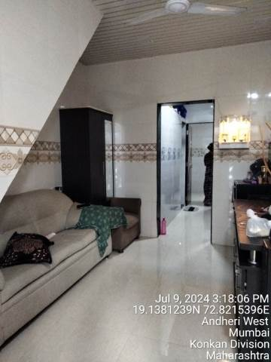
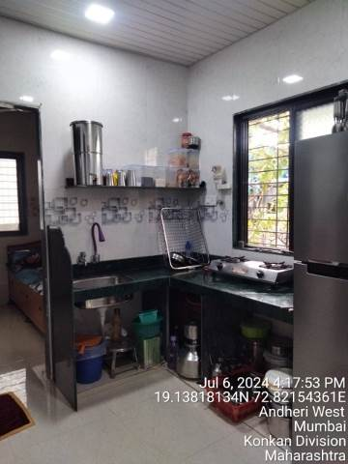

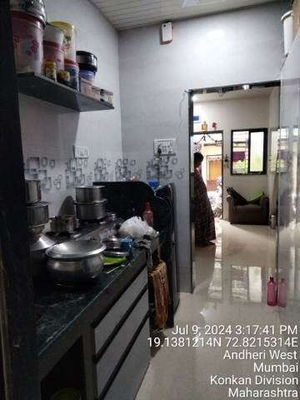
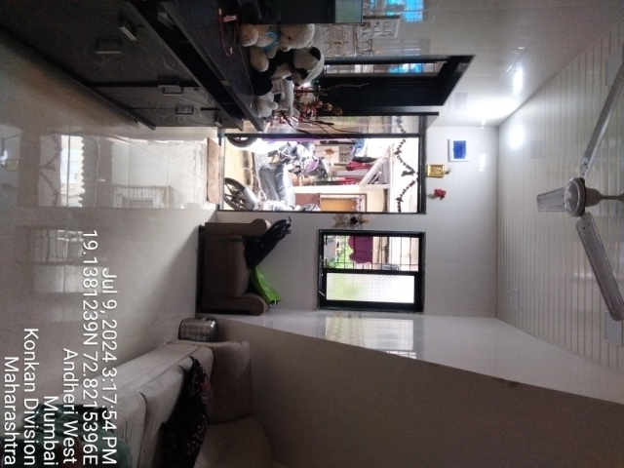

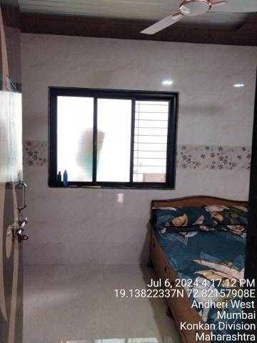
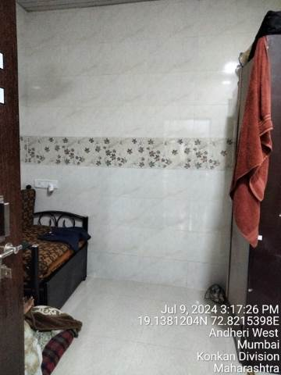

Actual site photographs
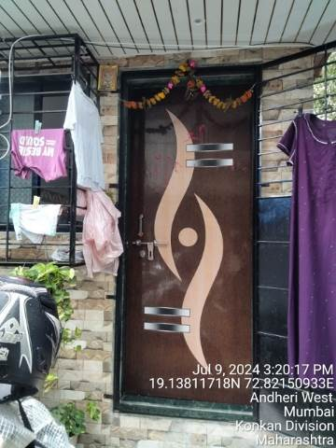
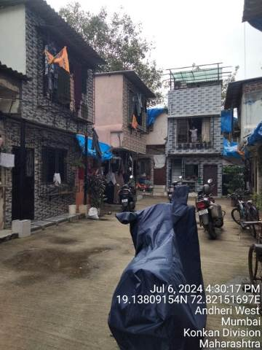
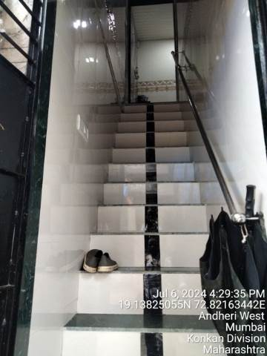
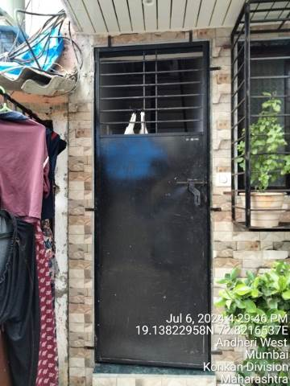

Route Map of the property
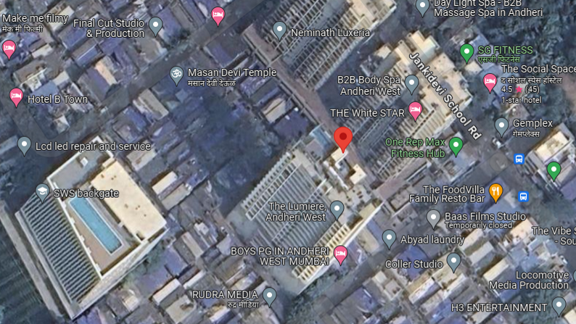
Site U/R

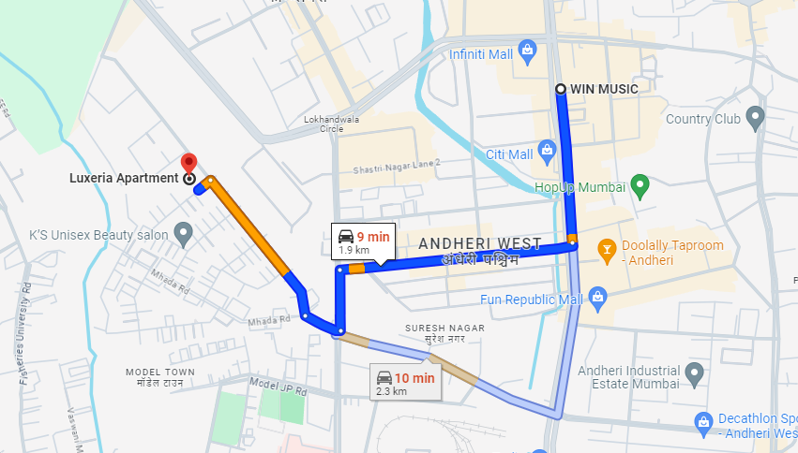

Latitude Longitude: 19°08’17.7”N 72°49’18.0”E

Note: The Blue line shows the route to site from nearest Metro station (Lower Oshiwara – 1.9 Km.)

Ready Reckoner Rate for Year 2001

Rate for Property
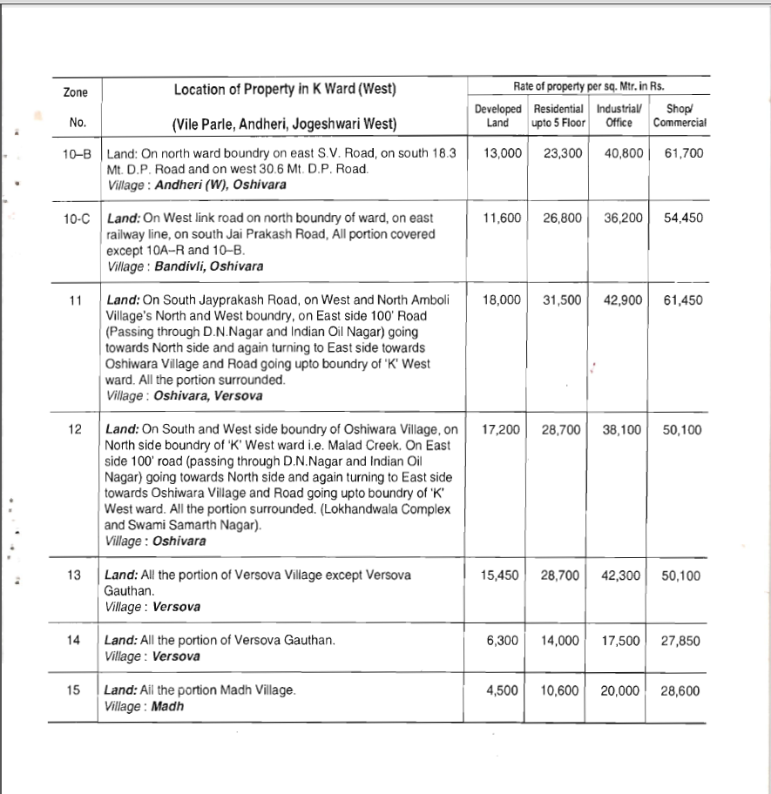

Construction Rate

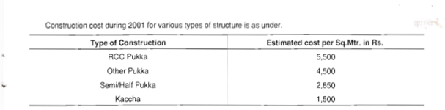

VALUATION OF THE PROPERTY PREMISES

Considering various parameters recorded herein above, existing economic scenario, and the information that is available with reference to the development of neighbourhood and method selected for valuation, we are of the opinion that, the property premises can be assessed and valued for calculation of Capital Gain Tax as on 1st April 2001 for ` 9,71,731.00 (Rupees Nine Lakh Seventy One Thousand Seven Hundred Thirty One Only).

For Vastukala Architects & Engineers

Sharadkumar B. Chalikwar
Govt. Reg. Valuer
Chartered Engineer (India)
Reg. No. (N) CCIT/1-14/52/2008-09

