Valuation Report of the Immovable Property

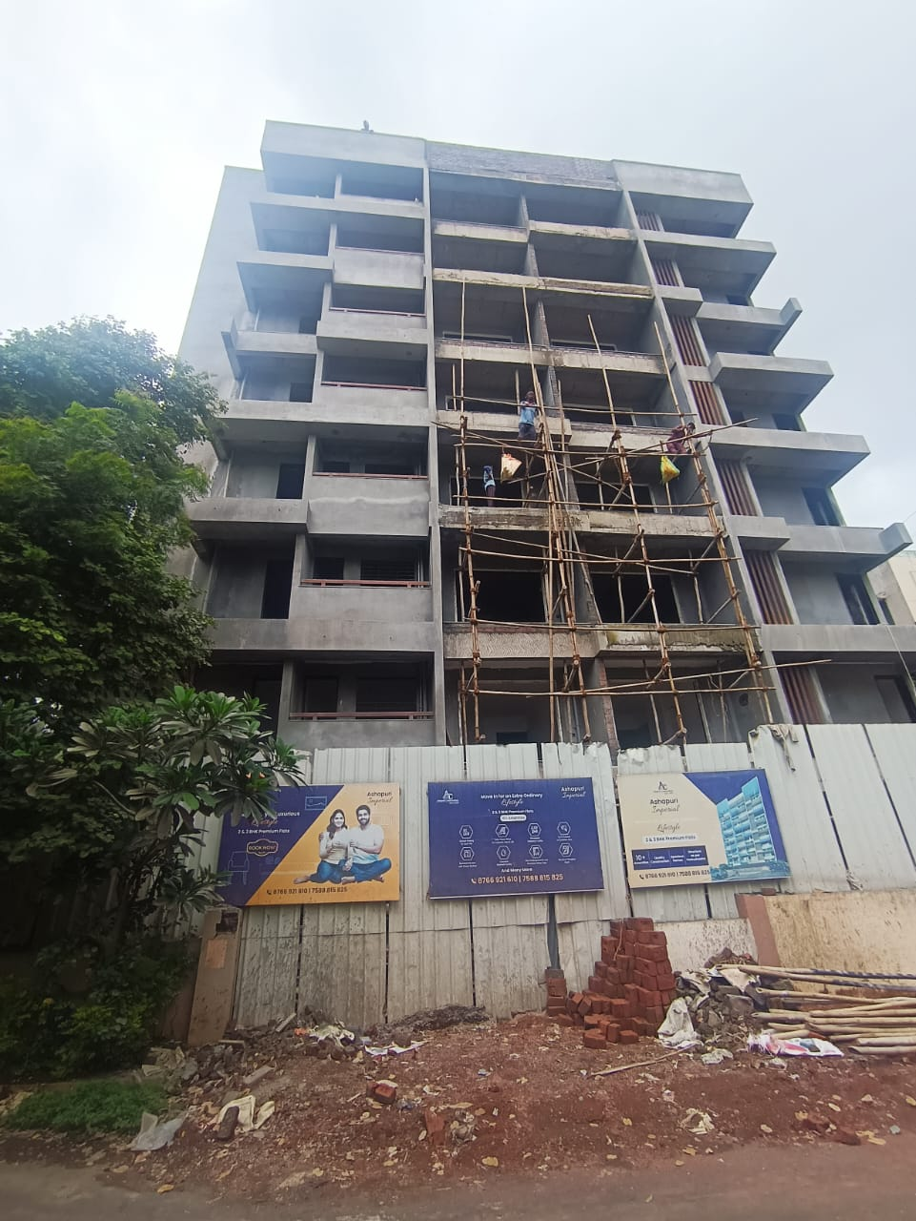

**Details of the property under consideration:**

Name of Owner: **Mr. Hiraman Govind Thakare &**

**Mrs. Prabhavati Hiraman Thakare.**

Residential Flat No. 702, Seventh Floor, **“ Ashapuri Imperial ”**, Survey No. 866/ B/ 50, Plot No. 50A+50B, Behind Vinay Nagar Police Station, Deepali Nagar, Wadala - Nashik Road, Village – Nashik, Taluka &

District – Nashik, Nashik - 422 009, State – Maharashtra, Country – India.

# **Longitude Latitude: 19°58'48.5"N 73°47'22.2"E**

**Intended User :**

**Bank of India**

**Kalbadevi Branch**

Round Building, Shamaldas Gandhi Marg, Mumbai

Mumbai - 4000 02, State - Maharashtra, Country - India.

Vastu/Mumbai/01/2020/16759/32210

20/06-210-NIA

Date:17.07.2024

# **VALUATION OPINION REPORT**

This is to certify that the property bearing Residential Flat No. 702, Seventh Floor, **“ Ashapuri Imperial ”**, Survey No. 866/ B/ 50, Plot No. 50A+50B, Behind Vinay Nagar Police Station, Deepali Nagar, Wadala - Nashik Road, Village – Nashik, Taluka & District – Nashik, Nashik - 422 009, State – Maharashtra, Country – India. belongs to **Name of Owner: Mr. Hiraman Govind Thakare & Mrs. Prabhavati Hiraman Thakare.**

|  |
| --- |
| **Boundaries of the property.** |
| |  |  |  | | --- | --- | --- | | **Boundaries** | **Building** | **Flat** | | North | Bungalow | By Flat No. 701 | | South | Road | By Side Margin | | East | Road | By Side Margin | | West | Bungalow | By Flat No. 703 & Duct | |

Considering various parameters recorded, existing economic scenario, and the information that is available with reference to the development of neighborhood and method selected for valuation, we are of the opinion that, the property premises can be assessed and valued for this particular purpose at**` 50,19,500.00 (Rupees Fifty Lakh Nineteen Thousand Five Hundred Only).** As per Site Inspection **71%** Construction Work is Completed.

The valuation of the property is based on the documents produced by the concern. Legal aspects have not been taken into considerations while preparing this valuation report.

Hence certified

## Sharadkumar B. Chalikwar

Govt. Reg. Valuer

Chartered Engineer (India)

Reg. No. (N) CCIT/1-14/52/2008-09

Encl: Valuation report.

|  |  |  |  |
| --- | --- | --- | --- |
|  |  |  |  |

|  |  |  |  |  |  |  |  |  |  |  |  |  |  |  |  |  |  |  |  |  |  |  |  |  |  |  |  |  |  |  |  |  |  |  |  |  |  |  |  |  |  |  |  |  |  |  |  |  |  |  |  |  |  |  |  |  |  |  |  |  |  |  |  |  |  |  |  |  |  |  |  |  |  |  |  |  |  |  |  |  |  |  |  |  |  |  |  |  |  |  |  |  |  |  |  |  |  |  |  |  |  |  |  |  |  |  |  |  |  |  |  |  |  |  |  |  |  |  |  |  |  |  |  |  |  |  |  |  |  |  |  |  |  |  |  |  |  |  |  |  |  |  |  |  |  |  |  |  |  |  |  |  |  |  |  |  |  |  |  |  |  |  |  |  |  |  |  |  |  |  |  |  |  |  |  |  |  |  |  |  |  |  |  |  |  |  |  |  |  |  |  |  |  |  |  |  |  |  |  |  |  |  |  |  |  |  |  |  |  |  |  |  |  |  |  |  |  |  |  |  |  |  |  |  |  |  |  |  |  |  |  |  |  |  |  |  |  |  |  |  |  |  |  |  |  |  |  |  |  |  |  |  |  |  |  |  |  |  |  |  |  |  |  |  |  |  |  |  |  |  |  |  |  |  |  |  |  |  |  |  |  |  |  |  |  |  |  |  |  |  |  |  |  |  |  |  |  |  |  |  |  |  |  |  |  |  |  |  |  |  |  |  |  |  |  |  |  |  |  |  |  |  |  |  |  |  |  |  |  |  |  |  |  |  |  |  |  |  |  |  |  |  |  |  |  |  |  |  |  |  |  |  |  |  |  |  |  |  |  |  |  |  |  |  |  |  |  |  |  |  |  |  |  |  |  |  |  |  |  |  |  |  |  |  |  |  |  |  |  |  |  |  |  |  |  |  |  |  |  |  |  |  |  |  |  |  |  |  |  |  |  |  |  |  |  |  |  |  |  |  |  |  |  |  |  |  |  |  |  |  |  |  |  |  |  |  |  |  |  |  |  |  |  |  |  |  |  |  |  |  |  |  |  |  |  |  |  |  |  |  |  |  |  |  |  |  |  |  |  |  |  |  |  |  |  |  |  |  |  |  |  |  |  |  |  |  |  |  |  |  |  |  |  |  |  |  |  |  |  |  |  |  |  |  |  |  |  |  |  |  |  |  |  |  |  |  |  |  |  |  |  |  |  |  |  |  |  |  |  |  |  |  |  |  |  |  |  |  |  |  |  |  |  |  |  |  |  |  |  |  |  |  |  |  |  |  |  |  |  |  |  |  |  |  |  |  |  |  |  |  |  |  |  |  |  |  |  |  |  |  |  |  |  |  |  |  |  |  |  |  |  |  |  |  |  |  |  |  |  |  |  |  |  |  |  |  |  |  |  |  |  |  |  |  |  |  |  |  |  |  |  |  |  |  |  |  |  |  |  |  |  |  |  |  |  |  |  |  |  |  |  |  |  |  |  |  |  |  |  |  |  |  |  |  |  |  |  |  |  |  |  |  |  |  |  |  |  |  |  |  |  |  |  |  |  |  |  |  |  |  |  |  |  |  |  |  |  |  |  |  |  |  |  |  |  |  |  |  |  |  |  |  |  |  |  |  |  |  |  |  |  |  |  |  |  |  |  |  |  |  |  |  |  |  |  |  |  |  |  |  |  |  |  |  |  |  |  |  |  |  |  |  |  |  |  |  |  |  |  |  |  |  |  |  |  |  |  |  |  |  |  |  |  |  |  |  |  |  |  |  |  |  |  |  |  |  |  |  |  |  |  |
| --- | --- | --- | --- | --- | --- | --- | --- | --- | --- | --- | --- | --- | --- | --- | --- | --- | --- | --- | --- | --- | --- | --- | --- | --- | --- | --- | --- | --- | --- | --- | --- | --- | --- | --- | --- | --- | --- | --- | --- | --- | --- | --- | --- | --- | --- | --- | --- | --- | --- | --- | --- | --- | --- | --- | --- | --- | --- | --- | --- | --- | --- | --- | --- | --- | --- | --- | --- | --- | --- | --- | --- | --- | --- | --- | --- | --- | --- | --- | --- | --- | --- | --- | --- | --- | --- | --- | --- | --- | --- | --- | --- | --- | --- | --- | --- | --- | --- | --- | --- | --- | --- | --- | --- | --- | --- | --- | --- | --- | --- | --- | --- | --- | --- | --- | --- | --- | --- | --- | --- | --- | --- | --- | --- | --- | --- | --- | --- | --- | --- | --- | --- | --- | --- | --- | --- | --- | --- | --- | --- | --- | --- | --- | --- | --- | --- | --- | --- | --- | --- | --- | --- | --- | --- | --- | --- | --- | --- | --- | --- | --- | --- | --- | --- | --- | --- | --- | --- | --- | --- | --- | --- | --- | --- | --- | --- | --- | --- | --- | --- | --- | --- | --- | --- | --- | --- | --- | --- | --- | --- | --- | --- | --- | --- | --- | --- | --- | --- | --- | --- | --- | --- | --- | --- | --- | --- | --- | --- | --- | --- | --- | --- | --- | --- | --- | --- | --- | --- | --- | --- | --- | --- | --- | --- | --- | --- | --- | --- | --- | --- | --- | --- | --- | --- | --- | --- | --- | --- | --- | --- | --- | --- | --- | --- | --- | --- | --- | --- | --- | --- | --- | --- | --- | --- | --- | --- | --- | --- | --- | --- | --- | --- | --- | --- | --- | --- | --- | --- | --- | --- | --- | --- | --- | --- | --- | --- | --- | --- | --- | --- | --- | --- | --- | --- | --- | --- | --- | --- | --- | --- | --- | --- | --- | --- | --- | --- | --- | --- | --- | --- | --- | --- | --- | --- | --- | --- | --- | --- | --- | --- | --- | --- | --- | --- | --- | --- | --- | --- | --- | --- | --- | --- | --- | --- | --- | --- | --- | --- | --- | --- | --- | --- | --- | --- | --- | --- | --- | --- | --- | --- | --- | --- | --- | --- | --- | --- | --- | --- | --- | --- | --- | --- | --- | --- | --- | --- | --- | --- | --- | --- | --- | --- | --- | --- | --- | --- | --- | --- | --- | --- | --- | --- | --- | --- | --- | --- | --- | --- | --- | --- | --- | --- | --- | --- | --- | --- | --- | --- | --- | --- | --- | --- | --- | --- | --- | --- | --- | --- | --- | --- | --- | --- | --- | --- | --- | --- | --- | --- | --- | --- | --- | --- | --- | --- | --- | --- | --- | --- | --- | --- | --- | --- | --- | --- | --- | --- | --- | --- | --- | --- | --- | --- | --- | --- | --- | --- | --- | --- | --- | --- | --- | --- | --- | --- | --- | --- | --- | --- | --- | --- | --- | --- | --- | --- | --- | --- | --- | --- | --- | --- | --- | --- | --- | --- | --- | --- | --- | --- | --- | --- | --- | --- | --- | --- | --- | --- | --- | --- | --- | --- | --- | --- | --- | --- | --- | --- | --- | --- | --- | --- | --- | --- | --- | --- | --- | --- | --- | --- | --- | --- | --- | --- | --- | --- | --- | --- | --- | --- | --- | --- | --- | --- | --- | --- | --- | --- | --- | --- | --- | --- | --- | --- | --- | --- | --- | --- | --- | --- | --- | --- | --- | --- | --- | --- | --- | --- | --- | --- | --- | --- | --- | --- | --- | --- | --- | --- | --- | --- | --- | --- | --- | --- | --- | --- | --- | --- | --- | --- | --- | --- | --- | --- | --- | --- | --- | --- | --- | --- | --- | --- | --- | --- | --- | --- | --- | --- | --- | --- | --- | --- | --- | --- | --- | --- | --- | --- | --- | --- | --- | --- | --- | --- | --- | --- | --- | --- | --- | --- | --- | --- | --- | --- | --- | --- | --- | --- | --- | --- | --- | --- | --- | --- | --- | --- | --- | --- | --- | --- | --- | --- | --- | --- | --- | --- | --- | --- | --- | --- | --- | --- | --- | --- | --- | --- | --- | --- | --- | --- | --- | --- | --- | --- | --- | --- | --- | --- | --- | --- | --- | --- | --- | --- | --- | --- | --- | --- | --- | --- | --- | --- | --- | --- | --- | --- | --- | --- | --- | --- | --- | --- | --- | --- | --- | --- | --- | --- | --- | --- | --- | --- | --- | --- | --- | --- | --- | --- | --- | --- | --- | --- | --- | --- | --- | --- | --- | --- | --- | --- | --- | --- | --- | --- | --- | --- | --- | --- | --- | --- | --- | --- | --- | --- | --- | --- | --- | --- | --- | --- | --- | --- | --- | --- | --- | --- | --- | --- | --- | --- | --- | --- | --- | --- | --- | --- | --- | --- | --- | --- | --- | --- | --- | --- | --- | --- | --- | --- | --- | --- | --- | --- | --- | --- | --- | --- | --- | --- | --- | --- | --- | --- | --- | --- | --- | --- | --- | --- | --- | --- | --- | --- | --- | --- | --- | --- | --- | --- | --- | --- | --- | --- | --- | --- |
| **Vastukala Consultants (I) Pvt. Ltd.**  B1-001, U/B Floor, **Boomerang**, Chandivali Farm Road, Powai, Andheri (East), Mumbai – 400 072  To,  **The Branch Manager,**  **Bank of India**  **Kalbadevi Branch**  Round Building, Shamaldas Gandhi Marg, Mumbai  Mumbai - 4000 02, State - Maharashtra, Country - India.  **VALUATION REPORT (IN RESPECT OF FLAT)**   |  |  |  |  |  |  |  | | --- | --- | --- | --- | --- | --- | --- | | I | **General** | | | | | | | 1. | Purpose for which the valuation is made | | | : | To assess fair market value of the property for Housing Loan Purpose. | | | 2. | a) | | Date of inspection | : | 17.07.2024 | | |  | b) | | Date on which the valuation is  Made |  | 17.07.2024 | | | 3 | List of documents produced for perusal:   1. Copy of Agreement For Sale No. 6643/ 2024 Dated.02.07.2024. 2. Copy of Commencement Certificate Pemit No. NMCB/ B/ 2023/ APL/ 07735 dated.31.08.2023 issued by Nashik Municipal Corporation, Nashik. 3. Copy of Approved Plan Digitally Signed by Sanjay Lalchand Agrawal dated.04.09.2024 issued by Executive Engineer Town Planning Nashik Municipal Corporation, Nashik. 4. Copy of RERA Certificate No. P51600053972 Dated.18.12.2023 Issued byMaharashtra Real Estate Regulatory Authority. | | | | | | | 4. | Name of the owner(s) and his / their address (es) with Phone no. (details of share of each owner in case of joint ownership) | | | : | Name of Owner:  **Mr. Hiraman Govind Thakare &**  **Mrs. Prabhavati Hiraman Thakare**  **Address** - Residential Flat No. 702, Seventh Floor, **“ Ashapuri Imperial ”**, Survey No. 866/ B/ 50, Plot No. 50A+50B, Behind Vinay Nagar Police Station, Deepali Nagar, Wadala - Nashik Road, Village – Nashik, Taluka & District – Nashik, Nashik - 422 009, State – Maharashtra, Country – India.  **Contact Person:**  Mr. Suyog Kothawade (Builder)  Contact No.: +91 7588815825  Joint Ownership. | | | 5. | Brief description of the property (Including Leasehold / freehold etc.) | | | : | The property is a residential flat No. 702 is in under construction building. The flat is located on Seventh floor in the said under construction building. As per Approved Plan the composition of flat will be 2 Bedroom + Living Room + Kitchen + 1 Attached Toilet + 1 Common Toilet balcony + Passage. **(i.e. 2BHK).**The property is at 8.7 Km. travelling distance from nearest Nashik Road Railway Station.  **Landmark:** Behind Vinay Nagar Police Station.  **At the time of inspection, the property was under construction. Extent of completion are as under:** | | |  | |  |  |  |  | | --- | --- | --- | --- | | **Stage of Construction** | | | | | RCC Footing/Foundation | **Completed** | RCC Plinth | **Completed** | | Full Building RCC | **Completed** | Internal Brick work | **Completed** | | External Brick work | **Completed** | Internal plastering | **Completed** | | External plastering | **Completed** |  |  | | **Total** | **71% Work completed** | | | | | | | | | | 6. | Location of property | | |  |  | | |  | a) | Plot No. / Survey No. | | : | Survey No. 866/ B/ 50, Plot No. 50A+50B | | |  | b) | Door No. | | : | Residential Flat No. 702 | | |  | c) | T.S. No. / Village | | : | Village - Nashik | | |  | d) | Ward / Taluka | | : | Taluka – Nashik | | |  | e) | Mandal / District | | : | District - Nashik | | |  | f) | Date of issue and validity of layout of approved map / plan | | : | Copy of Approved Plan Digitally Signed by Sanjay Lalchand Agrawal dated.04.09.2024 issued by Executive Engineer Town Planning Nashik Municipal Corporation, Nashik. | | |  | g) | Approved map / plan issuing authority | |  | Nashik Municipal Corporation, Nashik | | |  | h) | Whether genuineness or authenticity of approved map/ plan is verified | | : | Yes | | |  | i) | Any other comments by our empanelled valuers on authentic of approved plan | | : | No | | | 7. | Postal address of the property | | | : | Residential Flat No. 702, Seventh Floor, **“ Ashapuri Imperial ”**, Survey No. 866/ B/ 50, Plot No. 50A+50B, Behind Vinay Nagar Police Station, Deepali Nagar, Wadala - Nashik Road, Village – Nashik, Taluka &  District – Nashik, Nashik - 422 009, State – Maharashtra, Country – India. | | | 8. | City / Town | | | : | Nashik | | |  | Residential area | | | : | Yes | | |  | Commercial area | | | : | No | | |  | Industrial area | | | : | No | | | 9. | Classification of the area | | | : |  | | |  | i) High / Middle / Poor | | | : | Middle Class | | |  | ii) Urban / Semi Urban / Rural | | | : | Urban | | | 10. | Coming under Corporation limit / Village Panchayat / Municipality | | | : | Village- Nashik  Nashik Municipal Corporation, Nashik | | | 11. | Whether covered under any State / Central Govt. enactments (e.g., Urban Land Ceiling Act) or notified under agency area/ scheduled area / cantonment area | | | : | No | | | 12. | Boundaries of the property ( Building ) | | |  | **As per Site** | **As per Document** | |  | North | | | : | Bungalow | By Plot No. 49 | |  | South | | | : | Road | By 9 Mtrs. Vide Road | |  | East | | | : | Road | By 9 Mtrs. Vide Road | |  | West | | | : | Bungalow | By Plot No. 51 | | 13 | Boundaries of the property ( Flat No.10 ) | | |  |  |  | |  |  | | |  | **As per Site** | **As per Document** | |  | North | | | : | By Flat No. 701 | By Flat No. 701 | |  | South | | | : | By Side Margin | By Side Margin | |  | East | | | : | By Side Margin | By Side Margin | |  | West | | | : | By Flat No. 703 & Duct | By Flat No. 703 & Duct | |  |  | | |  |  |  | | 14. | Extent of the site | | | : | Carpet Area in Sq. Ft. = 622.00  Balcony Area in Sq. Ft. = 189.00  (Area as per Actual Site Inspection)  **Carpet Area in Sq. Ft. = 601.00**  **Enclose Balcony Area in Sq. Ft. = 65.00**  **Balcony Area in Sq. Ft. = 99.00**  **Total Carpet Area in Sq. Ft. = 765.00**  **(Area as per Agreement for sale)**  Built up Area in Sq. Ft. = 842.00  (Total Carpet Area + 10%) | | | 14.1 | Latitude, Longitude & Co-ordinates of flat | | | : | 19°58'48.5"N 73°47'22.2"E | | | 15. | Extent of the site considered for Valuation (least of 13A& 13B) | | | : | **Carpet Area in Sq. Ft. = 601.00**  **Enclose Balcony Area in Sq. Ft. = 65.00**  **Balcony Area in Sq. Ft. = 99.00**  **Total Carpet Area in Sq. Ft. = 765.00**  **(Area as per Agreement for sale)** | | | 16 | Whether occupied by the owner / tenant? If occupied by tenant since how long? Rent received per month. | | | : | Building is under construction | | | **II** | **APARTMENT BUILDING** | | |  |  | | |  | Nature of the Apartment | | | : | Residential | | |  | Location | | | : |  | | |  | S. No. / Plot No | | | : | Survey No. 866/ B/ 50, Plot No. 50A+50B | | |  | Block No. | | | : | - | | |  | Ward No. | | | : | - | | |  | Village / Municipality / Corporation | | | : | Village- Nashik  Nashik Municipal Corporation, Nashik | | |  | Door No., Street or Road (Pin Code) | | | : | Residential Flat No. 702, Seventh Floor, **“ Ashapuri Imperial ”**, Survey No. 866/ B/ 50, Plot No. 50A+50B, Behind Vinay Nagar Police Station, Deepali Nagar, Wadala - Nashik Road, Village – Nashik, Taluka &  District – Nashik, Nashik - 422 009, State – Maharashtra, Country – India. | | |  | Description of the locality Residential / Commercial / Mixed | | | : | Residential | | |  | Year of Construction | | | : | Building is under construction | | |  | Number of Floors | | | : | Proposed Ground + 7 Upper Floors | | |  | Type of Structure | | | : | R.C.C. Framed Structure | | |  | Number of Dwelling units in the building | | | : | 3 Flats on Seventh Floor | | |  | Quality of Construction | | | : | Building is under construction | | |  | Appearance of the Building | | | : | Building is under construction | | |  | Maintenance of the Building | | | : | Building is under construction | | |  | Facilities Available | | | : |  | | |  | Lift | | | : | Proposed 1 Lift | | |  | Protected Water Supply | | | : | Proposed Municipal Water supply | | |  | Underground Sewerage | | | : | Proposed Connected to Municipal Sewerage System | | |  | Car parking - Open / Covered | | | : | Proposed Covered Car Parking | | |  | Is Compound wall existing? | | | : | Building is under construction | | |  | Is pavement laid around the Building | | | : | Building is under construction | |  |  |  |  |  | | --- | --- | --- | --- | | **III** | **FLAT** |  |  | | 1 | The floor in which the flat is situated | : | Seventh Floor | | 2 | Door No. of the flat | : | Residential Flat No.702 | | 3 | Specifications of the flat | : | 2BHK | |  | Roof | : | Proposed R.C.C. Slab | |  | Flooring | : | Proposed Vitrified tiles flooring | |  | Doors | : | Proposed Teak wood door framed with flush doors | |  | Windows | : | Proposed Powder coated aluminum sliding windows | |  | Fittings | : | Proposed Concealed plumbing with C.P. fittings. Concealed wiring | |  | Finishing | : | Building is under construction | | 4 | House Tax | : |  | |  | Assessment No. | : | Not applied yet | |  | Tax paid in the name of : | : | Not applied yet | |  | Tax amount : | : | Not applied yet | | 5 | Electricity Service connection No. : | : | Not applied yet | |  | Meter Card is in the name of : | : | Not applied yet | | 6 | How is the maintenance of the flat? | : | Building is under construction | | 7 | Sale Deed executed in the name of | : | Name of Owner:  **Mr. Hiraman Govind Thakare &**  **Mrs. Prabhavati Hiraman Thakare.** | | 8 | What is the undivided area of land as per Sale Deed? | : | Details not available | | 9 | What is the plinth area of the flat? | : | Built up Area in Sq. Ft. = 842.00  (Total Carpet Area + 10%) | | 10 | What is the floor space index (app.) | : | As per NMC norms | | 11 | What is the Carpet Area of the flat? | : | Carpet Area in Sq. Ft. = 622.00  Balcony Area in Sq. Ft. = 189.00  (Area as per Actual Site Inspection)  **Carpet Area in Sq. Ft. = 601.00**  **Enclose Balcony Area in Sq. Ft. = 65.00**  **Balcony Area in Sq. Ft. = 99.00**  **Total Carpet Area in Sq. Ft. = 765.00**  **(Area as per Agreement for sale)** | | 12 | Is it Posh / I Class / Medium / Ordinary? | : | Medium Class | | 13 | Is it being used for Residential or Commercial purpose? | : | Residential purpose | | 14 | Is it Owner-occupied or let out? | : | Building is under construction | | 15 | If rented, what is the monthly rent? | : | ` 10,000.00 expected rent per month | | **IV** | **MARKETABILITY** | : |  | | 1 | How is the marketability? | : | Building is under construction | | 2 | What are the factors favoring for an extra Potential Value? | : | Located in developed area | | 3 | Any negative factors are observed which affect the market value in general? | : | No | | **V** | **Rate** | : |  | | 1 | After analyzing the comparable sale instances, what is the composite rate for a similar flat with same specifications in the adjoining locality? - (Along with details / reference of at - least two latest deals / transactions with respect to adjacent properties in the areas) | : | ` 5,500.00 to ` 6,500.00 per Sq. Ft. on Carpet area | | 2 | Assuming it is a new construction, what is the adopted basic composite rate of the flat under valuation after comparing with the specifications and other factors with the flat under comparison (give details). | : | `6,300.00 per Sq. Ft. on Carpet area | | 3 | Break – up for the rate | : |  | |  | I. Building + Services | : | ` 2,000.00 per Sq. Ft. | |  | II. Land + others | : | ` 4,300.00 per Sq. Ft. | | 4 | Guideline rate obtained from the Registrar's office(an evidence thereof to be enclosed) | : | ` 39,060.00 per Sq. M. i.e.  ` 3,629.00 per Sq. Ft. | |  | Guideline rate obtained from the Registrar’s  office (After Depreciation) |  | N.A. | | **VI** | **COMPOSITE RATE ADOPTED AFTER DEPRECIATION** |  |  | | **a** | Depreciated building rate | : | - | |  | Replacement cost of flat with Services (v(3)i) | : | ` 2,000.00 per Sq. Ft. | |  | Age of the building | : | Building is under construction | |  | Life of the building estimated | : | 60 years Subject to proper, preventive periodic maintenance & structural repairs. | |  | Depreciation percentage assuming the salvage value as 10% | : | Building is under construction | |  | Depreciated Ratio of the building | : |  | | **b** | Total composite rate arrived for Valuation | : |  | |  | Depreciated building rate VI (a) | : | ` 2,000.00 per Sq. Ft. | |  | Rate for Land & other V (3) ii | : | ` 4,300.00 per Sq. Ft. | |  | **Total Composite Rate** | : | **`6,300.00 per Sq. Ft.** | |  | **Remarks:** | | |   **Details of Valuation:**   |  |  |  |  |  | | --- | --- | --- | --- | --- | | **Sr. No.** | **Description** | **Qty.** | **Rate per  unit (`)** | **Estimated**  **Value (`)** | | 1 | Present value of the flat | 765.00 Sq. Ft. | 6,300.00 | **48,19,500.00** | | 2 | Parking | Lump Sum | Lump Sum | **2,00,000.00** | | 3 | Showcases / |  |  |  | | 4 | Kitchen arrangements |  |  |  | | 5 | Superfine finish |  |  |  | | 6 | Interior Decorations |  |  |  | | 7 | Electricity deposits / electrical fittings, etc. |  |  |  | | 8 | Extra collapsible gates / grill works etc. |  |  |  | | 9 | Potential value, if any |  |  |  | | 10 | Others |  |  |  | |  | **Present Market value of the property** | | | **50,19,500.00** | |  | **The realizable value of the property** | | | **47,68,525.00** | |  | **The distress value of the property** | | | **40,15,600.00** | |  | **Insurable value of the property (842.00 Sq. Ft. X** ` **2,000.00)** | | | **16,84,000.00** | |  | **Guideline value of the property(842.00Sq. Ft. X** ` **3,629.00)** | | | **30,55,618.00** |   The sales comparison approach uses the market data of sale prices to estimate the value of a real estate property. Property valuation in this method is done by comparing a property to other similar properties that have been recently sold. Comparable properties, also known as comparables, or comps, must share certain features with the property in question. Some of these include physical features such as square footage, number of rooms, condition, and age of the building; however, the most important factor is no doubt the location of the property. Adjustments are usually needed to account for differences as no two properties are exactly the same. To make proper adjustments when comparing properties, real estate appraisers must know the differences between the comparable properties and how to value these differences. The sales comparison approach is commonly used for Residential Flat, where there are typically many comparables available to analyze. As the property is a residential flat, we have adopted Sale Comparison Approach Method for the purpose of valuation .The Price for similar type of property in the nearby vicinity is in the range of ` 5,500.00 to ` 6,500.00 per Sq. Ft. on Carpet Area Considering the rate with attached report , current market conditions , demand and supply position, Flat size, location, upswing in real estate prices , sustained demand for Residential Flat , all round development of commercial and residential application in the locality etc. We estimate ` 6,300.00 per Sq. Ft. on Carpet Area for valuation.   |  |  | | --- | --- | | Impending threat of acquisition by government for road widening / publics service purposes, sub merging & applicability of CRZ provisions (Distance from sea-cost / tidal level must be incorporated) and their effect on |  | | 1. Sale ability | Good | | 1. Likely rental values in future in | ` 10,000.00 expected rent per month | | 1. Any likely income it may generate | Rental Income |   **Sharadkumar B. Chalikwar**  Govt. Reg. Valuer  Chartered Engineer (India)  Reg. No. (N) CCIT/1-14/52/2008-09  Place : Nashik  Date : 17.07.2024 |

**Actual Site Photographs**

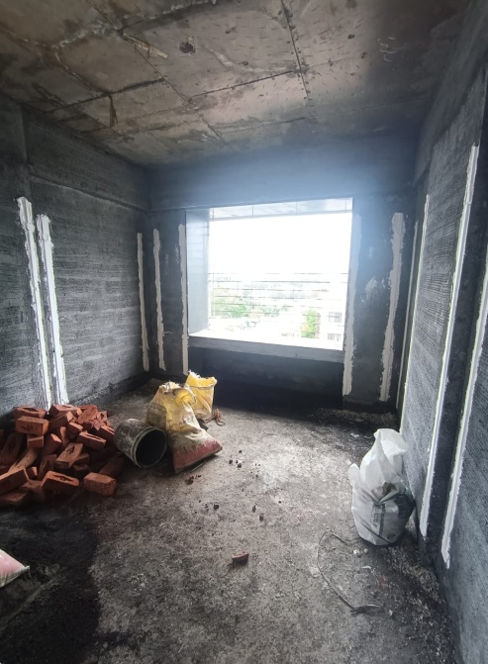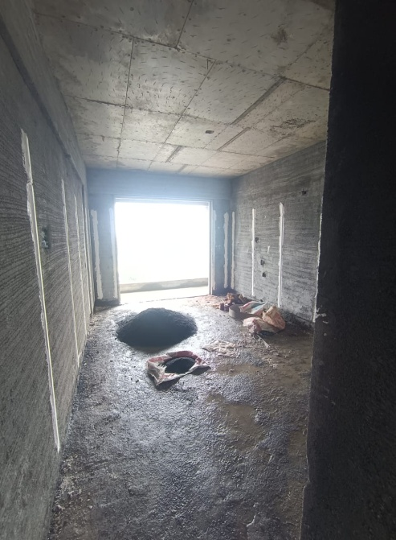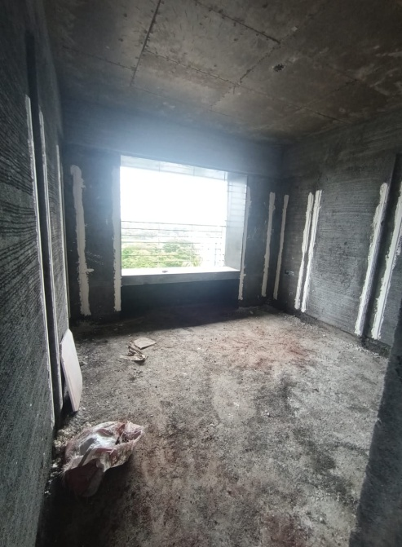

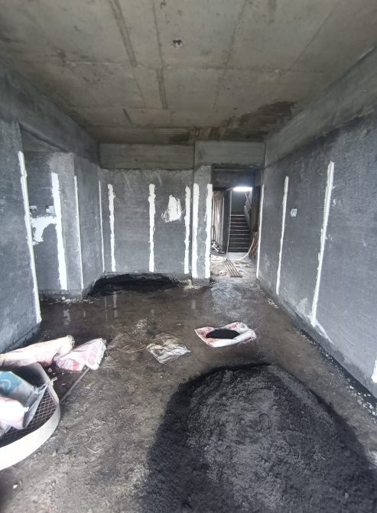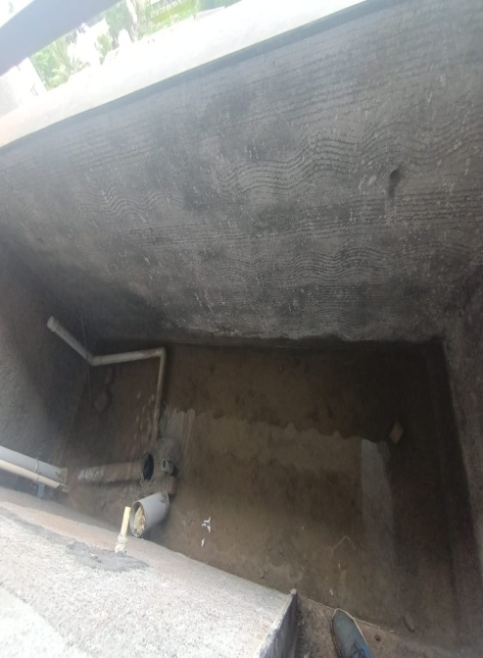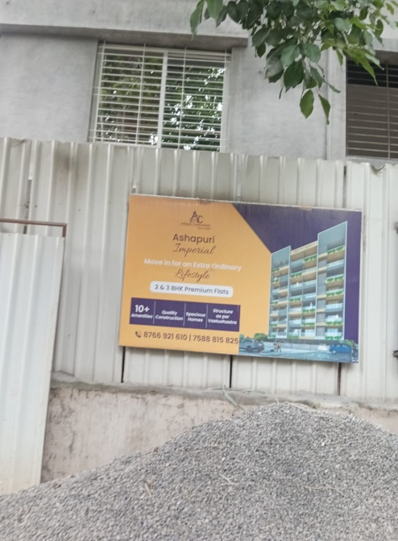



**Route Map of the property**

**Site u/r**

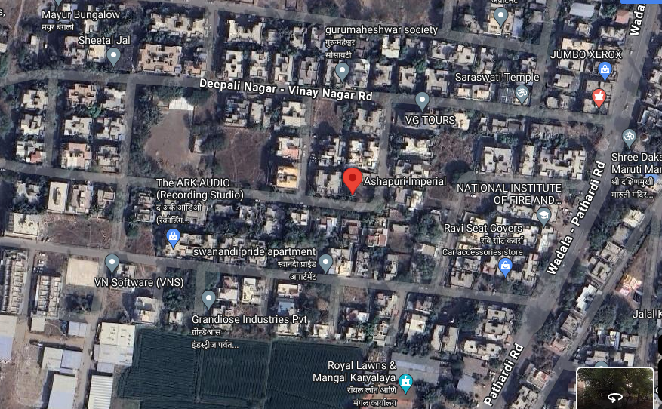

# 

# **Longitude Latitude: 19°58'48.5"N 73°47'22.2"E**

# **Note:** The Blue line shows the route to site from nearest railway station (Nashik–8.7 Km.)

**Ready Reckoner Rate**

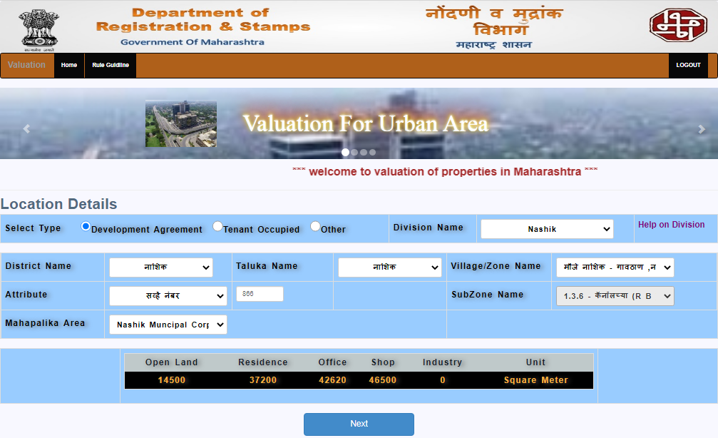

**Price Indicators**

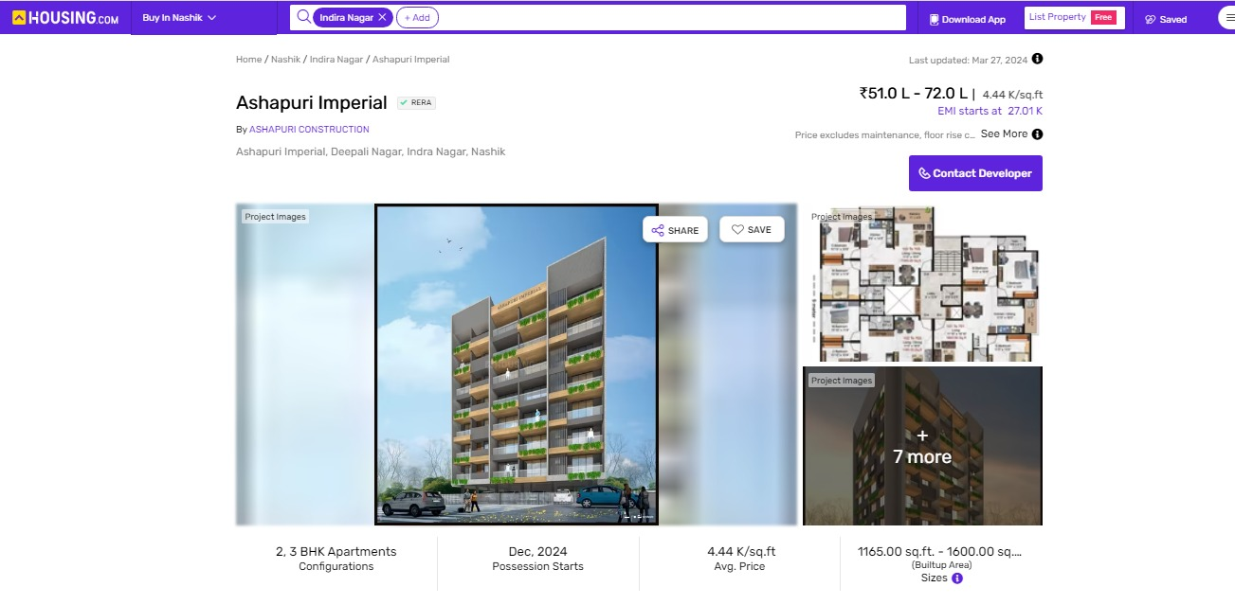

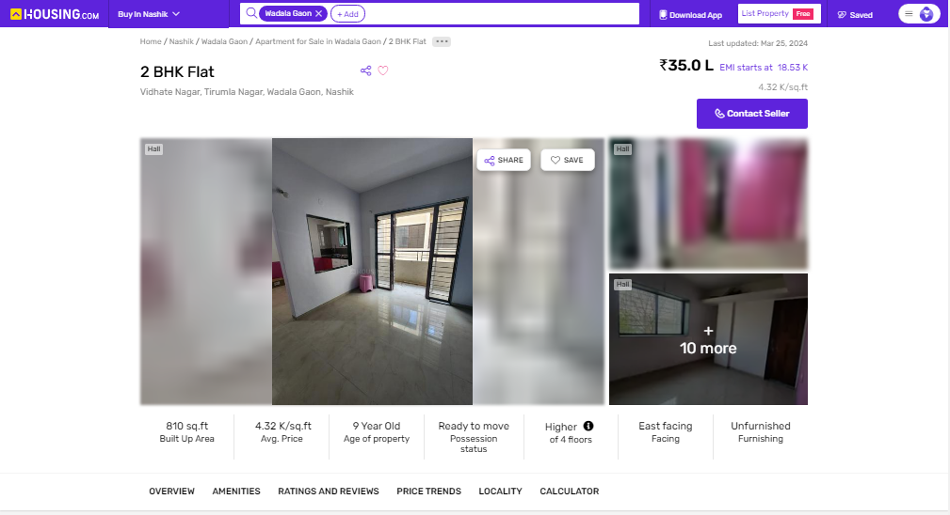

**Price Indicators**

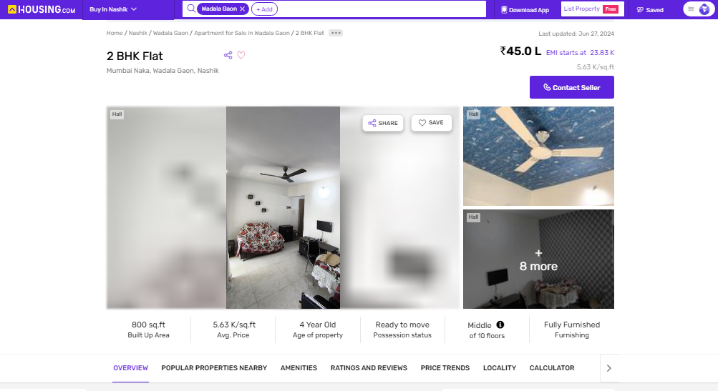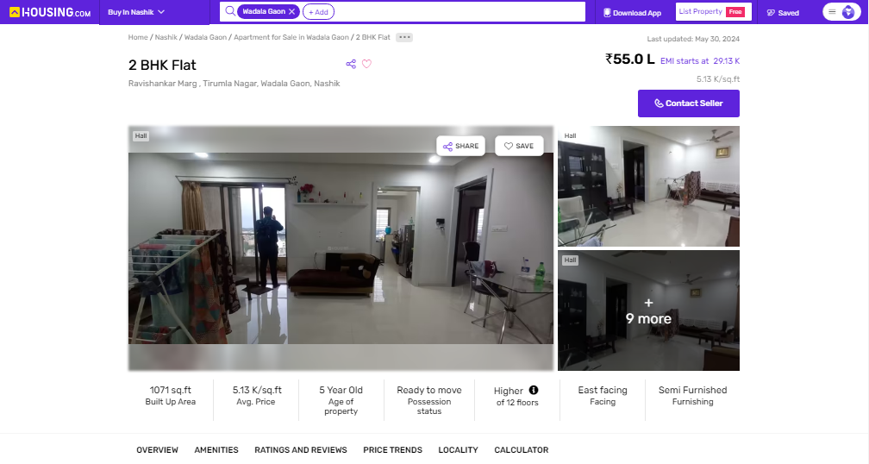

As a result of my appraisal and analysis, it is my considered opinion that the present fair market value of the above property in the prevailing condition with aforesaid specifications is **` 50,19,500.00 (Rupees Fifty Lakh Nineteen Thousand Five Hundred Only).**The Realizable Value of the above property is**` 47,68,525.00 (Rupees Forty Seven Lakh Sixty Eight Thousand Five Hundred Twenty Five Only).** And the distress value **` 40,15,600.00 (Rupees Forty Lakh Fifteen Thousand Six Hundred Only).**

Place :Nashik

Date :17.07.2024

**Sharadkumar B. Chalikwar**

Govt. Reg. Valuer

Chartered Engineer (India)

Reg. No. (N) CCIT/1-14/52/2008-09

The undersigned has inspected the property detailed in the Valuation Report dated _______________________

on ____________________. We are satisfied that the fair and reasonable market value of the property is`_________________________ (Rupees ________________________________________________________

________________________________________only).

Date

Signature

(Name & Designation of the Inspecting Official/s)

Countersigned

(BRANCH MANAGER)

|  |  |
| --- | --- |
| **Enclosures** | |
| Declaration from the valuer (Annexure – I) | Attached |
| Model code of conduct for valuer (Annexure – II) | Attached |

(**Annexure – I)**

**DECLARATION FROM VALUERS**

I, hereby declare that:

1. The information furnished in my valuation report dated 17.07.2024 is true and correct to the best of my knowledge and belief and I have made an impartial and true valuation of the property.
2. I have no direct or indirect interest in the property valued;
3. I/ my authorized representative have personally inspected the property on 17.07.2024. The work is not sub - contracted to any other valuer and carried out by myself.
4. I have not been convicted of any offence and sentenced to a term of imprisonment.
5. I have not been found guilty of misconduct in my professional capacity.
6. I have read the Handbook on Policy, Standards and procedure for Real Estate Valuation, 2011 of the IBA and this report is in conformity to the "Standards" enshrined for valuation in the Part - B of the above handbook to the best of my ability.
7. I have read the International Valuation Standards (IVS) and the report submitted to the Bank for the respective asset class is in conformity to the "Standards" as enshrined for valuation in the IVS in "General Standards" and "Asset Standards" as applicable.
8. I abide by the Model Code of Conduct for empanelment of valuer in the Bank. (Annexure IV - A signed copy of same to be taken and kept along with this declaration)
9. I am Director of the company, who is competent to sign this valuation report.

Further, I hereby provide the following information.

|  |  |  |
| --- | --- | --- |
| **Sr.**  **No.** | **Particulars** | **Valuer comment** |
|  | Background information of the asset being valued; | The property under consideration was purchased by Mr. Hiraman Govind Thakare & Mrs. Prabhavati Hiraman Thakare from M/s. Rishi Builders & Developers vide Agreement For Sale No. 6643/ 2024 Dated.02.07.2024. |
|  | Purpose of valuation and appointing authority | As per the request from Union Bank of India, Govind Nagar Branch, to assess fair market value of the property for Banking purpose |
|  | Identity of the valuer and any other experts involved in the valuation; | Sharadkumar B. Chalikwar – Regd. Valuer  Sanjay R. Phadol- Regional Technical Head  Swapnil Wagh – Valuation Engineer  Shobha Kuperkar- Technical Manager  Rishidatt Yadav- Technical Officer |
|  | Disclosure of valuer interest or conflict, if any; | We have no interest, either direct or indirect, in the property valued. Further to state that we do not have relation or any connection with property owner / applicant directly or indirectly. Further to state that we are an independent Valuer and in no way related to property owner / applicant |
|  | Date of appointment, valuation date and date of report; | Date of Appointment – 17.07.2024  Valuation Date – 17.07.2024  Date of Report – 17.07.2024 |
|  | Inspections and/or investigations undertaken; | Physical Inspection done 17.07.2024 |
|  | Nature and sources of the information used or relied upon; | * Market Survey at the time of site visit * Ready Reckoner rates / Circle rates * Online search for Registered Transactions * Online Price Indicators on real estate portals * Enquiries with Real estate consultants * Existing data of Valuation assignments carried out by us |
|  | Procedures adopted in carrying out the valuation and valuation standards followed; | Sales Comparison Method |
|  | Restrictions on use of the report, if any; | This valuation is for the use of the party to whom it is addressed and for no other purpose. No responsibility is accepted to any third party who may use or rely on the whole or any part of this valuation. The valuer has no pecuniary interest that would conflict with the proper valuation of the property. |
|  | major factors that were taken into account during the valuation; | current market conditions, demand and supply position, Residential Flat size, location, upswing in real estate prices, sustained demand for Residential Flat, all round development of Residential and residential application in the locality etc. |
|  | Caveats, limitations and disclaimers to the extent they explain or elucidate the limitations faced by valuer, which shall not be for the purpose of limiting his responsibility for the valuation report. | Attached |

**Assumptions, Disclaimers, Limitations & Qualifications**

**Value Subject to Change**

The subject appraisal exercise is based on prevailing market dynamics as on **17th July 2024** and does not take into account any unforeseeable developments which could impact the same in the future.

**Our Investigations**

We are not engaged to carry out all possible investigations in relation to the subject property. Where in our report we identify certain limitations to our investigations, this is to enable the reliant party to instruct further investigations where considered appropriate or where we recommend as necessary prior to reliance. Vastukala Consultants India Pvt. Ltd. (VCIPL) is not liable for any loss occasioned by a decision not to conduct further investigations

**Assumptions**

Assumptions are a necessary part of undertaking valuations. VCIPL adopts assumptions for the purpose of providing valuation advise because some matters are not capable of accurate calculations or fall outside the scope of our expertise, or out instructions. The reliant party accepts that the valuation contains certain specific assumptions and acknowledge and accept the risk of that if any of the assumptions adopted in the valuation are incorrect, then this may have an effect on the valuation.

**Information Supplied by Others**

The appraisal is based on the information provided by the client. The same has been assumed to be correct and has been used for appraisal exercise. Where it is stated in the report that another party has supplied information to VCIPL, this information is believed to be reliable but VCIPL can accept no responsibility if this should prove not to be so.

**Future Matters**

To the extent that the valuation includes any statement as to a future matter, that statement is provided as an estimate and/or opinion based on the information known to VCIPL at the date of this document. VCIPL does not warrant that such statements are accurate or correct.

**Map and Plans**

Any sketch, plan or map in this report is included to assist the reader while visualising the property and assume no responsibility in connection with such matters.

**Site Details**

Based on inputs received from Client's representative and site visit conducted, we understand that the subject property is Residential Flat, admeasuring **765.00 Sq. ft. Carpet Area** in the **Name of Owner: Mr. Hiraman Govind Thakare & Mrs. Prabhavati Hiraman Thakare.** Further, VCIPL has assumed that the subject property is free from any encroachment and is available as on the date of the appraisal.

**Property Title**

Based on our discussion with the Client, we understand that the subject property is owned by**Name of Owner: Mr. Hiraman Govind Thakare & Mrs. Prabhavati Hiraman Thakare.** For the purpose of this appraisal exercise, we have assumed that the subject property has a clear title and is free from any encumbrances, disputes and claims. VCIPL has made no further enquiries with the relevant local authorities in this regard and does not certify the property as having a clear and marketable title. Further, no legal advice regarding the title and ownership of the subject property has been obtained for the purpose of this appraisal exercise. It has been assumed that the title deeds are clear and marketable.

**Environmental Conditions**

We have assumed that the subject property is not contaminated and is not adversely affected by any existing or proposed environmental law and any processes which are carried out on the property are regulated by environmental legislation and are properly licensed by the appropriate authorities.

**Town Planning**

The permissible land use, zoning, achievable FSI, area statement adopted for purpose of this valuation is based on the information provided by the Client's representative and the same has been adopted for this valuation purpose. VCIPL has assumed the same to be correct and permissible. VCIPL has not validated the same from any authority.

**Area**

Based on the information provided by the Client's representative, we understand that the subject property is Residential Flat, admeasuring **Total Carpet Area in Sq. Ft. = 765.00.**

.

**Condition & Repair**

In the absence of any information to the contrary, we have assumed that there are no abnormal ground conditions, nor archaeological remains present which might adversely affect the current or future occupation, development or value of the property. The property is free from rat, infestation, structural or latent defect. No currently known deleterious or hazardous materials or suspect techniques will be used in the construction of or subsequent alteration or additions to the property and comments made in the property details do not purport to express an opinion about, or advise upon, the condition of uninspected parts and should not be taken as making an implied representation or statement about such parts

**Valuation Methodology**

For the purpose of this valuation exercise, the valuation methodology used is Direct Comparison Approach Method and proposed Highest and Best Use model is used for analysing development potential.

The Direct Comparison Approach involves a comparison of the property being valued to similar properties that have actually been sold in arms - length transactions or are offered for sale. This approach demonstrates what buyers have historically been willing to pay (and sellers willing to accept) for similarproperties in an open and competitive market and is particularly useful in estimating the value of the land and properties that are typically traded on a unit basis.

In case of inadequate recent transaction activity in the subject micro-market, the appraiser would collate details of older transactions. Subsequently, the appraiser would analysed rental / capital value trends in the subject micro-market in order to calculate the percentage increase / decrease in values since the date of the identified transactions. This percentage would then be adopted to project the current value of the same.

Where reliance has been placed upon external sources of information in applying the valuation methodologies, unless otherwise specifically instructed by Client and/or stated in the valuation, VCIPL has not independently verified that information and VCIPL does not advise nor accept it as reliable. The person or entity to whom the report is addressed acknowledges and accepts the risk that if any of the unverified information in the valuation is incorrect, then this may have an effect on the valuation.

**Not a Structural Survey**

We state that this is a valuation report and not a structural survey

**Other**

All measurements, areas and ages quoted in our report are approximate

**Legal**

We have not made any allowances with respect to any existing or proposed local legislation relating to taxation on realization of the sale value of the subject property. VCIPL is not required to give testimony or to appear in court by reason of this appraisal report, with reference to the property in question, unless arrangement has been made thereof. Further, no legal advice on any aspects has been obtained for the purpose of this appraisal exercise

Property specific assumptions

Based on inputs received from the client and site visit conducted, we understand that the subject property is Residential Flat, admeasuring **Total Carpet Area in Sq. Ft. = 765.00.**

**Sharadkumar B. Chalikwar**

Govt. Reg. Valuer

Chartered Engineer (India)

Reg. No. (N) CCIT/1-14/52/2008-09