COST VETTING REPORT
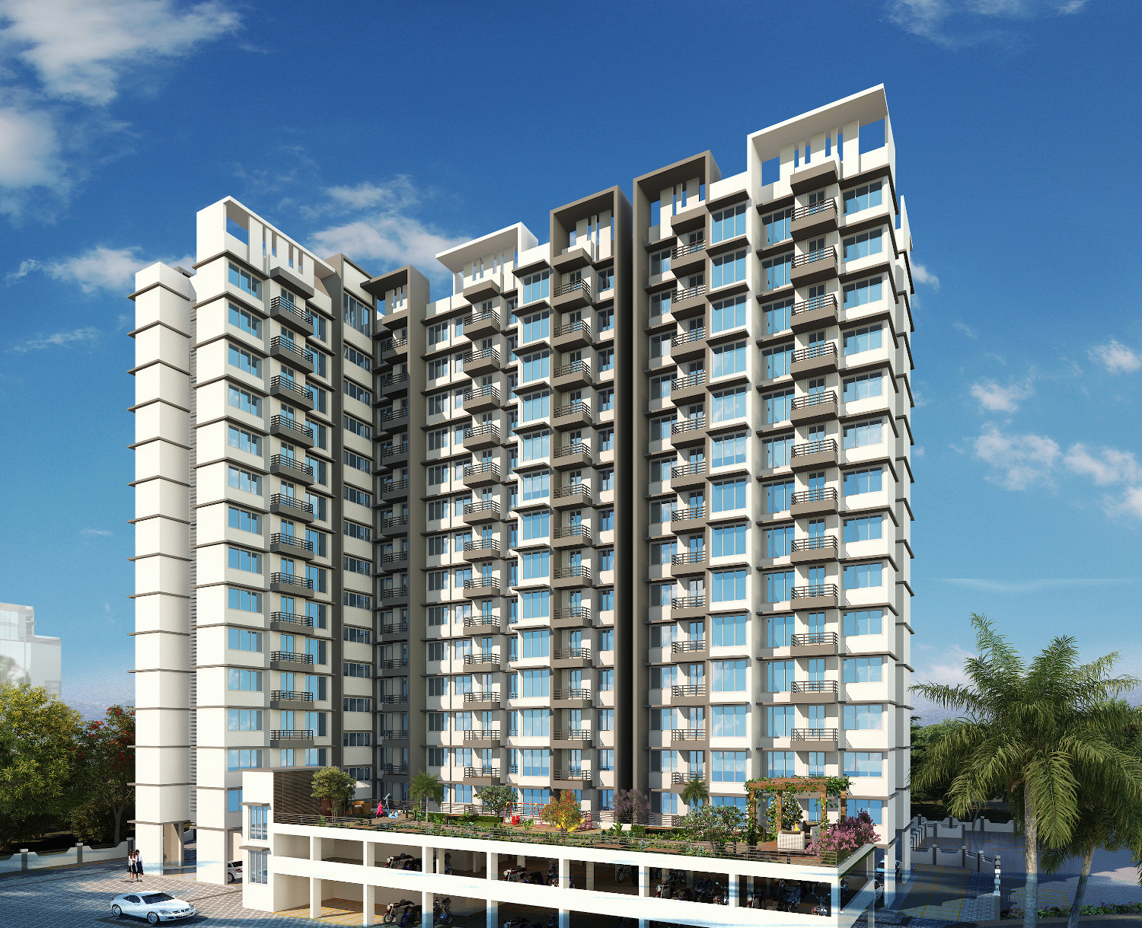

Details of the property under consideration:

Name of Project: "Vrindavan City”

"Vrindavan City”, Wing A & B, Proposed Residential & Commercial Complex on Plot Bearing S. No. 6,
H. No. 1A, 1B, 2, 3, 4 & 5, Village – Vadavali, Taluka – Kalyan, District – Thane, Pin Code – 401 207,
State – Maharashtra, Country – India

Latitude Longitude: 19°16'02.0"N 73°10'00.5"E

Valuation Done for:
State Bank of India
Industrial Finance Branch, Malad (West)
Industrial Finance Branch, Near Chincholi Phatak Signal, S. V. Road,
Malad (West), Mumbai - 400 064, State - Maharashtra, Country – India.

Vastu/SBI/Mumbai/07/2024/9676/2306570
03/02-14-PY
Date: 16.07.2024

To,
The Branch Manager,
State Bank of India
Industrial Finance Branch, Malad (West)
Industrial Finance Branch, Near Chincholi Phatak Signal,
S. V. Road, Malad (West), Mumbai - 400 064,
State - Maharashtra, Country – India.

Sub: Cost Vetting Report for "Vrindavan City”, Wing A & B, Vadavali, Pin Code – 401 207.

Dear Sir,
In accordance with your letter of engagement as stated above, we enclose our Report on Cost Vetting for "Vrindavan City”, Wing A & B, Proposed Residential & Commercial Complex on Plot Bearing S. No. 6, H. No. 1A, 1B, 2, 3, 4 & 5, Village – Vadavali, Taluka – Kalyan, District – Thane, Pin Code – 401 207, State – Maharashtra, Country – India
Mr. Mohd. Salim Yusuf is proposing Residential & Commercial Complex on Plot Bearing S. No. 6, H. No. 1A, 1B, 2, 3, 4 & 5, Village – Vadavali, Taluka – Kalyan, District – Thane, Pin Code – 401 207, State – Maharashtra, Country – India. Project is comprising Sale Building (Wing A to G) & Club House.
Residential of Sale Building (Wing A & B) is proposed of Ground Floor + 1st to 14th Upper Floors with total RERA carpet area of 70,974.90 Sq. Ft. which consists 1 BHK & 2 BHK with 148 nos. of Sell flats & 20 nos. of landlord’s flats providing with Club House, Fitness Centre, Society Office, & Other Amenities.
In this regard, SBI, Industrial Finance Branch, Malad (West), Industrial Finance Branch, Near Chincholi Phatak Signal, S. V. Road, Malad (West), Mumbai - 400 064 has approached Vastukala Consultants (I) Pvt. Ltd. (VCIPL) to conduct a Cost Vetting of the said project.
Our analysis of the cost vetting is enclosed in this report. This Report forms an integral whole and cannot be split in parts. The outcome of the report/ study can only lead to proper conclusions if the Report as a whole is taken into account.

The information used by Vastukala Consultants (I) Pvt. Ltd. (VCIPL) in preparing this report has been obtained from a variety of sources and other relevant documents provided by the client & bank. As agreed, we have performed our cost vetting exercise with the data available related to the business, considering the market prospects and projections. Our results are dependent on documents provided by client & bank, the underlying assumptions, which has been analyzed at a broader level by VCIPL while assessing their reasonableness.
Total Project Cost for the completion of Project will be ` 28.84 Cr.

For Vastukala Consultants (I) Pvt. Ltd.

Manoj B. Chalikwar
Registered Valuer
Chartered Engineer (India)
Reg. No. IBBI / RV / 07/2018/10366
Reg. No. CAT-I-F-1763
SBI Empanelment No.: SME/TCC/38/IBBI/3
About the Project:
Proposed Residential & Commercial Complex on Plot Bearing S. No. 6, H. No. 1A, 1B, 2, 3, 4 & 5, Village – Vadavali, Taluka – Kalyan, District – Thane, Pin Code – 401 207, State – Maharashtra, Country – India. It is about 850 M. travelling distance from Ambivli Railway station.

Area Statement as per Approved Plan
A. Area Statement |  | In Sq. M.
1 | Area of Plot (Minimum area of a, b, c, to be considered)
 | a) As per ownership document (As per 7/12) | 14,260.00
 | b) As per measurement sheet.
 | c) As per site.
2 | Deduction For
 | a) Proposed D.P. / D.P. Road widening area / Service Road / Highway widening (18.00 M. wide D.P. Road) | 788.00
 | b) Any D.P. Reservation area
 | Total (a + b) | 788.00
3 | Balance Area of Plot (1 - 2) | 13,472.00
4 | Amenity Space (if Applicable)
 | a) Required
 | b) Adjustment of 2 (b), if any.
 | c) Balanced Proposed
5 | Net plot Area (3 - 4(c)) | 13,472.00
6 | Recreational Open Space (if applicable)
 | a) required | 1,347.20
 | b) proposed | 1,461.80
7 | Internal Road Area
8 | Plotable area (if Applicable) | 13,472.00
9 | Built up area with reference to Basic F.S.I. as per front road width ( Sr. No. 5 x basic FSI ) (13472.00 x 1.1 ) | 14,819.20
10 | Additional of FSI on payment of premium
 | a) Maximum Permissible premium FSI based on road width/TOD zone. | 7,130.00
 | b) Proposed FSI on payment of premium. | 3,900.00
11 | In-situ FSI/TDR loading
 | a) In-situ area against D. P. Road (2.0 x Sr. No. 2 (a)), if any | 788.00
 | b) In-situ area against Amenity Space if handed over ( 2.0 or 1.85 x Sr. No. 4 (b) and / or ( c))
 | c) T.D.R.
 | d) Total in-situ FSI/TDR loading proposed (11 (a) + (b)) | 788.00
12 | Additional FSI area under Chapter No. 7
13 | Total entitlement of FSI in the proposal.
 | a) 9 + 10 (b) + 11 (d) or 12 whichever is applicable | 19,507.20
 | b) Ancillary area FSI upto 60% or 80% with payment of charges | 41,704.32
 | c) Total entitlement (a + b) | 31,211.52
14 | Maximum utilization of limit of FSI (building potential) Permissible as per Road width (as per Regulation no. 6.1 or 6.2 or 6.3 or 6.4 as applicable) x (1.6 or 1.8) | 4.00
15 | Total Built up Area in proposal (excluding area at Sr. No. 17b)
 | a) Existing Built up Area
 | b) Proposed Built up Area (as per 'P-Line') | 31,138.95
 | c) Total (a + b) | 31,138.95
16 | F.S.I. Consumed (15/13) (should not be more than sr. no. 14 above) | 0.99
17 | Area for Inclusive Housing, If any
 | a) Required (20% of Sr. No. 5) | 2,963.84
 | b) Proposed | 2,970.15

Construction Area as per Approved Plan for Sale Building

Sale Building (Wing A):
Sr. No | Floors | Built Up Area in Sq. M. | Other Area in Sq. M. | Refuge Area in Sq. M. | Stilt Area in Sq. M. | Total Area in Sq. M.
1 | Ground Floor | 29.92 | - | - | 324.87 | 354.79
2 | 1st Floor | 344.60 | 10.19 | - | - | 354.79
3 | 2nd Floor | 344.60 | 10.19 | - | - | 354.79
4 | 3rd Floor | 344.60 | 10.19 | - | - | 354.79
5 | 4th Floor | 344.60 | 10.19 | - | - | 354.79
6 | 5th Floor | 344.60 | 10.19 | - | - | 354.79
7 | 6th Floor | 344.60 | 10.19 | - | - | 354.79
8 | 7th Floor | 344.60 | 10.19 | - | - | 354.79
9 | 8th Floor | 344.60 | 10.19 | 23.96 | - | 378.75
10 | 9th Floor | 344.60 | 10.19 | - | - | 354.79
11 | 10th Floor | 344.60 | 10.19 | - | - | 354.79
12 | 11th Floor | 344.60 | 10.19 | - | - | 354.79
13 | 12th Floor | 344.60 | 10.19 | 23.96 | - | 378.75
14 | 13th Floor | 344.60 | 10.19 | - | - | 354.79
15 | 14th Floor | 344.60 | 10.19 | - | - | 354.79
16 | Terrace | - | 43.96 | - | - | 43.96
Total |  | 4,854.32 | 186.62 | 47.92 | 324.87 | 5,413.73

Sale Building (Wing B):
Sr. No | Floors | Built Up Area in Sq. M. | Other Area in Sq. M. | Refuge Area in Sq. M. | Stilt Area in Sq. M. | Total Area in Sq. M.
1 | Ground Floor | 28.43 | - | - | 359.60 | 388.03
2 | 1st Floor | 347.81 | 40.22 | - | - | 388.03
3 | 2nd Floor | 347.81 | 18.41 | - | - | 366.22
4 | 3rd Floor | 347.81 | 18.41 | - | - | 366.22
5 | 4th Floor | 347.81 | 18.41 | - | - | 366.22
6 | 5th Floor | 347.81 | 18.41 | - | - | 366.22
7 | 6th Floor | 347.81 | 18.41 | - | - | 366.22
8 | 7th Floor | 347.81 | 18.41 | - | - | 366.22
9 | 8th Floor | 347.81 | 18.41 | 21.82 | - | 388.04
10 | 9th Floor | 347.81 | 18.41 | - | - | 366.22
11 | 10th Floor | 347.81 | 18.41 | - | - | 366.22
12 | 11th Floor | 347.81 | 18.41 | - | - | 366.22
13 | 12th Floor | 347.81 | 18.41 | 21.82 | - | 388.04
14 | 13th Floor | 347.81 | 18.41 | - | - | 366.22
15 | 14th Floor | 347.81 | 18.41 | - | - | 366.22
16 | Terrace | - | 58.80 | - | - | 58.80
Total |  | 4,897.77 | 338.35 | 43.64 | 359.60 | 5,639.36

Total Construction Area (Wing A & B):
Sr. No | Floors | Built Up Area in Sq. M. | Other Area in Sq. M. | Refuge Area in Sq. M. | Stilt Area in Sq. M. | Total Area in Sq. M.
1 | Ground Floor | 58.35 | - | - | 684.47 | 742.82
2 | 1st Floor | 692.41 | 50.41 | - | - | 742.82
3 | 2nd Floor | 692.41 | 28.60 | - | - | 721.01
4 | 3rd Floor | 692.41 | 28.60 | - | - | 721.01
5 | 4th Floor | 692.41 | 28.60 | - | - | 721.01
6 | 5th Floor | 692.41 | 28.60 | - | - | 721.01
7 | 6th Floor | 692.41 | 28.60 | - | - | 721.01
8 | 7th Floor | 692.41 | 28.60 | - | - | 721.01
9 | 8th Floor | 692.41 | 28.60 | 45.78 | - | 766.79
10 | 9th Floor | 692.41 | 28.60 | - | - | 721.01
11 | 10th Floor | 692.41 | 28.60 | - | - | 721.01
12 | 11th Floor | 692.41 | 28.60 | - | - | 721.01
13 | 12th Floor | 692.41 | 28.60 | 45.78 | - | 766.79
14 | 13th Floor | 692.41 | 28.60 | - | - | 721.01
15 | 14th Floor | 692.41 | 28.60 | - | - | 721.01
16 | Terrace | - | 102.76 | - | - | 102.76
Total |  | 9,752.09 | 524.97 | 91.56 | 684.47 | 11,053.09

Project Cost
Sr. No. | Particulars | Total Estimated Amount in ` | Total Estimated Amount  in ` Cr.
1 | Land Cost
 | Acquisition Cost of Land or Development Rights, and Legal Cost. | 51,33,885.00 | 0.51
 | Rent to Tenants, Lease premium, Lease Rent, interest cost incurred or payable on Land Cost | 3,41,17,654.00 | 3.41
 | Amount of Premium payable to obtain development rights, FSI, additional FSI, fungible area, and any other incentive under DCR from Local Authority or State Government or any Statutory Authority. | 6,44,00,000.00 | 6.44
 | Acquisition cost of TDR (if any) | 2,62,00,000.00 | 2.62
2 | Cost of Construction
 | Estimated construction cost of rehab cum sale building including site development and infrastructure for the same. | 11,56,14,090.00 | 11.56
 | On site expenditure for development of entire project excluding cost of construction as per(i) above,
a. | Architect Fees & Consultant fees | 57,80,705.00 | 0.58
b. | Admin Cost includes salaries, site overheads, development works, cost of services (including water, electricity, sewerage, drainage, layout roads etc.), cost of machineries and equipment including its hire and maintenance cost, consumables etc. All costs directly incurred to complete the construction of the entire phase of the project registered. | 46,24,564.00 | 0.46
c. | Marketing Cost | 77,37,785.00 | 0.77
3 | Interest during the Project | 2,13,00,000.00 | 2.13
4. | Contingency Charges | 34,68,423.00 | 0.35
 | GRAND TOTAL: | 28,83,77,107.00 | 28.84

Manoj B. Chalikwar
Registered Valuer
Chartered Engineer (India)
Reg. No. IBBI / RV / 07/2018/10366
Reg. No. CAT-I-F-1763
SBI Empanelment No.: SME/TCC/38/IBBI/3
Comments on each element of Cost of Project: -
- Land Cost:
As per Present Ready Reckoner rate the Project Land Value is ` 0.89 Cr. considering Land Rate @ ` 660.00 per Sq. M. & Net Plot Area of 13,472.00 Sq. M.
As per document purchase cost of land & stamp duty cost is ` 48,31,460.00 i.e., ` 0.48 Cr. which is 1.07% of Total Project Cost.
Sr. No. | Date | Document Name | Description | Total Cost in ` | Incurred Cost in `
1 | 29/01/2011 | Developer Agreement | Stamp Duty | 48,00,000.00 | 48,00,000.00
2 | 29/01/2011 | Developer Agreement | Reg. Fees | 30,000.00 | 30,000.00
3 | 29/01/2011 | Developer Agreement | Reg. Fees | 1,460.00 | 1,460.00
TOTAL |  |  |  | 48,31,460.00 | 48,31,460.00

- Building Cost of Construction for Sale Building:
Total Construction Area of Sale Building = 11,053.09 Sq. M. i.e., 1,18,975.46 Sq. Ft.
Total estimated cost for construction of Building (includes cost of RCC work, manpower, lift, material, painting, finishing work, site development, etc.) is ` 27,63,27,250.00 i.e., ` 27.63 Cr. which comes ` 25,000.00 per Sq. M. on construction area for building, deep excavation & piling cost is ` 2,76,32,725.00 i.e., ` 2.76 Cr. which comes 10% of cost of construction.
Hence, total construction cost (Cost of construction of building + Cost of Deep Excavation Cost) (` 27,63,27,250.00 + ` 2,76,32,725.00) = ` 30,39,59,975.00 i.e., ` 30.40 Cr.
The total construction area is 11,053.09 Sq. M. i.e., 1,18,975.46 Sq. Ft., projected cost of ` 30.40 Cr is 67.36% of total project cost
VCIPL opinion the construction cost of 25,000/- Per Sq. M. which is in line with Market-Trend.
Particulars | Rate per Sq. Ft
Excavation Work | 1,500.00
Total RCC Work | 12,000.00
Final Finishing Work | 6,000.00
Other Work | 5,500.00
Cost of Construction | 25,000.00
Deep Excavation & Piling Cost | 10% of Cost of Construction

- Approval Charges:
The Total Approval Cost (Fungible Cost & Development Cess Premium Cost) as per architect letter will be ` 3,99,79,757.00 i.e., ` 4.00 Cr. which is 8.86% of Total Project Cost.
As per receipt received from KDMC Authority.
Sr. No. | Particulars | Estimated Cost in `
1 | 1st Installment Payment | 1,94,85,955.00
2 | 2nd Installment Payment | 1,07,02,272.00
3 | 3rd Installment Payment | 97,91,530.00
Total Estimated Approval Cost |  | 3,99,79,757.00

- Architect Cost, RCC & Other Professional Charges:
The total Architect charges of ` 1,51,97,999.00 i.e., ` 1.52 Cr. is 5.0% of total construction cost building & it is line up with Market trend.
The professional charge consists of Architect & Legal which in market is in the range of 2% - 5% of Total Construction cost of the project.

- Administrative Expenses:
Salaries, site overheads, development works, cost of services (including water, electricity, sewerage, drainage, layout roads etc.), cost of machineries and equipment including its hire and maintenance cost, consumables etc. All costs directly incurred to complete the construction of the entire phase of the project registered is estimated 6% of total construction cost Building which comes to ` 1,82,37,599.00 i.e., ` 1.82 Cr.
The admin charges which in market is in the range of 4% - 6% of Total Construction cost of the project.

- Marketing Expenses:
Marketing costs directly incurred to complete the construction of the entire phase of the project registered is estimated at 3% of total Sale income from the project which comes to ` 1,58,07,036.00 i.e., ` 1.58 Cr.
The marketing charge consists of brokerage & commission which in market is in the range of 1% - 3% of Total Sale income of the property.

- Interest Costs:
The Interest cost for the term loan is ` 4,41,00,000.00 i.e., ` 4.41 Cr., which is 9.77% of total project cost.
As per information provided by the client.

- Contingency Costs:
The contingency charges estimated at 3% of total cost of construction which comes to ` 91,18,799.00 i.e., ` 0.91 Cr.
Observation and Construction: -
Total estimated cost of project i.e., ` 28,83,77,104.00 (Rupees Twenty – Eight Crore Eighty – Three Lakh Seventy – Seven Thousand One Hundred Four Only) i.e., ` 28.84 Cr. is fair & reasonable.
The project cost is including land premium payable to concern authorities, Rent Cost, TDR Cost, Fungible FSI Premium, Cost of Construction of Sale Building, professional charges on site expenses including admin & marketing expenses, premiums / charges to be paid to competent authority and Bank interest, etc. we have not independently verified interest cost hence not consider in cost vetting.
As per present sanctioned building plan, permissible built-up area on the said plot is 31,138.95 Sq. M. The sale building (Wing A & B) is presently approved for Ground Floor + 1st to 14th Upper Floors only. Estimated cost of entire project of 14th upper floors are considered.
Total estimated cost of construction of Sales building is ` 27,63,27,250.00 i.e., ` 27.63 Cr. which comes ` 25,000.00 per Sq. M. on construction area for building, deep excavation & piling cost is ` 2,76,32,725.00 i.e., ` 2.76 Cr. which comes 10% of cost of construction. Hence, total construction cost (Cost of construction of building + Cost of Deep Excavation Cost) (` 27,63,27,250.00 + ` 2,76,32,725.00) = ` 30,39,59,975.00 i.e., ` 30.40 Cr., which is fair & reasonable considering the present status of project, type & quality of construction & specification of the building materials to be used, height of the structure, amenities to be provided in proposed building.

Assumptions & Remarks-
- The adequacy of Engineering / Structural design is beyond the scope of our assignment.
- Estimated project completion date is 01/03/2028. The cost is certified based on the assumptions that the project will be completed within time frame. Few assumptions are made regarding inflation & cost rise etc. during construction period.

Photo copy of following document is provided to us & this report should be read along with it:
- Copy of Developer Agreement dated 29.12.2010 between Shri. Shivram Gangaram Tare & Others (Landlords) and M/s. M. S. Developers (Developers) through registered agreement Doc. No. KLN-2/957/2011 dated 03.03.2011.
- Copy of Approved Plan Building Permit No. KDMC/TPD/BP/KD/2022-23/79 dated 09.01.2023 issued by Kalyan Dombivali Municipal Corporation (KDMC).
Approved upto:
Wing A to F – Ground Floor + 1st to 14th Upper Floors
Wing G – Stilt (Part) Floor + Ground (Part) Floor + 1st & 2nd Commercial Floor + 3rd to 14th Residential Upper Floors
Club House – Ground Floor + 1st Upper Floor
Podium 1 & 2 – Stilt Floor + 1st Floor
- Copy of Commencement Certificate Office No. KDMC/TPD/BP/KD/2022-23/79 dated 09.01.2023 issued by Kalyan Dombivali Municipal Corporation (KDMC).
Sanctioned Upto:
Wing A to F – Ground Floor + 1st to 14th Upper Floors
Wing G – Stilt (Part) Floor + Ground (Part) Floor + 1st & 2nd Commercial Floor + 3rd to 14th Residential Upper Floors
Club House – Ground Floor + 1st Upper Floor
Podium 1 & 2 – Stilt Floor + 1st Floor
- Copy of Environment Clearance Certificate EC Identification ID No. EC22B038MH137260 & File NO. SIA/MH/MIS/S/259513/2022 dated 06.08.2022 issued State Environment Impact Assessment Authority (SEIAA) Maharashtra.
- Copy of CA (Form 3) Certificate dated 12.04.2024 issued by M/s. Dilip Bramhecha & Associates.
- Copy of RERA Certificate RERA No. P51700050781 dated 03.05.2023 issued by Maharashtra Real Estate Regulatory Authority (MAHRERA).
- Copy of Architect (Form 1) Certificate dated 30.03.2024 issued by M/s. Creations Architects & Interior Designers.

Actual Site Photographs
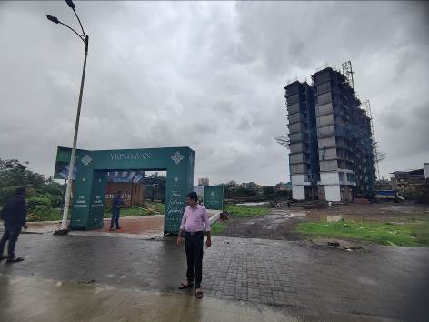
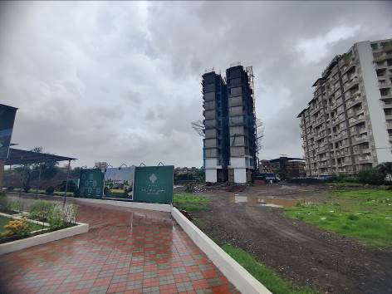
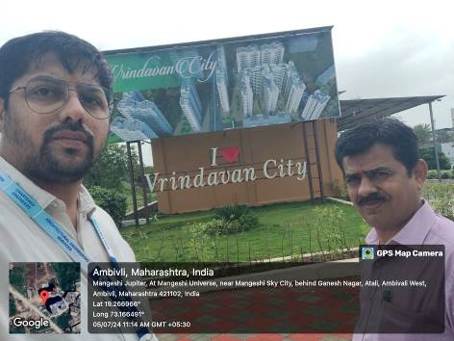
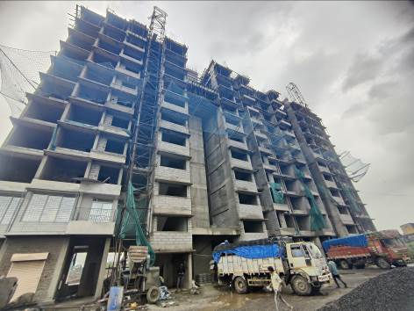
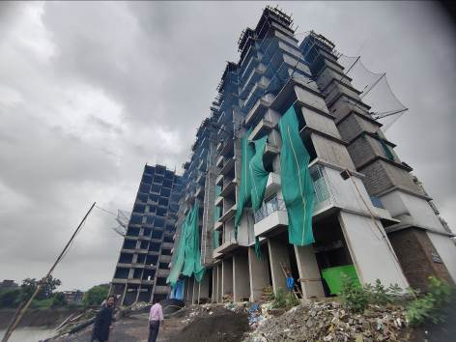
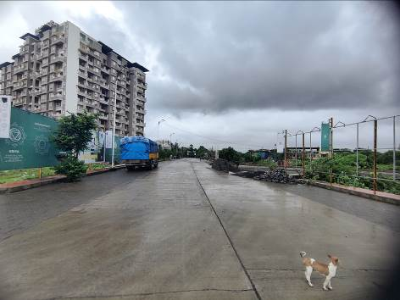

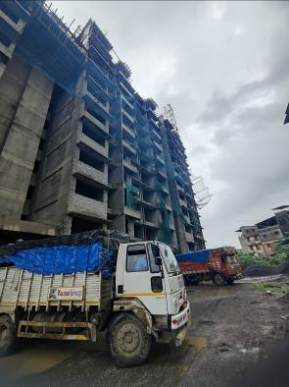
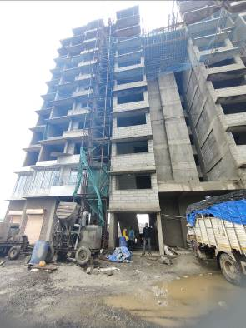
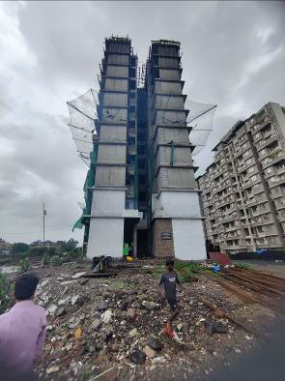
Actual Site Photographs
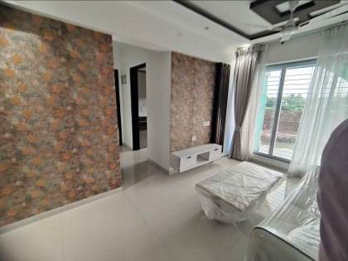
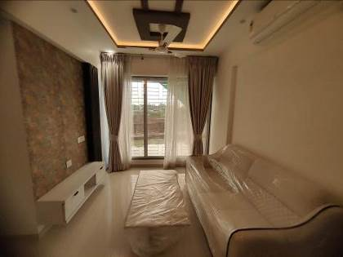
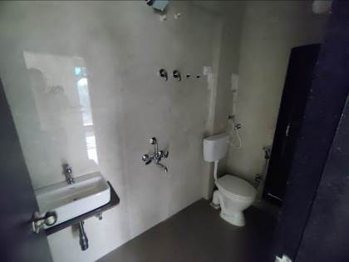
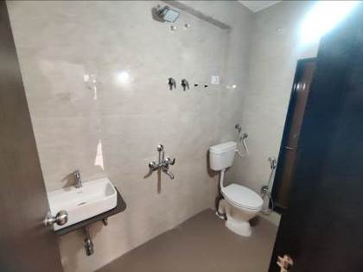
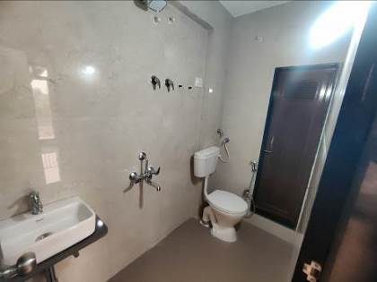
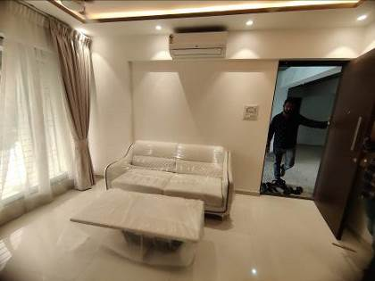
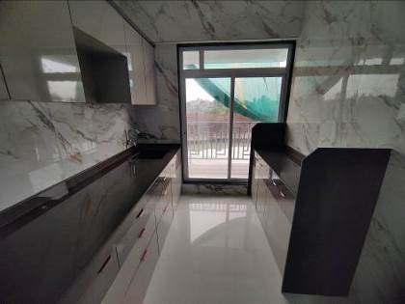
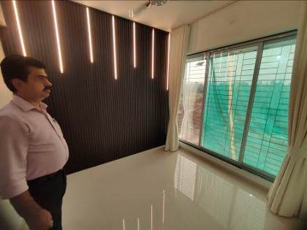
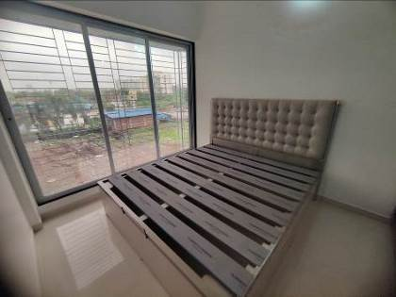
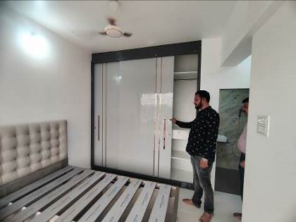
Actual Site Photographs
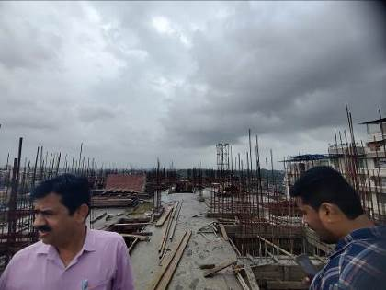
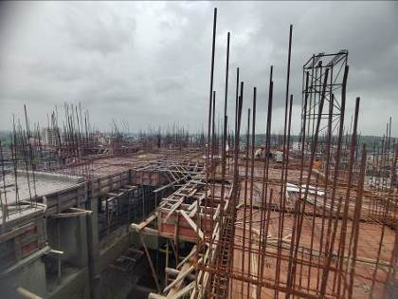
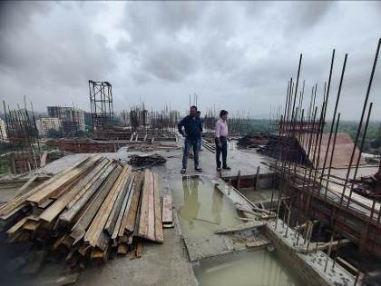
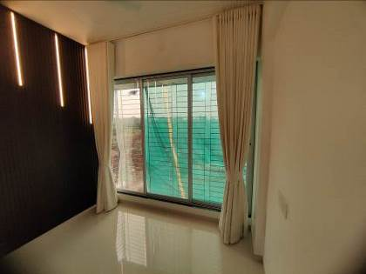
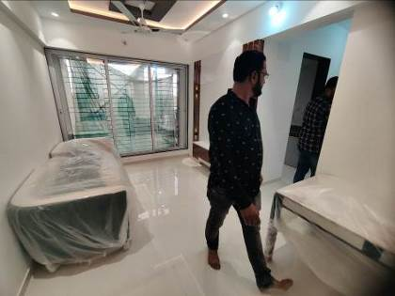
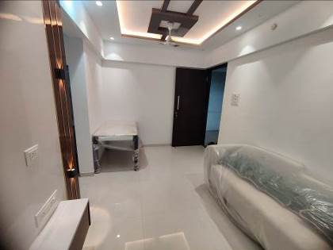
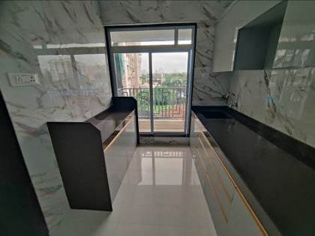
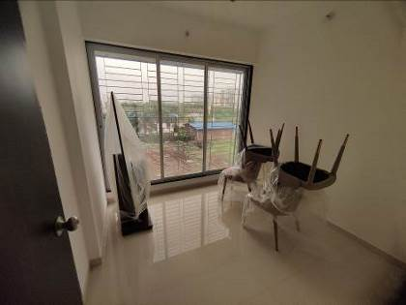
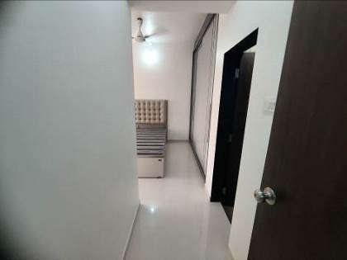
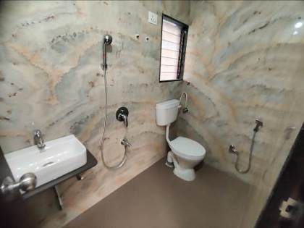
Actual Site Photographs
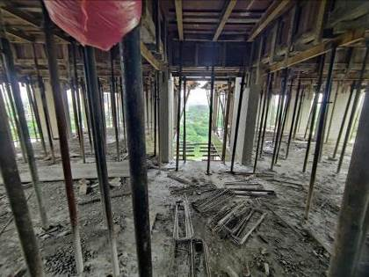
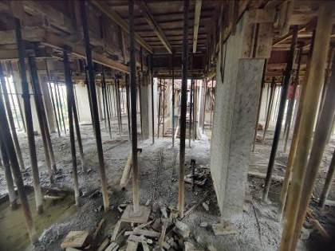
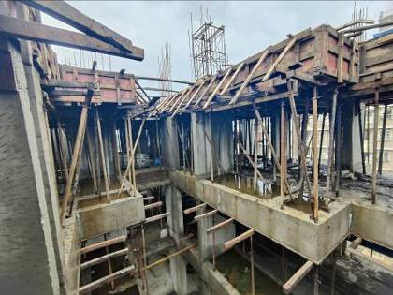
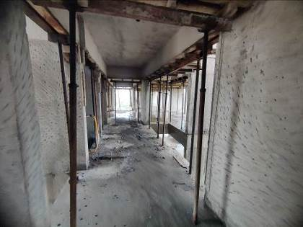
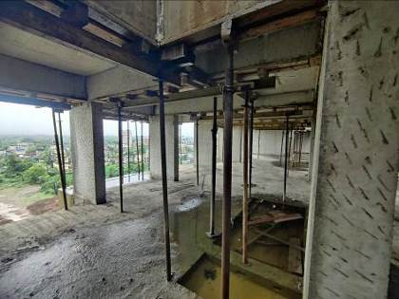
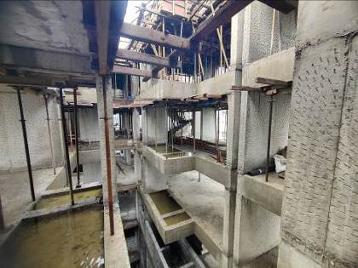
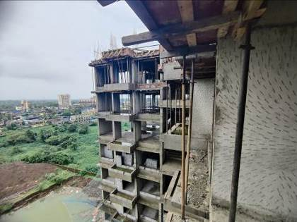
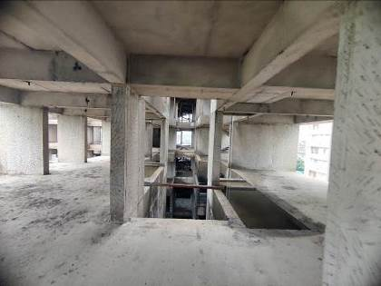
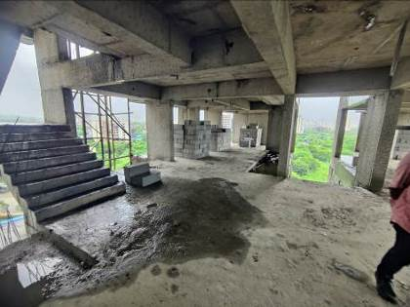
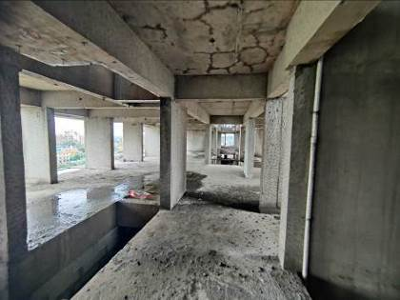
Actual Site Photographs
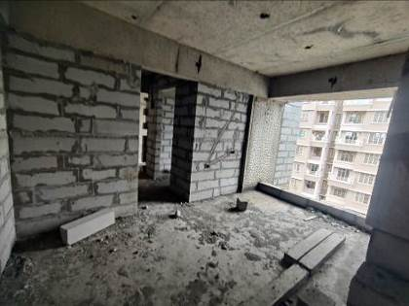
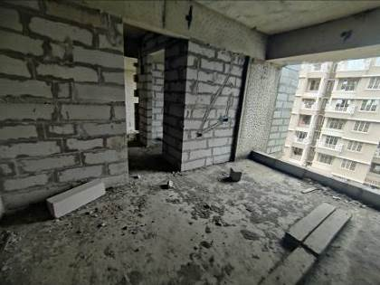
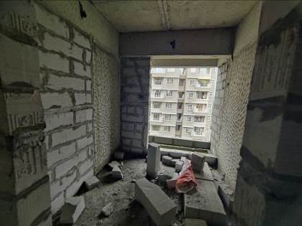
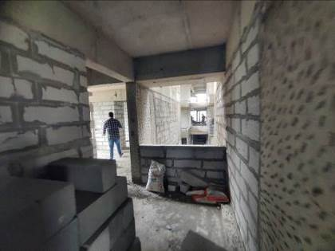
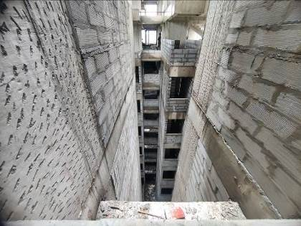
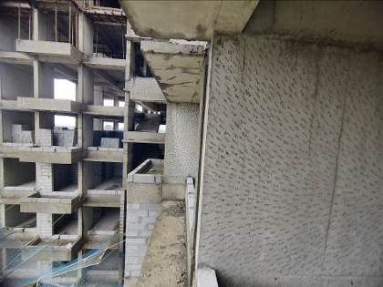
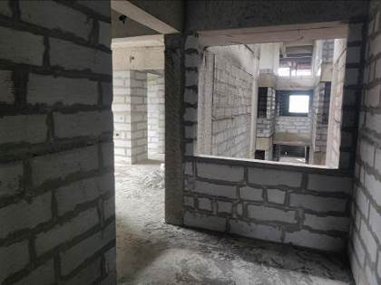
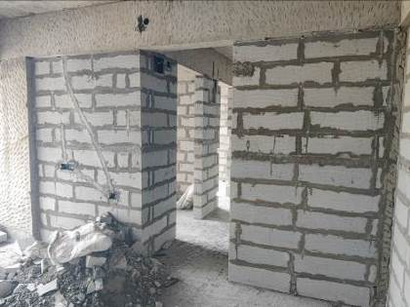
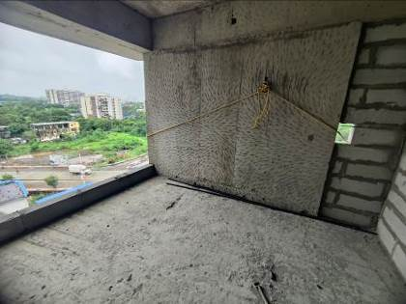
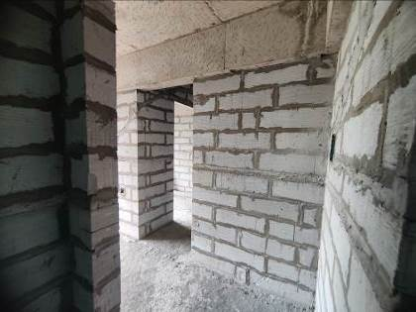
Actual Site Photographs
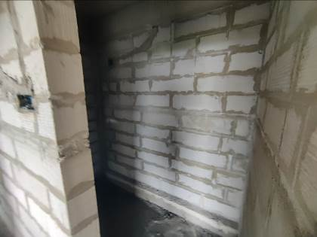
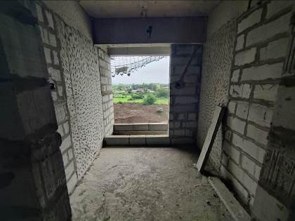
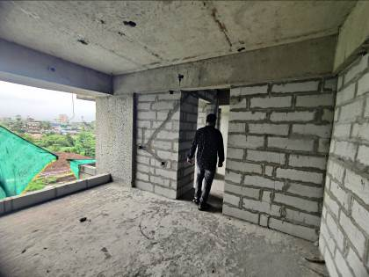
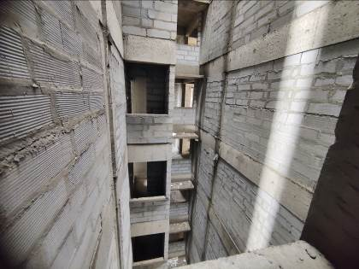
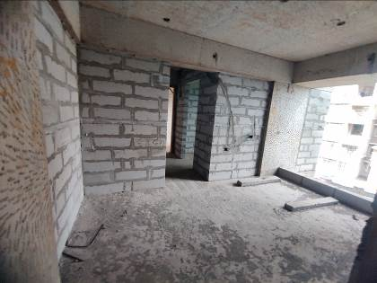
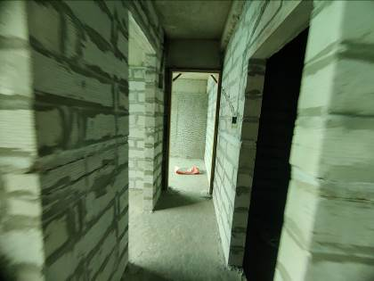
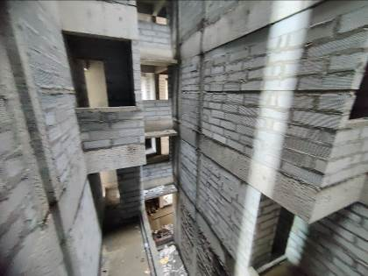
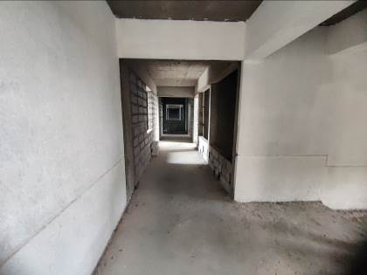
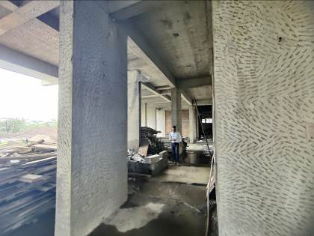
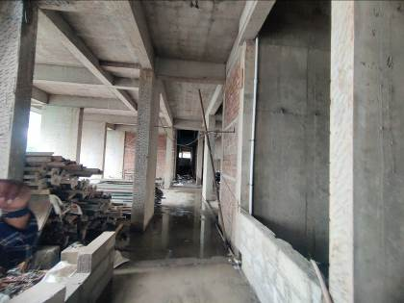
Route Map of the property
Site u/r
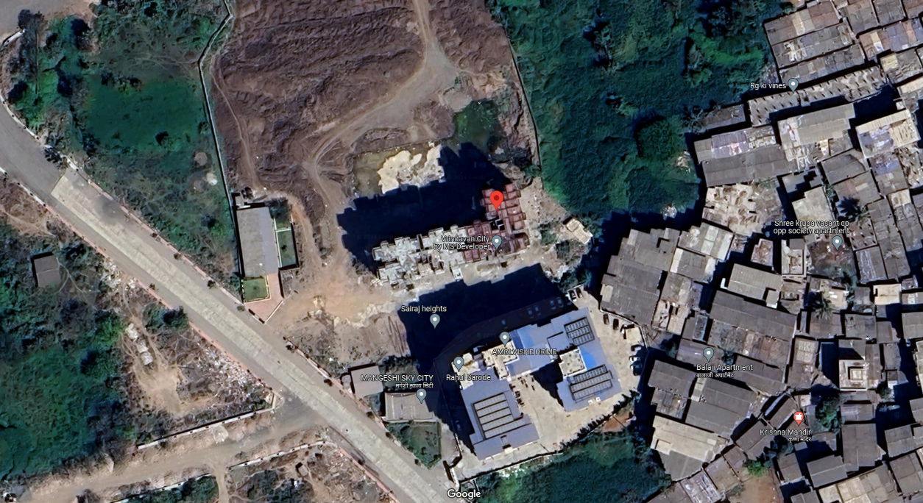

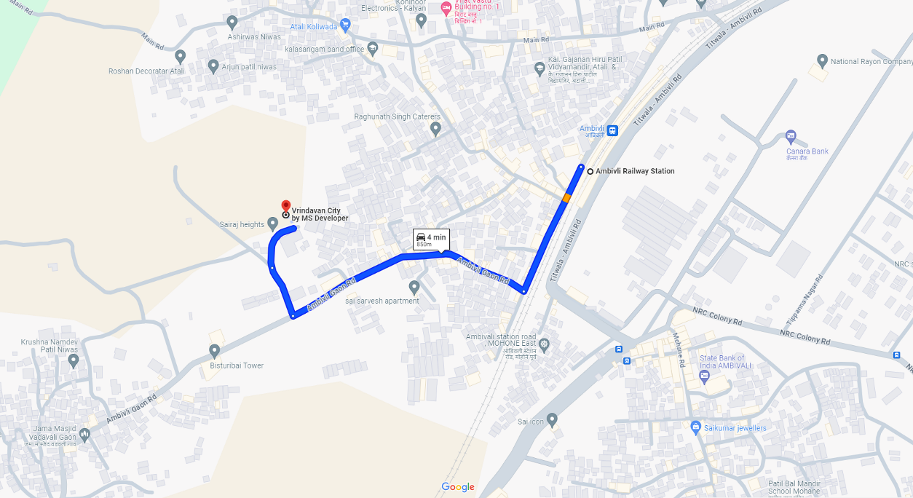

Latitude Longitude: 19°16'02.0"N 73°10'00.5"E
Note: The Blue line shows the route to site from nearest railway station (Ambivli – 850 M.)

