Valuation Report of the Immovable Property

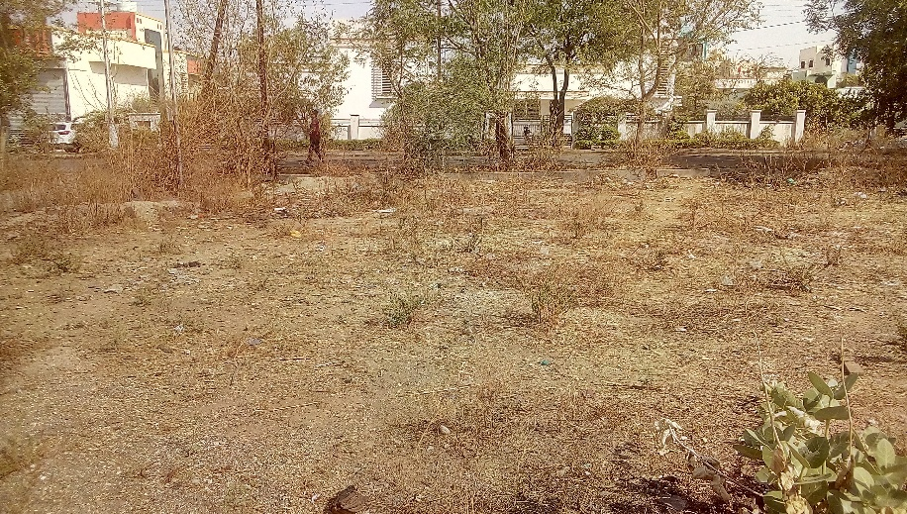

**Details of the property under consideration:**

Name of the Owner: **Mr. Ravindra Murlidhar Attarde**

N.A. Land on Plot No. 6, Gut No. 170, Tisgaon, Waluj Mahanagar CIDCO, Taluka & District - Aurangabad,

State –Maharashtra, Country - India

### Latitude Longitude: 19°50'58.5"N 75°15'21.7"E

**Valuation Done for:**

**Small Industries Development Bank of India**

**Direct Credit Vertical**

SIDBI Tower, 15, Ashok Marg, Lucknow - 226001, State - Uttar Pradesh, Country - India

# **Vastukala Consultants (I) Pvt. Ltd.**

Mumbai • Delhi NCR • Nanded • Aurangabad

Vastu/Mumbai/04/2018/0011728/27465

30/05-220-AU

Date: 30.04.2018

# **VALUATION OPINION REPORT**

The N.A. Land on Plot No. 6, Gut No. 170, Tisgaon, Waluj Mahanagar CIDCO, Taluka & District - Aurangabad, State –Maharashtra, Country - India belongs to **Mr. Ravindra Murlidhar Attarde**.

|  |  |  |
| --- | --- | --- |
| Boundaries of the property. | | |
| North | : | Plot No. 7,8 & 9 | |
| South | : | 18 M. wide road | |
| East | : | Plot No. 5 | |
| West | : | 9 M. wide road | |

Considering various parameters recorded, existing economic scenario, and the information that is available with reference to the development of neighborhood and method selected for valuation, we are of the opinion that, the property premises along with business premium can be assessed and valued for this particular purpose at **` 52,09,500.00 (` Fifty Two Lac Nine Thousand Five Hundred Only).**

The valuation of the property is based on the documents produced by the concern. Legal aspects have not been taken into considerations while preparing this valuation report.

Hence certified

**[**

## Sharad B. Chalikwar

Chartered Engineer (India)

Govt. Reg. Valuer

Reg. No. (N) CCIT/1-14/52/2008-09

Encl: Valuation report.

**Valuation Report of Immovable Property**

|  |  |  |  |  |  |  |  |  |  |  |  |  |  |  |  |  |  |  |  |  |  |  |  |  |  |  |  |  |  |  |  |  |  |
| --- | --- | --- | --- | --- | --- | --- | --- | --- | --- | --- | --- | --- | --- | --- | --- | --- | --- | --- | --- | --- | --- | --- | --- | --- | --- | --- | --- | --- | --- | --- | --- | --- | --- |
| 1 | **Customer Details** | | | | | | | | | | | | | | | | | | | | | | | | | | | | | | | | |
|  | Name | **Mr. Ravindra Murlidhar Attarde** | | | | | | | | | | | | | | | Apl.No. | | | | | | | | | |  | | | | | | |
|  | Case Type | Term Loan Under SMILE Scheme | | | | | | | | | | | | | | | | | | | | | | | | | | | | | | | |
| 2 | **Property Details** | | | | | | | | | | | | | | | | | | | | | | | | | | | | | | | | |
|  | Address | | | N.A. Land on Plot No. 6, Gut No. 170, Tisgaon, Waluj Mahanagar CIDCO, Taluka & District - Aurangabad, State –Maharashtra, Country - India. | | | | | | | | | | | | | | | | | | | | | | | | | | | | | |
|  | Nearby Landmark | | | Near MSEDCL Substation | | | | | | | | | | | | | | | | | | | | | | | | | | | | | |
| 3 | **Document Details** | | |  | | | | | | | | | | | | | | | | | | | | | | | | | | | | | |
|  | **Layout Plan** | | | Yes | | | Name of Approving Authority | | | | | | | | | | | | - | | | | | | Approval No. | | | | | | | - | |
| **Building Plan** | | | N.A. | | | Name of Approving Authority | | | | | | | | | | | | - | | | | | | Approval No. | | | | | | | **-** | |
| **Construction Permission** | | | N.A. | | | Name of Approving Authority | | | | | | | | | | | | - | | | | | | Approval No. | | | | | | | **-** | |
|  | **Legal Documents** | | | Yes | | 1. Copy of Sale Deed dated 16.01.2009 2. Copy of 7/12 Extracts 3. Copy of Plot Layout Plan | | | | | | | | | | | | | | | | | | | | | | | | | | | |
| 4 | **Physical Details** | | | | | | | | | | | | | | | | | | | | | | | | | | | | | | | | |
|  | **Adjoining Properties** | | | | East | | | | | | West | | | | | | | | | | North | | | | | | | | | South | | | |
|  | **As on site** | | | | Plot No. 5 | | | | | | 9 M. wide road | | | | | | | | | | Plot No. 7,8 & 9 | | | | | | | | | 18 M. wide road | | | |
|  | **As per document** | | | | Plot No. 5 | | | | | | 9 M. wide road | | | | | | | | | | Plot No. 7,8 & 9 | | | | | | | | | 18 M. wide road | | | |
|  | **Matching of Boundaries** | | | Yes | | **Plot Demarcated** | | | | | | Yes | | | | | | | **Approved land use** | | | | Non Agricultural purpose (As per 7/12 Extracts) | | | | **Type of Property** | | | | | | Non Agricultural purpose (As per 7/12 Extracts) |
|  | **No. of rooms** | Living | | | - | | | Bed Room | | | | | | - | | | | | | Kitchen | | | | | - | | | | Dining | | | | - |
|  |  | Toilet | | | - | | | Bathroom | | | | | | - | | | | | | WC | | | | | - | | | |  | | | |  |
|  | Brief description of the property | | | | | | | | | | | | | | | | | | | | | | | | | | | | | | | | |
|  | The immovable property comprises FreeholdN.A. Land. It is located at about 7.4 Km. distance from Aurangabad Railway Station.  As per agreement, the land area is 322.65 Sq. M. i.e. 3,473.00 Sq. Ft. | | | | | | | | | | | | | | | | | | | | | | | | | | | | | | | | |
|  | **Total no. of Floors** | N.A | | **Floor on which the property is located** | | | | N.A | | | | | **Approx. Age of the property** | | | | | | N.A | | | | | **Residual age of the property** | | | N.A | | | | | | **Type of structure :** N.A |
| 5 | **Tenure / Occupancy Details –Vacant and in Owner’s Possession** | | | | | | | | | | | | | | | | | | | | | | | | | | | | | | | | |
|  | **Status of Tenure** | | | N.A. | | **Owned / Rented** | | | N.A. | | | | | | **No of Year of Occupancy** | | | | | | | N.A. | | | | **Relationship of Tenant to Owner** | | | | | | | N.A. |
| 6 | **Stage of Construction** | | | | | | | | | | | | | | | | | | | | | | | | | | | | | | | | |
|  | **Stage of Construction** | | | | | N.A. | | | | | | | | | **If under construction, extent of completion** | | | | | | | | | | | | | N.A. | | | | | |
| 7 | **Violations if any observed** | | | | | | | | | | | | | | | | | | | | | | | | | | | | | | | | |
|  | Nature and extent of violations | | | | | | | | | N.A. | | | | | | | | | | | | | | | | | | | | | | | |
| 8 | **Area Details of the Property** | | | | | | | | | | | | | | | | | | | | | | | | | | | | | | | | |
|  | **Plot Area as per agreement** | | | | | | | | | | | | | | | 322.65 Sq. M. i.e. 3,473.00 Sq. Ft. | | | | | | | | | | | | | | | | | |
|  | **Remarks** | |  | | | | | | | | | | | | | | | | | | | | | | | | | | | | | | |
| 9 | **Date of Visit to the property** | | | | | | | | | | | | | | | | | 21.04.2018 | | | | | | | | | | | | | | | |
|  | **Name(s) of the person(s) visiting the property** | | | | | | | | | | | | | | | | | Mr. Shashikant Chalikwar | | | | | | | | | | | | | | | |
| 10 | **Valuation** | | | | | | | | | | | | | | | | |  | | | | | | | | | | | | | | | |
|  | i. Mention the value as per Government Approved Rates also | | | | | | | | | | | | | | | | | | | | | | | | | | | | | | | | |
|  | Guideline rate obtained from the Stamp Duty Ready Reckoner | | | | | | | | | | | ` 8,200.00 per Sq. M.  i.e. ` 761.80 per Sq. Ft. | | | | | | | | | | | | | | | | | | | | | |
|  | **Summary of Valuation** | | | | | | | | | | |  | | | | | | | | | | | | | | | | | | | | | |
|  | Area Considered for valuation | | | | | | | | | | |  | | | | | | | | | | | | | | | | | | | | | |
|  | Plot Area | | | | | | | | | | | 3,473.00 Sq. Ft. | | | | | | | | | | | | | | | | | | | | | |
|  | 1. **Guideline Value** | | | | | | | | | | |  | | | | | | | | | | | | | | | | | | | | | |
|  | Particulars | | | | | | | | | | | Area in Sq. Ft. | | | | | | | | | | | | | Rate in ` | | | | | | Value in ` | | |
| Plot Area | | | | | | | | | | | 3,473.00 | | | | | | | | | | | | | 761.80 | | | | | | 26,45,731.00 | | |
|  | 1. **Fair Market Value of the Property** | | | | | | | | | | |  | | | | | | | | | | | | | | | | | | | | | |
|  | Plot Area | | | | | | | | | | | 3,473.00 Sq. Ft. | | | | | | | | | | | | | | | | | | | | | |
|  | Prevailing market rate | | | | | | | | | | | ` 1,500.00 | | | | | | | | | | | | | | | | | | | | | |
|  | Total Value of the property | | | | | | | | | | | ` 52,09,500.00 | | | | | | | | | | | | | | | | | | | | | |
|  | Realizable Value of the Property | | | | | | | | | | | ` 46,88,550.00 | | | | | | | | | | | | | | | | | | | | | |
|  | Distress / Force Sale Value | | | | | | | | | | | ` 41,67,600.00 | | | | | | | | | | | | | | | | | | | | | |
| 11 | **Assumptions/Remarks** | | | | | The Prevailing Market rate for N.A.Plot is between ` 1,300.00 to ` 1,700.00 per Sq. Ft. Hence we have considered the Average Rate of ` 1,500.00 per Sq. Ft. | | | | | | | | | | | | | | | | | | | | | | | | | | | |
| 12 | **Comments on variance between market value and the valuation as per Govt. approved rates** | | | | | The Market Value of the property is based on facts of markets discovered by us during our enquiries, However the government rate value in this case is less than the market value arrived by us. We are of the opinion that the value arrive by us will prove to be correct if an Auction of the subject property is Carried out. As far as Government Value is concerned, it is not possible to comment on same, may be government rates are fixed by sampling during same point of time in part and whereas, Market values change every month.  In most of the cases the actual deal amount or Transaction value is not reflected in the agreement because of Various Market practices. As Valuer, we always try to give a value which is correct reflection of actual transaction value irrespective of any factors in market.  We Hope this will satisfy your requirements. | | | | | | | | | | | | | | | | | | | | | | | | | | | |
| 13 | **Declarations** | | | | | 1. The Property was inspected by the undersigned on dated 21.04.2018 2. The undersigned does not have any direct/indirect interest in the above property. 3. The undersigned does not have more than three pending cases from SIDBI. 4. The information furnished herein is true and correct to the best of our knowledge. | | | | | | | | | | | | | | | | | | | | | | | | | | | |

|  |  |  |  |  |
| --- | --- | --- | --- | --- |
| 14 | **Name, address & signature of Valuer** | **Vastukala Consultants (I) Pvt. Ltd.**  121, 1st Floor, Ackruti Star, Central Road, MIDC, Andheri (E), Mumbai - 400 093 |  | |
| **Sharad B. Chalikwar**  Govt. Reg. Valuer Chartered Engineer (India)  Reg. No. (N) CCIT/1-14/52/2008-09 | Date of valuation  30.04.2018 |
| 15 | **List of Documents enclosed** | 1. Copy of Sale Deed dated 16.01.2009 2. Copy of 7/12 Extracts 3. Copy of Plot Layout Plan 4. Price Indicators of the Property / Location | | |
| 16 | **List of Photos enclosed** | 1. Valuation Report  2. Location cum Route Map from Nearest Railway Station  3. Satellite Location Map  4. Photographs of the property | | |

**Actual Site Photographs**

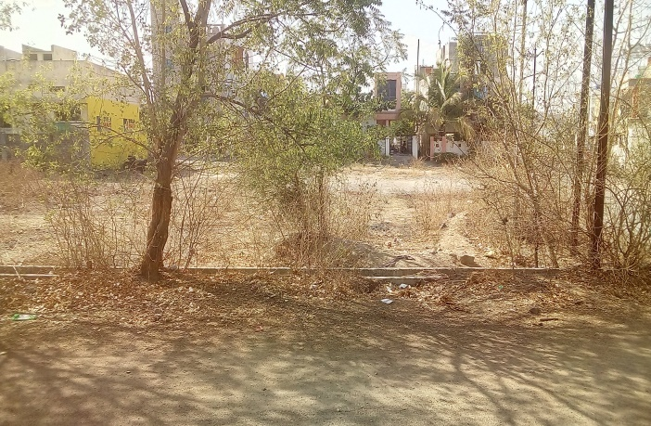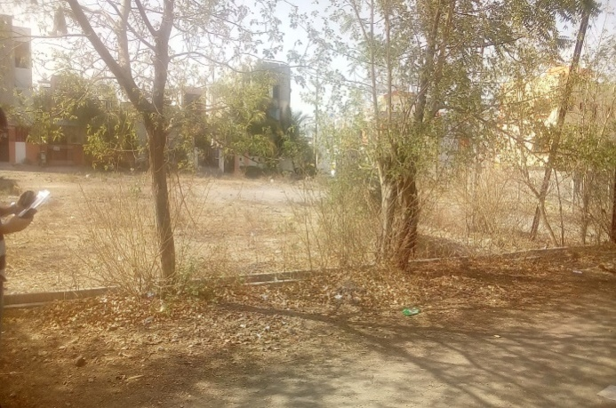

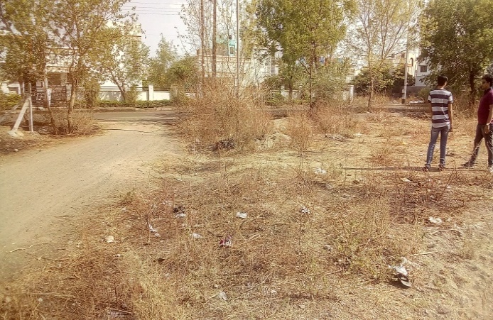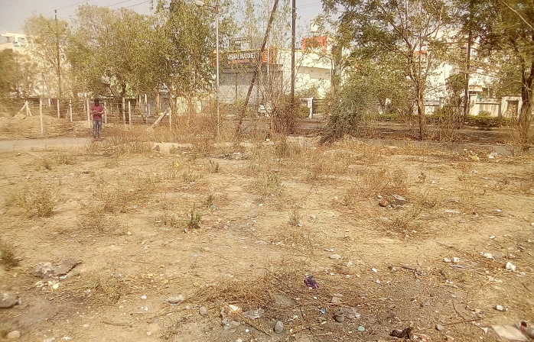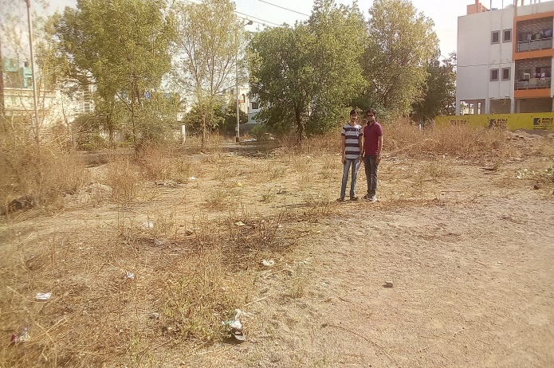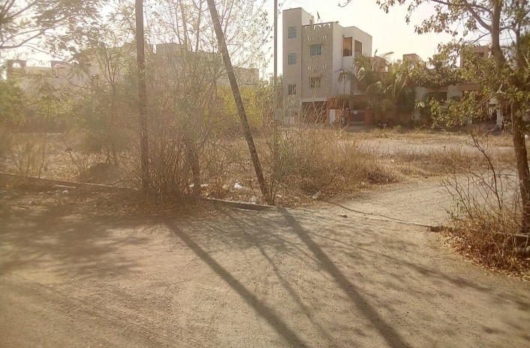**Route Map of the property  
Site u/r**

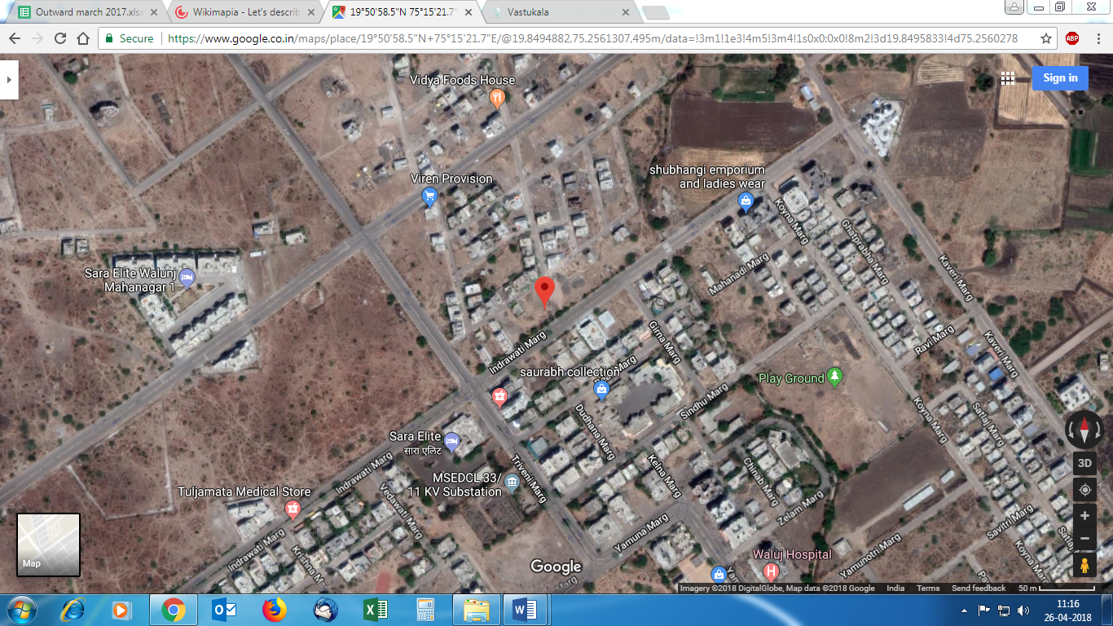

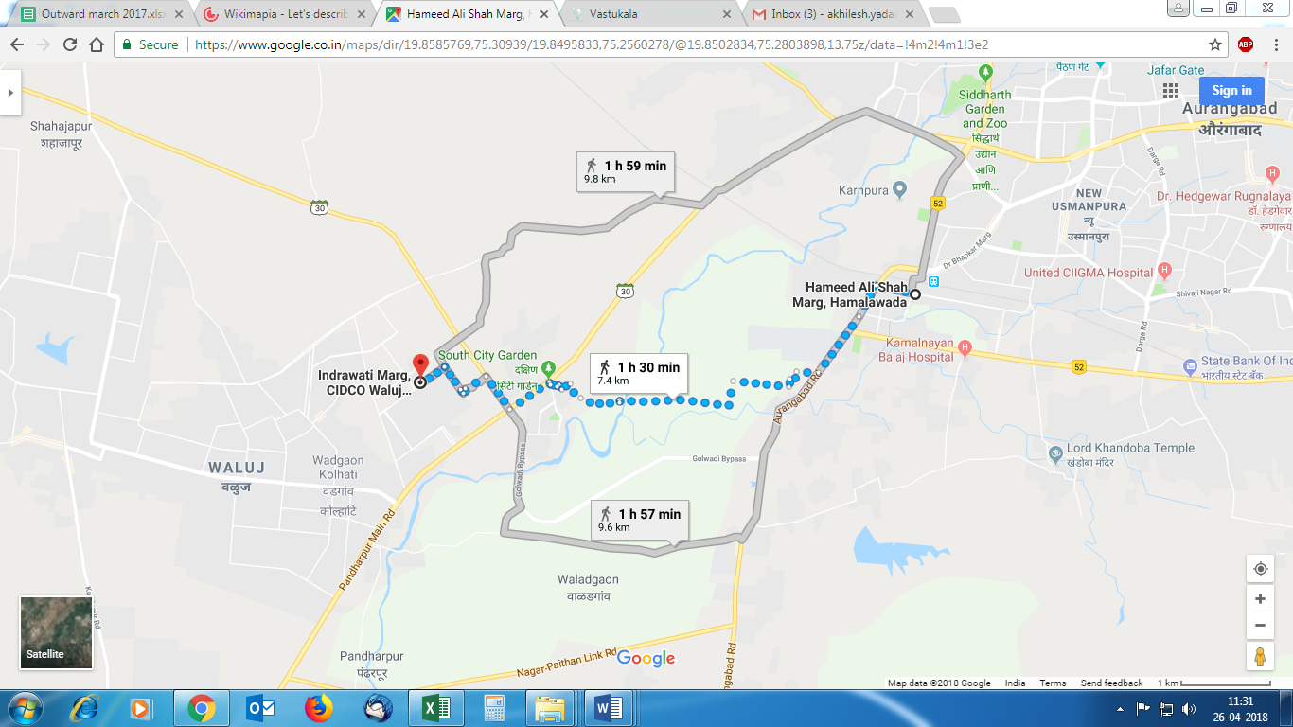

**Latitude Longitude: 19°50'58.5"N 75°15'21.7"E**

**Note :** The Blue line shows the route to site from nearest railway station (Aurangabad 7.4 Km.)

**Price Indicators**

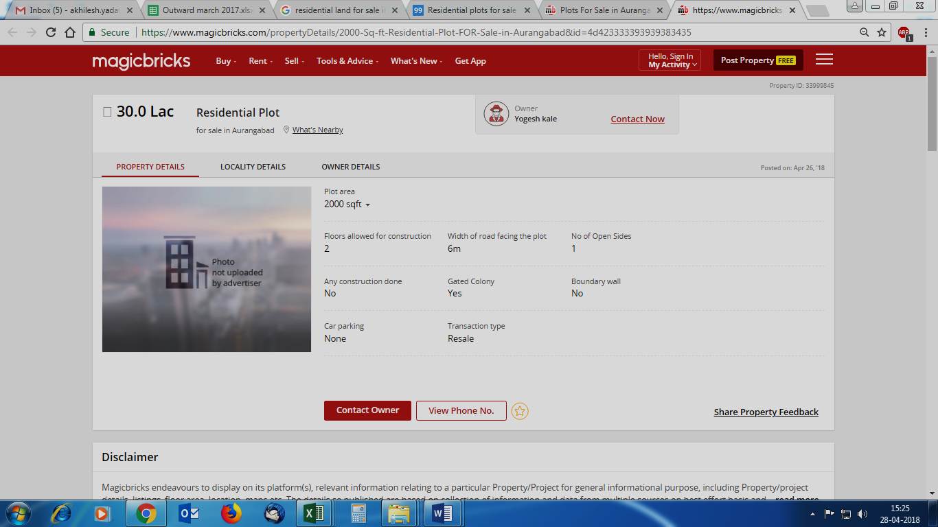

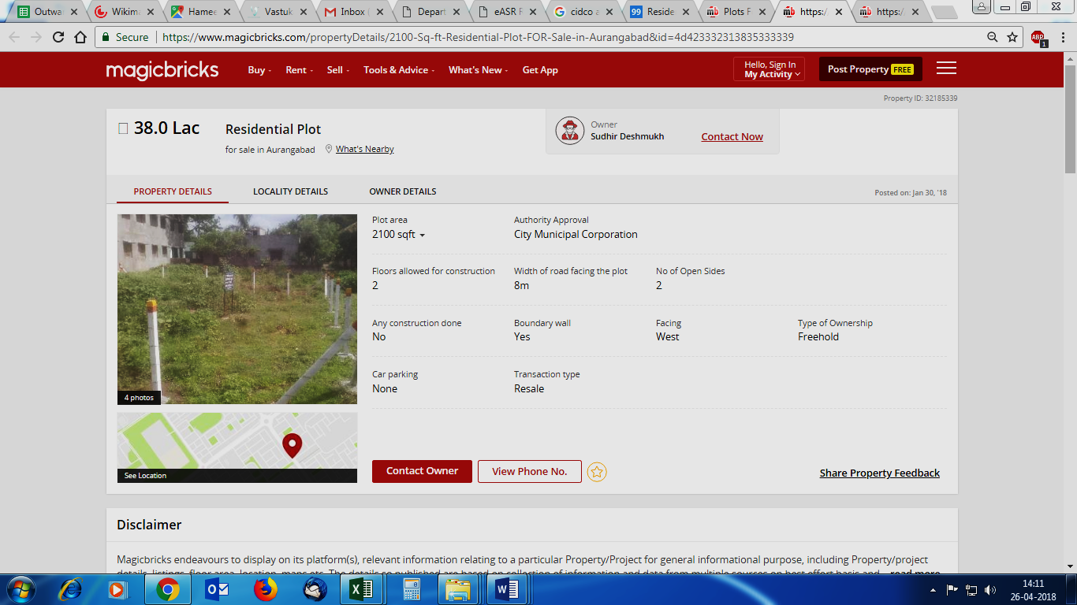**Ready Reckoner Rate**

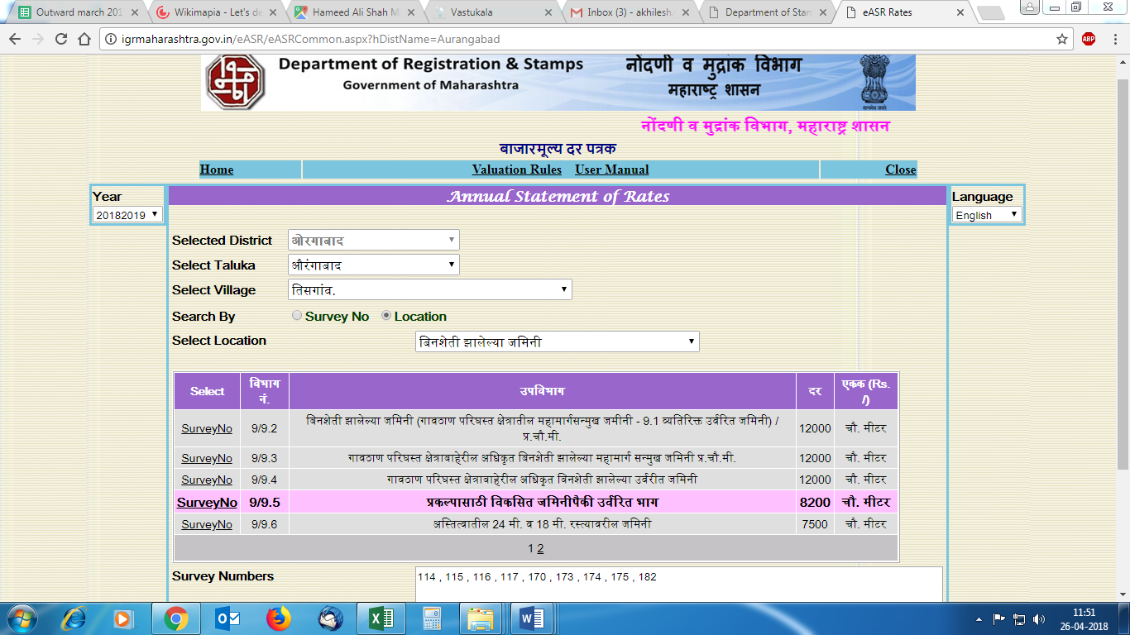

**DEFINITION OF VALUE FOR THIS SPECIFIC PURPOSE**

This exercise is to assess **Fair Market Value** of the property under reference as on **28.04.2018**

The term **Fair Market Value** is defined as

“The most probable price, as of a specified date, in cash, terms equivalent to cash, or in other precisely revealed terms for which the specified property rights would sell after reasonable exposure in a competitive market under all conditions requisite to a fair sale, with the buyer and seller each acting prudently knowledgeably and for self-interest assuming that neither is under undue duress”.

Fundamental assumptions and conditions presumed in this definition are:

1. Buyer and seller are motivated by self-interest.

2. Buyer and seller are well informed and are acting prudently.

3. The property is exposed for a reasonable time on the open market.

4. Payment is made in cash or equivalent or in specified financing terms.

#### UNDER LYING ASSUMPTIONS

1. We assume no responsibility for matters of legal nature affecting the property appraised or the title thereto, nor do we render our opinion as to the title, which is assumed to be good and marketable.

2. The property is valued as though under responsible ownership.

3. It is assumed that the property is free of liens and encumbrances.

4. It is assumed that there are no hidden or unapparent conditions of the subsoil or structure that would render it more or less valuable. No responsibility is assumed for such conditions or for engineering that might be required to discover such factors.

**Sharad B. Chalikwar**

Govt. Reg. Valuer

Chartered Engineer (India)

Reg. No. (N) CCIT/1-14/52/2008-09

**DECLARATION OF PROFESSIONAL FEES CHARGED**

We hereby declare that, our professional fees are not contingent upon the valuation findings. However, if the statute AND/OR clients demands that, the fees should be charged on the percentage of assessed value then, with the full knowledge of the AND/OR end user, it is being charged accordingly.

# **VALUATION OF THE PROPERTY PREMISES**

Considering various parameters recorded herein above, existing economic scenario, and the information that is available with reference to the development of neighborhood and method selected for valuation, we are of the opinion that, the property premises along with business premium can be assessed and valued for this particular **` 52,09,500.00 (` Fifty Two Lac Nine Thousand Five Hundred Only).**

**STATEMENT OF LIMITING CONDITIONS**

1. Assumptions are made to the best of our knowledge and belief. Reliance is based on the information furnished to us by the identifier AND/OR client.

2. The valuer shall not be responsible for matters of legal nature that affects the value and opinion expressed by us.

3. If our appearance is required, we will be pleased to appear and give the necessary clarification, provided the fees for each appearance (excluding traveling, dearness allowance and out of pocket expenses) is pre-determined before the acceptance of the assignment under reference.

4. In no event shall the valuer be held responsible or liable for special, direct, indirect or consequential damages, as the assignment has been completed on best efforts, available knowledge and in good intentions of persons concerned and belief.

5. **If it is proved that there is an apparent negligence on the part of a valuer,** liability of this assignment (whether arising from this assignment, negligence or whatsoever) is limited in respect of anyone event or series of events to the actual loss or damage sustained subject to maximum of 80% of the professional fees for the services rendered and in any case not exceeding the amount of ` 1,000/- (Rupees one Thousand Only). **All the claims against us shall expire after three month from the date of submission of the valuation report provided by us.**

6. We hereby declare that, the information furnished above is true and correct to the best of our knowledge and belief. We have no direct or indirect interest in the assets valued. We have not been convicted of any offence and sentenced to a term of imprisonment. We have not been found guilty of misconduct in our professional capacity.

**Sharad B. Chalikwar**

Govt. Reg. Valuer

Chartered Engineer (India)

Reg. No. (N) CCIT/1-14/52/2008-09