**Actual Site Photographs**

Whats app to Akhilesh Sir

**Route Map of the property**

**Site u/r**

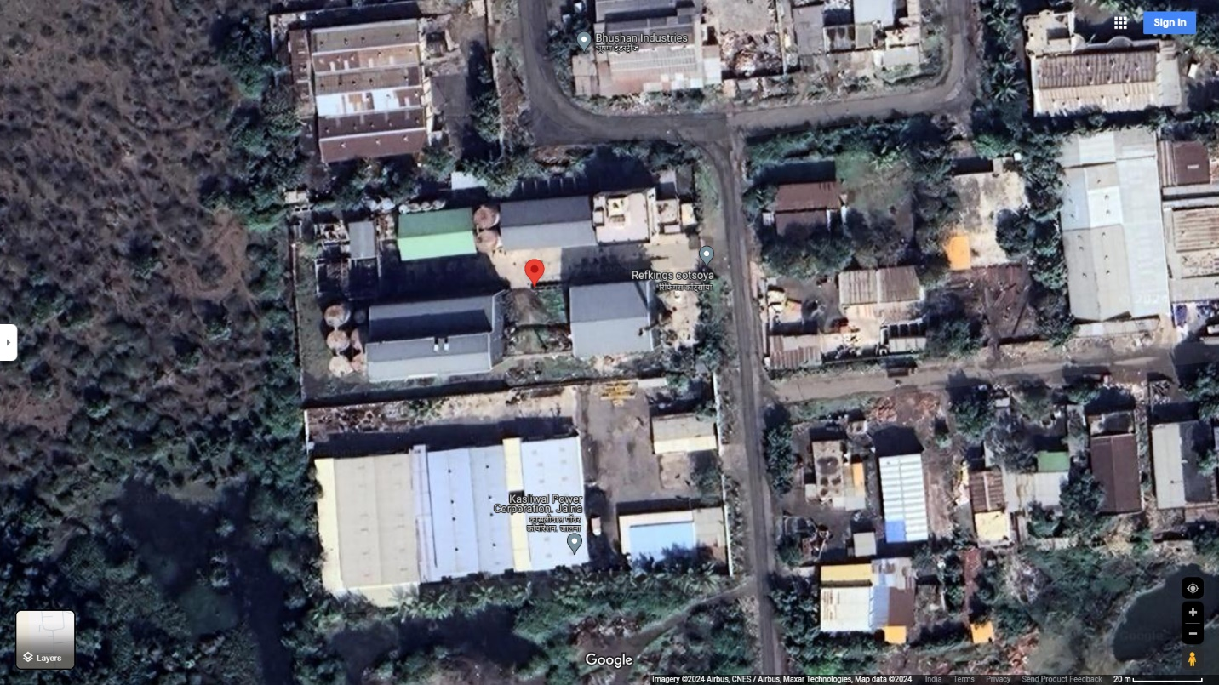

**Location Map**

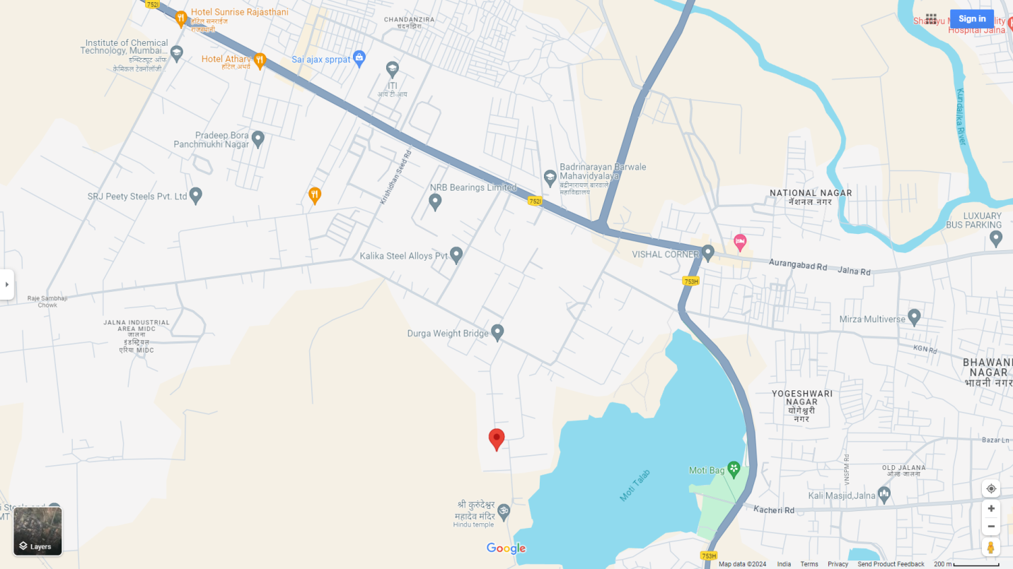

# LATITUDE & LONGITUDE: 19.841822, 75.8600137

# **Note:** The Red Rectangle shows Approx. Property.

**READY RECKONER RATE**

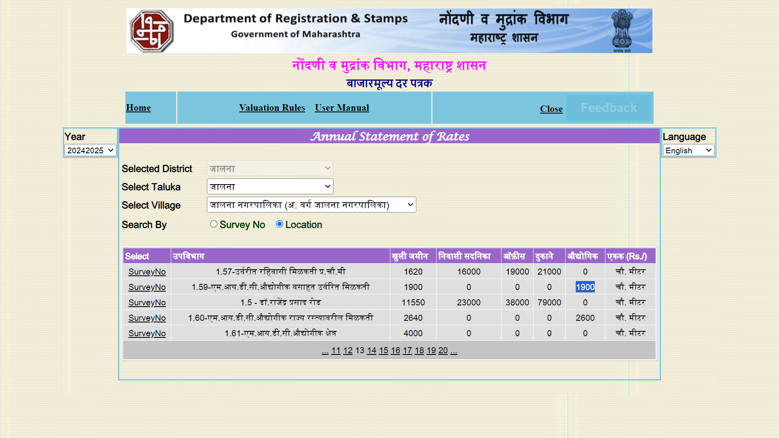

**MIDC RATE** 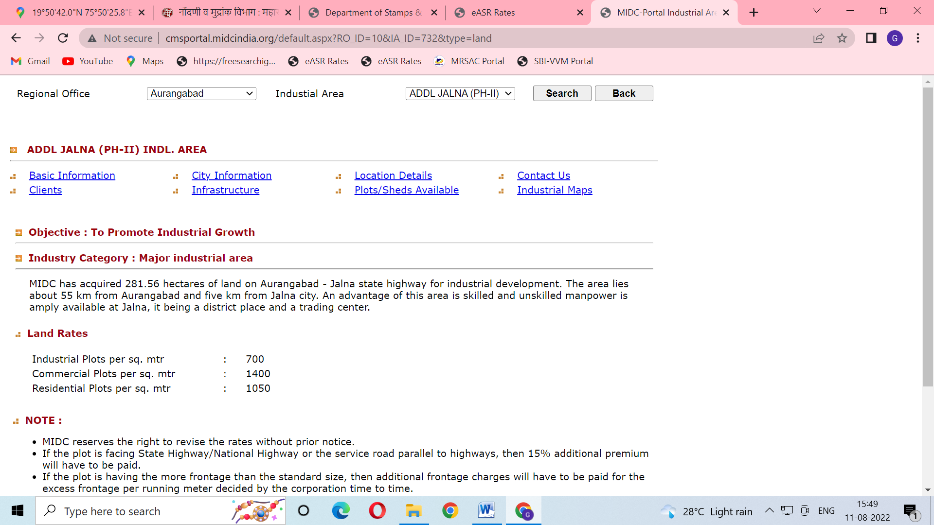

**Sale Instance – 1**

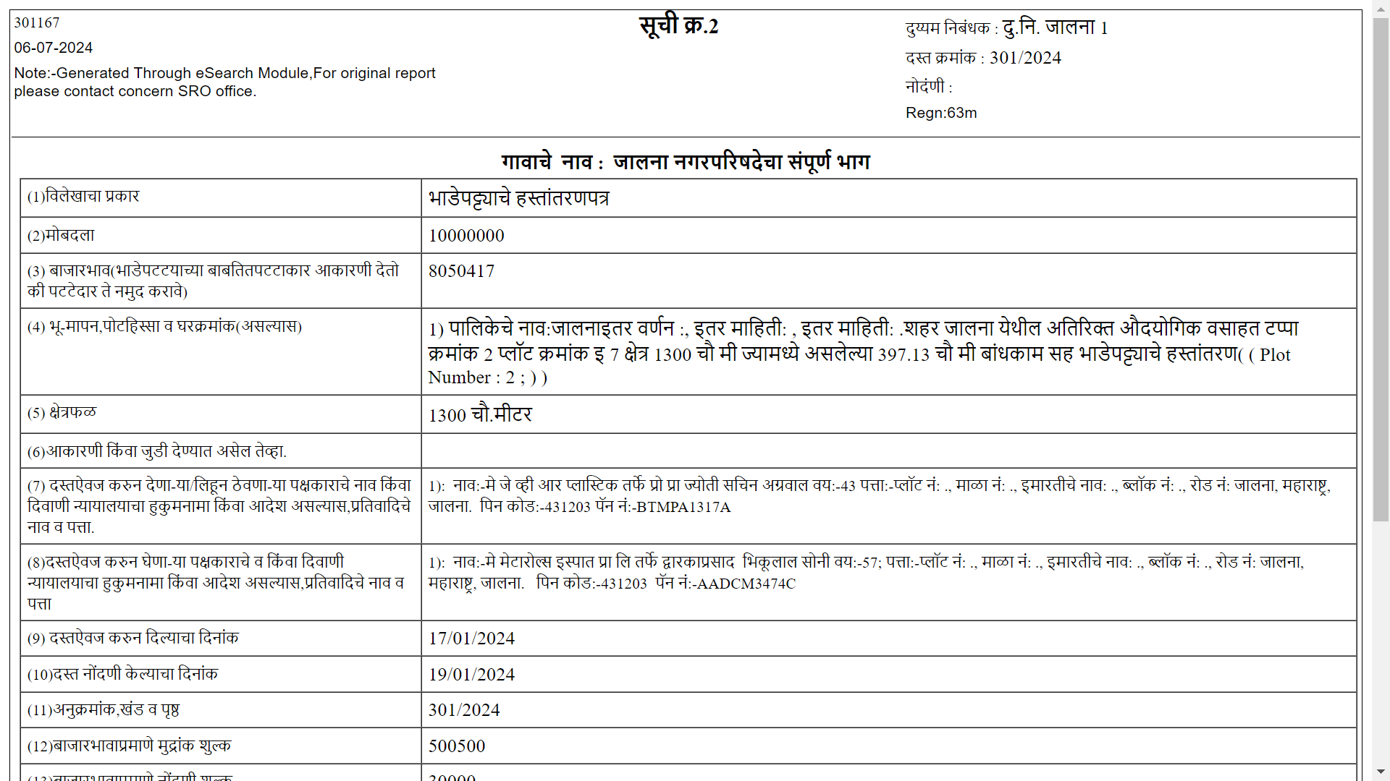

**Land Rate Arrived from this sale instance by Deducting Depreciated Cost of Construction (B/up Area 397.13 Sqm X Rs.7000.00 Per Sqm.) = Rs.5554.00 Per Sqm.**

**Sale Instance – 2**

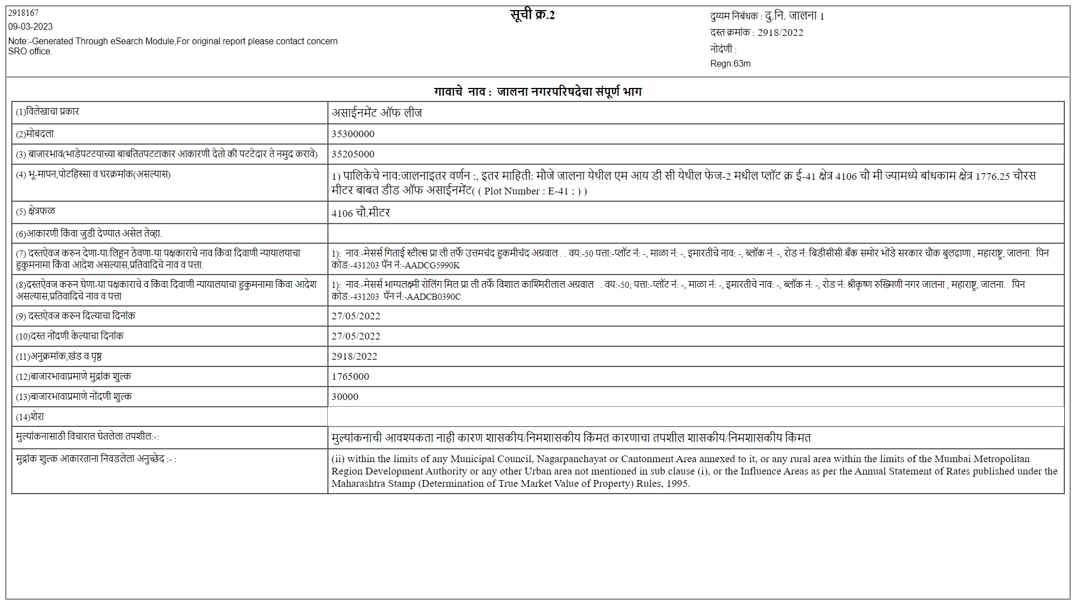

**Land Rate Arrived from this sale instance by Deducting Depreciated Cost of Construction**

**(B/up Area 1776.25 Sqm X Rs.7000.00 Per Sqm.) = Rs.5569/- Per Sqm.**

**Sale Instance – 3**

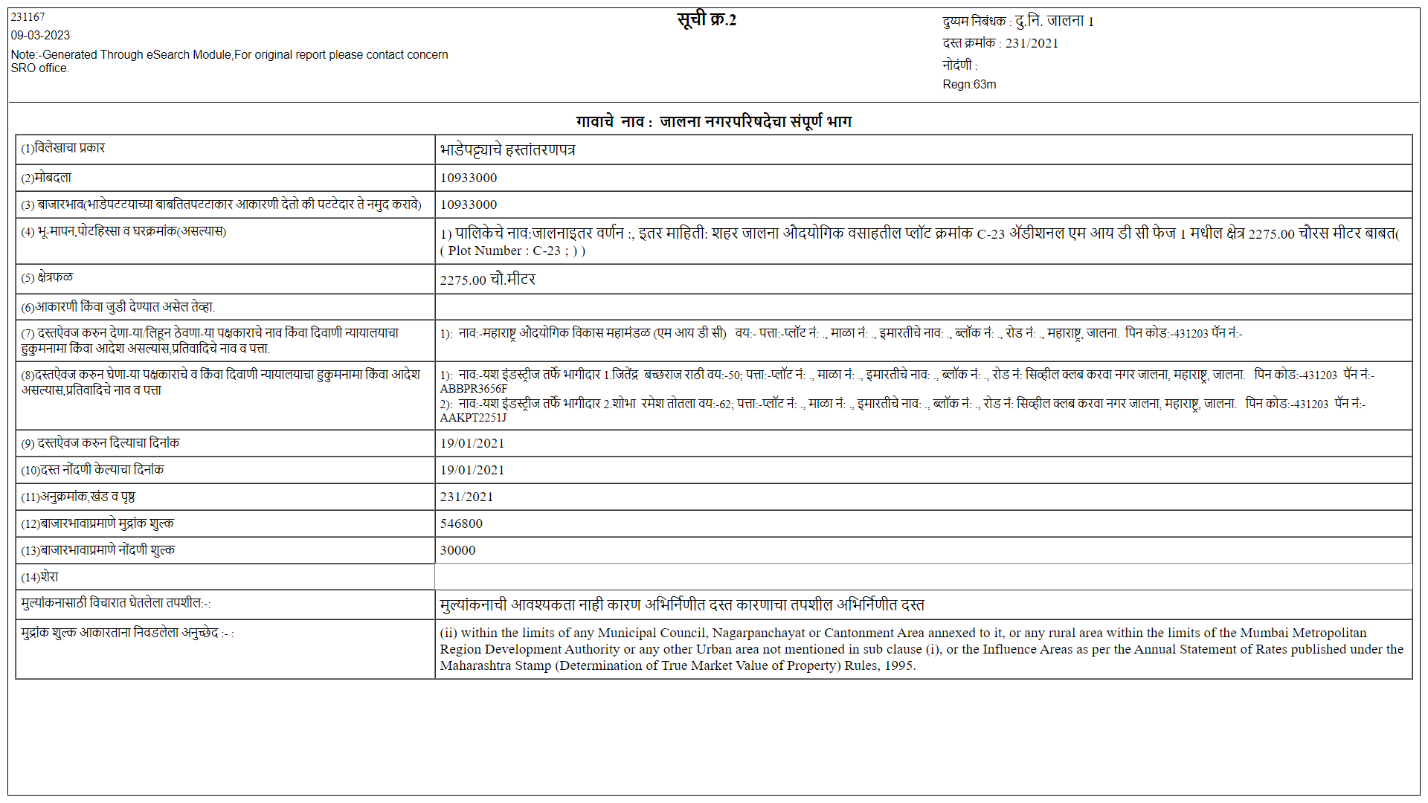

**Land Rate Arrived from this sale instance = Rs.4805/- Per Sqm in 2021.**

**Appreciate 5% Per Year & rate arrived in 2024 = Rs.5562.00 Per Sqm.**

**Land Rate Rs.5000.00 to Rs.6000.00 Per Sqm.**

**Considered rate of Rs.5500.00 Per Sqm for land & Appropriate Rate for Construction.**