Vastu/Nashik/06/2024/009608/2306967
28/18-411-RYBS
Date: 28.06.2024

To,
The Branch Manager,
Bank of Baroda
Regional Office
BSNL Building, Datta Mandir Road, Nashik Road,
Nashik, PIN – 422 101, State - Maharashtra, Country - India.

Sub: Vetting of Extra Amenities

Sir,

With reference to above subject, we have evaluated the Extra Amenities for Residential Flat No.202, Second Floor, "Utkarsh Heights ", Survey No.793/1/2/3/A+B, Plot No.5+6 , Near NMC Garden , Sadguru Nagar, Sadashiv Nagar Road, Village – Nashik, Taluka & District - Nashik, PIN Code – 422 008, State – Maharashtra, Country – India belongs to Shri.Rajendra Dharma Ushire.

We have verified the rates quoted as per current market rates. Details of Extra Amenities considered as per copy of Extra Amenities Agreement between Shri.Rajendra Dharma Ushire (First Party). M/s.Gayatri Infra Developers (Second Party) received on dated.25.06.2024. The Extra Amenities amount is Rs. 12,00,000/- (Rupees Twelve Lakh Only)

The said Cost Vetting Certificate is valid upto next 6 months Only.

Thanking you

Sincerely yours

Manoj B. Chalikwar
Registered Valuer
Chartered Engineer (India)
Reg. No. CAT-I-F-1763
Reg. No. IBBI/RV/07/2018/10366
BOB Empanelment No.: ZO:MZ:ADV:46:941
Encl: Valuation report.

Agreement for Extra Amenities
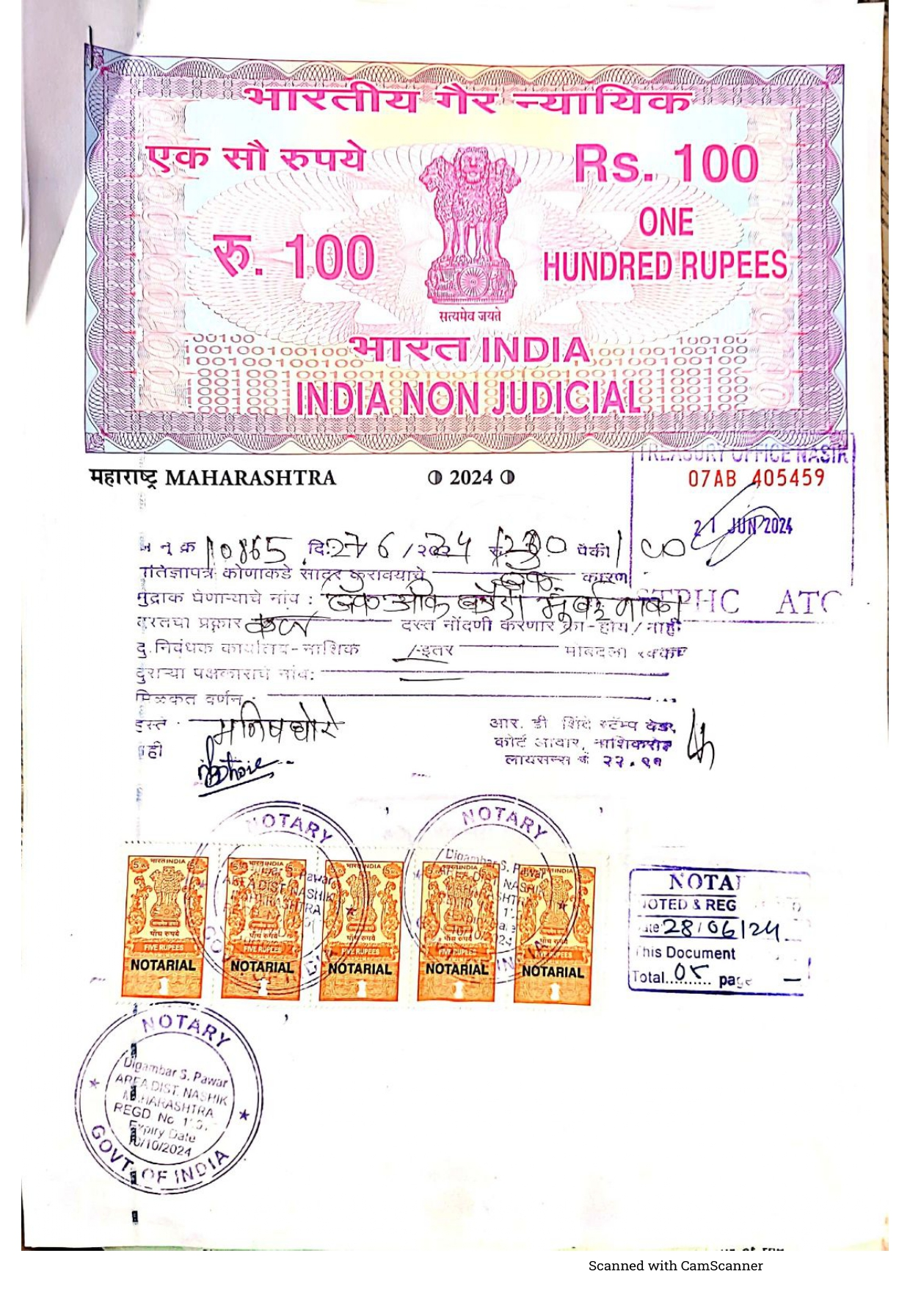
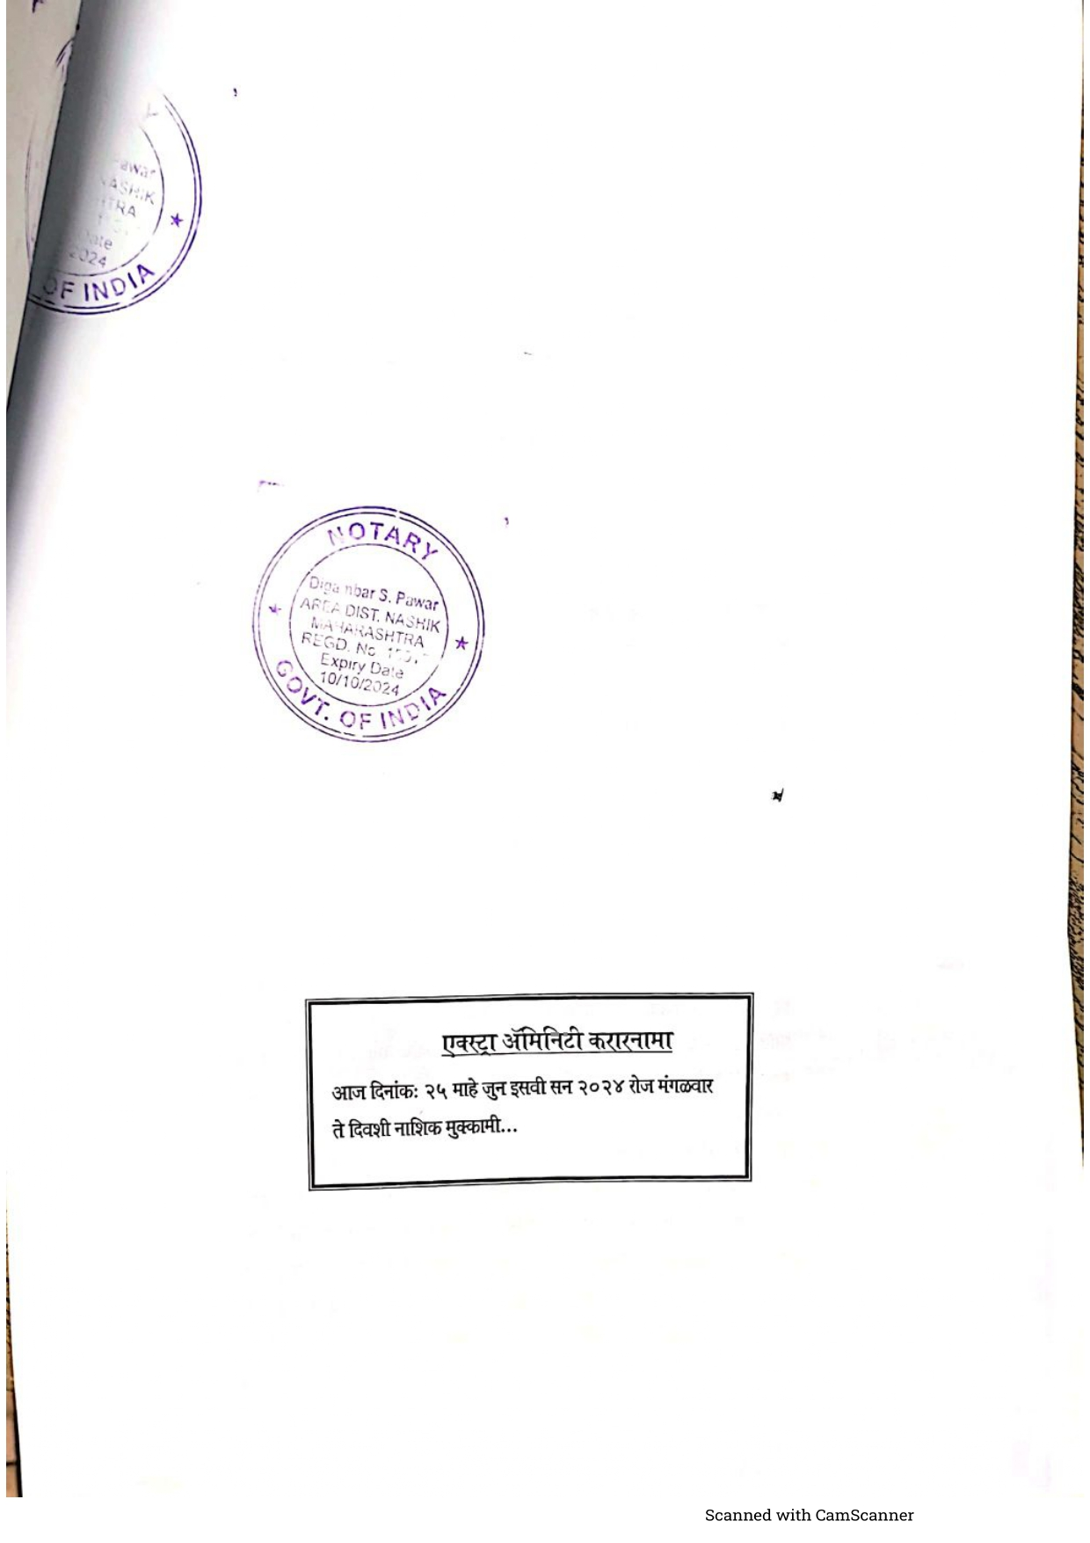

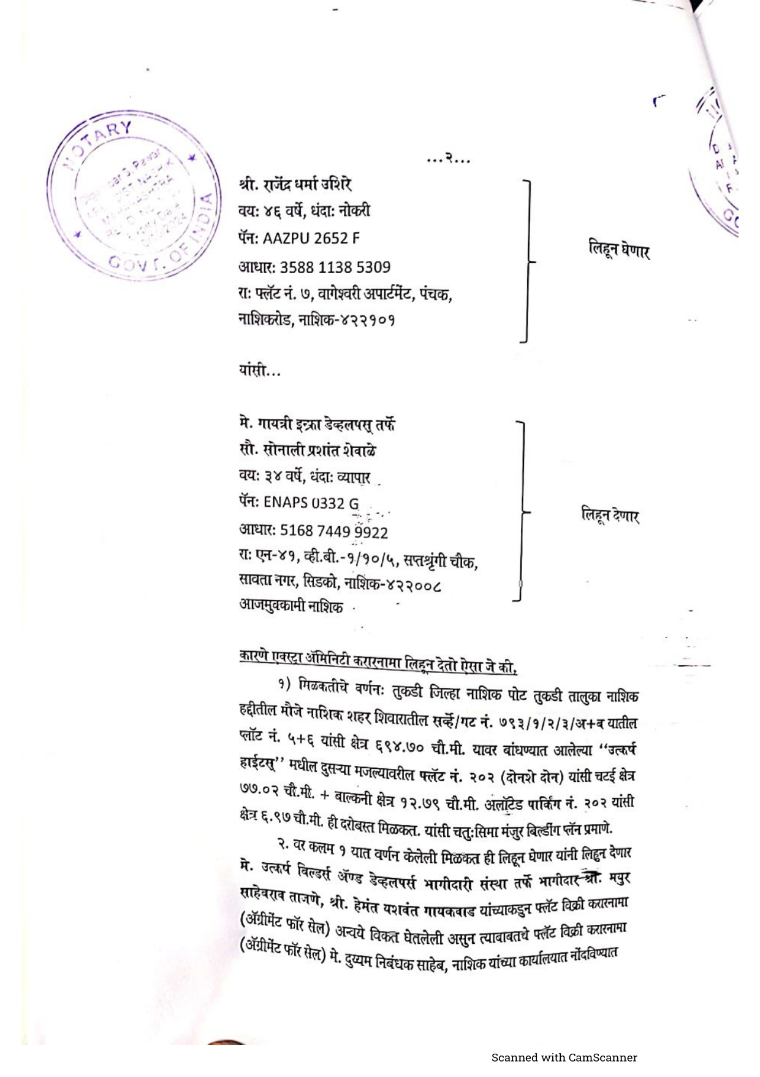
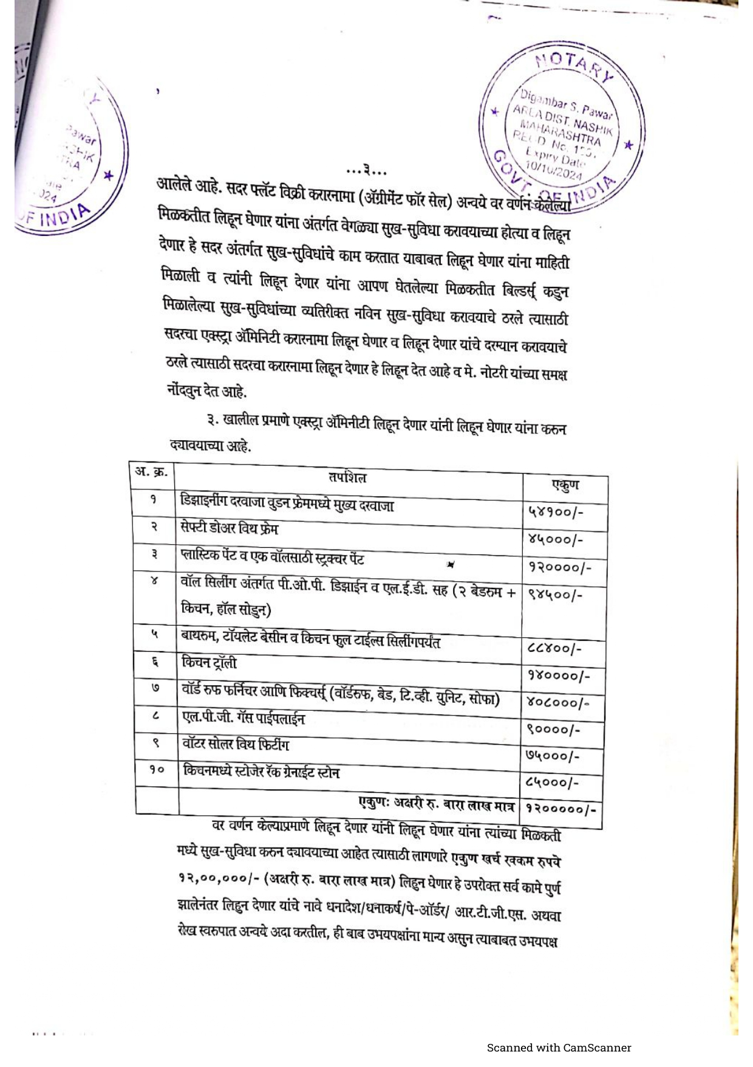

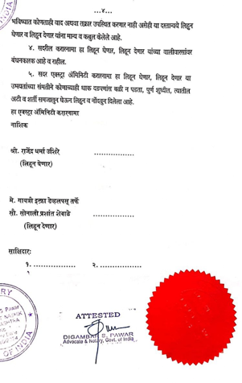

The Extra Amenities amount is Rs. 12,00,000/- (Rupees Twelve Lakh Only)

