Vastu/Nashik/06/2024/009608/2306967
28/18-411-RYBS
Date: 28.06.2024

To,
The Branch Manager,
Bank of Baroda
Regional Office
BSNL Building, Datta Mandir Road, Nashik Road,
Nashik, PIN – 422 101, State - Maharashtra, Country - India.

Sub: Vetting of Extra Amenities

Sir,

With reference to above subject, we have evaluated the Extra Amenities for Residential Flat No.103, A - Wing, First Floor, " Alpine ", Survey No. 204/ 1/ 1D/ 2+204/ 1/ 1D/ 3, Next to Shree Varad Vinayak Mandir, Shiv Kurpa Nagar, Dr. Nanasaheb Dharmadhikari Marg, Amrutdham, Village - Nashik, Taluka & District - Nashik, PIN Code – 422 003, State - Maharashtra, Country - lndia. belongs to Name of Owner: Mr. Shreekant Ramesh Kangane.

We have verified the rates quoted as per current market rates. Details of Extra Amenities considered as per copy of Extra Amenities Agreement between Mr. Shreekant Ramesh Kangane (First Party). Mr. Rajendra Ratriram Yadav (Second Party) received on dated.28.06.2024. The Extra Amenities amount is Rs. 4,50,000/- (Rupees Four Lakh Fifty Thousand Only)

The said Cost Vetting Certificate is valid upto next 6 months Only.

Thanking you

Sincerely yours

Manoj B. Chalikwar
Registered Valuer
Chartered Engineer (India)
Reg. No. CAT-I-F-1763
Reg. No. IBBI/RV/07/2018/10366
BOB Empanelment No.: ZO:MZ:ADV:46:941
Encl: Valuation report.

Agreement for Extra Amenities
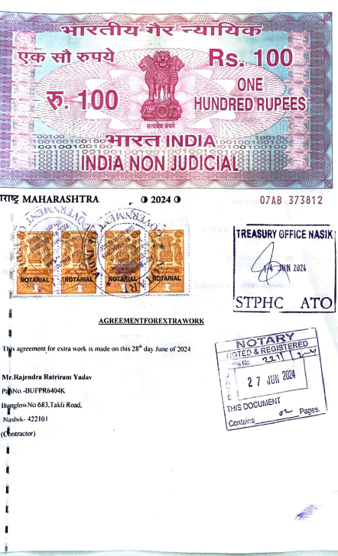
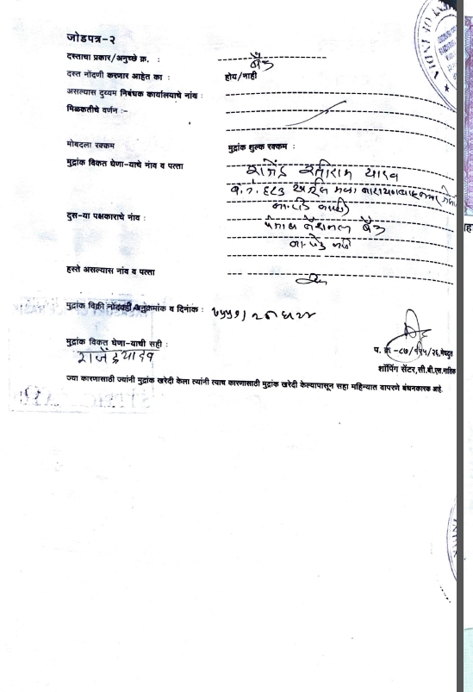

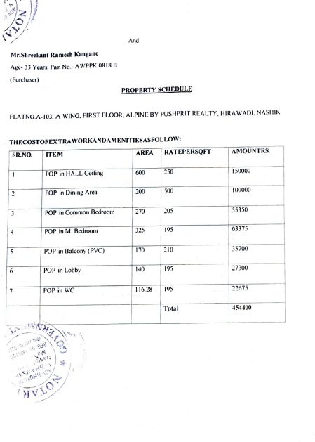
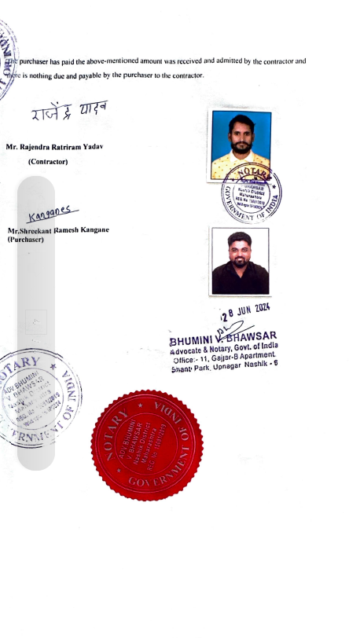

The Extra Amenities amount is Rs. 4,50,000/- (Rupees Four Lakh Fifty Thousand Only)

