Vastu/Nashik/06/2024/009555/2306919
26/17-363-RYBS
Date: 26.06.2024

To,
The Branch Manager,
Bank of Baroda
Regional Office
BSNL Building, Datta Mandir Road, Nashik Road,
Nashik, PIN – 422 101, State - Maharashtra, Country - India.

Sub: Vetting of Extra Amenities

Sir,

With reference to above subject, we have evaluated the Extra Amenities For Residential Flat No. 14, Fourth Floor, D-Type Building, " Bharatratna Dr. Babasaheb Ambedkar Magasvargiya Co-Op. Housing Society Ltd. Nashik ", Survey No. 297/ 2/ 2 Part, CTS No. 6245 PT, Near Radisson Blu Hotel, Prashant Nagar, Damodar Nagar Road, Village - Pathardi, Taluka & District - Nashik, PIN Code – 422010, State – Maharashtra, Country – India. belongs to Name of Owner: Shri. Divesh Sanjay Jadhav & Sau. Archana Sanjay Jadhav.

We have verified the rates quoted as per current market rates. Details of Extra Amenities considered as per copy of Extra Amenities Agreement between Shri. Divesh Sanjay Jadhav & Sau. Archana Sanjay Jadhav (First Party). Shri. Nitin Dadasaheb Patil (Second Party) received on dated.03.06.2024. The Extra Amenities amount is Rs. 6,00,000/- (Rupees Six Lakh Only)

The said Cost Vetting Certificate is valid upto next 6 months Only.

Thanking you

Sincerely yours

Manoj B. Chalikwar
Registered Valuer
Chartered Engineer (India)
Reg. No. CAT-I-F-1763
Reg. No. IBBI/RV/07/2018/10366
BOB Empanelment No.: ZO:MZ:ADV:46:941
Encl: Valuation report.

Agreement for Extra Amenities
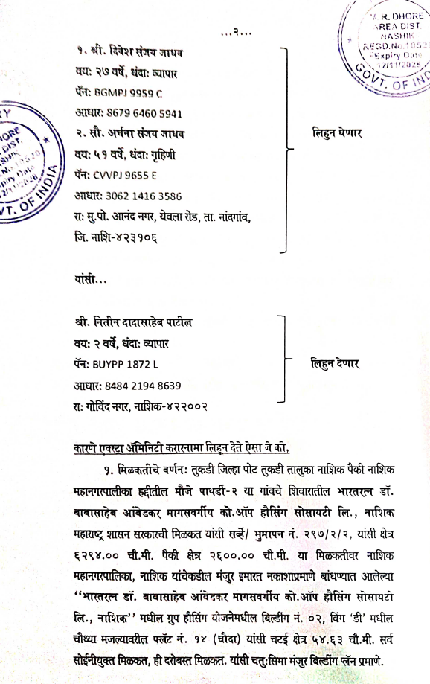
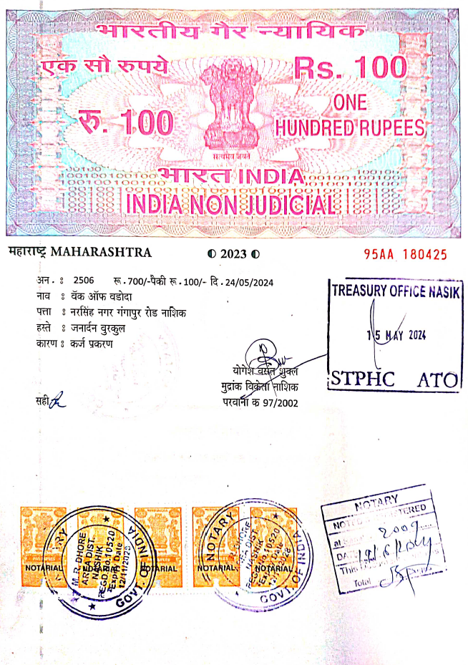

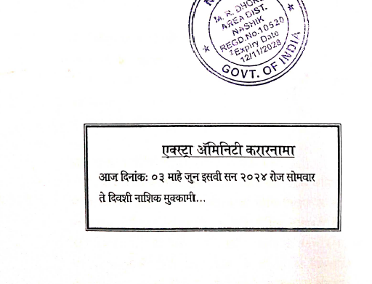

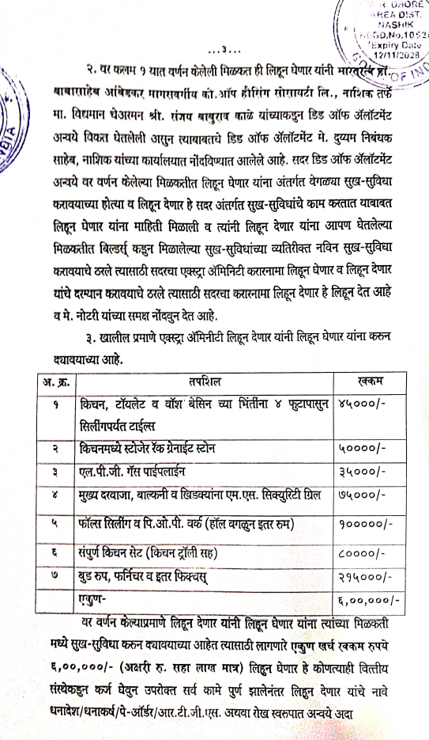
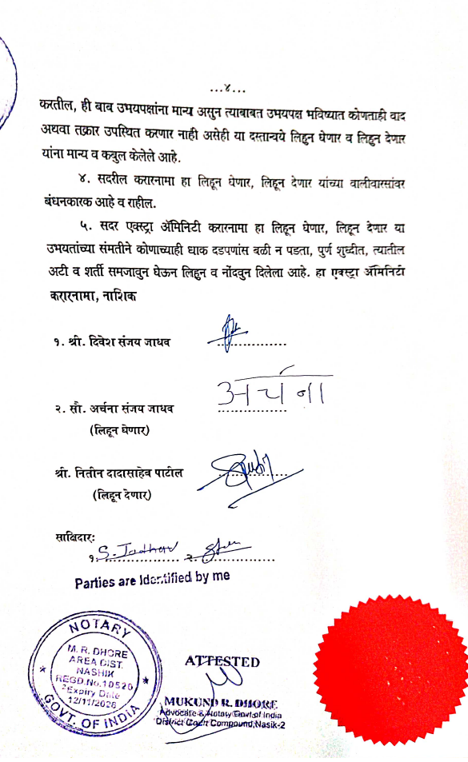

The Extra Amenities amount is Rs. 6,00,000/- (Rupees Six Lakh Only)

