Vastu/Nashik/03/2024/007930/2305703
23/3-451-RYBS
Date: 26.06.2024
To,
Bank of Baroda
Regional Office
BSNL Building, Datta Mandir Road, Nashik Road,
Nashik, PIN – 422 101, State - Maharashtra, Country - India.

Sub: Vetting of Estimate

Sir,

With reference to above subject, we have evaluated the Estimate for Residential Land and Proposed Bungalow on Plot No.8/2, Ground + First Floor, Survey No.75/1/1, Behind Samruddhi Hospital , Shree Swami Samarth Nagar Village- Nandur Dasak, Taluka – Nashik,District – Nashik, Pin Code – 422 006, State - Maharashtra, Country – India belongs Vaishali Dattu Mulmule.

We have verified the rates quoted as per current market rates. Details of Estimate considered as per copy of Estimate Provided by Krushna S.Adsare & Associates received on dated.17.06.2024. The Estimate amount is Rs.28,50,000/- (Rupees Twenty Eight Lakh Fifty Thousand Only.)

Note:1) The said Cost Vetting Certificate is valid upto next 6 months Only.

Thanking you

Sincerely yours

Sharadkumar B. Chalikwar
Govt. Reg. Valuer
Chartered Engineer (India)
Reg. No. (N) CCIT/1-14/52/2008-09
Encl: Vetting report

Estimate
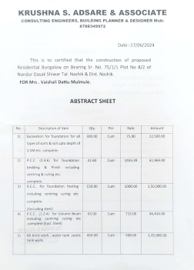
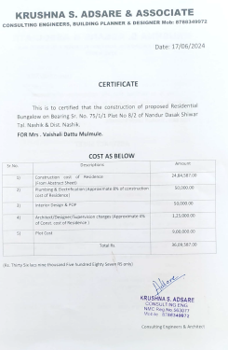

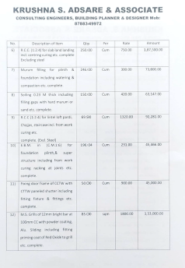
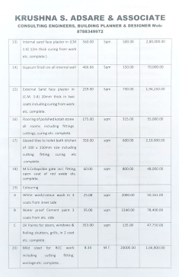

Estimate


The Estimate amount is Rs.28,50,000/- (Rupees Twenty Eight Lakh Fifty Thousand Only.)

