Valuation Report of the Immovable Property
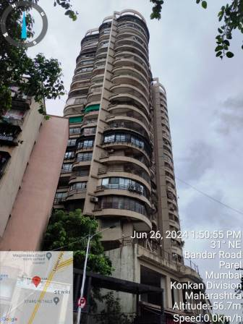

Details of the property under consideration:

Name of Owner: Mr. Shabbir Rajkotwala & Mrs. Tasneem Rajkotwala

Residential Flat No. 2201, 22nd Floor, Wing – II, Building No. B, “Krypton Twin Tower”, “Krypton Towers Co-op. Hsg. Soc. Ltd.”, C. S. No. 2/169, Krishna Cotton Press Compound, 156, Jakeria Bunder Road, Sewri (West), Mumbai – 400 015, State - Maharashtra, Country - India.

Latitude Longitude - 18°59'36.0"N 72°51'03.8"E

Valuation Done for:
Cosmos Bank
Chembur (East) Branch

Plot No. 239, Ground Floor, Central Avenue Road, Near Ambedkar Ggarden, Chembur (East),

Mumbai - 400 071, State - Maharashtra, Country - India.

Vastu/Mumbai/06/2024/9527/46194
20/23-388-JARJ
Date: 27.06.2024

VALUATION OPINION REPORT

The property bearing Residential Flat No. 2201, 22nd Floor, Wing – II, Building No. B, “Krypton Twin Tower”, “Krypton Towers Co-op. Hsg. Soc. Ltd.”, C. S. No. 2/169, Krishna Cotton Press Compound, 156, Jakeria Bunder Road, Sewri (West), Mumbai – 400 015, State - Maharashtra, Country - India belongs to Mr. Shabbir Rajkotwala & Mrs. Tasneem Rajkotwala.

Boundaries of the property.
North | : | Internal Road / Savla Compound
South | : | Sewri Cross Road
East | : | Zakeria Bunder Road
West | : | Krishna Building

Considering various parameters recorded, existing economic scenario, and the information that is available with reference to the development of neighborhood and method selected for valuation, we are of the opinion that, the property premises can be assessed and valued for banking purpose for ` 3,30,26,930.00 (Rupees Three Crore Thirty Lakhs Twenty Six Thousand Nine Hundred Thirty Only).
The valuation of the property is based on the documents produced by the concern. Legal aspects have not been taken into considerations while preparing this valuation report.

Hence certified

Manoj B. Chalikwar
Registered Valuer
Chartered Engineer (India)
Reg. No. CAT-I-F-1763
Encl: Valuation report in Form – 01

Valuation Report of Residential Flat No. 2201, 22nd Floor, Wing – II, Building No. B, “Krypton Twin Tower”, “Krypton Towers Co-op. Hsg. Soc. Ltd.”, C. S. No. 2/169, Krishna Cotton Press Compound, 156, Jakeria Bunder Road, Sewri (West), Mumbai – 400 015, State - Maharashtra, Country - India.
Form 0-1
(See Rule 8 D)
REPORT OF VALUATION OF IMMOVABLE PROPERTY (OTHER THAN AGRICULTURAL LANDS, PLANTATIONS, FORESTS, MINES AND QUARRIES)
GENERAL:

1 | Purpose for which the valuation is made |  | To assess the Fair Market Value as on 27.06.2024 for Banking Purpose
2 | Date of inspection |  | 26.06.2024
3 | Name of the owner/ owners |  | Mr. Shabbir Rajkotwala &  Mrs. Tasneem Rajkotwala
4 | If the property is under joint ownership / co-ownership, share of each such owner. Are the shares undivided? |  | Joint Ownership  Details of ownership share is not available
5 | Brief description of the property |  | Address: Residential Flat No. 2201, 22nd Floor, Wing – II, Building No. B, “Krypton Twin Tower”, “Krypton Towers Co-op. Hsg. Soc. Ltd.”, C. S. No. 2/169, Krishna Cotton Press Compound, 156, Jakeria Bunder Road, Sewri (West), Mumbai – 400 015, State - Maharashtra, Country - India.  Contact Person:  Mr. Shabbir Rajkotwala (Owner)  Contact No.: 9136465560
9833151457 | Location, street, ward no |  | Krishna Cotton Press Compound, 156, Jakeria Bunder Road, Sewri (West), Mumbai
 | Survey/ Plot no. of land |  | C. S. No. 2/169 of Parel Sewri Division
8 | Is the property situated in residential/ commercial/ mixed area/ Residential area? |  | Residential Area
9 | Classification of locality-high class/ middle class/poor class |  | Middle Class
10 | Proximity to civic amenities like schools, Hospitals, Units, market, cinemas etc. |  | All the amenities are available in the vicinity
11 | Means and proximity to surface communication by which the locality is served |  | Served by Buses, Taxies, Auto and Private cars
 | LAND
12 | Area of Flat supported by documentary proof. Shape, dimension and physical features |  | (Area as per Actual Site Measurement)  Carpet Area in Sq. Ft. = 883.00  (Area as per Agreement for Sale)  Built-up Area in Sq. Ft. = 971.00  (Carpet Area + 10%)
  Particulars | Area in Sq. Ft.
  Carpet Area | 1,319.00
  Dry Balcony Area | 56.00
  Balcony Area | 46.00
  Garden Area | 75.00
  Total | 1,496.00
13 | Roads, Streets or lanes on which the land is abutting |  | 156, Jakeria Bunder Road
14 | If freehold or leasehold land |  | Freehold
15 | If leasehold, the name of Lessor/lessee, nature of lease, date of commencement and termination of lease and terms of renewal of lease.  - Initial Premium  - Ground Rent payable per annum  - Unearned increased payable to the  Lessor in the event of sale or transfer |  | N.A.
16 | Is there any restriction covenant in regard to use of land? If so, attach a copy of the covenant. |  | As per documents
17 | Are there any agreements of easements? If so, attach a copy of the covenant |  | Information not available
18 | Does the land fall in an area included in any Town Planning Scheme or any Development Plan of Government or any statutory body? If so, give Particulars. |  | Information not available
19 | Has any contribution been made towards development or is any demand for such contribution still outstanding? |  | Information not available
20 | Has the whole or part of the land been notified for acquisition by government or any statutory body? Give date of the notification. |  | No
21 | Attach a dimensioned site plan |  | N.A.
 | IMPROVEMENTS
22 | Attach plans and elevations of all structures standing on the land and a lay-out plan. |  | Information not available
23 | Furnish technical details of the building on a separate sheet (The Annexure to this form may be used) |  | Attached
24 | Is the building owner occupied/ tenanted/ both? |  | Owner Occupied
 | If the property owner occupied, specify portion and extent of area under owner-occupation |  | N.A.
25 | What is the Floor Space Index permissible and Percentage actually utilized? |  | Floor Space Index permissible – As per MCGM norms  Percentage actually utilized – Details not available
26 | RENTS
 | (i) | Names of tenants/ lessees/ licensees, etc | NA
 | (ii) | Portions in their occupation | N.A.
 | (iii) | Monthly or annual rent /compensation/license fee, etc. paid by each | ` 69,000.00 expected rental income per month
 | (iv) | Gross amount received for the whole property | N.A.
27 | Are any of the occupants related to, or close to business associates of the owner? |  | N. A.
28 | Is separate amount being recovered for the use of fixtures, like fans, geysers, refrigerators, cooking ranges, built-in wardrobes, etc. or for services charges? If so, give details |  | N. A.
29 | Give details of the water and electricity charges, If any, to be borne by the owner |  | N. A.
30 | Has the tenant to bear the whole or part of the cost repairs and maintenance? Give particulars |  | N. A.
31 | If a lift is installed, who is to bear the cost of maintenance and operation- owner or tenant? |  | N. A.
32 | If a pump is installed, who is to bear the cost of maintenance and operation- owner or tenant? |  | N. A.
33 | Who has to bear the cost of electricity charges for lighting of common space like entrance hall, stairs, passage, compound, etc. owner or tenant? |  | N. A.
34 | What is the amount of property tax? Who is to bear it? Give details with documentary proof |  | Information not available
35 | Is the building insured? If so, give the policy no., amount for which it is insured and the annual premium |  | Information not available
36 | Is any dispute between landlord and tenant regarding rent pending in a court of rent? |  | N. A.
37 | Has any standard rent been fixed for the premises under any law relating to the control of rent? |  | N. A.
 | SALES
38 | Give instances of sales of immovable property in the locality on a separate sheet, indicating the Name and address of the property, registration No., sale price and area of land sold. |  | As per sub registrar of assurance records
39 | Land rate adopted in this valuation |  | N. A. as the property under consideration is a Residential Flat in a building. The rate is considered as composite rate.
40 | If sale instances are not available or not relied up on, the basis of arriving at the land rate |  | N. A.
 | COST OF CONSTRUCTION
41 | Year of commencement of construction and year of completion |  | Year of Completion – 2018 (As per Full Occupancy Certificate)
42 | What was the method of construction, by contract/By employing Labour directly/ both? |  | N. A.
43 | For items of work done on contract, produce copies of agreements |  | N. A.
44 | For items of work done by engaging Labour directly, give basic rates of materials and Labour supported by documentary proof. |  | N. A.
 | Remark:

PART II- VALUATION
GENERAL:

Under the instruction of Cosmos Bank, Chembur (East) Branch to assess fair market value as on 27.06.2024 for Residential Flat No. 2201, 22nd Floor, Wing – II, Building No. B, “Krypton Twin Tower”, “Krypton Towers Co-op. Hsg. Soc. Ltd.”, C. S. No. 2/169, Krishna Cotton Press Compound, 156, Jakeria Bunder Road, Sewri (West), Mumbai – 400 015, State - Maharashtra, Country - India belongs to Mr. Shabbir Rajkotwala & Mrs. Tasneem Rajkotwala.

We are in receipt of the following documents:
1 | Copy of Agreement dated 21.04.2017 between M/s. Krypton Construction Private Ltd. (the Promoters / Developer) AND Mr. Shabbir Rajkotwala & Mrs. Tasneem Rajkotwala (the Purchasers)
2 | Copy of Full Occupancy Certificate No. EB/9981/FS/A dated 30.11.2018 issued by Municipal Corporation of Greater Mumbai.
3 | Copy of Property Tax Bill, Book No. FS0503550400034 for Assessment Year 2023-2024 dated 26.02.2024 in the name of Shabbir Rajkotwala & Mrs. Tasneem Rajkotwala issued by MCGM.
4 | Copy of Maintenance Receipt dated 02.02.2024 in the name of Mr. Shabbir Rajkotwala & Mrs. Tasneem Rajkotwala issued by Krypton Tower CHS Ltd.
2 | Copy of Share Certificate No. 103 bearing Nos. 1031 to 1040 having 10 Shares of Rs. 50/- each dated 06.11.2019 in the name of Shri. Shabbir Rajkotwala issued by Krypton Towers Co-op. Hsg. Soc. Ltd.

LOCATION:

The said building is located at bearing C. S. No. 2/169 of Parel Sewri Division, within the limits of Municipal Corporation of Greater Mumbai. The property falls in Residential Zone. It is at a walkable distance of 650m. from Sewri railway station.

BUILDING:

The building under reference is having Ground + 3 Podium’s + 4 to 22 Upper Floors. It is a R.C.C. Framed Structure with 9" thick external walls and 6" thick internal brick walls. The walls are having sand faced plaster from outside. The staircase is of R.C.C. with R.C.C. trades and risers with chequered tile floor finish. The building external condition is good. The building is used for residential purpose. 22nd Floor is having 2 Residential Flat. The building has 2 lifts.

Residential Flat:
The residential flat under reference is situated on the 22nd Floor. The composition of residential flat consists of Living Room + Dining Area + 3 Bedrooms + Kitchen + 3 Toilets + Passage + Balcony + Dry Area + Dry Balcony Area + Garden Area (i.e., 3BHK + 3 Toilets). The residential flat is ﬁnished with Vitrified tiles flooring, Teak wood door frame with flush shutters, Powder coated Aluminum sliding windows & Concealed electrification & Concealed plumbing.

Valuation as on 27th June 2024
The Carpet Area of the Residential Flat | : | 883.00 Sq. Ft.
Deduct Depreciation:
Year of Construction of the building | : | 2018 (As per Full Occupancy Certificate)
Expected total life of building | : | 60 Years
Age of the building as on 2024 | : | 06 Years
Cost of Construction | : | 971.00 X 3,000.00 = ` 29,13,000.00
Depreciation {(100-10) X 06 / 60} | : | 09.00%
Amount of depreciation | : | ` 2,62,170.00
Guideline rate obtained from the Stamp Duty Ready Reckoner for new property | : | ` 1,58,677.00 per Sq. M.  i.e. ` 14,741.00 per Sq. Ft.
Guideline rate (after depreciation) | : | ` 1,52,442.00 per Sq. M.  i.e. ` 14,162.00 per Sq. Ft.
Prevailing market rate | : | ` 37,700.00 per Sq. Ft.
Value of property as on 27.06.2024 | : | 883.00 Sq. Ft. X ` 37,700.00 = ` 3,32,89,100.00
(Area of property x market rate of developed land & Residential premises as on 2024 - 25 published in The Indian Valuer’s Directory and Reference Book for purpose of valuation. – Depreciation)
Depreciated fair value of the property as on  27.06.2024 | : | ` 3,32,89,100.00 (-) ` 2,62,170.00  ` 3,30,26,930.00
Total Value of the property | : | ` 3,30,26,930.00
The realizable value of the property | : | ` 2,97,24,237.00
Distress value of the property | : | ` 2,64,21,544.00
Insurable value of the property | : | ` 29,13,000.00
Guideline value of the property (971.00 X 14,162.00) | : | ` 1,37,51,302.00

Taking into consideration above said facts, we can evaluate the value of Valuation Report of Residential Flat No. 2201, 22nd Floor, Wing – II, Building No. B, “Krypton Twin Tower”, “Krypton Towers Co-op. Hsg. Soc. Ltd.”, C. S. No. 2/169, Krishna Cotton Press Compound, 156, Jakeria Bunder Road, Sewri (West), Mumbai – 400 015, State - Maharashtra, Country - India for this particular purpose at ` 3,30,26,930.00 (Rupees Three Crore Thirty Lakhs Twenty Six Thousand Nine Hundred Thirty Only) as on 27th June 2024.
NOTES

- I, Manoj B. Chalikwar with my experience and ability to judgment I am of the considered opinion that the fair market value of the property as on 27th June 2024 is ` 3,30,26,930.00 (Rupees Three Crore Thirty Lakhs Twenty Six Thousand Nine Hundred Thirty Only). Value varies with time and purpose and hence this value should not be referred for any purpose other than mentioned in this report.

- This valuation is done on the basis of information, which the valuer has obtained by information provided by the client about the premises and location of the surrounding area and also prevailing rates in the surrounding area, and further subject to document as mentioned in valuation report.

- This valuer should not be held responsible for authentication of documents, clear title and other such related matters. For that purpose Latest Legal Opinion should be sought.

PART III- DECLARATION

I hereby declare that
    - The information furnished in part I is true and correct to the best of my knowledge and belief;
    - I have no direct or indirect interest in the property valued:

ANNEXURE TO FORM 0-1

Technical details Main Building
1. | No. of floors and height of each floor |  | Ground + 3 Podium’s + 4 to 22 Upper Floors
2. | Plinth area floor wise as per IS 3361-1966 |  | N.A. as the said property is a Residential Flat situated on 22nd Floor
3 | Year of construction |  | 2018 (As per Full Occupancy Certificate)
4 | Estimated future life |  | 54 Years Subject to proper, preventive periodic maintenance & structural repairs
5 | Type of construction- load bearing walls/RCC frame/ steel frame |  | R.C.C. Framed Structure
6 | Type of foundations |  | R.C.C. Foundation
7 | Walls |  | All external walls are 9" thick and partition walls are 6" thick.
8 | Partitions |  | 6” thick brick wall
9 | Doors and Windows |  | Teak wood door frame with flush shutters, Powder coated Aluminum sliding windows
10 | Flooring |  | Vitrified tiles flooring
11 | Finishing |  | Cement plastering with POP false ceiling
12 | Roofing and terracing |  | R.C.C. slab
13 | Special architectural or decorative features, if any |  | No
14 |  |  | Concealed electrification  Concealed plumbing
  (i) | Internal wiring – surface or conduit
  (ii) | Class of fittings: Superior/ Ordinary/ Poor.
15 | Sanitary installations |  | As per Requirement
  (i) | No. of water closets
  (ii) | No. of lavatory basins
  (iii) | No. of urinals
  (iv) | No. of sink
16 | Class of fittings: Superior colored / superior white/ordinary. |  | Ordinary
17 | Compound wall  Height and length  Type of construction |  | 6'.0" High, R.C.C. column with B. B. masonry wall
18 | No. of lifts and capacity |  | 2 Lifts
19 |  | Underground sump – capacity and type of construction |  | R.C.C tank
20 |  | Over-head tank  Location, capacity  Type of construction |  | R.C.C tank on terrace
21 |  | Pumps- no. and their horse power |  | May be provided as per requirement
22 |  | Roads and paving within the compound approximate area and type of paving |  | Cement concrete in open spaces, etc.
23 |  | Sewage disposal – whereas connected to public sewers, if septic tanks provided, no. and capacity |  | Connected to Municipal Sewerage System

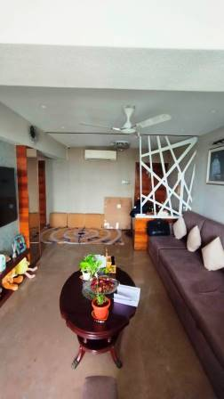
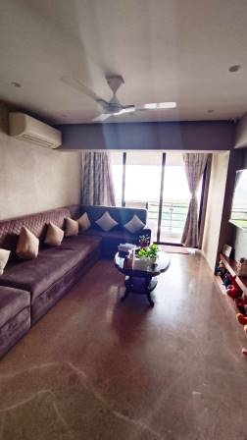
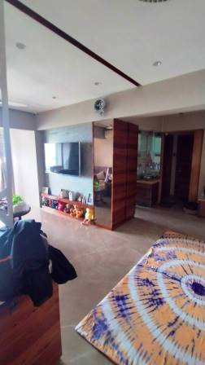
Actual site photographs

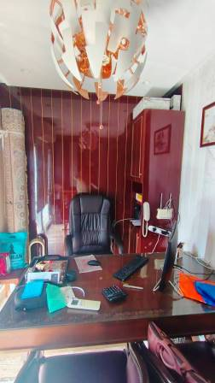
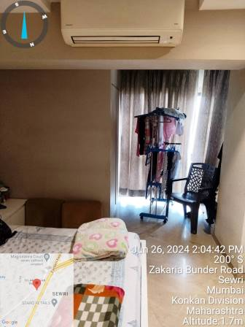
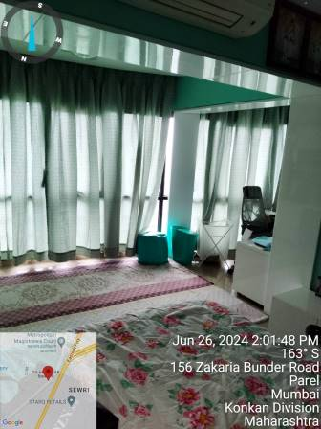

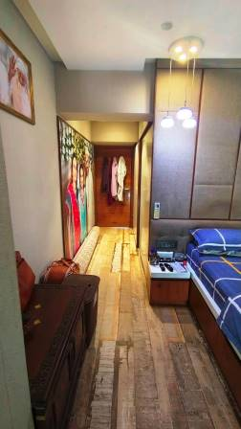
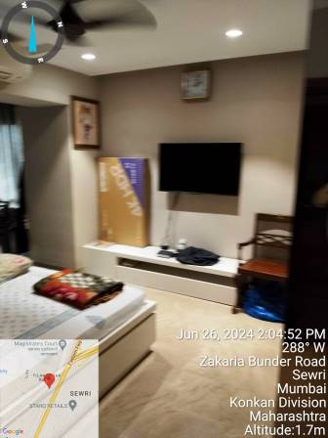
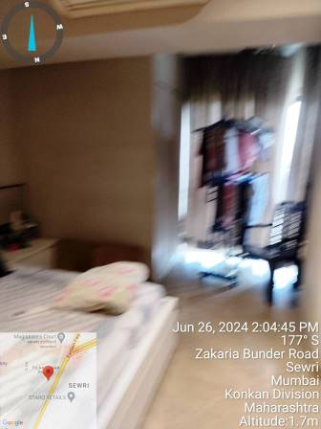
Actual site photographs
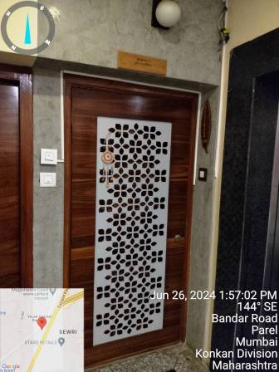
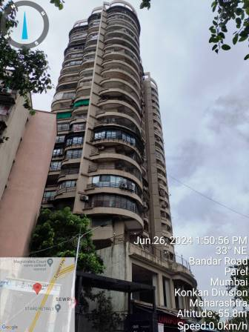
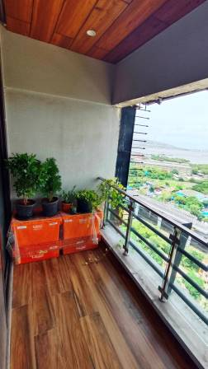
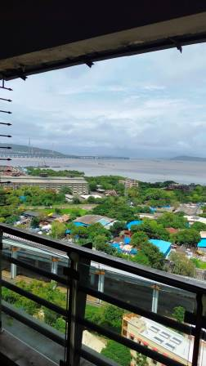
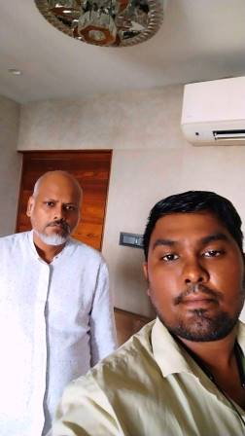
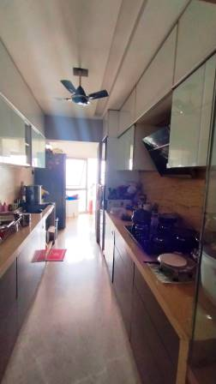
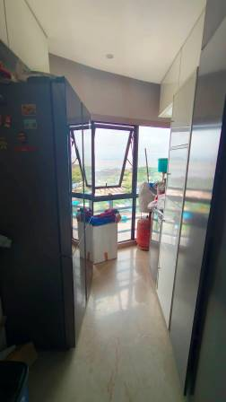
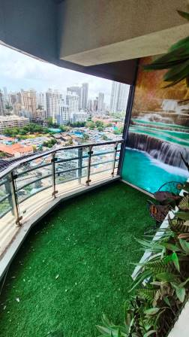
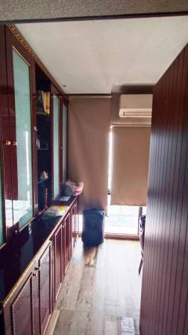
Route Map of the property
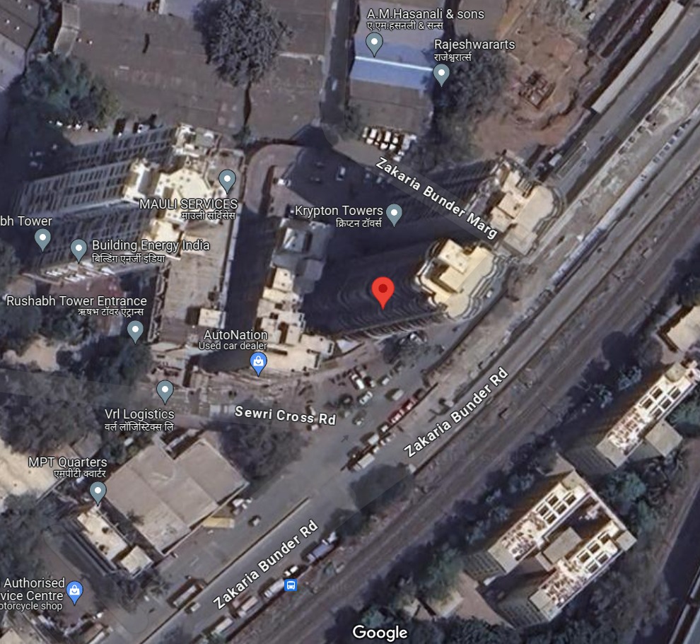
Site u/r

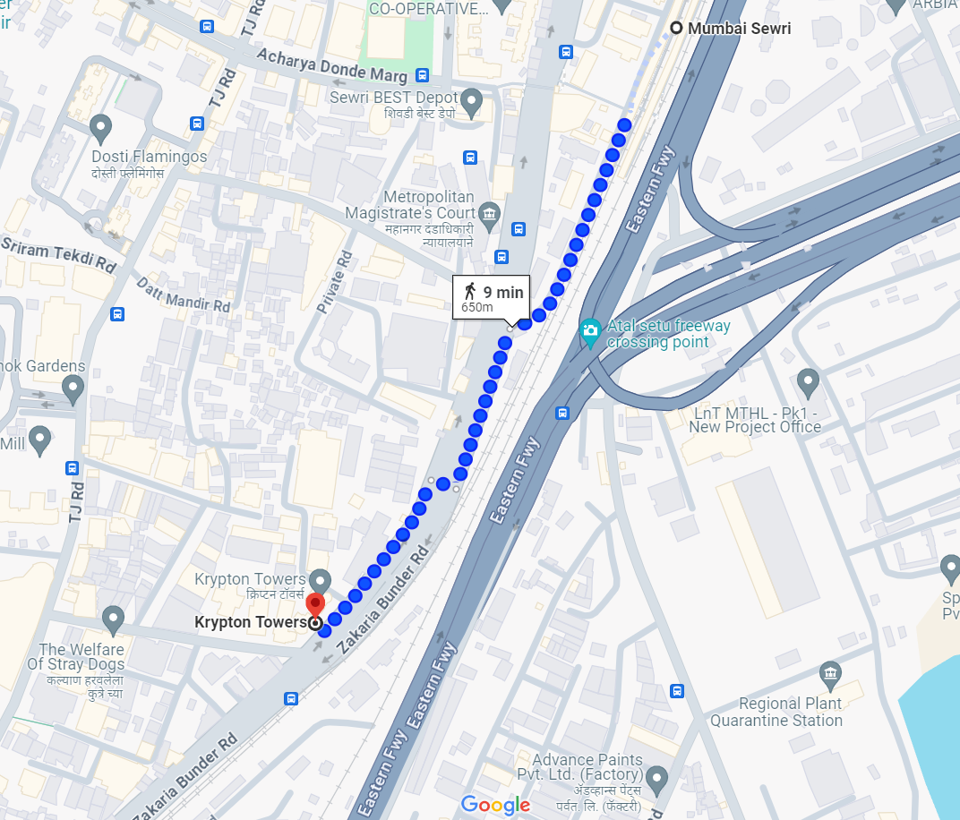

Latitude Longitude - 18°59'36.0"N 72°51'03.8"E

Note: The Blue line shows the route to site travelling distance from nearest railway station (Sewri – 650m.)
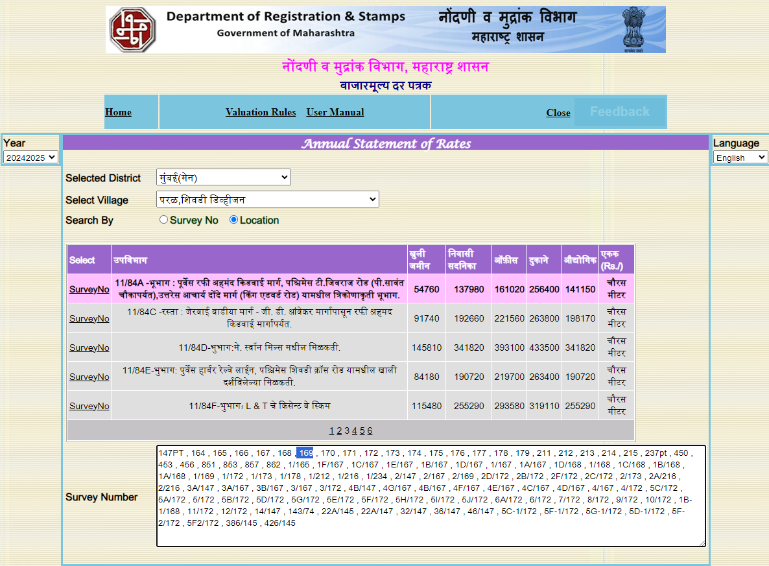
Ready Reckoner Rate

Stamp Duty Ready Reckoner Market Value Rate for Flat | 1,37,980.00
15% Increased on Flat located on 22nd floors with lift | 20,697.00
Stamp Duty Ready Reckoner Market Value Rate (After Increase) (A) | 1,58,677.00 | Sq. Mtr. | 14,741.00 | Sq. Ft.
Stamp Duty Ready Reckoner Market Value Rate for Land (B) | 54,760.00
The difference between land rate and building rate (A – B = C) | 1,03,917.00
Depreciation Percentage as per table (D) [100% - 06%]  (Age of the Building – 06 Years) | 94%
Rate to be adopted after considering depreciation [B + (C x D)] | 1,52,442.00 | Sq. Mtr. | 14,162.00 | Sq. Ft.
Multi-Storied building with Lift
For residential premises / commercial unit / office on above floor in multistoried building, the rate mentioned in the ready reckoner will be increased as under:
 | Location of Flat / Commercial Unit in the building | Rate
a) | On Ground to 4 Floors | No increase for all floors from ground to 4 floors
b) | 5 Floors to 10 Floors | Increase by 5% on units located between 5 to 10 floors
c) | 11 Floors to 20 Floors | Increase by 10% on units located between 11 to 20 floors
d) | 21 Floors to 30 Floors | Increase by 15% on units located between 21 to 30 floors
e) | 31 Floors and above | Increase by 20% on units located on 31 and above floors

Table – D: Depreciation Percentage Table

Completed Age of Building in Years | Value in percent after depreciation
 | R.C.C. Structure / other Pukka Structure | Cessed Building, Half or Semi – Pukka Structure & Kaccha Structure.
0 to 2 Years | 100% | 100%
Above 2 & up to 5 Years | 95% | 95%
Above 5 Years | After initial 5 year for every year 1% depreciation is to be considered. However maximum deduction available as per this shall be 70% of Market Value rate | After initial 5 year for every year 1.5% depreciation is to be considered. However maximum deduction available as per this shall be 85% of Market Value rate
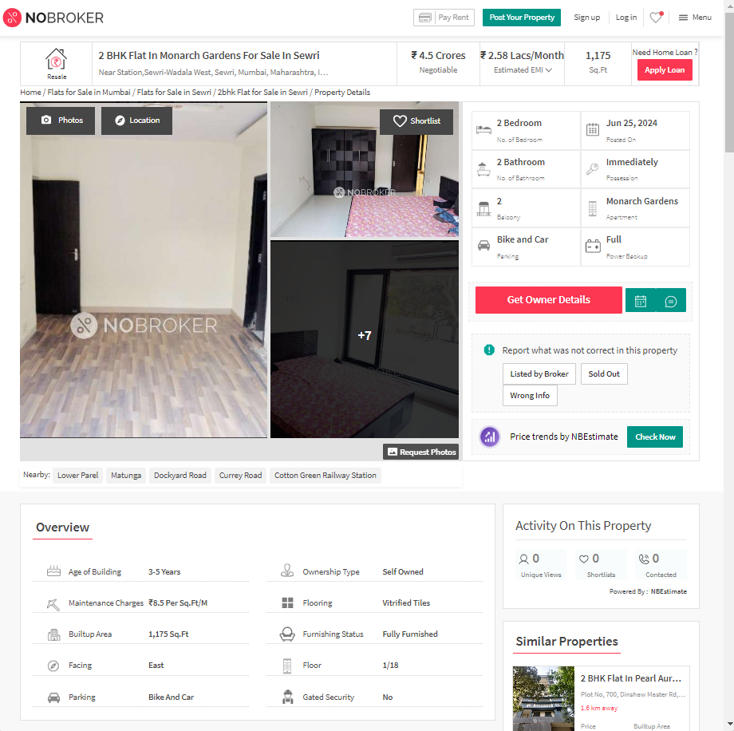
Price Indicators

Property | Flat
Source | NOBROKER
Floor | -
 | Carpet | Built Up | Saleable
Area | 979.00 | 1,175.00 | 1,410.00
Percentage | - | 20% | 20%
Rate Per Sq. Ft. | ₹ 45,965.00 | ₹ 38,298.00 | ₹ 31,915.00

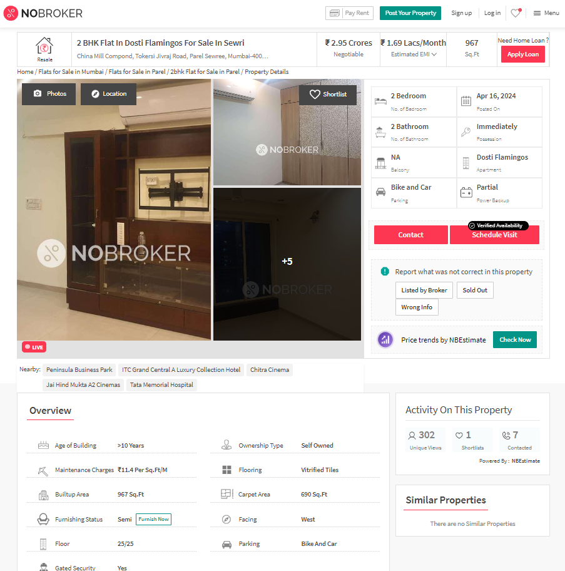
Price Indicators

Property | Flat
Source | BOBROKER
Floor | -
 | Carpet | Built Up | Saleable
Area | 690.00 | 828.00 | 994.00
Percentage | - | 20% | 20%
Rate Per Sq. Ft. | ₹ 42,754.00 | ₹ 35,628.00 | ₹ 29,678.00
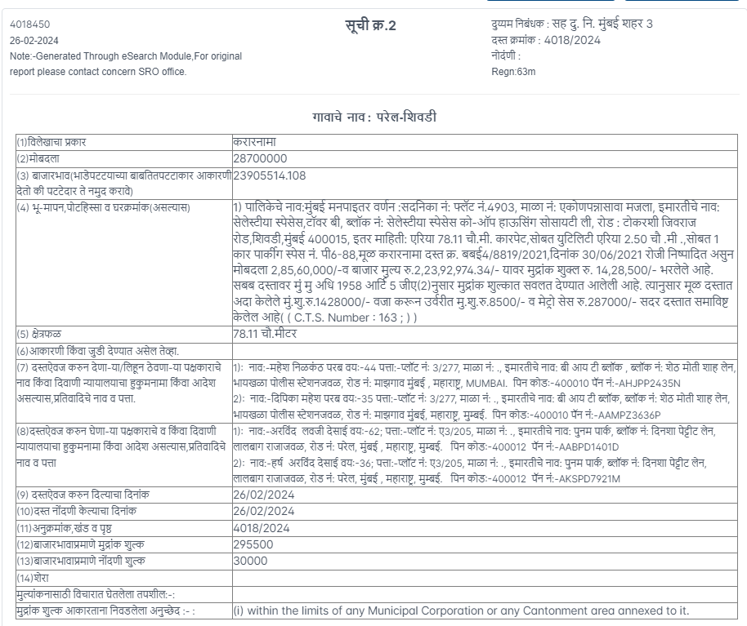
Sale Instance

Property | Flat
Source | Index II
Floor | -
 | Carpet | Built Up | Saleable
Area | 841.00 | 925.00 | -
Percentage | - | 10% | -
Rate Per Sq. Ft. | ₹ 34,126.00 | ₹ 31,027.00 | -

DEFINITION OF VALUE FOR THIS SPECIFIC PURPOSE

This exercise is to assess Fair Market Value of the property under reference as on 27th June 2024.

The term Value is defined as

“The most probable price, as of a specified date, in cash, terms equivalent to cash, or in other precisely revealed terms for which the specified property rights would sell after reasonable exposure in a competitive market under all conditions requisite to a fair sale, with the buyer and seller each acting prudently knowledgeably and for self interest assuming that neither is under undue duress”.
Fundamental assumptions and conditions presumed in this definition are:

1. Buyer and seller are motivated by self-interest.

2. Buyer and seller are well informed and are acting prudently.

3. The property is exposed for a reasonable time on the open market.

4. Payment is made in cash or equivalent or in specified financing terms.

UNDER LYING ASSUMPTIONS
1. We assume no responsibility for matters of legal nature affecting the property appraised or the title thereto, nor do we render our opinion as to the title, which is assumed to be good and marketable.
2. The property is valued as though under responsible ownership.
3. It is assumed that the property is free of liens and encumbrances.
4. It is assumed that there are no hidden or unapparent conditions of the subsoil or structure that would render it more or less valuable. No responsibility is assumed for such conditions or for engineering that might be required to discover such factors.
5. There is no direct/ indirect interest in the property valued.
6. The rates for valuation of the property are in accordance with the Govt. approved rates and prevailing market rates.

DECLARATION OF PROFESSIONAL FEES CHARGED

We hereby declare that, our professional fees are not contingent upon the valuation findings. However, if the statute AND/OR clients demands that, the fees should be charged on the percentage of assessed value then, with the full knowledge of the AND/OR end user, it is being charged accordingly.

VALUATION OF THE PROPERTY PREMISES

Considering various parameters recorded herein above, existing economic scenario, and the information that is available with reference to the development of neighbourhood and method selected for valuation, we are of the opinion that, the property premises can be assessed and valued for banking purpose as on day for ` 3,30,26,930.00 (Rupees Three Crore Thirty Lakhs Twenty Six Thousand Nine Hundred Thirty Only).

Manoj B. Chalikwar

Registered Valuer

Chartered Engineer (India)

Reg. No. CAT-I-F-1763

