Valuation Report of the Immovable Property
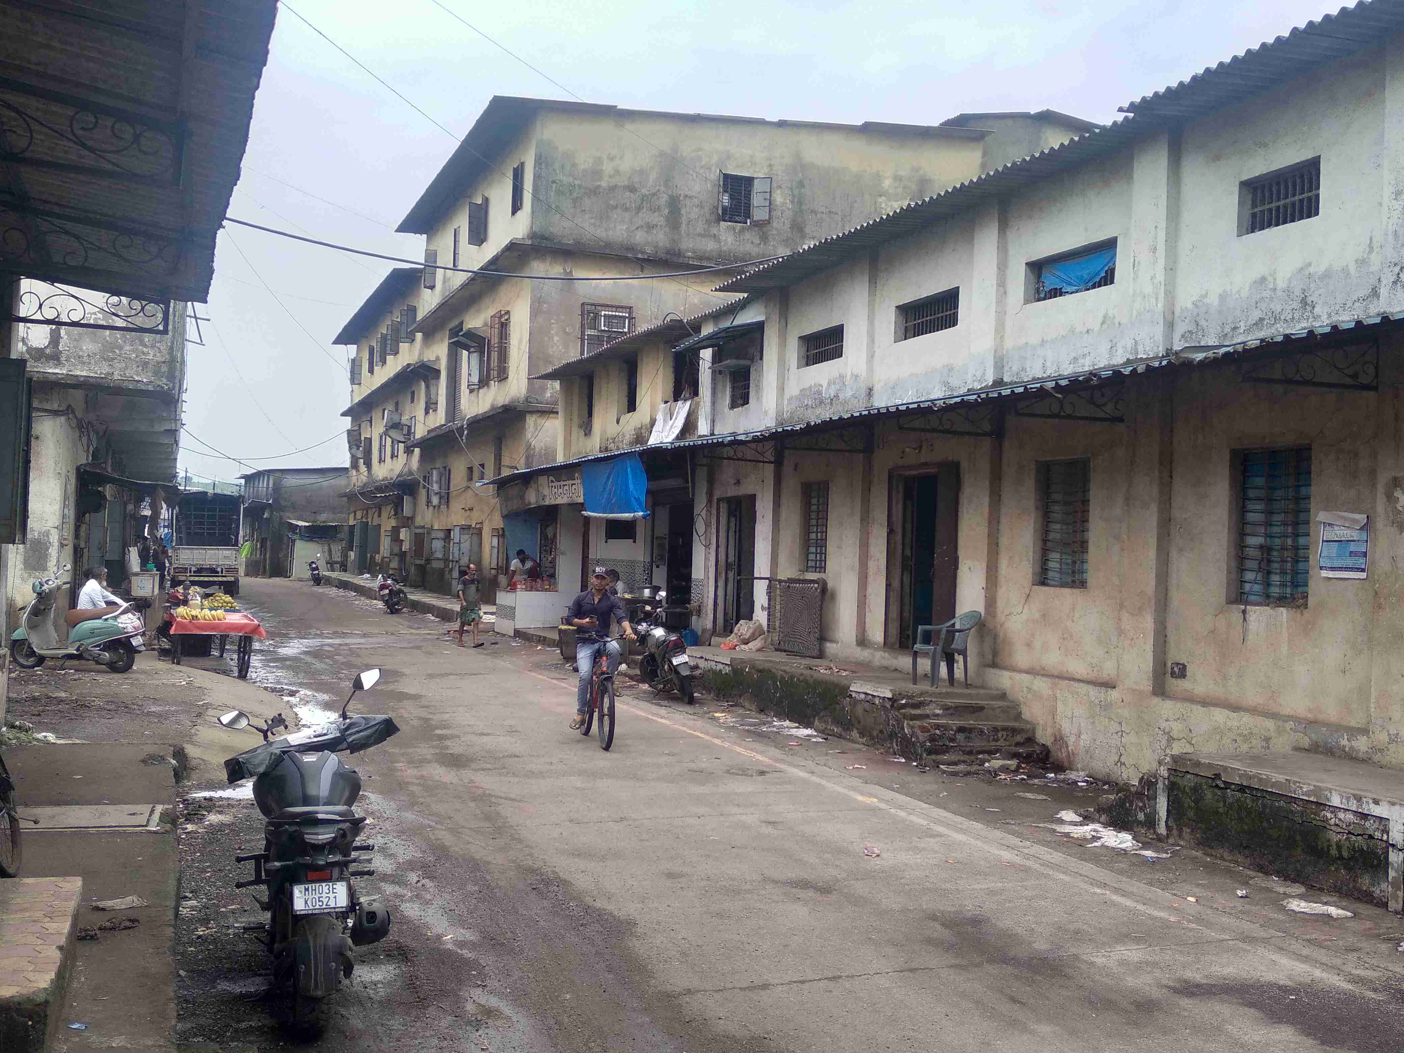

Details of the property under consideration:

Name of Owner: Smt. Hera Raisuzzaman Ansari

N.A. Land bearing Plot No. 30, Survey No. 14/2/33, Grampanchayat House Nos. 2033 & 2062,
Mulchand Compound Khadipar, Village - Khoni, Taluka - Bhiwandi, District - Thane, PIN - 421 302,
State - Maharashtra, India

Longitude Latitude: 19°18'37.2"N 73°03'09.2"E

Valuation Done for:

Central Bank of India
Nariman Point Branch
Chandermukhi, Ground Floor, Barrister Rajni Patel Marg, Mahatma Phule Nagar, Nariman Point,
Mumbai - 400 021, State - Maharashtra, Country - India.

Vastu/Mumbai/06/2024/9458/2306917
26/15-361-JAVSM
Date: 26.06.2024

VALUATION OPINION REPORT

This is to certify that the property N.A. Land bearing Plot No. 30, Survey No. 14/2/33, Grampanchayat House Nos. 2033 & 2062, Mulchand Compound Khadipar, Village - Khoni, Taluka - Bhiwandi, District - Thane, PIN - 421302, State - Maharashtra, India belongs to Smt. Hera Raisuzzaman Ansari.

Boundaries of the property.

North | : | Internal Road
South | : | Gala
East | : | Road
West | : | Open Space
Considering various parameters recorded, existing economic scenario, and the information that is available with reference to the development of neighborhood and method selected for valuation, we are of the opinion that, the property premises can be assessed and Fair market value of the property for banking purpose at ` 1,10,35,200.00 (Rupees One Crore Ten Lakh Thirty Five Thousand Two Hundred Only).

The valuation of the property is based on the documents produced by the concern. Legal aspects have not been taken into considerations while preparing this valuation report.

Hence certified

Manoj B. Chalikwar
Registered Valuer
Chartered Engineer (India)
Reg. No. CAT-I-F-1763
Emp. No. SMRO/CREDIT/2017-18/1311
Encl: Valuation report.
Vastukala Consultants (I) Pvt. Ltd.
B1-001, U/B Floor, Boomerang, Chandivali Farm Road, Powai, Andheri (East), Mumbai - 400 072.
To,
The Branch Manager,
Central Bank of India
Nariman Point Branch
Chandermukhi, Ground Floor,
Barrister Rajni Patel Marg,
Mahatma Phule Nagar,
Nariman Point, Mumbai - 400 021,
State - Maharashtra, Country - India.

VALUATION REPORT (IN RESPECT OF LAND)
I | General
1. | Purpose for which the valuation is made |  | : | As per the request from Central Bank of India, Nariman Point Branch, to assess Fair market value of the property for banking purpose.
2. | a) | Date of inspection | : | 22.06.2024
 | b) | Date on which the valuation is made | : | 26.06.2024
3. | List of documents produced for perusal
- Copy of Sale Deed dated 30.05.2024 between Smt. Hera Raisuzzaman Ansari (the Purchaser) AND Shri. Rajendraprasad Bhanwarlal Daga (the Vendor) – Grampanchayat House No. 2033
- Copy of Sale Deed dated 30.05.2024 between Smt. Hera Raisuzzaman Ansari (the Purchaser) AND Shri. Rajendraprasad Bhanwarlal Daga (the Vendor) – Grampanchayat House No. 2062
- Copy of 7/12 Revenue Extract of Survey No. 14/2/33
- Copy of Surveyor’s Plan of Survey No. 14, Hissa No. 2, Plot No. 30
- Copy of Site Plan by Grampanchayat Khoni
4. | Name of the owner(s) and his / their address (es) with Phone no. (details of share of each owner in case of joint ownership) |  | : | Smt. Hera Raisuzzaman Ansari  Address: N.A. Land bearing Plot No. 30, Survey No. 14/2/33, Grampanchayat House Nos. 2033 & 2062, Mulchand Compound Khadipar, Village - Khoni, Taluka - Bhiwandi, District - Thane, PIN - 421 302, State - Maharashtra, India  Contact Person:  Mr. Anas Ansari (Owner’s Son)  Contact No. + 91 7498133299  Sole Ownership
5. | Brief description of the property (Including Leasehold / freehold etc.):  The immovable property comprises of freehold Industrial Land at Mulchand Compound Khadipar, Village Khoni. The property is located in a developed Industrial Area having good infrastructure, connected by road and train. It is located at 7.8 km. travelling distance from nearest railway station Bhiwandi Road.  At the time of site visit we found Grampanchayat House Nos. 2033 & 2062 of ground floor load bearing structure with AC sheet roof. Grampanchayat House Nos. 2033 & 2062 are amalgamated with internal partition wall and having single entrance. As per site information the composition of House No. 2033 is Office + Toilet. All the machinery is in House No. 2062. As per our physical measurement Carpet area are as under:  As per Sale Deed the land area is as below:  For the purpose of valuation, we have considered total land area of 836.00 Sq. M. As per bank’s request we have valued only plot of land.
  Particular | Carpet area (Sq. Ft.)
  House No. 2062 | 3,732.00
  House No. 2033 | 3,859.00
  House Nos. | Area in Sq. Yds. | Area in Sq. M.
  2062 | 500.00 | 418.00
  2033 | 500.00 | 418.00
  Total | 1,000.00 | 836.00
6. | Location of property |  | :
 | a) | Plot No. / Survey No. | : | Plot No. 30, Survey No. 14/2/33
 | b) | Door No. | : | House Nos. 2062 & 2033
 | c) | T.S. No. / Village | : | Village – Khoni
 | d) | Ward / Taluka | : | Taluka – Bhiwandi
 | e) | Mandal / District | : | District – Raigad
7. | Postal address of the property |  | : | N.A. Land bearing Plot No. 30, Survey No. 14/2/33, Grampanchayat House Nos. 2033 & 2062, Mulchand Compound Khadipar, Village - Khoni, Taluka - Bhiwandi, District - Thane, PIN - 421 302, State - Maharashtra, India
8. | City / Town |  | : | Town
 | Residential area |  | : | No
 | Commercial area |  | : | No
 | Industrial area |  | : | Yes
9. | Classification of the area |  | :
 | i) High / Middle / Poor |  | : | Middle Class
 | ii) Urban / Semi Urban / Rural |  | : | Semi Urban
10. | Coming under Corporation limit / Village Panchayat / Municipality |  | : | Within the limits of Gram panchayat Khoni
11. | Whether covered under any State / Central Govt. enactments (e.g., Urban Land Ceiling Act) or notified under agency area/ scheduled area / cantonment area |  | : | No
12. | In Case it is Agricultural land, any conversion to house site plots is contemplated |  | : | N.A.
13. | Boundaries of the property |  |  | As per Document | As per Site Visits
 | North |  | : | Plot No. 29 | Internal Road
 | South |  | : | Plot No. 31 | Gala
 | East |  | : | Existing Road | Road
 | West |  | : | Plot No. 21 | Open Space
14.1 | Dimensions of the site
 |  |  |  | A As per the Deed | B Actuals
 | North |  | : | - | -
 | South |  | : | - | -
 | East |  | : | - | -
 | West |  | : | - | -
14.2 | Latitude, Longitude & Co-ordinates of property |  | : | 19°18'37.2"N 73°03'09.2"E
14. | Extent of the site |  | : | Total Land Area = 836.00 Sq. M.  (Area as per Sale Deed)
15. | Extent of the site considered for Valuation (least of 14A& 14B) |  | :
16 | Whether occupied by the owner / tenant? If occupied by tenant since how long? Rent received per month. |  | : | Property under owner’s possession
II | CHARACTERSTICS OF THE SITE
 | Classification of locality |  | : | Located in middle class locality
 | Development of surrounding areas |  | : | Developed Industrial Area
 | Possibility of frequent flooding/ sub-merging |  | : | No
 | Feasibility to the Civic amenities like School, Hospital, Bus Stop, Market etc. |  | : | All available near by
 | Level of land with topographical conditions |  | : | Plain
 | Shape of land |  | : | Rectangular
 | Type of use to which it can be put |  | : | For industrial purpose
 | Any usage restriction |  | : | Industrial
 | Is plot in town planning approved layout? |  | : | Yes
 | Corner plot or intermittent plot? |  | : | Intermittent
 | Road facilities |  | : | Yes
 | Type of road available at present |  | : | B.T. Road
 | Width of road – is it below 20 ft. or more than 20 ft. |  | : | 12.00 M. wide road
 | Is it a Land – Locked land? |  | : | No
 | Water potentiality |  | : | Good
 | Underground sewerage system |  | : | Connected to Municipal Sewerage System
 | Is Power supply is available in the site |  | : | Yes
 | Advantages of the site |  | : | Located in developed area
 | Special remarks, if any like threat of acquisition of land for publics service purposes, road widening or applicability of CRZ provisions etc. (Distance from sea-cost / tidal level must be incorporated) |  | : | No
Part – A (Valuation of land)
1 | Size of plot |  | : | Total Land Area = 836.00 Sq. M.  (Area as per Sale Deed)
 | North & South |  | : | -
 | East & West |  | : | -
2 | Total extent of the plot |  | : | Total Land Area = 836.00 Sq. M.  (Area as per Sale Deed)
3 | Prevailing market rate (Along With details / reference of at least two latest deals / transactions with respect to adjacent properties in the areas) |  | : | ` 13,000.00 to ` 14,000.00 per Sq. M.  Details of online listings are attached with the report.
4 | Guideline rate obtained from the Register’s Office (evidence thereof to be enclosed) |  | : | ` 2,910.00 per Sq. M.
5 | Assessed / adopted rate of valuation |  | : | ` 13,200.00 per Sq. M.
6 | Estimated value of land |  | : | ` 1,10,35,200.00
Part – B (Valuation of Building)
1 | Technical details of the building |  | :
 | - Type of Building (Residential / Commercial / Industrial) |  | : | N.A., as only land area has been considered for valuation
 | - Type of construction (Load bearing / RCC / Steel Framed) |  | : | N.A.
 | - Year of construction |  | : | N.A.
 | - Number of floors and height of each floor including basement, if any |  | : | N.A.
 | - Plinth area floor-wise |  | : | N.A.
 | - Condition of the building |  | : | N.A.
 | - Exterior – Excellent, Good, Normal, Poor |  | : | N.A.
 | - Interior – Excellent, Good, Normal, Poor |  | : | N.A.
 | - Date of issue and validity of layout of approved map |  | : | N.A., as only land area has been considered for valuation.
 | - Approved map / plan issuing authority |  | :
 | - Whether genuineness or authenticity of approved map / plan is verified |  | : | N.A.
 | - Any other comments by our empanelled valuers on authentic of approved plan |  | : | No.

Specifications of construction (floor-wise) in respect of

Sr. No. | Description
 | Foundation | : | N.A., as only land area has been considered for valuation.
 | Basement | : | N.A.
 | Superstructure | : | N.A.
 | Joinery / Doors & Windows (Please furnish details about size of frames, shutters, glazing, fitting etc. and specify the species of timber | : | N.A.
 | RCC Works | : | N.A.
 | Plastering | : | N.A.
 | Flooring, Skirting, dado | : | N.A.
 | Special finish as marble, granite, wooden paneling, grills etc. | : | N.A.
 | Roofing including weather proof course | : | N.A.
 | Drainage | : | Connected the municipal sewerage system

2. | Compound Wall | :
 | Height | : | Not Exiting
 | Length | : | Not Exiting
 | Type of construction | : | Not Exiting
3. | Electrical installation | : | N.A., as only land area has been considered for valuation.
 | Type of wiring | : | -
 | Class of fittings (superior / ordinary / poor) | : | -
 | Number of light points | : | -
 | Fan points | : | -
 | Spare plug points | : | -
 | Any other item | : | -
4. | Plumbing installation |  | N.A., as only land area has been considered for valuation.
 | - No. of water closets and their type | : | -
 | - No. of wash basins | : | -
 | - No. of urinals | : | -
 | - No. of bath tubs | : | -
 | - Water meters, taps etc. | : | -
 | - Any other fixtures | : | -

Part – C (Extra Items) |  | : | Amount in `
 | Portico | : | N.A., as only land area has been considered for valuation.
 | Ornamental front door | :
 | Sit out / Verandah with steel grills | :
 | Overhead water tank | :
 | Extra steel / collapsible gates | :
 | Total

Part – D (Amenities) |  | : | Amount in `
 | Wardrobes | : | N.A., as only land area has been considered for valuation.
 | Glazed tiles | :
 | Extra sinks and bath tub | :
 | Marble / ceramic tiles flooring | :
 | Interior decorations | :
 | Architectural elevation works
 | Paneling works
 | Aluminum works
 | Aluminum hand rails
 | False ceiling
 | Total

Part – E (Miscellaneous) |  | : | Amount in `
 | Separate toilet room | : | N.A., as only land area has been considered for valuation.
 | Separate lumber room | :
 | Separate water tank / sump | :
 | Trees, gardening | :
 | Total

Part – F (Services) |  | : | Amount in `
 | Water supply arrangements | : | N.A., as only land area has been considered for valuation.
 | Drainage arrangements | :
 | Compound wall | :
 | C.B. deposits, fittings etc. | :
 | Pavement
 | Total

Government Value

Particulars | Area in Sq. M. | Rate in ` | Value in `
Land | 836.00 | 2,910.00 | 24,32,760.00
 |  | TOTAL | 24,32,760.00

Total abstract of the entire property

Part – A | Land | : | ` 1,10,35,200.00
Part – B | Building | : | -
Part – C | Compound wall | : | -
Part – D | Amenities | : | -
Part – E | Pavement | : | -
Part – F | Services | : | -
 | Fair Market Value | : | ` 1,10,35,200.00
 | Realizable value | : | ` 99,31,680.00
 | Distress Sale value | : | ` 88,28,160.00
 | Insurable value | : | N.A., as only land area has been considered for valuation.
Remarks | - For the purpose of valuation, we have considered the land area as per Sale Deed.  - As per site inspection / information, House Nos. 2062 & 2033 are internally merged. The entire land is consisting of Industrial Gala / Structures without compound wall.  - As per bank’s request we have valued only plot of land.

Justification for price / rate

The Market Value of the property is based on facts of markets discovered by us during our enquiries, however the government rate value in this case is less than the market value arrived by us. We are of the opinion that the value arrive by us will prove to be correct if an Auction of the subject property is carried out. As far as Market Value as per property document is concerned, it is not possible to comment on same, may be government rates are fixed by sampling during same point of time in part and whereas, Market values change every month.

In most of the cases the actual deal amount or Transaction value is not reflected in the property documents because of various Market practices. As Valuer, we always try to give a value which is correct reflection of actual transaction value irrespective of any factors in market.

We hope this will satisfy your requirements.

Method of Valuation / Approach
Land cost can be estimated using the Sales Comparison Approach by studying recent sales of land close to the subject property, and these sales should be comparable in size and location with subject property.
As the property is Industrial land, we have adopted Comparative Sales Method / Market Approach for the purpose of valuation. The Price for similar type of property in the nearby vicinity is in the range of ` 13,000/- to ` 14,000/- per Sq. M. for land Considering the rate with attached report, current market conditions, demand and supply position, Land size, location, sustained demand for industrial land, all round development of commercial/industrial and industrial application in the locality etc. We estimate ` 13,200/- per Sq. M. for Land.

The salability of the property is: Normal
Expected rental values per month: N.A.
Any likely income it may generate: N.A.

Actual Site Photographs


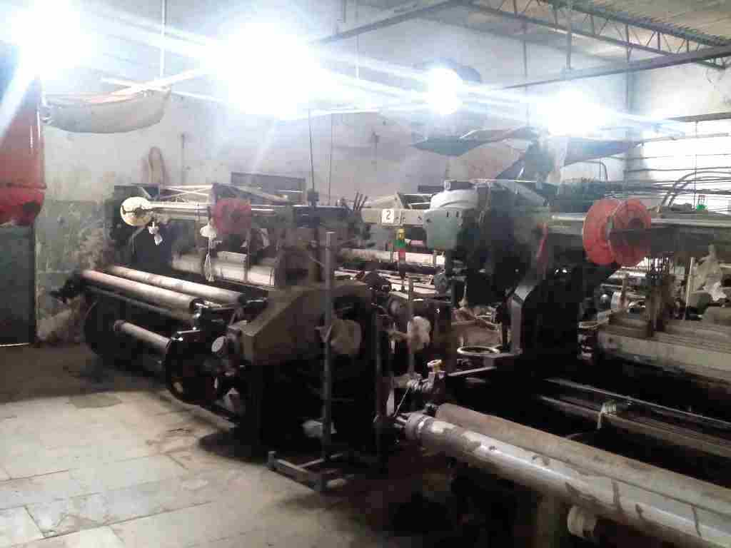
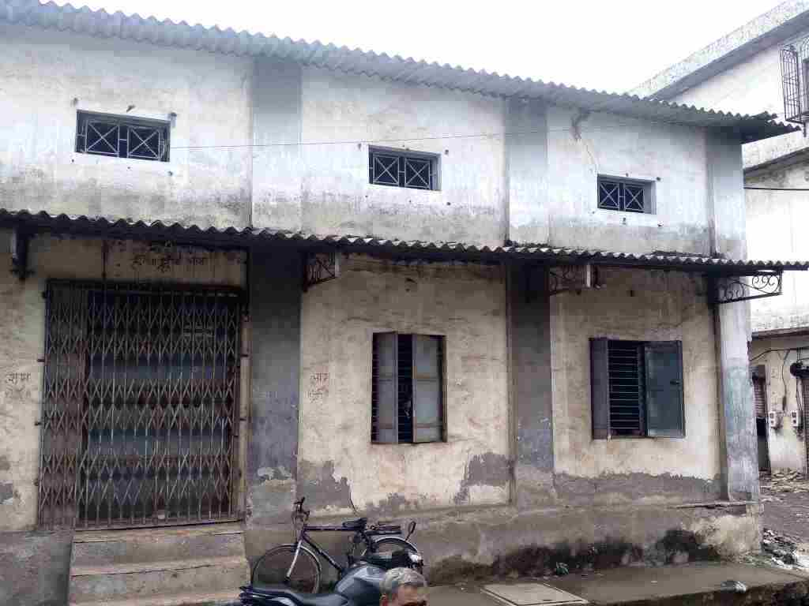
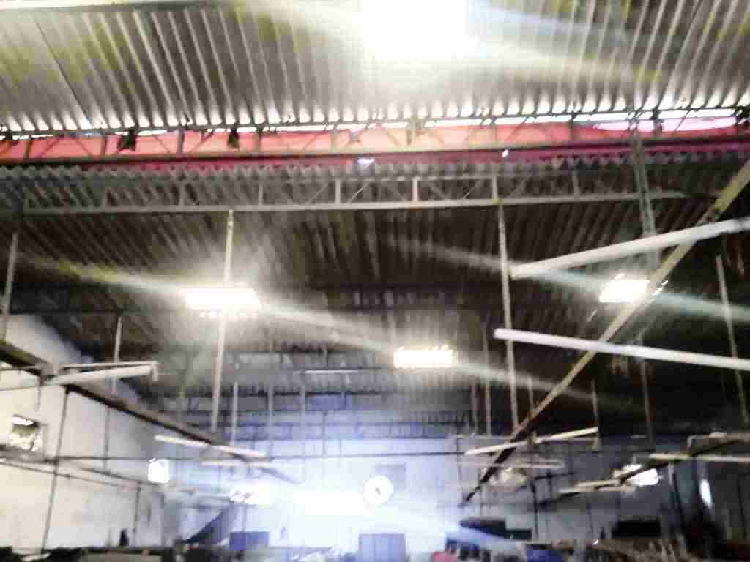
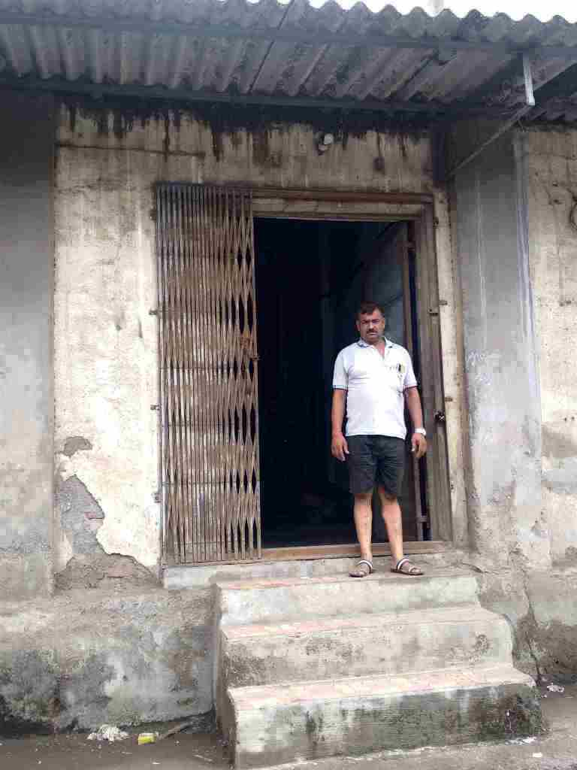

Actual Site Photographs
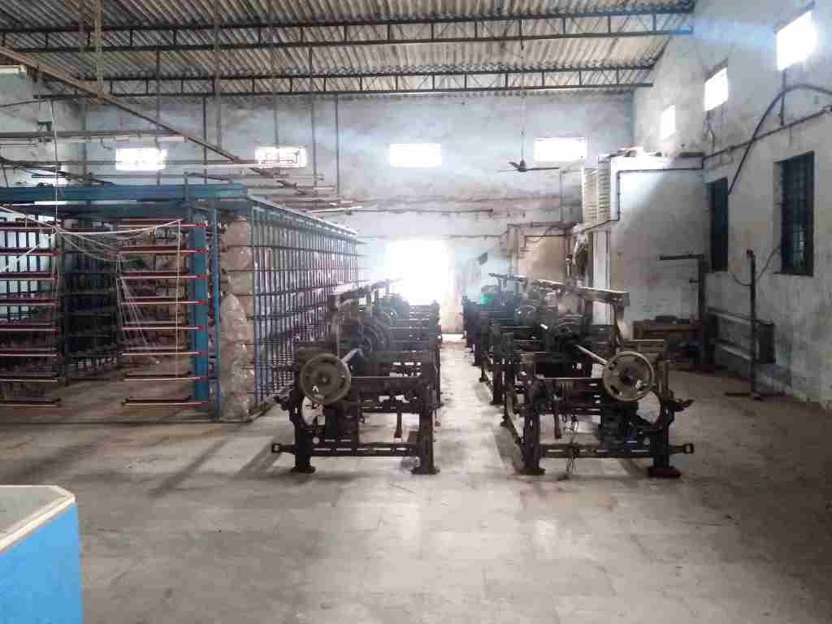
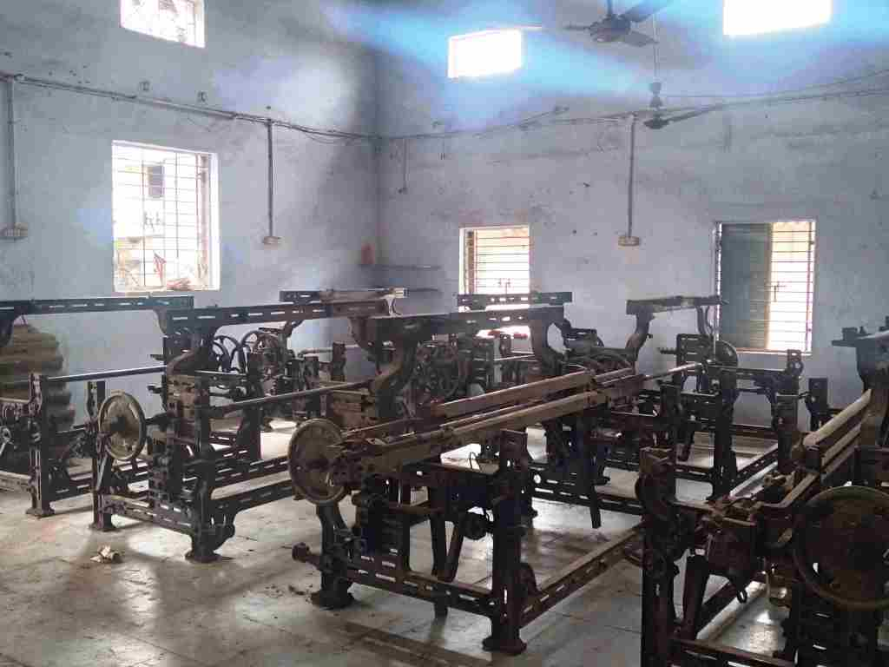

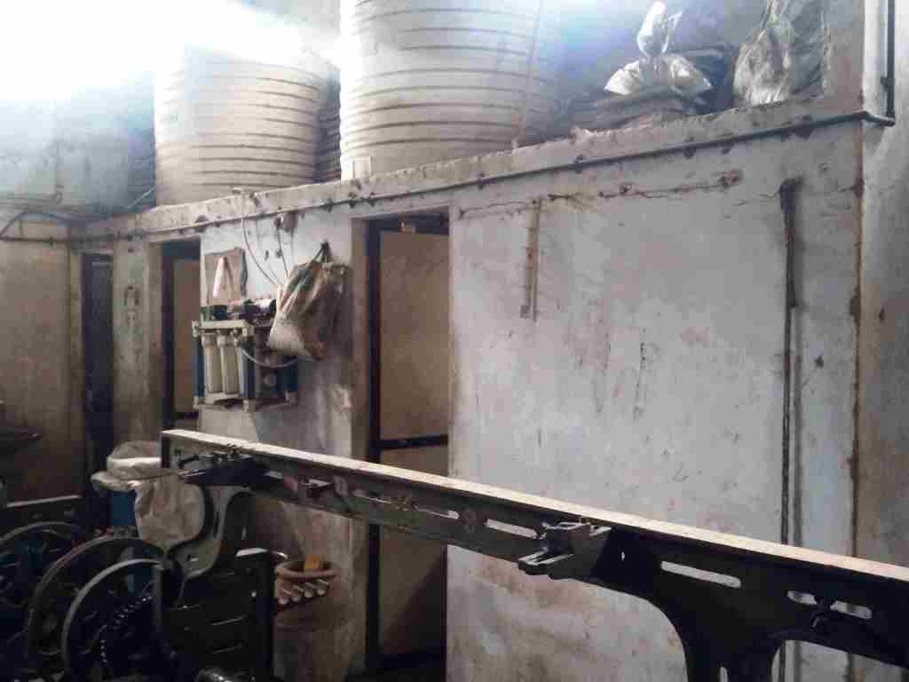
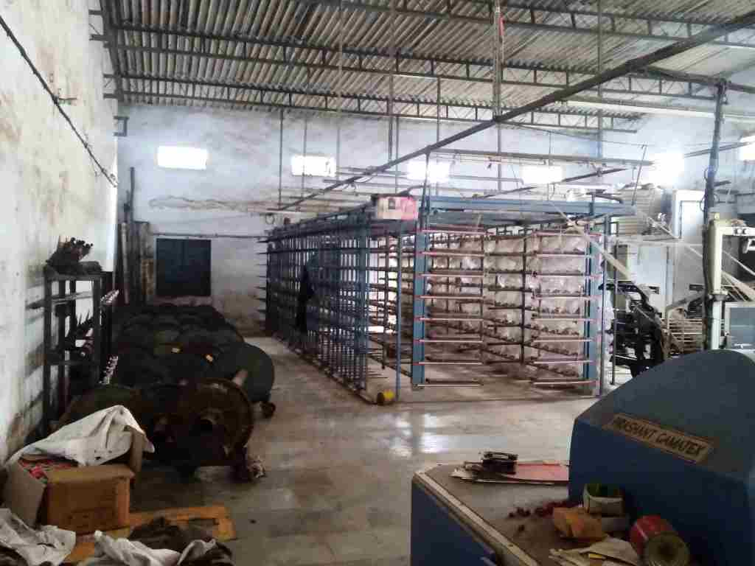

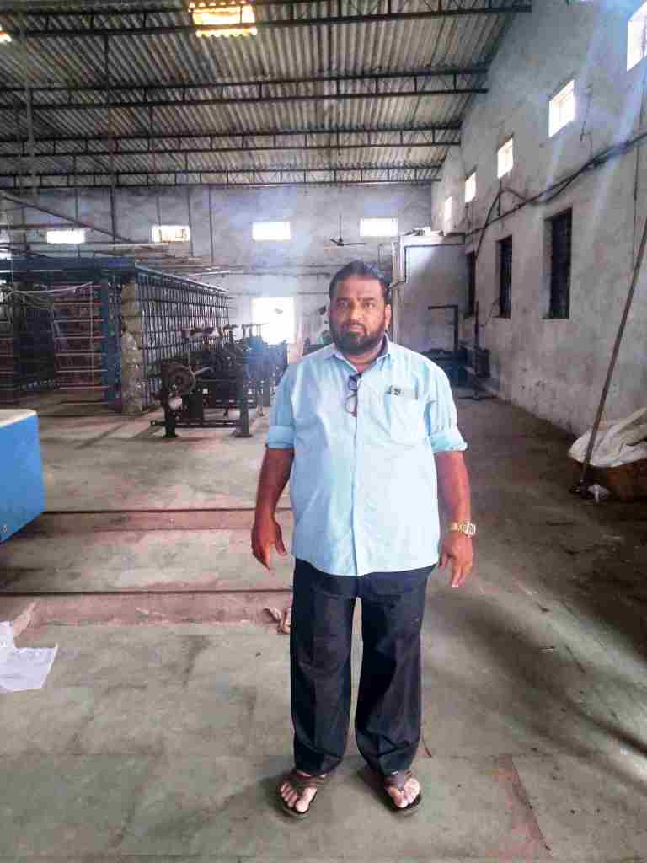
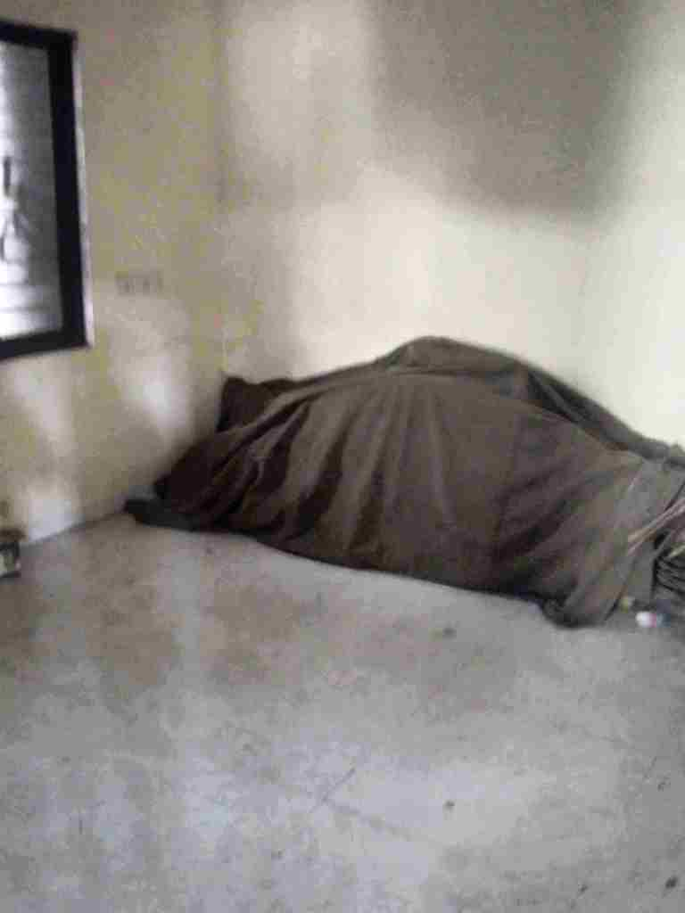
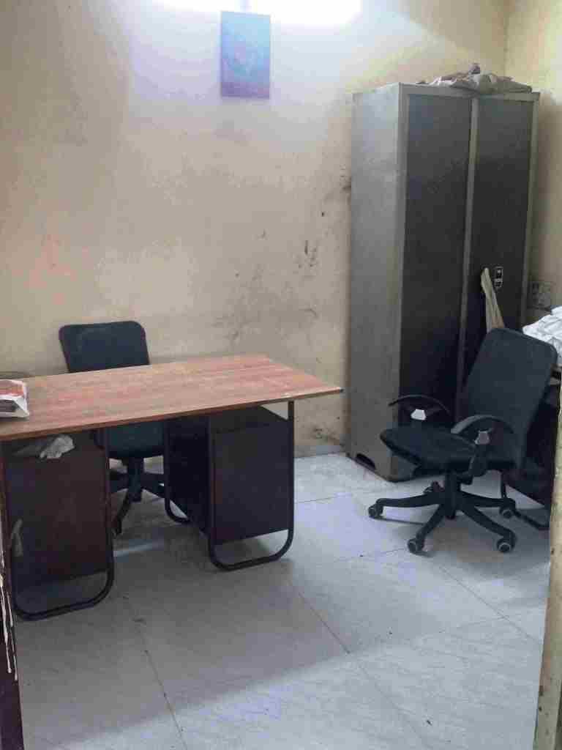

Actual Site Photographs
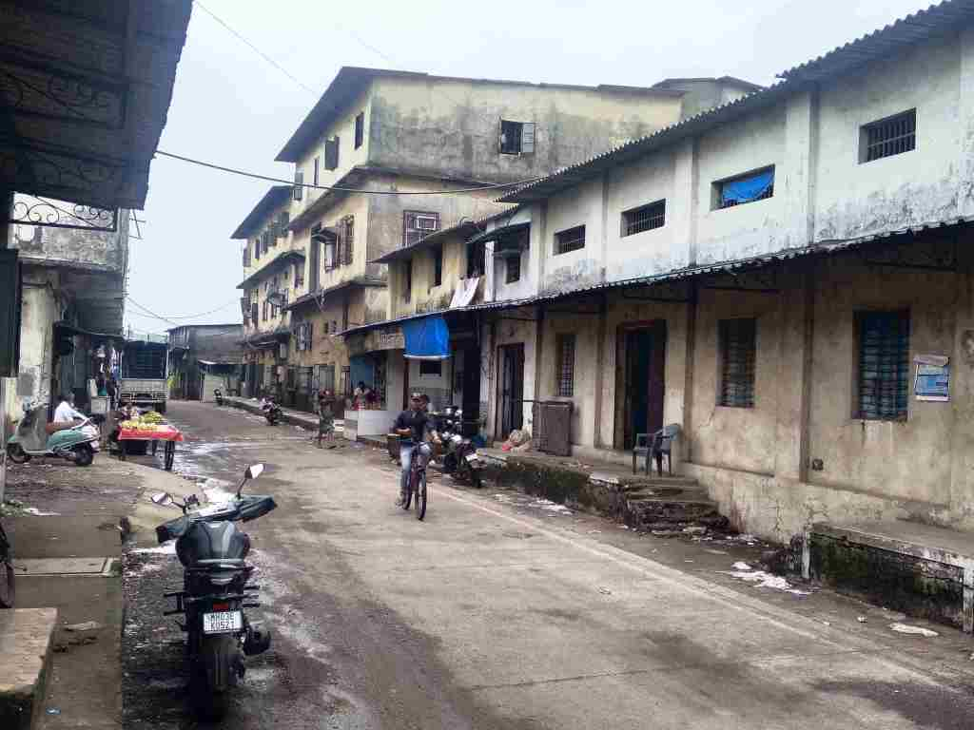
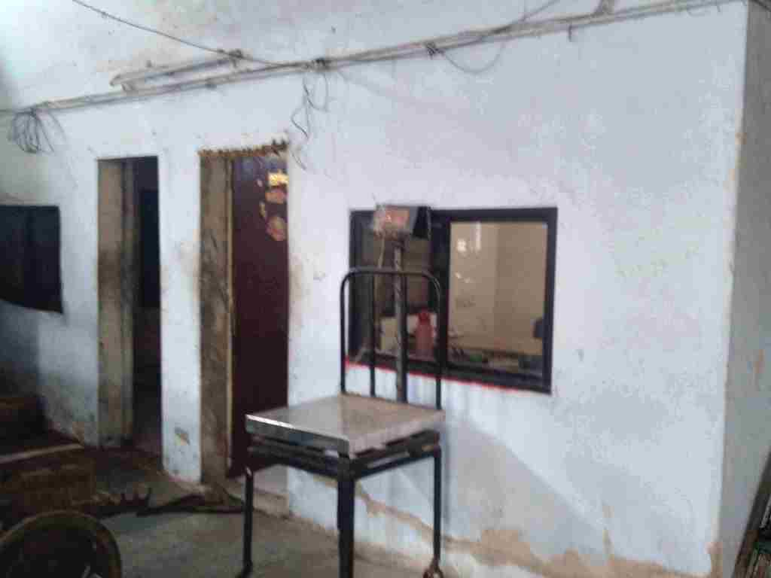

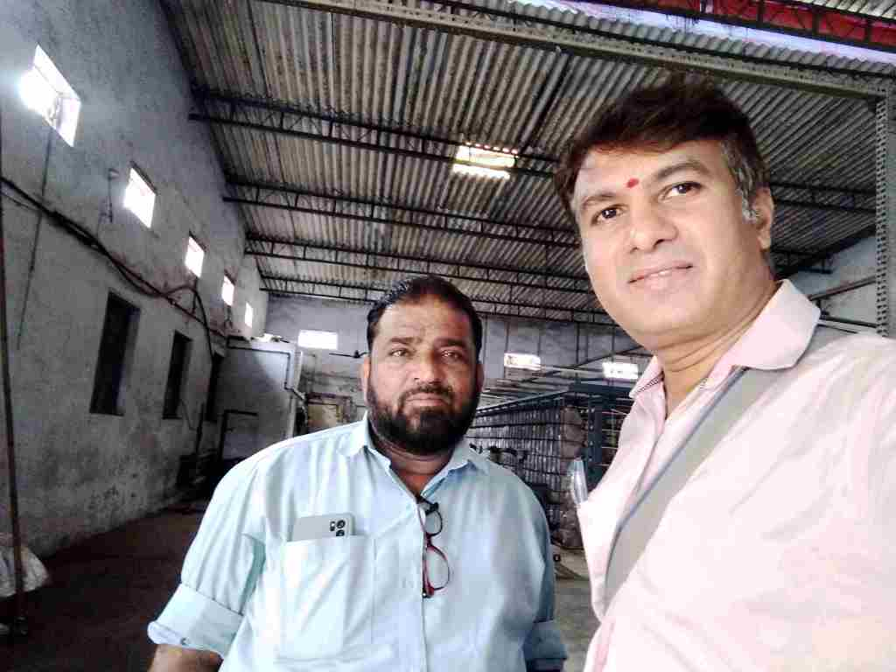
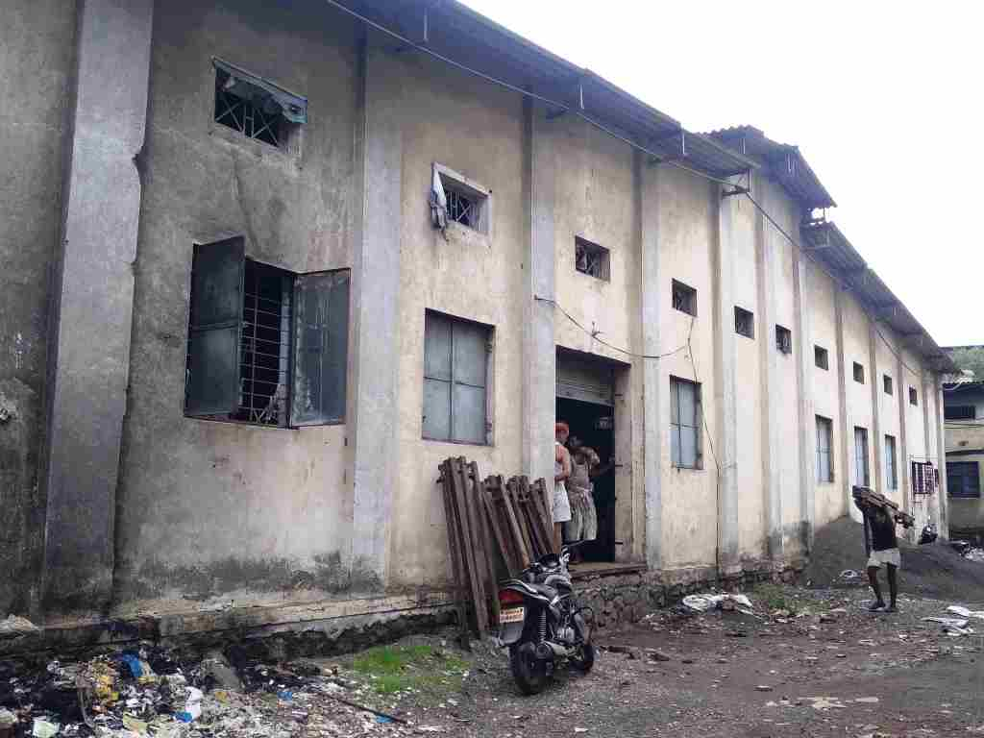

Route Map of the property
Site u/r
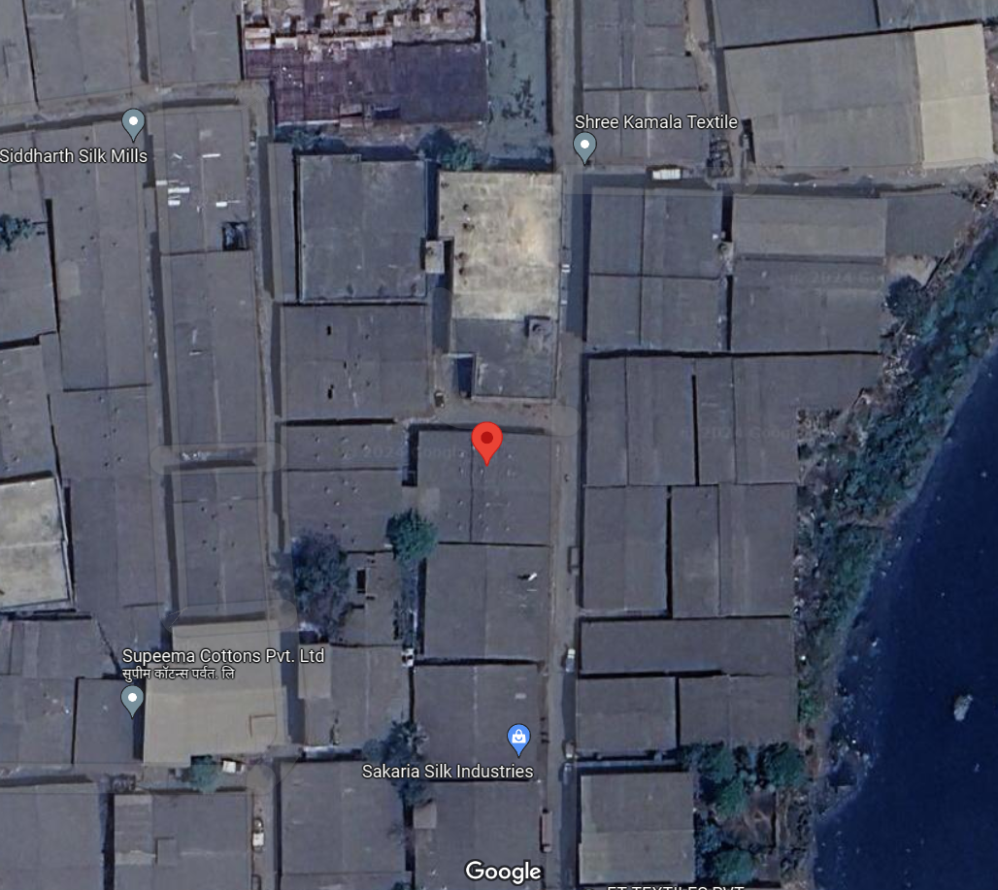

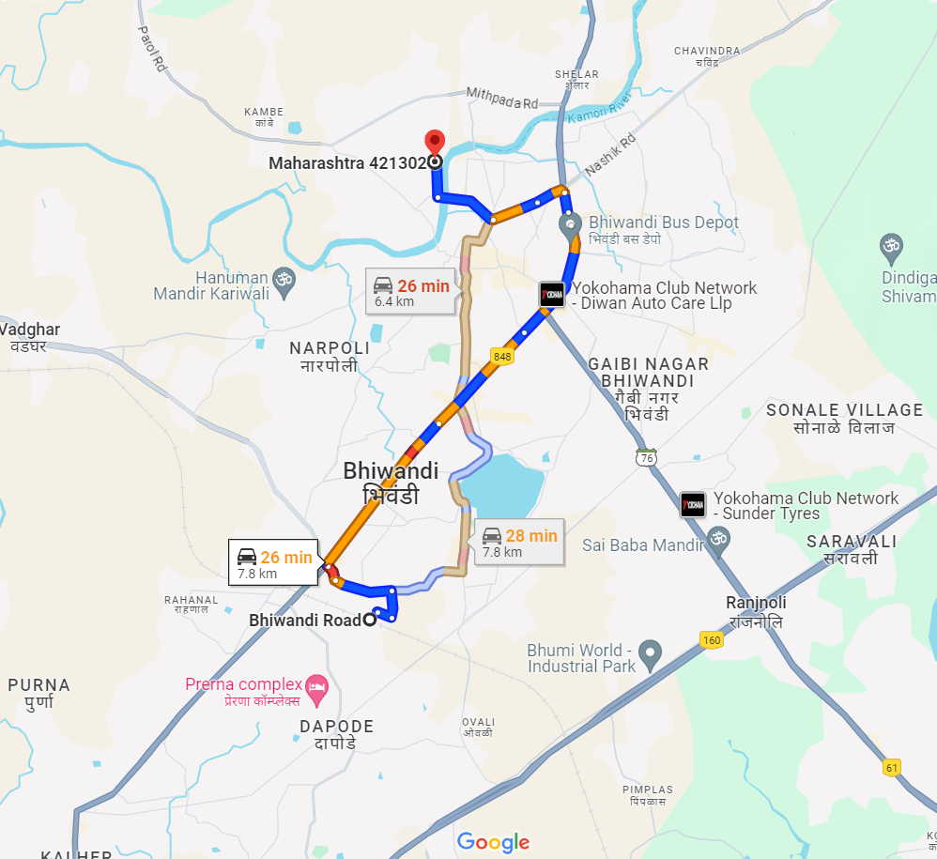

Longitude Latitude: 19°18'37.2"N 73°03'09.2"E
Note: The Blue line shows the route to site from nearest Railway station (Bhiwandi Road – 7.8 km.)
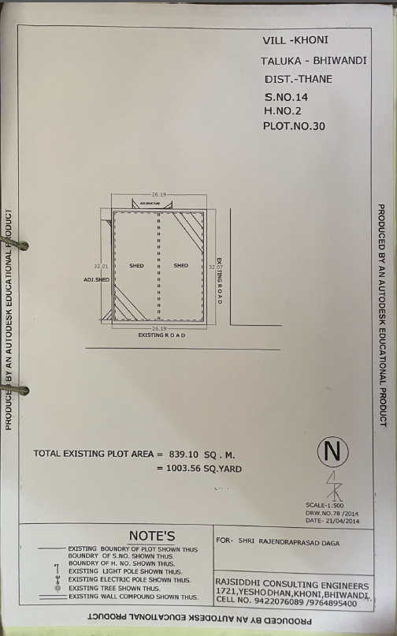
Surveyor’s Plan
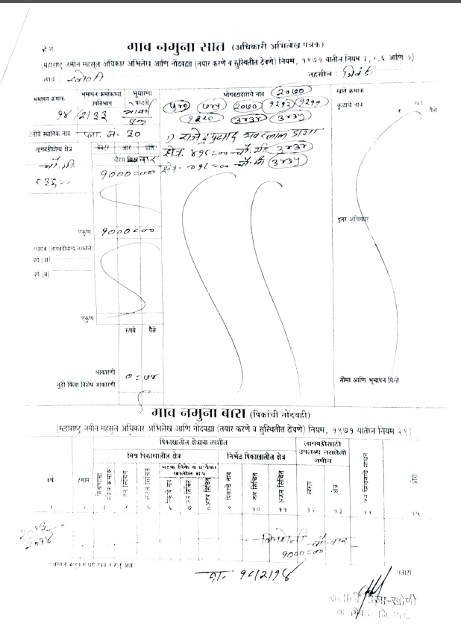
7/12 Revenue Extract
Ready Reckoner Rates
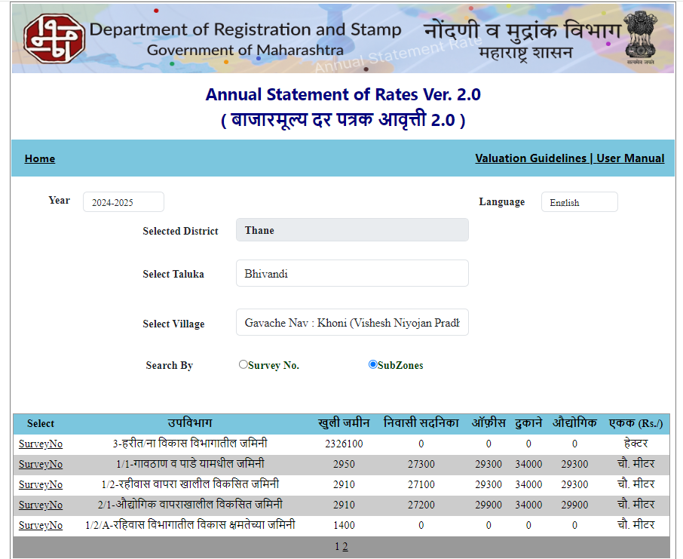

Price Indicators
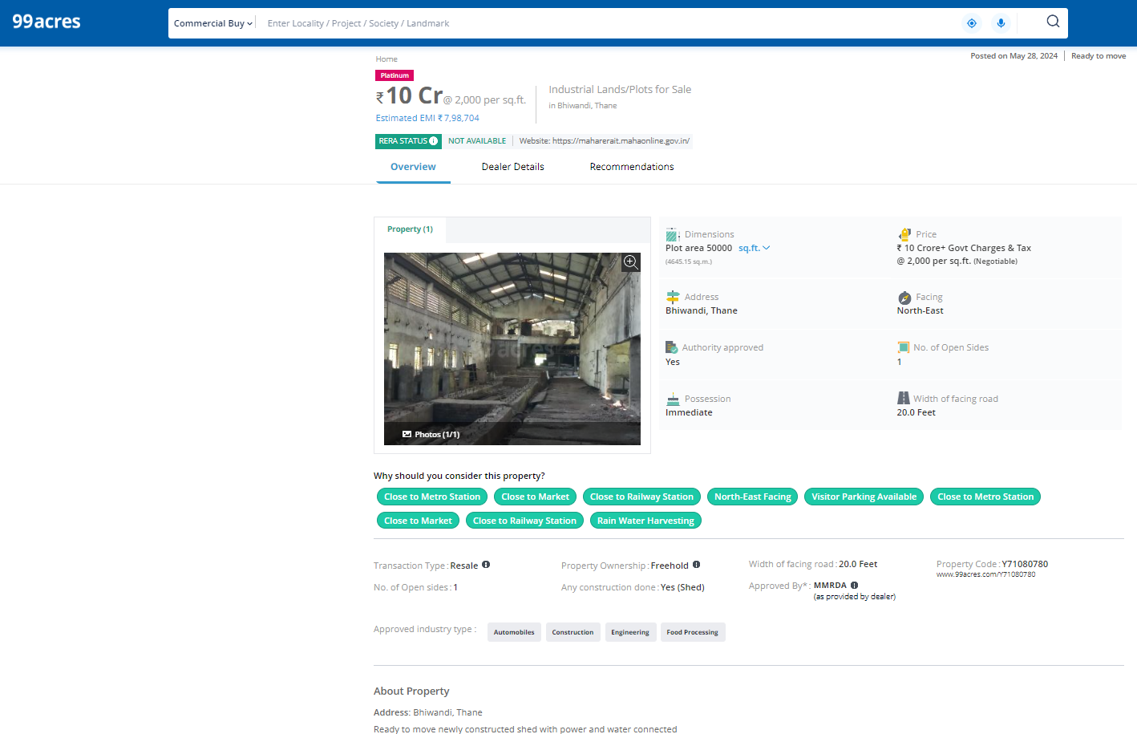

Plot | Unit | Value | Rate / Unit | Rate / Sq. M
50,000.00 | Sq. Ft. | 10,00,00,000.00 | 2,000.00 | 21,528.00
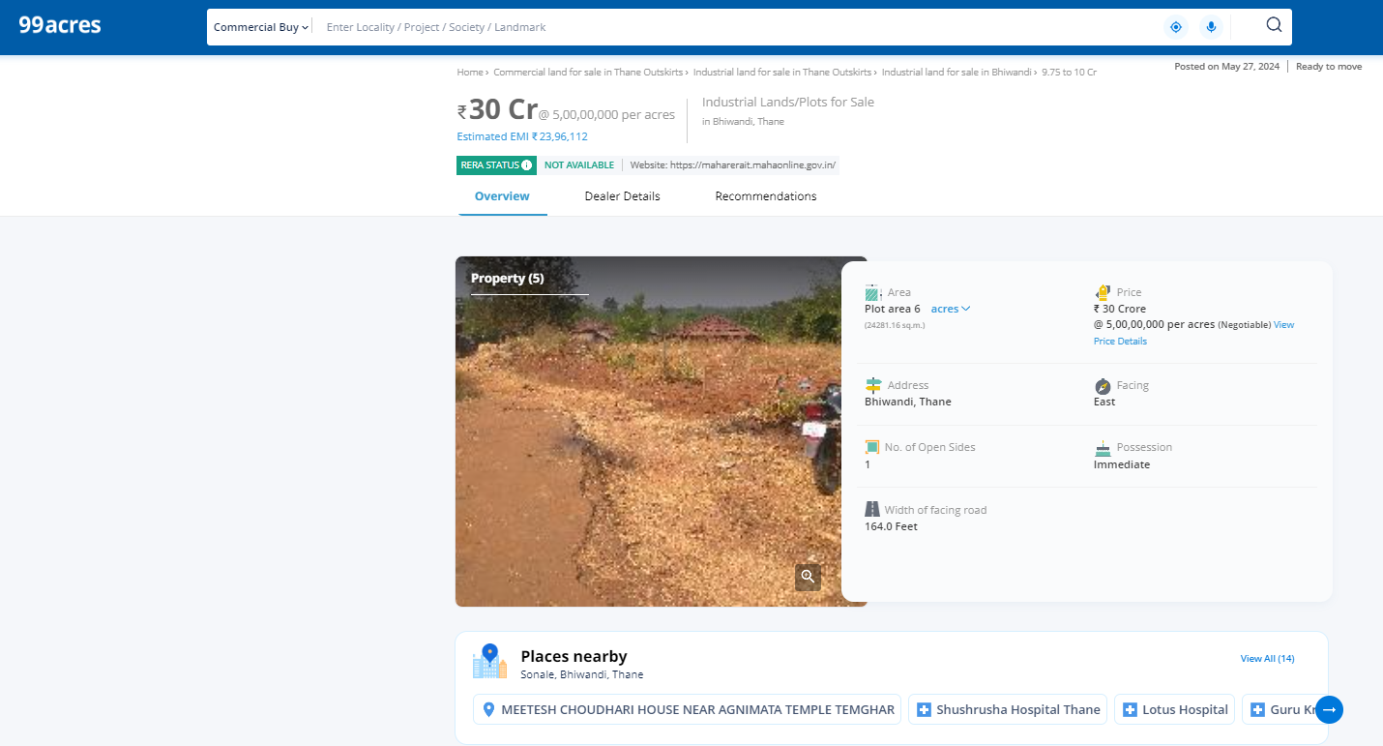

Plot | Unit | Value | Rate / Unit | Rate / Sq. M
6 | Acre | 30,00,00,000.00 | 5,00,00,000.00 | 12,355.00

As a result of my appraisal and analysis, it is my considered opinion that the present Market value of the above property in the prevailing condition with aforesaid specifications is ` 1,10,35,200.00 (Rupees One Crore Ten Lakh Thirty Five Thousand Two Hundred Only). The Realizable Value of the above property is ` 99,31,680.00 (Rupees Ninety Nien Lakh Thirty One Thousand Six Hundred Eighty Only). The Distress Sale Value ` 88,28,160.00 (Rupees Eighty Eight Lakh Twenty Eight Thousand One Hundred Sixty Only).

Place: Mumbai
Date: 26.06.2024

Manoj B. Chalikwar
Registered Valuer
Chartered Engineer (India)
Reg. No. CAT-I-F-1763
BOM Emp. No. AX33/CREMON/Valuer / Empanelment/2021-22
Encl: Valuation report.

The undersigned has inspected the property detailed in the Valuation Report dated _______________________

on ____________________. We are satisfied that the fair and reasonable market value of the property is

`_________________________ (Rupees ________________________________________________________

________________________________________only).

Date
Signature
(Name & Designation of the Inspecting Official/s)

Countersigned
(BRANCH MANAGER)

Enclosures
 | Declaration-cum-undertaking from the valuer (Annexure- I) | Attached
 | Model code of conduct for valuer - (Annexure - II) | Attached
(Annexure-I)

DECLARATION-CUM-UNDERTAKING

I, Manoj B.Chalikwar son of Shri. Baburao Chalikwar do hereby solemnly affirm and state that:

- I am a citizen of India.

- I will not undertake valuation of any assets in which I have a direct or indirect interest or become so interested at any time during a period of three years prior to my appointment as valuer or three years after the valuation of assets was conducted by me.

- The information furnished in my valuation report dated 26.06.2024 is true and correct to the best of my knowledge and belief and I have made an impartial and true valuation of the property.

- I/ my authorized representative has personally inspected the property on 22.06.2024. The work is not sub - contracted to any other valuer and carried out by myself.

- Valuation report is submitted in the format as prescribed by the bank.

- I have not been depanelled / delisted by any other bank and in case any such depanelment by other banks during my empanelment with you, I will inform you within 3 days of such depanelment.

- I have not been removed / dismissed from service / employment earlier.

- I have not been convicted of any offence and sentenced to a term of imprisonment

- I have not been found guilty of misconduct in my professional capacity.

- I have not been declared to be unsound mind

- I am not an undischarged bankrupt, or has not applied to be adjudicated as a bankrupt;

- I am not an undischarged insolvent.

- I have not been levied a penalty under section 271J of Income-tax Act, 1961 (43 of 1961) and time limit for filing appeal before Commissioner of Income-tax (Appeals) or Income-tax Appellate Tribunal, as the case may be having expired, or such penalty has been confirmed by Income-tax Appellate Tribunal, and five years have not elapsed after levy of such penalty

- I have not been convicted of an offence connected with any proceeding under the Income Tax Act 1961, Wealth Tax Act 1957 or Gift Tax Act 1958 and

- My PAN Card number as applicable is AERPC9086P

- I undertake to keep you informed of any events or happenings which would make me ineligible for empanelment as a valuer

- I have not concealed or suppressed any material information, facts and records and I have made a complete and full disclosure

- I have read the Handbook on Policy, Standards and procedure for Real Estate Valuation, 2011 of the IBA and this report is in conformity to the "Standards" enshrined for valuation in the Part - B of the above handbook to the best of my ability.

- I have read the International Valuation Standards (IVS) and the report submitted to the Bank for the respective asset class is in conformity to the "Standards" as enshrined for valuation in the IVS in "General Standards" and "Asset Standards" as applicable. The valuation report is submitted in the prescribed format of the bank.

- I am registered under Section 34 AB of the Wealth Tax Act, 1957.

- My CIBIL Score and credit worthiness is as per Bank's guidelines.

- I am Director of the company, who is competent to sign this valuation report.

- I will undertake the valuation work on receipt of Letter of Engagement generated from the system (i.e., LLMS / LOS) only.

- Further, I hereby provide the following information.

 | Particulars | Valuer comment
 | Background information of the asset being valued; | The N.A. Land under consideration is purchased by Smt. Hera Raisuzzaman Ansari from Shri. Rajendraprasad Bhanwarlal Daga, as per Sale Deed, Registration Nos. 5024-2024 & 5025-2024 dated 30.05.2024
 | Purpose of valuation and appointing authority | As per the request from Central Bank of India, Nariman Point Branch, to assess Fair market value of the property for banking purpose.
 | Identity of the Valuer and any other experts involved in the valuation; | Manoj B. Chalikwar - Regd. Valuer  Vaibhav Bhagat - Valuation Engineer  Vaishali Sarmalkar - Technical Manager  Jayaraja Acharya - Technical Officer
 | Disclosure of Valuer interest or conflict, if any; | We have no interest, either direct or indirect, in the property valued. Further to state that we do not have relation or any connection with property owner / applicant directly or indirectly. Further to state that we are an independent Valuer and in no way related to property owner / applicant
 | Date of appointment, valuation date and date of report; | Date of Appointment – 22.06.2024  Valuation Date – 26.06.2024  Date of Report – 26.06.2024
 | Inspections and/or investigations undertaken; | Physical Inspection done on date 26.06.2024
 | Nature and sources of the information used or relied upon; | Market Survey at the time of site visit  Ready Reckoner rates / Circle rates  Online search for Registered Transactions  Online Price Indicators on real estate portals  Enquiries with Real estate consultants  Existing data of Valuation assignments carried out by us
 | Procedures adopted in carrying out the valuation and valuation standards followed; | Comparative Sales Method / Market Approach (For Land component)
 | Restrictions on use of the report, if any; | This valuation is for the use of the party to whom it is addressed and for no other purpose. No responsibility is accepted to any third party who may use or rely on the whole or any part of this valuation. The valuer has no pecuniary interest that would conflict with the proper valuation of the property.
 | Major factors that were taken into account during the valuation; | Current market conditions, demand and supply position, industrial land size, location, sustained demand for industrial land, all round development of commercial and industrial application in the locality etc.
 | Major factors that were not taken into account during the valuation; | Nil
 | Caveats, limitations and disclaimers to the extent they explain or elucidate the limitations faced by valuer, which shall not be for the purpose of limiting his responsibility for the valuation report. | Attached

Assumptions, Disclaimers, Limitations & Qualifications

Value Subject to Change
The subject appraisal exercise is based on prevailing market dynamics as on 26th June 2024 and does not take into account any unforeseeable developments which could impact the same in the future.
Our Investigations
We are not engaged to carry out all possible investigations in relation to the subject property. Where in our report we identify certain limitations to our investigations, this is to enable the reliant party to instruct further investigations where considered appropriate or where we recommend as necessary prior to reliance. Vastukala Consultants India Pvt. Ltd. (VCIPL) is not liable for any loss occasioned by a decision not to conduct further investigations
Assumptions
Assumptions are a necessary part of undertaking valuations. VCIPL adopts assumptions for the purpose of providing valuation advise because some matters are not capable of accurate calculations or fall outside the scope of our expertise, or out instructions. The reliant party accepts that the valuation contains certain specific assumptions and acknowledge and accept the risk of that if any of the assumptions adopted in the valuation are incorrect, then this may have an effect on the valuation.
Information Supplied by Others
The appraisal is based on the information provided by the client. The same has been assumed to be correct and has been used for appraisal exercise. Where it is stated in the report that another party has supplied information to VCIPL, this information is believed to be reliable but VCIPL can accept no responsibility if this should prove not to be so.
Future Matters
To the extent that the valuation includes any statement as to a future matter, that statement is provided as an estimate and/or opinion based on the information known to VCIPL at the date of this document. VCIPL does not warrant that such statements are accurate or correct.
Map and Plans
Any sketch, plan or map in this report is included to assist the reader while visualising the property and assume no responsibility in connection with such matters.
Site Details
Based on inputs received from Client's representative and site visit conducted, we understand that the subject property is currently a contiguous and non-agricultural land parcel admeasuring 836.00 Sq. M. The property is owned by Smt. Hera Raisuzzaman Ansari. At present, the property is Owner occupied. Further, VCIPL has assumed that the subject property is free from any encroachment and is available as on the date of the appraisal.
Property Title
Based on our discussion with the Client, we understand that the property is owned by Smt. Hera Raisuzzaman Ansari. For the purpose of this appraisal exercise, we have assumed that the subject property has a clear title and is free from any encumbrances, disputes and claims. VCIPL has made no further enquiries with the relevant local authorities in this regard and does not certify the property as having a clear and marketable title. Further, no legal advice regarding the title and ownership of the subject property has been obtained for the purpose of this appraisal exercise. It has been assumed that the title deeds are clear and marketable.

Environmental Conditions
We have assumed that the subject property is not contaminated and is not adversely affected by any existing or proposed environmental law and any processes which are carried out on the property are regulated by environmental legislation and are properly licensed by the appropriate authorities.
Town Planning
The permissible land use, zoning, achievable FSI, area statement adopted for purpose of this valuation is based on the information provided by the Client's representative and the same has been adopted for this valuation purpose. VCIPL has assumed the same to be correct and permissible. VCIPL has not validated the same from any authority.
Area
Based on the information provided by the Client's representative, we understand that the subject property is contiguous and non-agricultural land parcel admeasuring 836.00 Sq. M.
Condition & Repair
In the absence of any information to the contrary, we have assumed that there are no abnormal ground conditions, nor archaeological remains present which might adversely affect the current or future occupation, development or value of the property. The property is free from rat, infestation, structural or latent defect. No currently known deleterious or hazardous materials or suspect techniques will be used in the construction of or subsequent alteration or additions to the property and comments made in the property details do not purport to express an opinion about, or advise upon, the condition of uninspected parts and should not be taken as making an implied representation or statement about such parts
Valuation Methodology
For the purpose of this valuation exercise, the valuation methodology used is Proposed development potential Method and proposed Highest and Best Use model is used for analysing development potential.
In this method we have analysed the development potential of land in terms of FSI Applicable, TDR, Fungible FSI and other development control regulations are taken into consideration. Accordingly we have calculated development potential as a commercial cum residential project development. As the subject location is very premium for commercial showroom and residential project, we have considered the same for evaluation process. We have considered prevailing market rates for residential & commercial properties for calculation of sale price.
In case of inadequate recent transaction activity in the subject micro-market, the appraiser would collate details of older transactions. Subsequently, the appraiser would analyse rental / capital value trends in the subject micro-market in order to calculate the percentage increase / decrease in values since the date of the identified transactions. This percentage would then be adopted to project the current value of the same.
Where reliance has been placed upon external sources of information in applying the valuation methodologies, unless otherwise specifically instructed by Client and/or stated in the valuation, VCIPL has not independently verified that information and VCIPL does not advise nor accept it as reliable. The person or entity to whom the report is addressed acknowledges and accepts the risk that if any of the unverified information in the valuation is incorrect, then this may have an effect on the valuation.
Not a Structural Survey
We state that this is a valuation report and not a structural survey
Other
All measurements, areas and ages quoted in our report are approximate

Legal
We have not made any allowances with respect to any existing or proposed local legislation relating to taxation on realization of the sale value of the subject property. VCIPL is not required to give testimony or to appear in court by reason of this appraisal report, with reference to the property in question, unless arrangement has been made thereof. Further, no legal advice on any aspects has been obtained for the purpose of this appraisal exercise
Property specific assumptions
Based on inputs received from the client and site visit conducted, we understand that the subject property is currently owner occupied, contiguous and non-agricultural land parcel admeasuring 836.00 Sq. M.

ASSUMPTIONS, CAVEATS, LIMITATION AND DISCLAIMERS

- We assume no responsibility for matters of legal nature affecting the property appraised or the title thereto, nor do we render our opinion as to the title, which is assumed to be good and marketable.
- The property is valued as though under responsible ownership.
- It is assumed that the property is free of liens and encumbrances.
- It is assumed that there are no hidden or unapparent conditions of the subsoil or structure that would render it more or less valuable. No responsibility is assumed for such conditions or for engineering that might be required to discover such factors.
- There is no direct/ indirect interest in the property valued.
- The rates for valuation of the property are in accordance with the Govt. approved rates and prevailing market rates
Annexure - III

MODEL CODE OF CONDUCT FOR VALUERS
{Adopted in line with Companies (Registered Valuers and Valuation Rules, 2017)}
All valuers empanelled with bank shall strictly adhere to the following code of conduct:

Integrity and Fairness
- A valuer shall, in the conduct of his/its business, follow high standards of integrity and fairness in all his/its dealings with his/its clients and other valuers.
- A valuer shall maintain integrity by being honest, straightforward, and forthright in all professional relationships.
- A valuer shall endeavour to ensure that he/it provides true and adequate information and shall not misrepresent any facts or situations.
- A valuer shall refrain from being involved in any action that would bring disrepute to the profession.
- A valuer shall keep public interest foremost while delivering his services.

Professional Competence and Due Care
- A valuer shall render at all times high standards of service, exercise due diligence, ensure proper care and exercise independent professional judgment.
- A valuer shall carry out professional services in accordance with the relevant technical and professional standards that may be specified from time to time.
- A valuer shall continuously maintain professional knowledge and skill to provide competent professional service based on up-to-date developments in practice, prevailing regulations / guidelines and techniques.
- In the preparation of a valuation report, the valuer shall not disclaim liability for his/its expertise or deny his/its duty of care, except to the extent that the assumptions are based on statements of fact provided by the company or its auditors or consultants or information available in public domain and not generated by the valuer.
- A valuer shall not carry out any instruction of the client insofar as they are incompatible with the requirements of integrity, objectivity and independence.
- A valuer shall clearly state to his client the services that he would be competent to provide and the services for which he would be relying on other valuers or professionals or for which the client can have a separate arrangement with other valuers.

Independence and Disclosure of Interest
- A valuer shall act with objectivity in his/its professional dealings by ensuring that his/its decisions are made without the presence of any bias, conflict of interest, coercion, or undue influence of any party, whether directly connected to the valuation assignment or not.
- A valuer shall not take up an assignment if he/it or any of his/its relatives or associates is not independent in terms of association to the company.
- A valuer shall maintain complete independence in his/its professional relationships and shall conduct the valuation independent of external influences.
- A valuer shall wherever necessary disclose to the clients, possible sources of conflicts of duties and interests, while providing unbiased services.
- A valuer shall not deal in securities of any subject company after any time when he/it first becomes aware of the possibility of his / its association with the valuation, and in accordance with the Securities and Exchange Board of India (Prohibition of Insider Trading)Regulations,2015 or till the time the valuation report becomes public, whichever is earlier.
- A valuer shall not indulge in "mandate snatching" or offering "convenience valuations" in order to cater to a company or client's needs.
- As an independent valuer, the valuer shall not charge success fee. (Success fees may be defined as a compensation / incentive paid to any third party for successful closure of transaction. In this case, approval of credit proposals).
- In any fairness opinion or independent expert opinion submitted by a valuer, if there has been a prior engagement in an unconnected transaction, the valuer shall declare the association with the company during the last five years.

Confidentiality
- A valuer shall not use or divulge to other clients or any other party any confidential information about the subject company, which has come to his / its knowledge without proper and specific authority or unless there is a legal or professional right or duty to disclose.

Information Management
- A valuer shall ensure that he/ it maintains written contemporaneous records for any decision taken, the reasons for taking the decision, and the information and evidence in support of such decision. This shall be maintained so as to sufficiently enable a reasonable person to take a view on the appropriateness of his /its decisions and actions.
- A valuer shall appear, co-operate and be available for inspections and investigations carried out by the authority, any person authorised by the authority, the registered valuers organisation with which he/it is registered or any other statutory regulatory body.

- A valuer shall provide all information and records as may be required by the authority, the Tribunal, Appellate Tribunal, the registered valuers organisation with which he/it is registered, or any other statutory regulatory body.
- A valuer while respecting the confidentiality of information acquired during the course of performing professional services, shall maintain proper working papers for a period of three years or such longer period as required in its contract for a specific valuation, for production before a regulatory authority or for a peer review. In the event of a pending case before the Tribunal or Appellate Tribunal, the record shall be maintained till the disposal of the case.

Gifts and hospitality:
- A valuer or his / its relative shall not accept gifts or hospitality which undermines or affects his independence as a valuer.
Explanation: For the purposes of this code the term 'relative' shall have the same meaning as defined in clause (77) of Section 2 of the Companies Act, 2013 (18 of 2013).
- A valuer shall not offer gifts or hospitality or a financial or any other advantage to a public servant or any other person with a view to obtain or retain work for himself / itself, or to obtain or retain an advantage in the conduct of profession for himself / itself.

Remuneration and Costs.
- A valuer shall provide services for remuneration which is charged in a transparent manner, is a reasonable reflection of the work necessarily and properly undertaken, and is not inconsistent with the applicable rules.
- A valuer shall not accept any fees or charges other than those which are disclosed in a written contract with the person to whom he would be rendering service.

Occupation, employability and restrictions.
- A valuer shall refrain from accepting too many assignments, if he/it is unlikely to be able to devote adequate time to each of his/ its assignments.
- A valuer shall not conduct business which in the opinion of the authority or the registered valuer organisation discredits the profession.

Manoj B. Chalikwar
Registered Valuer
Chartered Engineer (India)
Reg. No. CAT-I-F-1763
Emp. No. SMRO/CREDIT/2017-18/1311

