Valuation Report of the Immovable Property
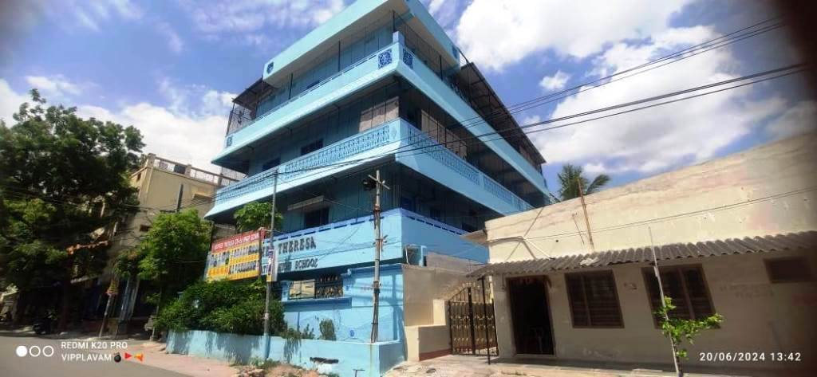

Details of the property under consideration:

Name of Owner: Sri. A. Chaitanya Reddy, S/o. A. Adinarayana Reddy

New House No. 11-269 (Old House No. 11-137), Plot Nos. 208 & 209/A, Survey No. 42/1, Venkateswara Nagar Colony, Meerpet Village, Uppal Mandal, Rangareddy District
State - Andhra Pradesh, Country - India

Longitude Latitude: 17°27'17.9"N 78°33'48.2"E

Intended User:

Siemens Financial Services Private Limited
SFS COF E RU-IN RM AM
RspaceD Center, Thane Belapur Road
Thane-400 708, State - Maharashtra, Country – India

INDEX
Particulars Page No.

1. VALUATION OPINION REPORT 3
2. VALUATION REPORT (IN RESPECT OF LAND AND STRUCTURES) 4
3. TOTAL ABSTRACT OF THE ENTIRE PROPERTY 10
4. ACTUAL SITE PHOTOGRAPHS 12
5. ROUTE MAP OF THE PROPERTY 15
6. READY RECKONER RATE 16
7. ASSUMPTIONS, DISCLAIMERS, LIMITATIONS & QUALIFICATIONS 21
8. ASSUMPTIONS, CAVEATS, LIMITATION AND DISCLAIMERS 24

Vastu/Mumbai/06/2024/9441/45178
02/12-27-JABS
Date: 24.06.2024

VALUATION OPINION REPORT
This is to certify that the property bearing New House No. 11-269 (Old House No. 11-137), Plot Nos. 208 & 209/A, Survey No. 42/1, Venkateswara Nagar Colony, Meerpet Village, Uppal Mandal, Rangreddy District, State - Andhra Pradesh, Country – India belongs to Sri. A. Chaitanya Reddy, S/o. A. Adinarayana Reddy.

Boundaries of the property.
orth | : | 30 Feet Wide Road
South | : | Plot No. 207 & 210
East | : | Plot No. 209(pt)
West | : | 40 Feet Wide Road

Considering various parameters recorded, existing economic scenario, and the information that is available with reference to the development of neighborhood and method selected for valuation, we are of the opinion that, the property premises can be assessed and Fair Market Value for this particular purpose at
Particulars |  | Area in Sq. M. |  | Rate per Sq. M. (`) |  | Value (`) |  | Orderly Liquidation Value (OLV)  (`)
- Land |  | 267.50 |  | 50,000/- |  | 1,33,75,000/- |  | 1,07,00,000/-
- School Building
Particular  of  Building | Area in  Sq. Ft. |  | Estimated  replacement rate per Sq. Ft. (`) |  | Depreciated Replacement rate per Sq. Ft. (`) |  | Depreciated Replacement  Value (`) | Orderly Liquidation Value (OLV)  (``)
RCC Structures | 1,507.00 |  | 2,000/- |  | 710/- |  | 10,69,970/- | 8,55,976/-
Fair Market Value (A + B) |  |  |  |  |  |  | 1,44,44,970/- | 1,15,55,976/-
Realizable Value |  |  |  |  |  |  | 1,30,00,473/- | -
Distress Sale Value |  |  |  |  |  |  | 1,15,55,976/- | -
Insurable Value |  |  |  |  |  |  | 25,61,900/- | -

The valuation of the property is based on the documents produced by the concerned. Legal aspects have not been taken into consideration while preparing this valuation report.
Hence certified.

Manoj B. Chalikwar
Registered Valuer
Chartered Engineer (India)
Reg. No. CAT-I-F-1763
Encl.: Valuation Report
Vastukala Consultants (I) Pvt. Ltd.
B1-001, U/B Floor, Boomerang, Chandivali Farm Road, Powai, Andheri (East), Mumbai – 400 072

VALUATION REPORT (IN RESPECT OF LAND AND STRUCTURES)

I | General
1. | Purpose for which the valuation is made |  |  | : | To assess the Orderly Liquidation Value (OLV) of Land & Building for loan purpose.
2. | a) | Date of inspection |  | : | 20.06.2024
 | b) | Date on which the valuation is made |  | : | 24.06.2024
3. | Copy of List of documents produced for perusal:
 | - Sale Deed dated 06.11.1996 between Sri. A. Adinarayana Reddy, S/o. Sri. Narayana Reddy (the Vendor) AND Sri. A. Chaitanya Reddy, S/o. A. Adinarayana Reddy (the Vendee)
4. | Name of the owner(s) and his / their address (es) with Phone no. (details of share of each owner in case of joint ownership) |  |  | : | Sri. A. Chaitanya Reddy, S/o. A. Adinarayana Reddy  Address:  New House No. 11-269 (Old House No. 11-137), Plot Nos. 208 & 209/A, Survey No. 42/1, Venkateswara Nagar Colony, Meerpet Village, Uppal Mandal, Rangareddy District. State - Andhra Pradesh, Country – India  Contact Person:  Sri. A. Chaitanya Reddy (Owner)  Sole Ownership
5. | Brief description of the property (Including Leasehold / freehold etc.) |  |  | :
The immovable property comprises of freehold land & School Building thereof. The property is located in a developing area having good infrastructure, well connected by road and train. It is located at about – 4.6 km. travelling distance from Moula Ali Railway Station.

Land
As per Sale Deed, the Land Area is 267.5 Sq. M.

Structure:
The property consists of School Building of Ground + 3 upper floors. It is a R.C.C. framed structure with RCC beams, columns, slabs (3rd floor has G. I. Sheet roofing) and RCC staircase is provided for access to the upper floors

The composition of the School Building as per site is as below –
Floor | Descripation
Ground | Parking & Staff Office
1st to 3rd Floor | Class Rooms

As per Sale Deed, the Built-up Area is 1,507.00 Sq. Ft., which is considered for valuation.
6. | Location of property |  |  | :
 | a) | Plot No. / Survey No. |  | : | Plot Nos. 208 & 209/A, Survey No. 42/
 | b) | Door No. |  | : | New House No. 11-269 (Old House No. 11-137)
 | c) | C.T.S. No. / Village |  | : | Village - Meerpet
 | d) | Ward / Taluka |  | : | -
 | e) | Mandal / District |  | : | District - Ranga Reddy
7. | Postal address of the property |  |  | : | New House No. 11-269 (Old House No. 11-137), Plot Nos. 208 & 209/A, Survey No. 42/1, Venkateswara Nagar Colony, Meerpet Village, Uppal Mandal, Rangreddy District, State - Andhra Pradesh, State - Madhya Pradesh, Country - India.
8. | City / Town |  |  | : | City
 | Residential area |  |  | : | Yes
 | Commercial area |  |  | : | No
 | Industrial area |  |  | : | No
9. | Classification of the area |  |  | :
 | i) High / Middle / Poor |  |  | : | Middle Class
 | ii) Urban / Semi Urban / Rural |  |  | : | Semi - Urban
10. | Coming under Corporation limit / Village Panchayat / Municipality |  |  | : | Khapra Municipality
11. | Whether covered under any State / Central Govt. enactments (e.g., Urban Land Ceiling Act) or notified under agency area/ scheduled area / cantonment area |  |  | : | No
12. | In Case it is Agricultural land, any conversion to house site plots is contemplated |  |  | : | N.A.
 | Landmark |  |  | : | Venkateswara Nagar Colony
13. | Boundaries of the property
 | Particulars |  | North | South |  | East |  | West
 | As per Site Visit
 |  |  | 30 Feet Wide Road | Plot No. 207 & 210 |  | Plot No. 209(pt) |  | 40 Feet Wide Road
 | As per Sale Deed
 | Survey No. 679/2/1 |  | 30 Feet Wide Road | Plot No. 207 & 210 |  | Plot No. 209(pt) |  | 40 Feet Wide Road
13.1 | Dimensions of the site |  |  | :
 |  |  |  |  | A As per the Deed |  | B Actuals
 | North |  |  |  | N.A. as the Plot is irregular in shape.
 | South
 | East
 | West
13.2 | Latitude, Longitude & Co-ordinates of property |  |  |  | 17°27'17.9"N 78°33'48.2"E
14. | Extent of the site |  |  | : | Land area = 267.5 Sq. M. & Built-up Area = 1,507.00 Sq. Ft.  (Area as per Sale Deed)
 | Extent of the site considered for Valuation (least of 14A& 14B) |  |  | :
16 | Whether occupied by the owner / tenant? If occupied by tenant since how long? Rent received per month. |  |  | : | Owner Occupied in the name of Mother Theresa High School
II | CHARACTERSTICS OF THE SITE
 | Classification of locality |  |  | : | Middle class
 | Development of surrounding areas |  |  | : | Developed
 | Possibility of frequent flooding/ sub-merging |  |  | : | No
 | Feasibility to the Civic amenities like School, Hospital, Bus Stop, Market etc. |  |  | : | All available near by
 | Level of land with topographical conditions |  |  | : | Plain
 | Shape of land |  |  | : | Rectangular
 | Type of use to which it can be put |  |  | : | For commercial purpose
 | Any usage restriction |  |  | : | Commercial
 | Is plot in town planning approved layout? |  |  | : | Yes
 | Corner plot or intermittent plot? |  |  | : | Intermittent
 | Road facilities |  |  | : | Yes
 | Type of road available at present |  |  | : | B.T. Road
 | Width of road – is it below 20 ft. or more than 20 ft. |  |  | : | More than 20 ft.
 | Is it a Land – Locked land? |  |  | : | No
 | Water potentiality |  |  | : | Good
 | Underground sewerage system |  |  | : | Available
 | Is Power supply is available in the site |  |  | : | Yes
 | Advantages of the site |  |  | : | Located in developed area
 | Special remarks, if any like threat of acquisition of land for publics service purposes, road widening or applicability of CRZ provisions etc. (Distance from sea-cost / tidal level must be incorporated) |  |  | : | No
Part – A (Valuation of land)
1 | Size of plot |  |  | : | Land area = 267.5 Sq. M.  (Area as per Sale Deed)
 | North & South |  |  | : | -
 | East & West |  |  | : | -
2 | Total extent of the plot |  |  | : | Land area = 267.5 Sq. M.  (Area as per Sale Deed)
3 | Prevailing market rate (Along with details / reference of at least two latest deals / transactions with respect to adjacent properties in the areas) |  |  | : | ` 45,000/- to ` 55,000/- per Sq. M.  Details of online listings are attached with the report.
4 | Government Ready Reckoner Rate of Land |  |  | : | Village - Meerpet  ` 12,600/- per Sq. Yard. equivalent to ` 10,533/- per Sq. M.
5 | Assessed / adopted rate of valuation of Land |  |  | : | ` 50,000/- per Sq. M.
6 | Estimated value of land |  |  | : | ` 1,33,75,000/-
Part – B (Valuation of Building)
1 | Technical details of the building |  |  | :
 | - Type of Building (Residential / Commercial / Industrial) |  |  | : | Commercial Structures (School Building)
 | - Year of construction |  |  | : | Approx. 1981 (As per Sale Deed)  Age of the structure – 43 years  Future Life of the property - 17 years Subject to proper, preventive periodic Maintenance & structural repairs.
 | - Number of floors and height of each floor including basement, if any |  |  | : | Ground + 3 upper floors
 | - Plinth area floor-wise |  |  | : | Built-up Area is 1,507.00 Sq. Ft.  (As per Sale Deed)
 | - Condition of the building |  |  | :
 | - Exterior – Excellent, Good, Normal, Poor |  |  | : | Normal
 | - Interior – Excellent, Good, Normal, Poor |  |  | : | Normal
 | - Date of issue and validity of layout of approved map |  |  | : | Approved Layout Plan not provided

Specifications of construction (floor-wise) in respect of

Sr.  No. | Description
 | Foundation | : | R.C.C. Foundation
 | Basement | : | No
 | Superstructure | : | RCC framed structure
 | Joinery / Doors & Windows (Please furnish details about size of frames, shutters, glazing, fitting etc. and specify the species of timber | : | Door / Windows – Teak wood door frame with flush shutters and Aluminium sliding windows
 | RCC Works | : | As per Brief Description
 | Plastering | : | Cement plaster
 | Flooring, Skirting, dado | : | Concrete Cement, PCC and Vitrified tiles flooring
 | Special finish as marble, granite, wooden paneling, grills etc. | : | No
 | Roofing including weatherproof course | : | R.C.C.
 | Drainage | : | Underground Sewerage connected to Municipal Sewerage lines
2. | Compound Wall | :
 | Height | : | No
 | Length | : | No
 | Type of construction | : | No
3. | Electrical installation | :
 | Type of wiring | : | Concealed
 | Class of fittings (superior / ordinary / poor) | : | Ordinary
 | Number of light points | : | Provided as per requirement
 | Fan points | : | Provided as per requirement
 | Spare plug points | : | Provided as per requirement
 | Any other item | : | -
4. | Plumbing installation
 | - No. of water closets and their type | : | Provided as per requirement
 | - No. of wash basins | : | Provided as per requirement
 | - No. of urinals | : | Provided as per requirement
 | - No. of bathtubs | : | Provided as per requirement
 | - Water meters, taps etc. | : | Provided as per requirement
 | - Any other fixtures | : | Provided as per requirement
Structure
Particular  of  Building | Area in  Sq. Ft. | Estimated  replacement rate per Sq. Ft. (`) | Depreciated Replacement rate per Sq. Ft. (`) | Depreciated Replacement  Value (`) | Full Value  (`)
RCC Structures | 1,507.00 | 2,000/- | 710/- | 10,69,970/- | 30,14,000/-
Total |  |  |  | 10,69,970/- | 30,14,000/-

Part – C (Extra Items) |  | : | Amount in `
 | Portico | : | Included in the Cost of Construction
 | Ornamental front door | : | Included in the Cost of Construction
 | Sit out / Verandah with steel grills | : | Included in the Cost of Construction
 | Overhead water tank | : | Included in the Cost of Construction
 | Extra steel / collapsible gates | : | Included in the Cost of Construction
 | Total
Part – D (Amenities) |  | : | Amount in `
 | Wardrobes | : | Included in the Cost of Construction
 | Glazed tiles | : | Included in the Cost of Construction
 | Extra sinks and bathtub | : | Included in the Cost of Construction
 | Marble / ceramic tiles flooring | : | Included in the Cost of Construction
 | Interior decorations | : | Included in the Cost of Construction
 | Architectural elevation works |  | Included in the Cost of Construction
 | Paneling works |  | Included in the Cost of Construction
 | Aluminum works |  | Included in the Cost of Construction
 | Aluminum handrails |  | Included in the Cost of Construction
 | False ceiling |  | Included in the Cost of Construction
 | Total |  | Included in the Cost of Construction

Part – E (Miscellaneous) |  | : | Amount in `
 | Separate toilet room | : | Included in the Cost of Construction
 | Separate lumber room | : | Included in the Cost of Construction
 | Separate water tank / sump | : | Included in the Cost of Construction
 | Trees, gardening | : | Included in the Cost of Construction
 | Total |  | Included in the Cost of Construction

Part – F (Services) |  | : | Amount in `
 | Water supply arrangements | : | Included in the Cost of Construction
 | Drainage arrangements | : | Included in the Cost of Construction
 | Compound wall | : | Included in the Cost of Construction
 | C.B. deposits, fittings etc. | : | Included in the Cost of Construction
 | Pavement |  | Included in the Cost of Construction
 | Total |  | Included in the Cost of Construction
Government Value

Particulars | Area in Sq. M. | Rate per Sq. M. ( `) | Value in (`)
Village Meerpet - Land | 267.5 | 10,533/- | 28,17,578/-
Structure | As per valuation table |  | 10,69,970/-
Total |  |  | 38,87,548/-

TOTAL ABSTRACT OF THE ENTIRE PROPERTY

Part - A | Land |  | ` 1,33,75,000/-
Part - B | Buildings |  | ` 10,69,970/-
 | Land Development |  | -
Part – C | Compound Wall |  | -
Part – D | Amenities |  | -
Part - E | Pavement |  | -
Part - F | Services |  | -
 | Fair Market Value In (`) |  | ` 1,44,44,970/-
 | Realisable Value In (`) |  | ` 1,30,00,473/-
 | Distress Value In (`) |  | ` 1,15,55,976/-
 | Insurable Value In (`) (Full Replacement Cost (30,14,000/-) – Subsoil structure cost (15%) |  | ` 25,61,900/-
Remarks | - Layout plan from T & CP is not provided for our verification.  - Approved building plan copy is not provided for the structures on site. We have considered the area as per Sale Deed.

Justification for price /rate
The Market Value of the property is based on facts of markets discovered by us during our enquiries, however the government rate value in this case is less than the market value arrived by us. We are of the opinion that the value arrive by us will prove to be correct if an Auction of the subject property is carried out. As far as Market Value as per property document is concerned, it is not possible to comment on same, may be government rates are fixed by sampling during same point of time in part and whereas, Market values change every month.
In most of the cases the actual deal amount or Transaction value is not reflected in the property documents because of various Market practices. As Valuer, we always try to give a value which is correct reflection of actual transaction value irrespective of any factors in market.
Method of Valuation / Approach
The replacement cost of the building (construction costs) minus the physical and functional depreciation. This approach is most commonly used for real estate properties that are not easily sold like schools, hospitals, and government buildings.

Land cost can be estimated using the Sales Comparison Approach by studying recent sales of land close to the subject property, and these sales should be comparable in size and location with subject property.

There are different ways to estimate replacement costs, the most common being finding out the cost to build a square foot of comparable properties multiplied by the total square footage of the building. The cost approach is commonly used for Residential House, Commercial Building and properties mentioned above.

As the property is Commercial land and building thereof, we have adopted Cost approach / Land and Building Method for the purpose of valuation. The Price for similar type of property in the nearby vicinity is in the range of ` 45,000/- to ` 55,000/- per Sq. M. for land Considering the rate with attached report, current market conditions, demand and supply position, Land size, location, sustained demand for Commercial Plot, all round development of industrial and commercial application in the locality etc. We estimate ` 50,000/- per Sq. M. for Land with appropriate cost of construction for valuation.

The saleability of the property is: Normal
Expected rental values per month: N.A.
Any likely income it may generate: N.A.

ACTUAL SITE PHOTOGRAPHS
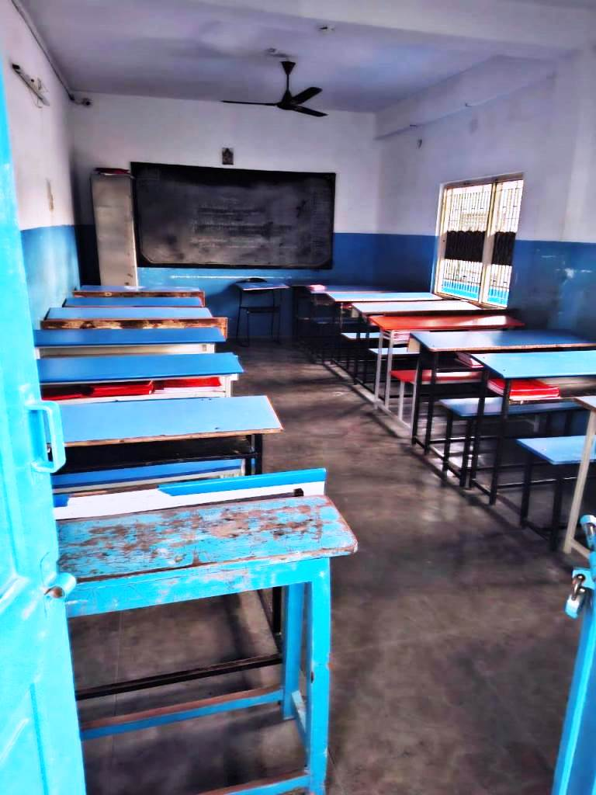
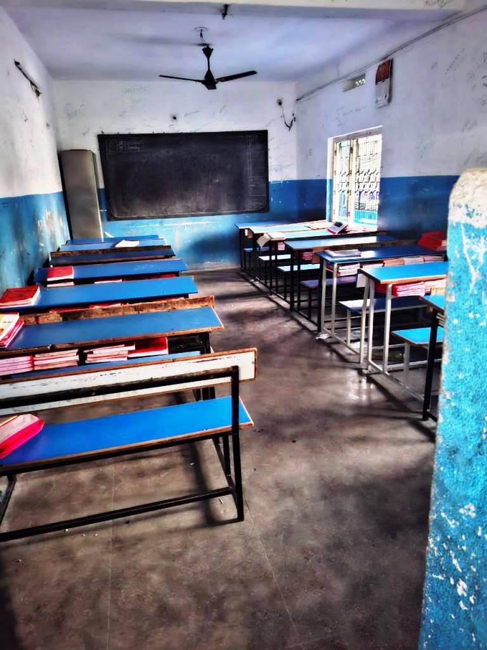
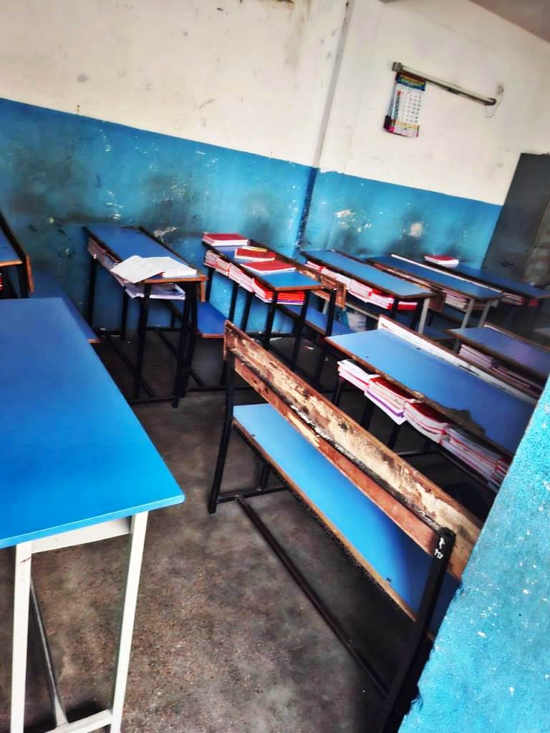

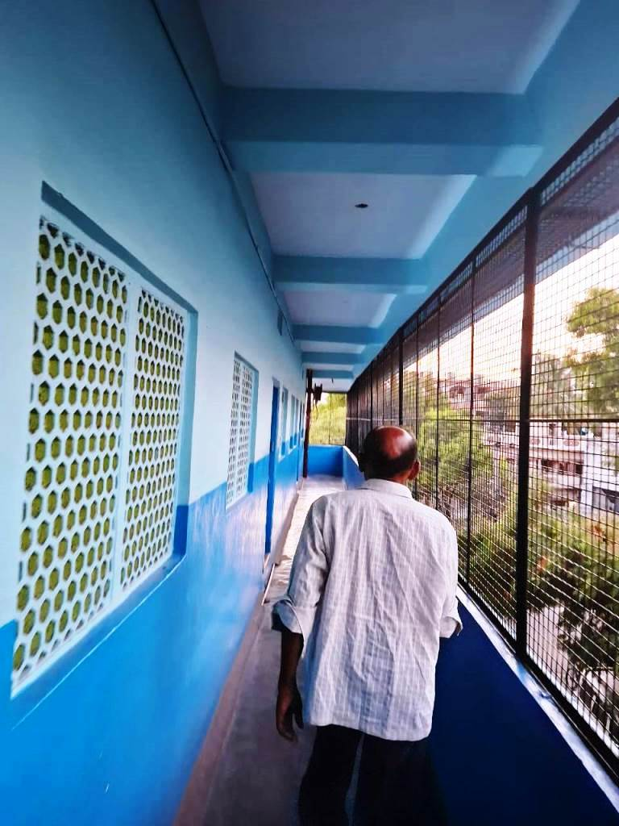
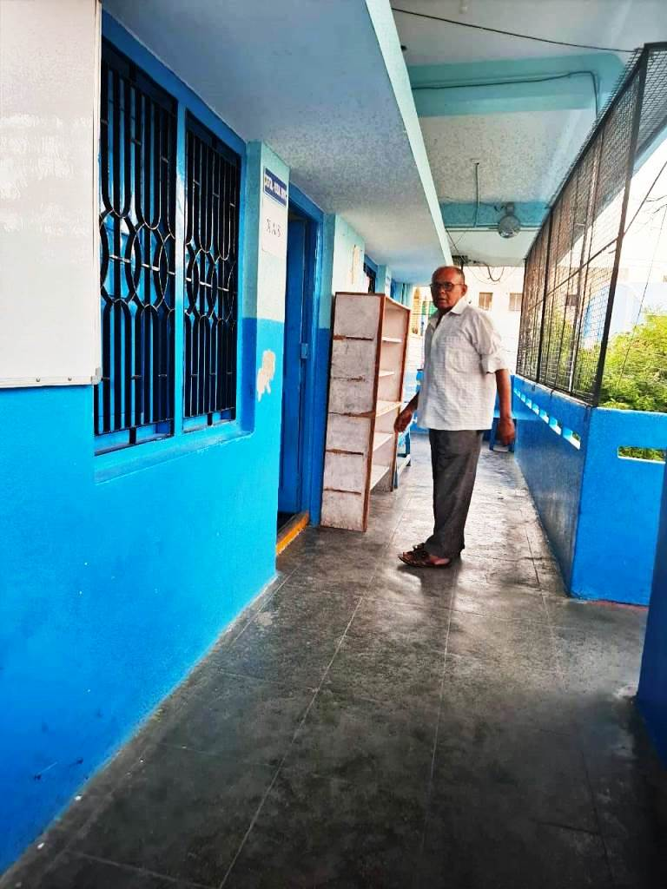
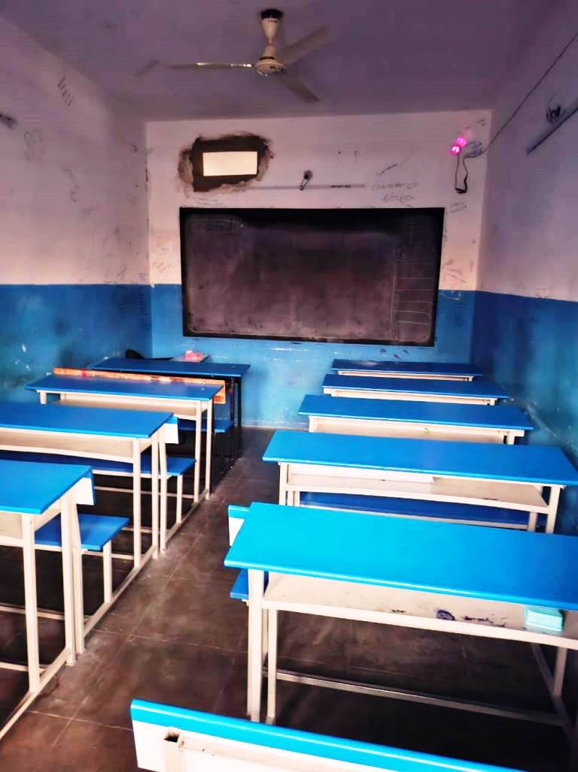

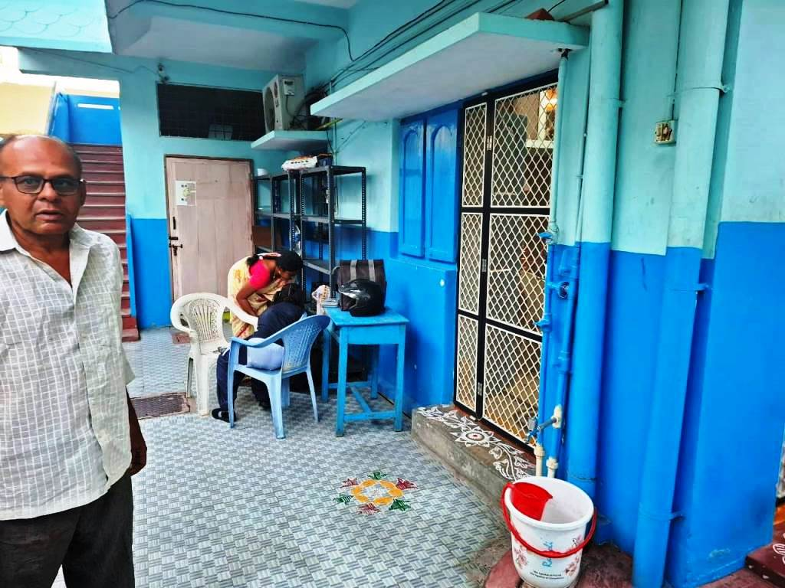
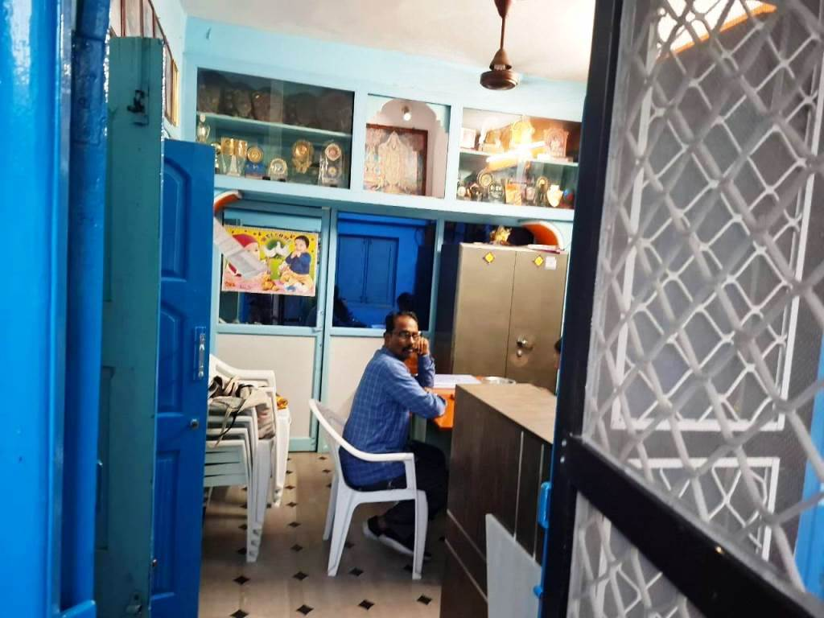

ACTUAL SITE PHOTOGRAPHS
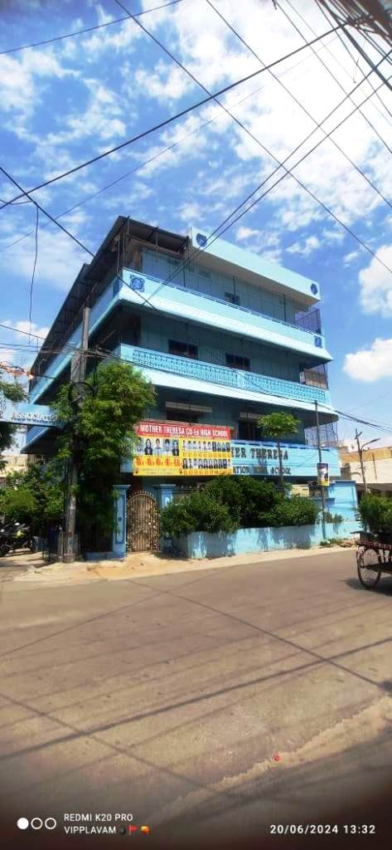
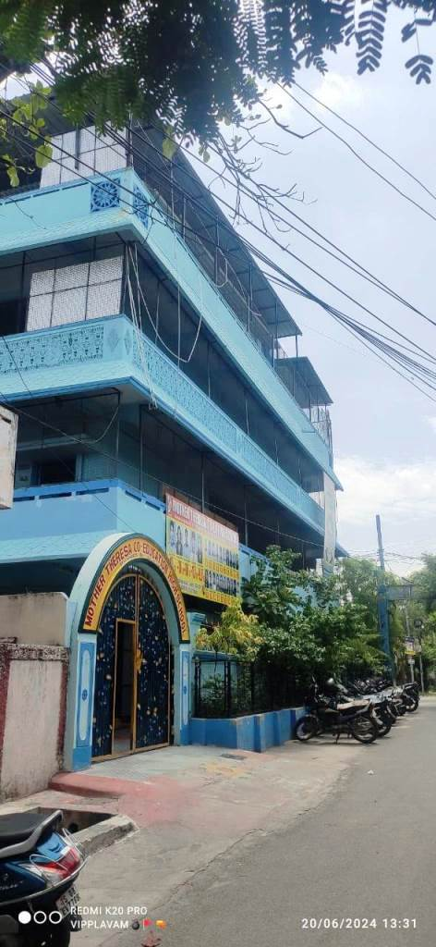
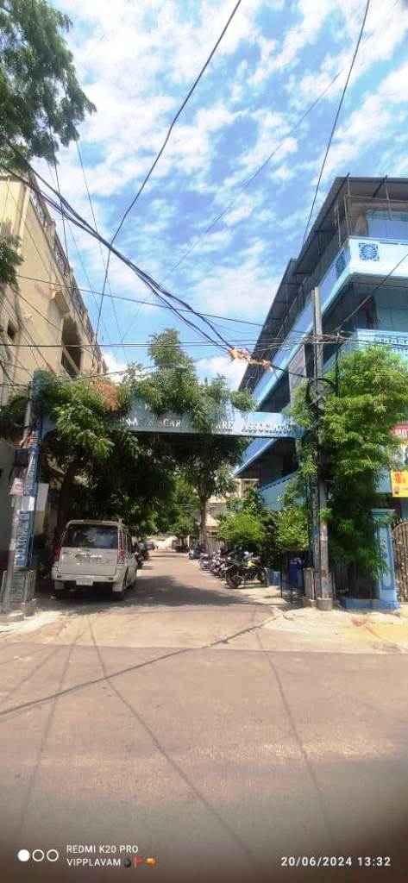

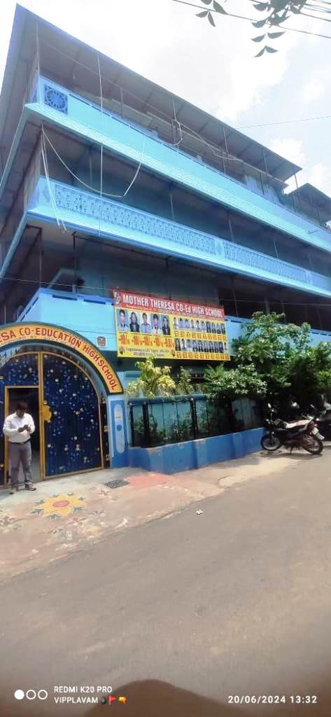

ROUTE MAP OF THE PROPERTY
Site u/r
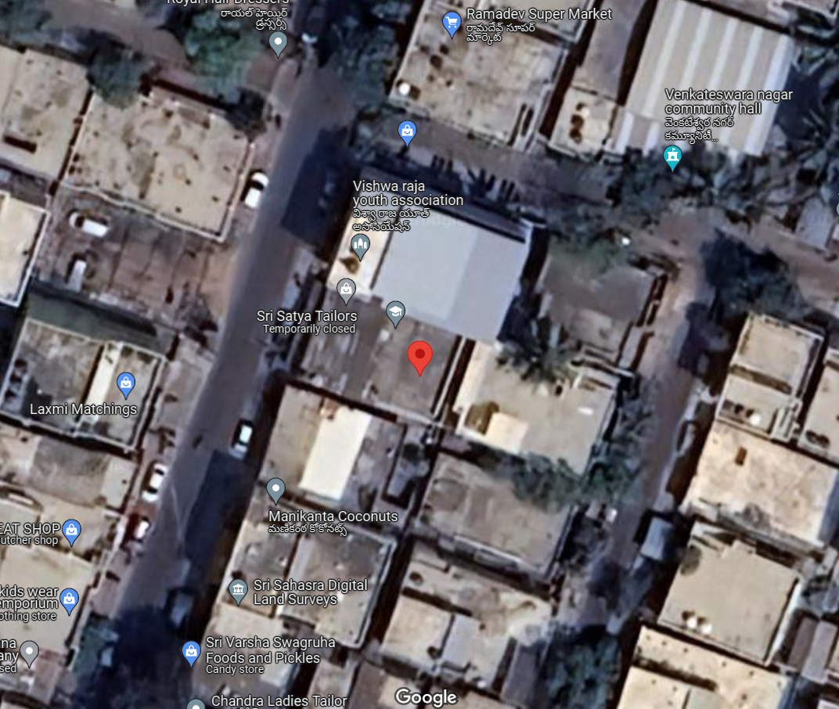

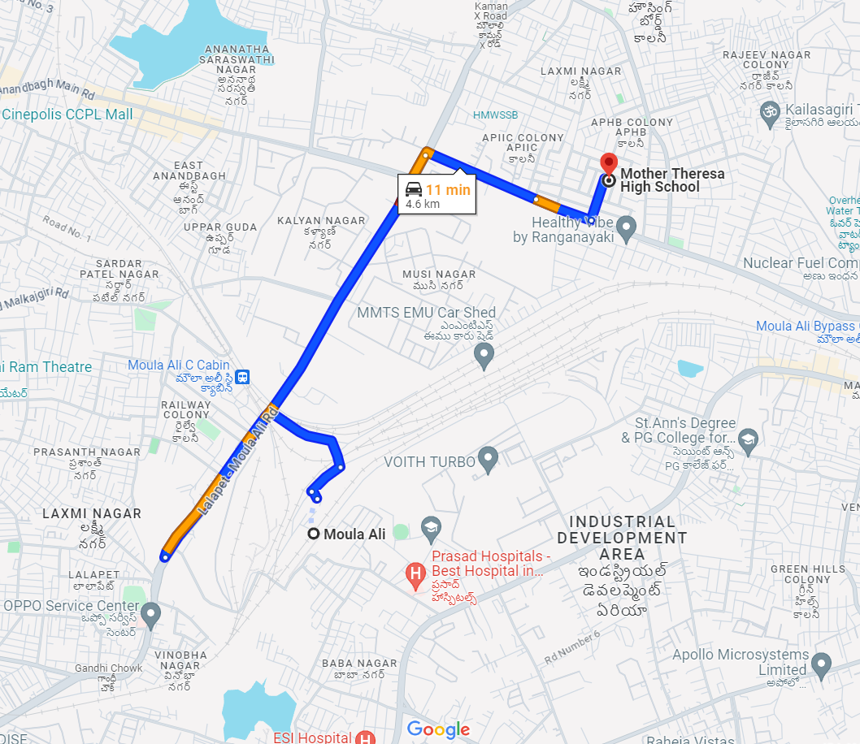

Longitude Latitude: 17°27'17.9"N 78°33'48.2"E
Note: The Blue line shows the route to site from nearest railway station (Moula Ali – 4.6 km.)

READY RECKONER RATE
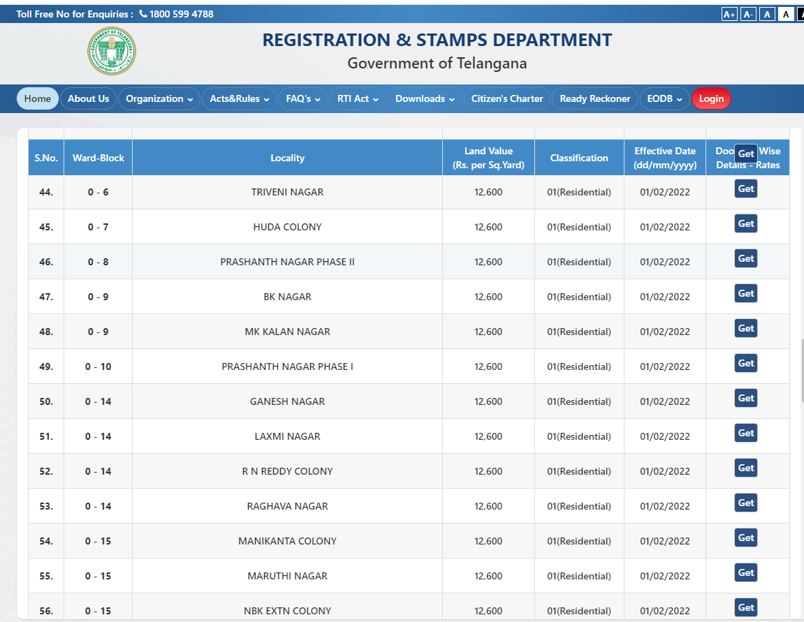

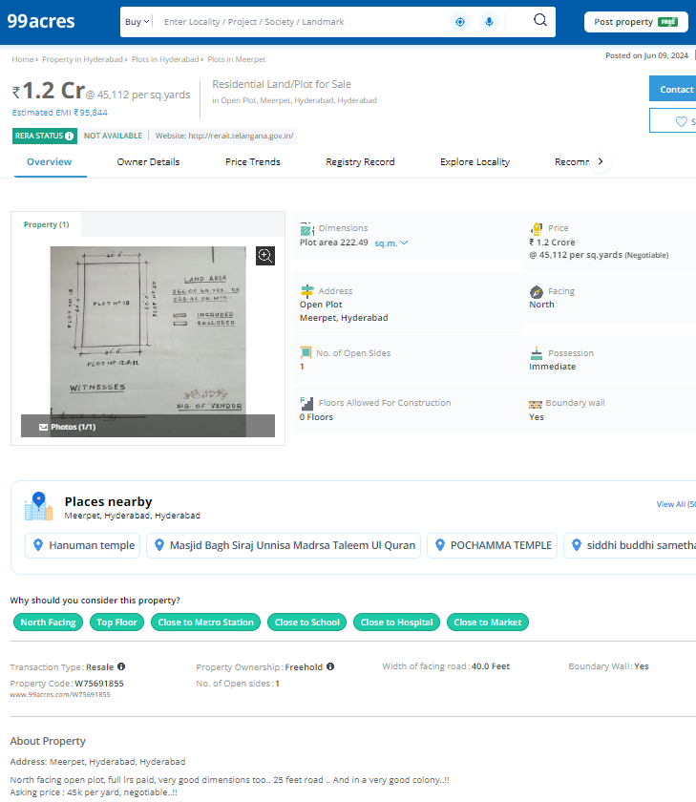
PRICE INDICATORS
PRICE INDICATORS
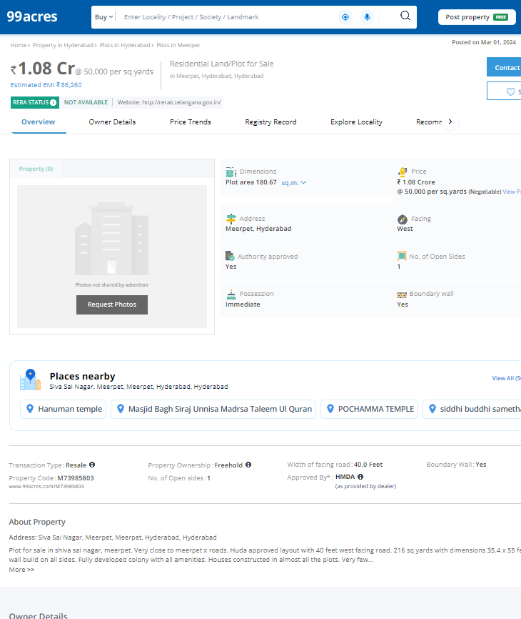

As a result of my appraisal and analysis, it is my considered opinion that the Fair Market Value for this particular above property in the prevailing condition with aforesaid specification is as below –

Particulars | Fair Market Value In (`) | Realizable Value In (`) | Distress Sale Value In (`) | Insurable Value In  (`)
Land and School Building | 1,44,44,970/- | 1,30,00,473/- | 1,15,55,976/- | 25,61,900/-

Place: Indore
Date: 24.06.2024

Manoj B. Chalikwar
Registered Valuer
Chartered Engineer (India)
Reg. No. CAT-I-F-1763

Sr. No. | Particulars | Valuer comment
1 | Background information of the asset being valued; | The land under consideration is owned by Sri. A. Chaitanya Reddy, S/o. A. Adinarayana Reddy
2 | Purpose of valuation and appointing authority | To assess the Orderly Liquidation Value (OLV) of Land & Building for loan purpose for Siemens Financial Services Private Limited.
3 | Identity of the Valuer and any other experts involved in the valuation; | Manoj B. Chalikwar - Regd. Valuer  Singarapu Saikumar - Valuation Engineer  Binumon Moozhickal - Technical Manager  Jayaraja Acharya - Technical Officer
4 | Disclosure of Valuer interest or conflict, if any; | We have no interest, either direct or indirect, in the property valued. Further to state that we do not have relation or any connection with property owner / applicant directly or indirectly. Further to state that we are an independent Valuer and in no way related to property owner / applicant
5 | Date of appointment, valuation date and date of report; | Date of Appointment - 20.06.2024  Valuation Date - 24.06.2024  Date of Report - 24.06.2024
6 | Inspections and/or investigations undertaken; | Physical Inspection done on date 20.06.2024
7 | Nature and sources of the information used or relied upon; | - Market Survey at the time of site visit  - Ready Reckoner rates / Circle rates  - Online Price Indicators on real estate portals  - Enquiries with Real estate consultants  - Existing data of Valuation assignments carried out by us
8 | Procedures adopted in carrying out the valuation and valuation standards followed; | Cost Approach (For building construction)  Comparative Sales Method (For Land component)
9 | Restrictions on use of the report, if any; | This valuation is for the use of the party to whom it is addressed and for no other purpose. No responsibility is accepted to any third party who may use or rely on the whole or any part of this valuation. The valuer has no pecuniary interest that would conflict with the proper valuation of the property.
10 | Major factors that were taken into account during the valuation. | Current market conditions, demand and supply position, Commercial land size, location, sustained demand for Commercial land, all round development of commercial and industrial application in the locality etc.
11 | Major factors that were not taken into account during the valuation. | Nil
11 | Caveats, limitations, and disclaimers to the extent they explain or elucidate the limitations faced by valuer, which shall not be for the purpose of limiting his responsibility for the valuation report. | Attached

ASSUMPTIONS, DISCLAIMERS, LIMITATIONS & QUALIFICATIONS

Value Subject to Change
The subject appraisal exercise is based on prevailing market dynamics as on 24th June 2024 and does not take into account any unforeseeable developments which could impact the same in the future.
Our Investigations
We are not engaged to carry out all possible investigations in relation to the subject property. Where in our report we identify certain limitations to our investigations, this is to enable the reliant party to instruct further investigations where considered appropriate or where we recommend as necessary prior to reliance. Vastukala Consultants India Pvt. Ltd. (VCIPL) is not liable for any loss occasioned by a decision not to conduct further investigations.
Assumptions
Assumptions are a necessary part of undertaking valuations. VCIPL adopts assumptions for the purpose of providing valuation advice because some matters are not capable of accurate calculations or fall outside the scope of our expertise, or out instructions. The reliant party accepts that the valuation contains certain specific assumptions and acknowledge and accept the risk of that if any of the assumptions adopted in the valuation are incorrect, then this may have an effect on the valuation.
Information Supplied by Others
The appraisal is based on the information provided by the client. The same has been assumed to be correct and has been used for appraisal exercise. Where it is stated in the report that another party has supplied information to VCIPL, this information is believed to be reliable but VCIPL can accept no responsibility if this should prove not to be so.
Future Matters
To the extent that the valuation includes any statement as to a future matter, that statement is provided as an estimate and/or opinion based on the information known to VCIPL at the date of this document. VCIPL does not warrant that such statements are accurate or correct.
Map and Plans
Any sketch, plan or map in this report is included to assist the reader while visualizing the property and assume no responsibility in connection with such matters.
Site Details
Based on inputs received from Client's representative and site visit conducted, we understand that the subject property is land parcel total admeasuring 267.50 Sq. M. and structures thereof. The property is owned by Sri. A. Chaitanya Reddy, S/o. A. Adinarayana Reddy. At present, the property is various lessee occupied. Further, VCIPL has assumed that the subject property is free from any encroachment and is available as on the date of the appraisal.
Property Title
Based on our discussion with the Client, we understand that the property is owned by Sri. A. Chaitanya Reddy, S/o. A. Adinarayana Reddy For the purpose of this appraisal exercise, we have assumed that the subject property has a clear title and is free from any encumbrances, disputes and claims. VCIPL has made no further enquiries with the relevant local authorities in this regard and does not certify the property as having a clear and marketable title. Further, no legal advice regarding the title and ownership of the subject property has been obtained for the purpose of this appraisal exercise. It has been assumed that the title deeds are clear and marketable.
Environmental Conditions
We have assumed that the subject property is not contaminated and is not adversely affected by any existing or proposed environmental law and any processes which are carried out on the property are regulated by environmental legislation and are properly licensed by the appropriate authorities.
Town Planning
The permissible land use, zoning, achievable FSI, area statement adopted for purpose of this valuation is based on the information provided by the Client's representative and the same has been adopted for this valuation purpose. VCIPL has assumed the same to be correct and permissible. VCIPL has not validated the same from any authority.
Area
Based on the documents, we understand that the subject property is contiguous land parcel total admeasuring 267.50 Sq. Ft. and structures thereof.

Condition & Repair
In the absence of any information to the contrary, we have assumed that there are no abnormal ground conditions, nor archaeological remains present which might adversely affect the current or future occupation, development or value of the property. The property is free from rat, infestation, structural or latent defect. No currently known deleterious or hazardous materials or suspect techniques will be used in the construction of or subsequent alteration or additions to the property and comments made in the property details do not purport to express an opinion about, or advise upon, the condition of uninspected parts and should not be taken as making an implied representation or statement about such parts.

Valuation Methodology
For the purpose of this valuation exercise, the valuation methodology used is cost approach.
The cost approach is a Real Property Valuation method which considers the value of a property as the cost of the land plus the replacement cost of the building (construction costs) minus the physical and functional depreciation. This approach is most commonly used for real estate properties that are not easily sold like schools, hospitals, government buildings and above type of property.

Land cost can be estimated using the Sales Comparison Approach by studying recent sales of land close to the subject property, and these sales should be comparable in size and location with subject property.
There are different ways to estimate replacement costs, the most common being finding out the cost to build a square foot of comparable properties multiplied by the total square footage of the building. The cost approach is commonly used for Residential House, Commercial Building and properties mentioned above.
Where reliance has been placed upon external sources of information in applying the valuation methodologies, unless otherwise specifically instructed by Client and/or stated in the valuation, VCIPL has not independently verified that information and VCIPL does not advise nor accept it as reliable. The person or entity to whom the report is addressed acknowledges and accepts the risk that if any of the unverified information in the valuation is incorrect, then this may have an effect on the valuation.
Not a Structural Survey
We state that this is a valuation report and not a structural survey.
Other
All measurements, areas and ages quoted in our report are approximate.
Legal
We have not made any allowances with respect to any existing or proposed local legislation relating to taxation on realization of the sale value of the subject property. VCIPL is not required to give testimony or to appear in court by reason of this appraisal report, with reference to the property in question, unless arrangement has been made thereof. Further, no legal advice on any aspects has been obtained for the purpose of this appraisal exercise.
Property specific assumptions
Based on inputs received from the client and site visit conducted, we understand that the subject property is land total admeasuring 267.50 Sq. M. and structures thereof. It is occupied by Sri. A. Chaitanya Reddy, S/o. A. Adinarayana Reddy.

ASSUMPTIONS, CAVEATS, LIMITATION AND DISCLAIMERS
- We assume no responsibility for matters of legal nature affecting the property appraised or the title thereto, nor do we render our opinion as to the title, which is assumed to be good and marketable.
- The property is valued as though under responsible ownership.
- It is assumed that the property is free of liens and encumbrances.
- It is assumed that there are no hidden or unapparent conditions of the subsoil or structure that would render it more or less valuable. No responsibility is assumed for such conditions or for engineering that might be required to discover such factors.
- There is no direct/ indirect interest in the property valued.
- The rates for valuation of the property are in accordance with the Govt. approved rates and prevailing market rates.

Manoj B. Chalikwar
Registered Valuer
Chartered Engineer (India)
Reg. No. CAT-I-F-1763

