Vastu/Nashik/06/2024/009374/ 2306816
19/10-260-RYBS
Date: 19.06.2024

To,
The Assistant General Manager,
State Bank of India
RACC Nashik Branch
RBO.2, The Wave Building, 1 st Floor, Opposite Shell Petrol Pump, Pathardi Road,
Nashik – 422 010, State – Maharashtra, Country – India.

Sub: Vetting of Quotation

Sir,

With reference to above subject, we have evaluated the Quotation for Residential Flat No. 304, Third Floor, “Ashok Tower ”, Survey No. 62/ 1/ 72/ 1, Plot No. 4/ 5/ 1, Near Zudio Shop, Navshya Ganapati Parisar, Gangapur Road, Village – Anandwalli, Taluka & District – Nashik, Nashik - 422 013, State – Maharashtra, Country – India. belongs to Name of Owner: Mr. Yadnesh Ramesh Zawar & Mrs. Meenakshi Yadnesh Zawar.

We have verified the rates quoted as per current market rates. Details of Quotation considered as per copy of Quotation Provided by M/s. Aaradhya Enterprises received on dated.16.06.2024. The Quotation amount is Rs.16,65,519/- (Rupees Sixteen Lakh Sixty-Five Thousand Five Hundred Nineteen Only.)

Note:1) The said Cost Vetting Certificate is valid upto next 6 months Only.

Thanking you

Sincerely yours

Manoj B. Chalikwar
Registered Valuer
Chartered Engineer (India)
Reg. No. CAT-I-F-1763
Reg. No. IBBI/RV/07/2018/10366
BOB Empanelment No.: ZO:MZ:ADV:46:941
Encl: Valuation Report

Quotation
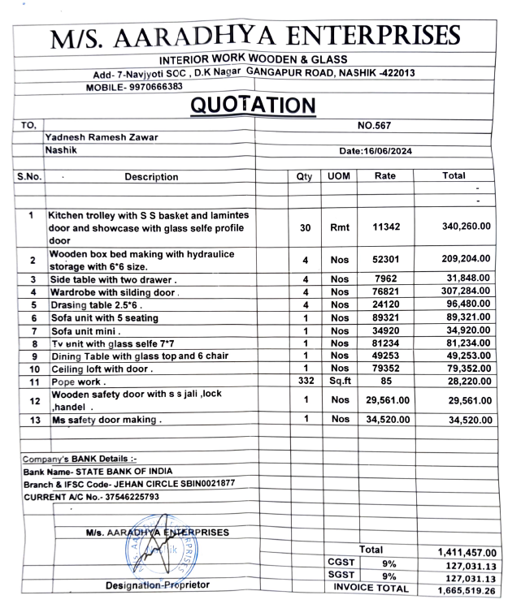

The Quotation amount is Rs.16,65,519/- (Rupees Sixteen Lakh Sixty-Five Thousand Five Hundred Nineteen Only.)

