

**Name of Owner: M/s. Eurja Energy Generation Pvt. Ltd.**

**Plant Location: -** Hindustan Copper Ltd (HCL) Indian Copper Complex (ICC), Near Waste Slag Dumping Area, Moubhandar, Ghatsila, District-Singhbhum, PIN Code-832 303, State-Jharkhand, Country-India.

**Report Prepared For**

**Shivsagar Estate Branch Worli (South)**

**Devchand House, Ground Floor, Dr. Annie Besant Road, Worli, Mumbai - 400 018,   
State - Maharashtra, Country - India**

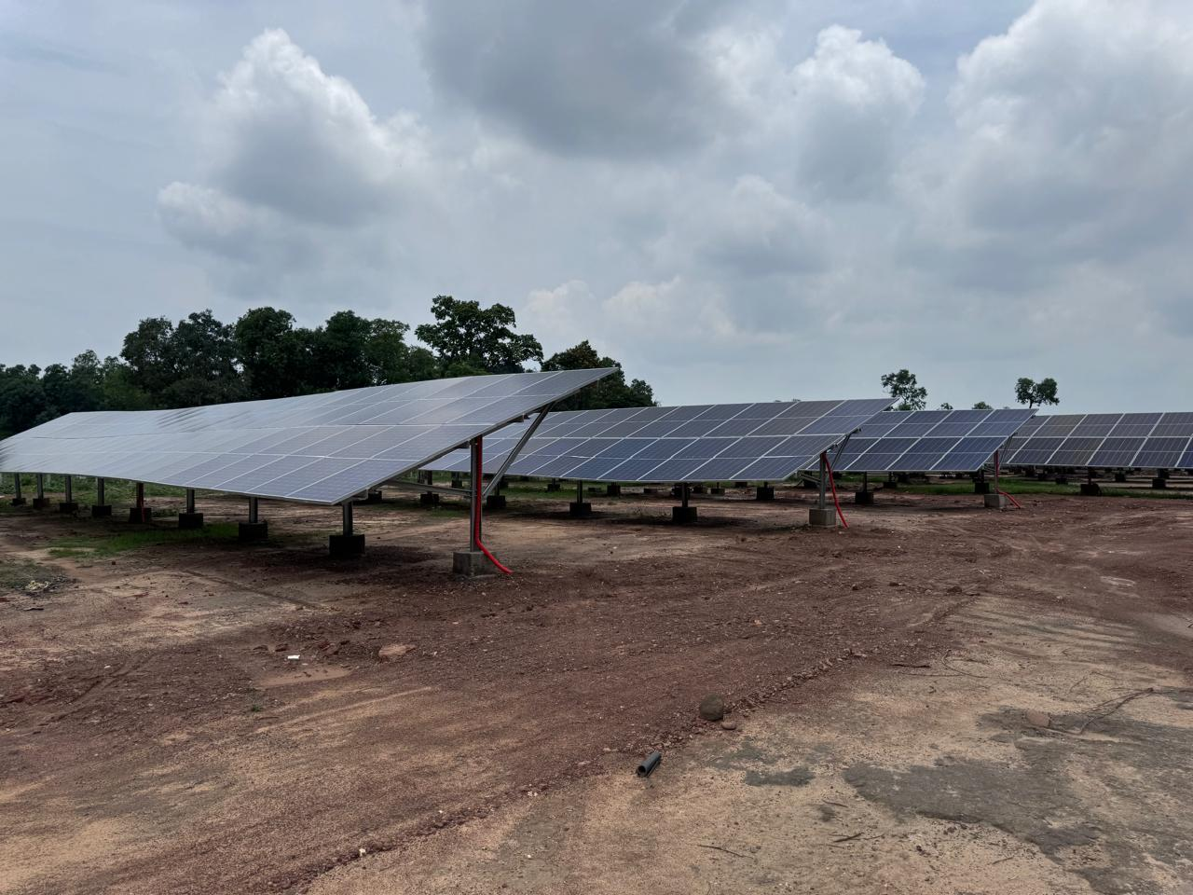

**INDEX**

|  |  |  |
| --- | --- | --- |
| CHAPTER | NAME | PAGE NO. |
| 1 | **PREAMBLE** | **03** |
| 2 | **ASSIGNMENT OVERVIEW** | **05** |
| 3 | **ABOUT COMPANY & THE PROJECT** | **08** |
| 4 | **PROJECT EXECUTION** | **24** |
| 5 | **NOTES, LIMITATIONS, DISCLAIMERS & CAVEATS** | **43** |
| 6 | **SUMMARY** | **45** |
| 7 | **OPINION** | **50** |

Vastu/SBI/Mumbai/07/2024/9366/2304747

30/21-449-APU

Date: 16.07.2024

1. **PREAMBLE**

**M/s. Eurja Energy Generation Private Limited (“The Company” or “EEGPL”)** has appointed M/s Vastukala Consultants (I) Pvt. Ltd., Mumbai, (VCIPL) as Lender’s Independent Engineers (LIE) for 1 MW Grid Connected Ground Mounted Solar PV Power Plant in RESCO Mode for 25 Years for Government premises by M/s. Eurja Energy Generation Pvt. Ltd.

The Total Cost incurred for 1000 kW Grid Connected Ground Mounted Solar PV Power Plant in RESCO Mode for 25 Years for Government premises by EEGPL is ₹ 3.29 Crores. EEGPL has appointed VCIPL for the monitoring of 1000 KW Grid Connected Ground Mounted Solar PV Power Plant in RESCO Mode for 25 Years for Government premises.

State Bank of India, Shivsagar Estate Branch, Worli (South), Dr. A.B. Road, Devchand House, Ground Floor, Worli, Mumbai-400 018 has sanctioned the Line of Credit (Term Loan) of Rs. 18.00 Cr under World Bank Scheme for Design, Purchase, Supply, installation, Commissioning, Operations & Maintenance (O&M) of roof top solar projects at various sited with aggregate capacity of 7500 kWp to be utilized by way of various term loans with a door-to-door tenor of 10 years (including moratorium period of 6 months) from the date of 1st disbursement of each individual Term loan sanctioned for each independent site.

EEGPL has appointed VCIPL for the monitoring of 1000 KW Grid Connected Ground Mounted Solar PV Power Plant in RESCO Mode for 25 Years for Government premises. The Cost of Project for 1000 KW Solar Plant sanctioned by SBI is as under:-

**(Rs in Cr)**

| S. No | Particular | Capacity (kW) | Project Cost |
| --- | --- | --- | --- |
| 1 | Hindustan Copper Ltd (HCL) Indian Copper Complex (ICC) | 1,000 | 3.29 |
|  | **Total** | **1,000** | **3.29** |

Pursuant to instruction from Relationship Manager (SME), State Bank of India, Shivsagar Estate Branch Worli (South) and subsequent work order from **M/s. Eurja Energy Generation Pvt. Ltd.**, for the appointment of Lender’s Independent Engineer, VCIPL’s Engineer has visited the project site as on 03.07.2024 with a view to ascertain and certify the quantity and amount of work progressively undertaken/completed by the borrower for Term Loan and LIE is submitting the progress report for the project as under.

1. **ASSIGNMENT OVERVIEW**

#### 2.1 NATURE OF ASSIGNMENT

To monitor on behalf of lender the progress of the 1 MW Grid Connected Ground Mounted Solar PV Power Plant in RESCO Mode for 25 Years for Government premises by M/s. Eurja Energy Generation Pvt. Ltd.

#### 2.2 SCOPE OF WORK: -

#### The scope of work is as per work order provided by the company is under: -

* To provide independent recommendations/comments on the quality and performance of project.
* To monitor compliance of applicable Environmental, Health and Safety (EHS) norms post commissioning.
* To submit review of commissioned projects & give its final completion report including its recommendations and observations.
* Projects Vetting. The vetting should cover (i) Project Viability (ii) suitability of technology proposed to be adopted (iii) credentials of technology/equipment supplier and EPC Contractor iv) Review of implementation philosophy/schedule etc.

As per discussion with Bank Official and Company the Project viability is not in the Scope of LIE, therefore the same is not included in LIE Report.

#### 2.3 DATE OF VISIT: -

VCIPL’s Engineer has visited the project site as on 03.07.2024 with a view to ascertain and certify the quantity and amount of work progressively undertaken/completed by EEGPL. Mr. Prakash Baraik, Site Engineer of EEGPL (+91 80924 50933) accompanied our Engineer and showed the Solar Plant.

#### 2.4 DOCUMENTS PROVIDED FOR VALUATION: -

The following documents were perused during the said assignment:

* Letter for Sanction of Credit Limit issued by State Bank of India, Shivsagar Estate Branch, Worli (South).
* Company Profile.
* Pan Card, GST Registration Certificate, Udyog Aadhaar, Udyam Registration Certificate, ISO 9001:2015 Certificate.
* List of Work Completed.
* CA Certificate for Cost incurred toward the project certified by M/s. CAGK and Co., Chartered Accountants Mumbai dated 05.06.2024.
* Letter for Commercial Date of Operation submitted by EEGPL to Hindustan Copper Limited dated 21.06.2024.
* Joint Inspection Report.
* Power Purchase Agreement (PPA) made between Hindustan Copper Limited-Indian Copper Complex, Moubhandar, Ghatsila, Jharkhand-832 103 (“Purchaser”) and M/s. SIL Mercury Solar Pvt. Ltd. (Power Producer) for Design, Manufacture, Supply, Erection, Testing and Commissioning including Warranty, Operational & maintenance of 1000 kWp Grid connected Ground Mounted Solar photovoltaic System at Hindustan Copper Limited-Indian Copper Complex, Moubhandar, Ghatsila, Jharkhand-832 103 dated 03.07.2023 for the period of 25 years from the commercial operation date (COD).
* Minutes of Meeting dated 03.07.2023 between HCl, SIL Mercury Solar and EEGPL.
* Agreement dated 30.06.2023 made between M/s. Eurja Energy Generation Pvt. Ltd. and M/s. SIL Mercury Solar Pvt. Ltd. for the transfer of PPA.
* Novation Agreement dated 03.07.2023 made between Hindustan Copper Limited-Indian Copper Complex (“Power Purchaser”) and M/s. SIL Mercury Solar Pvt. Ltd. (“Transferor”) and M/s. Eurja Energy Generation Pvt. Ltd. (“Transferee”).
* Over all Single Line Diagram dated 29.03.2024.
* String Layout for DC Cables dated 07.06.2024.
* SBI General Bharat Sookshma Udyam Suraksha Policy valid till 17.05.2025 issued by SBI General Insurance Company.
* Overall Plot Plan approved by Electrical Inspector, Energy Department, Jharkhand Electrical Inspectorate, Ranchi vide Certificate No. MAC23112412172 dated 24.11.2023.
* Permission to energize the Solar Power Plant of Capacity 1000 KWp granted by Senior Electrical Inspector, Energy Department, Jharkhand Electrical Inspectorate, Ranchi vide Certificate No. INS2406058995 dated 04.06.2024.
* 1st Sale Invoice billed to Hindustan Copper Ltd. (HCL) India Copper Complex (ICC) vide Invoice No. EG/TI/24-23/095 dated 02.07.2024.
* Performance Report prepared by EEGPL dated 05.06.2024.

#### 2.5 METHODOLOGY ADOPTED

* LIE visit to the project site of Grid Connected Ground Mounted Solar PV Power Plant in RESCO Mode for 25 Years for Government premises by EEGPL to inspect the project work undertaken/completed by borrower.
* Perusal of documents and information provided by the Company.
* Physical verification of the project site.
* Explanations and information given by the following executives of the Company,
* Mr. Prashant Tiwari, Director, EEGPL.
* Examinations of documents provided by the Company.
* Selective photographs of the project site are enclosed.
* Finalization of LIE Report.

1. **ABOUT COMPANY & THE PROJECT**

#### 3.1. ABOUT COMPANY: -

**M/s. Eurja Energy Generation Private Limited (“EEGPL”)** is a Private Limited Company incorporated on 16th February 2021. It is classified as non-Govt. Company and is registered at Registrar of Companies, Mumbai. Its authorized share capital is Rs. 1,000,000 and its paid-up capital is Rs. 18,240. Directors of Eurja Energy Generation Private Limited are Mr. Sharad Kumar and Mr. Prashant Kumar Tiwari.

Eurja Energy Generation Private Limited's Corporate Identification Number is (CIN) U40106MH2021PTC355294 and its registration number is 355294. Its registered address is 611, G1-G2, Gold Crest Business Park, L.B.S. Road, Ghatkopar (W) Mumbai- 400 086.

**M/s. Eurja Infrastructure (“EI”)** is a partnership company based in Mumbai. Mr. Sharad Kumar and Mr. Prashant Kumar Tiwari are partner of Company. EI are system integrators of various solar systems. EI carry out Designing, Engineering, Supply, Installation, Testing & Commissioning. EI are Empanelled Channel Partner of MEDA. EI specialize in Off Grid & On Grid connected system. EI ensure reliability, risk free yields & durability by using quality multi system products complementing each other. EI don’t consider Solar PV system as a product rather they treat it as a service that’s required in making sure that the client gets the maximum out of the money they invested. EI use components which are BIS & IEC certified. Eurja Infrastructure is driving India’s development through clean & low-cost energy systems.

**3.2. ORGANISATION STRUCTURE: -**

Mr. Sharad Kumar and Mr. Prashant Kumar Tiwari promoters have two organisations with same sharing patter i.e. Organisation 1: **Eurja Infrastructure (EI) (Promoter Company)** & Organization 2 : **Eurja Energy Generation Private Limited ( EEGPL) ( Applicant Company)**. Prashant Tiwari & Sharad Kumar are Partners & Directors of both the Group company with equal share holding.

Originally the Power Purchase Agreement (PPA) made between Hindustan Copper Limited-Indian Copper Complex, Moubhandar, Ghatsila, Jharkhand-832 103 (“Purchaser”) and M/s. SIL Mercury Solar Pvt. Ltd. (Power Producer) for Design, Manufacture, Supply, Erection, Testing and Commissioning including Warranty, Operational & maintenance of 1000 kWp Grid connected Ground Mounted Solar photovoltaic System at Hindustan Copper Limited-Indian Copper Complex, Moubhandar, Ghatsila, Jharkhand-832 103 dated 03.07.2023 for the period of 25 years from the commercial operation date (COD). Later the PPA is transferred through Novation Agreement dated 03.07.2023 made between Hindustan Copper Limited-Indian Copper Complex (“Power Purchaser”) and M/s. SIL Mercury Solar Pvt. Ltd. (“Transferor”) and M/s. Eurja Energy Generation Pvt. Ltd. (“Transferee”).

**3.3) ABOUT THE PROJECT**

EEGPL has appointed VCIPL for the monitoring of 1 MW Grid Connected Ground Mounted Solar PV Power Plant in RESCO Mode for 25 Years for Government premises located at Hindustan Copper Ltd (HCL) Indian Copper Complex (ICC), Near Waste Slag Dumping Area, Moubhandar, Ghatsila, District-Singhbhum, PIN Code-832 303, State-Jharkhand, Country-India.

| S. No | Particular of Project | Project Location | Capacity (kW) |
| --- | --- | --- | --- |
| 1 | Hindustan Copper Ltd (HCL) Indian Copper Complex (ICC) | Near Waste Slag Dumping Area, Moubhandar, Ghatsila, District-Singhbhum, PIN Code-832 303, State-Jharkhand, Country-India | 1000 |
|  |  | **Total** | **1000** |

EEGPL has started the execution of the project. The details execution of the project is mention in the Chapter-4.

**3.4) COST OF PROJECT**

The Total Cost incurred for 1000 kW Grid Connected Ground Mounted Solar PV Power Plant in RESCO Mode for 25 Years for Government premises by EEGPL is ₹ 3.29 Crores. EEGPL has appointed VCIPL for the monitoring of 1000 KW Grid Connected Ground Mounted Solar PV Power Plant in RESCO Mode for 25 Years for Government premises.

**(Rs in Cr)**

| S. No | Particular | Capacity (kW) | Project Cost |
| --- | --- | --- | --- |
| 1 | Hindustan Copper Ltd (HCL) Indian Copper Complex (ICC) | 1,000 | 3.29 |
|  | **Total** | **1,000** | **3.29** |

**3.5) APPROVALS AND CLEARANCES**

Status of Approvals and clearances is as under: -

* Overall Plot Plan approved by Electrical Inspector, Energy Department, Jharkhand Electrical Inspectorate, Ranchi vide Certificate No. MAC23112412172 dated 24.11.2023.
* Permission to energize the Solar Power Plant of Capacity 1000 KWp granted by Senior Electrical Inspector, Energy Department, Jharkhand Electrical Inspectorate, Ranchi vide Certificate No. INS2406058995 dated 04.06.2024.

**Company has obtained the necessary approvals and clearances for the commercial operation of project.**

**3.6) ABOUT TECHNOLOGY ADOPTED: -**

EEGPL has adopted Solar Photovoltaic Technology for the 1.00 MW Grid Connected Ground Mounted Solar PV Power Plant in RESCO Mode for 25 Years for Government premises.

The Flow Chart of Basic Grid Connected Solar Electric System is as under: -



Solar Photovoltaic Power Plant consists of solar modules in series and parallel connections; these convert solar radiations into DC electrical power at the pre-determined range of Voltages whenever sufficient solar radiation is available. In order to achieve a higher system voltage, modules are installed in a series arrangement, called a string. These Strings are fed to the Central / String inverters/ Power Control Unit (PCU) to invert solar generated DC power in to conventional 3 phase AC power. AC power from inverters will be linked with the local LT power distribution box for local use or can be exported to the grid.

Solar panels mounted in the field generate DC electric power. The DC electric power generated by the solar panels cannot be used directly. The power is fed to the inverters which invert the direct current into grid compliant AC voltage. The system automatically starts up in the morning when the sun gives sufficient radiation and begins to export power to the grid, provided there is sufficient solar energy and the grid voltage, frequency is within the range. If the grid goes out of range the inverter will be immediately disconnected to avoid islanding and reconnect automatically at a pre-determined time after the grid comes back within range. The basic principle of installation of Solar PV is reduction of utility consumption (Units). The system is so designed that Solar PV generation is given preference over grid supply. The power generated can be directly consumed by interconnecting the same with the existing system.

The capacity of SPV is to be interconnected to the system based on best suited load profile of the system, which can directly reduce the Utility electricity consumption. Solar PV & Grid supply may operate in parallel as per load. However, DG & PV will not operate in parallel. i.e., Whenever grid supply fails and DG is operating at that time PV will be OFF. Or in any case when DG is operating PV will be in OFF mode.

**PV Technology and Optimal Capacity: -**

In order to maximize the electricity generation, the module placement is very important. As sun travels from east to west due south, modules will get maximum exposure to sun if facing south direction. In addition to this, the panels will be arranged with a uniform profile, so as to reduce shadowing effect. There would be no overlapping of panels in the power plant, and this would reduce any losses that could have occurred due to shadowing. To avoid shadow of adjacent strings of modules optimum distance has been calculated.

**Design Classification**

The proposed system shall be classified as Grid-connected PV System evacuated at 415 voltage level. The system would consist of fixed-tilt arrays at 15-degree angle from the horizontal plane to maximize insolation capture.

**PV Module**

The proposed design utilizes poly-crystalline silicon modules. The PV module used for power plant will be TUV, CE certified and conform to IEC 61215, 61701, 61730. The modules would be free from Potential Induced Degradation (PID) phenomenon. All parallel and series connections will be done as per IEC/IS standards. The PV array will be facing south direction to have maximum energy generation throughout the year. PV array will be free from shadows or under tolerating limits.

**Module Mounting Structure**

The mounting structures on which PV modules are to be placed will be designed as per the IS standards will be tilted at an angle of 15 degrees from the horizontal and will be at a height of 0.3 meters to 0.9 meters on the mounting structures from the ground level, which will ensure proper ventilation and passage for excess air. Optimum distance is to be ensured in between adjacent PV strings to avoid shadow falling from one string on to the other.

**DCDB**

A PV array disconnect switch will be required in between PV array and inverter ensuring protection of the PV array in case of any hazard. The cables used for the interconnection of PV modules and strings (combination of the modules) shall conform to IEC 60227 / IS 694, IEC 60502 / IS 1554 (Pt. I & II) taking into account all the de-rating factors like temperature and open circuit voltage and other factors mentioned in the standard. The PV arrays will be placed nearby inverter to minimize the cable losses and associated cost.

All the strings will be paralleled in the junction boxes. The junction box will have IP 65 rating ensuring protection against rain, corrosion and other solid objects.

**Inverter**

Pure sine wave grid connected solar inverter have been selected for converting DC power into AC.

Each inverter is based on highly efficient IGBT technology with generation voltage of 415 Vac, three phase, 50 Hz. The inverters have a Maximum Power Point Tracker (MPPT). The enclosure of the inverter is dust, vermin and water proof. The inverter meets the all requirements as stipulated in IEC 60529, IEC 62103, IEC 721-3-4, EN 60664-1 and EN 61643-11. The inverter coupled to the PV array is suitable in all aspects for operating with the grid.

The interconnection of the inverters with the AC panel is being done with the help of XLPE cables. All the cables are sized as per IS/IEC standards and as per the fault current, which has to flow in case of any fault. Since the module voltage and current vary considerably, depending upon the weather conditions, the inverter needs to move its working point in order to function optimally. The inverter is using MPPT ensuring maximum power extraction from PV array by tracking the array„s maximum power point. The MPPT is based on buck-boost technology ensuring function of inverter in lowest irradiance level too.

**Lightning Protection**

The PV mounting area considered is sufficiently covered by existing Lightning spikes; additional lightning protection system is not required, hence not considered in present scope.

**Monitoring system**

The monitoring system shall monitor the electrical and metrological parameters as given below:

* DC voltage for PV arrays
* Global irradiance
* DC current PV
* DC power PV array
* Grid voltage at inverters
* Ambient temperature
* Grid current for inverters
* Status of all the inverters
* Fault of all the inverters
* Frequency
* Grid voltage
* Grid current
* Active grid power
* Reactive grid power
* Energy value from and into the grid
* Daily energy
* Monthly Energy and Annual energy

**Cables:-**

**DC Cables:-**

Power cables of adequate rating shall be required for interconnection of:

* Modules/panels within arrays- 1CX4 sq mm CU Solar Cable
* Arrays and inverters - 1CX4sq mm CU Solar Cable

Annealed tinned flexible copper conductor Electron Beam Cross Linked XLPO 120 oC insulated and sheathed Single core 1.8kV DC rated Solar cable as per TUV spec 2Pfg 1169/08.2007 ( + 5 % Tolerance).

**AC cable**

* Inverters and ACDB – Cu, XLPE , As per IS 1554 , Flexible AC Cable
* AC Distribution Board to Existing - AL, XLPE , As per IS 7098 , Armoured

**Circuit breaker**

The circuit breaker and accessories will be in general conforming to IEC: 600 56, IS 60947 Part I,II,III , EN 50521 and IS:13118 as applicable. The circuit breaker will be totally re-strike free under all the duty conditions and will be capable of breaking magnetizing current of transformer and capacitive current of unloaded overhead lines without causing over voltages of abnormal magnitudes.

**Earthing of Equipment**

Earthing is essential for the protection of the equipment and people. Two main grounds used in the power equipment are:

* System earth
* Equipment earth
* LA Earthing

Earth resistance shall not be more than 5 ohms. It shall be ensured that all the earths are bonded together to make them at the same potential. The earthing conductor shall be rated for the maximum short circuit current and shall be 1.56 times the short circuit current. The area of   
cross-section shall not be less than 1.6 Sq. mm in any case. The array structure of the PV modules shall be grounded properly using adequate numbers of earthing pits. For earthing design IS-3043 is to be referred.

The grounding of the PV array will provide a well-defined low resistance path from selected points of the PV array to the ground.

**Civil Works and Array Structures**

The structures for mounting PV modules will be made up of GI / Al and designed to withstand wind loads and dead loads as per site conditions according to IS875: Part-3. The foundation design takes into consideration all the loads from solar PV modules with mounting structures and live loads as per the manufacturer’s loading data. The design and construction are being done as per provisions laid down in IS Standards. The grade of concrete for the complete foundation shall be at least M-20 as per IS: 456.

**Cable trays, Pipes and Conduits**

Cable trays, pipes and conduits shall be suitably sized to carry the requisite cables. Necessary embodiments and edge protection angles shall be provided as per functional requirements.

**Excess Material Removal**

All the materials and equipment employed for construction purpose shall be taken away from the site. All the rubbish and unwanted plant material shall be cleared and dumped away from the site. All areas within and outside the site, which have been used during the construction, shall be cleared and the roof surface shall be left in a safe and aesthetically good condition.

**Cable Losses**

Power is also lost to resistance in the system wiring. These losses should be kept to a minimum but it is difficult to keep these losses below 3% for the DC system. For this project the total energy loss in the cables has been considered to be 5.0 %.

**Boundary Points**

Outgoing of Existing Distribution board

**Exclusion**

* Any modification works on Individual floors other than that required for Solar PV System.
* Electricity Charges & Water charges required during construction.
* Regularization /intimation to statutory agencies unless specifically agreed in Scope
* Dismantling / Removal / Relocation of any tanks, pipes or other structures required for Solar PV installation.

**Support form CLIENT**

* Storage of Materials
* Water & Electricity required during construction
* Necessary documents required for Approval
* Any other (If required)
* Providing of electrical and civil drawings of the existing systems
* Access for Eurja Infrastructure personnel & the contract workers for carrying out the work.
* The raised structure on the terrace & other temporary structures shall be dismantled at suitable height by client to avoid shadow effect on PV panels.

**The advantages of adopting solar photovoltaic technology are:**

* No need of arranging, maintaining, and feeding fuel.
* Operating Cost is practically nil, except for manpower for cleaning modules.
* No special manpower necessary for operating and maintaining these systems.
* This is a proven technology and has been used successfully, globally and in India for many decades.
* The components are standardized and reliable.
* No moving parts and hence no wear.
* Main Component, Solar module comes with 25 years of performance warranty.

**OBSERVATION: -**

Company has selected the best suitable technology for the Project 1 MW Grid Connected Ground Mounted Solar PV Power Plant in RESCO Mode for 25 Years for Government premises.

**3.7) ABOUT EPC CONTRACTOR: -**

Eurja Energy Generation Pvt. Ltd. has appointed Eurja Infrastructure as an EPC Contractor for the project for Supply, Installation, Testing and Commissioning of the 5 MW Grid Connected Roof Top Power Plant with 25 years of operation & maintenance.

**M/s. Eurja Infrastructure (“EI”)** is a partnership company based in Mumbai. Mr. Sharad Kumar and Mr. Prashant Kumar Tiwari are partner of Company. EI are system integrators of various solar systems. EI carry out Designing, Engineering, Supply, Installation, Testing & Commissioning. EI are Empanelled Channel Partner of MEDA. EI specialize in Off Grid & On Grid connected system. EI ensure reliability, risk free yields & durability by using quality multi system products complementing each other. EI do not consider Solar PV system as a product rather they treat it as a service that is required in making sure that the client gets the maximum out of the money they invested. EI use components which are BIS & IEC certified. Eurja Infrastructure is driving India’s development through clean & low-cost energy systems.

EI has experience of approx. 8 MW Grid tied Roof top projects of various sizes. EI has worked on RCC , Metal Roof , Ground Mount & Raised Structure Solar PV Mounting. EI has Self-sufficient Engineering, Execution, O & M team.

Services provided by EI is as under: -

* Pre – Bid Consultation
* Project Development
* Roof top Solar
* Ground Mount Solar
* Balance of Plant
* Project Finance
* EPC
* Operation & Maintenance
* Engineering Consultancy
* Undertake Lesioning activities for Net Metering, CEIG, Open Access, Connectivity Approval, Billing issues.
* Preparation & Review of Tender Specification, DPR, Feasibility reports, Detailed Engineering works
* Obtained approval from with Reliance Energy, MSEDCL, TATA Power, Torrent Power & PWD
* Regulation knowledge & guidance
* Expertise in Logistics, Freight forwarding, Warehousing & Distribution, Custom clearance services & Inland Transportation.
* AC Package
* DC package

**THE PROJECT EXECUTED BY EI IS AS UNDER:-**

| S. No | Name of Agency/ Organization | Capacity (kW) | Purchase Order No., Date & Ordered Qty. | Delivery Schedule | Date of Full Supply | Cost of Project (Rs.) |
| --- | --- | --- | --- | --- | --- | --- |
| 1 | GE, Military Engineering services, Colaba, Mumbai | 500 | REN/Govt.Build/RESCO Work Order/CR-1/Solar2019-20/2206 dated 2nd july 2019 | 60 days | 25.03.2021 | 5,40,00,000 |
| 2 | GE, Military Engineering services, Kalina, Mumbai | 500 | REN/Govt.Build/RESCO Work Order/CR-1/Solar2019- 20/2206 dated 2nd july 2019 | 60 days | 30.03.2021 |
| 3 | GE, MES, Ordinance Factory Depot, Kandivali, Mumbai | 200 | REN/Govt.Build/RESCO/Work Order/CR-1/Solar2019- 20/2206 dated 2nd july 2019 | 45 days | 13.03.2021 |
| 4 | Jharkhand State Cricket Association International Cricket Stadium, H.E.C, Dhurwa, Ranchi- 834004 | 400 | JSCA/RNC/134/384-A/2019 dated.05.09.2019 | 150 days | 03.12.2019 | 1,75,98,712 |
| 5 | SNDT Womens University & BSNL Administrative Building Juhu, AGE RCC Energy Pvt Ltd, , Mumbai & 100kWp Solar PV Power plant at BSNL , Juhu , Mumbai | 600 | AGEPL/SECI3MW/SNDT & BSNL/PO, 14/02/2018 | 45 days | 31-03-2018 | 1,71,48,180 |
| 6 | CRPF, Nagpur, AGE RCC Energy Pvt Ltd , higna , Nagpur, Maharashtra | 1000 | AGERCCEPL/SECIL/PROC/ EURJA/CPRF NAGPUR /814,01/06/2018 | 60 days | 26-07-2018 |  |
| 7 | CRPF, Bhandara, AGE, RCC Energy Pvt Ltd, Bhandara, Maharashtra | 300 | AGEPL/SECI3MW/SNDT & BSNL/PO, 05/08/2018 | 45 days | 10-05-2018 |  |
| 8 | Bharat Sanchar Nigam Limited, Telecom Factory, AGE RCC Energy Pvt Ltd, BSNL Deonar, Mumbai | 250 | AGERCCEPL/SECIL/PROC/EURJA/BSNL-Deonar/815 dated.01.06.2018 | 45 days | 26-07-2018 |  |
| 9 | Divisional Commissioner Office, Amravati | 131 | Meda/Amt/Solar/I/A1- 37/2020-21/355 | 45 days | 19.02.2021 | 59,94,001 |
| 10 | Lekhakosh Bhavan & Treasury Office, Amravati | 65 | Meda/Amt/Solar/I/A1- 33/2020-21/356 dated 20.10.2020 | 45 days | 18.01.2021 | 25,58,400 |
| 11 | SP Office Gondia | 70 | REN/SOLAR-Gondia/2020- 21/116/2580, dated:24.09.2020 | 45 days | 14.12.2020 | 27,55,200 |
| 12 | Serenity CHSL Andheri,Mumbai | 25 | Eurja/SPV/19/2 dated.07.01.2019 | 120 days | 08-05-2019 | 14,42,925 |
| 13 | Ignis Co-operative Housing Society Limited, Thane | 30 | Eurja/SPV/19/4 dated.15.04.2019 | 60 days | 22-11-2019 | 1469061 |
| 14 | Maharashtra Environmental Engineering Training & Research Academy (MEETRA), Nashik | 40 | जा . 􀅢ं . ले . शां /२/िनिवदा /२८८/२०१९ | 180 days | 22-12-2019 | 19,93,938 |
| 15 | Sanskruti CHS Ltd, Sunrays Infratech, Opposite St. Lawrence High School, Thakur Complex, Kandivali E , Mumbai | 29.25 | SI / EURJA / SANSKRUTI/ 003 , 8/11/2017 | 30 days | 30-11-2017 | 15,66,338 |
| 16 | Railway Station, Roha | 10 | IES / 18-19 /Eurja/001 | 45 days | 21-01-2019 | 4,36,650 |
| 17 | Railway Station, Roha | 5 | IES / 18-19 /Eurja/001 | 45 days | 21-01-2019 | 2,71,575 |
| 18 | Railway Station, Pen | 5 | IES / 18-19 /Eurja/001 | 45 days | 21-01-2019 | 2,71,575 |
| 19 | Railway Station, Apta | 5 | IES / 18-19 /Eurja/001 | 60 days | 21-01-2019 | 2,71,575 |
| 20 | Jai Bharat College of Commerce ang Junior College, Mulund Colony, Mulund West, Mumbai | 10 | SEPL/2018/20 dated.16.03.2018 | 30 days | 28-03-2018 | 5,98,500 |
| 21 | Kandivali Education Society's B.K.Shroff College of Arts & M.H. Shroff College of Commerce, Sunrays Infratech, Kandivali W,Mumbai | 30 | SI / EURJA / 16-17 / 0215 , 18/11/2016 | 45 days | 07-12-2016 | 19,80,000 |
| 22 | Bora Agro Foods, Jawaji Buwachi Wadi , Solarpur Road , Tal. Daund , Dist . Pune | 300 | P.O. , 15/06/2017 | 50 days | 30-07-2017 | 3,45,000 |
| 23 | Polyrub Extrusions ( India) Pvt. Ltd, Behing 3T Logistics, Village Jalisana, Taluka Mandal ,Vithalapur, Road, Dist Ahmedabad, Gujarat | 520 | PO- SRJ101003 - 1 , 10/10/2017 | 180 days | 20-03-2018 | 45,32,008 |
| 24 | Aditya Green Energy Pvt. Ltd, Amberkhane Blood Blank(Indian Redcross Society) , Udgir, Maharashtra | 25 | AGEPL/PO/Eurja/217 dated.04.11.2017 | 30 days | 15-11-2017 | 1,90,000 |
| 25 | J.K Sweets, Sunrays Infrastructure, Malad,Andheri, Mumbai | 15 | PO- SRJ101058 - 1 ,20/06/2018 | 30 days | 05-07-2018 | 1,37,377 |
| 26 | Pratima Ashok Jain, Palghar,Thane | 6 | Eurja/SPV/19/1 dated.25.11.2018 | 180 days | 25-05-2019 | 1,68,081 |
| 27 | Jankalyan Sevashram, Sunrays Infratech, Panvel, Navi Mumbai. | 20 | SI / EURJA / EXOTIC/ 18-19/008 - Ammedment -1 , 27/02/2019 | 120 days | 19-07-2019 | 10,56,330 |
| 28 | Exotic Palace, Sunrays Infratech , Versova, Andheri, Mumbai | 9 | SI / EURJA / EXOTIC/ 18-19/008 - Ammedment -1 , 27/02/2019 | 150 days | 19-07-2019 | 1,82,055 |
| 29 | Blanche D'souza, Surja Energy, Virar, Thane. | 3 | Eurja/SPV/19/3 dated.07.01.2019 | 60 days | 25-05-2019 | 1,83,749 |
|  |  |  |  |  | **Total** | **11,71,51,230** |

**OBSERVATION:-**

Eurja Energy Generation Pvt. Ltd. has appointed Eurja Infrastructure as an EPC Contractor for the project. EI has executed more than 25 Solar project of different capacity ranging from 3 kW to 1000 kW. EI has vast experience for the execution of such type of project.

**3.8) ABOUT EQUIPMENT SUPPLIER: -**

The major Cost for the Solar Power Plant will be Solar PV Module and Invertor. The Solar PV Module was manufactured & supplied by M/s. Rayzon Solar Pvt. Ltd. and Invertor was manufactured & supplied by Shimato Enterprises Pvt. Ltd.

**a. ABOUT RAYZON SOLAR PRIVATE LIMITED: -**

Rayzon Solar, India’s top solar panel manufacturing company, has achieved a production capacity of 4 GW with the latest TOPCon solar technology. The company operates in 17 countries, including the United States, Europe, and the Middle East, with a strong industrial base in Surat, Gujarat. It is committed to expanding its global presence and plans to inaugurate operations in the USA. Rayzon Solar's success is attributed to its focus on delivering superior products, embracing emerging technologies, and ensuring a greener and more sustainable future.

Rayzon Solar panels are designed to last 25 to 30 years, providing long-term reliability and consistent energy production throughout their validity period. This ensures that investments in solar energy yield returns for decades, making it a sustainable and dependable choice.

**b. ABOUT SHIMATO ENTERPRISES PRIVATE LIMITED: -**

Shimato Enterprises Private Limited is a Private Limited Company incorporated on 17th January 2011. It is classified as Non-Govt. Company and is registered at Registrar of Companies, Chennai. Shimato Enterprises Private Limited's Corporate Identification Number is (CIN) U74990TN2011PTC078851 and its registration number is 78851. Its registered address is 371 SIDCO Industrial Estate NP Ambattur Chennai-600 098.

Shimato Enterprises Pvt. Ltd. is a flagship company of Evolve Energy Group and is one of the fastest growing Solar EPC (Manufacturing, Procurement and Distribution) company for Rooftop Solar Power Plants with existence in five countries. They service both industrial and domestic requirements, with innovative, affordable solutions.

Evolve has executed 20+ MW of Solar Rooftop Projects for leading MNCs across the world. Highly skilled team, equipped with state of art technology makes Evolve a preferred partner for a host of companies in sector such as Educational Institutions, Port, Airport, Hospitals and many other Industries. Their end-to-end solutions, from Design to maintenance, powered by cost effective and streamlined commissioning processes bring the power of solar within reach.

Evolve is having world class manufacturing unit with in-house testing facilities at Shenzhen, China and Surat, India. Evolve India Solar is the Solar division of SEPL and as a pioneer name in the industry, they are engaged in manufacturing and trading of a wide range of products such as Solar Power Plant, Solar Modules, Solar Inverters and Aluminium Solar Panel Frame.

**OBSERVATION:-**

The major Cost for the Solar Power Plant will be Solar PV Module and Invertor. The Solar PV Module was manufactured & supplied by M/s. Rayzon Solar Private Limited and Invertor was manufactured & supplied by Shimato Enterprises Pvt. Ltd. The supplier of major Equipments is reputed and well known in the industry.

#### 3.9) INSURANCE

| S. No. | Project | Type of Policy | Policy Period | Policy Issuer |
| --- | --- | --- | --- | --- |
| 1 | Complex, Moubhandar,, Hindustan Copper Ltd. Copper, Ghatsila Jharkhand, East Singhbhum, Jharkhand - 832303 | SBI General Bharat Sookshma Udyam Suraksha | 18.05.2024 to 17.05.2024 | SBI General Insurance Company |

**OBSERVATION:-**

Company has taken the insurance policy for Project site.

#### 3.10) IMPLEMENTATION SCHEDULE

Permission to energize the Solar Power Plant of Capacity 1000 KWp granted by Senior Electrical Inspector, Energy Department, Jharkhand Electrical Inspectorate, Ranchi vide Certificate No. INS2406058995 dated 04.06.2024. and as per Letter for Commercial Date of Operation submitted by EEGPL to Hindustan Copper Limited dated 21.06.2024, COD declared by EEGPL is 21.06.2024.

**OBSERVATION:-**

During the date and time of our visit, the Plant was in operation and Company has declared the COD on 21.06.2024. Company has also raised 1st Commercial invoice for the month of June-2024. Net meter is not installed. The installation of Net meter is in the scope of HCL.

1. **PROJECT EXECUTION**

#### 4.1) PROJECT: -

EEGPL has appointed VCIPL for the monitoring of 1 MW Grid Connected Ground Mounted Solar PV Power Plant in RESCO Mode for 25 Years for Government premises located at Hindustan Copper Ltd (HCL) Indian Copper Complex (ICC), Near Waste Slag Dumping Area, Moubhandar, Ghatsila, District-Singhbhum, PIN Code-832 303, State-Jharkhand, Country-India.

| S. No | Particular of Project | Project Location | Capacity (kW) |
| --- | --- | --- | --- |
| 1 | Hindustan Copper Ltd (HCL) Indian Copper Complex (ICC) | Near Waste Slag Dumping Area, Moubhandar, Ghatsila, District-Singhbhum, PIN Code-832 303, State-Jharkhand, Country-India | 1000 |
|  |  | **Total** | **1000** |

EEGPL has commissioned 1 MW Grid Connected Ground Mounted Solar PV Power Plant in RESCO Mode for 25 Years for Government premises located at Hindustan Copper Ltd (HCL) Indian Copper Complex (ICC), Near Waste Slag Dumping Area, Moubhandar, Ghatsila, District-Singhbhum, PIN Code-832 303, State-Jharkhand, Country-India. Google Map of the Project Site as under:-

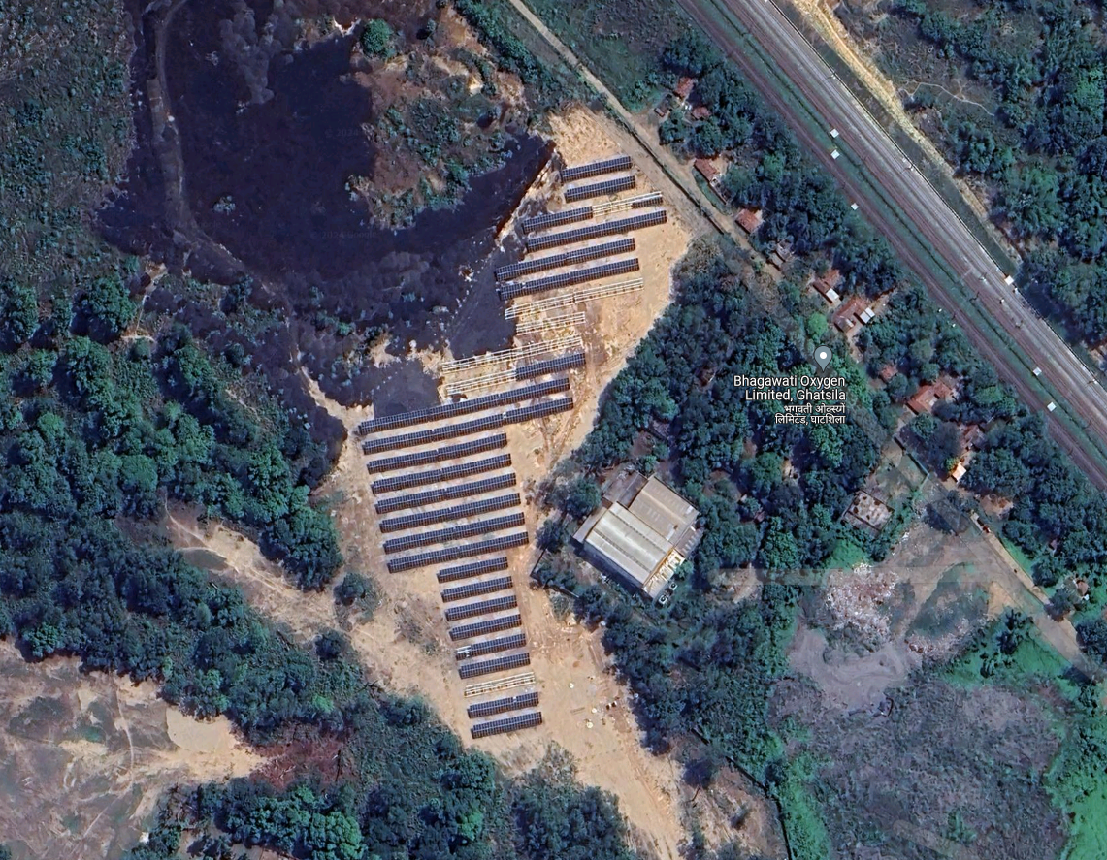

**Latitude and Longitude:- 22°36'16.9"N 86°27'08.1"E**

VCIPL’s Engineer has visited the project site on 03.07.2024 with a view to ascertain and certify the quantity and amount of work progressively undertaken/completed by EEGPL. Based on the Site Visit and documents provided by the Company, the installation of Solar Plant is completed and the COD was declared on 21.06.2024.

**OBSERVATION: -**

* 1 MW Grid Connected Ground Mounted Solar PV Power Plant mainly consist of 1,824 Nos. of 550 Wp PV Modules, 10 Nos. of 100 KWp Inventers,2 Nos. of Meters, 2 Nos. of ACDB Panels, Structure, etc.
* Installation of all Equipments are completed and the commercial production is going on.
* During the date and time of our visit on 03.07.2024, the Net meter is not installed. The Plant was in operation.
* After our Site Visit the Company Official has informed us that the Solar Plant was commissioned on 31.03.2021 and party has provided the Joint Inspection Report of Meda Official.

The Photographs of 1 MW Grid Connected Ground Mounted Solar PV Power Plant is as under:-

|  |  |
| --- | --- |
|  |  |
|  |  |
|  |  |
|  |  |

**Photographs: -**

|  |  |
| --- | --- |
|  |  |
|  |  |
|  |  |
|  |  |

**Photographs: -**

|  |  |
| --- | --- |
|  |  |
|  |  |
|  |  |
|  |  |

**Photographs: -**

|  |  |
| --- | --- |
|  |  |
|  |  |
|  |  |
|  |  |

**Photographs: -**

|  |  |
| --- | --- |
|  |  |
|  |  |
|  |  |
|  |  |

**Photographs: -**

|  |  |
| --- | --- |
|  |  |
|  |  |
|  |  |
|  |  |

**Photographs: -**

|  |  |
| --- | --- |
|  |  |
|  |  |
|  |  |
|  |  |

**Photographs: -**

|  |  |
| --- | --- |
|  |  |
|  |  |
|  |  |
|  |  |

**Photographs: -**

|  |  |
| --- | --- |
|  |  |
|  |  |
|  |  |
|  |  |

**Photographs: -**

|  |  |
| --- | --- |
|  |  |
|  |  |
|  |  |
|  |  |

#### 4.2) EXPENDITURE FOR THE PROJECT:-

Company has provided the CA Certificate, as er CA Certificate the cost incurred towards

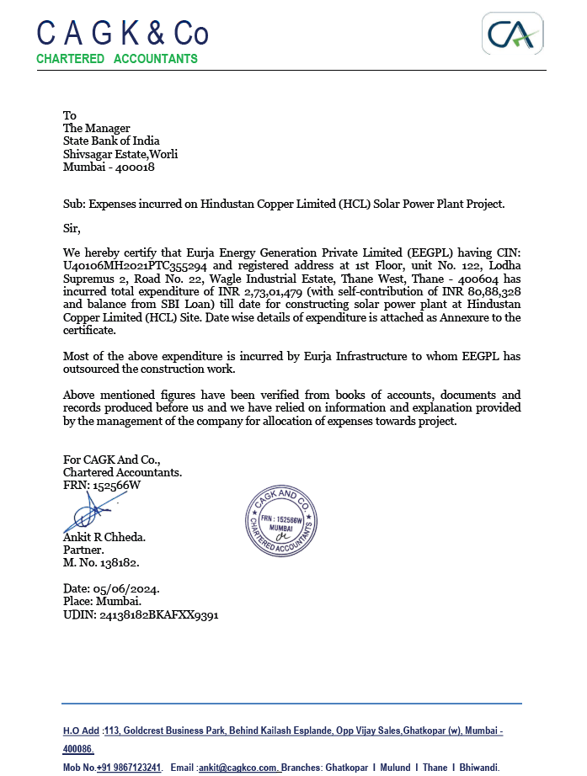

**………………..CA CERTIFICATE**

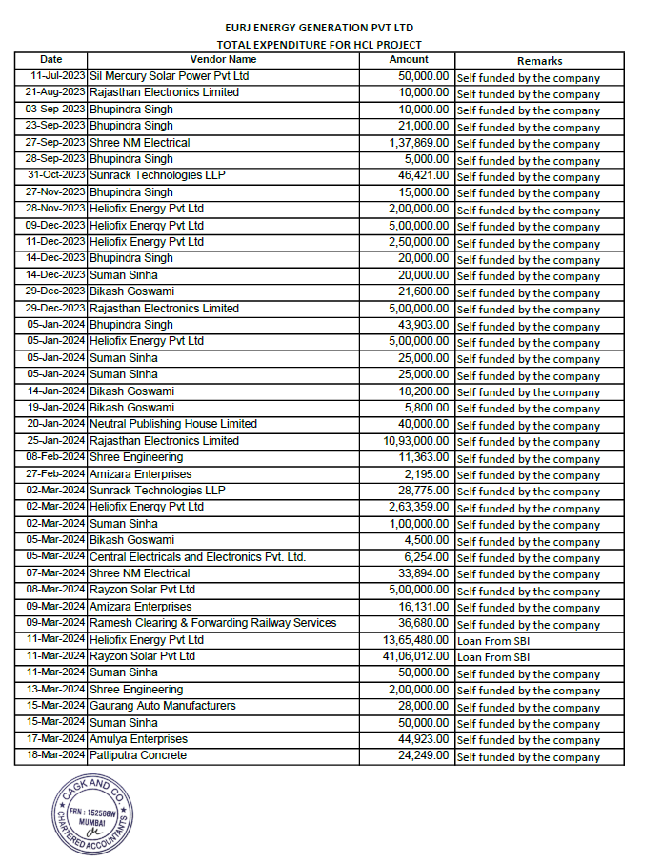

**………………..CA CERTIFICATE**

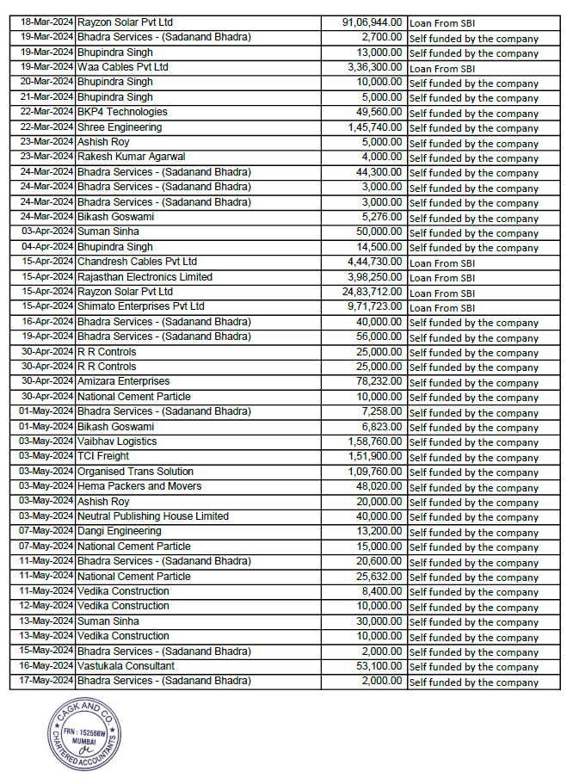

**………………..CA CERTIFICATE**

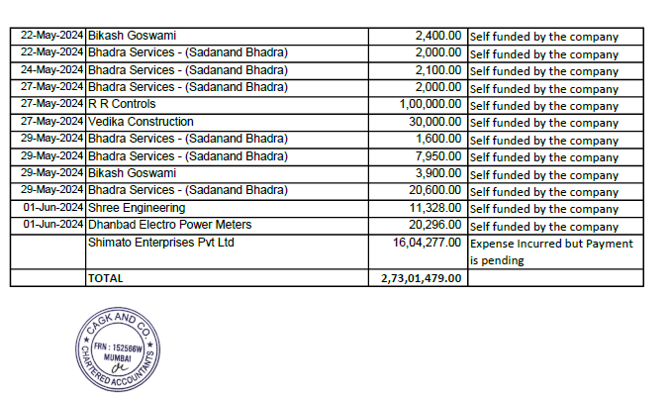

**Company has incurred additional cost after the issue of CA Certificate and the details for the same is as under:-**

| S. No. | Vendor Name | Amount (Rs.) |
| --- | --- | --- |
| 1 | Chandresh Cables Pvt Ltd | 18,79,361 |
| 2 | Hema Packers And Movers | 980 |
| 3 | Organised Trans Solution | 2,240 |
| 4 | R R Controls | 1,00,000 |
| 5 | Rayzon Solar Pvt Ltd | 25,74,428 |
| 6 | TCI Freight | 3,100 |
| 7 | Vaibhav Logistics | 3,240 |
| 8 | Vastukala Consultant | 5,900 |
| 9 | Vedika Construction | 1,600 |
| 10 | Ramesh Clearing | 1,600 |
| 11 | Pramod Kumar Baraik | 5,000 |
| 12 | Dangi Engineering | 5,000 |
| 13 | Rakesh Kumar Agarwal | 6,400 |
| 14 | Sanjay Pal | 5,000 |
| 15 | Krishna Kumar Dhibar | 4,000 |
| 16 | Krishna Kumar Dhibar | 5,000 |
| 17 | Rakesh Kadam | 6,000 |
| 18 | SBI Insurance | 31,483 |
| 19 | Employee Imprest | 1,20,040 |
| 20 | Eastern Trade | 5,664 |
| 21 | Raj Sales | 2,800 |
| 22 | Dulal Chandra | 2,000 |
| 23 | SK Ashraf | 5,000 |
| 24 | SK Ashraf | 5,000 |
| 25 | Amizara | 3,481 |
| 26 | TCI Freight | 1,53,000 |
| 27 | Gaurang Auto | 3,360 |
| 28 | Employee Imprest | 95,315 |
| 29 | Accelios Solar | 2,28,525 |
| 30 | Nespro | 5,457 |
| 31 | Bhadara Enclosure | 5,192 |
| 32 | Guarang Auto | 3,360 |
| 33 | Amizara | 18,412 |
| 34 | Amizara | 1,388 |
| 35 | Gandhi Electrical | 11,226 |
| 36 | Ravi Earthing | 13,128 |
| 37 | Ravi Earthing | 3,186 |
| 38 | Ashsish Roy | 18,850 |
| 39 | Ashsish Roy | 10,000 |
| 40 | Ashsish Roy | 11,500 |
| 41 | Sudipto Mukherjee | 23,600 |
| 42 | Ajay Kumar Employee Interest | 38,458 |
| 43 | Mahaveer Electrical | 1,687 |
| 44 | Rr Enterprises | 7,316 |
| 45 | Suraj Ispat | 5,830 |
| 46 | SK Steel | 4,150 |
| 47 | Ganesh Trading | 1,251 |
| 48 | Glotitans | 17,100 |
| 49 | Glotitans | 17,100 |
| 50 | Glotitans | 17,100 |
| 51 | Krishna Kumar Dhibar | 17,160 |
| 52 | Sanjay Pal | 15,000 |
| 53 | Moni Devi | 9,900 |
| 54 | Gupta Fabrication | 8,446 |
| 55 | Mahabeer Das | 13,000 |
| 56 | Shivshakti | 24,850 |
| 57 | Shyam Steel | 2,100 |
| 58 | Shayam Steel | 15,525 |
| 59 | Amizara | 1,758 |
| 60 | Shyam Steel | 21,320 |
| 61 | Amizara | 3,481 |
|  | **Total** | **56,32,348** |

**OBSERVATION:-**

1. As per invoice and CA Certificate provided by the company the total cost incurred for the of 1 MW Grid Connected Ground Mounted Solar PV Power Plant in RESCO Mode is Rs. 2.73 Crores.
2. After the issue of CA Certificate company has also incurred the cost of Rs. 0.56 Crores.
3. Therefore, the total cost incurred toward the project is Rs. 3.29 Crores.
4. Company has purchased addition 528 Nos. of PV Modules to increase the generation of plant on DC side and Company has provided the invoice of Rs. 43,42,391.00/- for the same out of which Company has only considered Rs. 25,74,428.00/- for the Project Cost and balance is borne by Party. During the date and time of our visit, the same was not arrived at HCL Site and the same is in transit.
5. **NOTES, LIMITATIONS, DISCLAIMERS & CAVEATS**

#### Notes, Limitations, Disclaimers & Caveats forms important part of the report.

* The Lender’s Independent Engineer report is made to review the progress of project of 1 MW Grid Connected Ground Mounted Solar PV Power Plant in RESCO Mode, outlining the activities completed along with the status.
* Our Engineer has visited the project site of 1 MW Grid Connected Ground Mounted Solar PV Power Plant in RESCO Mode on 03.07.2024 with a view to ascertain and certify the quantity and amount of work progressively undertaken by the borrower.
* LIE progress report is based on the physical verification of the site on 03.07.2024, invoices provided, discussions held with the Directors of the Company and information and explanation given & documents provided. Accordingly, the percentage of work of completion of project activities is worked out. The photographs are enclosed.
* The Company has provided the necessary documents. LIE has referred the same for preparation of report.
* Company has not executed the EPC Contract with Eurja Infrastructure.
* Installation of Net Metering is pending.
* Our report does not cover verification of ownership, title clearance, or legality and subject to adequacy of engineering / structural design. The report is delayed as compared with the visit date because of delay in receipt of documents.
* It should be noted that VCIPL’s project progress assessments are based upon the facts and evidence available at the time of assessment and the documents provided. The lenders should do the progress assessment from time to time.
* The legal documents pertaining to the ownership of the properties has been referred to on its face value and that is presumed that Bank /financer have got the same verified through its legal counsel. We do not certify the veracity of the documents. This report does not certify valid or legal or marketable title of any of the parties over the property. Our report does not cover verification of ownership, title clearance, or legality and subject to adequacy of engineering / structural design.
* Our report is only for the use of the party to whom it is addressed, and no responsibility is accepted to any third party for the whole or any part of its contents.
* It is presumed that the soft copies of documents are taken from the originals duly tested and verified at the party’s end.
* The progress report is made based on our visit, information furnished, discussions, documents made available at the time of visit. We presume optimistically that the project assessed by us will be a top success project. In case on a future date if the project does not come up to an expectation of the lenders and borrowers, due to various factors i.e., socio, economic and political factors in this region and country, any decrease in projections, profits, non-repayment of regular installments of loan and interest thereon, the VCIPL should not be held responsible on a future date. The market scenario in India at particular and the whole world at large is at volatile trend since last many months and future cannot be anticipated as of date.
* Our report should be read along with disclaimers. We have given our opinion as the percentage of work completion of the project as on date of visit to the project site.

1. **SUMMARY**

#### 6.1) WORK COMPLETION FOR THE PROJECT: -

Permission to energize the Solar Power Plant of Capacity 1000 KWp granted by Senior Electrical Inspector, Energy Department, Jharkhand Electrical Inspectorate, Ranchi vide Certificate No. INS2406058995 dated 04.06.2024. and as per Letter for Commercial Date of Operation submitted by EEGPL to Hindustan Copper Limited dated 21.06.2024, COD declared by EEGPL is 21.06.2024.

Company has purchased addition 528 Nos. of PV Modules to increase the generation of plant on DC side and Company has provided the invoice of Rs. 43,42,391.00/- for the same out of which Company has only considered Rs. 25,74,428.00/- for the Project Cost and balance is borne by Party. During the date and time of our visit, the same was not arrived at HCL Site and the same is in transit.

**OBSERVATION:-**

During the date and time of our visit, the Plant was in operation and Company has declared the COD on 21.06.2024. Company has also raised 1st Commercial invoice for the month of June-2024. Net meter is not installed. The installation of Net meter is in the scope of HCL. The 1st Commercial invoice is enclosed for reference: -

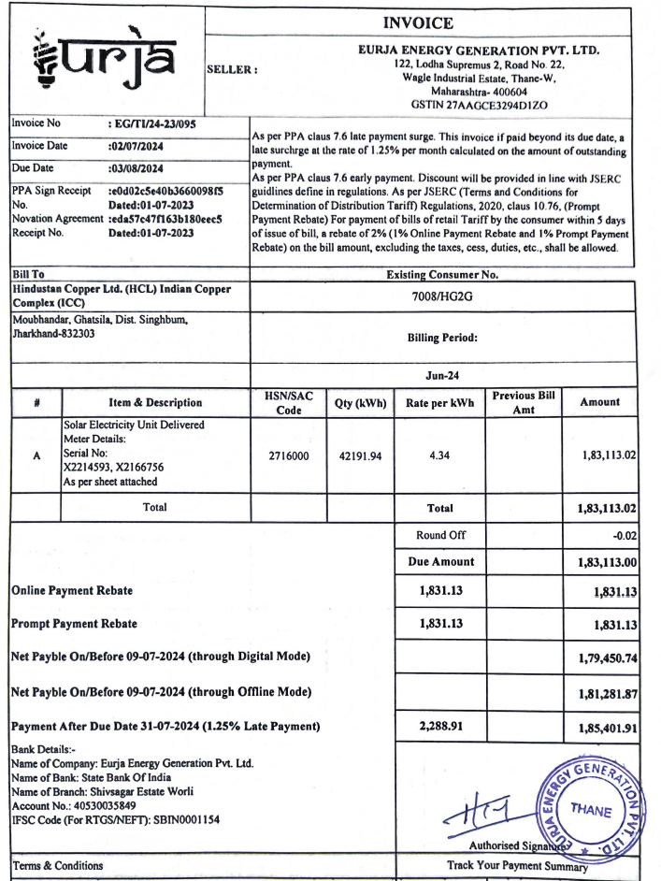

**OBSERVATION:-**

1. The Project is commissioned and COD for the Project is 21.06.2024.

#### 6.2) LIE SCOPE OF WORK: -

* **To provide independent recommendations/comments on the quality and performance of project.**

**LIE Comments:-** EEGPL has selected the best suitable technology for technology for the Project 1 MW Grid Connected Ground Mounted Solar PV Power Plant in RESCO Mode. The EPC Contractor for the project is having huge experience for the implementation and operation of such type of project. The major Cost for the Solar Power Plant will be Solar PV Module and Invertor. The Solar PV Module was manufactured & supplied by M/s. Rayzon Solar Pvt. Ltd. and Invertor was manufactured & supplied by Shimato Enterprises Pvt. Ltd. The supplier of major Equipments is reputed and well known in the industry.

Based on the technology and equipment procured by the EEGPL, we are on the opinion that the performance of the plant will be optimum subjected to proper operation and maintenance.

* **To monitor compliance of applicable Environmental, Health and Safety (EHS) norms post commissioning.**

**LIE Comments:-**

The generic environmental and safety concerns likely are given in Table as under:-

| Specific Requirements | Level of Concern | Mitigation Measures |
| --- | --- | --- |
| Lopping and Pruning of Trees for shadow free areas on roof | Moderate | None required, if there are no trees adjacent to building. In case of trees, which cast shadow on the roof, permissions from competent authorities are to be obtained for periodic lopping and/or pruning of trees through life cycle of facility. |
| Availability of Water | Moderate | None required, if assured dedicated extension from existing water supply system to the building. If not, services in terms of a new municipal water supply connection or commercial water tankers are to be availed. If commercial water tankers are not viable or not dependable then a new tube well has to be installed to serve the washing/cleaning needs of the panels. Required permissions for a new tube well from competent authorities and consents from building owner are to be obtained, as may be required. |
| Disposal of damaged and/or discarded panels | Moderate | None required, if there are take-back arrangements with manufacturer or supplier(s). If not, damaged/discarded panels can be disposed as per the local laws for disposal of hazardous wastes. |
| Safety of installers and  O&M Personnel | Moderate | Can be managed by taking care of basic safety measures e.g. providing safety gears like boots, hard hats, and safety belts while working at heights. |
| Safety and Fire Hazards | Moderate | Can be managed by taking care of basic safety measures like providing rubber mats, gloves, first-aid box, fire extinguishers to handle all type of fires and well-lit exit routes while installers and O&M personnel at work, in case of fire or any type of emergencies. |

OBSERVATION: -

1. EEGPL has made the necessary provisions for the EHS Cencerns.

* **To submit review of commissioned projects & give its final completion report including its recommendations and observations.**

**LIE Comments:-**

Ref:- Chapter:- 6.1

* **Projects Vetting. The vetting should cover**

| Scope of Work | LIE Comments |
| --- | --- |
| i. Project Viability | As per discussion with Bank Official and Company the Project viability is not in the Scope of LIE, therefore the same is not included in LIE Report. |
| ii. Suitability of technology proposed to be adopted | Ref:- Chapter-3.6 |
| iii. Credentials of technology/equipment supplier and EPC Contractor | Ref:- Chapter-3.7 & 3.8 |
| iv. Review of implementation philosophy/ schedule etc. | Ref:- Chapter-3.10 |

1. **OPINION**

Based on the physical inspection and verification of project site, information and explanation given to us and the documents referred by us; we are of the opinion that the installation and commissioning of 1 MW Grid Connected Ground Mounted Solar PV Power Plant in RESCO Mode for 25 Years for Government premises located at Hindustan Copper Ltd (HCL) Indian Copper Complex (ICC), Near Waste Slag Dumping Area, Moubhandar, Ghatsila, District-Singhbhum, PIN Code-832 303, State-Jharkhand, Country-India by M/s. Eurja Energy Generation Pvt. Ltd. is completed subject to observations made in the main report.

**Date:-16.07.2024**

**Place:- Mumbai**

**For Vastukala Consultants (I) Pvt. Ltd.**

|  |
| --- |
| **Umang A Patel** |
| **Registered Valuer**  **Chartered Engineer (India)**  **Reg. No. IBBI/RV/04/2019/10803** |