Vastu/Nashik/06/2024/009161/2306630
07/8-74-RYBS
Date: 18.06.2024

To,
The Branch Manager,
Bank of Baroda
Regional Office
BSNL Building, Datta Mandir Road, Nashik Road,
Nashik, PIN – 422 101, State - Maharashtra, Country - India.

Sub: Vetting of Extra Amenities

Sir,

With reference to above subject, we have evaluated the Extra Amenities for Residential Row House No.8, Ground Floor + First Floor ,“ Niddhi Row Houses ”,Survey No.3A1/B/4/1/3A1/1, Plot No.10/32/8, Jijamata Bhosale Udyan ,Dhara Society, Village - Dasak, Taluka & District - Nashik, PIN Code – 422 214, State – Maharashtra, Country – India belongs to Shri.Ashish Machindra Khandagale & Harshada Ashok Pawar (Before Marriage) Sau. Harshada Ashish Khandagale ( after Marriage ).

We have verified the rates quoted as per current market rates. Details of Extra Amenities considered as per copy of Extra Amenities Agreement between Shri.Ashish Machindra Khandagale & Harshada Ashok Pawar (Before Marriage) Sau. Harshada Ashish Khandagale ( after Marriage ). (First Party). Shri.Akshay Suresh Ahire (Second Party) received on dated.18.06.2024. The Extra Amenities amount is Rs. 5,00,000/- (Rupees Five Lakh Only)

The said Cost Vetting Certificate is valid upto next 6 months Only.

Thanking you

Sincerely yours

Manoj B. Chalikwar
Registered Valuer
Chartered Engineer (India)
Reg. No. CAT-I-F-1763
Reg. No. IBBI/RV/07/2018/10366
BOB Empanelment No.: ZO:MZ:ADV:46:941
Encl: Valuation report.

Agreement for Extra Amenities
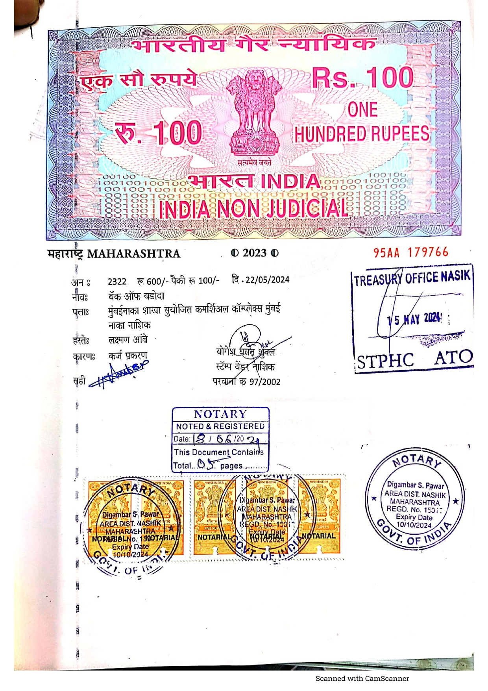
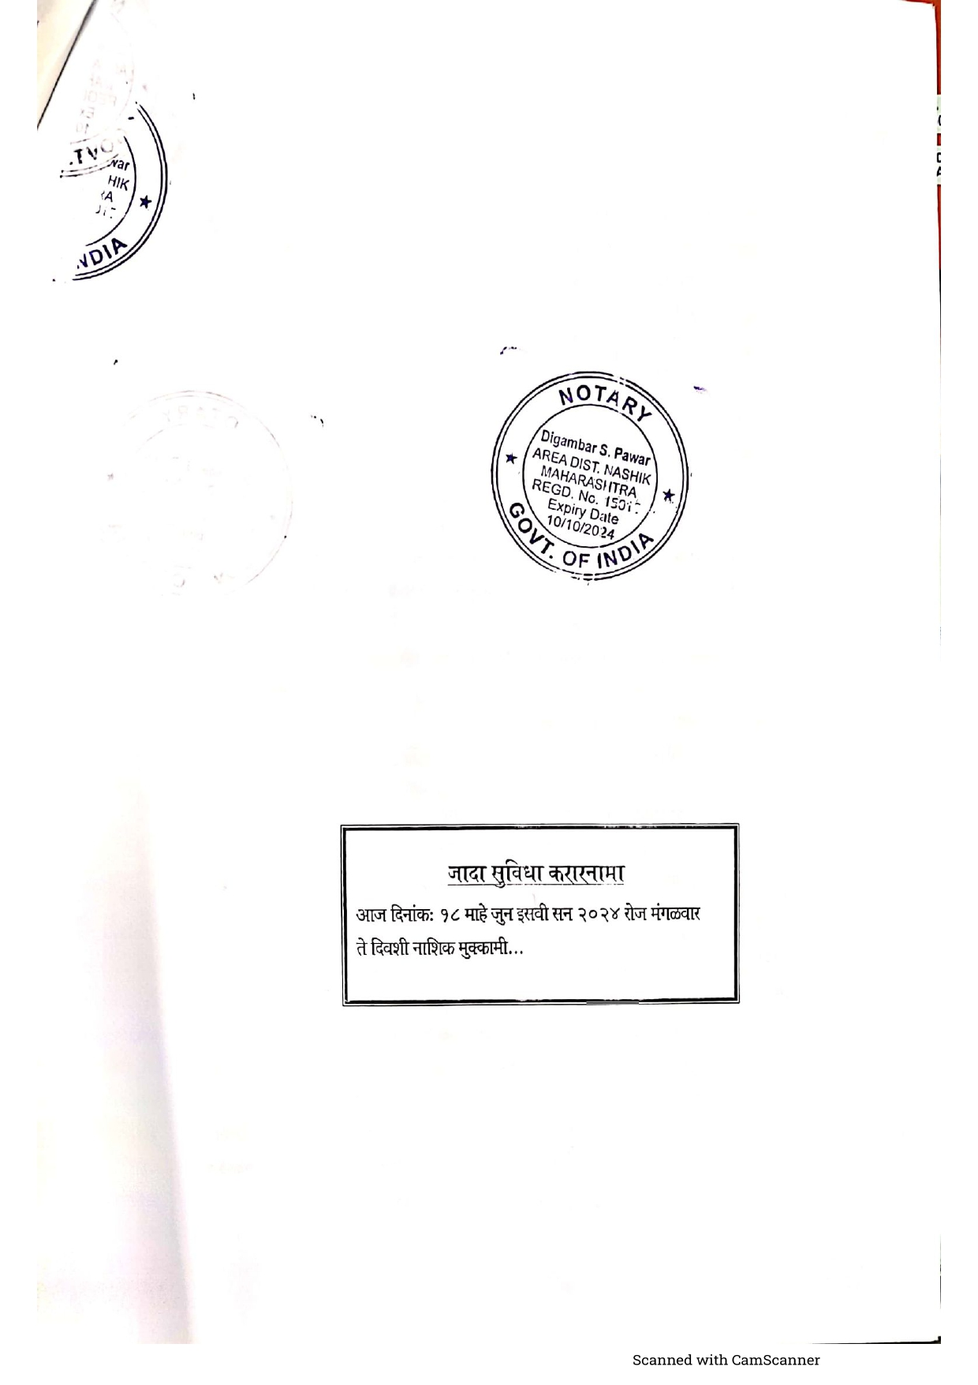

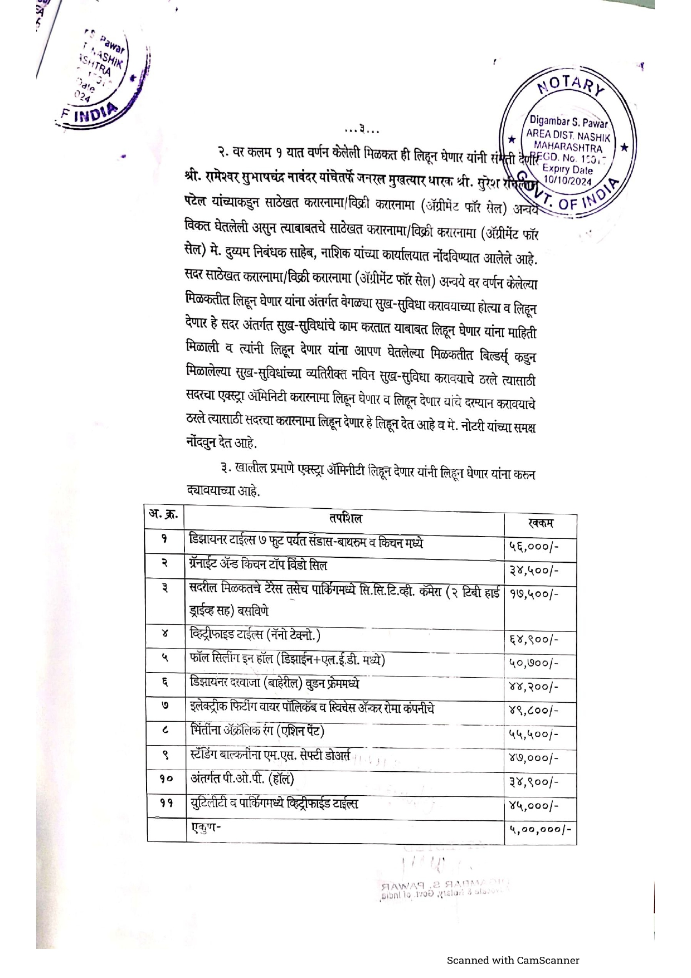
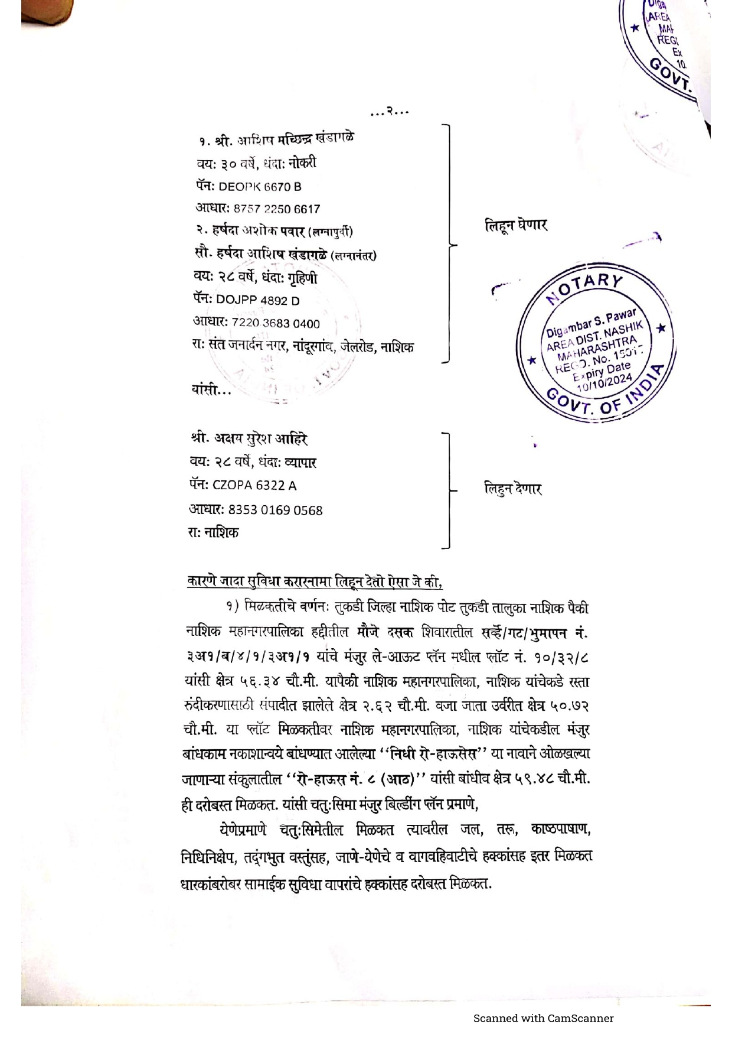

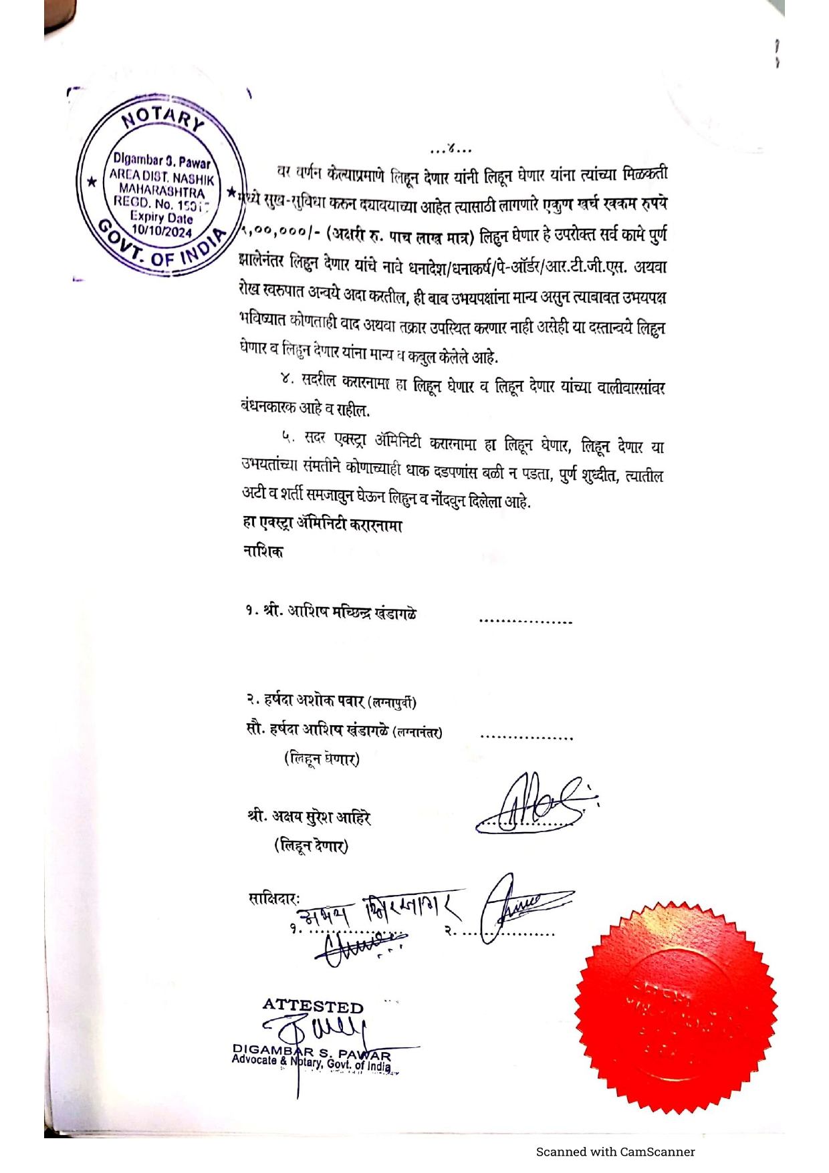

The Extra Amenities amount is Rs. 5,00,000/- (Rupees Five Lakh Only)

