Vastu/Nashik/06/2024/009161/2306630
07/8-74-RYBS
Date: 14.06.2024

To,
The Branch Manager,
Bank of Baroda
Regional Office
BSNL Building, Datta Mandir Road, Nashik Road,
Nashik, PIN – 422 101, State - Maharashtra, Country - India.

Sub: Vetting of Renovation Work

Sir,

With reference to above subject, we have evaluated the Renovation Work for Residential Flat No.1104, Eleventh Floor, Wing – F, Phase - II - A, "Parksyde Homes", Survey No. 256 Part & 257 Part, Opp. to Rasbihari International School, Hanuman Nagar, Mumbai - Agra National Highway, Village – Nashik, Taluka & District - Nashik, PIN Code – 422 003, State – Maharashtra, Country – India. belongs to Mr.Jitendra Omprakash Agrawal Name of Proposed Purchaser : Mr.Hitesh Ravindra Shettigar & Mr.Ravindra Keshav Shettigar.

We have verified the rates quoted as per current market rates. Details of Renovation Work considered as per copy of Renovation Work Estimate Provided by Shree Engineers received on dated.12.06.2024. The Renovation Work amount is Rs. 10,00,000/- (Rupees Ten Lakh Only)

The said Cost Vetting Certificate is valid upto next 6 months Only.

Thanking you

Sincerely yours

Manoj B. Chalikwar
Registered Valuer
Chartered Engineer (India)
Reg. No. CAT-I-F-1763
Reg. No. IBBI/RV/07/2018/10366
BOB Empanelment No.: ZO:MZ:ADV:46:941
Encl: Valuation report.

Estimate of Renovation Work
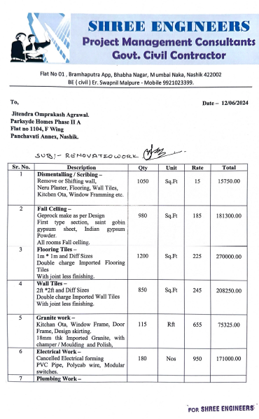
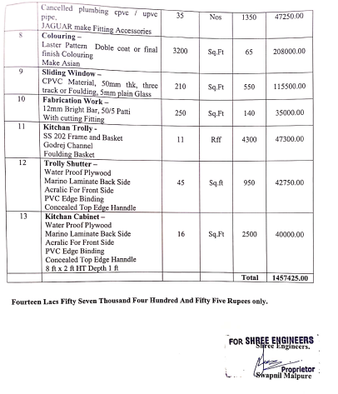

The Renovation Work amount is Rs.10,00,000/- (Rupees Ten Lakh Only)

