Valuation Report of the Immovable Property

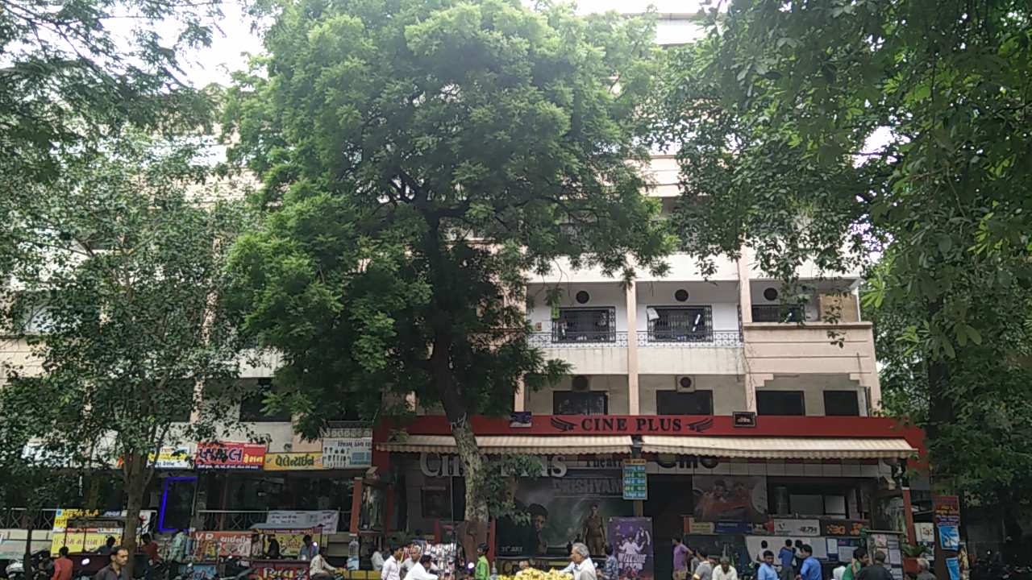

Details of the property under consideration:

(M/s. V.D. Global Pvt. Ltd.)

Name of Owner: M/s. Vallabhbhai Dhanjibhai & Co.

Office No. 105, 1st floor, “Kamla Estate”, Katargam R.S. No. 369 paiki, T.P.S No. 4, F. P. No. 52/B paiki, S.P. No. 52/B-1, City Survey No. 1623 to 1652 Paiki, Kohinoor Road, Mouje: Katargam – Surat, Taluka & District Surat, Gujarat

Latitude Longitude: 21°12'40.0"N 72°50'50.9"E

Valuation Done for:

State Bank of India
Bharat Diamond Branch
Tower D – 3, Ground Floor, Bharat Diamond Bourse,
‘G’ Block, Bandra Kurla Complex,
Mumbai – 400 051

Vastukala Consultants (I) Pvt. Ltd.
Mumbai • Nanded • Navi Mumbai • Aurangabad

Vastu/SBI/Mumbai/08/2015/0010627
20/07-229-AU
Date: 20.08.2015

CERTIFICATE

This is to certify that the property bearing Office No. 105, 1st floor, “Kamla Estate”, Katargam R.S. No. 369 paiki, T.P.S No. 4, F. P. No. 52/B paiki, S.P. No. 52/B-1, City Survey No. 1623 to 1652 Paiki, Kohinoor Road, Mouje: Katargam – Surat, Taluka & District Surat, Gujarat belongs to M/s. Vallabhbhai Dhanjibhai & Co.

Boundaries of the property.

North | : | Internal Road & Open Plot
South | : | Kohinoor Road & M.K. Chambers
East | : | V.D. Global Factory
West | : | Internal Road & Sarvani Apartment
Considering various parameters recorded, existing economic scenario, and the information that is available with reference to the development of neighborhood and method selected for valuation, we are of the opinion that, the property premises along with business premium can be assessed and valued for this particular purpose at ` 2,88,47,750/- (Rupees Two Crore Eighty Eight Lac Forty Seven Thousand Seven Hundred & Fifty Only).

The valuation of the property is based on the documents produced by the concern. Legal aspects have not been taken into considerations while preparing this valuation report.

Hence certified

Sharad B. Chalikwar
Govt. Reg. Valuer & Chartered Engineer (India)
Reg. No. (N) CCIT/1-14/52/2008-09
Encl: Valuation report.
Valuation Report of Immovable Property

1. Introduction
a) |  |  | Name of the Property Owner  (with address & phone nos.) |  |  | M/s. Vallabhbhai Dhanjibhai & Co.  Address – Office No. 105, 1st floor, “Kamla Estate”, Katargam R.S. No. 369 paiki, T.P.S No. 4, F. P. No. 52/B paiki, S.P. No. 52/B-1, City Survey No. 1623 to 1652 Paiki, Kohinoor Road, Mouje: Katargam – Surat, Taluka & District Surat, Gujarat.  Phone Nos. - 09825209531 (Mr. Bharat Kaswala, Staff)
b) |  |  | Purpose of Valuation |  |  | As per request from State Bank of India, Bharat Diamond Branch to assess fair market value of the property for bank loan purpose.
c) |  |  | Date of Inspection of Property |  |  | 04.08.2015
d) |  |  | Date of Valuation Report |  |  | 20.08.2015
e) |  |  | Name of the Developer of Property  (in case of developer built properties) |  |  | Information not available
2. Physical Characteristics of the Property
a) |  |  | Location of the Property |  |  | Office No. 105, 1st floor, “Kamla Estate”, Katargam R.S. No. 369 paiki, T.P.S No. 4, F. P. No. 52/B paiki, S.P. No. 52/B-1, City Survey No. 1623 to 1652 Paiki, Kohinoor Road, Mouje: Katargam – Surat, Taluka & District Surat, Gujarat
 |  |  | Brief description of the property
The property is located in a developed area having good infrastructure, well connected by road and train. The immovable property comprises of Commercial Offices located in the building known as Kamla Estate. The building is of Ground + 4 Upper floors. It is located at about 7 to 10 minutes travelling distance from Surat Railway Station. As per agreement, the built up area is 369.66 Sq. M. i.e. 3979 Sq. Ft.
Composition of Property – Manager Cabin + Working area + Toilet.
 |  |  | Nearby landmark |  |  | Above Cine Plus Cinema
 |  |  | Postal Address of the Property |  |  | Office No. 105, 1st floor, “Kamla Estate”, Katargam R.S. No. 369 paiki, T.P.S No. 4, F. P. No. 52/B paiki, S.P. No. 52/B-1, City Survey No. 1623 to 1652 Paiki, Kohinoor Road, Mouje: Katargam – Surat, Taluka & District Surat, Gujarat.
 |  |  | Area of the plot/land (supported by a plan) |  |  | N.A. as the property under consideration is commercial offices located on 1st floor.
 |  |  | Type of Land: Solid, Rocky, Marsh land, reclaimed land, Water-logged, Land locked. |  |  | Solid land
 |  |  | Independent access/approach to the property etc. |  |  | Yes
 |  |  | Google Map Location of the Property with a neighborhood layout map |  |  | Provided
 |  |  | Details of roads abutting the property |  |  | 12.19 M. wide B.T. Road
 |  |  | Description of adjoining property |  |  | Located in Higher middle class locality
 |  |  | Plot No. Survey No. |  |  | R.S. No. 369 paiki, T.P.S No. 4, F. P. No. 52/B paiki, S.P. No. 52/B-1, City Survey No. 1623 to 1652 Paiki,
 |  |  | Ward/Village/Taluka |  |  | Mouje: Ashwani Kumar - Navagam, Taluka Surat
 |  |  | Sub-Registry/Block |  |  | Katargam
 |  |  | District |  |  | Surat
 |  |  | Any other aspect |  |  | -
b) |  |  | Plinth Area, Built up Area, and Saleable are to be mentioned separately and clarified |  |  | Built up area = 3979.00 Sq. Ft. (369.66 Sq. M.)  (Area as per agreement)
c) |  |  | Boundaries of the Plot |  |  | As per Sale Deed/TIR |  |  | Actual
 |  |  | North |  |  | Kamala Estate Parking |  |  | Internal Road & Open Plot
 |  |  | South |  |  | Kohinoor Road |  |  | Kohinoor Road & M.K. Chambers
 |  |  | East |  |  | Kamala Estate’s Society Road |  |  | V.D. Global Factory
 |  |  | West |  |  | Society’s Road |  |  | Internal Road & Sarvani Apartment
3. Town Planning parameters
a) |  |  |  | Master Plan provisions related to property in terms of land use |  | Commercial building
a) |  |  |  | FAR- Floor Area Rise/FSI- Floor Space Index permitted & consumed |  | FSI permitted : Not provided  Consumed: Not provided
a) |  |  |  | Ground coverage |  | N.A.
a) |  |  |  | Comment on whether OC- Occupancy Certificate has been issued or not |  | Copy of Occupancy Certificate is not provided
a) |  |  |  | Comment on unauthorized constructions if any |  | No.
a) |  |  |  | Transferability of developmental rights if any, Building by-laws provision as applicable to the property viz. setbacks, height restriction etc. |  | No TDR Applicable
a) |  |  |  | Planning area/zone |  | Information not available
a) |  |  |  | Developmental controls |  | Surat Municipal Corporation
a) |  |  |  | Zoning regulations |  | Information not available
a) |  |  |  | Comment on the surrounding land uses and adjoining properties in terms of uses |  | Land used for Commercial use.
a) |  |  |  | Comment on demolition proceedings if any |  | No
a) |  |  |  | Comment on compounding / regularization proceedings |  | Information not available
a) |  |  |  | Any other Aspect |  | -
 | 4. Document Details and Legal Aspects of Property
a) |  |  |  | Ownership Documents
 |  |  |  | Sale Deed, Gift Deed, Lease Deed
 |  |  |  | - Copy of Agreement for sale dated 24.05.2002
 |  |  |  | - Copy of Previous valuation report dated 28.06.2014 issued by Dadbhawala Architects, Engineers & Valuers Pvt. Ltd.
 |  |  |  | - Copy of TIR Report dated 18.04.2015 issued by Sujit B. Ramoliya - Advocate
 |  |  |  | - Copy of Plot Layout Plan
 |  |  |  | - Copy of Insurance Policy
 |  |  |  | - Copy of 7/12 Extracts
 |  |  |  | TIR of the Property |  | Provided
b) |  |  |  | Name of the Owner/s |  | M/s. Vallabhbhai Dhanjibhai & Co.
c) |  |  |  | Ordinary status of freehold or leasehold including restrictions on transfer |  | Freehold
d) |  |  |  | Agreement of easement if any |  | Information not available
e) |  |  |  | Notification of acquisition if any |  | Information not available
f) |  |  |  | Notification of road widening if any |  | Information not available
g) |  |  |  | Heritage restriction, if any |  | No
h) |  |  |  | Comment on transferability of the property ownership |  | As per TIR
i) |  |  |  | Comment on existing mortgages/charges/encumbrances on the property, if any |  | Property is mortgaged to Bank of India, Mumbai Branch
j) |  |  |  | Comment on whether the owners of the property have issued any guarantee (personal or corporate) as the case may be |  | Information not available
k) |  |  |  | Building plan sanction: Authority approving the plan - Name of the office of the Authority - Any violation from the approved Building Plan |  | Copy of approved building plans were not provided and not verified.
l) |  |  |  | Whether Property is Agricultural Land if yes, any conversion is contemplated |  | N.A. as the property under consideration is commercial offices located on 1st floor.
m) |  |  |  | Whether the property is SARFAESI compliant |  | Yes
n) |  |  |  | a. All legal documents, receipts related to electricity, Water tax, Municipal tax and other building taxes to be verified and copies as applicable to be enclosed with the report. b. Observation on Dispute or Dues if any in payment of bills/taxes to be reported. |  | All the provided documents are enclosed with the valuation report.
o) |  |  |  | Whether entire piece of land on which the unit is set up / property is situated has been mortgaged or to be mortgaged. |  | Information not available
p) |  |  |  | Qualification in TIR/mitigation suggested if any. |  | As per TIR report
q) |  |  |  | Any other aspect |  | -
 | 5. Economic Aspects of the Property
a) |  |  |  | Reasonable letting value |  | Information not available
a) |  |  |  | If property is occupied by tenant |  | Owner Occupied
a) |  |  |  | Number of tenants |  | N.A.
a) |  |  |  | Since how long (tenant- wise) |  | N.A.
a) |  |  |  | Status of tenancy right |  | Information not available
a) |  |  |  | Rent received per month (tenant-wise) with a comparison of existing market rent |  | Information not available
a) |  |  |  | Taxes and other outings |  | Information not available
a) |  |  |  | Property Insurance |  | Yes, Policy No. 2303001114010001444, Insurance Company – The New India Assurance Co. Ltd. , Sum Assured - `1,15,00,000/- valid upto 21.07.2015
a) |  |  |  | Monthly maintenance charges |  | Information not available
a) |  |  |  | Security charges |  | Information not available
a) |  |  |  | Any other aspect |  | -
 | 6. Socio-cultural Aspects of the Property
a) |  |  |  | Descriptive account of the location of the property in terms of social structure of the area, population, social stratification, regional origin, economic level, location of slums, squatter settlements nearby, etc. |  | Developed Commercial Locality, Higher Middle class
b) |  |  |  | Whether property belongs to social infrastructure like hospital, school, old age homes etc. |  | No
 | 7. Functional and Utilitarian Aspects of the Property
a) |  |  |  | Description of the functionality and utility of the property in terms of:
 |  |  |  | Space allocation |  | Provided
 |  |  |  | Storage Spaces |  | Provided
 |  |  |  | Utility spaces provided within the building |  | Provided
 |  |  |  | Car Parking facility |  | Open Car parking provided
 |  |  |  | Balconies, etc. |  | Yes
b) |  |  |  | Any other aspect |  | -
 | 8. Infrastructure Availability
a) |  |  |  | Description of aqua infrastructure availability in terms of i.
a) |  |  |  | Water supply |  | Municipal Corporation
a) |  |  |  | Sewerage/sanitation System Underground or Open |  | Underground Sewerage connected to municipal Corporation
a) |  |  |  | Storm water drainage |  | Yes
b) |  |  |  | Description of other physical infrastructure facilities viz.
 |  |  |  | Solid waste management |  | yes
 |  |  |  | Electricity |  | Available
 |  |  |  | Road and public transport connectivity |  | All well connected with public transport like auto, taxi, bus, private vehicles etc.
 |  |  |  | Availability of other public utilities nearby |  | All available near by
c) |  |  |  | Social infrastructure in terms of  - School  - Medical facilities  - Recreational facility in terms of parks and open space |  | All available near by
 | 9. Marketability of the Property
a) |  |  |  | Marketability of the property in terms of |  | Location, development of surrounding area, type of construction, construction specifications, age of building, condition of the premises & building, facilities provided and its prevailing market rate.
 |  |  |  | Locational attributes |  | Developed Area
 |  |  |  | Scarcity |  | Normal
 |  |  |  | Demand and supply of the kind of subject property |  | Normal
 |  |  |  | Comparable sale prices in the locality |  | Price Indicators from online property portals attached.
b) |  |  |  | Any other aspect which has relevance on the value or marketability of the property |  | No
 | 10. Engineering and Technology Aspects of the Property
a) |  |  | Type of construction |  |  | R.C.C. framed structures
b) |  |  | Material & technology used |  |  | A Grade
c) |  |  | Specifications, |  |  | Standard
d) |  |  | Maintenance issues |  |  | Well Maintained
e) |  |  | Age of the building |  |  | 17 years (Approx.)
f) |  |  | Total life of the building |  |  | 50 years
g) |  |  | Extent of deterioration |  |  | 33 years Subject to proper, preventive periodic Maintenance & structural repairs.
h) |  |  | Structural safety |  |  | Normal
i) |  |  | Protection against natural disaster viz. earthquakes, |  |  | Normal
j) |  |  | Visible damage in the building |  |  | The quality of construction is Good. Well maintained
k) |  | System of air-conditioning |  |  |  | Provided
l) |  | Provision of firefighting |  |  |  | Provided
m) |  | Copies of the plan and elevation of the building to be included |  |  |  | Not provided
11. Environmental Factors
a) |  | Use of environment friendly building materials, Green Building techniques if any |  |  |  | No
b) |  | Provision of rain water harvesting |  |  |  | yes
c) |  | Use of solar heating and lightening systems, etc., |  |  |  | No
d) |  | Presence of environmental pollution in the vicinity of the property in terms of industry, heavy traffic etc. |  |  |  | No
12. Architectural and aesthetic quality of the Property
a) |  | Descriptive account on whether the building is modern, old fashioned, plain looking or decorative, heritage value, presence of landscape elements etc. |  |  |  | Modern Style
13. Valuation
a) |  | Methodology of valuation – Procedures adopted for arriving at the valuation. Valuers may consider various approaches and state explicitly the reason for adopting particular approach and assumptions made, basis adopted with supporting data, comparable sales, and reconciliation of various factors on which final value judgment is arrived at. |  |  |  | Composite Method is used for this valuation report.
b) |  | Prevailing Market Rate/Price trend of the Property in the locality/city from property search sites viz magickbricks.com, 99acres.com, makaan.com etc. if available |  |  |  | ` 7,000/- to ` 7,500/- per Sq. Ft. Considering the rate with attached report, current market conditions, demand and supply position, Commercial Building size, location, upswing in real estate prices, sustained demand for commercial building, all round development of commercial and residential application in the locality etc. We estimate ` 7,250.00 per Sq. Ft. of office area.
c) |  | Guideline Rate obtained from the Stamp Duty Ready Reckoner for above floor |  |  |  | ` 21,975.00 per Sq. M. i.e. ` 2041.53 per Sq. Ft.
d) |  | Summary of Valuation
 |  | - Guideline Value
 |  |  |  |  |  | Area in Sq. Ft. |  | Rate in ` |  |  | Value in `
 |  | Built up area |  |  |  | 3979.00 |  | 2041.53 |  |  | 81,23,248/-
 |  | - Fair Market Value
 |  | Unit No. |  |  | Built up area  (Sq. Ft.) |  | Rate in Sq. Ft. |  |  | Value in `
 |  | Office No. 105 |  |  | 3979.00 |  | 7,250.00 |  |  | 2,88,47,750/-
 |  |  |  |  |  |  | Total
 |  | Summary of Valuation
 |  | Total Value of the Property |  |  |  | ` 2,88,47,750/-
 |  | Realizable Value |  |  |  | ` 2,59,62,975/-
 |  | Forced/ Distress Sale value. |  |  |  | ` 2,30,78,200/-
 |  | Insurable value of the property |  |  |  | ` 79,58,000/-
e) |  | In case of variation of 20% or more in the valuation proposed by the valuer and the Guideline value provided in the State Govt. notification or Income Tax Gazette justification on variation has to be given. |  |  |  | Provided
 |  | Details of last two transactions in the locality/area to be provided, if available. |  |  |  | As per Attachment with Report
 |  | Remarks |  |  |  | As per site inspection, Office No. 105 is partly used for industrial purpose. For the purpose of valuation we have considered the area as per agreement.
14. Declaration
I hereby declare that:
- The information provided is true and correct to the best of my knowledge and belief.
- The analysis and conclusions are limited by the reported assumptions and conditions.
- I have read the Handbook on Policy, Standard and Procedures for Real Estate Valuation by Banks and HFIs in India, 2011, issued by IBA and NHB, fully understood the provisions of the same and followed the provisions of the same to the best of my ability and this report is in conformity to the Standards of Reporting enshrined in the above Handbook.
- I have no direct or indirect interest in the above property valued.
- I/ my authorized representative, has inspected the subject property on 04.08.2015
- I am a registered Valuer under Section 34AB of Wealth Tax Act, 1957, Category-I for valuing property up to no limit
- I am an approved Valuer under SARFAESI ACT-2002 and am approved by the Bank.
- I have not been depanelled or removed from any Bank/Financial Institution/Government Organization at any point of time in the past.
- I have submitted the Valuation Report (s) directly to the Bank.

S. B. Chalikwar
Govt. Reg. Valuer & Chartered Engineer (India)
Wealth Tax Reg. No.: (N) CCIT/1-14/52/2008-09

Address:
Vastukala Consultants (I) Pvt. Ltd.
Office No. 121, 1st Floor, Ackruti Star,
Central Road, MIDC, Andheri (East),
Mumbai - 400 093

Name of Valuer association of which I am a bonafide member in good standing: Institution of Valuers & Practicing Valuers Association of India.
Date 20.08.2015
Tel No. - +91 22 28371324 /25
Mobile No. - +91 98195 97579
Email Id – mumbai@vastukala.org

15. Enclosures
a) |  | Layout plan sketch of the area in which the property is located with latitude and longitude |  |  |  | Latitude and longitude provided along with satellite image of the building
b) |  | Building Plan |  |  |  | Not Provided
c) |  | Floor Plan |  |  |  | Not Provided
d) |  | Site Photograph of the property |  |  |  | Site photographs of the property is provided
e) |  | Certified copy of the approved / sanctioned plan wherever applicable from the concerned office |  |  |  | Not Provided
f) |  | Google Map location of the property |  |  |  | Provided
g) |  | Price trend of the Property in the locality/city from property search sites viz Magickbricks.com, 99Acres.com, Makan.com etc. |  |  |  | Provided
h) |  | Any other relevant documents/ extracts |  |  |  | No

Actual Site Photographs
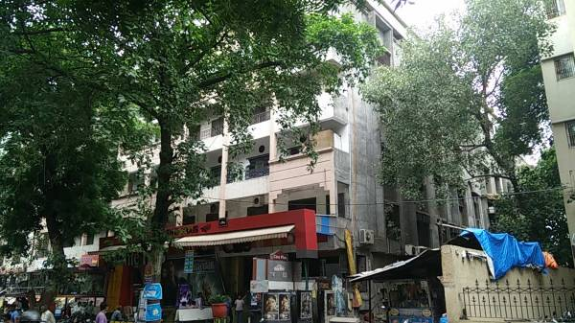
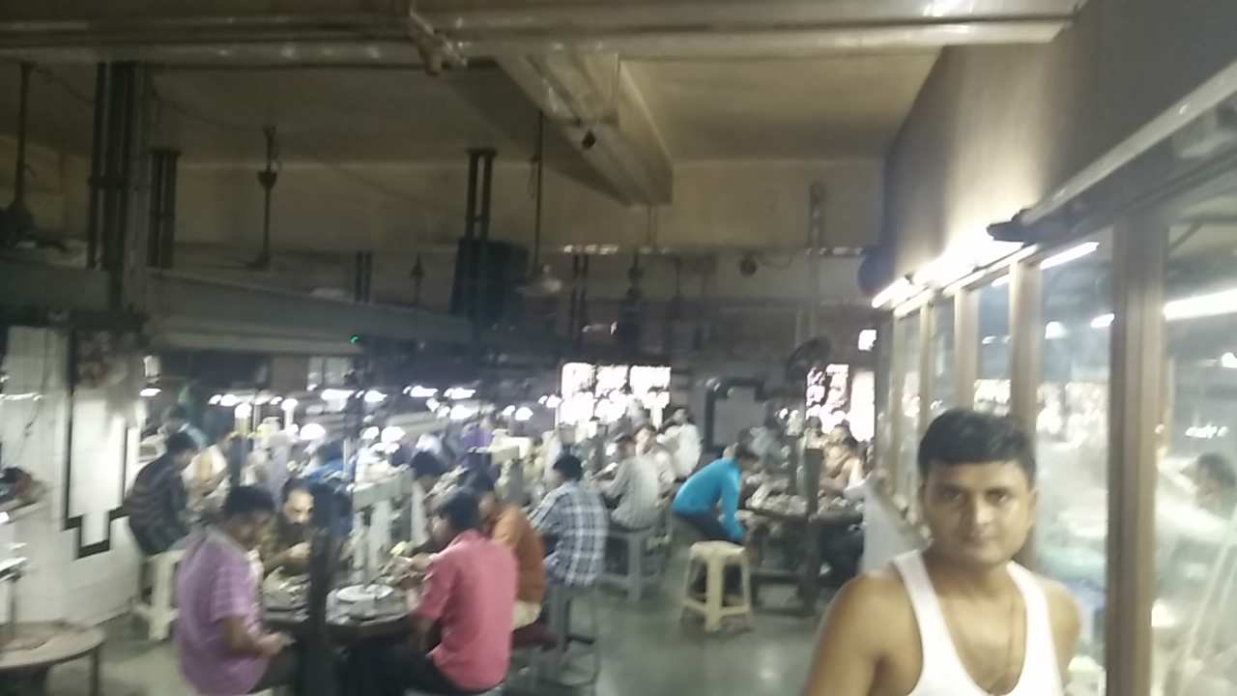
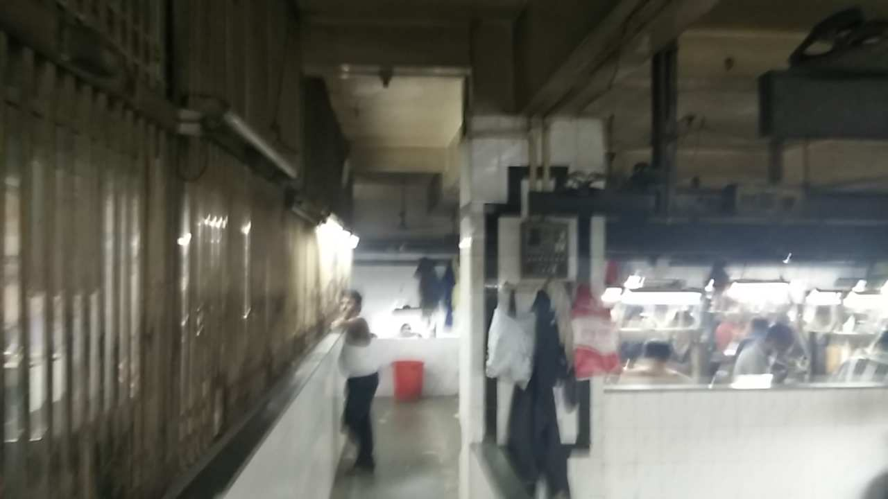
Route Map of the property
Site u/r
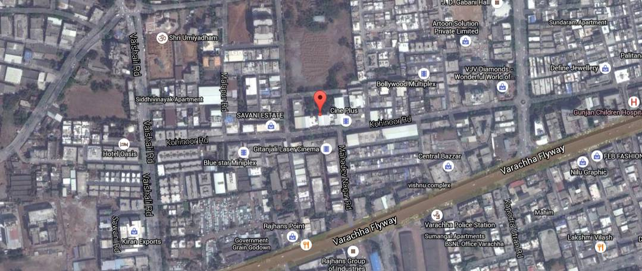

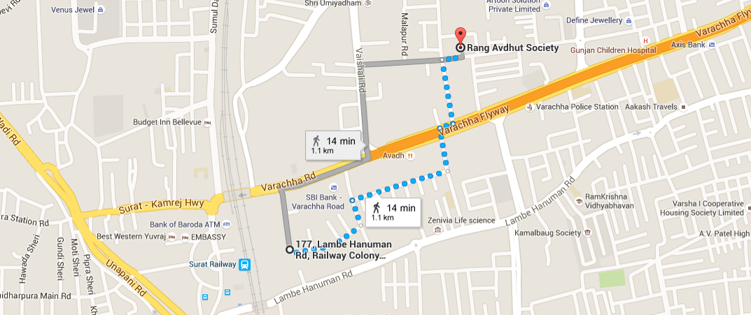

Latitude Longitude: 21°12'40.0"N 72°50'50.9"E

Note: The Blue line shows the route to site from nearest Railway station (Surat – 1.1 Km.)

Price Indicators (As per 99acres.com)
References found are for Shops on ground Floor

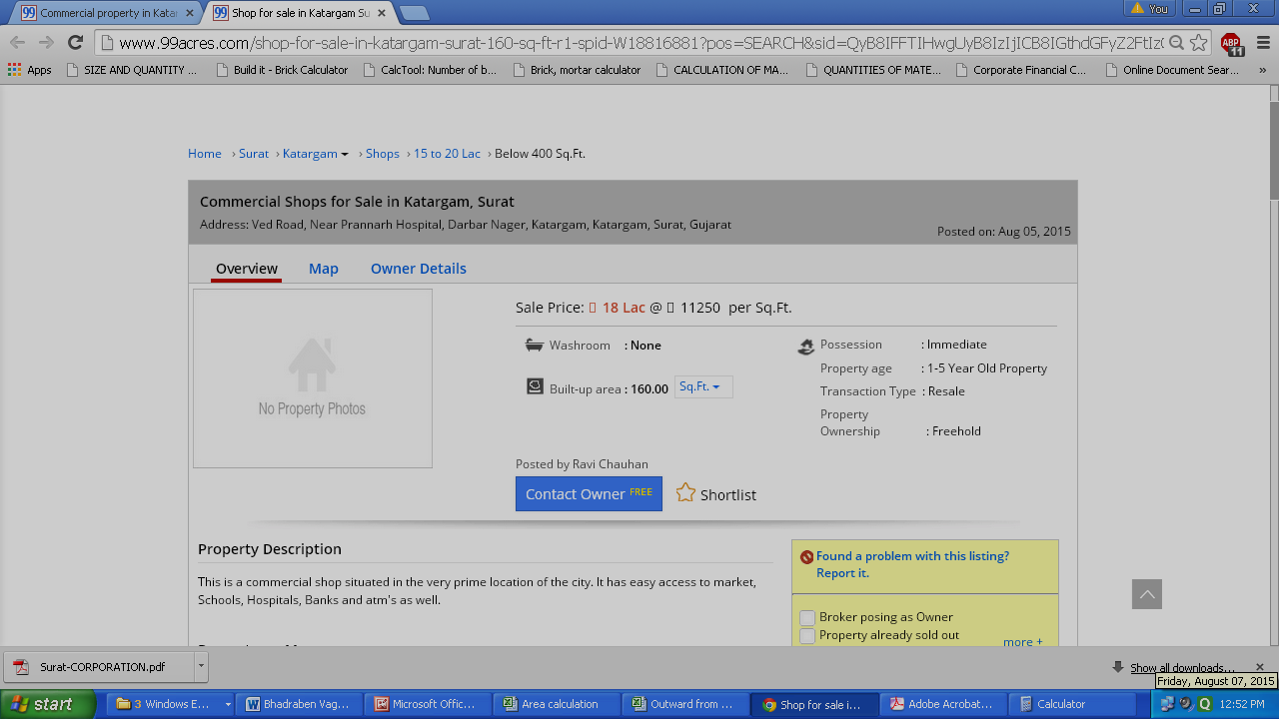

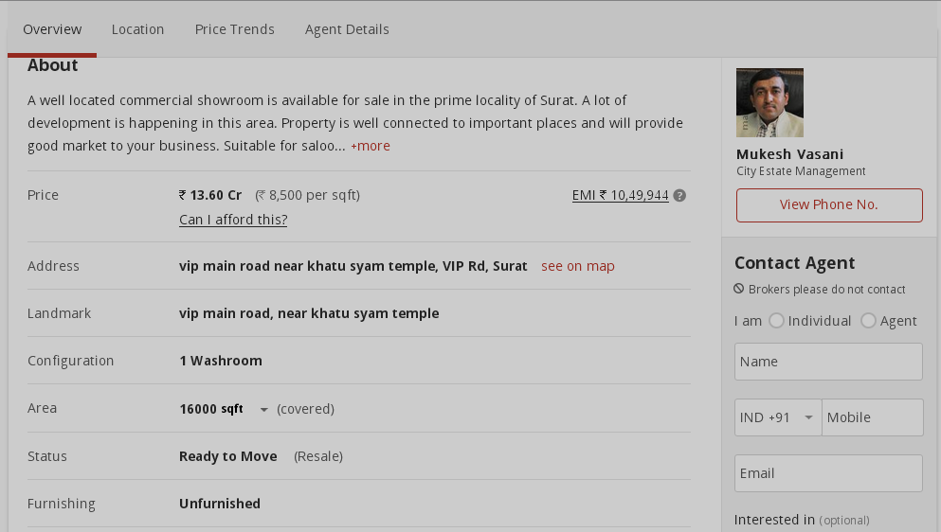

Price Trend (propertywala.com)

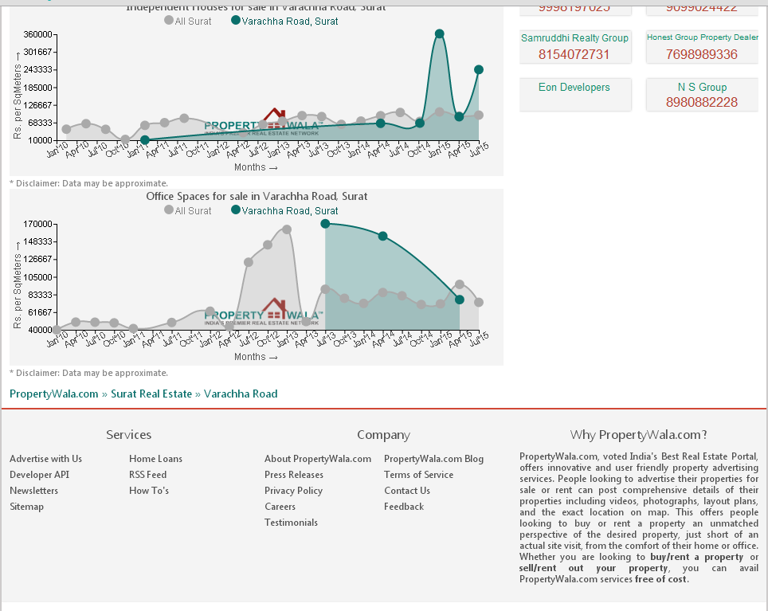
Jantri Rates (2011)
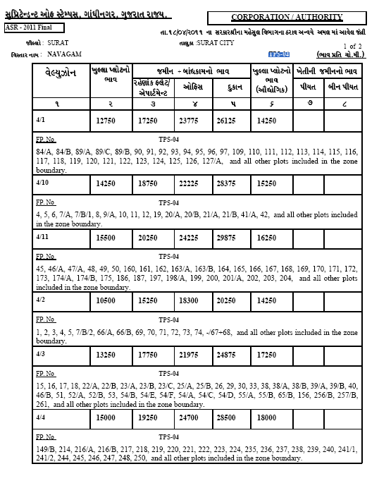
DEFINITION OF VALUE FOR THIS SPECIFIC PURPOSE

This exercise is to assess Fair Market Value of the property under reference as on 20th August 2015.

The term Fair Market Value is defined as

“The most probable price, as of a specified date, in cash, terms equivalent to cash, or in other precisely revealed terms for which the specified property rights would sell after reasonable exposure in a competitive market under all conditions requisite to a fair sale, with the buyer and seller each acting prudently knowledgeably and for self-interest assuming that neither is under undue duress”.

Fundamental assumptions and conditions presumed in this definition are:

1. Buyer and seller are motivated by self-interest.
2. Buyer and seller are well informed and are acting prudently.
3. The property is exposed for a reasonable time on the open market.
4. Payment is made in cash or equivalent or in specified financing terms.

UNDER LYING ASSUMPTIONS
1. We assume no responsibility for matters of legal nature affecting the property appraised or the title thereto, nor do we render our opinion as to the title, which is assumed to be good and marketable.
2. The property is valued as though under responsible ownership.
3. It is assumed that the property is free of liens and encumbrances.
4. It is assumed that there are no hidden or unapparent conditions of the subsoil or structure that would render it more or less valuable. No responsibility is assumed for such conditions or for engineering that might be required to discover such factors.

Sharad B. Chalikwar
Govt. Reg. Valuer & Chartered Engineer (India)
Reg. No. (N) CCIT/1-14/52/2008-09

DECLARATION OF PROFESSIONAL FEES CHARGED

We hereby declare that, our professional fees are not contingent upon the valuation findings. However, if the statute AND/OR clients demands that, the fees should be charged on the percentage of assessed value then, with the full knowledge of the AND/OR end user, it is being charged accordingly.

VALUATION OF THE PROPERTY PREMISES

Considering various parameters recorded herein above, existing economic scenario, and the information that is available with reference to the development of neighborhood and method selected for valuation, we are of the opinion that, the property premises along with business premium can be assessed and valued for this particular purpose at ` 2,88,47,750/- (Rupees Two Crore Eighty Eight Lac Forty Seven Thousand Seven Hundred & Fifty Only).

STATEMENT OF LIMITING CONDITIONS

1. Assumptions are made to the best of our knowledge and belief. Reliance is based on the information furnished to us by the identifier AND/OR client.
2. The valuer shall not be responsible for matters of legal nature that affects the value and opinion expressed by us.
3. If our appearance is required, we will be pleased to appear and give the necessary clarification, provided the fees for each appearance (excluding traveling, dearness allowance and out of pocket expenses) is pre-determined before the acceptance of the assignment under reference.
4. In no event shall the valuer be held responsible or liable for special, direct, indirect or consequential damages, as the assignment has been completed on best efforts, available knowledge and in good intentions of persons concerned and belief.
5. If it is proved that there is an apparent negligence on the part of a valuer, liability of this assignment (whether arising from this assignment, negligence or whatsoever) is limited in respect of anyone event or series of events to the actual loss or damage sustained subject to maximum of 80% of the professional fees for the services rendered and in any case not exceeding the amount of ` 1,000/- (Rupees one Thousand Only). All the claims against us shall expire after three month from the date of submission of the valuation report provided by us.
6. We hereby declare that, the information furnished above is true and correct to the best of our knowledge and belief. We have no direct or indirect interest in the assets valued. We have not been convicted of any offence and sentenced to a term of imprisonment. We have not been found guilty of misconduct in our professional capacity.

Sharad B. Chalikwar
Govt. Reg. Valuer & Chartered Engineer (India)
Reg. No. (N) CCIT/1-14/52/2008-09

