Vastu/Nashik/06/2024/009161/2306630
07/8-74-RYBS
Date: 07.06.2024

To,
The Branch Manager,
Bank of Baroda
Regional Office
BSNL Building, Datta Mandir Road, Nashik Road,
Nashik, PIN – 422 101, State - Maharashtra, Country - India.

Sub: Vetting of Extra Amenities

Sir,

With reference to above subject, we have evaluated the Extra Amenities for Residential Flat No. 505, Fifth Floor, " Madhav Pride ", Survey No. 304/ 2/ 1, Plot No. 01, Near St Peters English Medium School, Konark Nagar, Jatra Nandur Road, Village - Adgaon, Taluka & District - Nashik, PIN Code – 422003, State – Maharashtra, Country – India. belongs to Name of Proposed Purchaser: Mr. Sandip Laxman Darade & Mrs. Puman Sandip Darade. Name of Owner: Mr. Satish Ramnath Pekhale & Mrs. Anant Madhav Jagtap.

We have verified the rates quoted as per current market rates. Details of Extra Amenities considered as per copy of Extra Amenities Agreement between Shri. Sandip Laxman Darade & Sau. Puman Sandip Darade (First Party). Sau. Sonali Yogesh Burkul (Second Party) received on dated.04.03.2024. The Extra Amenities amount is Rs. 7,00,000/- (Rupees Seven Lakh Only)

The said Cost Vetting Certificate is valid upto next 6 months Only.

Thanking you

Sincerely yours

Manoj B. Chalikwar
Registered Valuer
Chartered Engineer (India)
Reg. No. CAT-I-F-1763
Reg. No. IBBI/RV/07/2018/10366
BOB Empanelment No.: ZO:MZ:ADV:46:941
Encl: Valuation report.

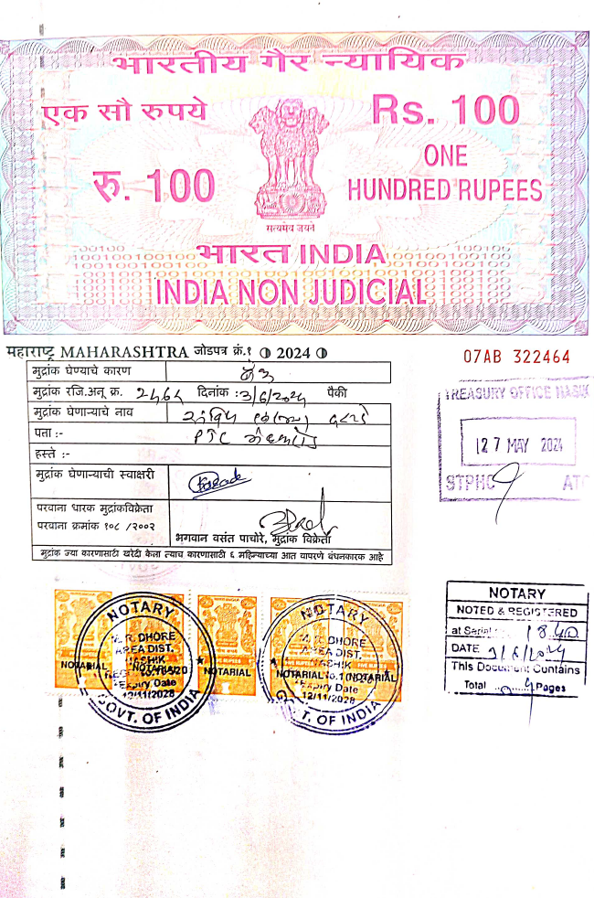
Agreement for Extra Amenities
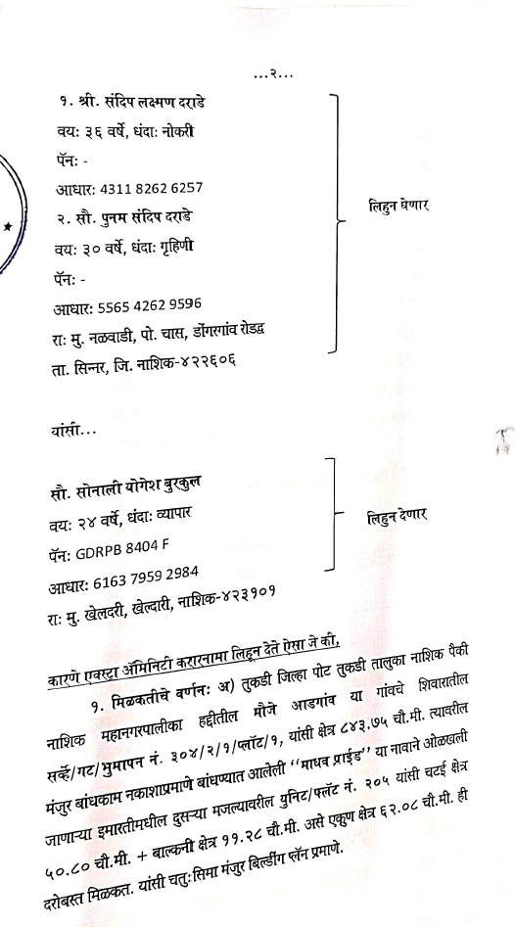

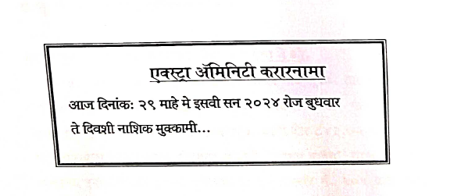

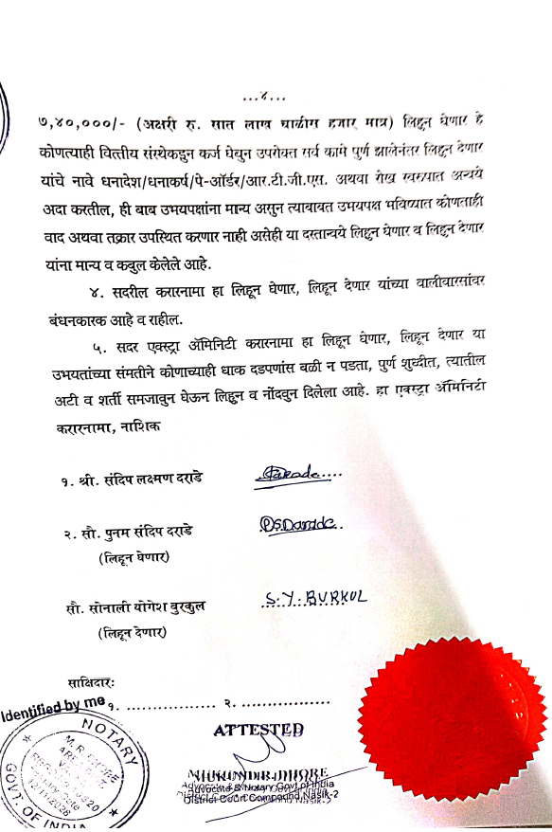
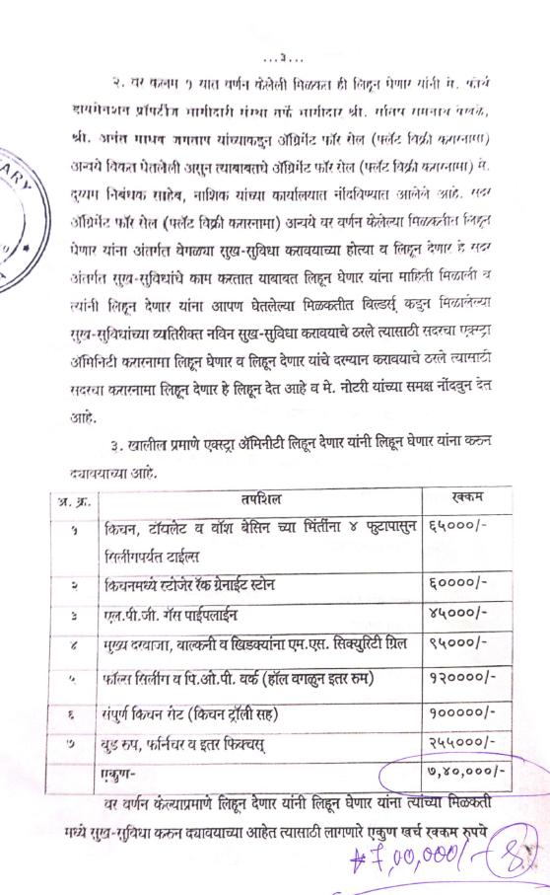

The Extra Amenities amount is Rs. 7,00,000/- (Rupees Seven Lakh Only)

