# Valuation Report of the Immovable Property

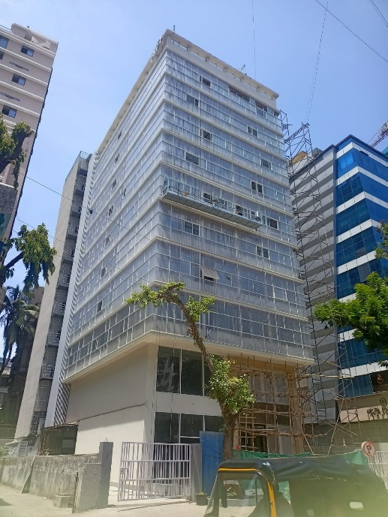

**Details of the property under consideration:**

Name of Owner: **M/s. Giristyle**

Commercial Shop No. 1, Ground Floor, **"Kalpak Optimus"**, Turner Road, Village – Bandra,

Bandra (West), Mumbai – 400 050, State – Maharashtra, Country – India.

# Latitude Longitude - 19°03'33.4"N 72°50'00.7"E

**Valuation Done for:**

**The Zoroastrian Co-operative Bank Ltd.**

**Fort Branch**

Yusuf Building, Veer Nariman Road, Mumbai – 400 001,

State – Maharashtra, Country – India.

Vastu/Mumbai/11/2023/005121/ 2303569

21/12-265-BH

Date: 05.06.2024

**VALUATION OPINION REPORT**

This is to certify that the property bearing Commercial Shop No. 1, Ground Floor, **"Kalpak Optimus"**, Turner Road, Village – Bandra, Bandra (West), Mumbai – 400 050, State – Maharashtra, Country – India belongs to **M/s. Giristyle.**

|  |  |
| --- | --- |
| Boundaries of the property. | |
| North | Turner Road |
| South | Shiv Krupa CHSL |
| East | Pearl Croft Building |
| West | Mehta Jewellers |

Considering various parameters recorded, existing economic scenario, and the information that is available with reference to the development of neighbourhood and method selected for valuation, we are of the opinion that, the property premises can be assessed and **Fair Market Value** for this particular purpose at **` 6,35,76,000.00 (Rupees Six Crore Thirty Five Lakh Seventy Six Thousand Only).**

The valuation of the property is based on the documents produced by the concern. Legal aspects have not been taken into considerations while preparing this report.

Hence certified

**Manoj B. Chalikwar**

Registered Valuer

Chartered Engineer (India)

Reg. No. CAT-I-F-1763

TZCBL Emp. No. Ref: ZCBL/CO/AUD/19-20/100

Encl.: Valuation report

**VALUATION REPORT IN RESPECT OF IMMOVABLE PROPERTY**

|  |  |  |  |  |  |  |  |  |  |
| --- | --- | --- | --- | --- | --- | --- | --- | --- | --- |
| 1 | Date of Inspection | : | 04.06.2024 | | | | | | |
| 2 | Purpose of valuation | : | As per request from The Zoroastrian Co-operative Bank Ltd, Fort Branch, Fair Market Value of the property under reference for Bank Loan Purpose | | | | | | |
| 3 | Name and address of the Valuer | : | **Manoj B. Chalikwar**  **Vastukala Consultants (I) Pvt. Ltd.**  B1-001, U/B Floor, Boomerang, Chandivali Farm Road, Powai, Andheri (East), Mumbai – 400 072. | | | | | | |
| 4 | **List of Documents Handed Over to The Valuer by The Bank**   1. Copy of Agreement for Sale dated 10.03.2022 Between Messrs. A.P. Properties (the Promoter) and M/s. Giristyle. (the Purchaser). 2. Copy of Part Occupancy Certificate No. CE / 1225 / WS / AH / OCC / 1 / New dated 03.05.2024 issued by Municipal Corporation of Greater Mumbai. | | | | | | | | |
| 5 | Details of enquiries made/ visited to government Office for arriving fair market value. | : | Market analysis and as per sub-registrar value. | | | | | | |
| 6 | Factors for determining its market value. | : | Location, development of surrounding area, type of construction, construction specifications, age of building, condition of the premises & building, facilities provided and its prevailing market rate. | | | | | | |
| 7 | ANY CRITICAL ASPECTS ASSOCIATED WITH PROPERTY | : | No | | | | | | |
| 8 | Present/Expected Income from the property | : | ` 1,60,000.00 Expected rental income per month | | | | | | |
|  | **Property Details** | : |  | | | | | | |
| 9 | Name(s) of the Owner and Postal address of the property under consideration. | : | **M/s. Giristyle.** | | | | | | |
|  |  | : | **Address:** Commercial Shop No. 1, Ground Floor, **"Kalpak Optimus"**, Turner Road, Village – Bandra, Bandra (West), Mumbai – 400 050, State – Maharashtra, Country – India  **Contact Person:**  Mr. Mohot Jain (Owner)  9820064606 | | | | | | |
| 10 | If the property is under joint ownership/ co-ownership share of each such owner/ are the share is undivided. | : | Company Ownership  Details of ownership share is not available | | | | | | |
| 11 | Brief description of the property. | : | The property is a Commercial Shop No. 1 located on Ground Floor. The composition of shop is single unit. The property is at 1.1 Km. Travelling distance from nearest railway station Bandra | | | | | | |
| 12 | Location of the property (C.T.S. No., Survey No., Hissa No., Plot No., etc.). | : | C.T.S No. F/ 907 of Village – Bandra | | | | | | |
| 13 | **Boundaries** | : | **As per Site** | | | | **As per Documents** | | |
|  | North | : | Turner Road | | | | Details not available | | |
|  | South | : | Shiv Krupa CHSL | | | | Details not available | | |
|  | East | : | Pearl Croft Building | | | | Details not available | | |
|  | West | : | Mehta Jewellers | | | | Details not available | | |
| 14 | Matching of Boundaries | : | N.A. | | | | | | |
| 15 | Route map | : | Enclosed | | | | | | |
| 16 | Any specific identification marks | : | Turner Road, Nera Mehta Brothers | | | | | | |
| 17 | Whether covered under Corporation/ Panchayat/ Municipality. | : | Municipal Corporation of Greater Mumbai | | | | | | |
| 18 | Whether covered under any land ceiling of State/ Central Government. | : | No | | | | | | |
| 19 | Is the land freehold/ leasehold? | : | Freehold | | | | | | |
| 20 | Are there any restrictive covenants in regard to use of Land? If so, attach a copy of the covenant. | : | As per Agreement | | | | | | |
| 21 | Type of the property | : | Commercial | | | | | | |
| 22 | Year of acquisition/ purchase. | : | 10.03.2022 | | | | | | |
| 23 | Purchase value as per document | : | ` 5,80,00,000.00 | | | | | | |
| 24 | Whether the property is occupied by owner or tenant. If occupied by tenant since how long he is staying and the amount of rent being paid. | : | Vacant | | | | | | |
| 25 | Classification of the site | : |  | | | | | | |
|  | 1. Population group | : | Urban | | | | | | |
|  | 1. High/ Middle/ Poor class | : | Middle Class | | | | | | |
|  | 1. Residential/ Non-Residential | : | Commercial | | | | | | |
|  | 1. Development of surrounding area | : | Developed Area | | | | | | |
|  | 1. Possibility of any threat to the property (Floods, calamities etc.). | : | No | | | | | | |
| 26 | Proximity of civic amenities (like school, hospital, bus stop, market etc.). | : | All Available near by | | | | | | |
| 27 | Level of the land (Plain, rock etc.) | : | Plain | | | | | | |
| 28 | Terrain of the Land. | : | Levelled | | | | | | |
| 29 | Shape of the land (Square/ rectangle etc.). | : | Irregular | | | | | | |
| 30 | Type of use to which it can be put (for construction of house, factory etc.). | : | Commercial purpose | | | | | | |
| 31 | Whether the plot is under town planning approved layout? | : | Information not Available | | | | | | |
| 32 | Whether the building is intermittent or corner? | : | Intermittent | | | | | | |
| 33 | Whether any road facility is available? | : | Yes | | | | | | |
| 34 | Type of road available (B.T/Cement Road etc.). | : | B.T. Road | | | | | | |
| 35 | Front Width of the Road? | : | 12.00 M. Wide Road | | | | | | |
| 36 | Source of water & water potentiality. | : | Municipal Water supply | | | | | | |
| 37 | Type of Sewerage System. | : | Connected to Municipal Sewerage System | | | | | | |
| 38 | Availability of power supply. | : | Yes | | | | | | |
| 39 | Advantages of the site. | : | Located in developed area | | | | | | |
| 40 | Disadvantages of the site. | : | No | | | | | | |
| 41 | Give instances of sales of immovable property in the locality on a separate sheet, indicating the name & address of the property, registration No. sale price and area of land sold. | : | As per Sub-Registrar of Assurance records | | | | | | |
|  | **Valuation of the property:** | | | | | | | | |
| 42 | Total area of the Commercial Shop | : | Carpet Area in Sq. Ft. = 760.00  (Area as per actual site measurement)  **Carpet Area in Sq. Ft. = 739.00**  **(Area as per Agreement for sale)**  Built Up Area in Sq. Ft. = 813.00  (Area as per Index II) | | | | | | |
| 43 | Prevailing market rate. | : | ` 84,000.00 per Sq. Ft. Rate on Carpet Area | | | | | | |
| 44 | Floor Rise Rate per Sq. Ft. | : | ` 0.00 | | | | | | |
| 45 | PLC Rate per Sq. Ft. | : | ` 0.00 | | | | | | |
| 46 | Total Rate per Sq. Ft. | : | ` 84,000.00 per Sq. Ft. Rate on Carpet Area | | | | | | |
| 47 | Guideline rate obtained from the Stamp Duty Ready Reckoner. | : | ` 4,46,700 per Sq. M. i.e.  ` 41,500.00 per Sq. Ft. | | | | | | |
| 48 | Government Value | : | **` 3,06,68,500.00** | | | | | | |
|  |  |  | **Area in**  **Sq. Ft.** | | | **Rate** | | **Value** | |
|  | Carpet area | : | 739.00 | | | ` 41,500.00 | | ` 3,06,68,500.00 | |
| 49 | Value of the property |  |  | | | | | | |
|  |  |  | **Area in Sq. Ft.** | | **Rate** | | | | **Value** |
|  | Carpet area | : | 739.00 | | ` 84,000.00 | | | | **` 6,20,76,000.00** |
|  | Car Parking |  | 1 Nos | | ` 15,00,000.00 | | | | **` 15,00,000.00** |
|  | Total Value of the Property |  |  | | | | | | **` 6,35,76,000.00** |
| 50 | The realizable value of the property | : | **` 5,72,18,400.00** | | | | | | |
| 51 | Distress value of the property | : | **` 5,08,60,800.00** | | | | | | |
| 52 | Insurable value of the property | : | **` 22,17,000.00** | | | | | | |
|  | **Technical details of the building:** | | | | | | | | |
| 53 | Type of building (Residential / Commercial / Industrial). | : | | Commercial | | | | | |
| 54 | Year of construction. | : | | 2024 (As per Occupancy Certificate) | | | | | |
| 55 | Future life of the property. | : | | 60 years Subject to proper, preventive periodic maintenance & structural repairs. | | | | | |
| 56 | No. of floors and height of each floor including basement. | : | | Basement + Ground + 1st + 9th Upper Floors  Ground Floor is having 2 Shops. | | | | | |
|  | **Type of construction** | | | | | | | | |
| 57 | (Load bearing/ R.C.C./ Steel framed) | : | | R.C.C. Framed Structure | | | | | |
|  | **Condition of the building.** | | | | | | | | |
| 58 | External (excellent/ good/ normal/ poor) | : | | Good | | | | | |
| 59 | Internal (excellent/ good/ normal/ poor). | : | | Good | | | | | |
| 60 | Whether the Commercial Shop is constructed strictly according to the sanctioned plan, details of variations noticed if any and effect of the same on the valuation | : | | As Occupancy Certificate is received may be assumed that the construction is as per sanctioned plan | | | | | |
|  | **Remarks:** | | | | | | | | |
| 61 | **Specifications of Construction:** | | | | | | | | |
| **sr.** | **Description** | : | | **Ground Floor** | | | | | |
| a | Foundation | : | | R.C.C. Foundation | | | | | |
| b | Basement | : | | Yes | | | | | |
| c | Superstructure | : | | R.C.C. frame work with 9-inch-thick B. B. Masonry for external walls 6-inch thick B.B. Masonry for internal walls | | | | | |
| d | Joinery/Doors/Windows | : | | Glass Door & Glass Window | | | | | |
| e | RCC Work | : | | R.C.C. Framed Structure | | | | | |
| f | Plastering | : | | Cement Plastering | | | | | |
| g | Flooring, Skirting | : | | Marble flooring | | | | | |
| h | Pantry Platform | : | | Yes | | | | | |
| i | Whether any proof course is provided? | : | | Yes | | | | | |
| j | Drainage | : | | Connected to Municipal Sewerage System | | | | | |
| k | Compound Wall (Height, length and type of construction) | : | | 5'6" High, R.C.C. columns with B. B. Masonry wall | | | | | |
| l | Electric Installation (Type of wire, Class of construction) | : | | Concealed Electrification | | | | | |
| m | Plumbing Installation (No. of closets and wash basins etc.) | : | | - | | | | | |
| n | Bore Well | : | | Not found | | | | | |
| o | Wardrobes, if any | : | | No | | | | | |
| p | Development of open area | : | | Cemented road in open spaces, etc. | | | | | |
|  | **Valuation of proposed construction/ additions/ renovation if any: Interior Work in Progress** | | | | | | | | |
| 62 | **SUMMARY OF VALUATION:** | : | |  | | | | | |
|  | Part I Land | : | | ` 0.00 | | | | | |
|  | Part II Building | : | | **` 6,35,76,000.00** | | | | | |
|  | Part III Other amenities/ Miscellaneous | : | | ` 0.00 | | | | | |
|  | Part IV Proposed construction | : | | ` 0.00 | | | | | |
|  | **TOTAL.** | : | | **` 6,35,76,000.00** | | | | | |
|  | **Calculation:** | | | | | | | | |
| **1** | **Construction** | : | |  | | | | | |
| 1.01 | Carpet Area of Commercial Shop | : | | 739.00 Sq. Ft. | | | | | |
| 1.02 | Rate per Sq. Ft. | : | | ` 3,000.00 | | | | | |
| 1.03 | Cost of Construction = (1.01x1.02) | : | | **` 22,17,000.00** | | | | | |
| **2** | **Value of property** | : | |  | | | | | |
| 2.01 | Carpet Area of Commercial Shop | : | | 739.00 Sq. Ft. | | | | | |
| 2.02 | Rate per Sq. Ft. | : | | ` 84,000.00 | | | | | |
| 2.03 | Floor Rise Rate per Sq. Ft. | : | | ` 0.00 | | | | | |
| 2.04 | PLC Rate per Sq. Ft. | : | | ` 0.00 | | | | | |
| 2.05 | Total Rate per Sq. Ft. | : | | ` 84,000.00 | | | | | |
| 2.06 | Car Parking Space 1 | : | | ` 15,00,000.00 | | | | | |
| 2.07 | Value of Commercial Shop = (2.01x2.05+2.06) | : | | **` 6,35,76,000.00** | | | | | |
| **3** | **The value of the property.** | : | | **` 6,35,76,000.00** | | | | | |

I certify that,

I/ my authorized representative, has inspected the subject property on 04.06.2024. Mohit Jain (Owner) has shown the property.

The rates for valuation of the property are in accordance with the Govt. approved rates and prevailing market rates.

There is no direct/ indirect interest in the property valued.

The fair value of the property as on 05.06.2024 is **` 6,35,76,000.00 (Rupees Six Crore Thirty Five Lakh Seventy Six Thousand Only).**

**Actual site photographs**

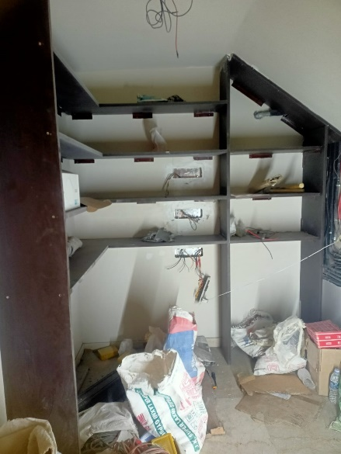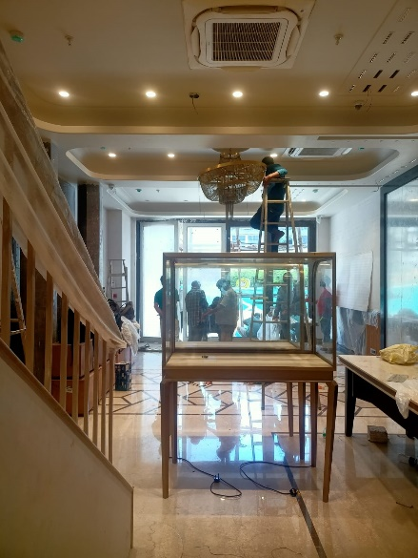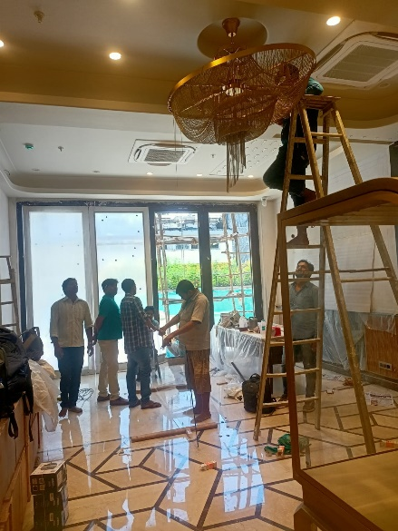

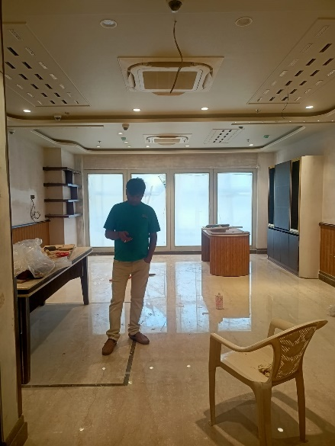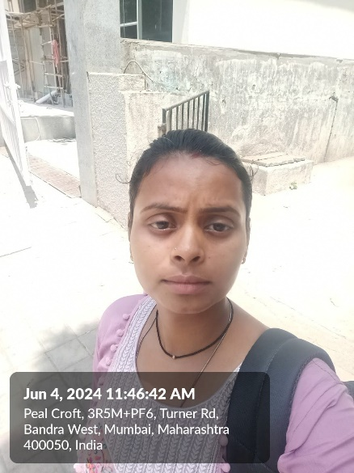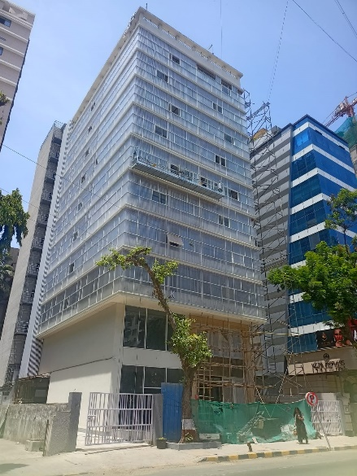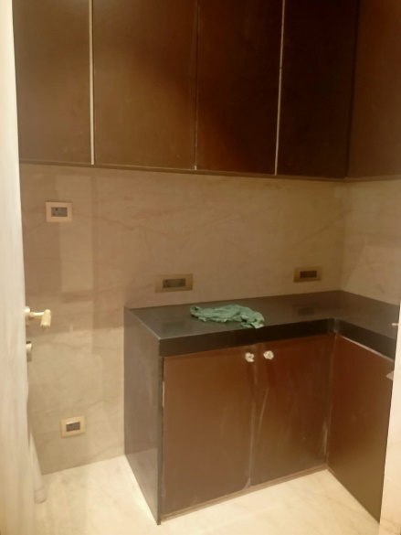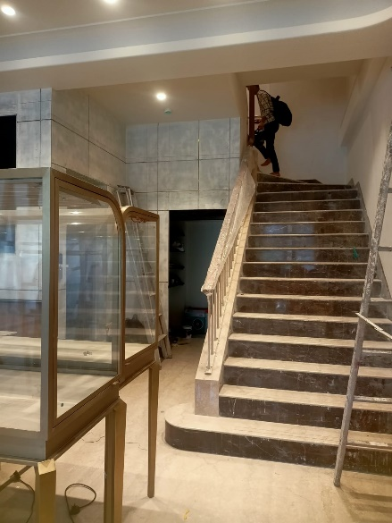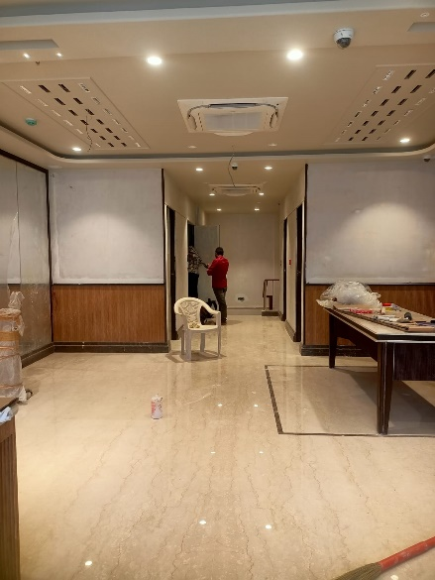

**Route Map of the property**

**Site u/r**

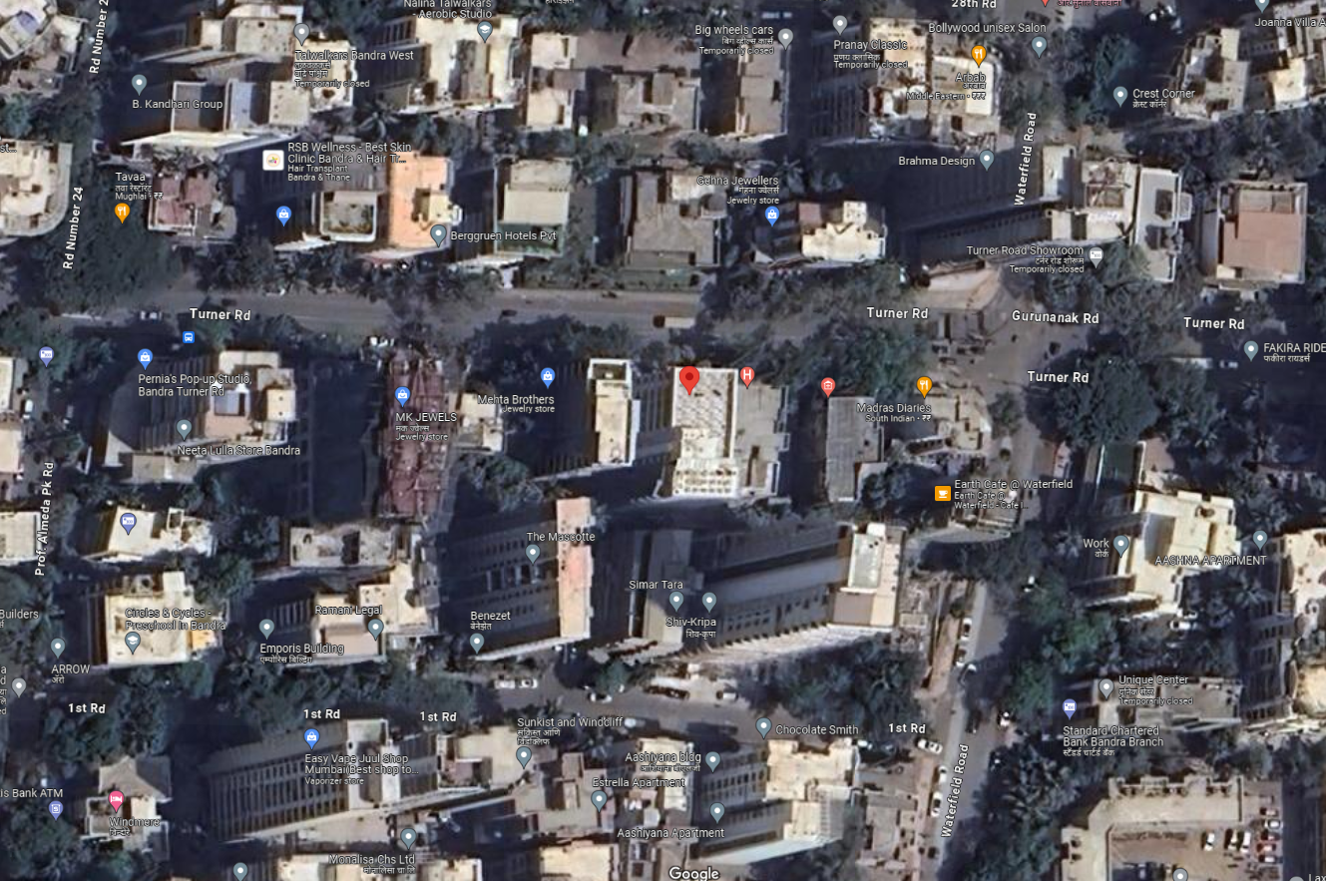

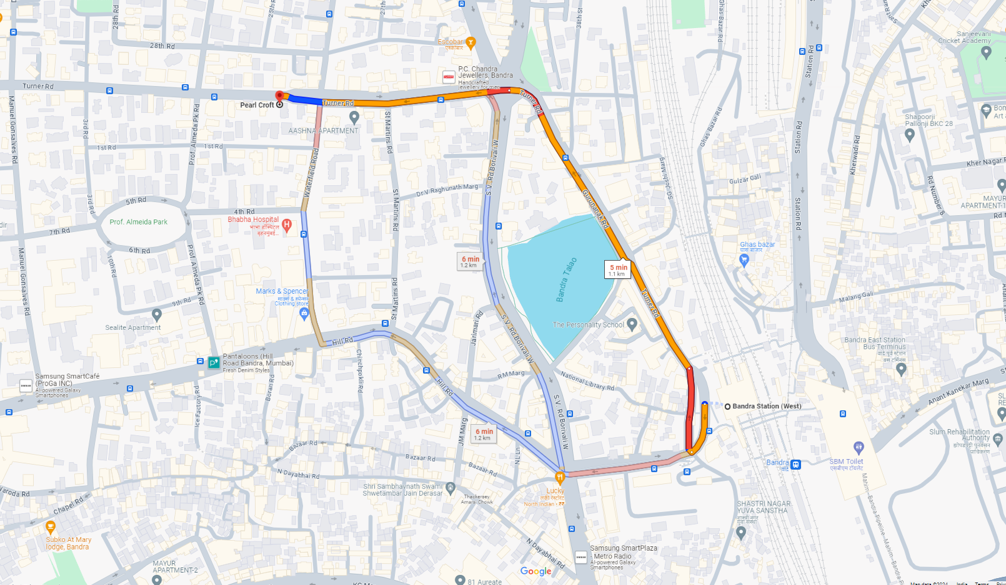

# Latitude Longitude - 19°03'33.4"N 72°50'00.7"E

**Note**: The Blue line shows the route to site from nearest railway station (Bandra – 1.1 Km.)

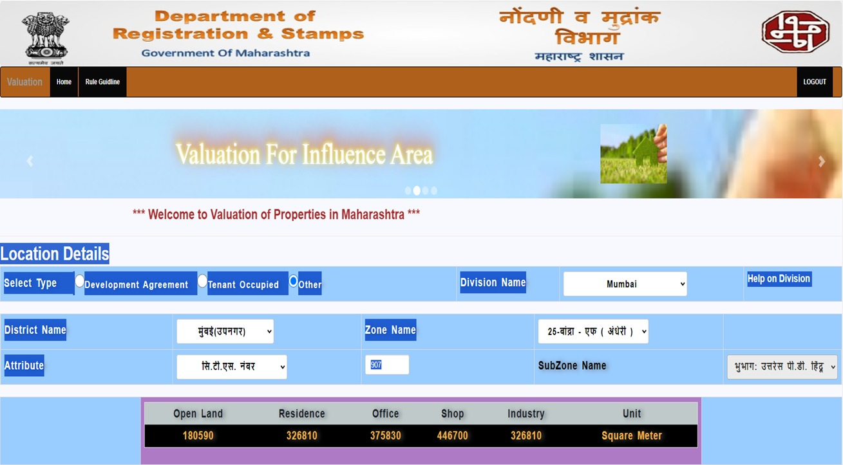**Ready Reckoner Rate**

|  |  |  |  |  |
| --- | --- | --- | --- | --- |
| Stamp Duty Ready Reckoner Market Value Rate for **Shop** | 4,46,700.00 |  |  |  |
| No increase on Shop Located on Ground Floor | 00.00 |  |  |  |
| **Stamp Duty Ready Reckoner Market Value Rate (After Increase) (A)** | **4,46,700** | **Sq. Mtr.** | **41,500.00** | **Sq. Ft.** |
| Stamp Duty Ready Reckoner Market Value Rate for **Land (B)** | - |  |  |  |
| The difference between land rate and building rate (A – B = C) |  |  |  |  |
| Depreciation Percentage as per table (D) [100% - 0%]  (Age of the Building – Just Completed) | - |  |  |  |
| **Rate to be adopted after considering depreciation [B + (C x D)]** | - | **Sq. Mtr.** | - | **Sq. Ft.** |

**Multi-Storied building with Lift**

For residential premises / commercial unit / office on above floor in multistore building, the rate mentioned in the ready reckoner will be increased as under:

|  |  |  |
| --- | --- | --- |
|  | **Location of Flat / Commercial Unit in the building** | **Rate** |
| a) | On Ground to 4 Floors | No increase for all floors from ground to 4 floors |
| b) | 5 Floors to 10 Floors | Increase by 5% on units located between 5 to 10 floors |
| c) | 11 Floors to 20 Floors | Increase by 10% on units located between 11 to 20 floors |
| d) | 21 Floors to 30 Floors | Increase by 15% on units located between 21 to 30 floors |
| e) | 31 Floors and above | Increase by 20% on units located on 31 and above floors |

**Table – D: Depreciation Percentage Table**

|  |  |  |
| --- | --- | --- |
| **Completed Age of Building in Years** | **Value in percent after depreciation** | |
|  | **R.C.C. Structure / other Pukka Structure** | **Cessed Building, Half or Semi – Pukka Structure & Kaccha Structure.** |
| 0 to 2 Years | 100% | 100% |
| Above 2 & up to 5 Years | 95% | 95% |
| Above 5 Years | After initial 5 year for every year 1% depreciation is to be considered. However maximum deduction available as per this shall be 70% of Market Value rate | After initial 5 year for every year 1.5% depreciation is to be considered. However maximum deduction available as per this shall be 85% of Market Value rate |

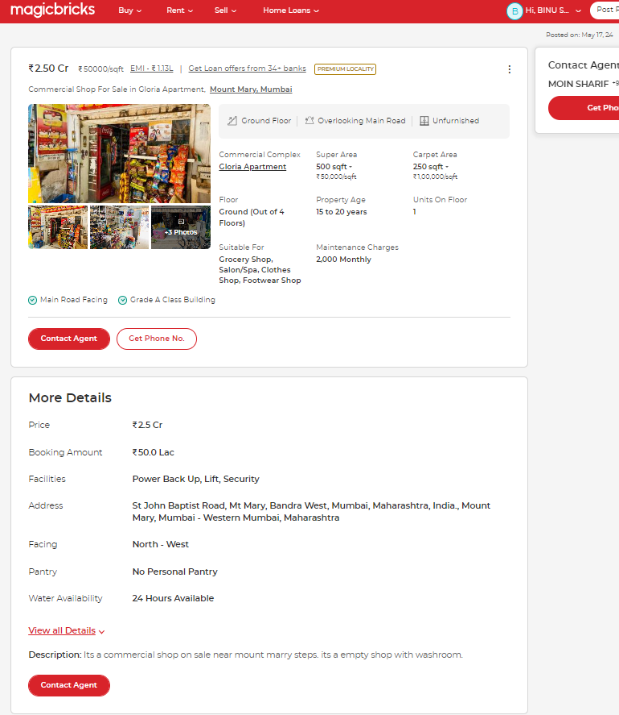**Price Indicators**

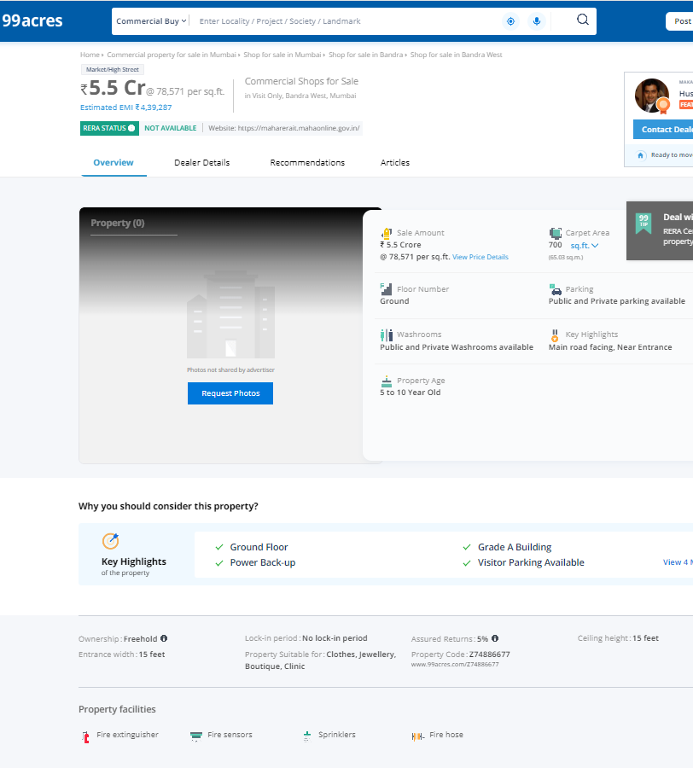 **Sales Intense**

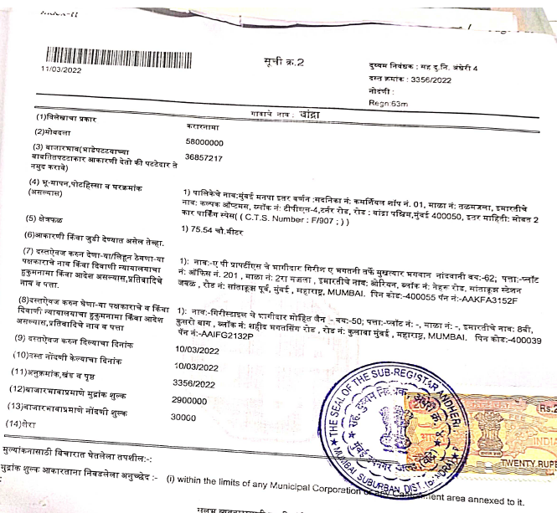

**DEFINITION OF VALUE FOR THIS SPECIFIC PURPOSE**

This exercise is to assess **Fair Market Value** of the property under reference for **Fair Market Value** purpose as on dated **5th June 2024.**

The term **Fair Market Value** is defined as

*"The most probable price, as of a specified date, in cash, terms equivalent to cash, or in other precisely revealed terms for which the specified property rights would sell after reasonable exposure in a competitive market under all conditions requisite to a fair sale, with the buyer and seller each acting prudently knowledgeably and for self-interest assuming that neither is under undue duress"*

Fundamental assumptions and conditions presumed in this definition are:

1. Buyer and seller are motivated by self-interest.
2. Buyer and seller are well informed and are acting prudently.
3. The property is exposed for a reasonable time on the open market.
4. Payment is made in cash or equivalent or in specified financing terms.

**ASSUMPTIONS, CAVEATS, LIMITATION AND DISCLAIMERS**

1. We assume no responsibility for matters of legal nature affecting the property appraised or the title thereto, nor do we render our opinion as to the title, which is assumed to be good and marketable.
2. The property is valued as though under responsible ownership.
3. It is assumed that there are no hidden or unapparent conditions of the subsoil or structure that would render it more or less valuable. No responsibility is assumed for such conditions or for engineering that might be required to discover such factors.
4. There is no direct/ indirect interest in the property valued.
5. The rates for valuation of the property are in accordance with the Govt. approved rates and prevailing market rates.

**DECLARATION OF PROFESSIONAL FEES CHARGED**

We hereby declare that; our professional fees are not contingent upon the valuation findings. However, if the statute AND/OR clients demands that, the fees should be charged on the percentage of assessed value then, with the full knowledge of the AND/OR end user, it is being charged accordingly.

**VALUATION OF THE PROPERTY PREMISES**

Considering various parameters recorded herein above, existing economic scenario, and the information that is available with reference to the development of neighbourhood and method selected for valuation, we are of the opinion that, the property premises can be assessed and valued for this particular purpose at **` 6,35,76,000.00 (Rupees Six Crore Thirty Five Lakh Seventy Six Thousand Only).**

**Manoj B. Chalikwar**

Registered Valuer

Chartered Engineer (India)

Reg. No. CAT-I-F-1763

TZCBL Emp. No. Ref: ZCBL/CO/AUD/19-20/100