Vastu/SBI/SME/03/2021/10844
Date: 21-05-2024

CE CERTIFICATE FOR MACHINE INSTALLATION

To,

The Manager,

Credit Saison India,
Revenue Village- Kondivita, 2nd Level,
33 CTS No. 195-A, Kalpatru Square, Andheri-Kurla Road,
Andheri East, Mumbai-400 059,
State - Maharashtra, Country - India.

Sub: CE Certificate for Installation of Valuation of High Precision Cold Rolling Machine with complete mechanical and electrical accessories, Model: TP-CRM-40.

Ref: Proforma Invoice/Quotation, Tax Invoice, Bill of Entry, Packing List, Technical Specification received from Client.

Dear Sir,

With reference to above subject, we have visited the Unit of M/s. Jay Jagdamba Limited located at Gut No. 92/3, 422, 423,424 Village Abitghar, Shirispada Shahapur Road Taluka-Wada, District- Palghar PIN Code- 421 303, State-Maharashtra, Country-India on 14.05.2024. During the time of our visit, we found that the machinery is installed and trail run is in progress. During the time of our visit, our observation are as under:-
S. No. | Particular | Details
1 | Date of Site Visit | 14.05.2024
2 | Condition | Machine is installed and trail run is in progress.
3 | Input Size | 48 mm X 4 mm X 4.80 m
4 | Output Size | 25 mm X 2 mm X 16.40 m
5 | Machine Train Start Time | 12.12 PM
6 | Machine Trail End Time | 12.30 PM
7 | Average Speed | 9 min/ meter

During on our site visit, the Machine is installed and trail run is going on and the photographs are enclosed.

Kindly refer our previous report no: Vastu/Mumbai/03/2024/7863/2305666 Dated:19/03/2024 for market Value Of Machine.
Hence Certified.

This report is prepared for Credit Saison India, Mumbai.

We further declare that: --

In the preparation of the CE Certificate, we have relied on the information provided by the client.

The information furnished in this Certificate is true and correct to the best of our knowledge and belief.

We have no direct or indirect interest in the Unit.

Date: -21.05.2024
Place: - Mumbai

For Vastukala Consultants (I) Pvt. Ltd.

Umang Ashwin Patel
Regd. Valuer
Chartered Engineer (India)
Reg. No. IBBI/RV/04/2019/10803

PHOTOGRAPHS:-
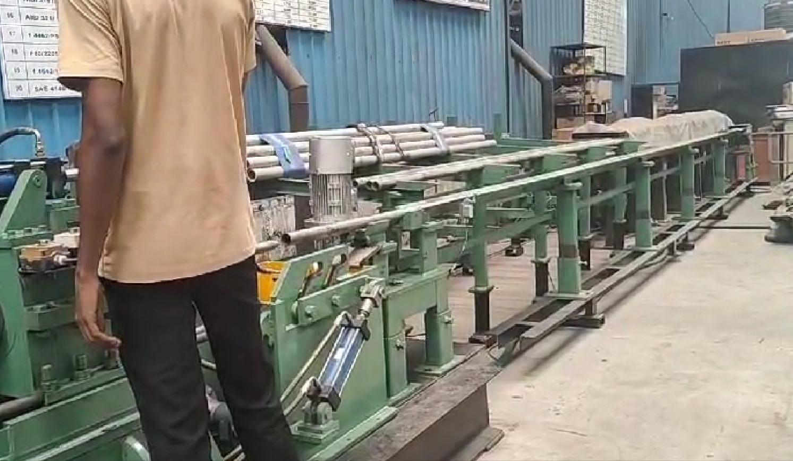 | 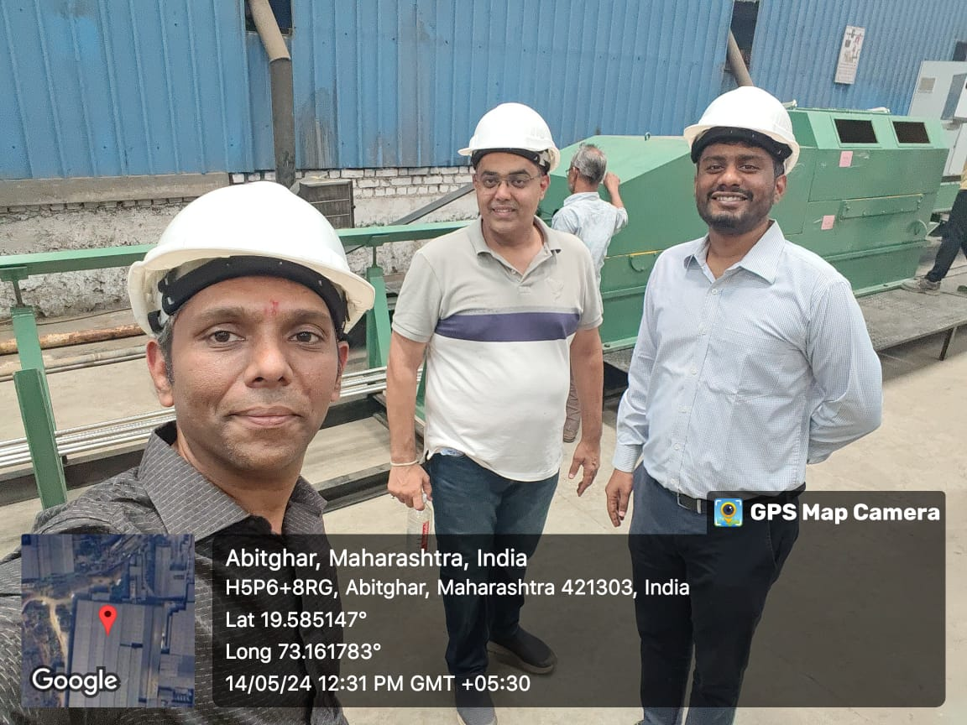
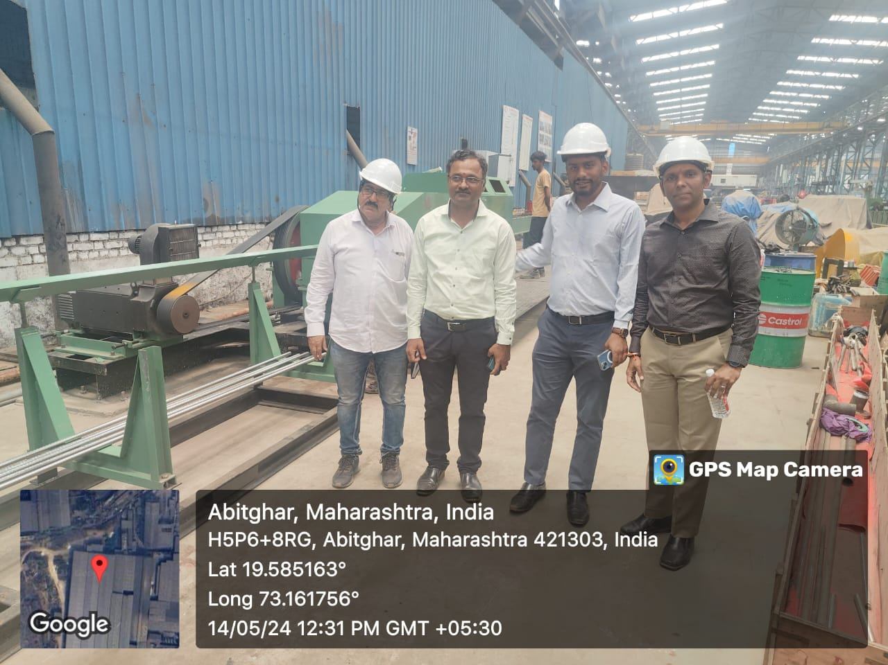 | 