**Valuation Report of the Immovable Property**

**Details of the property under consideration:**

Name of Owner: **M/s. Ros Equipments**

Industrial Unit No. 2, Ground Floor**, "Aditya Industrial Estate"**, Chincholi Bunder Road, Malad (West),   
Mumbai - 400064, State - Maharashtra, Country - India

**Latitude Longitude: 19°10'39.7"N 72°50'06.3"E**

**Valuation Done for:**

**Punjab National Bank**

**Bandra (East) Retail Asset Branch**

Retail Asset Branch, Plot No. C-9, G-Block, Ground Floor, B.K.C., Bandra (East), Mumbai - 400 051,   
State - Maharashtra, Country - India.

**Vastukala Consultants (I) Pvt. Ltd.**

|  |  |  |  |  |  |  |
| --- | --- | --- | --- | --- | --- | --- |
| **Mumbai** | **.** | **Navi Mumbai** | **.** | **Aurangabad** | **.** | **Nanded** |

Vastu/Mumbai/09/2016/003697 / 19590

27/09-353-S

Date: 27.09.2016

**VALUATION OPINION REPORT**

The property bearing Industrial Unit No. 2, Ground Floor**, "Aditya Industrial Estate"**, Chincholi Bunder Road, Malad (West), Mumbai - 400064, State - Maharashtra, Country - India belongs to **Ms. Ros Equipments.**

|  |  |
| --- | --- |
| Boundaries of the property. | |
| North | Internal Road |
| South | Industrial Building |
| East | Mother Nature Studio |
| West | Euro House & Road |

Considering various parameters recorded, existing economic scenario, and the information that is available with reference to the development of neighbourhood and method selected for valuation, we are of the opinion that, the property premises can be assessed and valued for banking purpose at **` 88,16,000.00 (Rupees Eighty Eight Lac Sixteen Thousand Only).**

The valuation of the property is based on the documents produced by the concern. Legal aspects have not been taken into considerations while preparing this report.

Hence certified

**Sharad B. Chalikwar**

Govt. Reg. Valuer

Chartered Engineer (India)

Reg. No. (N) CCIT/1-14/52/2008-09

Encl.: Valuation report

**Valuation Report of Immovable Property**

|  |  |  |  |  |  |  |  |  |  |  |  |  |  |  |  |  |  |  |  |  |  |  |  |  |  |
| --- | --- | --- | --- | --- | --- | --- | --- | --- | --- | --- | --- | --- | --- | --- | --- | --- | --- | --- | --- | --- | --- | --- | --- | --- | --- |
| 1 | **Customer Details** | | | | | | | | | | | | | | | | | | | | | | | | |
|  | Name(s) of the owner(s). | | | | **Ms. Ros Equipments** | | | | | | | | | | Application No. | | | | |  | | | | | |
|  | Case Type | | | |  | | | | | | | | | | | | | | | | | | | | |
| 2 | **Asset Details** | | | | | | | | | | | | | | | | | | | | | | | | |
|  | Address | | | | | Industrial Unit No. 2, Ground Floor**, "Aditya Industrial Estate"**, Chincholi Bunder Road, Malad (West), Mumbai - 400064, State - Maharashtra, Country - India | | | | | | | | | | | | | | | | | | | |
|  | Nearby Landmark | | | | | Landmark: Near Mother Nature Studio  **Latitude Longitude: 19°10'39.7"N 72°50'06.3"E** | | | | | | | | | | | | | | | | | | | |
| 3 | **Document Details** | | | | | Name of Approving Authority | | | | | | | | | | | |  | | | | | | | |
|  | **Layout Plan** | | | | No | Details not provided | | | | | | | | Approval No. | | | | | | | Details not provided | | | | |
|  | **Building Plan** | | | | No | Details not provided | | | | | | | | Approval No. | | | | | | | Details not provided | | | | |
|  | **Construction Permission** | | | | Yes | Municipal Corporation of Greater Mumbai | | | | | | | | Approval No. | | | | | | | No. CHE / 1692 / BP (WS) / AP/AR | | | | |
|  | **Legal Documents** | | | | Yes | 1. Copy of Agreement for sale dated 09.01.2001 2. Copy of Commencement Certificate No. CHE / 1692 / BP (WS) / AP/AR dated 23.02.1996 issued by Municipal Corporation of Greater Mumbai | | | | | | | | | | | | | | | | | | | |
| 4 | **Physical Details** | | | | | | | | | | | | | | | | | | | | | | | | |
|  | **Adjoining Properties** | | East | | | | | West | | | | | | | | North | | | | | | South | | | |
|  | **As on site** | | Mother Nature Studio | | | | | Euro House & Road | | | | | | | | Internal Road | | | | | | Industrial Building | | | |
|  | **As per document** | | By Property Bearing C.T.S. No. 1068-D | | | | | By Part Portion of Property Bearing C.T.S. No. 1406 | | | | | | | | By Property Bearing C.T.S. No. 1068-A | | | | | | By Property Bearing C.T.S. No. 1069-A | | | |
|  | **Matching of Boundaries** | | - | | | **Plot Demarcated** | | | No | | | | **Approved land use** | | | |  | | **Type of Property** | | | | | Commercial | |
|  | **Composition** | | Basement = Storage area  Ground Floor = Storage area + Toilet | | | | | | | | | | | | | | | | | | | | | | |
|  | **Total no. of Floors** | 1 Basement + Ground + 4 Upper floors | | **Floor on which the property is located** | | | Ground Floor | | | **Approx. Age of the property** | | | | | 19 years | | | **Residual age of the property** | | 41 years Subject to proper, preventive periodic maintenance & structural repairs. | | | | | **Type of structure :**R.C.C. Foundation |
| 5 | **Occupancy Details - Owner** | | | | | | | | | | | | | | | | | | | | | | | | |
|  | **Status of Tenure** | | N.A. | | | **No. of years of Occupancy** | | | | | |  | | | | | | **Relationship of tenant with owner** | | | | |  | | |
| 6 | **Stage of Construction** | | | | | | | | | | | | | | | | | | | | | | | | |
|  | Stage of construction | | | | | | | | | | Completed | | | | | | | | | | | | | | |
|  | **If under construction, extent of completion** | | | | | | | | | | **N.A.** | | | | | | | | | | | | | | |

|  |  |  |  |  |  |  |  |  |  |
| --- | --- | --- | --- | --- | --- | --- | --- | --- | --- |
| 7 | **Violations if any observed** | | | | | | | | |
|  | Nature and extent of violations | | | Nil | | | | | |
| 8 | **Area Details of the Property** | | | | | | | | |
|  | Carpet Area in Sq. Ft. | Basement area = 170.00  Ground Floor = 255.00  (Area as per actual measurement) | | | **Plinth area / Built up area (Area as per agreement)** | | | **551.00 Sq. Ft.** | |
|  | Remarks: | *As per site inspection, The Property is Basement + Ground floors but as per agreement, The Property is of Ground floor which is considered for the purpose of valuation. For the purpose of valuation, we have considered the area as per agreement.* | | | | | | | |
| 9 | **Valuation** | | | | | | | | |
|  | Built Up Area | | | | | ` 551.00Sq. Ft. | | | |
|  | Prevailing market rate | | | | | ` 16,000.00 | | | |
|  | Floor Rise Rate per Sq. Ft. | | | | | ` 0.00 | | | |
|  | PLC Rate per Sq. Ft. | | | | | ` 0.00 | | | |
|  | Total Rate per Sq. Ft. | | | | | ` 16,000.00 | | | |
|  | Value of the property | | | | | ` 88,16,000.00 | | | |
|  | Realizable Value of the Property | | | | | ` 79,34,400.00 | | | |
|  | Distress / Force Sale Value | | | | | ` 70,52,800.00 | | | |
|  | Insurable Value of the Assets | | | | | ` 8,26,500.00 | | | |
|  | Govt. Approved Rate/ Ready Reckoner Rate Per Sq. M. for new property | | | | | ` 1,58,200.00 per Sq. M.  i.e.` 14,697.00 per Sq. Ft. | | | |
|  | Govt. Approved Rate/ Ready Reckoner Rate Per Sq. M. after depreciate | | | | | ` 1,54,971.00 per Sq. M.  i.e.` 14,397.00 per Sq. Ft. | | | |
| 10 | **Assumptions /Remarks** | | Attached | | | | | | |
| 11 | **Declaration** | | 1. The property was inspected by me / our site Engineer Mr. Suraj Mistry (Mobile No. - 9664604226) personally on 25.09.2016 2. The undersigned does not have any direct / indirect interest in the above property. 3. The information furnished herein is true and correct to the best of our knowledge. | | | | | | |
| 12 | **Name, address & signature of Valuer** | | **Vastukala Consultants (I) Pvt. Ltd.**  121, 1st Floor, Ackruti Star, Central Road, MIDC, Andheri (E), Mumbai - 400 093 | | | |  | | |
| **Sharad B. Chalikwar**  Govt. Reg. Valuer  Chartered Engineer (India)  Reg. No. (N) CCIT/1-14/52/2008-09 | | Date of valuation:  27.09.2016 |
| 13 | **List of Documents enclosed** | | 1. Valuation Report 2. Location cum Route Map from Nearest Railway Station 3. Satellite Location Map | | | | | | |
| 14 | **List of Photographs enclosed** | | Internal & External Photographs of the property | | | | | | |

**Actual site photographs**

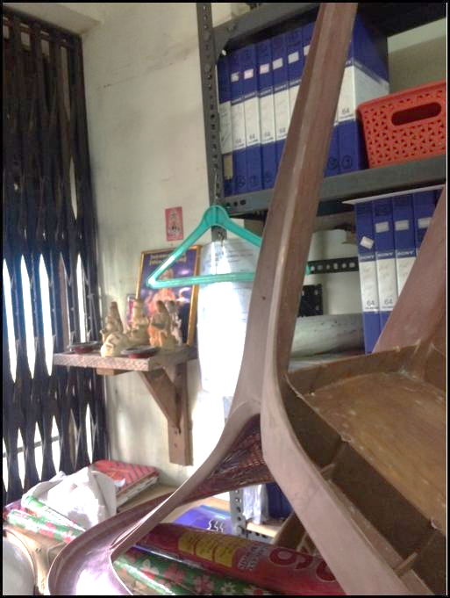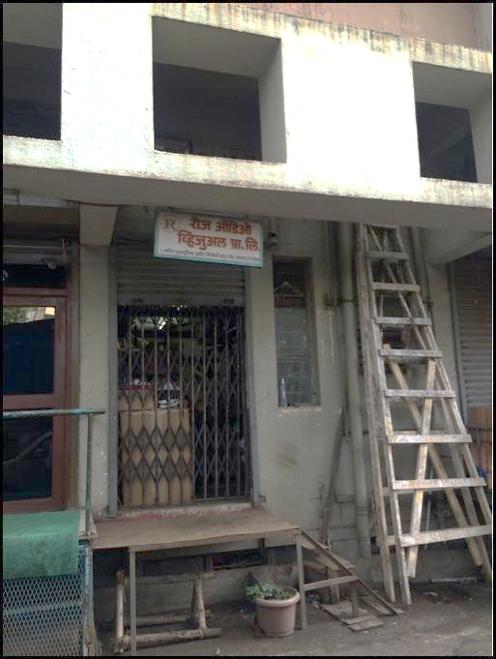

|  |  |
| --- | --- |
|  |  |
|  |  |
|  |  |
|  | W:\Valuation Work\Punjab National Bank\BKC - Bandra\Rose Equipments - Malad\IOTv0cdv_photo_011.jpg |
|  |  |
|  | |

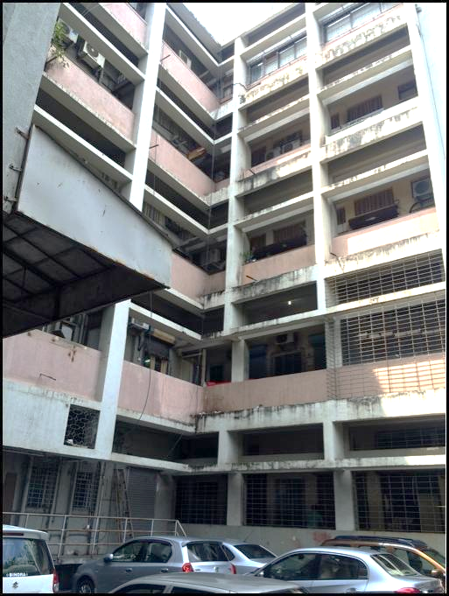

**Route Map of the property**

**Site u/r**

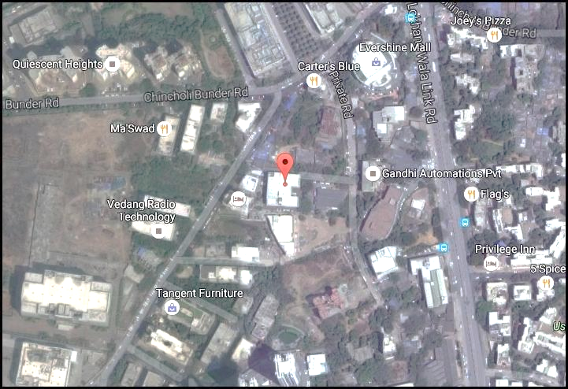

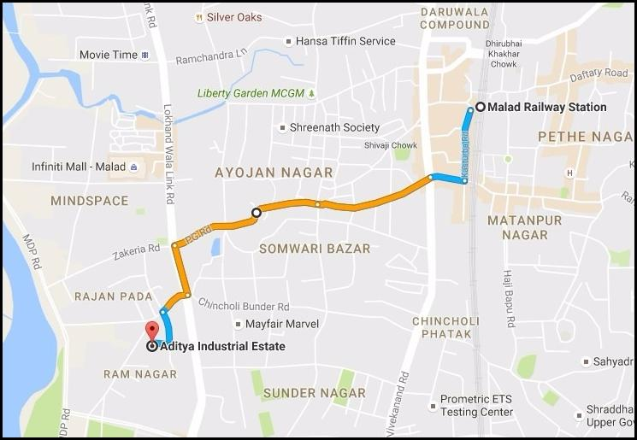

**Latitude Longitude - 19°10'39.7"N 72°50'06.3"E**

**Note**: The Blue line shows the route to site from nearest railway station (Malad 2.3 Km)

**DEFINITION OF VALUE FOR THIS SPECIFIC PURPOSE**

This exercise is to assess **Fair Market Value** of the property under reference for **Housing Loan** purpose as on date **27**th **September 2016**

The term Fair Market Value is defined as

*"The most probable price, as of a specified date, in cash, terms equivalent to cash, or in other precisely revealed terms for which the specified property rights would sell after reasonable exposure in a competitive market under all conditions requisite to a fair sale, with the buyer and seller each acting prudently knowledgeably and for self-interest assuming that neither is under undue duress"*

Fundamental assumptions and conditions presumed in this definition are:

1. Buyer and seller are motivated by self-interest.
2. Buyer and seller are well informed and are acting prudently.
3. The property is exposed for a reasonable time on the open market.
4. Payment is made in cash or equivalent or in specified financing terms.

**UNDER LYING ASSUMPTIONS**

1. We assume no responsibility for matters of legal nature affecting the property appraised or the title thereto, nor do we render our opinion as to the title, which is assumed to be good and marketable
2. The property is valued as though under responsible ownership.
3. It is assumed that the property is free of liens and encumbrances.
4. It is assumed that there are no hidden or unapparent conditions of the subsoil or structure that would render it more or less valuable. No responsibility is assumed for such conditions or for engineering that might be required to discover such factors.

**Sharad B. Chalikwar**

Govt. Reg. Valuer

Chartered Engineer (India)

Reg. No. (N) CCIT/1-14/52/2008-09

**DECLARATION OF PROFESSIONAL FEES CHARGED**

We hereby declare that, our professional fees are not contingent upon the valuation findings. However, if the statute AND/OR clients demands that, the fees should be charged on the percentage of assessed value then, with the full knowledge of the AND/OR end user, it is being charged accordingly.

**VALUATION OF THE PROPERTY PREMISES**

Considering various parameters recorded herein above, existing economic scenario, and the information that is available with reference to the development of neighbourhood and method selected for valuation, we are of the opinion that, the property premises can be assessed and valued for Banking Purpose as on day for **` 88,16,000.00 (Rupees Eighty Eight Lac Sixteen Thousand Only).**

**STATEMENT OF LIMITING CONDITIONS**

1. Assumptions are made to the best of our knowledge and belief. Reliance is based on the information furnished to us by the identifier AND/OR client.
2. The Valuer shall not be responsible for matters of legal nature that affects the value and opinion expressed by us.
3. If our appearance is required, we will be pleased to appear and give the necessary clarification, provided the fees for each appearance (excluding traveling, dearness allowance and out of pocket expenses) is pre-determined before the acceptance of the assignment under reference.
4. In no event shall the Valuer be held responsible or liable for special, direct, indirect or consequential damages, as the assignment has been completed on best efforts, available knowledge and in good intentions of persons concerned and belief.
5. **If it is proved that there is an apparent negligence on the part of a Valuer**, liability of this assignment (whether arising from this assignment, negligence or whatsoever) is limited in respect of anyone event or series of events to the actual loss or damage sustained subject to maximum of 80% of the professional fees for the services rendered and in any case not exceeding the amount of **` 1,000 (Rupees One Thousand Only). All the claims against us shall expire after three month from the date of submission of the valuation report provided by us.**
6. We hereby declare that, the information furnished above is true and correct to the best of our knowledge and belief. We have no direct or indirect interest in the assets valued. We have not been convicted of any offence and sentenced to a term of imprisonment. We have not been found guilty of misconduct in our professional capacity. We have personally inspected the assets.

**Sharad B. Chalikwar**

Govt. Reg. Valuer

Chartered Engineer (India)

Reg. No. (N) CCIT/1-14/52/2008-09