Vastu/Nashik/05/2024/009012/2306523
30/12-383-CCBS
Date: 30.05.2024

To,
The Branch Manager,
State Bank of India
Maharashtra Eng. Research Institute Branch
Dindori Road, MERI, Nashik, Maharashtra, Nashik - 422004,
State - Maharashtra, Country - lndia

Sub: Vetting of Extra Work

Sir,

With reference to above subject, we have evaluated the Extra Amenities for Residential Row House on Plot No. 53/3, “Sai Pujan Row House”, Survey No. 265/1/3, Opposite GIS and Remote Sensing Office, Sambhaji Nagar, Dindori Link Road, Village – Mhasrul, Taluka & District – Nashik, PIN – 422 004, State – Maharashtra, Country – India belongs to: Hemlata Ambadas Gavit.

We have verified the rates quoted as per current market rates. Details of Extra Work considered as per copy of Extra Work Agreement between Hemlata Ambadas Gavit (First Party). Shri.Ramani Pratikkumar Shantilal (Second Party) received on dated 29.05.2024. The Extra Work amount is Rs. 11,00,000/- (Rupees Eleven Lakh Only)

The said Cost Vetting Certificate is valid upto next 6 months Only.

Thanking you

Sincerely yours

Manoj B. Chalikwar
Registered Valuer
Chartered Engineer (India)
Reg. No. CAT-I-F-1763
SBI Empanelment No.: SME/TCC/2021-22/86/3
Encl: Vetting report.

Vetting of Extra Work
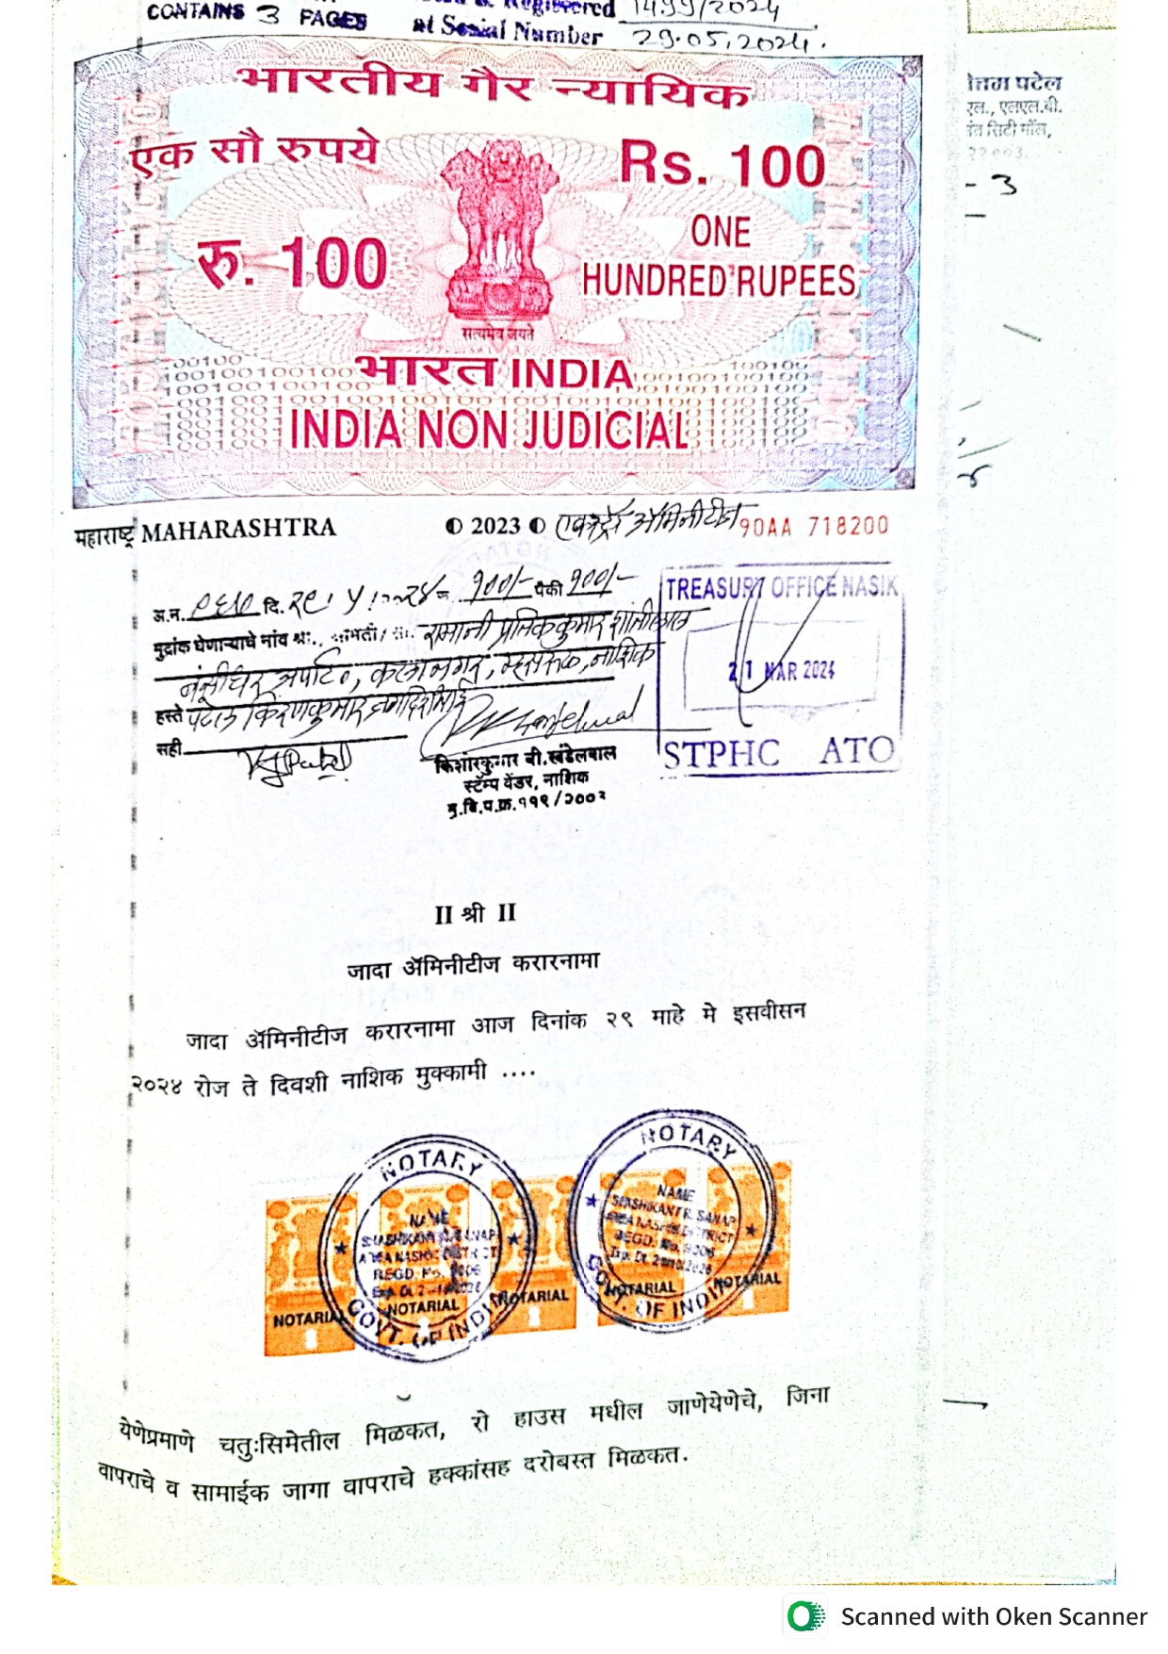
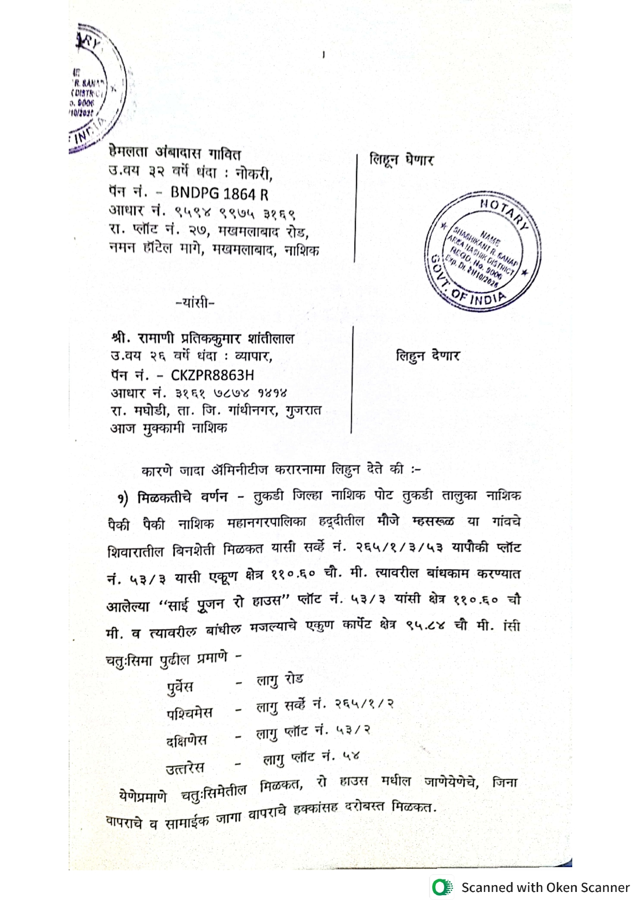

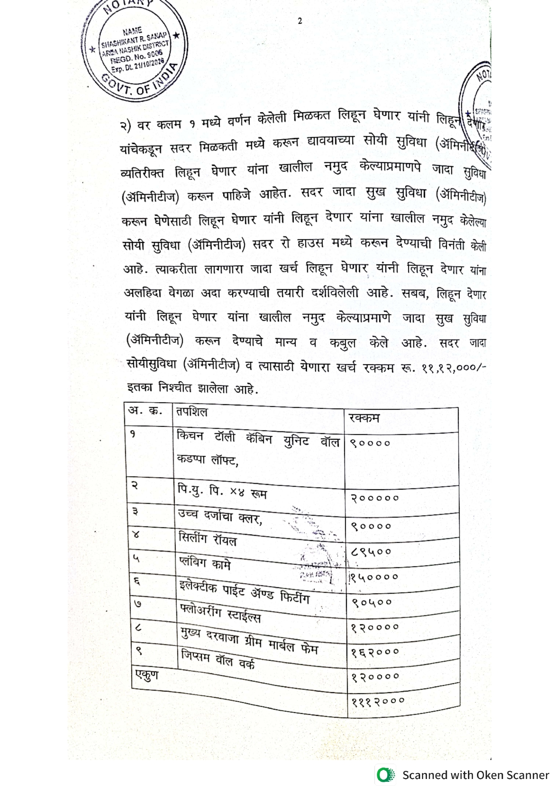
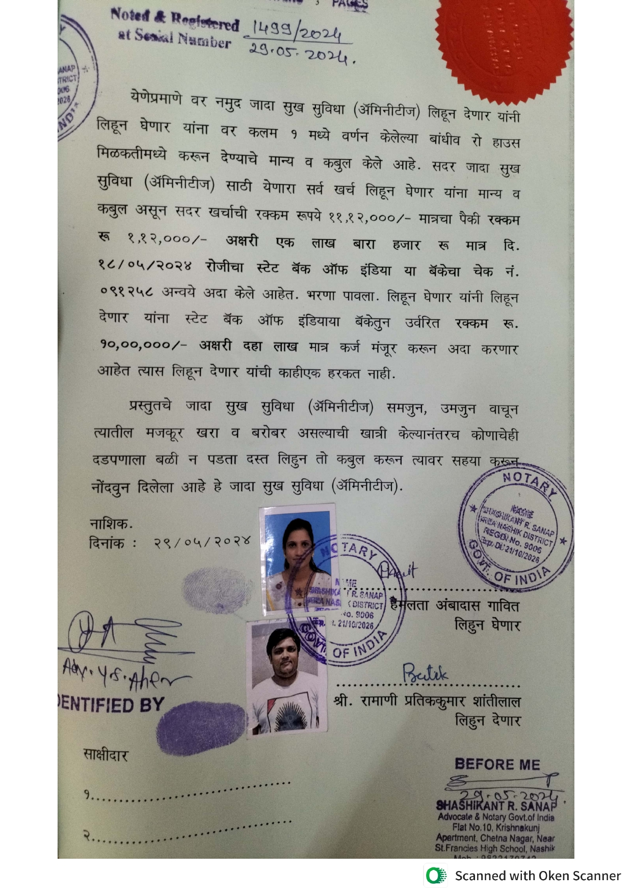

The Extra Work amount is Rs. 11,00,000/- (Rupees Eleven Lakh Only)

